# Internet Variable Relation Report: Single Females

Source file: 20251214-ScalesData-Combined_ver0.7-Cleaned-IncomeNormalized.csv

## Emotional Support - Raw Score vs Functional Impairment - Raw Score

Test: spearman; statistic: -0.14846403803707967; p-value: 0.26177444179351583;

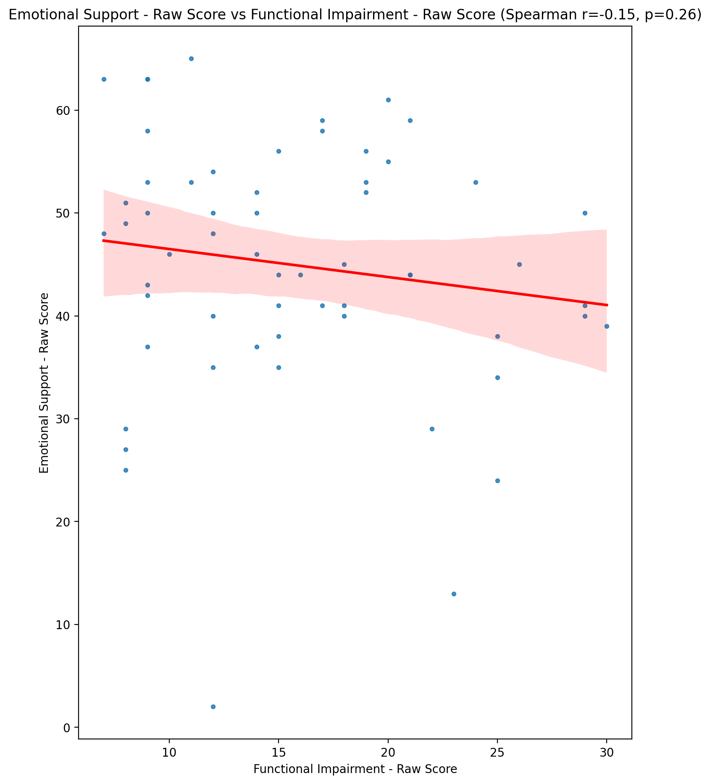

## Informational Support - Raw Score vs Functional Impairment - Raw Score

Test: spearman; statistic: -0.09004207642774283; p-value: 0.4976399408557386;

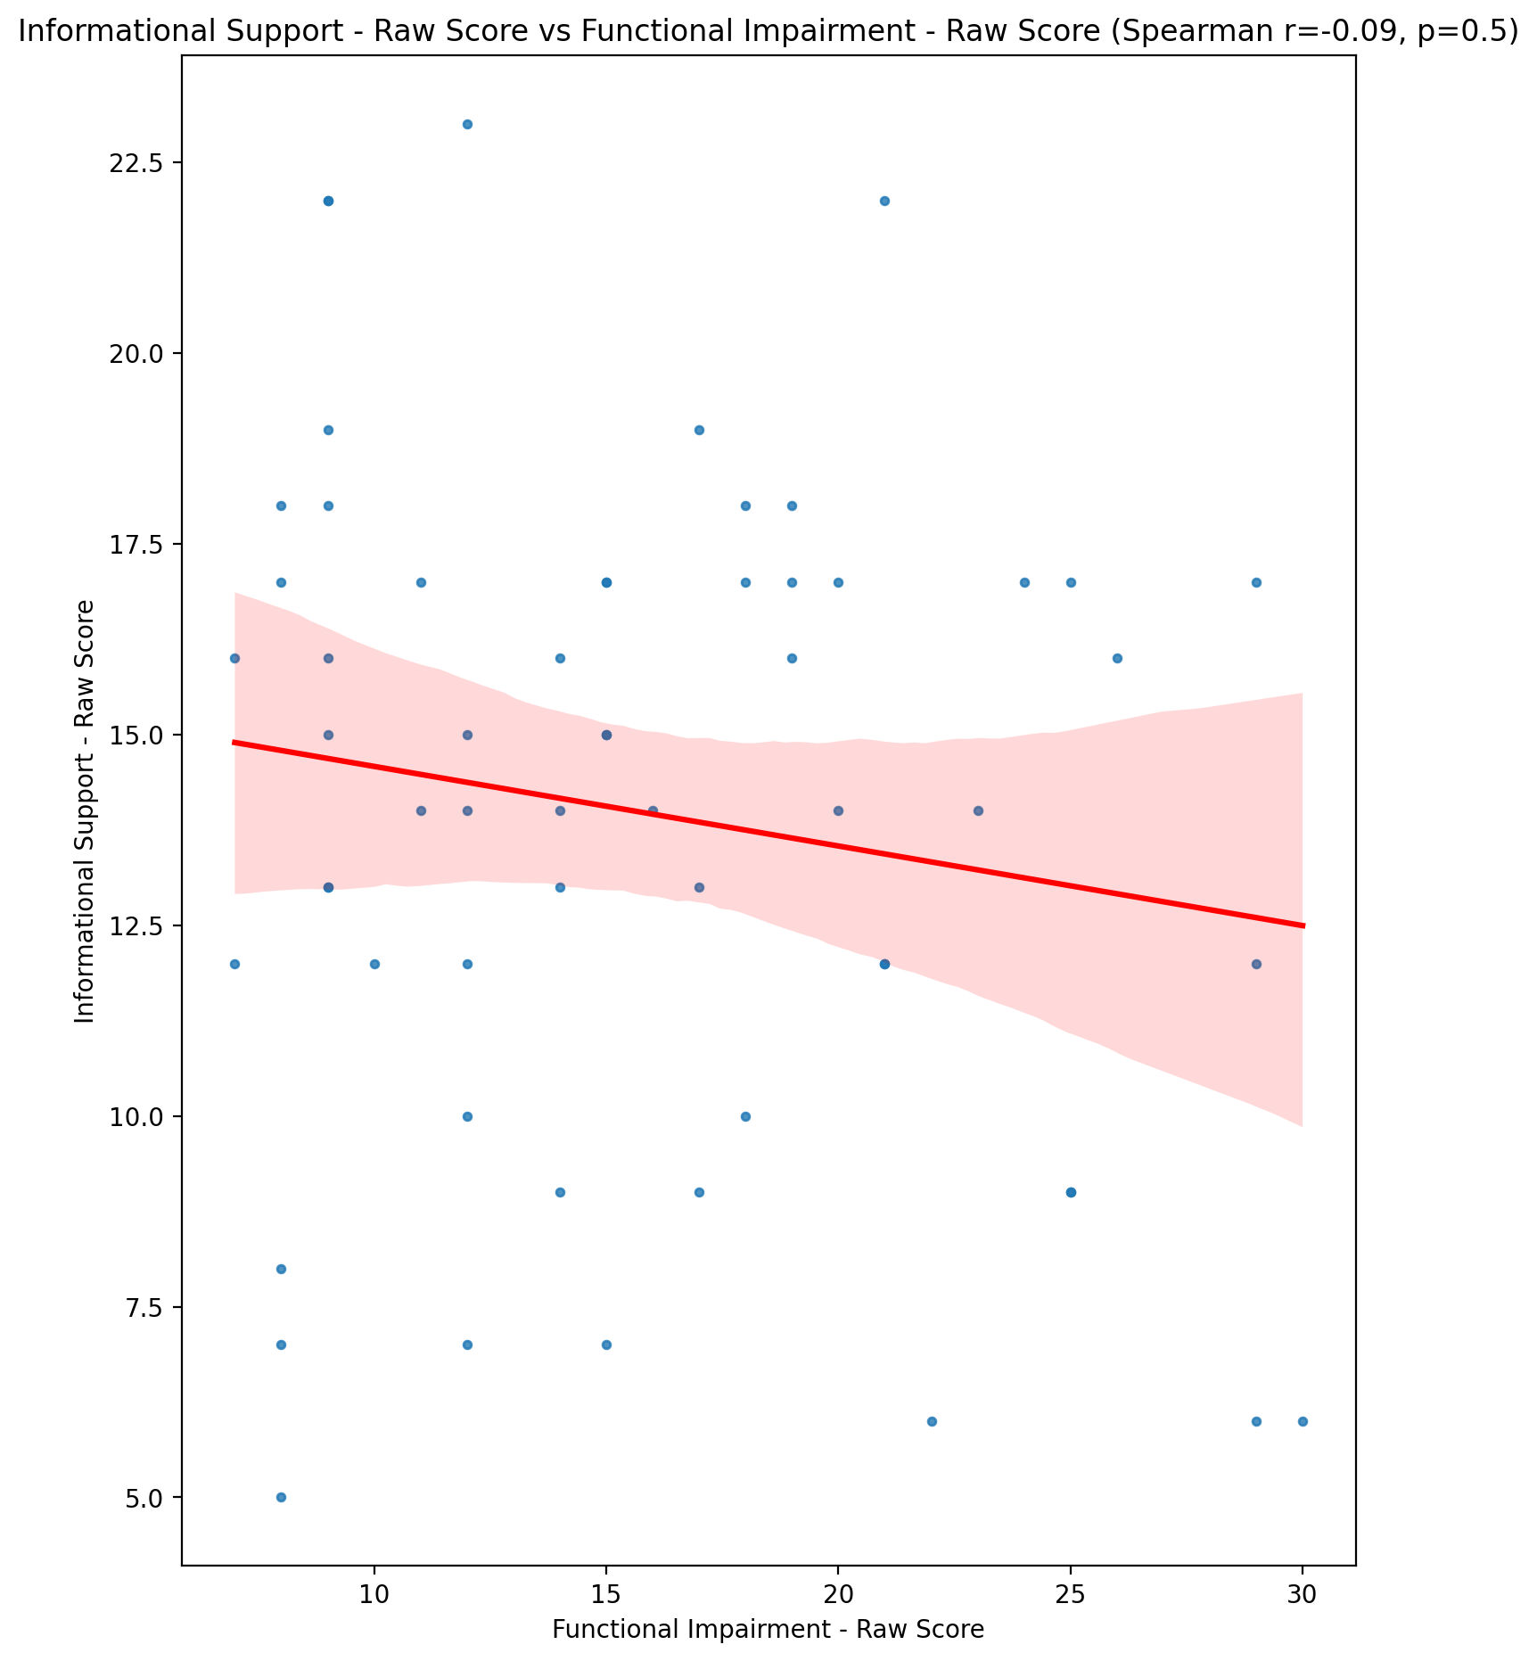

## Instrumental Support - Raw Score vs Functional Impairment - Raw Score

Test: spearman; statistic: -0.23856891349367754; p-value: 0.06881274695718086;

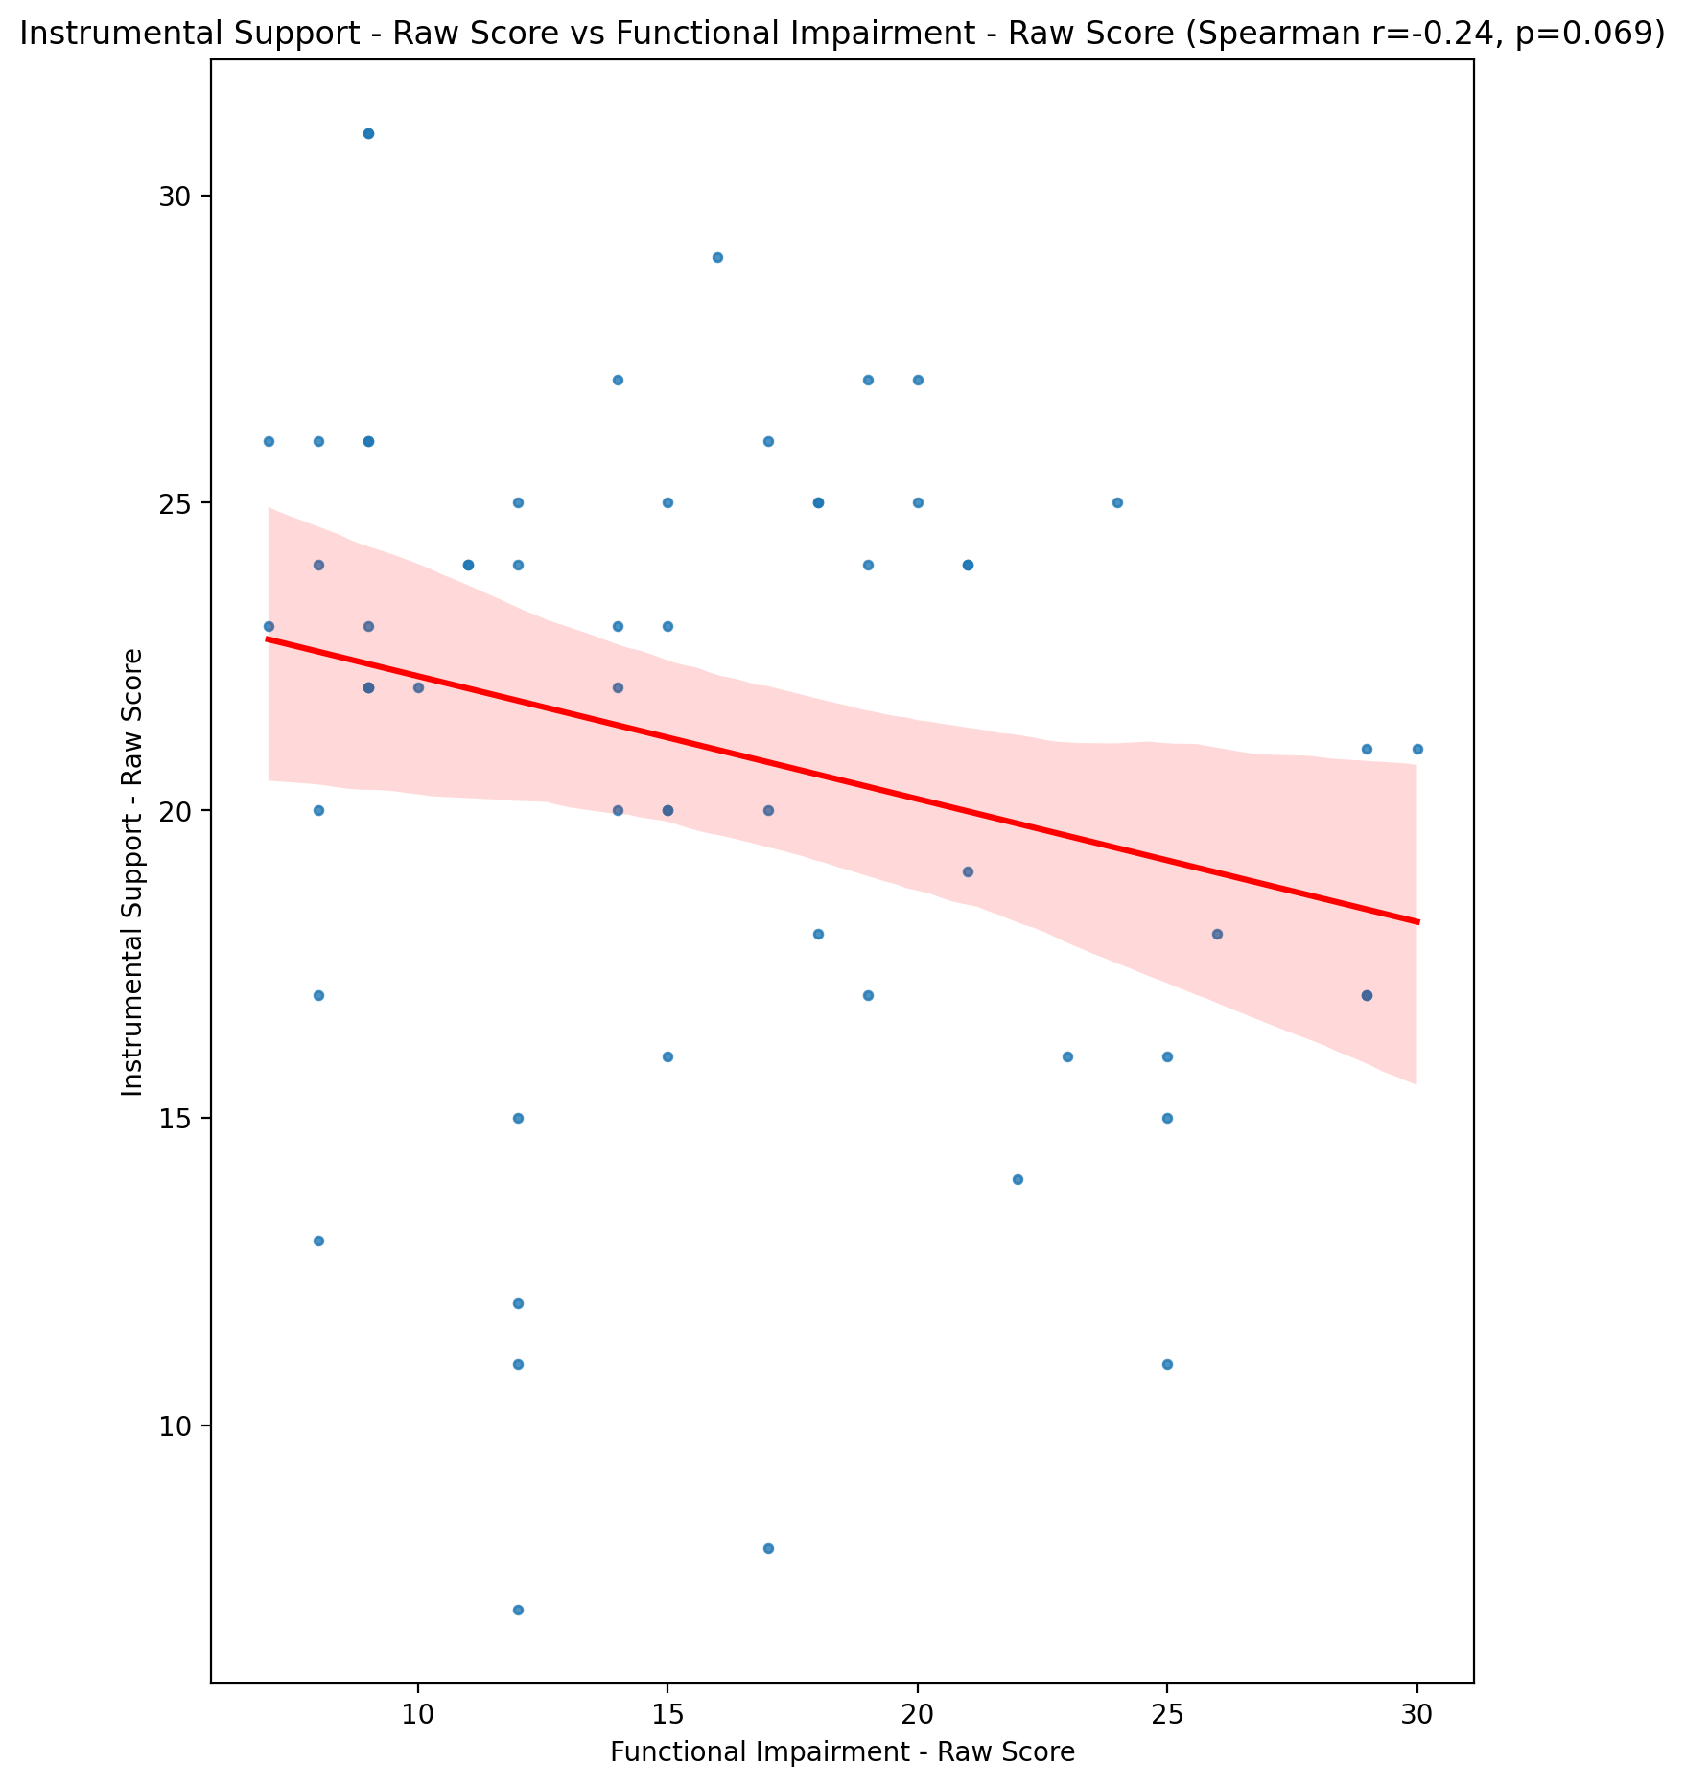

## Emotional Support - T Score vs Functional Impairment - Raw Score

Test: spearman; statistic: -0.1439303814592648; p-value: 0.27678476025743276;

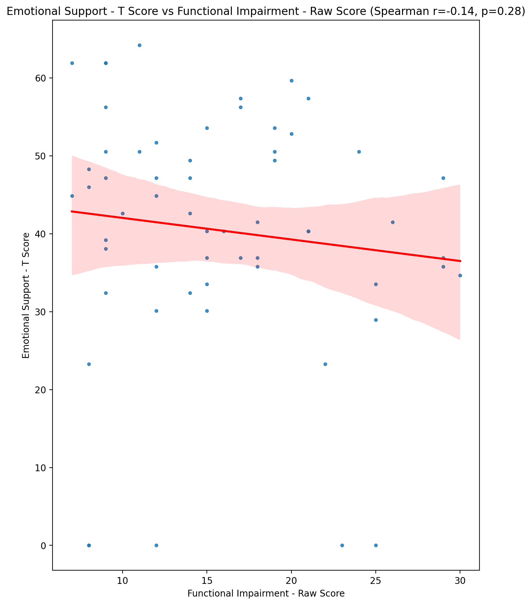

## Informational Support - T Score vs Functional Impairment - Raw Score

Test: spearman; statistic: -0.08063810583716123; p-value: 0.5437643501058921;

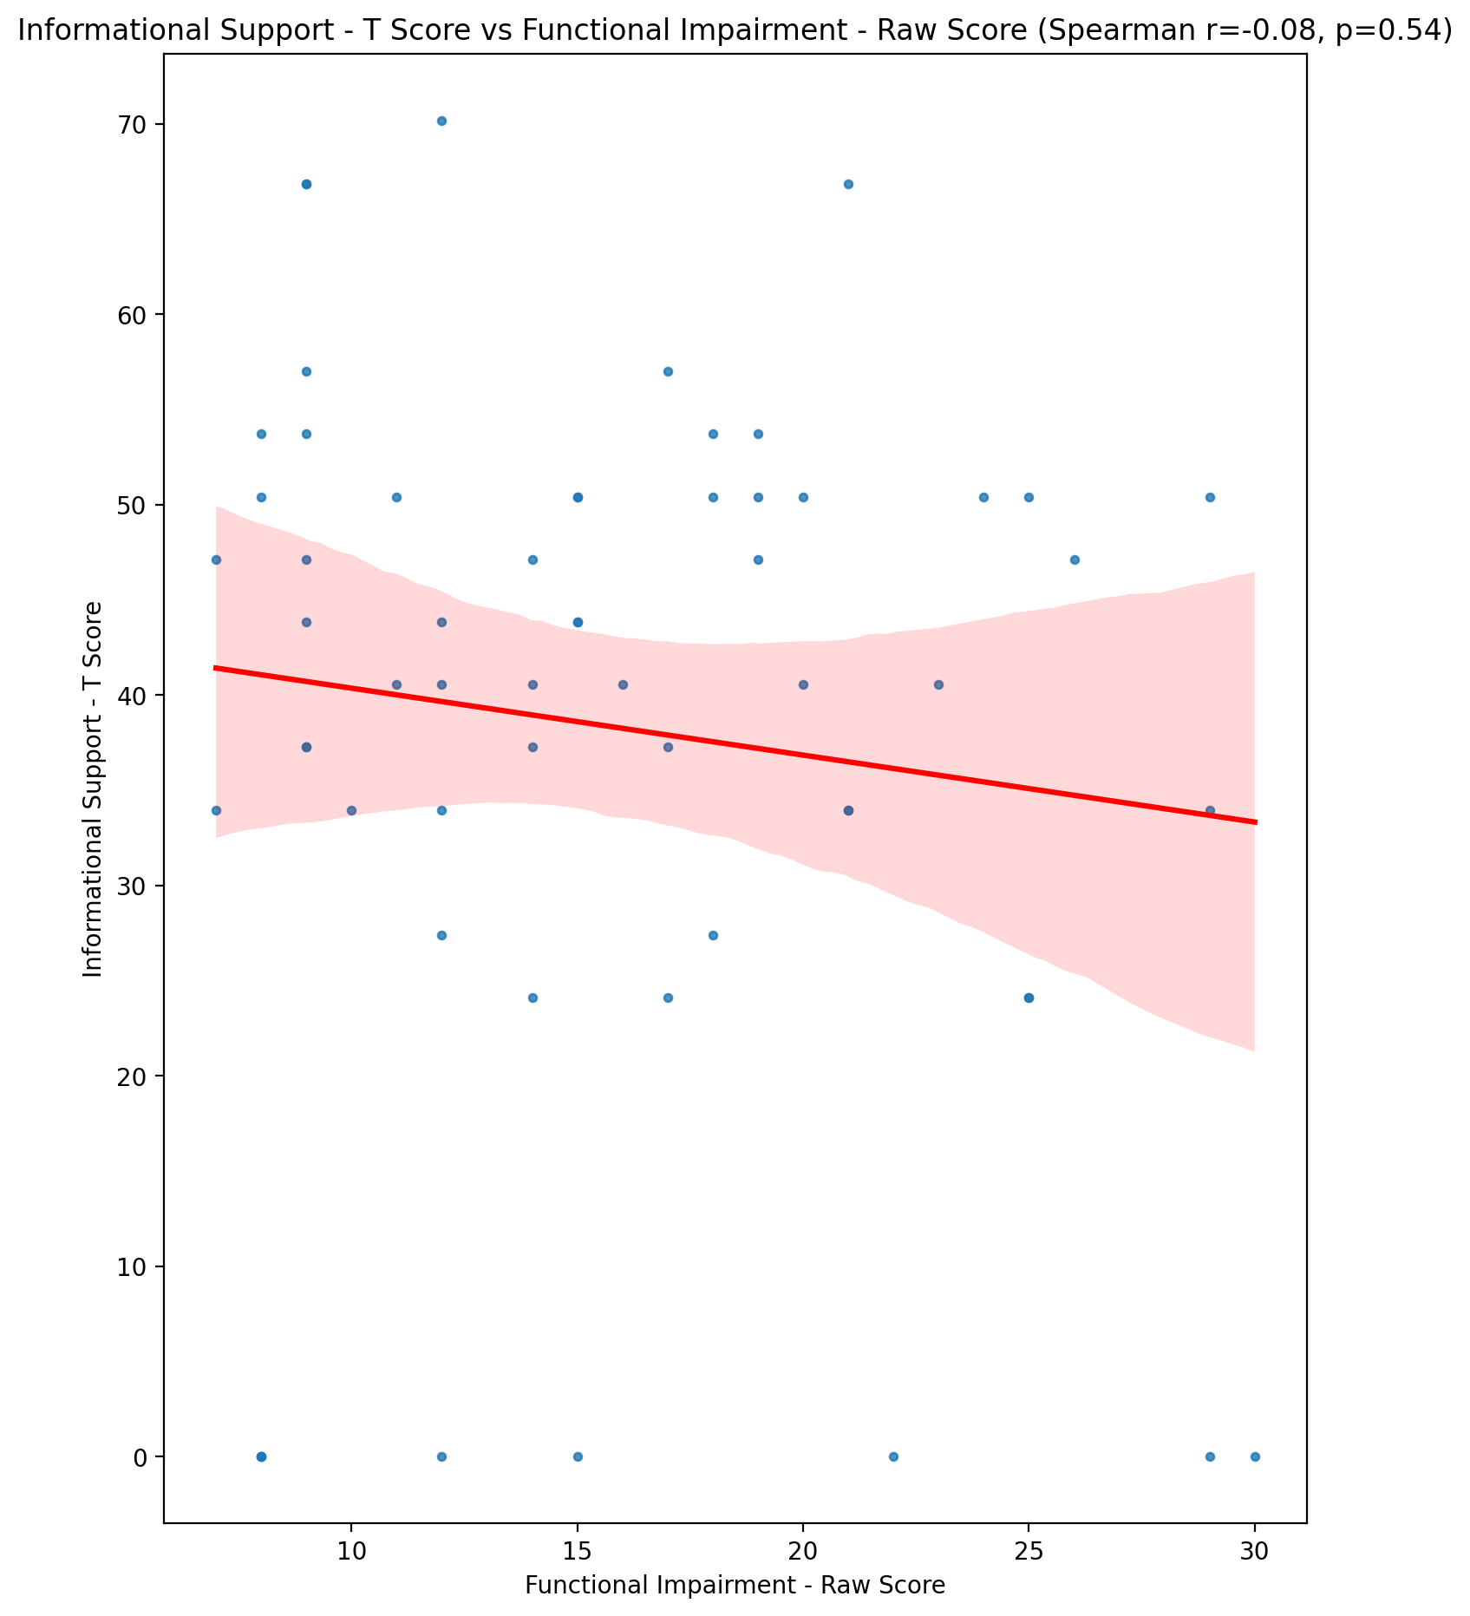

## Instrumental Support - T Score vs Functional Impairment - Raw Score

Test: spearman; statistic: -0.2349836949981757; p-value: 0.07321272042178936;

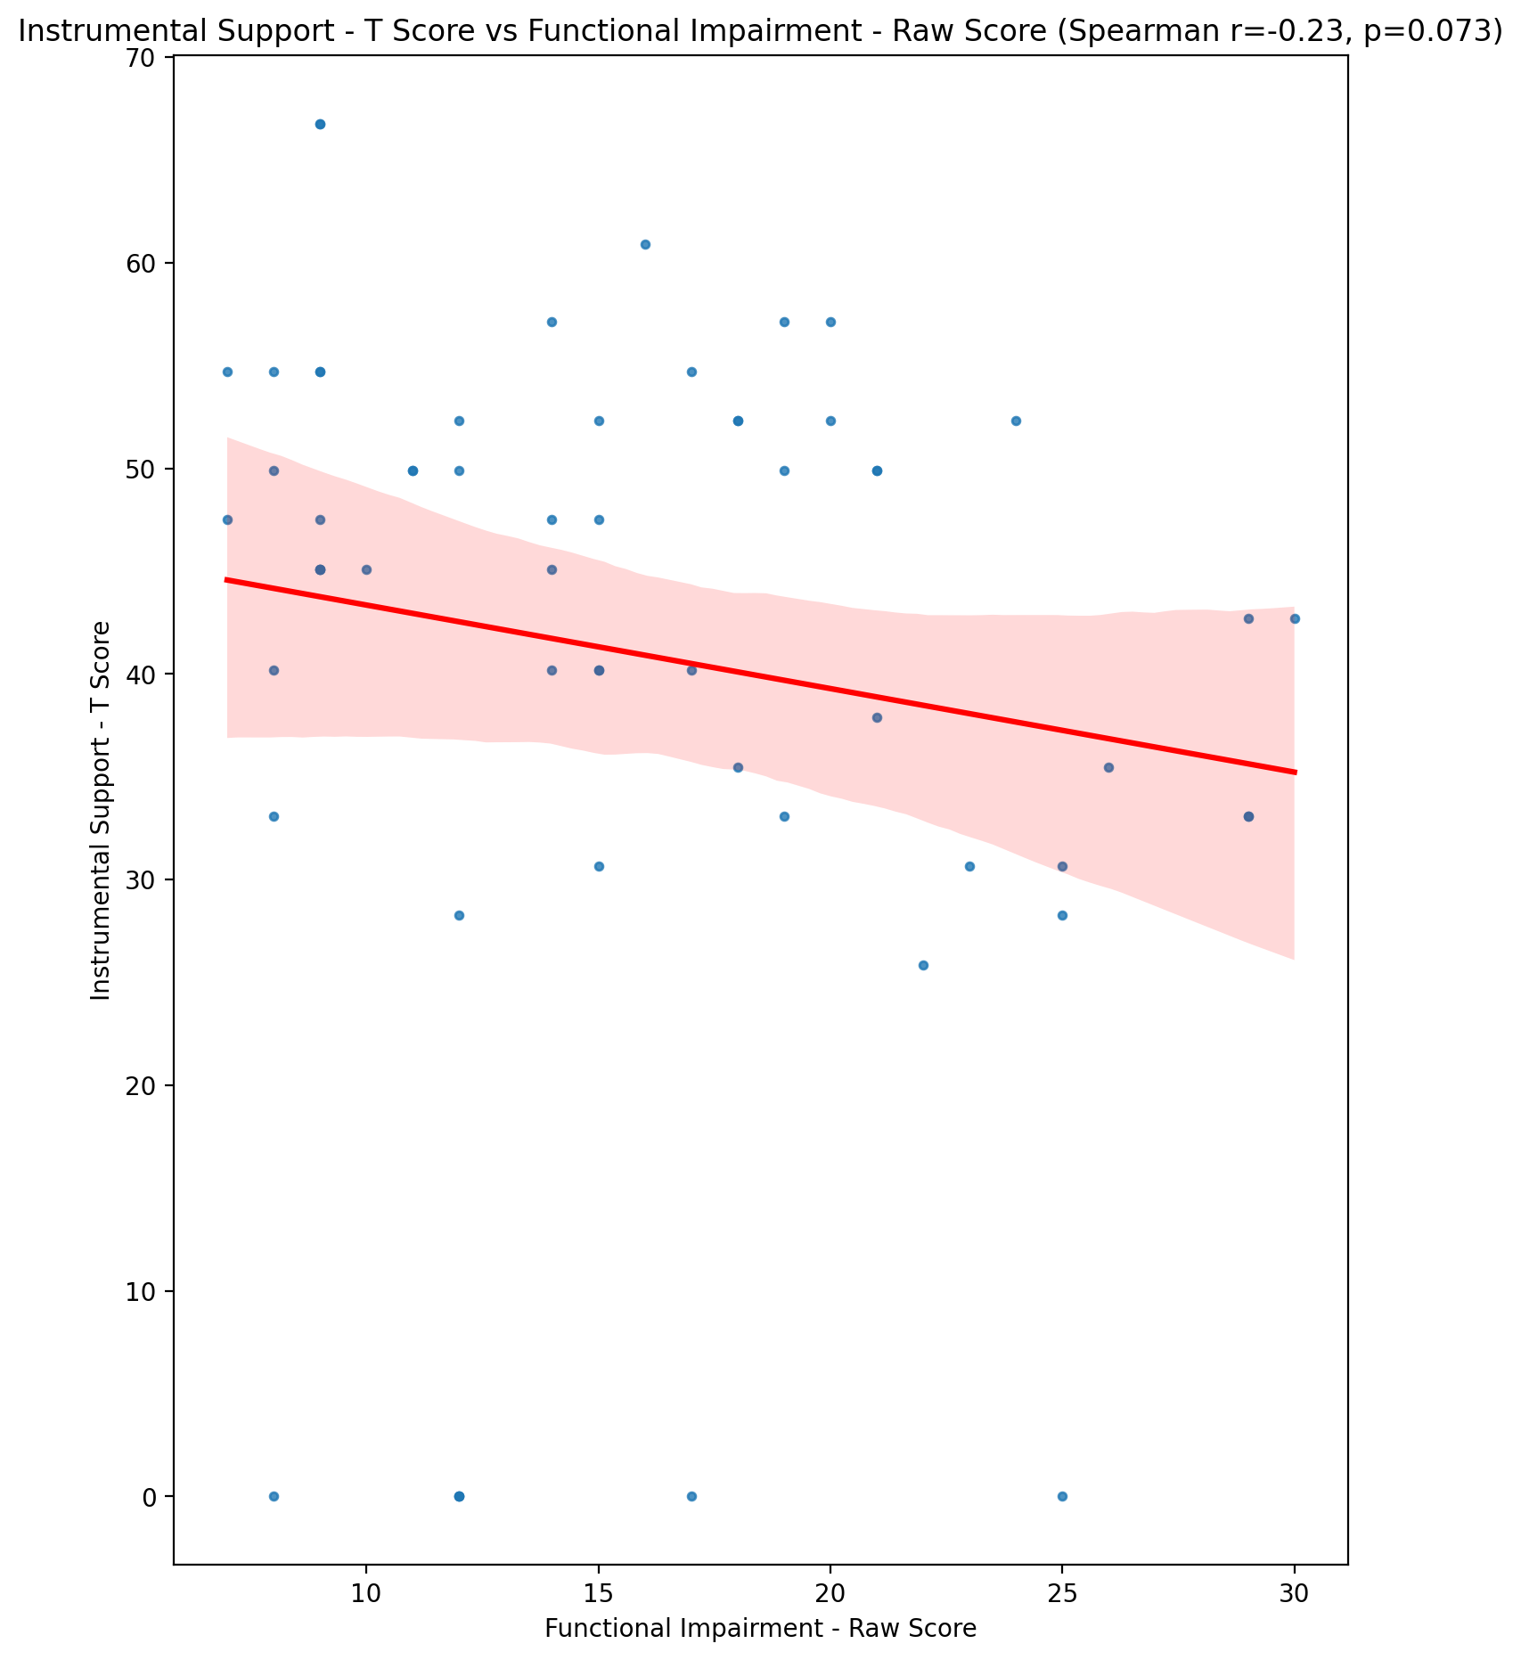

## Perceived Social Support Total T Score vs Functional Impairment - Raw Score

Test: spearman; statistic: -0.21075165779926341; p-value: 0.10910453344613959;

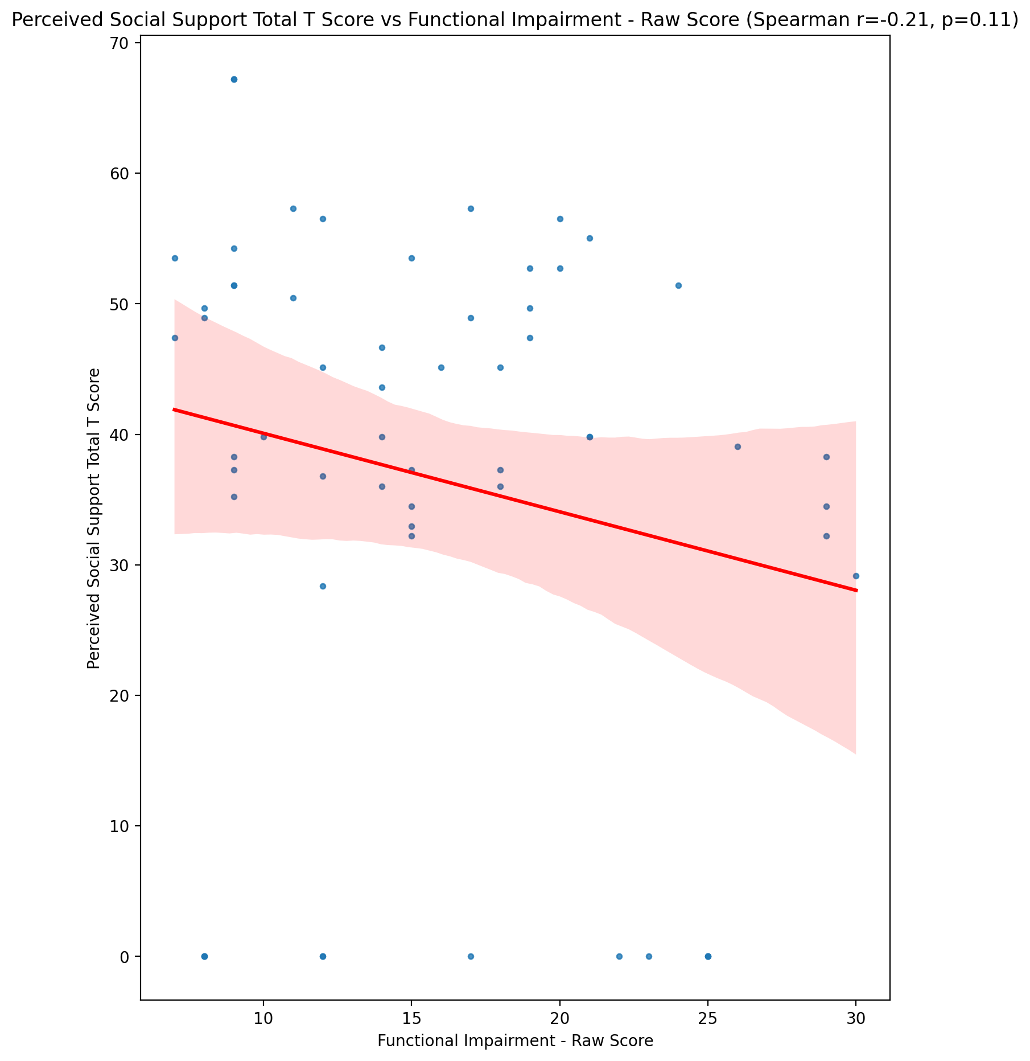

## Emotional Support - Rank vs Functional Impairment - Raw Score

Test: None; statistic: None; p-value: None; Test not run: unsupported type combination.

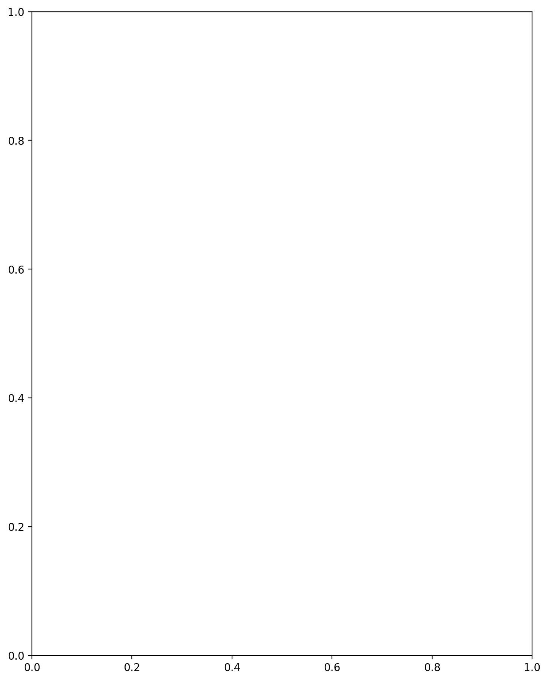

## Informational Support - Rank vs Functional Impairment - Raw Score

Test: None; statistic: None; p-value: None; Test not run: unsupported type combination.



## Instrumental Support - Rank vs Functional Impairment - Raw Score

Test: None; statistic: None; p-value: None; Test not run: unsupported type combination.



## Perceived Social Support TOTAL - Rank vs Functional Impairment - Raw Score

Test: None; statistic: None; p-value: None; Test not run: unsupported type combination.



## Power Self Concept - Real Self Concept Score vs Functional Impairment - Raw Score

Test: spearman; statistic: -0.23192783664635316; p-value: 0.07713734596921973;

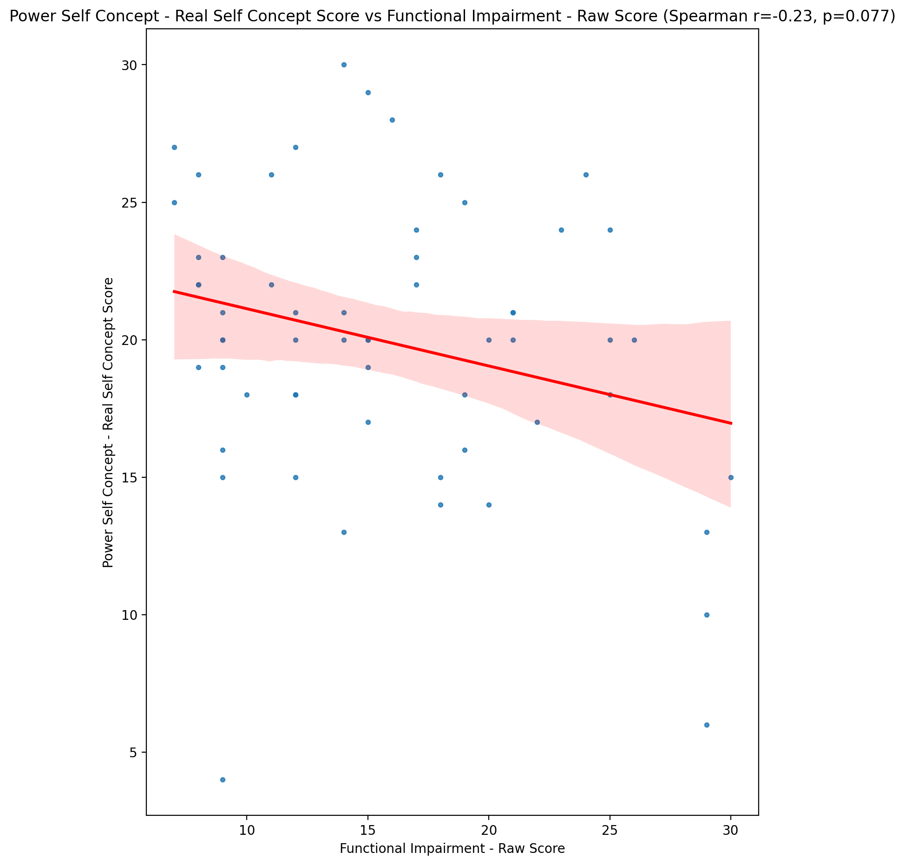

## Power Self Concept - Ideal Self Concept score vs Functional Impairment - Raw Score

Test: spearman; statistic: -0.2541334380987325; p-value: 0.05210221845715695;

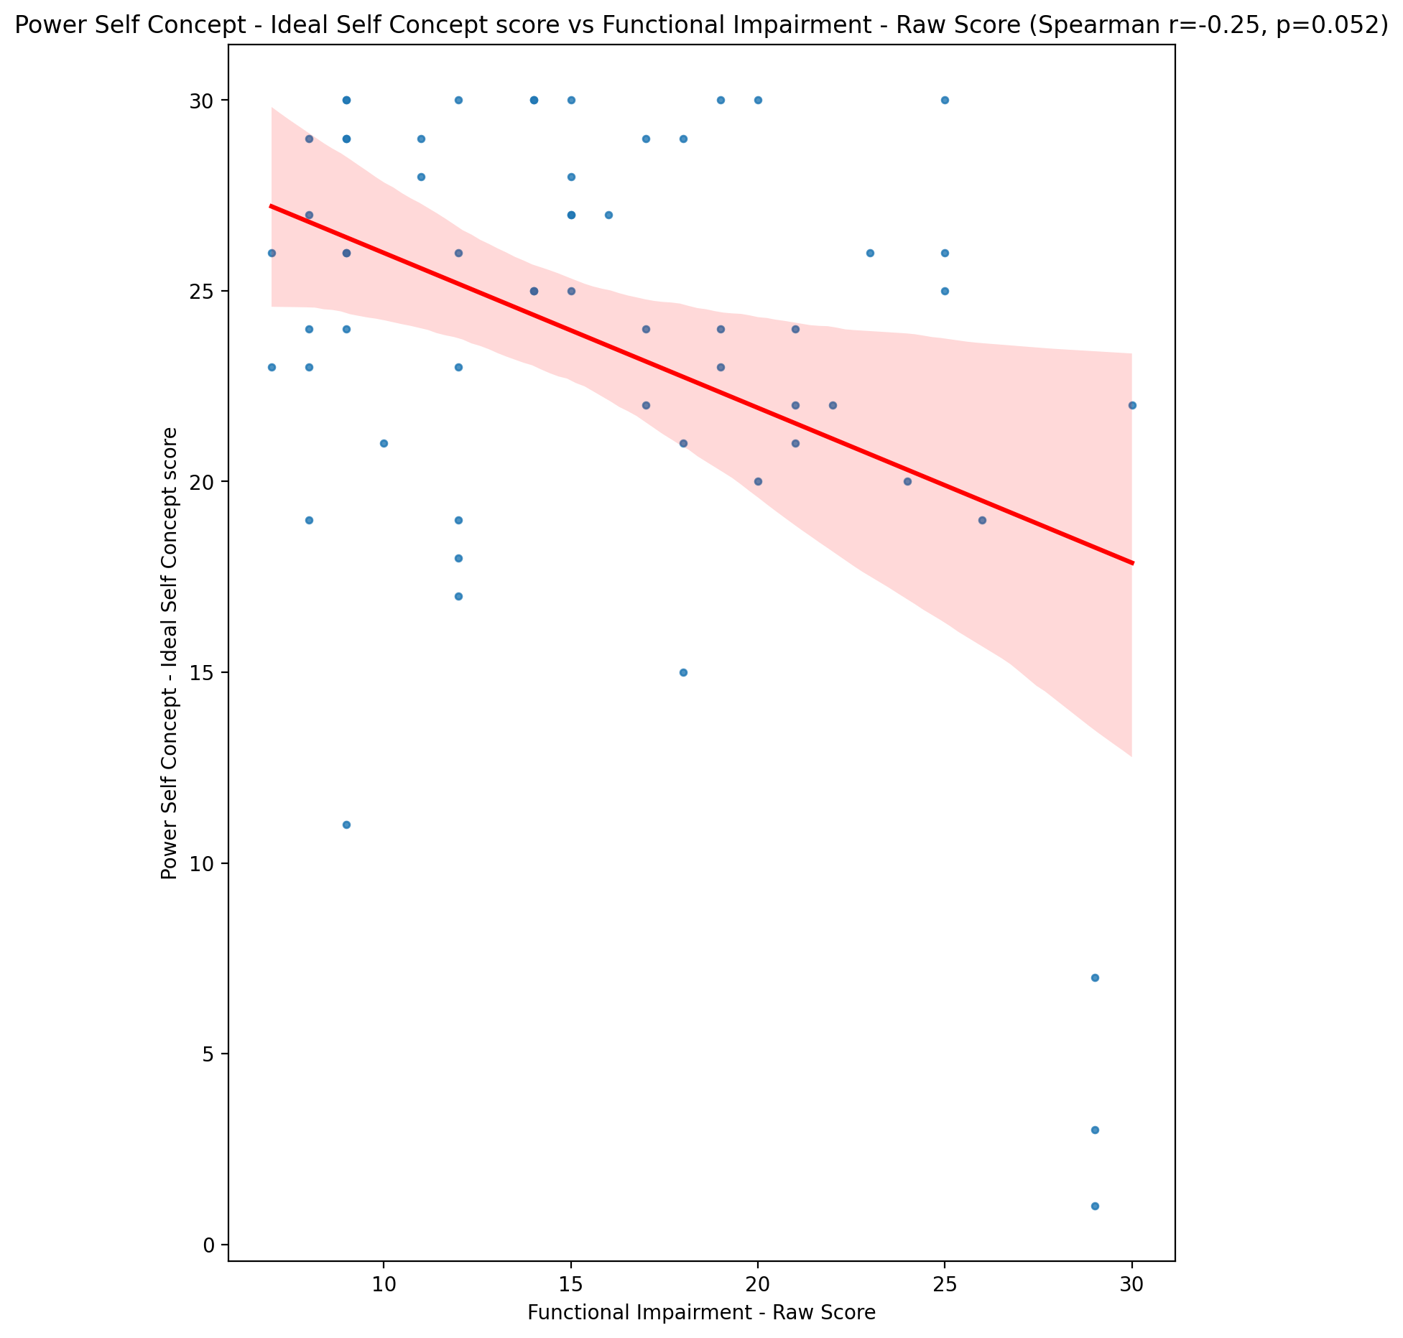

## Power Self Concept – Social Self Concept Score vs Functional Impairment - Raw Score

Test: spearman; statistic: -0.040850205206124174; p-value: 0.7586979661756884;

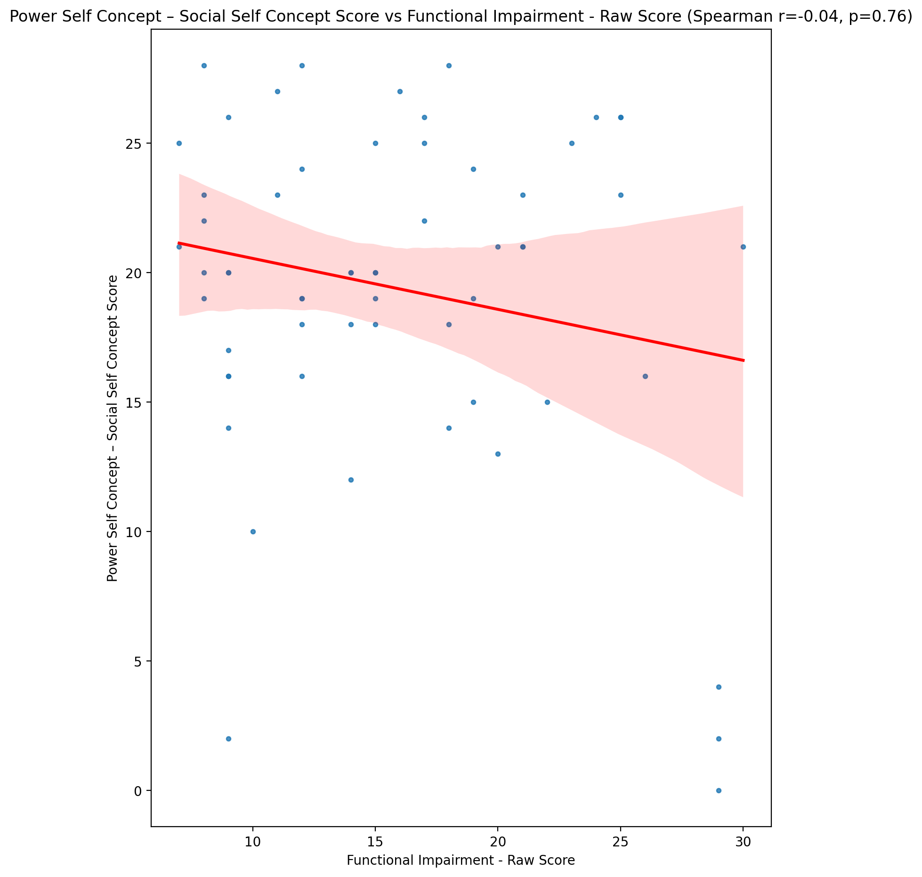

## Social Self Concept - Real Self Concept Score vs Functional Impairment - Raw Score

Test: spearman; statistic: -0.44356562526323956; p-value: 0.0004337108306095348;

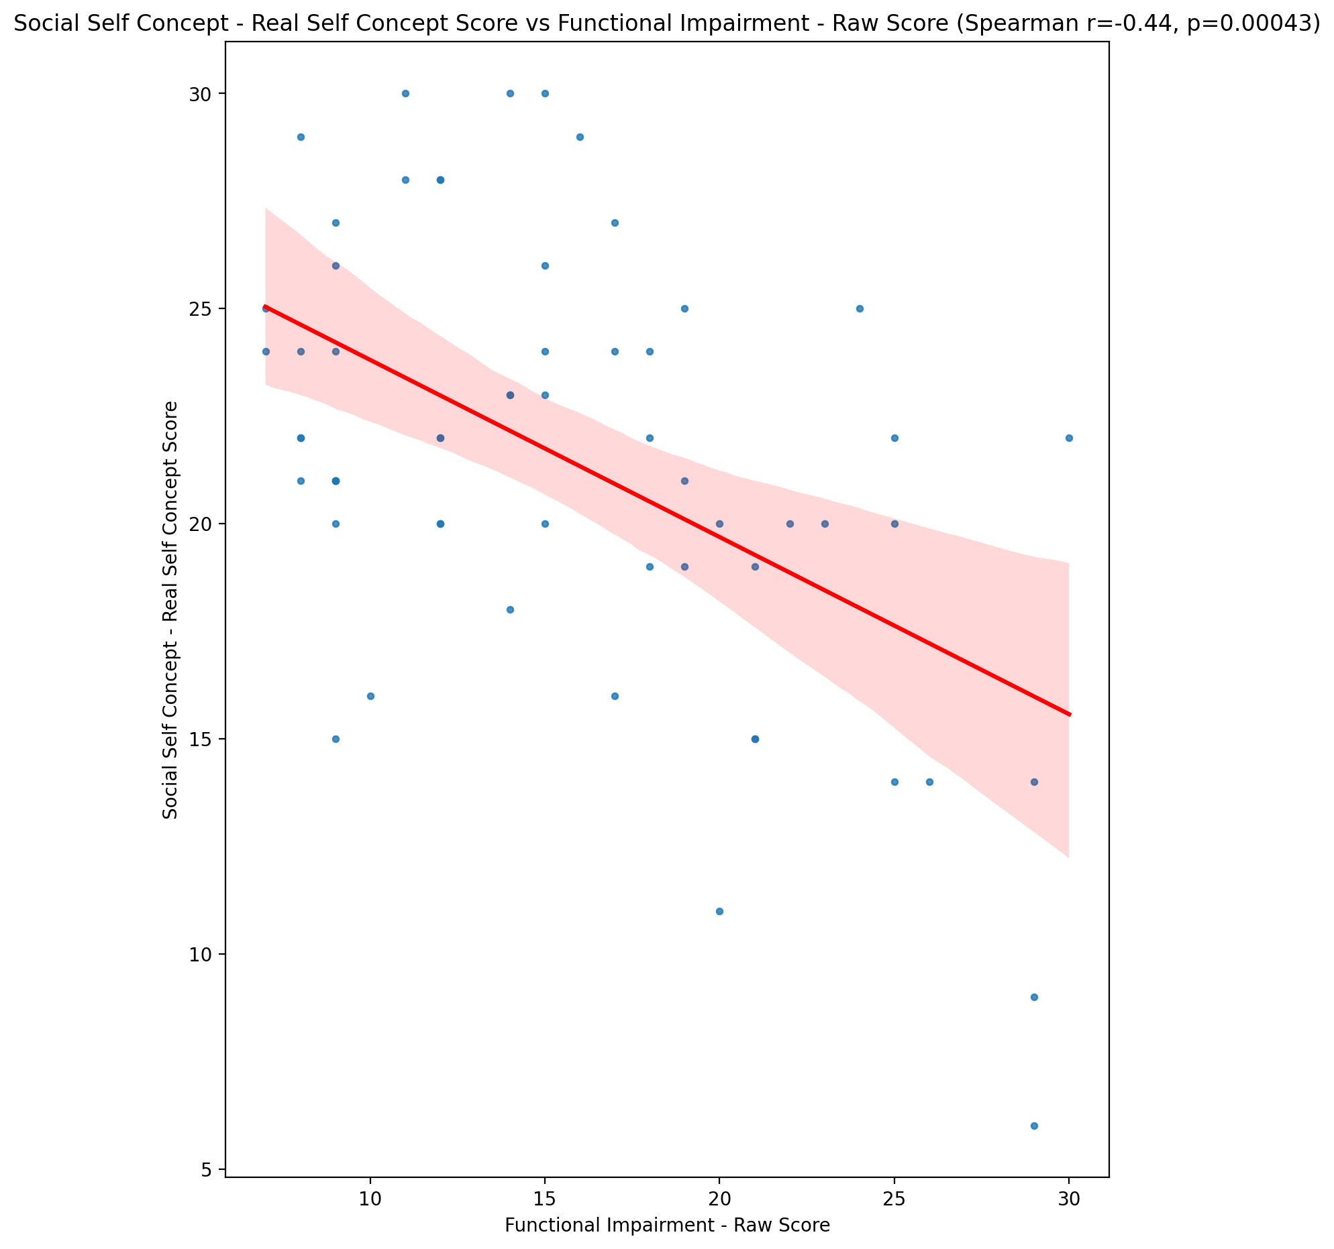

## Social Self Concept – Social Self Concept Score vs Functional Impairment - Raw Score

Test: spearman; statistic: -0.22278256279794062; p-value: 0.08988600337917232;

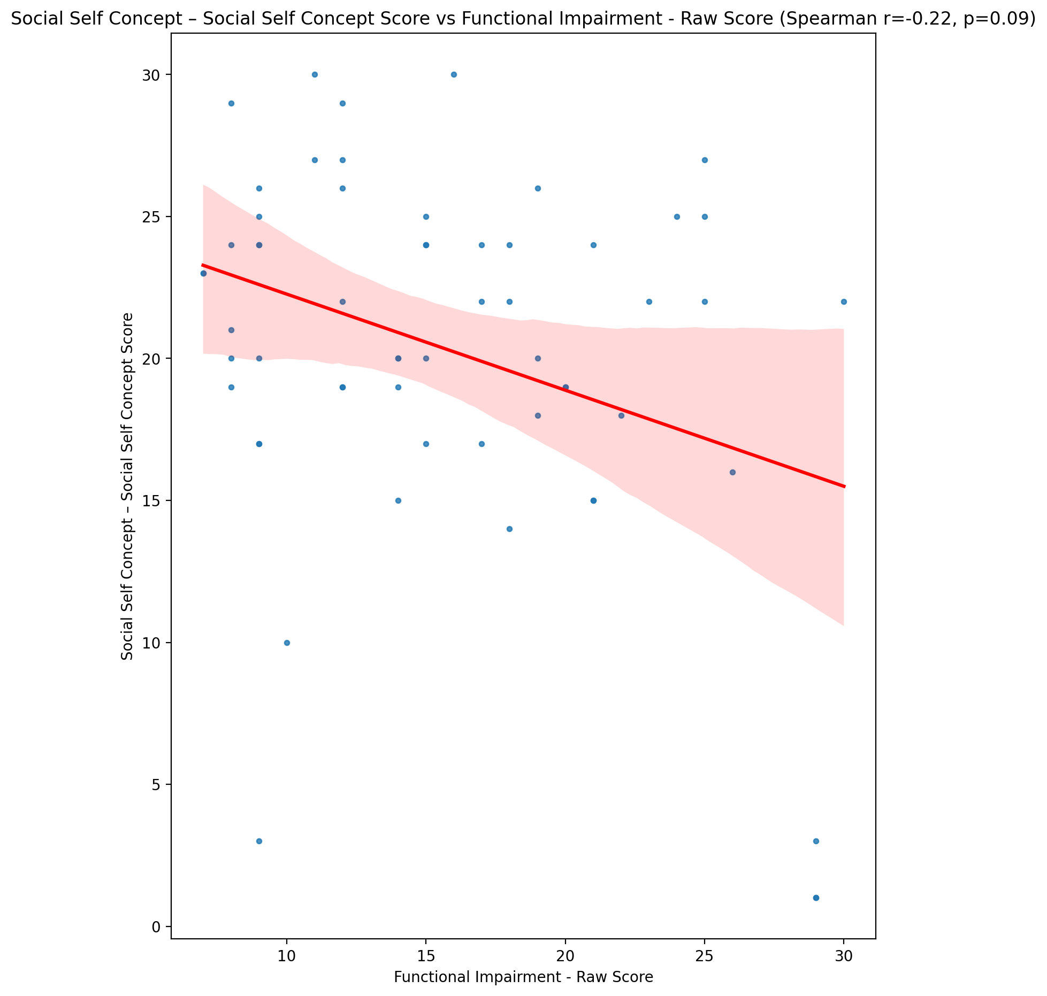

## Ability Self Concept - Real Self Concept Score vs Functional Impairment - Raw Score

Test: spearman; statistic: -0.3233704614050961; p-value: 0.012481544521155706;

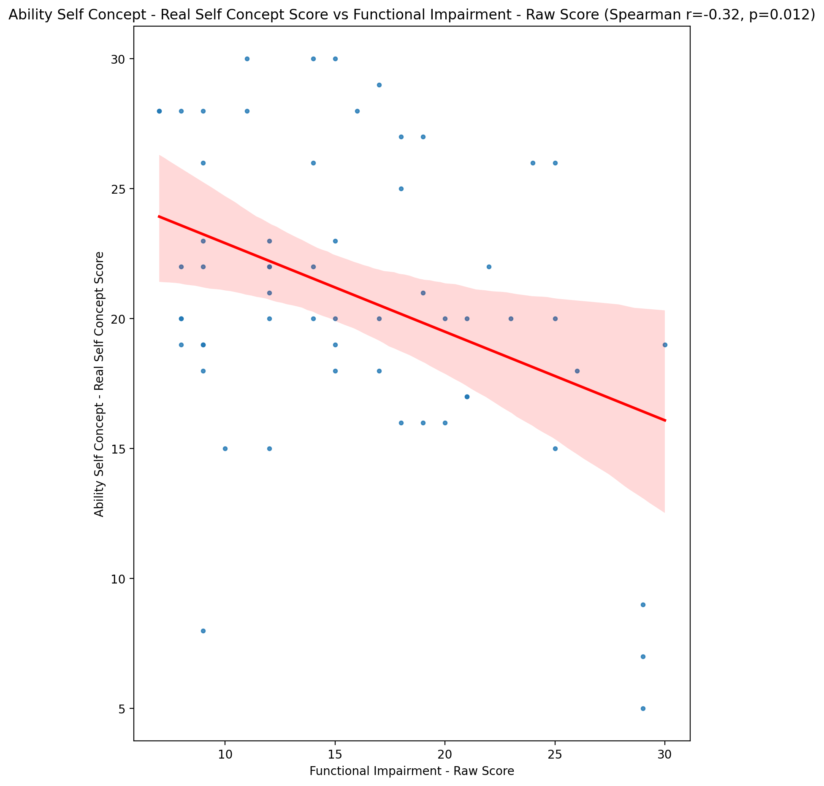

## Ability Self Concept - Ideal Self Concept Score vs Functional Impairment - Raw Score

Test: spearman; statistic: -0.24846668019135382; p-value: 0.057755491404030364;

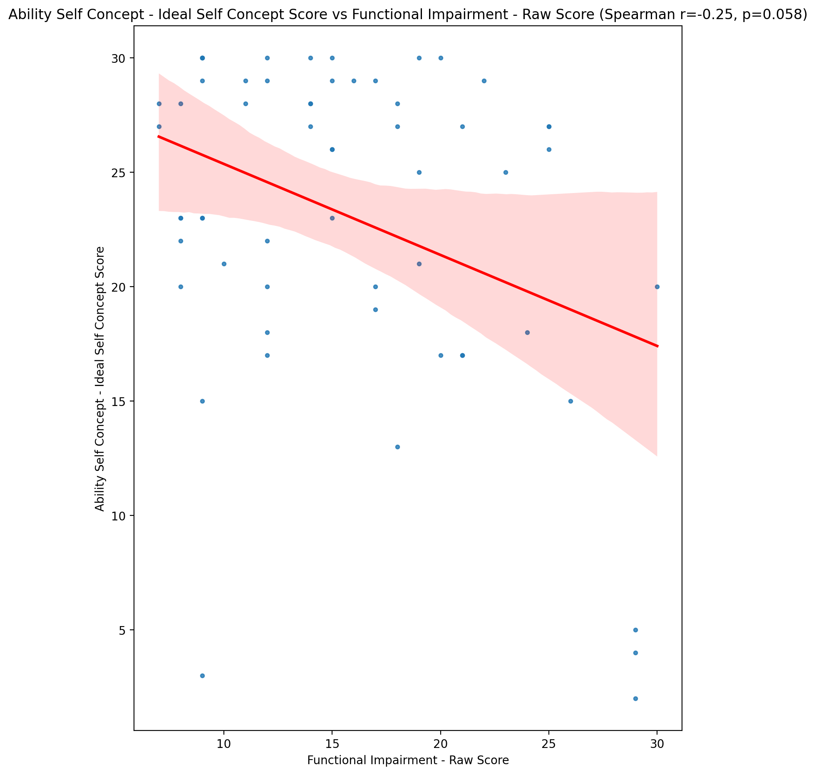

## Ability Self Concept – Social Self Concept Score vs Functional Impairment - Raw Score

Test: spearman; statistic: -0.09666036631810289; p-value: 0.4664394515230531;

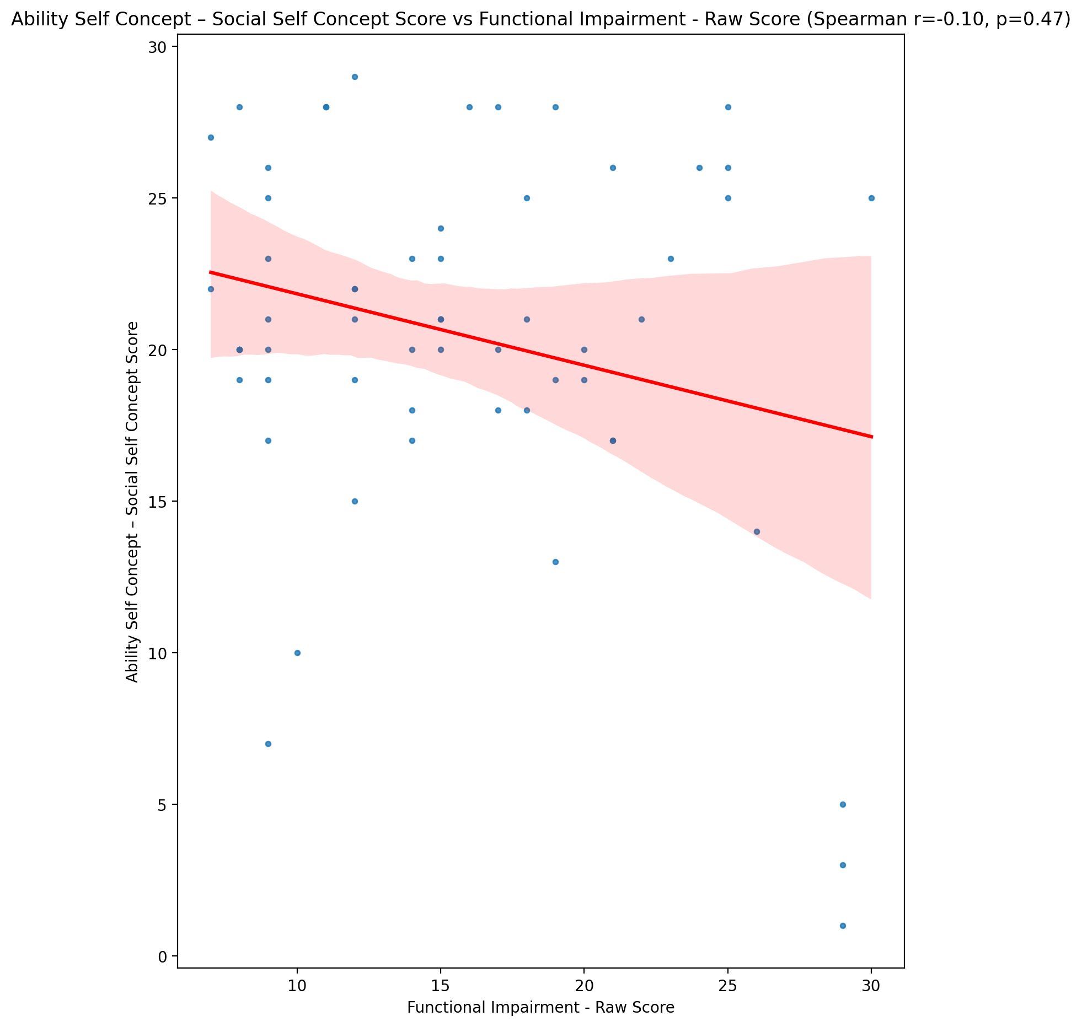

## Physical Self Concept - Real Self Concept Score vs Functional Impairment - Raw Score

Test: spearman; statistic: -0.3739094289610874; p-value: 0.003531659882963538;

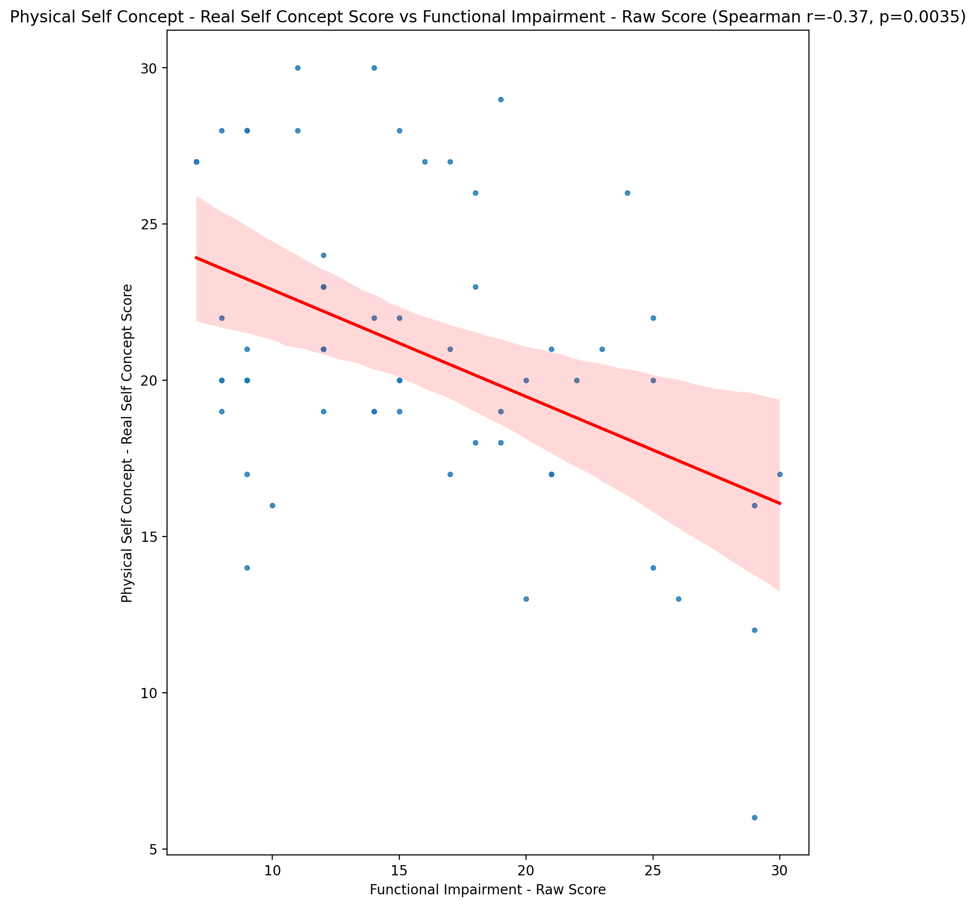

## Physical Self Concept – Ideal Self Concept Score vs Functional Impairment - Raw Score

Test: spearman; statistic: -0.2048156194706195; p-value: 0.11968309430331575;

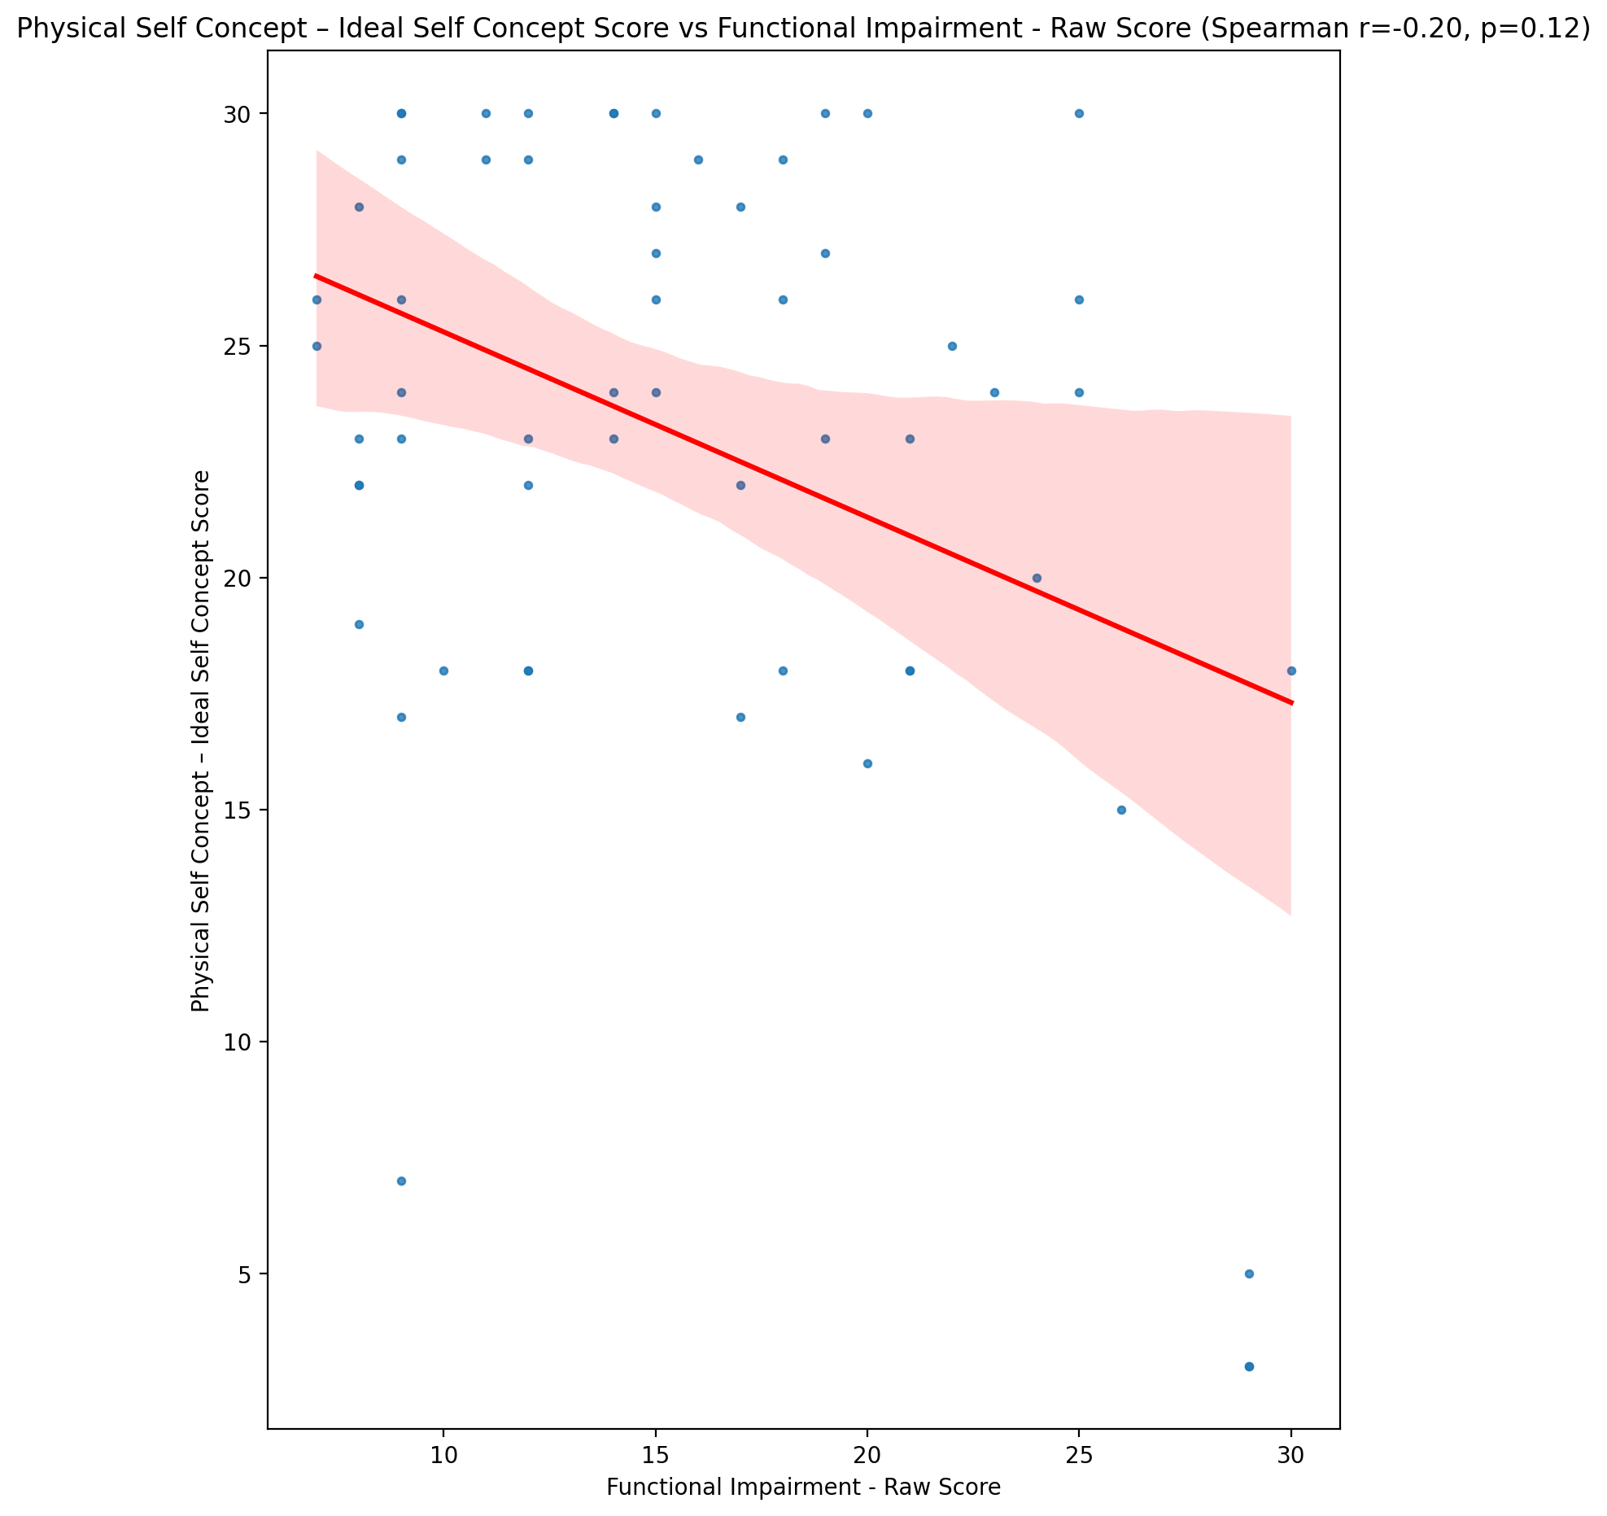

## Physical Self Concept – Social Self Concept Score vs Functional Impairment - Raw Score

Test: spearman; statistic: -0.09305792728858102; p-value: 0.4832898106008411;

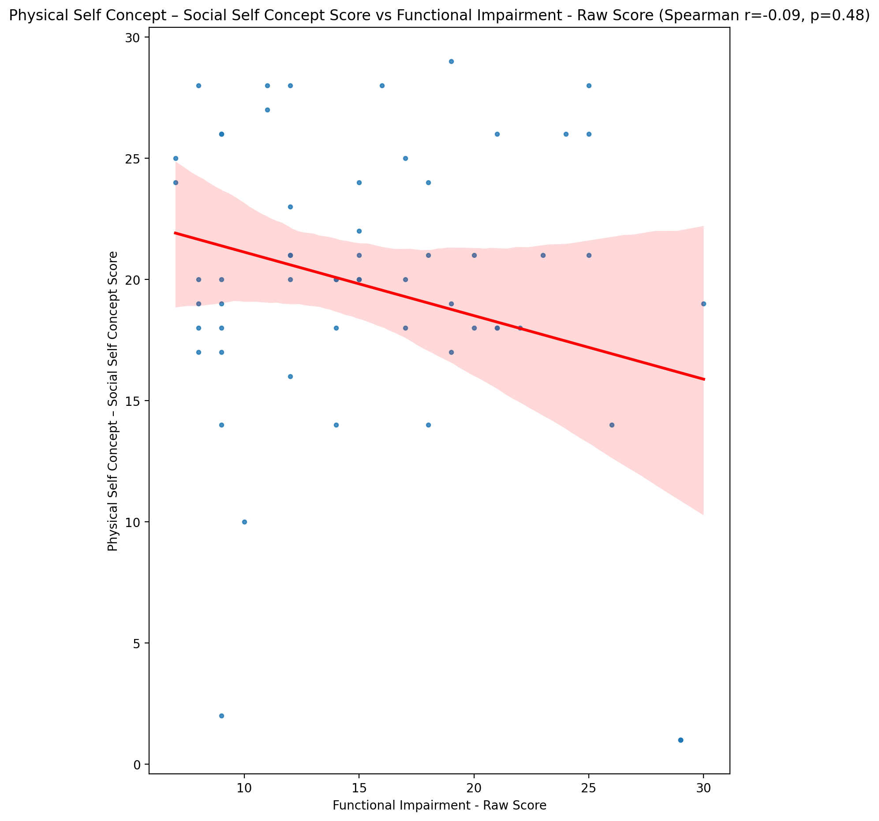

## Psychological Self Concept - Real Self Concept Score vs Functional Impairment - Raw Score

Test: spearman; statistic: -0.42441005570132534; p-value: 0.0008078556730025397;

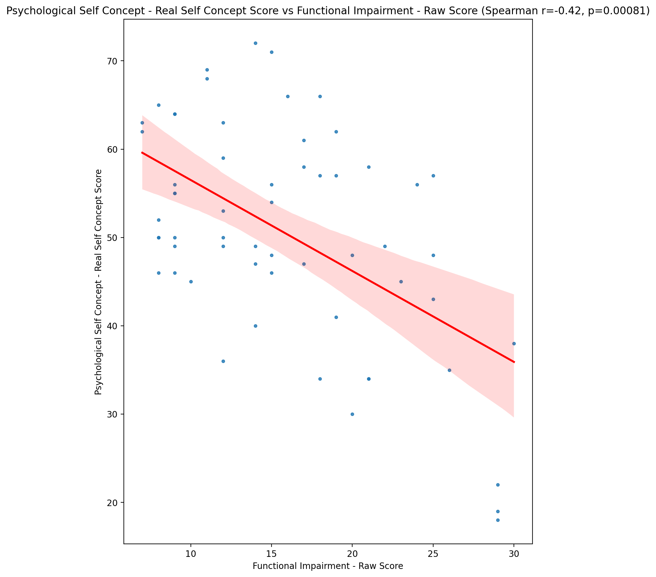

## Psychological Self Concept – Ideal Self Concept Score vs Functional Impairment - Raw Score

Test: spearman; statistic: -0.22583730033397215; p-value: 0.0854560060601485;

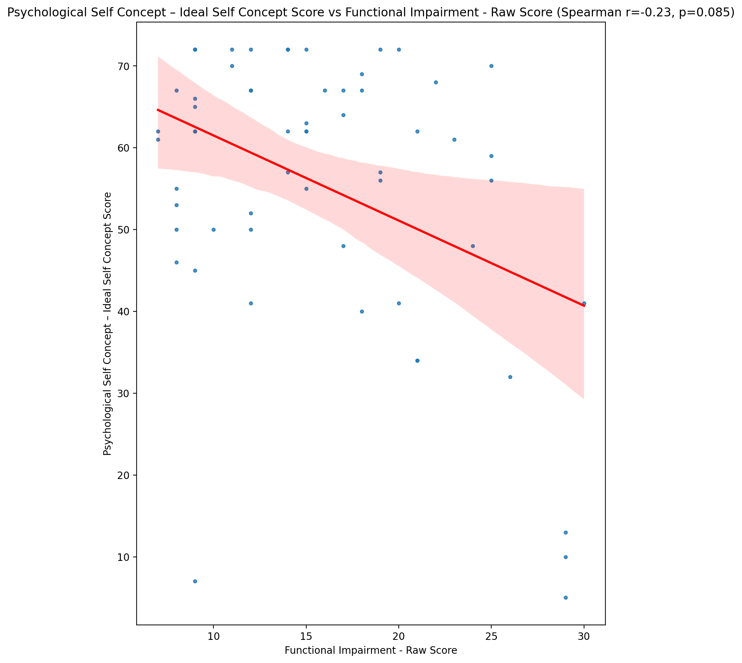

## Psychological Self Concept – Social Self Concept Score vs Functional Impairment - Raw Score

Test: spearman; statistic: -0.2094718460333205; p-value: 0.11132210406085664;

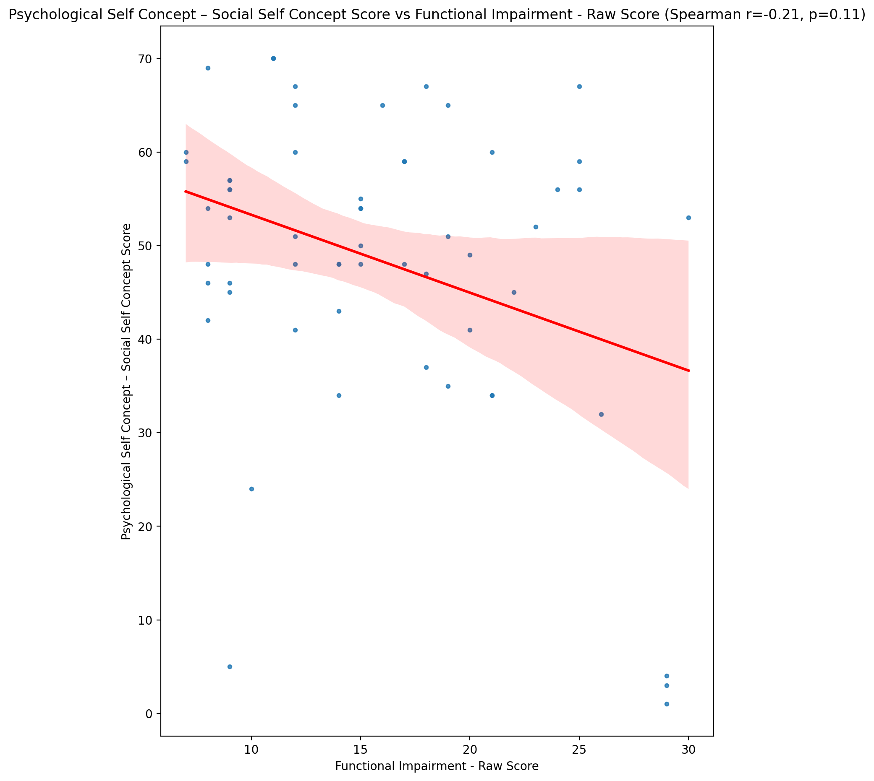

## Real Self Concept Total Score vs Functional Impairment - Raw Score

Test: spearman; statistic: -0.3971597285314755; p-value: 0.0018421917845238688;

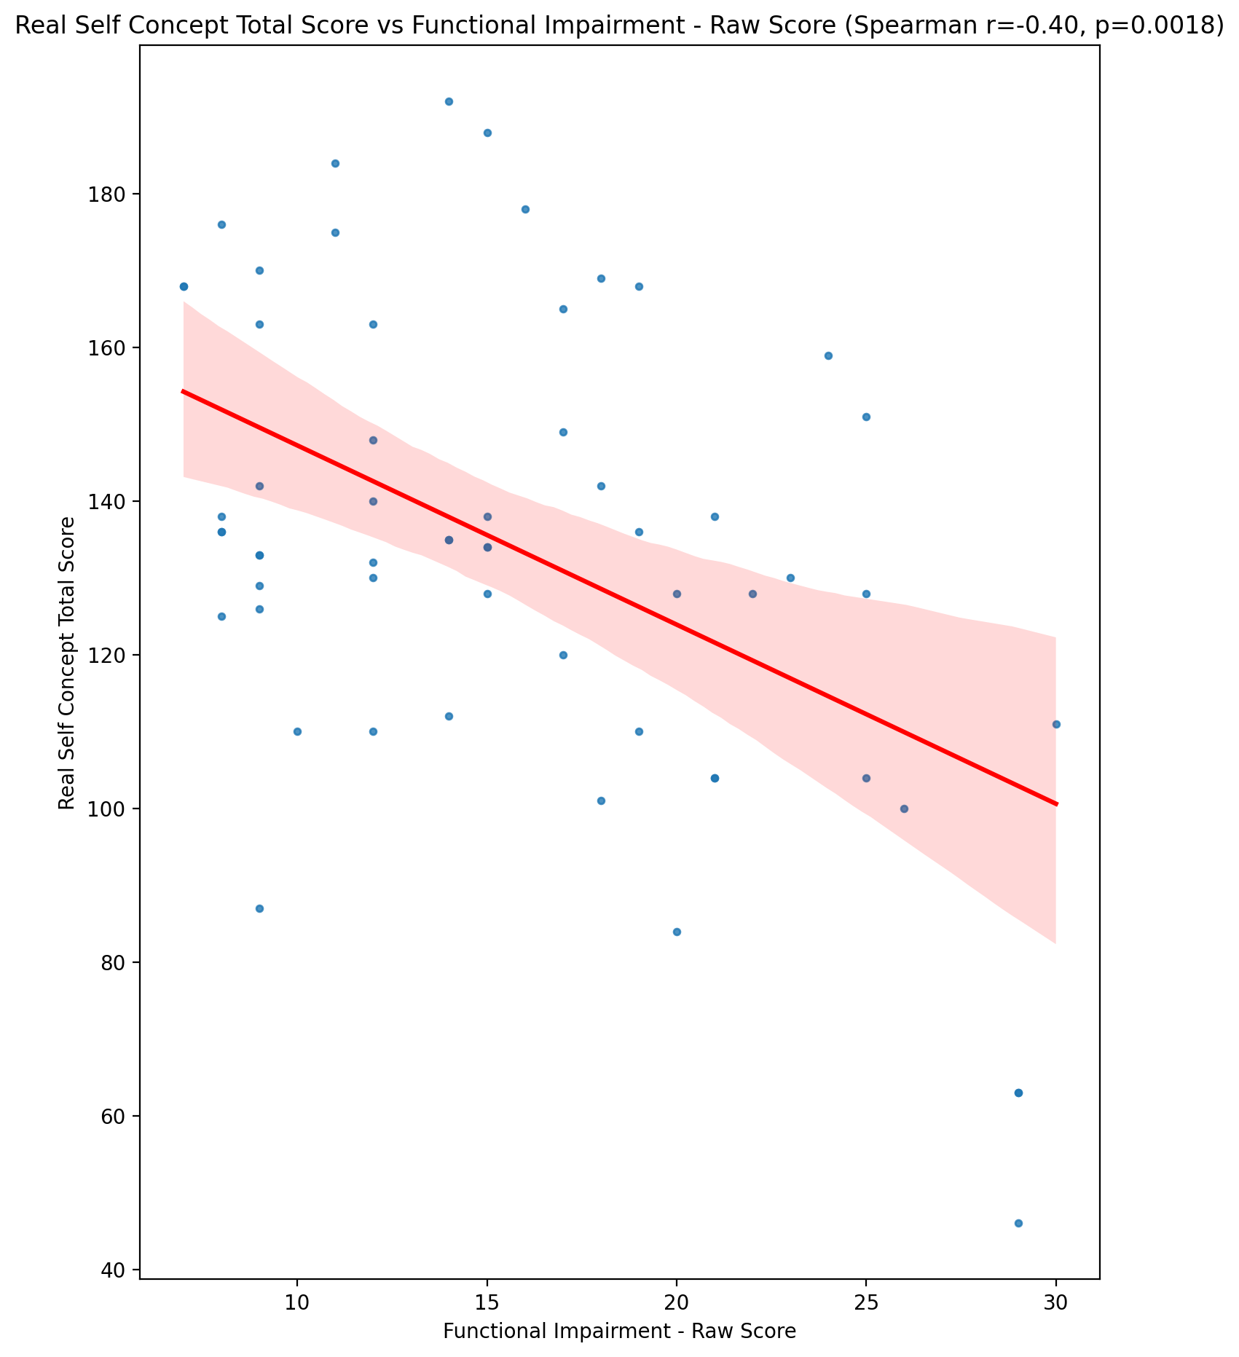

## Ideal Self Concept Total Score vs Functional Impairment - Raw Score

Test: spearman; statistic: -0.23243821986088684; p-value: 0.07647050035107977;

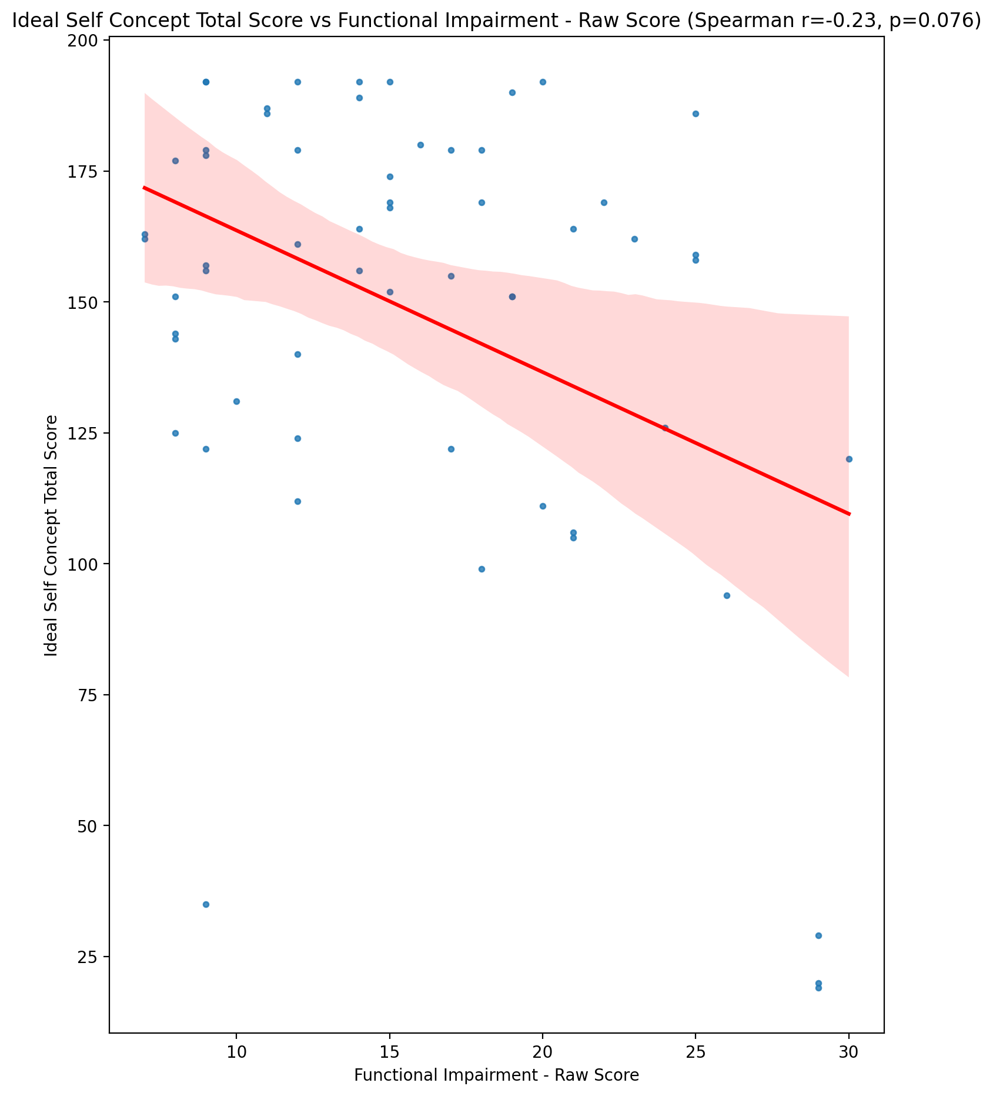

## Social Self Concept Total Score vs Functional Impairment - Raw Score

Test: spearman; statistic: -0.1576306433300219; p-value: 0.23312428011006378;

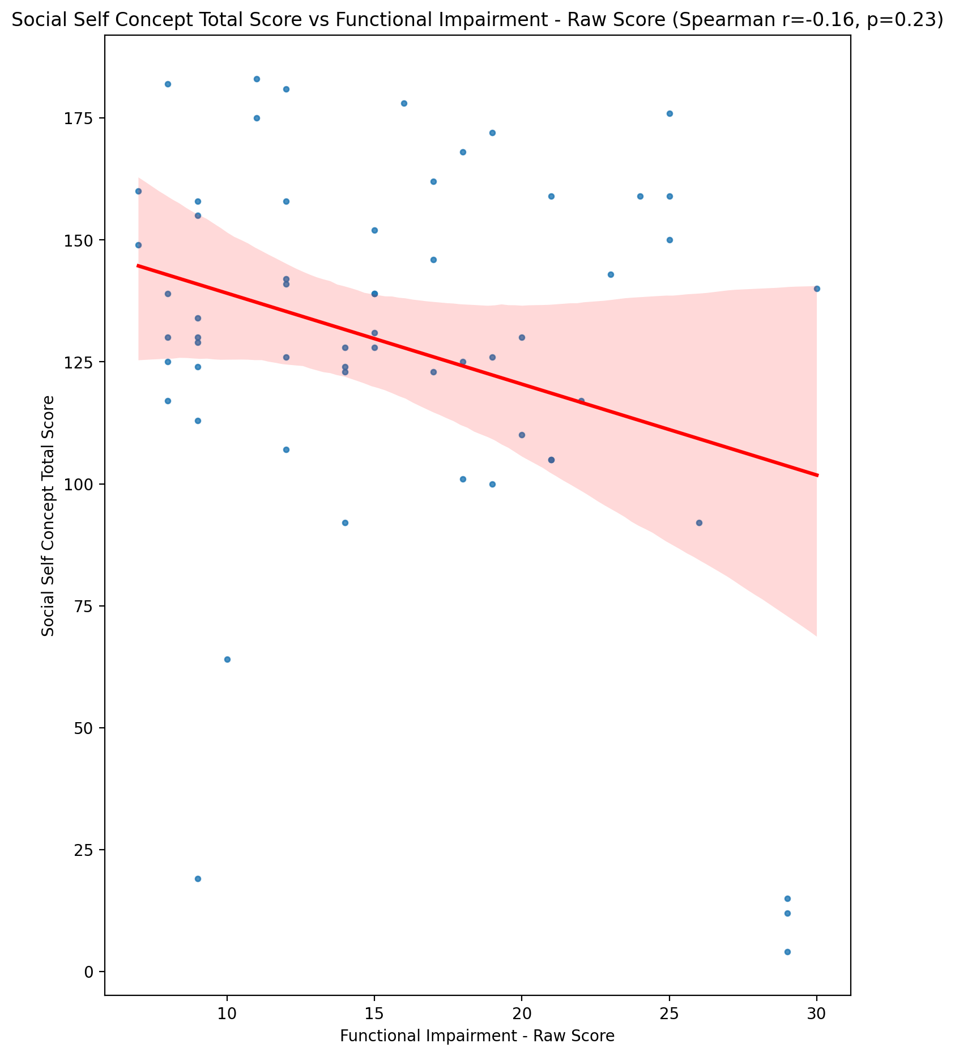

## Ideal Self Concept Total Category vs Functional Impairment - Raw Score

Test: None; statistic: None; p-value: None; Test not run: unsupported type combination.



## Perceived Social Stress Score vs Functional Impairment - Raw Score

Test: spearman; statistic: 0.35078312935389877; p-value: 0.006451425466625407;

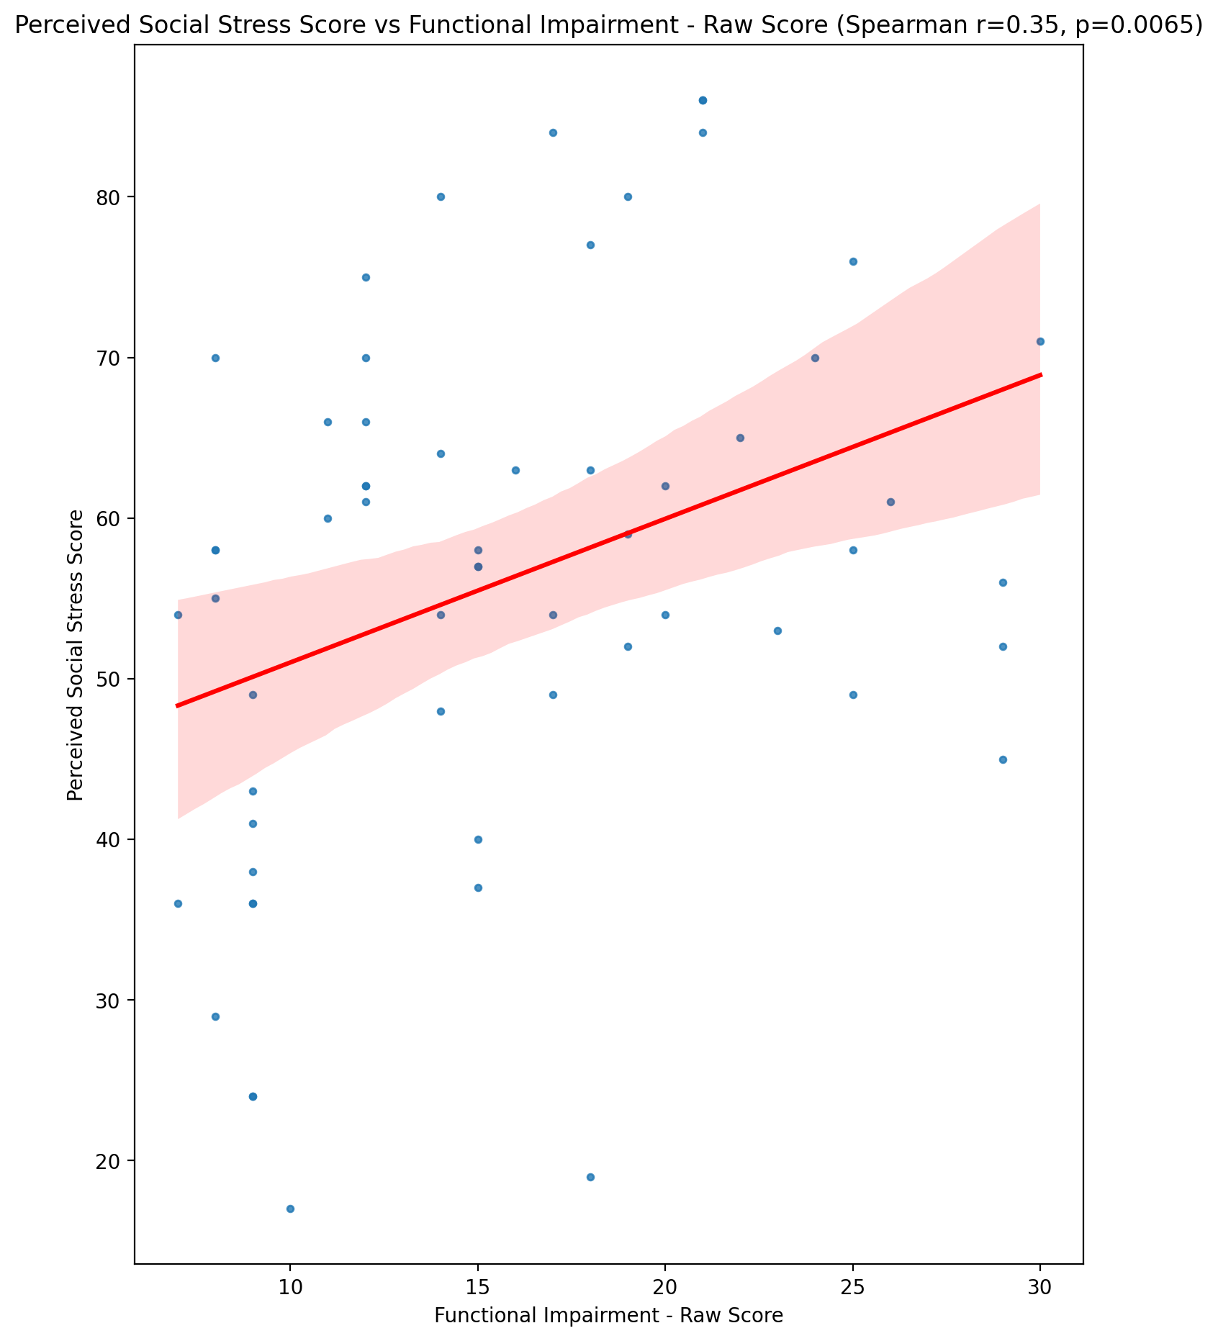

## Perceived Social Stress Category vs Functional Impairment - Raw Score

Test: None; statistic: None; p-value: None; Test not run: unsupported type combination.



## Emotional Support - Raw Score vs Withdrawl - Raw Score

Test: spearman; statistic: -0.08270280597775266; p-value: 0.5334628863077862;

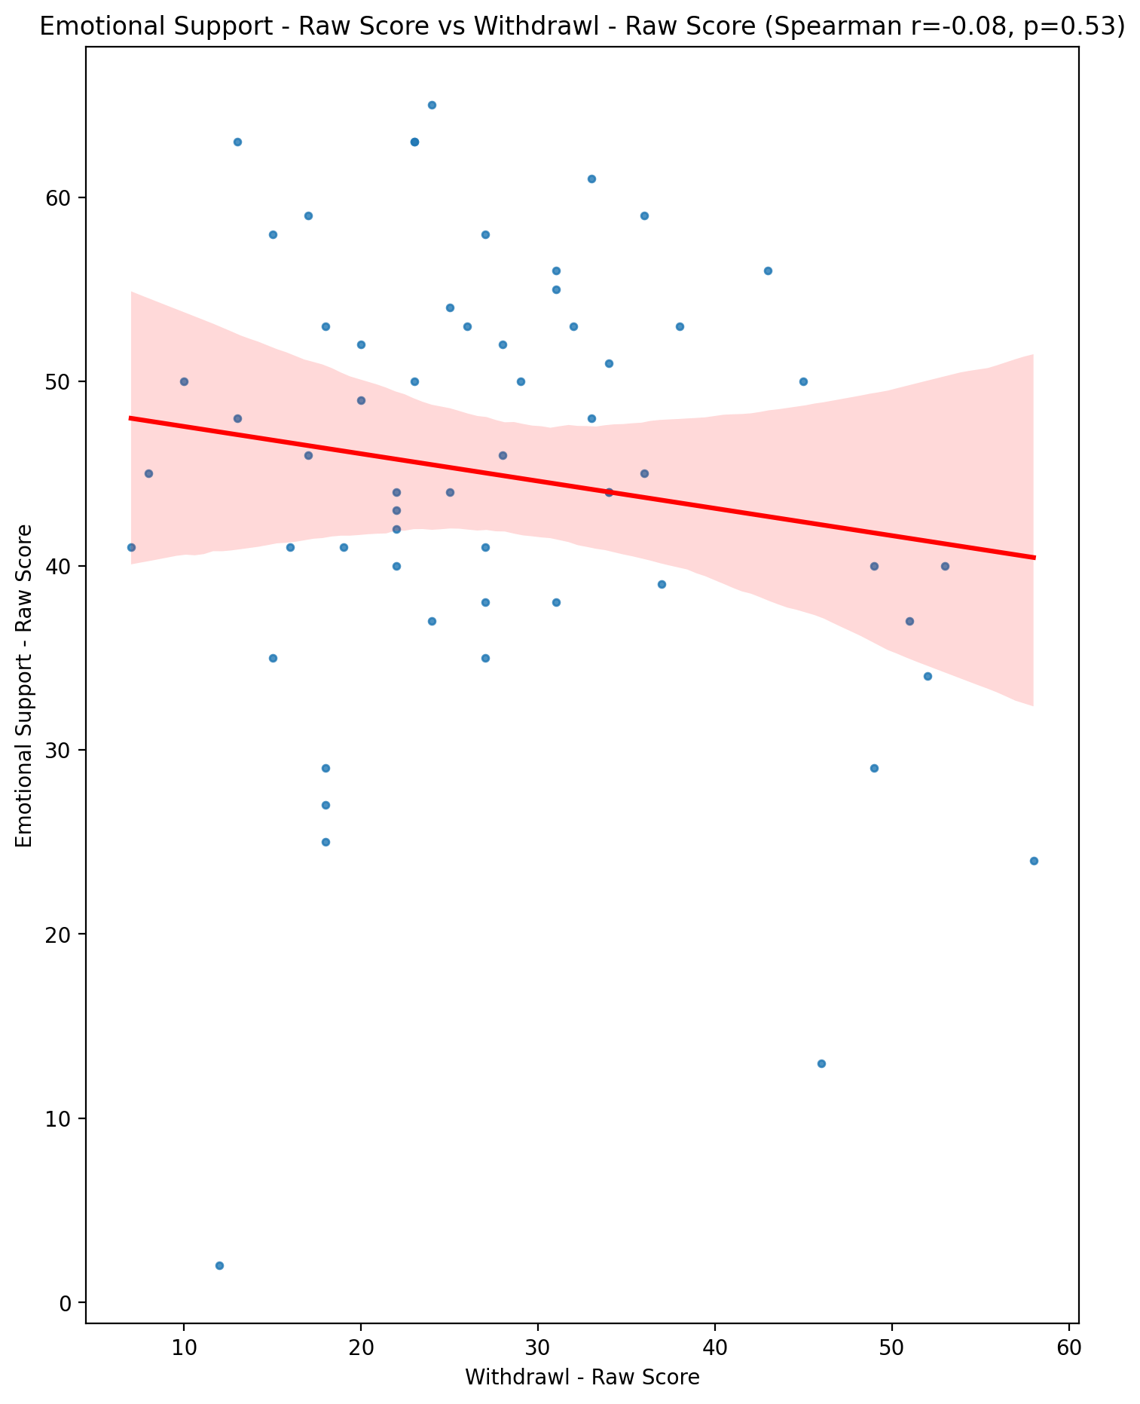

## Informational Support - Raw Score vs Withdrawl - Raw Score

Test: spearman; statistic: -0.015364612483430845; p-value: 0.9080492370742217;

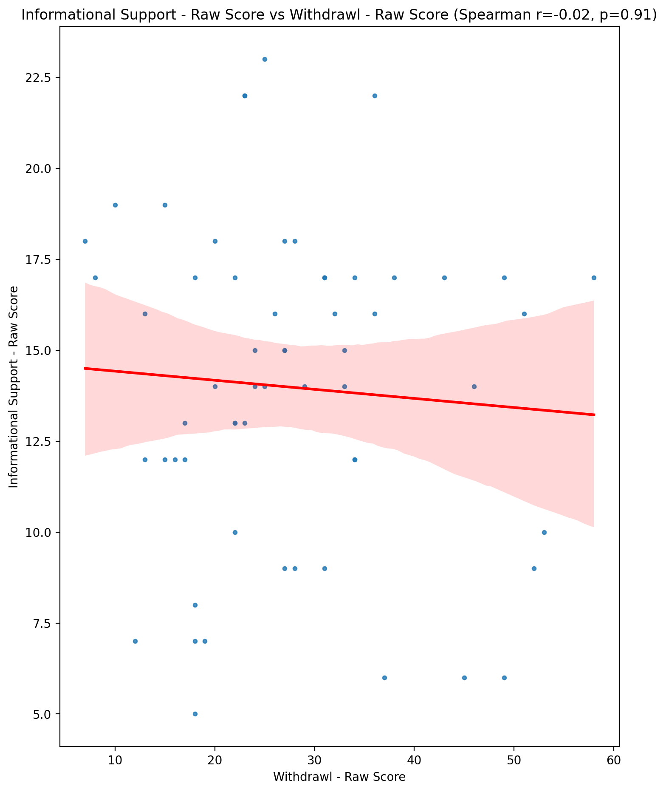

## Instrumental Support - Raw Score vs Withdrawl - Raw Score

Test: spearman; statistic: -0.02708057385381028; p-value: 0.8386688117939272;

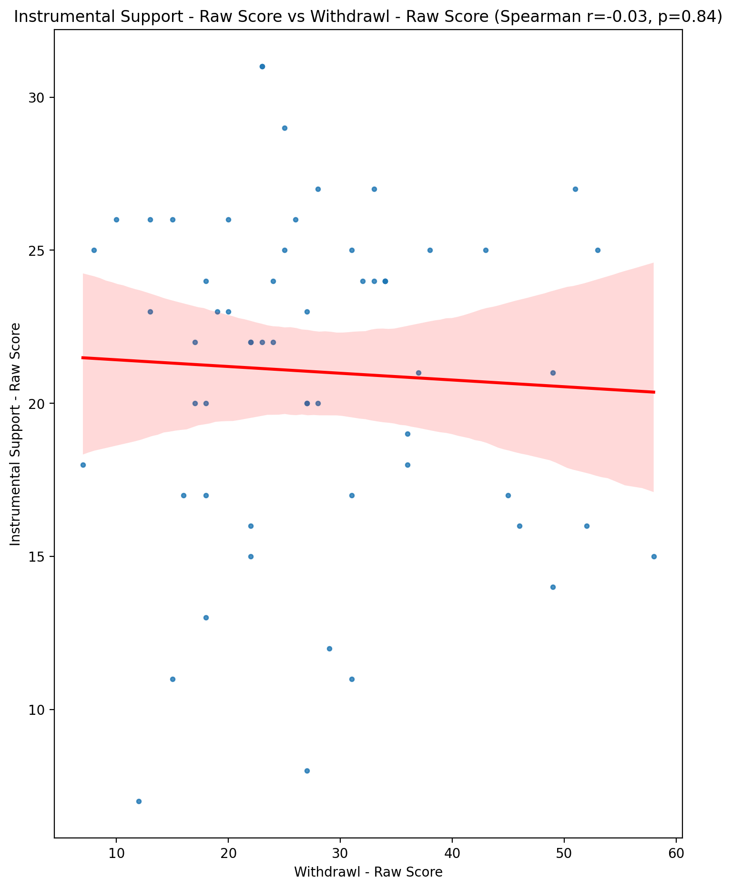

## Emotional Support - T Score vs Withdrawl - Raw Score

Test: spearman; statistic: -0.08152659876487343; p-value: 0.5393195838539444;

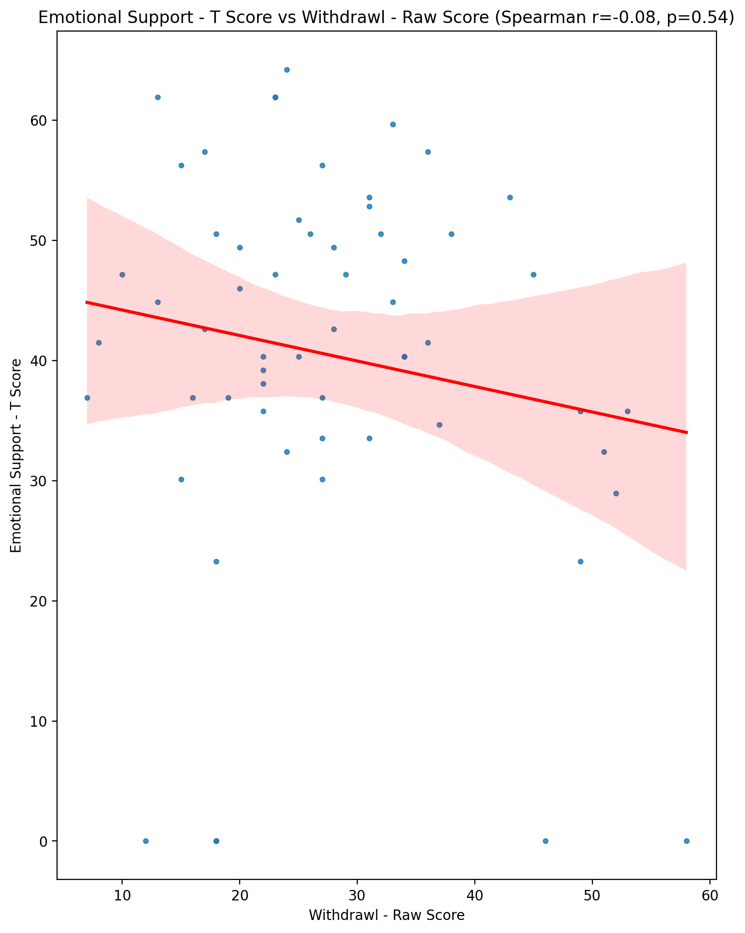

## Informational Support - T Score vs Withdrawl - Raw Score

Test: spearman; statistic: -0.00461749871008019; p-value: 0.9723118018223663;

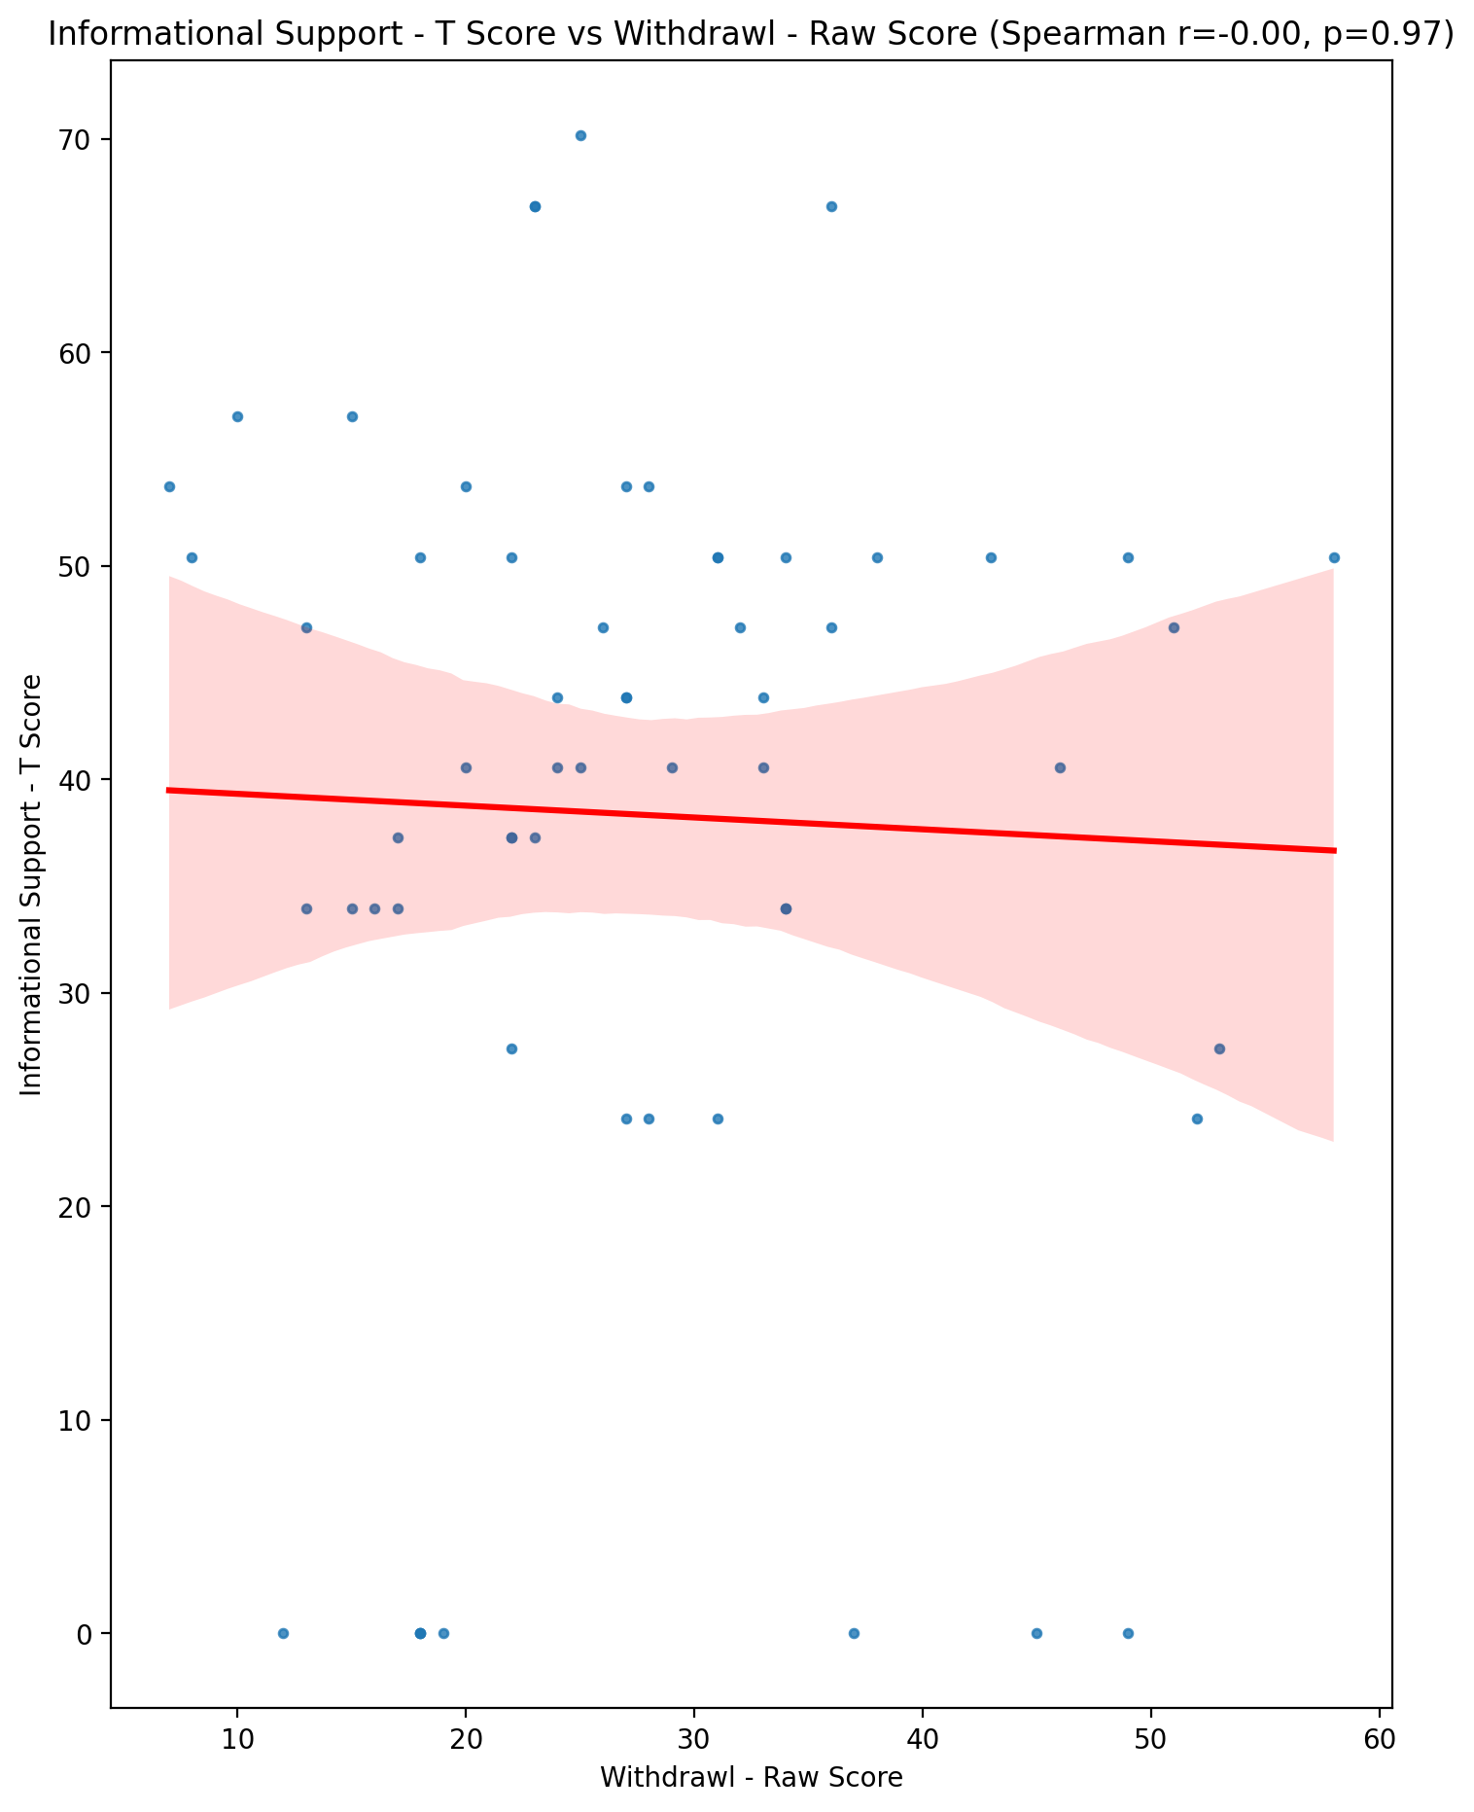

## Instrumental Support - T Score vs Withdrawl - Raw Score

Test: spearman; statistic: -0.02888375880553748; p-value: 0.8280846900064176;

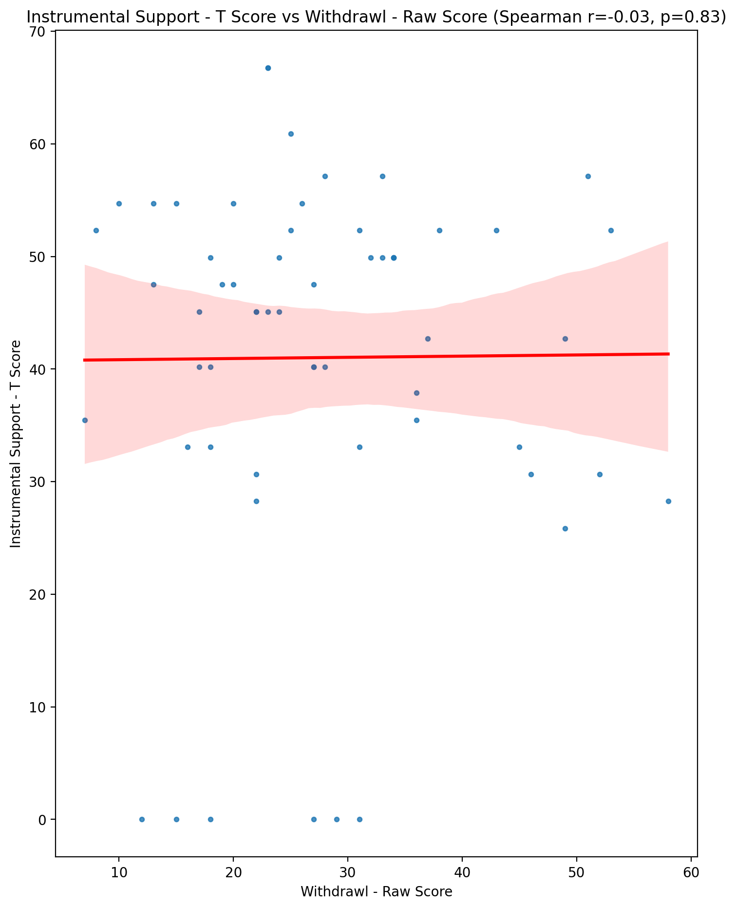

## Perceived Social Support Total T Score vs Withdrawl - Raw Score

Test: spearman; statistic: -0.0786248208444566; p-value: 0.553901152999422;

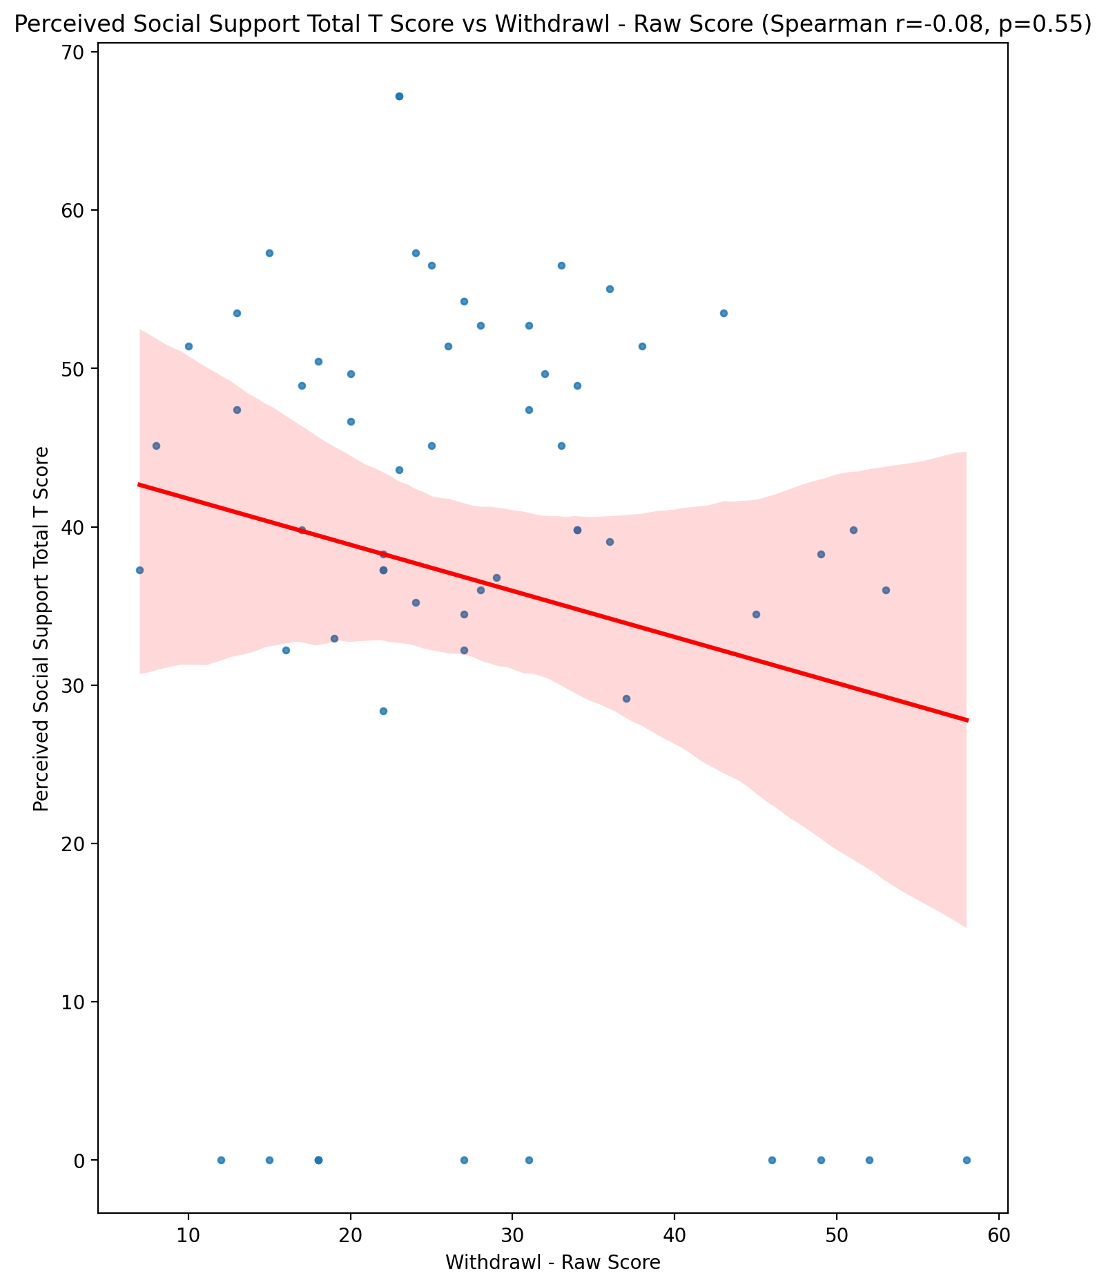

## Emotional Support - Rank vs Withdrawl - Raw Score

Test: None; statistic: None; p-value: None; Test not run: unsupported type combination.



## Informational Support - Rank vs Withdrawl - Raw Score

Test: None; statistic: None; p-value: None; Test not run: unsupported type combination.



## Instrumental Support - Rank vs Withdrawl - Raw Score

Test: None; statistic: None; p-value: None; Test not run: unsupported type combination.



## Perceived Social Support TOTAL - Rank vs Withdrawl - Raw Score

Test: None; statistic: None; p-value: None; Test not run: unsupported type combination.



## Power Self Concept - Real Self Concept Score vs Withdrawl - Raw Score

Test: spearman; statistic: -0.3262214239018; p-value: 0.011684334645385154;

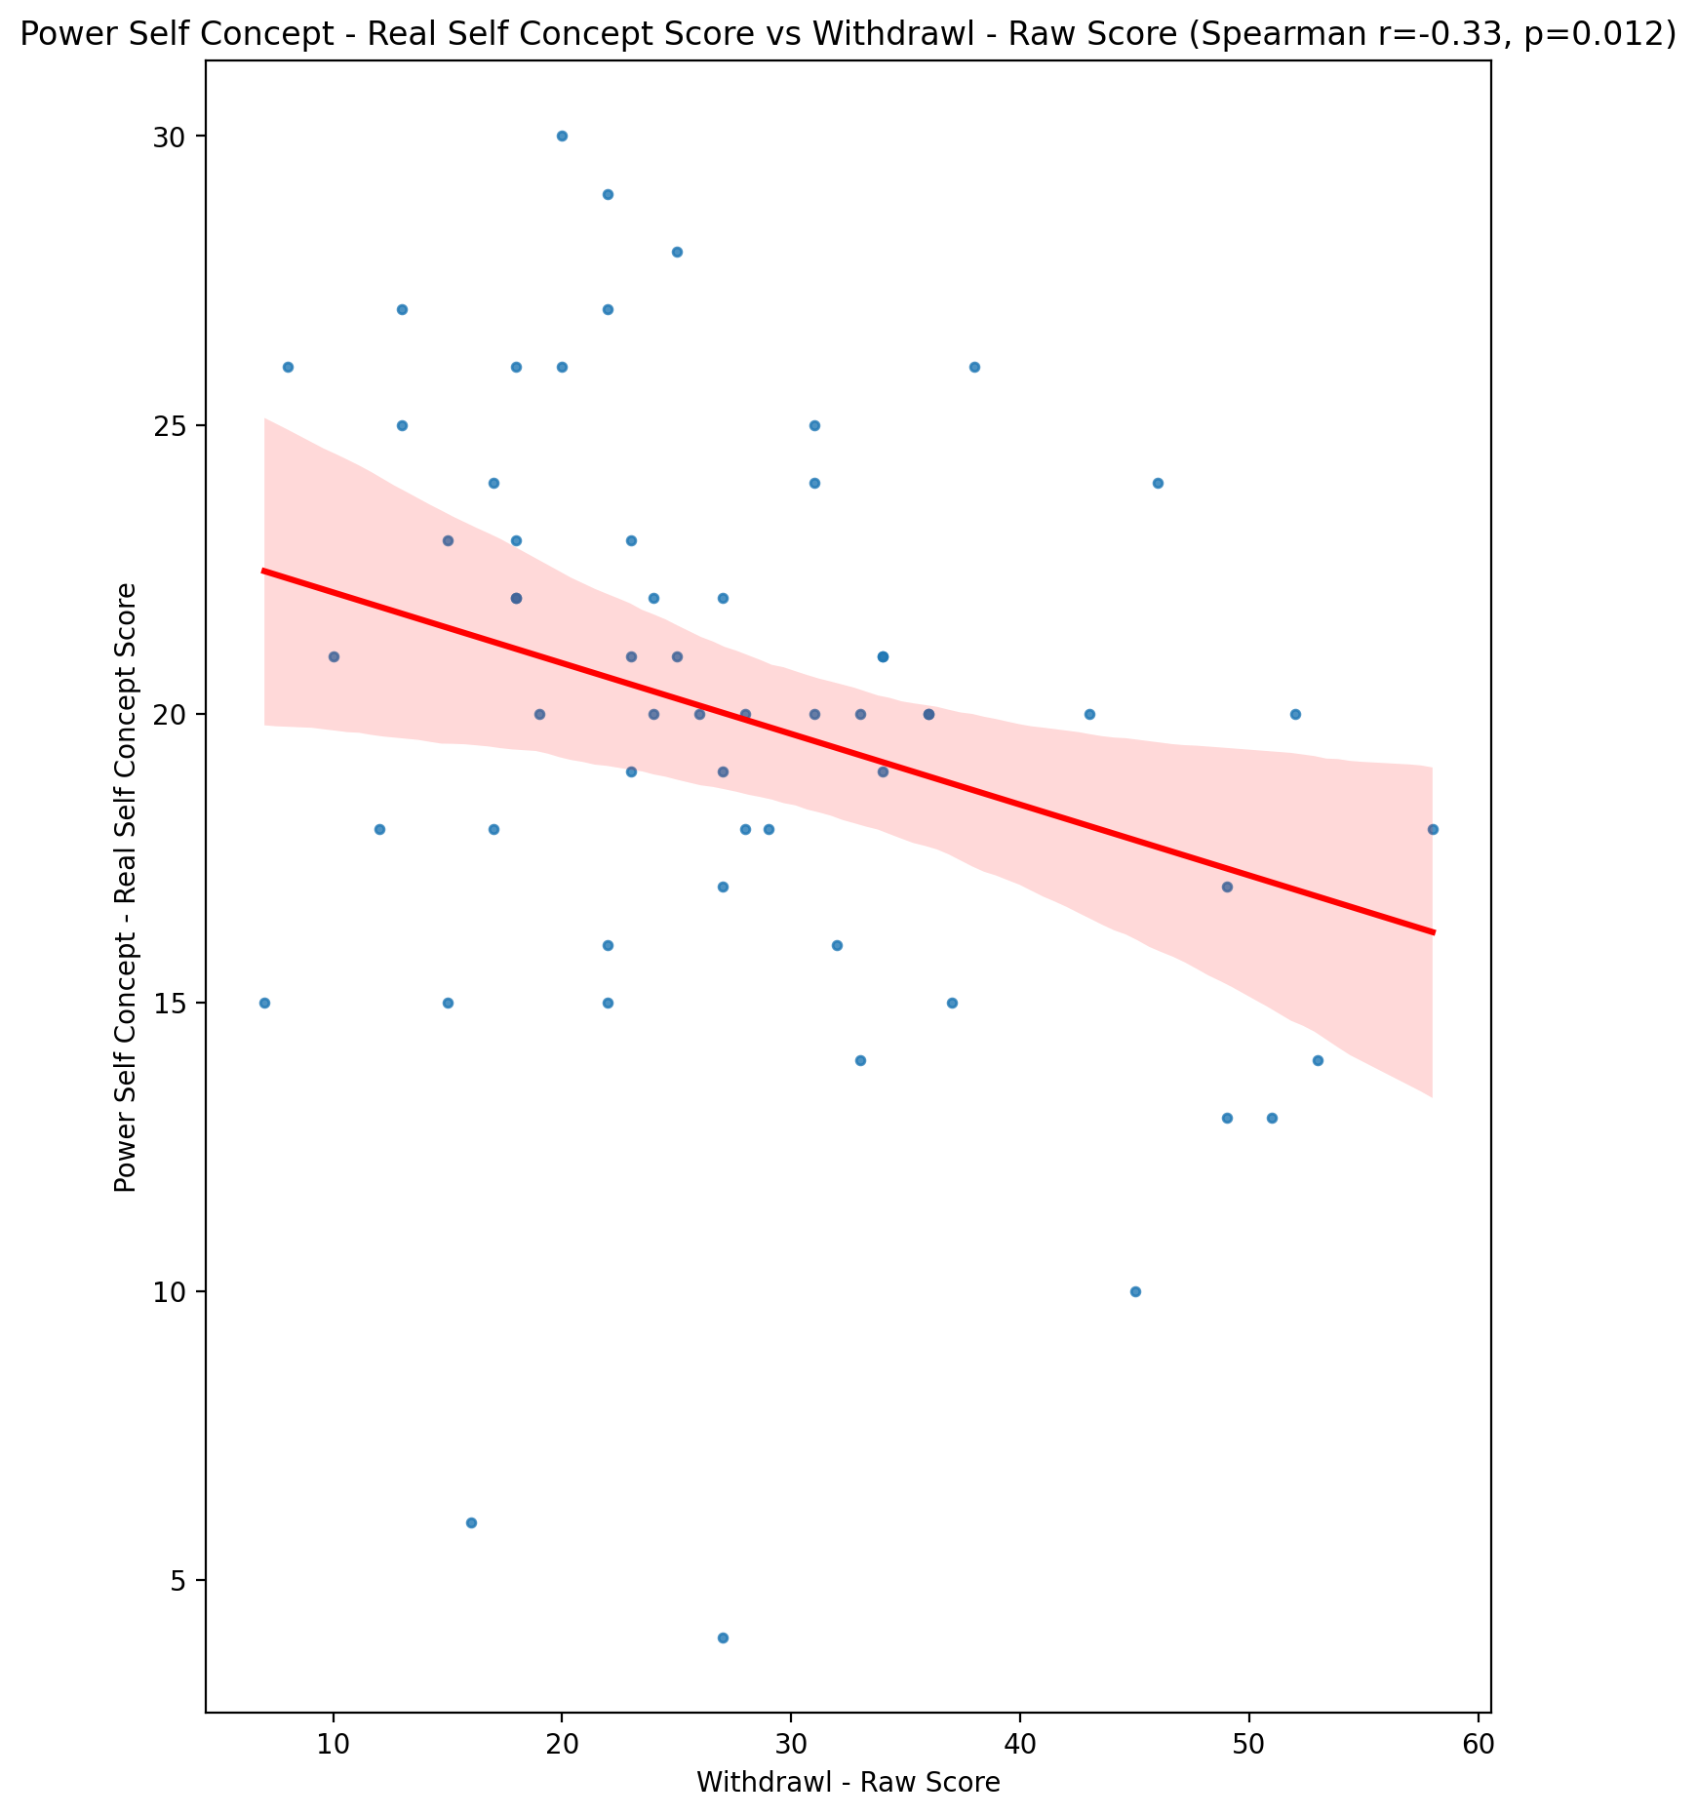

## Power Self Concept - Ideal Self Concept score vs Withdrawl - Raw Score

Test: spearman; statistic: -0.18453585301129724; p-value: 0.16176257770216532;

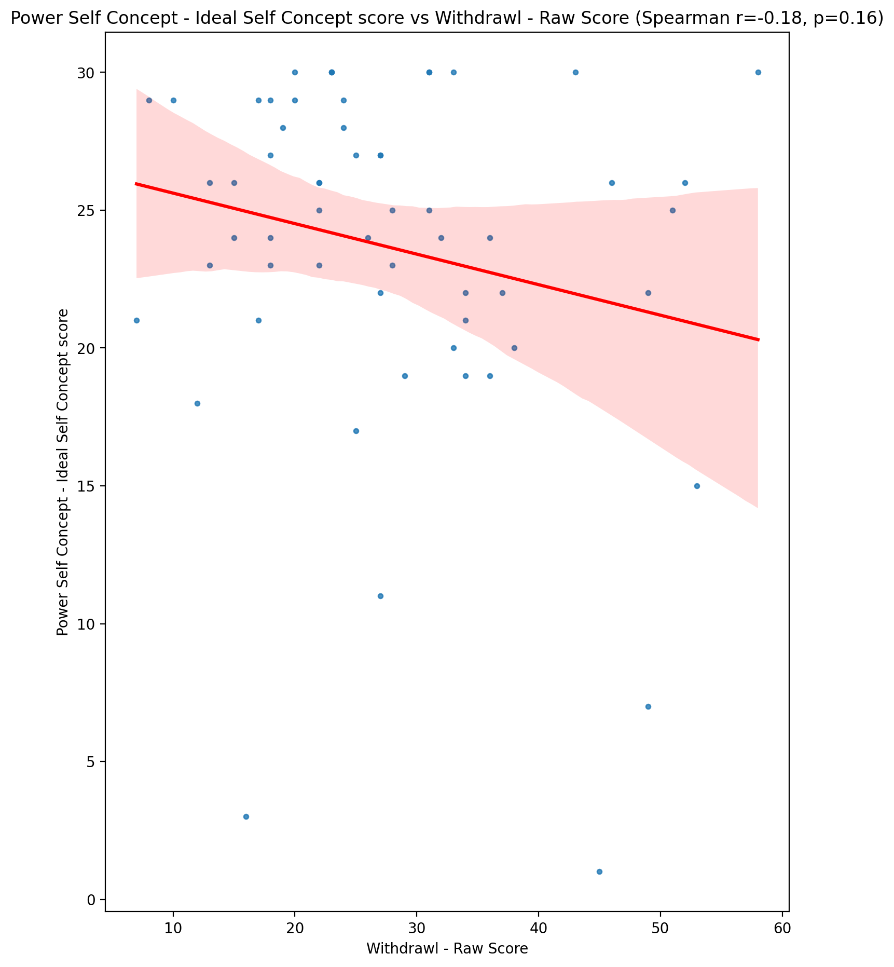

## Power Self Concept – Social Self Concept Score vs Withdrawl - Raw Score

Test: spearman; statistic: -0.06596121900075955; p-value: 0.619641593926065;

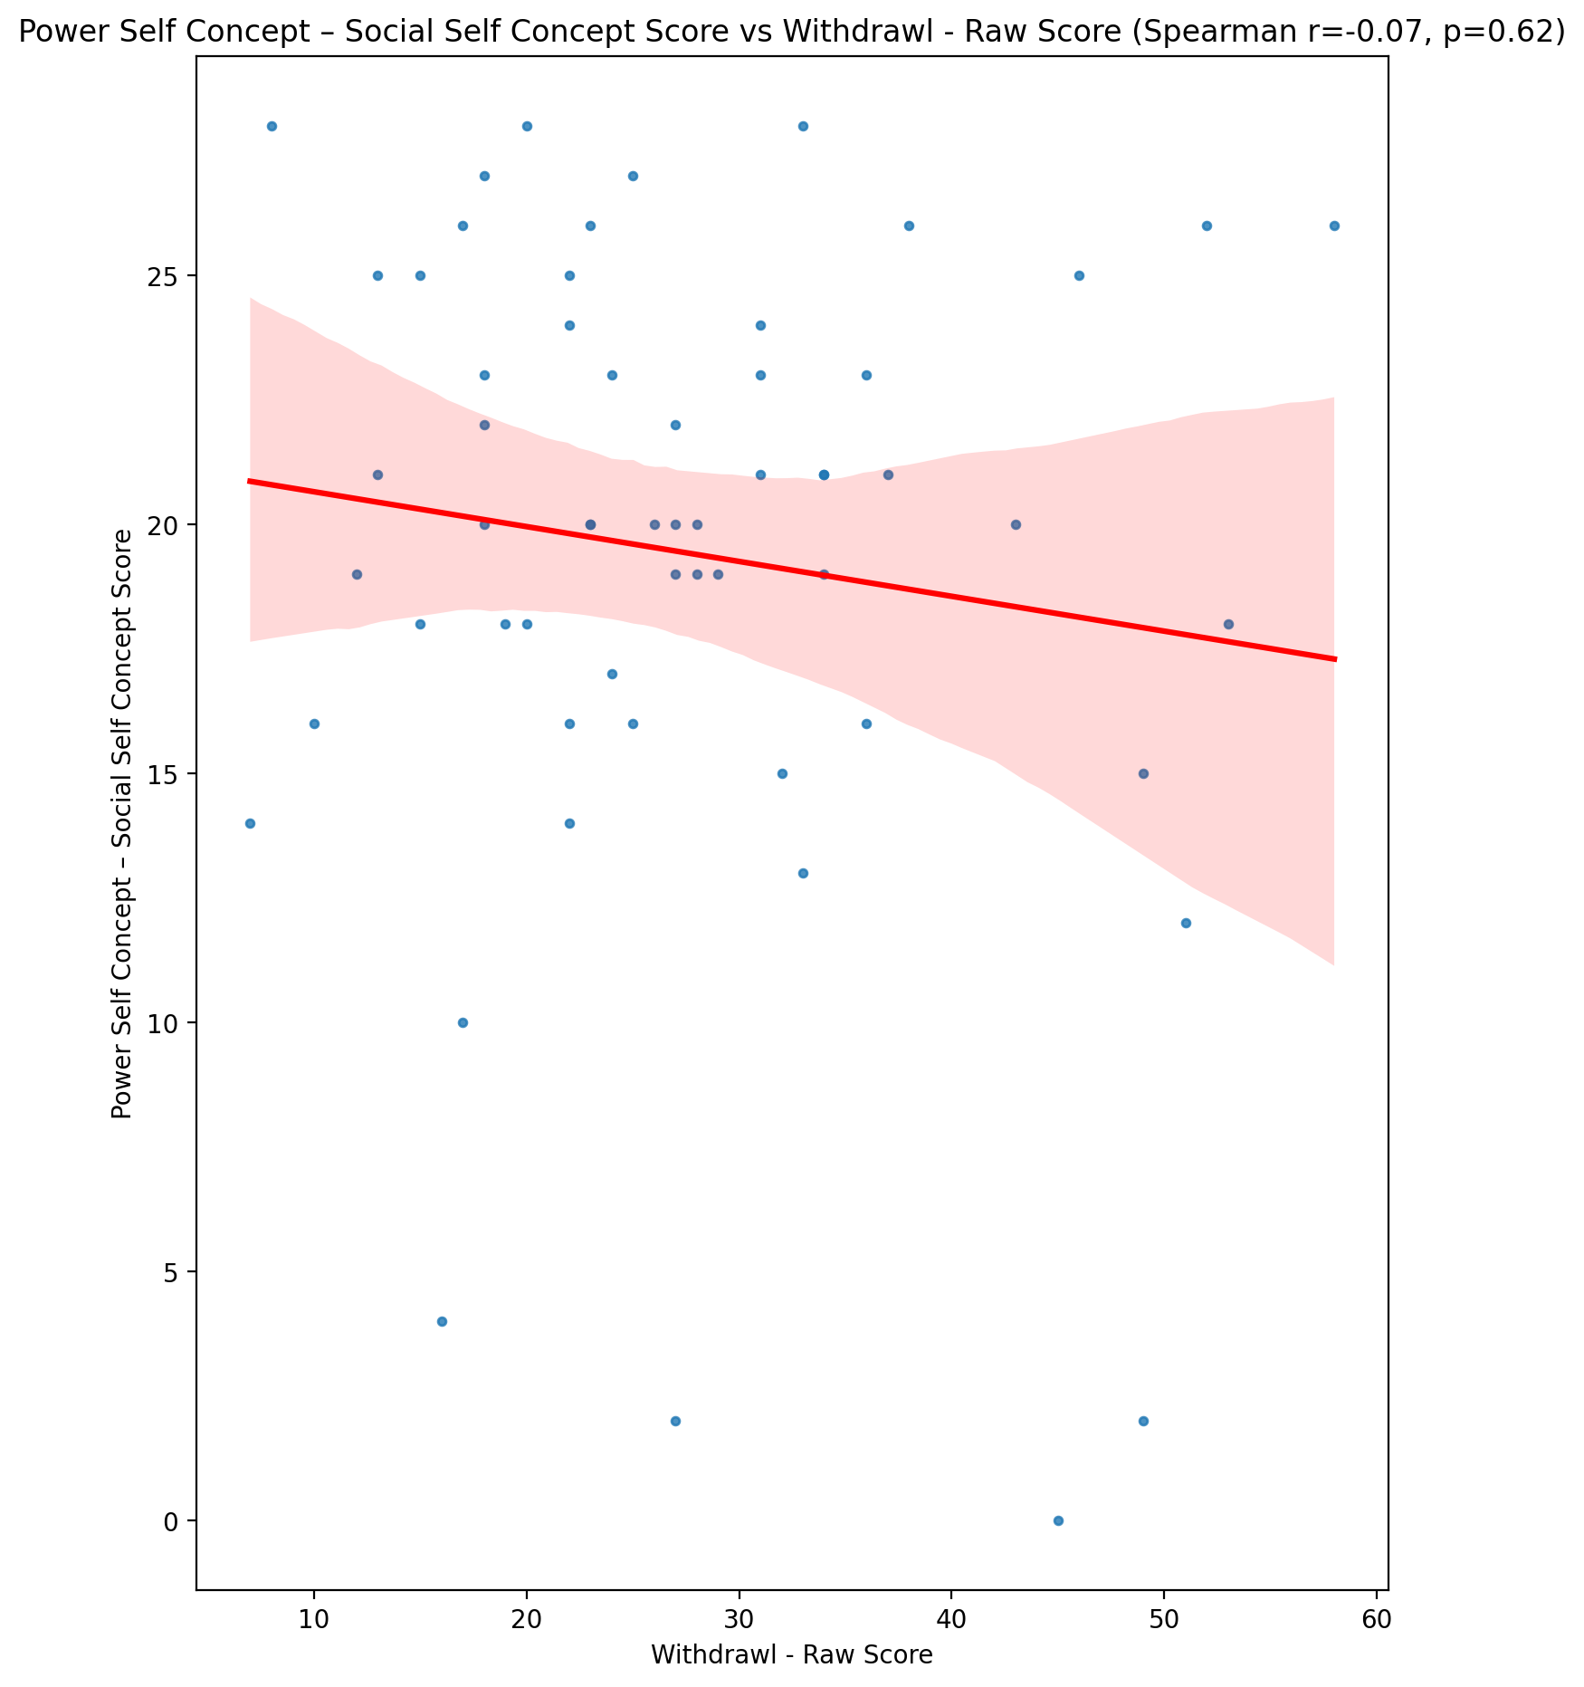

## Social Self Concept - Real Self Concept Score vs Withdrawl - Raw Score

Test: spearman; statistic: -0.4642259398985322; p-value: 0.0002125850425771805;

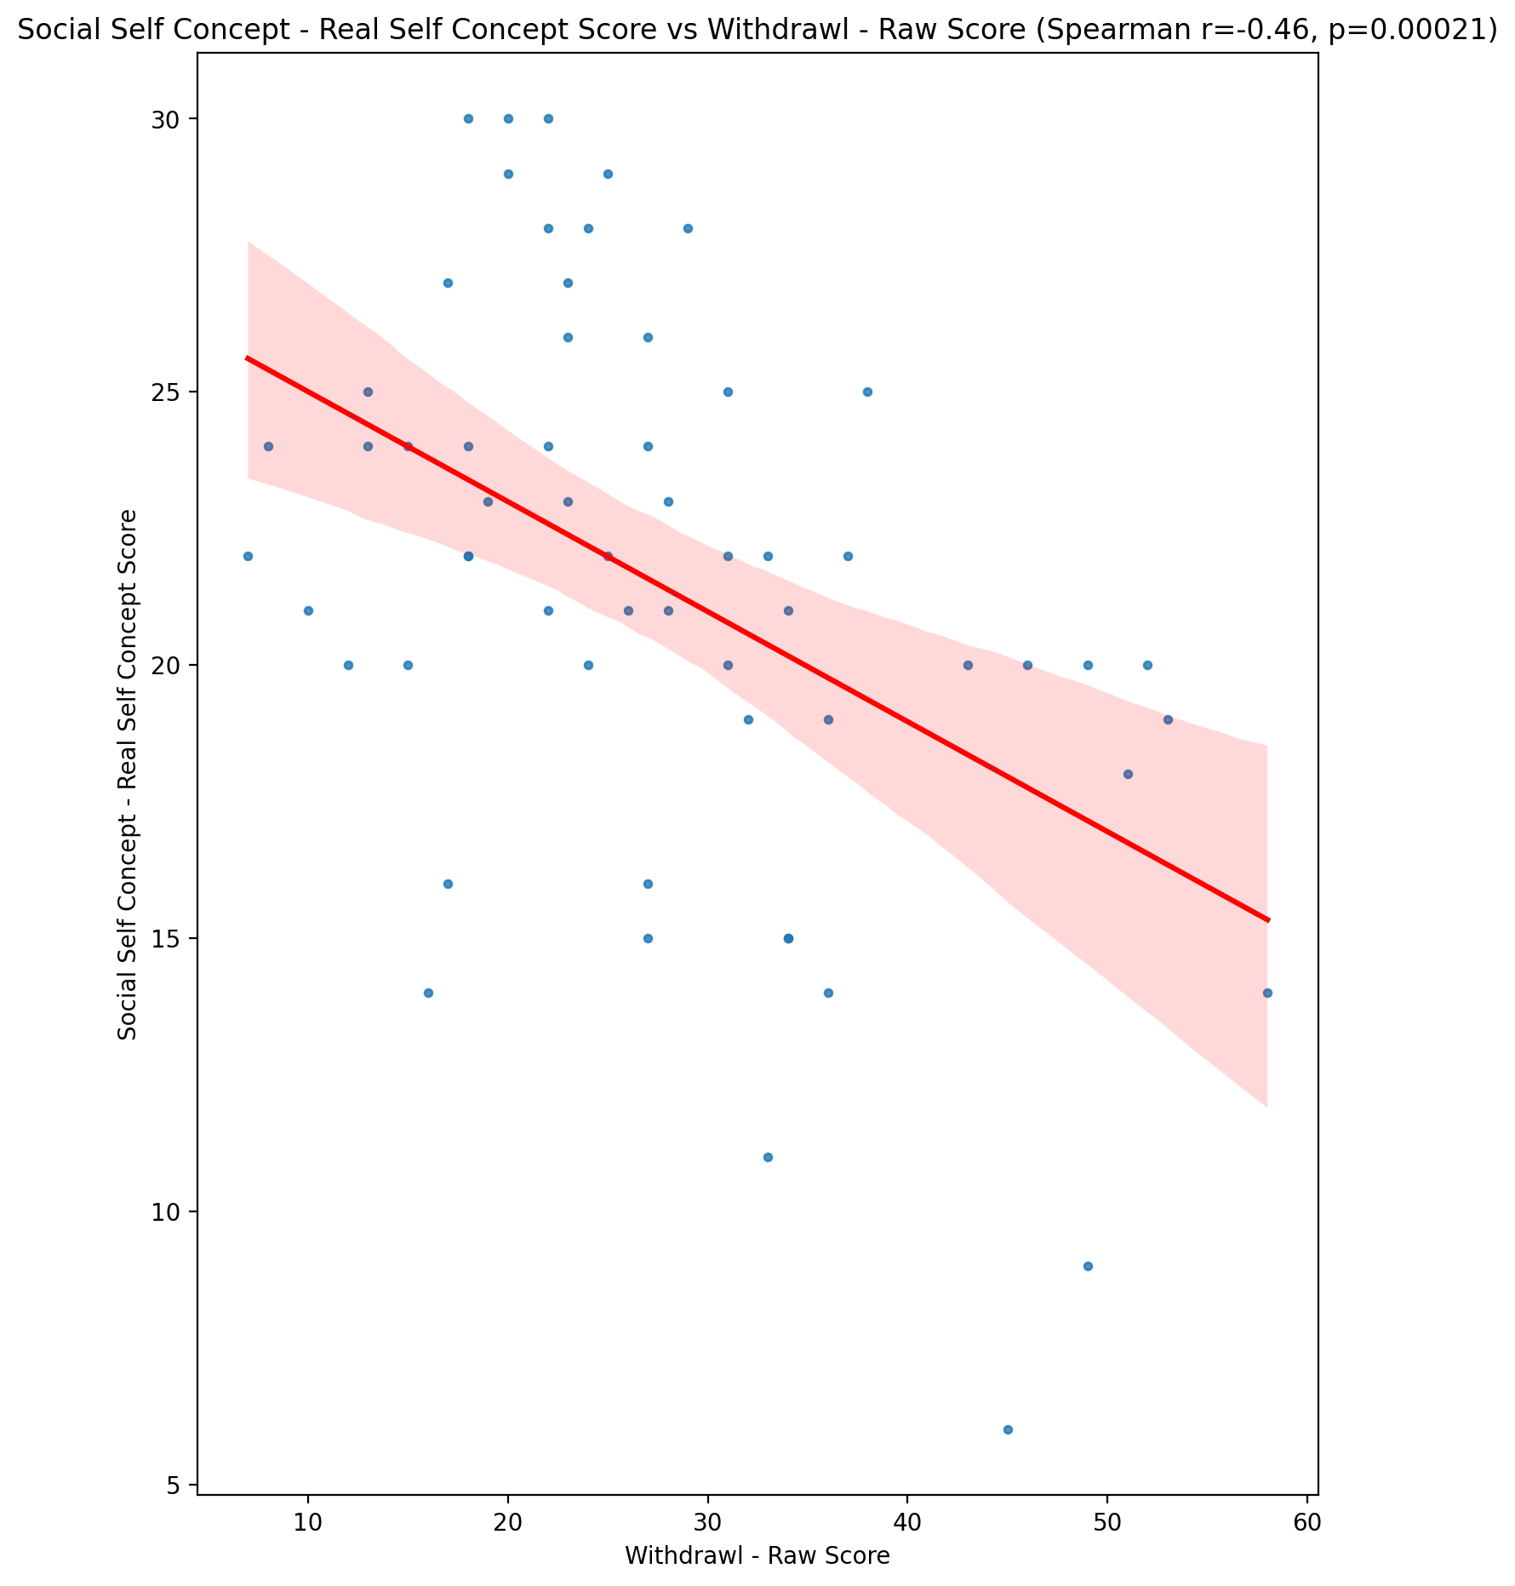

## Social Self Concept – Social Self Concept Score vs Withdrawl - Raw Score

Test: spearman; statistic: -0.14545022337886507; p-value: 0.27169045446520934;

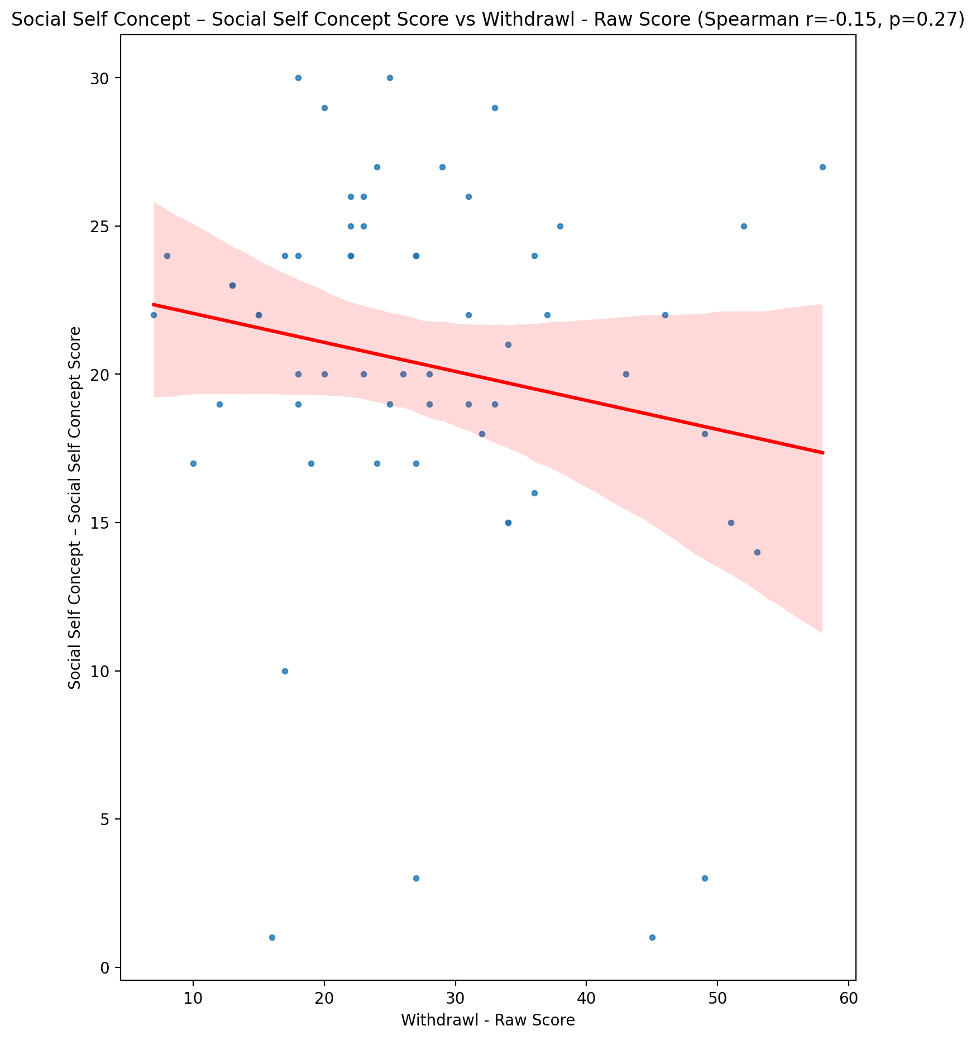

## Ability Self Concept - Real Self Concept Score vs Withdrawl - Raw Score

Test: spearman; statistic: -0.3916081945713569; p-value: 0.0021610862592715513;

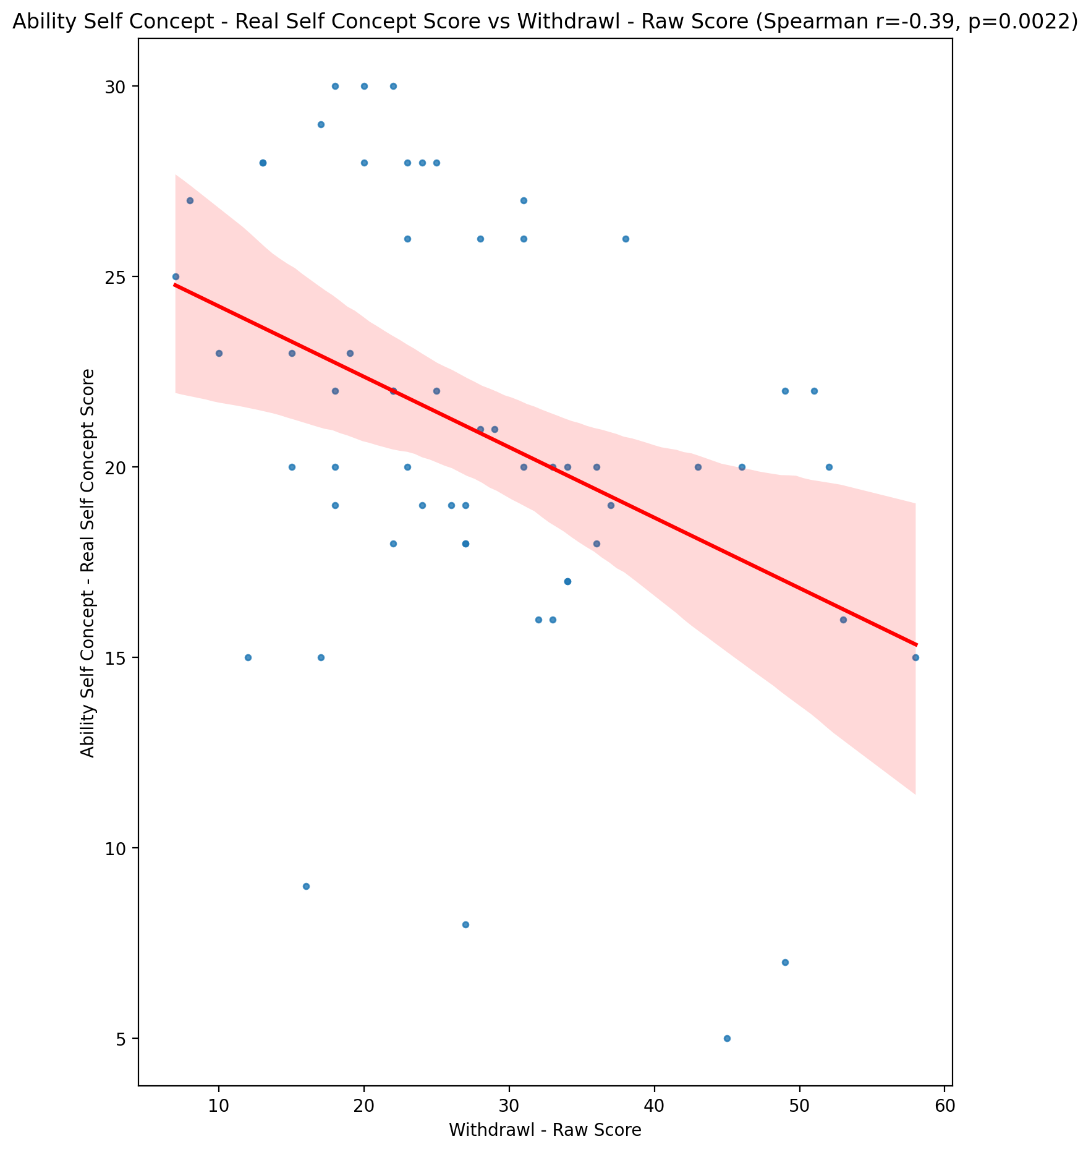

## Ability Self Concept - Ideal Self Concept Score vs Withdrawl - Raw Score

Test: spearman; statistic: -0.18595691229773645; p-value: 0.1585000999532485;

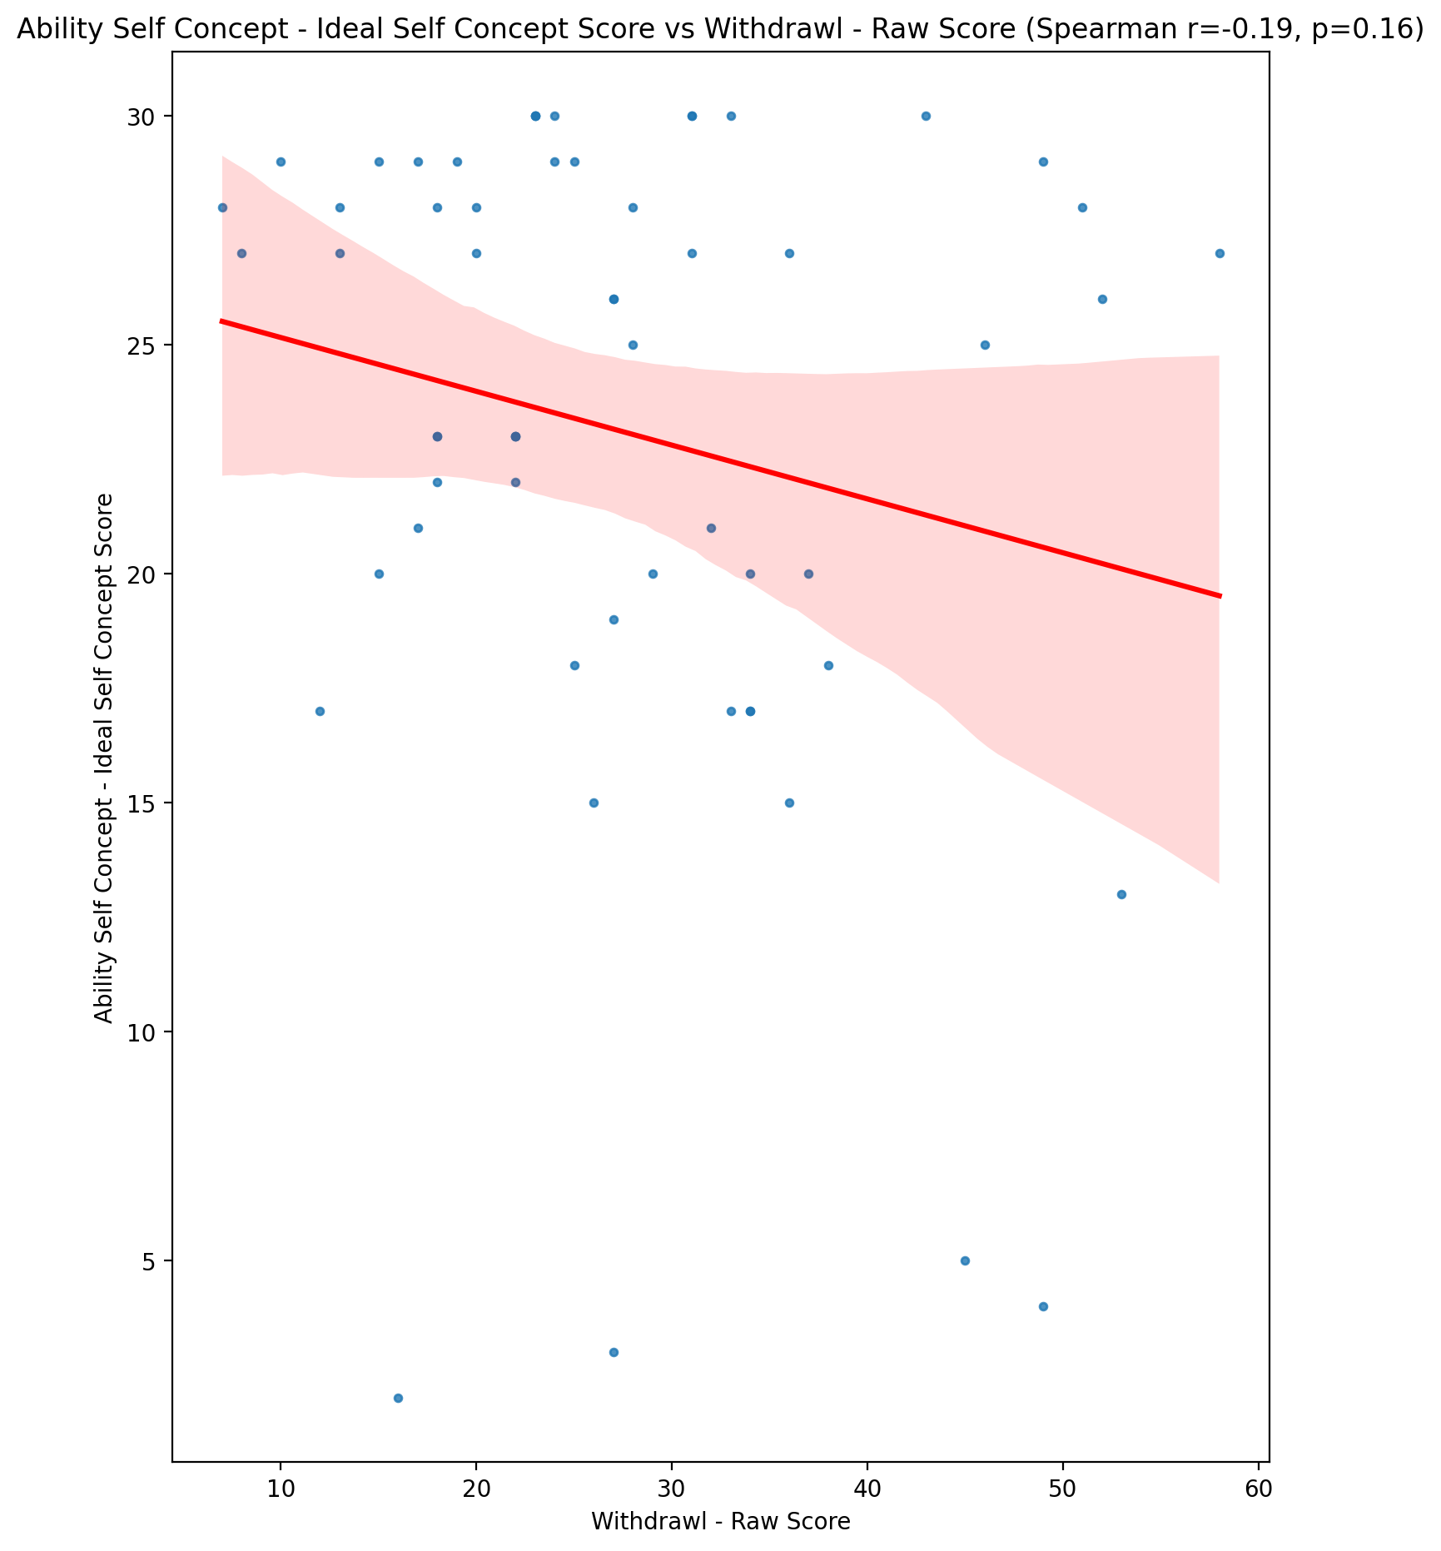

## Ability Self Concept – Social Self Concept Score vs Withdrawl - Raw Score

Test: spearman; statistic: -0.08173779263264036; p-value: 0.5382656797376699;

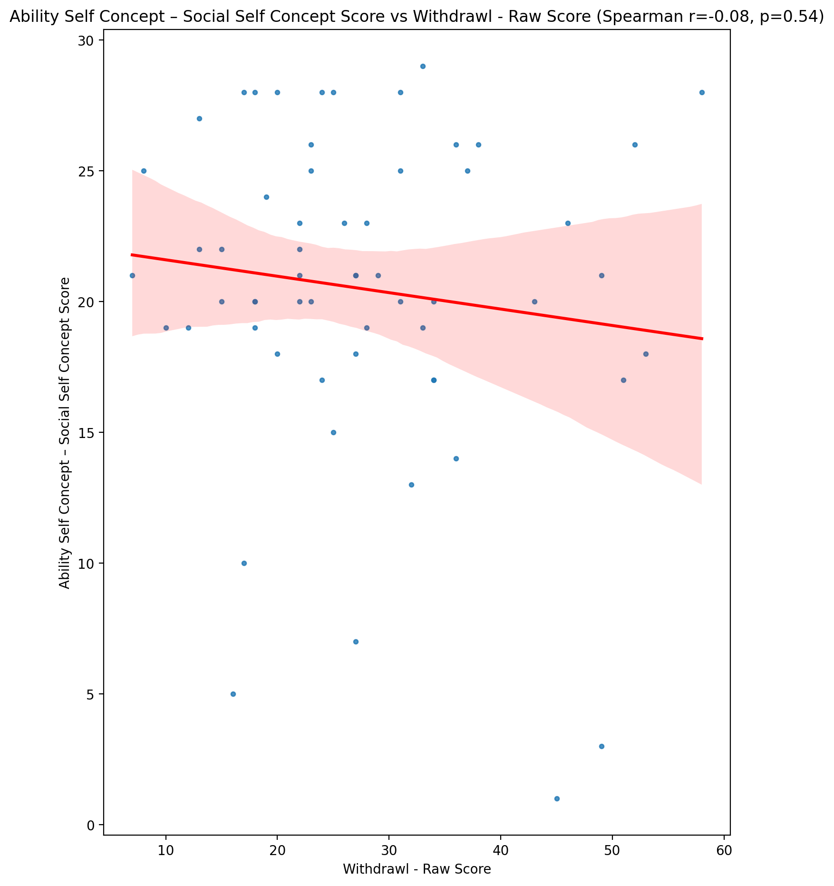

## Physical Self Concept - Real Self Concept Score vs Withdrawl - Raw Score

Test: spearman; statistic: -0.44068573885621887; p-value: 0.00047734288807000887;

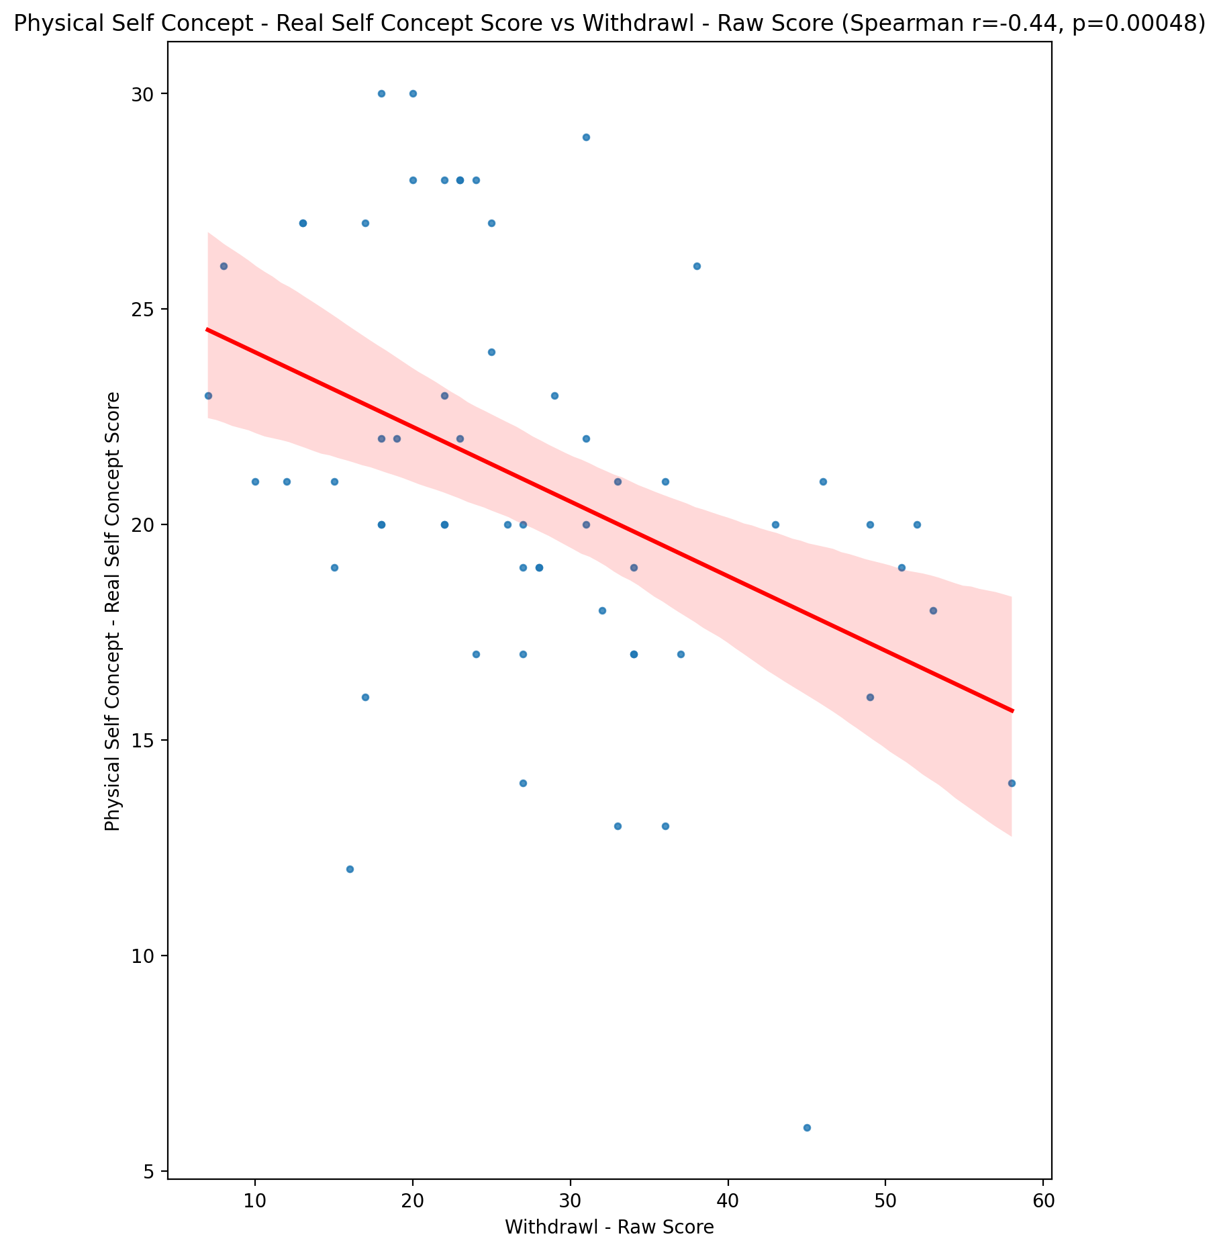

## Physical Self Concept – Ideal Self Concept Score vs Withdrawl - Raw Score

Test: spearman; statistic: -0.1925252371272246; p-value: 0.14404851081115402;

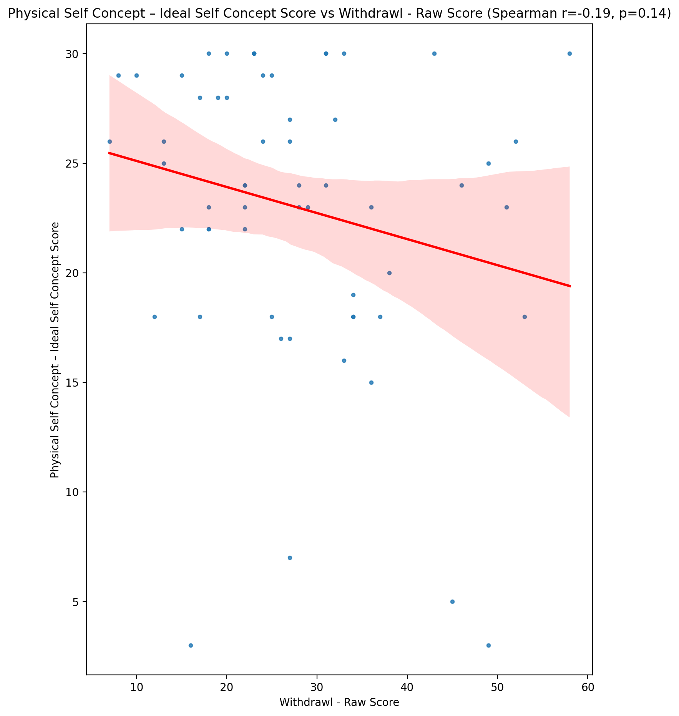

## Physical Self Concept – Social Self Concept Score vs Withdrawl - Raw Score

Test: spearman; statistic: -0.14047468707009694; p-value: 0.2886022682535452;

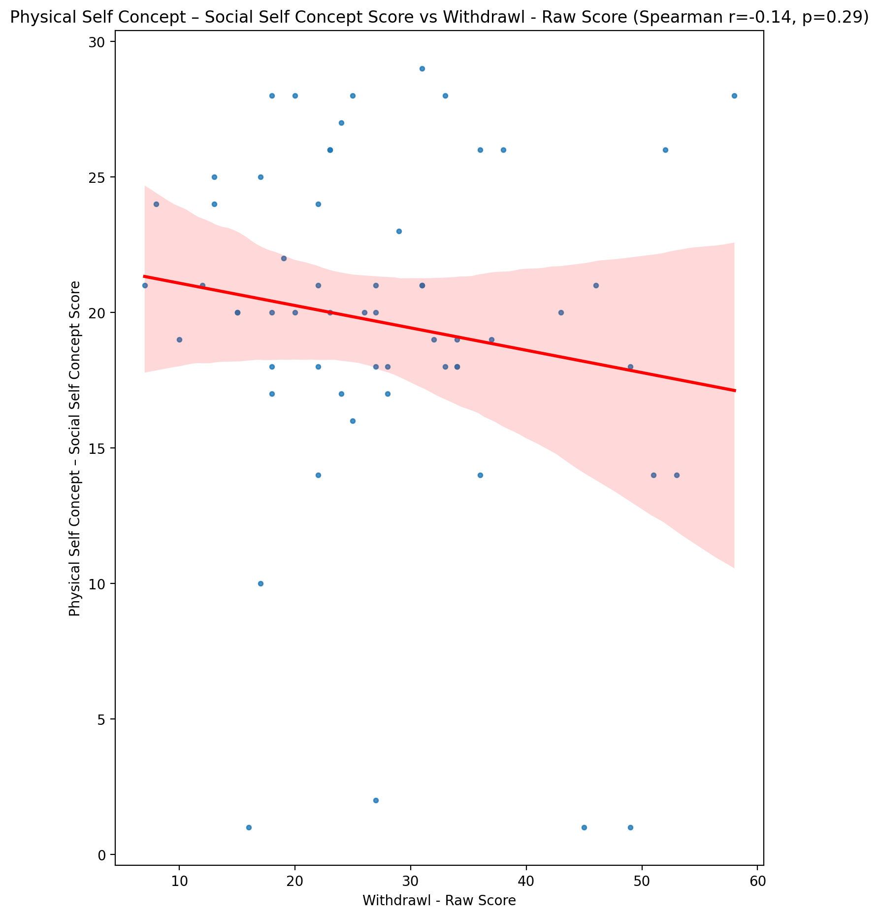

## Psychological Self Concept - Real Self Concept Score vs Withdrawl - Raw Score

Test: spearman; statistic: -0.515042435766634; p-value: 2.9953248072788012e-05;

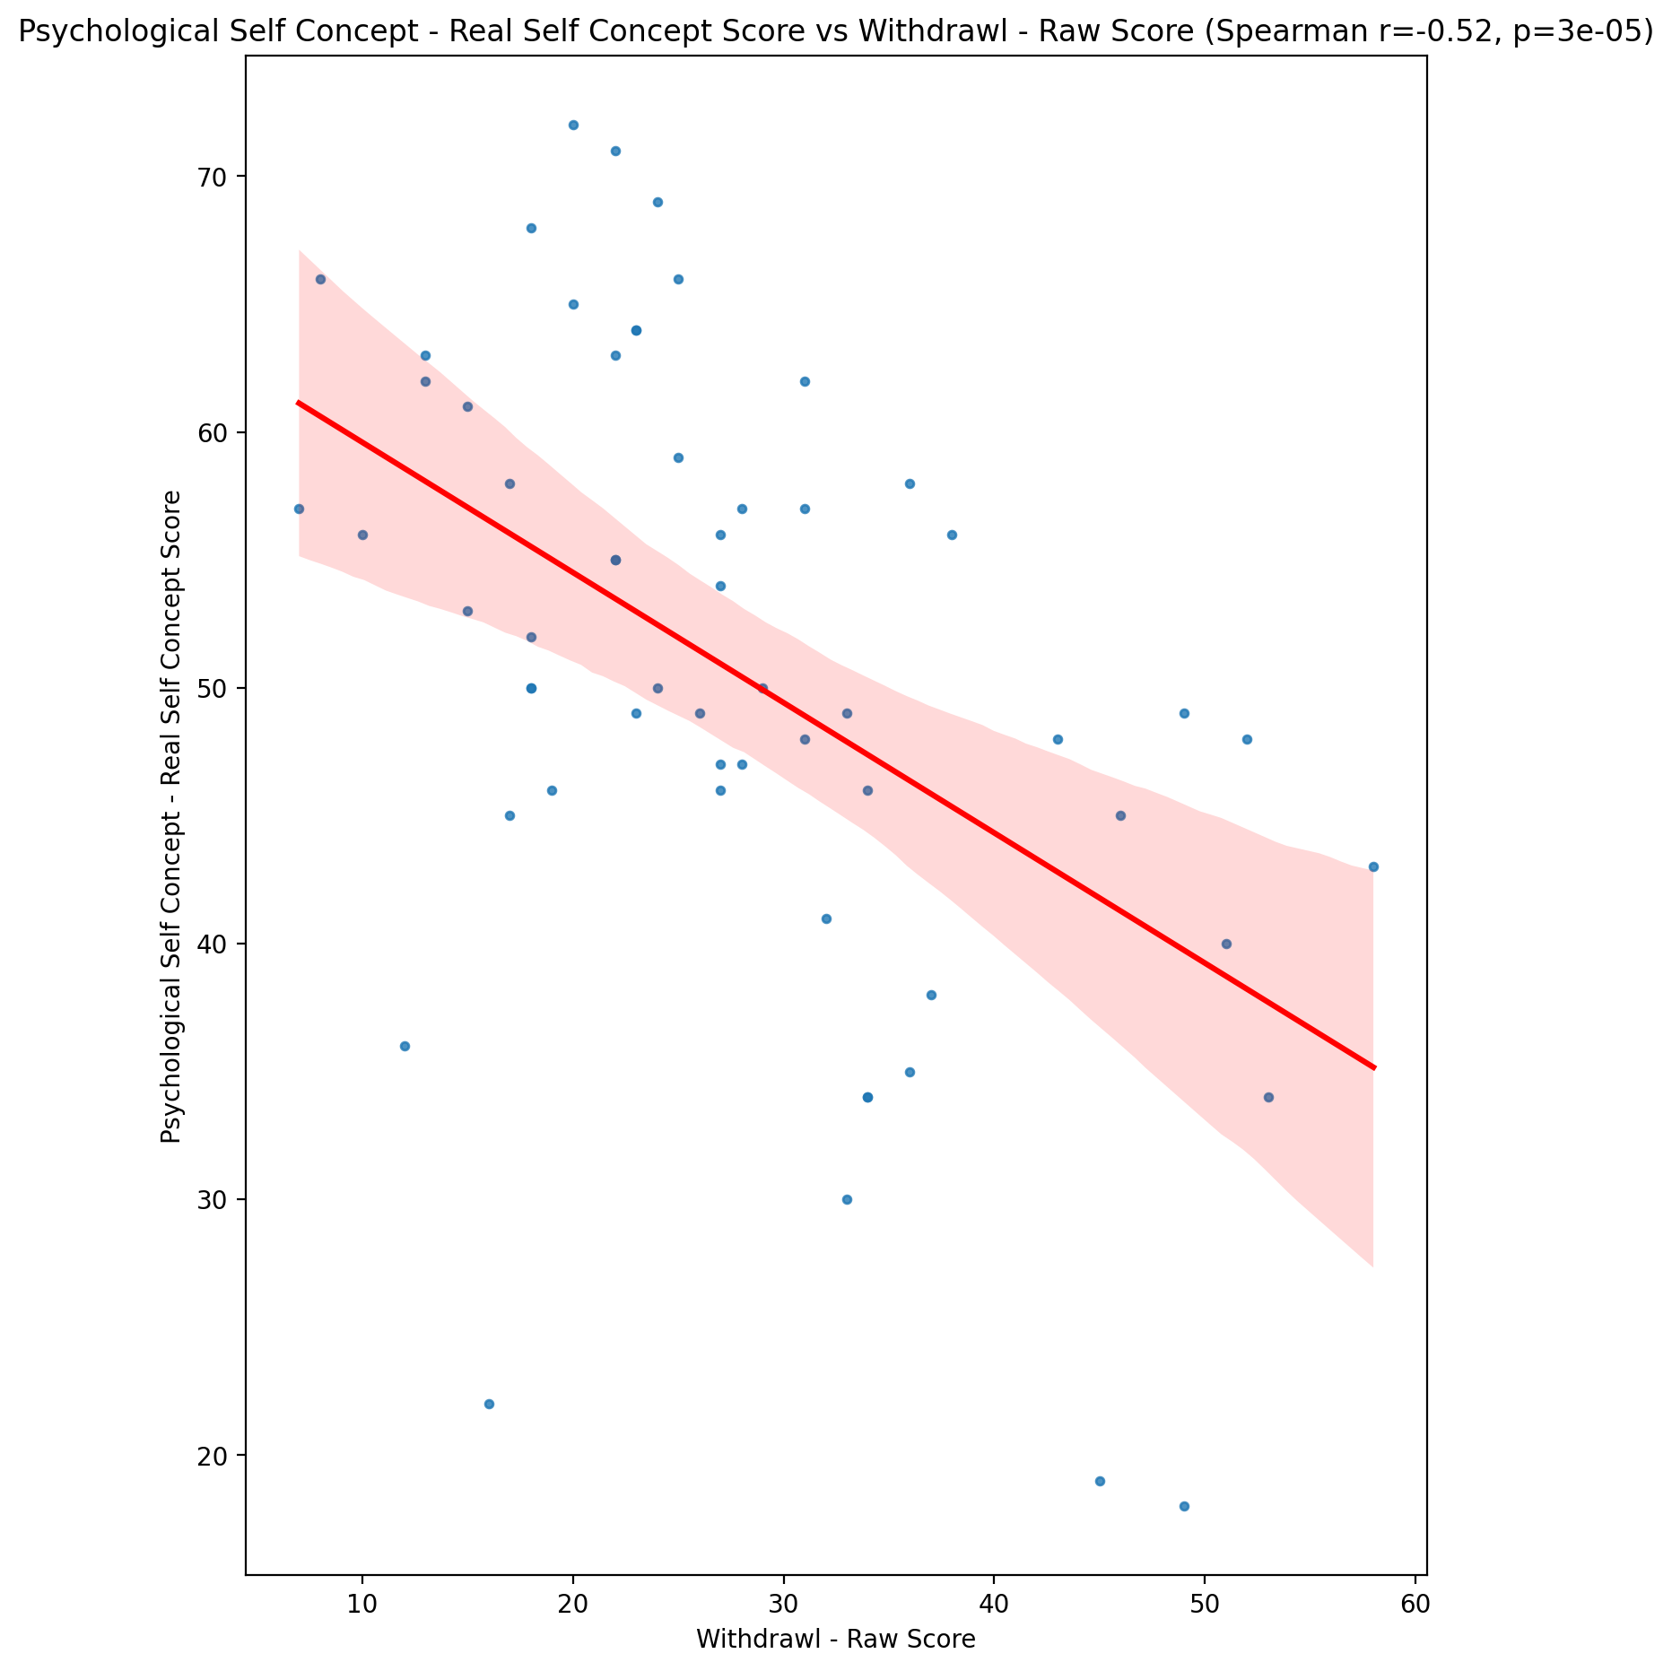

## Psychological Self Concept – Ideal Self Concept Score vs Withdrawl - Raw Score

Test: spearman; statistic: -0.2462817214348234; p-value: 0.06006364427612421;

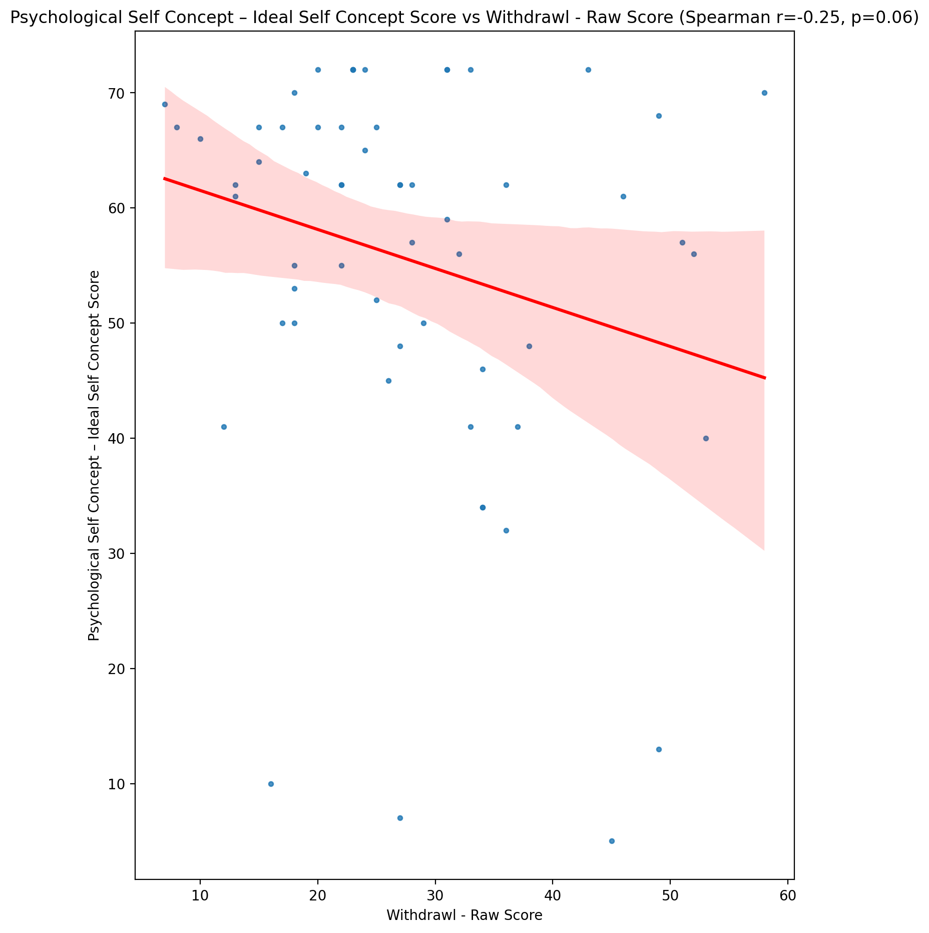

## Psychological Self Concept – Social Self Concept Score vs Withdrawl - Raw Score

Test: spearman; statistic: -0.2786431914575839; p-value: 0.032595749691112424;

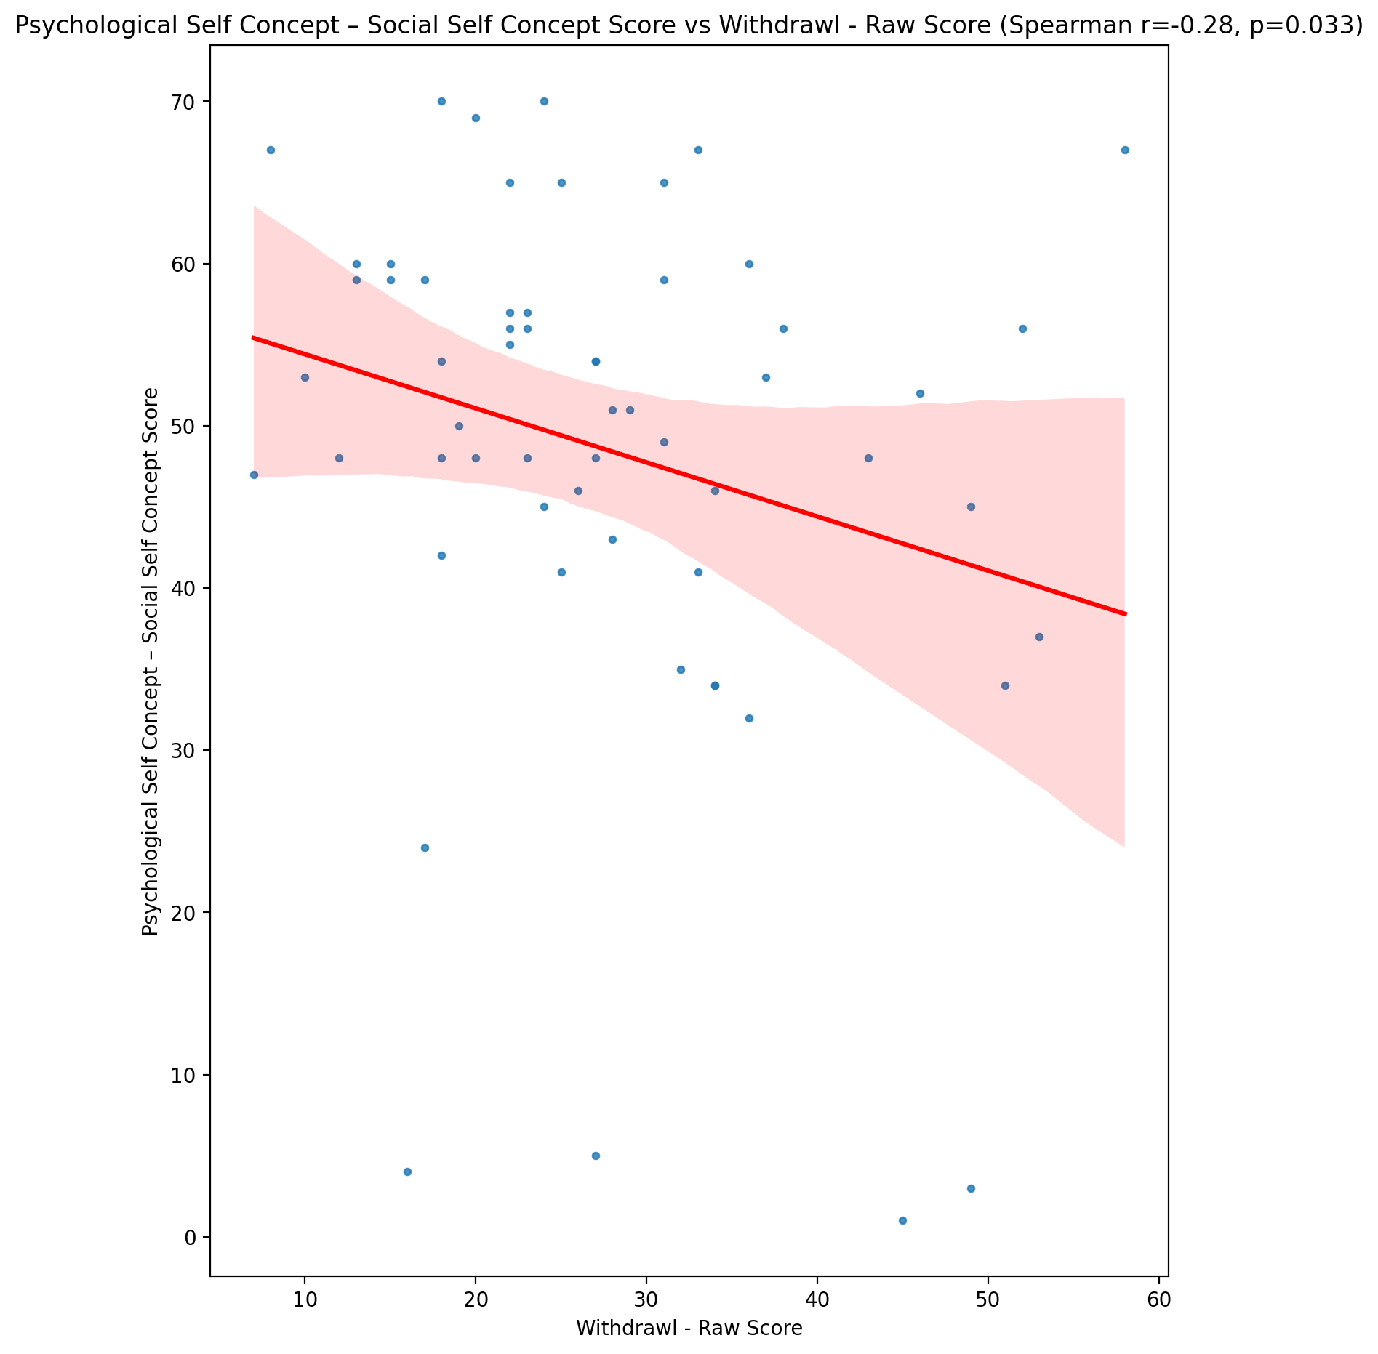

## Real Self Concept Total Score vs Withdrawl - Raw Score

Test: spearman; statistic: -0.5047768259545615; p-value: 4.5642300203283925e-05;

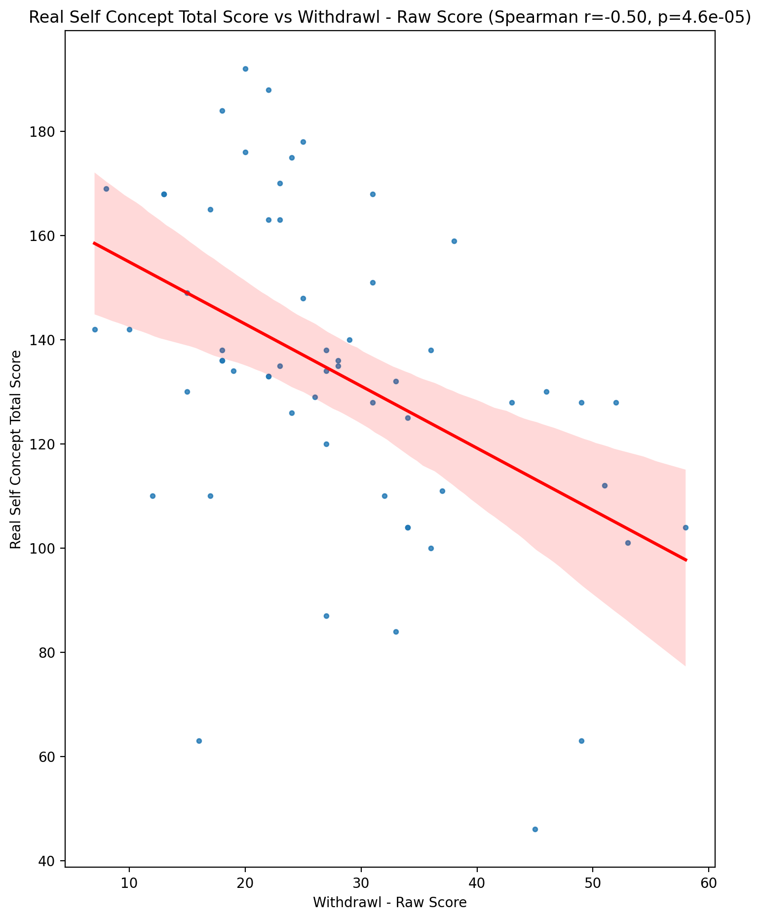

## Ideal Self Concept Total Score vs Withdrawl - Raw Score

Test: spearman; statistic: -0.21226401369700243; p-value: 0.10652803683159671;

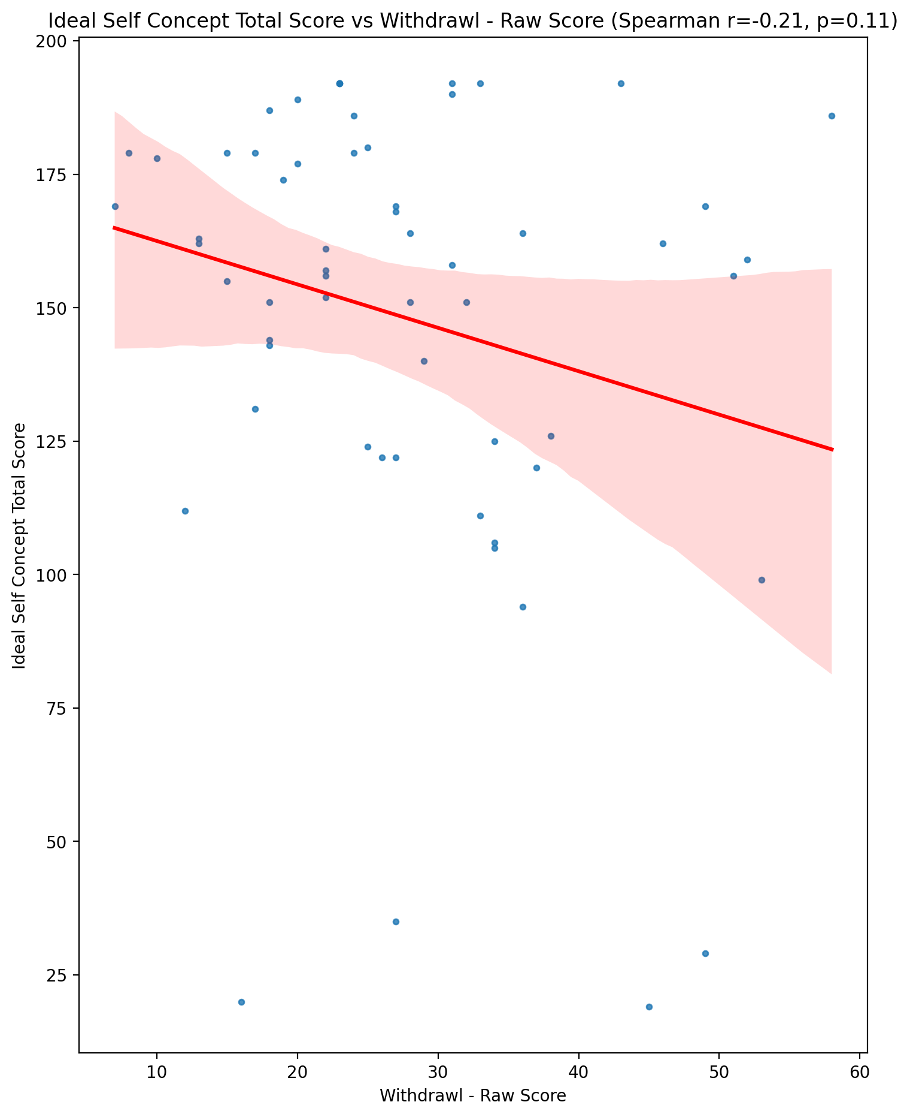

## Social Self Concept Total Score vs Withdrawl - Raw Score

Test: spearman; statistic: -0.19076456975938874; p-value: 0.14782207716354798;

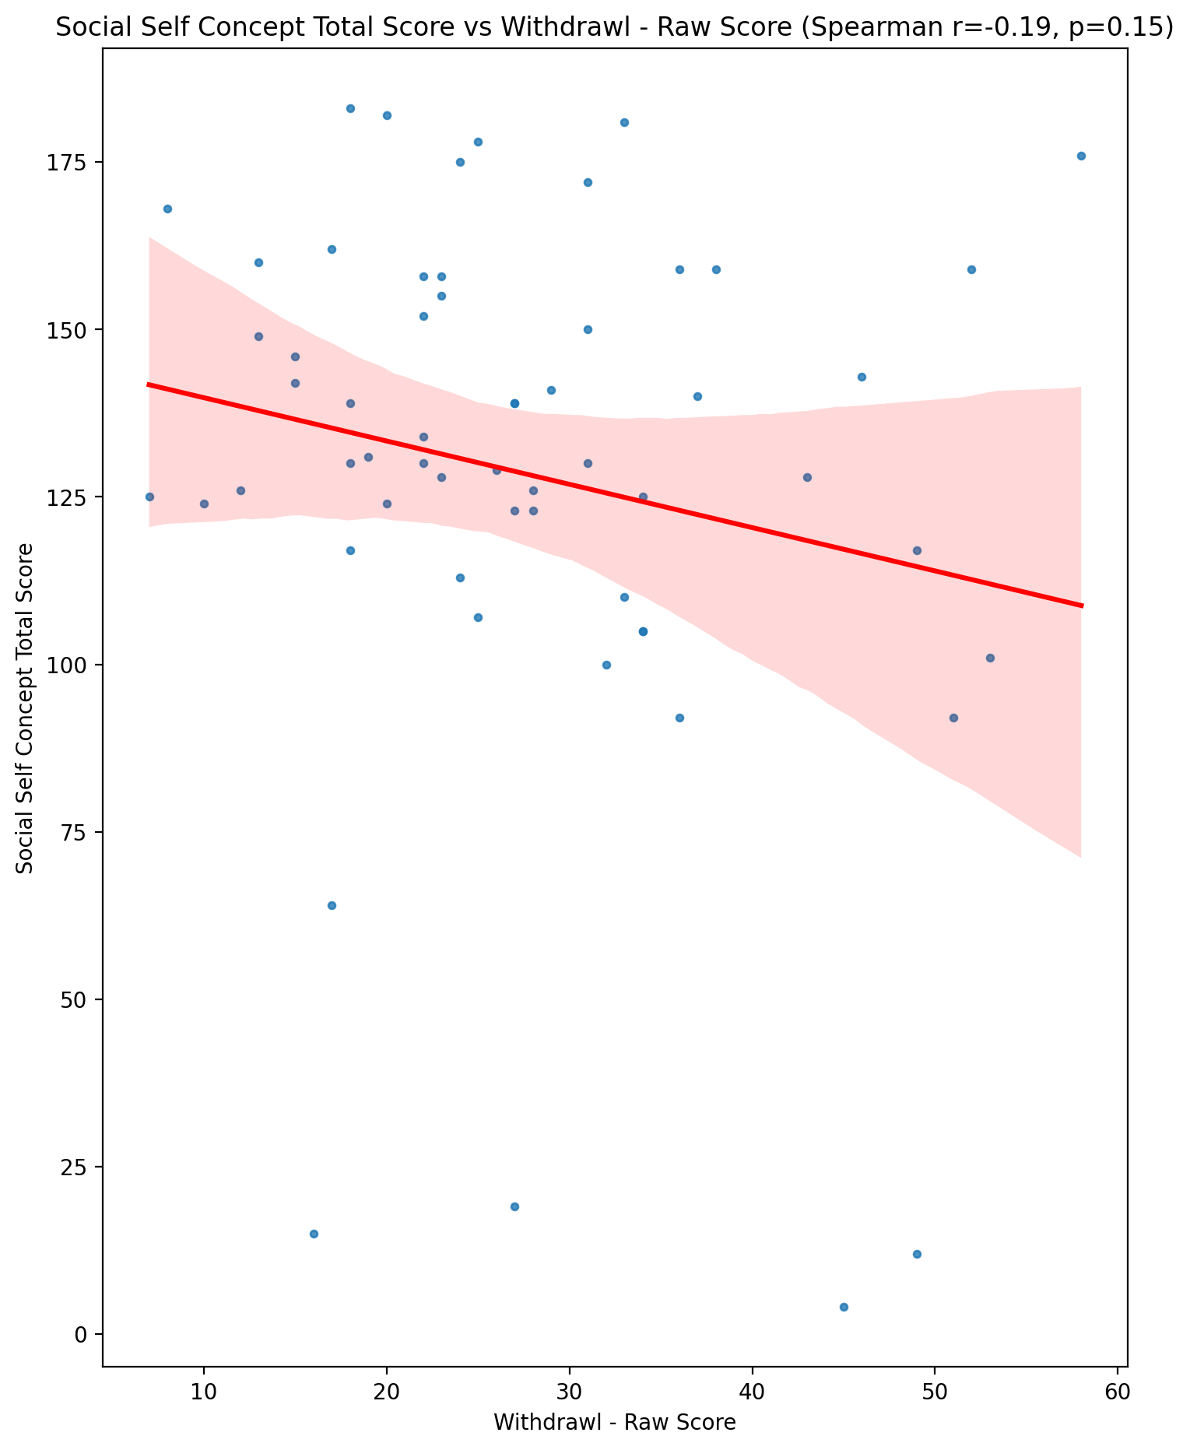

## Ideal Self Concept Total Category vs Withdrawl - Raw Score

Test: None; statistic: None; p-value: None; Test not run: unsupported type combination.



## Perceived Social Stress Score vs Withdrawl - Raw Score

Test: spearman; statistic: 0.3287681272092055; p-value: 0.011009770535084682;

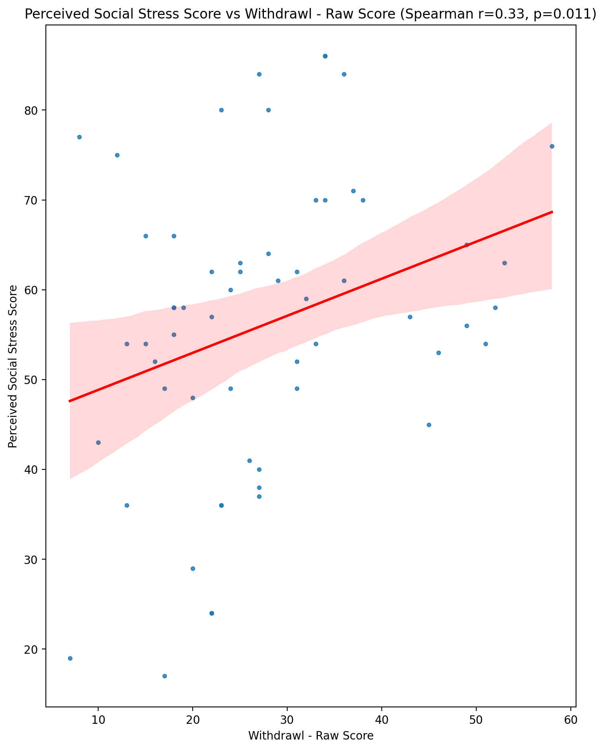

## Perceived Social Stress Category vs Withdrawl - Raw Score

Test: None; statistic: None; p-value: None; Test not run: unsupported type combination.



## Emotional Support - Raw Score vs Occupational & Relationship Consequences - Raw Score

Test: spearman; statistic: -0.3260220500949069; p-value: 0.011738618948395027;

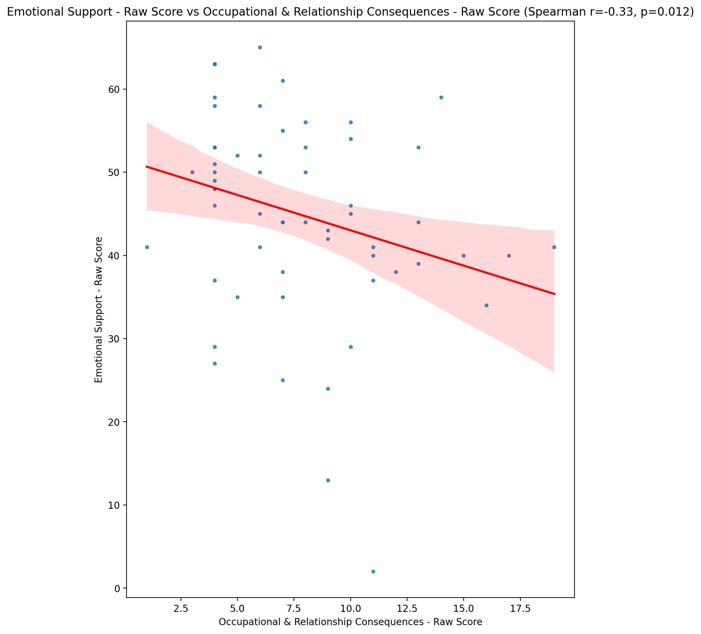

## Informational Support - Raw Score vs Occupational & Relationship Consequences - Raw Score

Test: spearman; statistic: -0.25150433709493963; p-value: 0.05466634337490762;

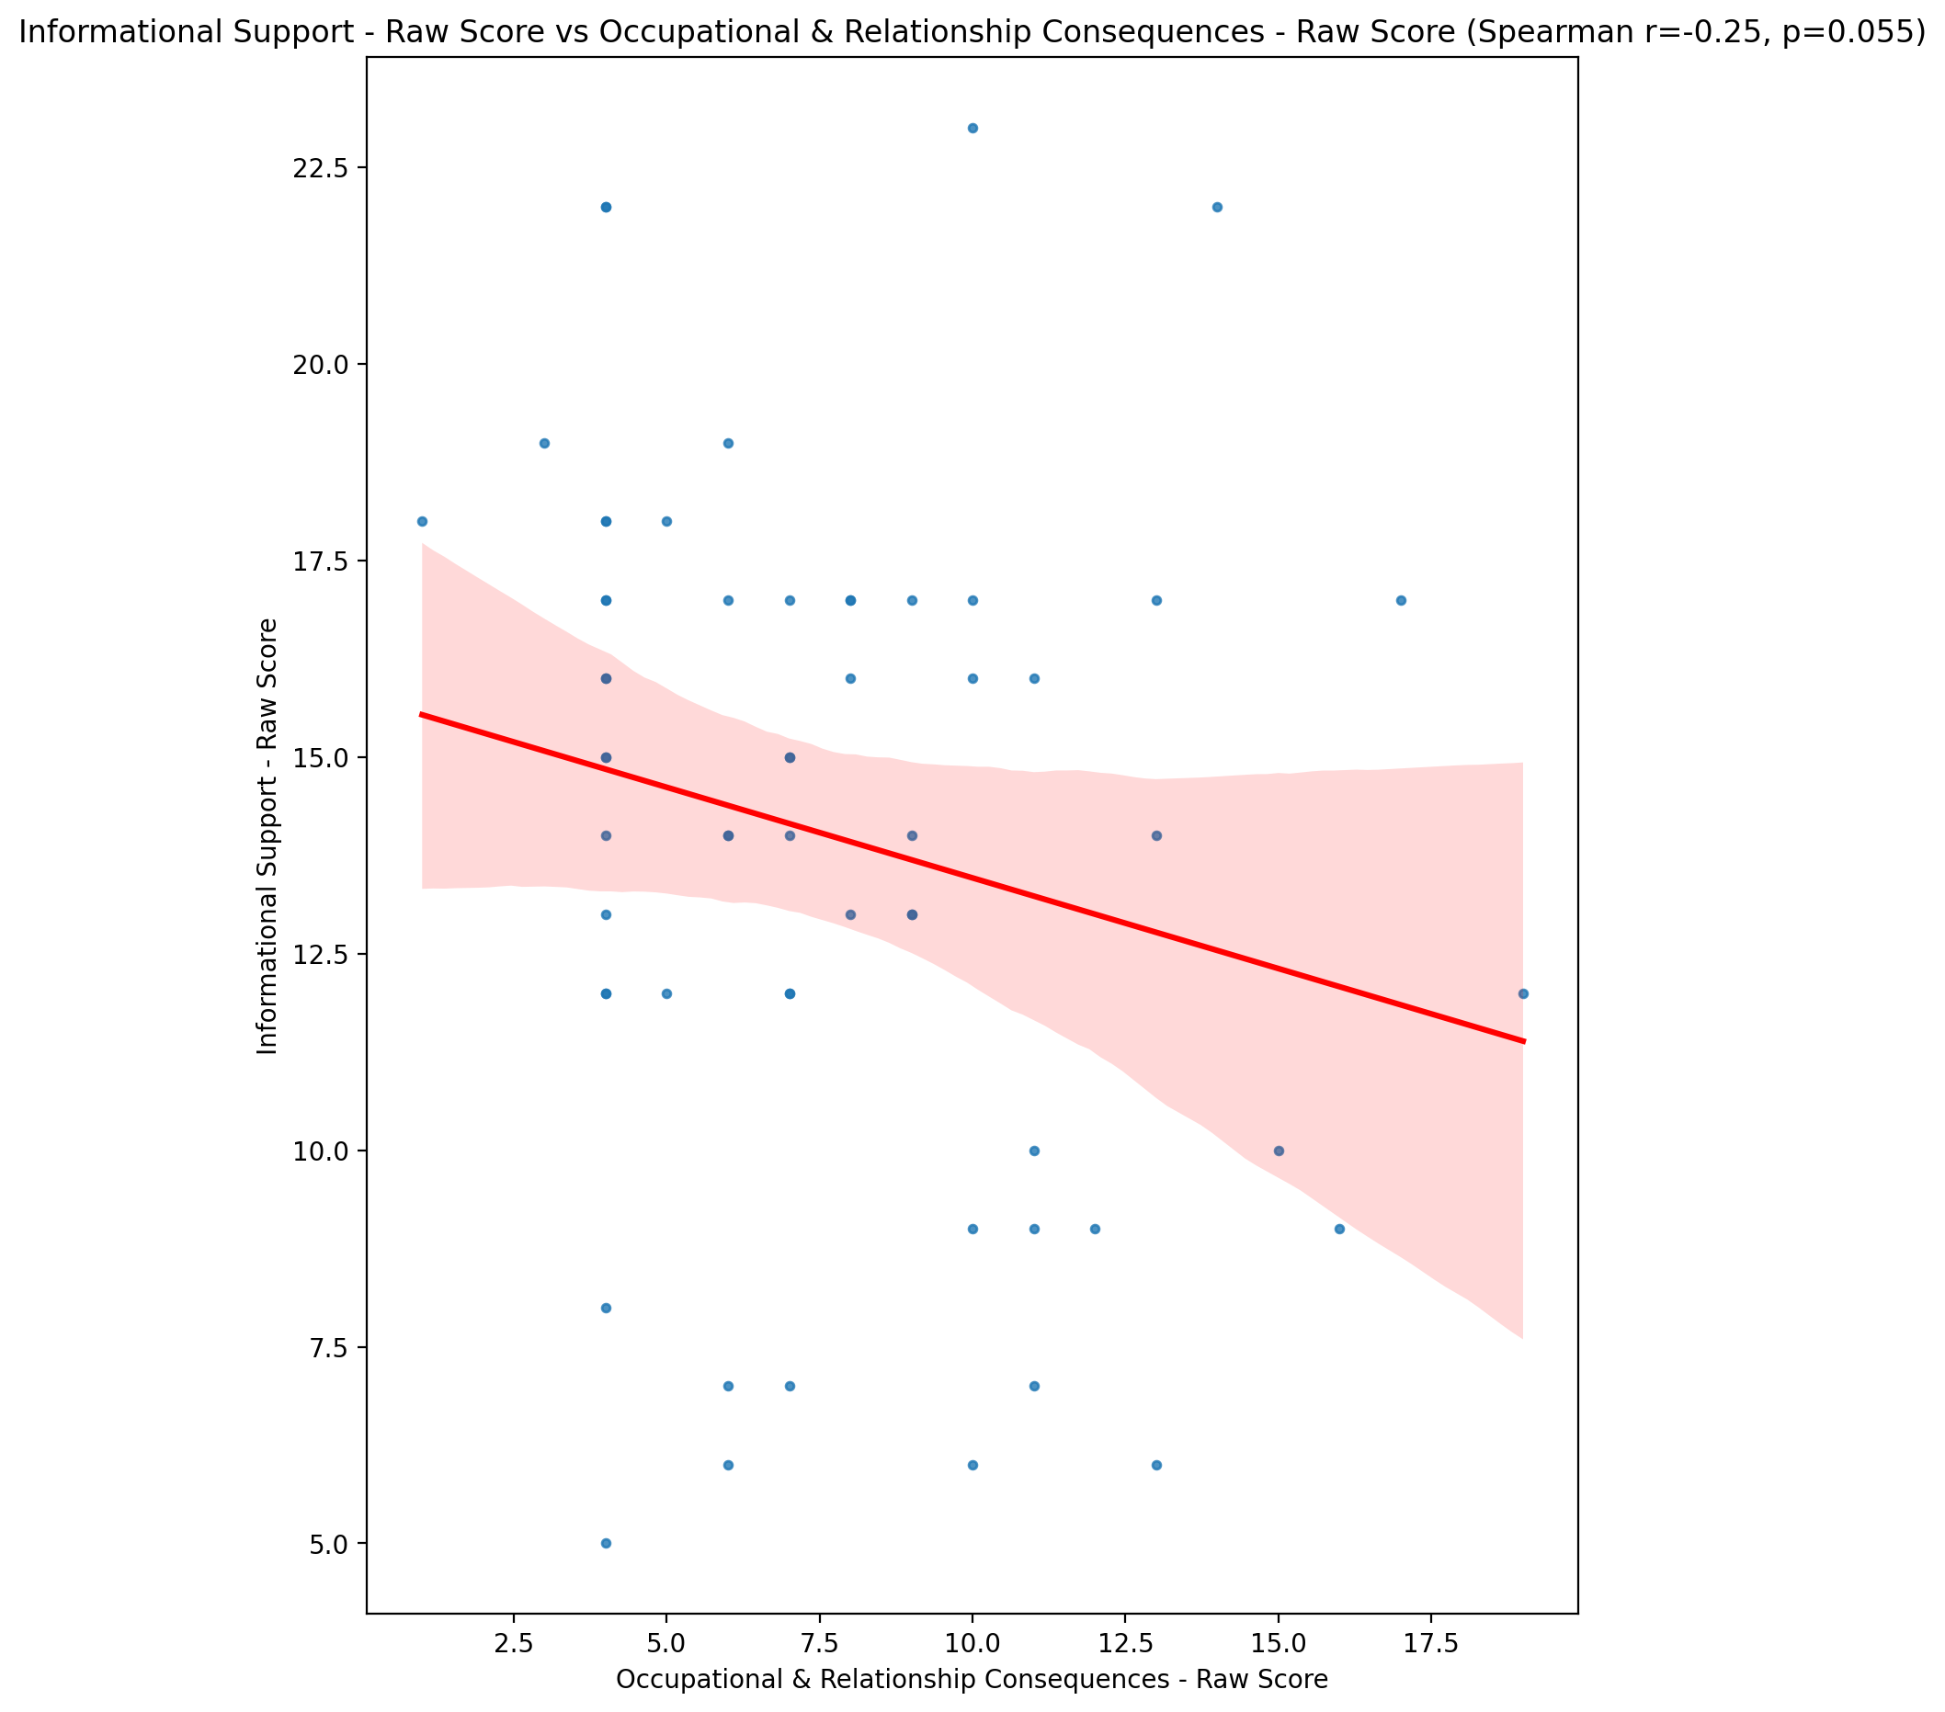

## Instrumental Support - Raw Score vs Occupational & Relationship Consequences - Raw Score

Test: spearman; statistic: -0.2828246240310647; p-value: 0.029971843801167807;

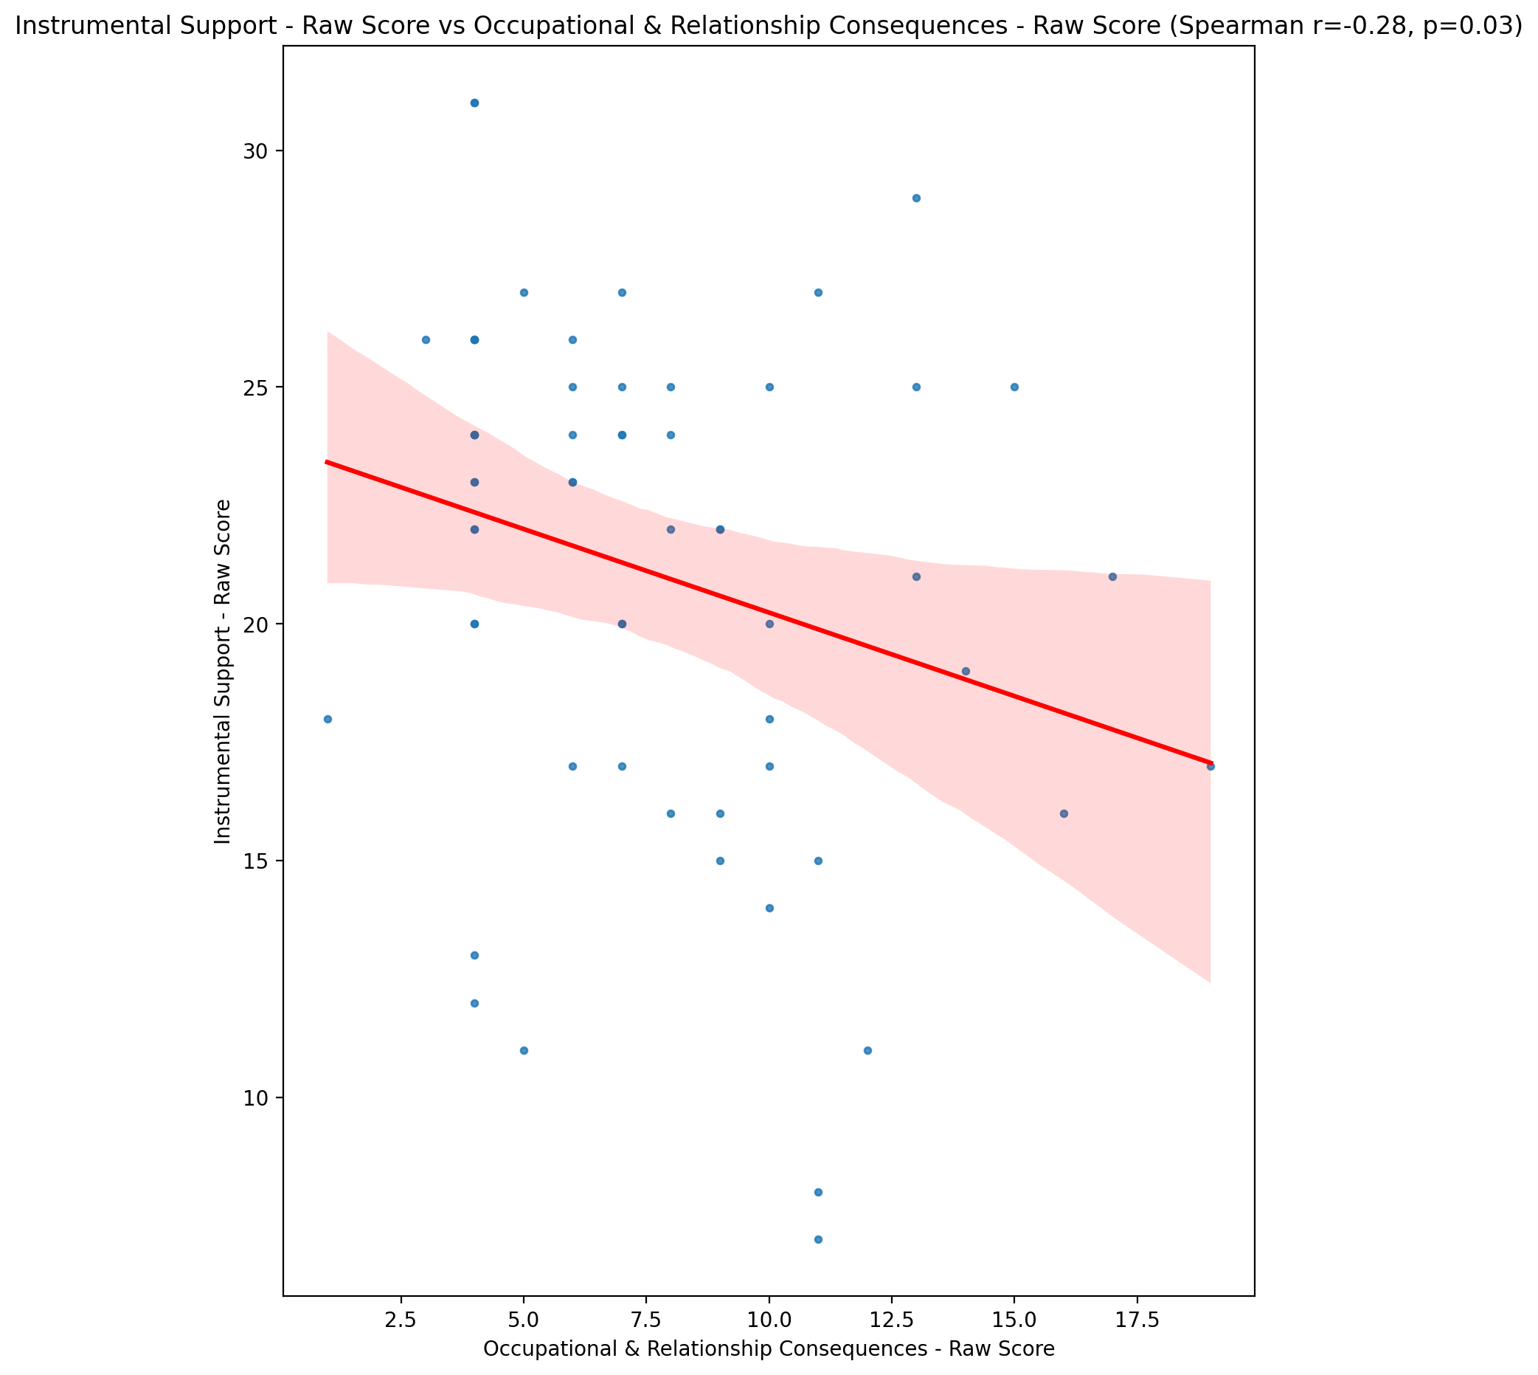

## Emotional Support - T Score vs Occupational & Relationship Consequences - Raw Score

Test: spearman; statistic: -0.3210531782636944; p-value: 0.013163640923997385;

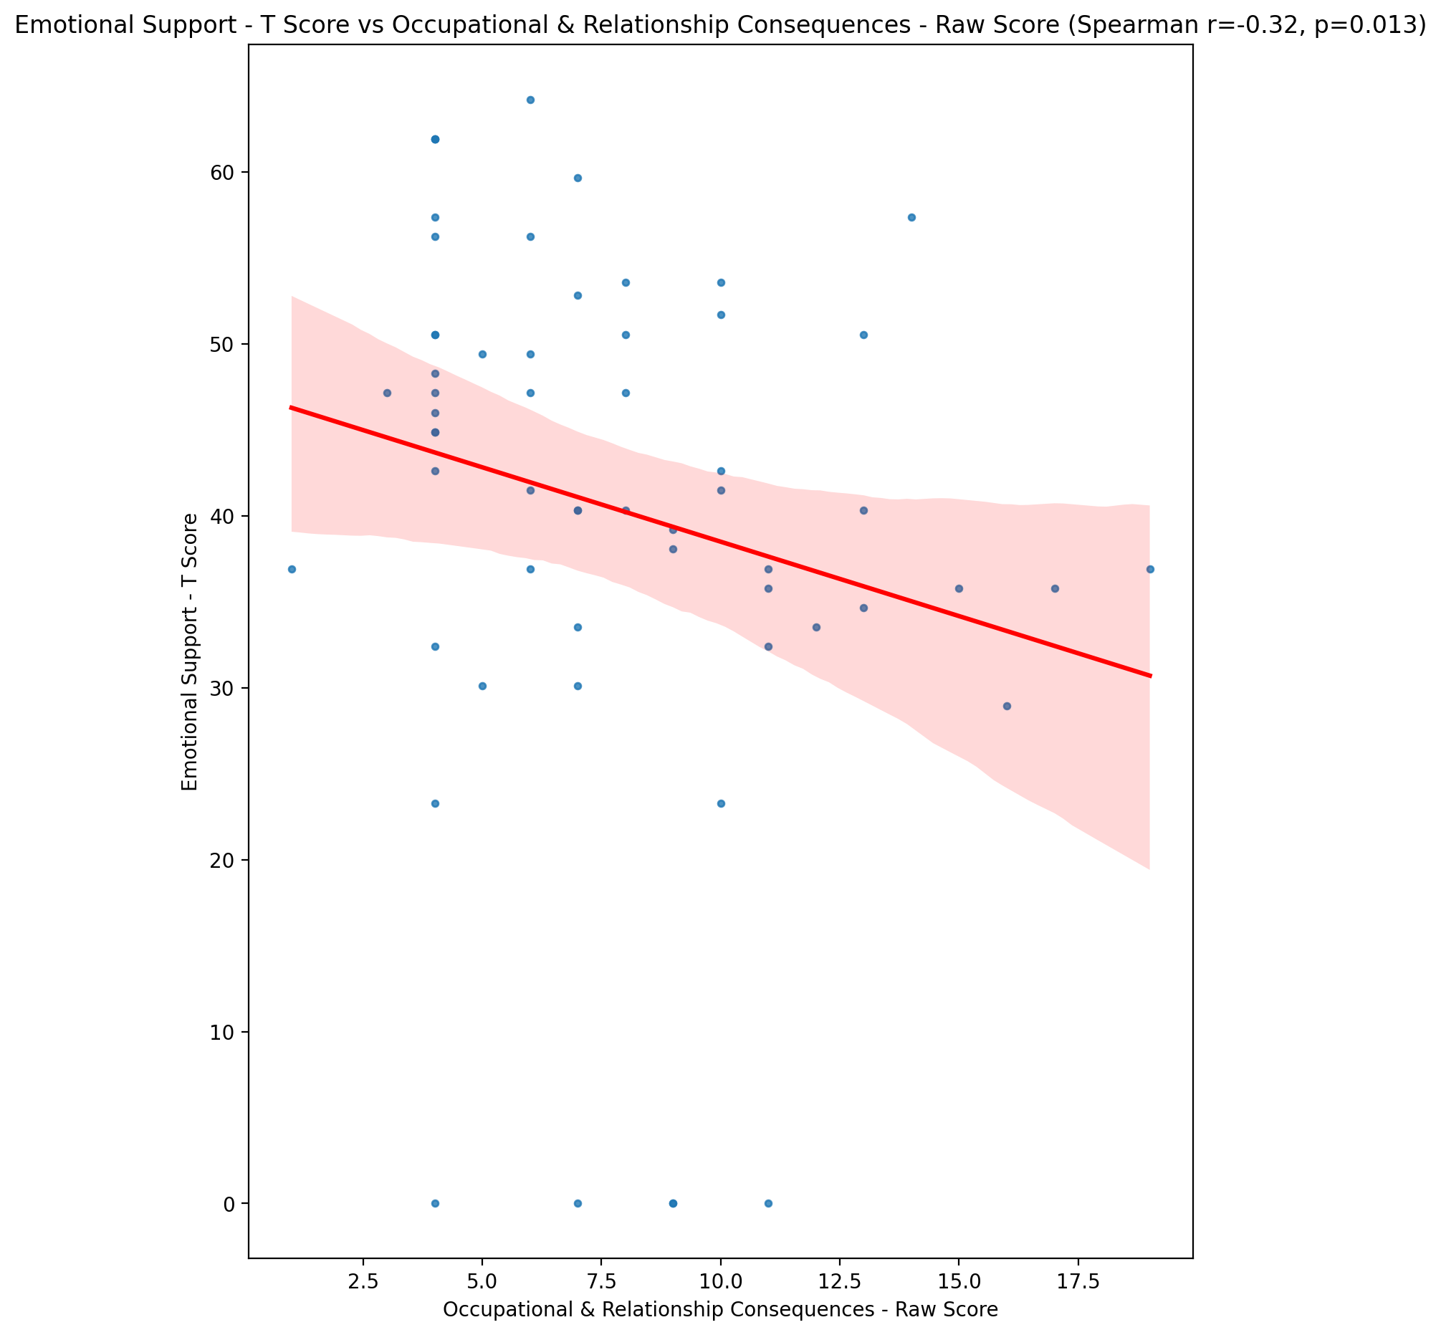

## Informational Support - T Score vs Occupational & Relationship Consequences - Raw Score

Test: spearman; statistic: -0.2501355337978137; p-value: 0.0560413240878798;

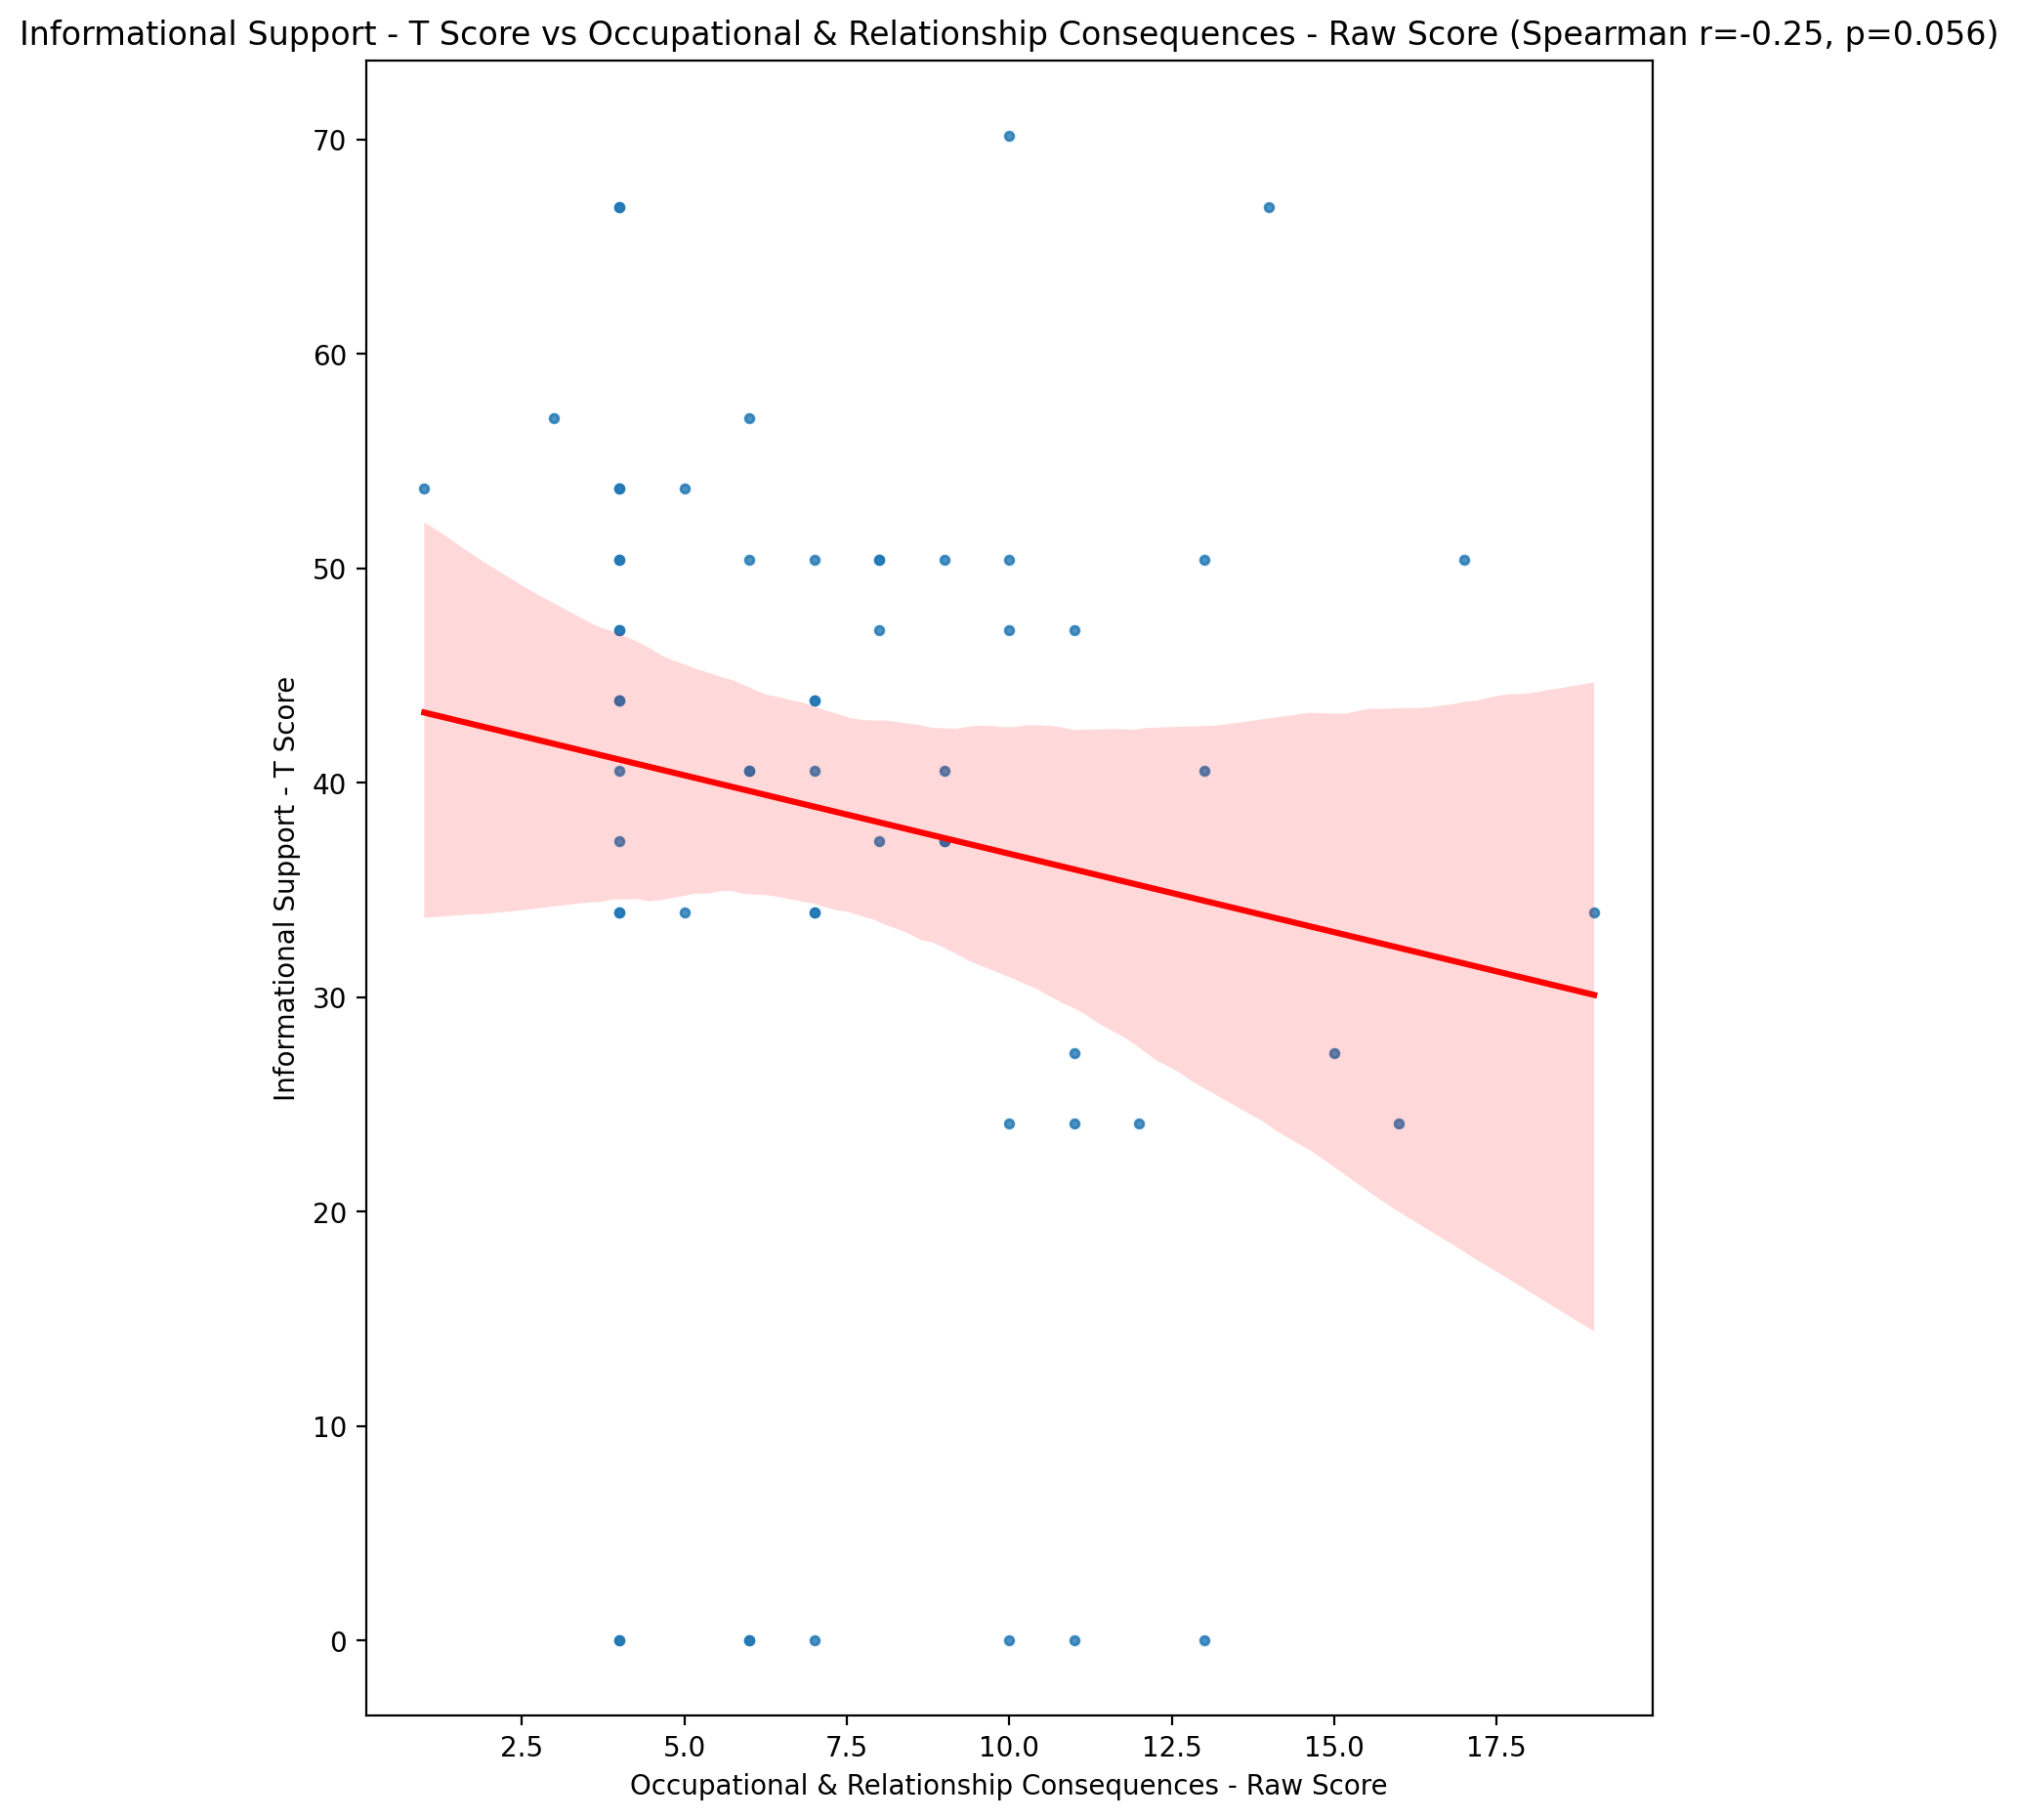

## Instrumental Support - T Score vs Occupational & Relationship Consequences - Raw Score

Test: spearman; statistic: -0.2739443186741241; p-value: 0.03577008943812326;

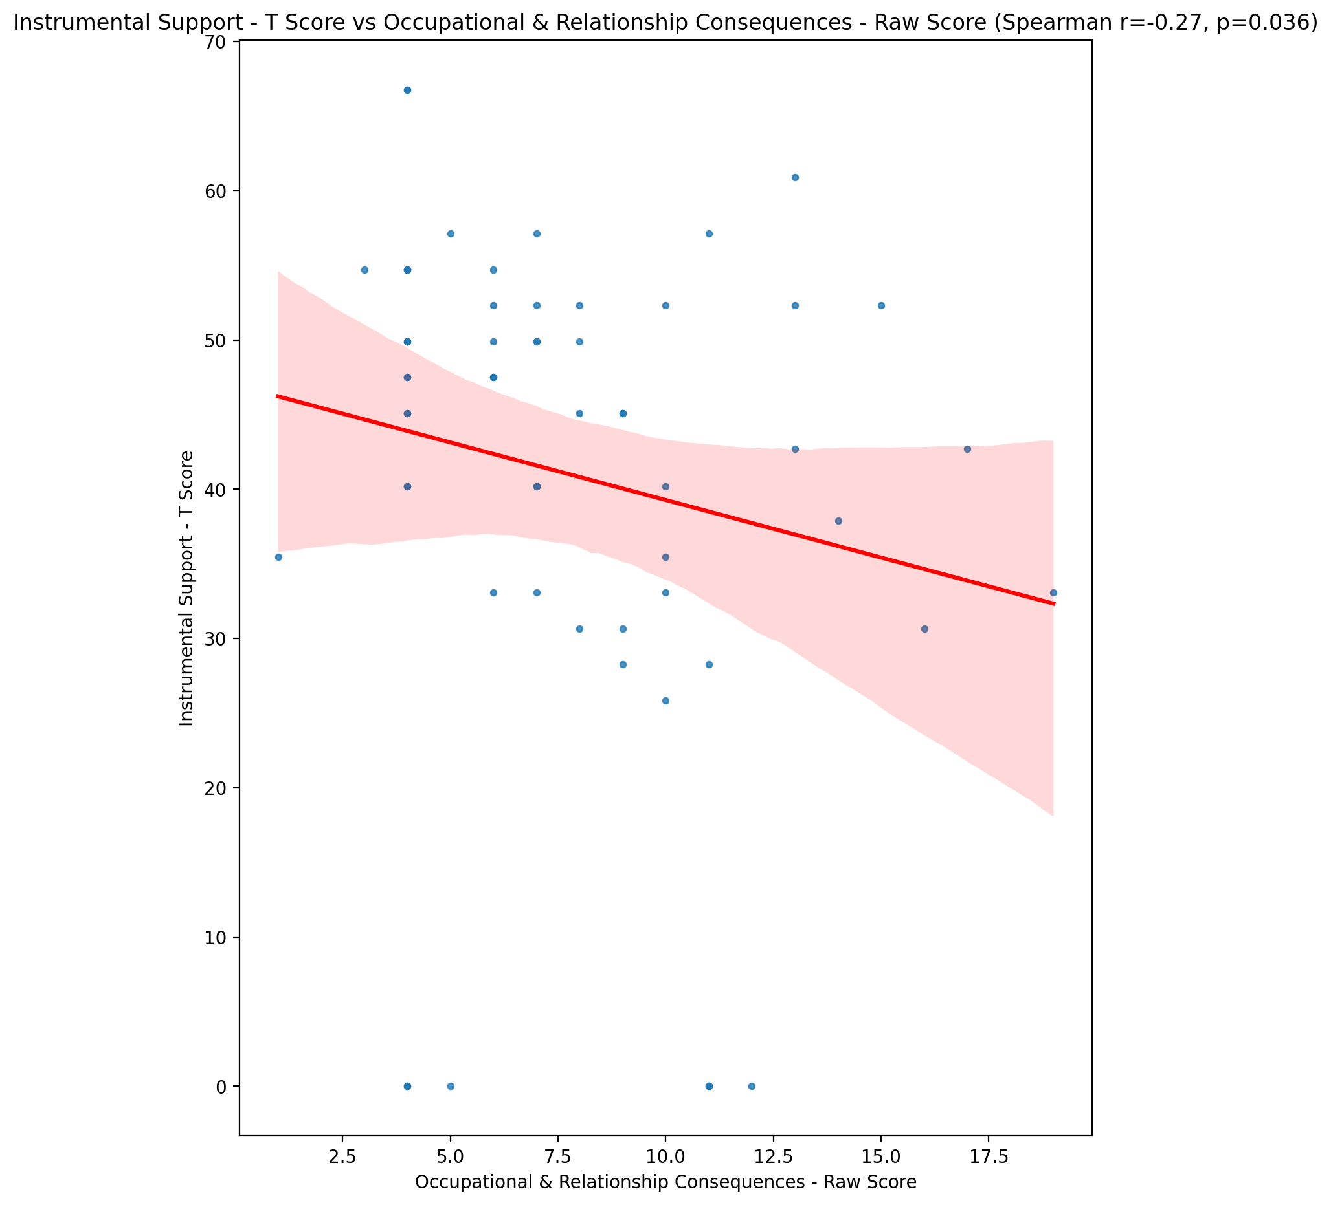

## Perceived Social Support Total T Score vs Occupational & Relationship Consequences - Raw Score

Test: spearman; statistic: -0.3277434082438921; p-value: 0.011277033906955662;

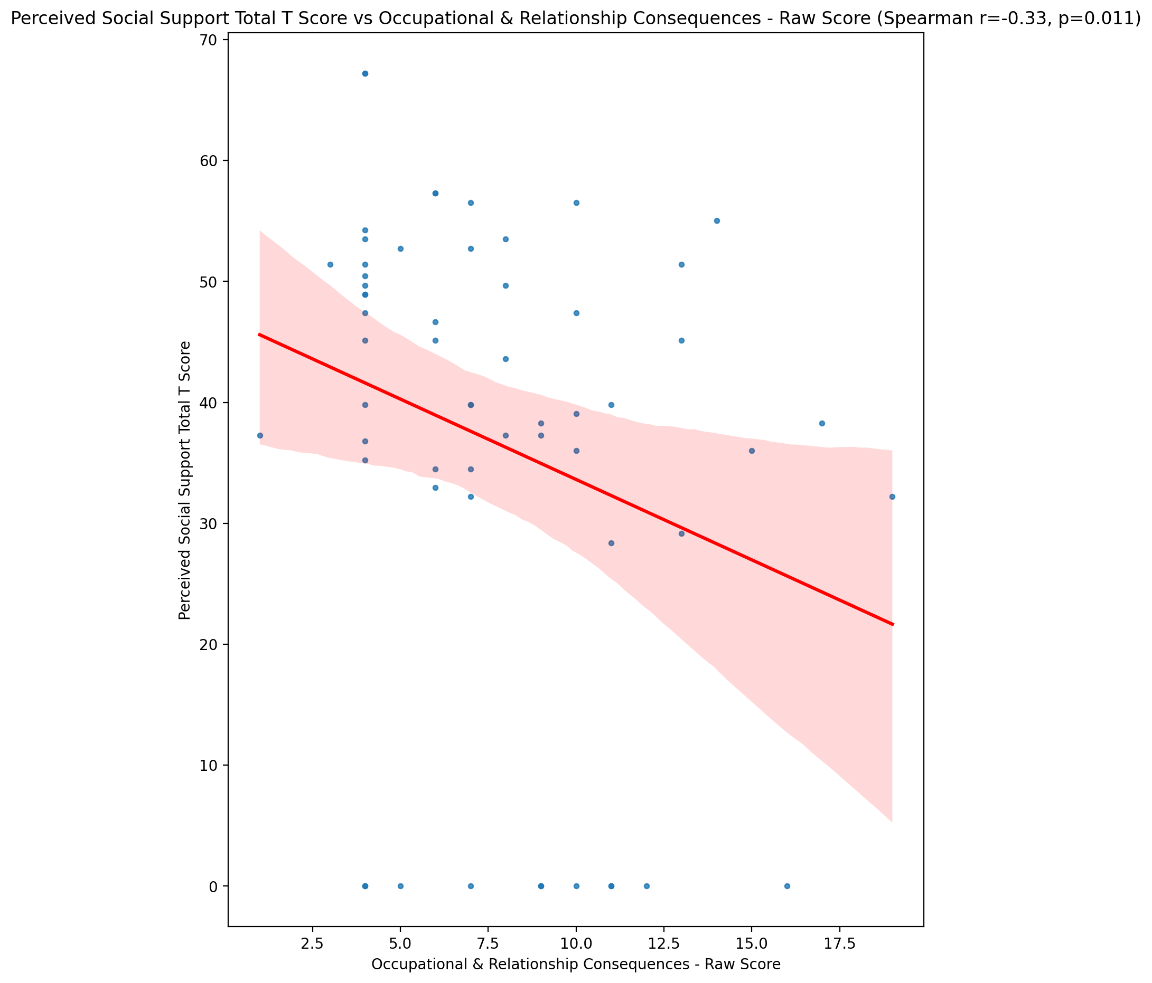

## Emotional Support - Rank vs Occupational & Relationship Consequences - Raw Score

Test: None; statistic: None; p-value: None; Test not run: unsupported type combination.



## Informational Support - Rank vs Occupational & Relationship Consequences - Raw Score

Test: None; statistic: None; p-value: None; Test not run: unsupported type combination.



## Instrumental Support - Rank vs Occupational & Relationship Consequences - Raw Score

Test: None; statistic: None; p-value: None; Test not run: unsupported type combination.



## Perceived Social Support TOTAL - Rank vs Occupational & Relationship Consequences - Raw Score

Test: None; statistic: None; p-value: None; Test not run: unsupported type combination.



## Power Self Concept - Real Self Concept Score vs Occupational & Relationship Consequences - Raw Score

Test: spearman; statistic: -0.13638948944978654; p-value: 0.30299337424420064;

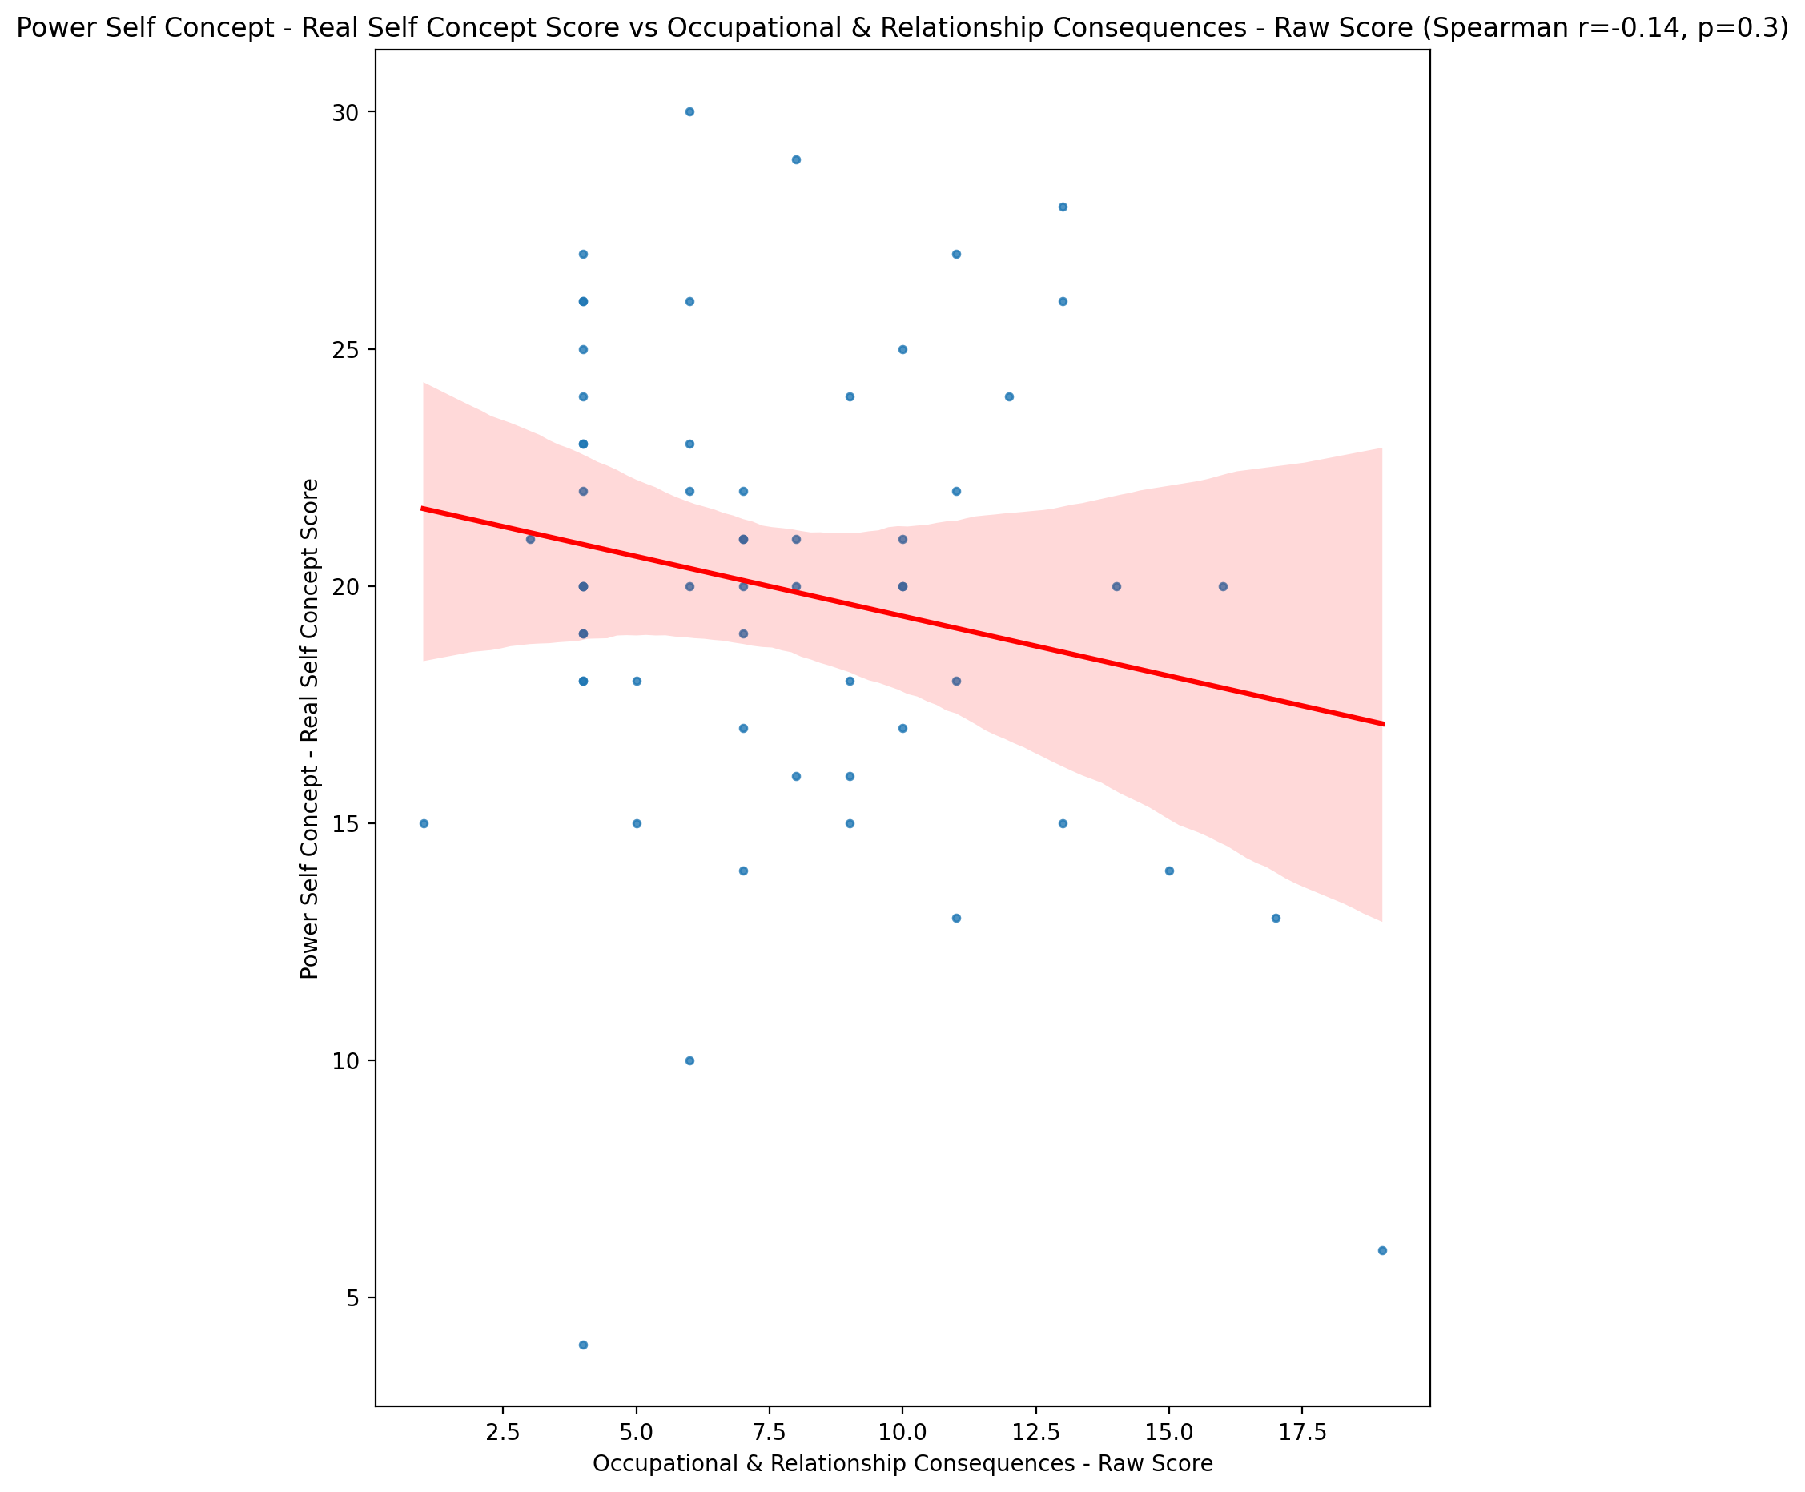

## Power Self Concept - Ideal Self Concept score vs Occupational & Relationship Consequences - Raw Score

Test: spearman; statistic: -0.2706393626615261; p-value: 0.038153156079394894;

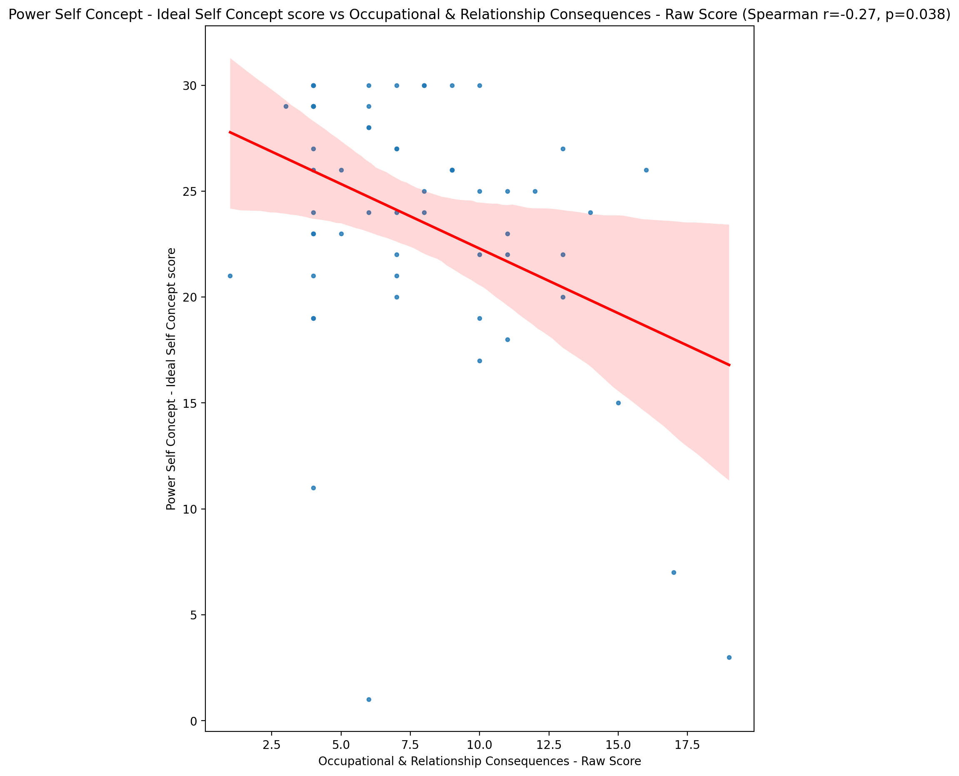

## Power Self Concept – Social Self Concept Score vs Occupational & Relationship Consequences - Raw Score

Test: spearman; statistic: -0.03642980726315595; p-value: 0.7841411381470763;

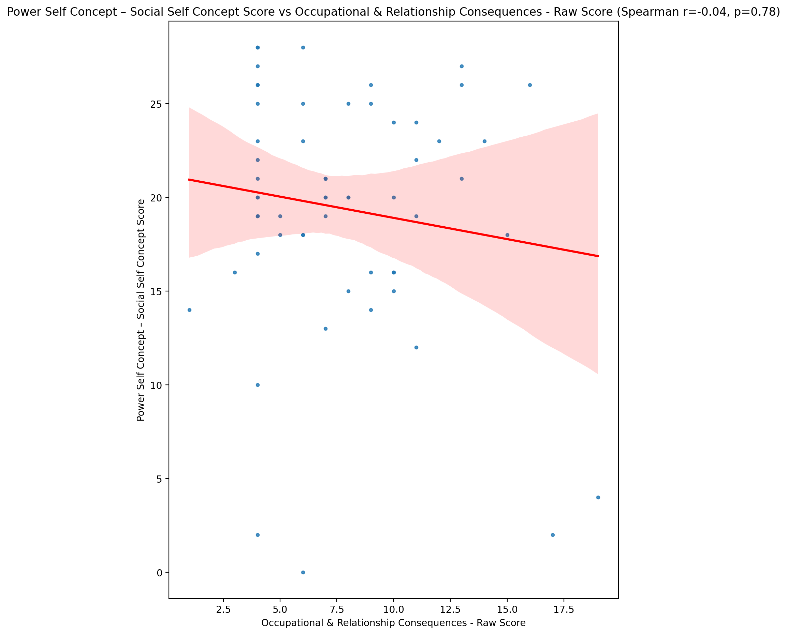

## Social Self Concept - Real Self Concept Score vs Occupational & Relationship Consequences - Raw Score

Test: spearman; statistic: -0.2877226468375078; p-value: 0.027125330825481058;

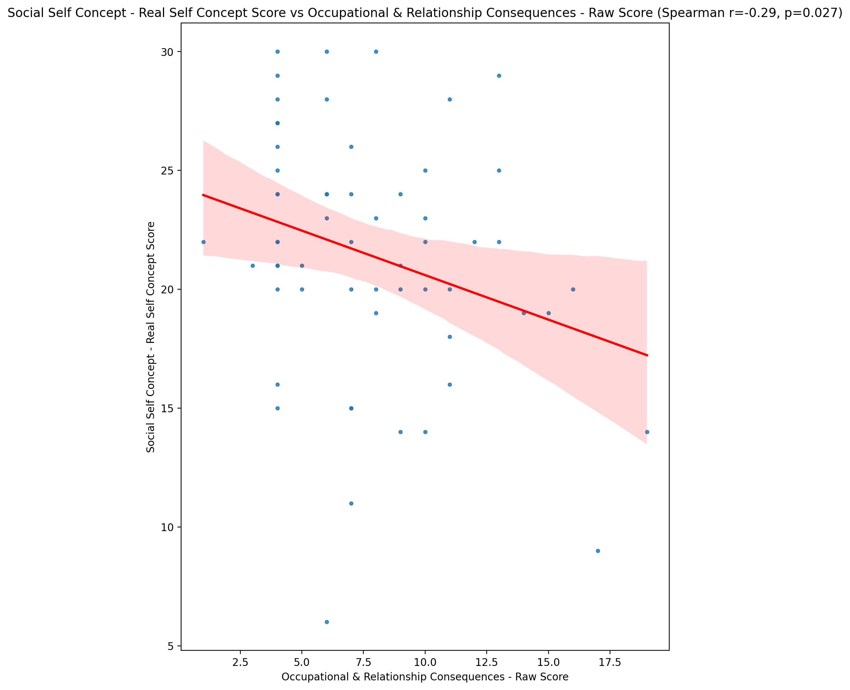

## Social Self Concept – Social Self Concept Score vs Occupational & Relationship Consequences - Raw Score

Test: spearman; statistic: -0.13632247956722443; p-value: 0.30323323757390575;

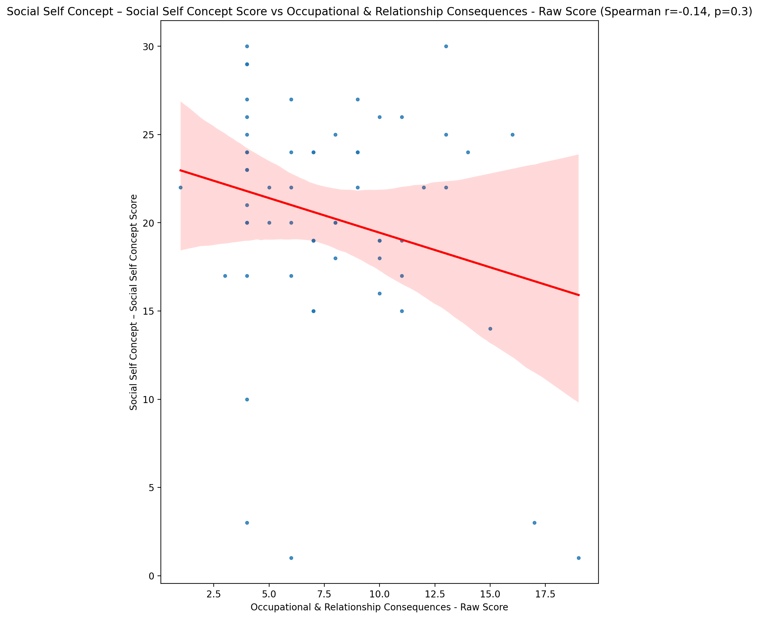

## Ability Self Concept - Real Self Concept Score vs Occupational & Relationship Consequences - Raw Score

Test: spearman; statistic: -0.24761616929634198; p-value: 0.05864527579382614;

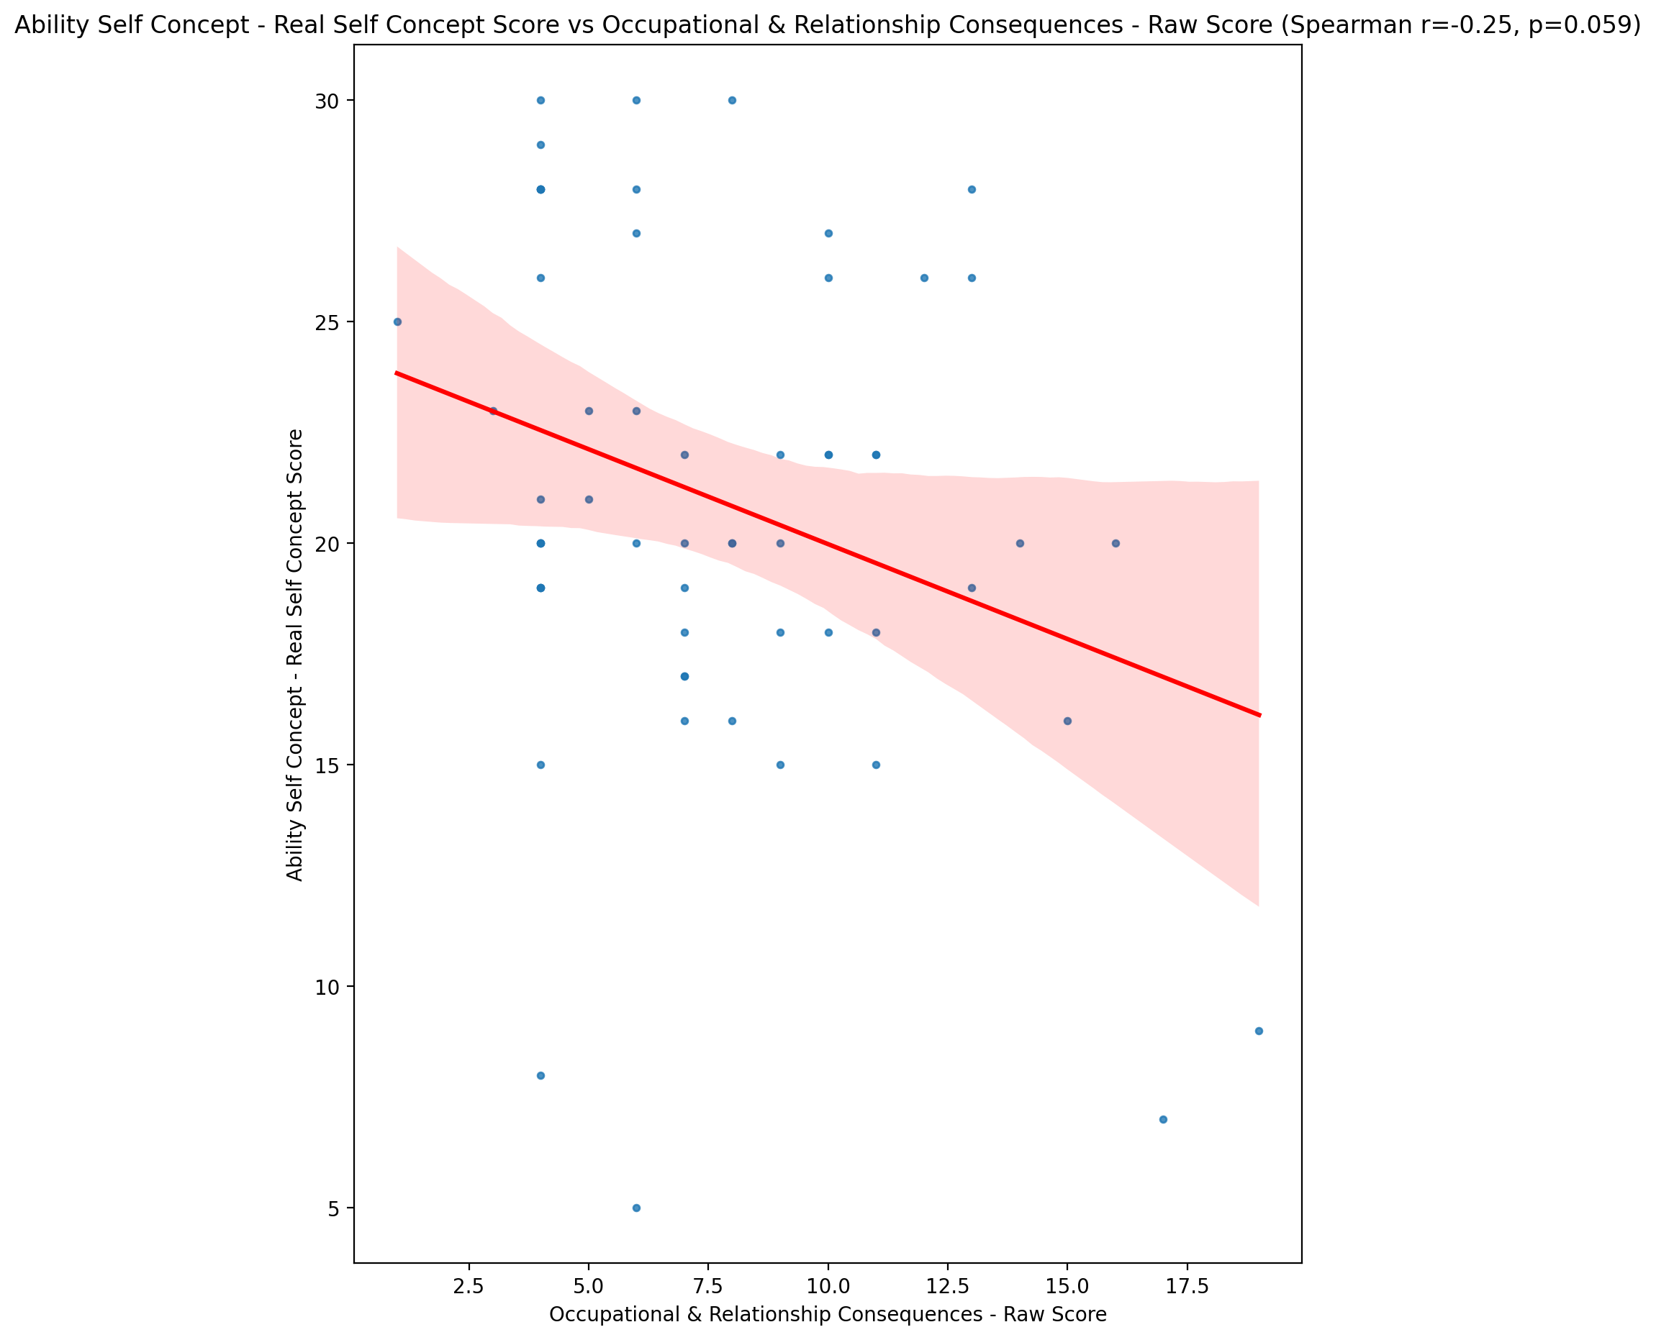

## Ability Self Concept - Ideal Self Concept Score vs Occupational & Relationship Consequences - Raw Score

Test: spearman; statistic: -0.28104328897886344; p-value: 0.031067203631433695;

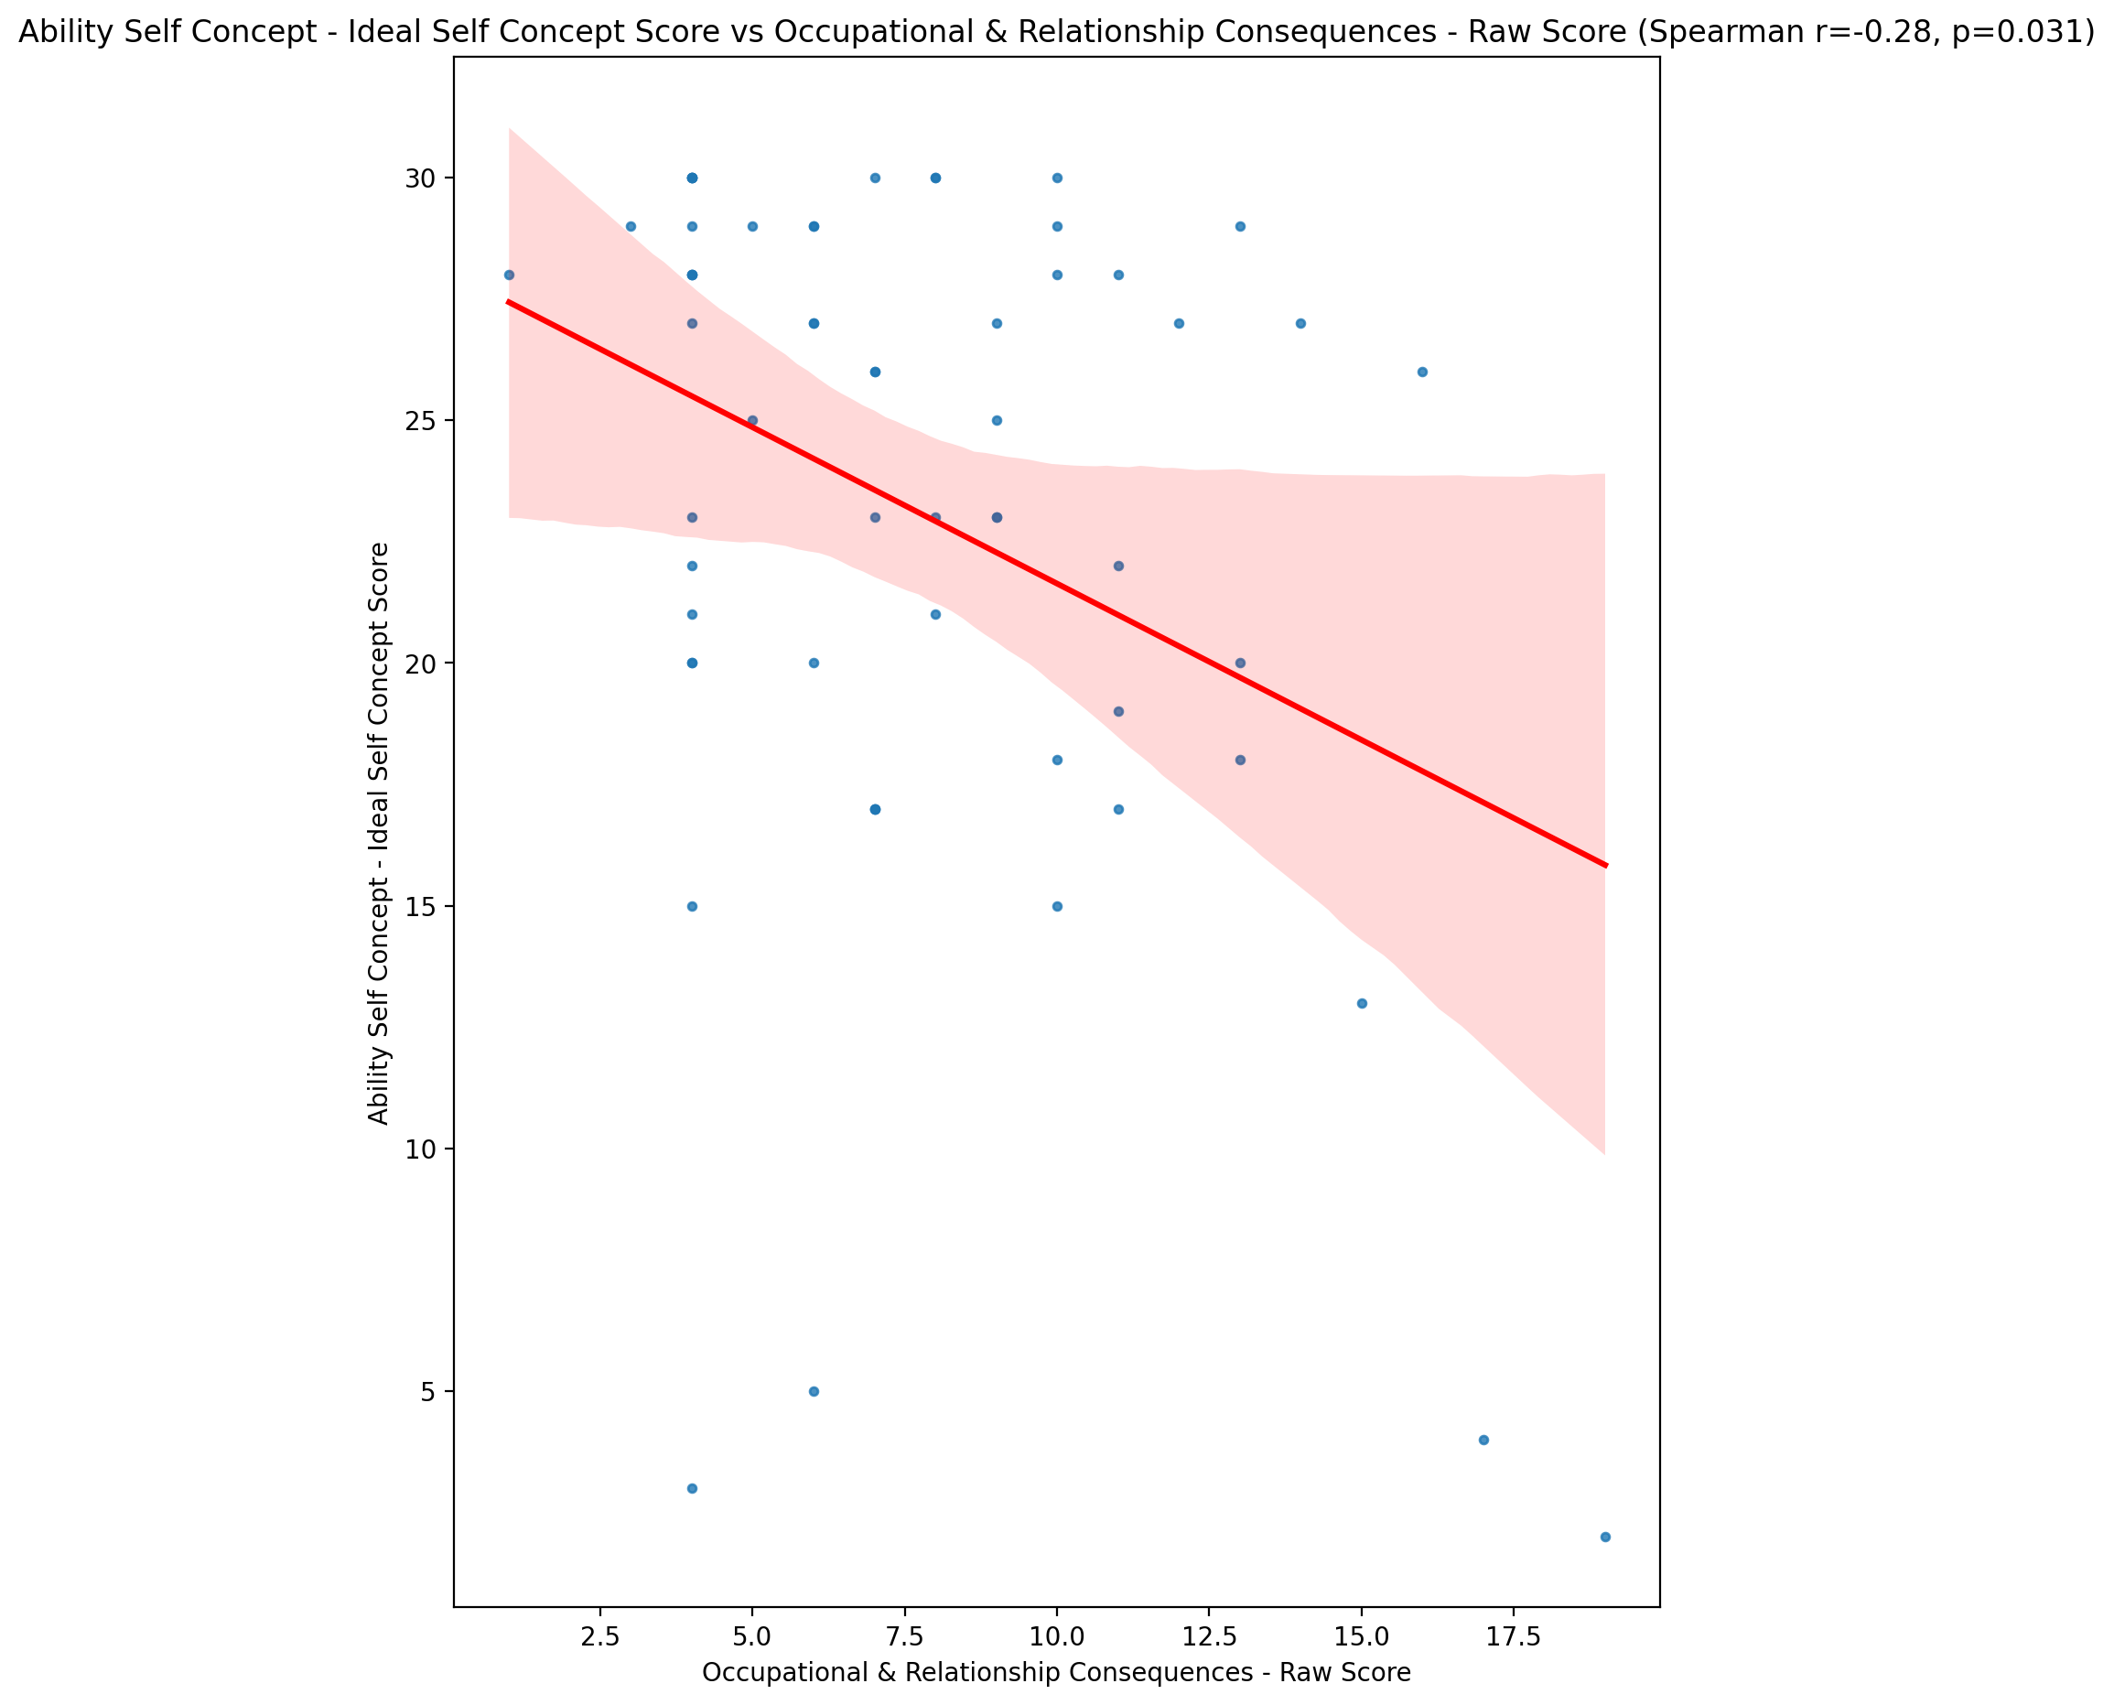

## Ability Self Concept – Social Self Concept Score vs Occupational & Relationship Consequences - Raw Score

Test: spearman; statistic: -0.0886913320210593; p-value: 0.5041379383567481;

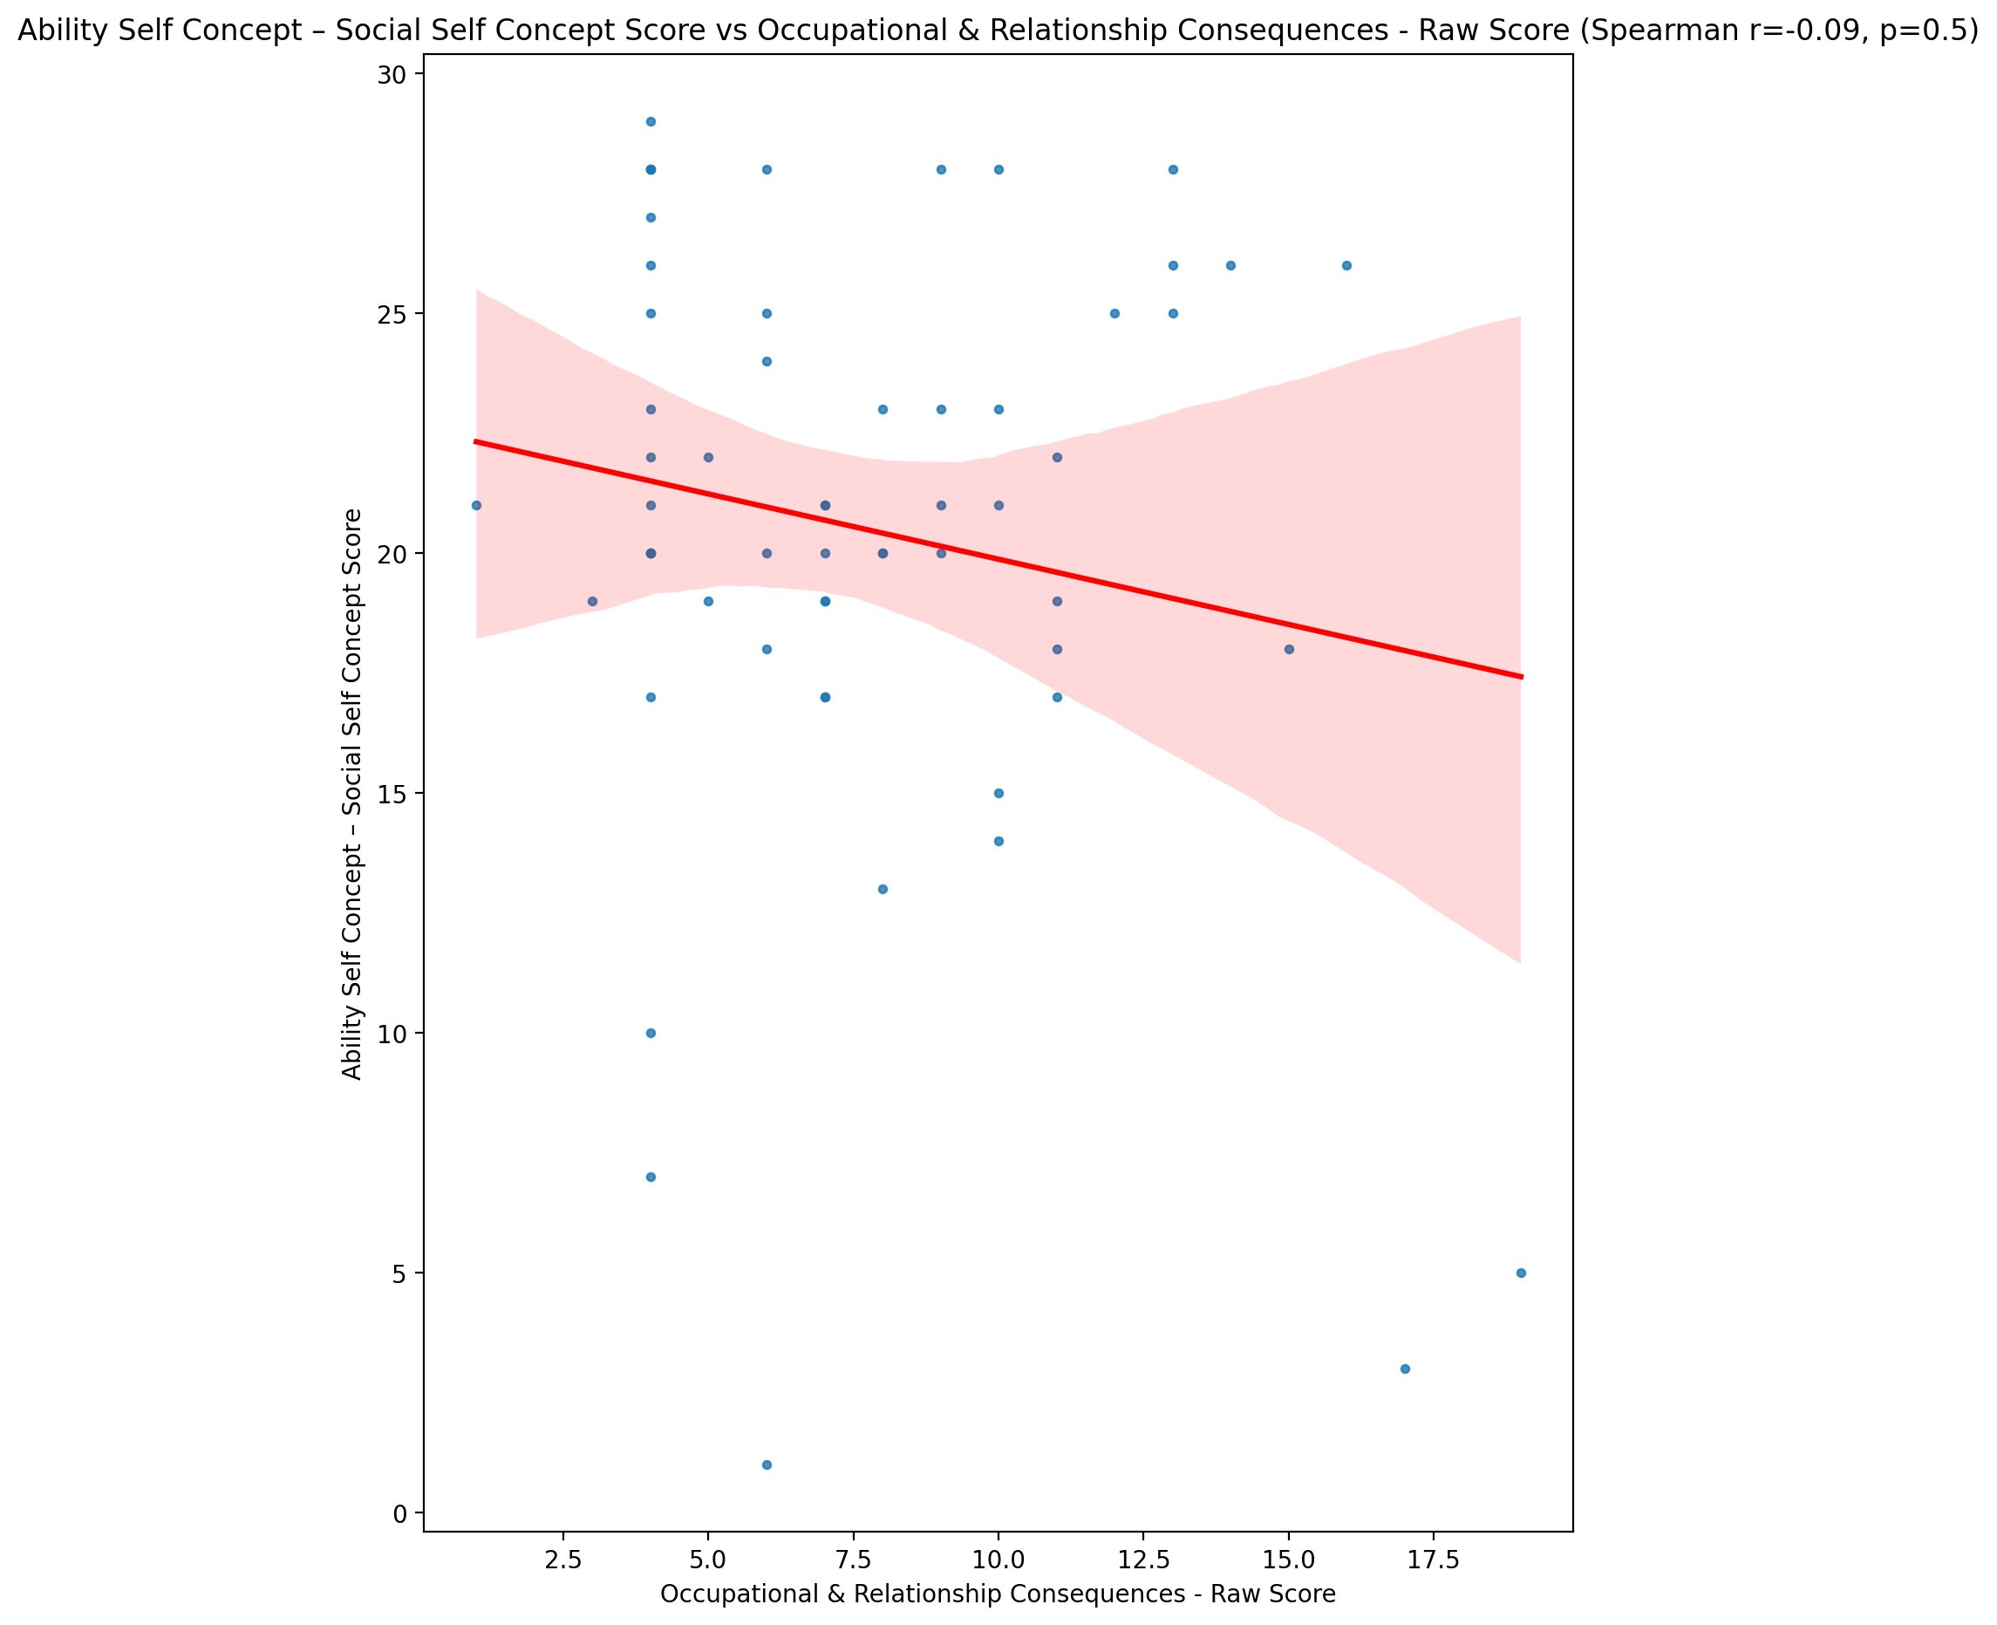

## Physical Self Concept - Real Self Concept Score vs Occupational & Relationship Consequences - Raw Score

Test: spearman; statistic: -0.25189065228723106; p-value: 0.05428327967847835;

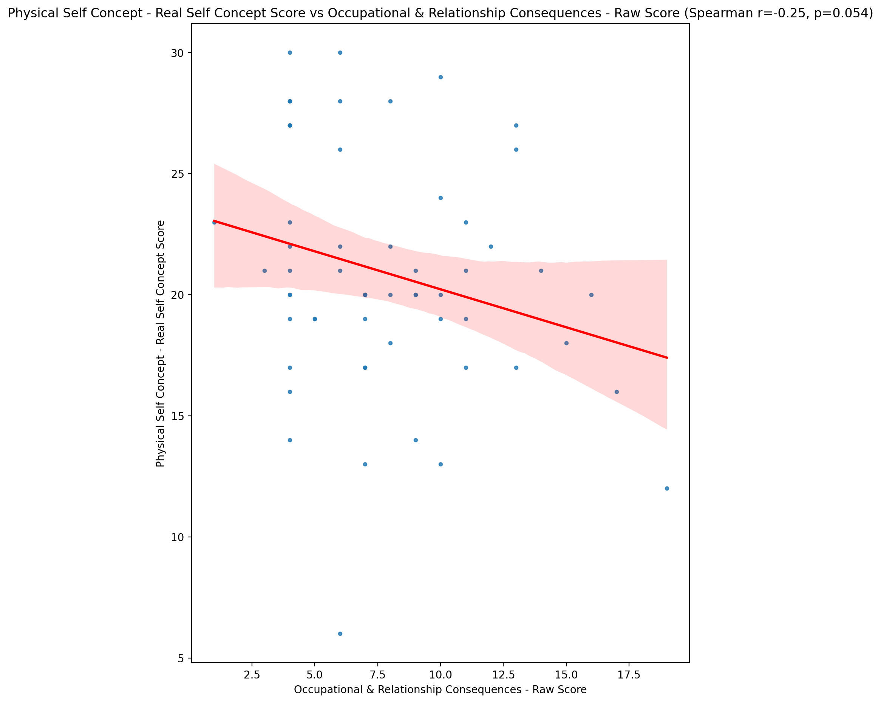

## Physical Self Concept – Ideal Self Concept Score vs Occupational & Relationship Consequences - Raw Score

Test: spearman; statistic: -0.2856200032285607; p-value: 0.028318171095694736;

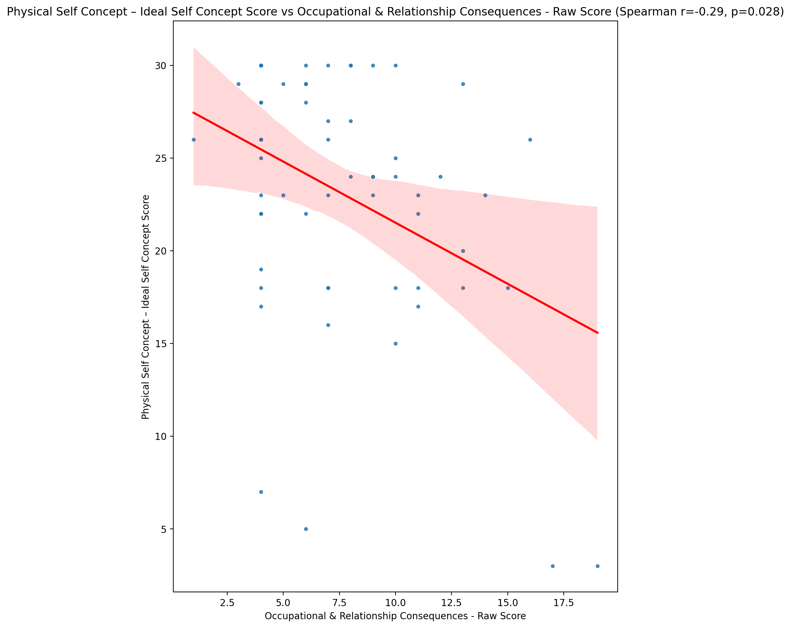

## Physical Self Concept – Social Self Concept Score vs Occupational & Relationship Consequences - Raw Score

Test: spearman; statistic: -0.1582115788406436; p-value: 0.23138458155087016;

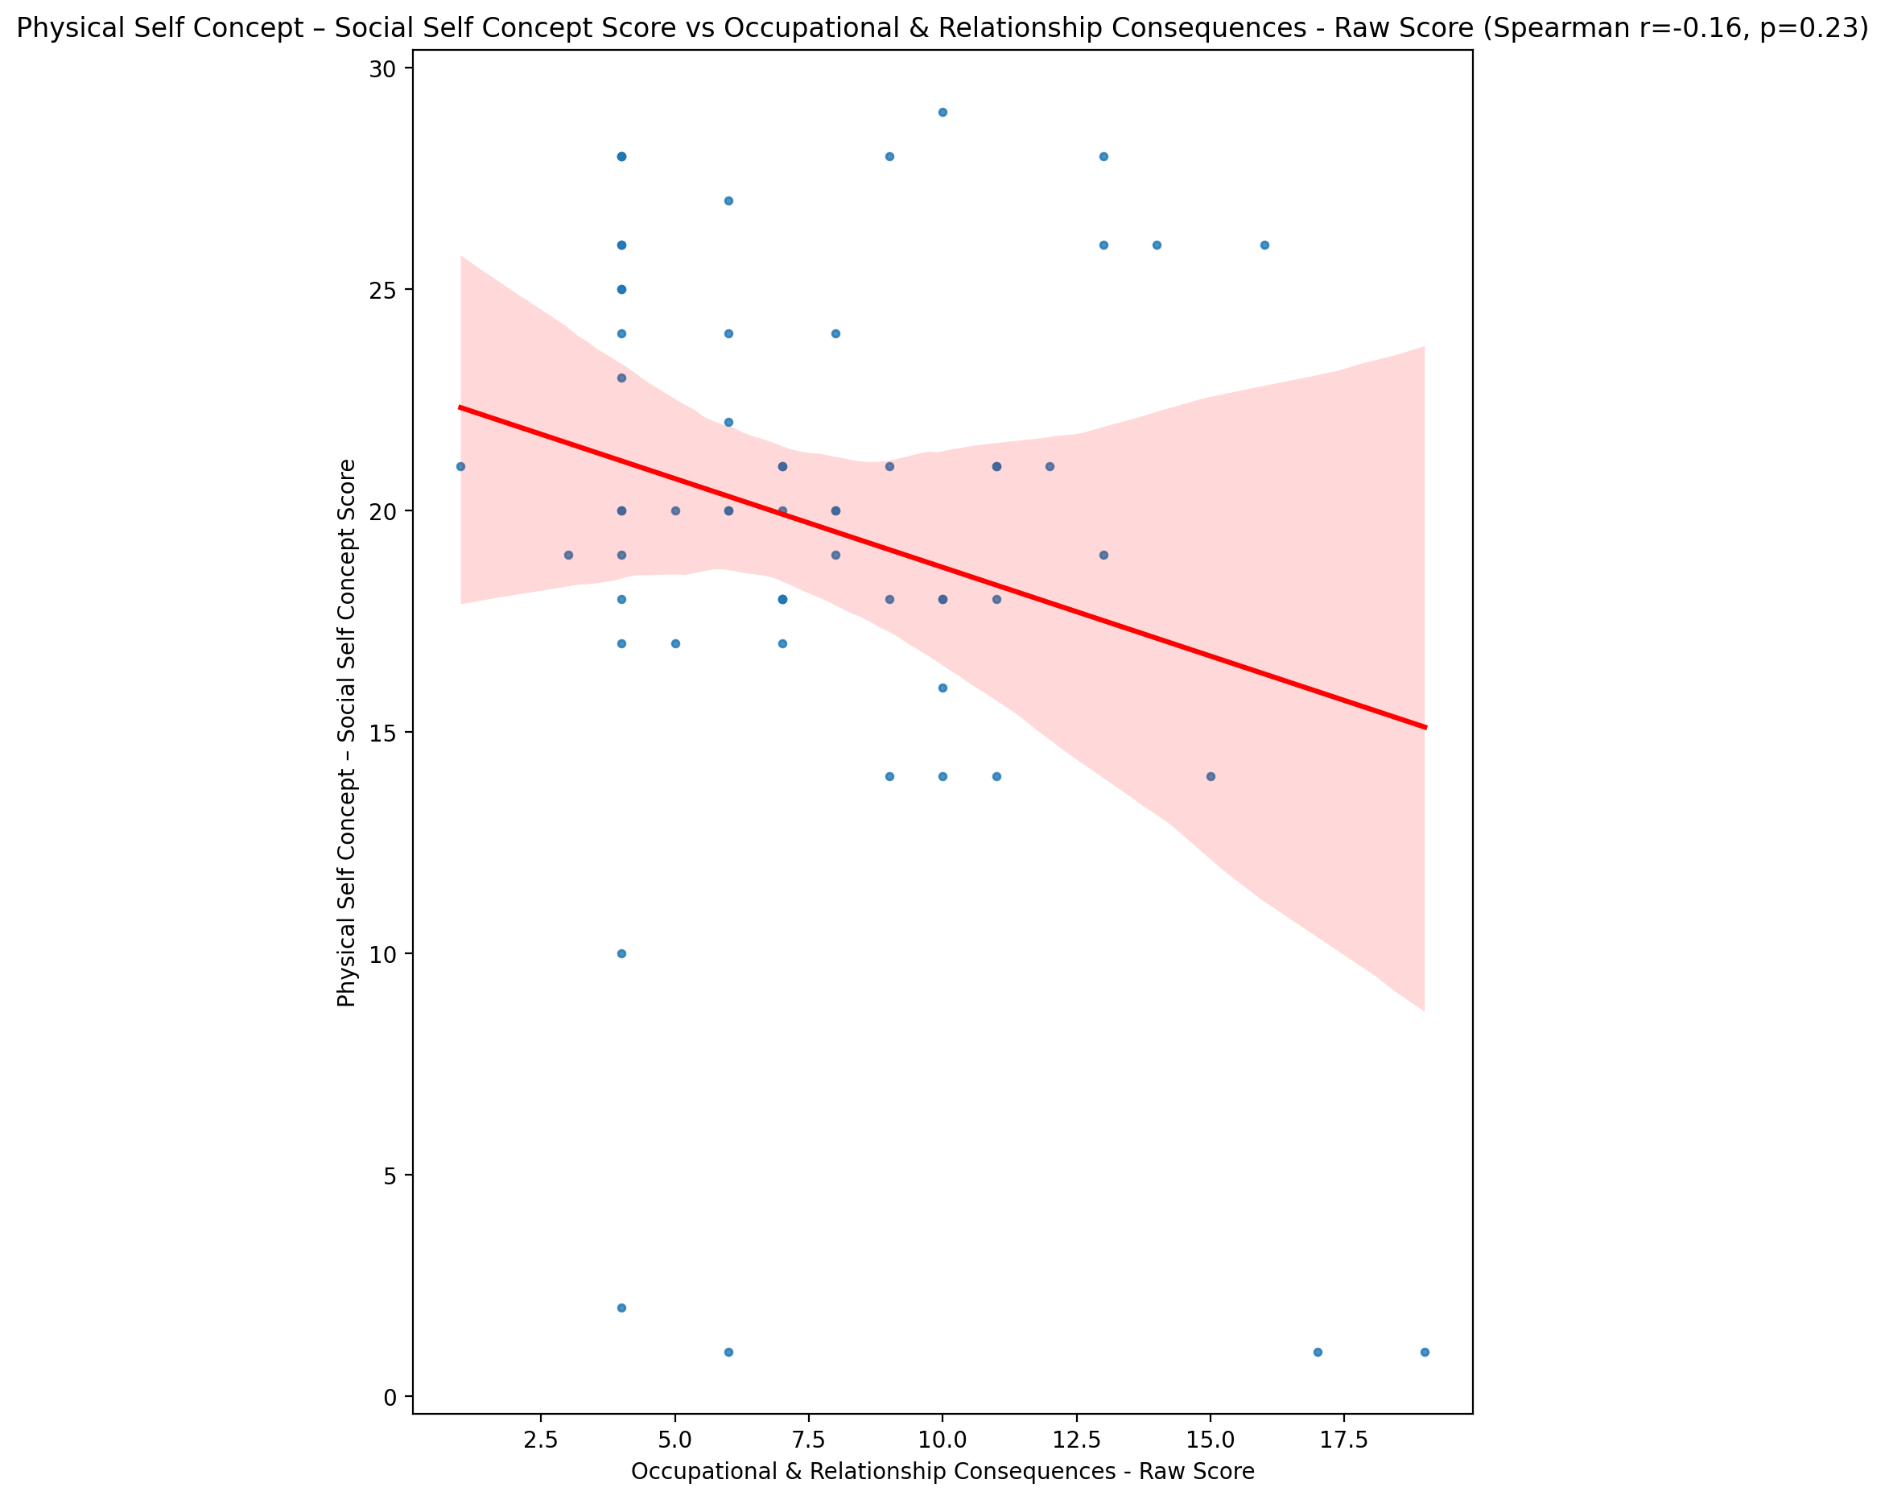

## Psychological Self Concept - Real Self Concept Score vs Occupational & Relationship Consequences - Raw Score

Test: spearman; statistic: -0.31307761870590817; p-value: 0.01576205244691859;

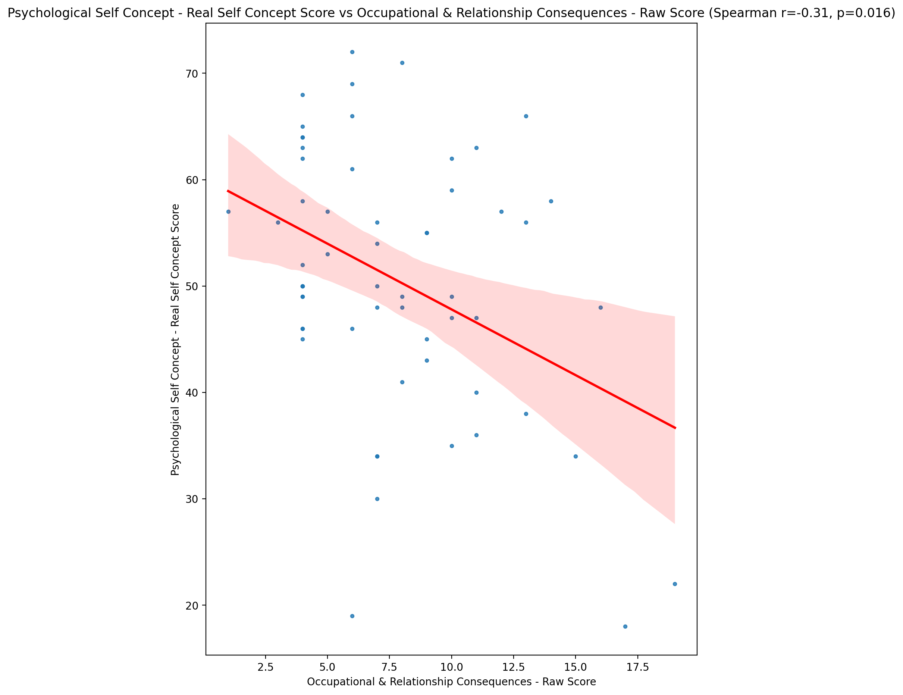

## Psychological Self Concept – Ideal Self Concept Score vs Occupational & Relationship Consequences - Raw Score

Test: spearman; statistic: -0.2607244084174373; p-value: 0.046102366278529566;

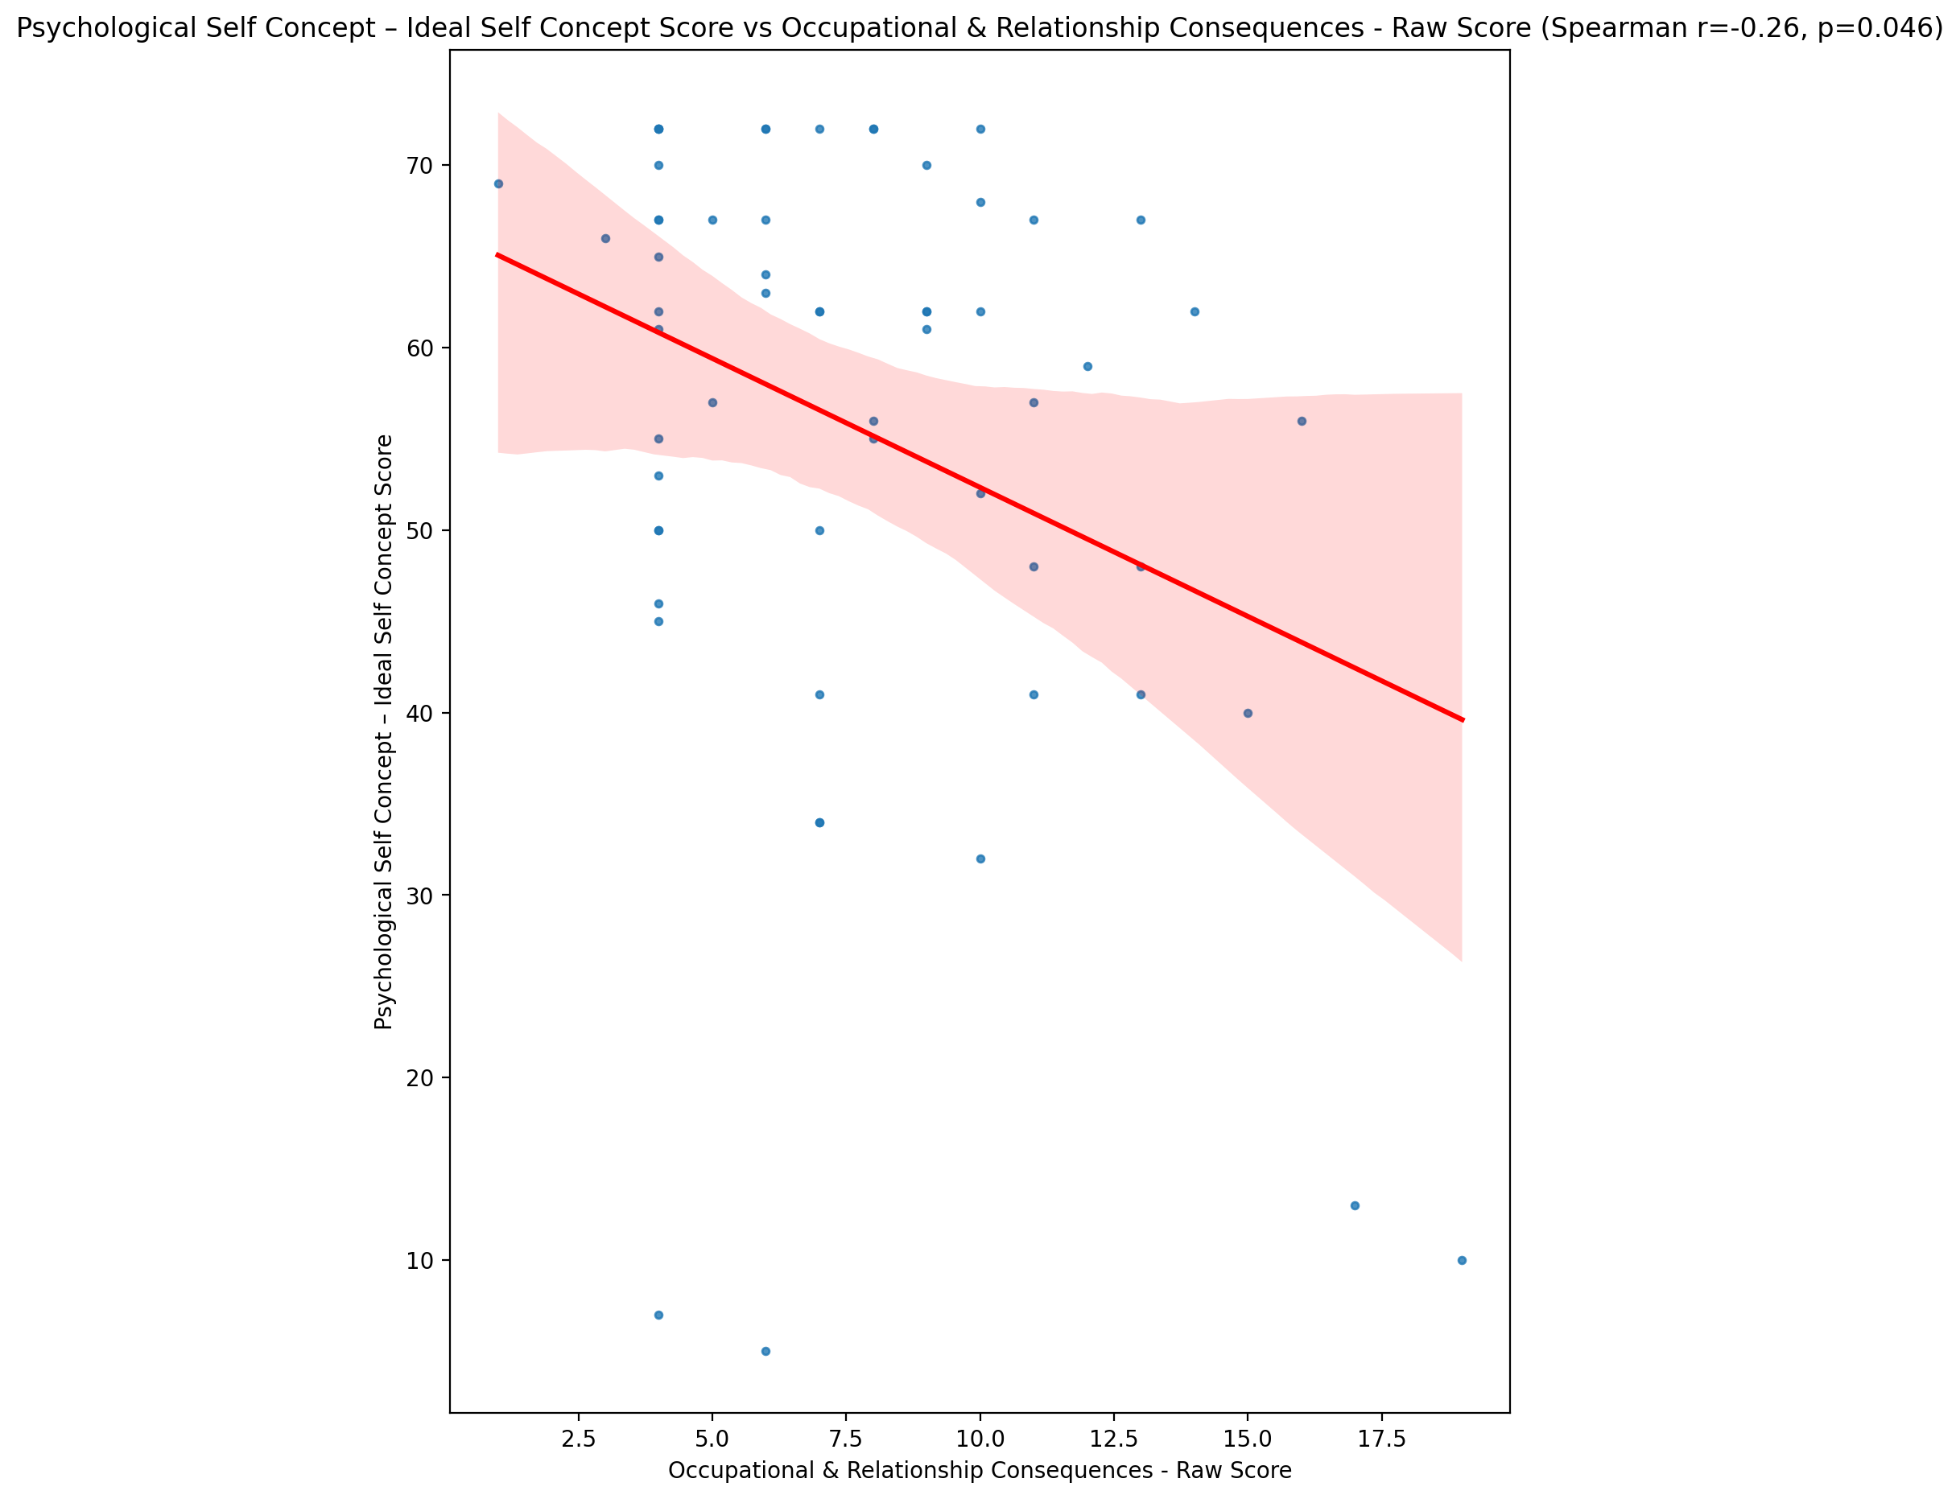

## Psychological Self Concept – Social Self Concept Score vs Occupational & Relationship Consequences - Raw Score

Test: spearman; statistic: -0.13203431167116084; p-value: 0.3188382180365428;

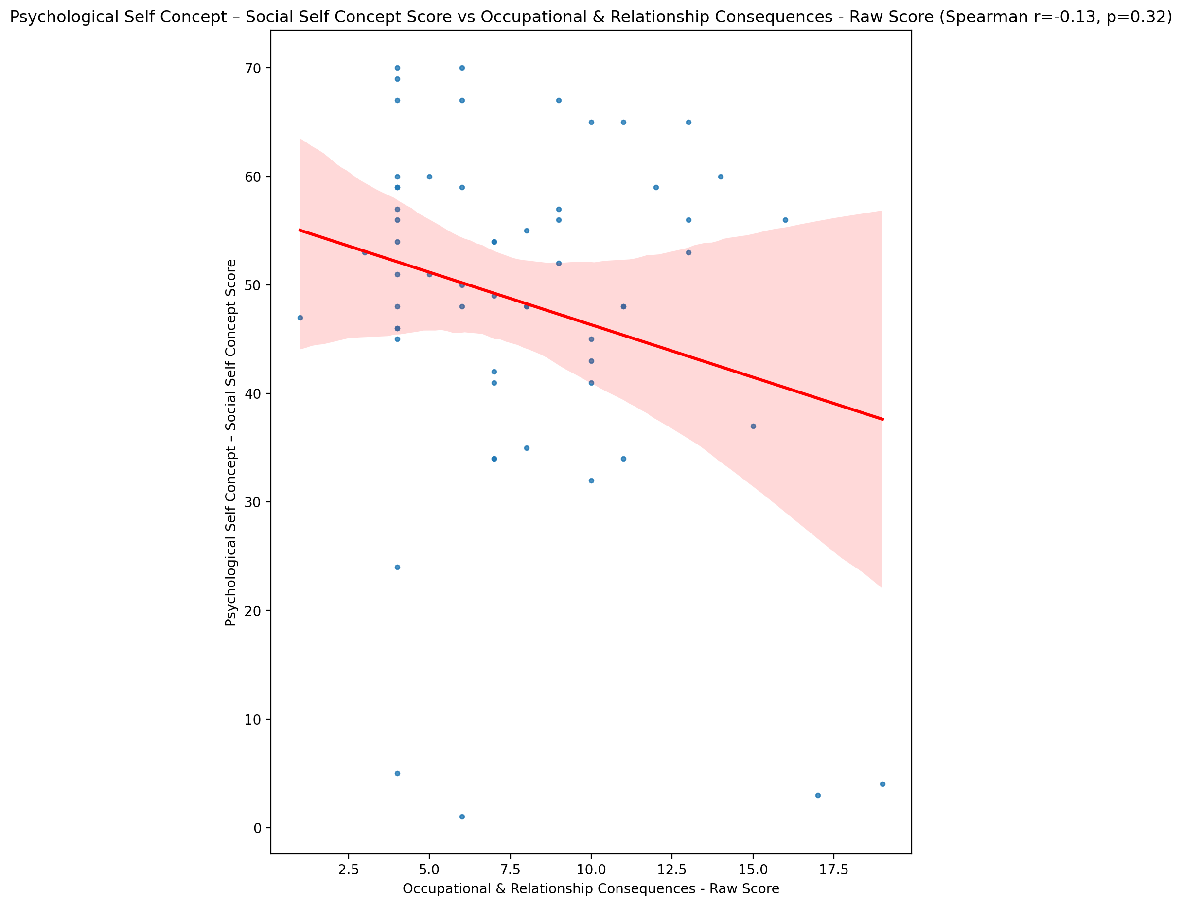

## Real Self Concept Total Score vs Occupational & Relationship Consequences - Raw Score

Test: spearman; statistic: -0.29350743514748323; p-value: 0.02405937491521981;

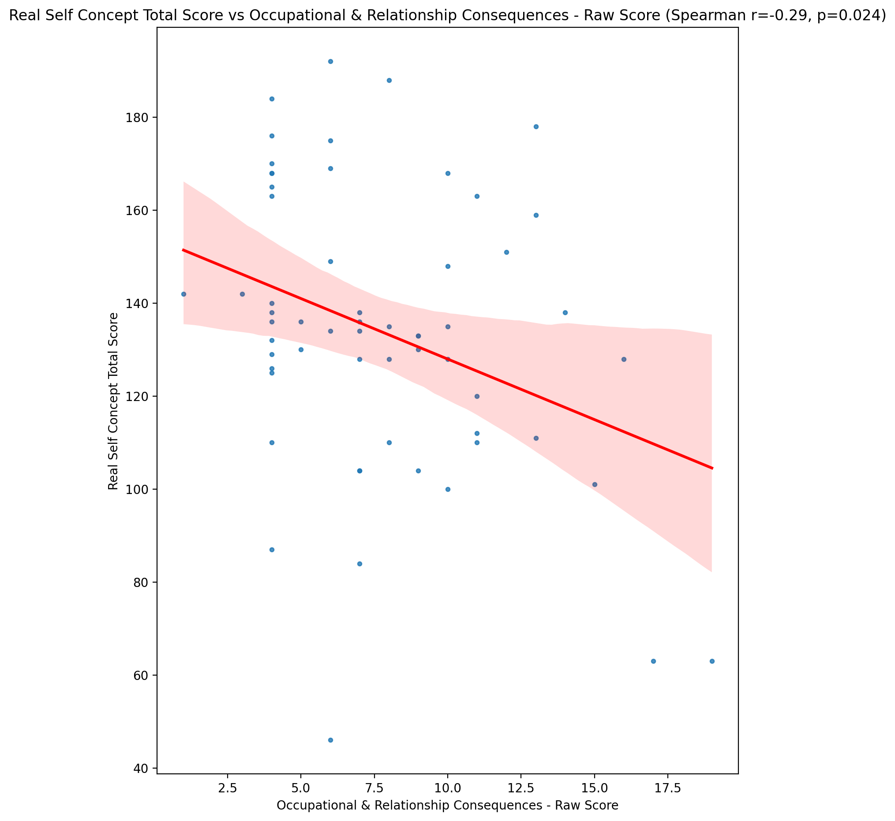

## Ideal Self Concept Total Score vs Occupational & Relationship Consequences - Raw Score

Test: spearman; statistic: -0.27882374961607237; p-value: 0.032478617880859394;

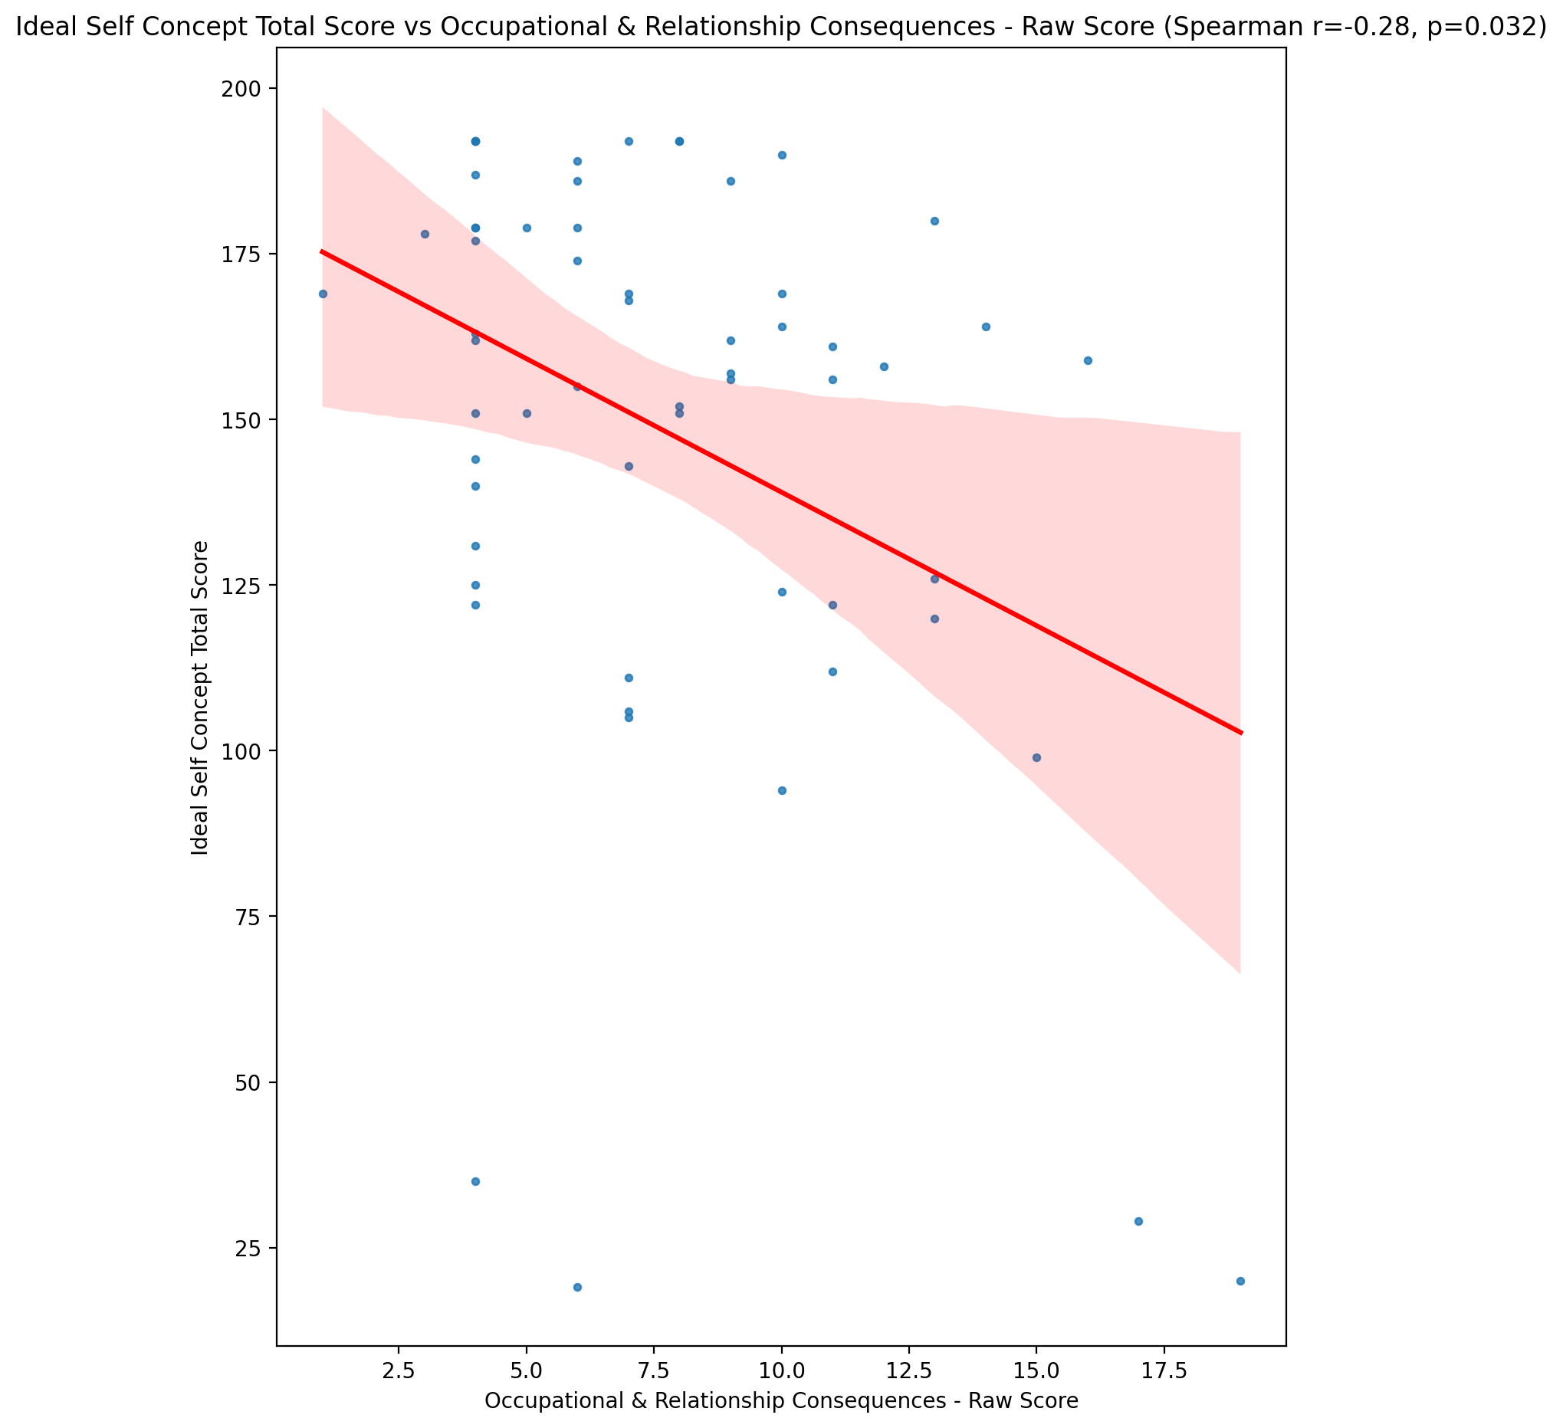

## Social Self Concept Total Score vs Occupational & Relationship Consequences - Raw Score

Test: spearman; statistic: -0.12774418022208497; p-value: 0.33495313286022643;

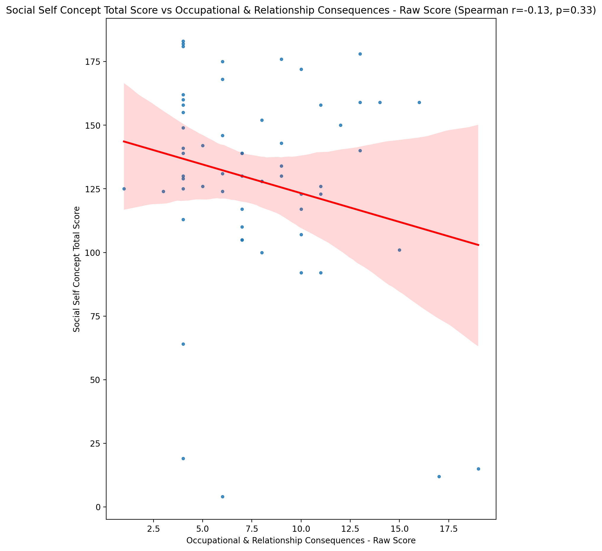

## Ideal Self Concept Total Category vs Occupational & Relationship Consequences - Raw Score

Test: None; statistic: None; p-value: None; Test not run: unsupported type combination.



## Perceived Social Stress Score vs Occupational & Relationship Consequences - Raw Score

Test: spearman; statistic: 0.3620837123728717; p-value: 0.00483211864550597;

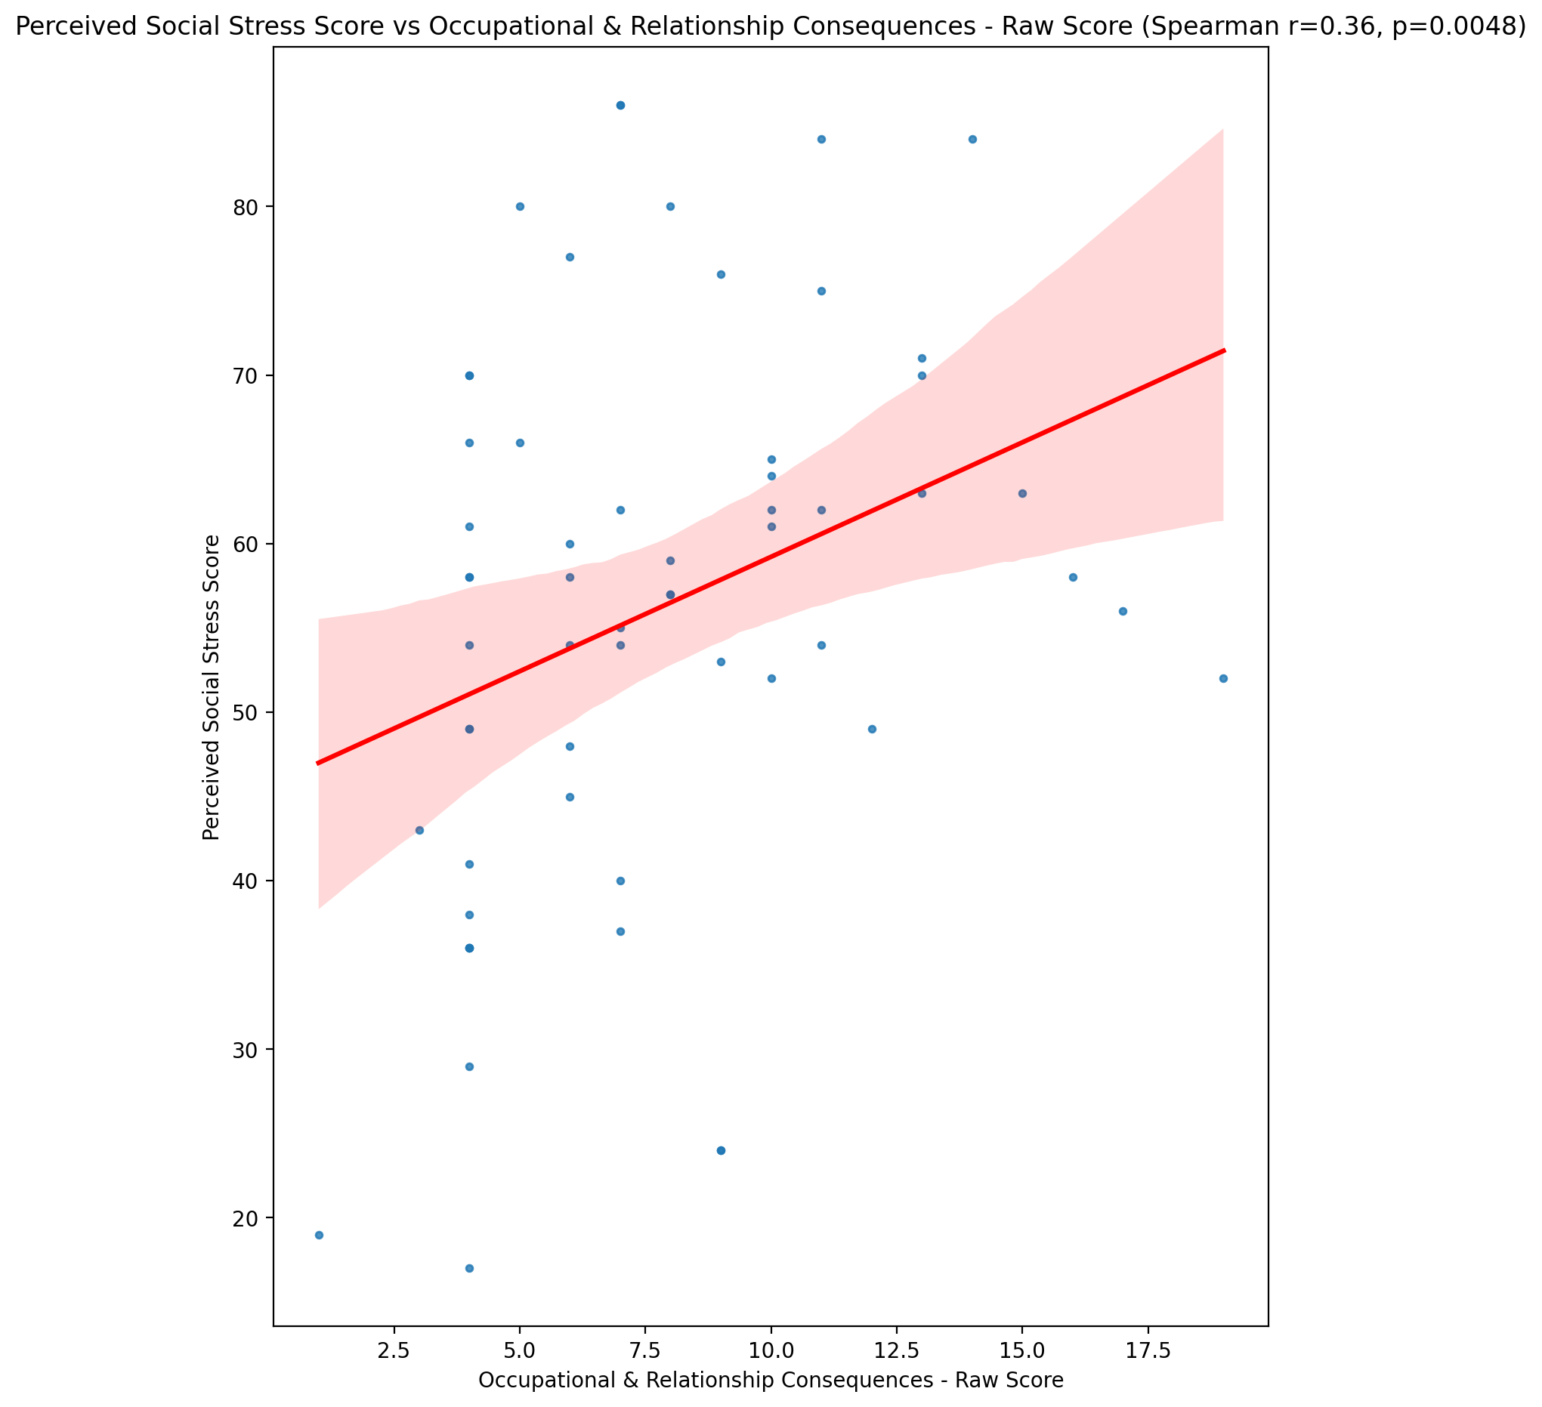

## Perceived Social Stress Category vs Occupational & Relationship Consequences - Raw Score

Test: None; statistic: None; p-value: None; Test not run: unsupported type combination.



## Emotional Support - Raw Score vs Compulsive Behaviour - Raw Score

Test: spearman; statistic: -0.20733762904590747; p-value: 0.11509693215782638;

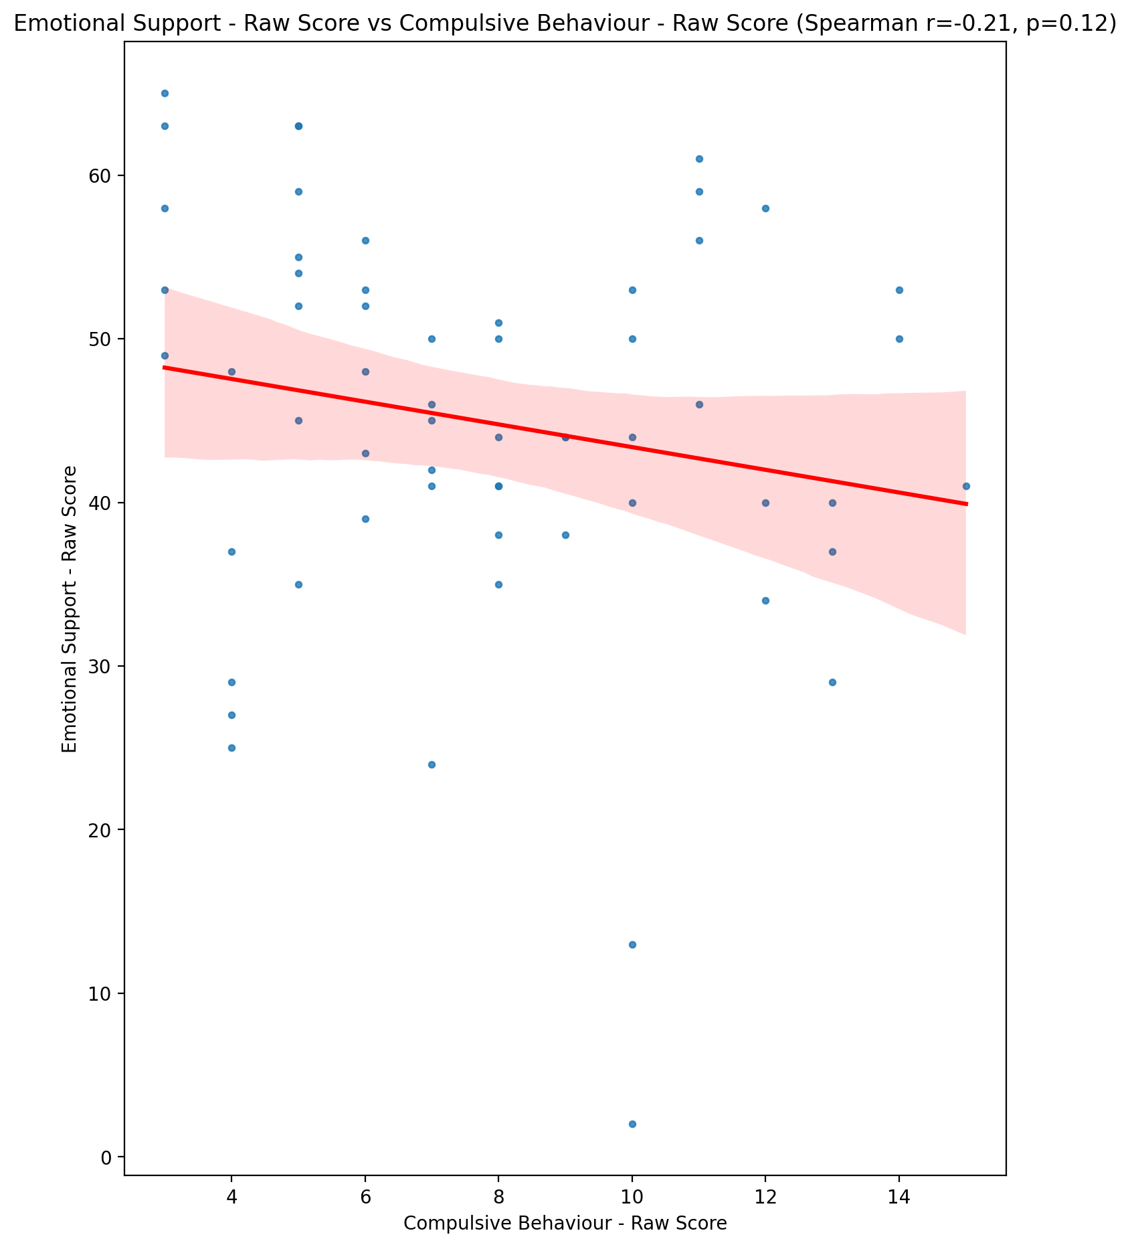

## Informational Support - Raw Score vs Compulsive Behaviour - Raw Score

Test: spearman; statistic: -0.16591716676087995; p-value: 0.2091551784850914;

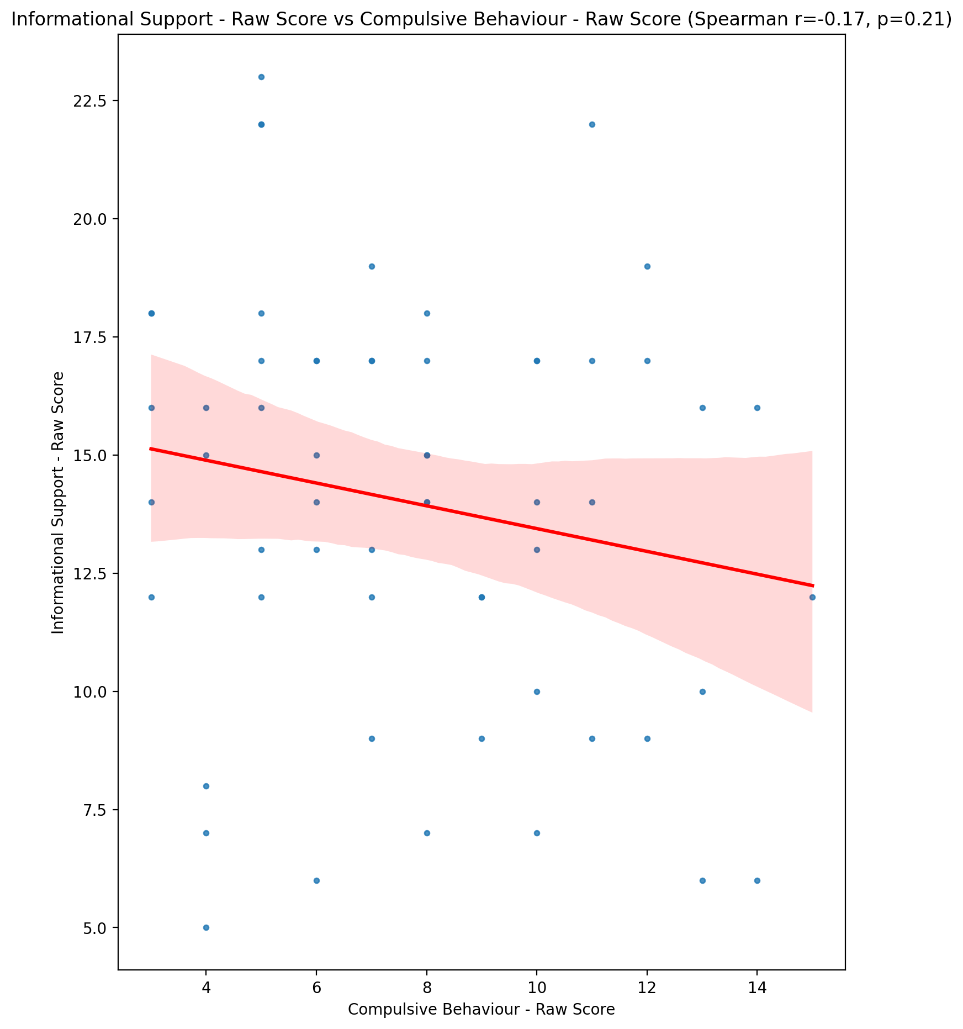

## Instrumental Support - Raw Score vs Compulsive Behaviour - Raw Score

Test: spearman; statistic: -0.22177290122730076; p-value: 0.09138913638656687;

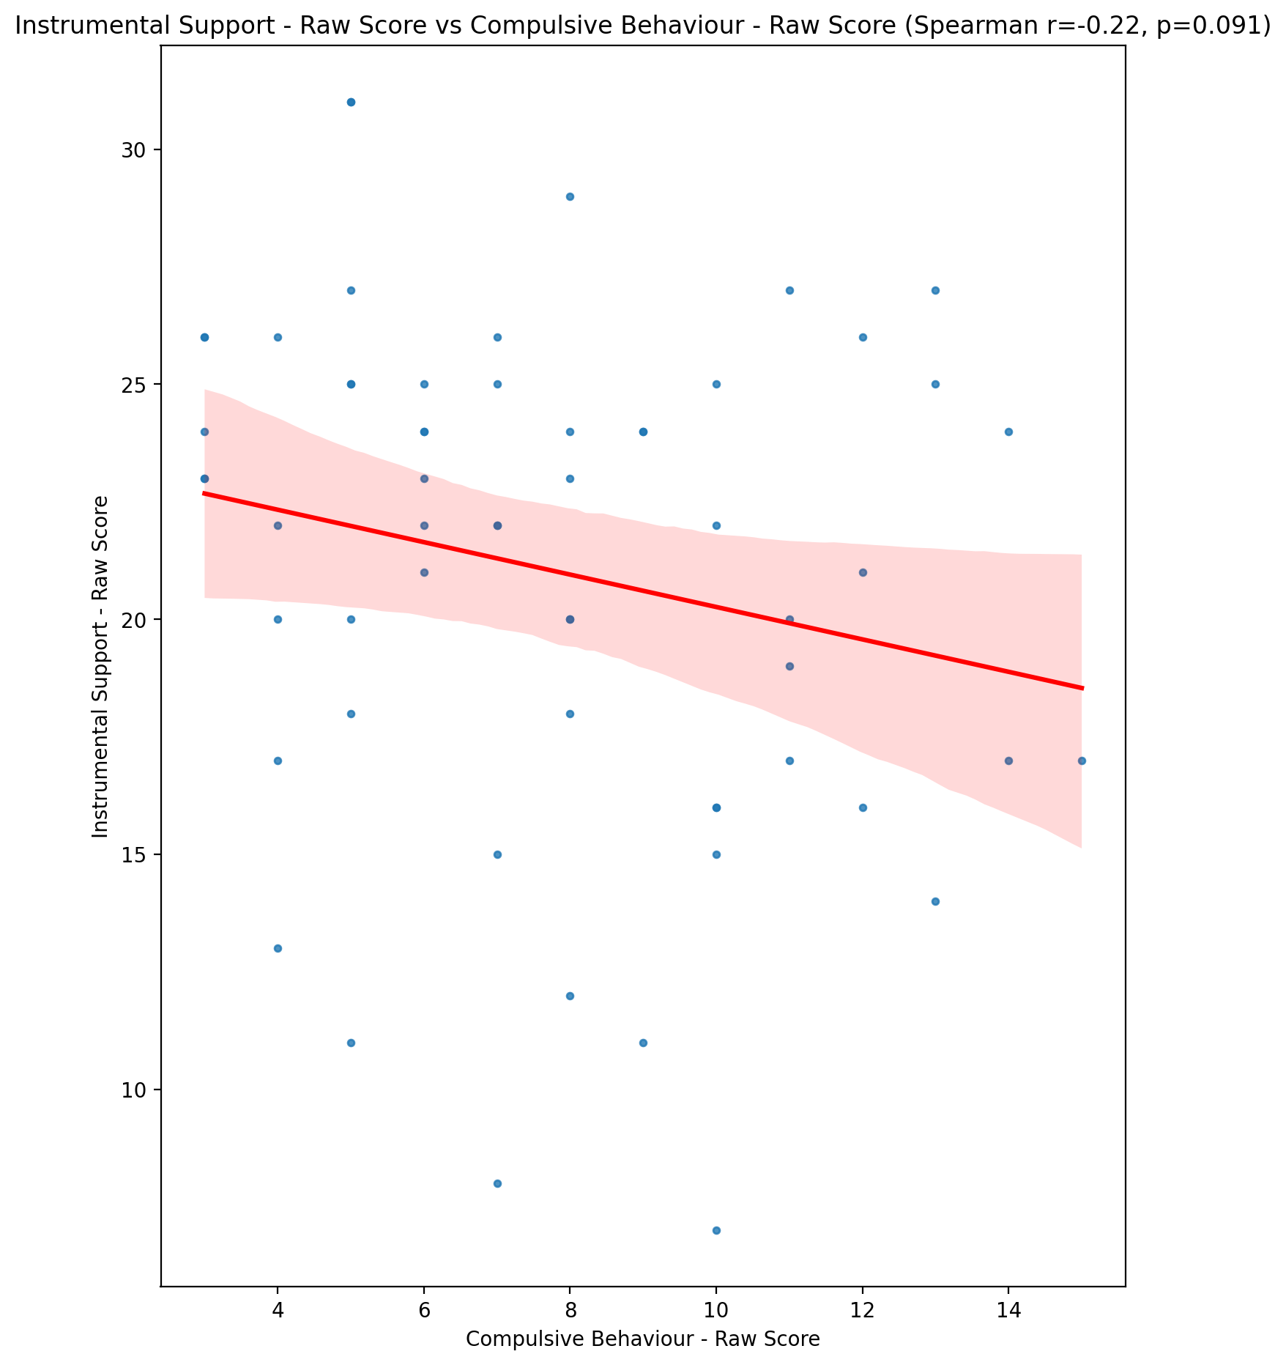

## Emotional Support - T Score vs Compulsive Behaviour - Raw Score

Test: spearman; statistic: -0.2011384876189177; p-value: 0.1266177443198528;

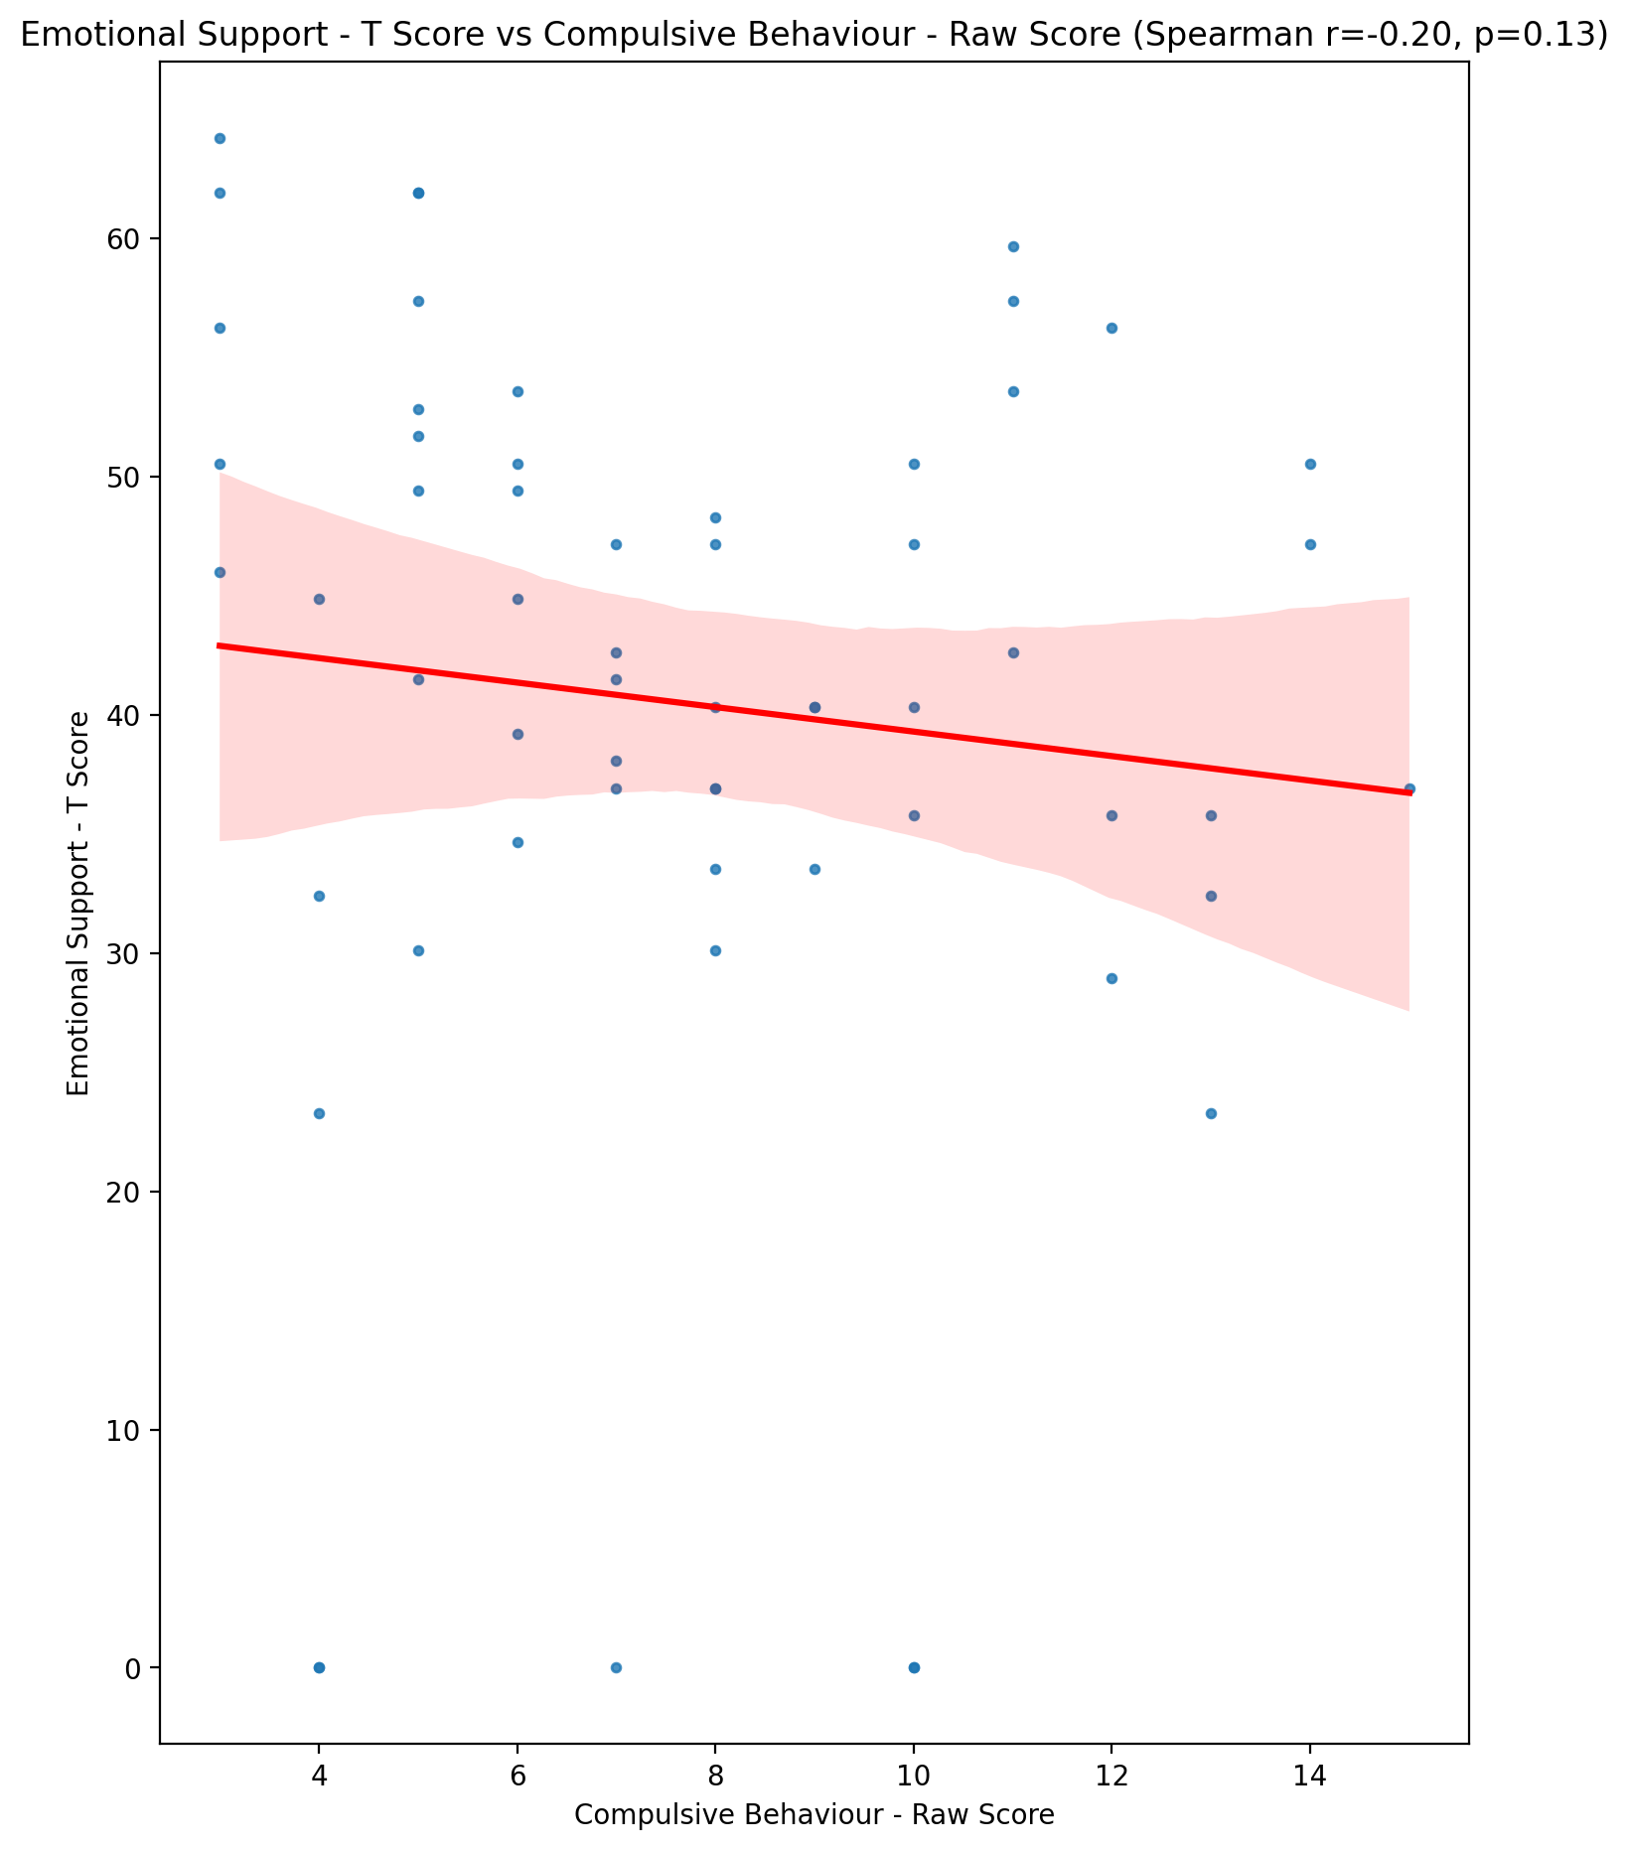

## Informational Support - T Score vs Compulsive Behaviour - Raw Score

Test: spearman; statistic: -0.16180800744624887; p-value: 0.22081431168892773;

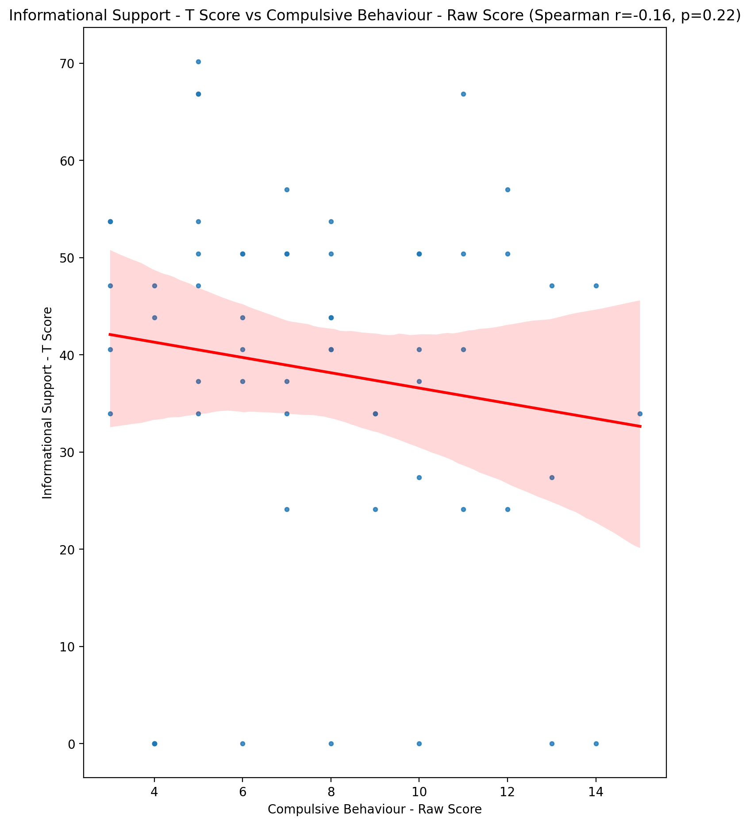

## Instrumental Support - T Score vs Compulsive Behaviour - Raw Score

Test: spearman; statistic: -0.21723080593692645; p-value: 0.09839577468074212;

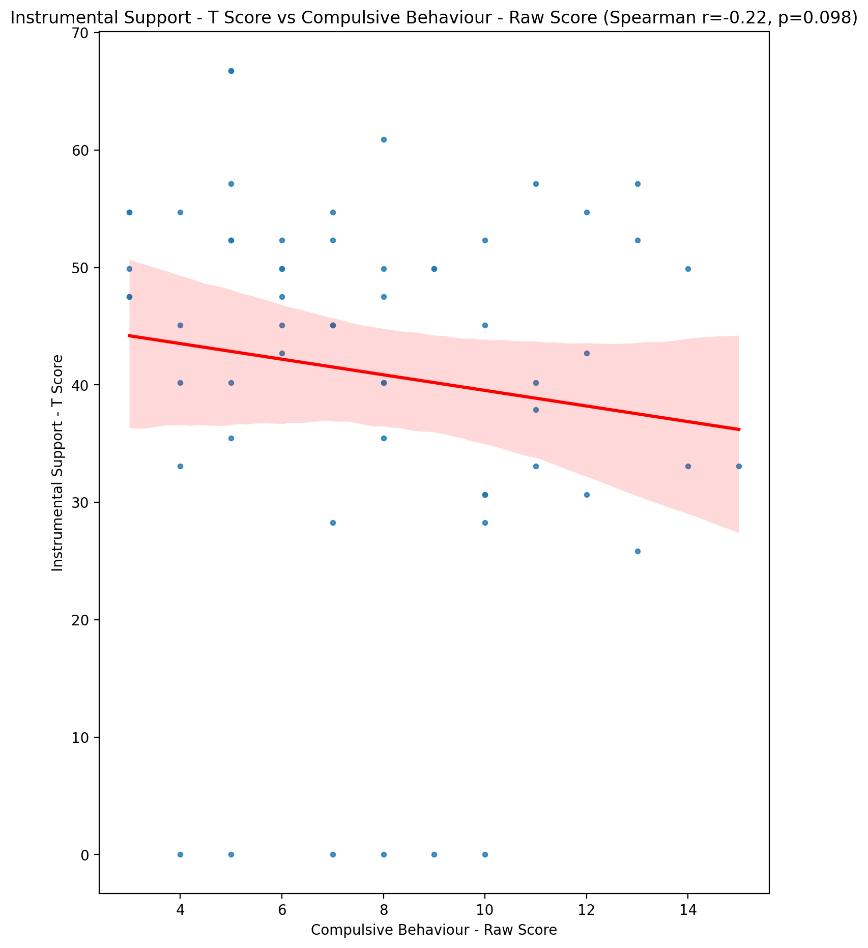

## Perceived Social Support Total T Score vs Compulsive Behaviour - Raw Score

Test: spearman; statistic: -0.250478879463382; p-value: 0.05569382264449527;

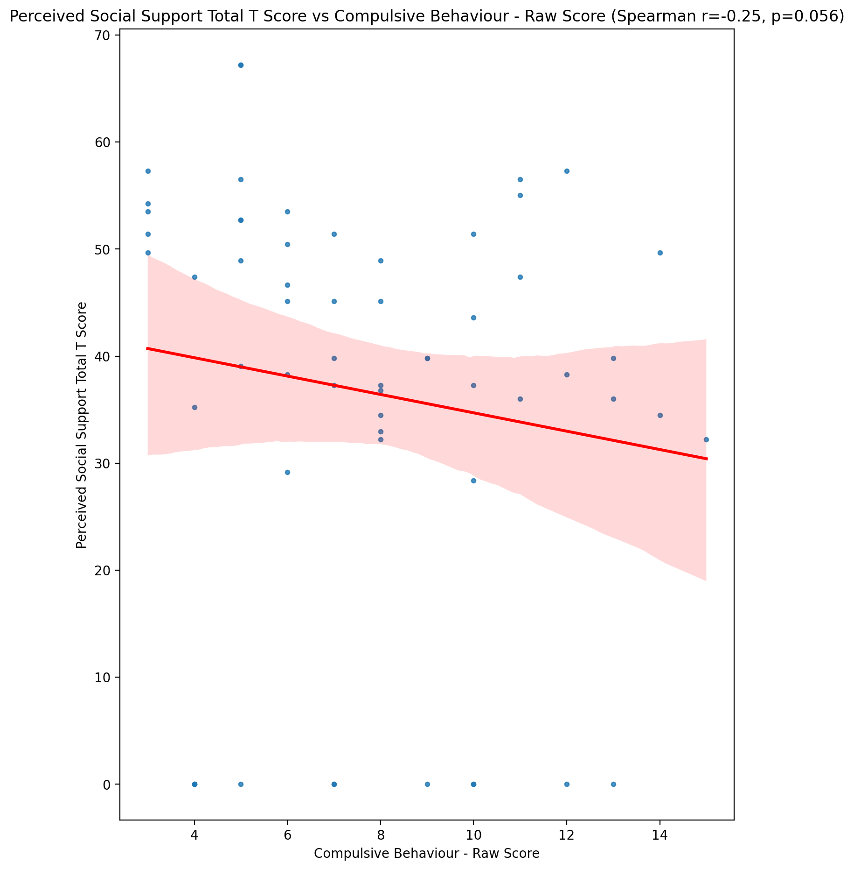

## Emotional Support - Rank vs Compulsive Behaviour - Raw Score

Test: None; statistic: None; p-value: None; Test not run: unsupported type combination.



## Informational Support - Rank vs Compulsive Behaviour - Raw Score

Test: None; statistic: None; p-value: None; Test not run: unsupported type combination.



## Instrumental Support - Rank vs Compulsive Behaviour - Raw Score

Test: None; statistic: None; p-value: None; Test not run: unsupported type combination.



## Perceived Social Support TOTAL - Rank vs Compulsive Behaviour - Raw Score

Test: None; statistic: None; p-value: None; Test not run: unsupported type combination.



## Power Self Concept - Real Self Concept Score vs Compulsive Behaviour - Raw Score

Test: spearman; statistic: -0.27572601458197377; p-value: 0.034537512813787884;

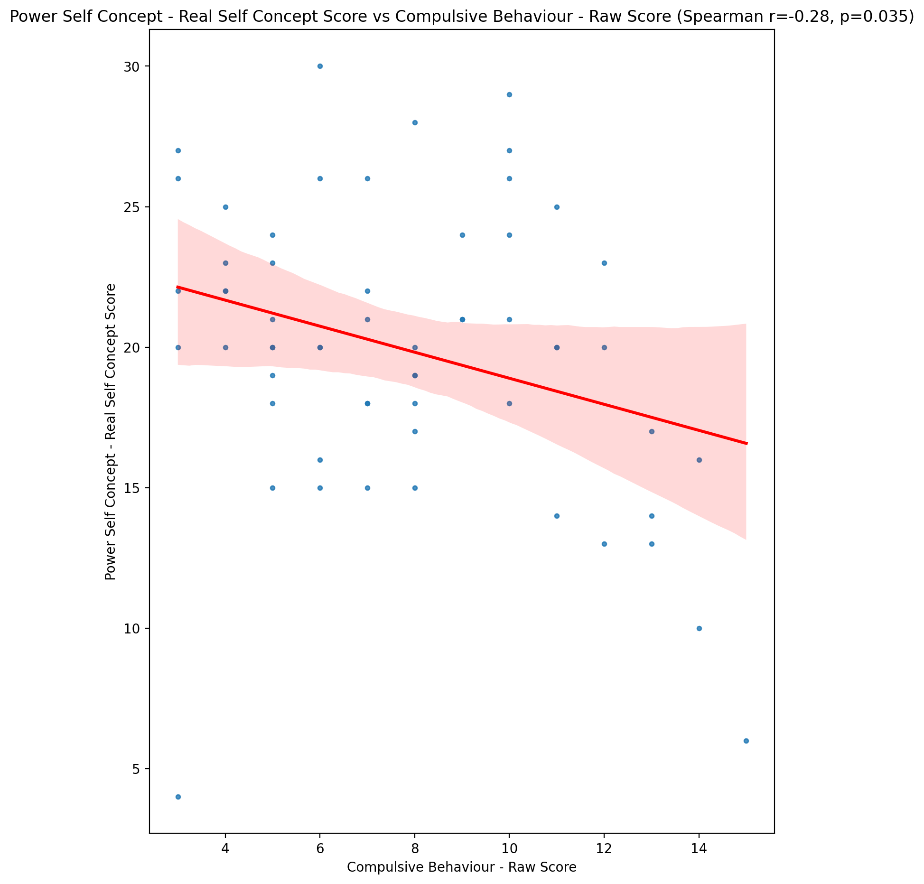

## Power Self Concept - Ideal Self Concept score vs Compulsive Behaviour - Raw Score

Test: spearman; statistic: -0.32702742737326707; p-value: 0.011467084221851071;

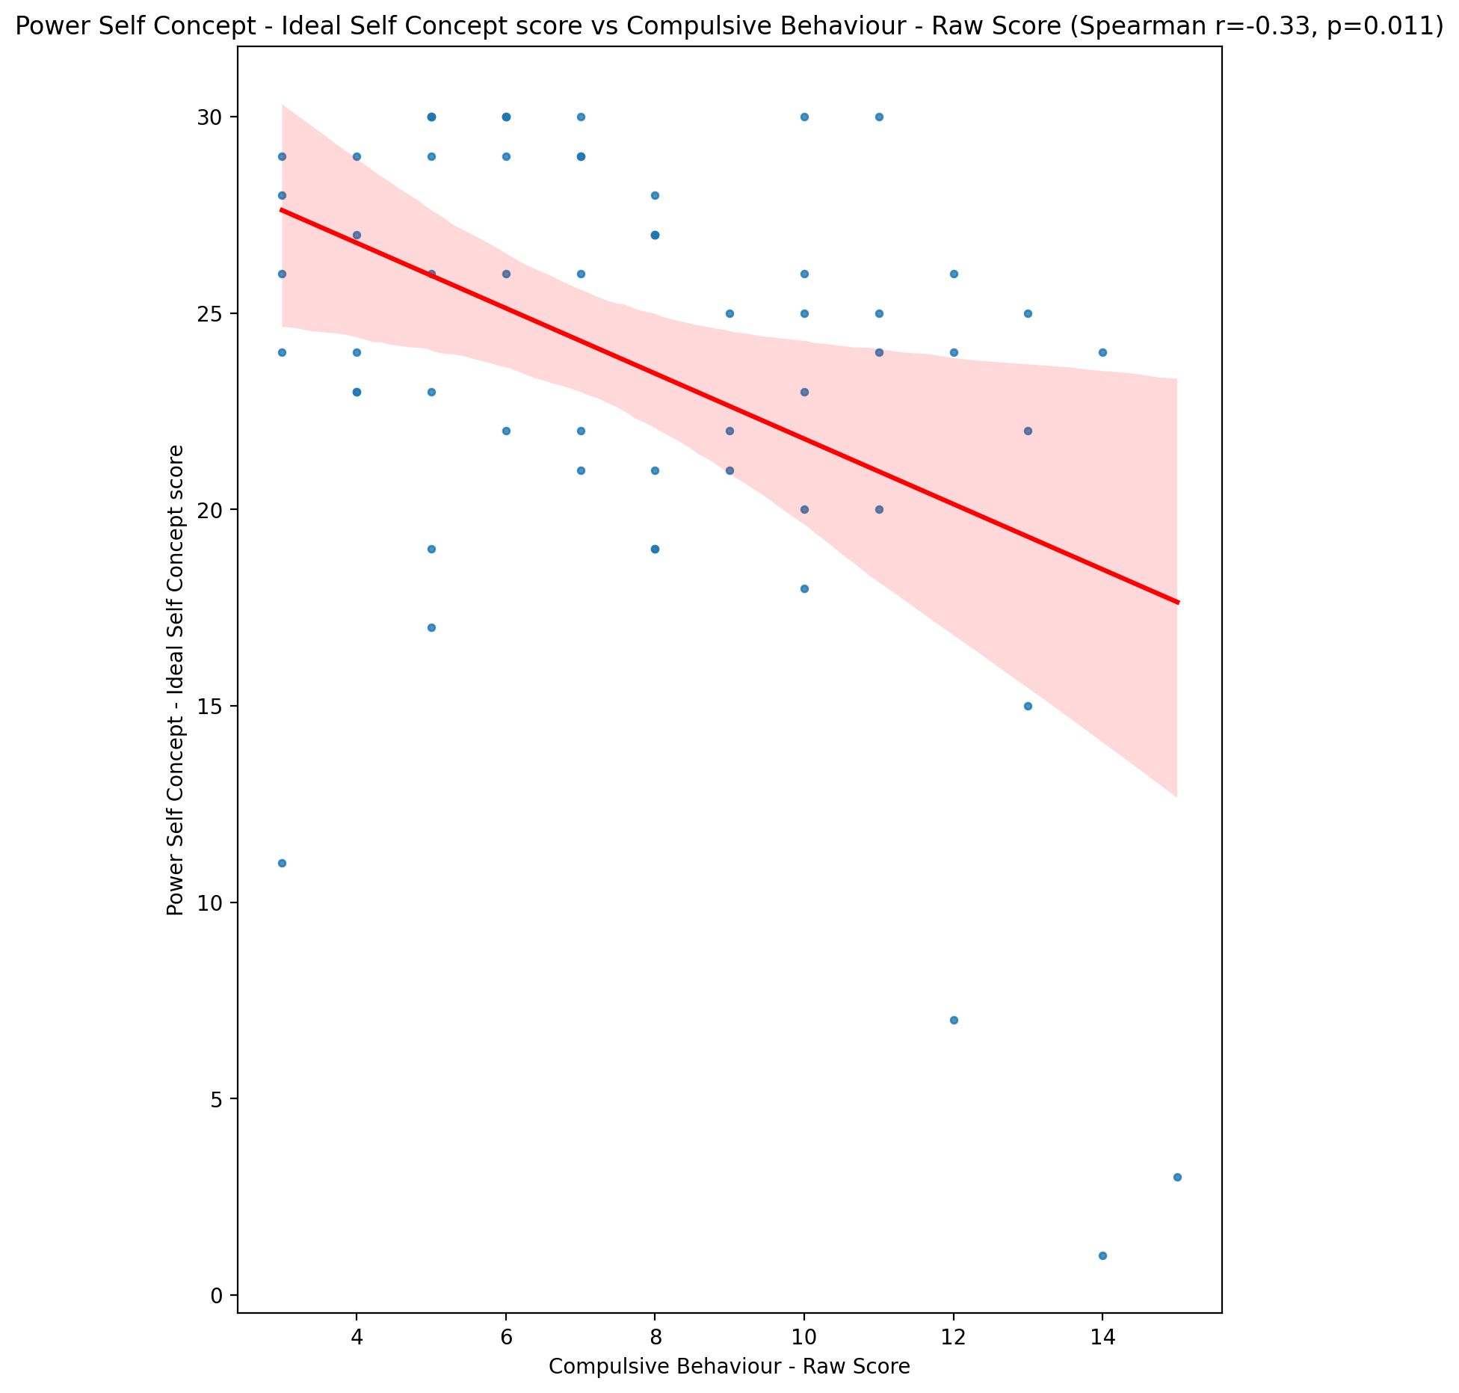

## Power Self Concept – Social Self Concept Score vs Compulsive Behaviour - Raw Score

Test: spearman; statistic: -0.1985555932899617; p-value: 0.13166793204551067;

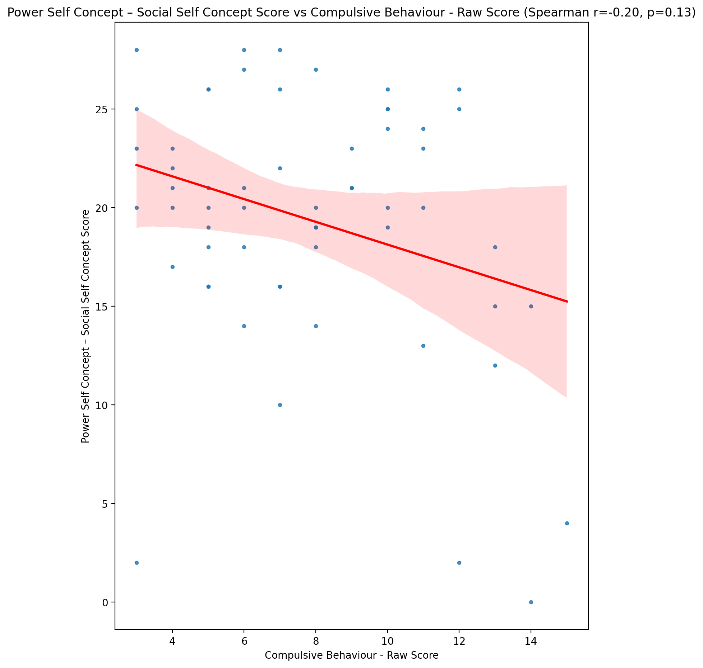

## Social Self Concept - Real Self Concept Score vs Compulsive Behaviour - Raw Score

Test: spearman; statistic: -0.31178874990889116; p-value: 0.016220693805421488;

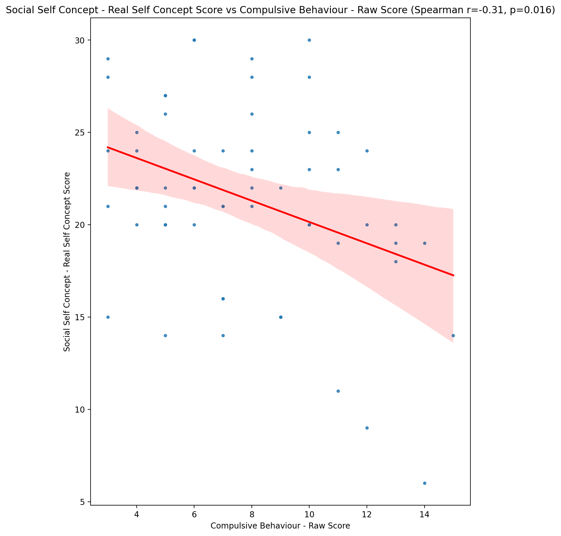

## Social Self Concept – Social Self Concept Score vs Compulsive Behaviour - Raw Score

Test: spearman; statistic: -0.23379738303200245; p-value: 0.07471697510356752;

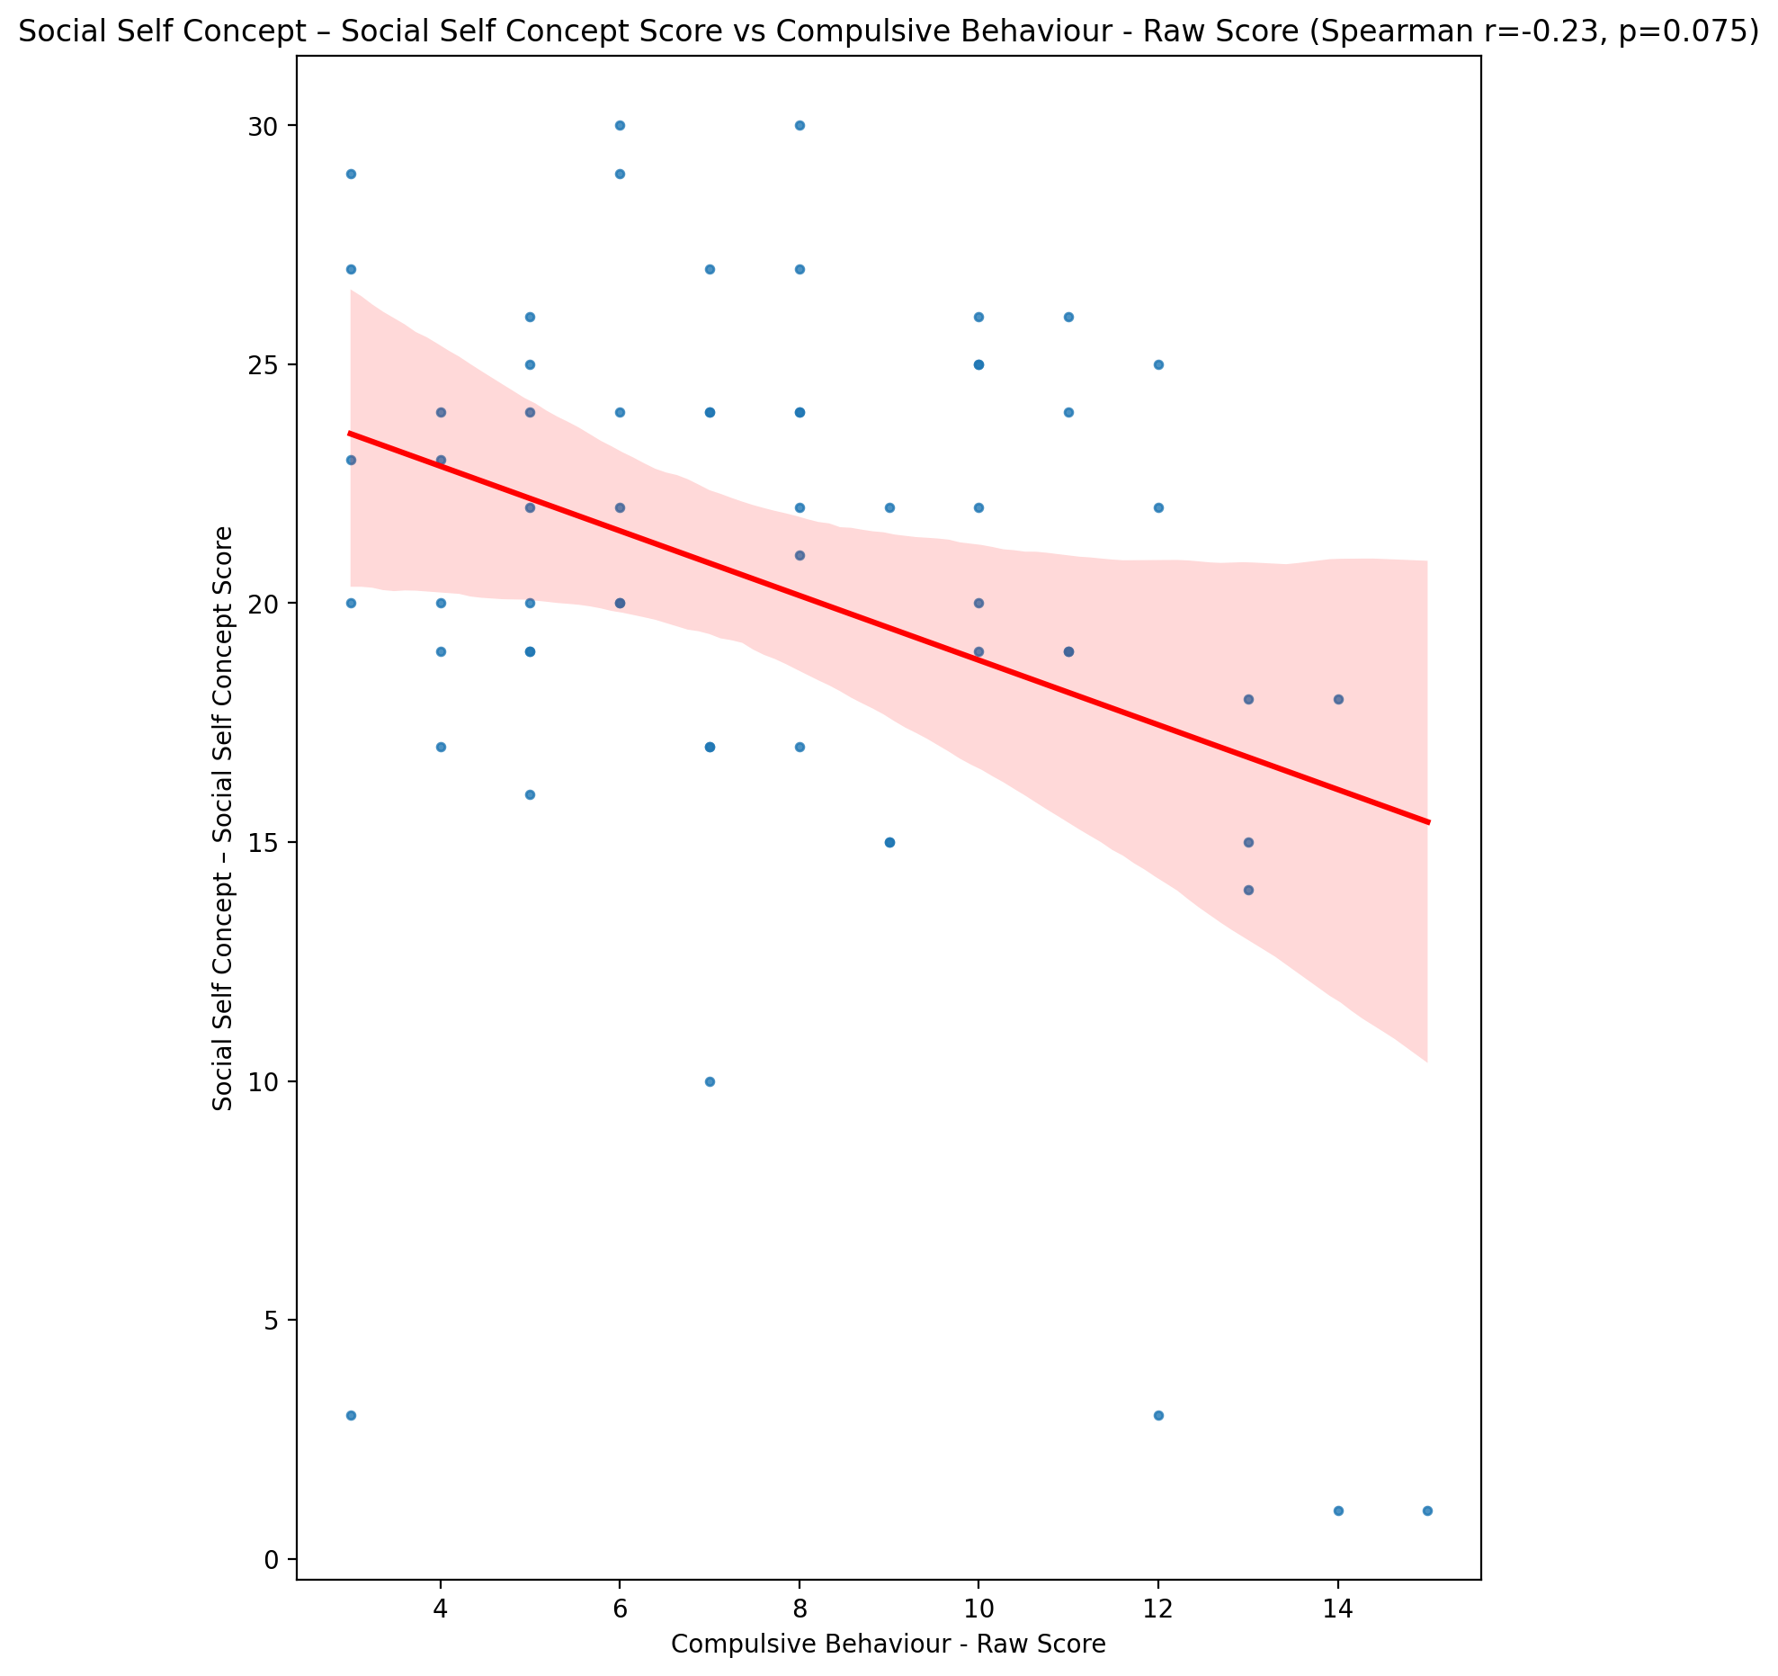

## Ability Self Concept - Real Self Concept Score vs Compulsive Behaviour - Raw Score

Test: spearman; statistic: -0.28230490886852166; p-value: 0.030288031086583848;

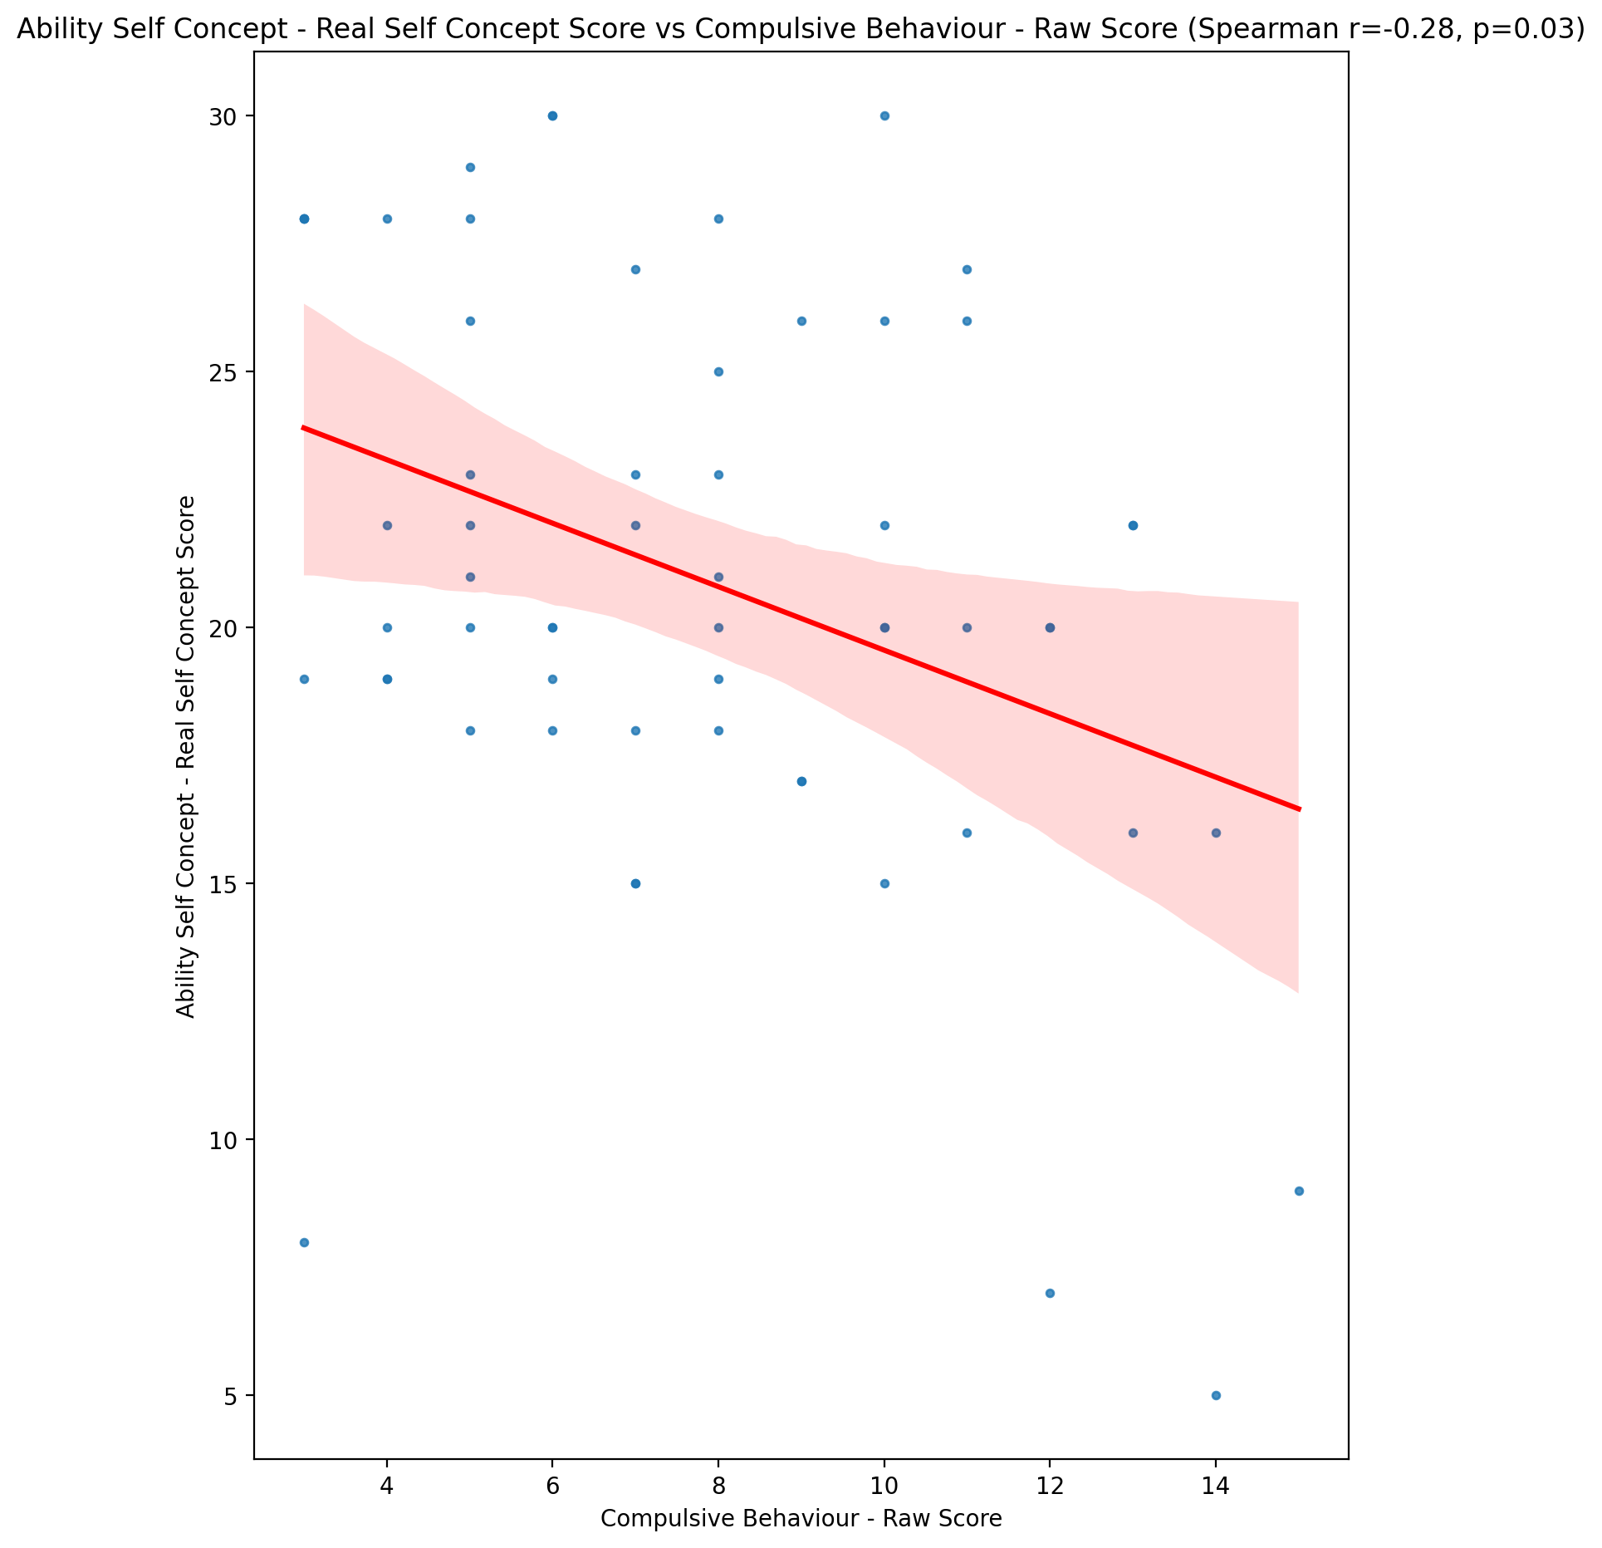

## Ability Self Concept - Ideal Self Concept Score vs Compulsive Behaviour - Raw Score

Test: spearman; statistic: -0.25258946072315863; p-value: 0.05359589244013672;

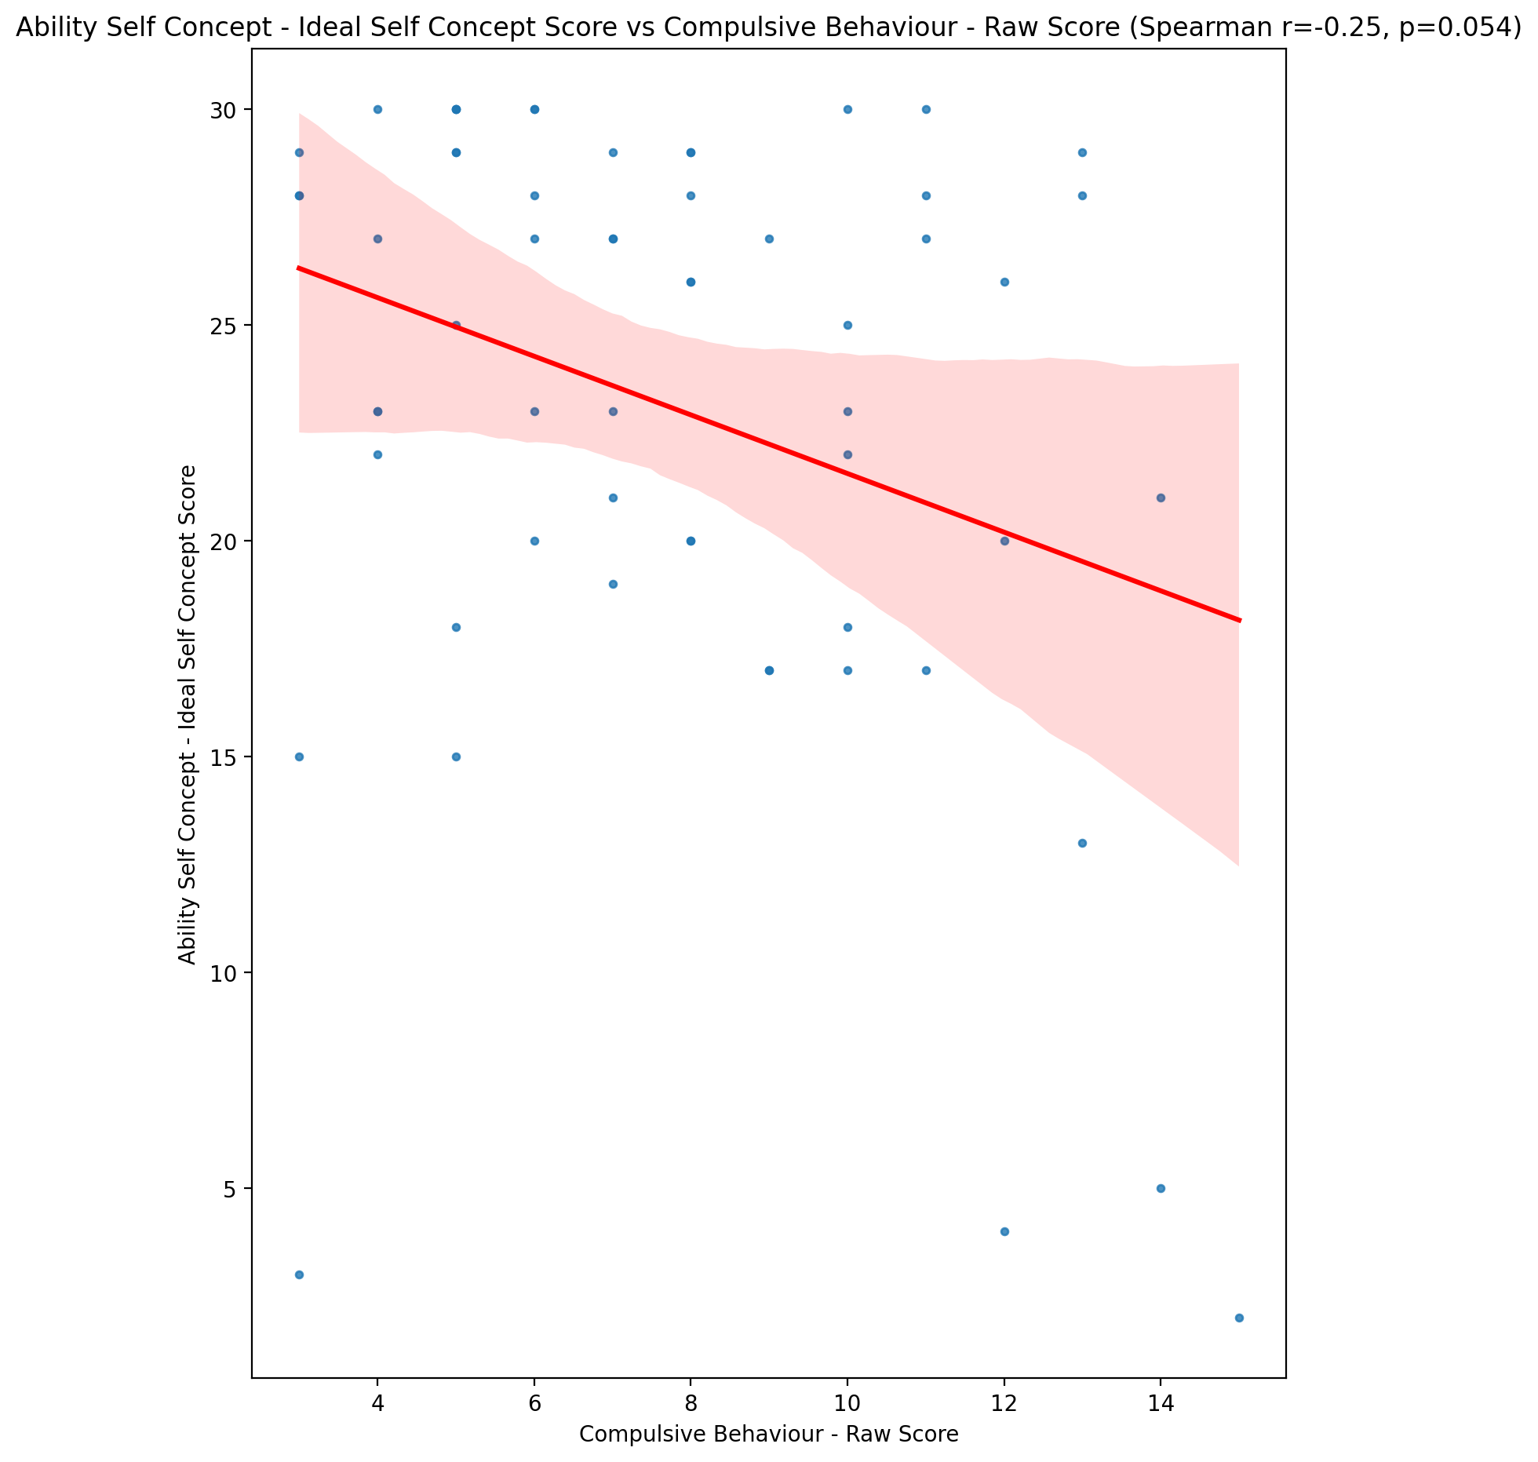

## Ability Self Concept – Social Self Concept Score vs Compulsive Behaviour - Raw Score

Test: spearman; statistic: -0.2025660460935217; p-value: 0.12389024560968558;

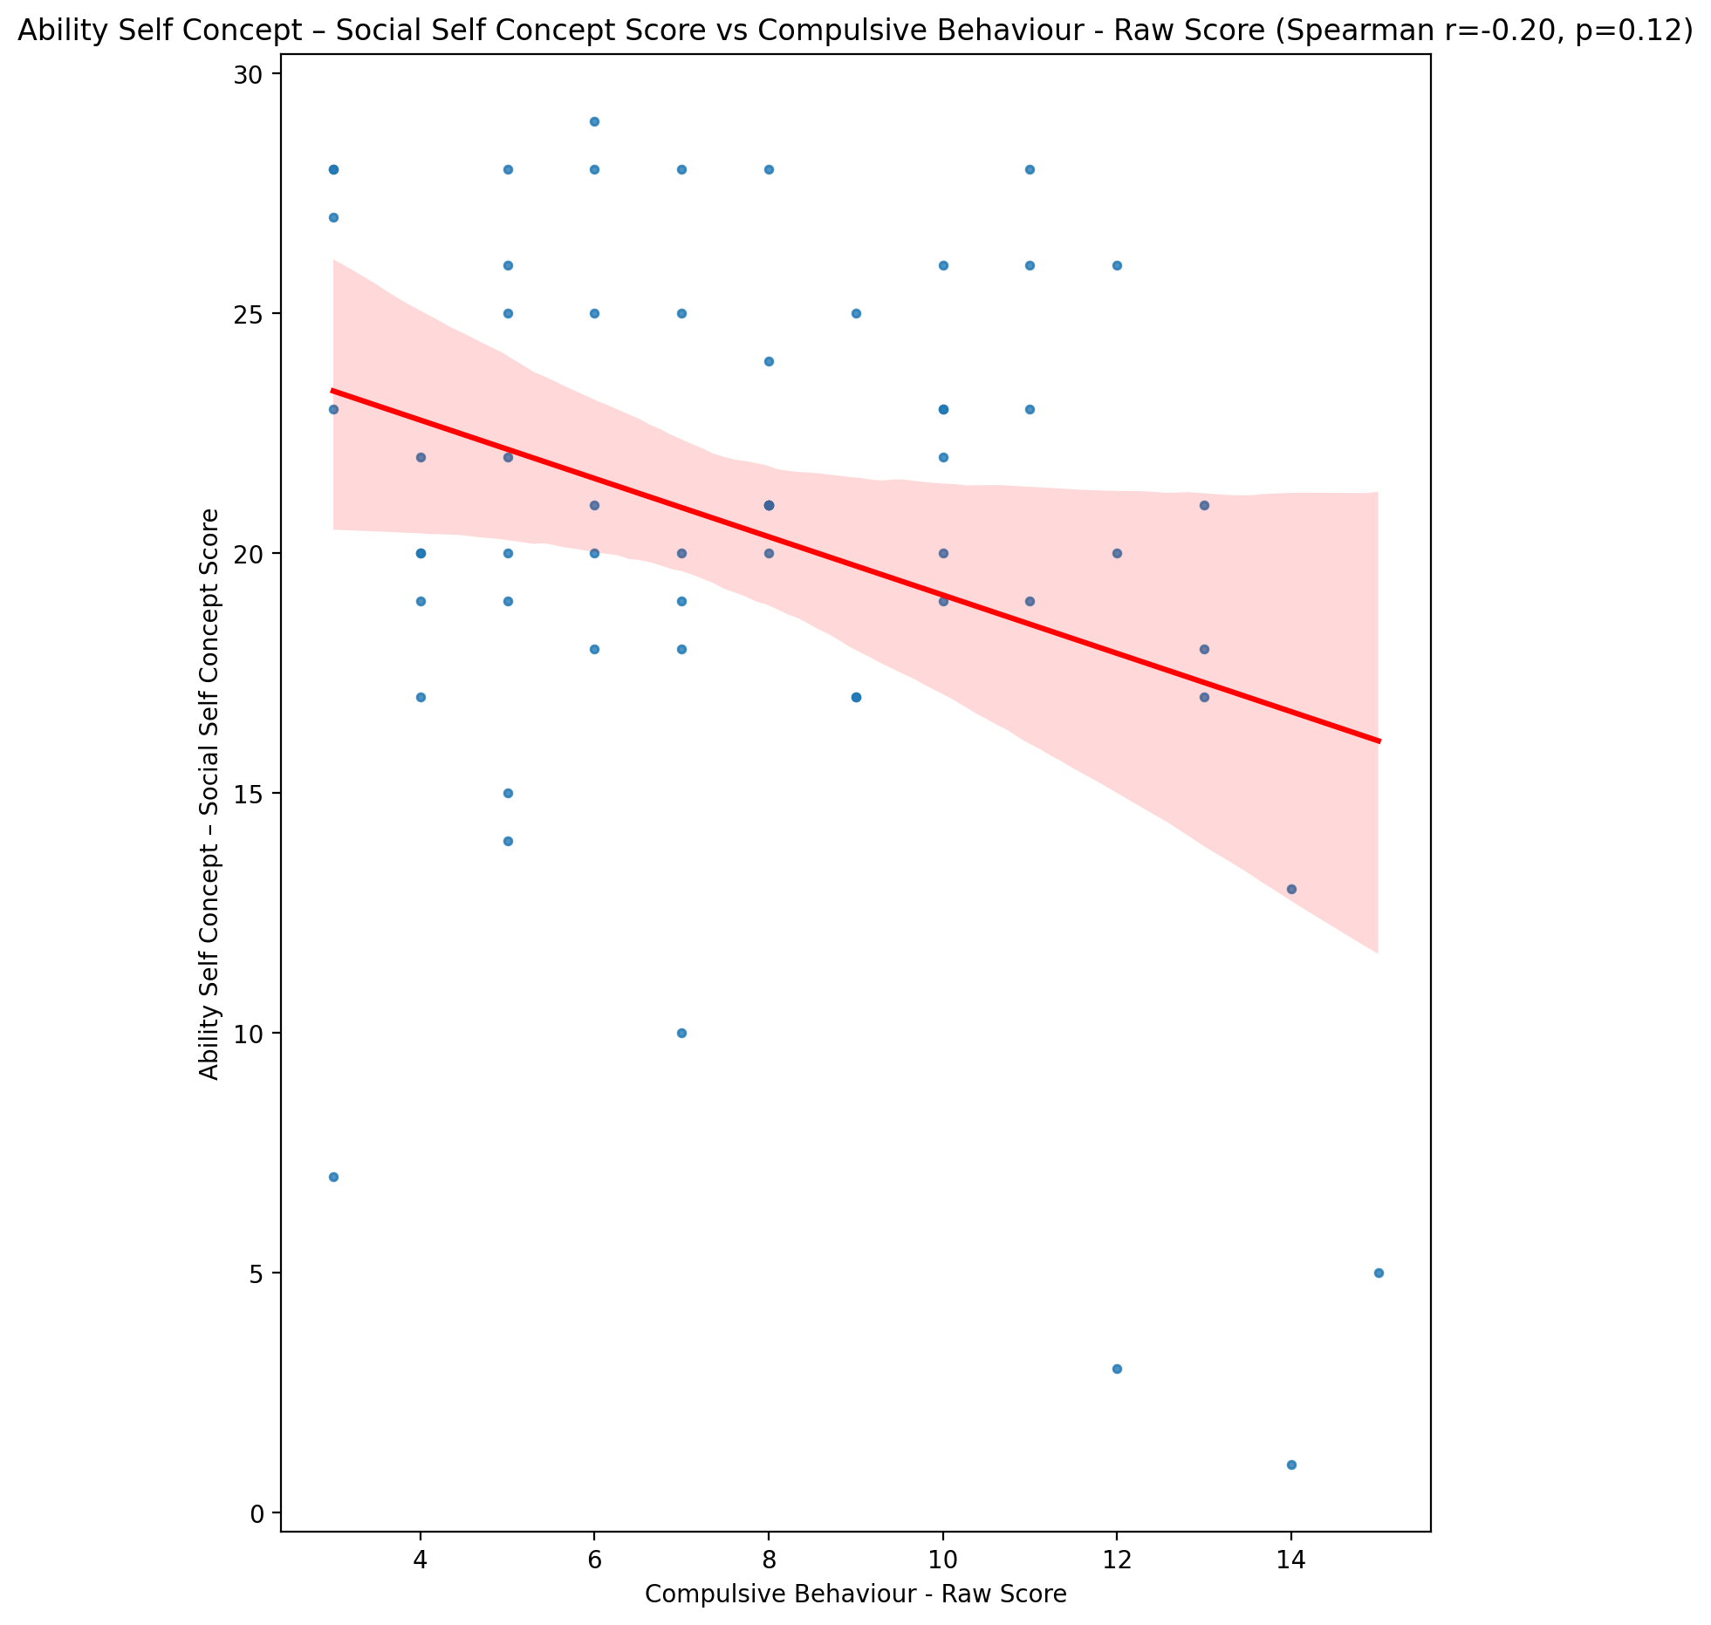

## Physical Self Concept - Real Self Concept Score vs Compulsive Behaviour - Raw Score

Test: spearman; statistic: -0.25548822765197393; p-value: 0.050819646771397706;

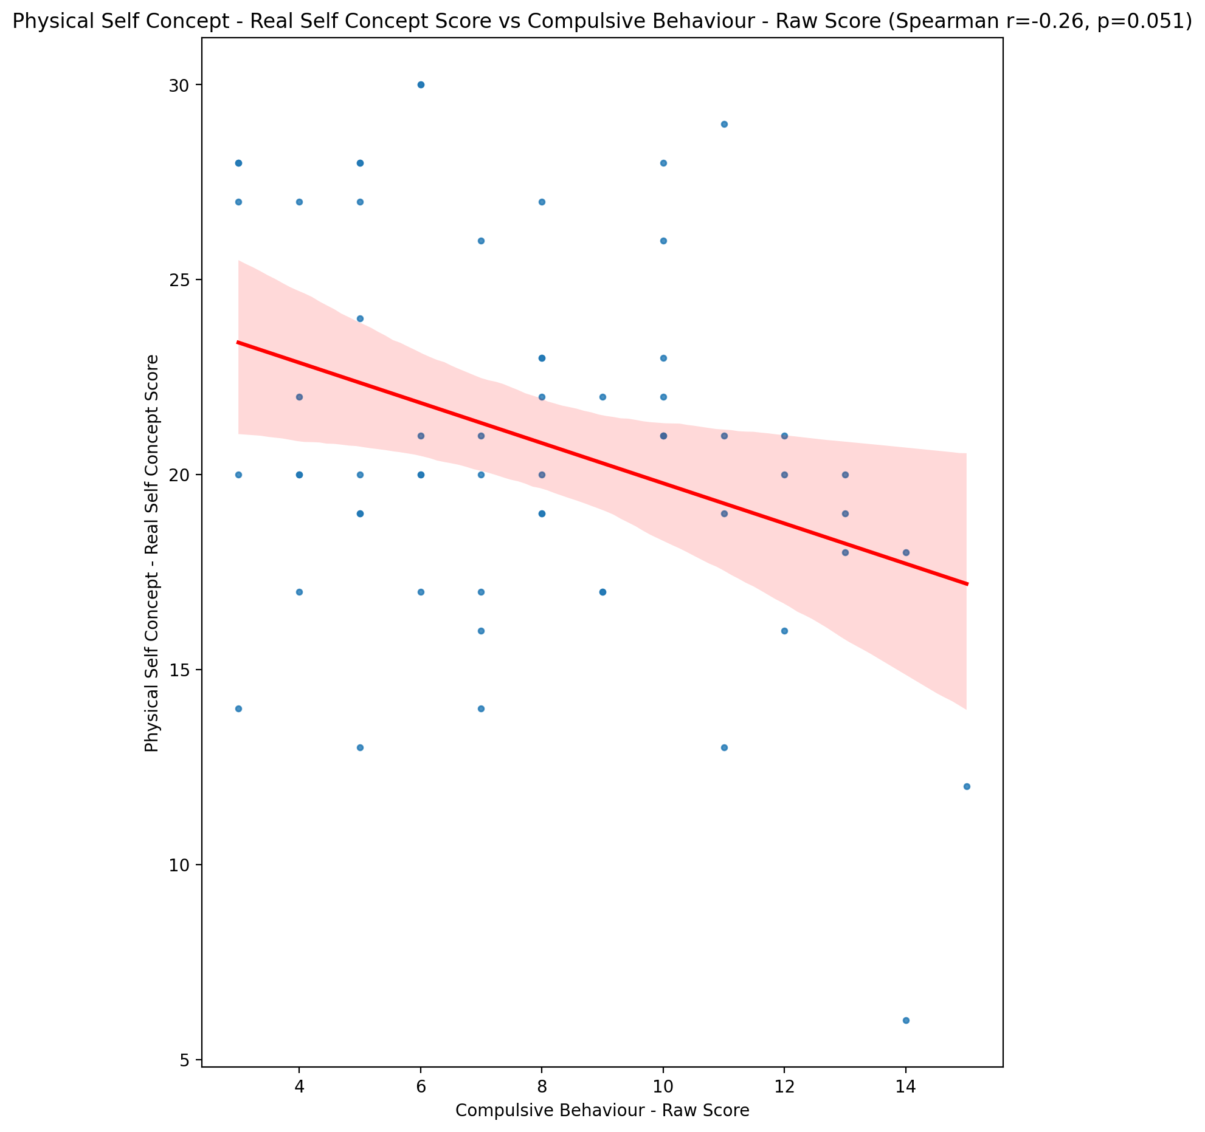

## Physical Self Concept – Ideal Self Concept Score vs Compulsive Behaviour - Raw Score

Test: spearman; statistic: -0.22764684997950008; p-value: 0.08291395165000313;

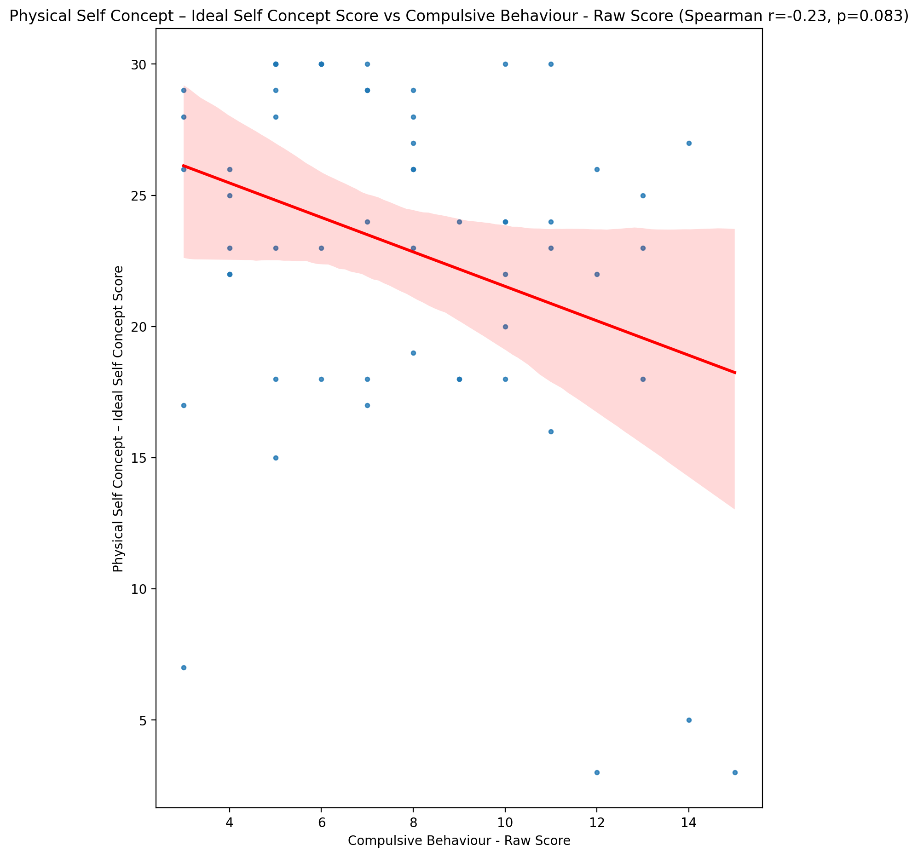

## Physical Self Concept – Social Self Concept Score vs Compulsive Behaviour - Raw Score

Test: spearman; statistic: -0.15396182114415752; p-value: 0.2443196703333972;

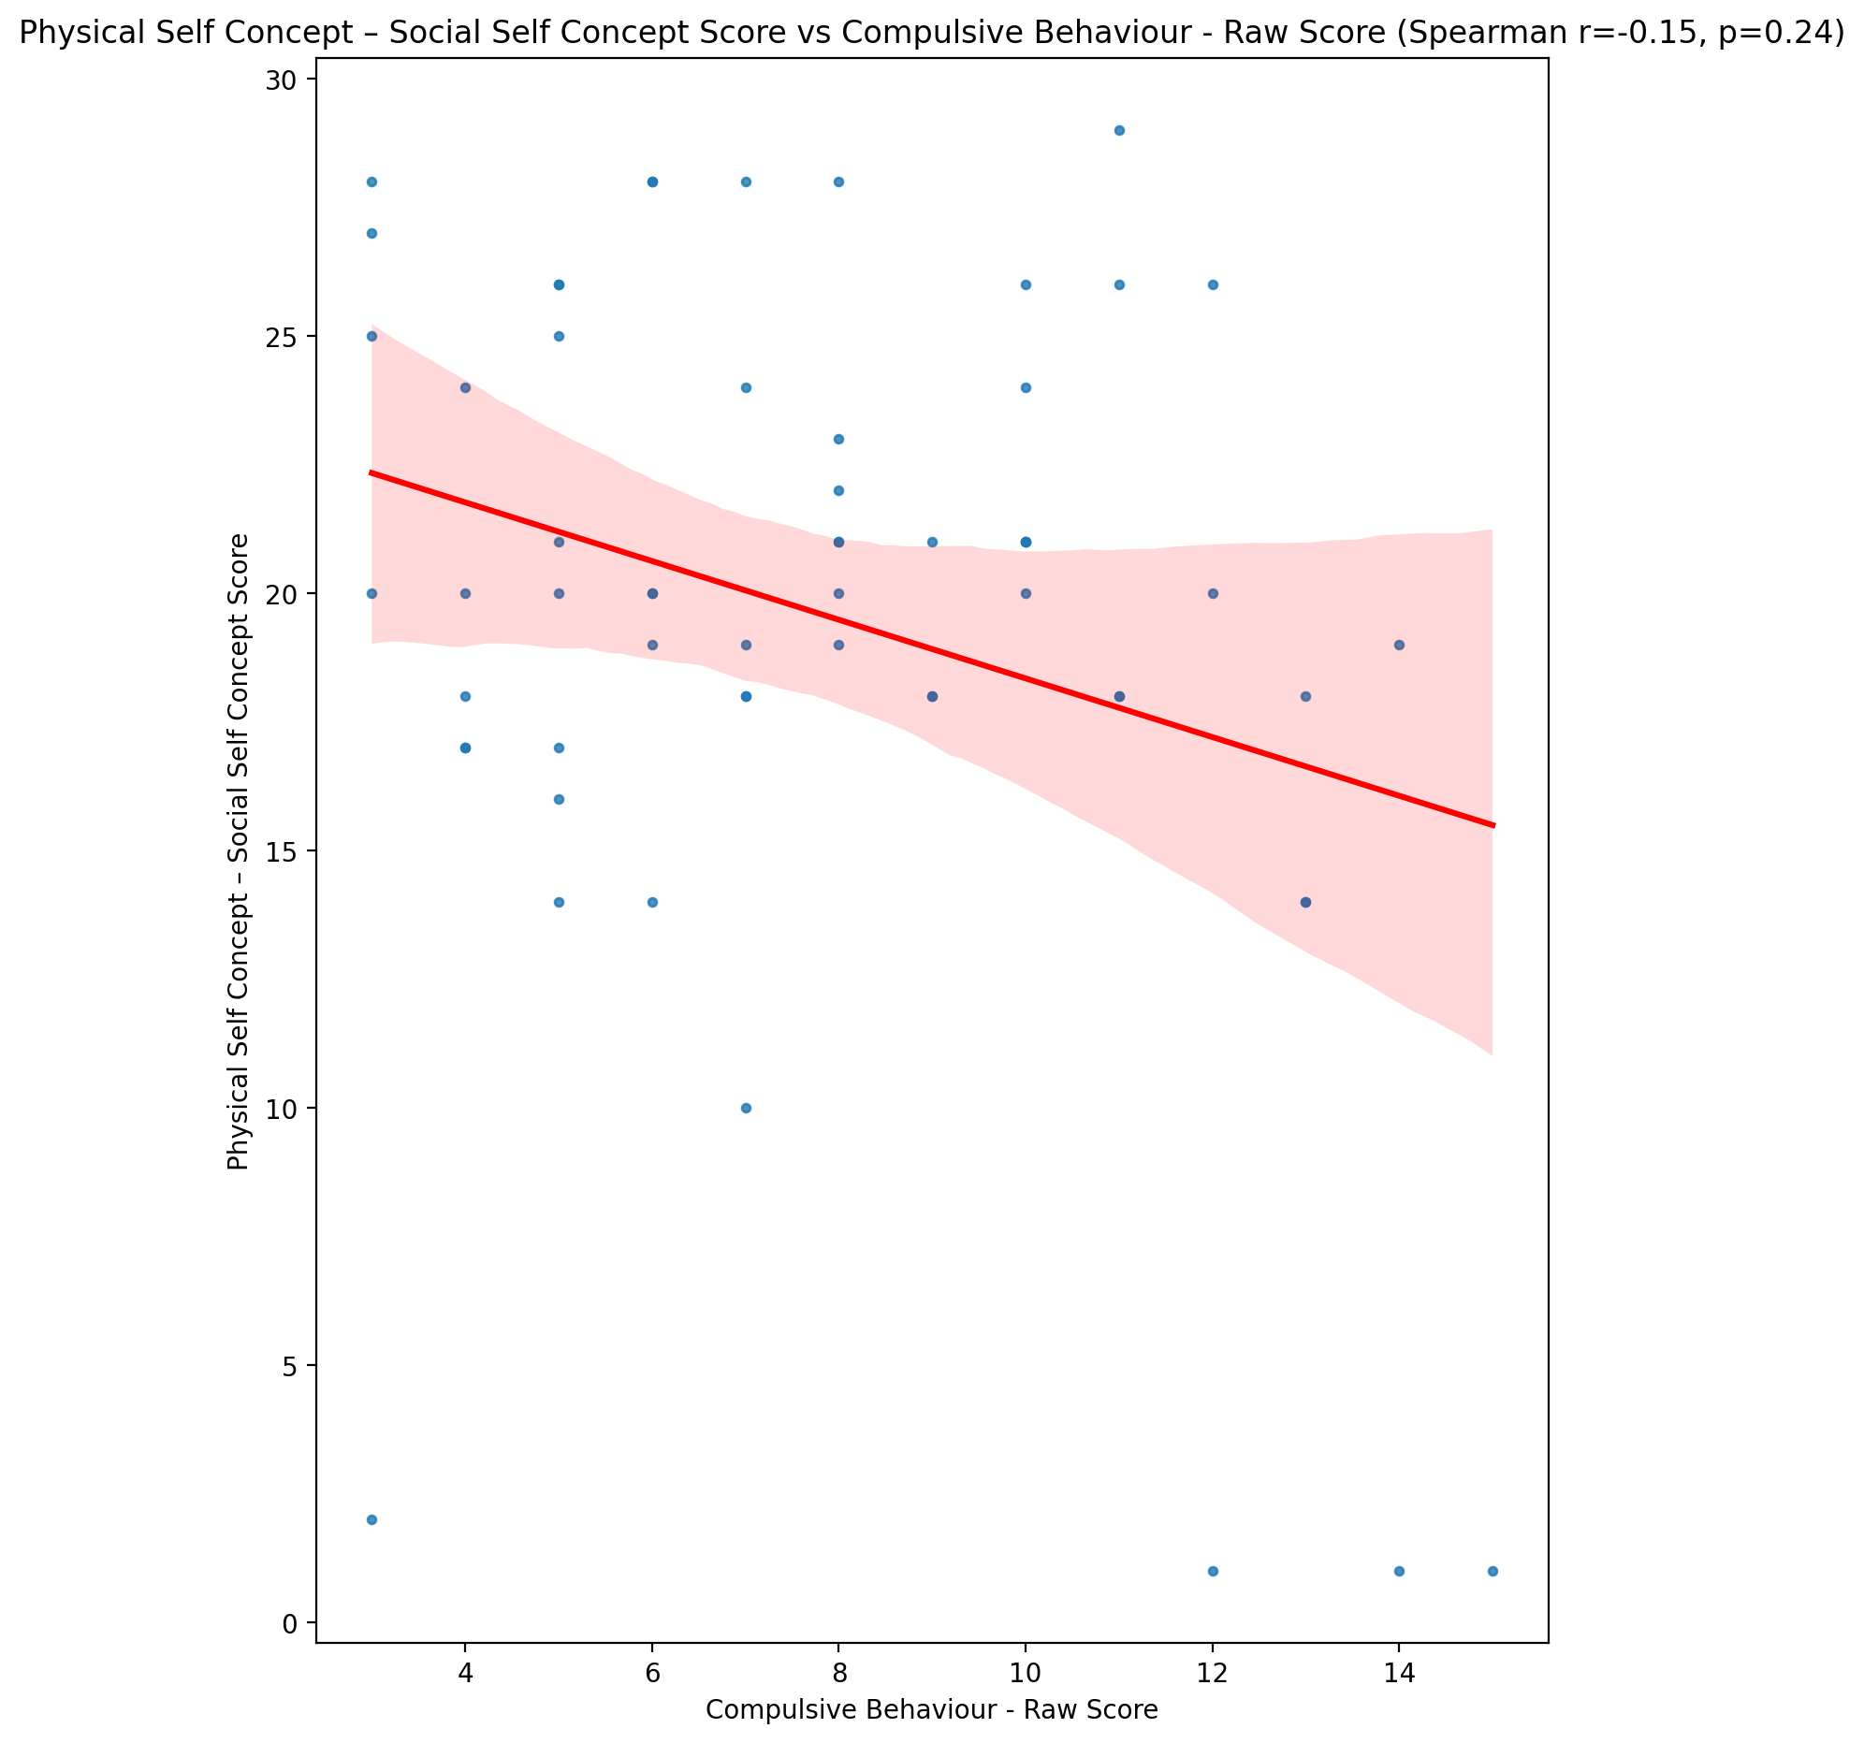

## Psychological Self Concept - Real Self Concept Score vs Compulsive Behaviour - Raw Score

Test: spearman; statistic: -0.39529399334155185; p-value: 0.001944327610536804;

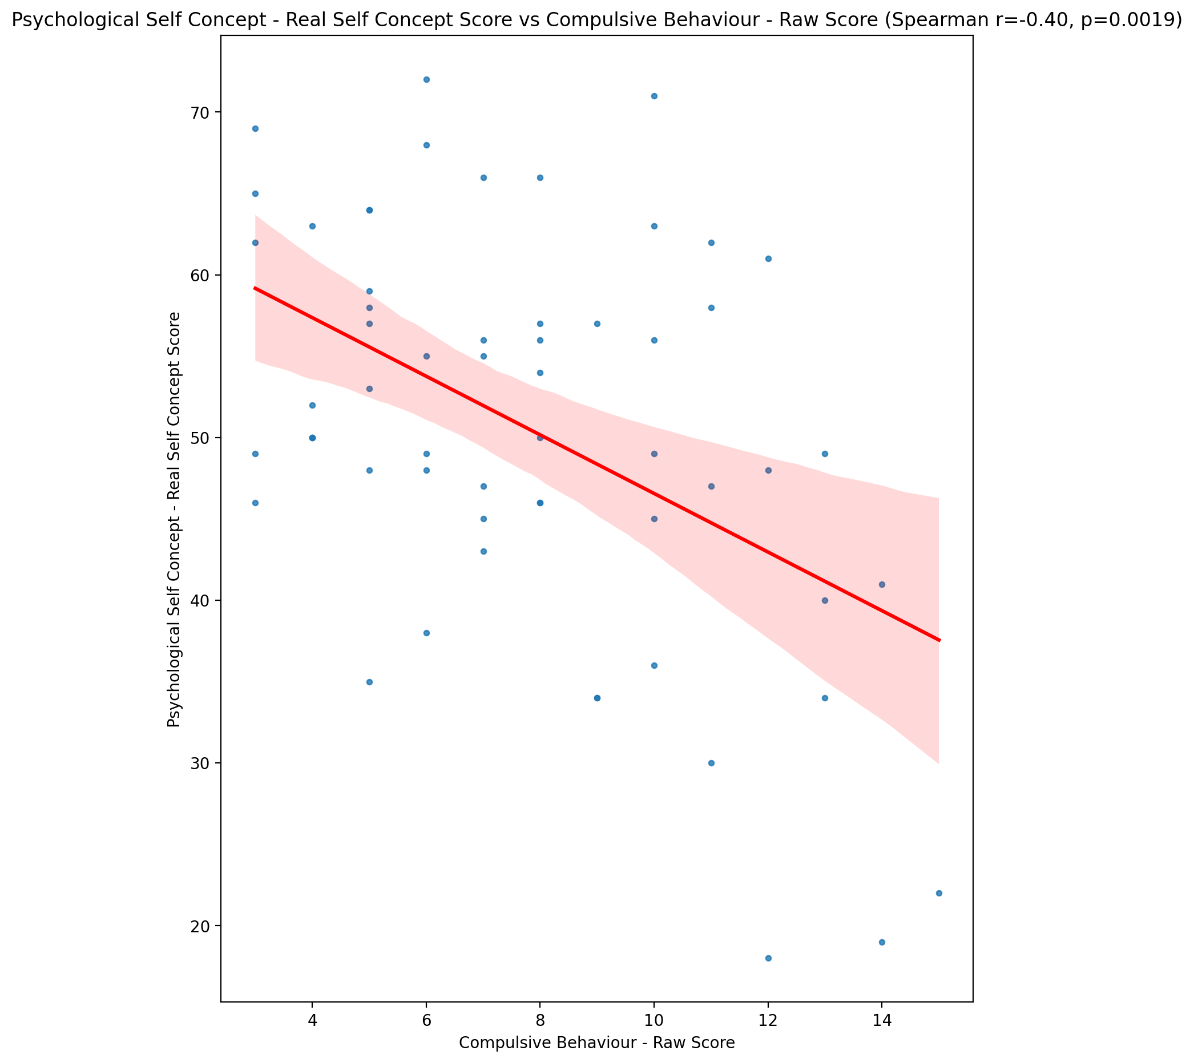

## Psychological Self Concept – Ideal Self Concept Score vs Compulsive Behaviour - Raw Score

Test: spearman; statistic: -0.22398626173648722; p-value: 0.08811938749349195;

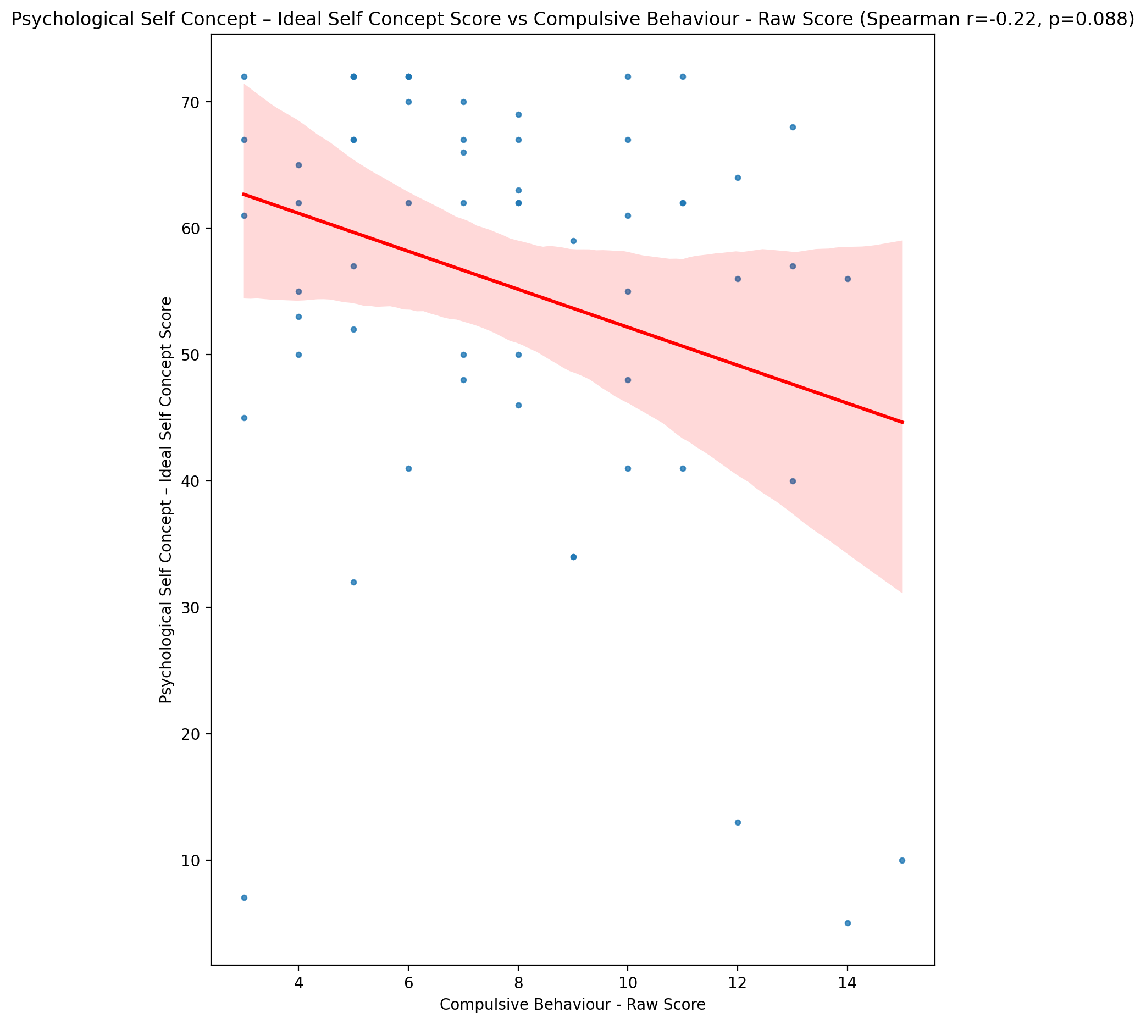

## Psychological Self Concept – Social Self Concept Score vs Compulsive Behaviour - Raw Score

Test: spearman; statistic: -0.27349158908147364; p-value: 0.036089039959584304;

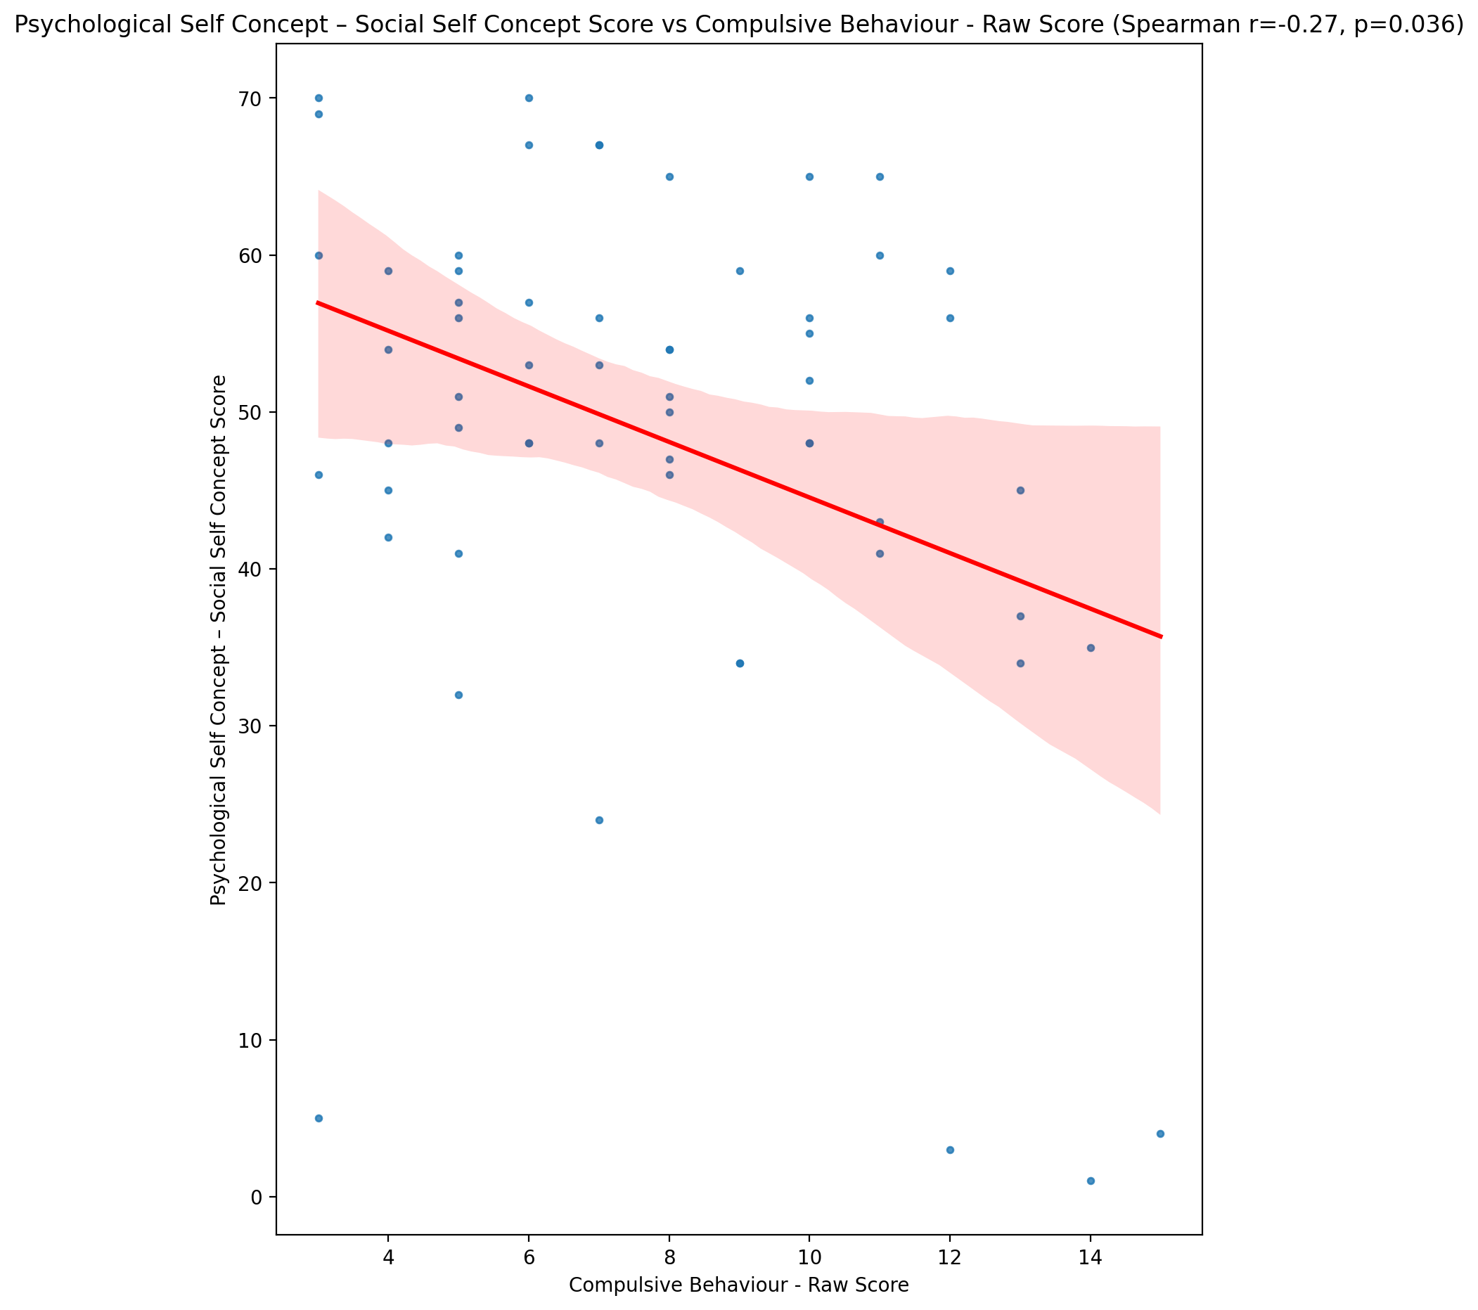

## Real Self Concept Total Score vs Compulsive Behaviour - Raw Score

Test: spearman; statistic: -0.3252687481189899; p-value: 0.011945693539138044;

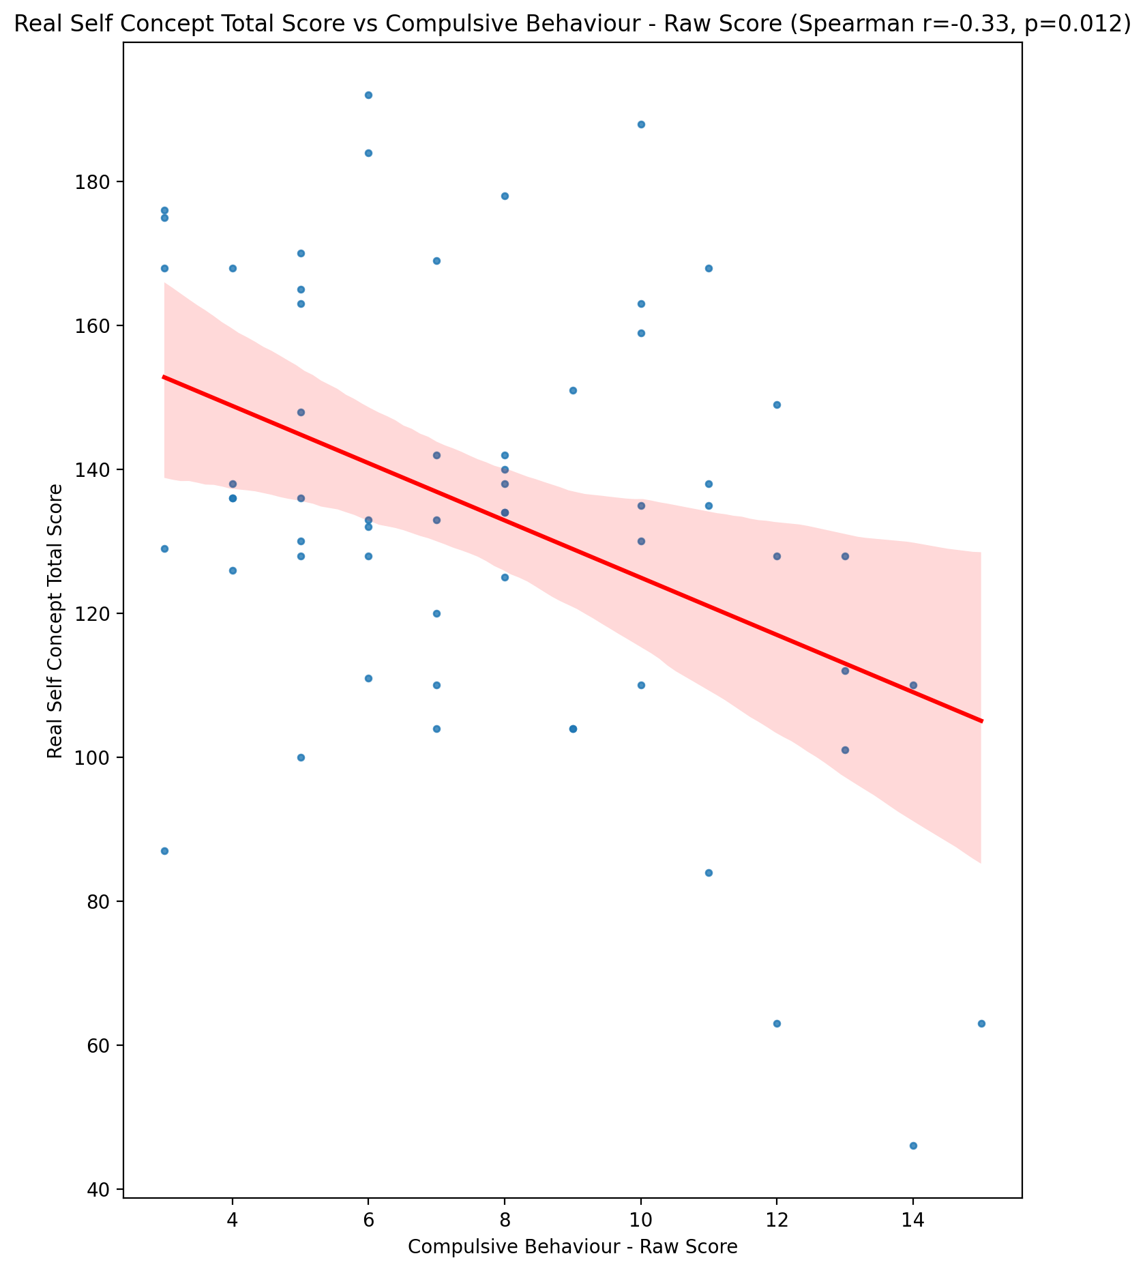

## Ideal Self Concept Total Score vs Compulsive Behaviour - Raw Score

Test: spearman; statistic: -0.2559144090295135; p-value: 0.05042154713763933;

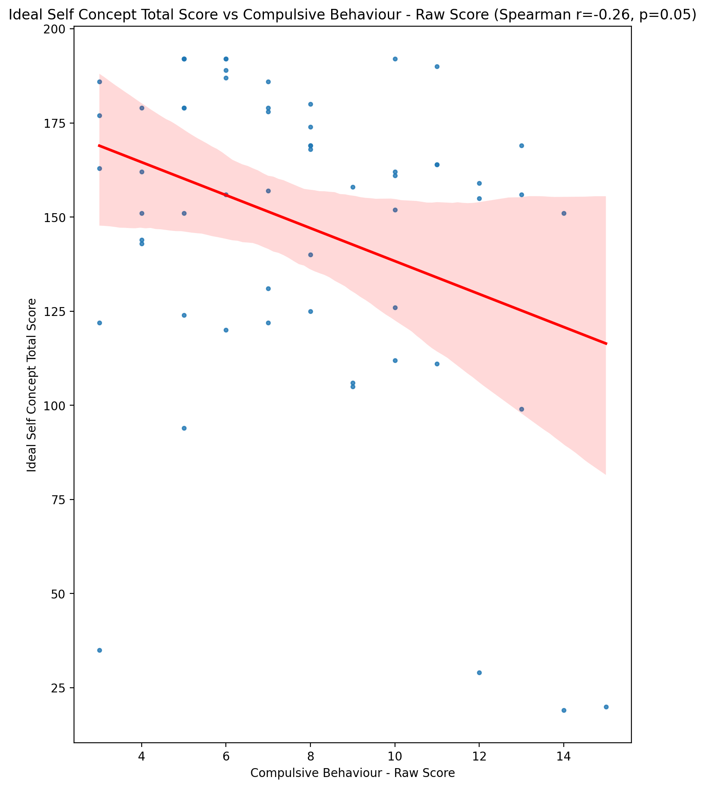

## Social Self Concept Total Score vs Compulsive Behaviour - Raw Score

Test: spearman; statistic: -0.25421963734205477; p-value: 0.05201983673248275;

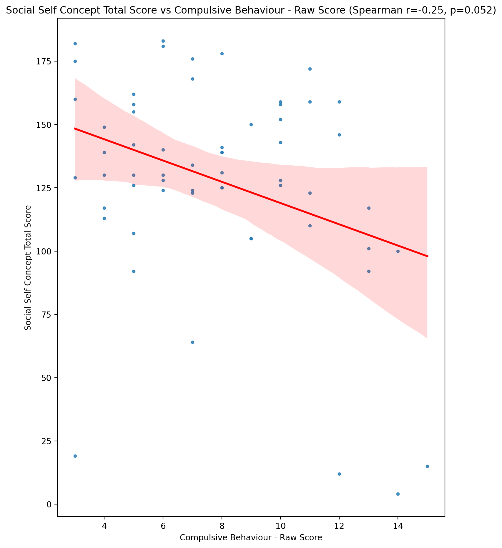

## Ideal Self Concept Total Category vs Compulsive Behaviour - Raw Score

Test: None; statistic: None; p-value: None; Test not run: unsupported type combination.



## Perceived Social Stress Score vs Compulsive Behaviour - Raw Score

Test: spearman; statistic: 0.2100416627279927; p-value: 0.11033052633024948;

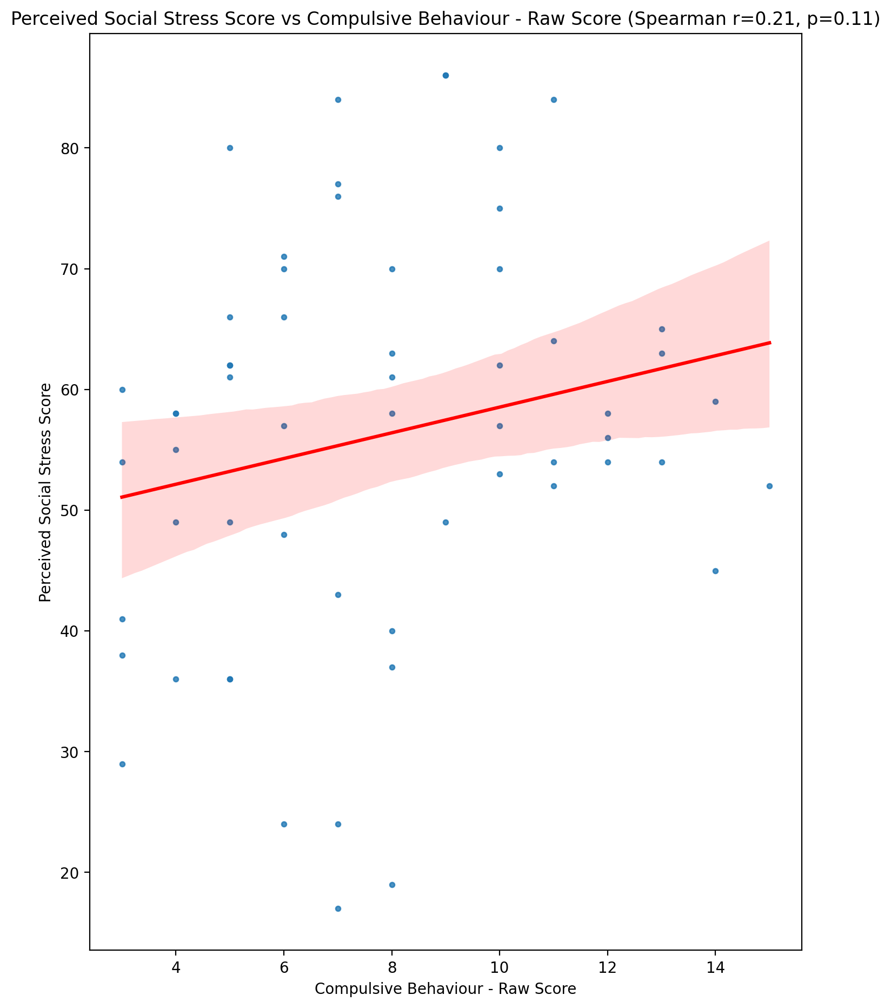

## Perceived Social Stress Category vs Compulsive Behaviour - Raw Score

Test: None; statistic: None; p-value: None; Test not run: unsupported type combination.



## Emotional Support - Raw Score vs Obsession with Internet - Raw Score

Test: spearman; statistic: -0.12132954453890155; p-value: 0.3599828435707494;

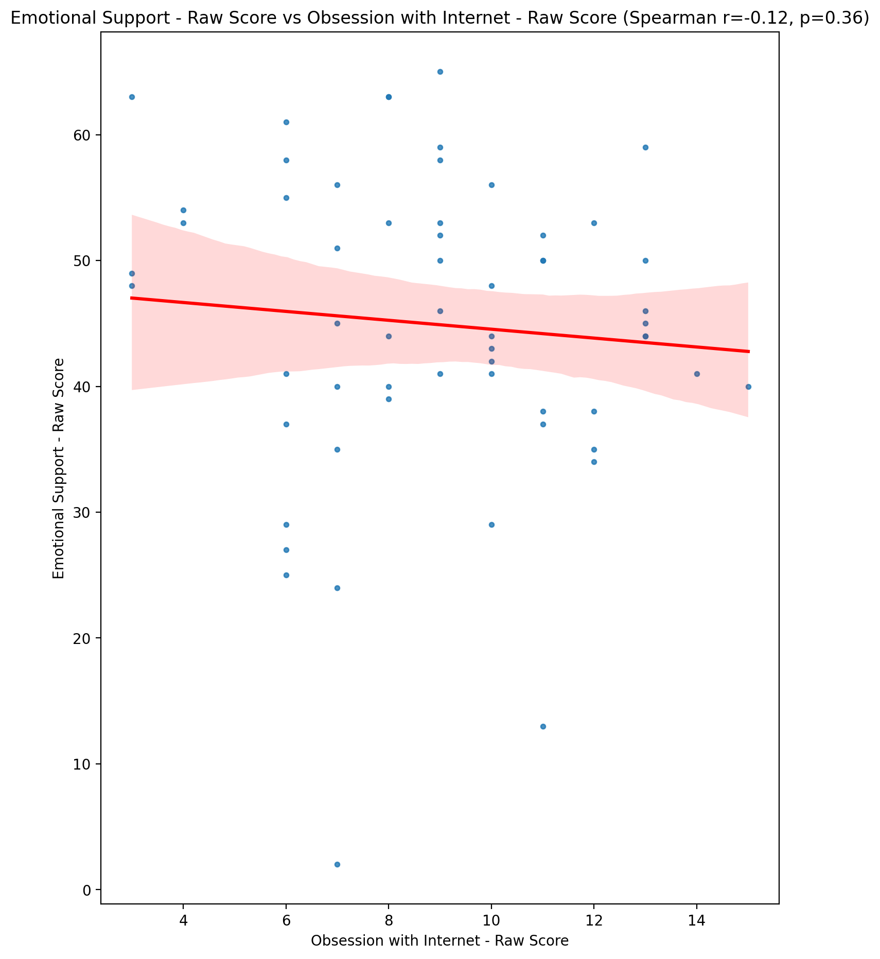

## Informational Support - Raw Score vs Obsession with Internet - Raw Score

Test: spearman; statistic: -0.0847175618094659; p-value: 0.5235040623786278;

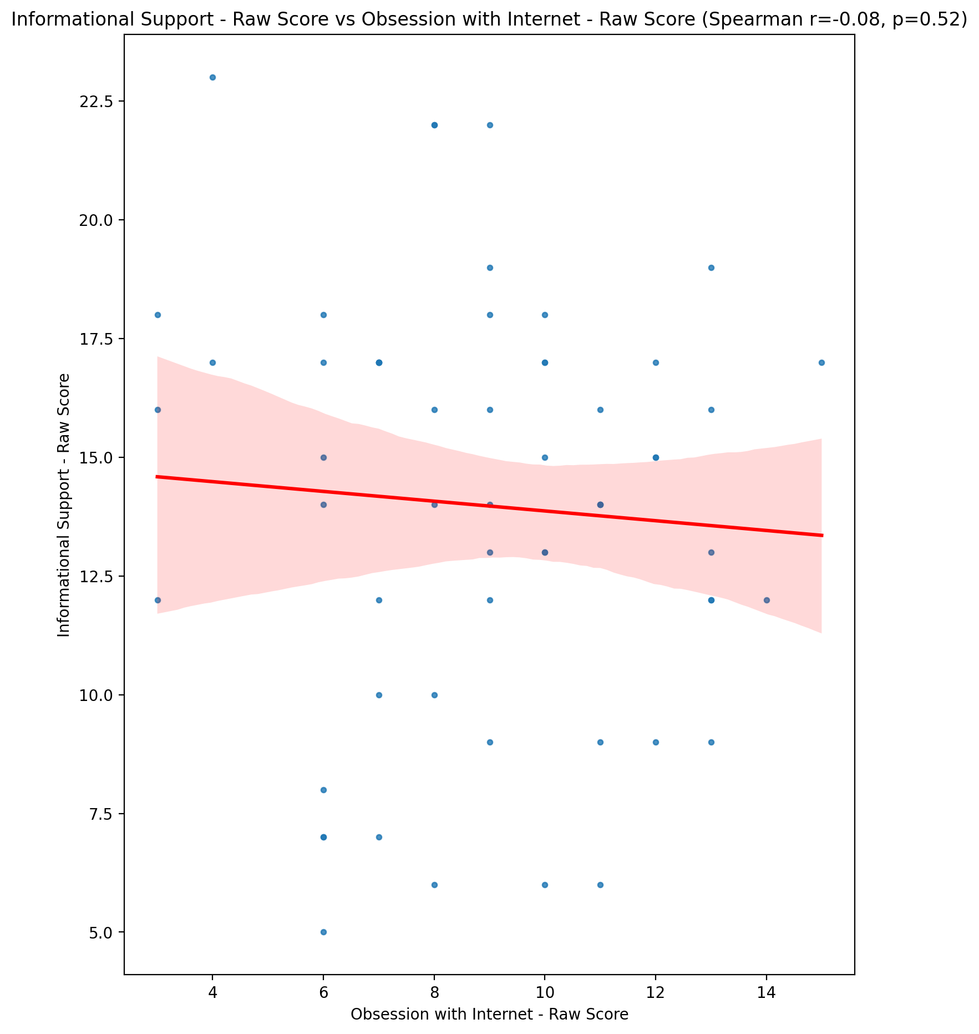

## Instrumental Support - Raw Score vs Obsession with Internet - Raw Score

Test: spearman; statistic: -0.22904501802144334; p-value: 0.08099095741977974;

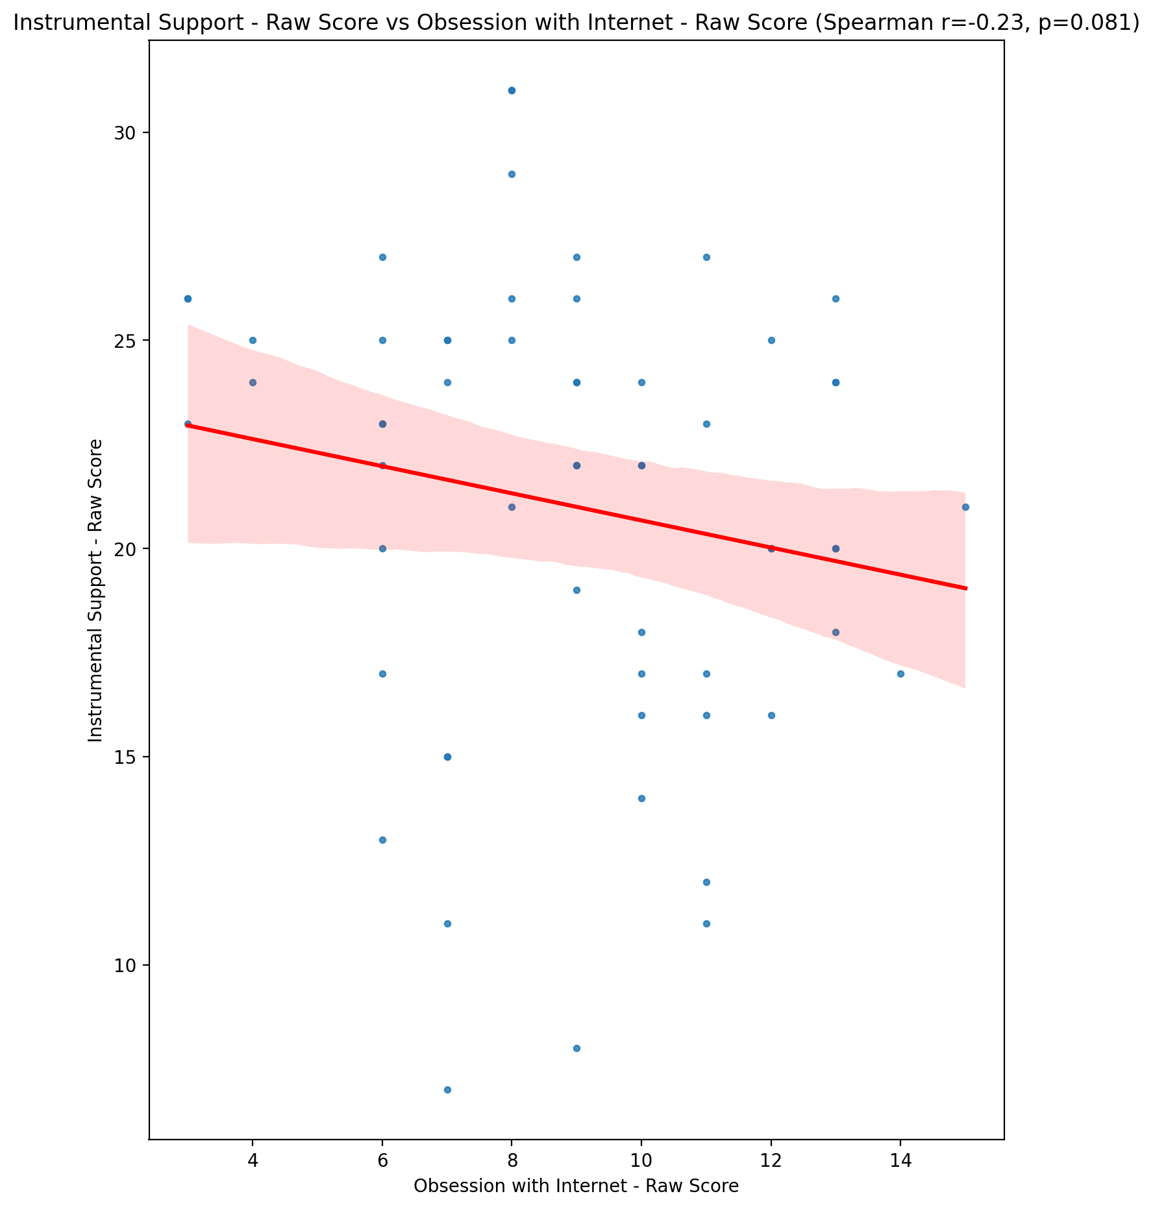

## Emotional Support - T Score vs Obsession with Internet - Raw Score

Test: spearman; statistic: -0.11842218000141554; p-value: 0.3716940131864309;

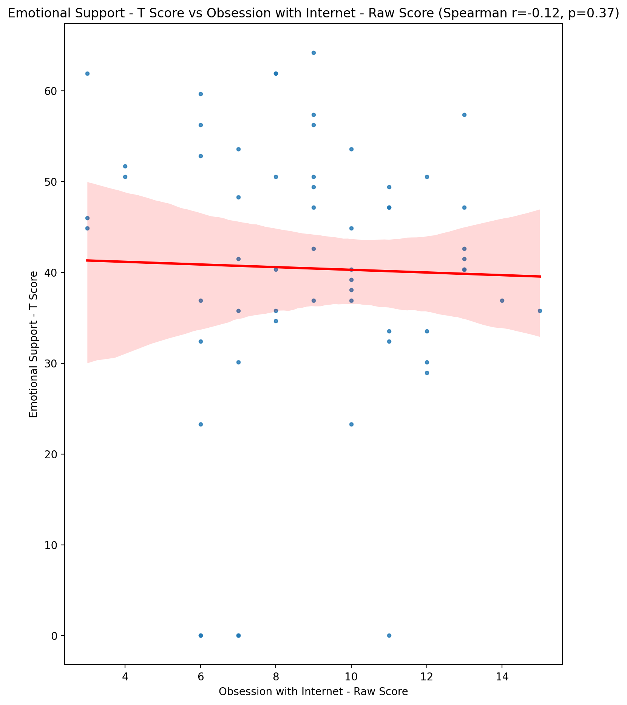

## Informational Support - T Score vs Obsession with Internet - Raw Score

Test: spearman; statistic: -0.07860468746888877; p-value: 0.5540029766498347;

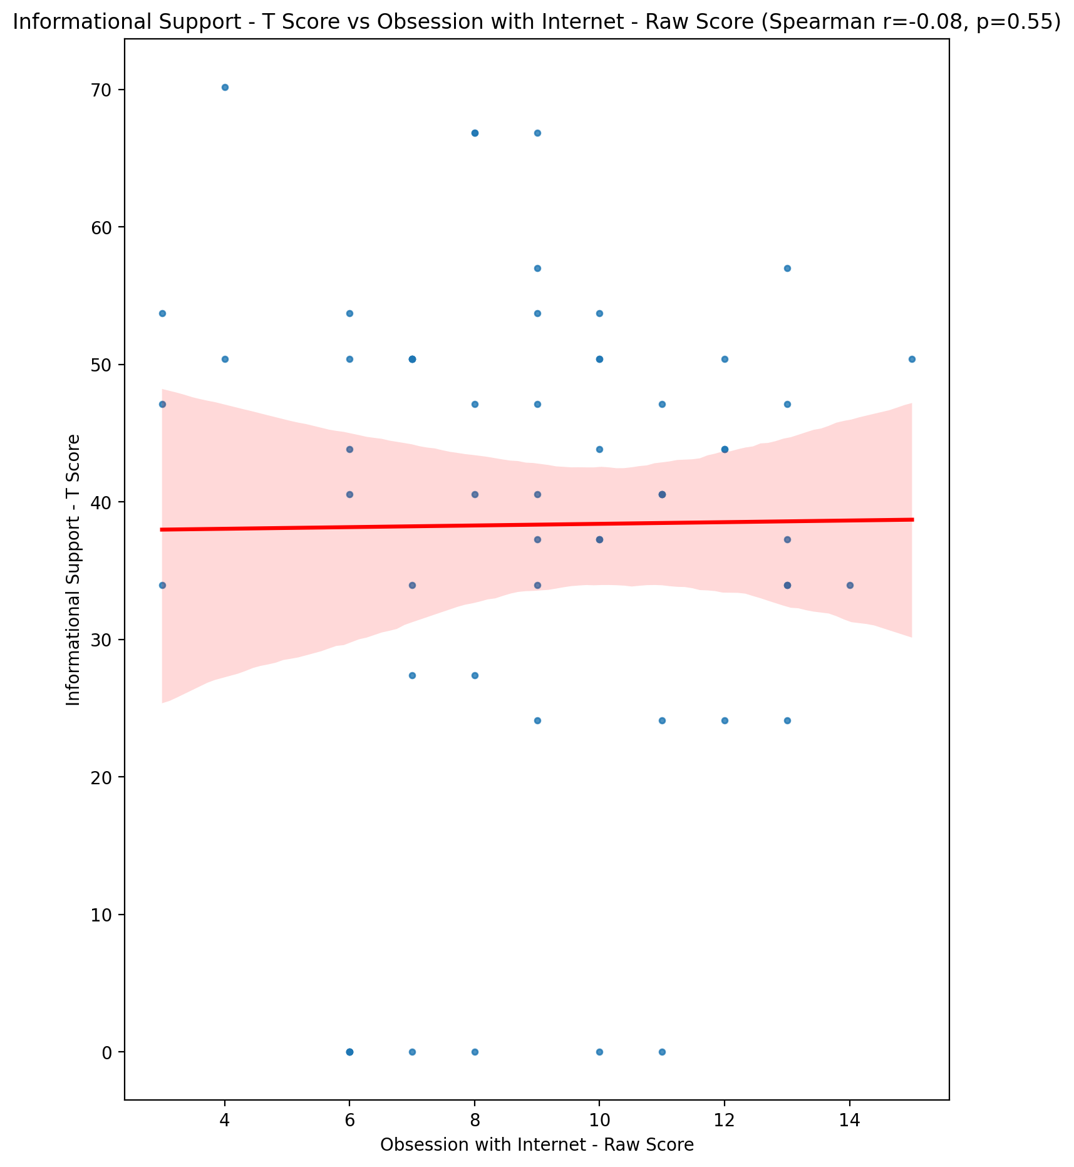

## Instrumental Support - T Score vs Obsession with Internet - Raw Score

Test: spearman; statistic: -0.22929220596281266; p-value: 0.08065467928555597;

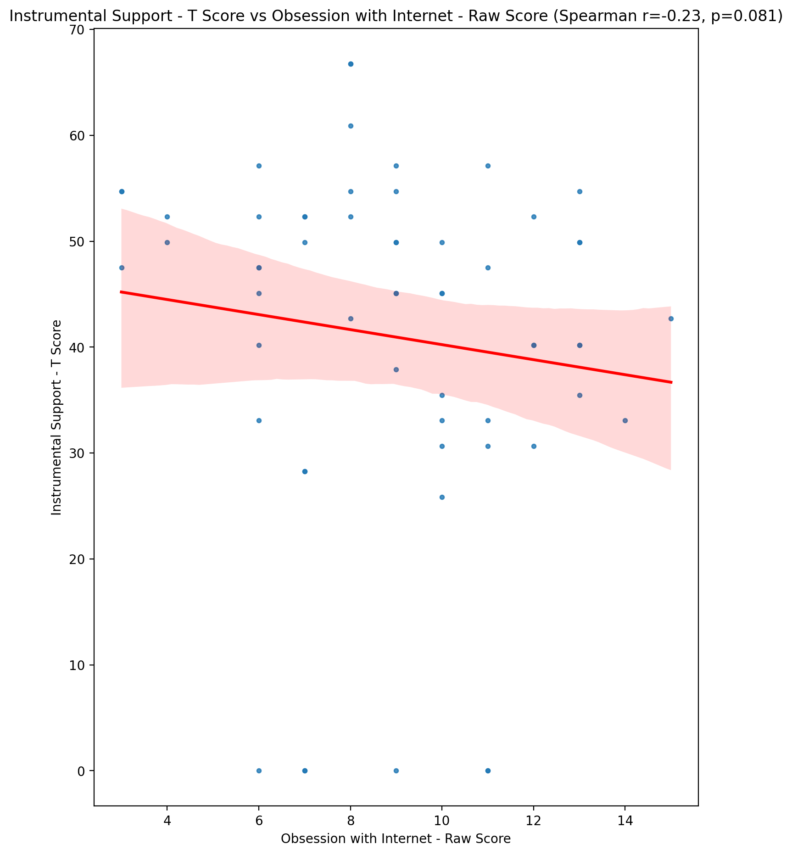

## Perceived Social Support Total T Score vs Obsession with Internet - Raw Score

Test: spearman; statistic: -0.18076045822174283; p-value: 0.17066942455415163;

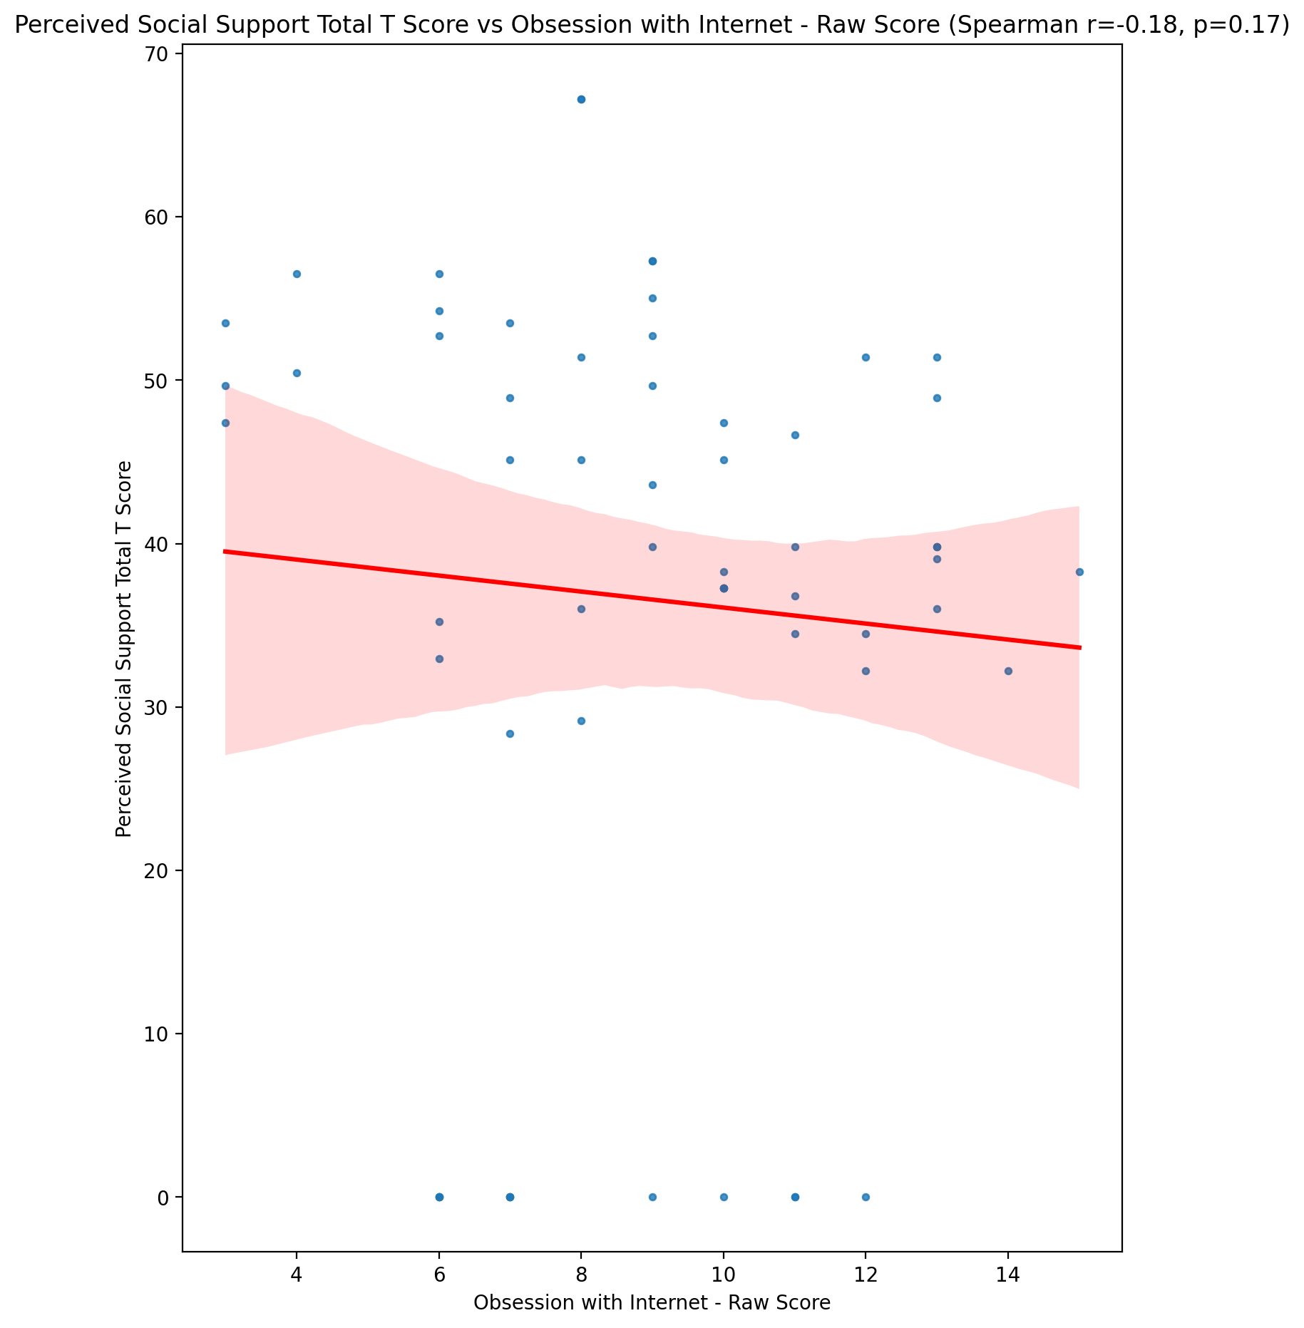

## Emotional Support - Rank vs Obsession with Internet - Raw Score

Test: None; statistic: None; p-value: None; Test not run: unsupported type combination.



## Informational Support - Rank vs Obsession with Internet - Raw Score

Test: None; statistic: None; p-value: None; Test not run: unsupported type combination.



## Instrumental Support - Rank vs Obsession with Internet - Raw Score

Test: None; statistic: None; p-value: None; Test not run: unsupported type combination.



## Perceived Social Support TOTAL - Rank vs Obsession with Internet - Raw Score

Test: None; statistic: None; p-value: None; Test not run: unsupported type combination.



## Power Self Concept - Real Self Concept Score vs Obsession with Internet - Raw Score

Test: spearman; statistic: -0.1794743624333148; p-value: 0.17378373336033143;

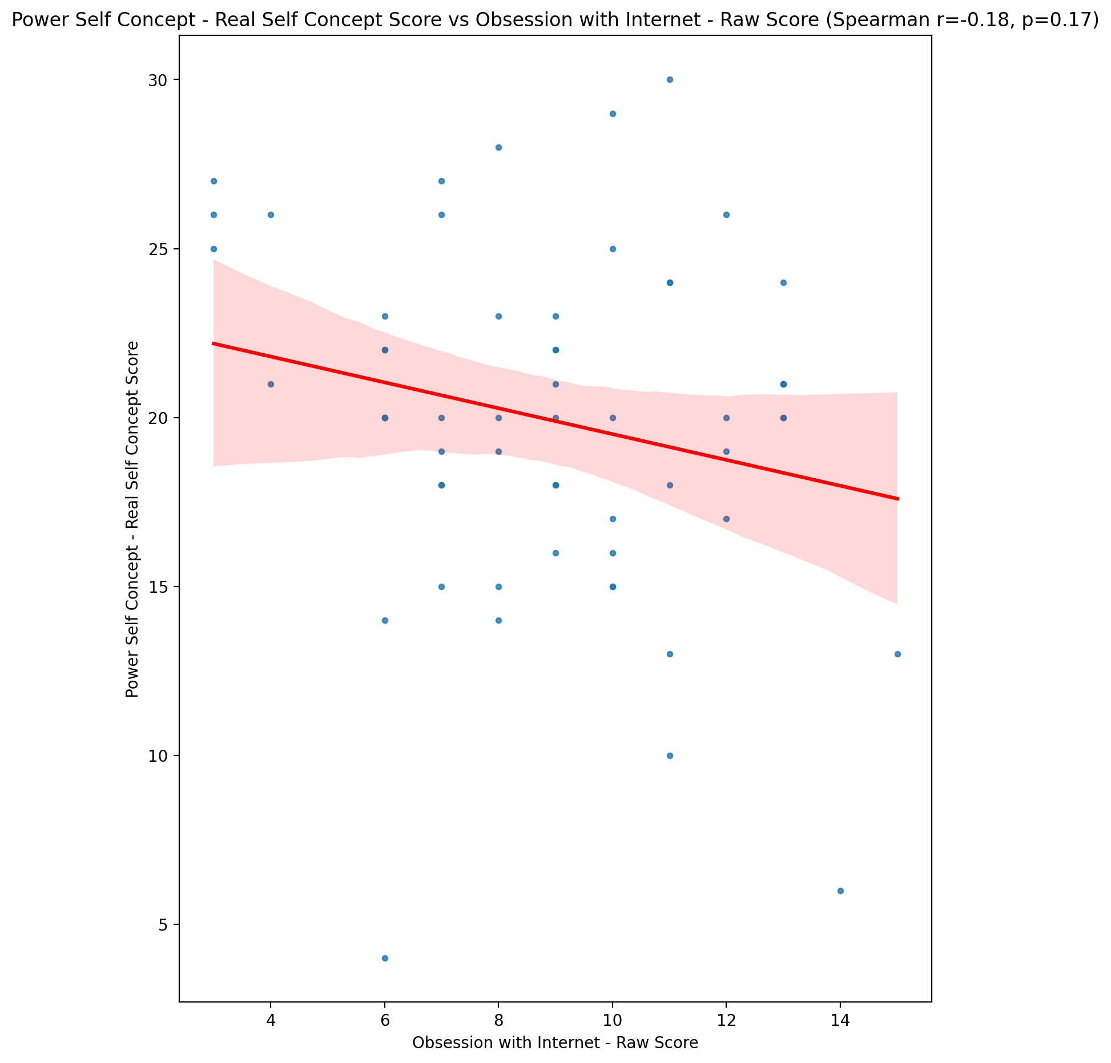

## Power Self Concept - Ideal Self Concept score vs Obsession with Internet - Raw Score

Test: spearman; statistic: -0.15275925179676395; p-value: 0.248067951813523;

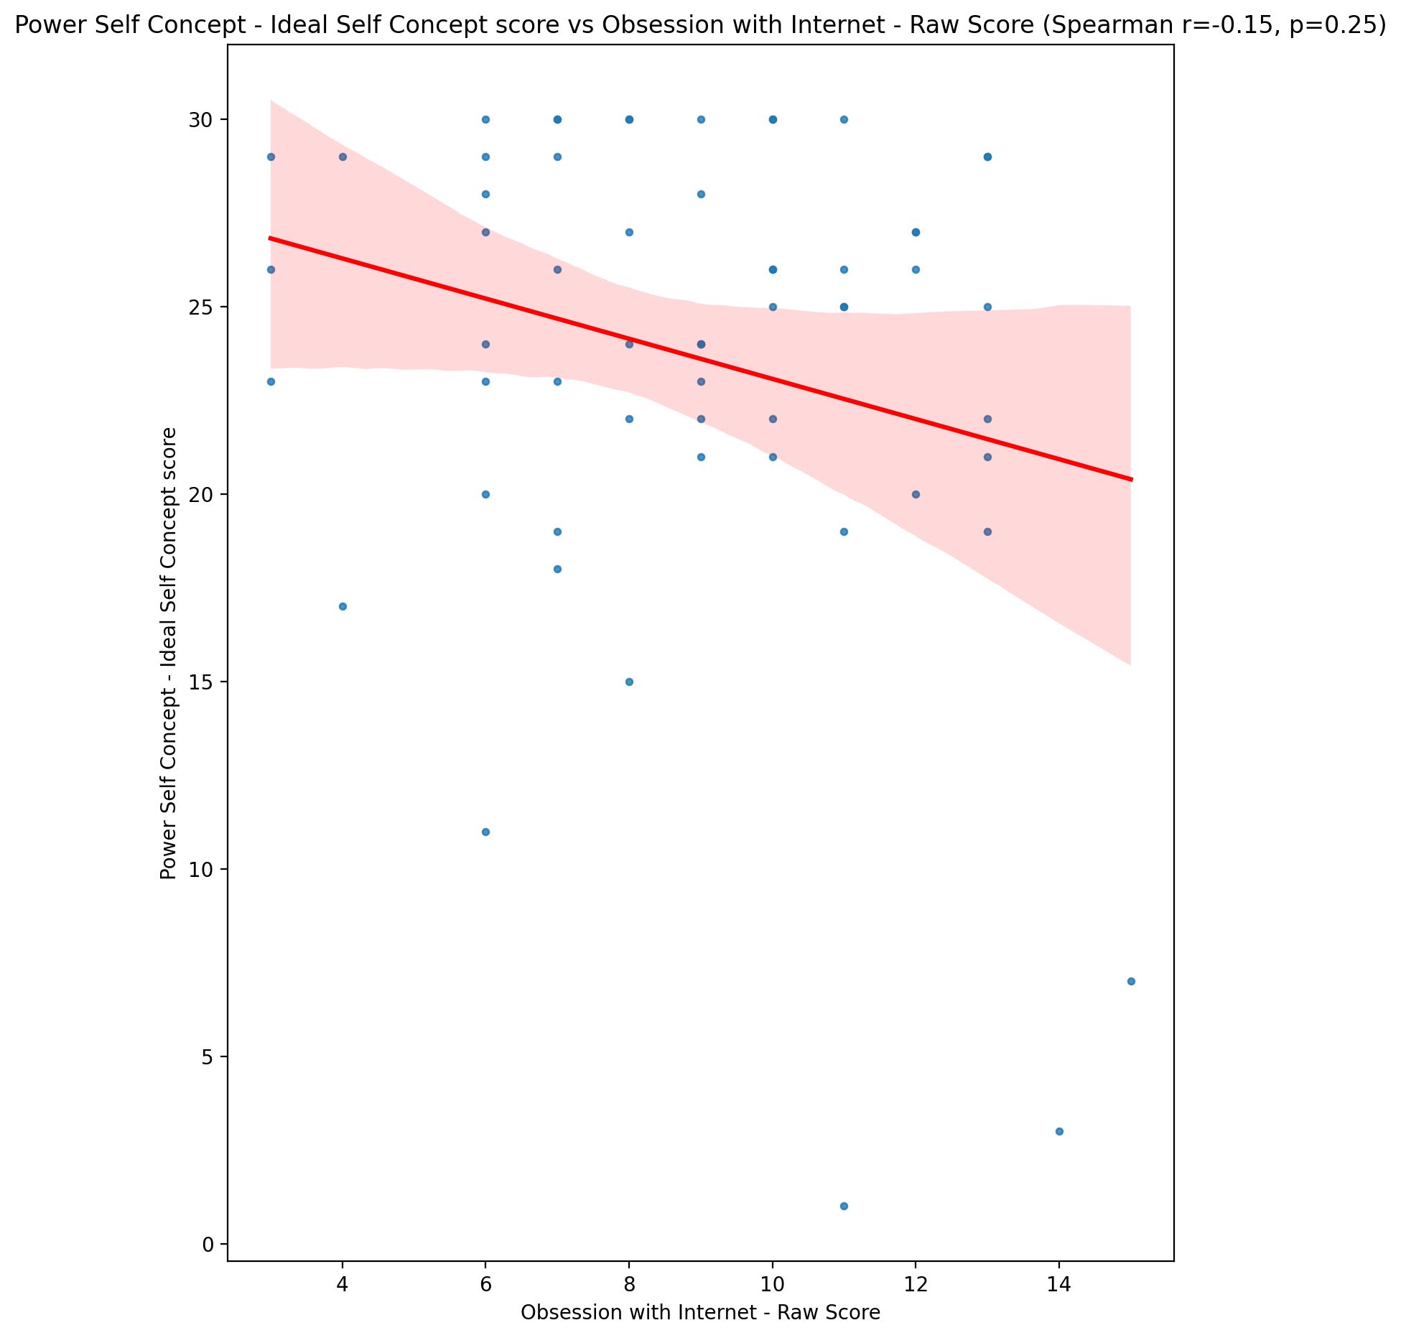

## Power Self Concept – Social Self Concept Score vs Obsession with Internet - Raw Score

Test: spearman; statistic: -0.17488391051460728; p-value: 0.18523648084041286;

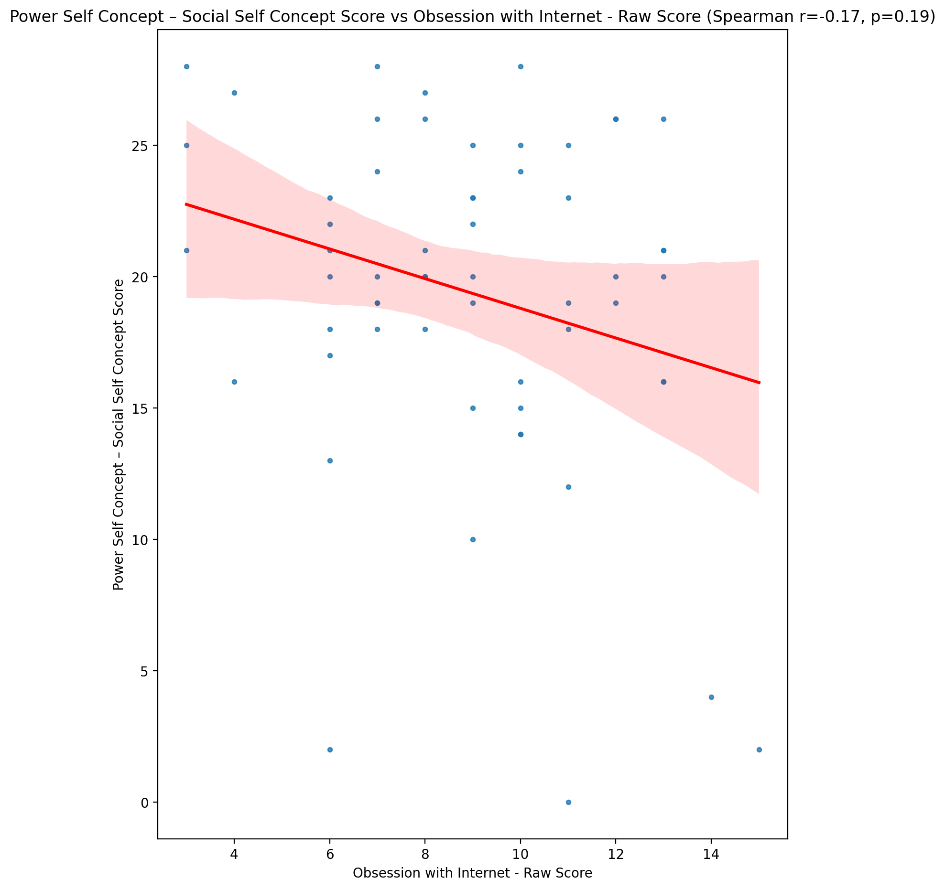

## Social Self Concept - Real Self Concept Score vs Obsession with Internet - Raw Score

Test: spearman; statistic: -0.17082325949518734; p-value: 0.19581194442073707;

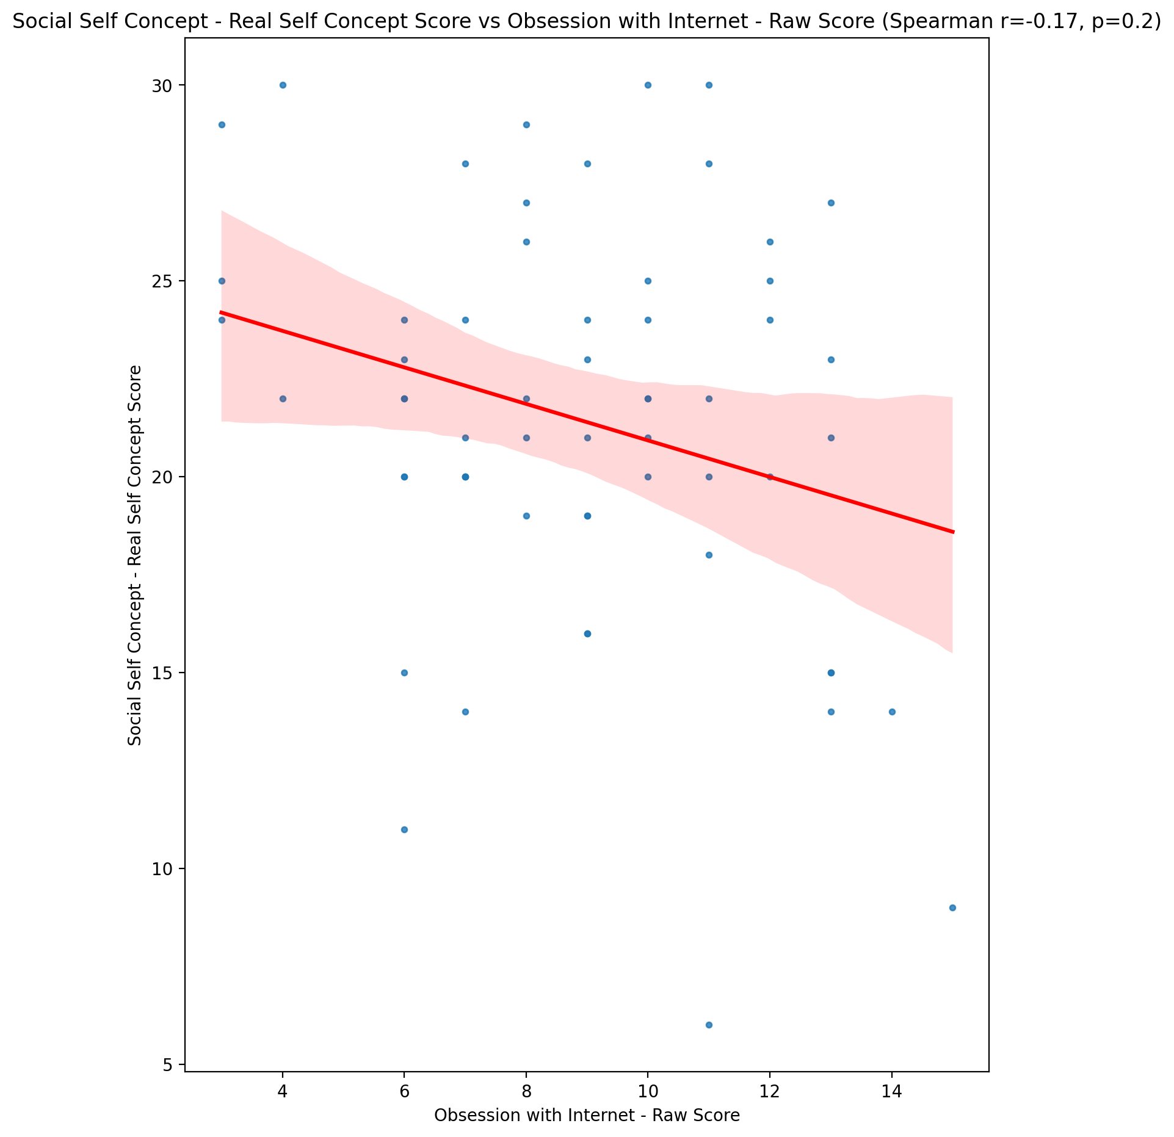

## Social Self Concept – Social Self Concept Score vs Obsession with Internet - Raw Score

Test: spearman; statistic: -0.16623710327082586; p-value: 0.2082659802771406;

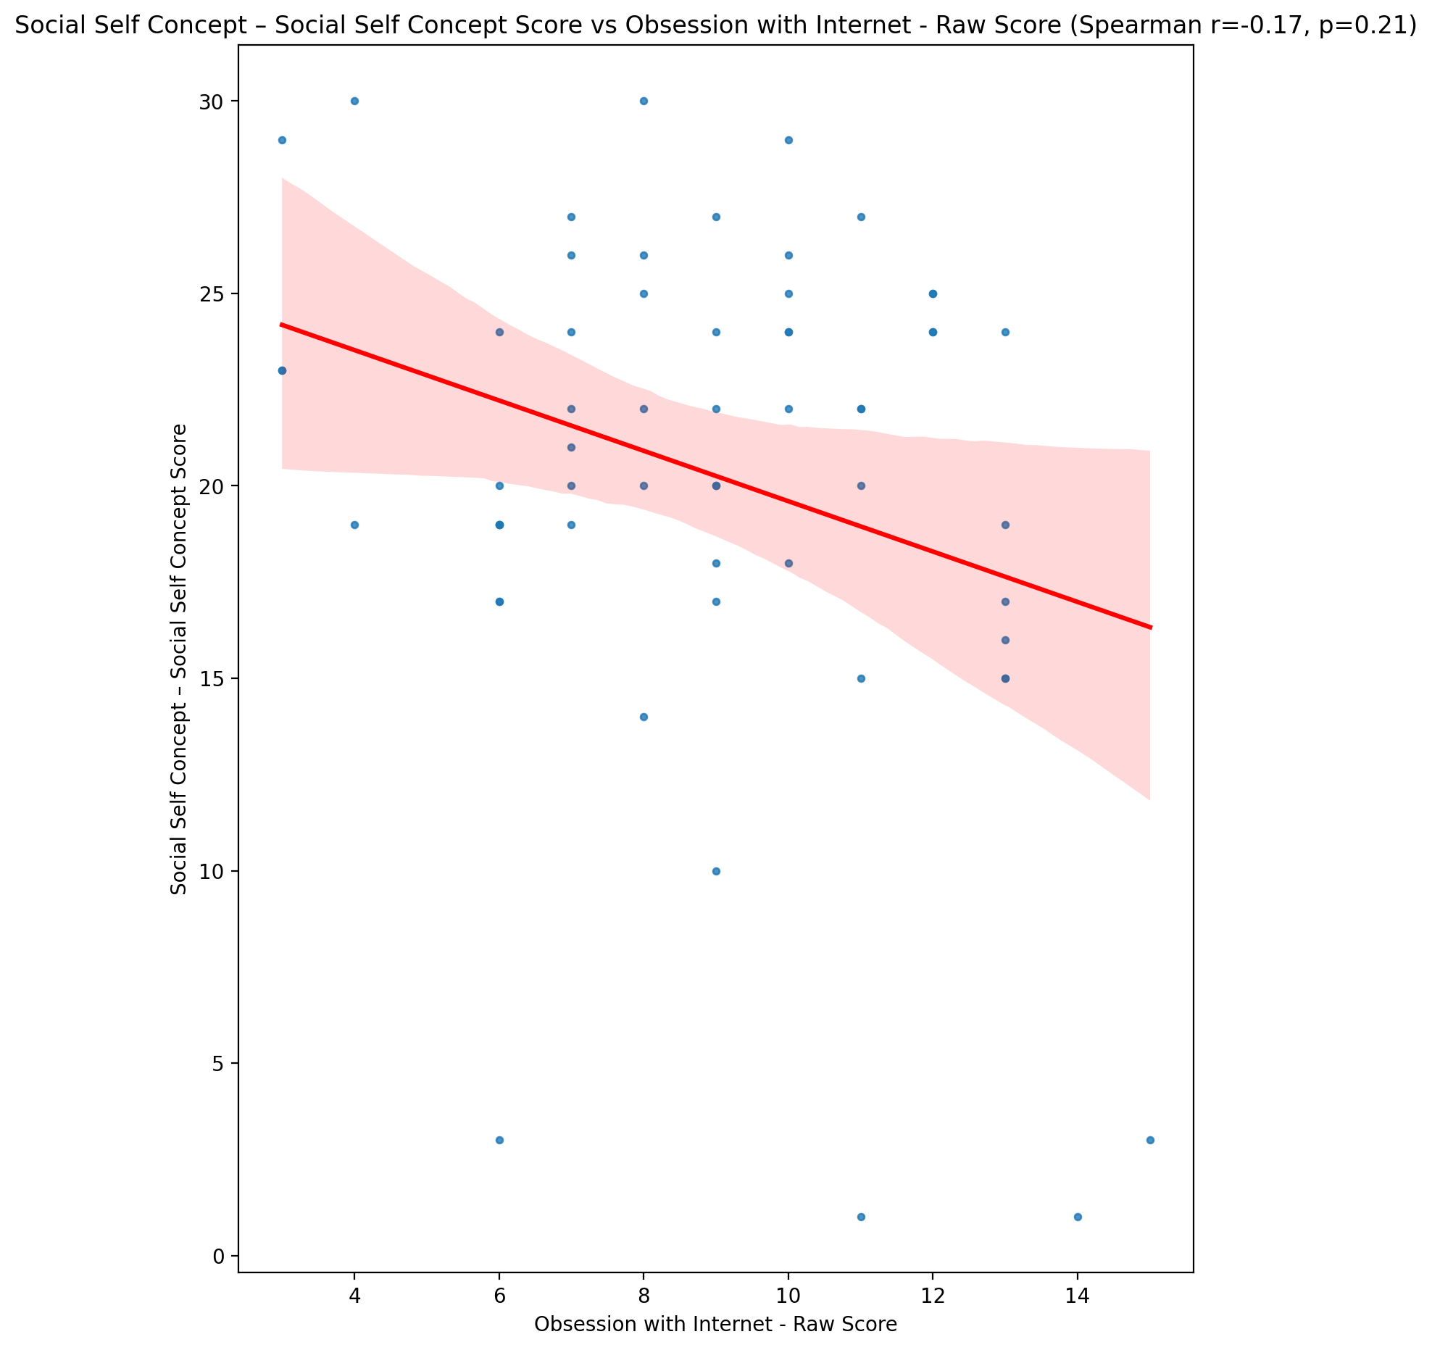

## Ability Self Concept - Real Self Concept Score vs Obsession with Internet - Raw Score

Test: spearman; statistic: -0.1502378363127206; p-value: 0.2560535669833141;

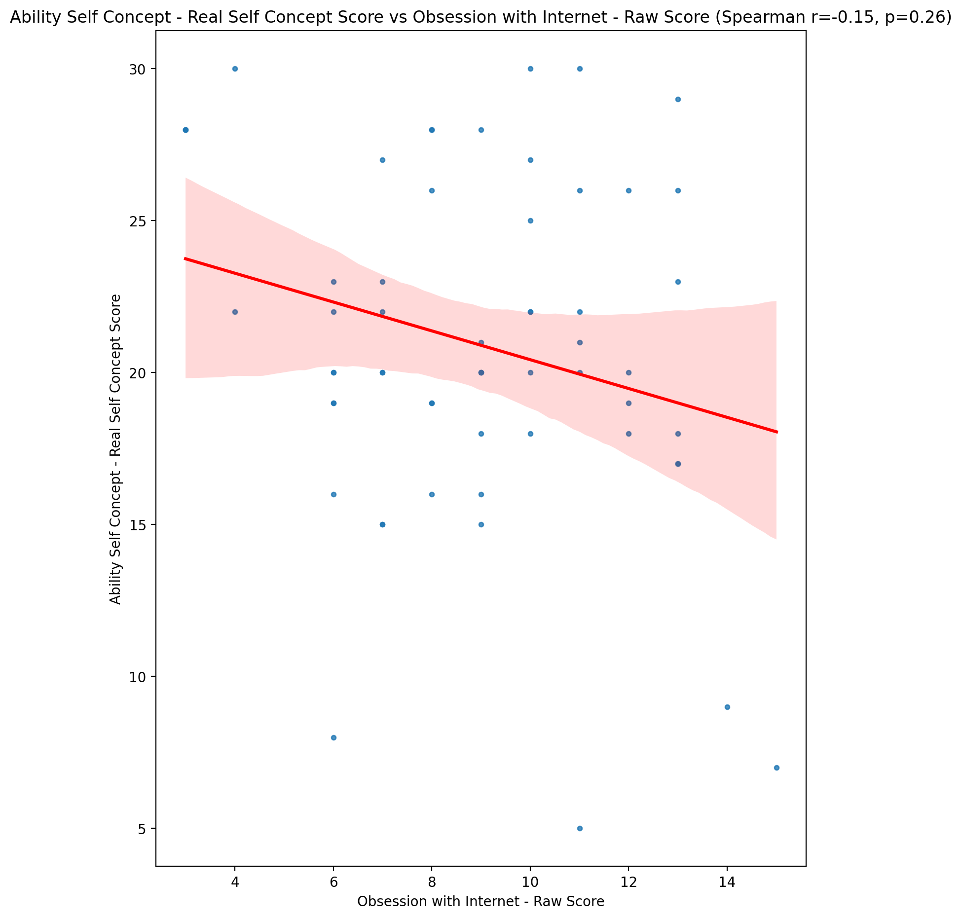

## Ability Self Concept - Ideal Self Concept Score vs Obsession with Internet - Raw Score

Test: spearman; statistic: -0.17276265231748691; p-value: 0.1907085338280812;

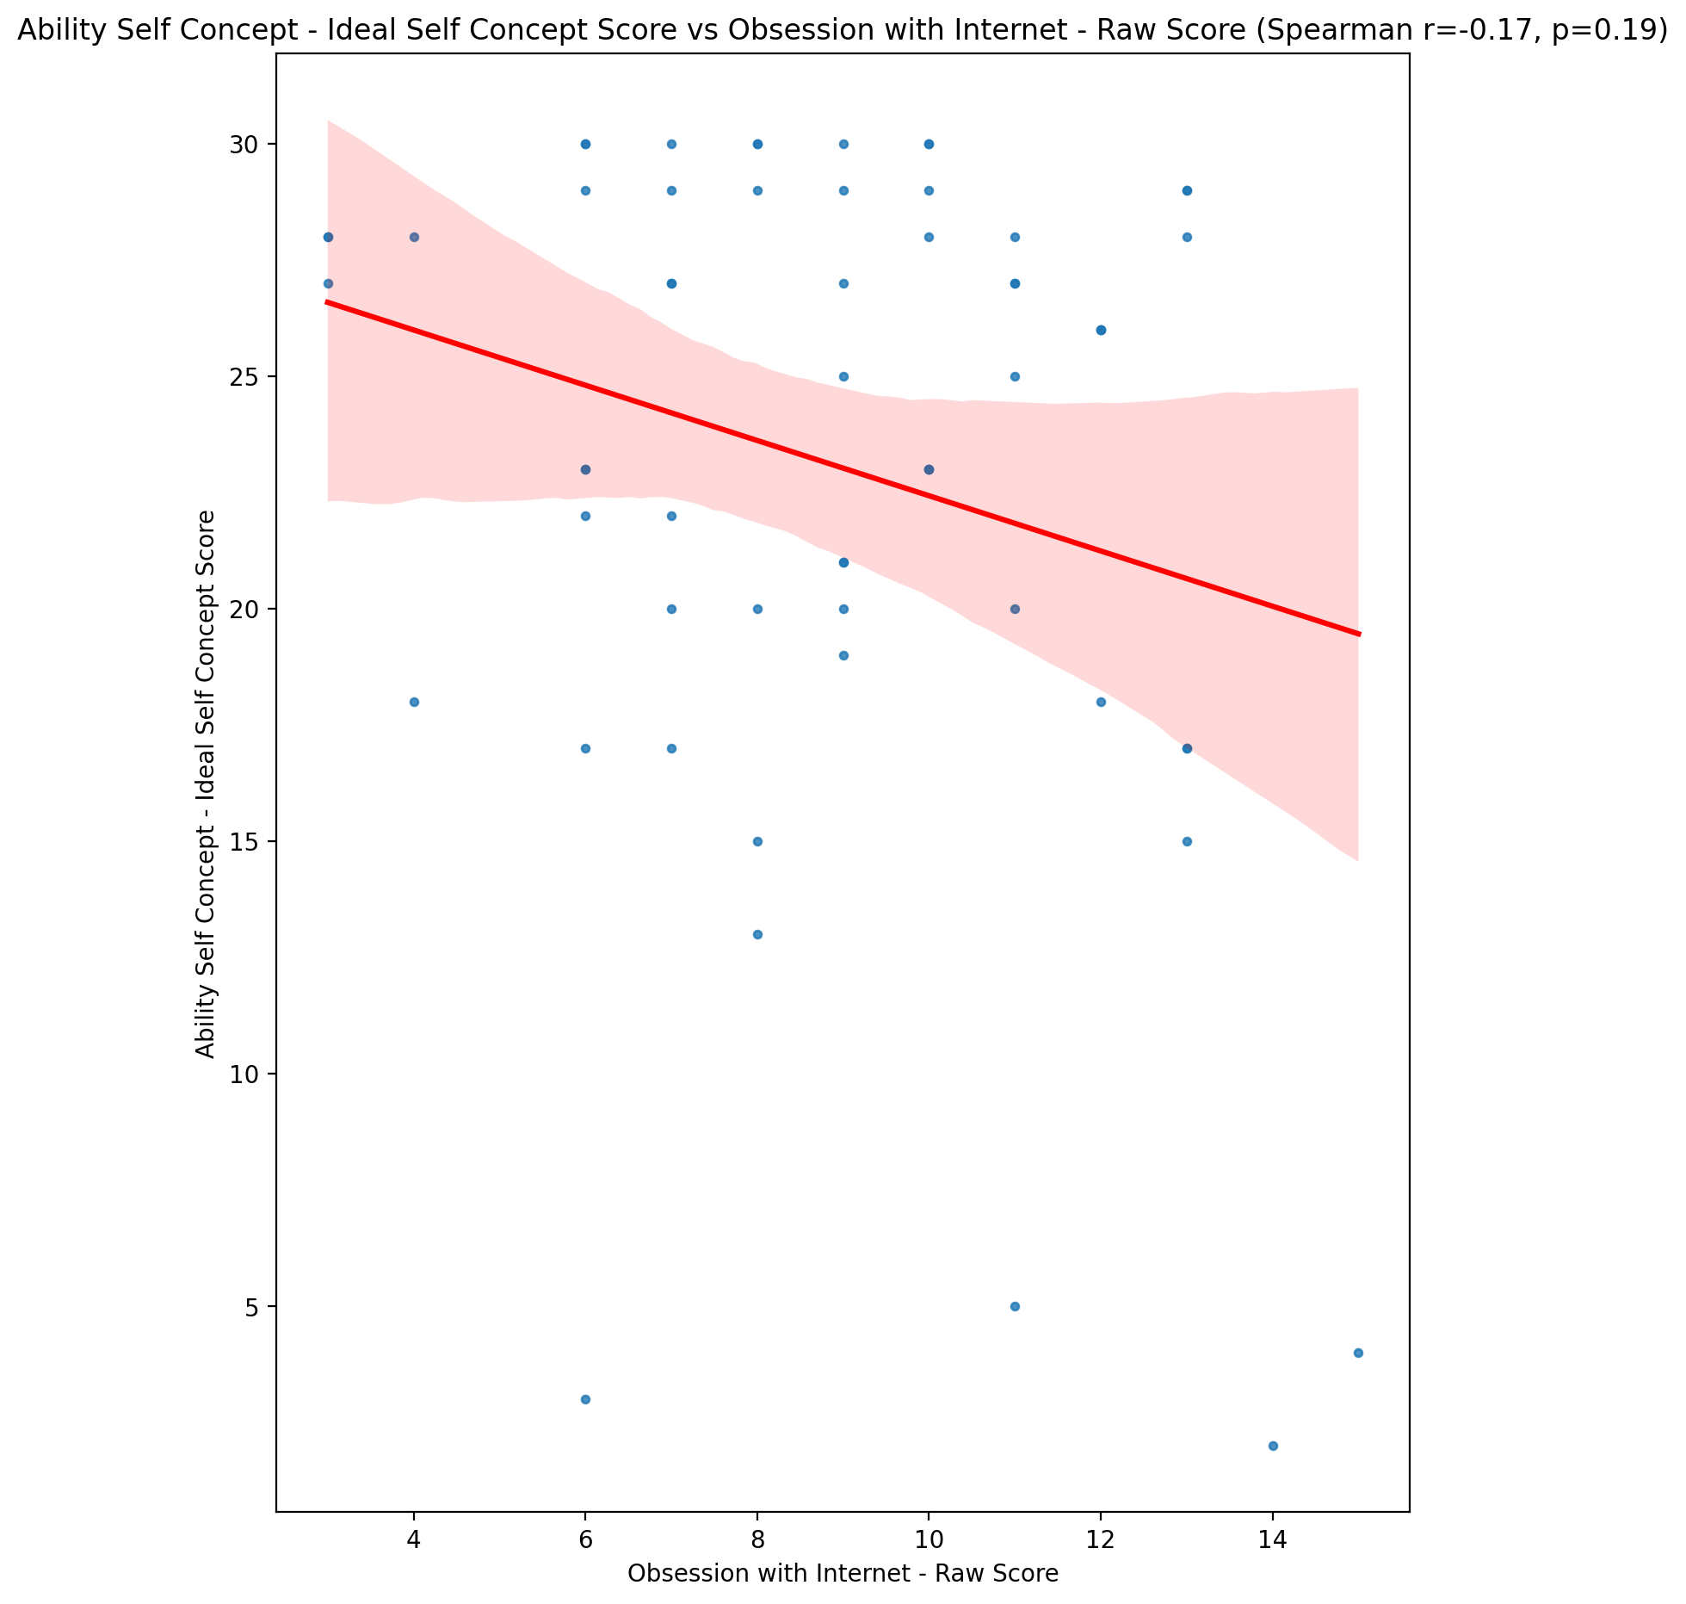

## Ability Self Concept – Social Self Concept Score vs Obsession with Internet - Raw Score

Test: spearman; statistic: -0.15685101867711515; p-value: 0.23547314219774504;

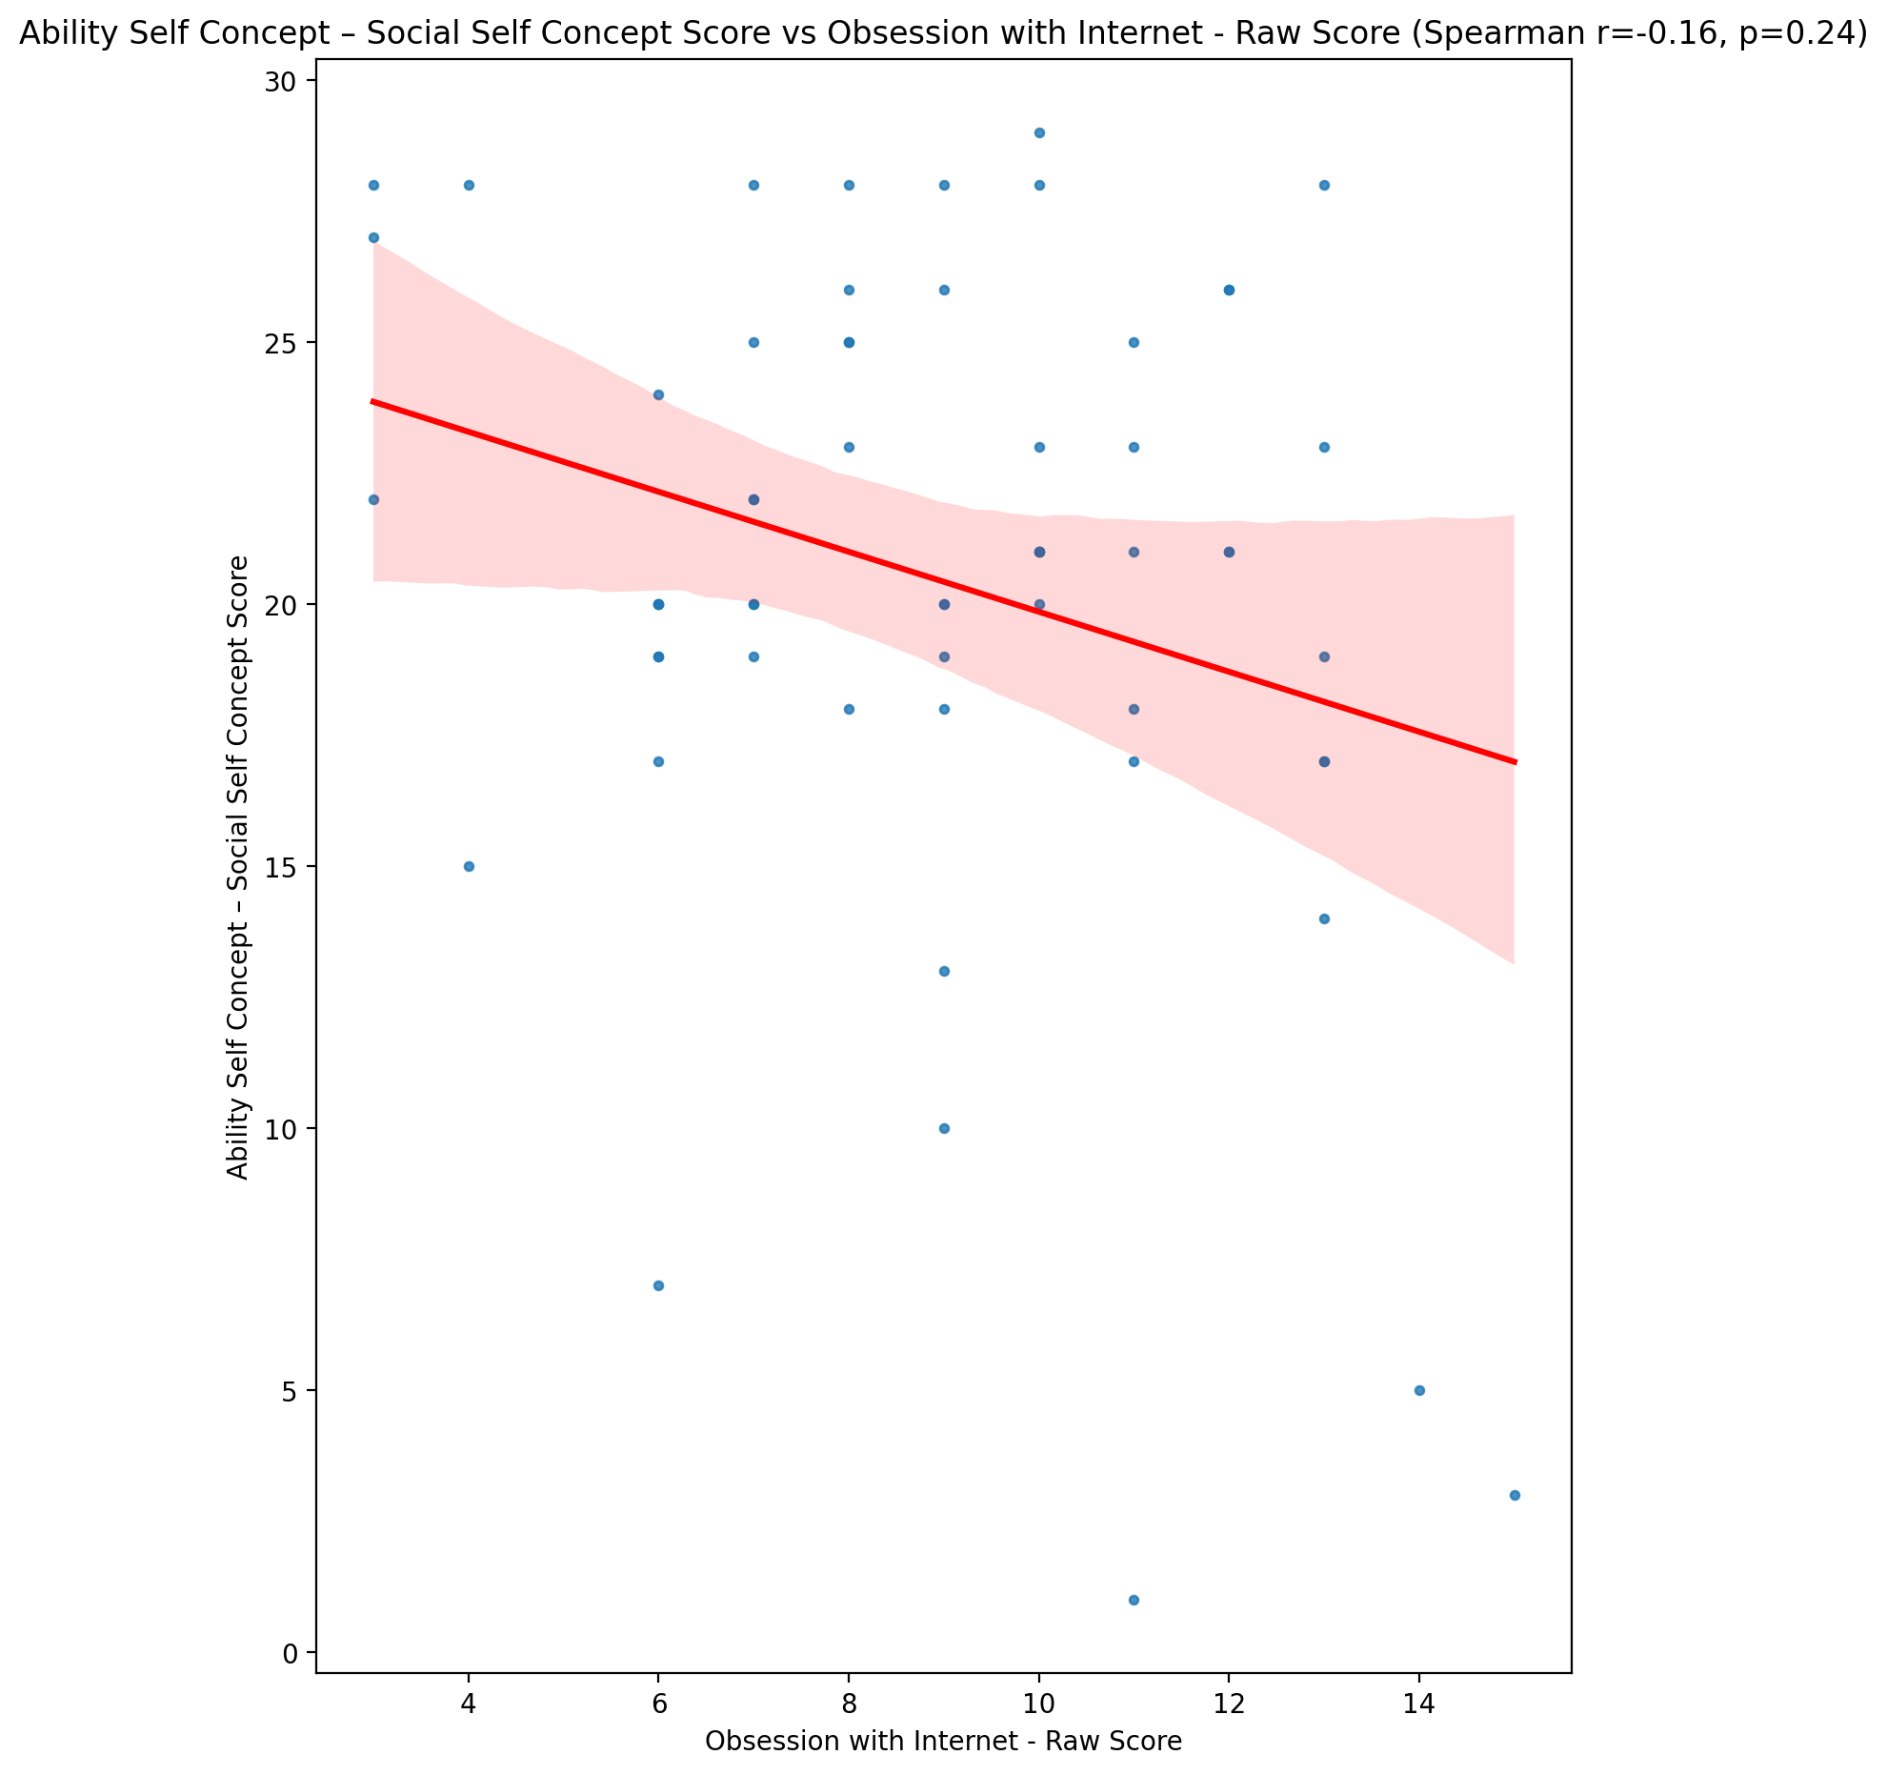

## Physical Self Concept - Real Self Concept Score vs Obsession with Internet - Raw Score

Test: spearman; statistic: -0.21638760486795774; p-value: 0.09974126880808742;

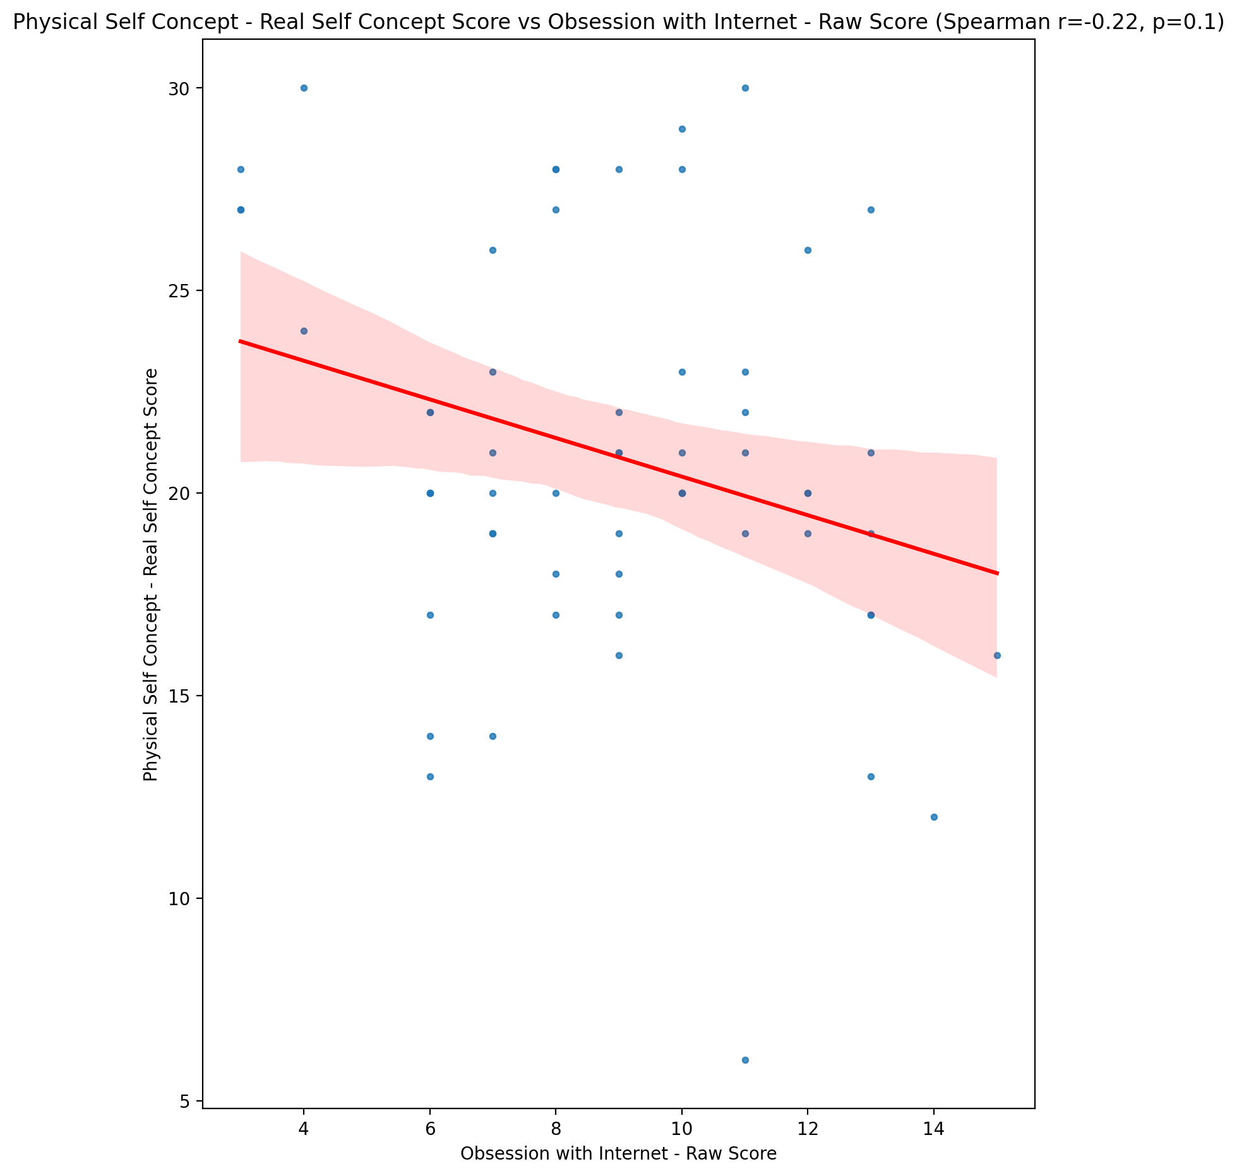

## Physical Self Concept – Ideal Self Concept Score vs Obsession with Internet - Raw Score

Test: spearman; statistic: -0.1578295140333036; p-value: 0.2325277184457201;

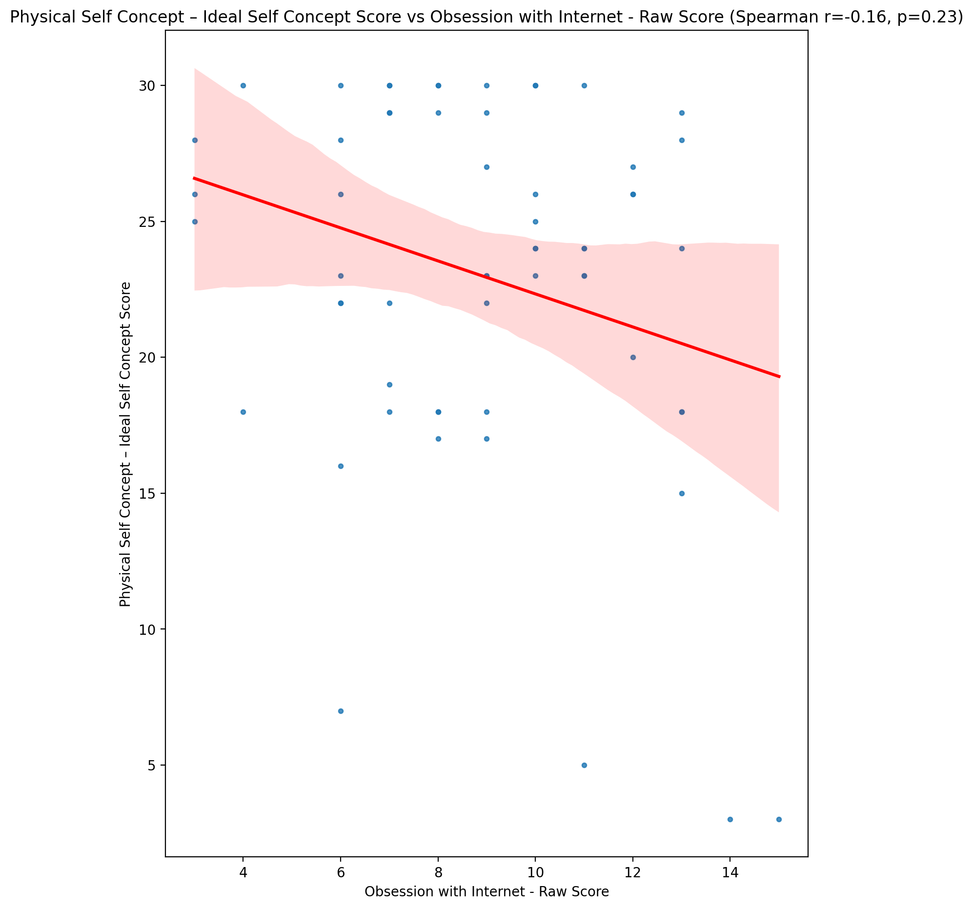

## Physical Self Concept – Social Self Concept Score vs Obsession with Internet - Raw Score

Test: spearman; statistic: -0.18958438281579082; p-value: 0.1503923697950966;

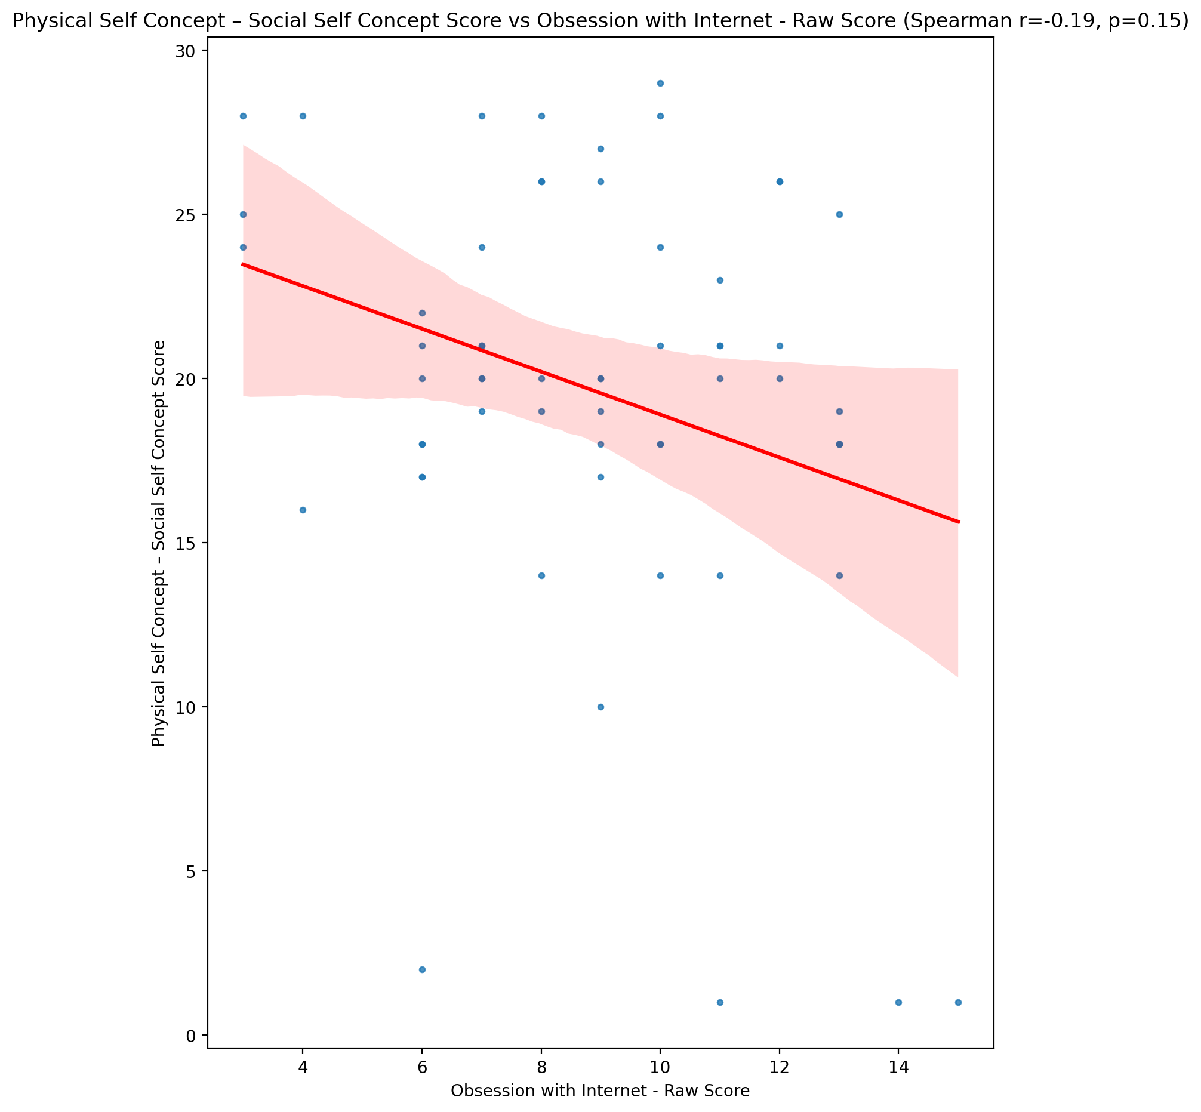

## Psychological Self Concept - Real Self Concept Score vs Obsession with Internet - Raw Score

Test: spearman; statistic: -0.24342895937289935; p-value: 0.06318869811755788;

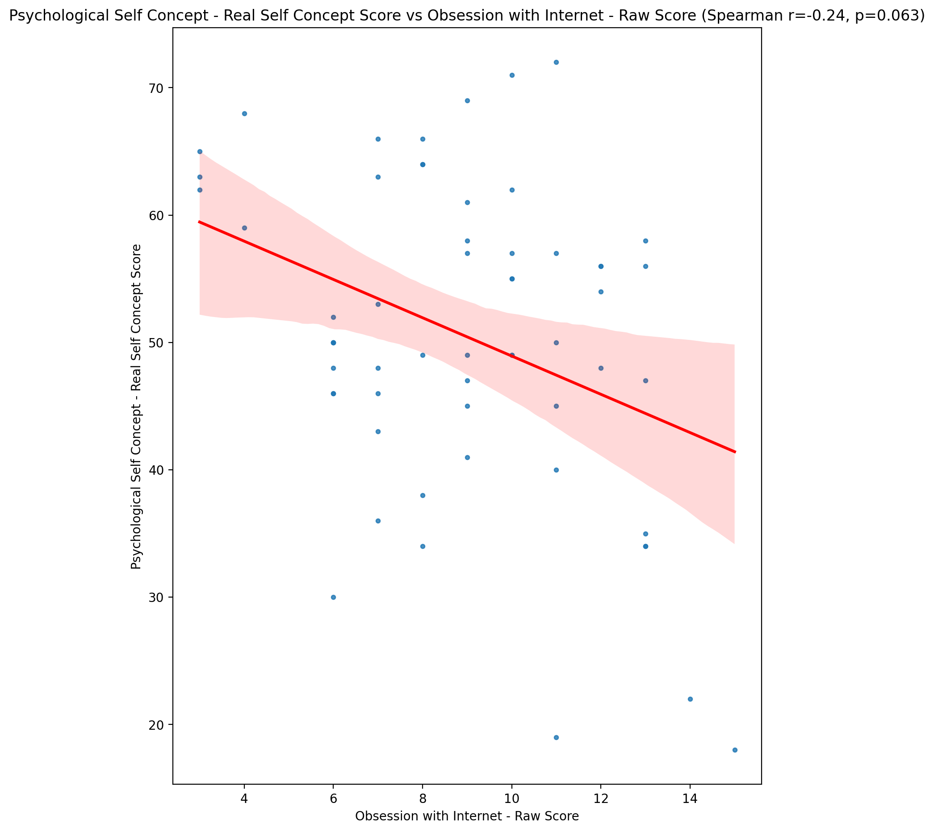

## Psychological Self Concept – Ideal Self Concept Score vs Obsession with Internet - Raw Score

Test: spearman; statistic: -0.18505089374839523; p-value: 0.16057449042506736;

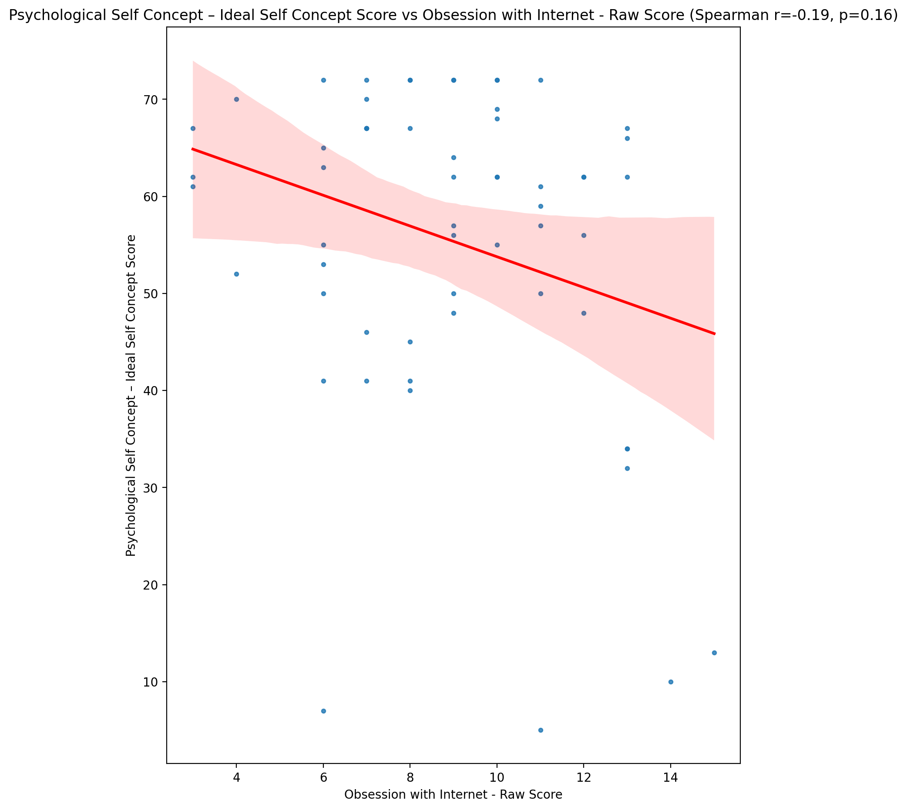

## Psychological Self Concept – Social Self Concept Score vs Obsession with Internet - Raw Score

Test: spearman; statistic: -0.24225522003765895; p-value: 0.0645118639588118;

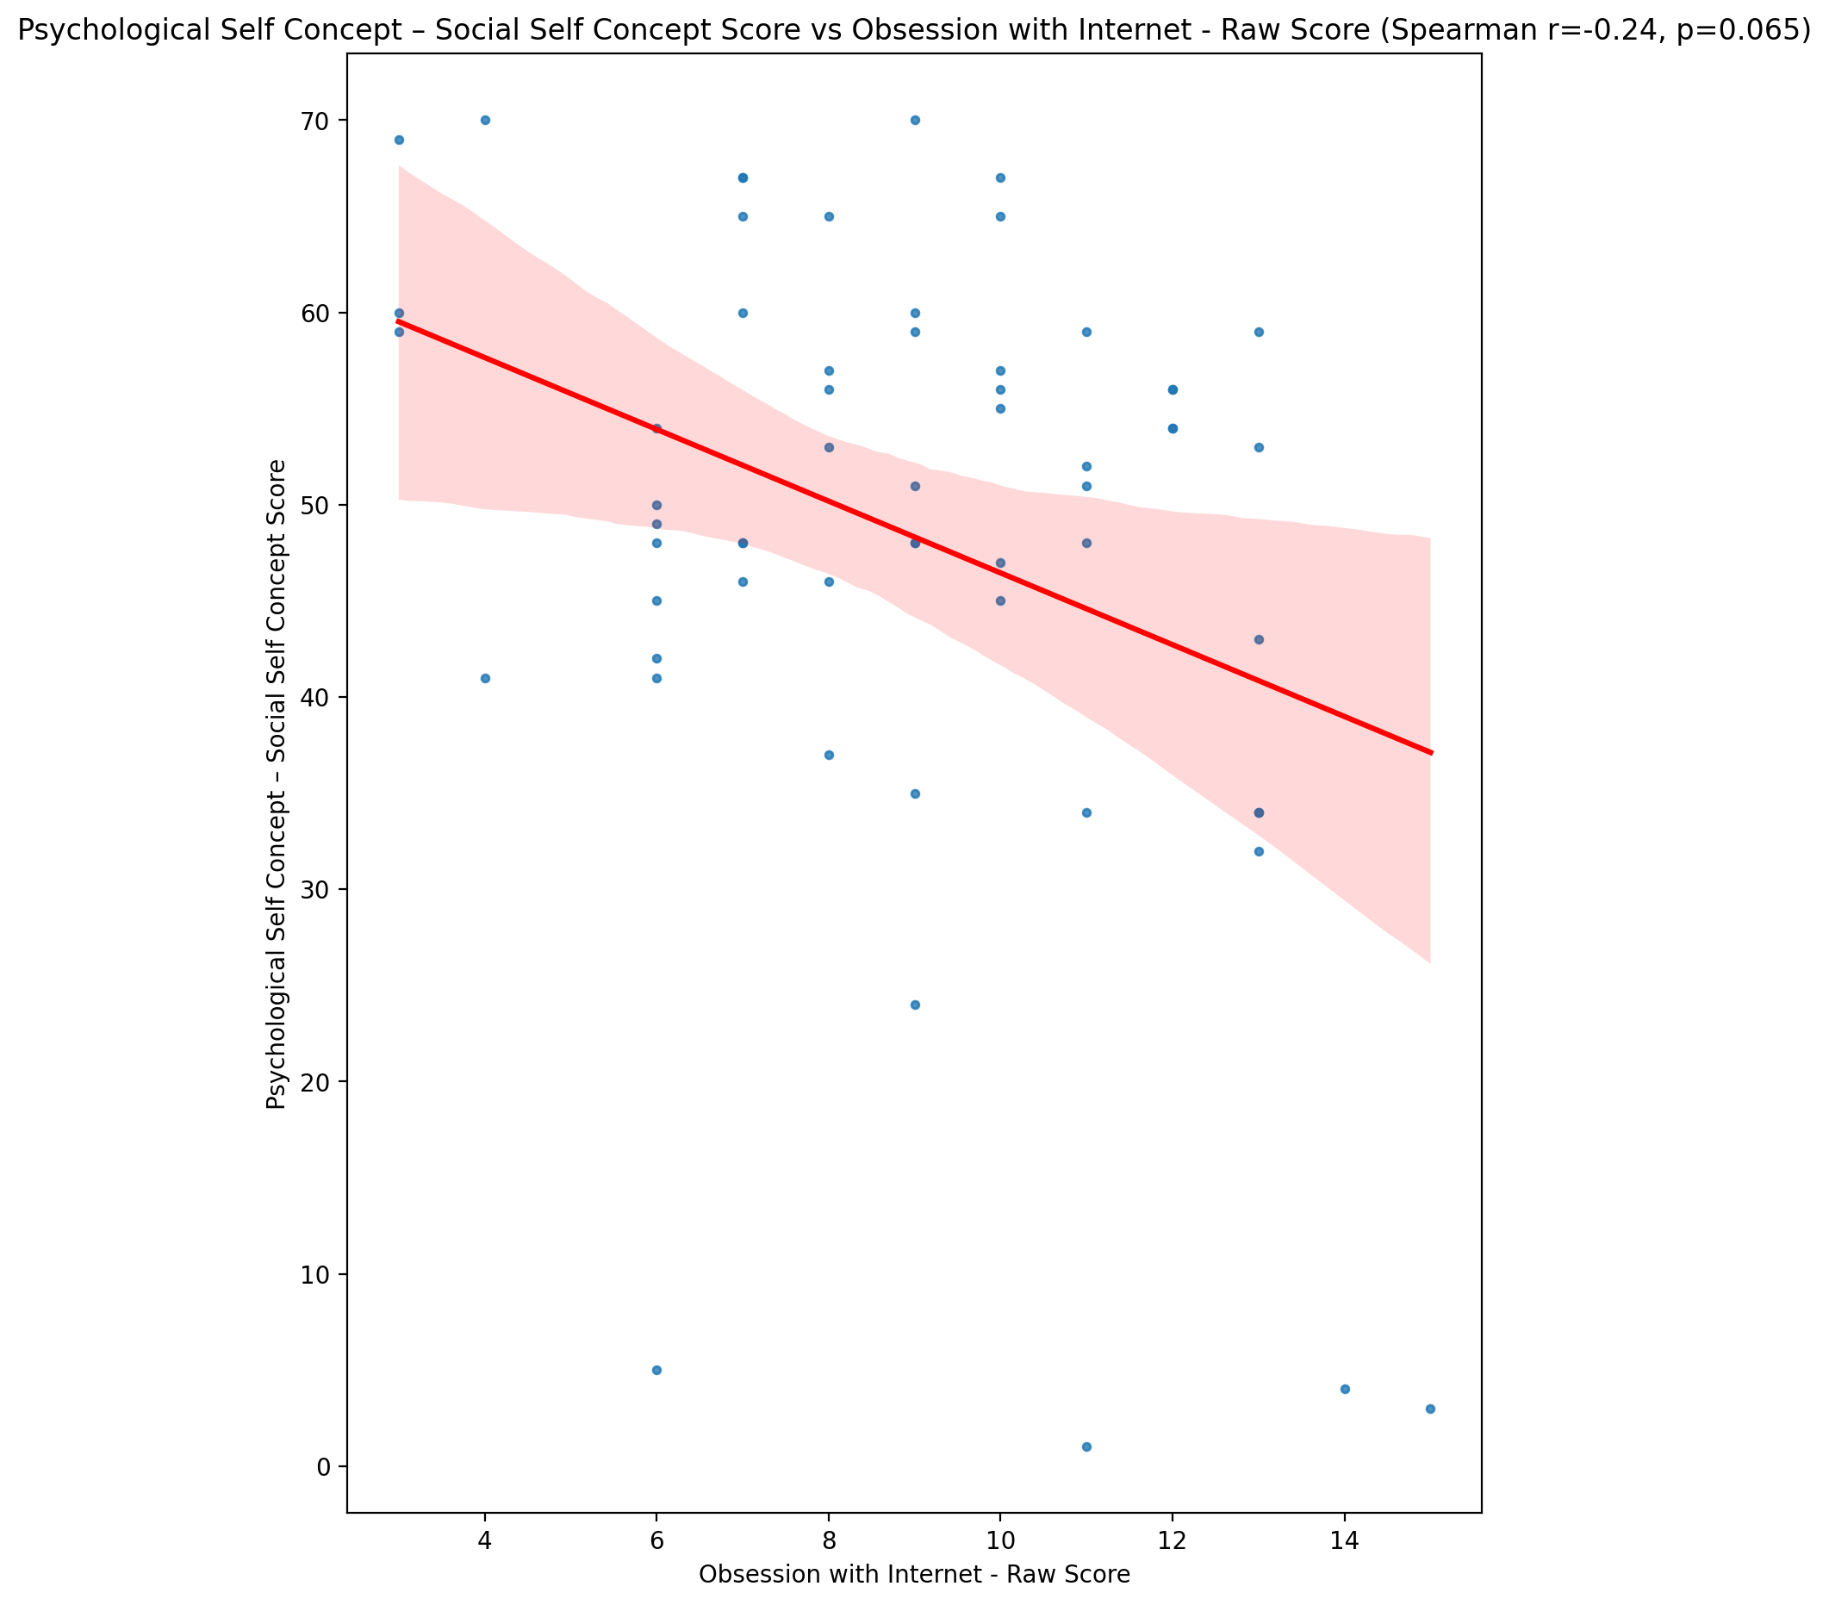

## Real Self Concept Total Score vs Obsession with Internet - Raw Score

Test: spearman; statistic: -0.19065606984794845; p-value: 0.14805700283937037;

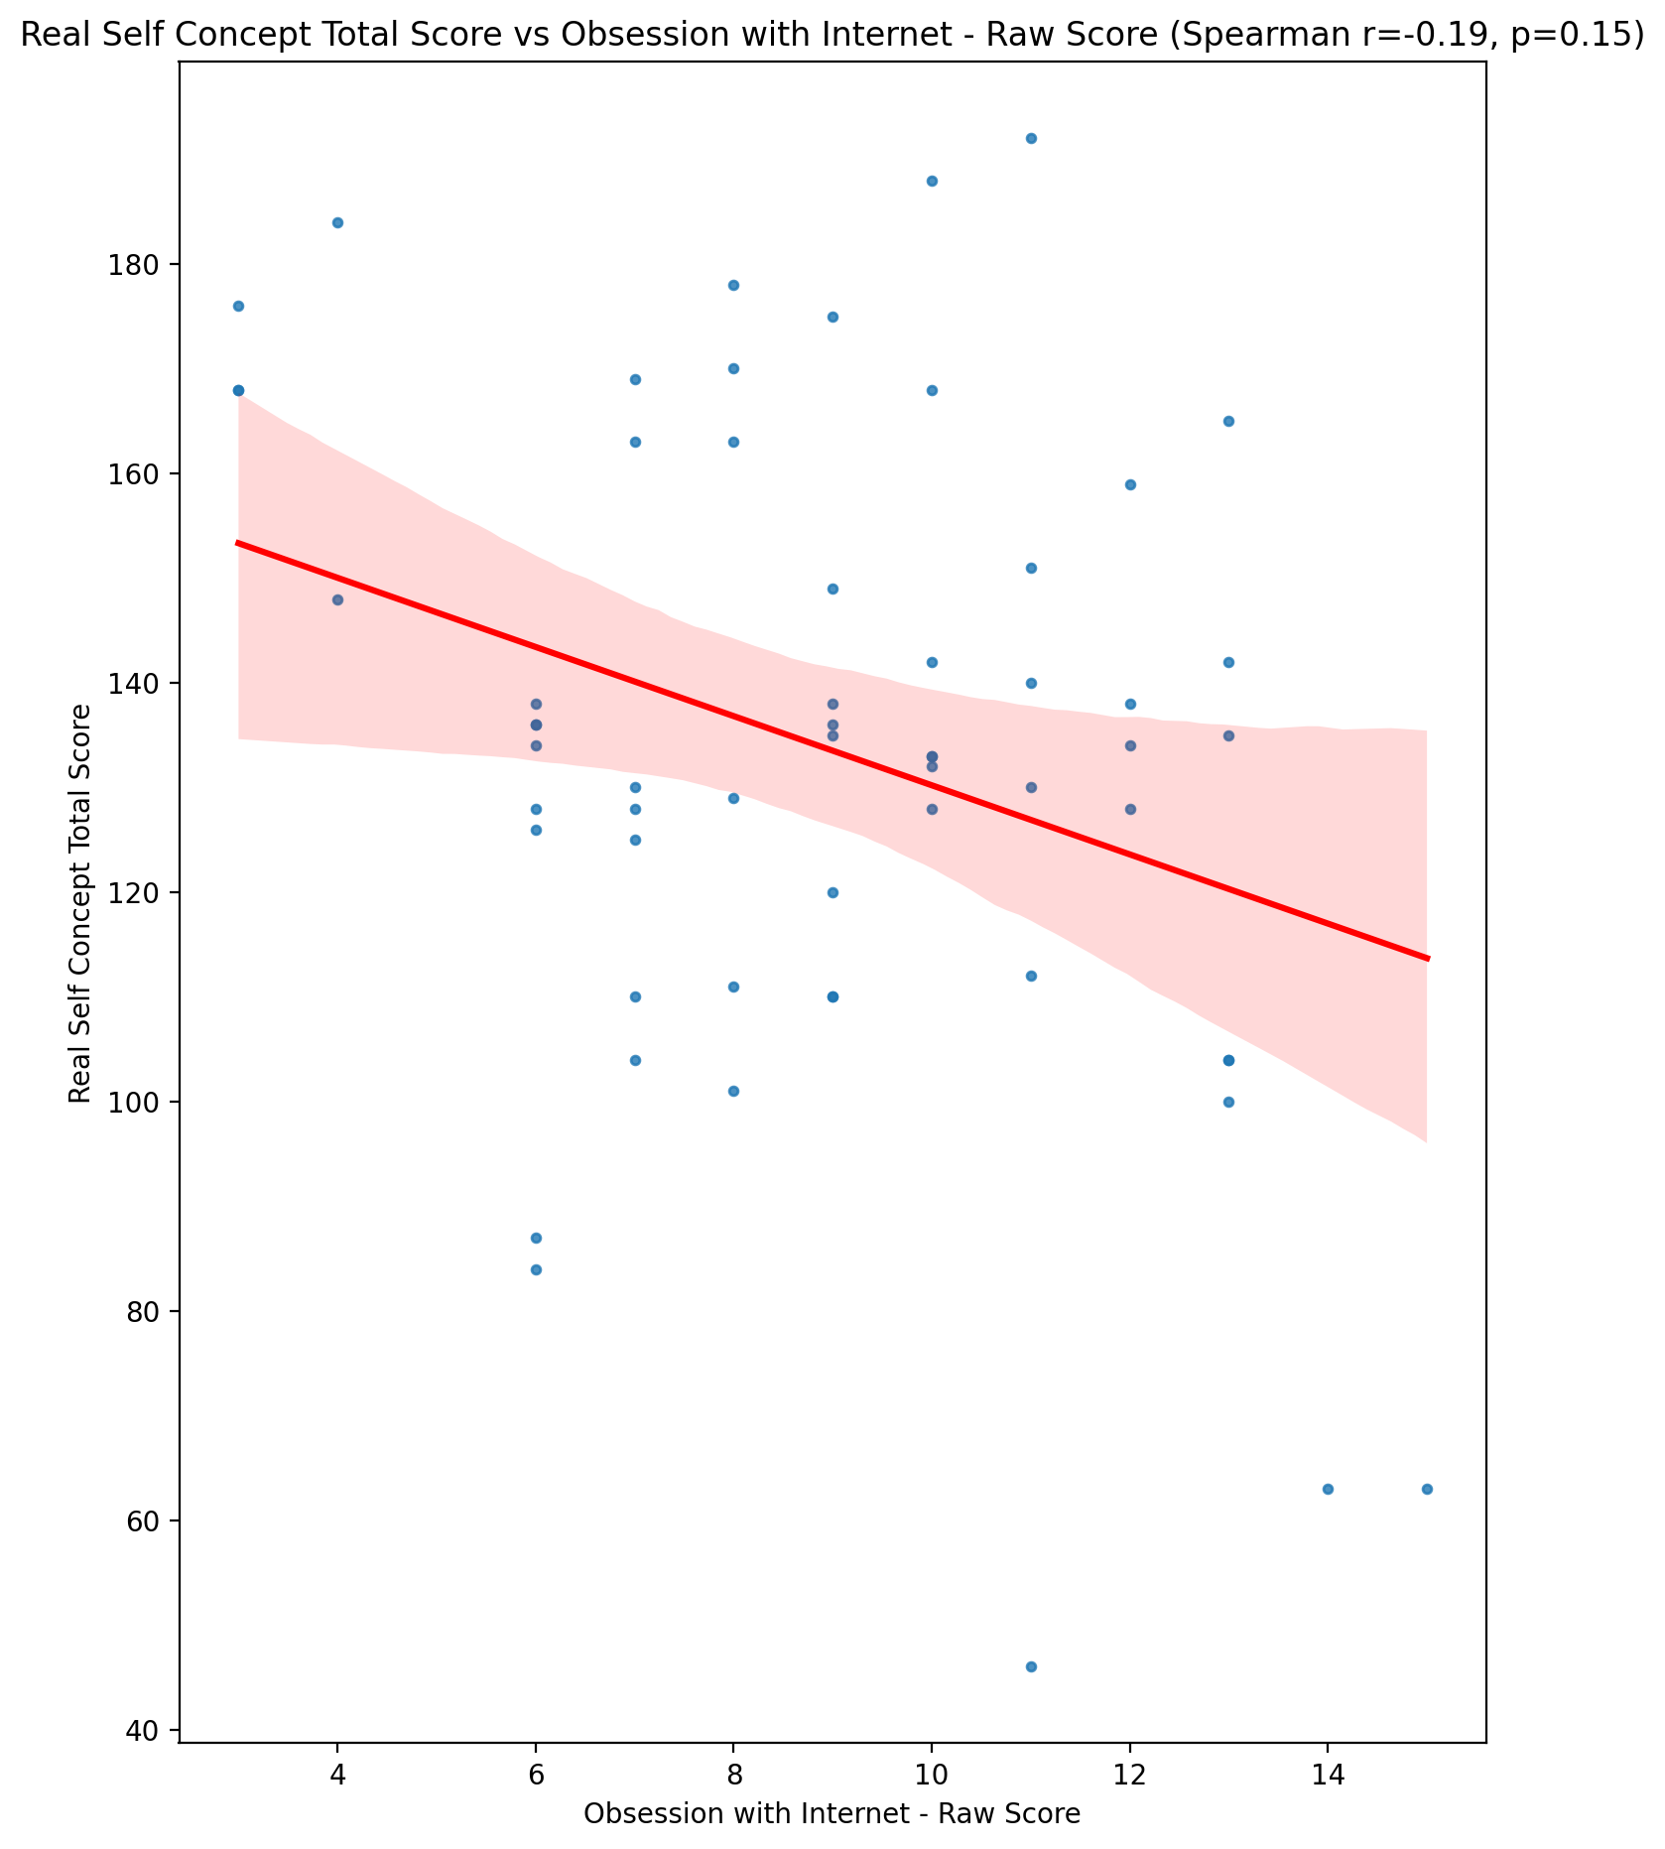

## Ideal Self Concept Total Score vs Obsession with Internet - Raw Score

Test: spearman; statistic: -0.18050594690520672; p-value: 0.17128247635276597;

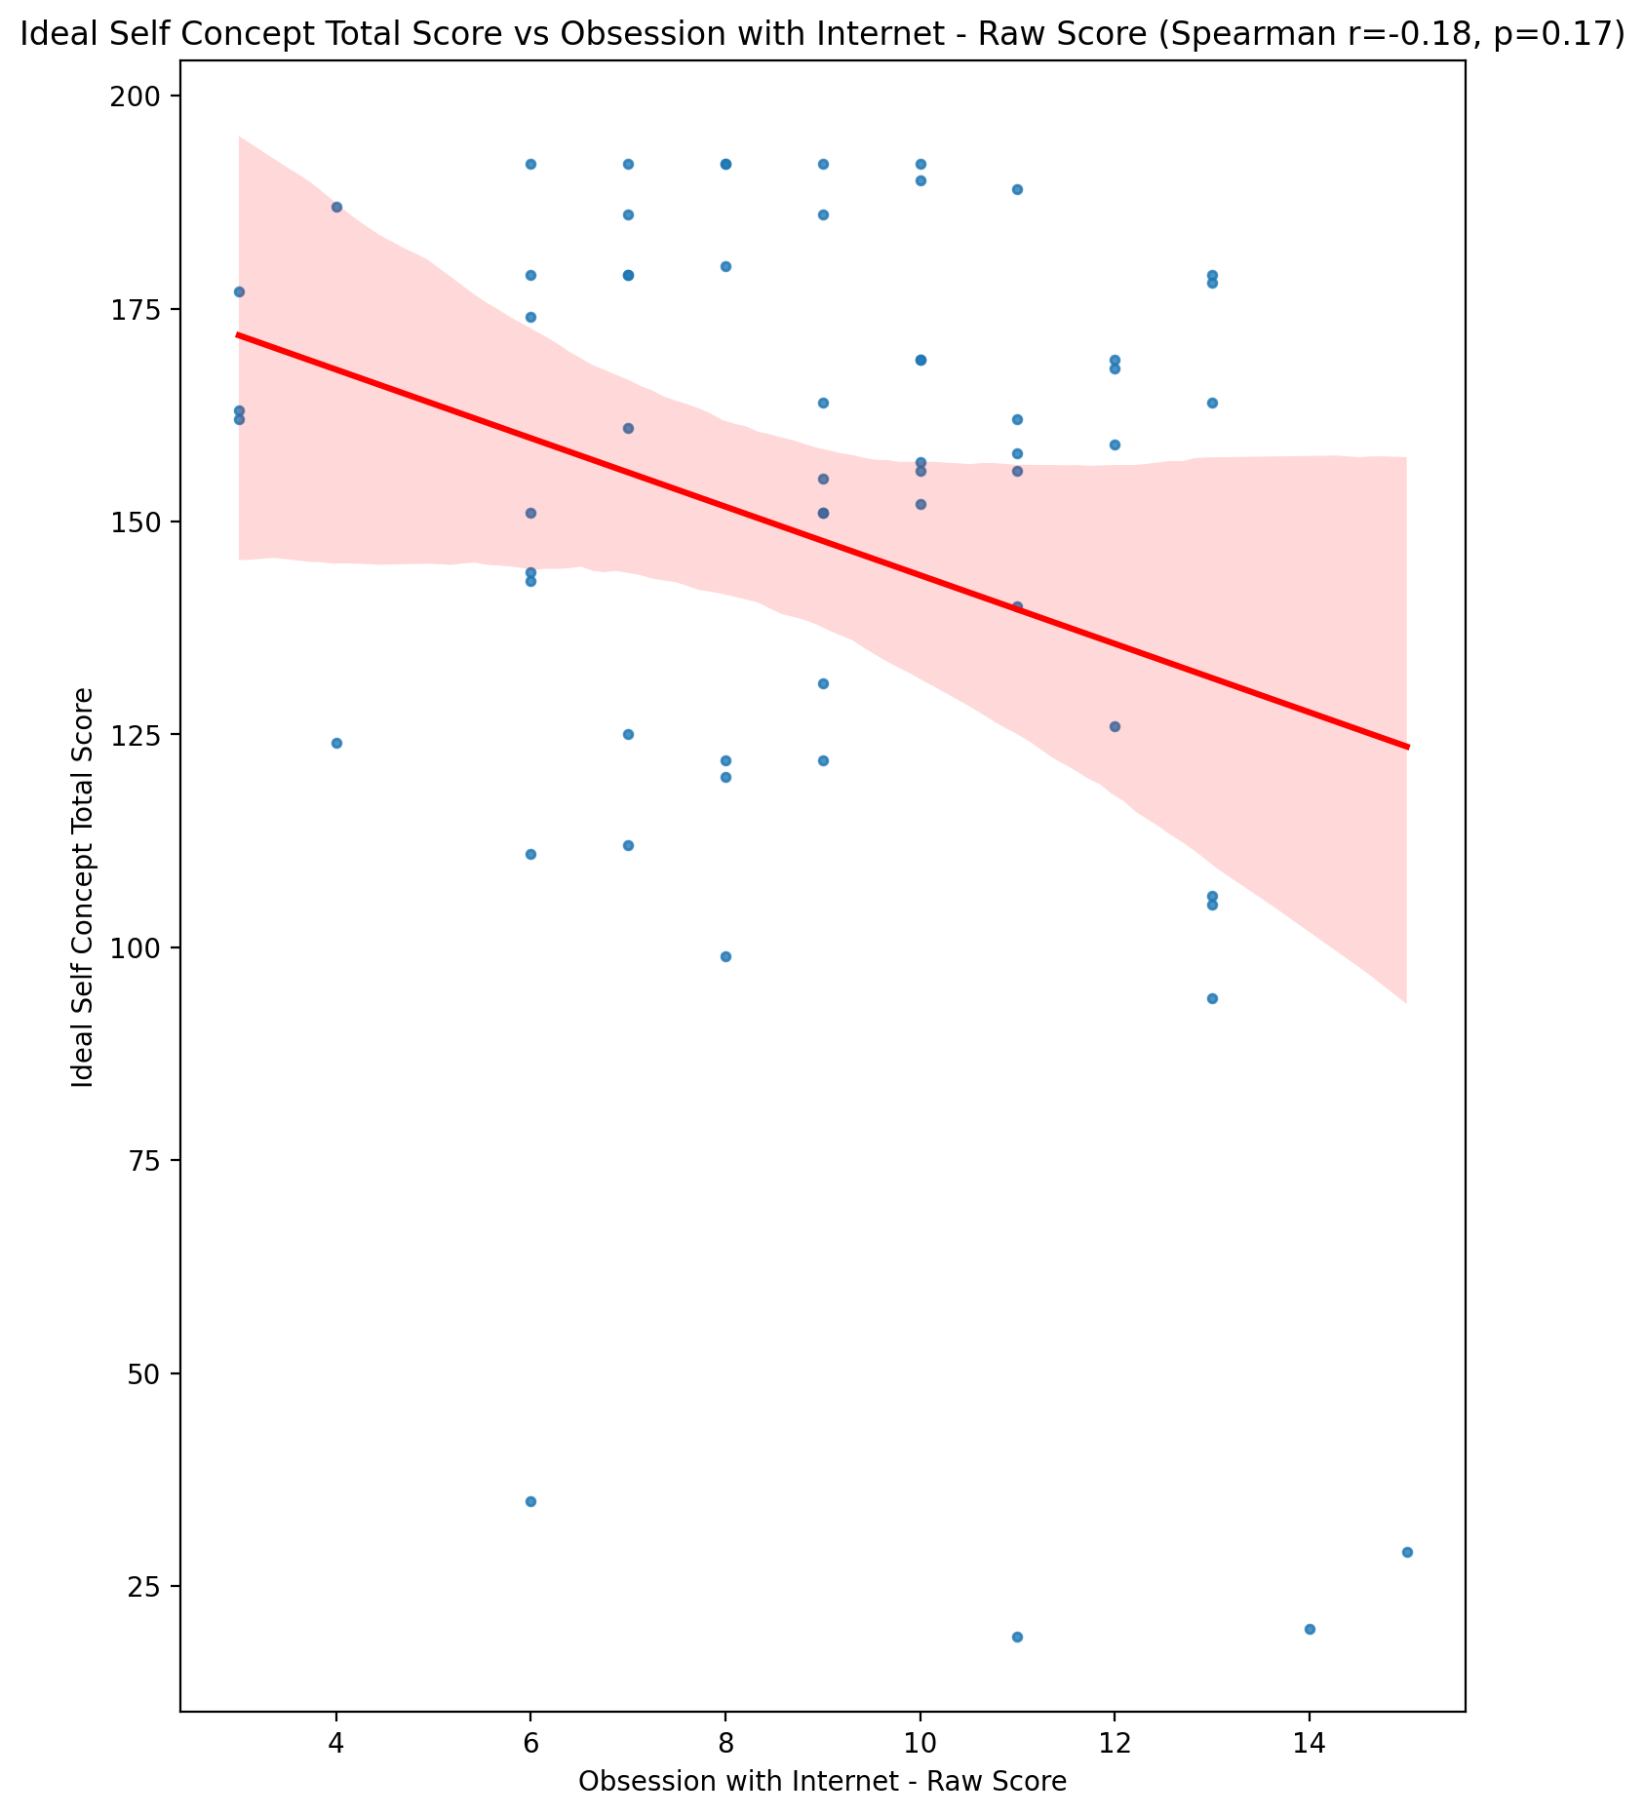

## Social Self Concept Total Score vs Obsession with Internet - Raw Score

Test: spearman; statistic: -0.22776342631789062; p-value: 0.08275225286995934;

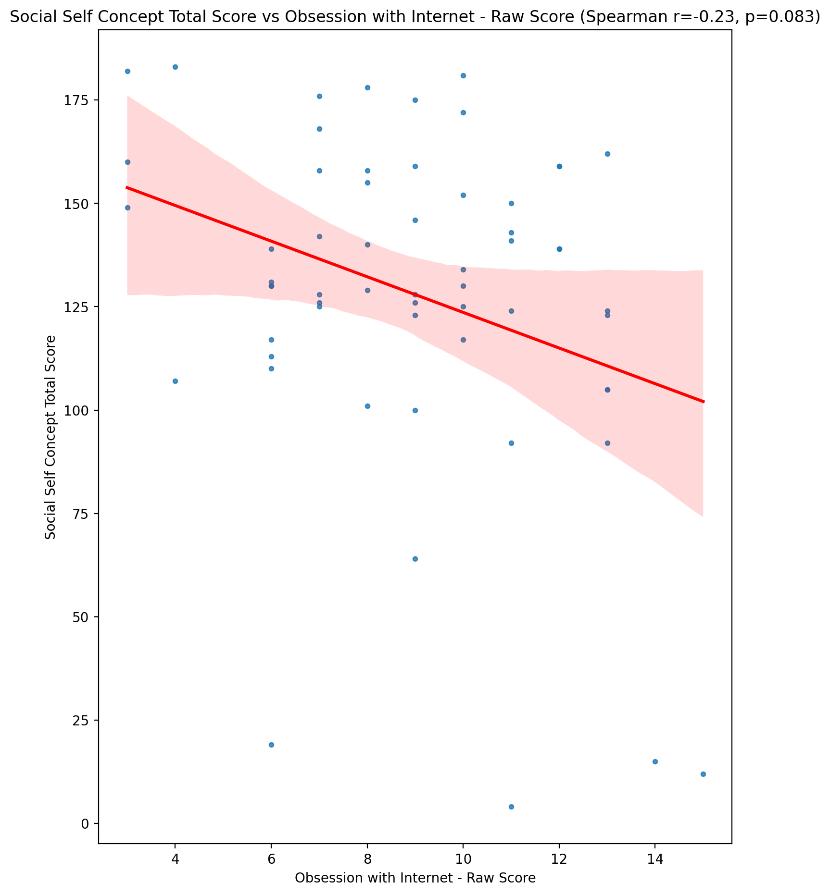

## Ideal Self Concept Total Category vs Obsession with Internet - Raw Score

Test: None; statistic: None; p-value: None; Test not run: unsupported type combination.



## Perceived Social Stress Score vs Obsession with Internet - Raw Score

Test: spearman; statistic: -0.03520895108686524; p-value: 0.7912092390366422;

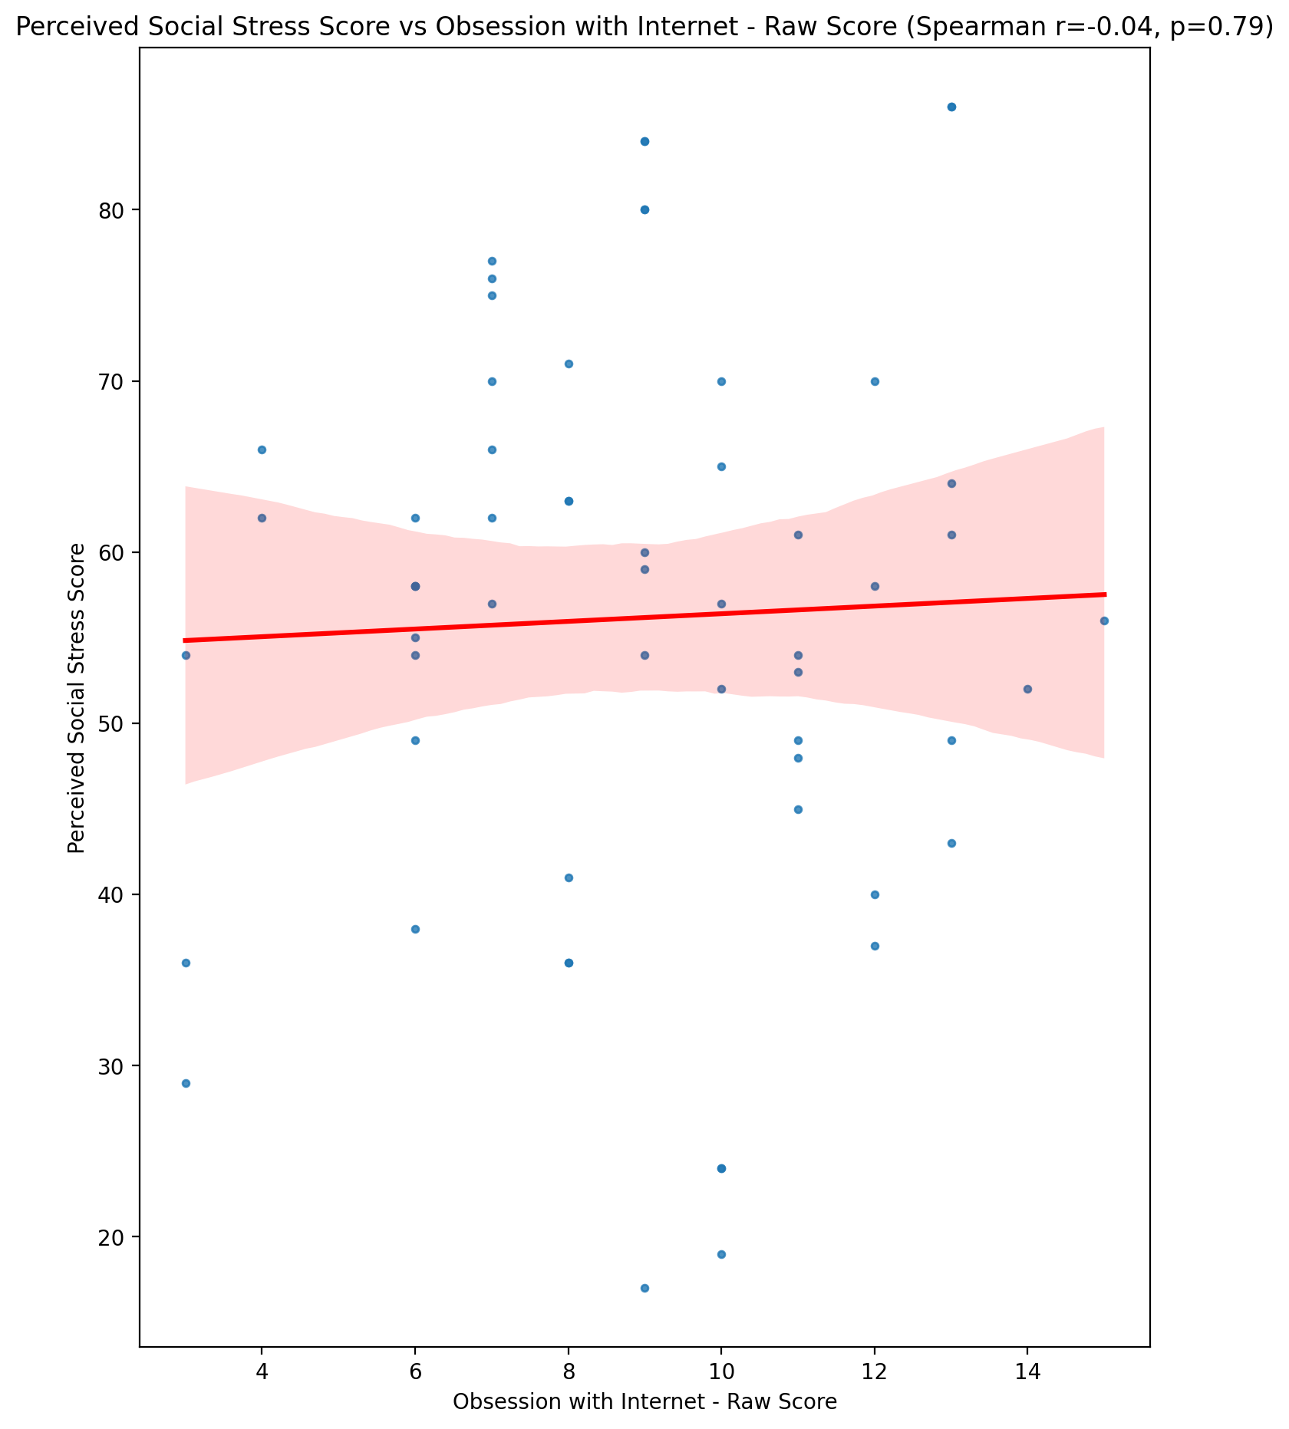

## Perceived Social Stress Category vs Obsession with Internet - Raw Score

Test: None; statistic: None; p-value: None; Test not run: unsupported type combination.



## Emotional Support - Raw Score vs Internet as a Source of Recreation - Raw Score

Test: spearman; statistic: 0.016453987858784984; p-value: 0.9015610117347737;

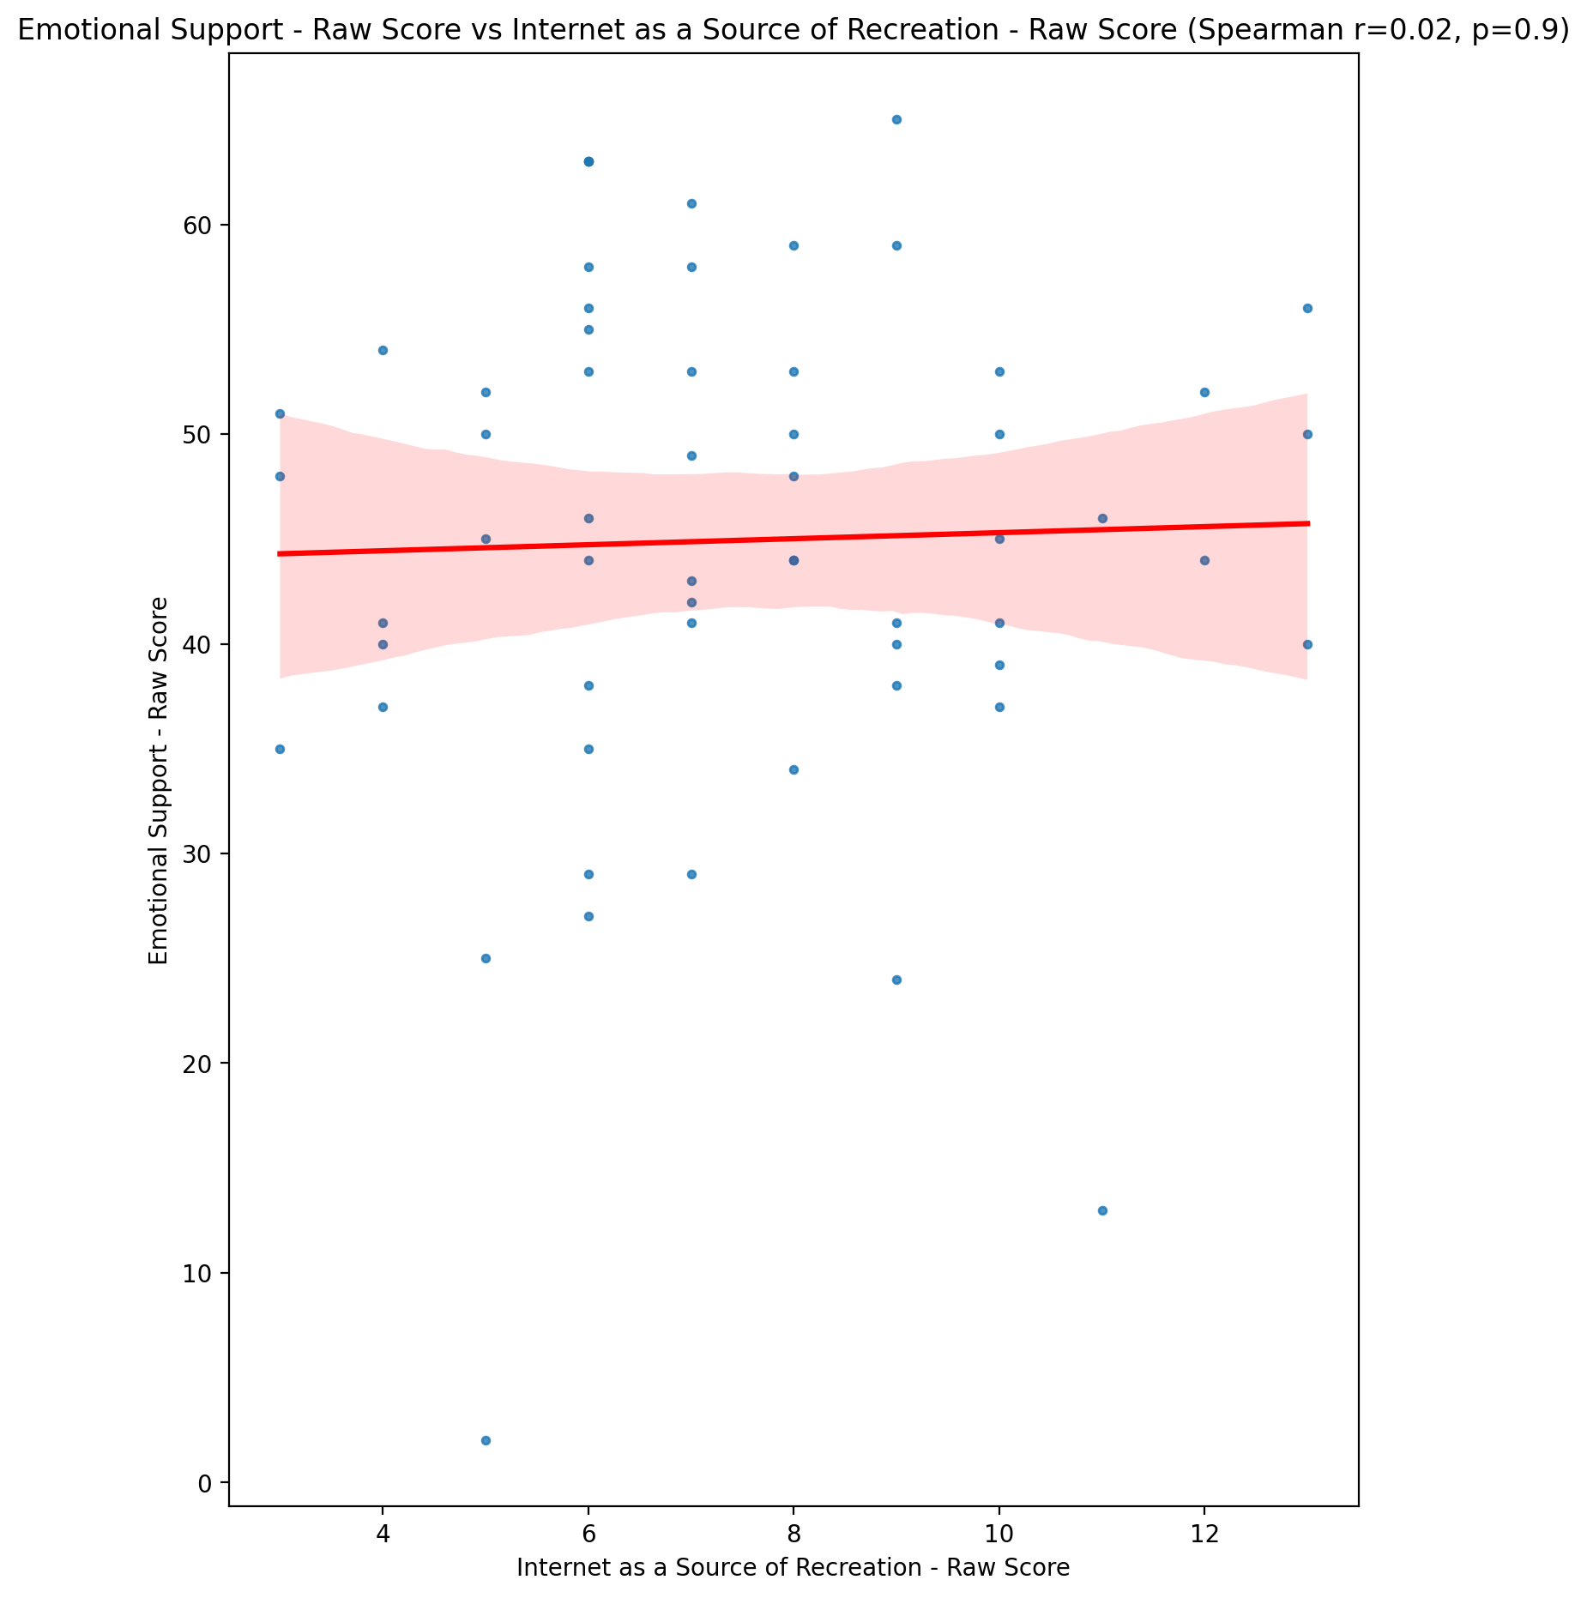

## Informational Support - Raw Score vs Internet as a Source of Recreation - Raw Score

Test: spearman; statistic: 0.08097302579570287; p-value: 0.5420868015450828;

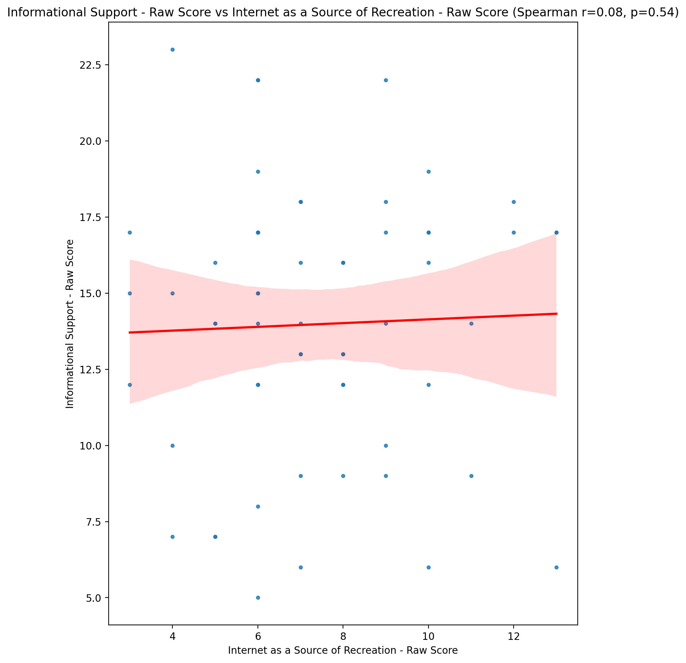

## Instrumental Support - Raw Score vs Internet as a Source of Recreation - Raw Score

Test: spearman; statistic: -0.08184429588392261; p-value: 0.5377345867552382;

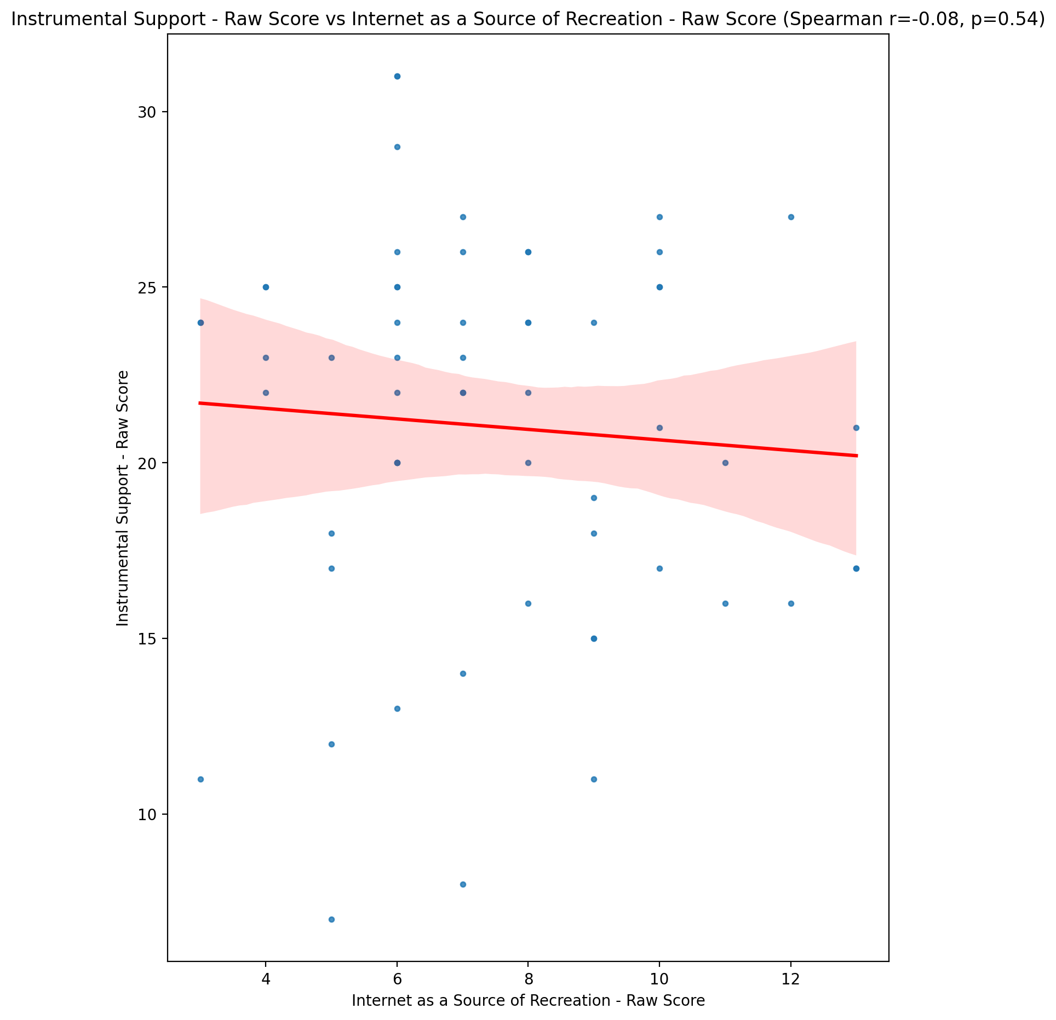

## Emotional Support - T Score vs Internet as a Source of Recreation - Raw Score

Test: spearman; statistic: 0.01796445524817236; p-value: 0.8925754683656892;

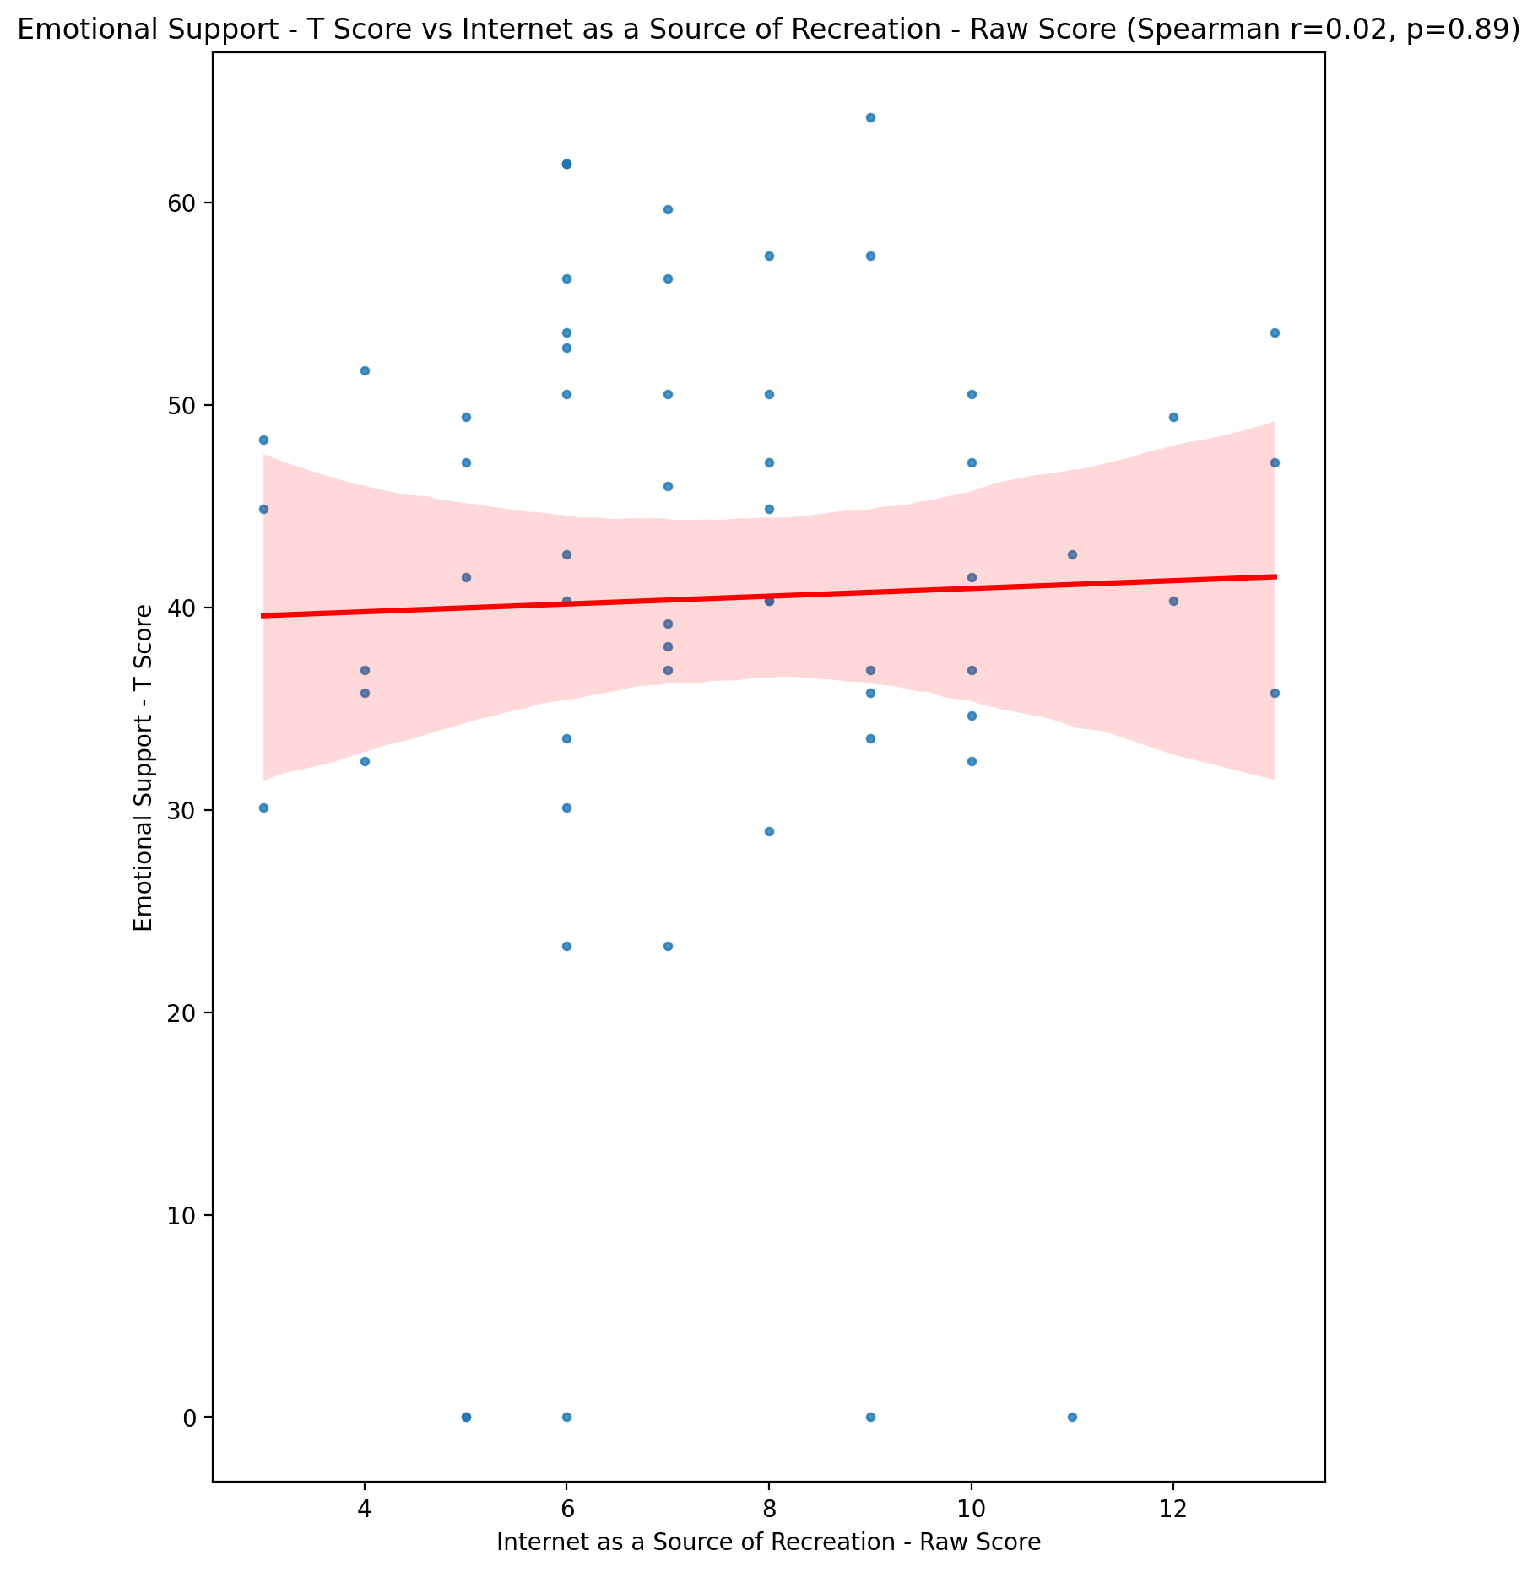

## Informational Support - T Score vs Internet as a Source of Recreation - Raw Score

Test: spearman; statistic: 0.09098375430122728; p-value: 0.49313564647102015;

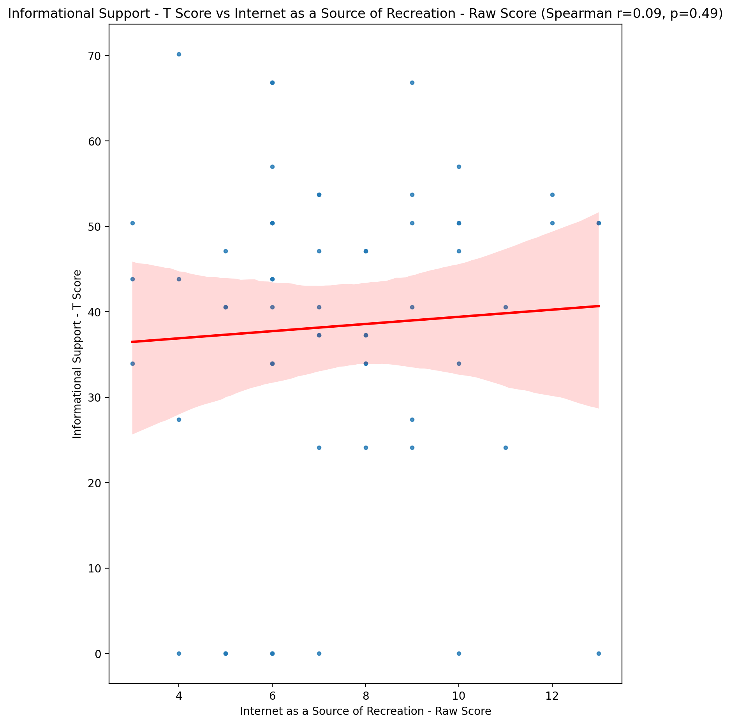

## Instrumental Support - T Score vs Internet as a Source of Recreation - Raw Score

Test: spearman; statistic: -0.08148583752743822; p-value: 0.5395231072217401;

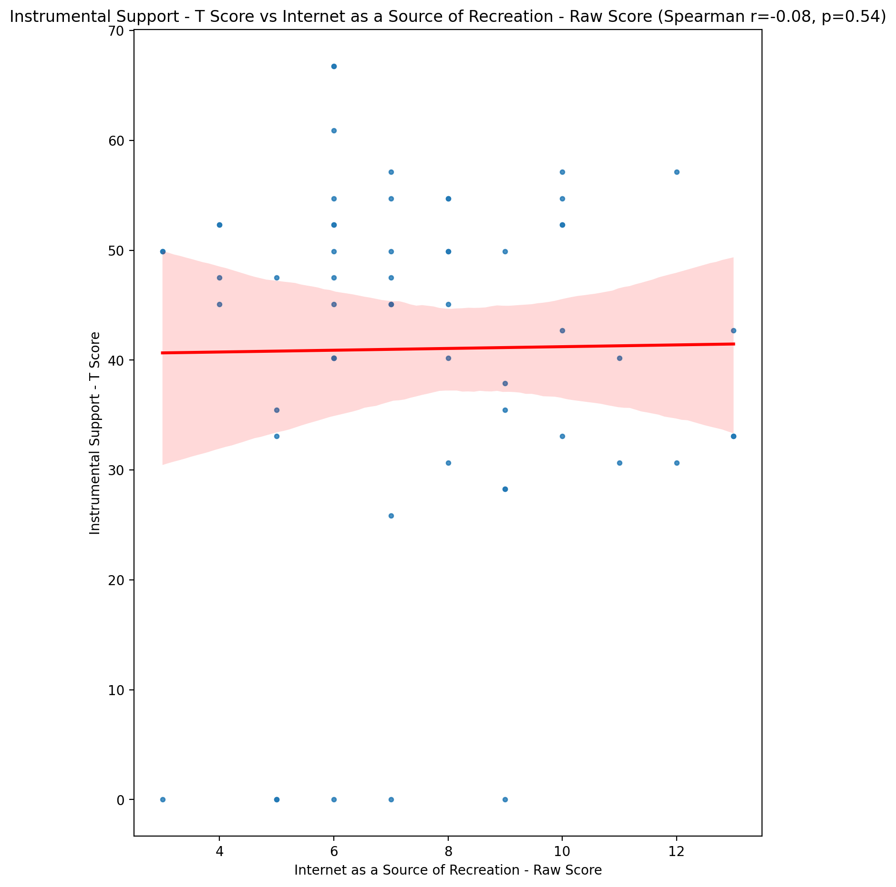

## Perceived Social Support Total T Score vs Internet as a Source of Recreation - Raw Score

Test: spearman; statistic: -0.013926084101260708; p-value: 0.9166260765161393;

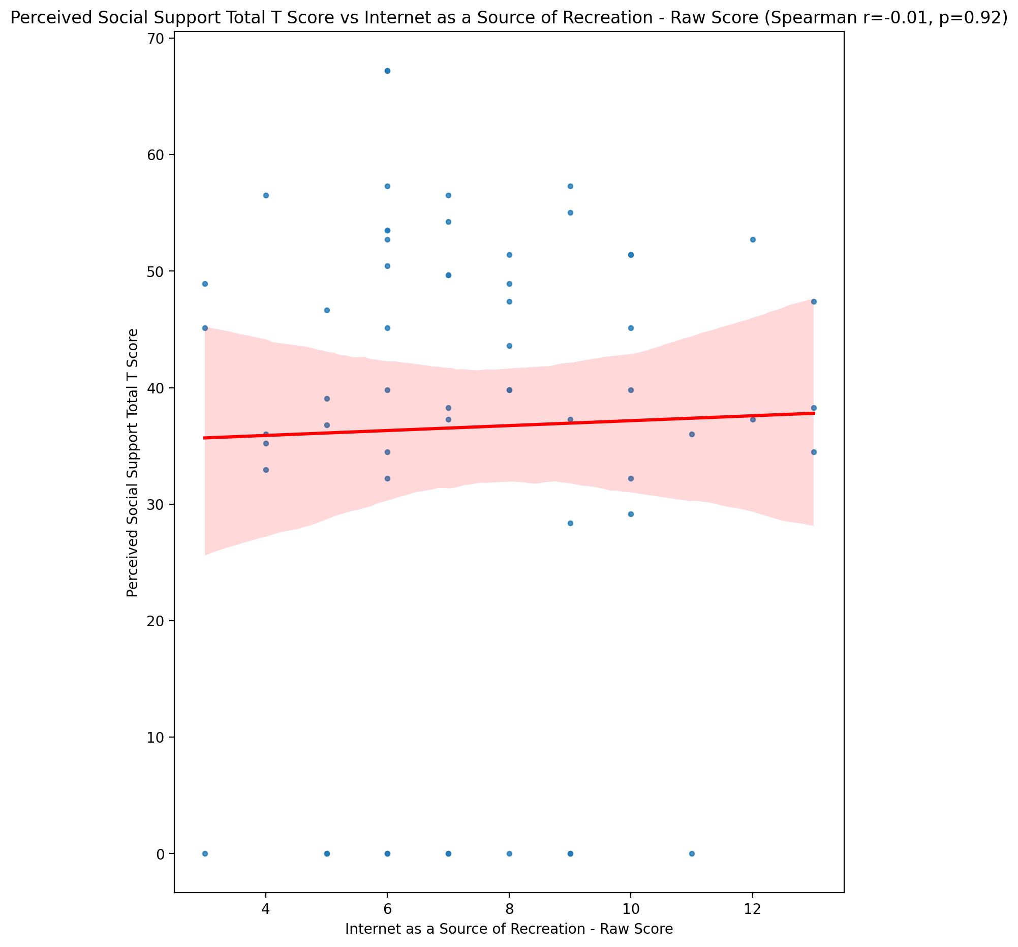

## Emotional Support - Rank vs Internet as a Source of Recreation - Raw Score

Test: None; statistic: None; p-value: None; Test not run: unsupported type combination.



## Informational Support - Rank vs Internet as a Source of Recreation - Raw Score

Test: None; statistic: None; p-value: None; Test not run: unsupported type combination.



## Instrumental Support - Rank vs Internet as a Source of Recreation - Raw Score

Test: None; statistic: None; p-value: None; Test not run: unsupported type combination.



## Perceived Social Support TOTAL - Rank vs Internet as a Source of Recreation - Raw Score

Test: None; statistic: None; p-value: None; Test not run: unsupported type combination.



## Power Self Concept - Real Self Concept Score vs Internet as a Source of Recreation - Raw Score

Test: spearman; statistic: 0.013807486934504178; p-value: 0.9173336154691321;

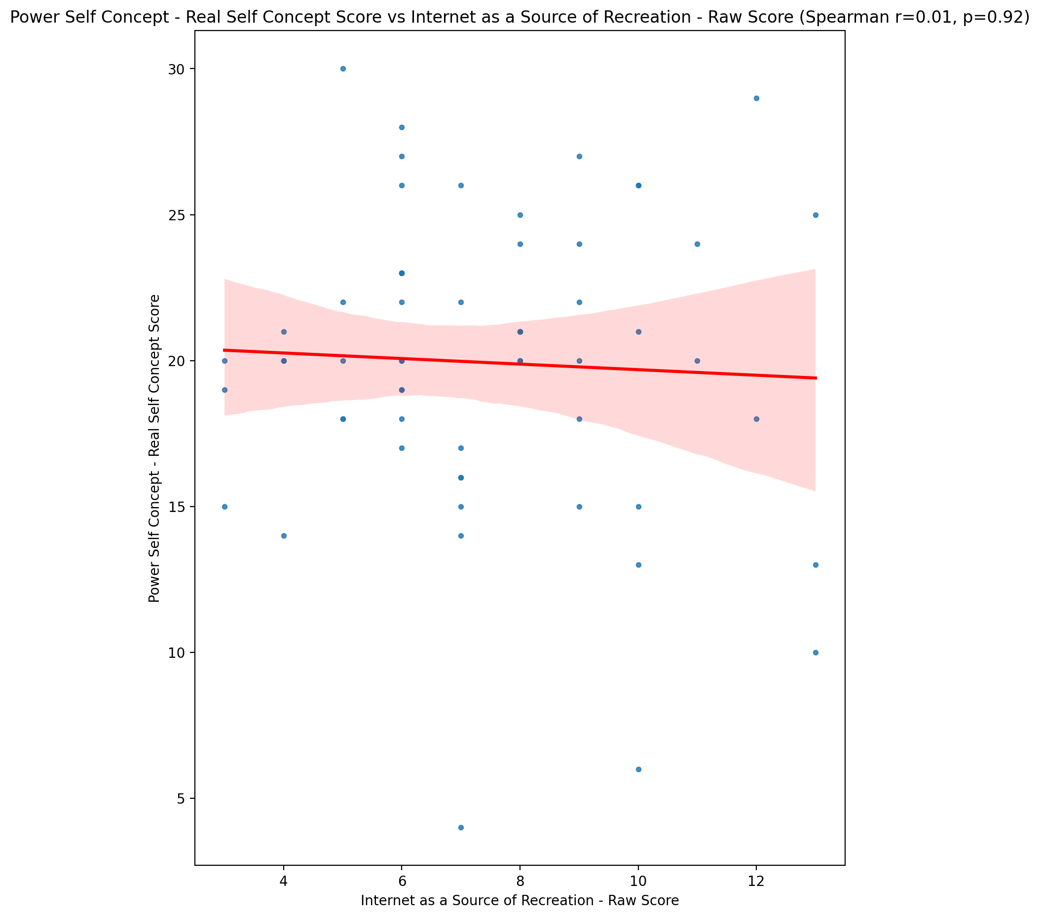

## Power Self Concept - Ideal Self Concept score vs Internet as a Source of Recreation - Raw Score

Test: spearman; statistic: -0.09605554685307788; p-value: 0.4692461154242463;

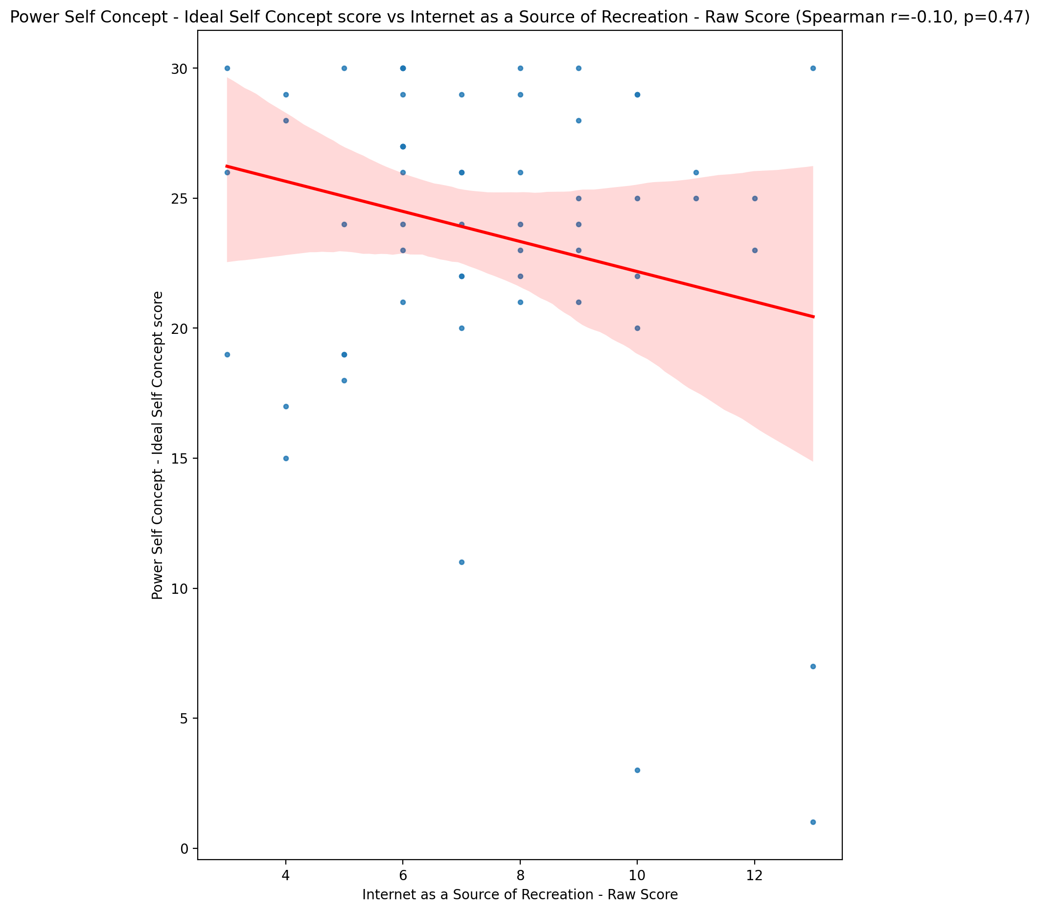

## Power Self Concept – Social Self Concept Score vs Internet as a Source of Recreation - Raw Score

Test: spearman; statistic: 0.07063412303147938; p-value: 0.5949980330402362;

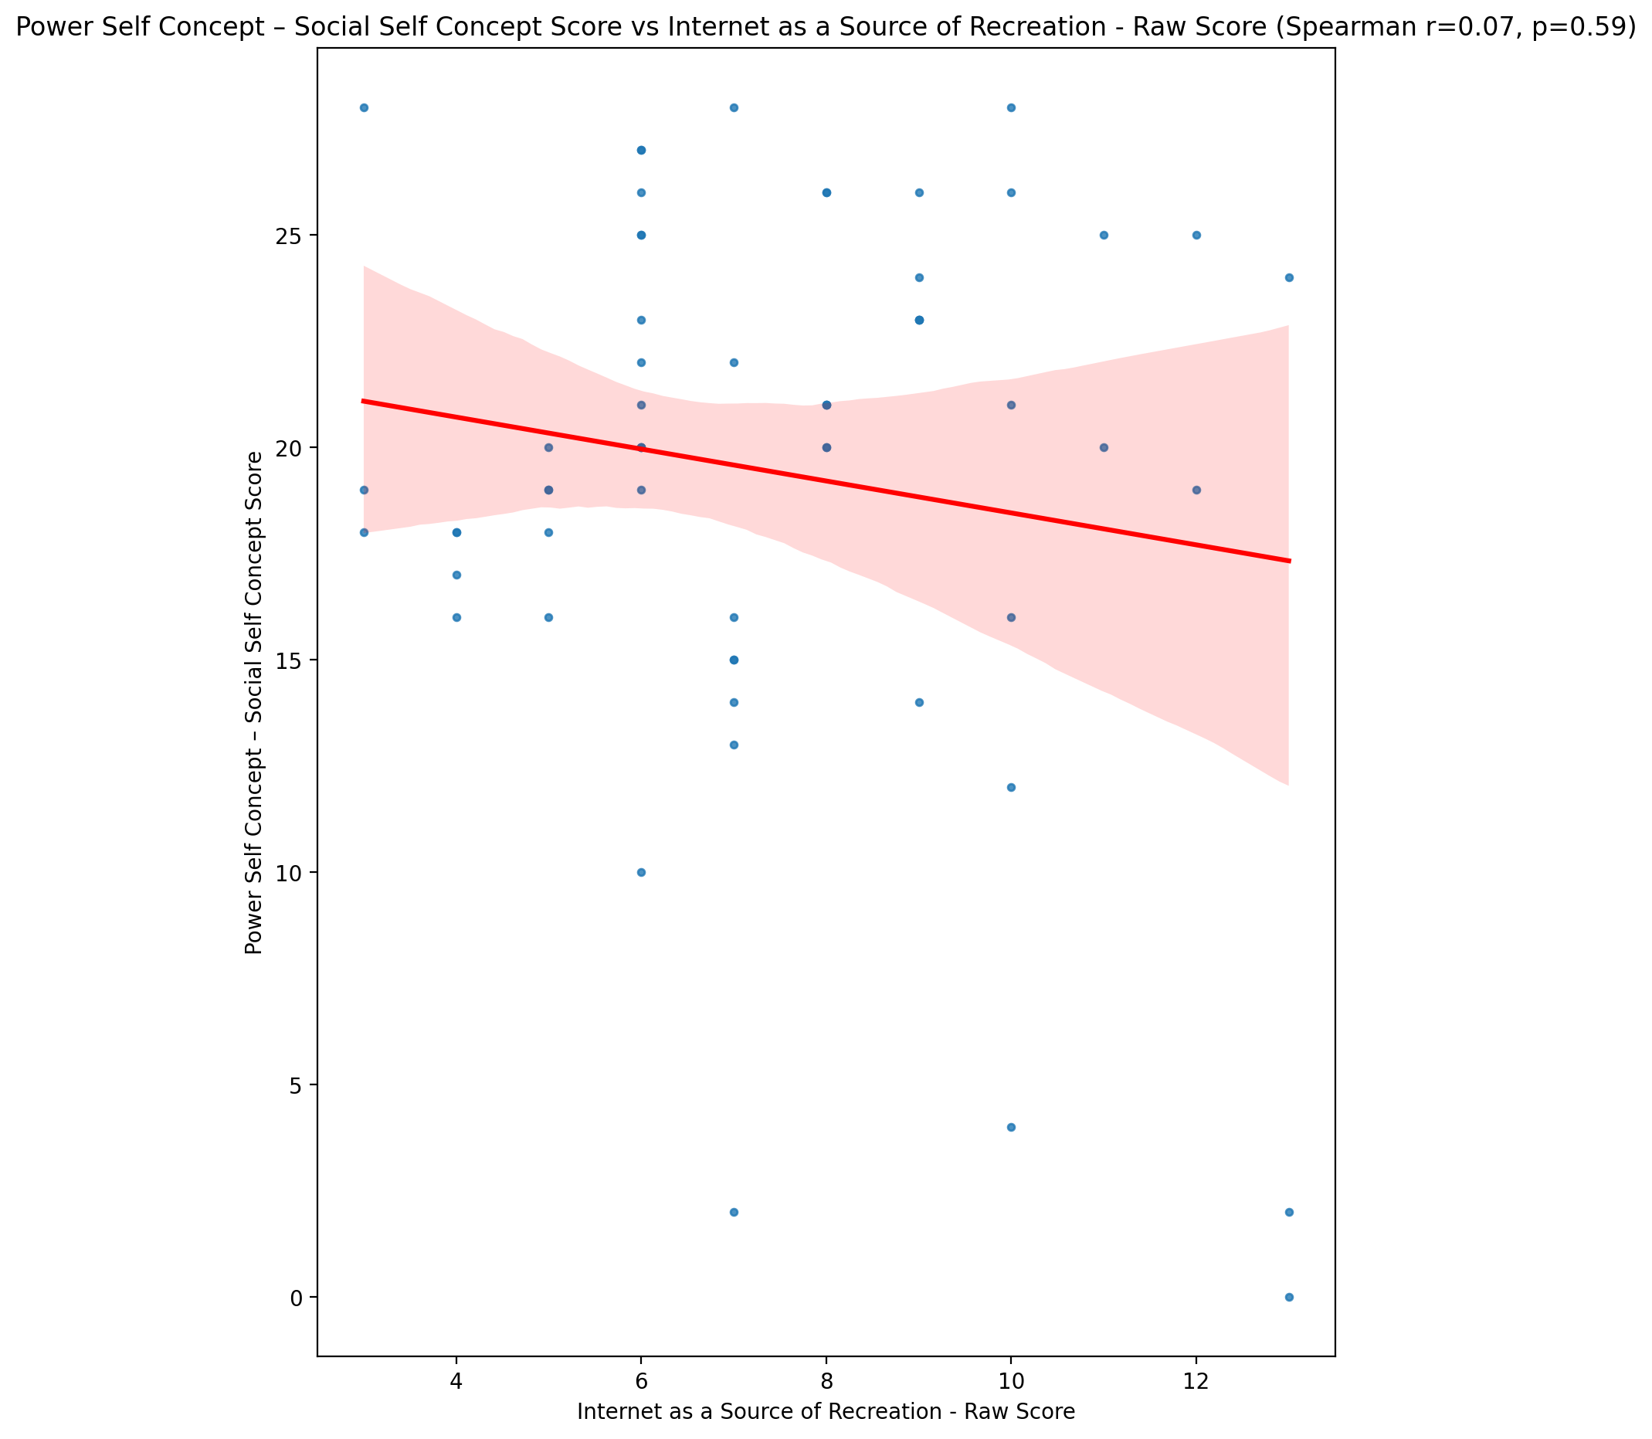

## Social Self Concept - Real Self Concept Score vs Internet as a Source of Recreation - Raw Score

Test: spearman; statistic: -0.10572814870023843; p-value: 0.4254657326186493;

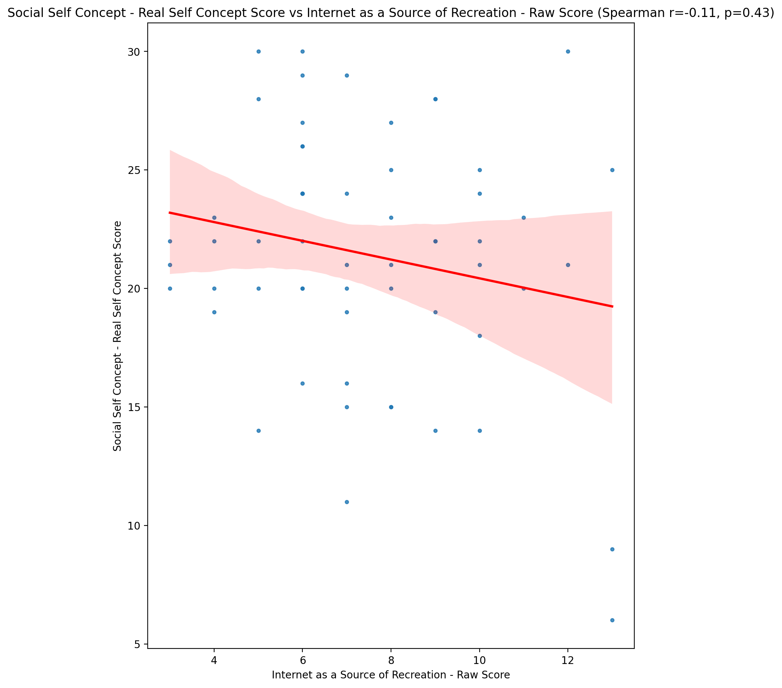

## Social Self Concept – Social Self Concept Score vs Internet as a Source of Recreation - Raw Score

Test: spearman; statistic: -0.009600891074080697; p-value: 0.942466938739782;

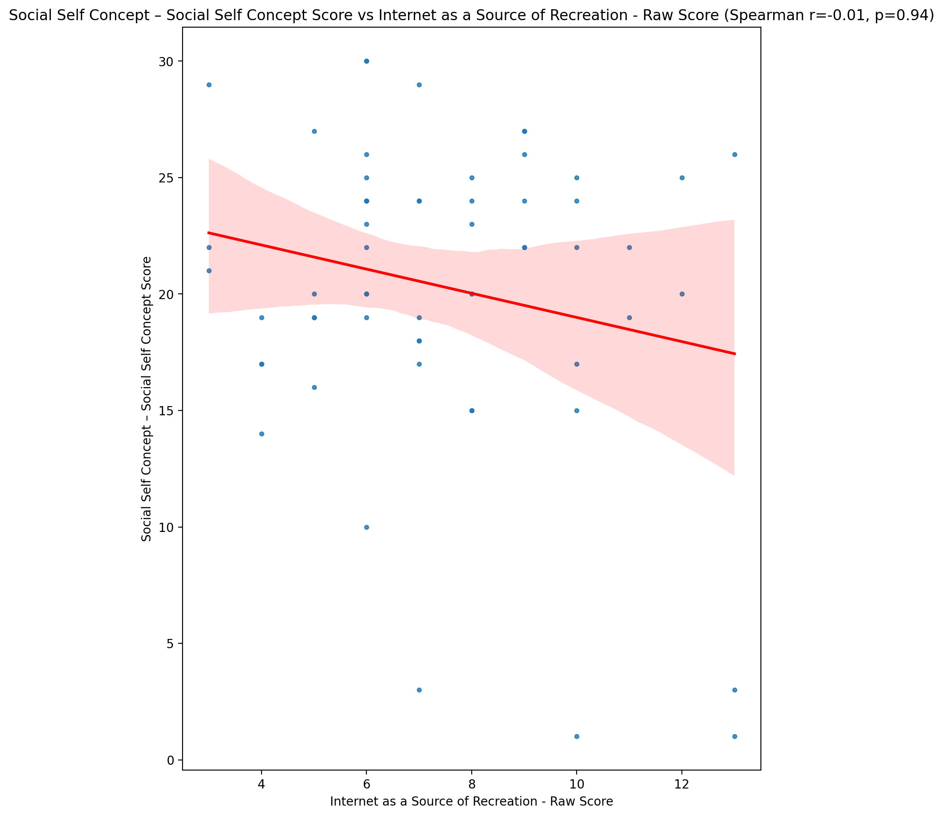

## Ability Self Concept - Real Self Concept Score vs Internet as a Source of Recreation - Raw Score

Test: spearman; statistic: 0.03311060094835281; p-value: 0.8033963904269315;

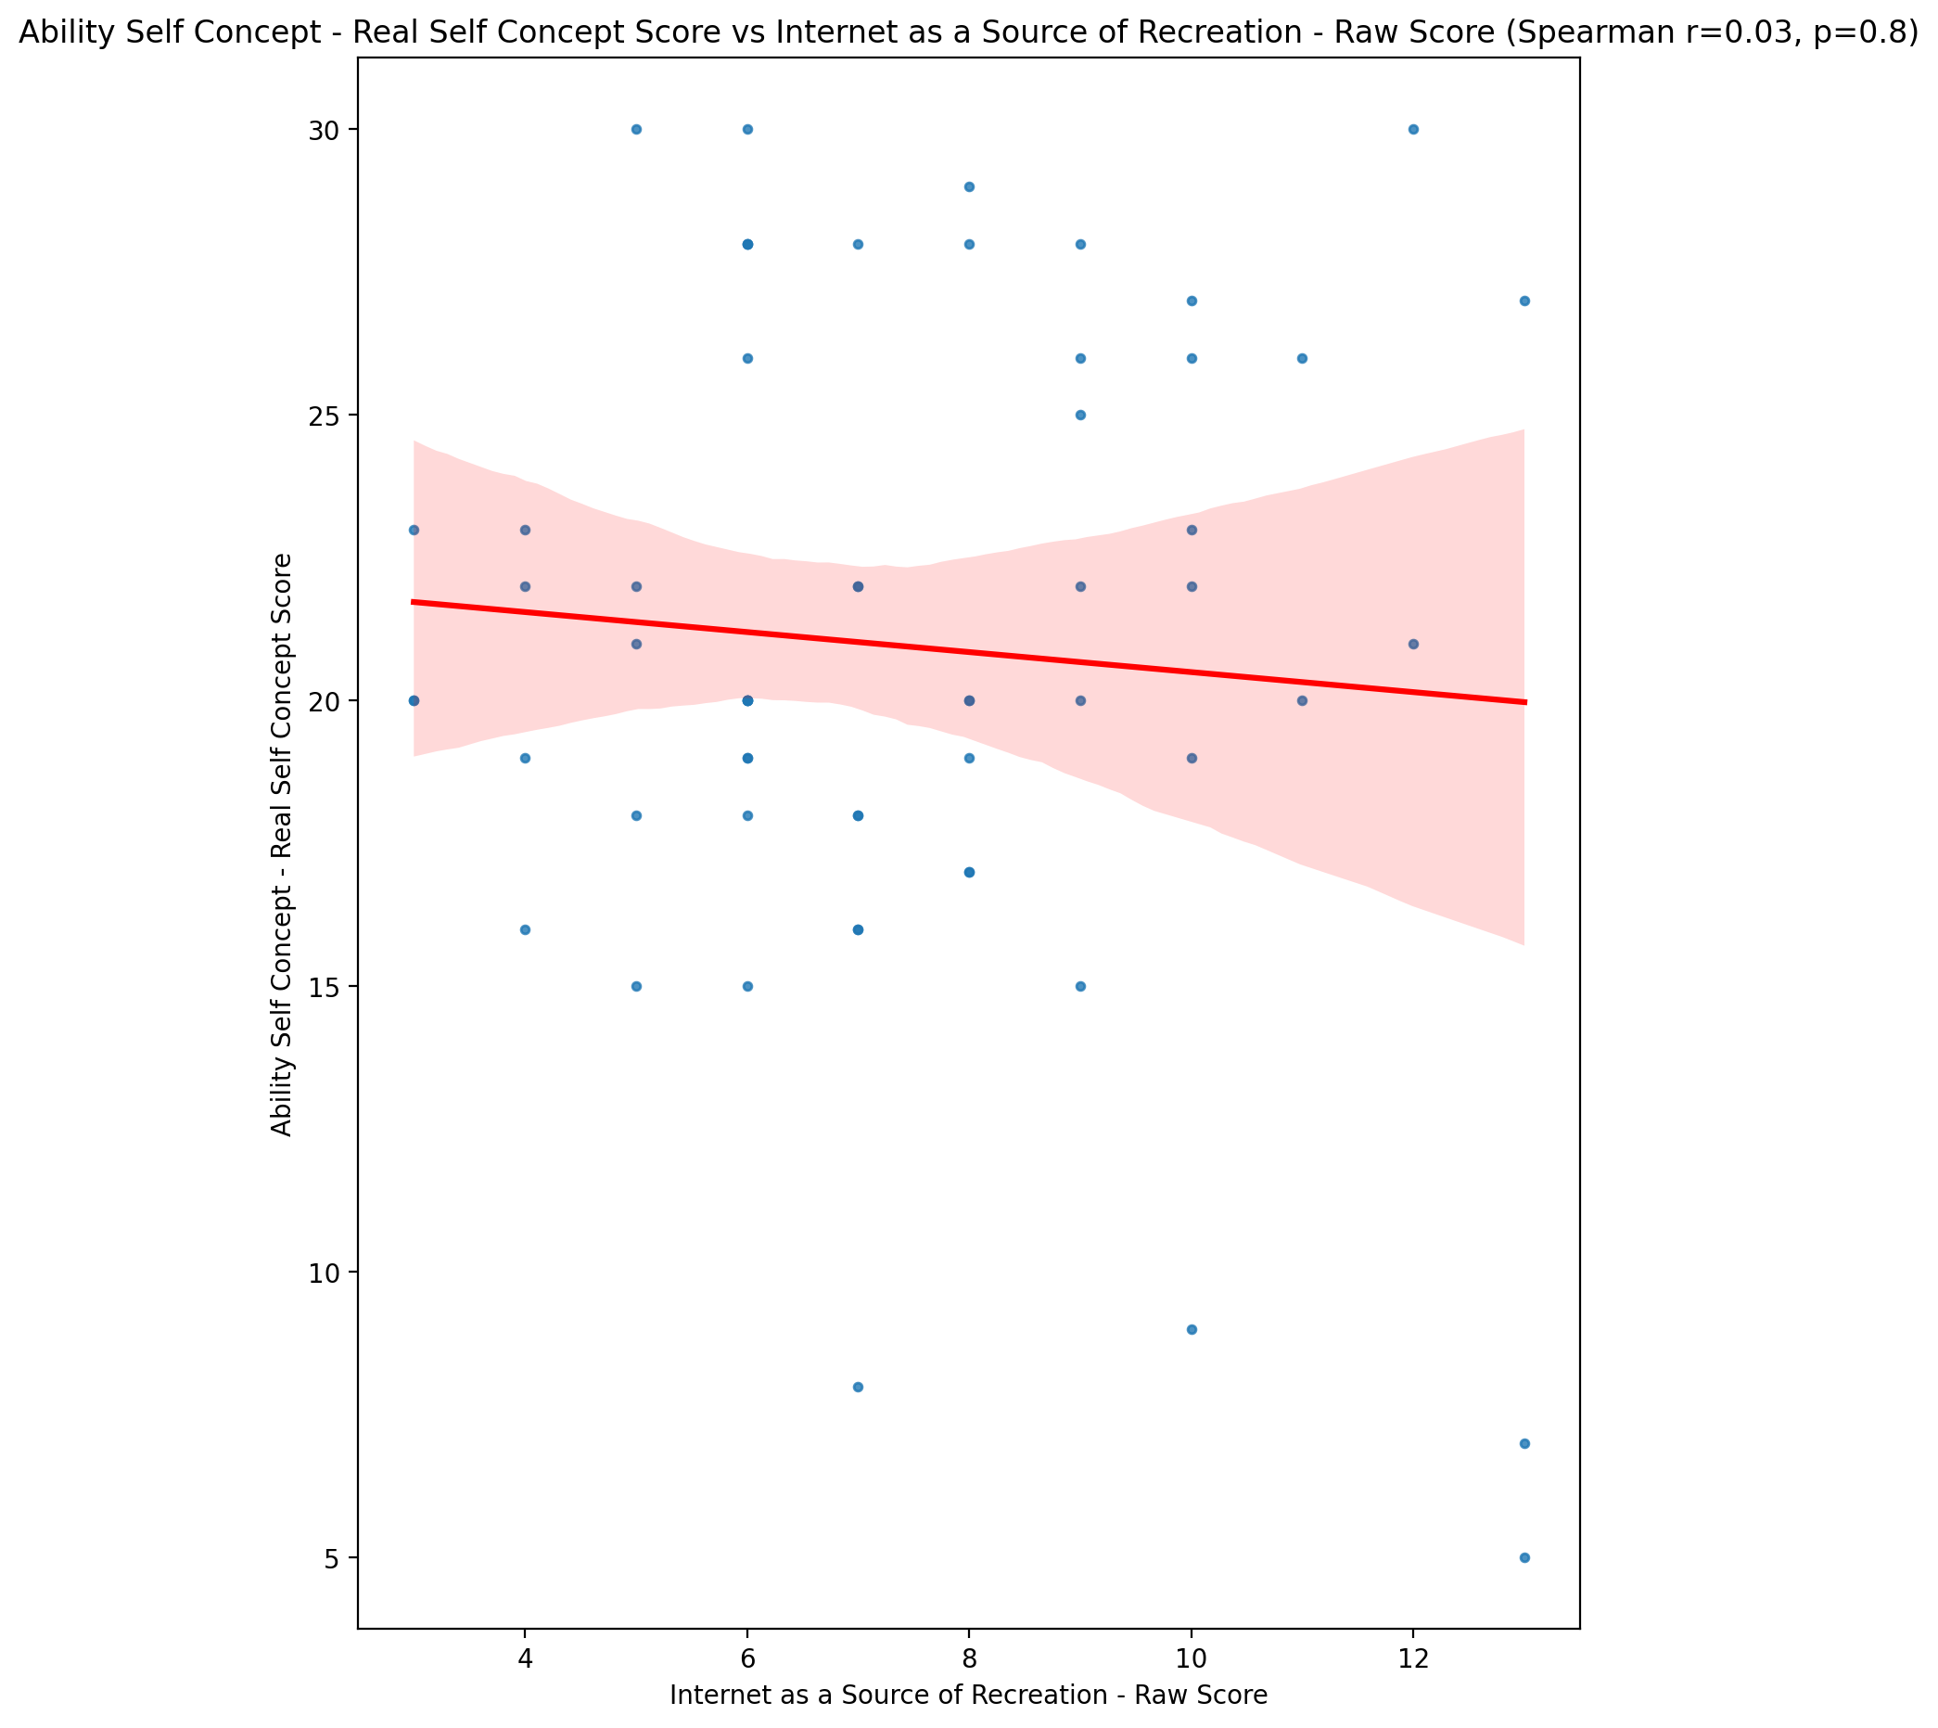

## Ability Self Concept - Ideal Self Concept Score vs Internet as a Source of Recreation - Raw Score

Test: spearman; statistic: -0.0984369855441392; p-value: 0.45824775329795553;

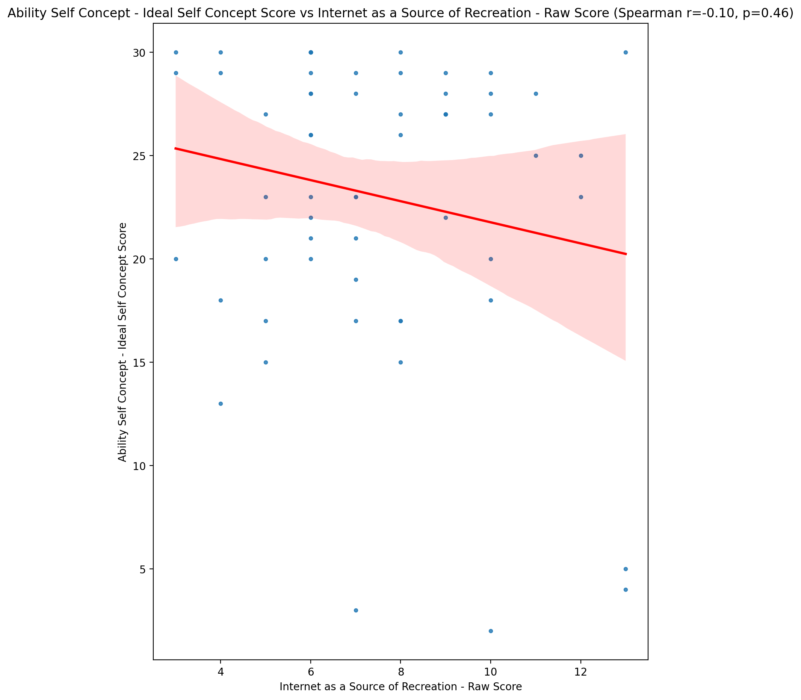

## Ability Self Concept – Social Self Concept Score vs Internet as a Source of Recreation - Raw Score

Test: spearman; statistic: 0.09129652381424681; p-value: 0.4916443047098844;

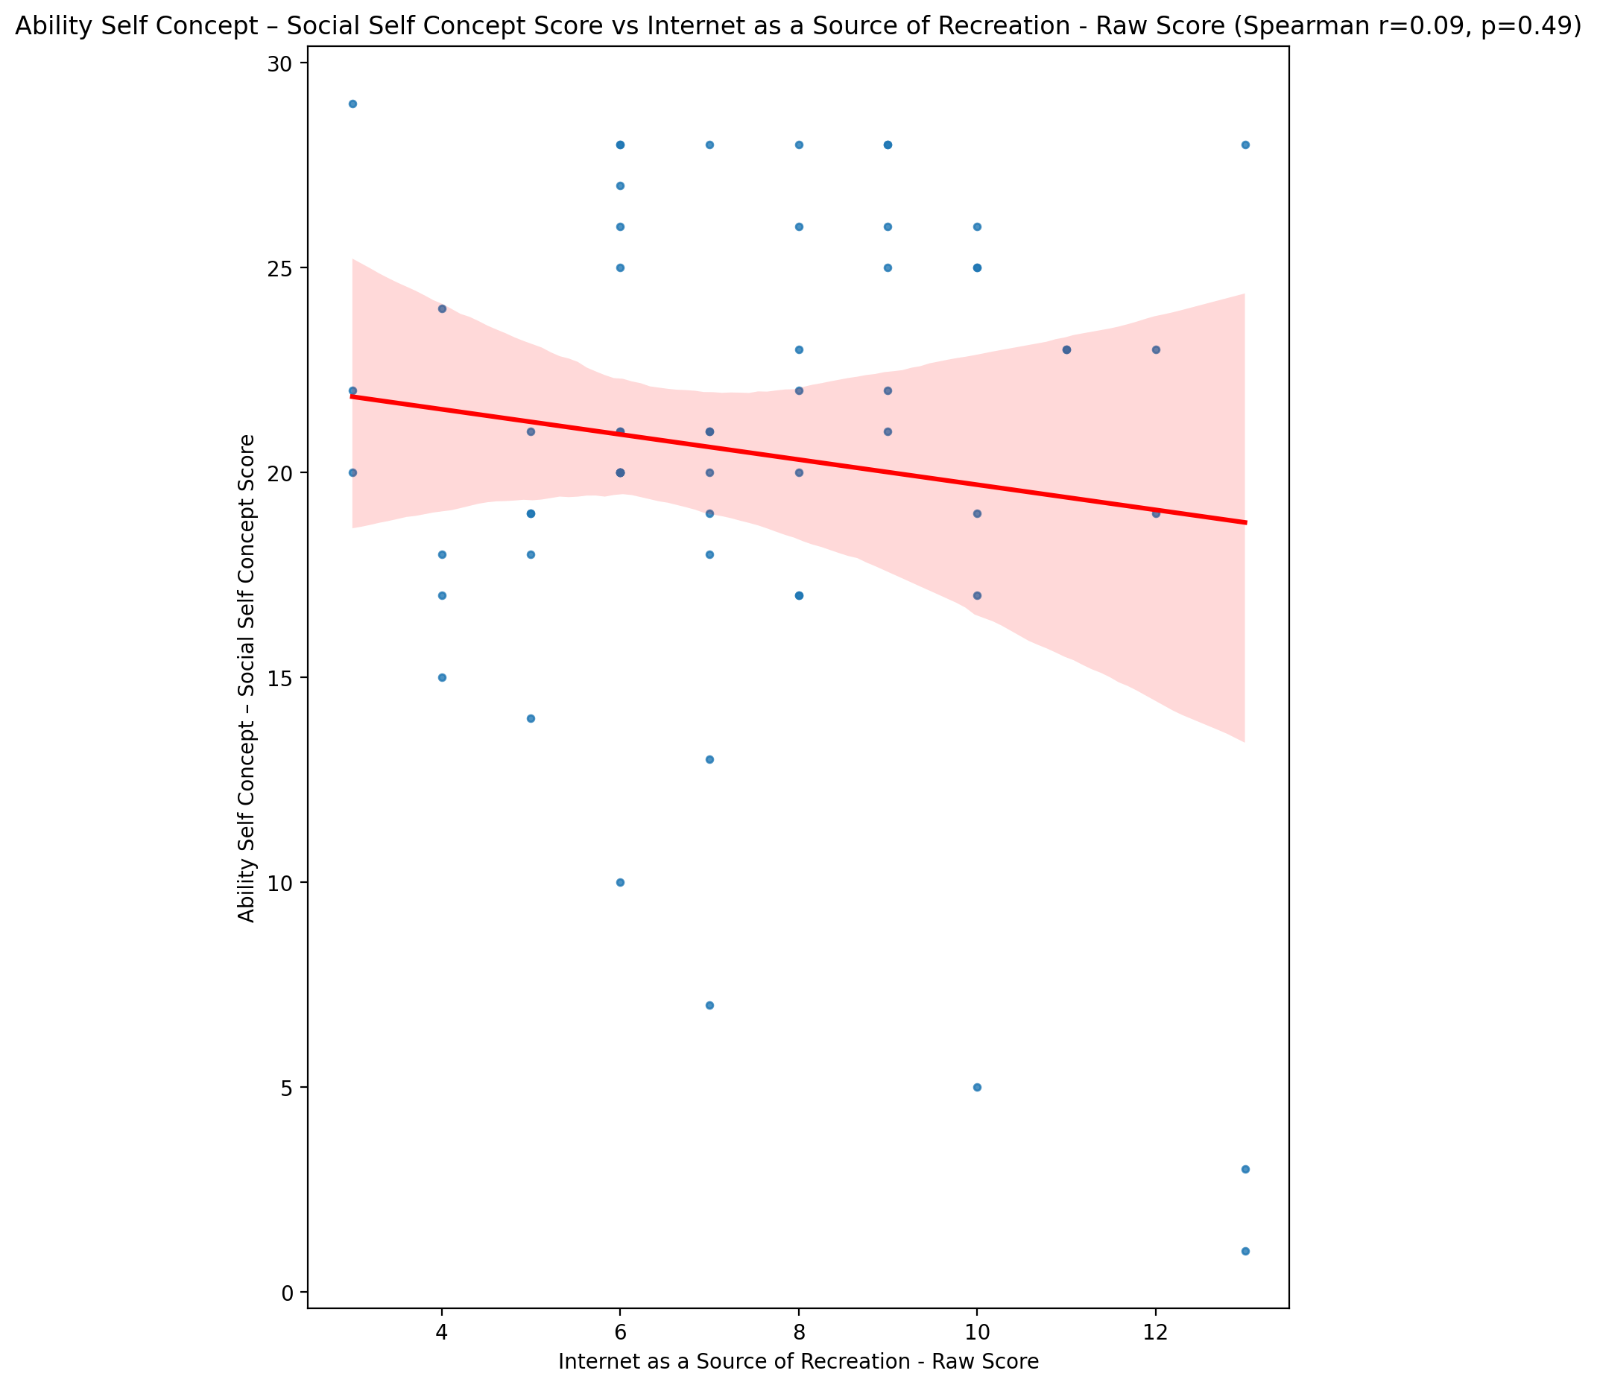

## Physical Self Concept - Real Self Concept Score vs Internet as a Source of Recreation - Raw Score

Test: spearman; statistic: -0.04745240075293412; p-value: 0.7211731690536372;

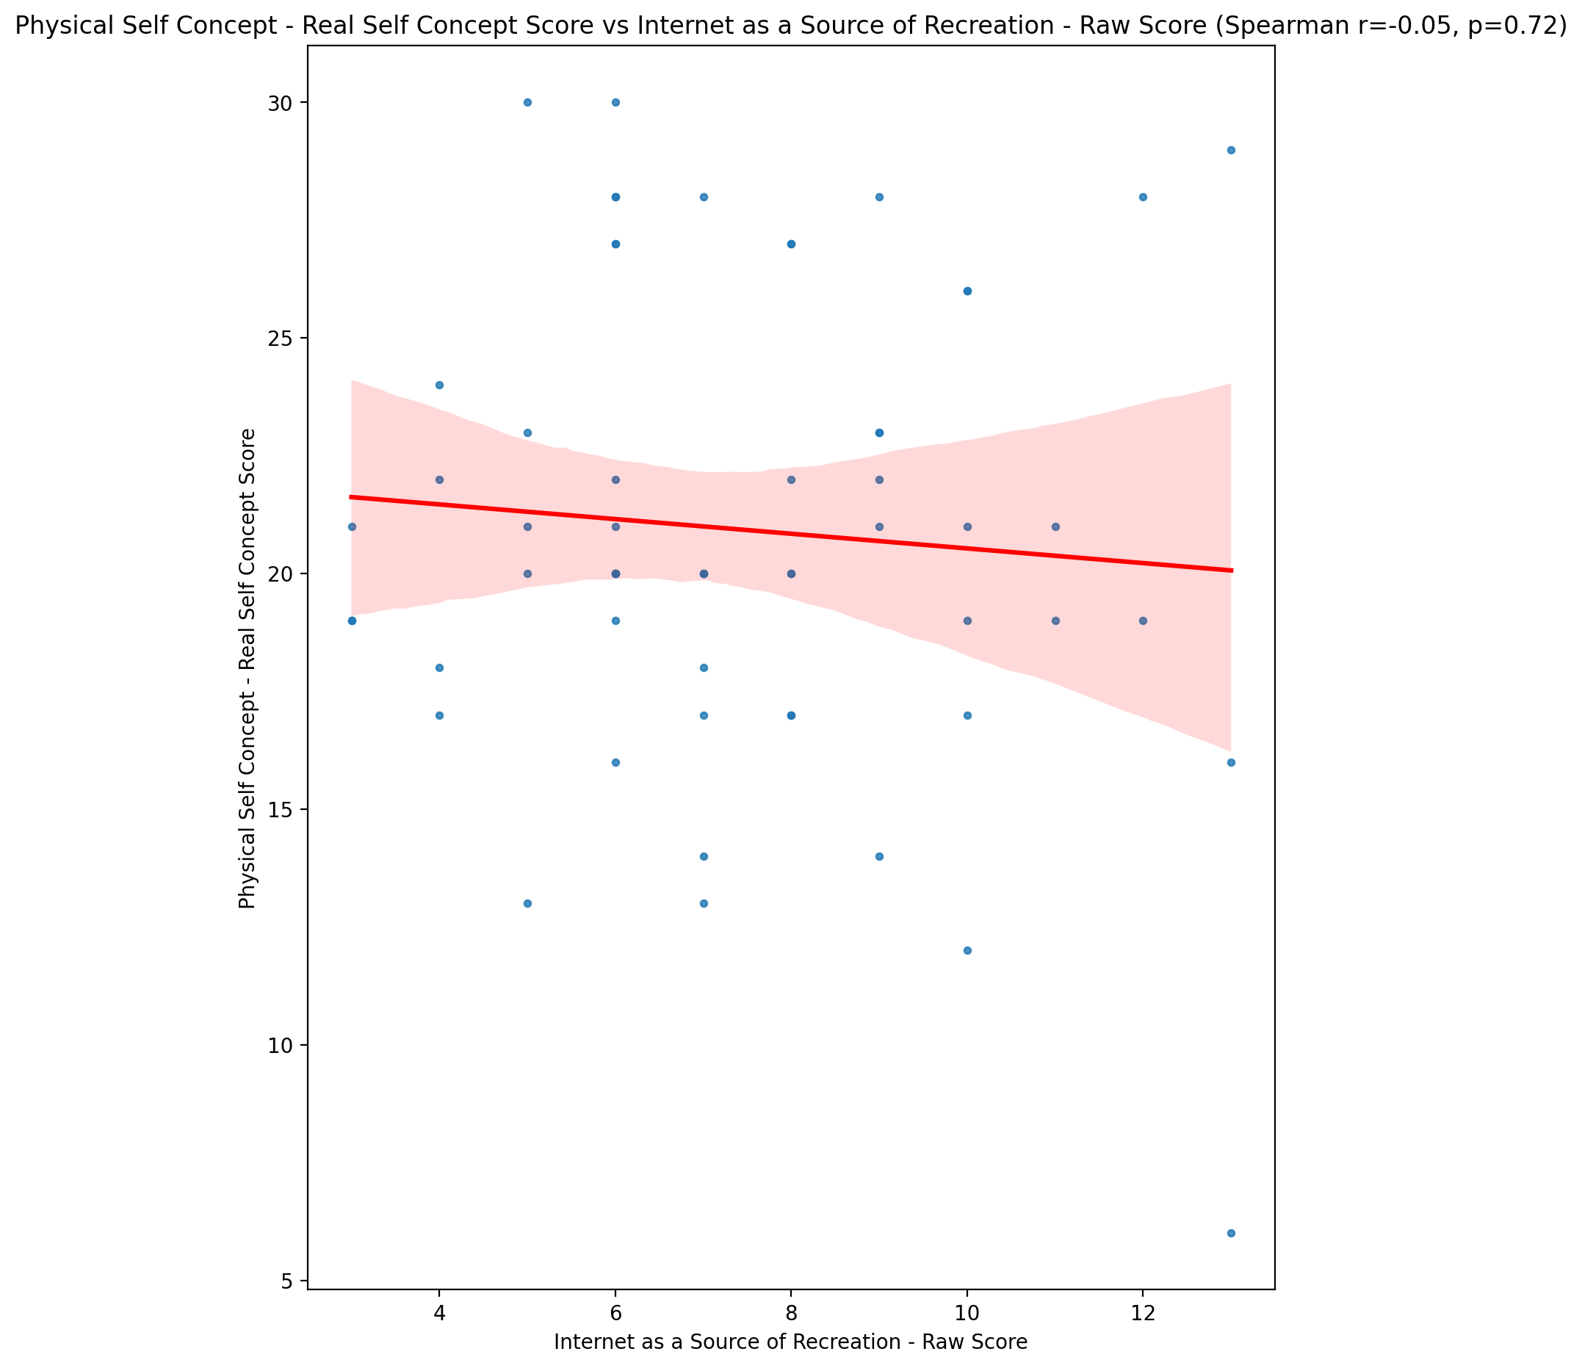

## Physical Self Concept – Ideal Self Concept Score vs Internet as a Source of Recreation - Raw Score

Test: spearman; statistic: -0.13450598771264793; p-value: 0.30978220214993285;

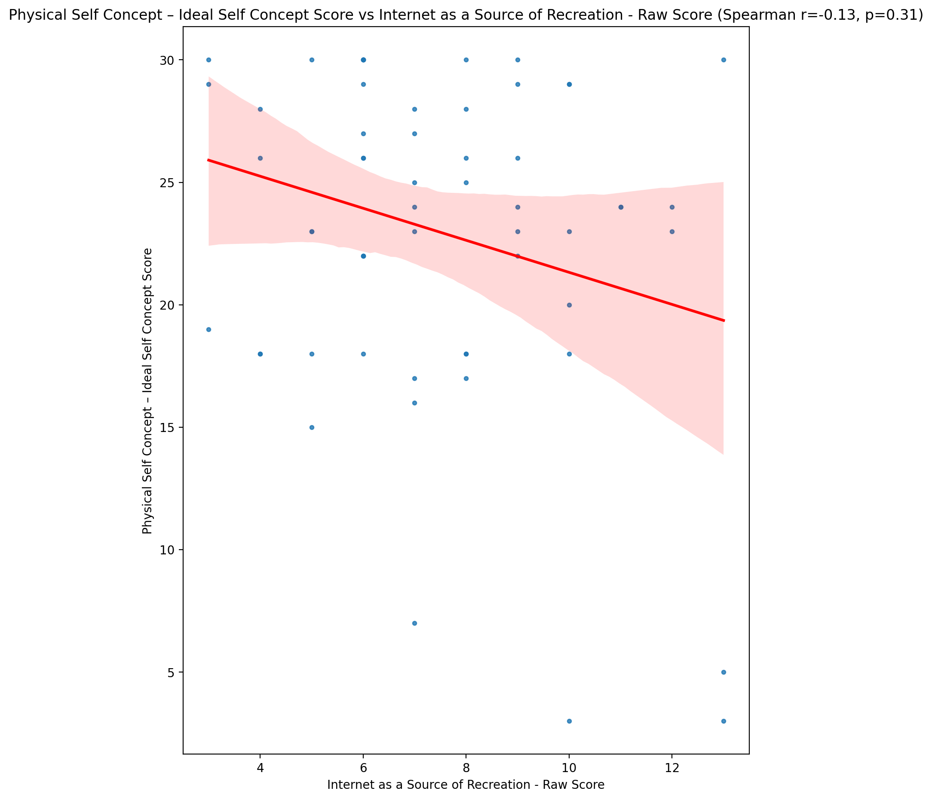

## Physical Self Concept – Social Self Concept Score vs Internet as a Source of Recreation - Raw Score

Test: spearman; statistic: 0.0042204555112462135; p-value: 0.9746918029981984;

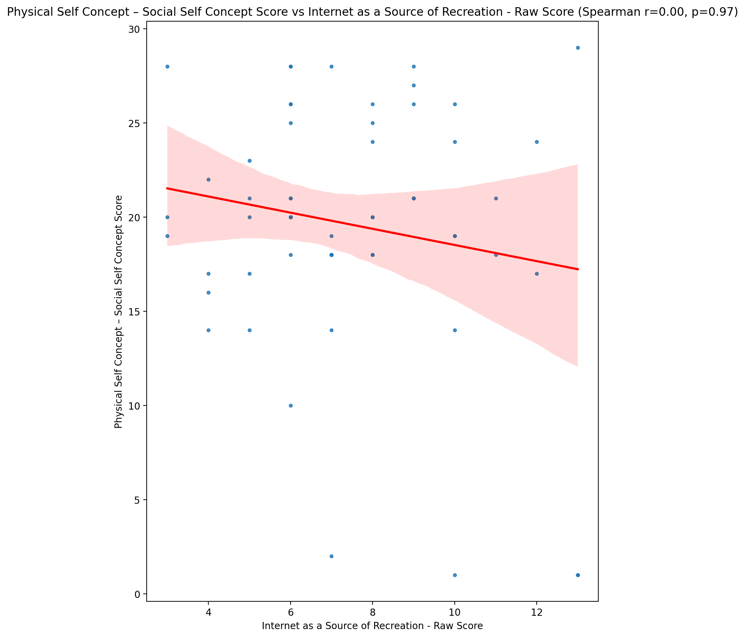

## Psychological Self Concept - Real Self Concept Score vs Internet as a Source of Recreation - Raw Score

Test: spearman; statistic: -0.02885992807567472; p-value: 0.8282243752116708;

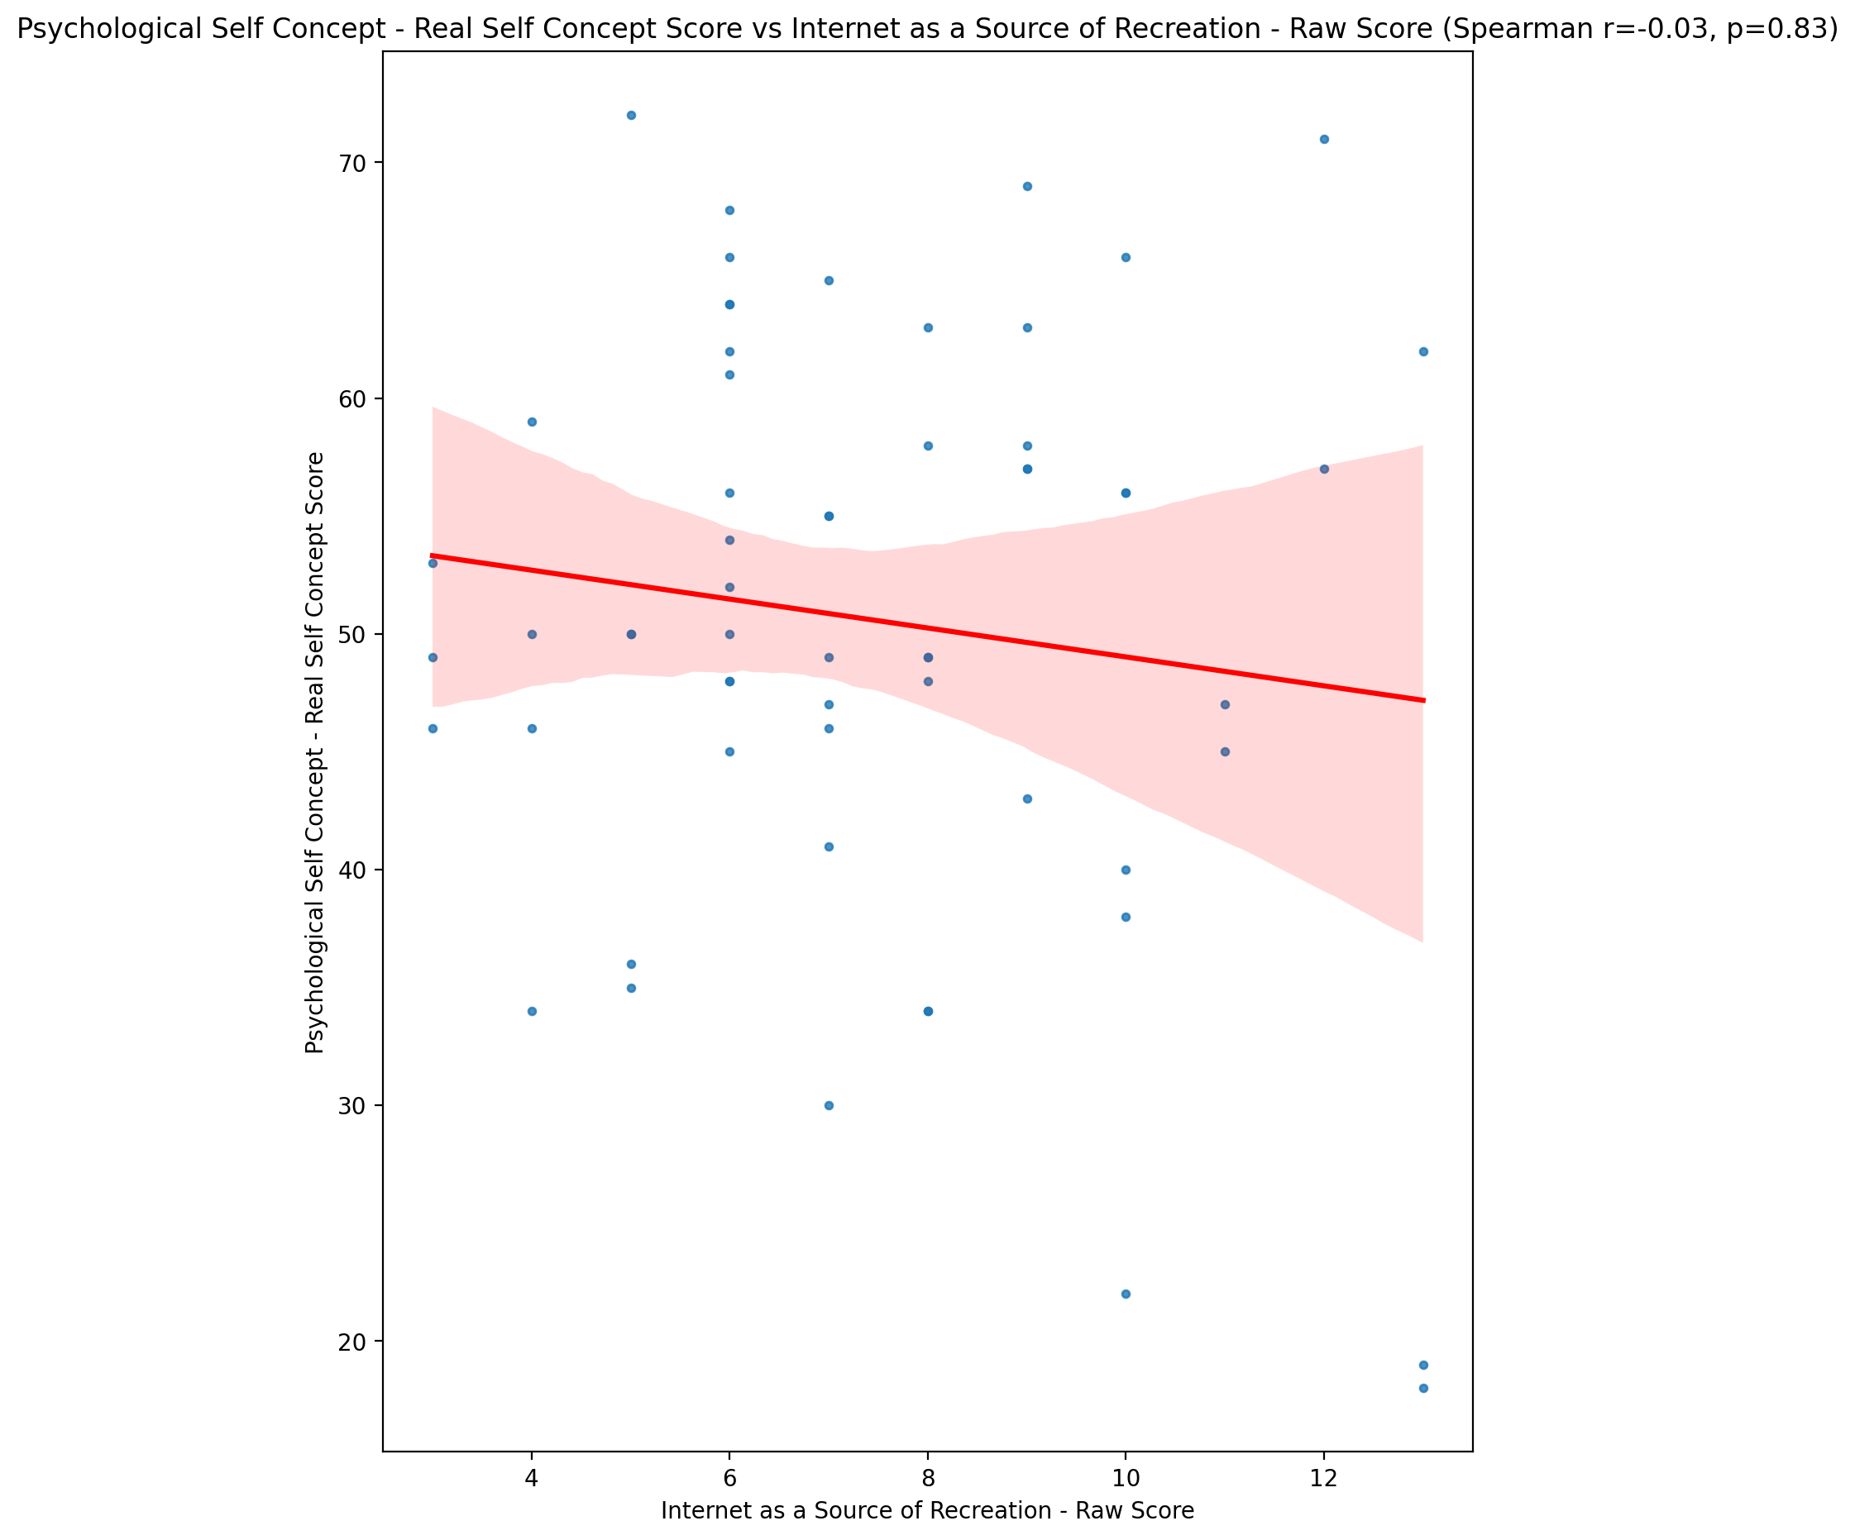

## Psychological Self Concept – Ideal Self Concept Score vs Internet as a Source of Recreation - Raw Score

Test: spearman; statistic: -0.09889216148596136; p-value: 0.45616172622049944;

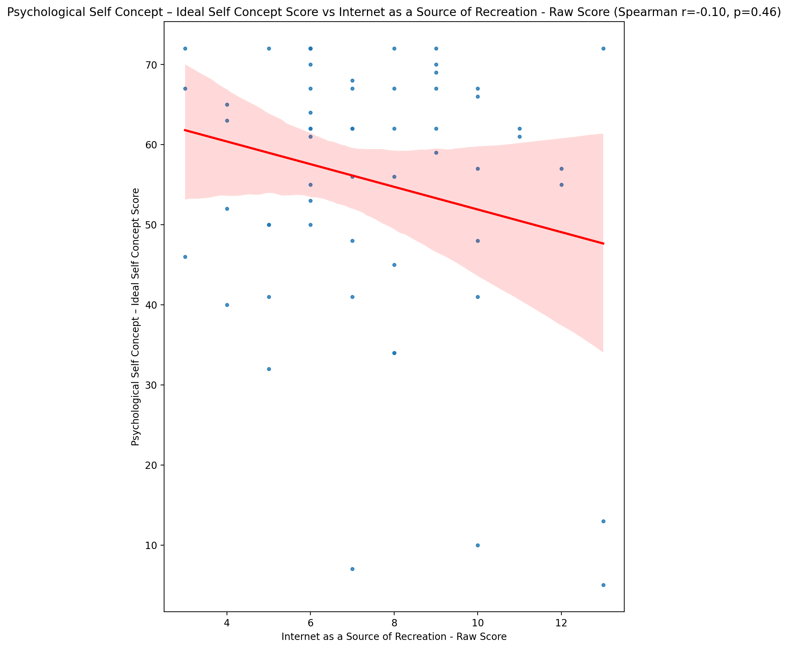

## Psychological Self Concept – Social Self Concept Score vs Internet as a Source of Recreation - Raw Score

Test: spearman; statistic: 0.025464294900973485; p-value: 0.8481801174314939;

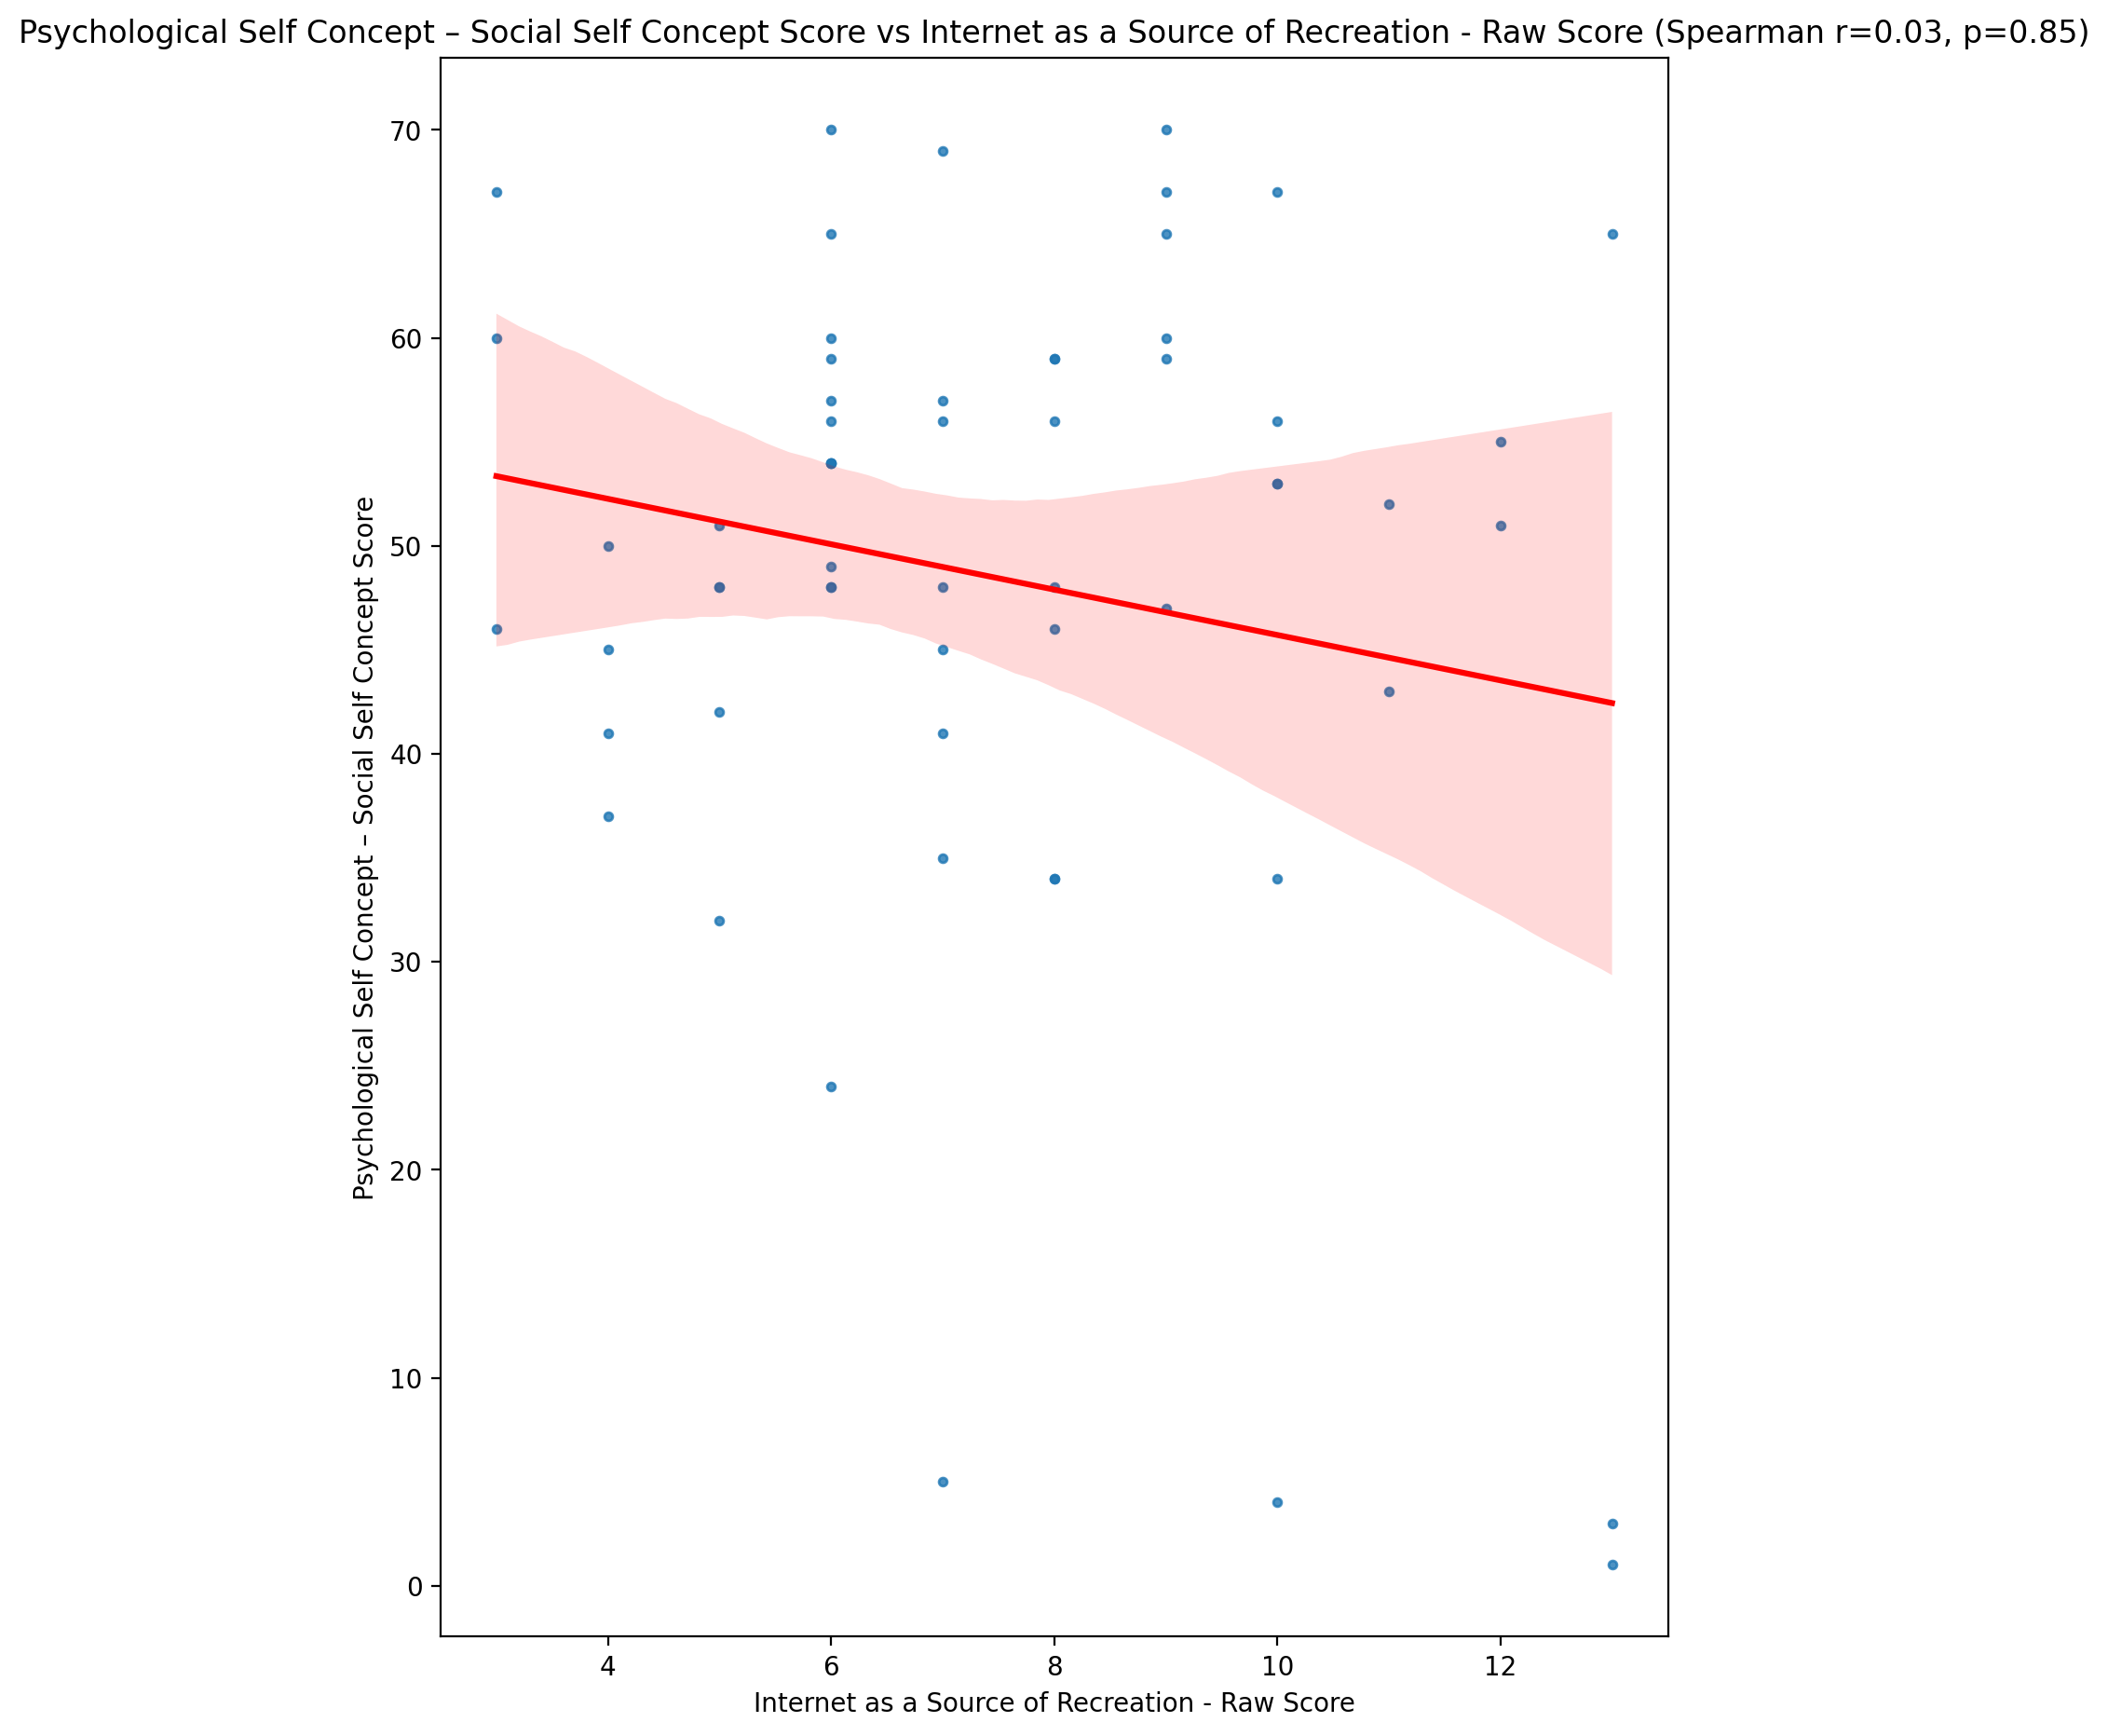

## Real Self Concept Total Score vs Internet as a Source of Recreation - Raw Score

Test: spearman; statistic: 0.006904025048570293; p-value: 0.9586109538959744;

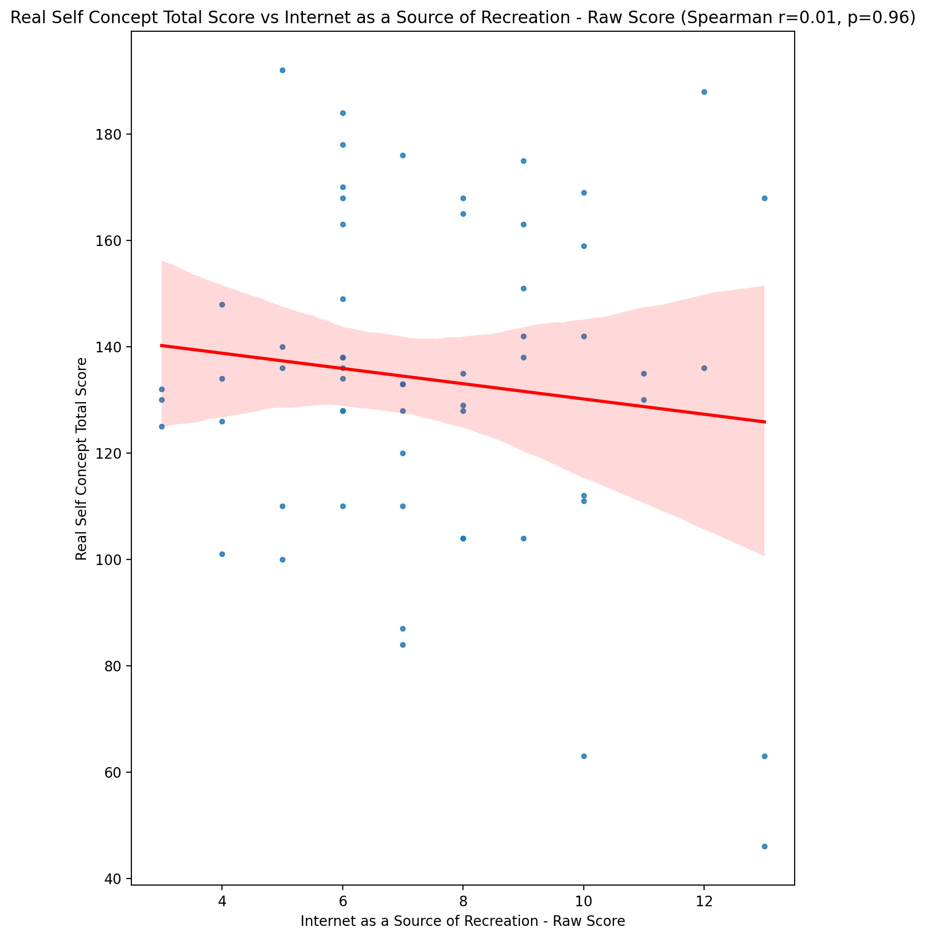

## Ideal Self Concept Total Score vs Internet as a Source of Recreation - Raw Score

Test: spearman; statistic: -0.12363183197433529; p-value: 0.3508709378351721;

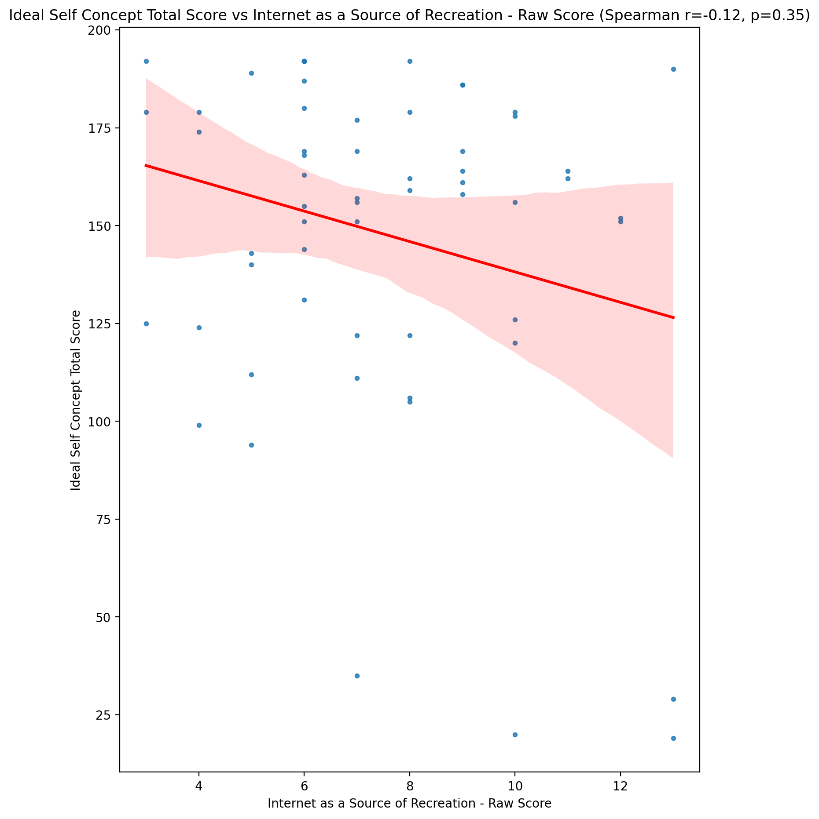

## Social Self Concept Total Score vs Internet as a Source of Recreation - Raw Score

Test: spearman; statistic: 0.03256521563550518; p-value: 0.8065717317626815;

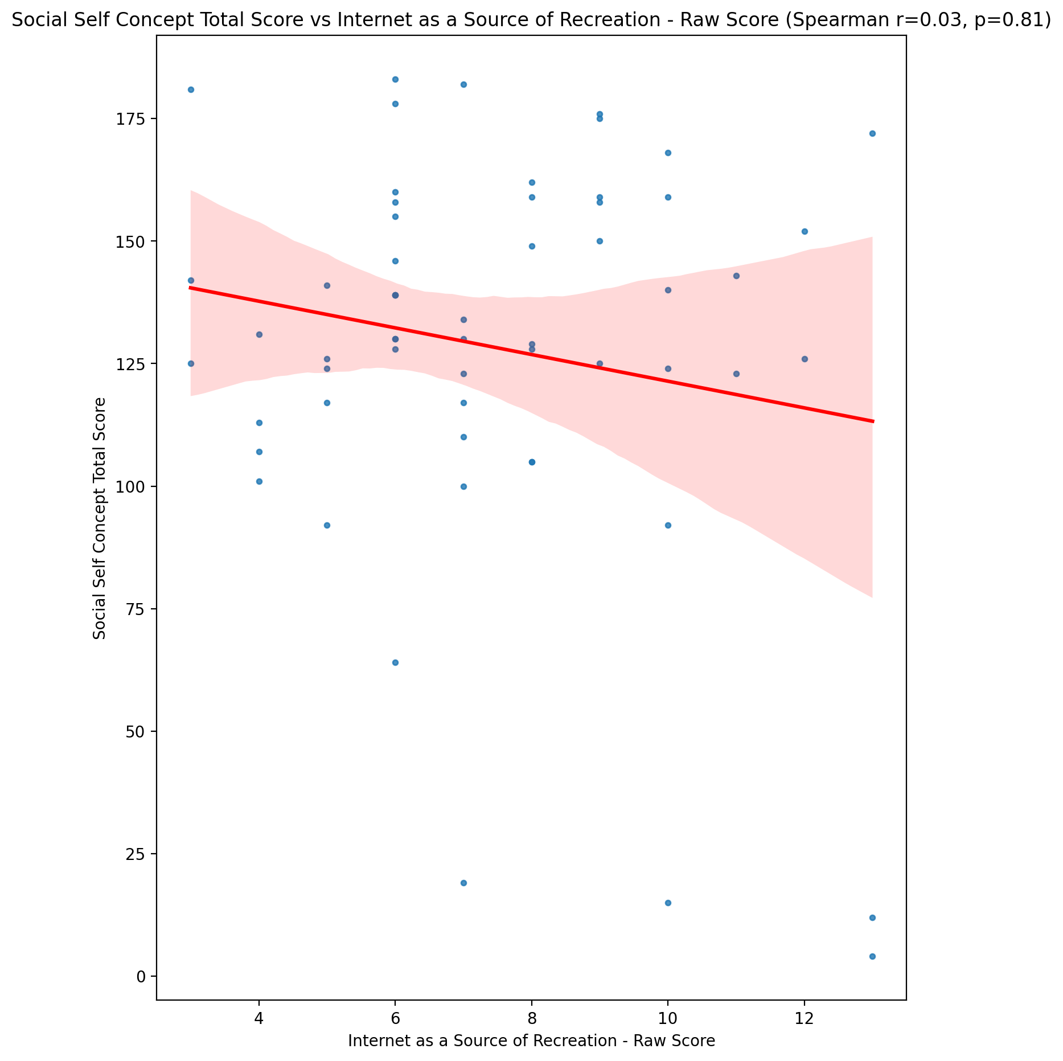

## Ideal Self Concept Total Category vs Internet as a Source of Recreation - Raw Score

Test: None; statistic: None; p-value: None; Test not run: unsupported type combination.



## Perceived Social Stress Score vs Internet as a Source of Recreation - Raw Score

Test: spearman; statistic: -0.003703233126398059; p-value: 0.9777925217106456;

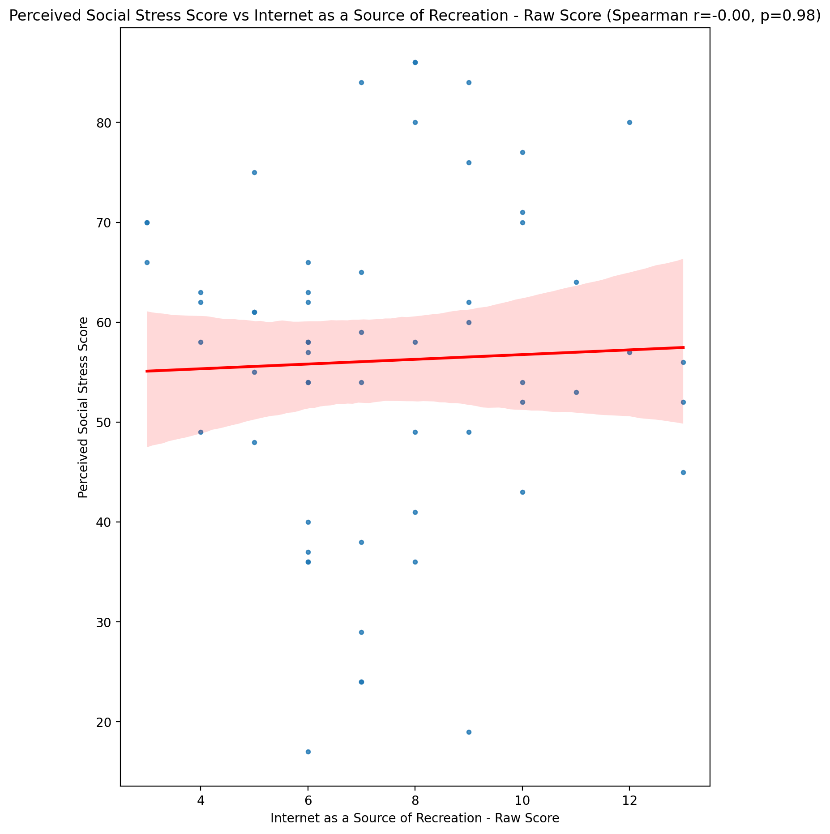

## Perceived Social Stress Category vs Internet as a Source of Recreation - Raw Score

Test: None; statistic: None; p-value: None; Test not run: unsupported type combination.



## Emotional Support - Raw Score vs Enhanced Socialization - Raw Score

Test: spearman; statistic: 0.05937601715903143; p-value: 0.655082960634235;

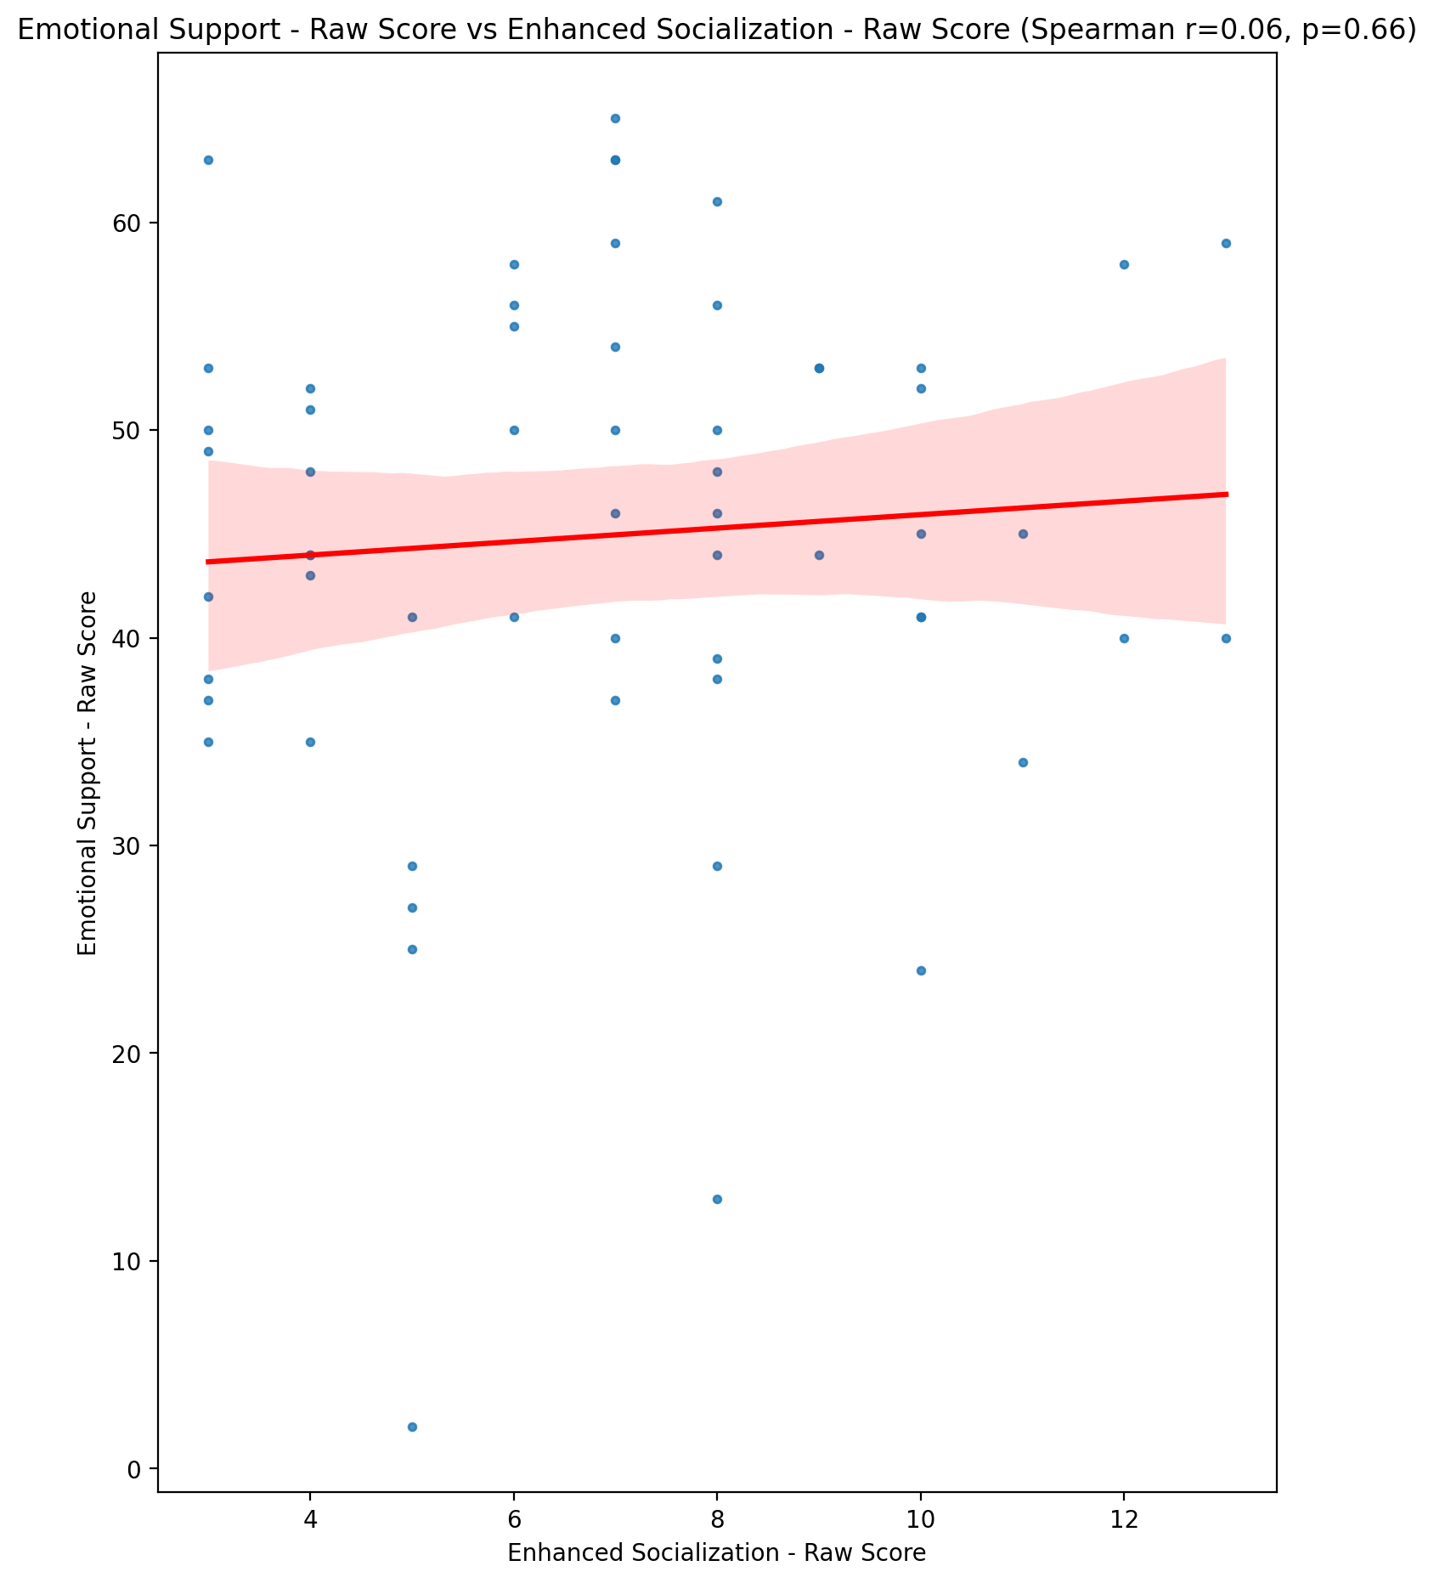

## Informational Support - Raw Score vs Enhanced Socialization - Raw Score

Test: spearman; statistic: 0.10302599467573333; p-value: 0.43745660852280177;

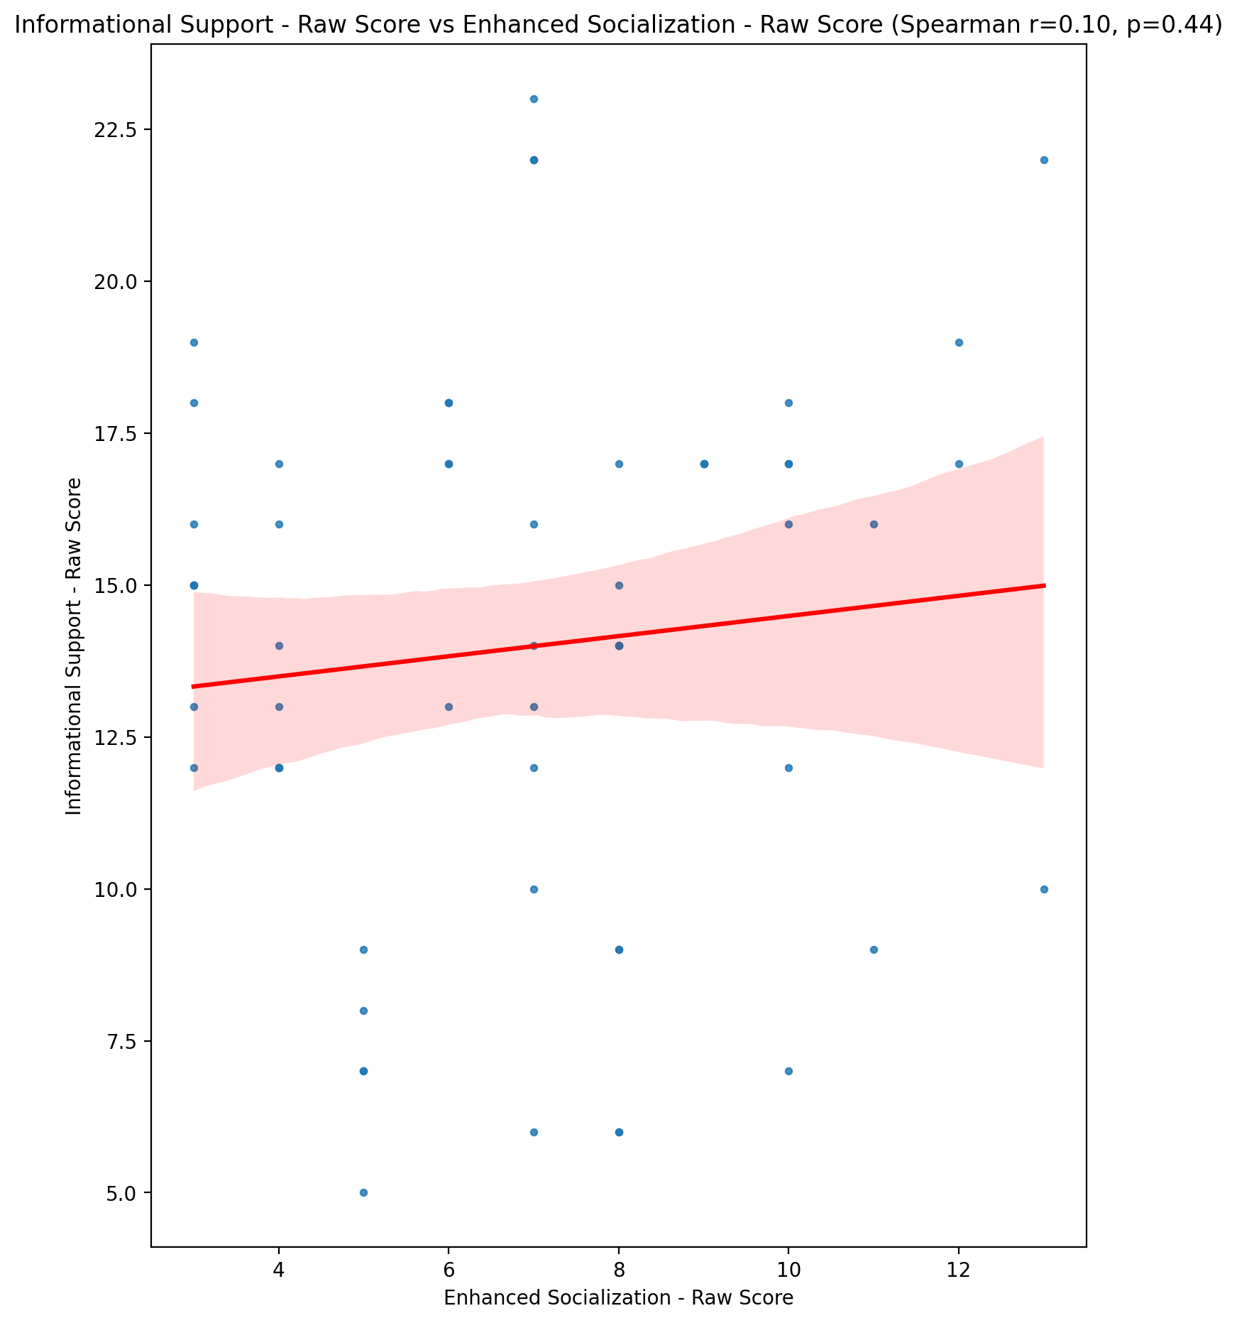

## Instrumental Support - Raw Score vs Enhanced Socialization - Raw Score

Test: spearman; statistic: -0.11697722577639953; p-value: 0.3775990045111858;

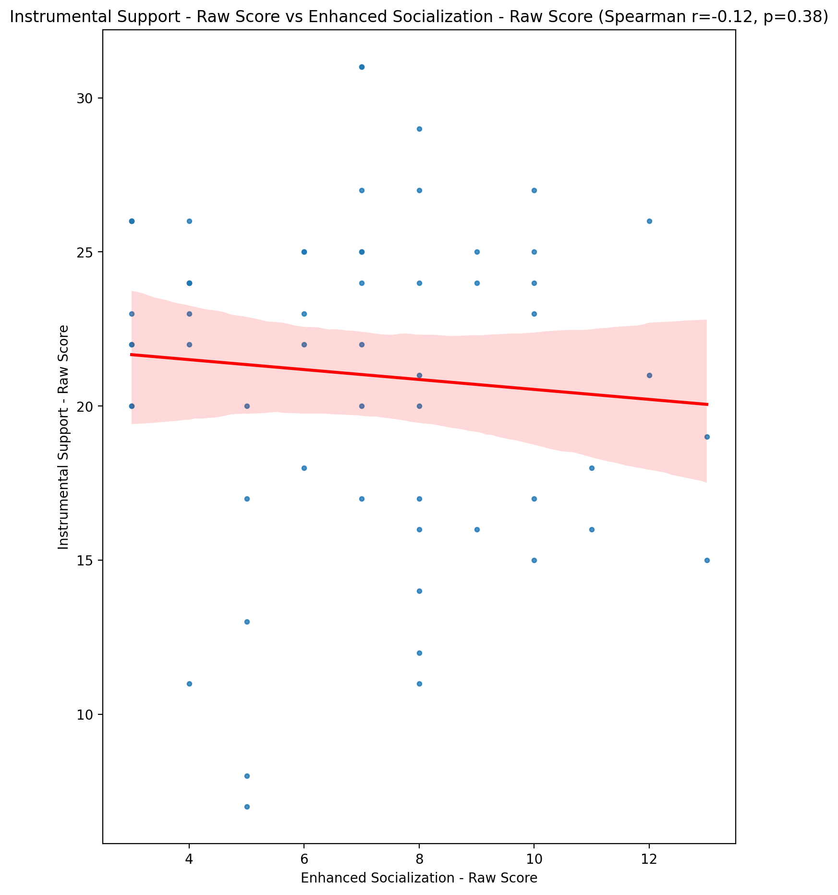

## Emotional Support - T Score vs Enhanced Socialization - Raw Score

Test: spearman; statistic: 0.06066085836102158; p-value: 0.6481051102481576;

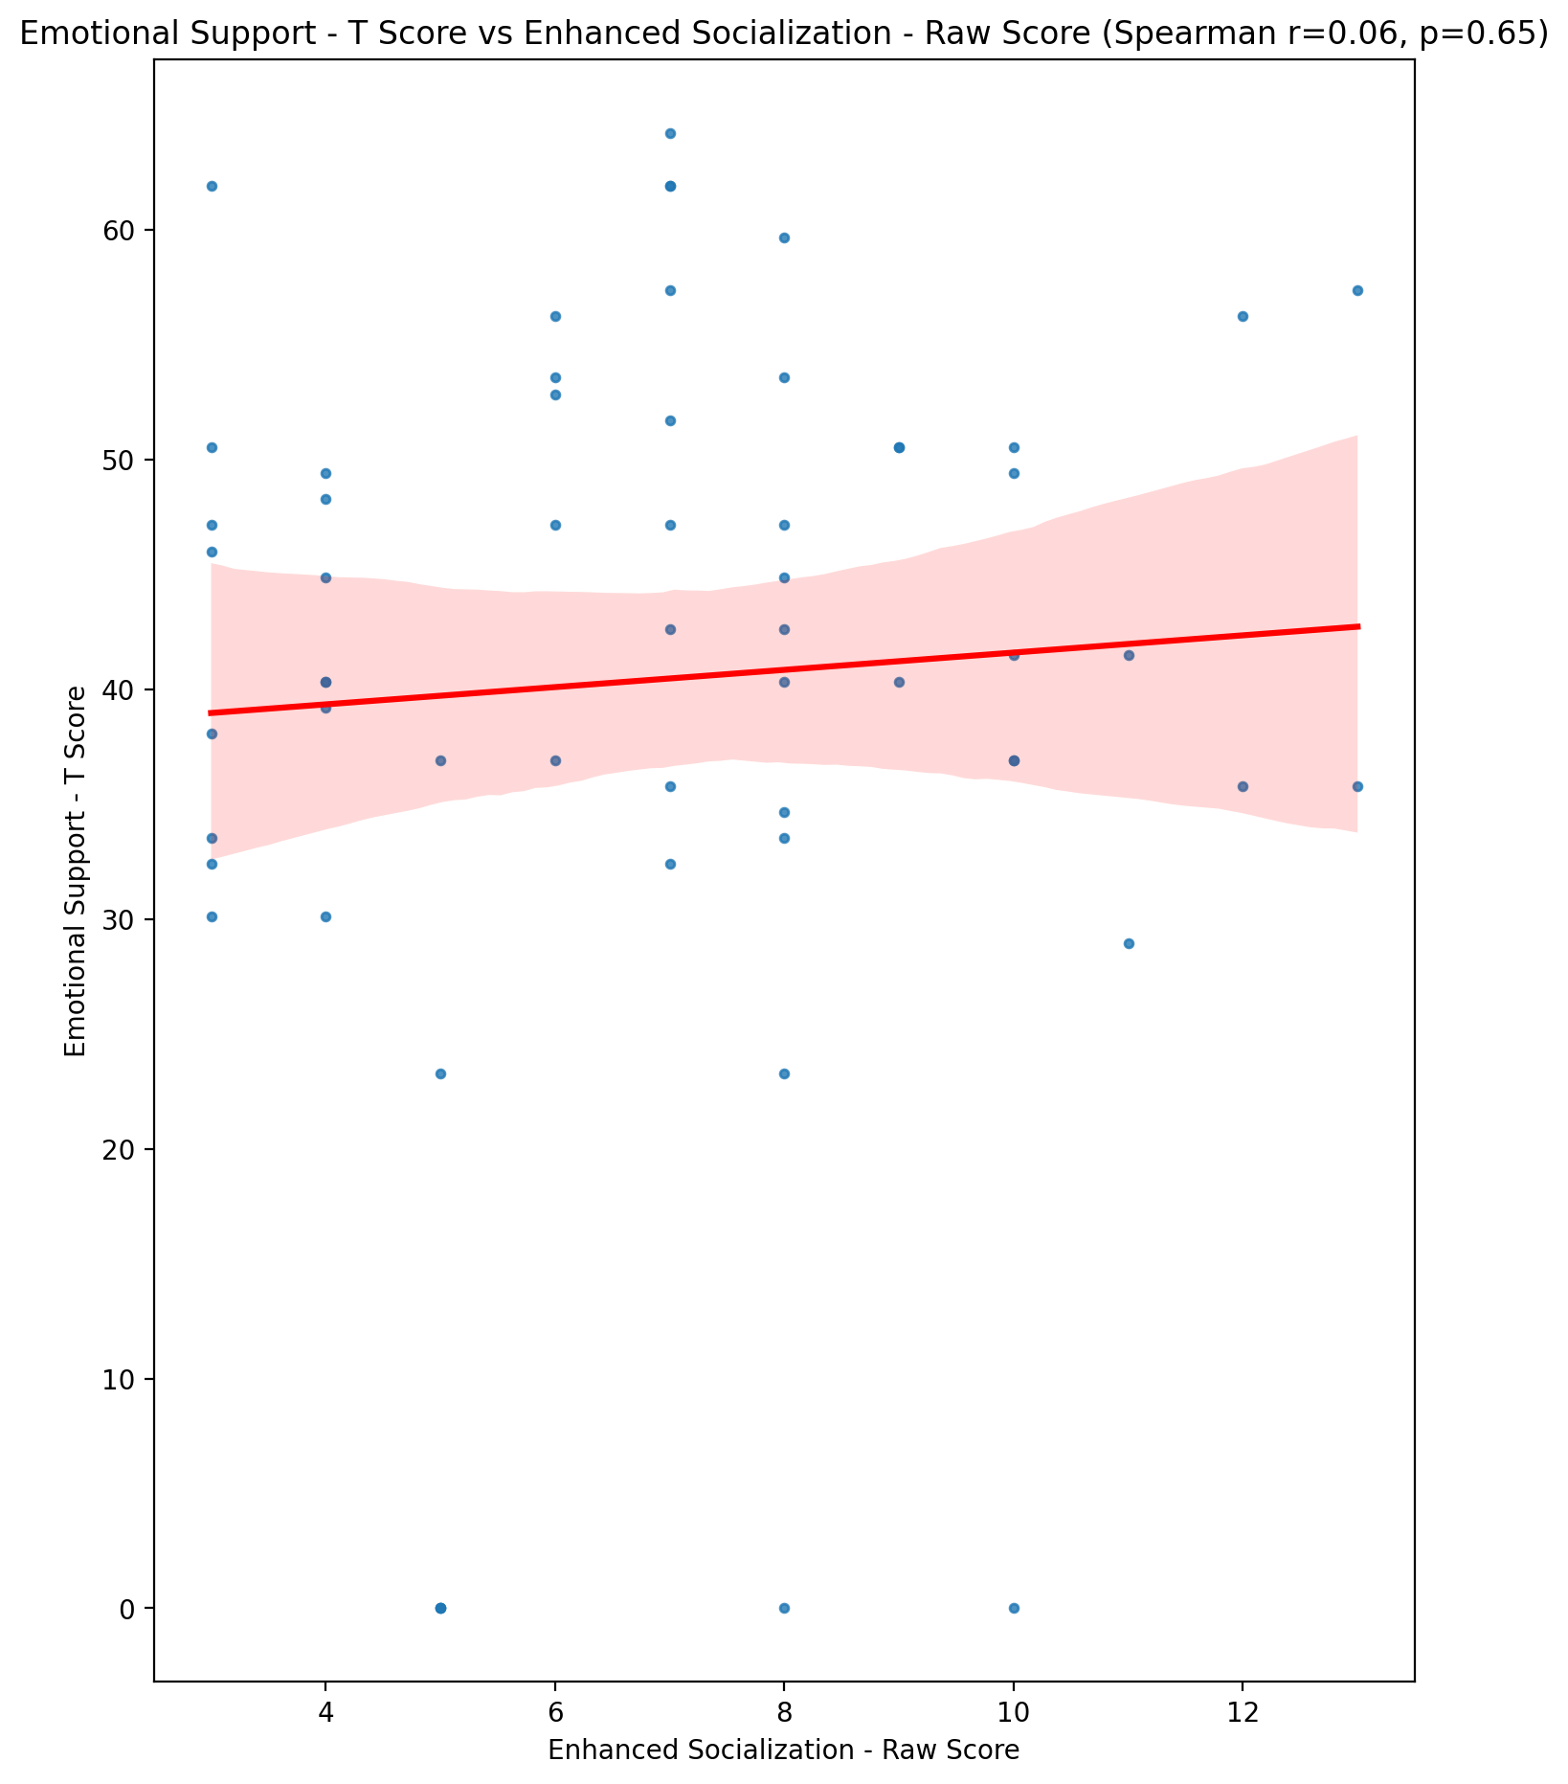

## Informational Support - T Score vs Enhanced Socialization - Raw Score

Test: spearman; statistic: 0.10514022004613219; p-value: 0.4280586576862101;

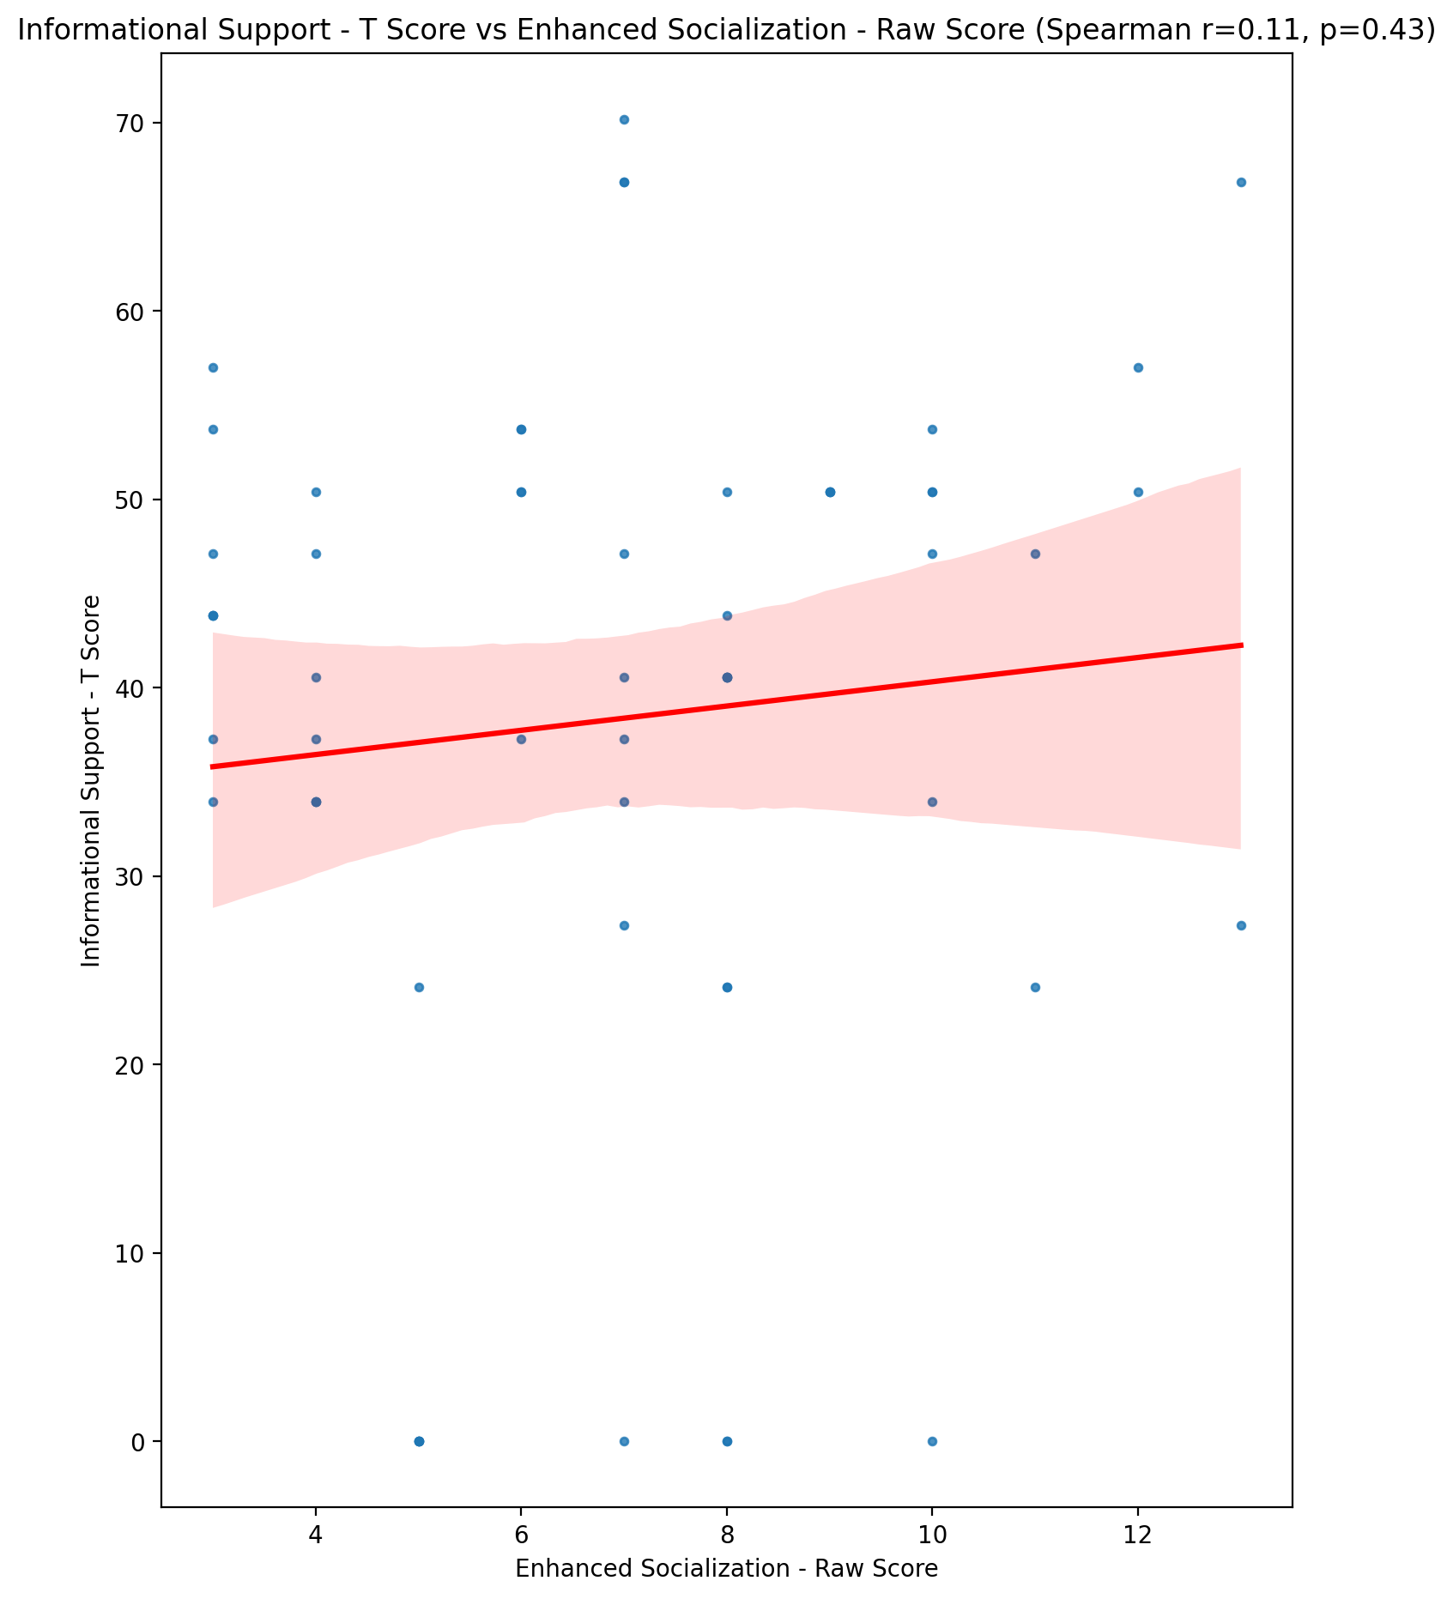

## Instrumental Support - T Score vs Enhanced Socialization - Raw Score

Test: spearman; statistic: -0.11894075688189032; p-value: 0.3695884519037158;

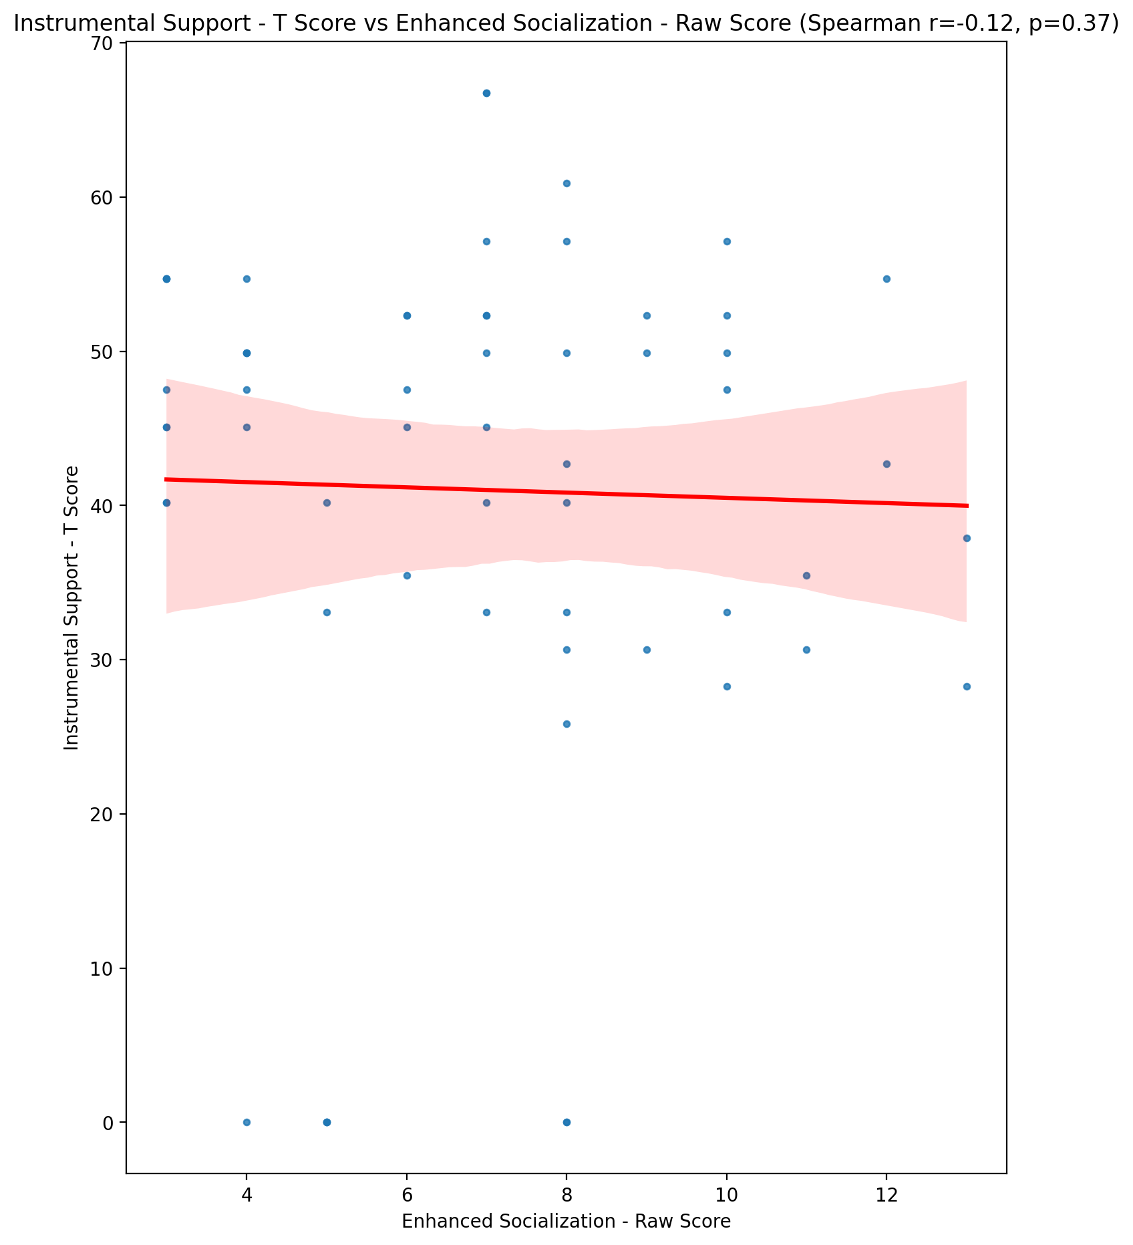

## Perceived Social Support Total T Score vs Enhanced Socialization - Raw Score

Test: spearman; statistic: 0.004137205875331072; p-value: 0.9751908558743911;

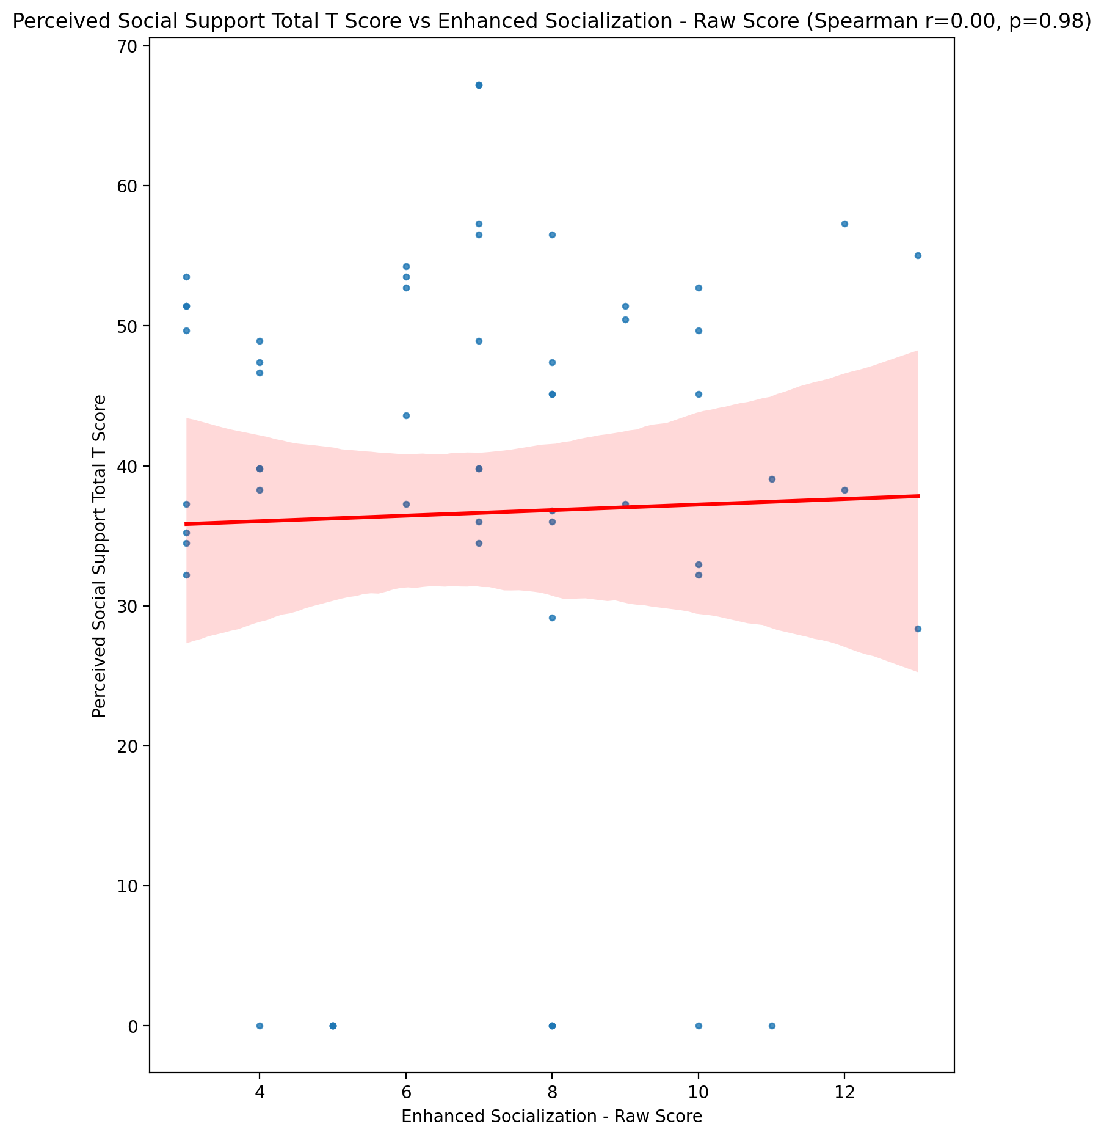

## Emotional Support - Rank vs Enhanced Socialization - Raw Score

Test: None; statistic: None; p-value: None; Test not run: unsupported type combination.



## Informational Support - Rank vs Enhanced Socialization - Raw Score

Test: None; statistic: None; p-value: None; Test not run: unsupported type combination.



## Instrumental Support - Rank vs Enhanced Socialization - Raw Score

Test: None; statistic: None; p-value: None; Test not run: unsupported type combination.



## Perceived Social Support TOTAL - Rank vs Enhanced Socialization - Raw Score

Test: None; statistic: None; p-value: None; Test not run: unsupported type combination.



## Power Self Concept - Real Self Concept Score vs Enhanced Socialization - Raw Score

Test: spearman; statistic: 0.0012115924568210131; p-value: 0.9927335296884163;

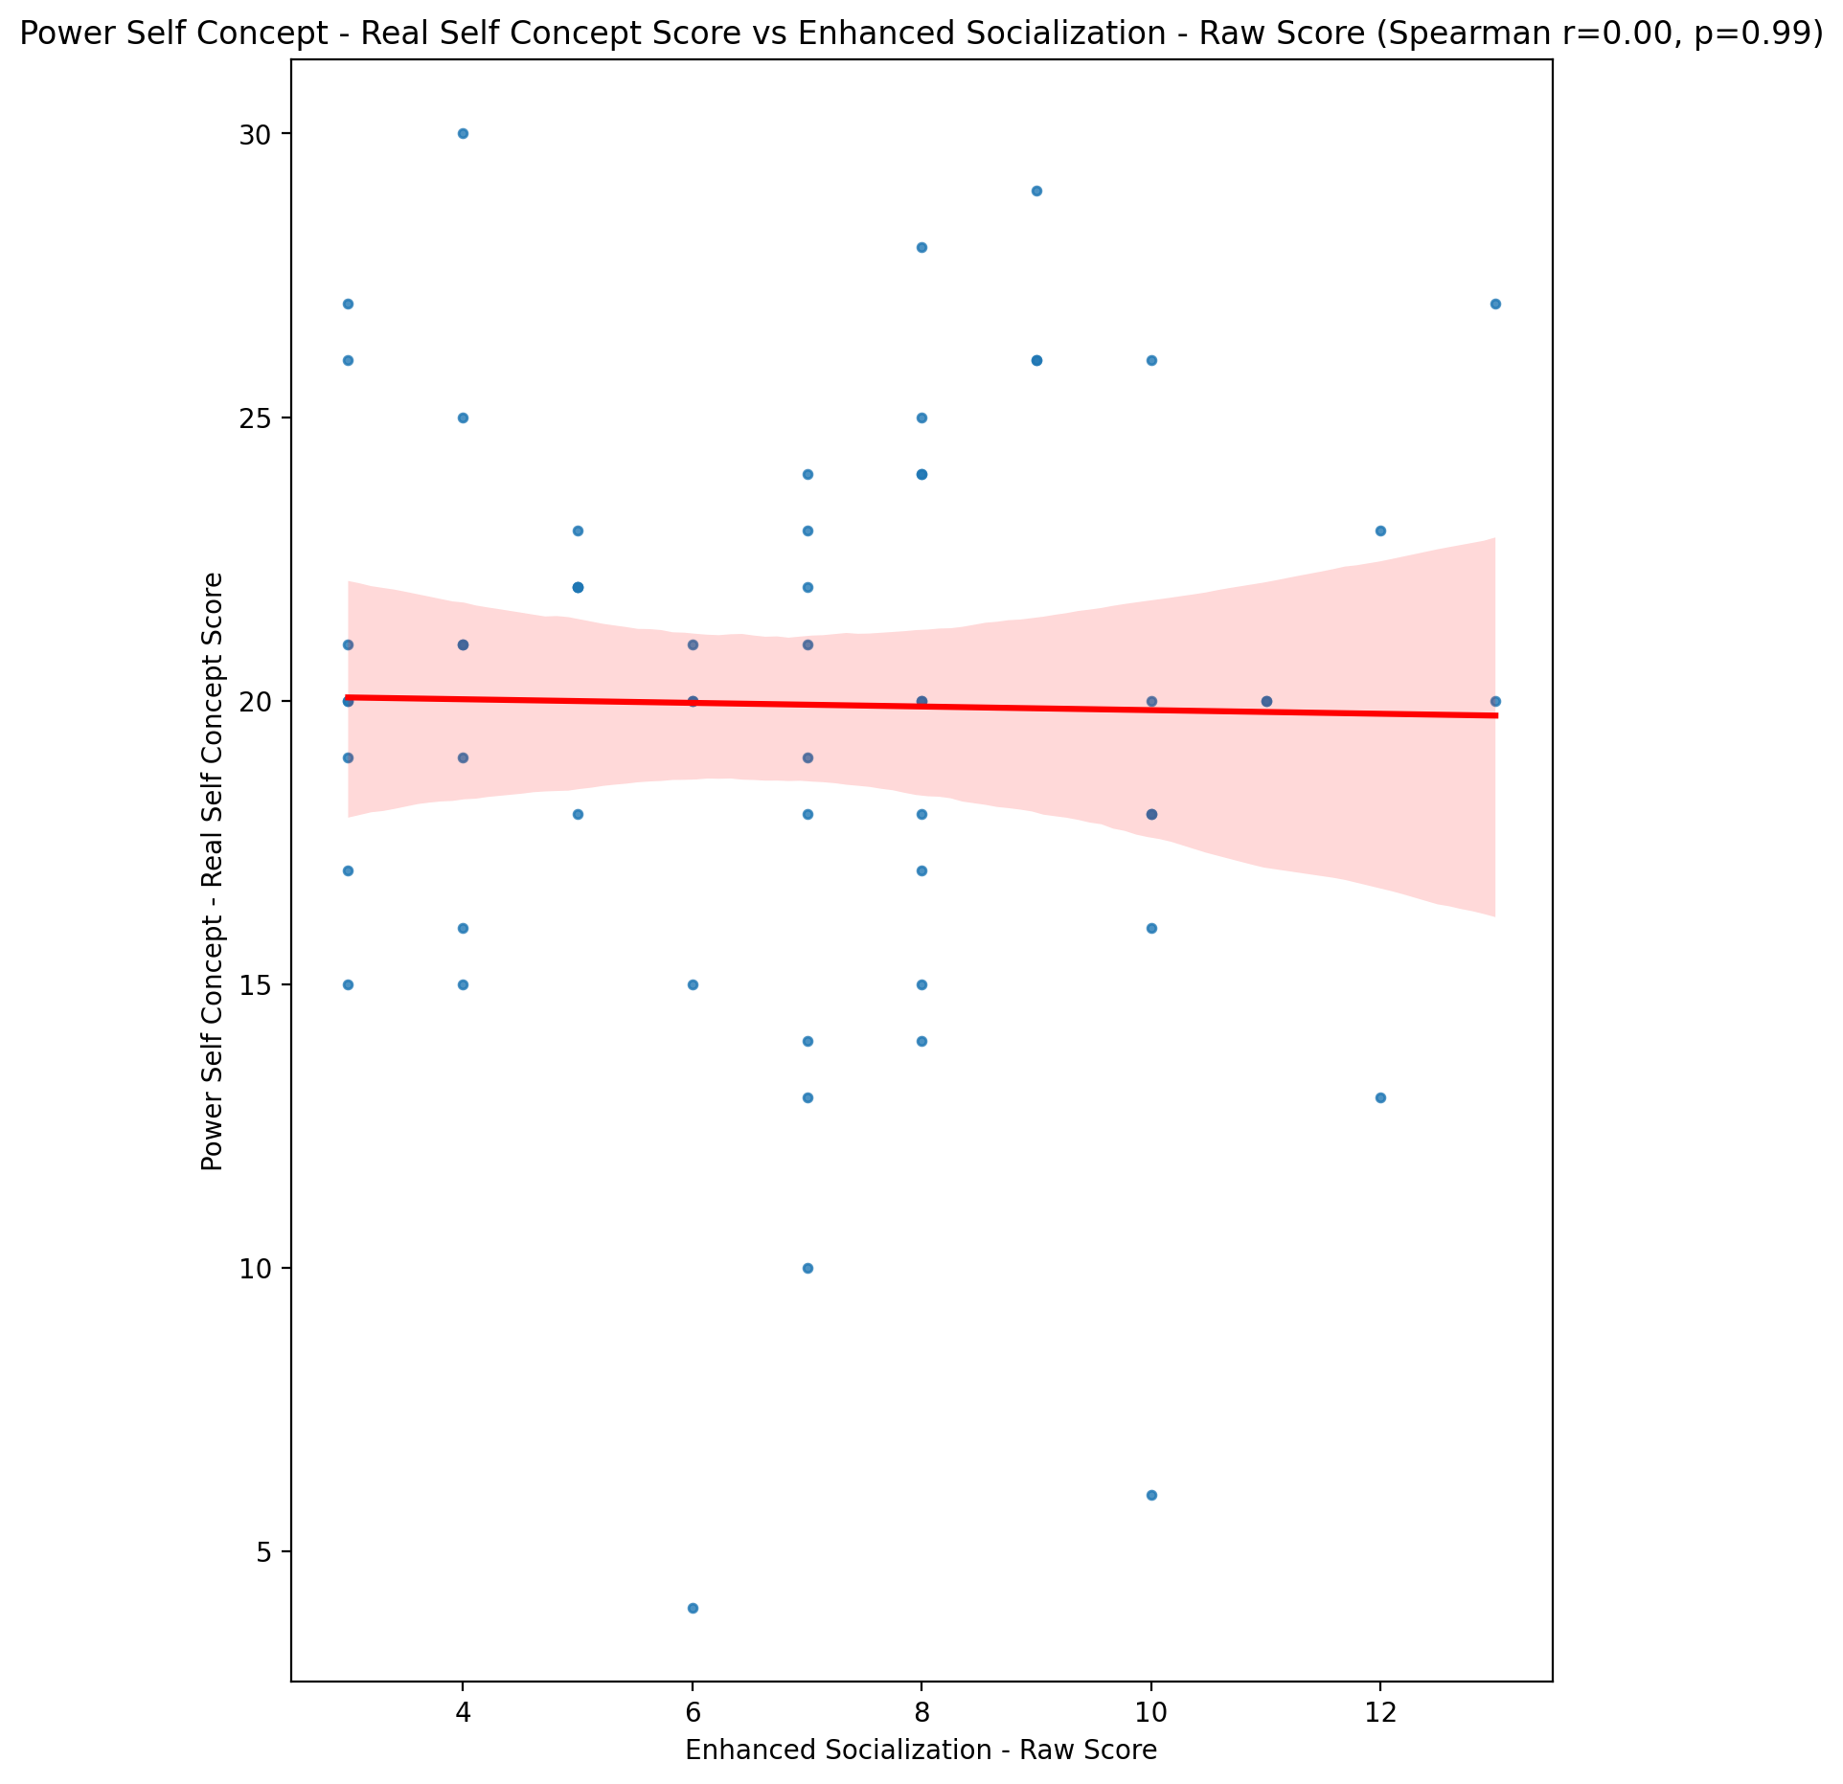

## Power Self Concept - Ideal Self Concept score vs Enhanced Socialization - Raw Score

Test: spearman; statistic: -0.15733115007955067; p-value: 0.23402467610228686;

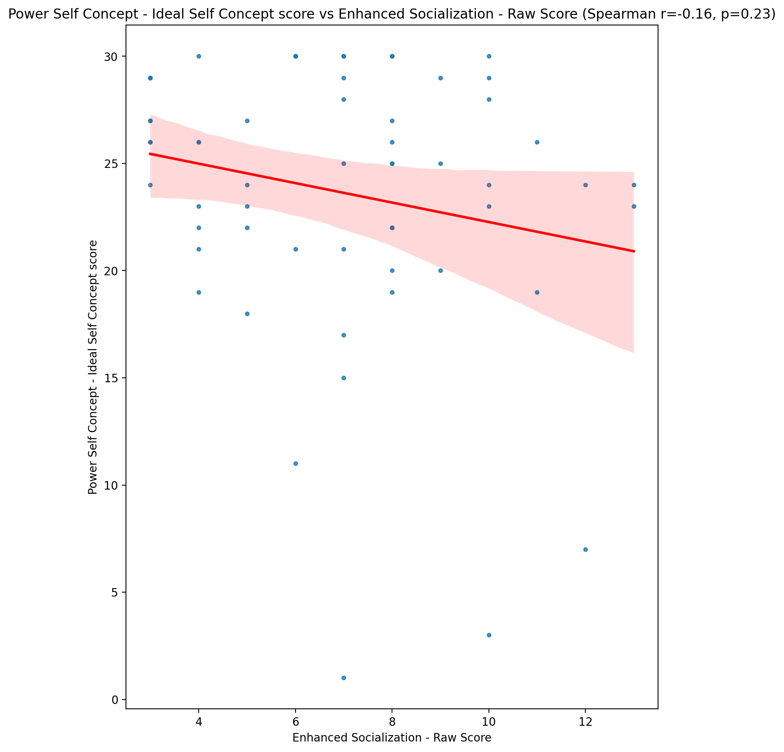

## Power Self Concept – Social Self Concept Score vs Enhanced Socialization - Raw Score

Test: spearman; statistic: 0.16844695086819594; p-value: 0.20219695677958535;

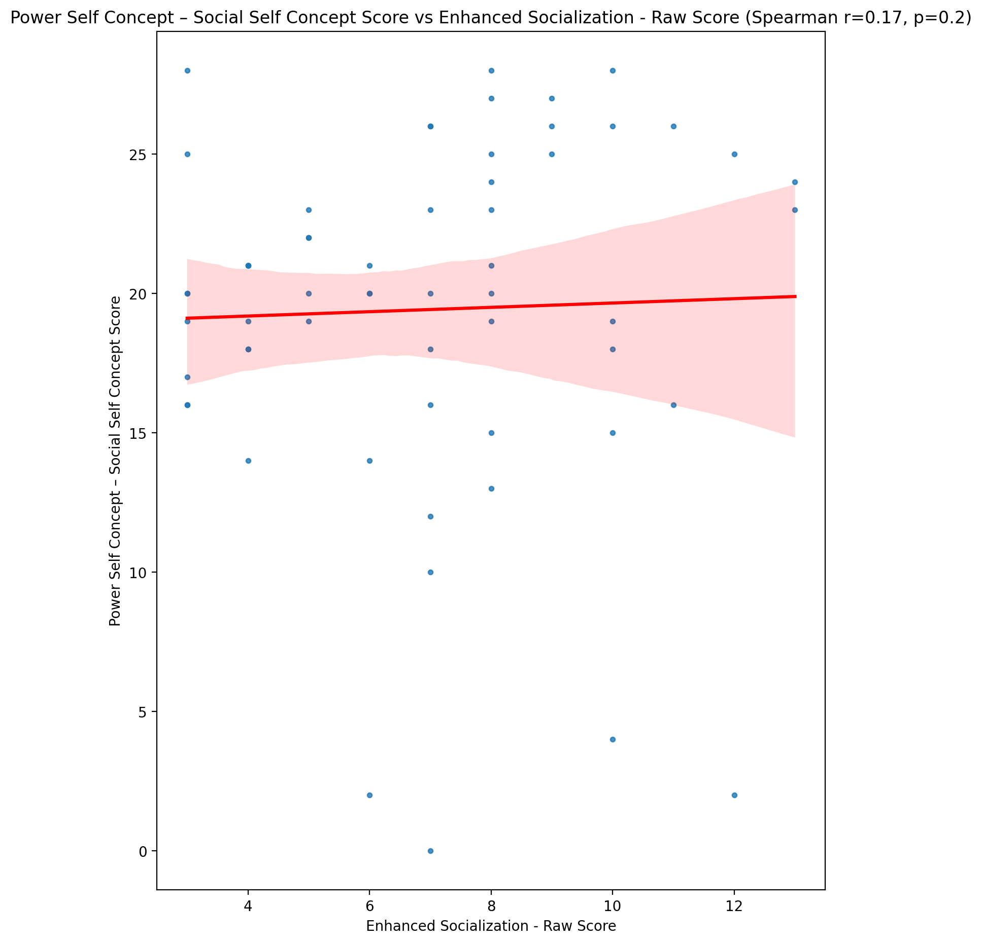

## Social Self Concept - Real Self Concept Score vs Enhanced Socialization - Raw Score

Test: spearman; statistic: -0.08269648006528078; p-value: 0.5334943010686454;

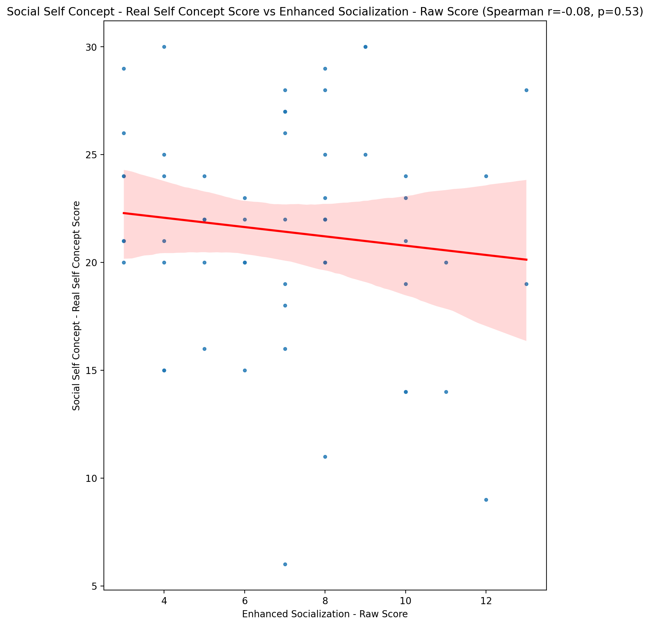

## Social Self Concept – Social Self Concept Score vs Enhanced Socialization - Raw Score

Test: spearman; statistic: 0.1072144577234994; p-value: 0.4189506613253089;

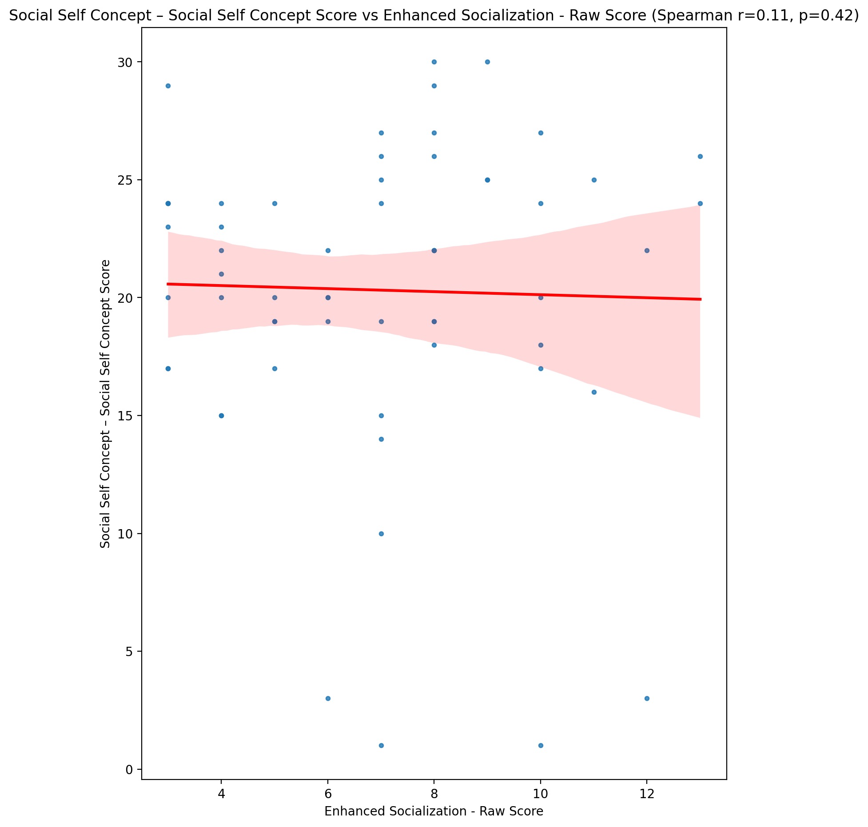

## Ability Self Concept - Real Self Concept Score vs Enhanced Socialization - Raw Score

Test: spearman; statistic: -0.010984841349838558; p-value: 0.9341908331746998;

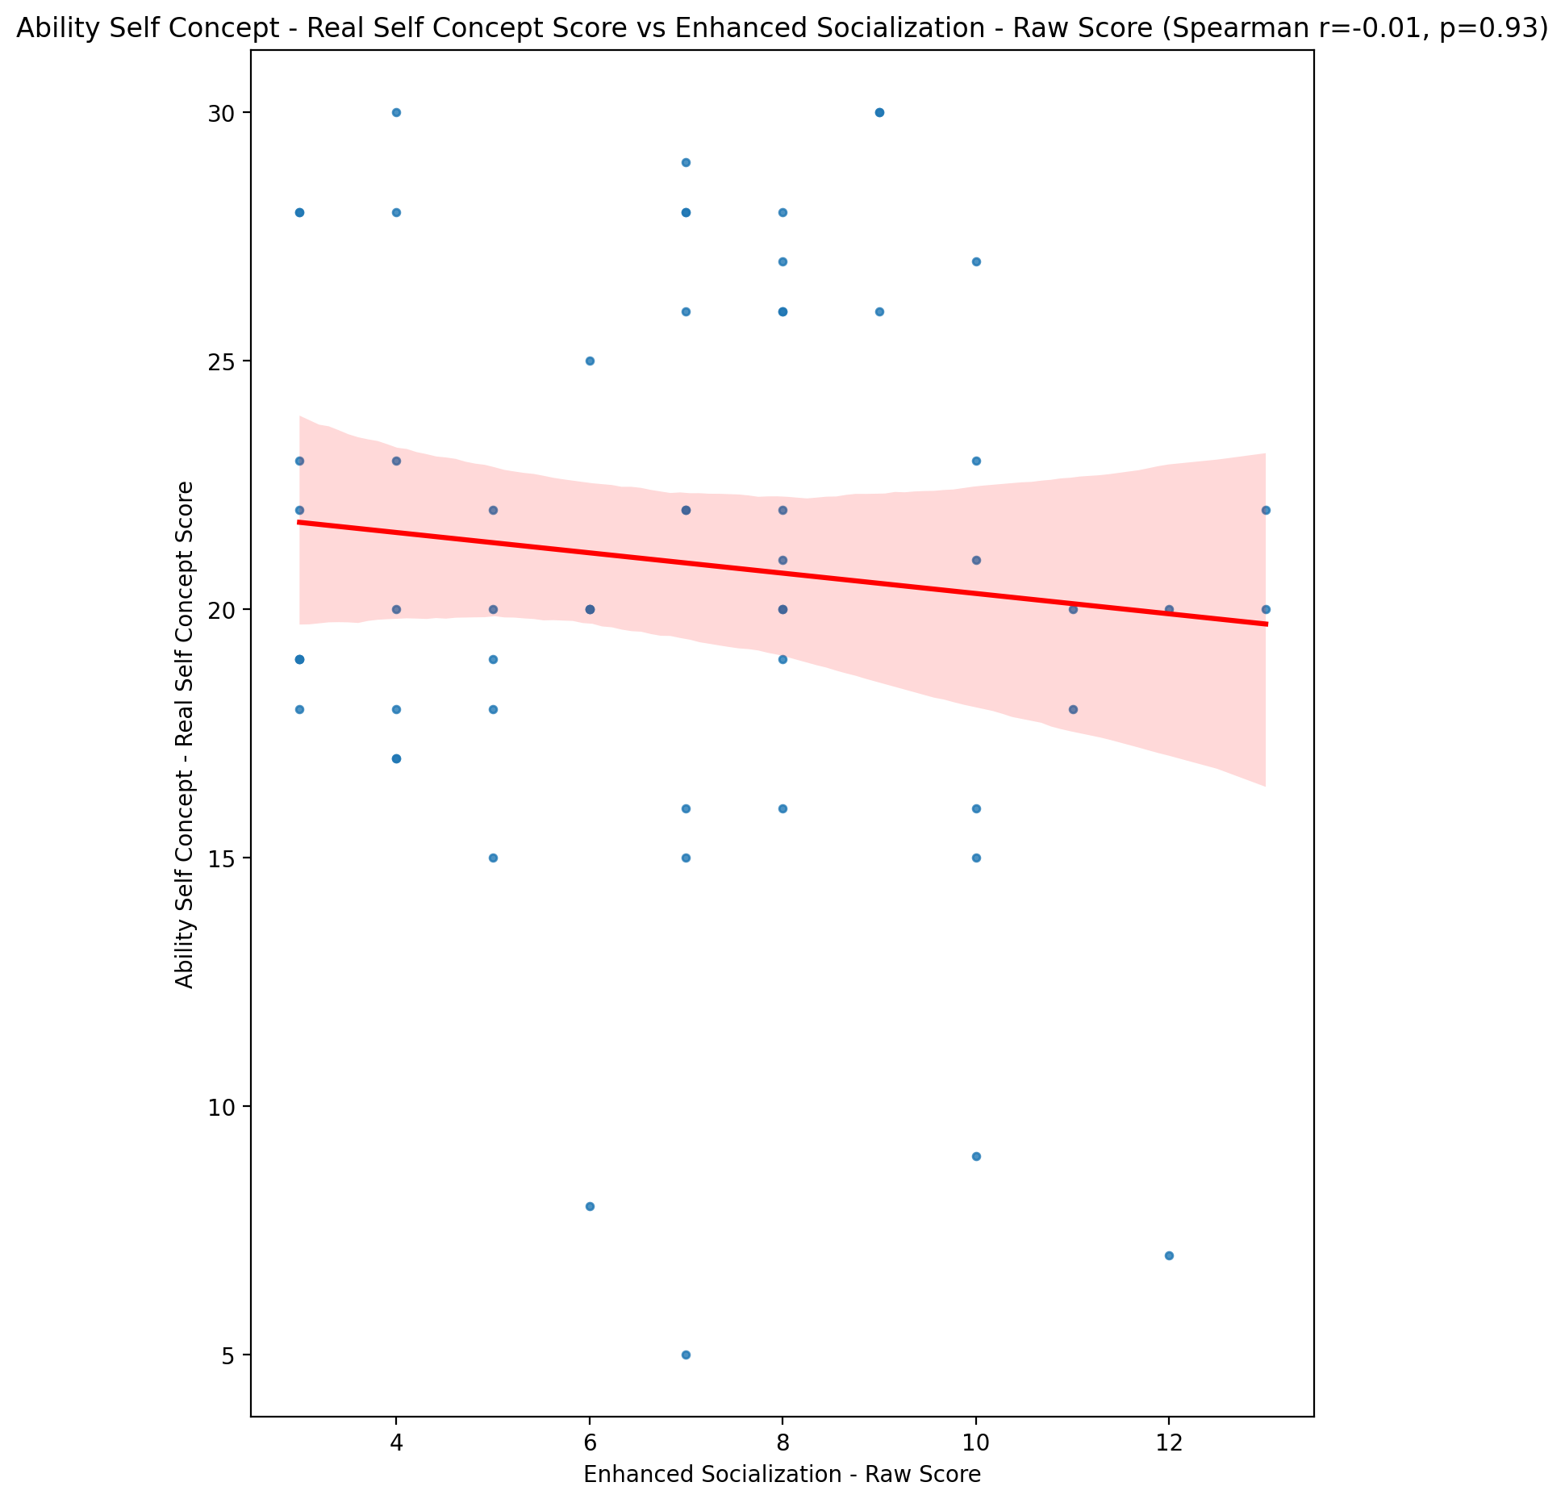

## Ability Self Concept - Ideal Self Concept Score vs Enhanced Socialization - Raw Score

Test: spearman; statistic: -0.10878697039435205; p-value: 0.412120341338994;

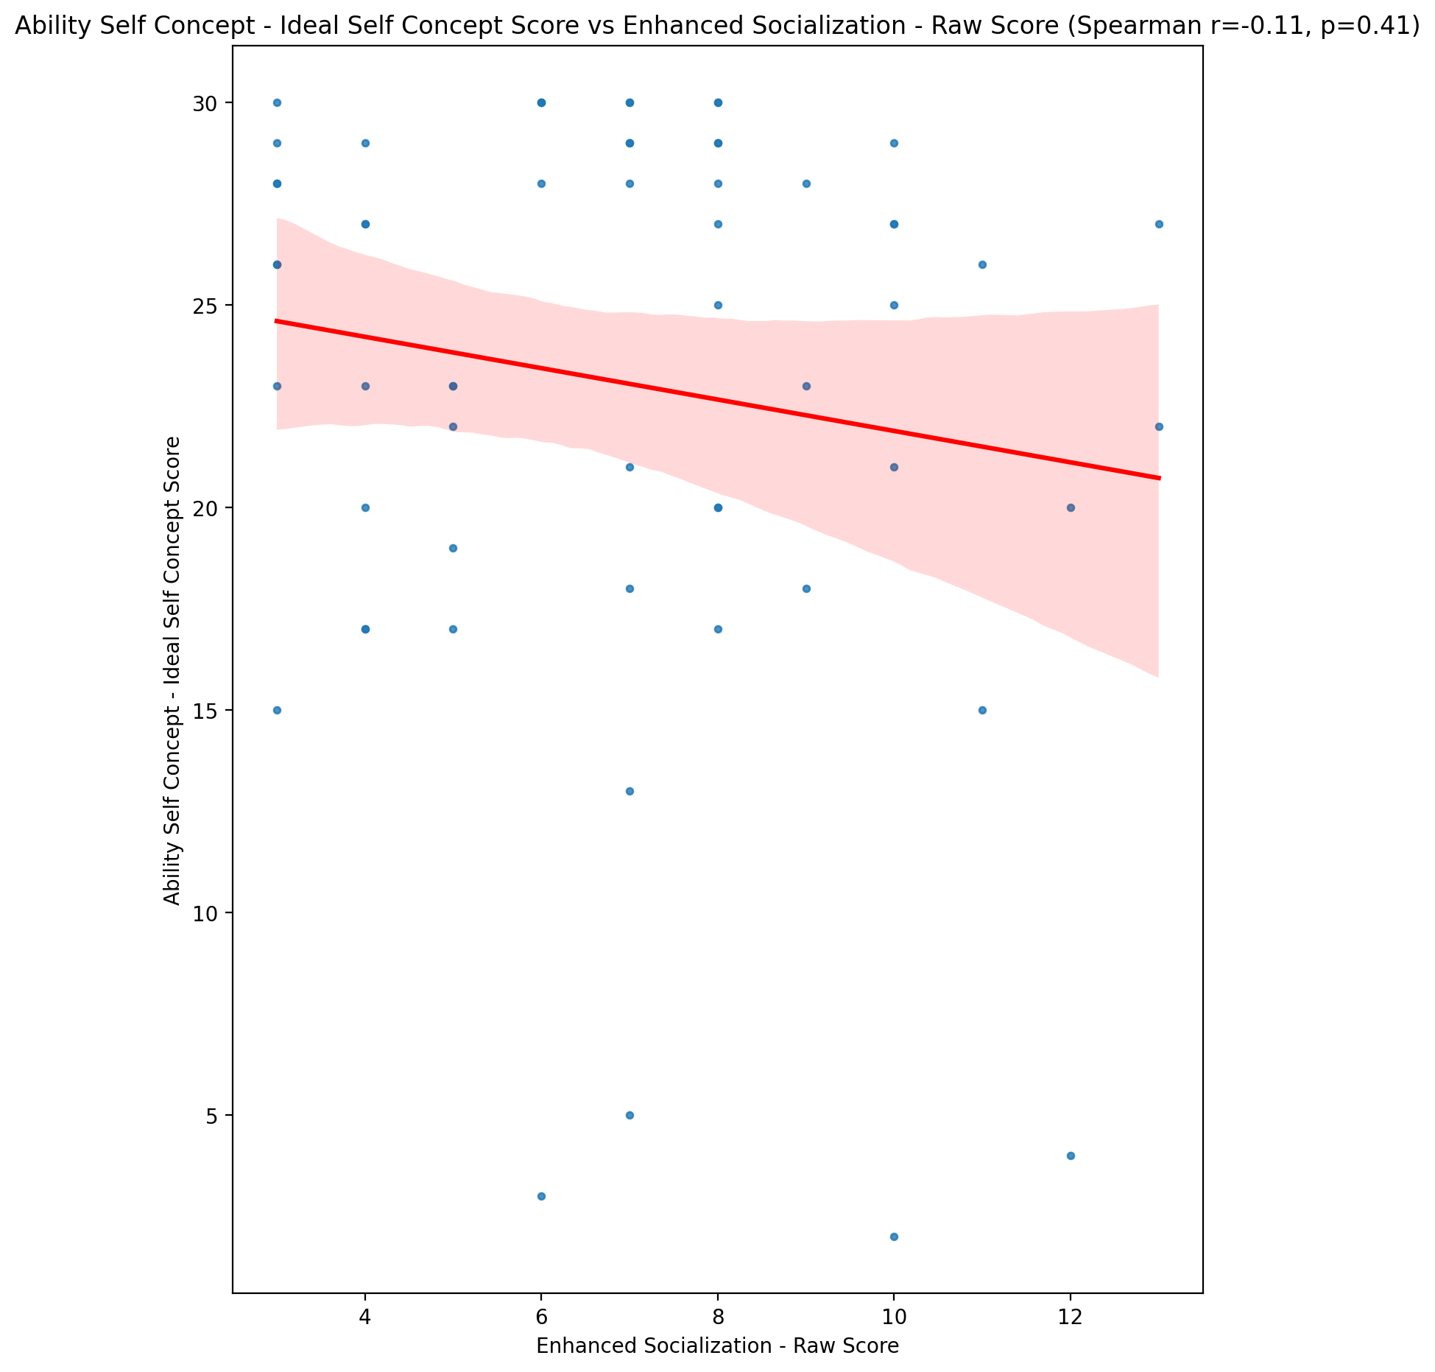

## Ability Self Concept – Social Self Concept Score vs Enhanced Socialization - Raw Score

Test: spearman; statistic: 0.1554303444906712; p-value: 0.2397951756048421;

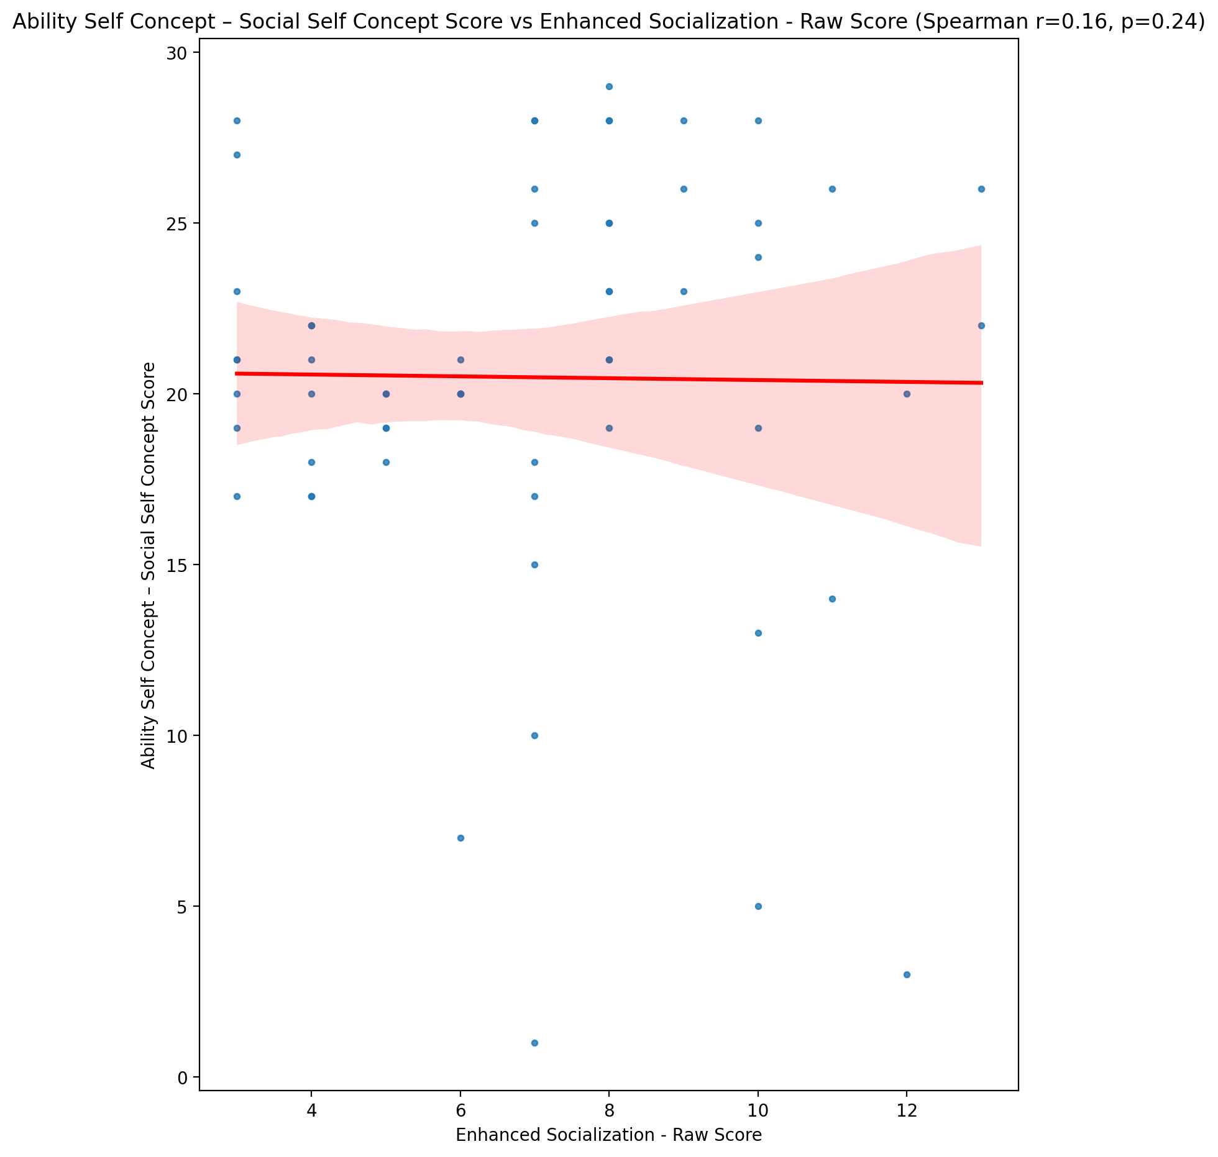

## Physical Self Concept - Real Self Concept Score vs Enhanced Socialization - Raw Score

Test: spearman; statistic: -0.012672322455076997; p-value: 0.9241090407320212;

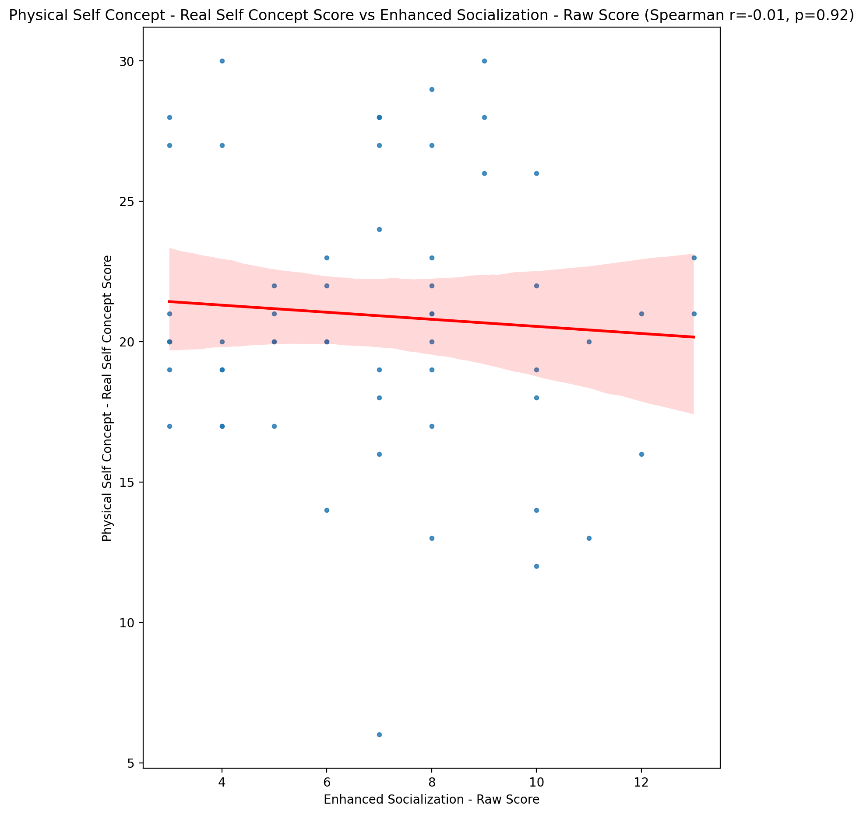

## Physical Self Concept – Ideal Self Concept Score vs Enhanced Socialization - Raw Score

Test: spearman; statistic: -0.07603687676495202; p-value: 0.5670621338160808;

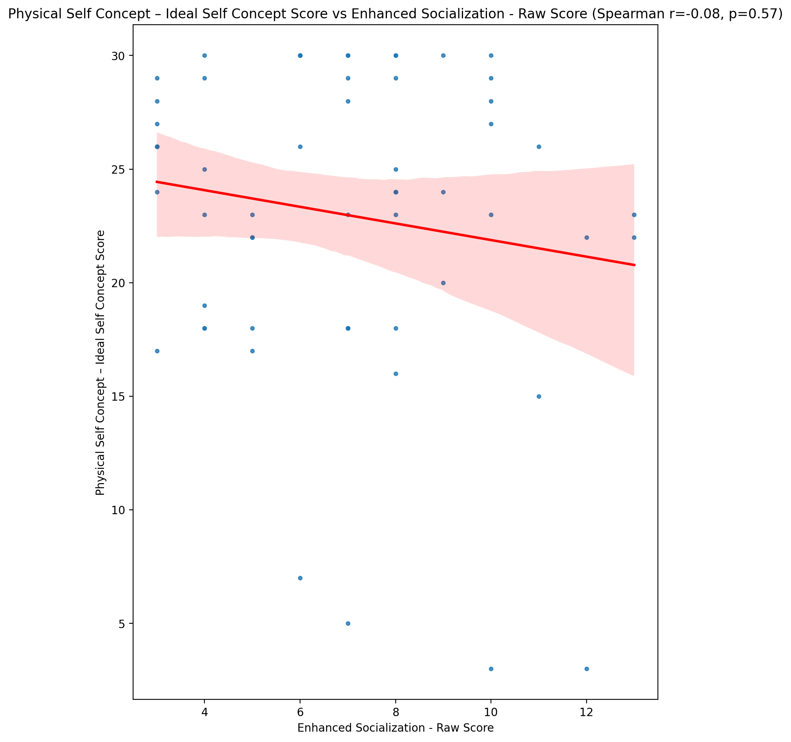

## Physical Self Concept – Social Self Concept Score vs Enhanced Socialization - Raw Score

Test: spearman; statistic: 0.1451600822598312; p-value: 0.27265810900734216;

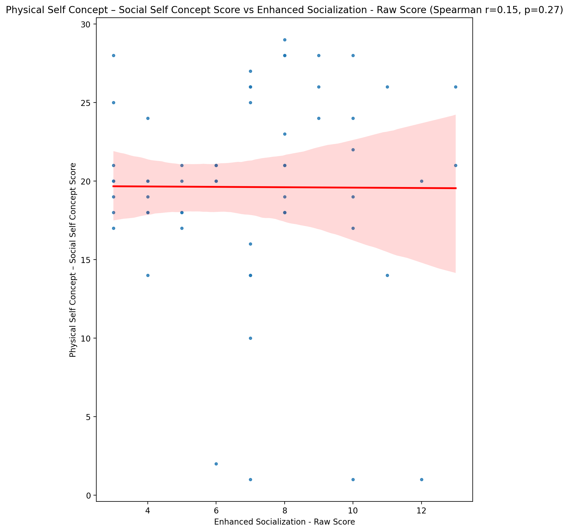

## Psychological Self Concept - Real Self Concept Score vs Enhanced Socialization - Raw Score

Test: spearman; statistic: -0.06997287444352492; p-value: 0.5984587104519912;

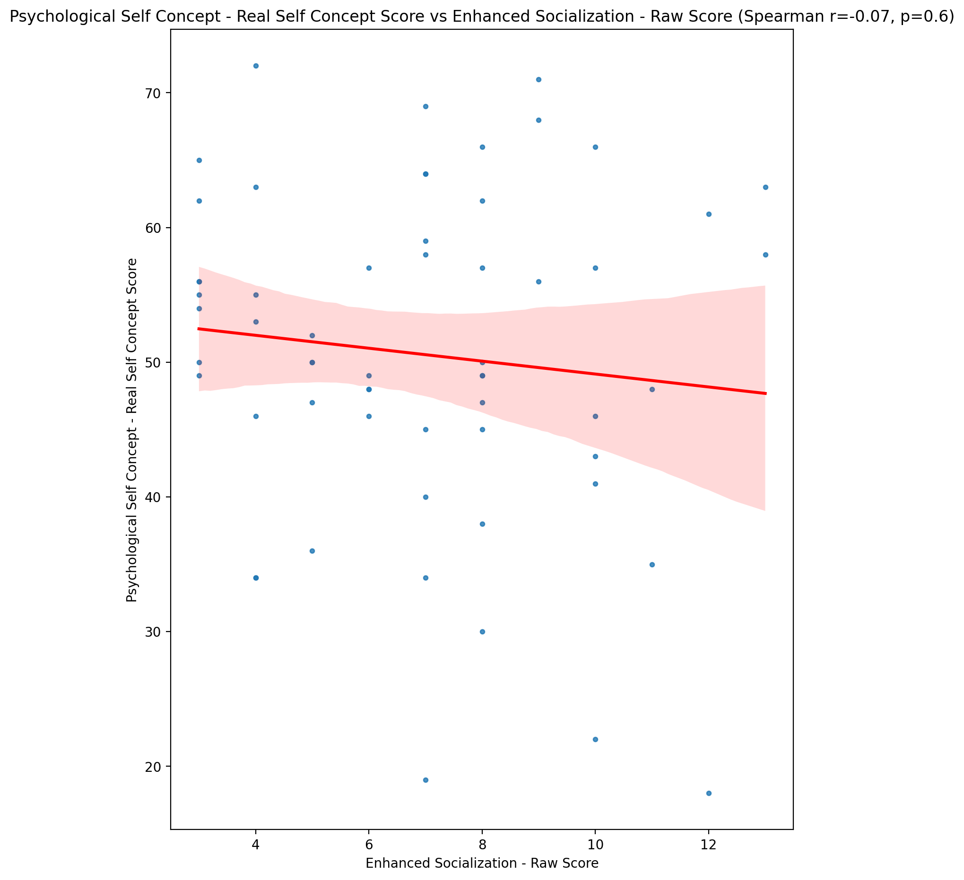

## Psychological Self Concept – Ideal Self Concept Score vs Enhanced Socialization - Raw Score

Test: spearman; statistic: -0.025019785093153217; p-value: 0.8507997588454392;

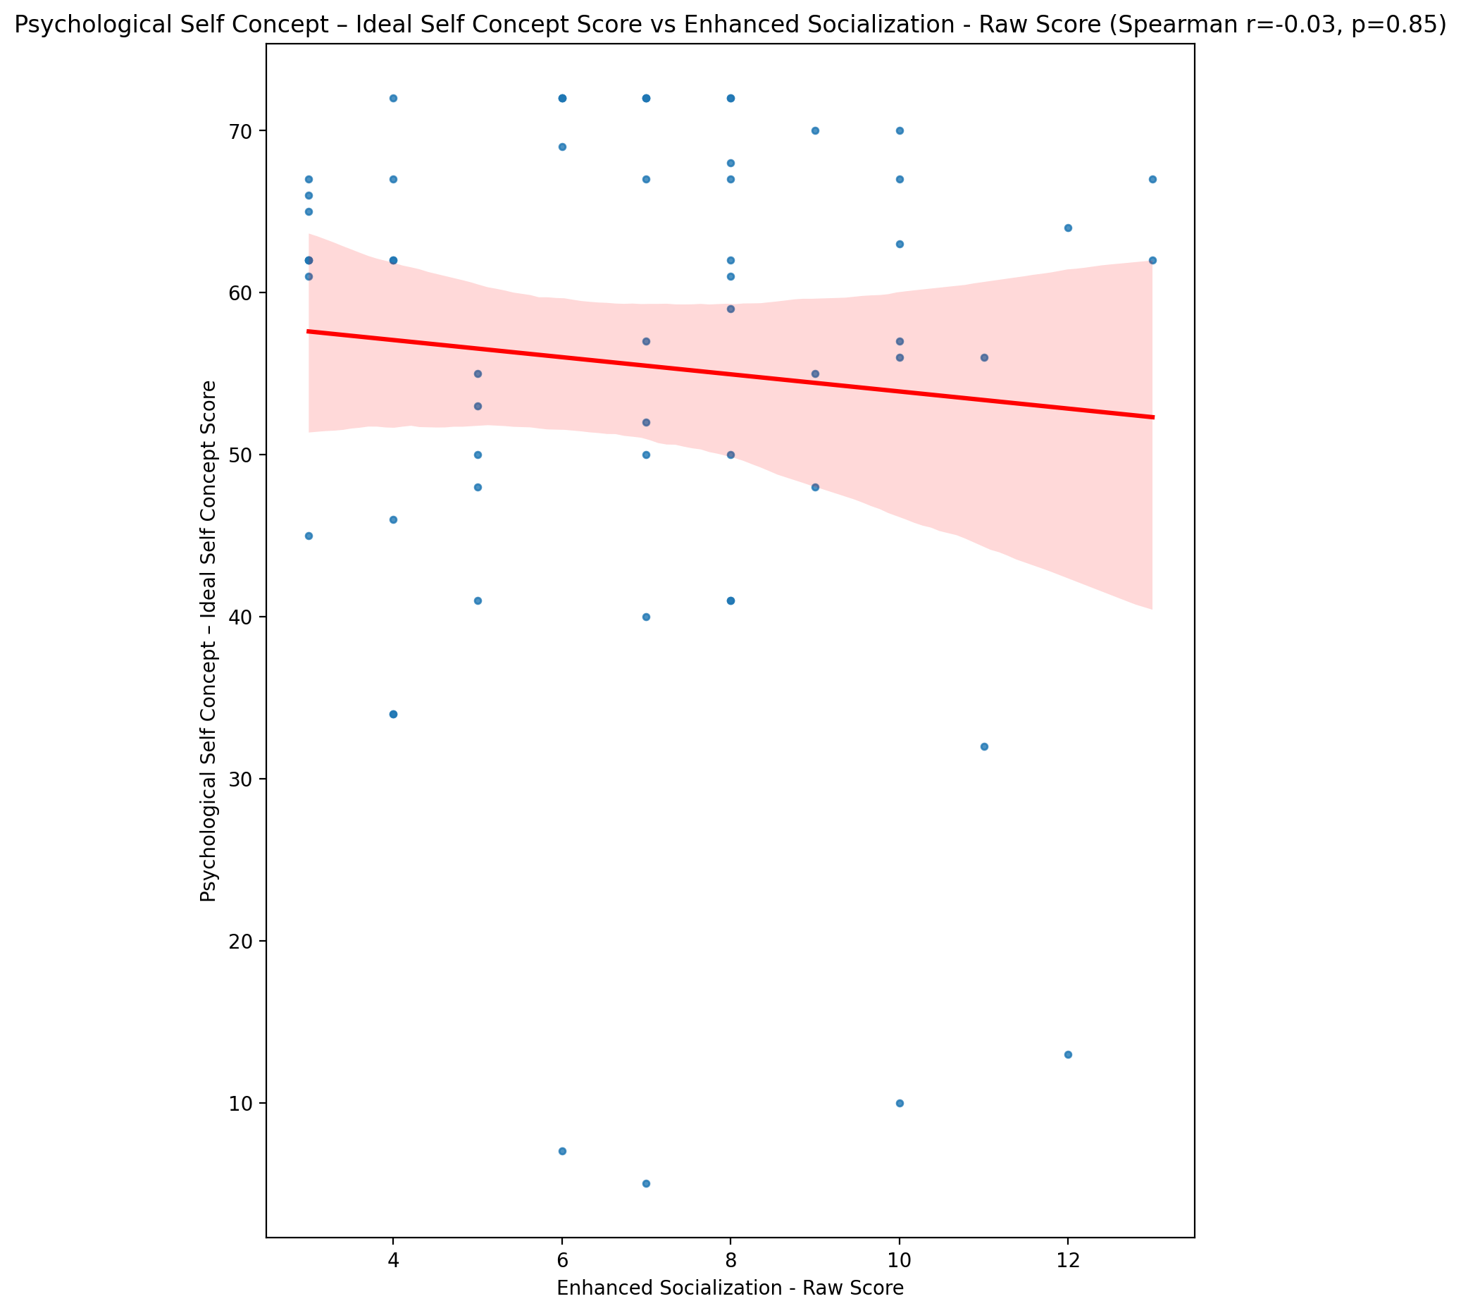

## Psychological Self Concept – Social Self Concept Score vs Enhanced Socialization - Raw Score

Test: spearman; statistic: 0.08902033118040352; p-value: 0.5025512258371112;

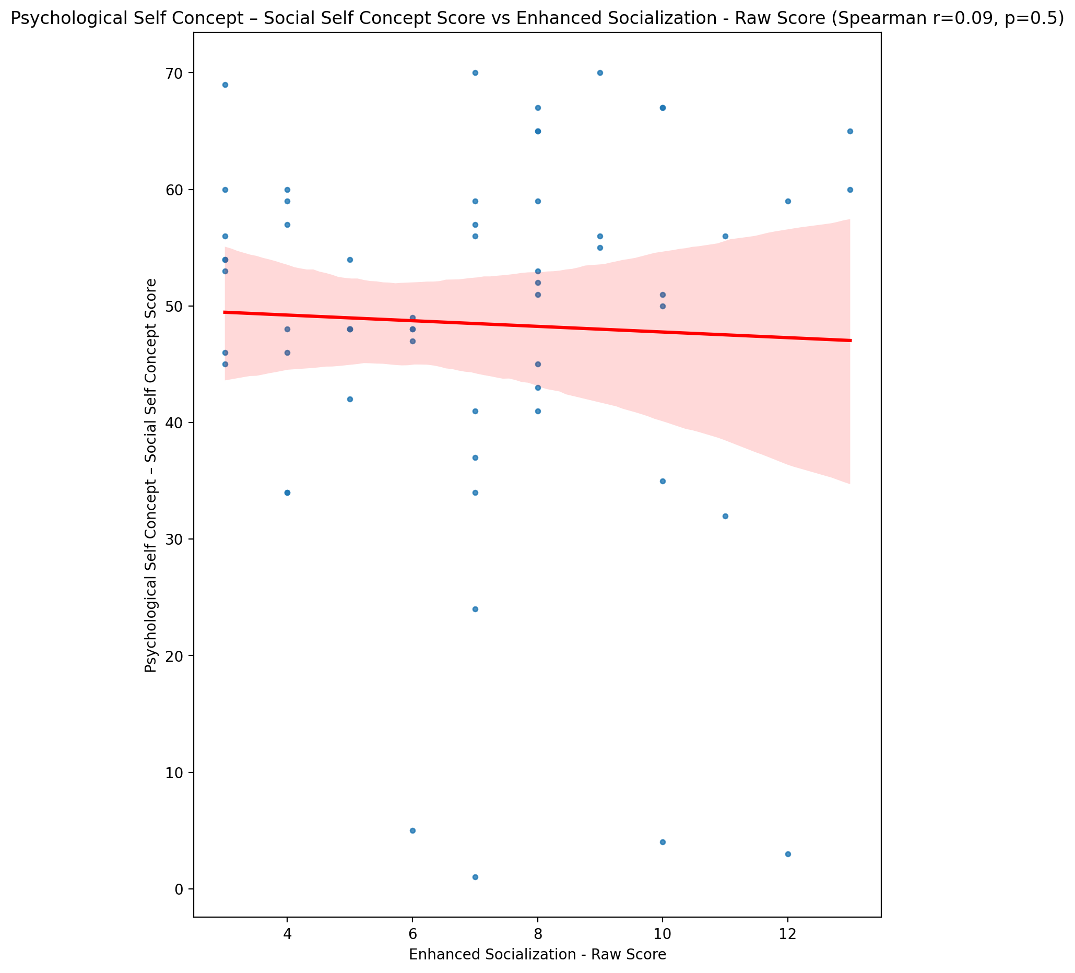

## Real Self Concept Total Score vs Enhanced Socialization - Raw Score

Test: spearman; statistic: -0.0305327216593296; p-value: 0.8184322816072569;

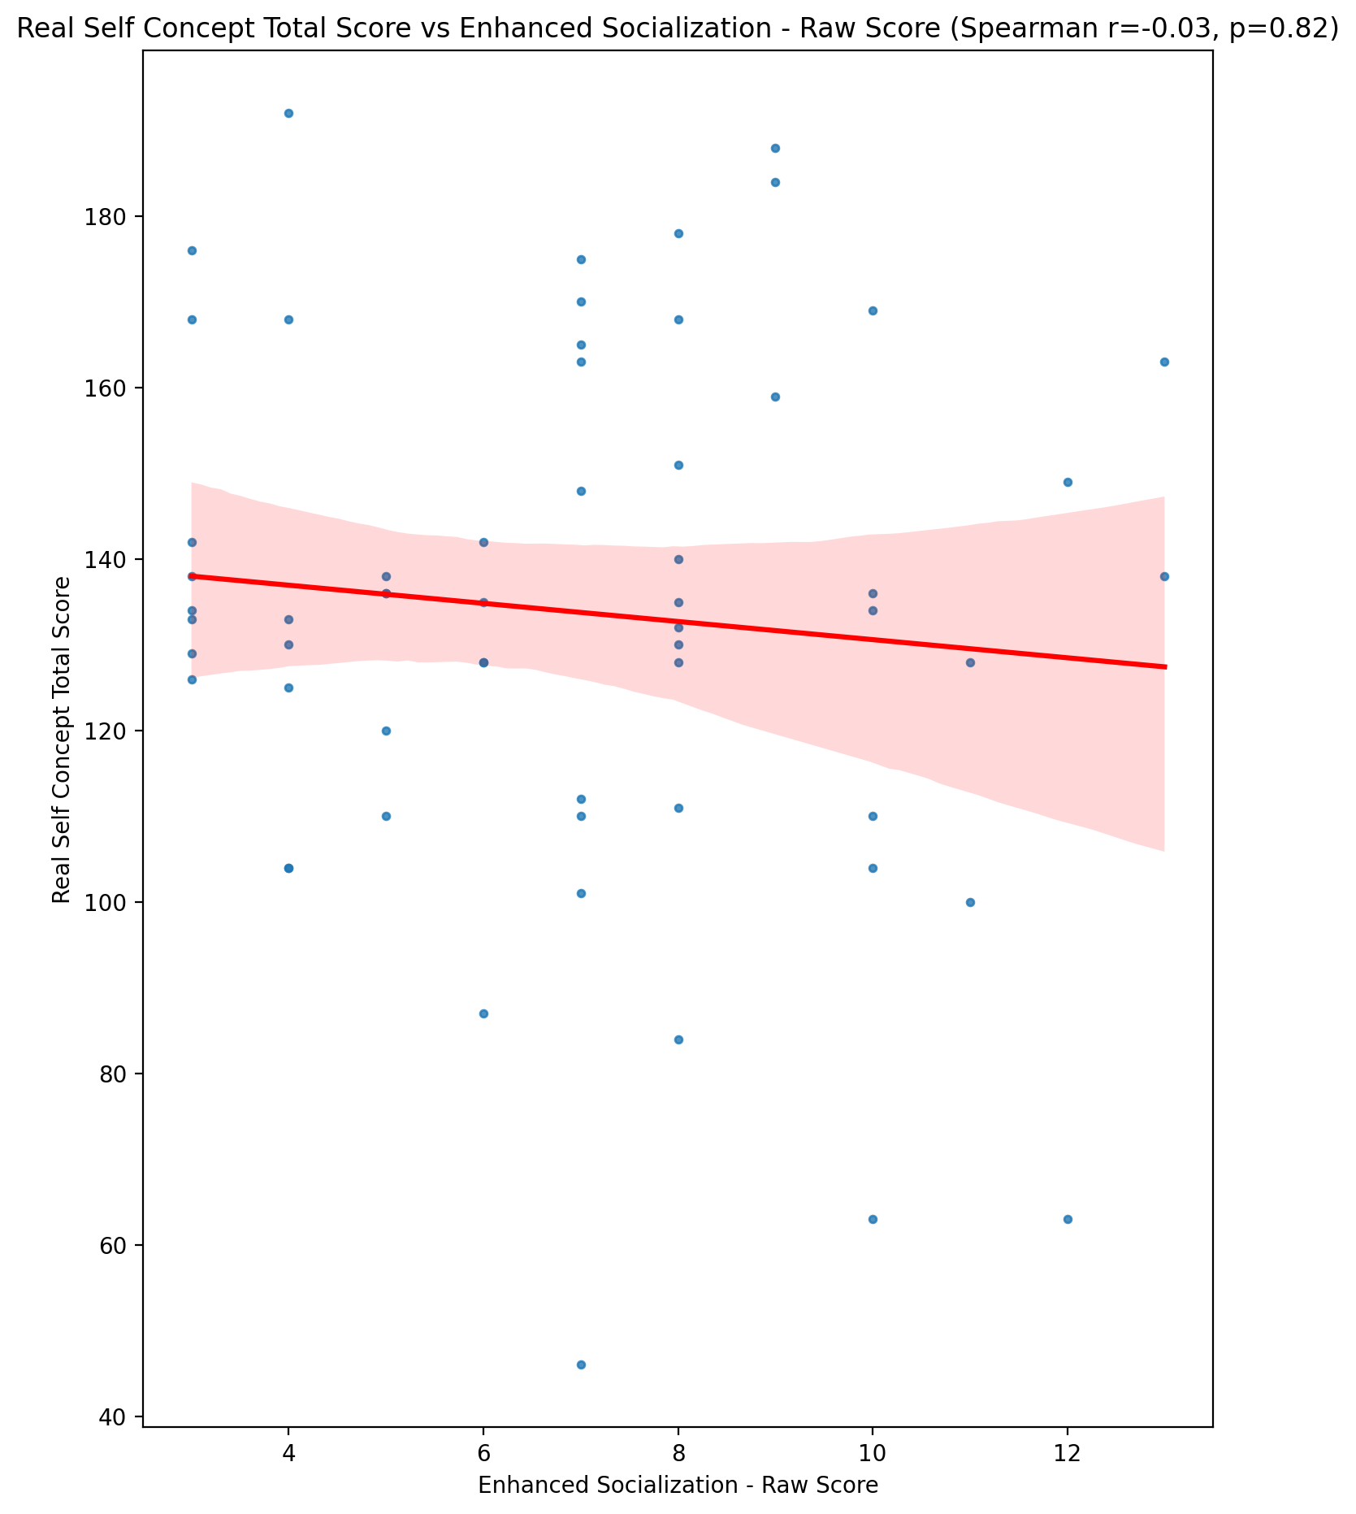

## Ideal Self Concept Total Score vs Enhanced Socialization - Raw Score

Test: spearman; statistic: -0.0696000495541076; p-value: 0.6004138186699493;

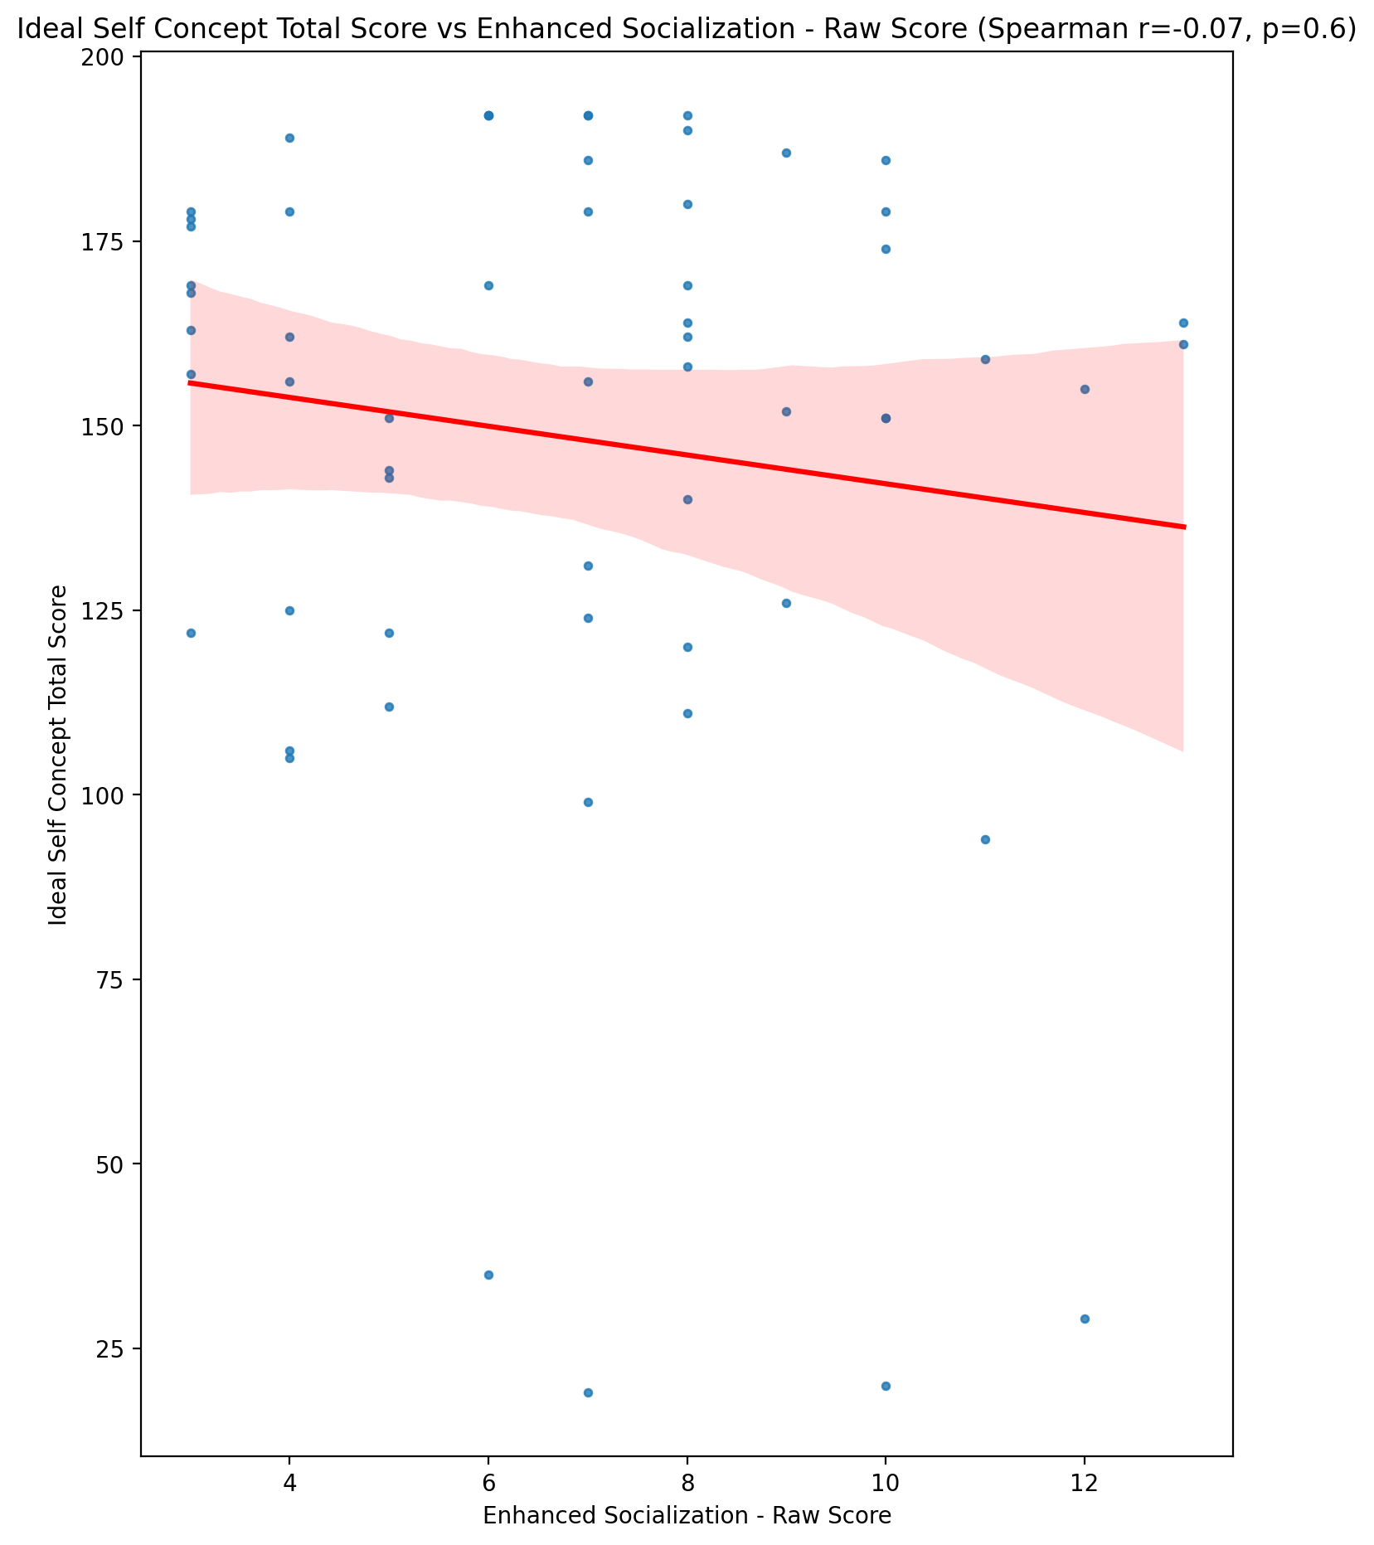

## Social Self Concept Total Score vs Enhanced Socialization - Raw Score

Test: spearman; statistic: 0.14413138540514078; p-value: 0.2761074103318718;

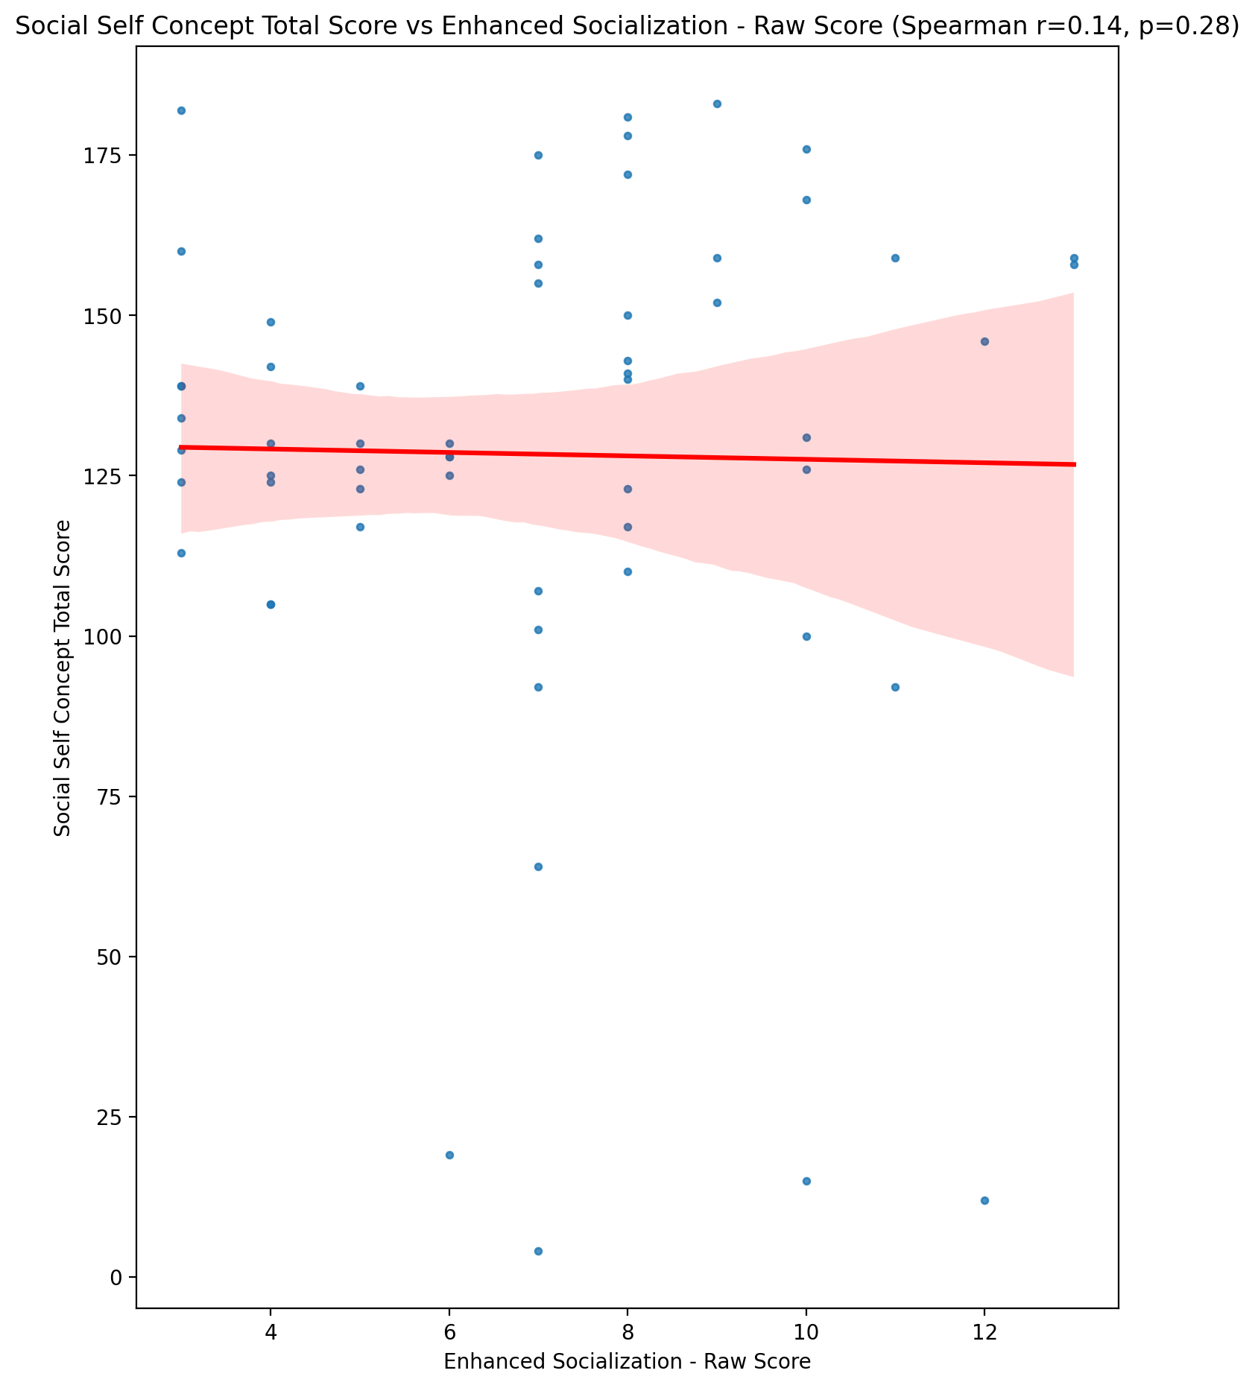

## Ideal Self Concept Total Category vs Enhanced Socialization - Raw Score

Test: None; statistic: None; p-value: None; Test not run: unsupported type combination.



## Perceived Social Stress Score vs Enhanced Socialization - Raw Score

Test: spearman; statistic: 0.3545480404011339; p-value: 0.005865814845673005;

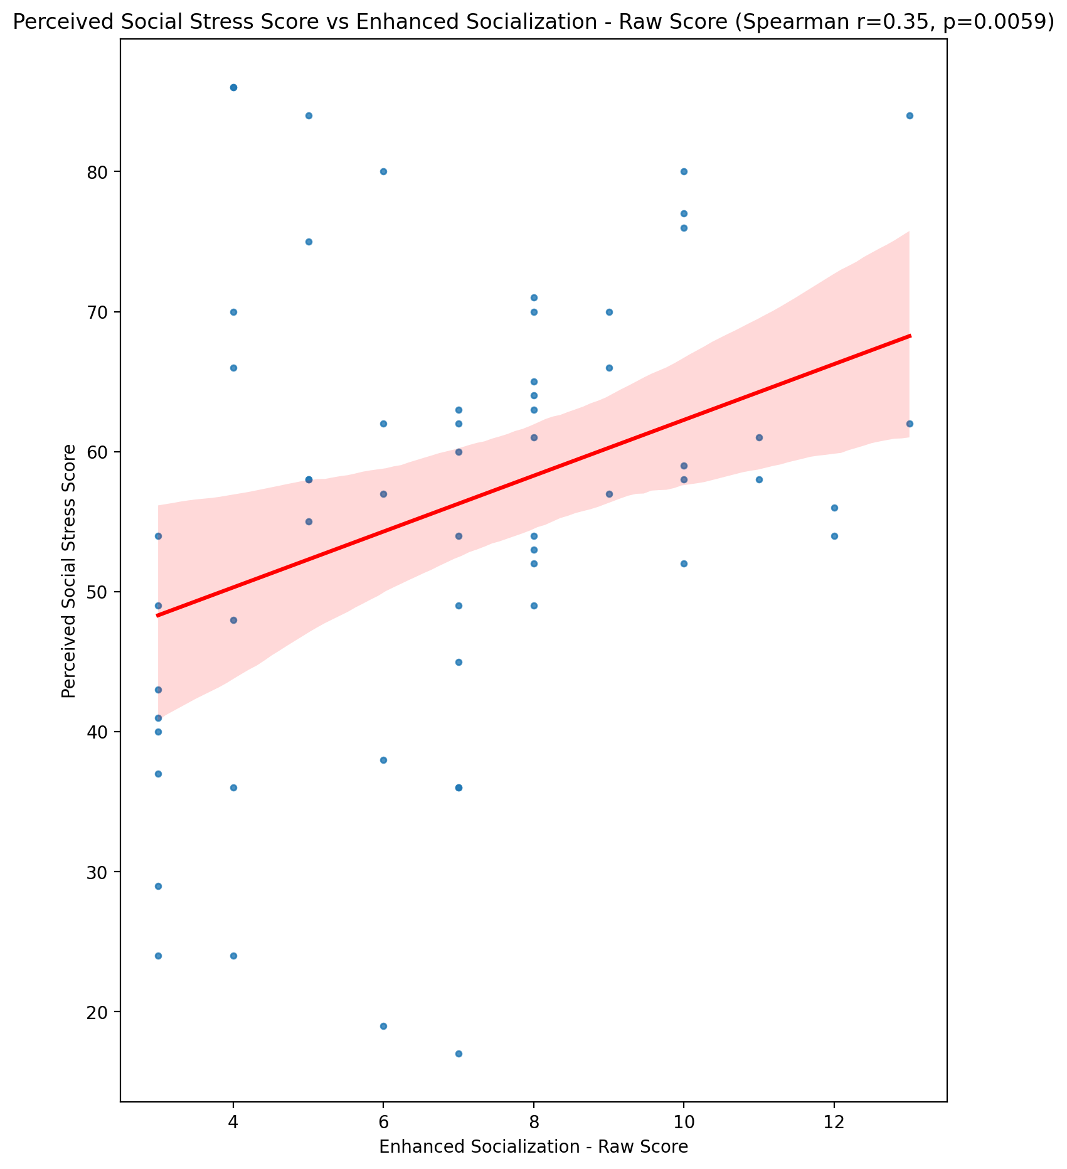

## Perceived Social Stress Category vs Enhanced Socialization - Raw Score

Test: None; statistic: None; p-value: None; Test not run: unsupported type combination.



## Emotional Support - Raw Score vs Perceived Control of Internet Use - Raw Score

Test: spearman; statistic: -0.07185090503570181; p-value: 0.5886533053776111;

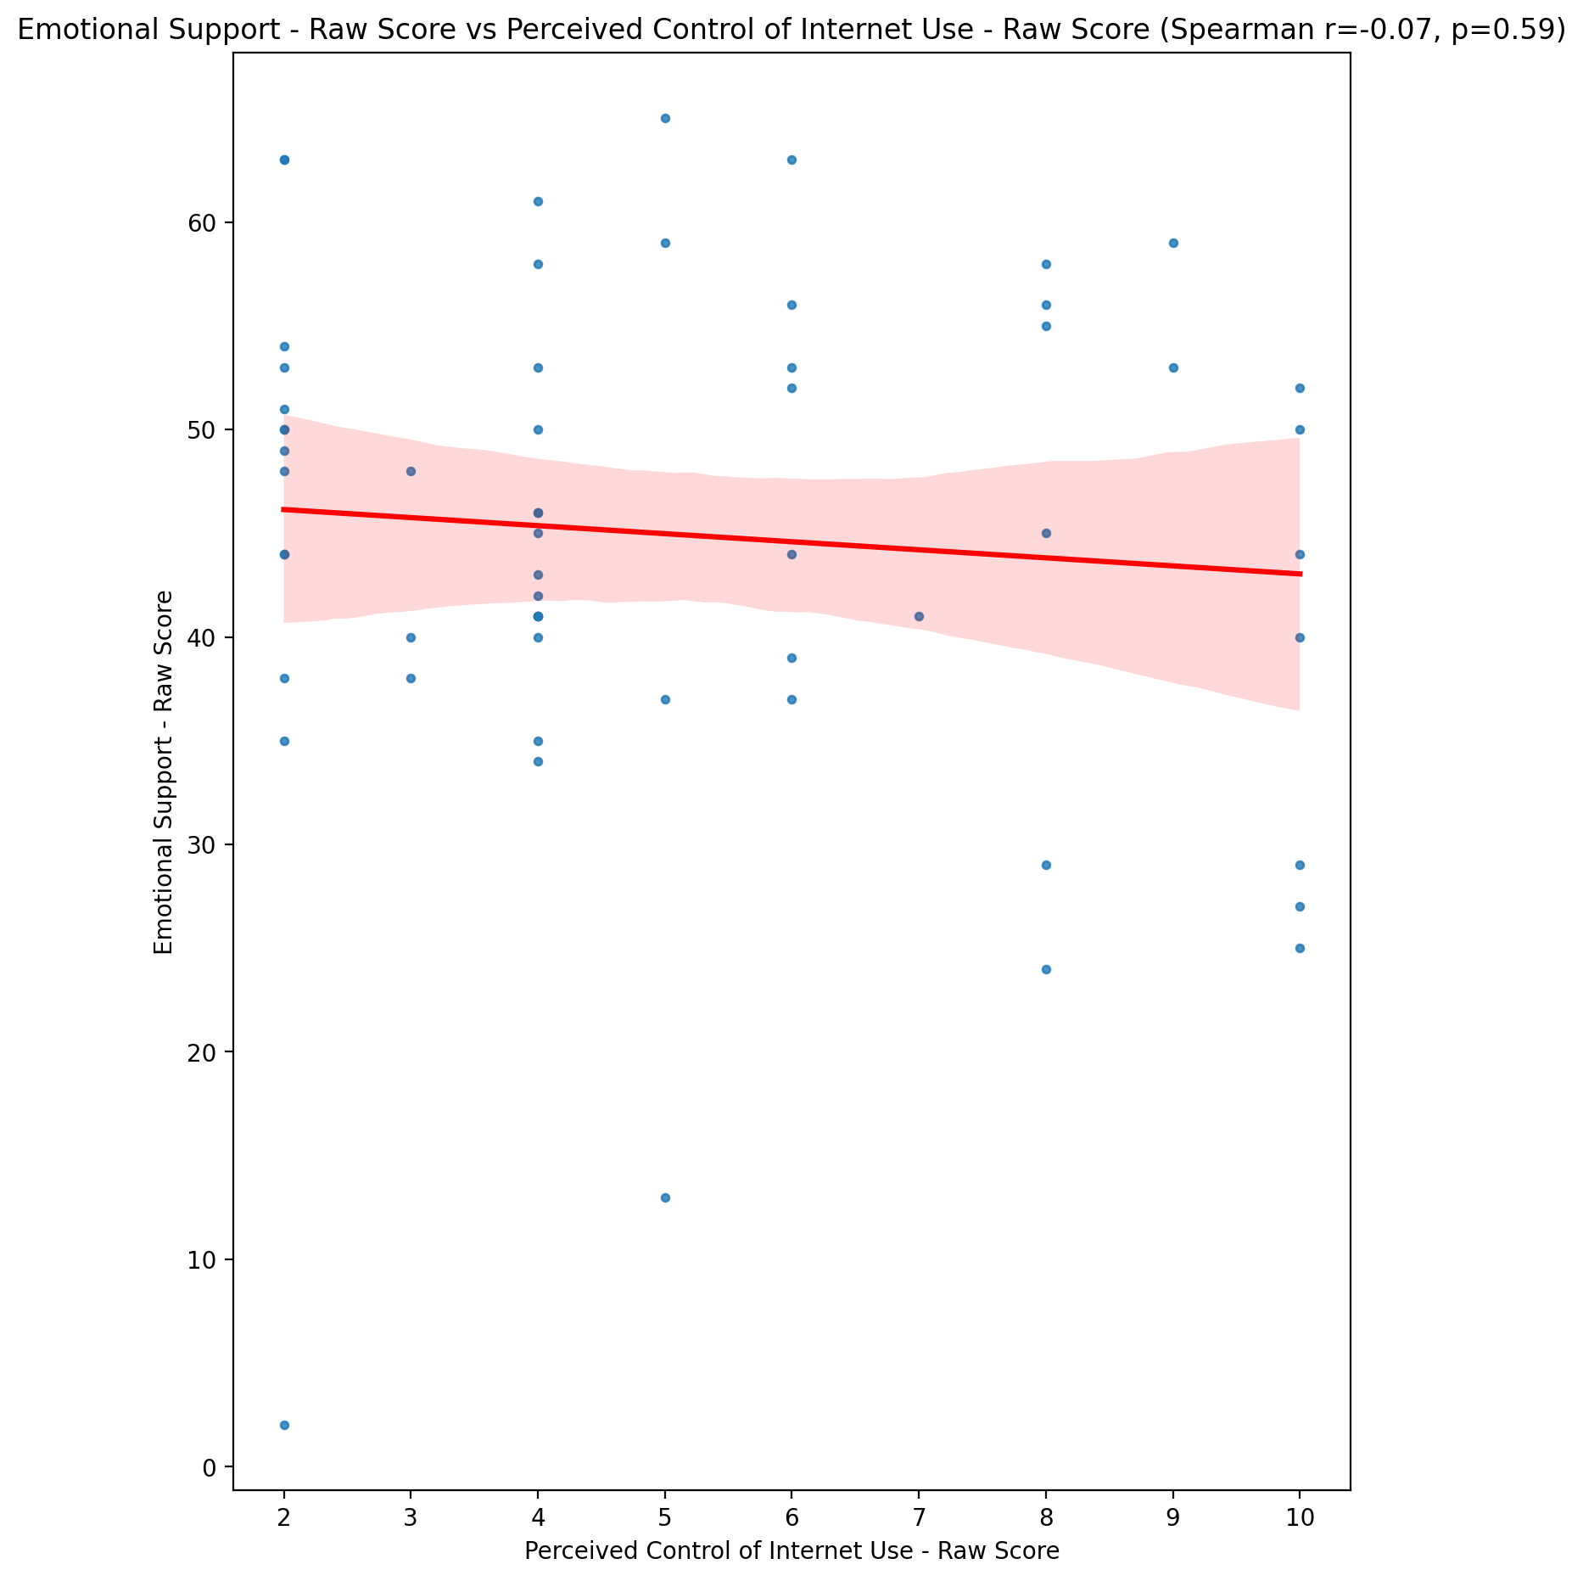

## Informational Support - Raw Score vs Perceived Control of Internet Use - Raw Score

Test: spearman; statistic: -0.11707528666838359; p-value: 0.3771964952960559;

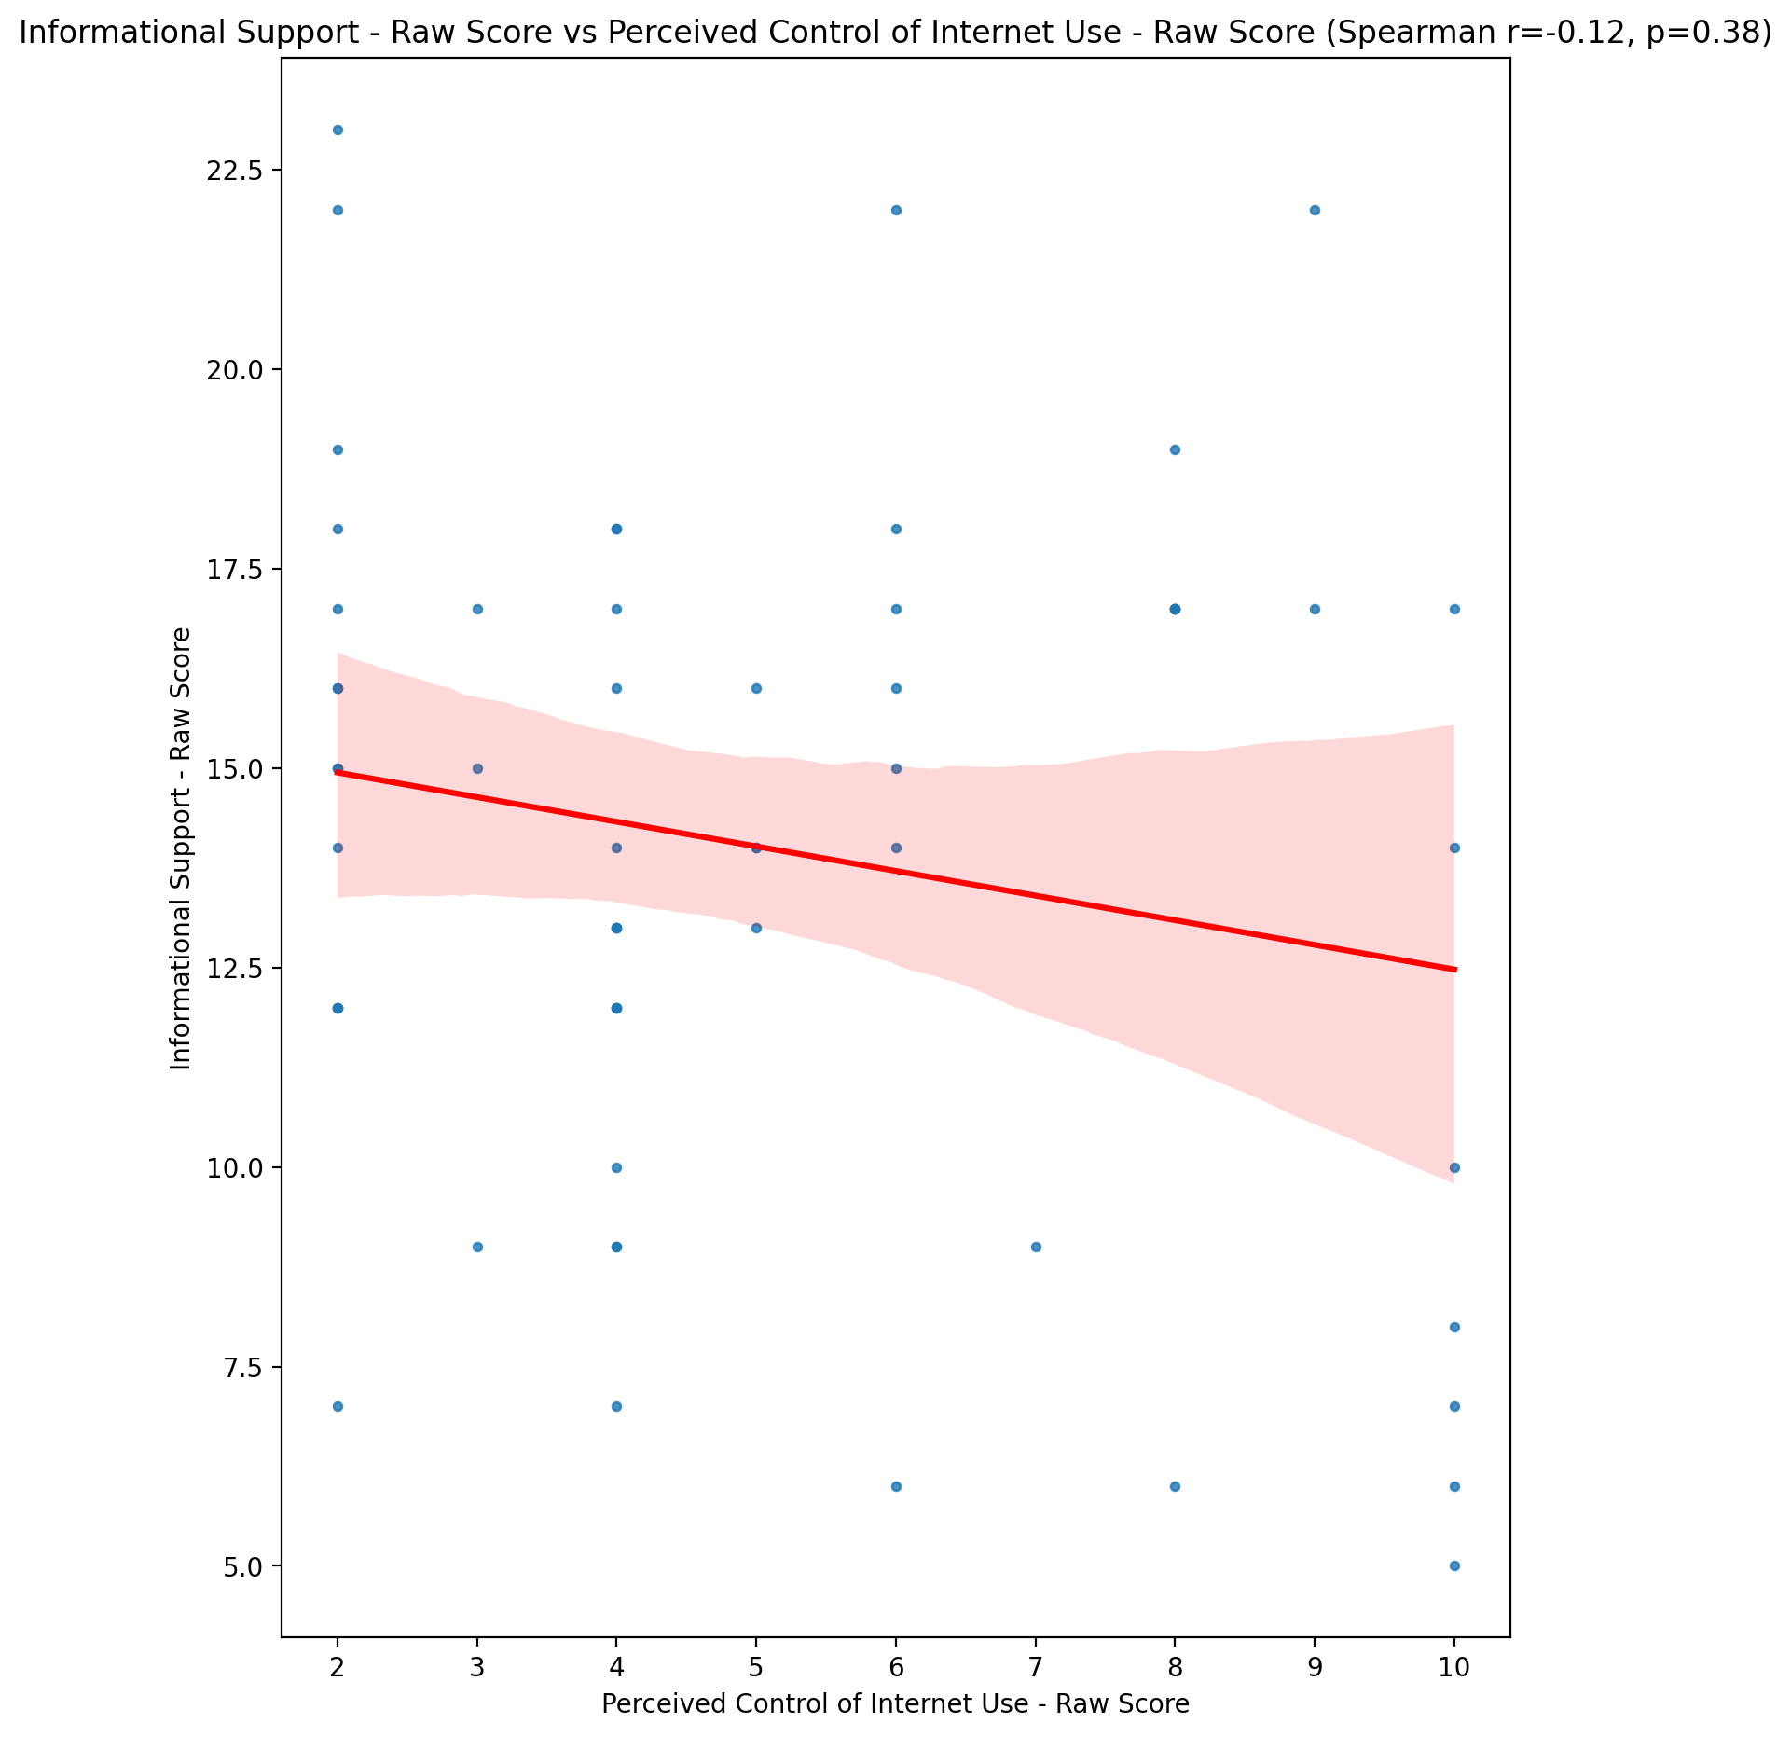

## Instrumental Support - Raw Score vs Perceived Control of Internet Use - Raw Score

Test: spearman; statistic: -0.20421444922730667; p-value: 0.12079658421642474;

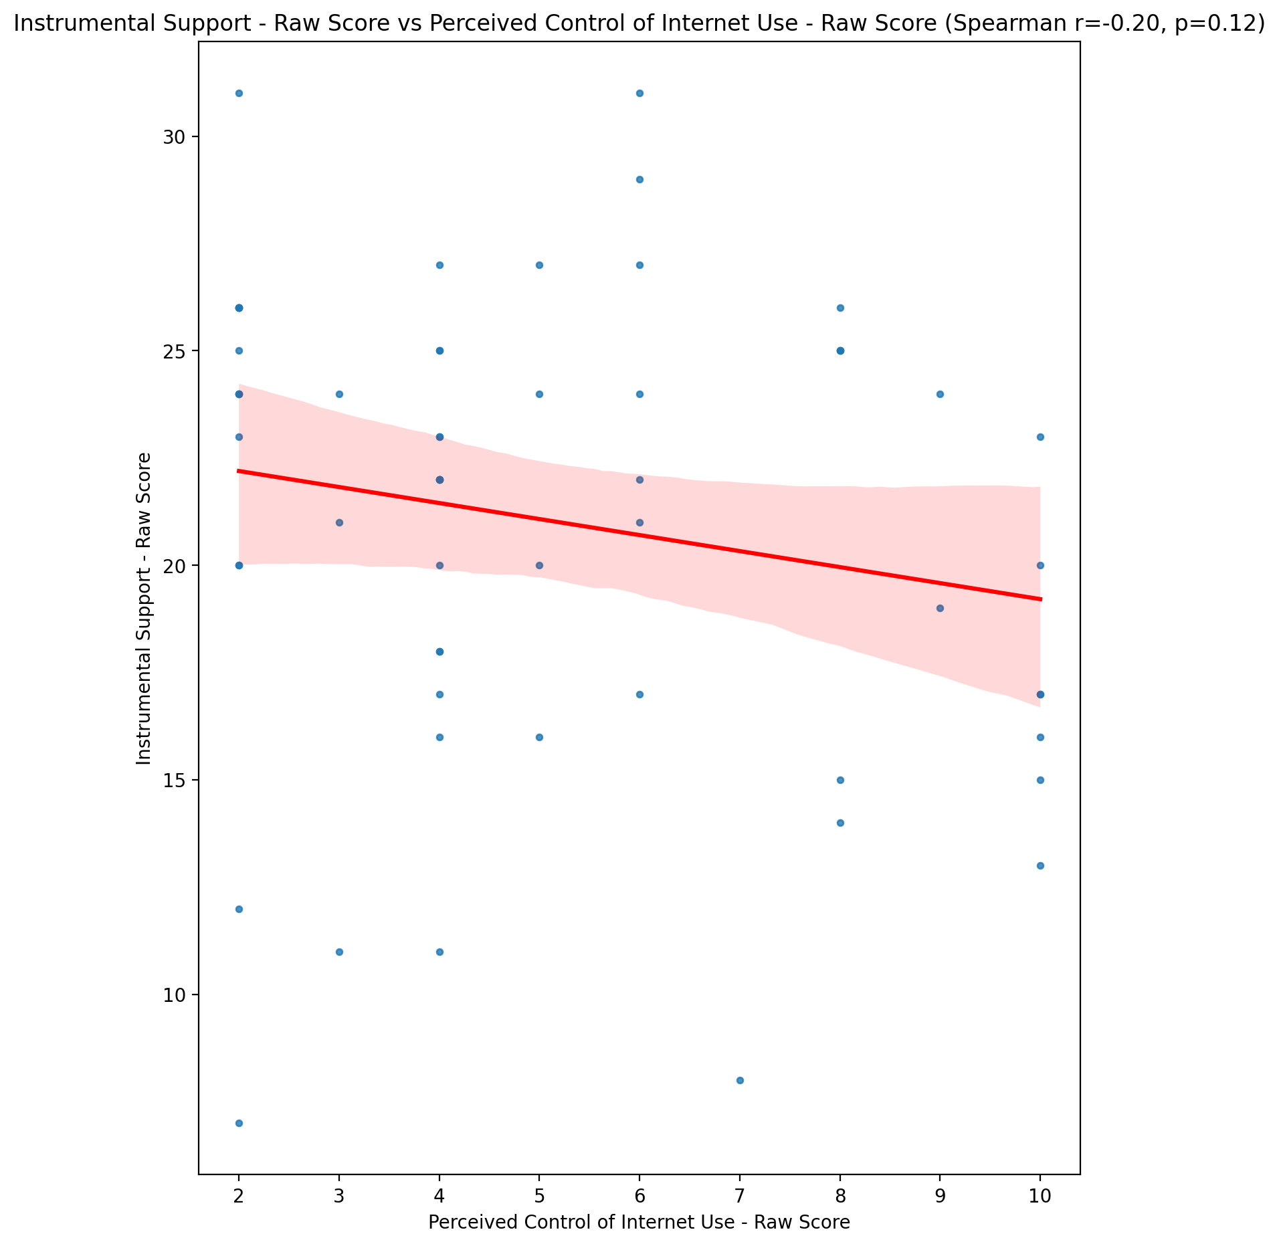

## Emotional Support - T Score vs Perceived Control of Internet Use - Raw Score

Test: spearman; statistic: -0.0789281409632302; p-value: 0.5523682053453591;

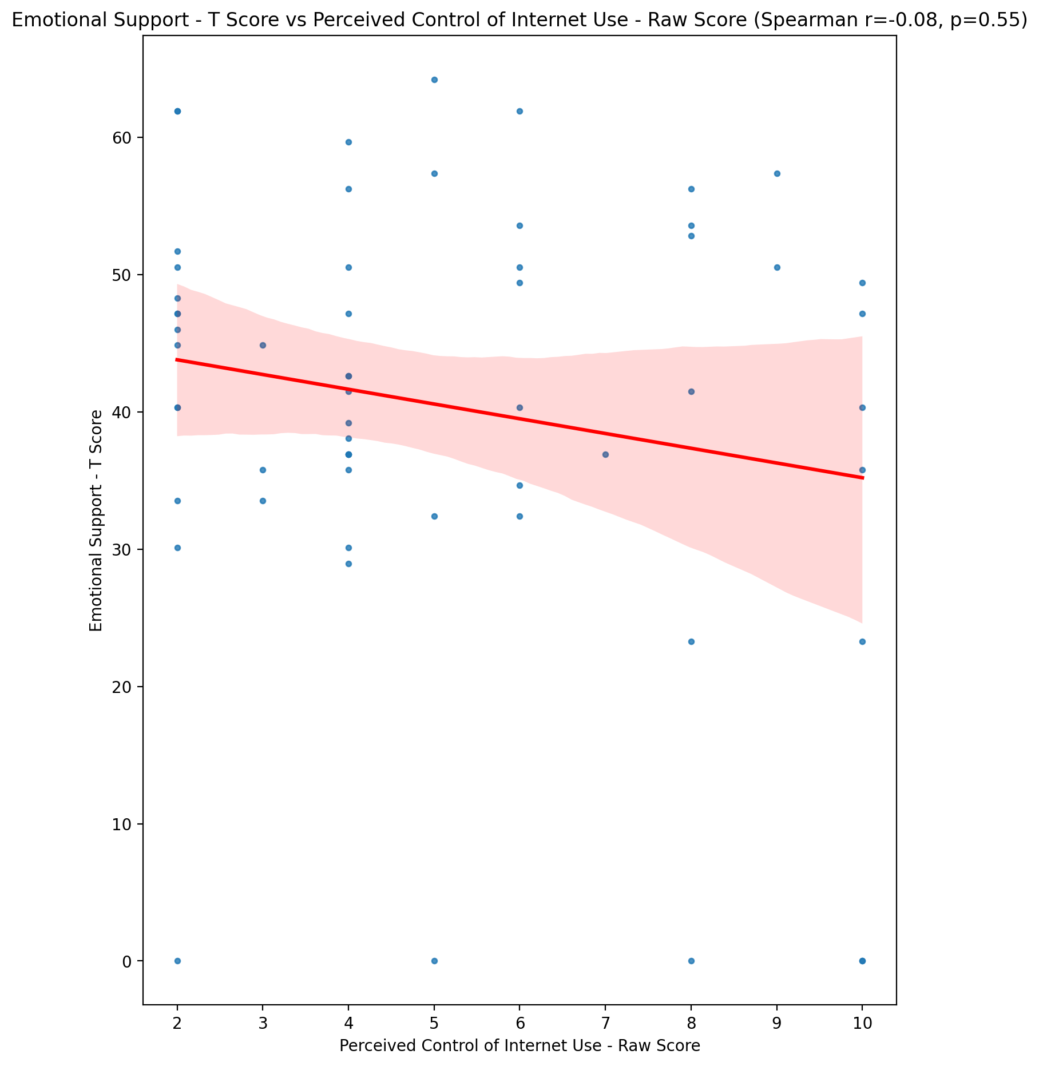

## Informational Support - T Score vs Perceived Control of Internet Use - Raw Score

Test: spearman; statistic: -0.11227199573515625; p-value: 0.39721404018894124;

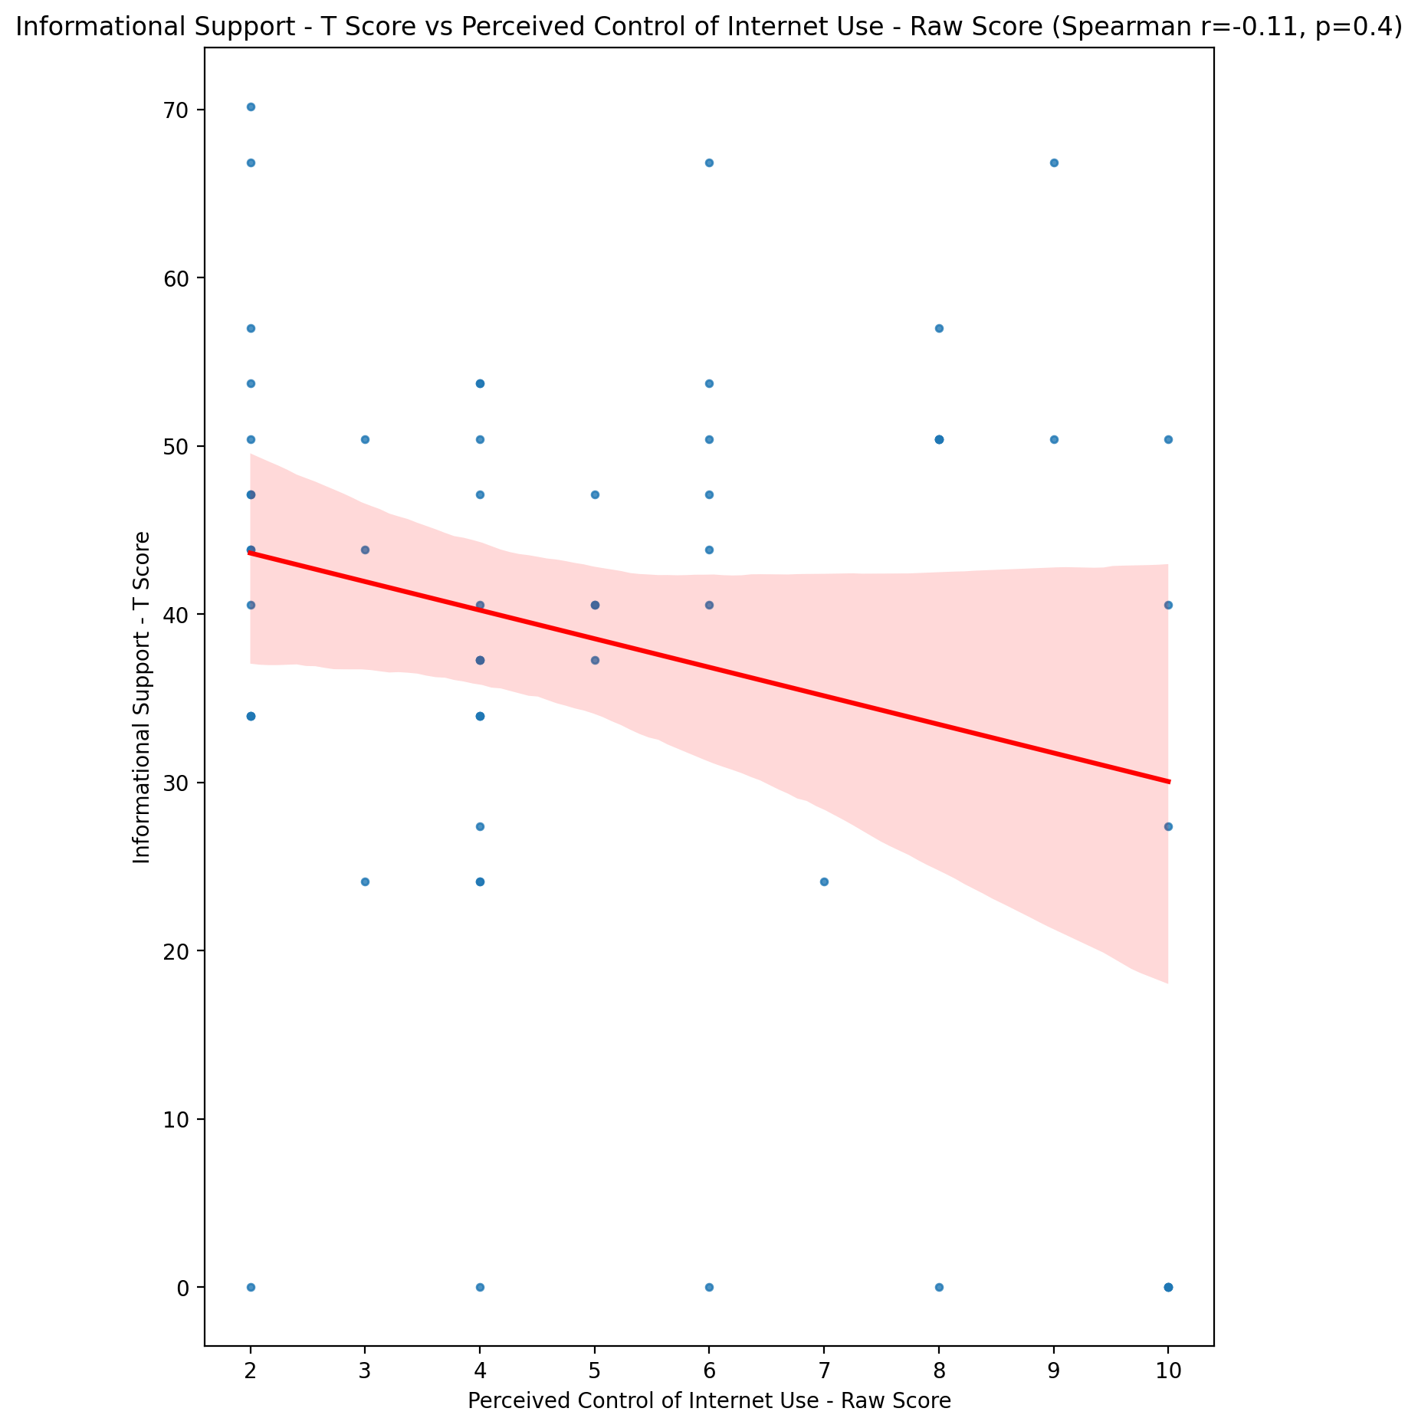

## Instrumental Support - T Score vs Perceived Control of Internet Use - Raw Score

Test: spearman; statistic: -0.20828441539506717; p-value: 0.11341041744540499;

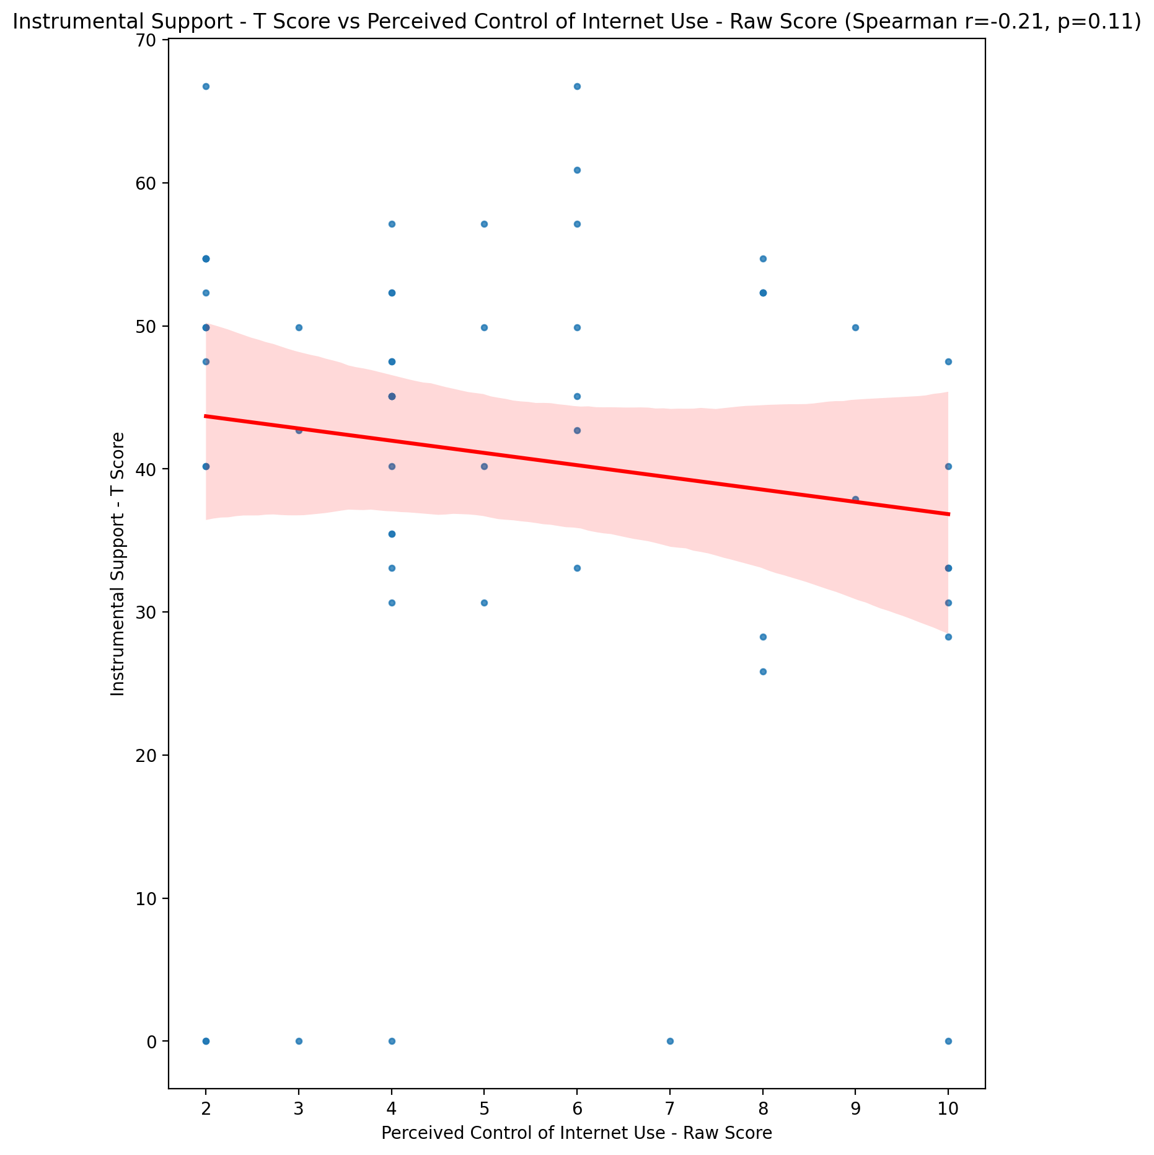

## Perceived Social Support Total T Score vs Perceived Control of Internet Use - Raw Score

Test: spearman; statistic: -0.14775536569099668; p-value: 0.26408391269734005;

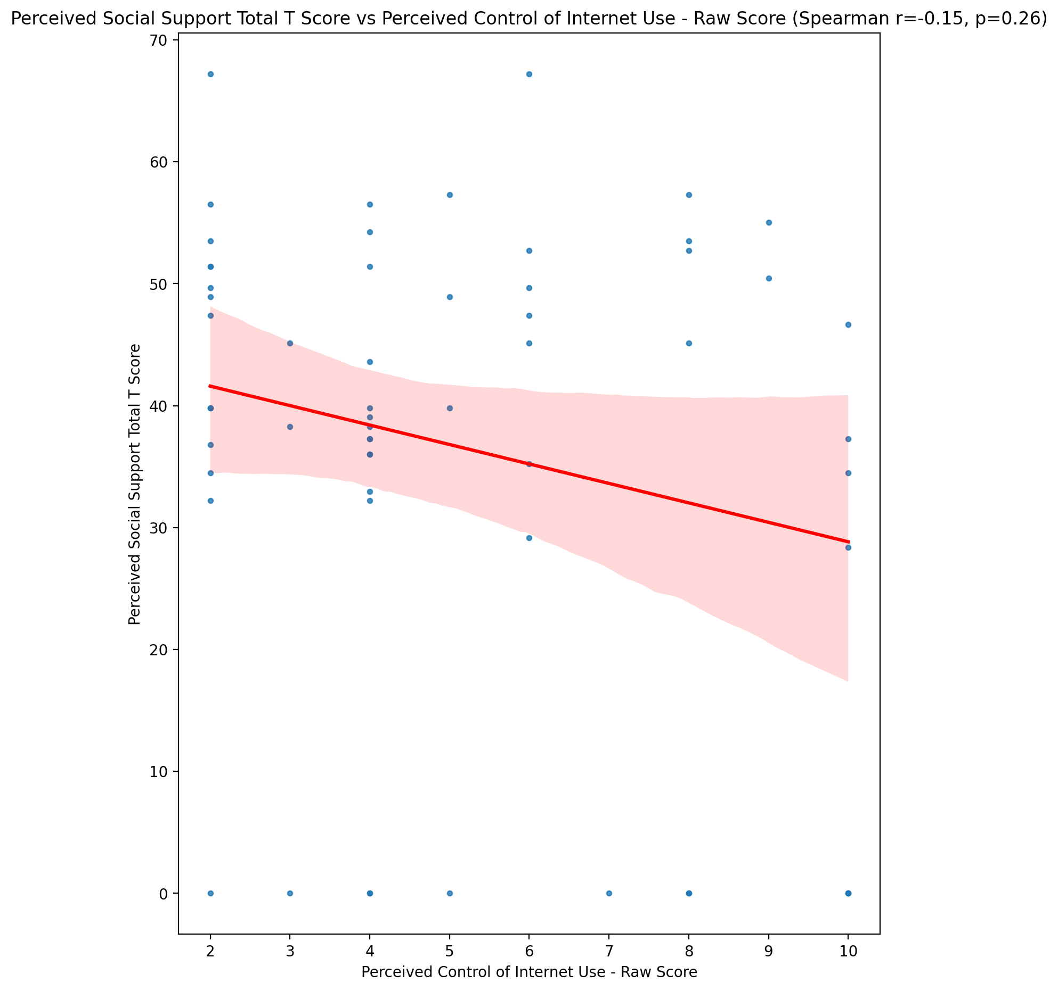

## Emotional Support - Rank vs Perceived Control of Internet Use - Raw Score

Test: None; statistic: None; p-value: None; Test not run: unsupported type combination.



## Informational Support - Rank vs Perceived Control of Internet Use - Raw Score

Test: None; statistic: None; p-value: None; Test not run: unsupported type combination.



## Instrumental Support - Rank vs Perceived Control of Internet Use - Raw Score

Test: None; statistic: None; p-value: None; Test not run: unsupported type combination.



## Perceived Social Support TOTAL - Rank vs Perceived Control of Internet Use - Raw Score

Test: None; statistic: None; p-value: None; Test not run: unsupported type combination.



## Power Self Concept - Real Self Concept Score vs Perceived Control of Internet Use - Raw Score

Test: spearman; statistic: 0.21719719031569593; p-value: 0.0984491436268585;

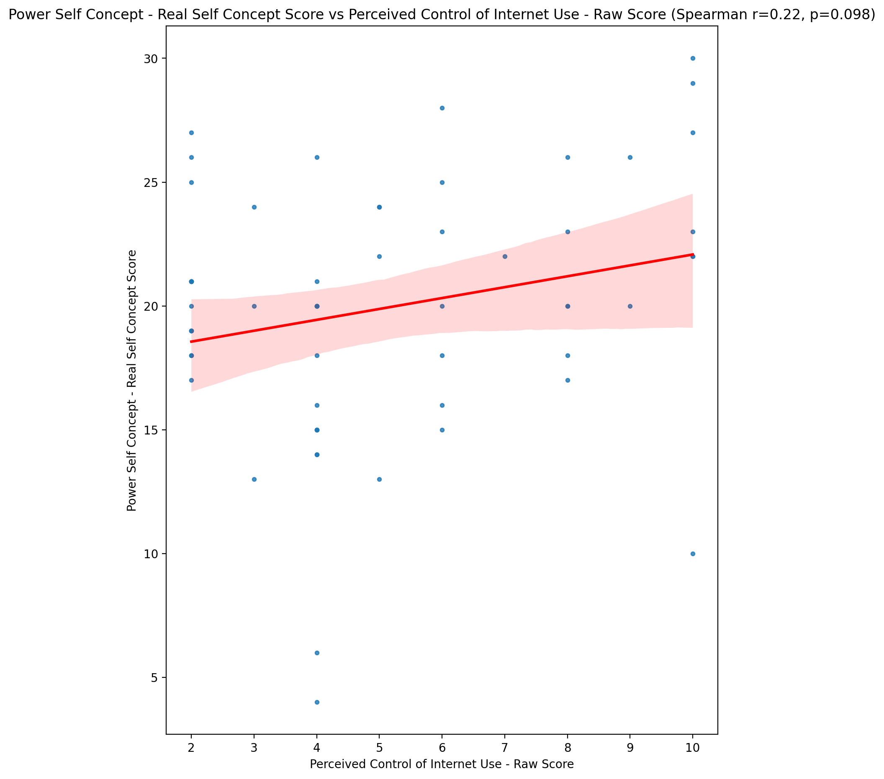

## Power Self Concept - Ideal Self Concept score vs Perceived Control of Internet Use - Raw Score

Test: spearman; statistic: 0.19806938414080238; p-value: 0.13263535035403487;

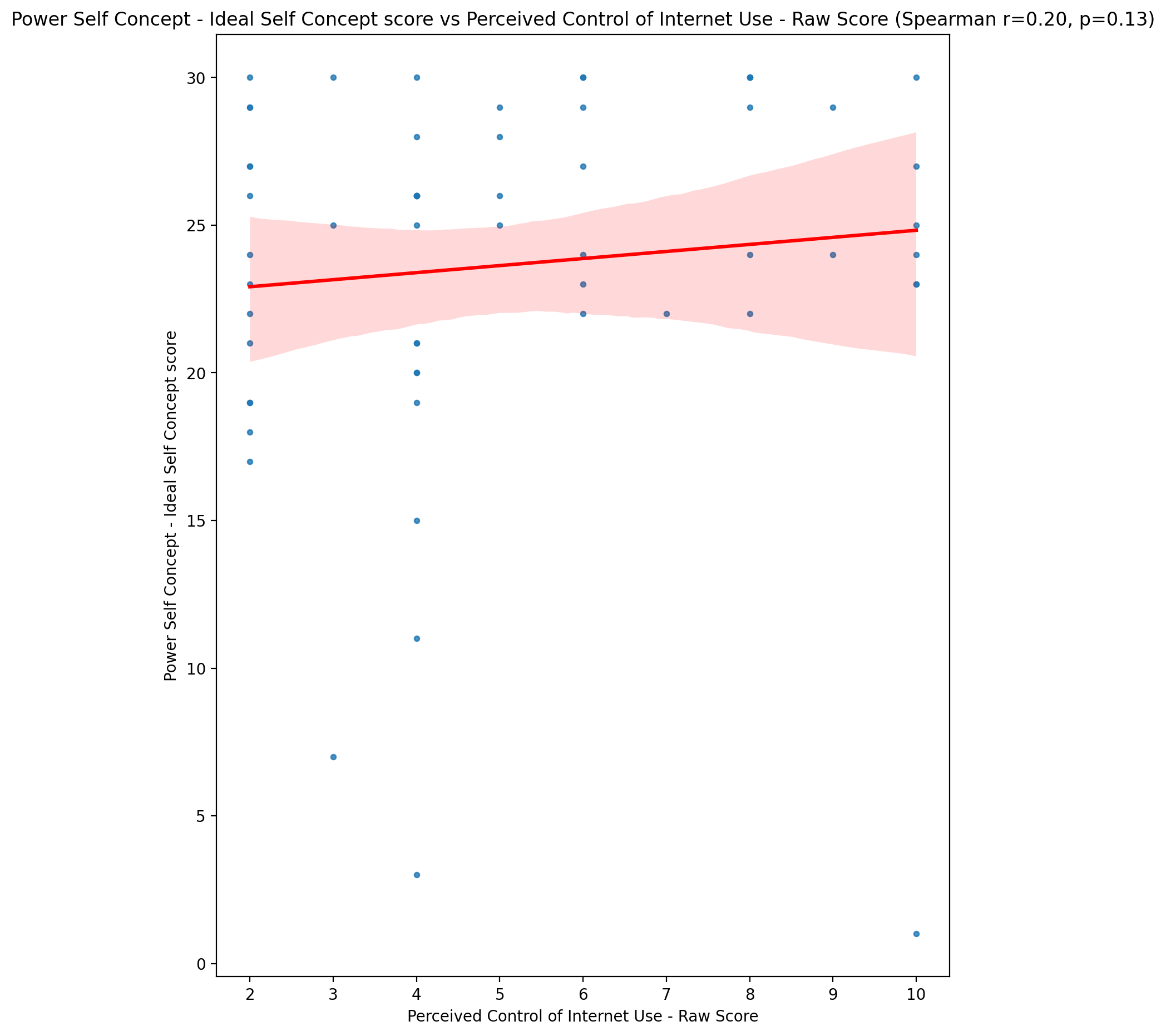

## Power Self Concept – Social Self Concept Score vs Perceived Control of Internet Use - Raw Score

Test: spearman; statistic: 0.1934583305621347; p-value: 0.14207802817154372;

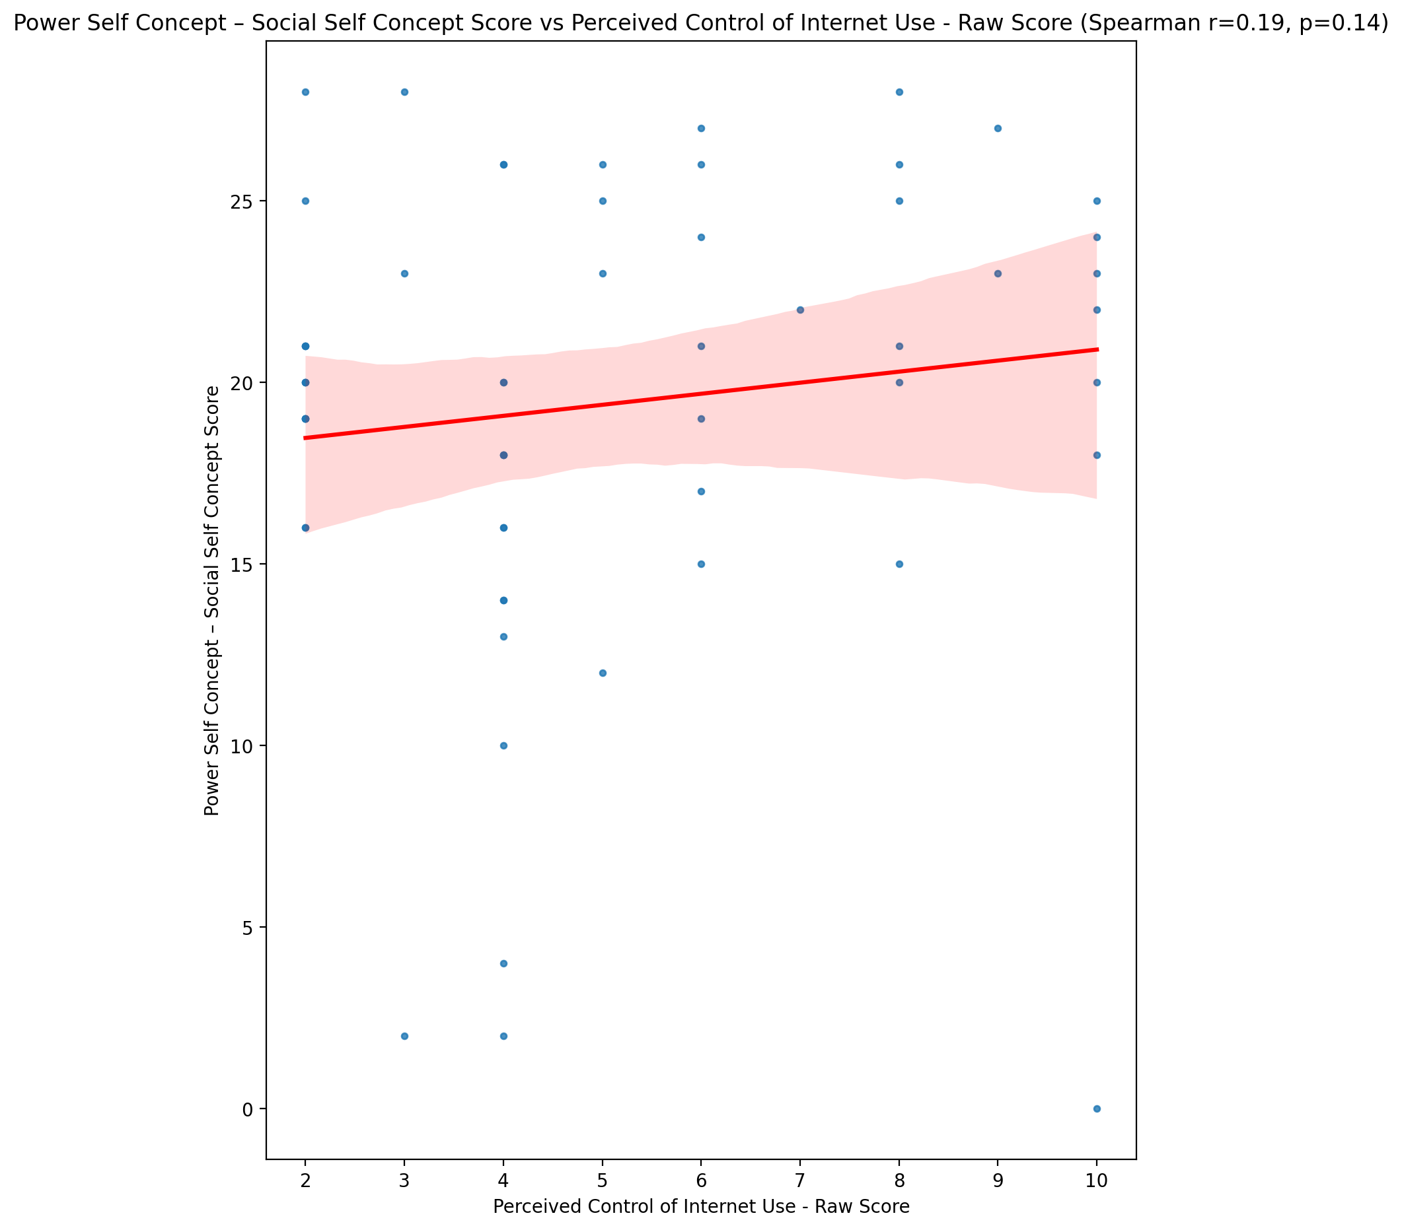

## Social Self Concept - Real Self Concept Score vs Perceived Control of Internet Use - Raw Score

Test: spearman; statistic: 0.06177898268828461; p-value: 0.6420570444118925;

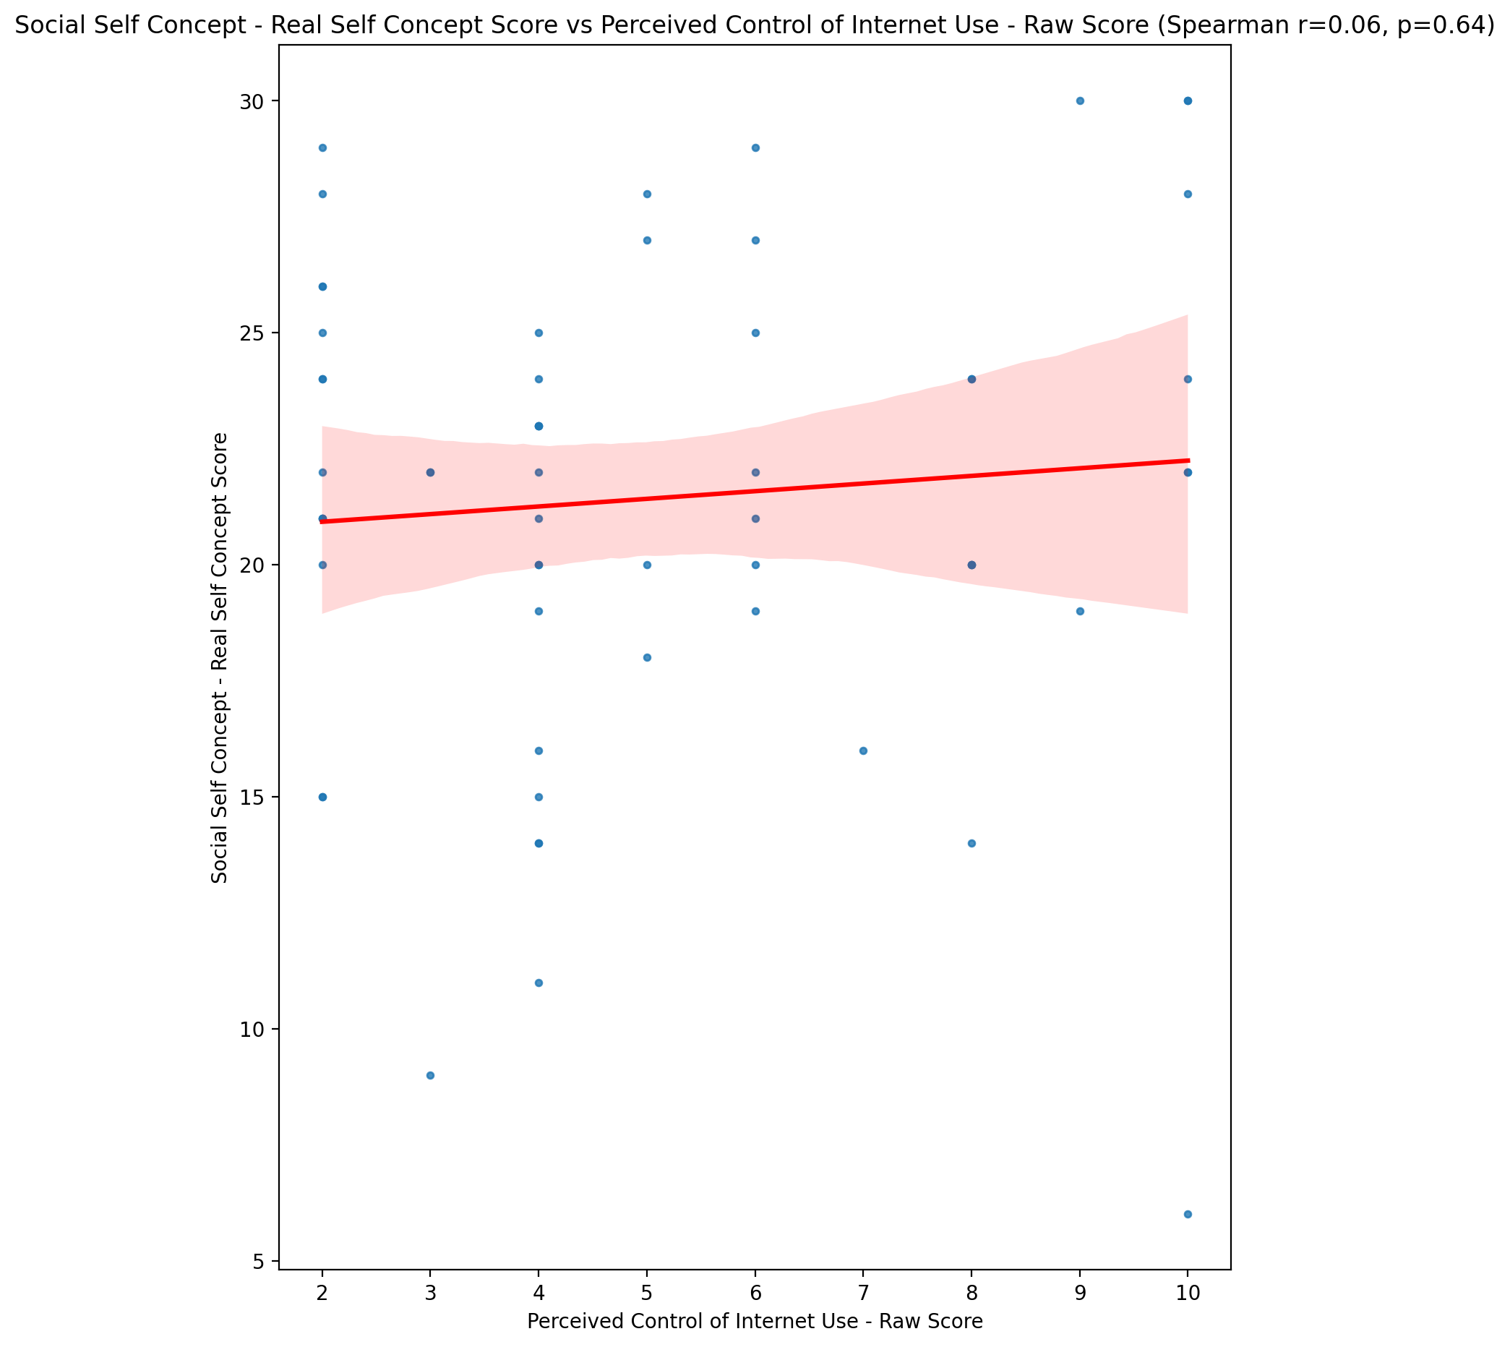

## Social Self Concept – Social Self Concept Score vs Perceived Control of Internet Use - Raw Score

Test: spearman; statistic: 0.0754297359265798; p-value: 0.5701707330635212;

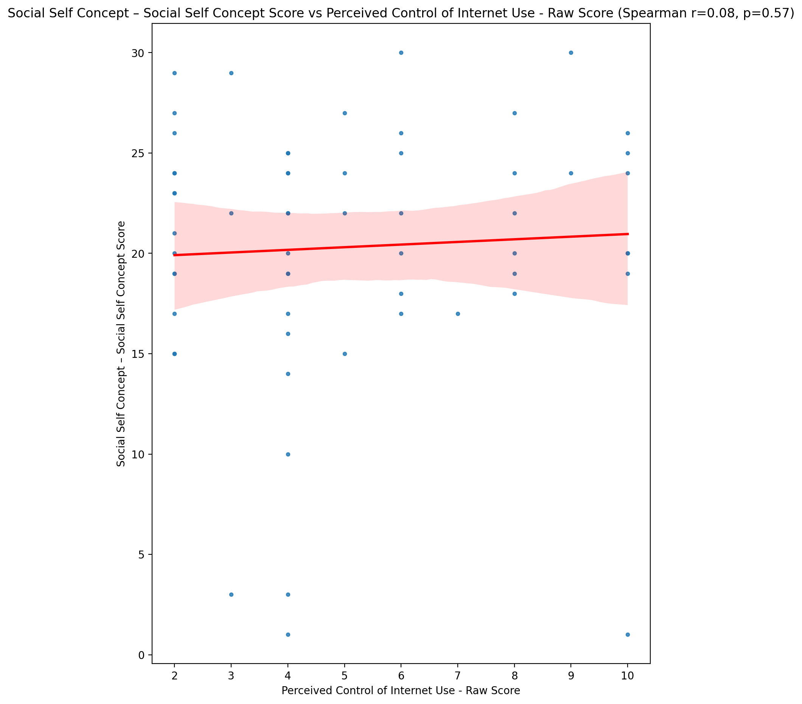

## Ability Self Concept - Real Self Concept Score vs Perceived Control of Internet Use - Raw Score

Test: spearman; statistic: 0.11303226895632594; p-value: 0.3940047540117657;

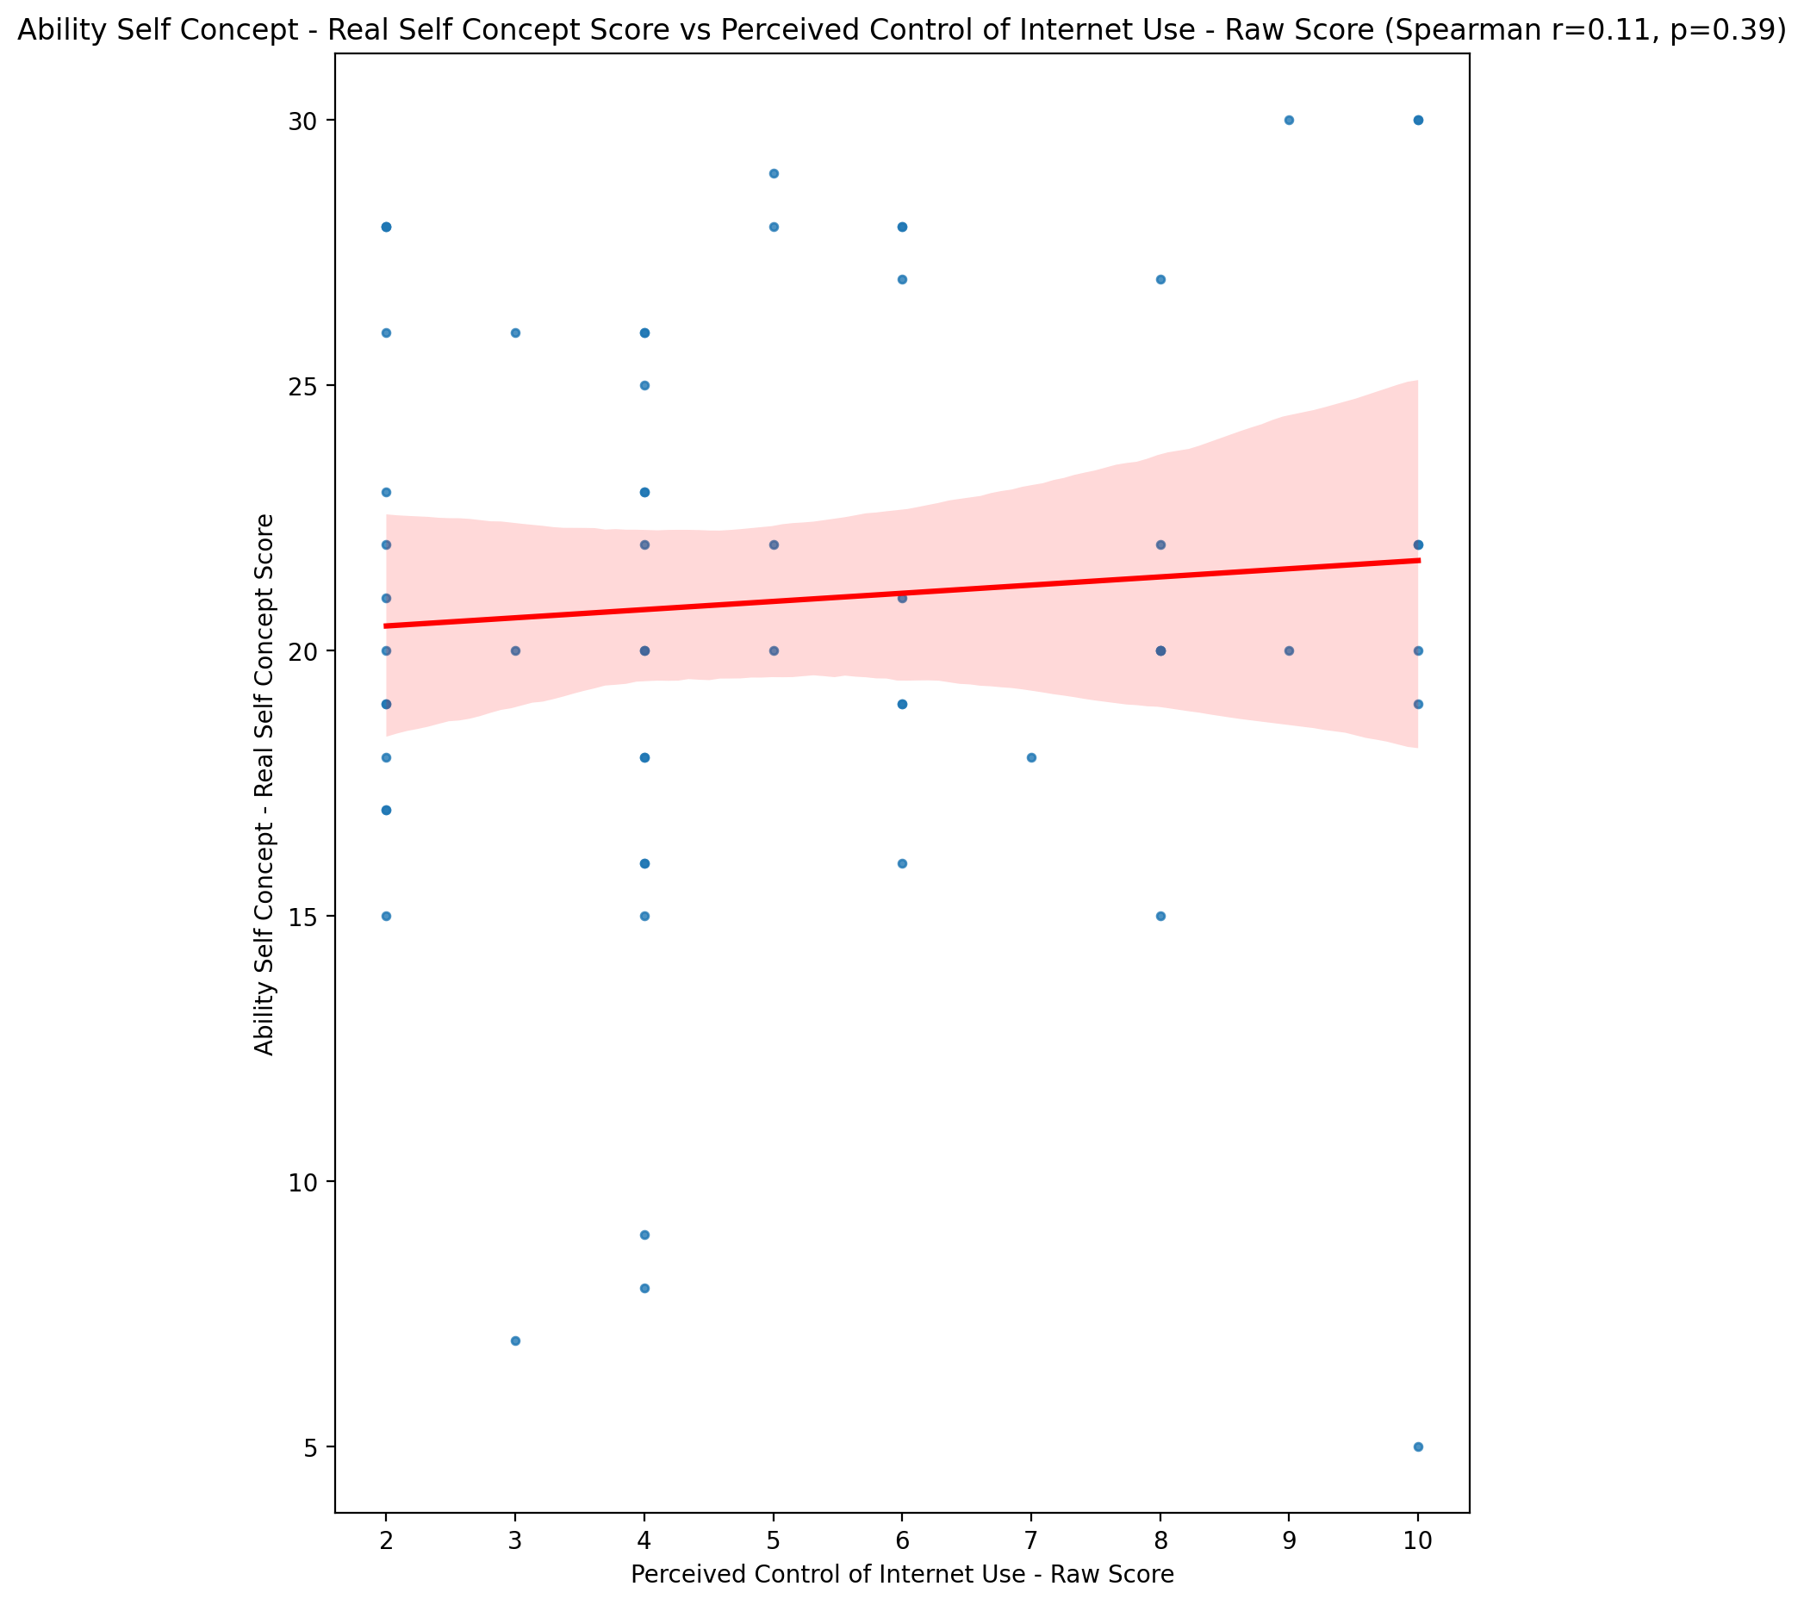

## Ability Self Concept - Ideal Self Concept Score vs Perceived Control of Internet Use - Raw Score

Test: spearman; statistic: 0.14463180669301687; p-value: 0.2744258571398722;

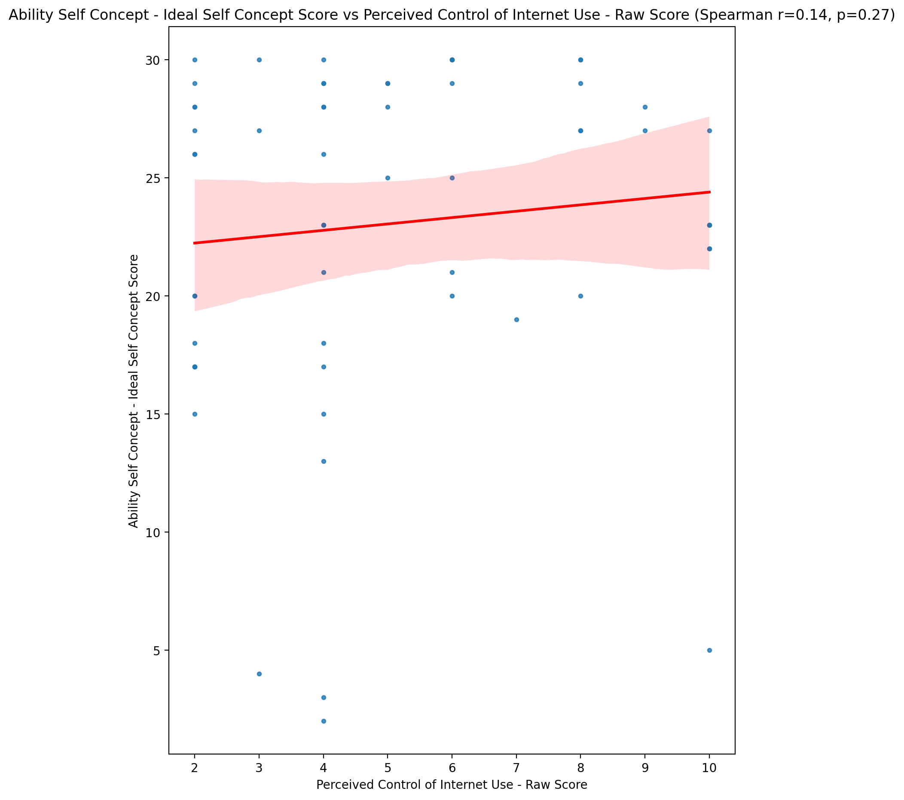

## Ability Self Concept – Social Self Concept Score vs Perceived Control of Internet Use - Raw Score

Test: spearman; statistic: 0.02808389710294041; p-value: 0.8327759917942923;

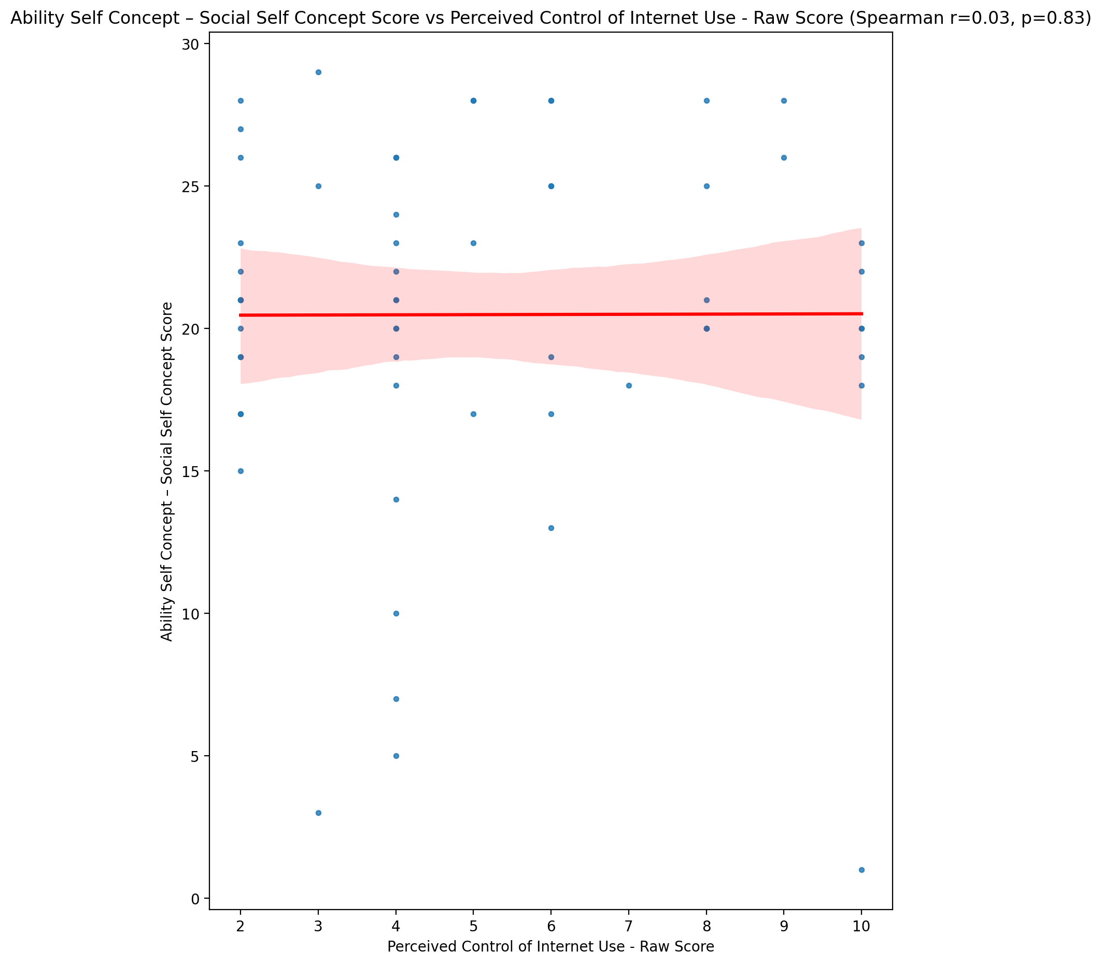

## Physical Self Concept - Real Self Concept Score vs Perceived Control of Internet Use - Raw Score

Test: spearman; statistic: 0.055756094869296155; p-value: 0.6748990470165812;

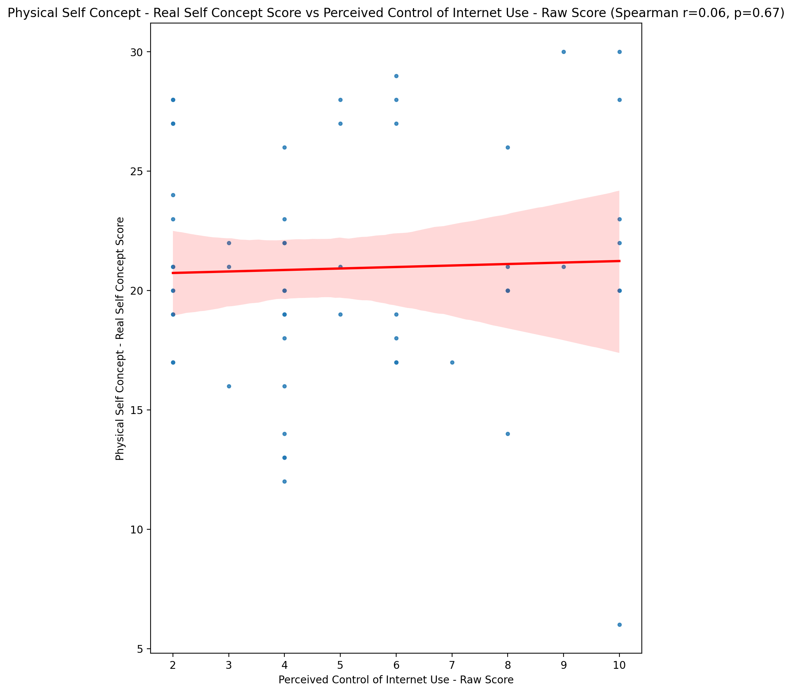

## Physical Self Concept – Ideal Self Concept Score vs Perceived Control of Internet Use - Raw Score

Test: spearman; statistic: 0.14645038073921304; p-value: 0.26837237512644224;

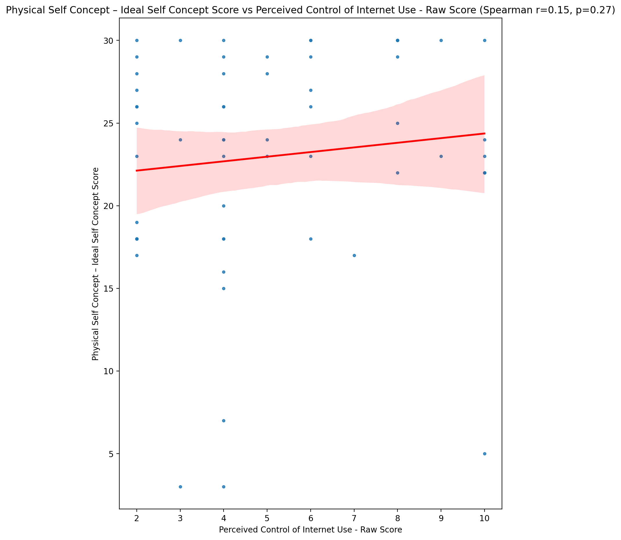

## Physical Self Concept – Social Self Concept Score vs Perceived Control of Internet Use - Raw Score

Test: spearman; statistic: 0.0211170161675364; p-value: 0.8738658317937458;

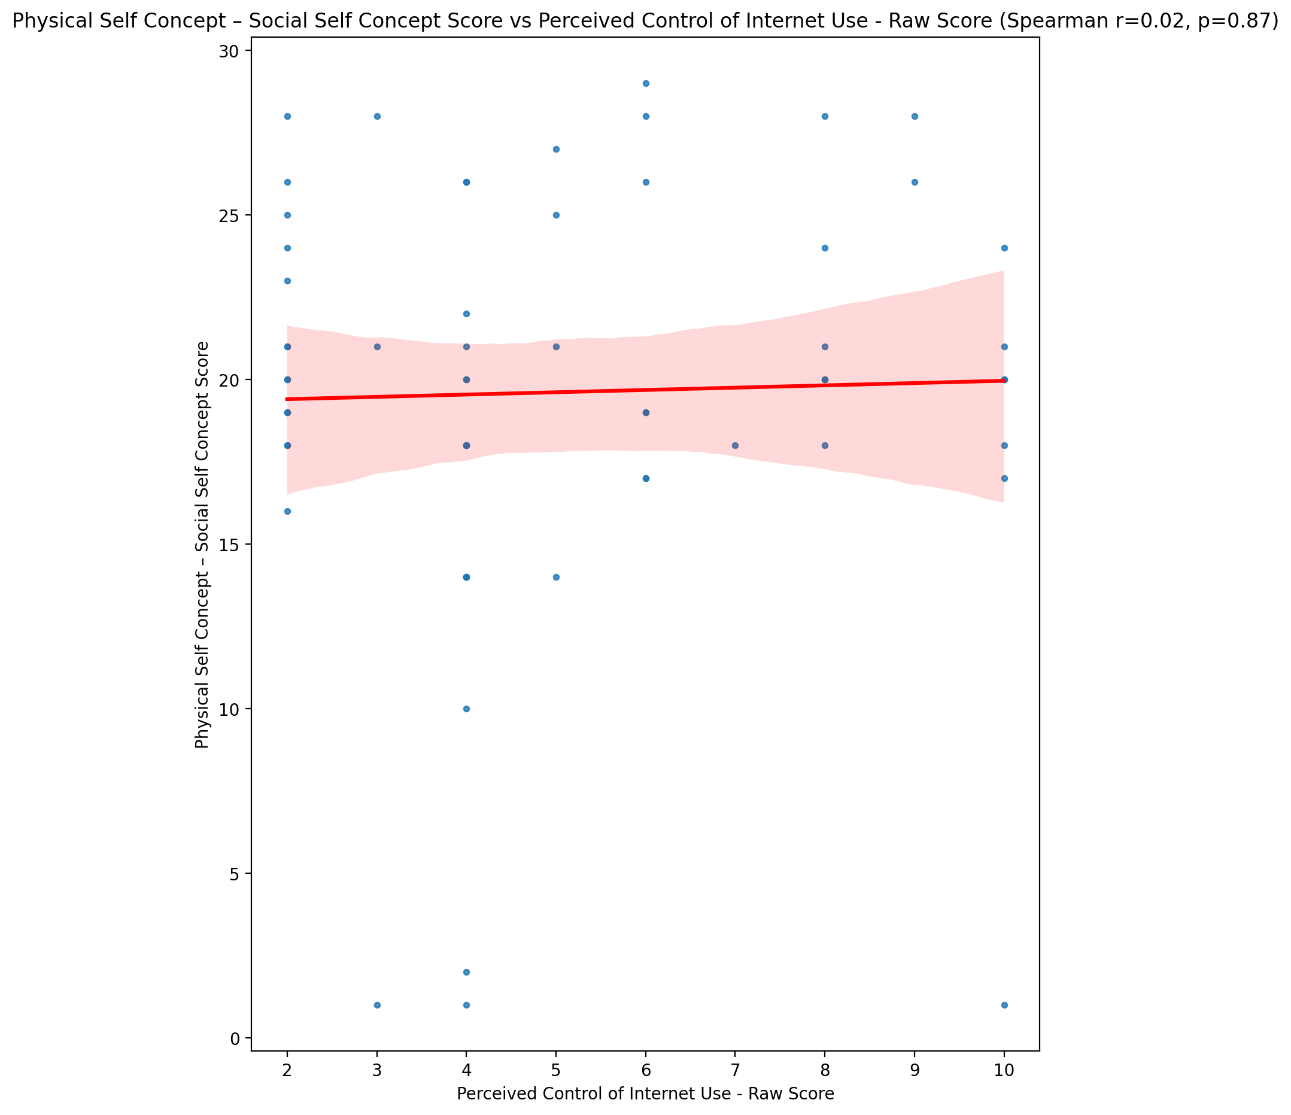

## Psychological Self Concept - Real Self Concept Score vs Perceived Control of Internet Use - Raw Score

Test: spearman; statistic: 0.16263545620515182; p-value: 0.21843083193841548;

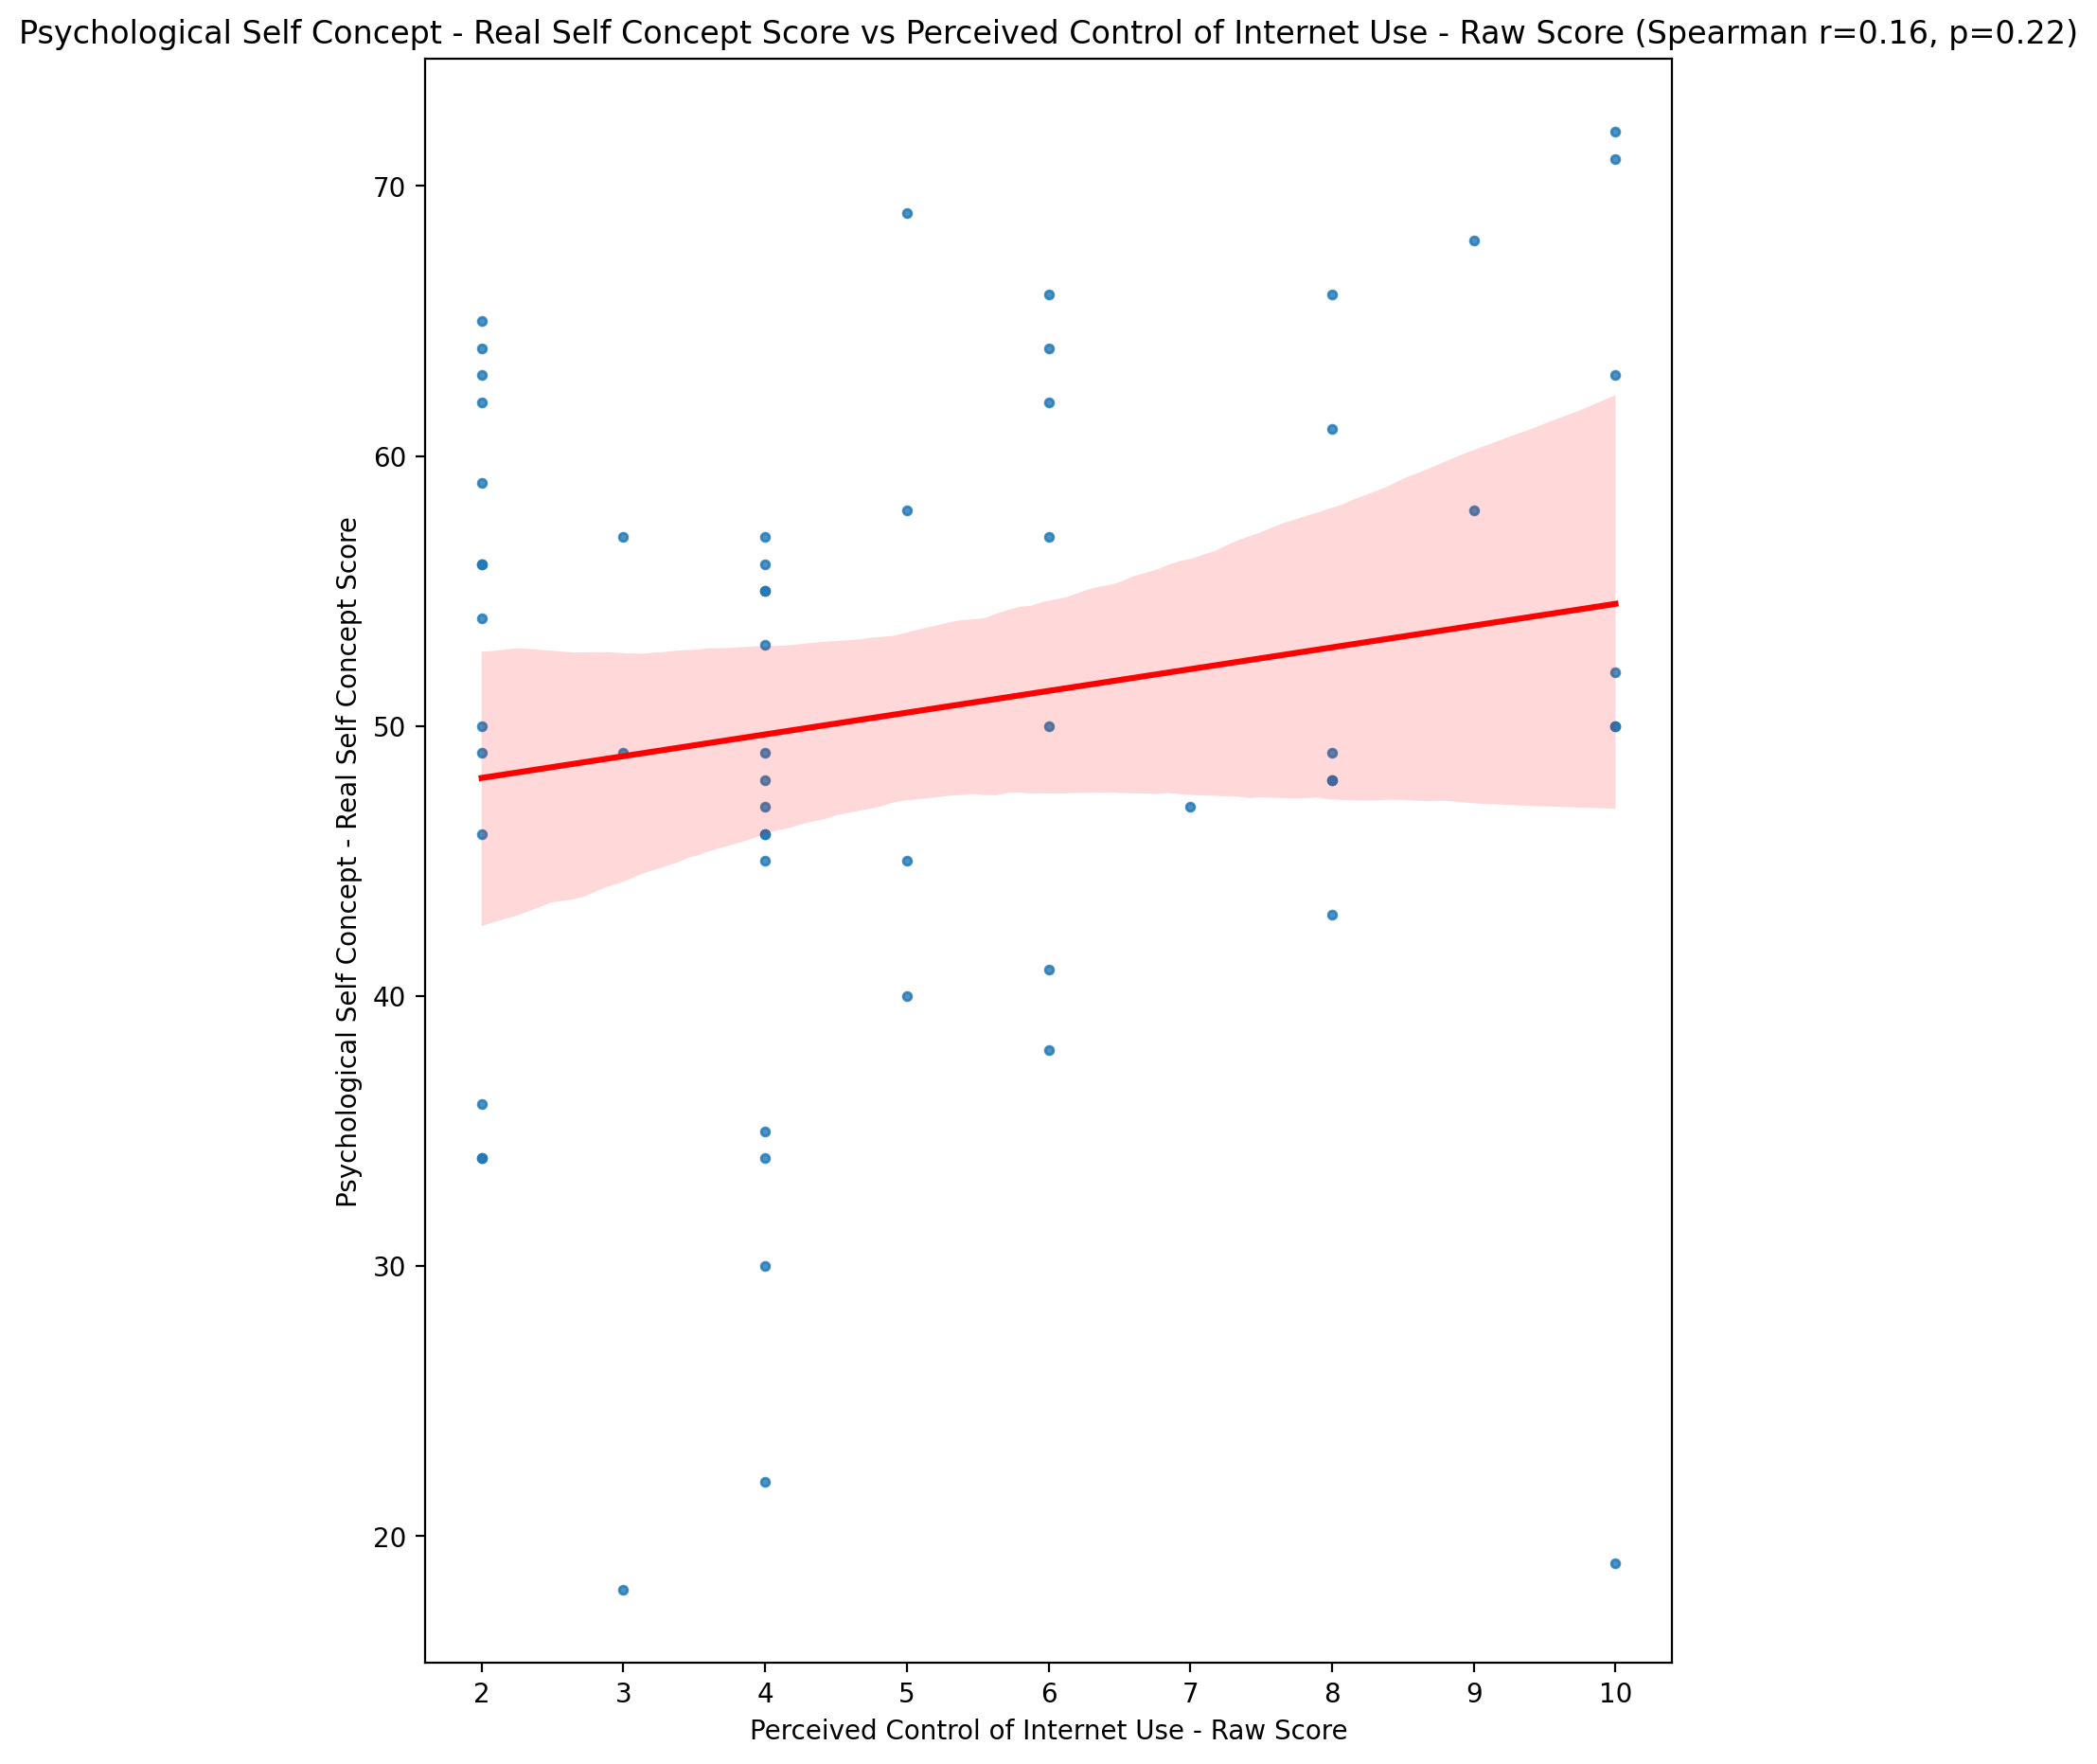

## Psychological Self Concept – Ideal Self Concept Score vs Perceived Control of Internet Use - Raw Score

Test: spearman; statistic: 0.237415182261327; p-value: 0.07020496693657942;

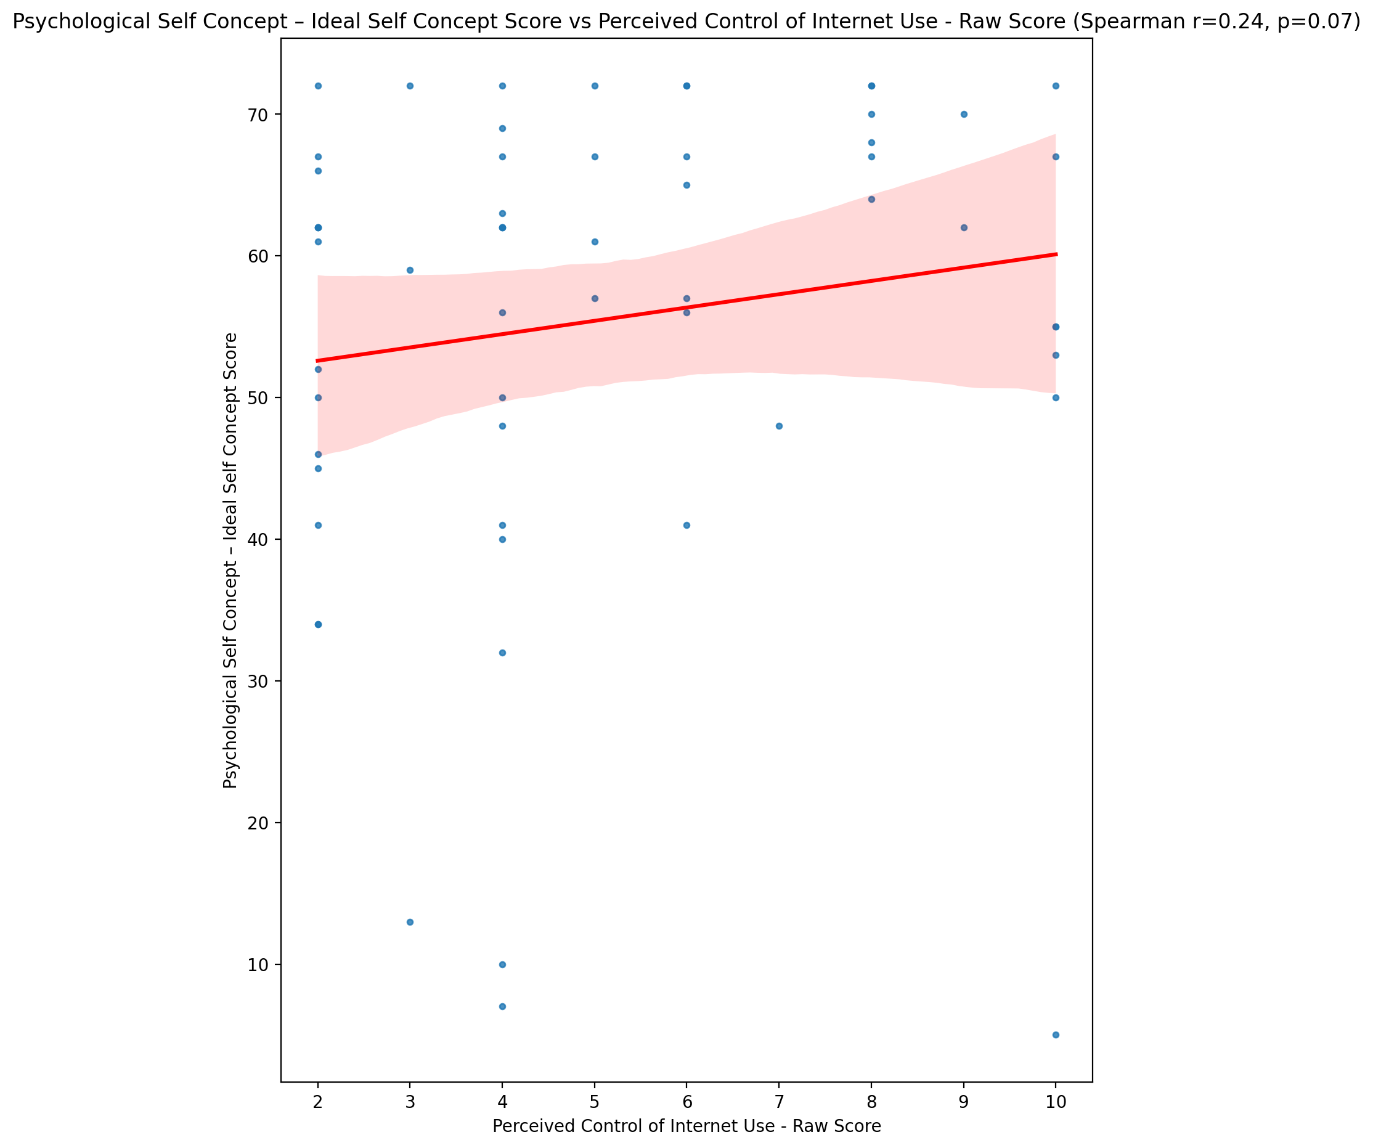

## Psychological Self Concept – Social Self Concept Score vs Perceived Control of Internet Use - Raw Score

Test: spearman; statistic: 0.11141534539181473; p-value: 0.4008484807924574;

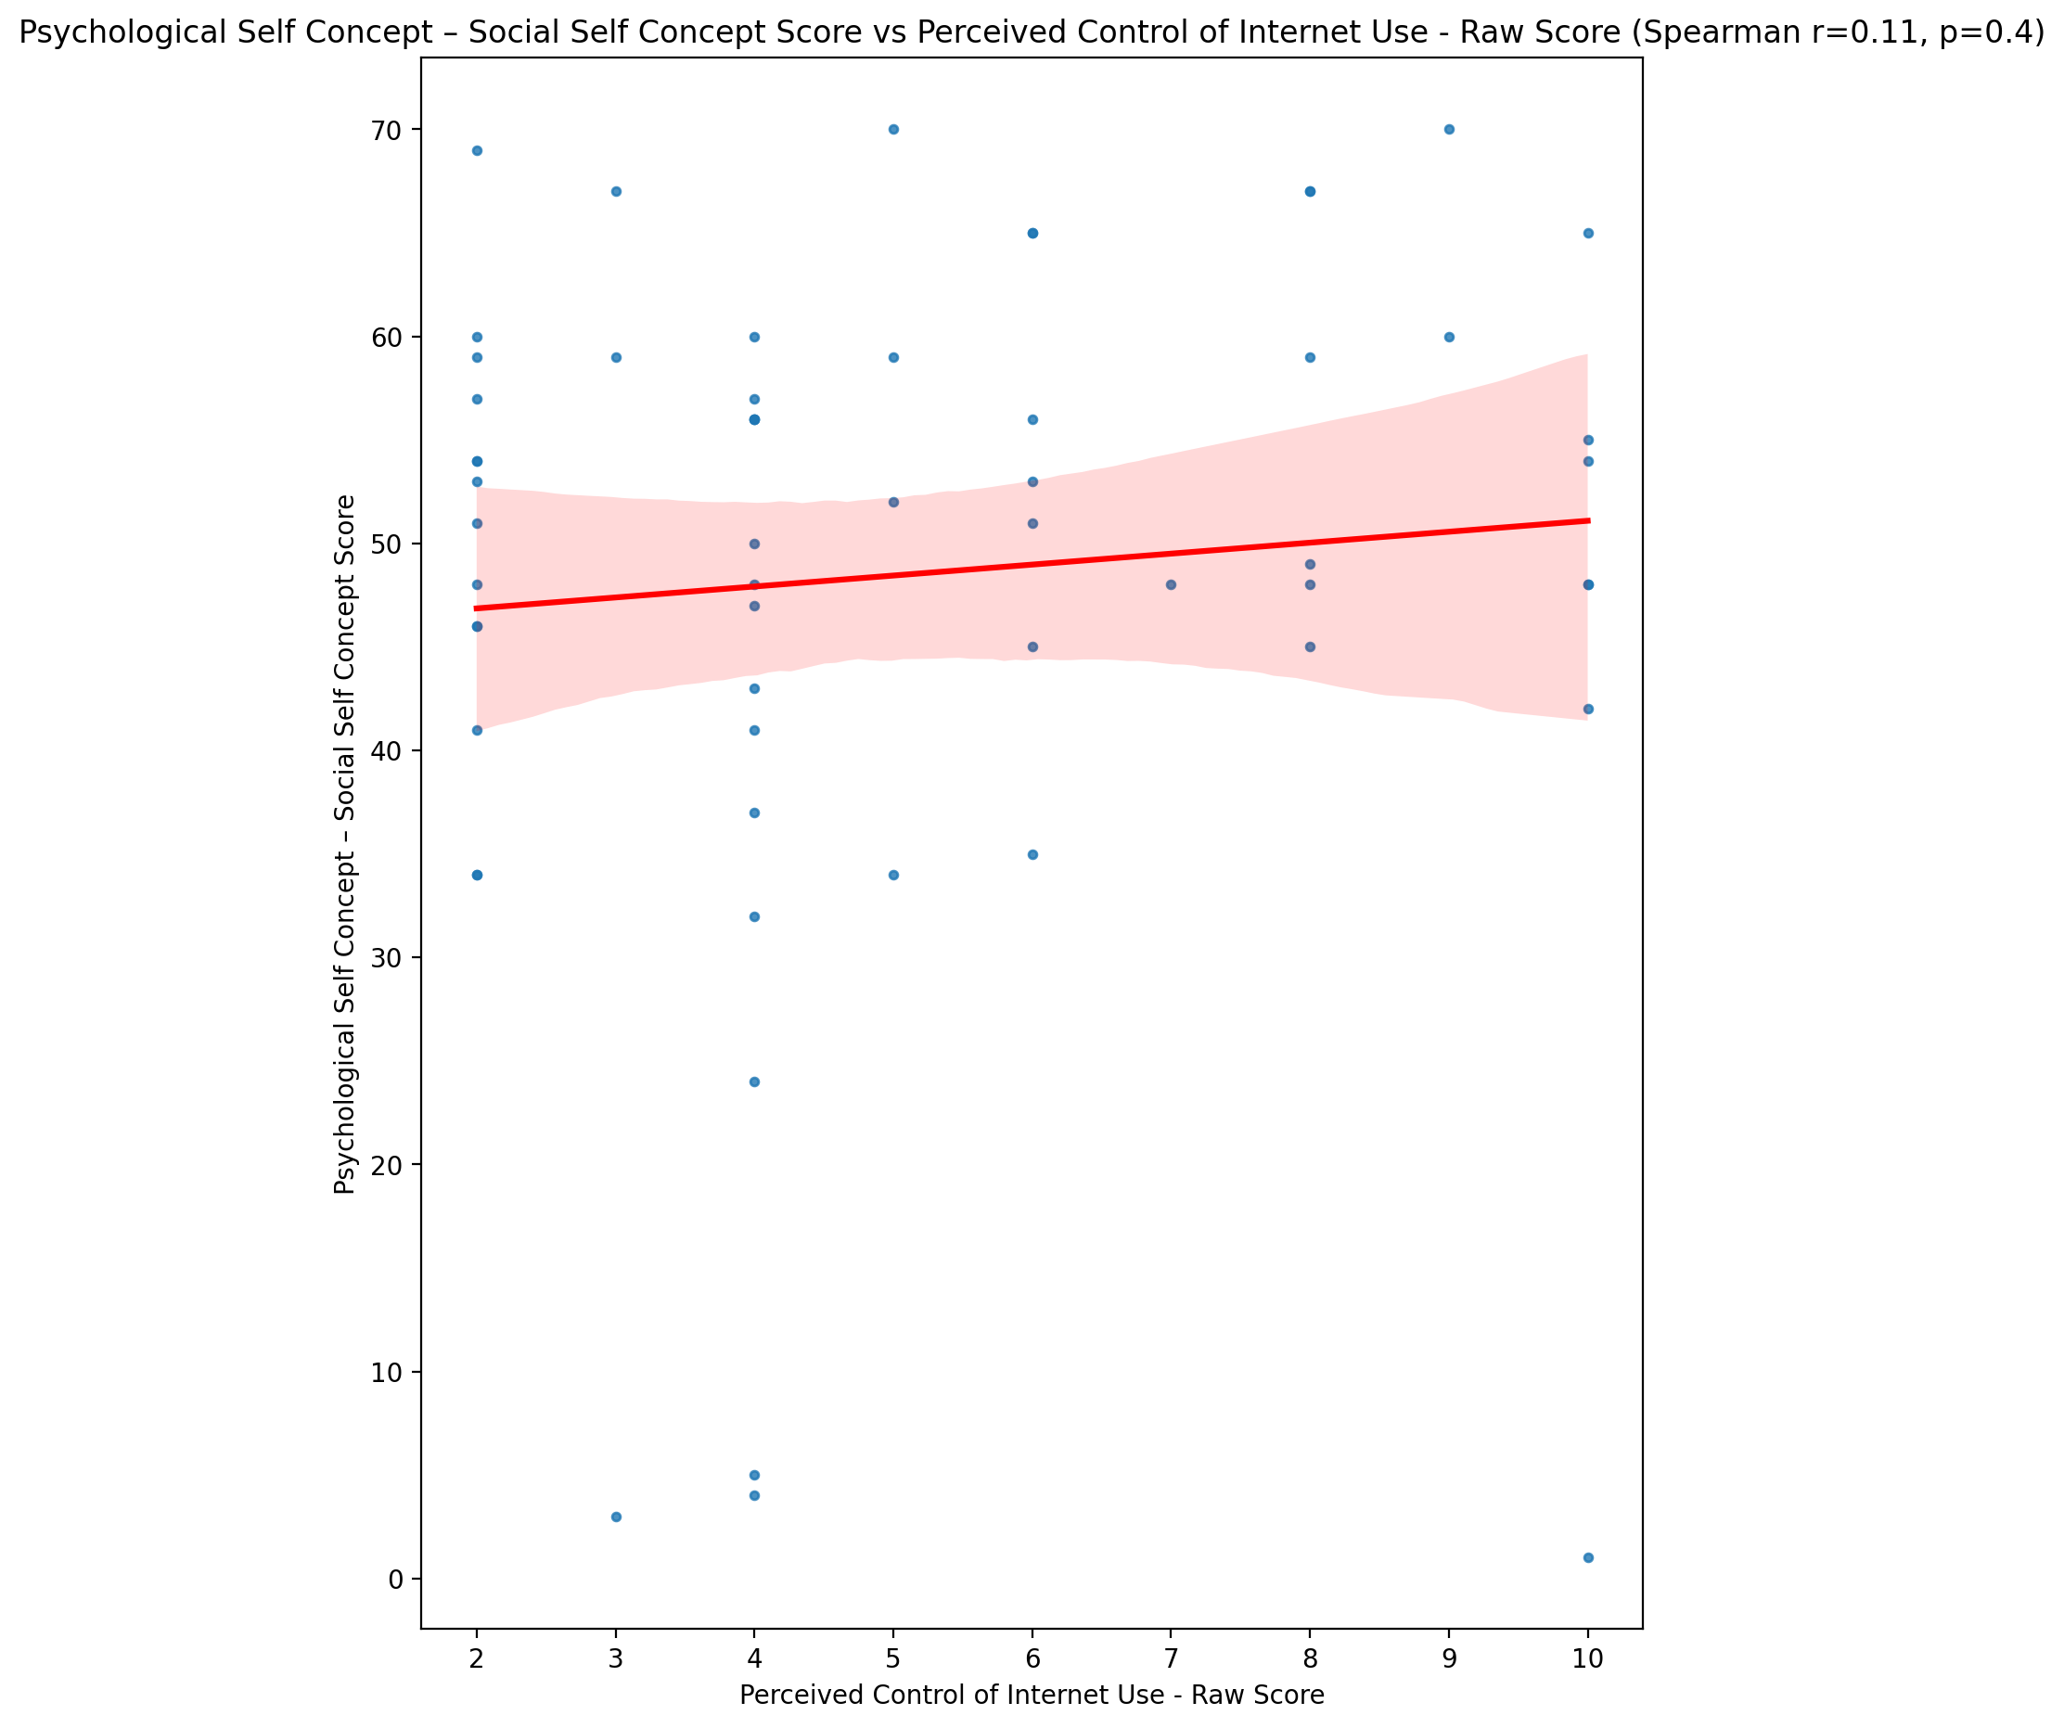

## Real Self Concept Total Score vs Perceived Control of Internet Use - Raw Score

Test: spearman; statistic: 0.13263145352917213; p-value: 0.3166350385248555;

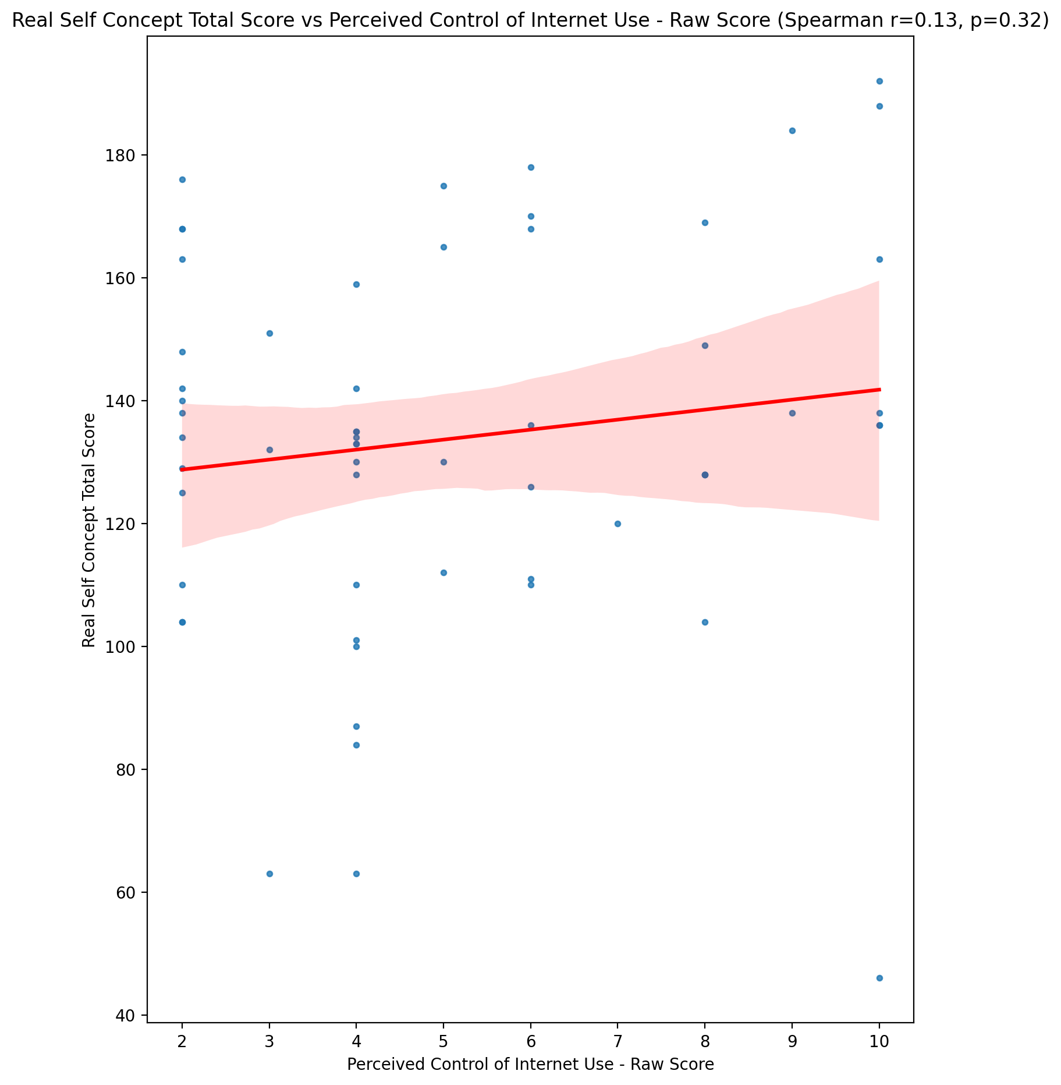

## Ideal Self Concept Total Score vs Perceived Control of Internet Use - Raw Score

Test: spearman; statistic: 0.1861131455502966; p-value: 0.15814439890476598;

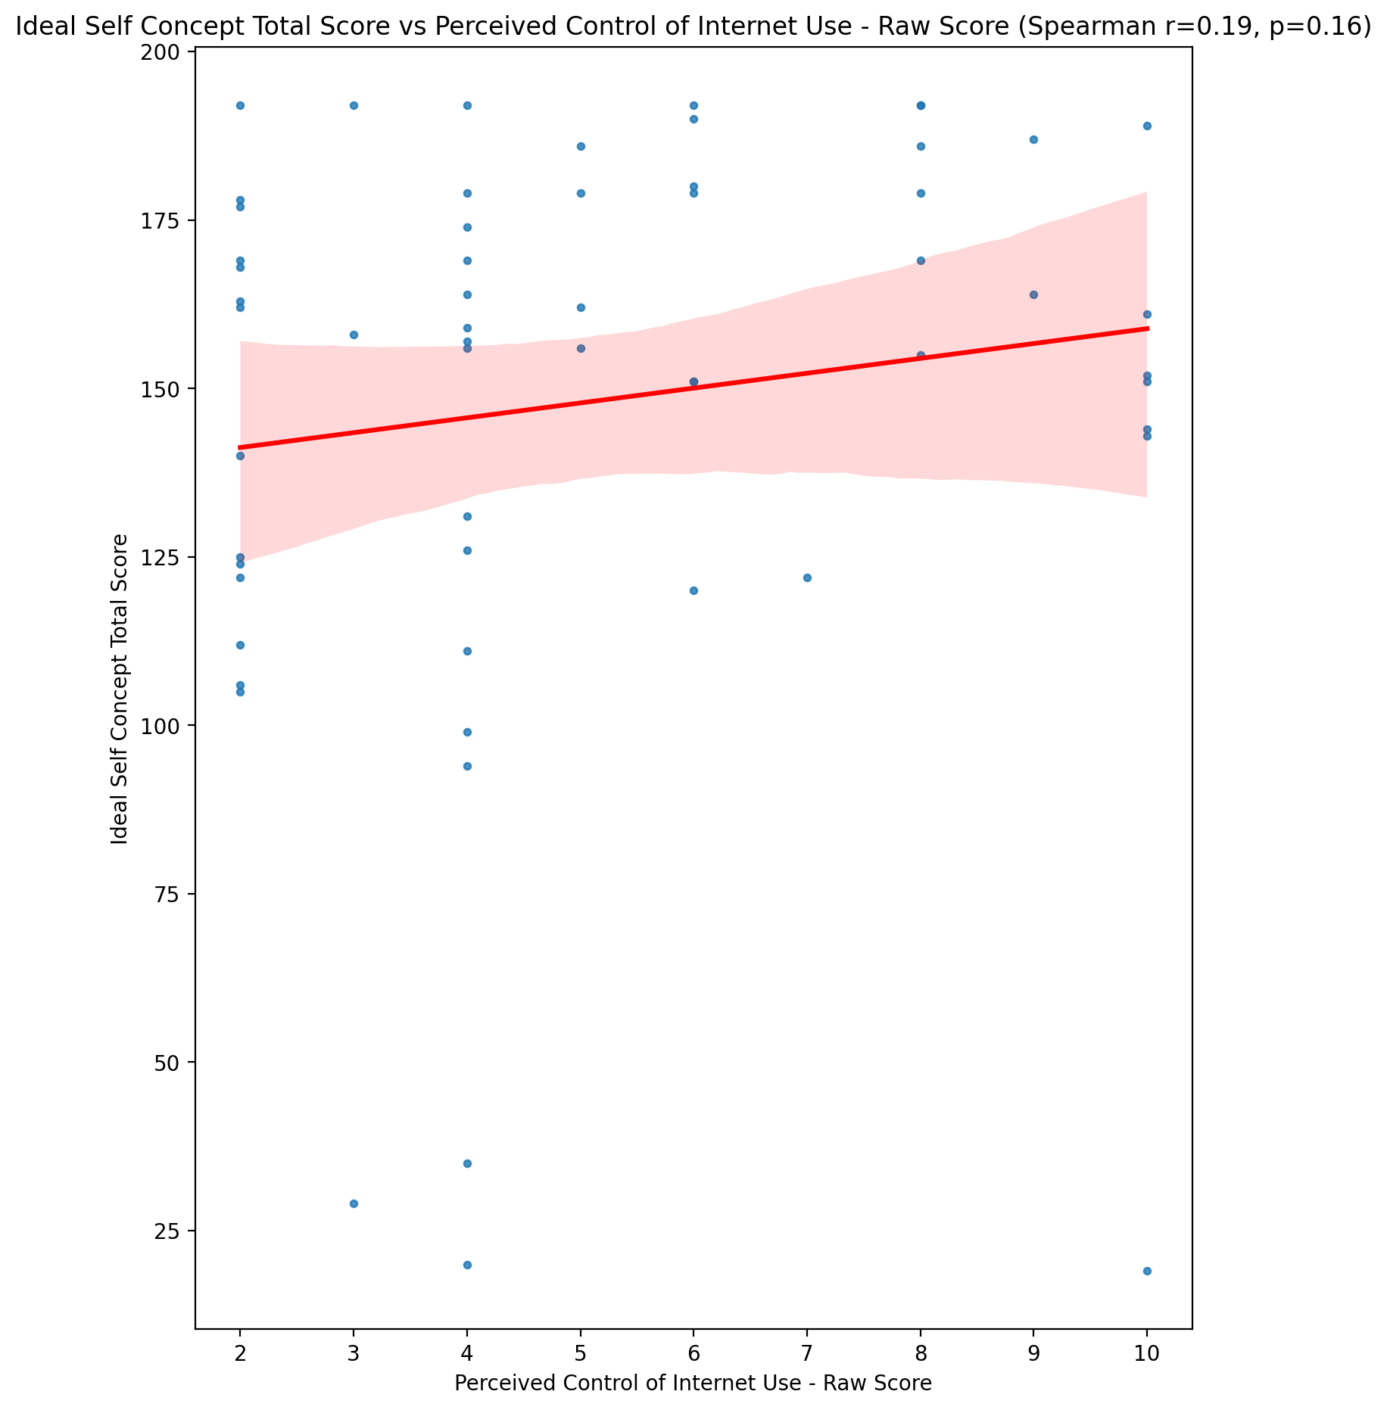

## Social Self Concept Total Score vs Perceived Control of Internet Use - Raw Score

Test: spearman; statistic: 0.09995231070001613; p-value: 0.4513233794438991;

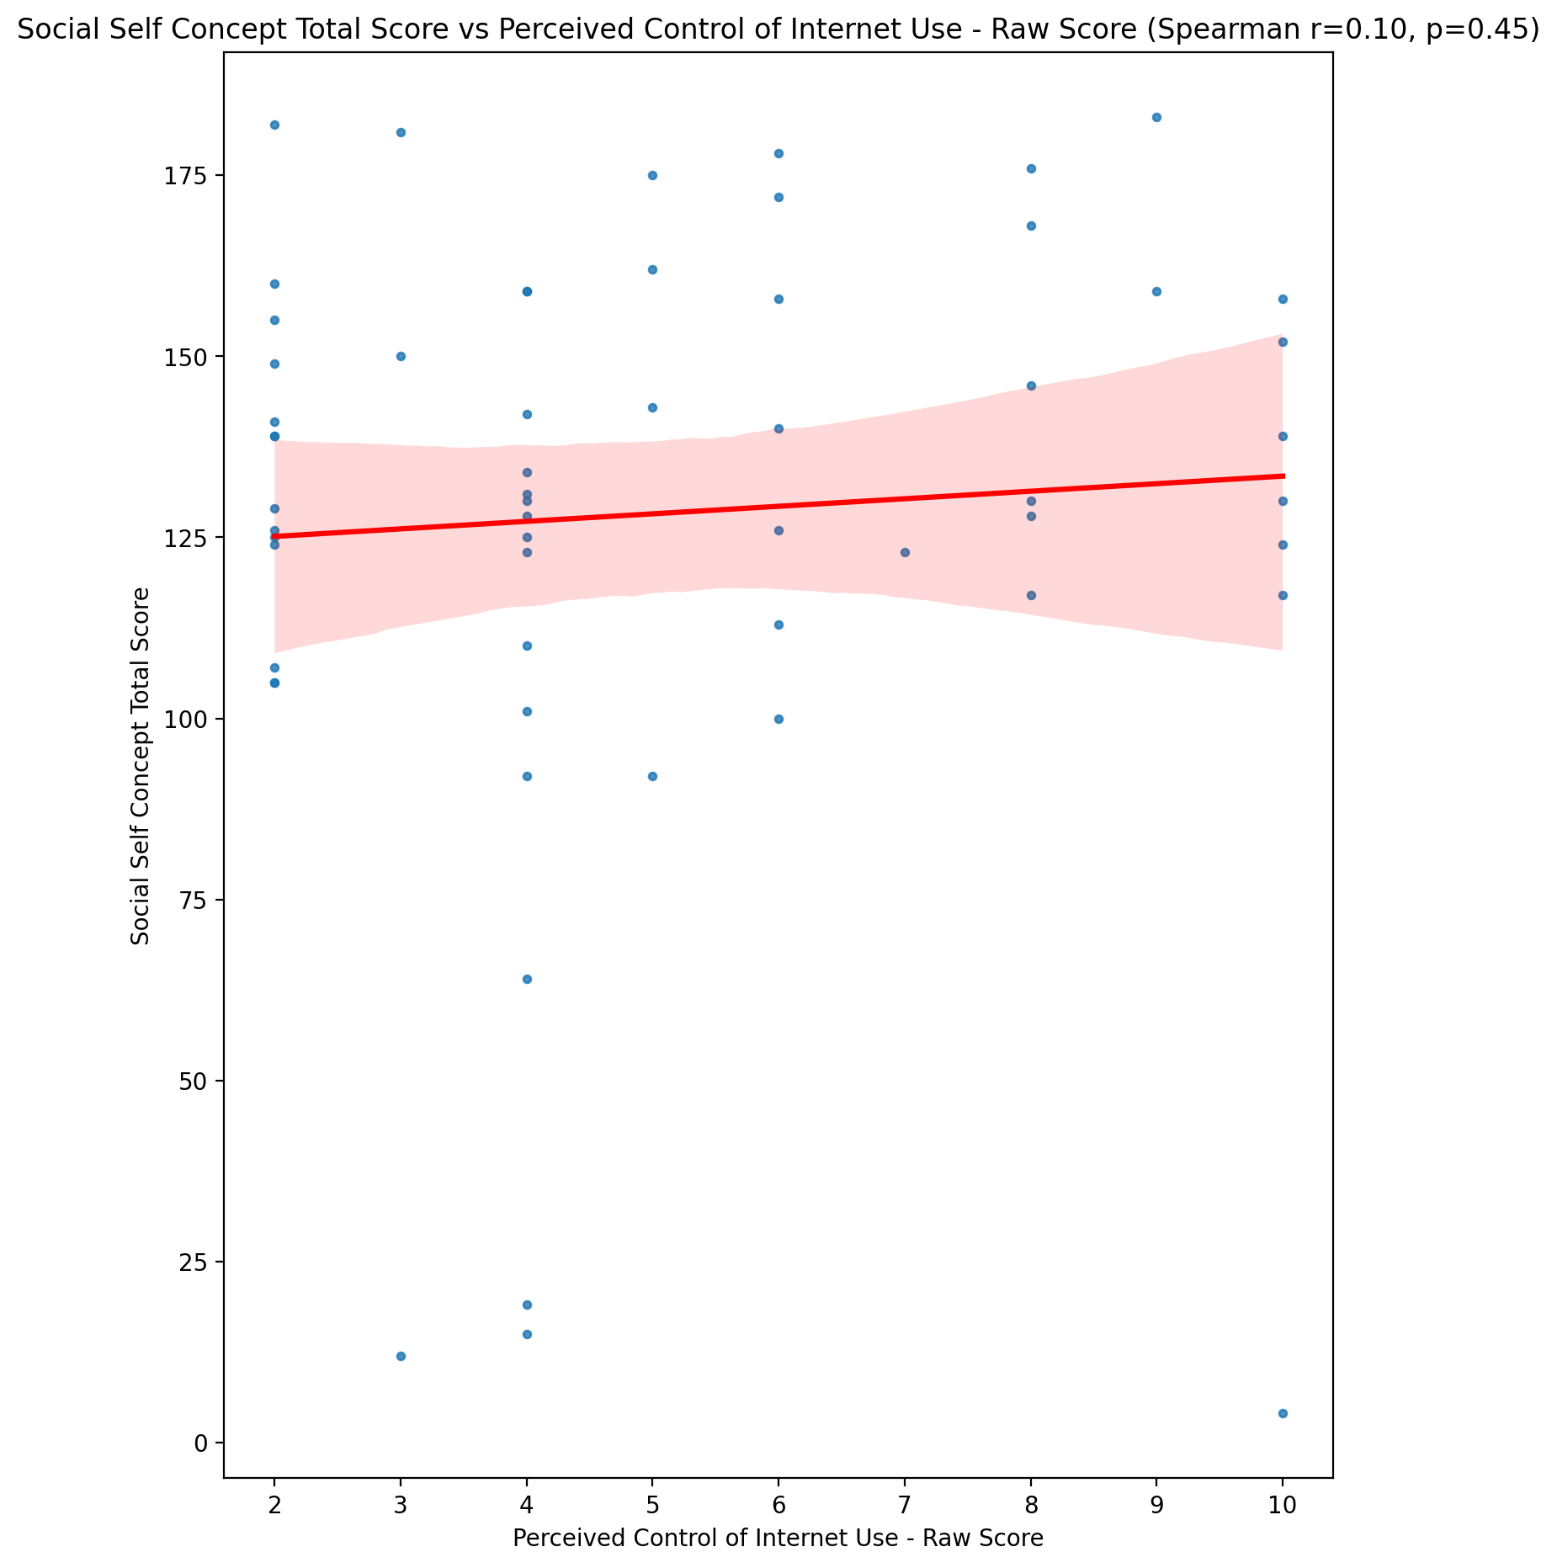

## Ideal Self Concept Total Category vs Perceived Control of Internet Use - Raw Score

Test: None; statistic: None; p-value: None; Test not run: unsupported type combination.



## Perceived Social Stress Score vs Perceived Control of Internet Use - Raw Score

Test: spearman; statistic: 0.1717491922386978; p-value: 0.19336337975766416;

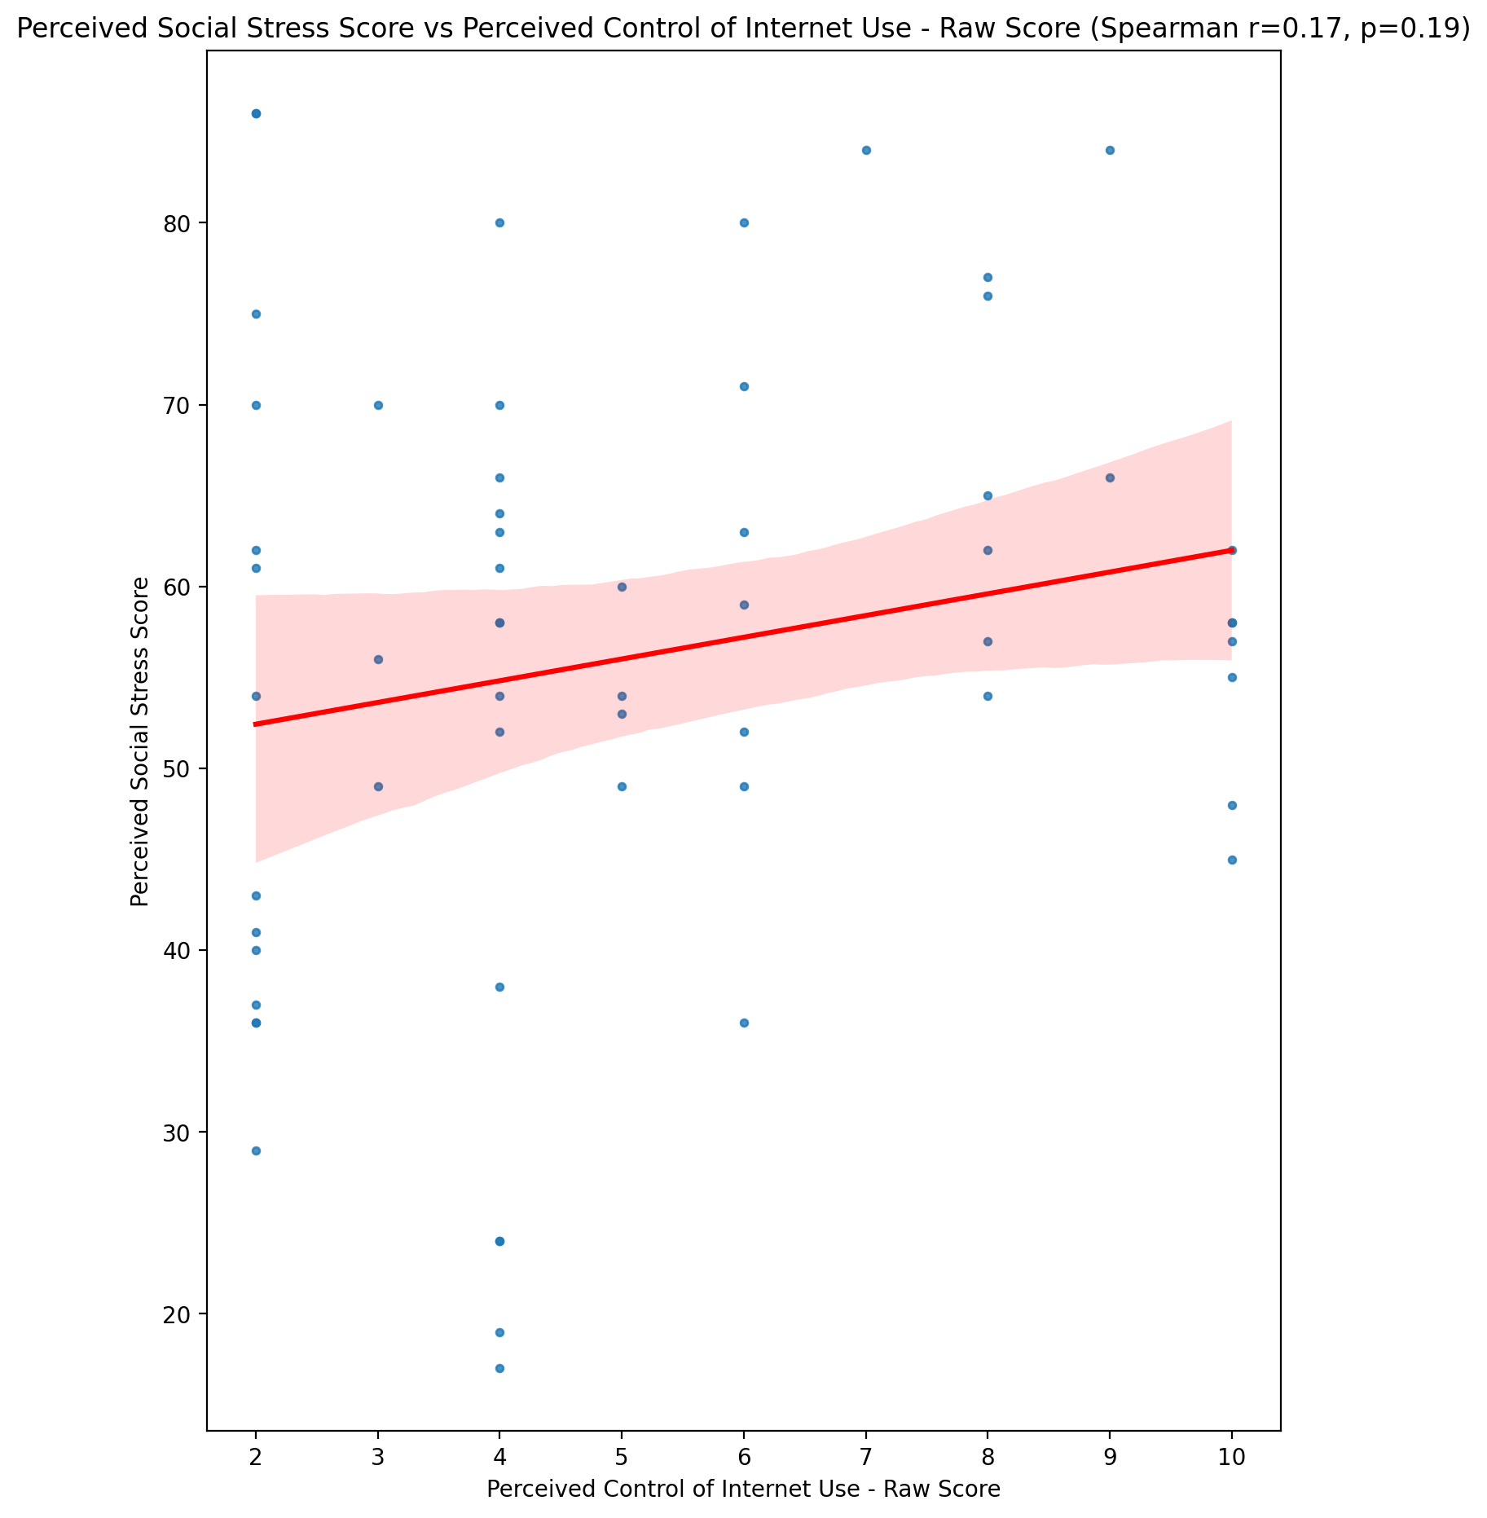

## Perceived Social Stress Category vs Perceived Control of Internet Use - Raw Score

Test: None; statistic: None; p-value: None; Test not run: unsupported type combination.



## Emotional Support - Raw Score vs Functional Impairment - Weighted Score

Test: spearman; statistic: -0.14846403803707967; p-value: 0.26177444179351583;

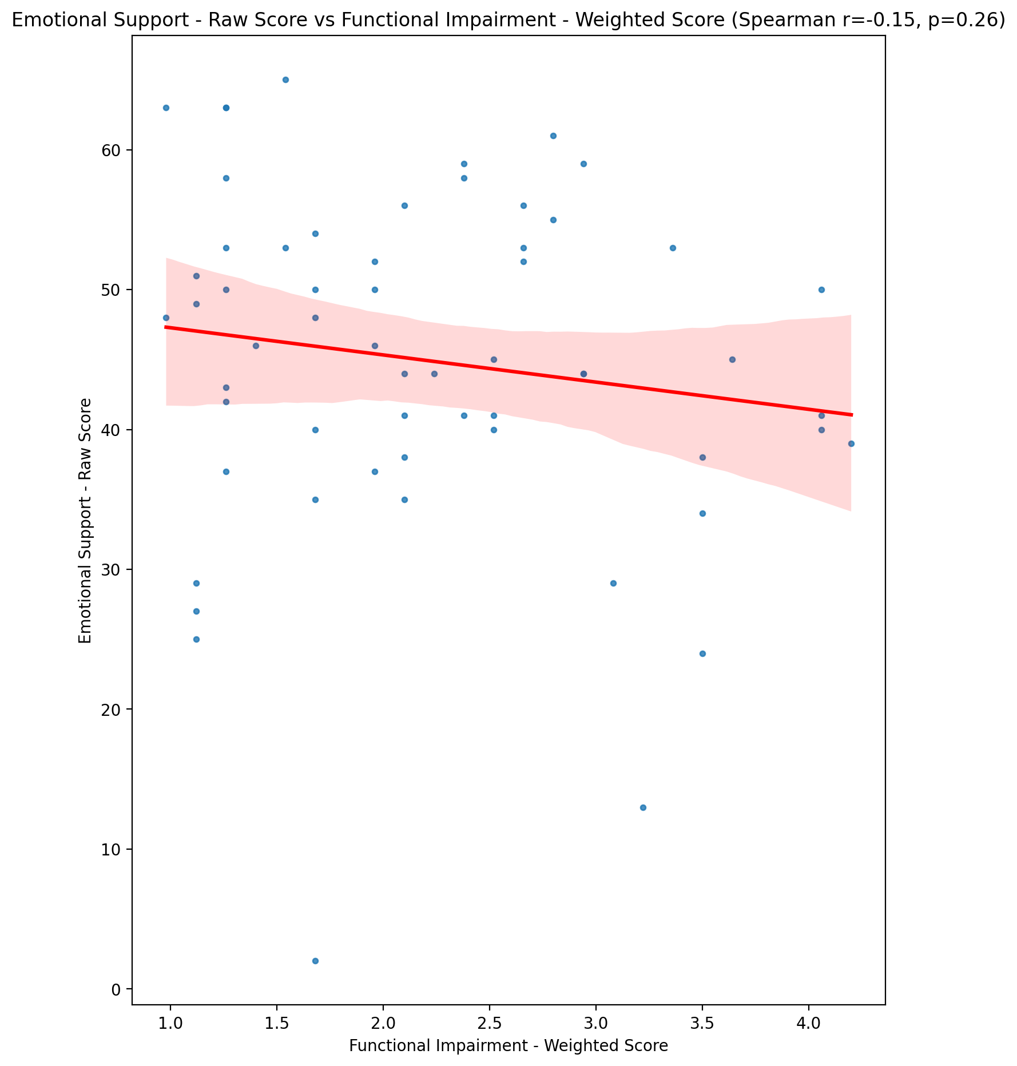

## Informational Support - Raw Score vs Functional Impairment - Weighted Score

Test: spearman; statistic: -0.09004207642774283; p-value: 0.4976399408557386;

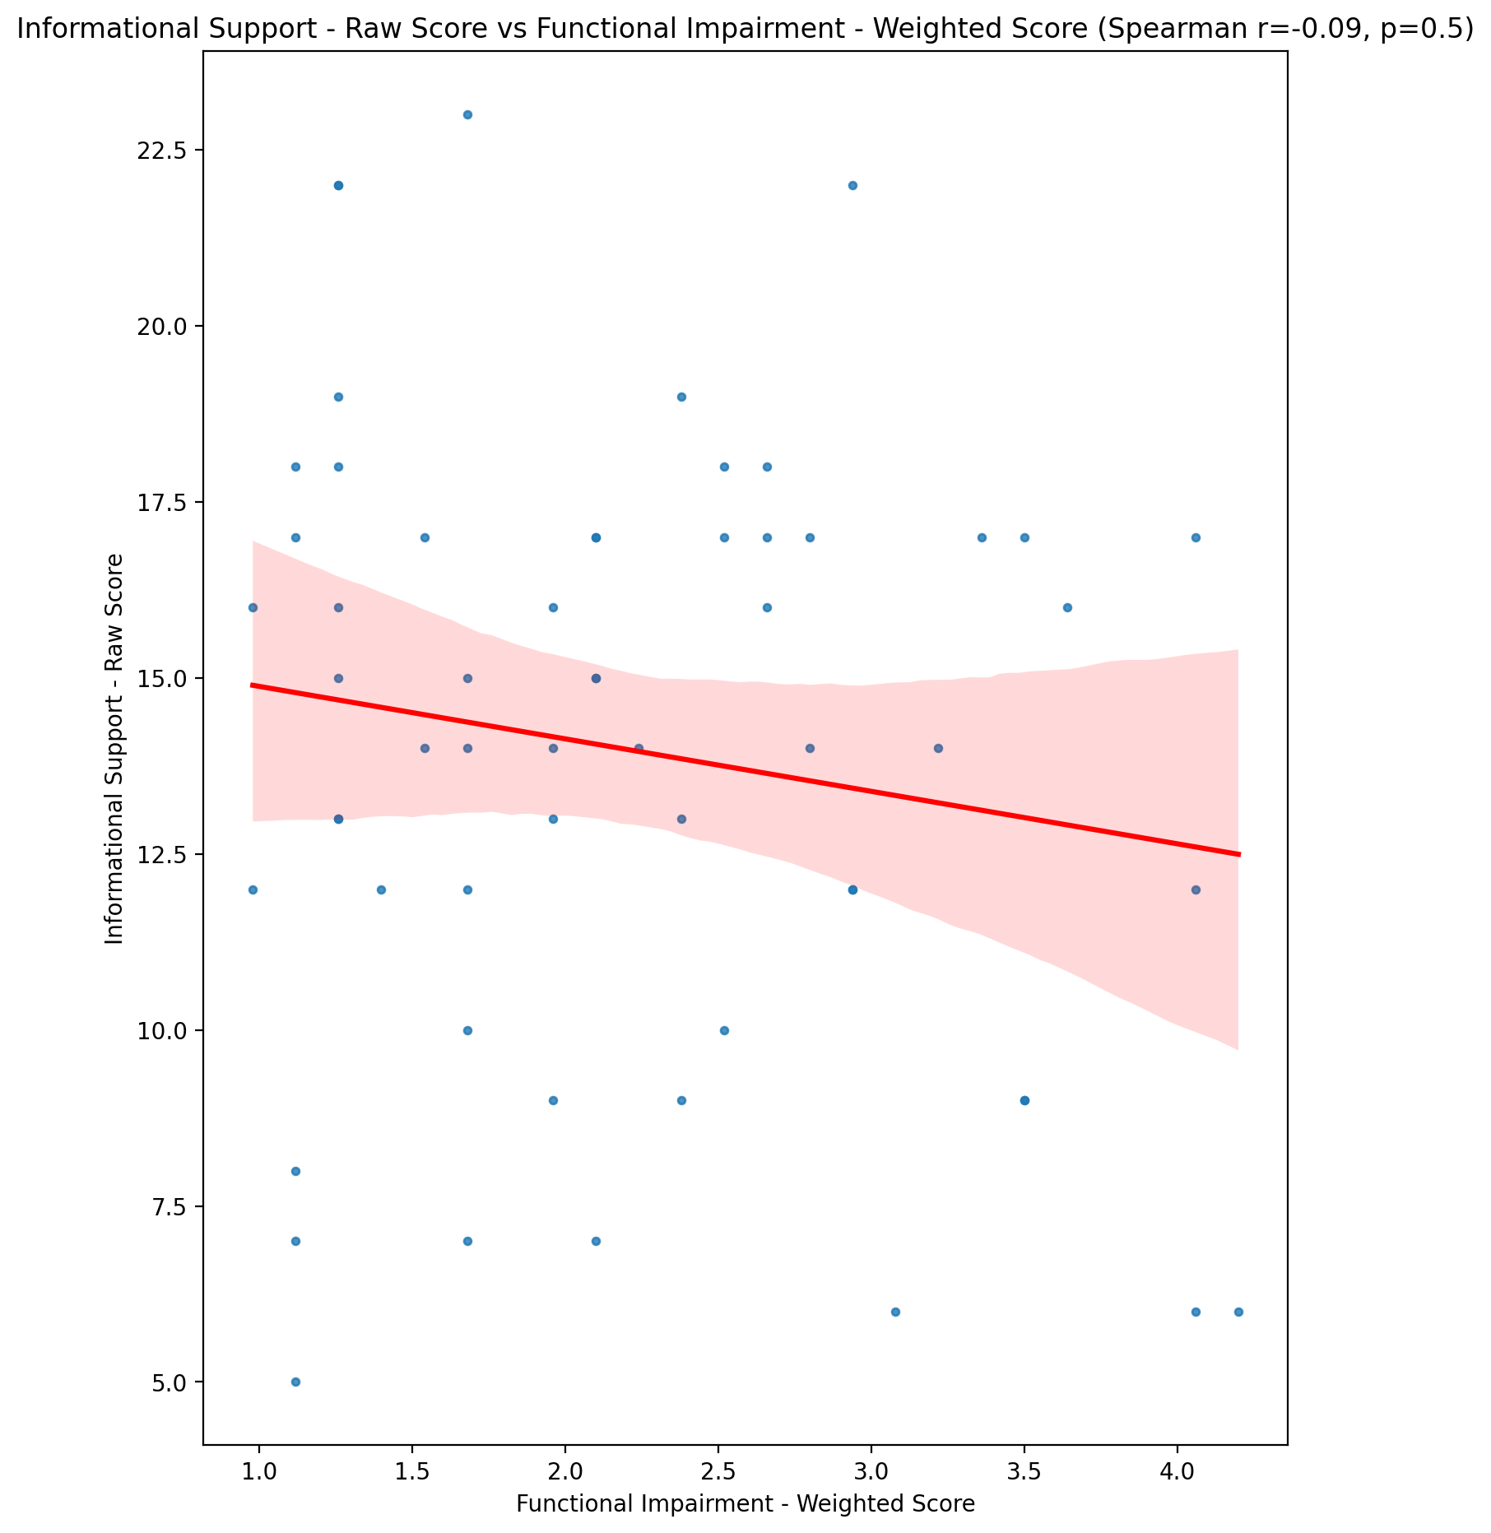

## Instrumental Support - Raw Score vs Functional Impairment - Weighted Score

Test: spearman; statistic: -0.23856891349367754; p-value: 0.06881274695718086;

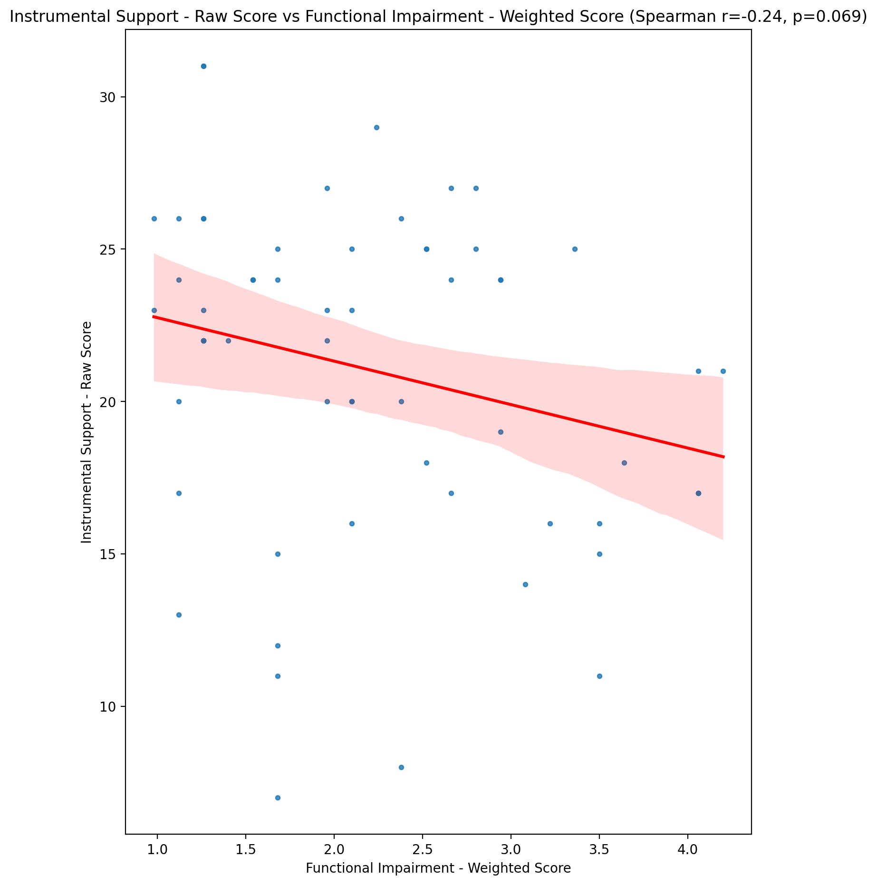

## Emotional Support - T Score vs Functional Impairment - Weighted Score

Test: spearman; statistic: -0.1439303814592648; p-value: 0.27678476025743276;

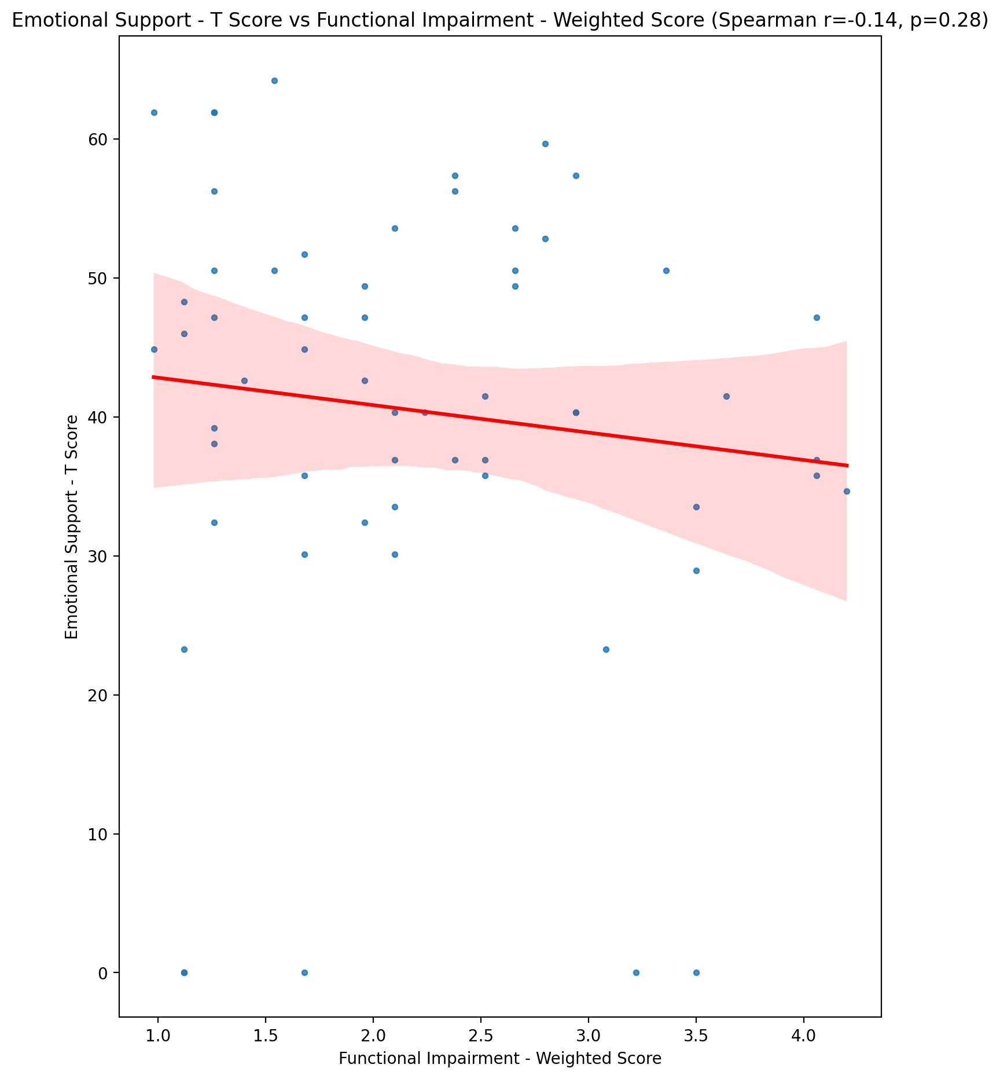

## Informational Support - T Score vs Functional Impairment - Weighted Score

Test: spearman; statistic: -0.08063810583716123; p-value: 0.5437643501058921;

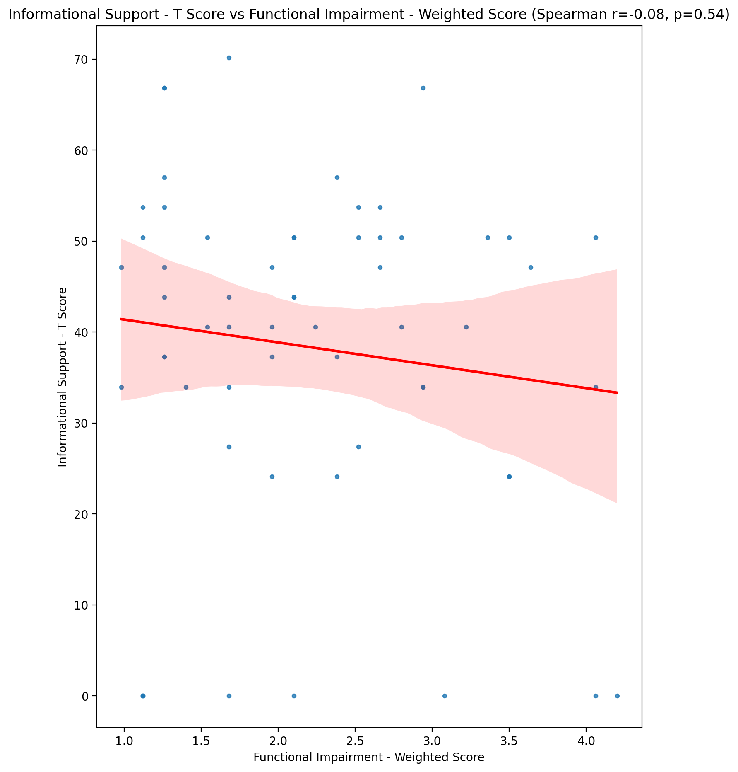

## Instrumental Support - T Score vs Functional Impairment - Weighted Score

Test: spearman; statistic: -0.2349836949981757; p-value: 0.07321272042178936;

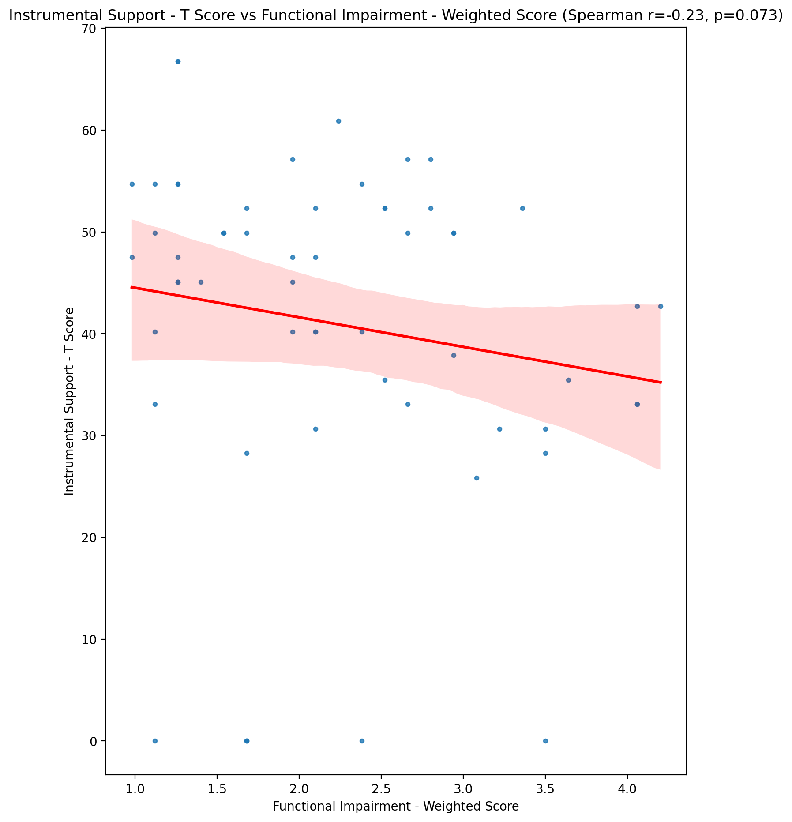

## Perceived Social Support Total T Score vs Functional Impairment - Weighted Score

Test: spearman; statistic: -0.21075165779926341; p-value: 0.10910453344613959;

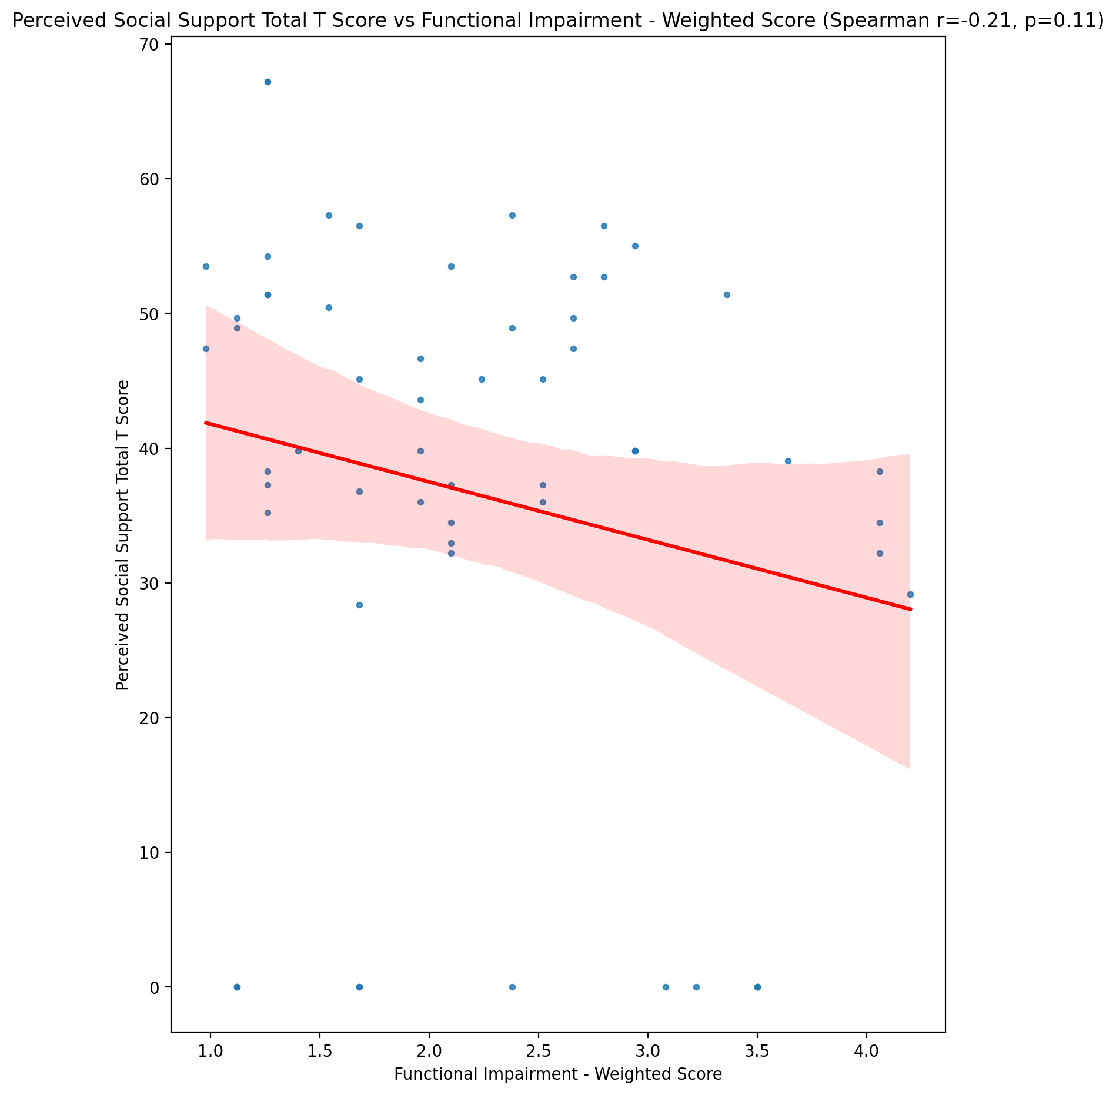

## Emotional Support - Rank vs Functional Impairment - Weighted Score

Test: None; statistic: None; p-value: None; Test not run: unsupported type combination.



## Informational Support - Rank vs Functional Impairment - Weighted Score

Test: None; statistic: None; p-value: None; Test not run: unsupported type combination.



## Instrumental Support - Rank vs Functional Impairment - Weighted Score

Test: None; statistic: None; p-value: None; Test not run: unsupported type combination.



## Perceived Social Support TOTAL - Rank vs Functional Impairment - Weighted Score

Test: None; statistic: None; p-value: None; Test not run: unsupported type combination.



## Power Self Concept - Real Self Concept Score vs Functional Impairment - Weighted Score

Test: spearman; statistic: -0.23192783664635316; p-value: 0.07713734596921973;

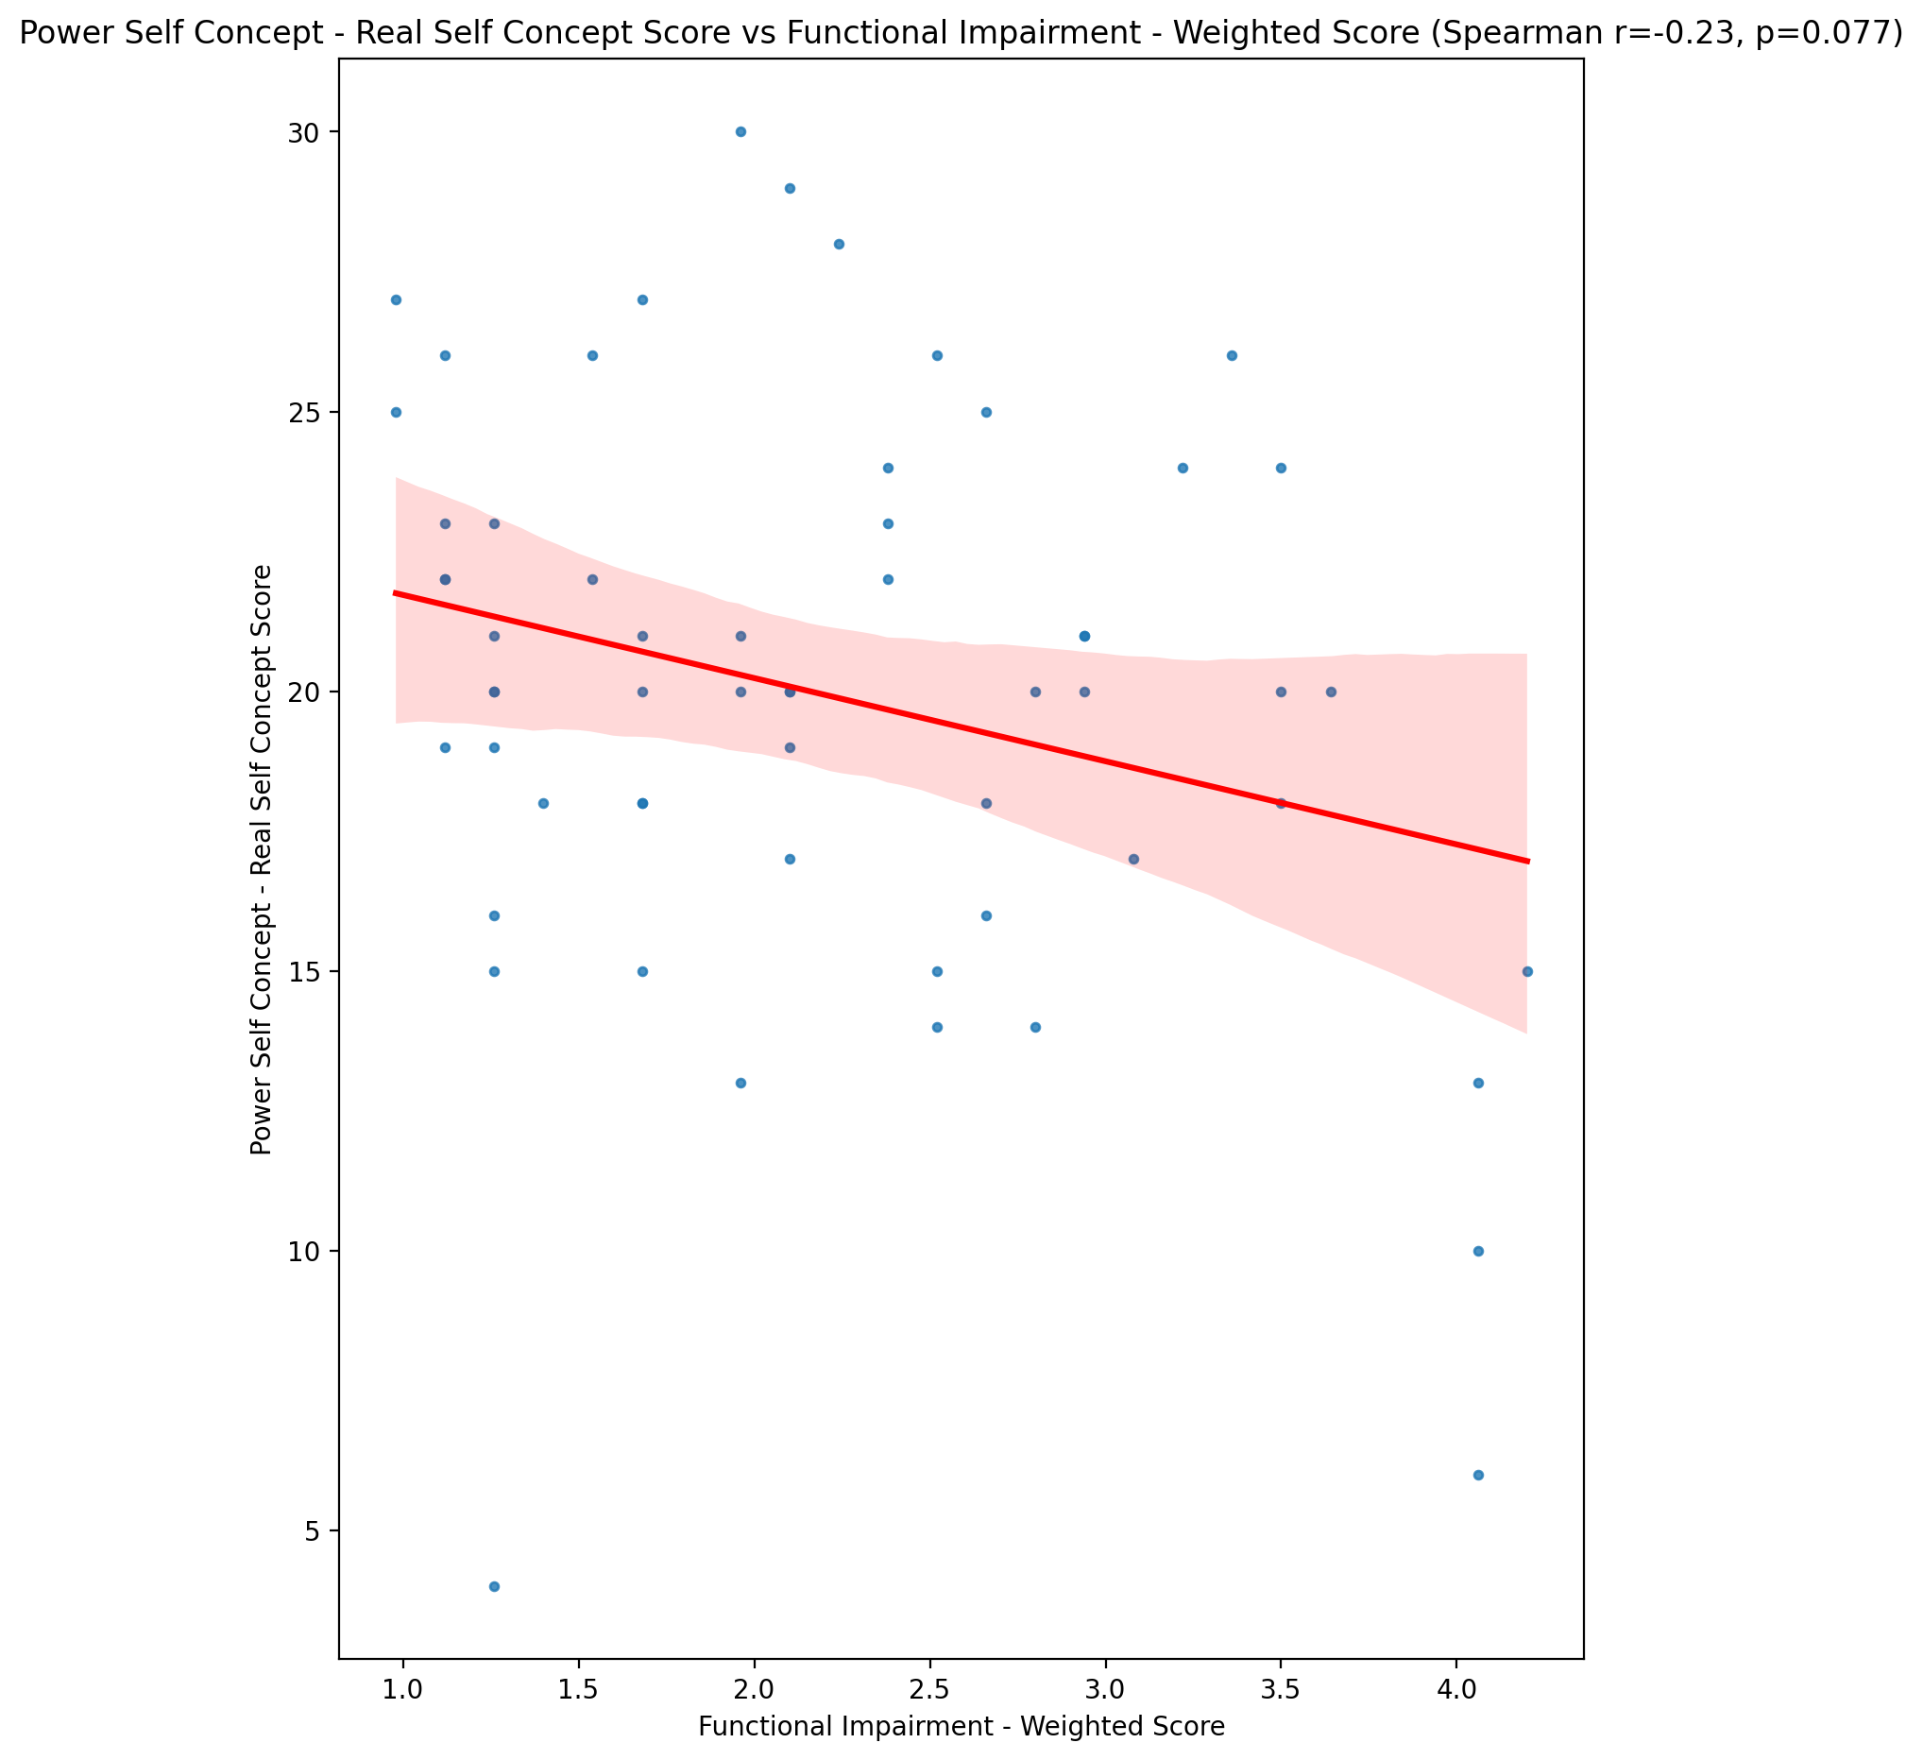

## Power Self Concept - Ideal Self Concept score vs Functional Impairment - Weighted Score

Test: spearman; statistic: -0.2541334380987325; p-value: 0.05210221845715695;

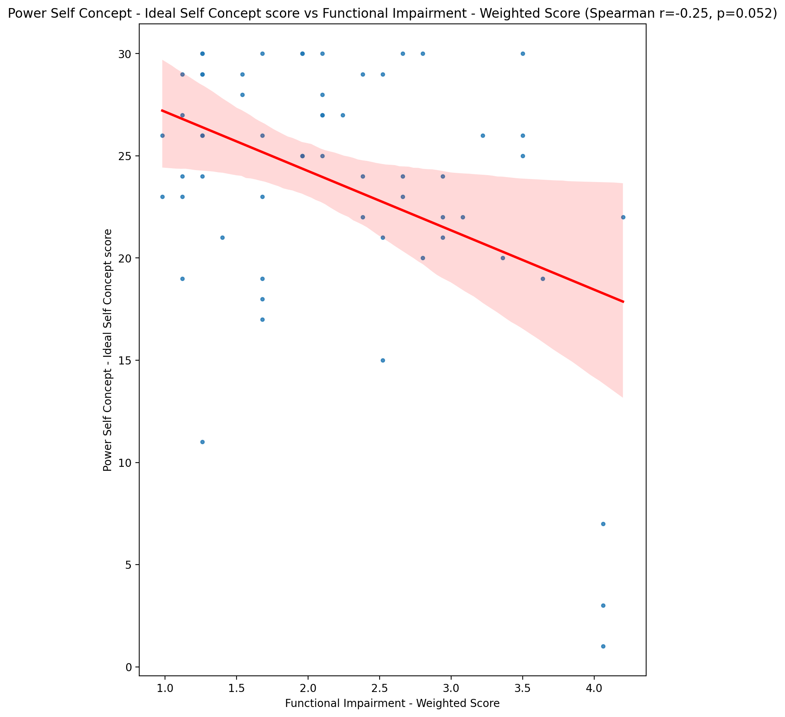

## Power Self Concept – Social Self Concept Score vs Functional Impairment - Weighted Score

Test: spearman; statistic: -0.040850205206124174; p-value: 0.7586979661756884;

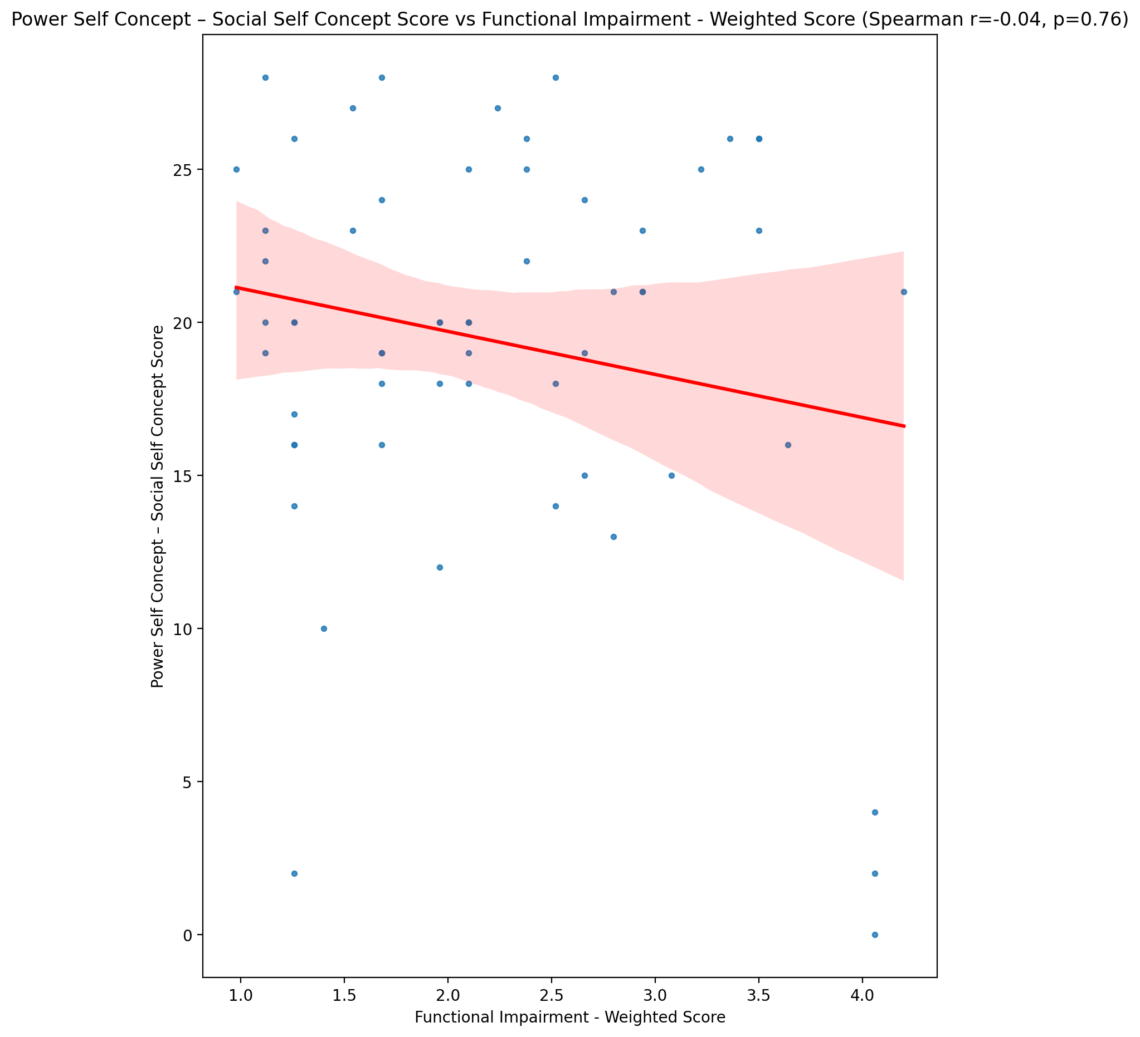

## Social Self Concept - Real Self Concept Score vs Functional Impairment - Weighted Score

Test: spearman; statistic: -0.44356562526323956; p-value: 0.0004337108306095348;

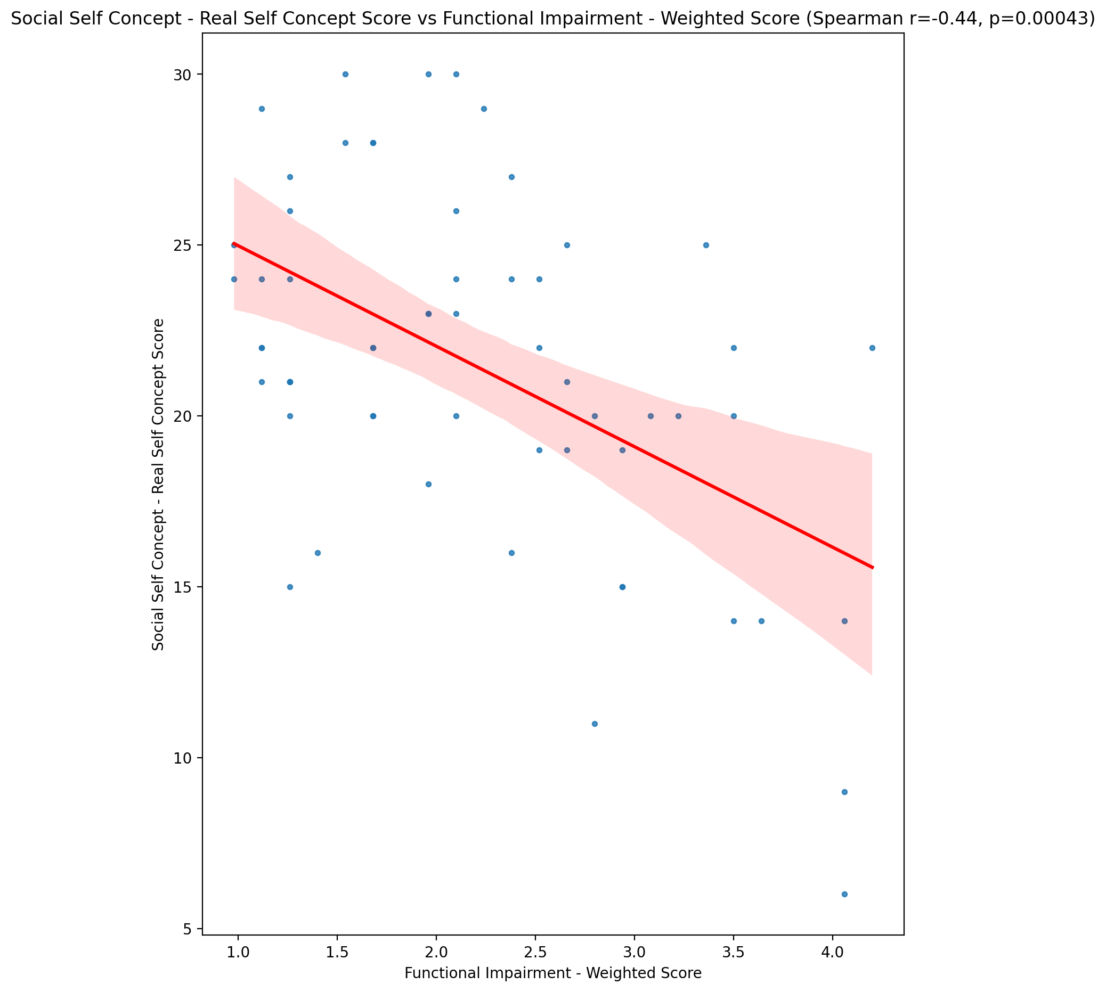

## Social Self Concept – Social Self Concept Score vs Functional Impairment - Weighted Score

Test: spearman; statistic: -0.22278256279794062; p-value: 0.08988600337917232;

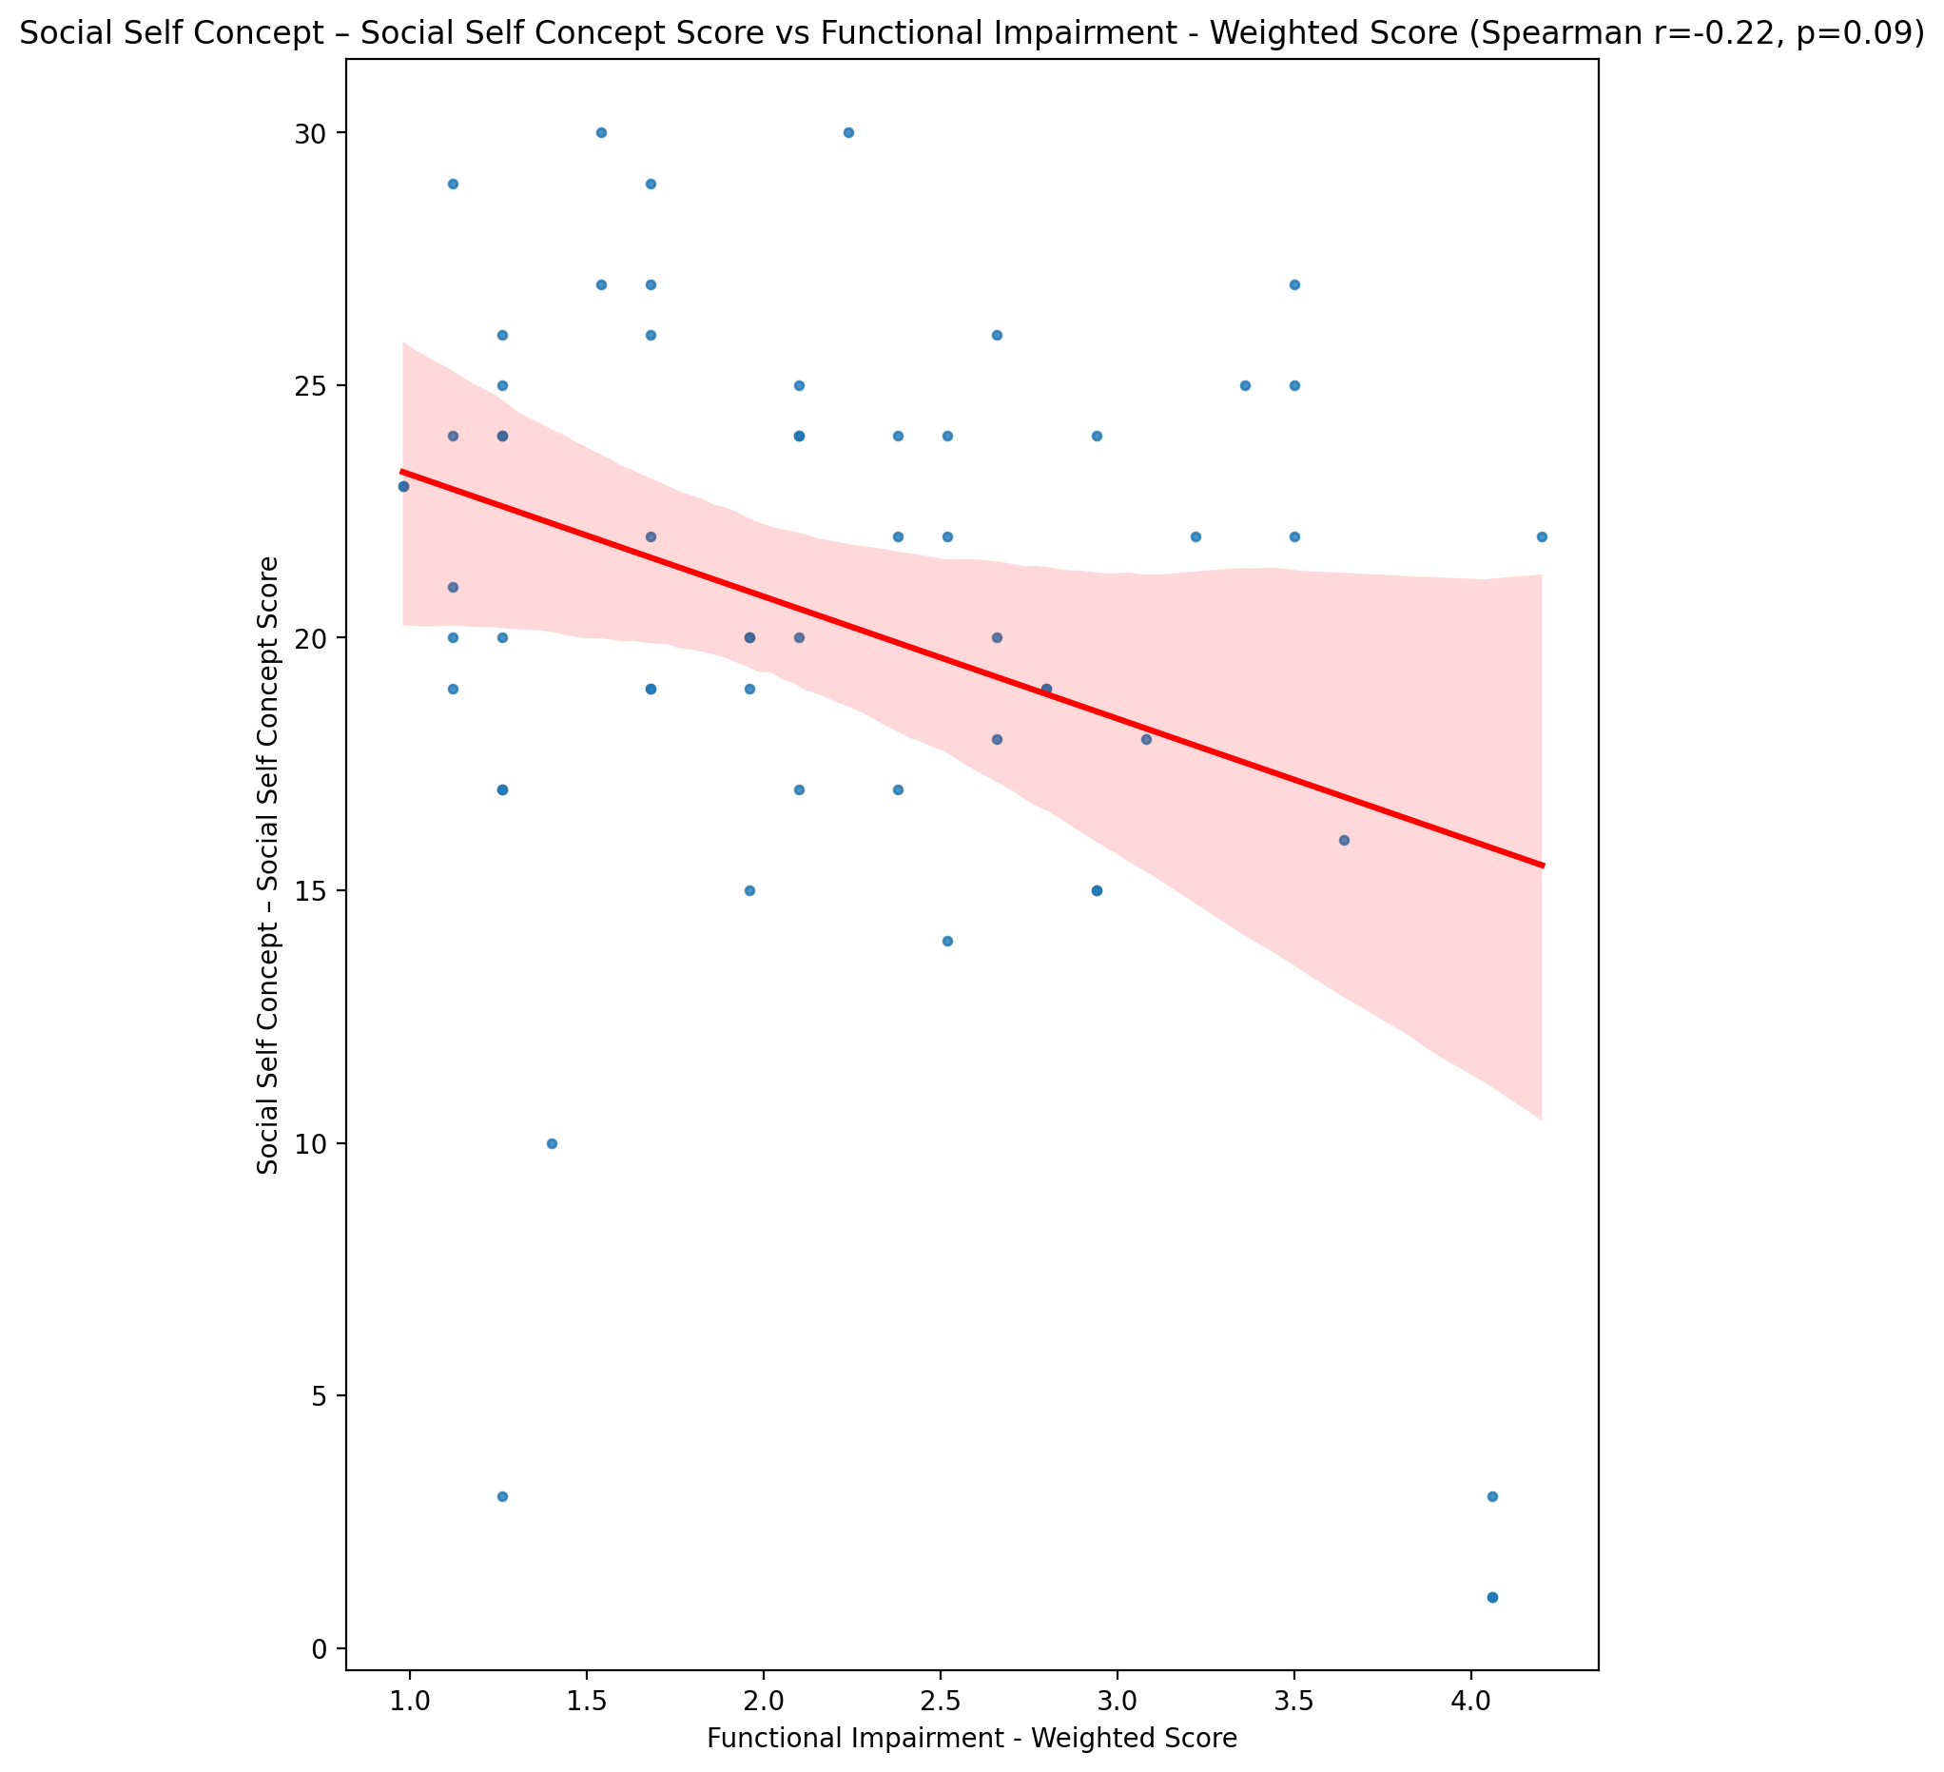

## Ability Self Concept - Real Self Concept Score vs Functional Impairment - Weighted Score

Test: spearman; statistic: -0.3233704614050961; p-value: 0.012481544521155706;

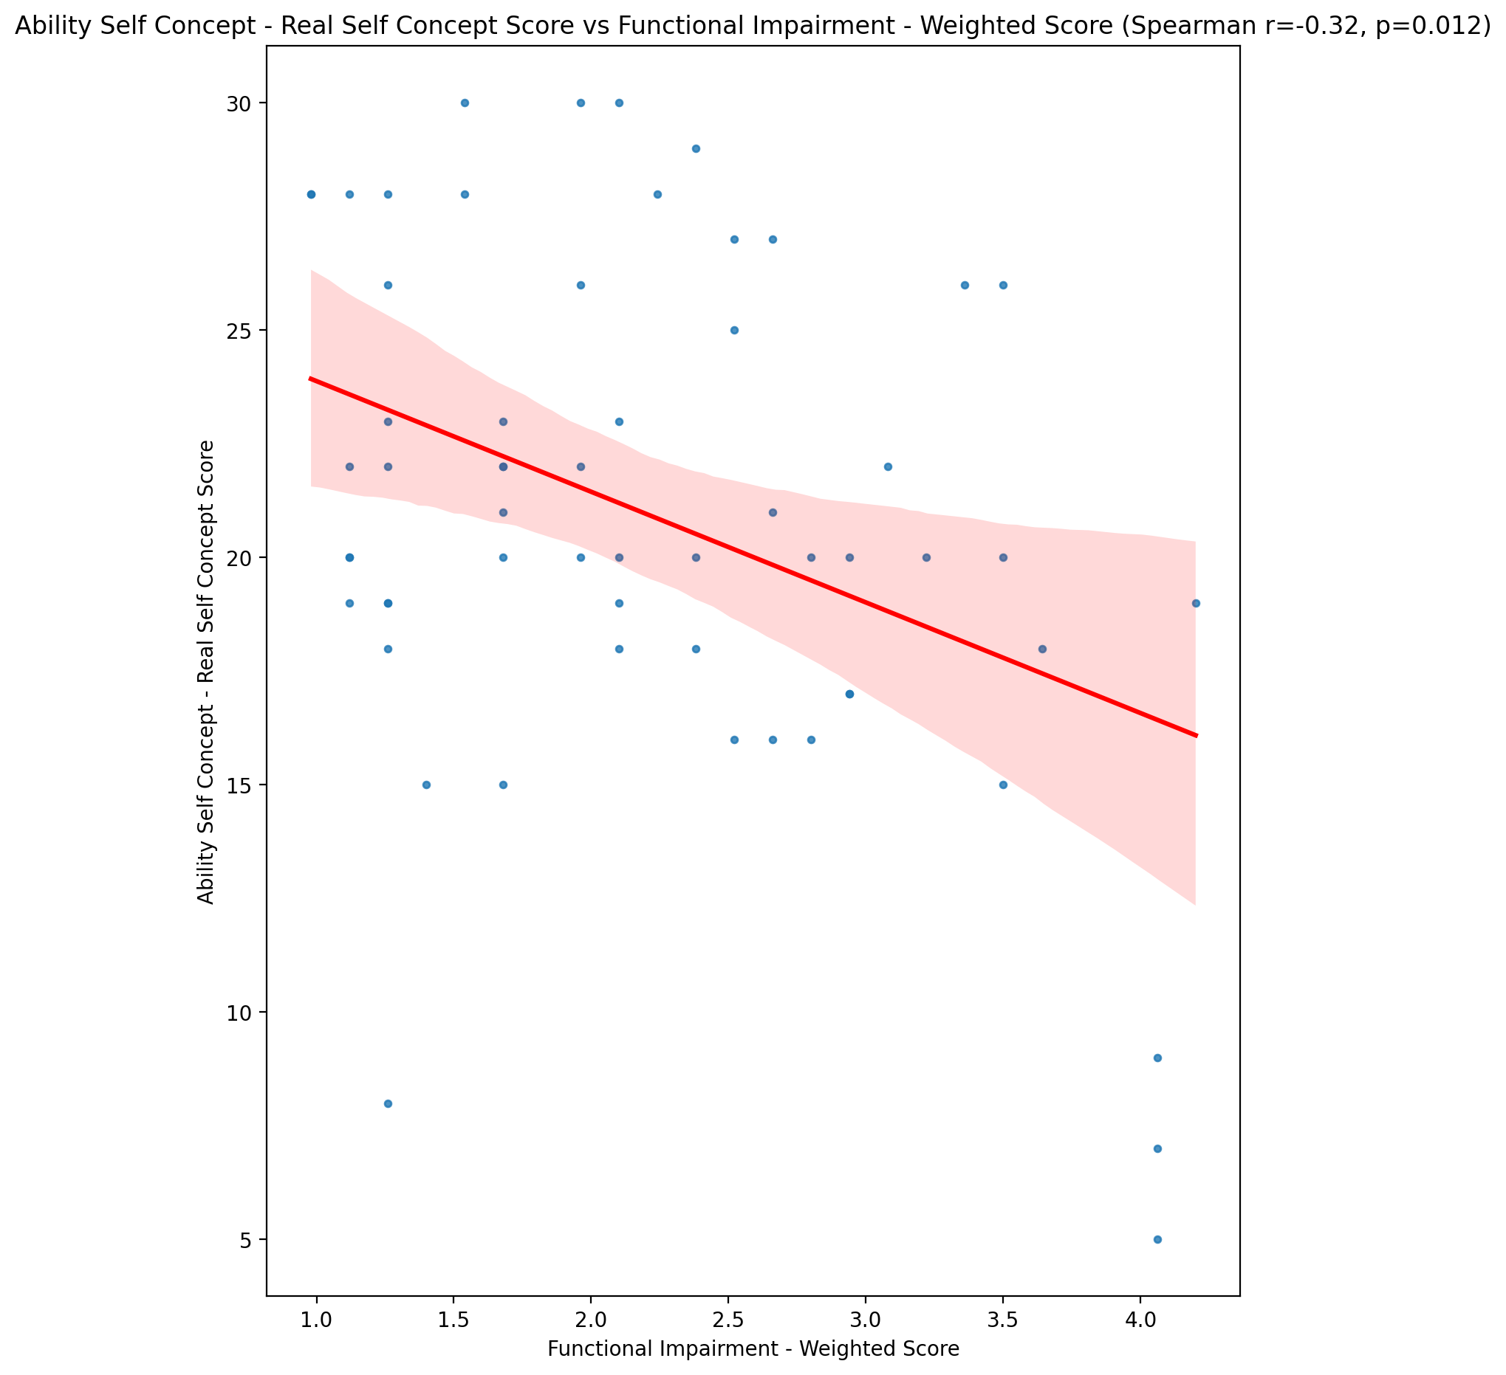

## Ability Self Concept - Ideal Self Concept Score vs Functional Impairment - Weighted Score

Test: spearman; statistic: -0.24846668019135382; p-value: 0.057755491404030364;

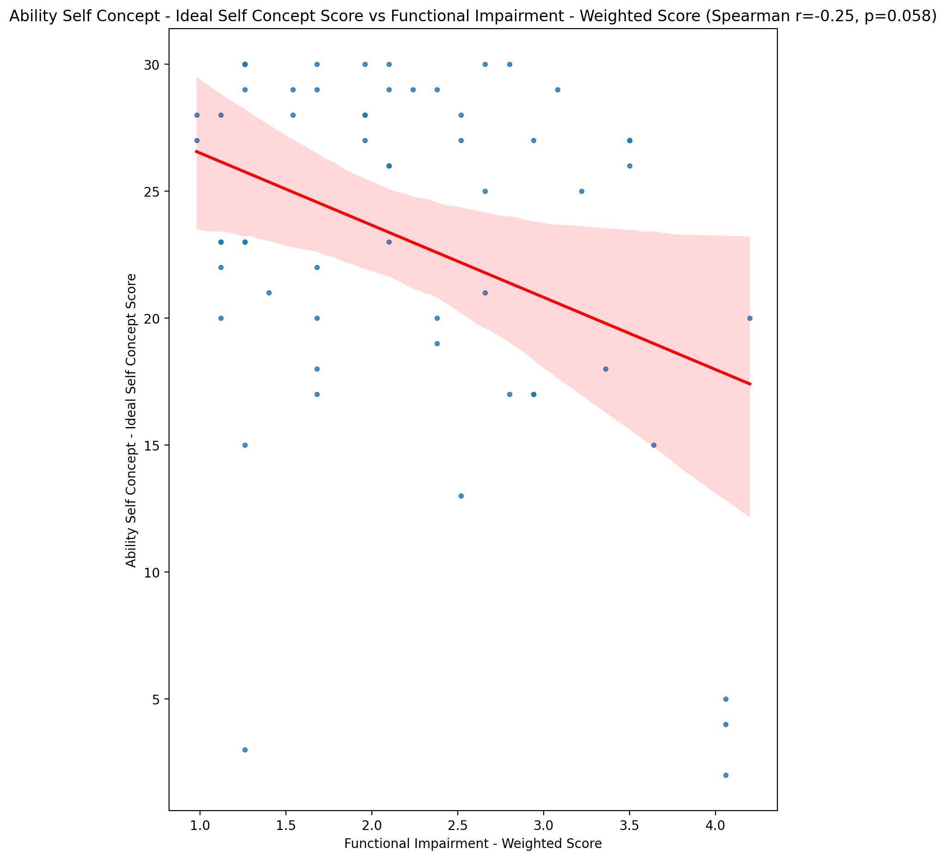

## Ability Self Concept – Social Self Concept Score vs Functional Impairment - Weighted Score

Test: spearman; statistic: -0.09666036631810289; p-value: 0.4664394515230531;

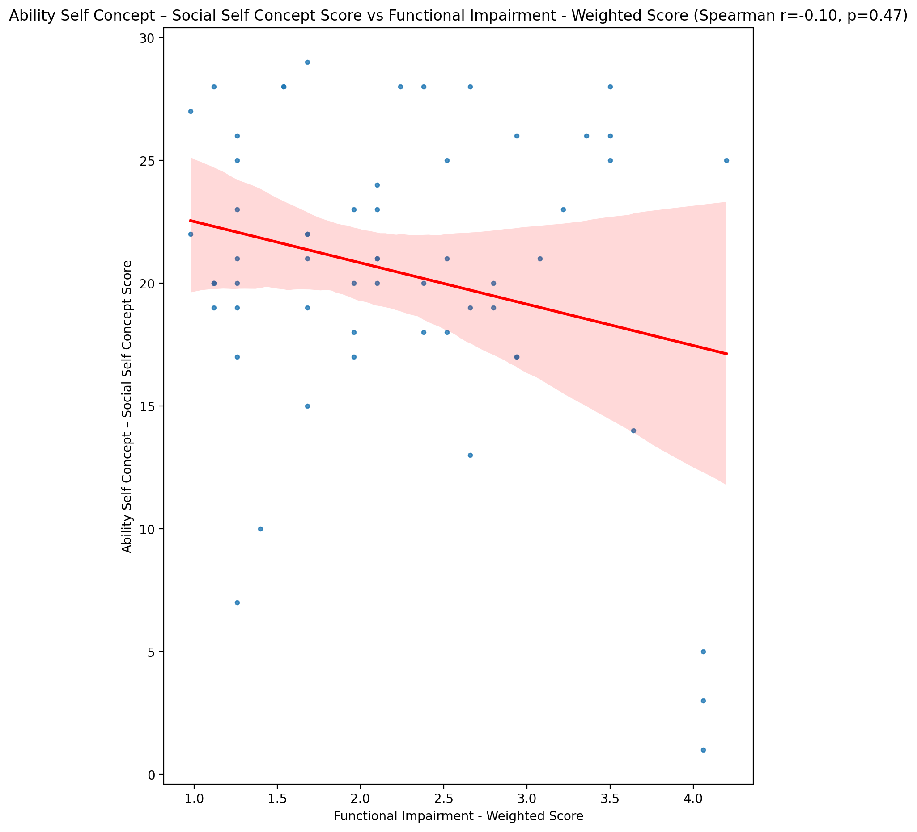

## Physical Self Concept - Real Self Concept Score vs Functional Impairment - Weighted Score

Test: spearman; statistic: -0.3739094289610874; p-value: 0.003531659882963538;

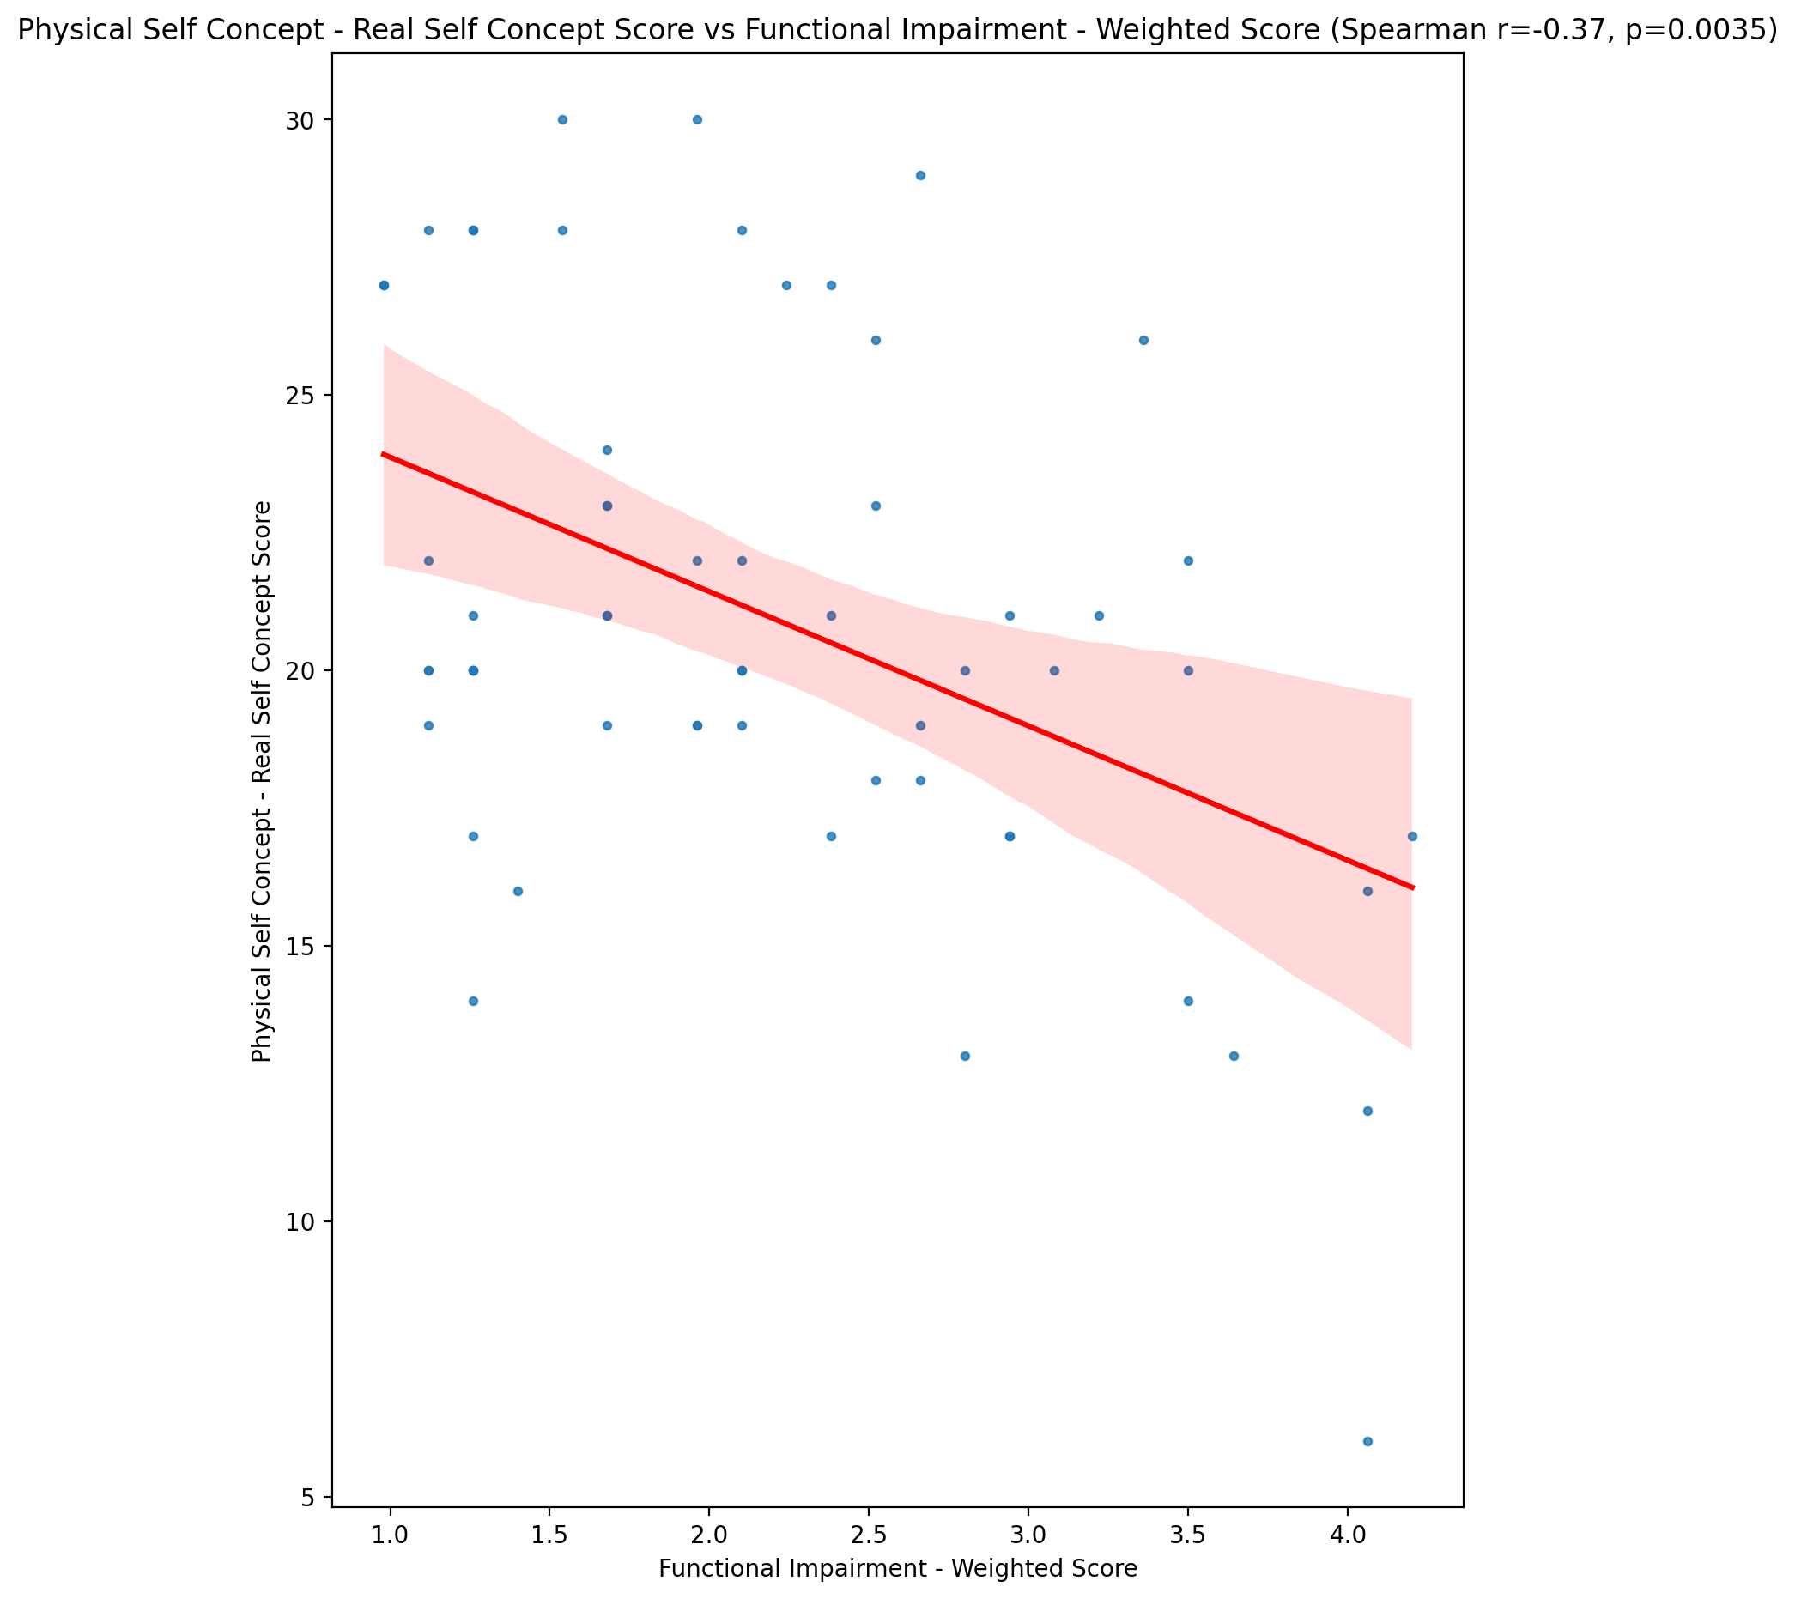

## Physical Self Concept – Ideal Self Concept Score vs Functional Impairment - Weighted Score

Test: spearman; statistic: -0.2048156194706195; p-value: 0.11968309430331575;

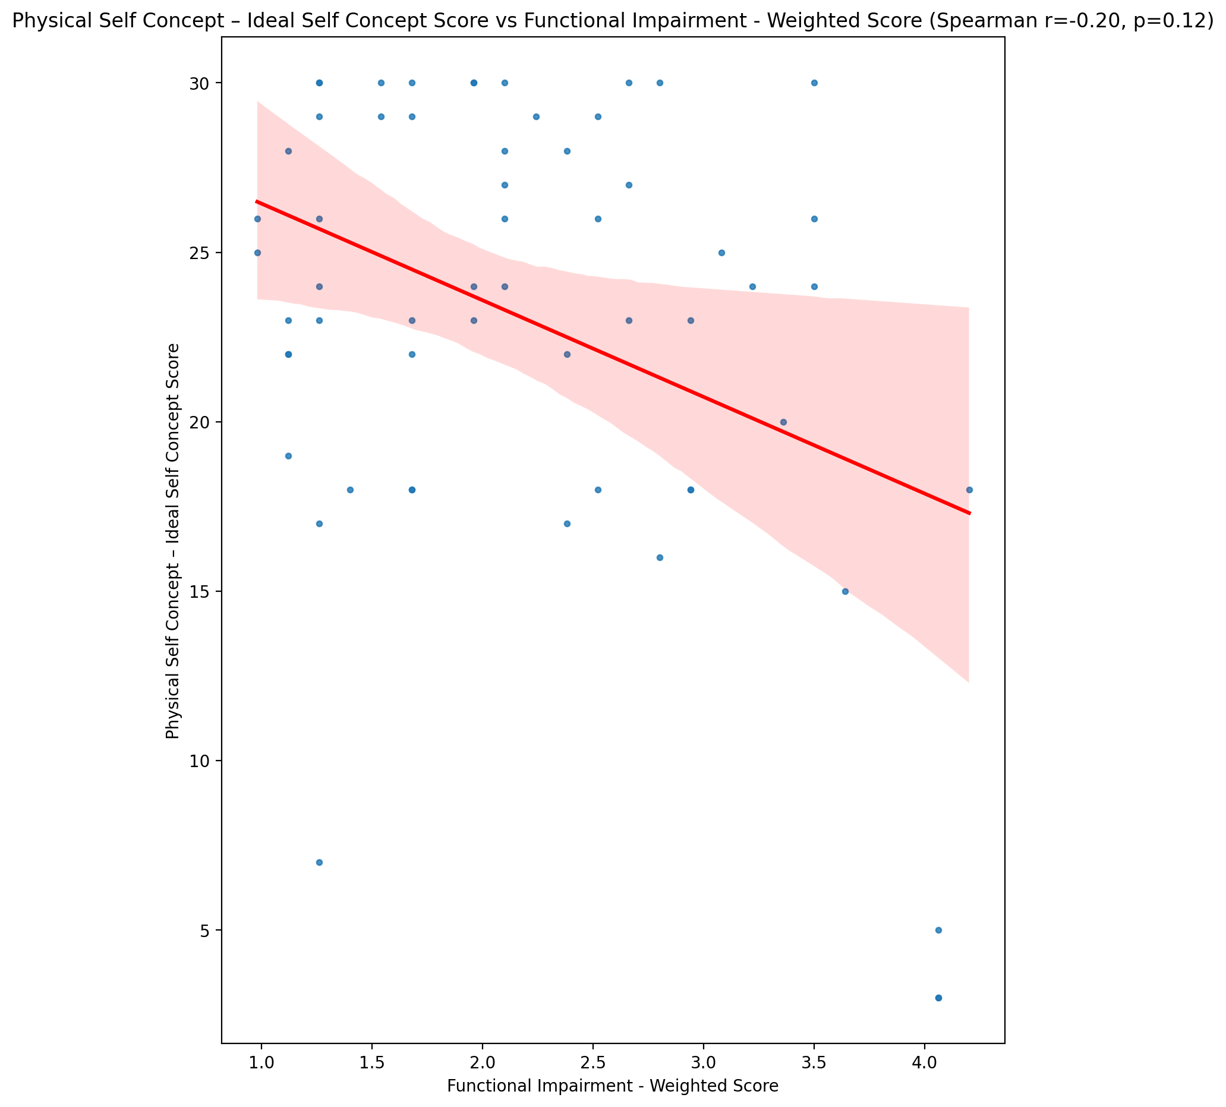

## Physical Self Concept – Social Self Concept Score vs Functional Impairment - Weighted Score

Test: spearman; statistic: -0.09305792728858102; p-value: 0.4832898106008411;

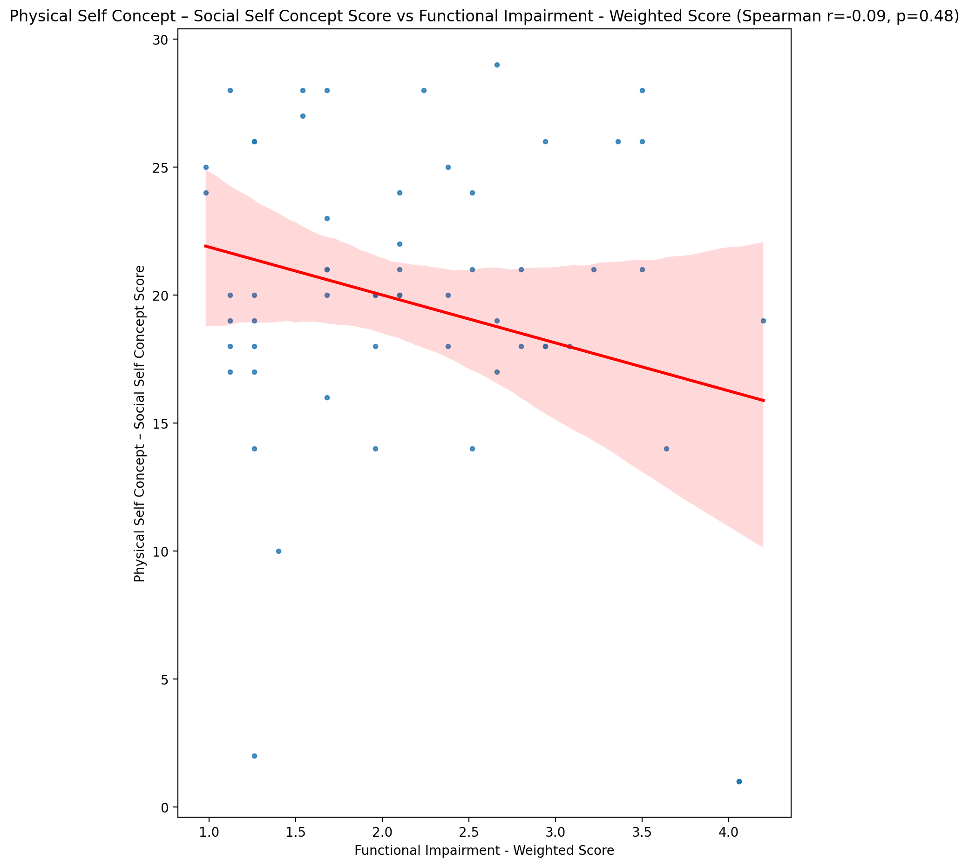

## Psychological Self Concept - Real Self Concept Score vs Functional Impairment - Weighted Score

Test: spearman; statistic: -0.42441005570132534; p-value: 0.0008078556730025397;

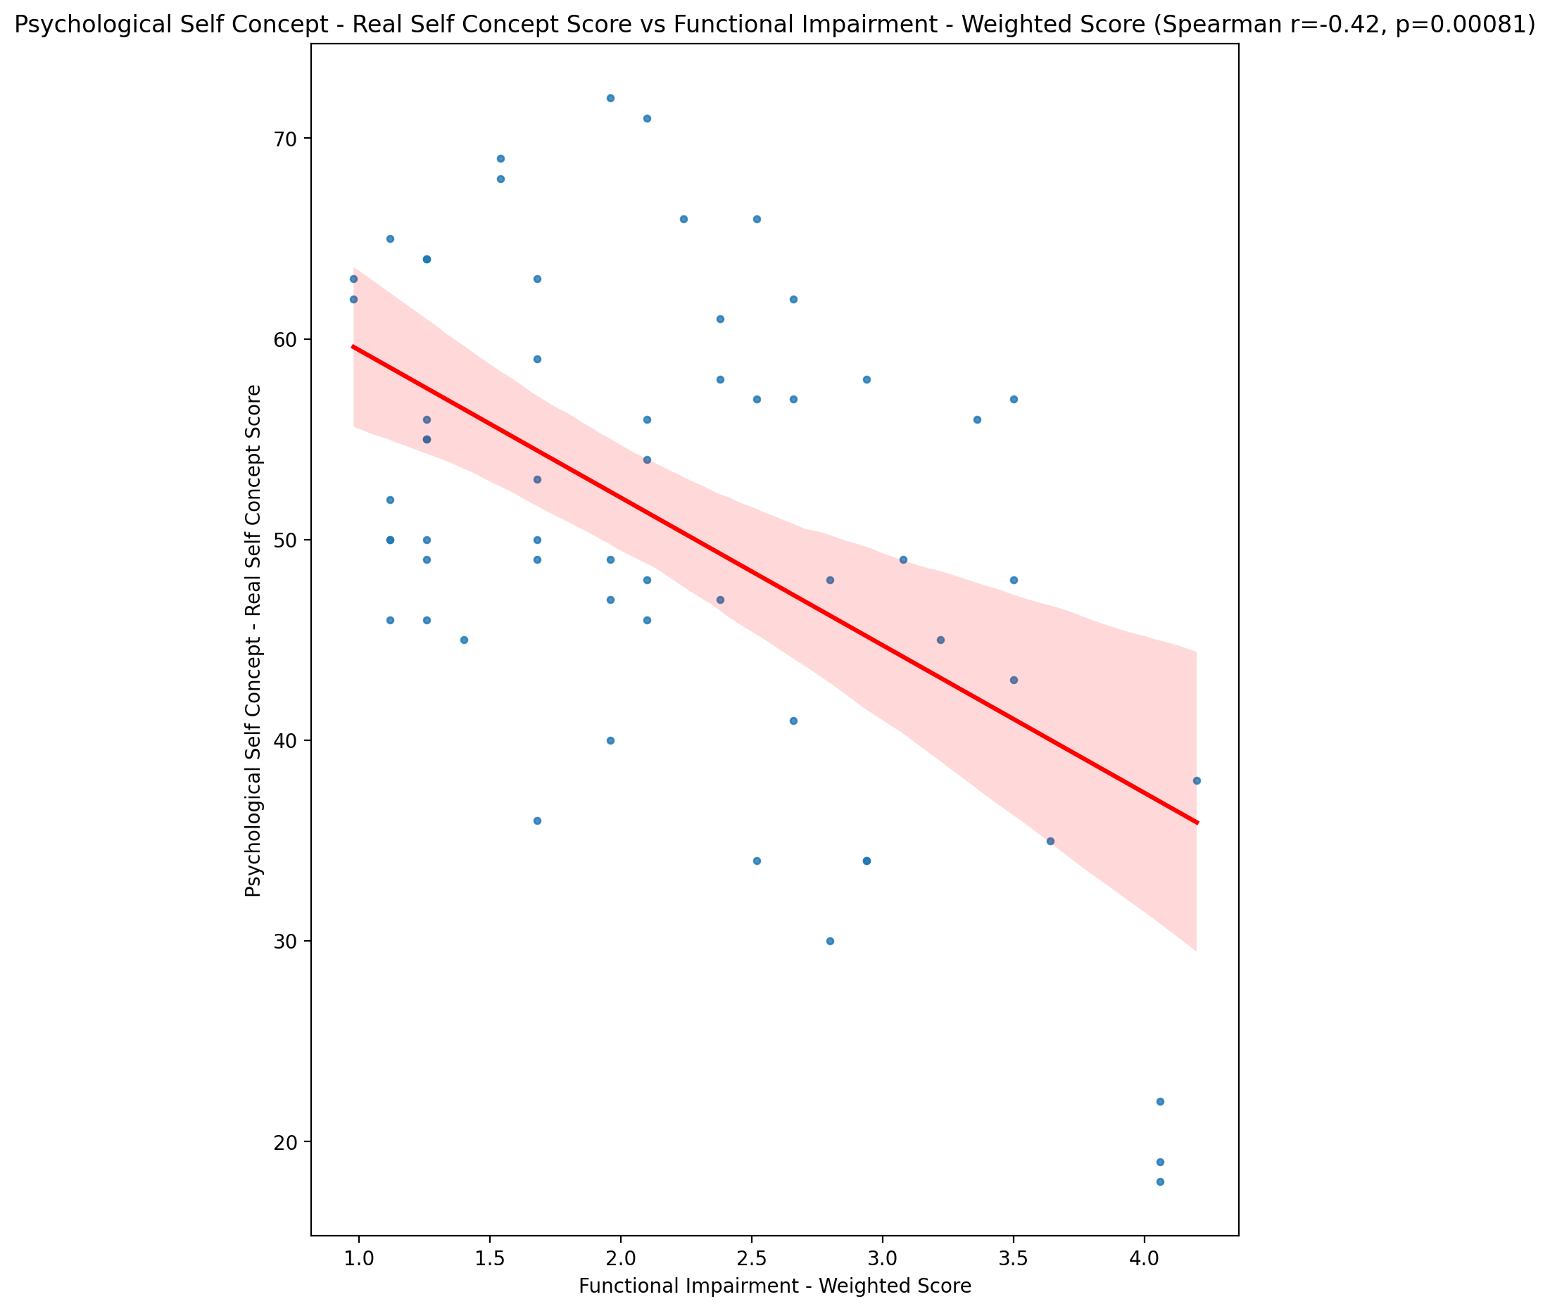

## Psychological Self Concept – Ideal Self Concept Score vs Functional Impairment - Weighted Score

Test: spearman; statistic: -0.22583730033397215; p-value: 0.0854560060601485;

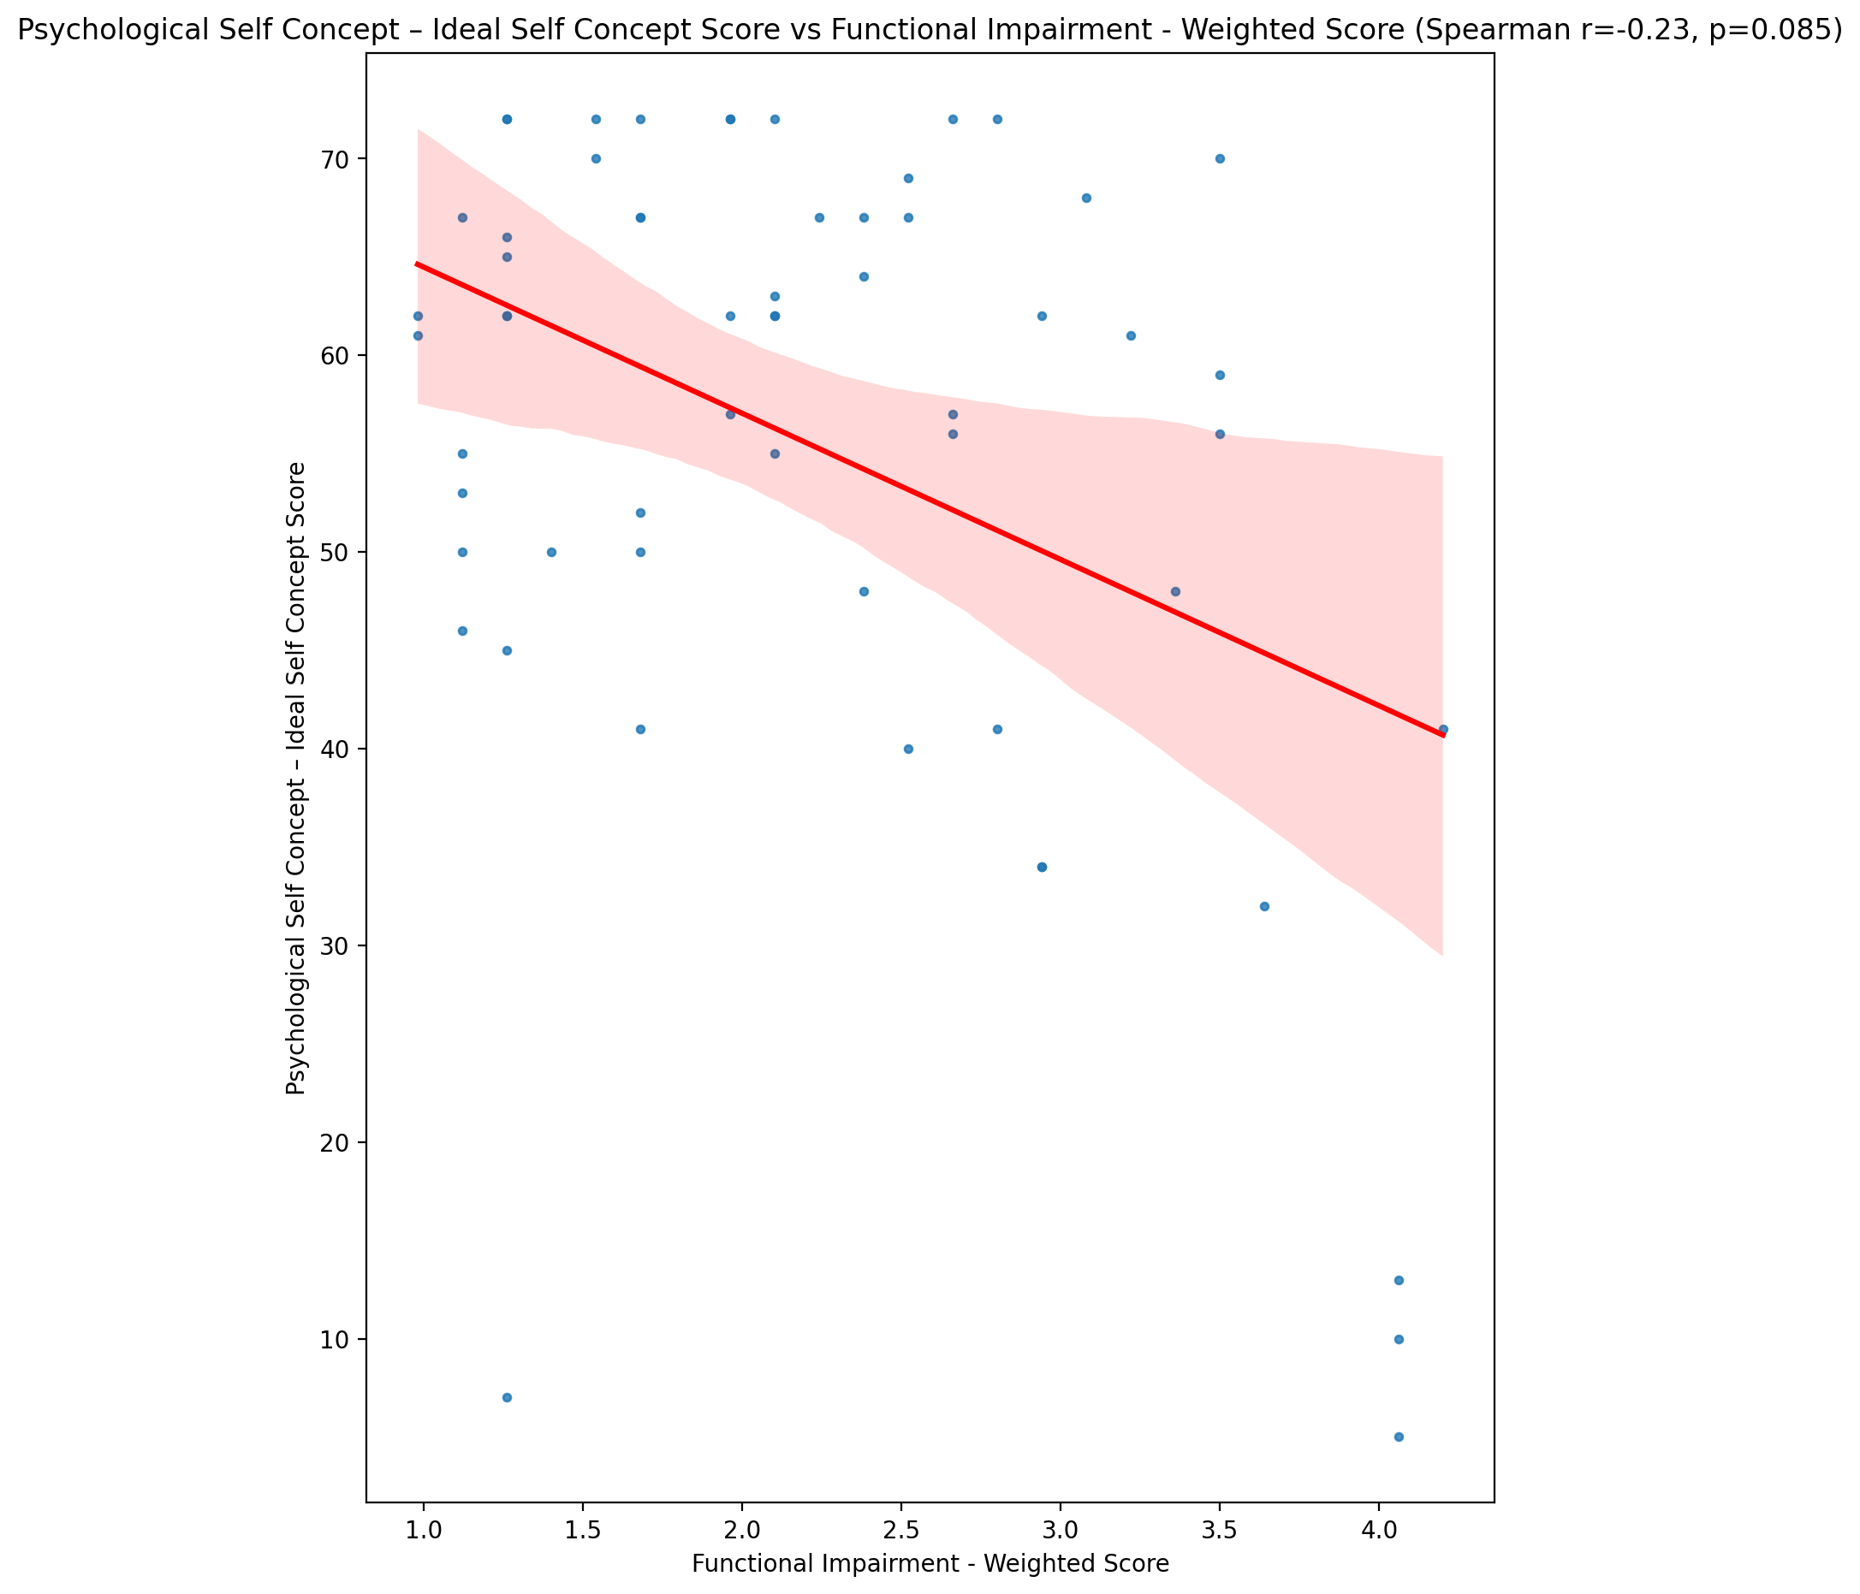

## Psychological Self Concept – Social Self Concept Score vs Functional Impairment - Weighted Score

Test: spearman; statistic: -0.2094718460333205; p-value: 0.11132210406085664;

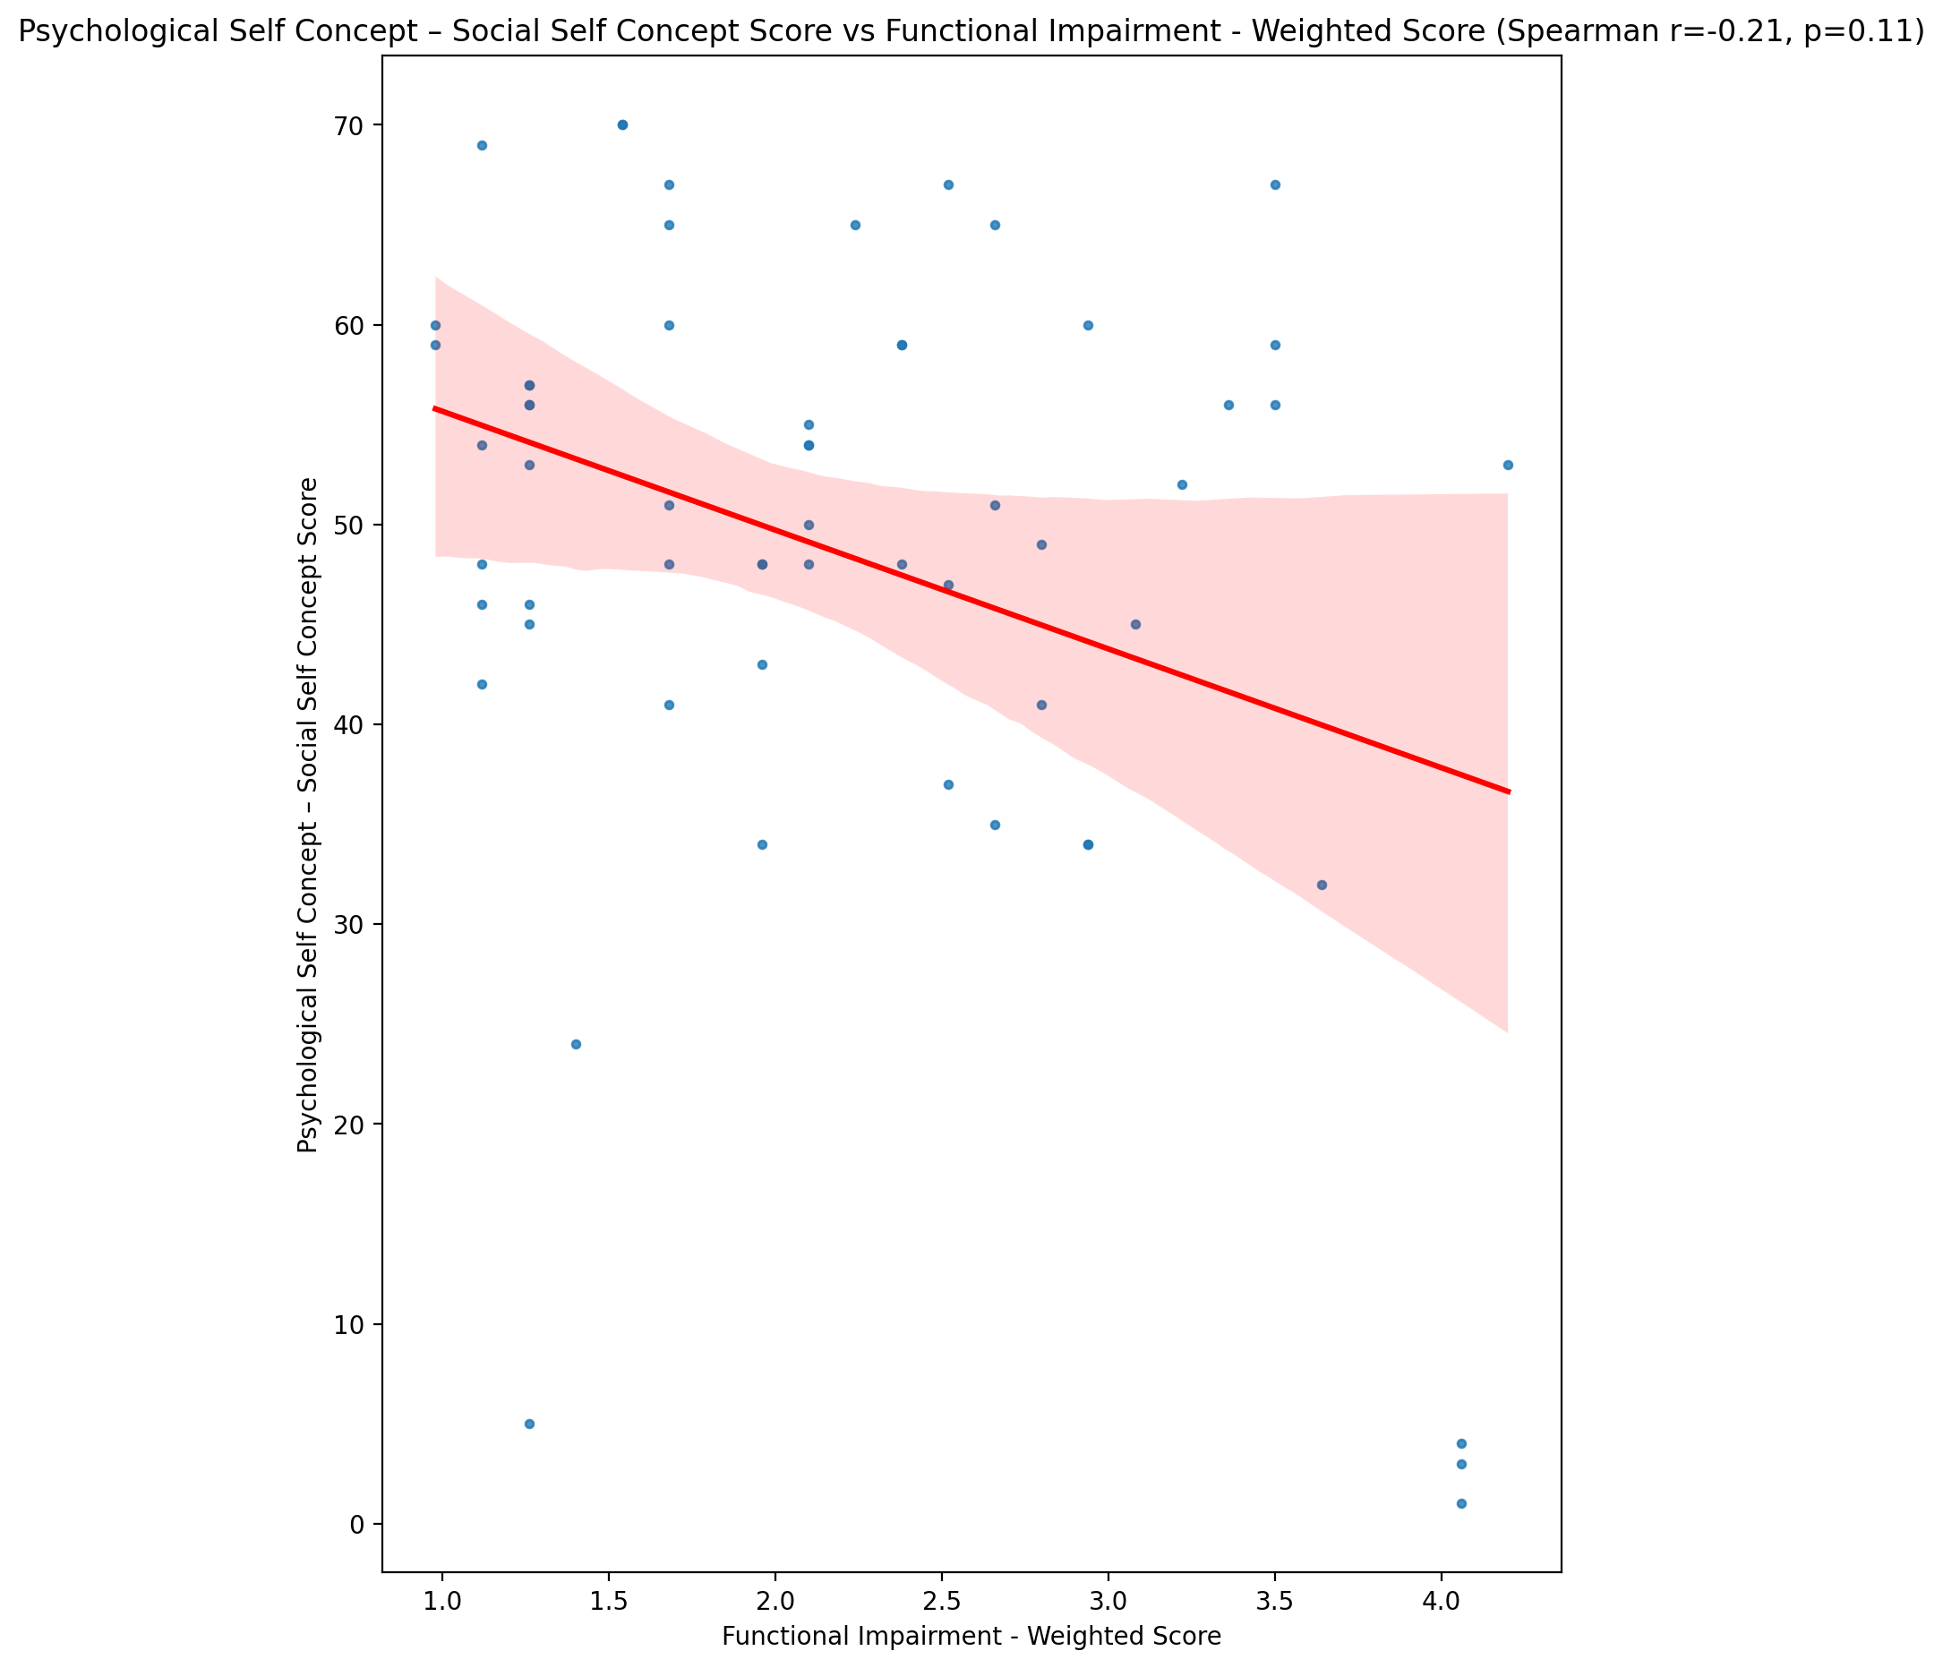

## Real Self Concept Total Score vs Functional Impairment - Weighted Score

Test: spearman; statistic: -0.3971597285314755; p-value: 0.0018421917845238688;

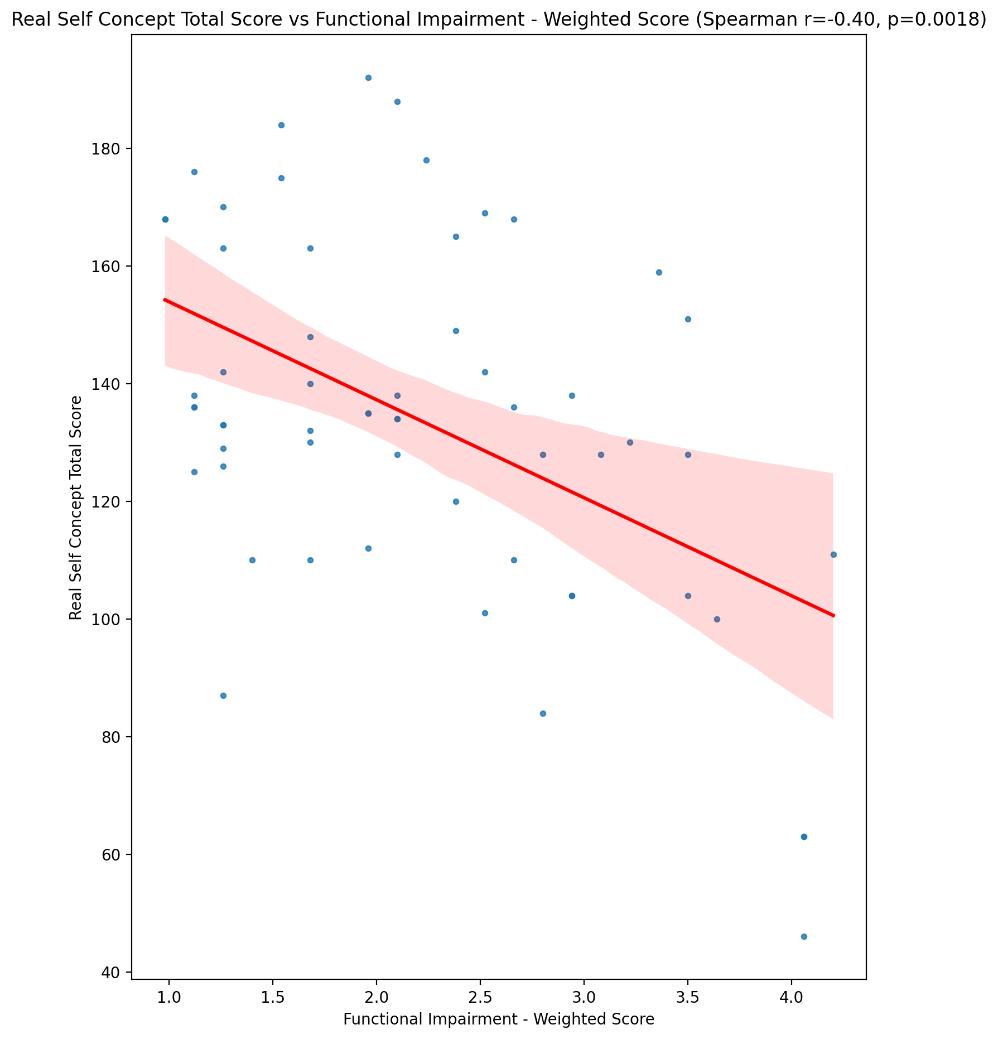

## Ideal Self Concept Total Score vs Functional Impairment - Weighted Score

Test: spearman; statistic: -0.23243821986088684; p-value: 0.07647050035107977;

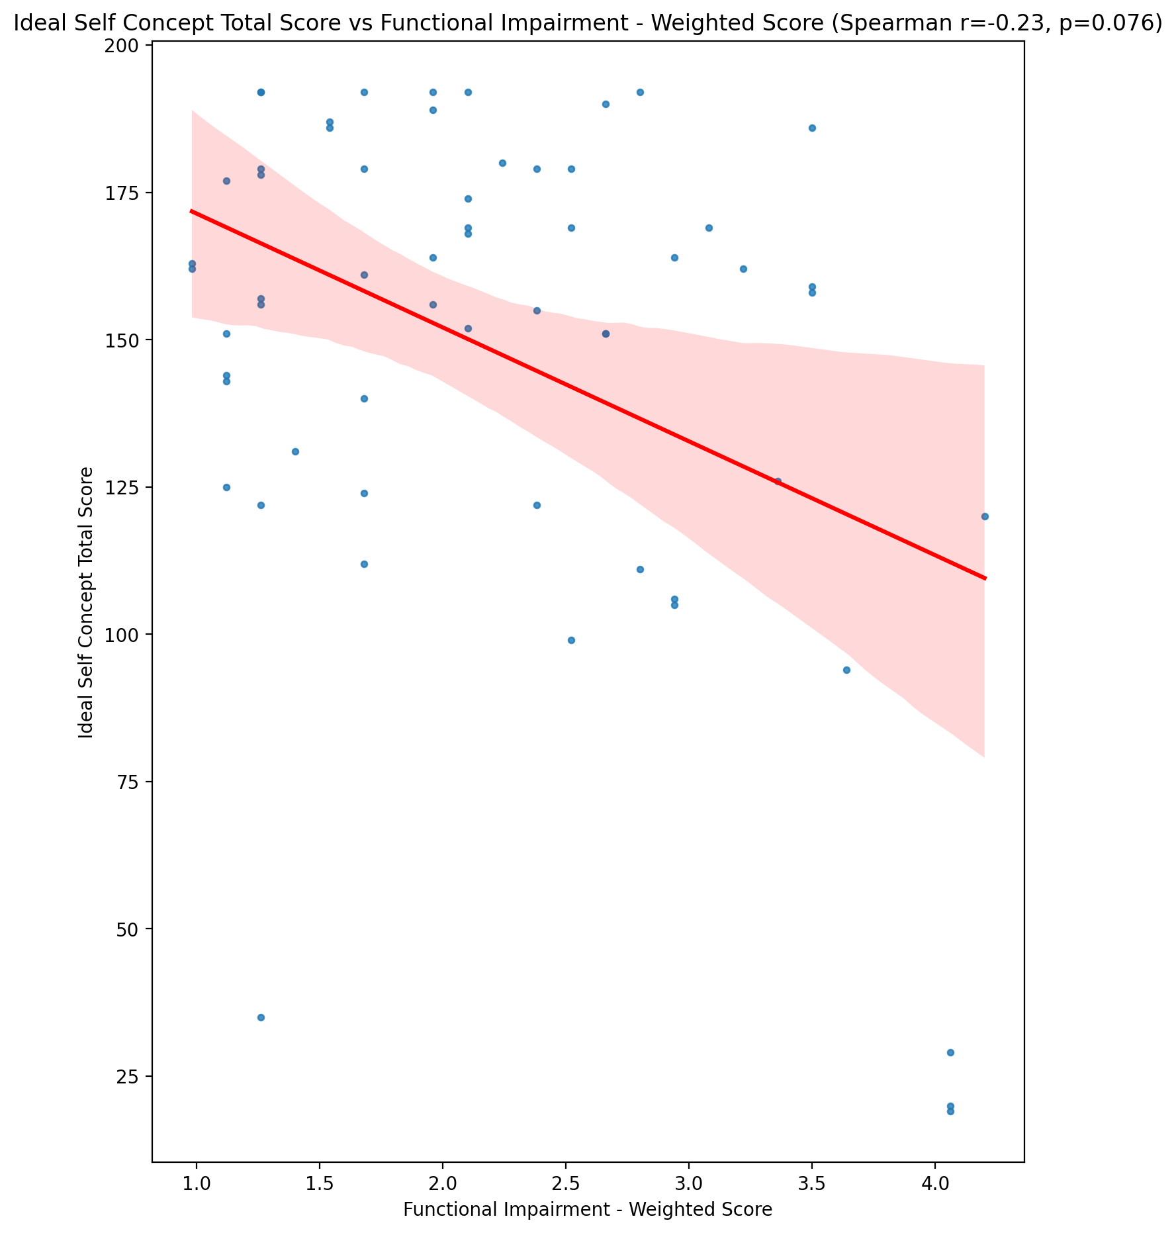

## Social Self Concept Total Score vs Functional Impairment - Weighted Score

Test: spearman; statistic: -0.1576306433300219; p-value: 0.23312428011006378;

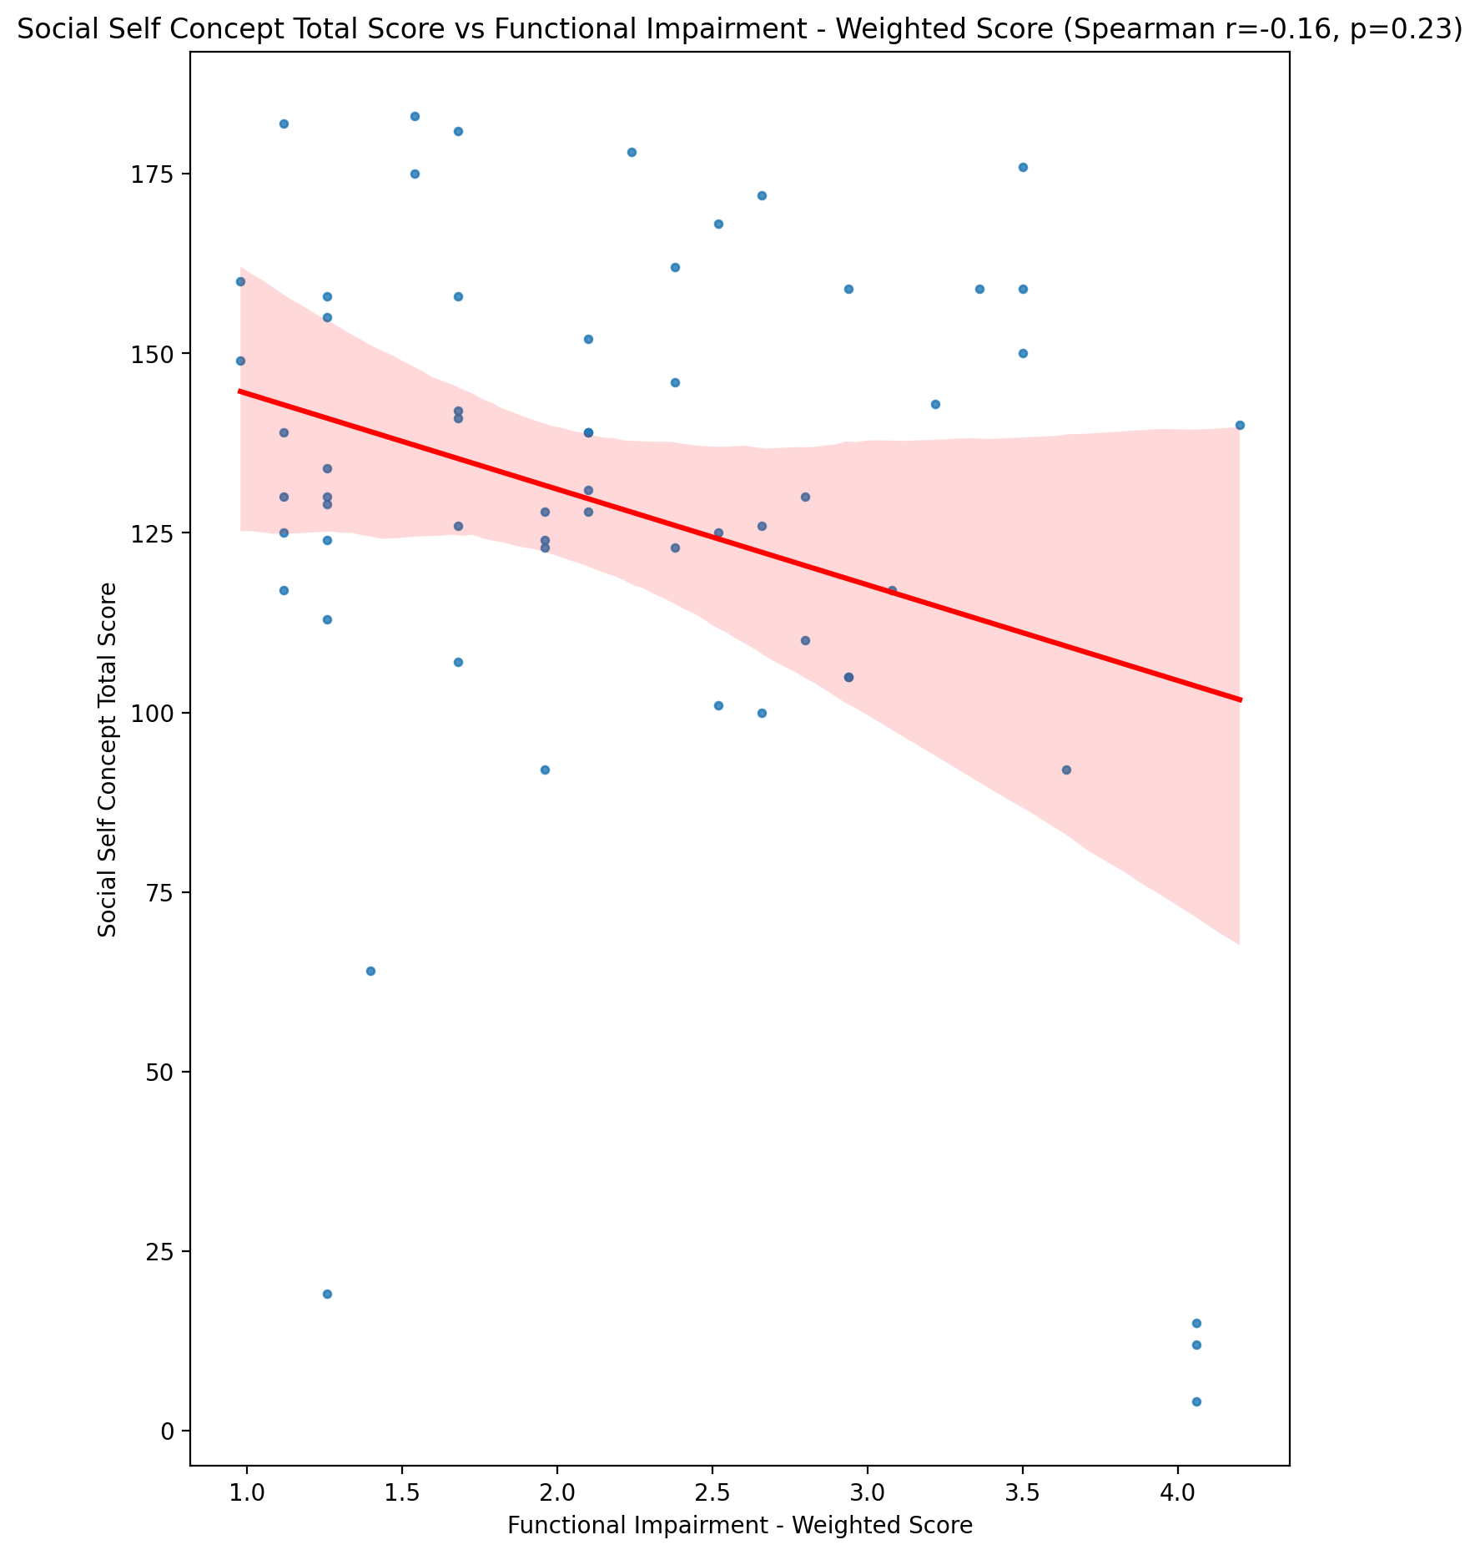

## Ideal Self Concept Total Category vs Functional Impairment - Weighted Score

Test: None; statistic: None; p-value: None; Test not run: unsupported type combination.



## Perceived Social Stress Score vs Functional Impairment - Weighted Score

Test: spearman; statistic: 0.35078312935389877; p-value: 0.006451425466625407;

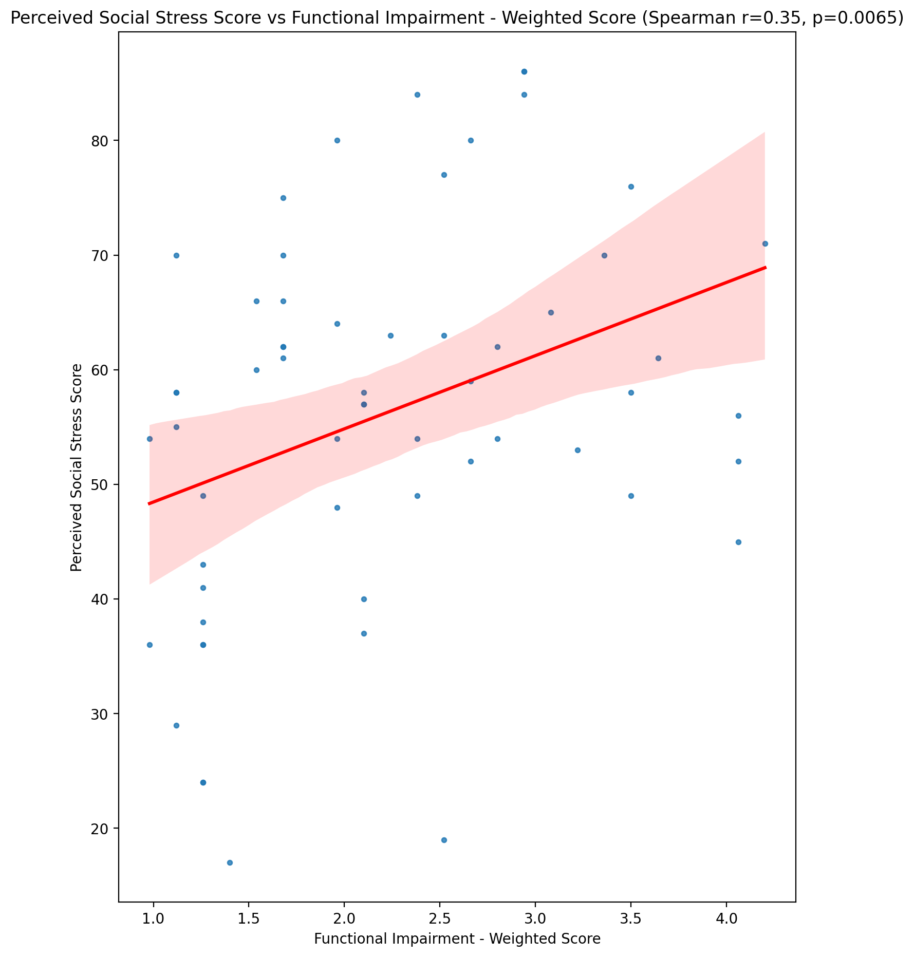

## Perceived Social Stress Category vs Functional Impairment - Weighted Score

Test: None; statistic: None; p-value: None; Test not run: unsupported type combination.



## Emotional Support - Raw Score vs Withdrawl - Weighted Score

Test: spearman; statistic: -0.08270280597775266; p-value: 0.5334628863077862;

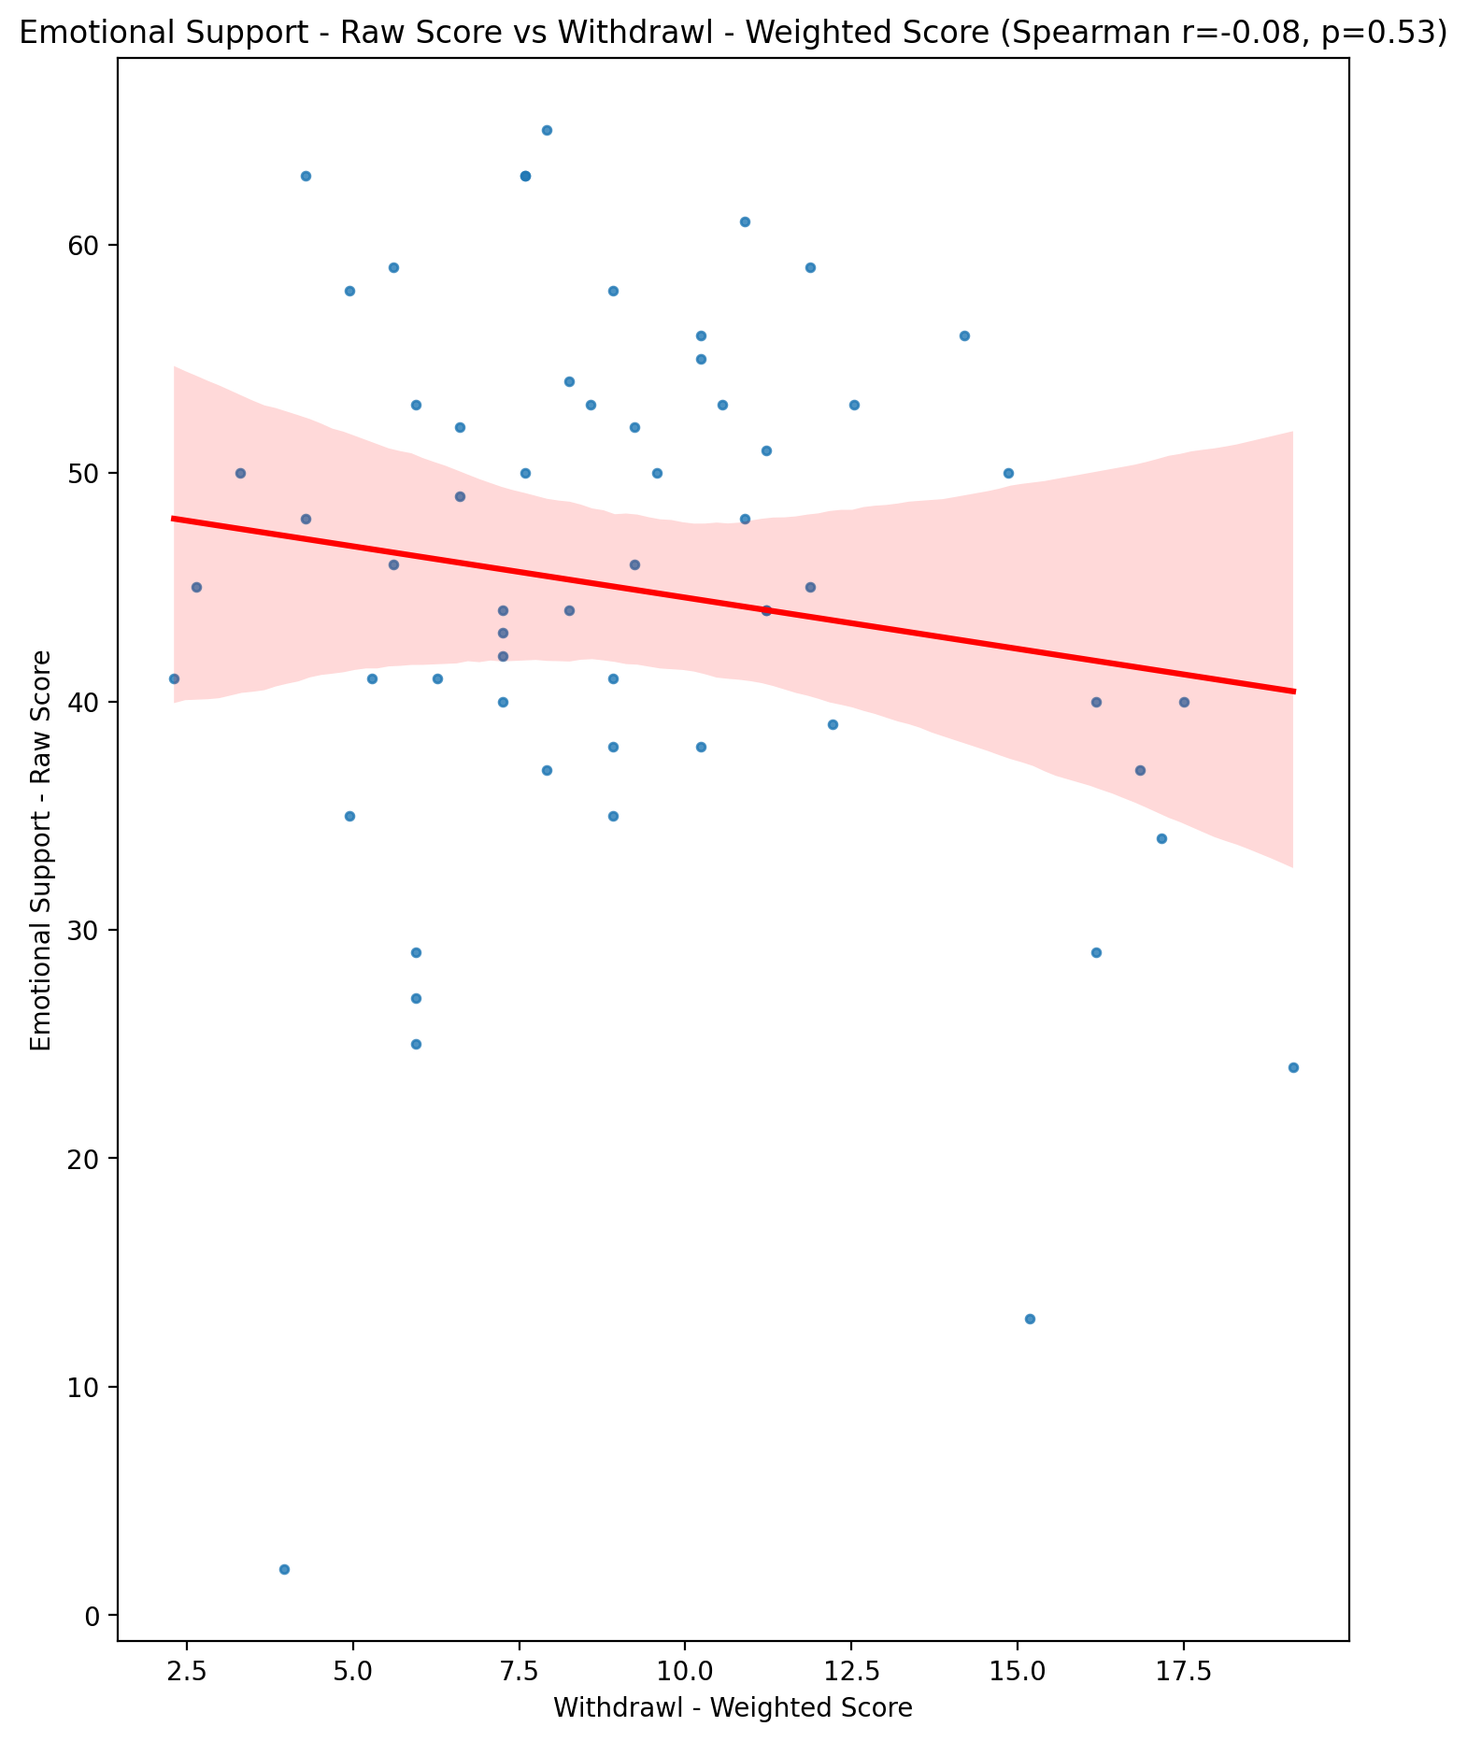

## Informational Support - Raw Score vs Withdrawl - Weighted Score

Test: spearman; statistic: -0.015364612483430845; p-value: 0.9080492370742217;

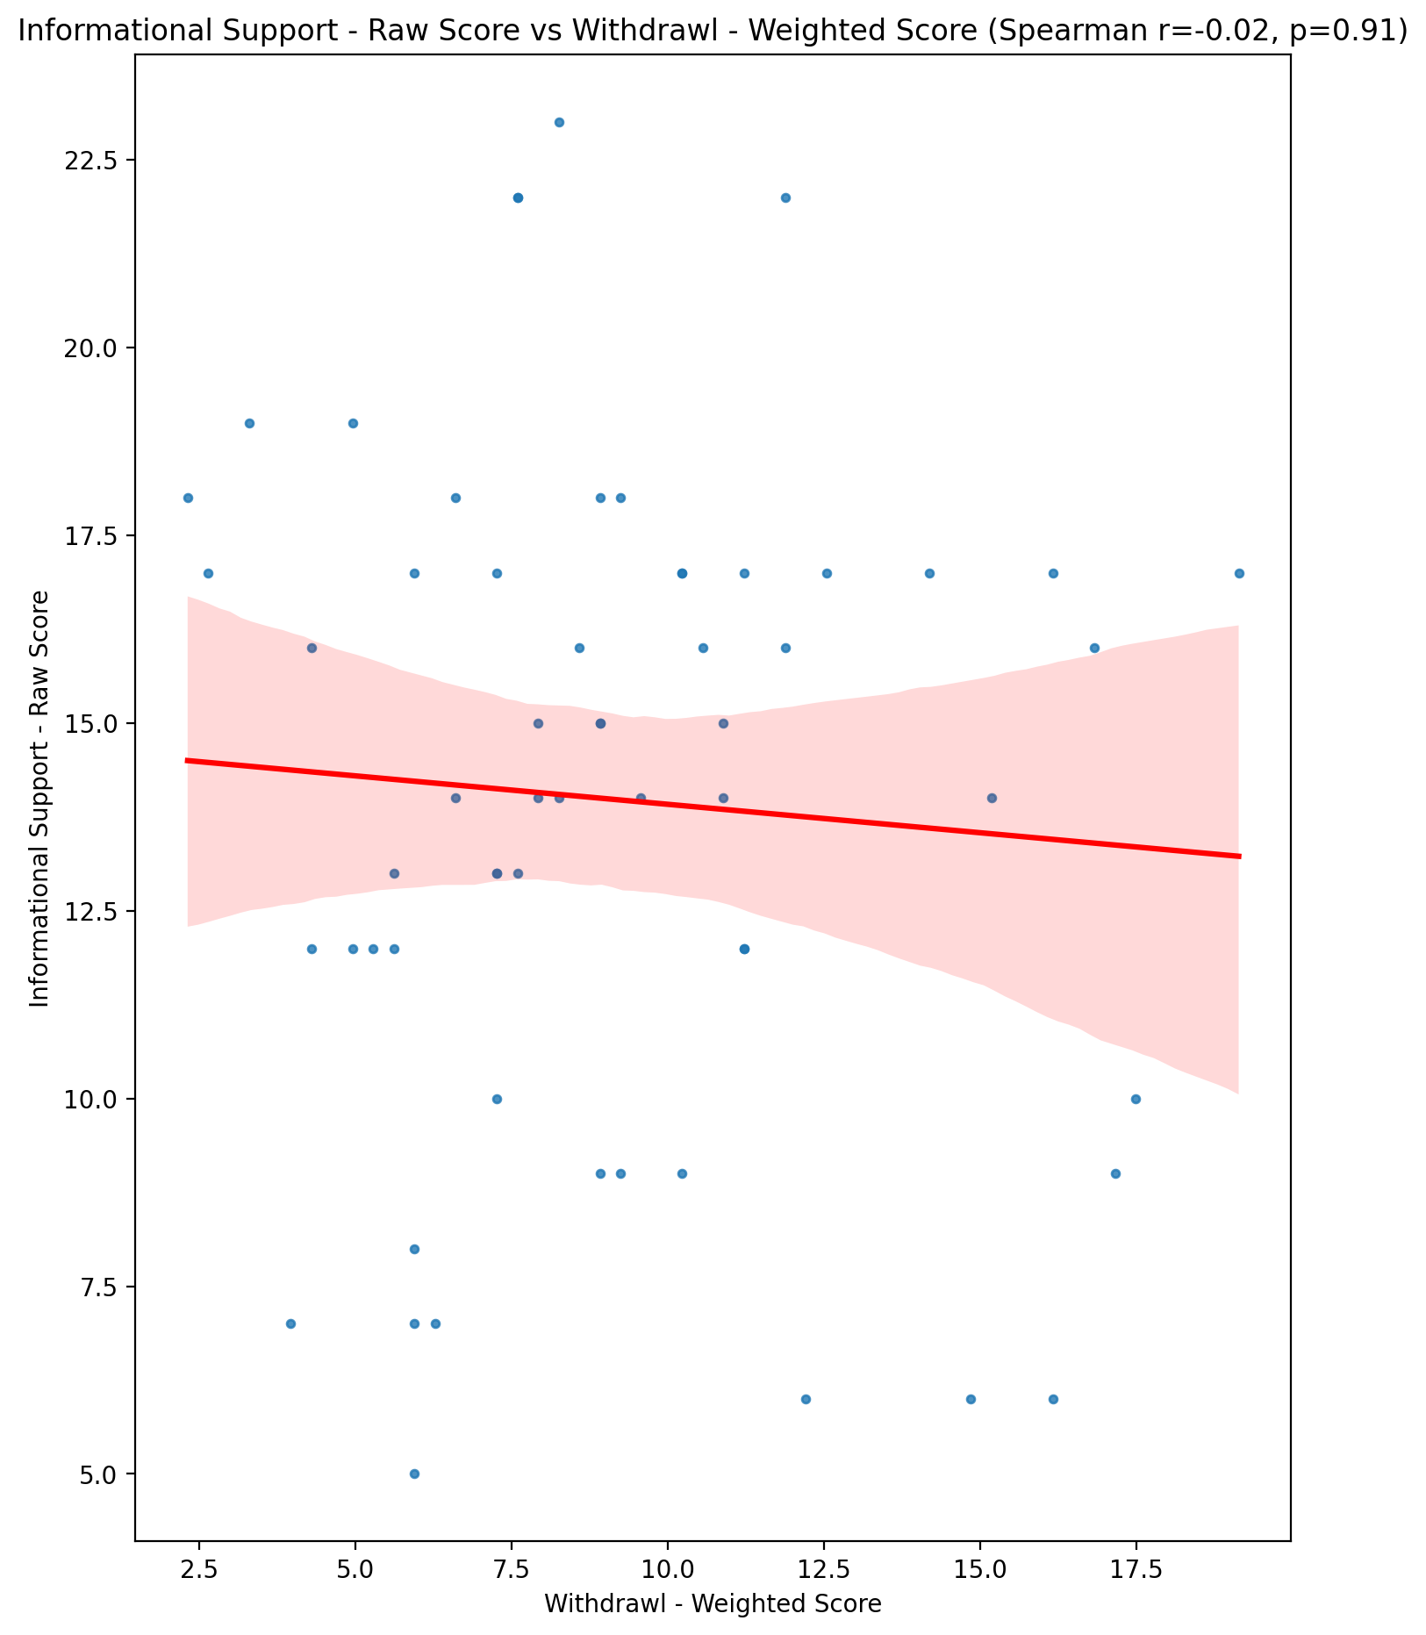

## Instrumental Support - Raw Score vs Withdrawl - Weighted Score

Test: spearman; statistic: -0.02708057385381028; p-value: 0.8386688117939272;

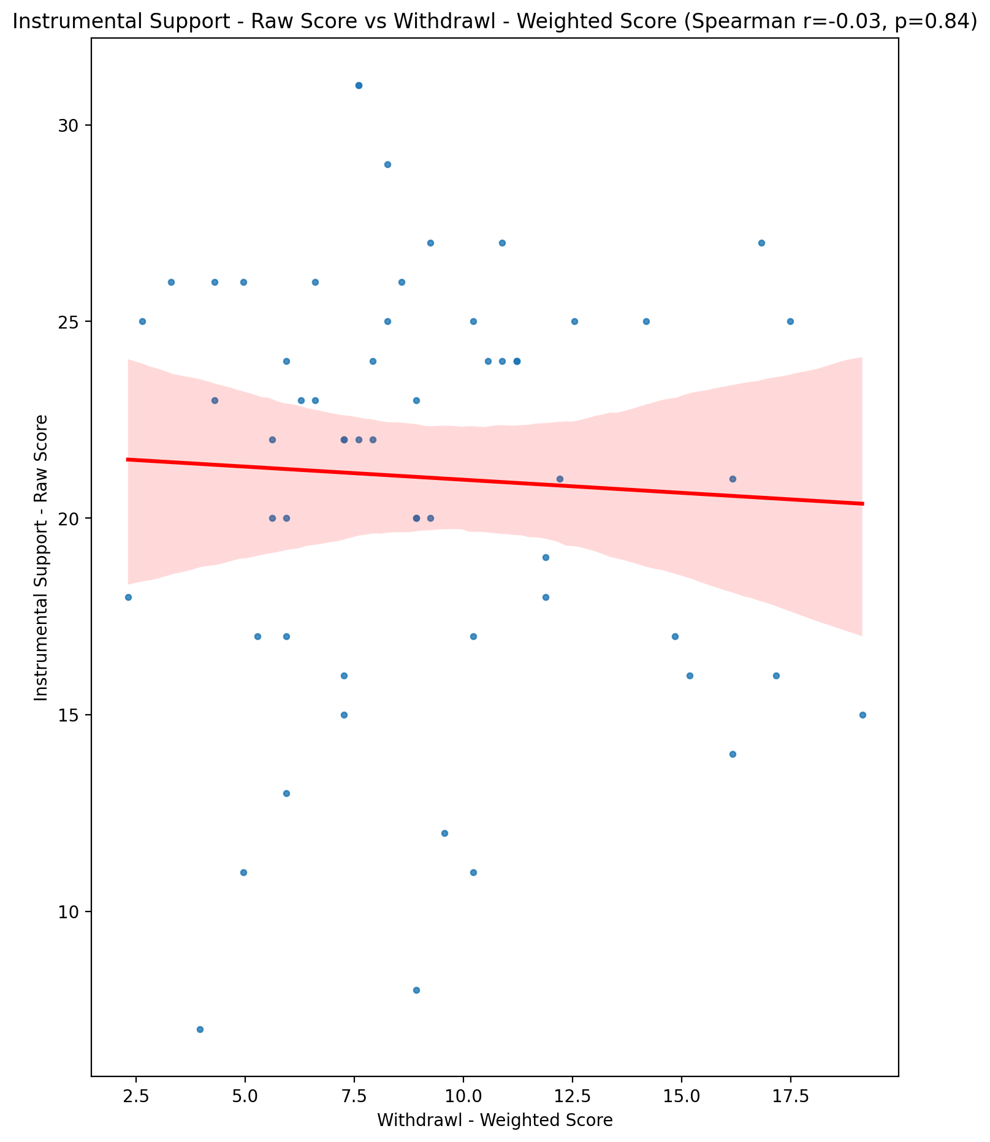

## Emotional Support - T Score vs Withdrawl - Weighted Score

Test: spearman; statistic: -0.08152659876487343; p-value: 0.5393195838539444;

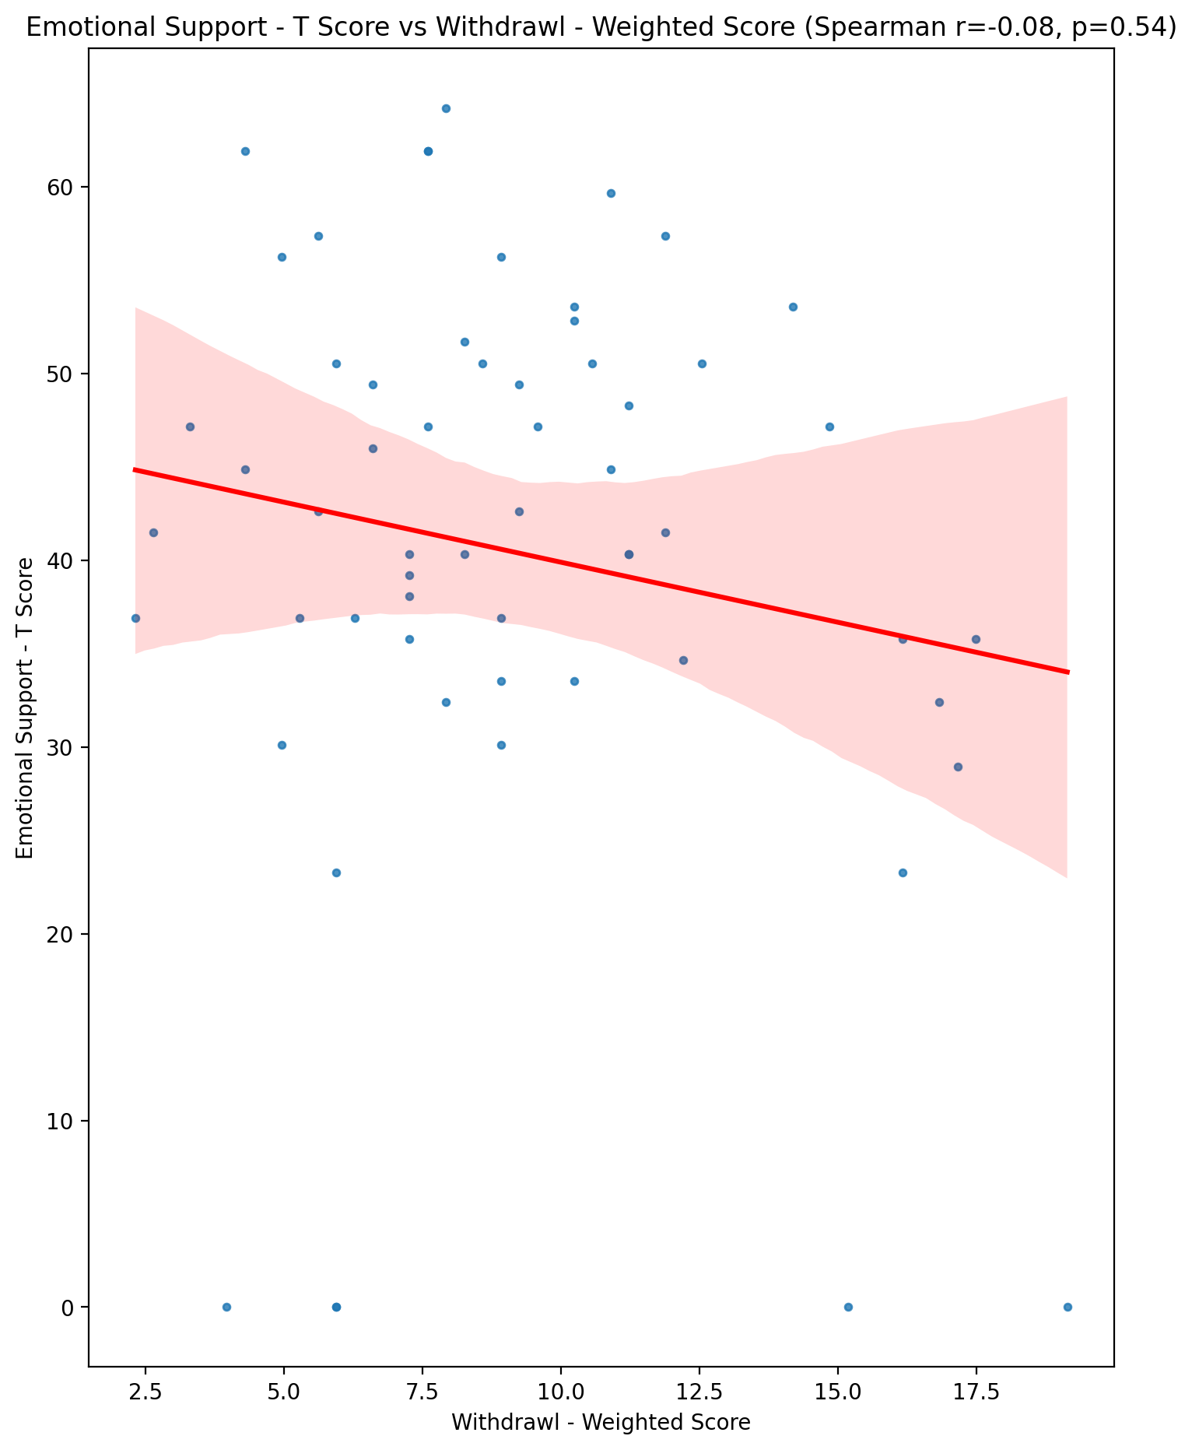

## Informational Support - T Score vs Withdrawl - Weighted Score

Test: spearman; statistic: -0.00461749871008019; p-value: 0.9723118018223663;

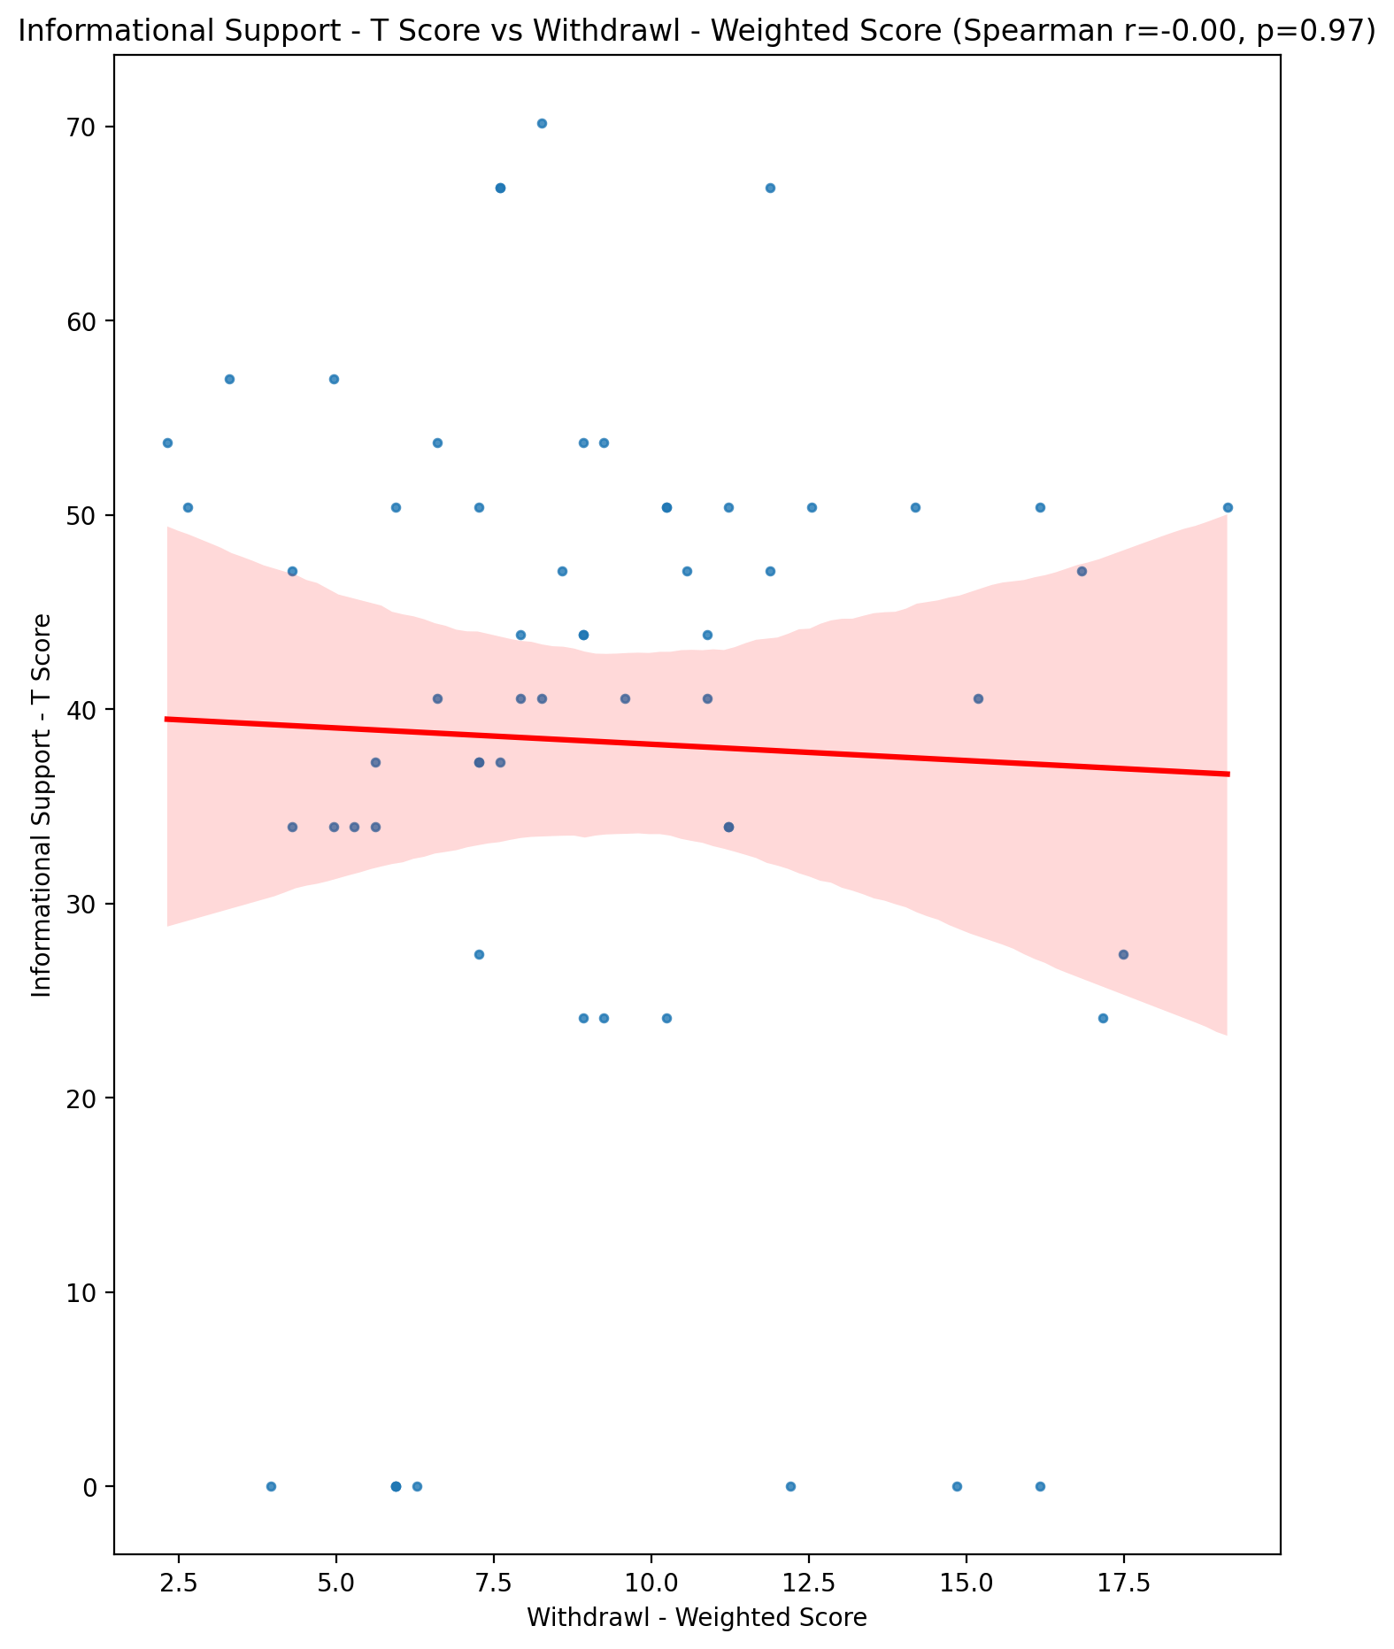

## Instrumental Support - T Score vs Withdrawl - Weighted Score

Test: spearman; statistic: -0.02888375880553748; p-value: 0.8280846900064176;

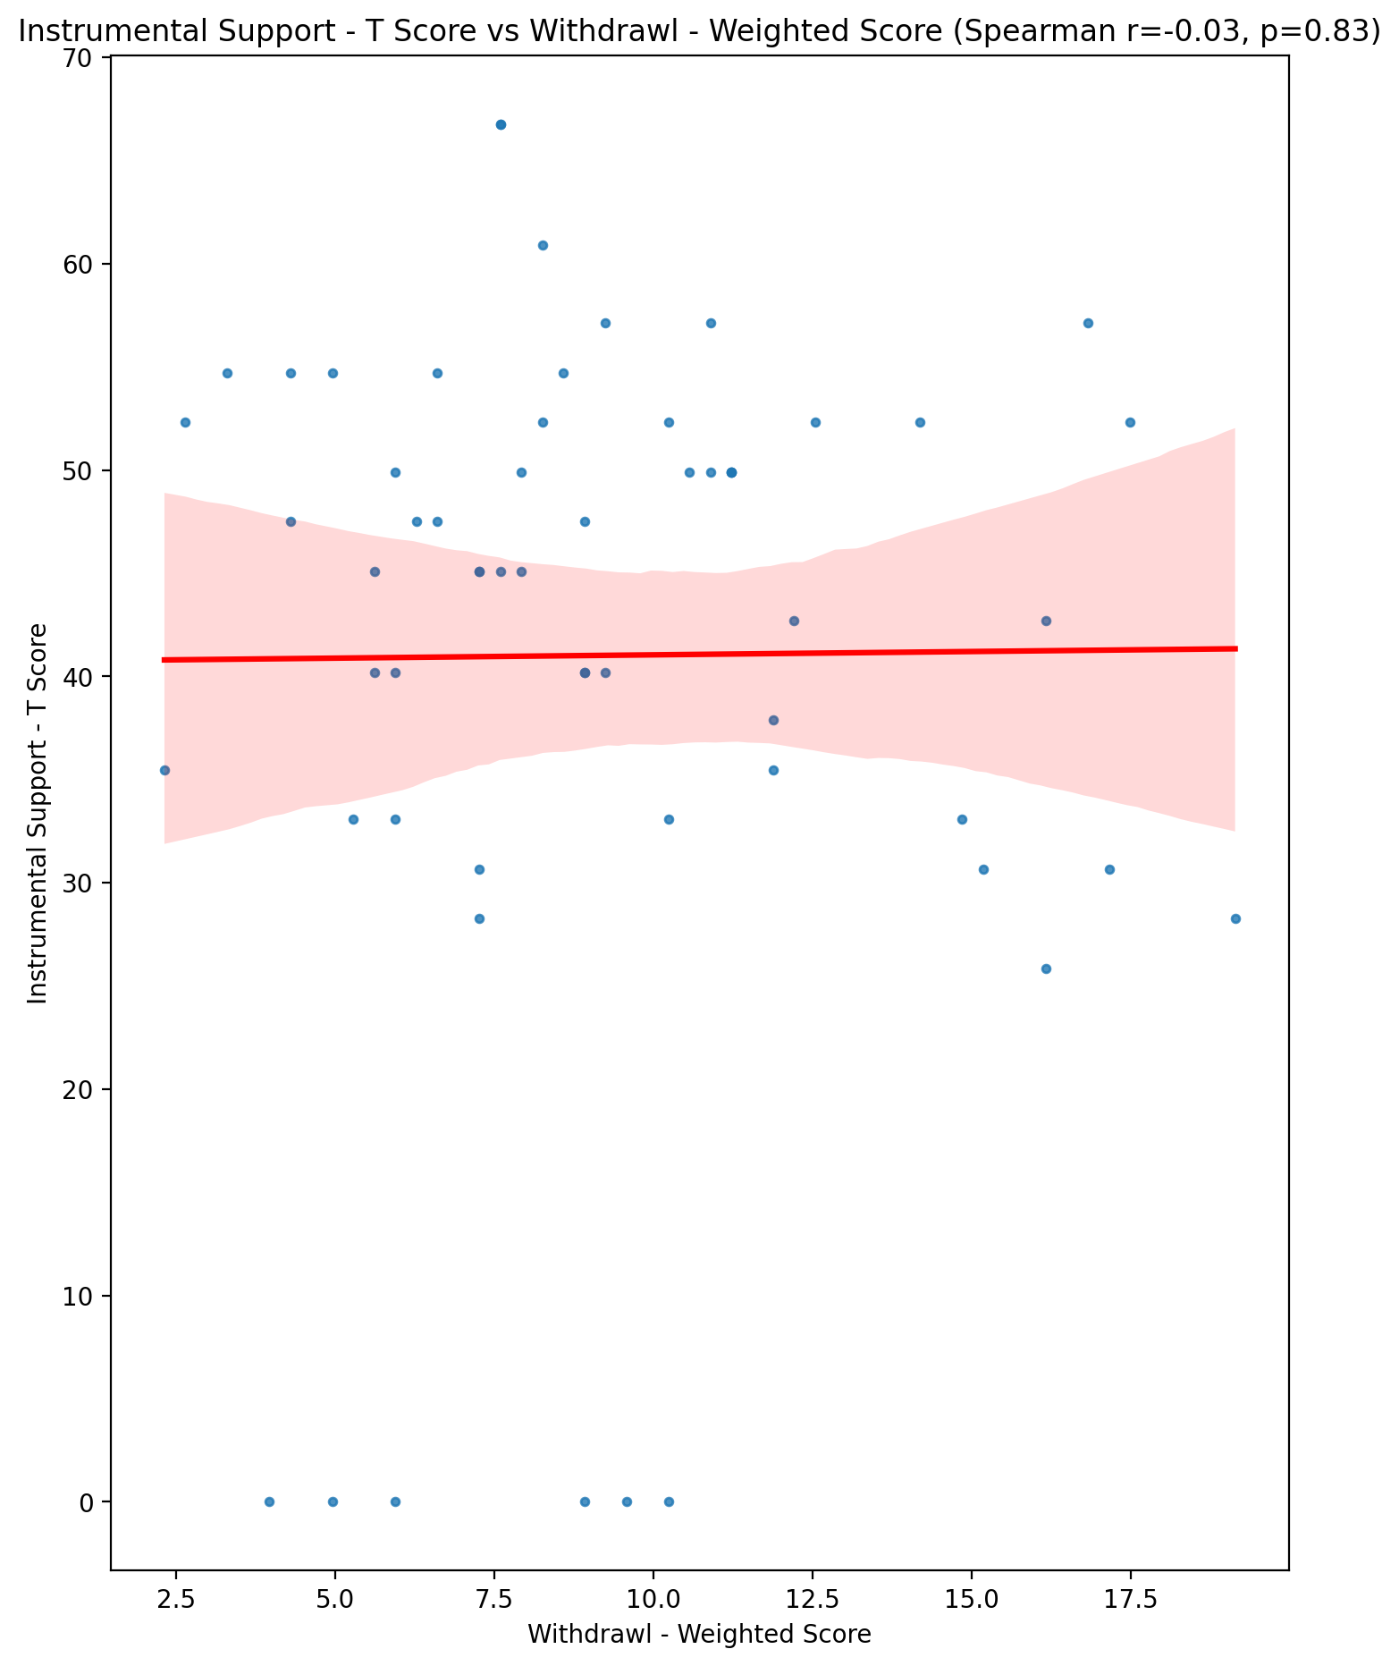

## Perceived Social Support Total T Score vs Withdrawl - Weighted Score

Test: spearman; statistic: -0.0786248208444566; p-value: 0.553901152999422;

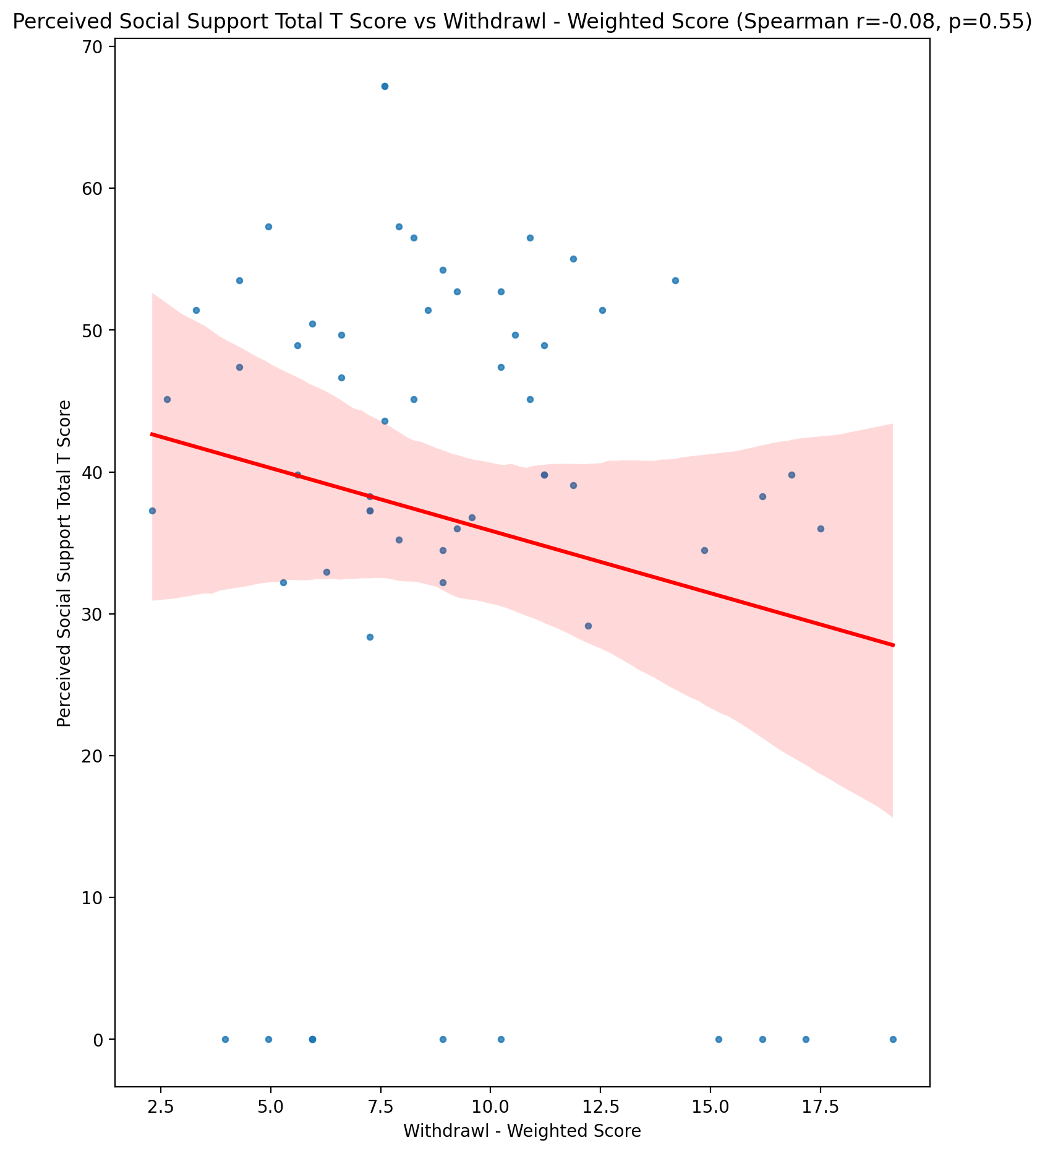

## Emotional Support - Rank vs Withdrawl - Weighted Score

Test: None; statistic: None; p-value: None; Test not run: unsupported type combination.



## Informational Support - Rank vs Withdrawl - Weighted Score

Test: None; statistic: None; p-value: None; Test not run: unsupported type combination.



## Instrumental Support - Rank vs Withdrawl - Weighted Score

Test: None; statistic: None; p-value: None; Test not run: unsupported type combination.



## Perceived Social Support TOTAL - Rank vs Withdrawl - Weighted Score

Test: None; statistic: None; p-value: None; Test not run: unsupported type combination.



## Power Self Concept - Real Self Concept Score vs Withdrawl - Weighted Score

Test: spearman; statistic: -0.3262214239018; p-value: 0.011684334645385154;

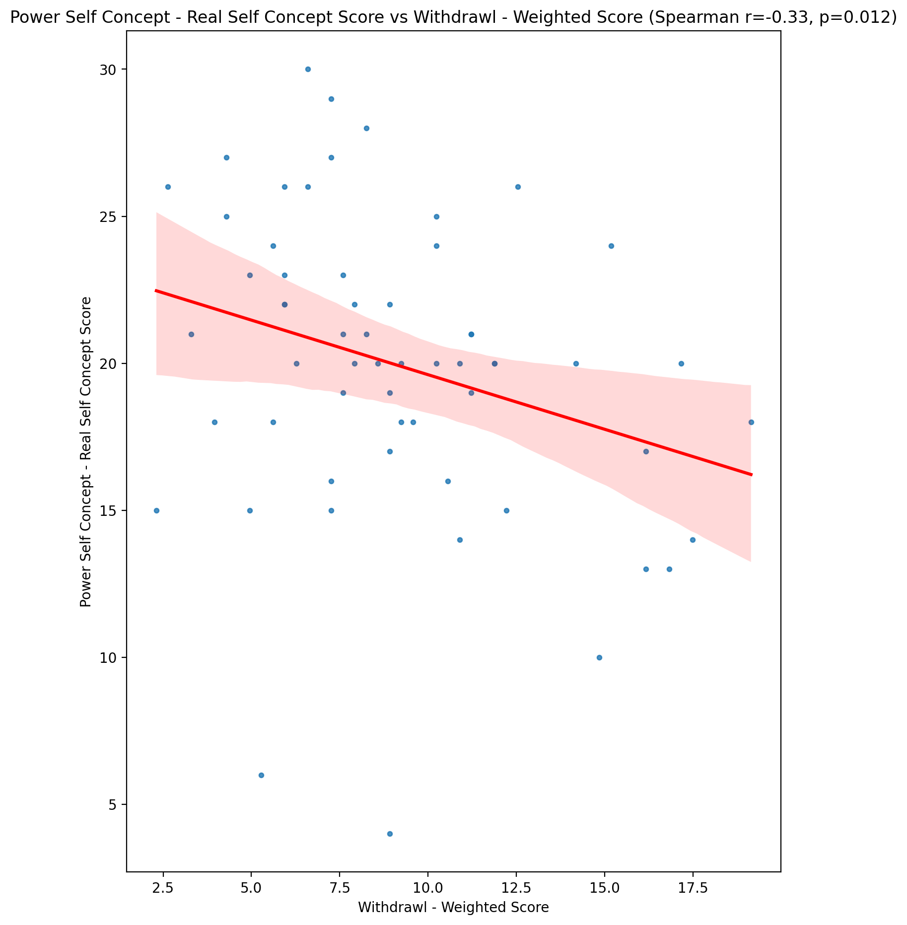

## Power Self Concept - Ideal Self Concept score vs Withdrawl - Weighted Score

Test: spearman; statistic: -0.18453585301129724; p-value: 0.16176257770216532;

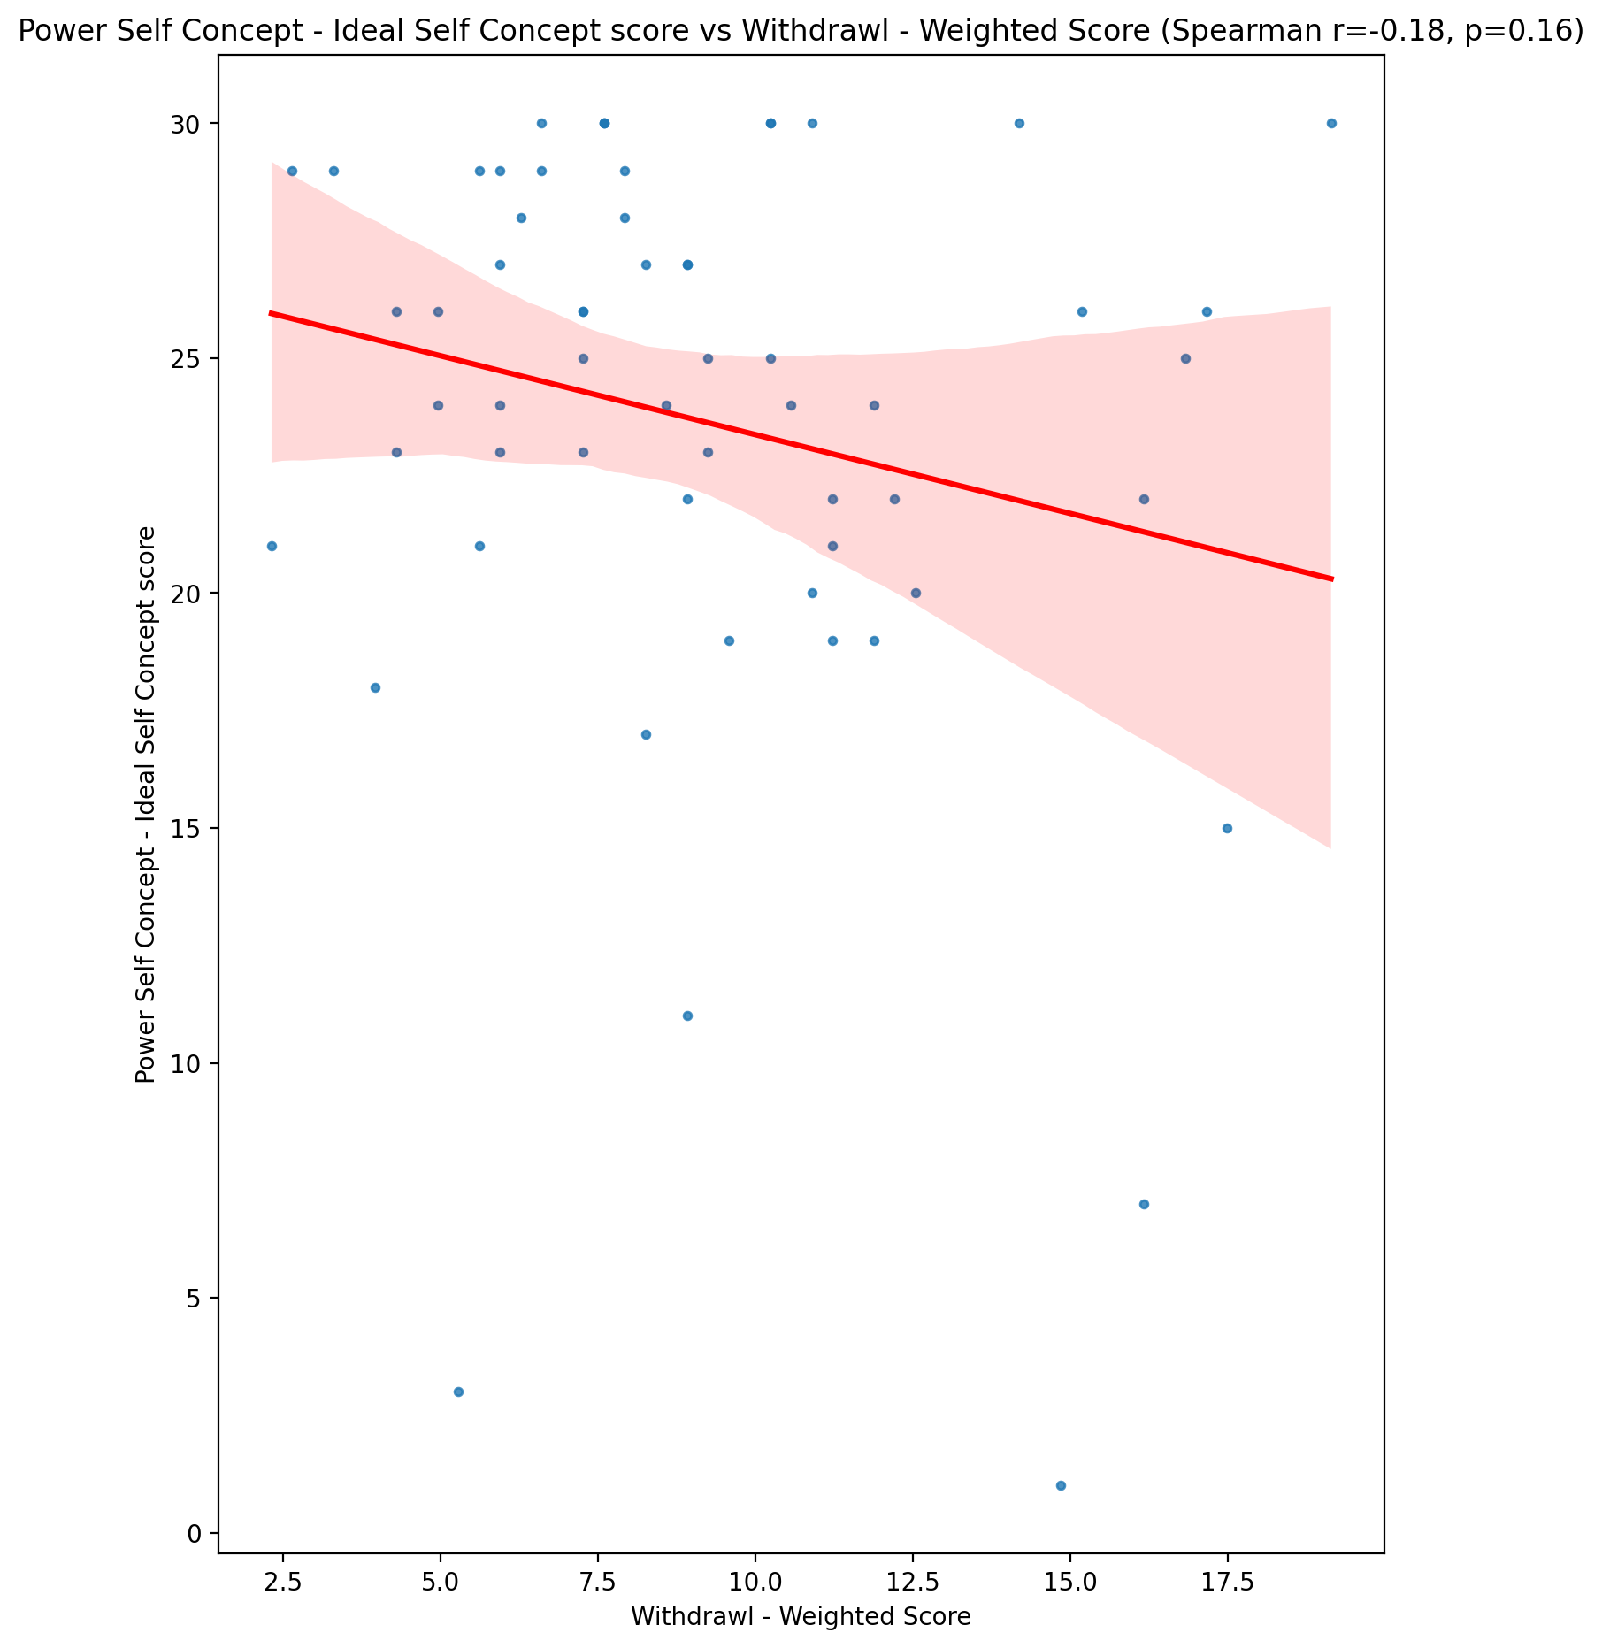

## Power Self Concept – Social Self Concept Score vs Withdrawl - Weighted Score

Test: spearman; statistic: -0.06596121900075955; p-value: 0.619641593926065;

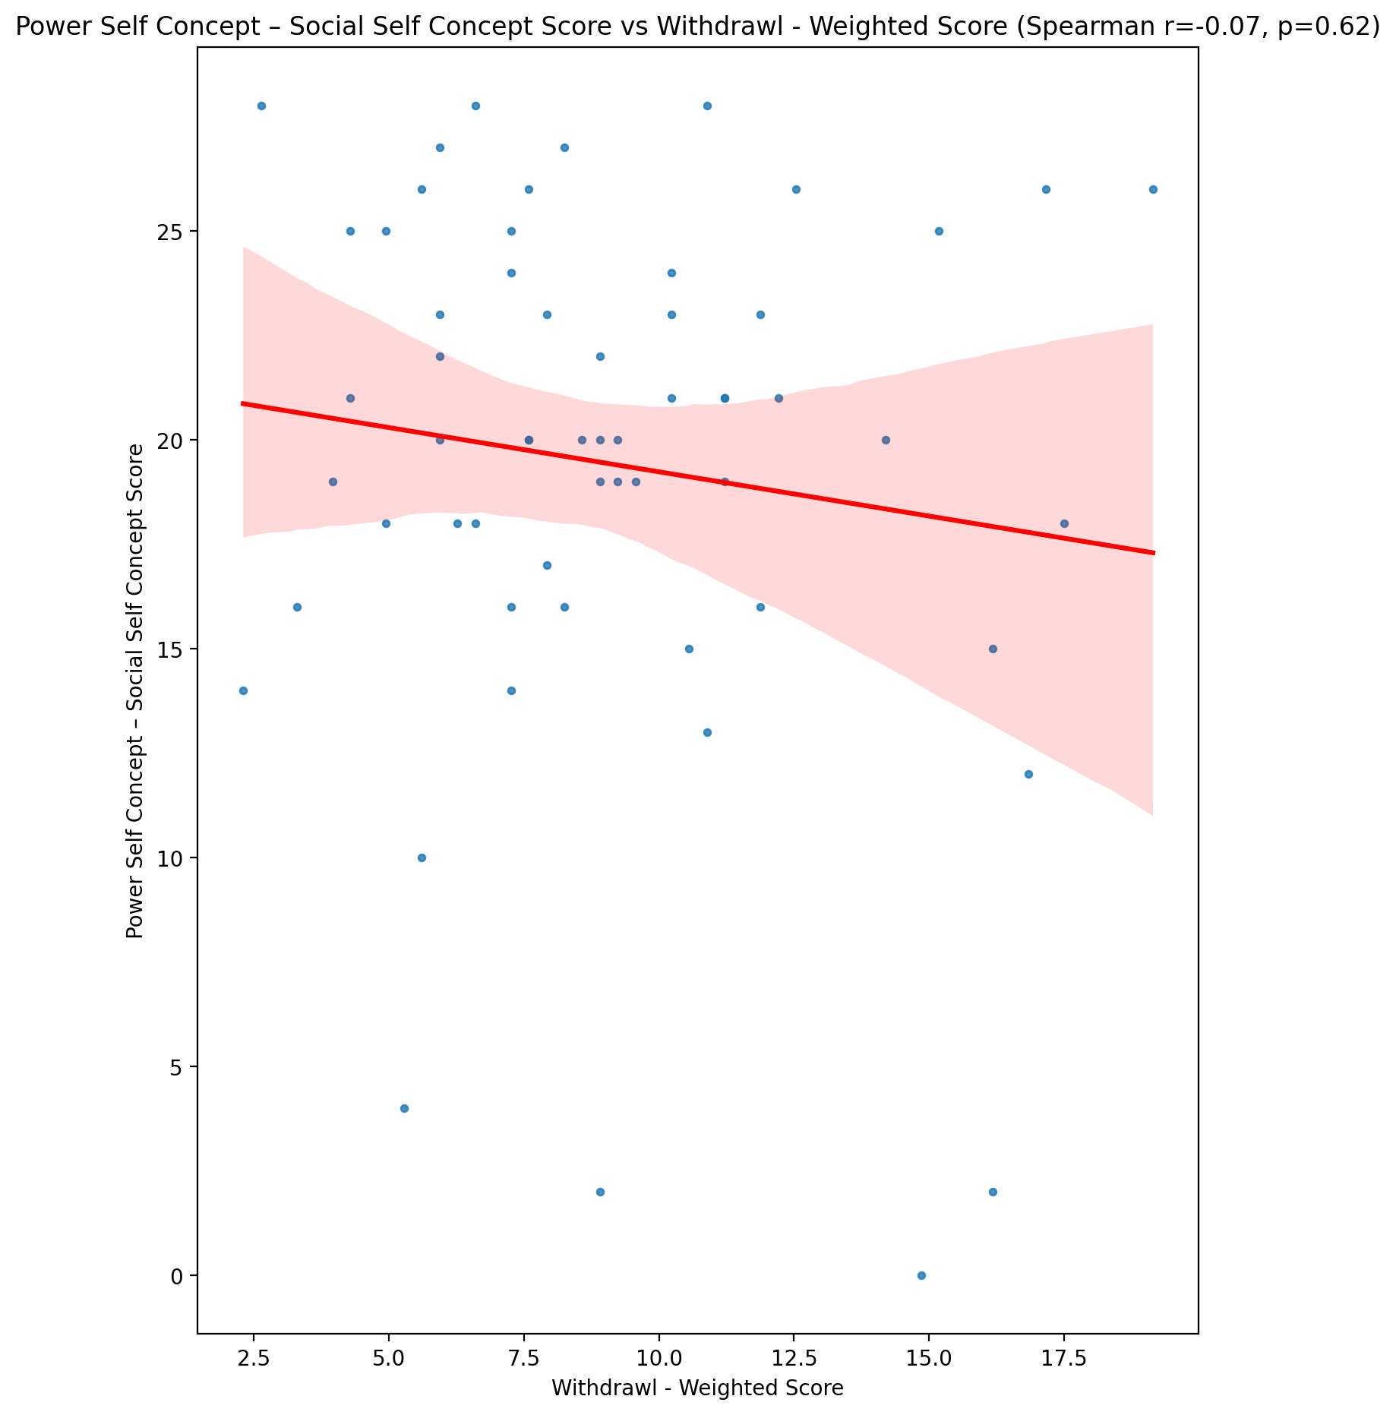

## Social Self Concept - Real Self Concept Score vs Withdrawl - Weighted Score

Test: spearman; statistic: -0.4642259398985322; p-value: 0.0002125850425771805;

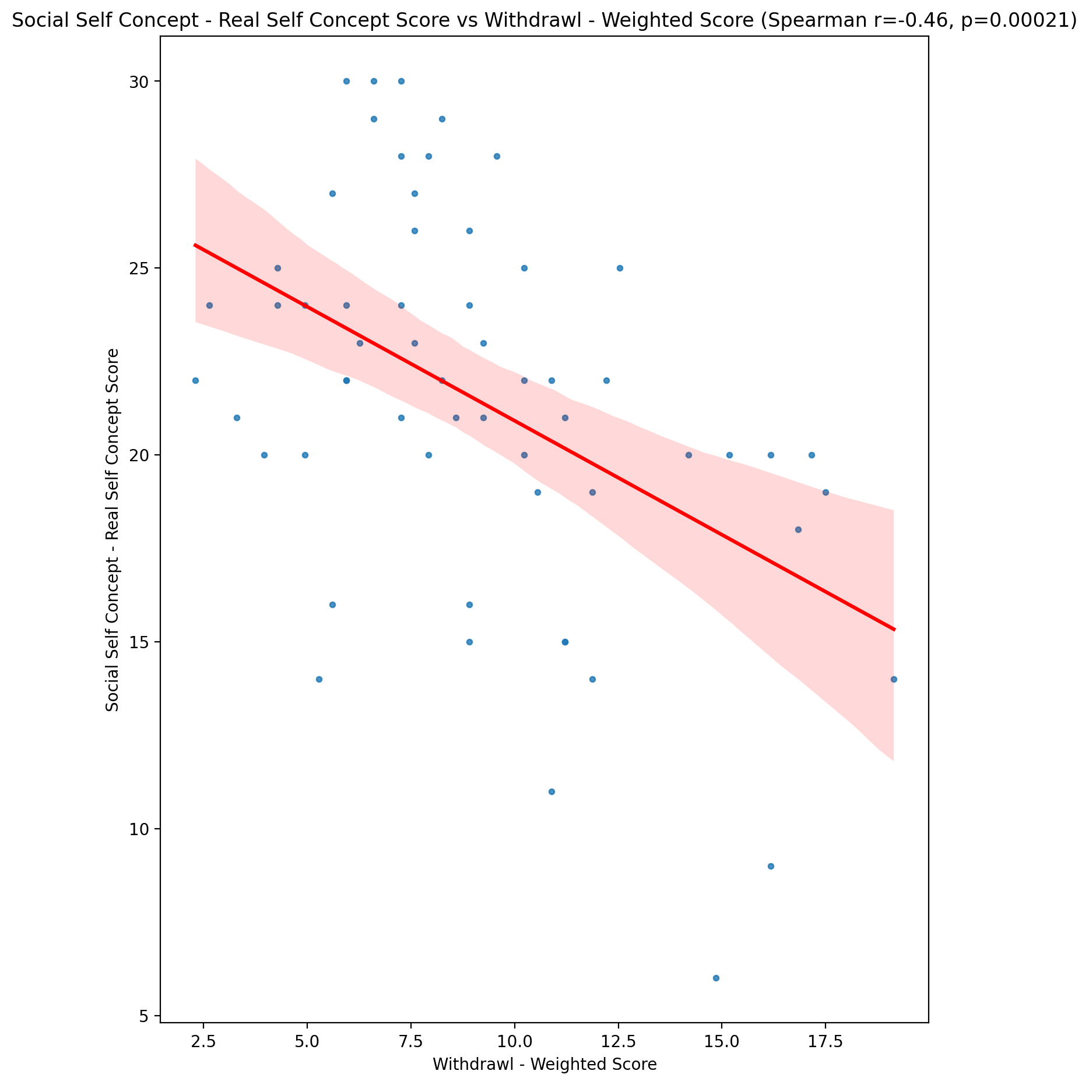

## Social Self Concept – Social Self Concept Score vs Withdrawl - Weighted Score

Test: spearman; statistic: -0.14545022337886507; p-value: 0.27169045446520934;

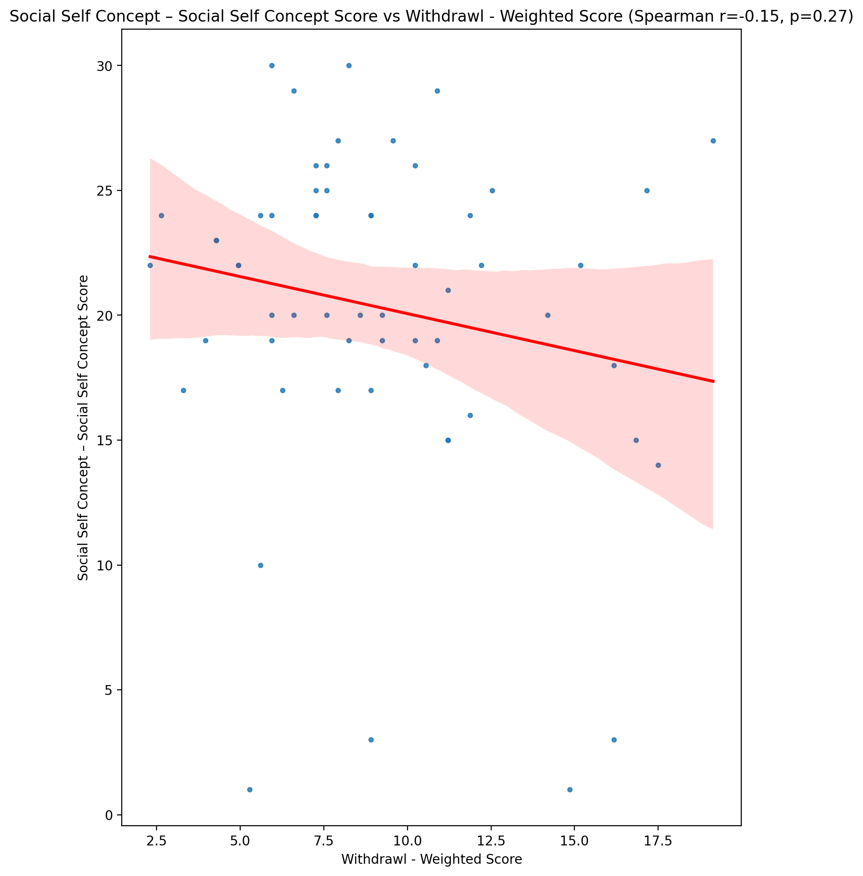

## Ability Self Concept - Real Self Concept Score vs Withdrawl - Weighted Score

Test: spearman; statistic: -0.3916081945713569; p-value: 0.0021610862592715513;

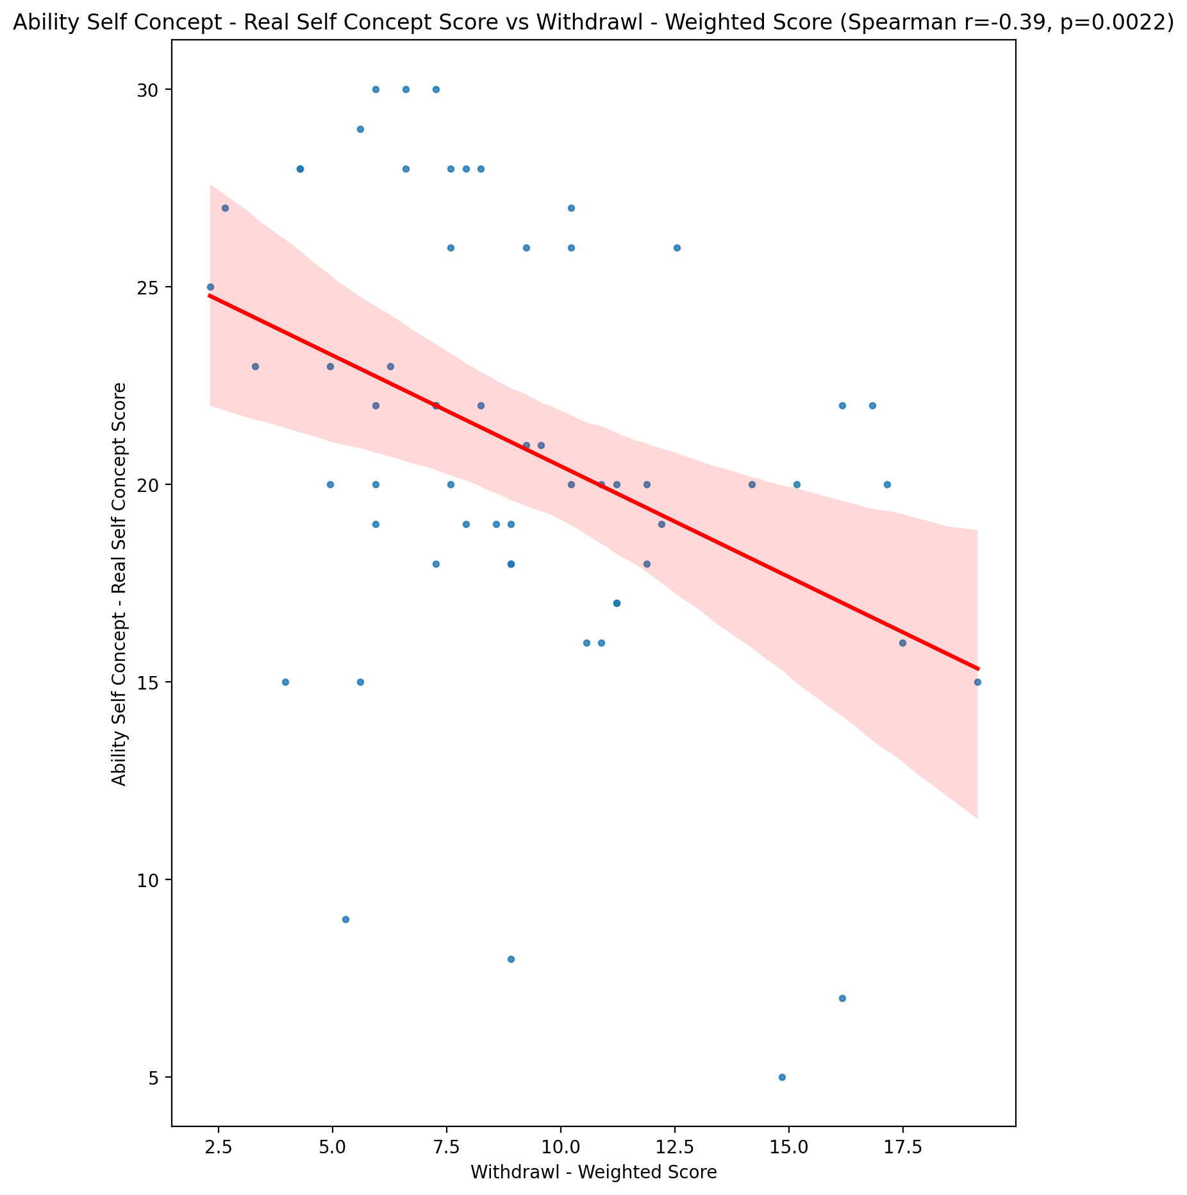

## Ability Self Concept - Ideal Self Concept Score vs Withdrawl - Weighted Score

Test: spearman; statistic: -0.18595691229773645; p-value: 0.1585000999532485;

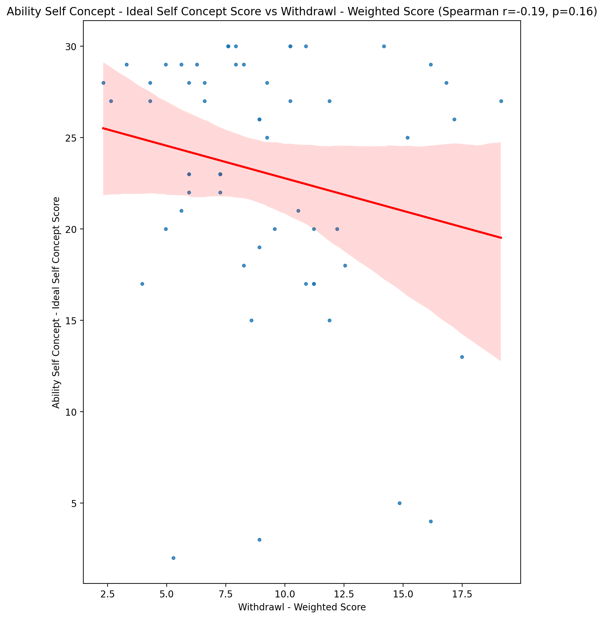

## Ability Self Concept – Social Self Concept Score vs Withdrawl - Weighted Score

Test: spearman; statistic: -0.08173779263264036; p-value: 0.5382656797376699;

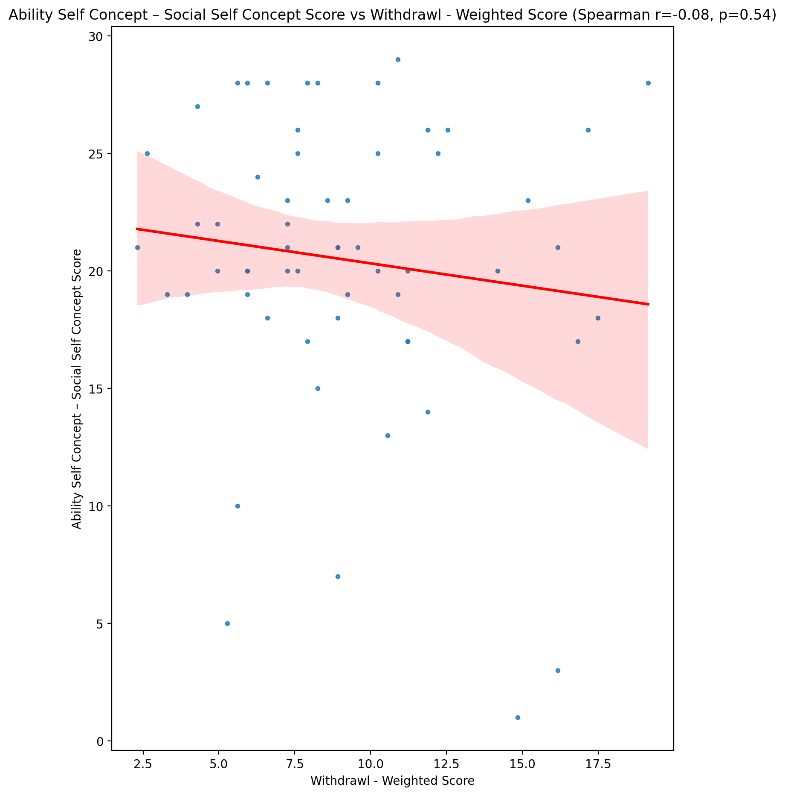

## Physical Self Concept - Real Self Concept Score vs Withdrawl - Weighted Score

Test: spearman; statistic: -0.44068573885621887; p-value: 0.00047734288807000887;

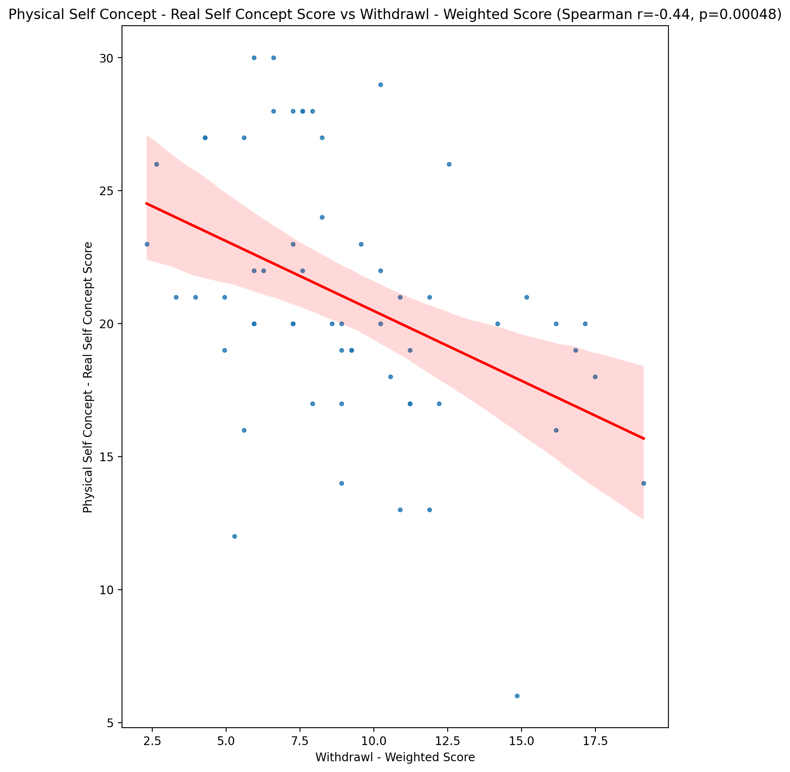

## Physical Self Concept – Ideal Self Concept Score vs Withdrawl - Weighted Score

Test: spearman; statistic: -0.1925252371272246; p-value: 0.14404851081115402;

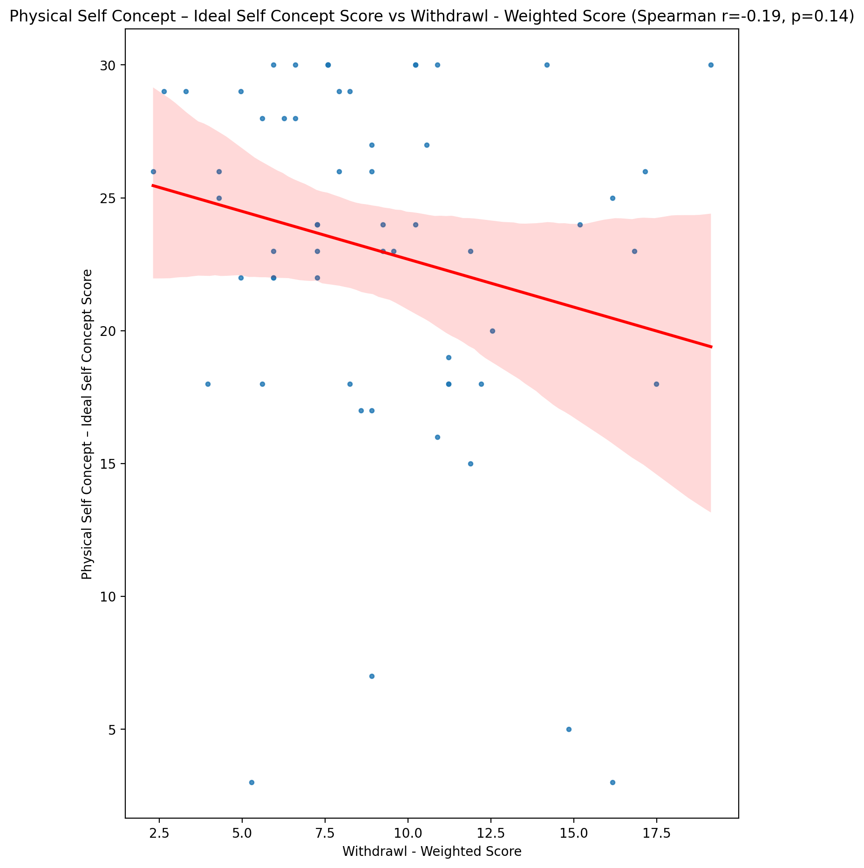

## Physical Self Concept – Social Self Concept Score vs Withdrawl - Weighted Score

Test: spearman; statistic: -0.14047468707009694; p-value: 0.2886022682535452;

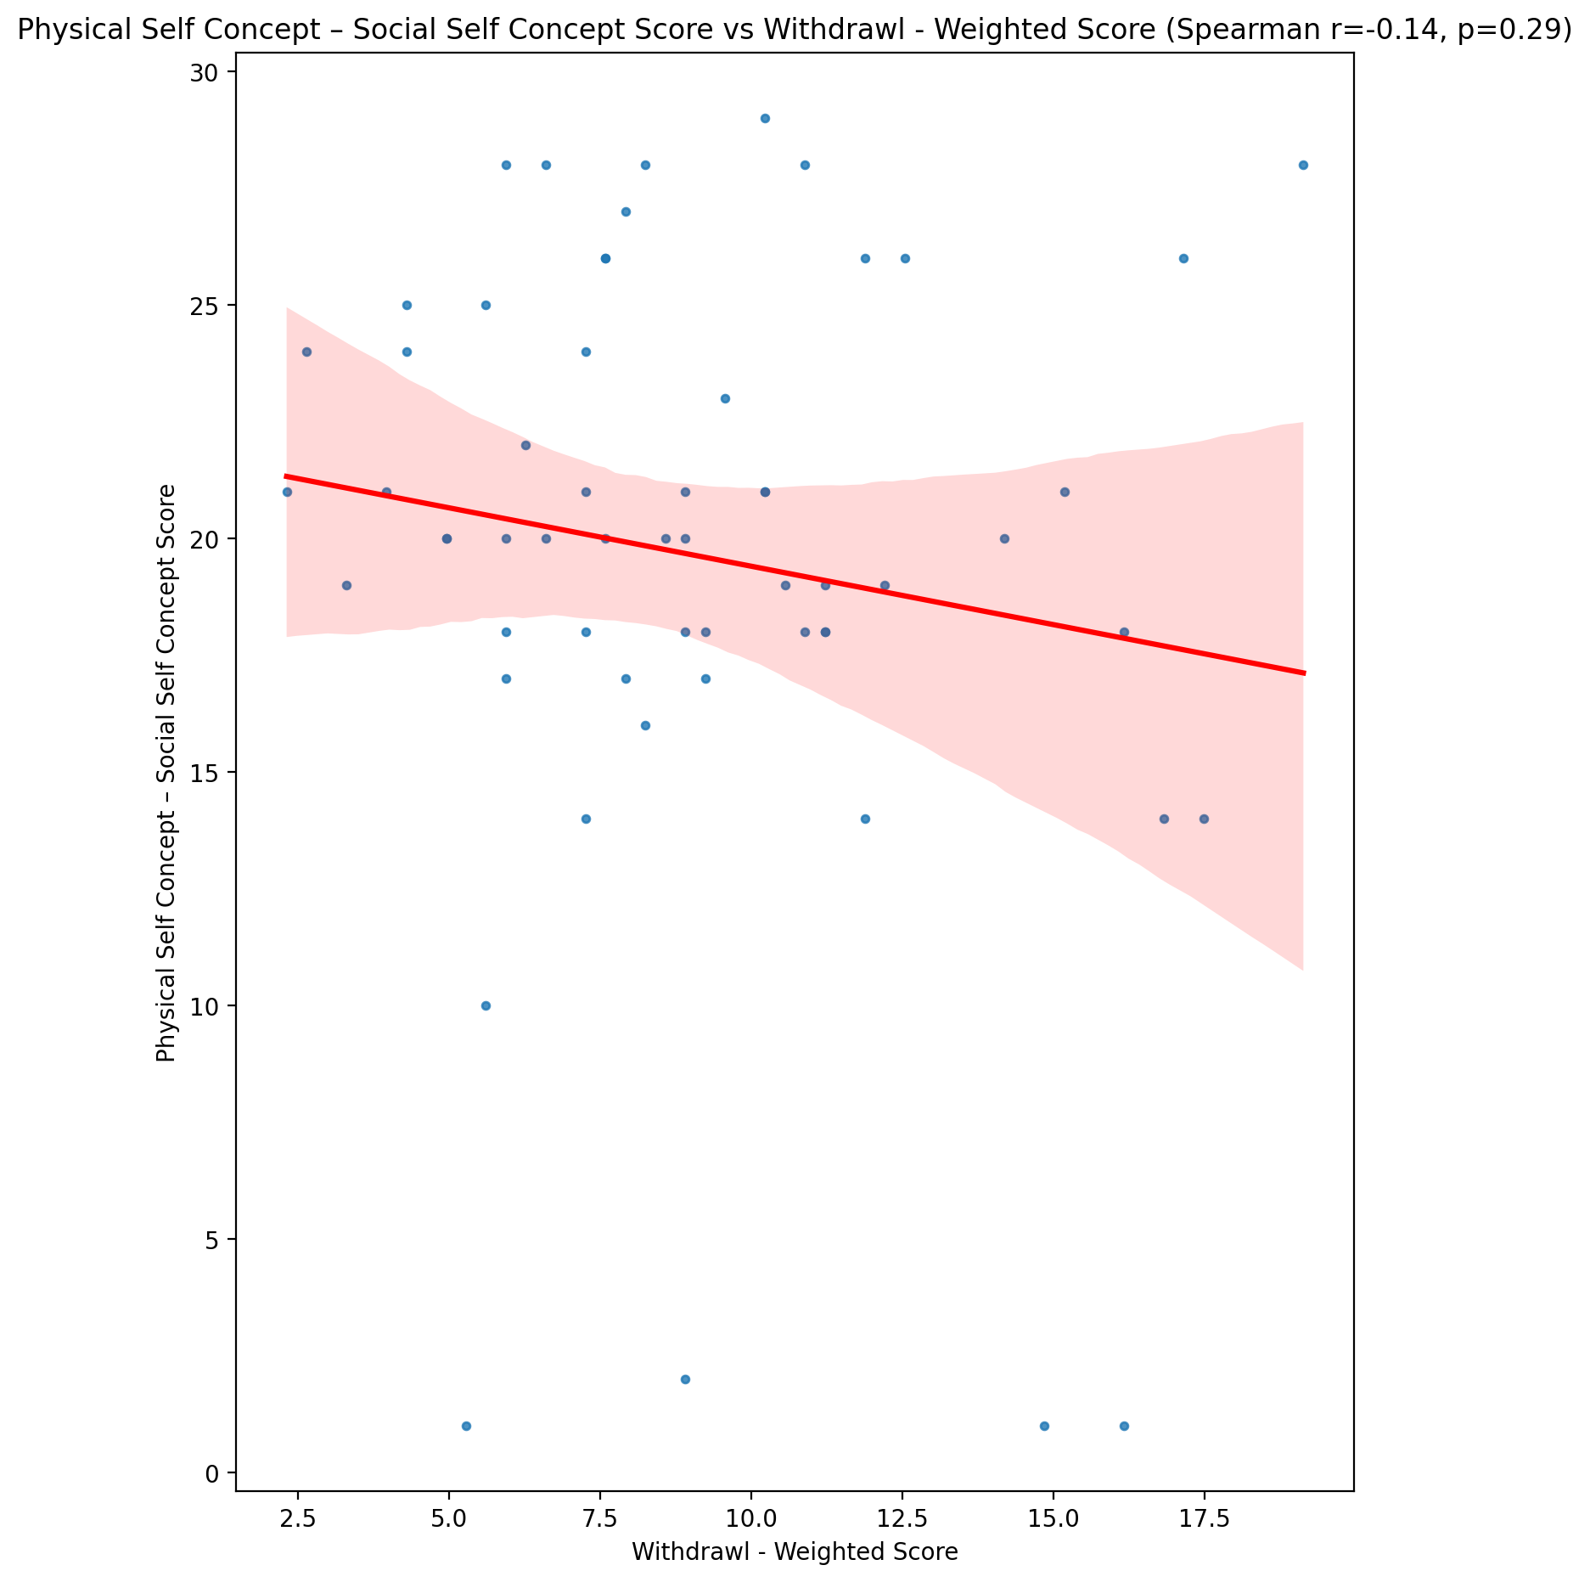

## Psychological Self Concept - Real Self Concept Score vs Withdrawl - Weighted Score

Test: spearman; statistic: -0.515042435766634; p-value: 2.9953248072788012e-05;

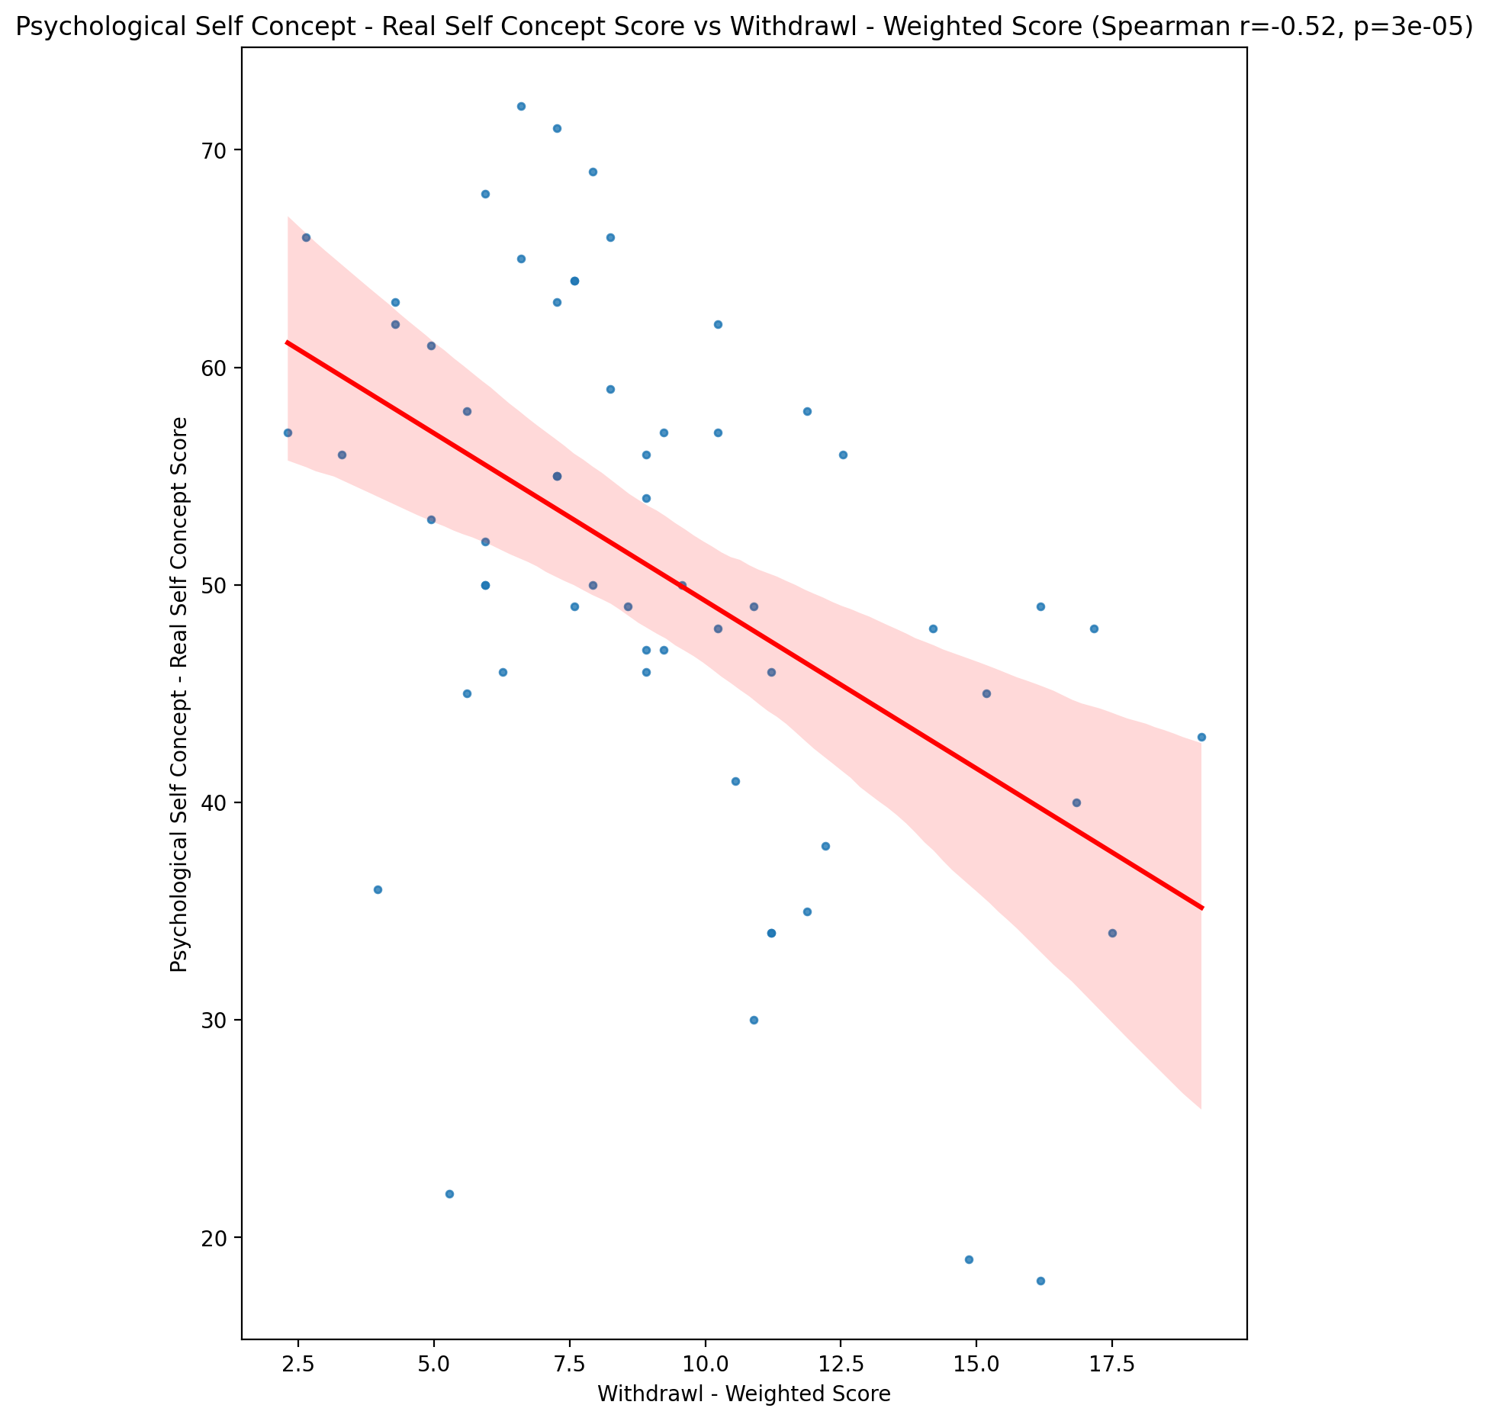

## Psychological Self Concept – Ideal Self Concept Score vs Withdrawl - Weighted Score

Test: spearman; statistic: -0.2462817214348234; p-value: 0.06006364427612421;

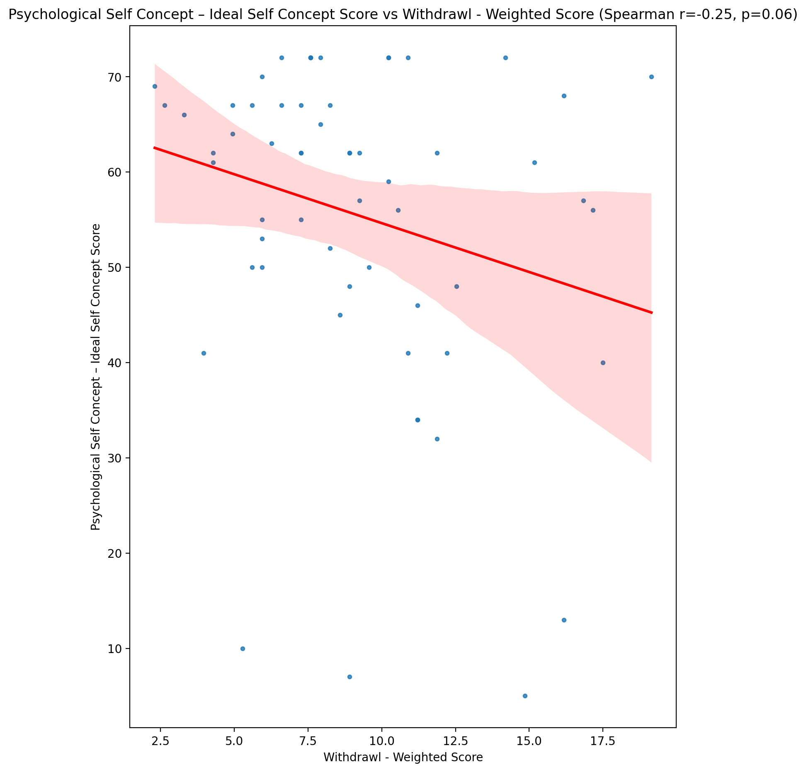

## Psychological Self Concept – Social Self Concept Score vs Withdrawl - Weighted Score

Test: spearman; statistic: -0.2786431914575839; p-value: 0.032595749691112424;

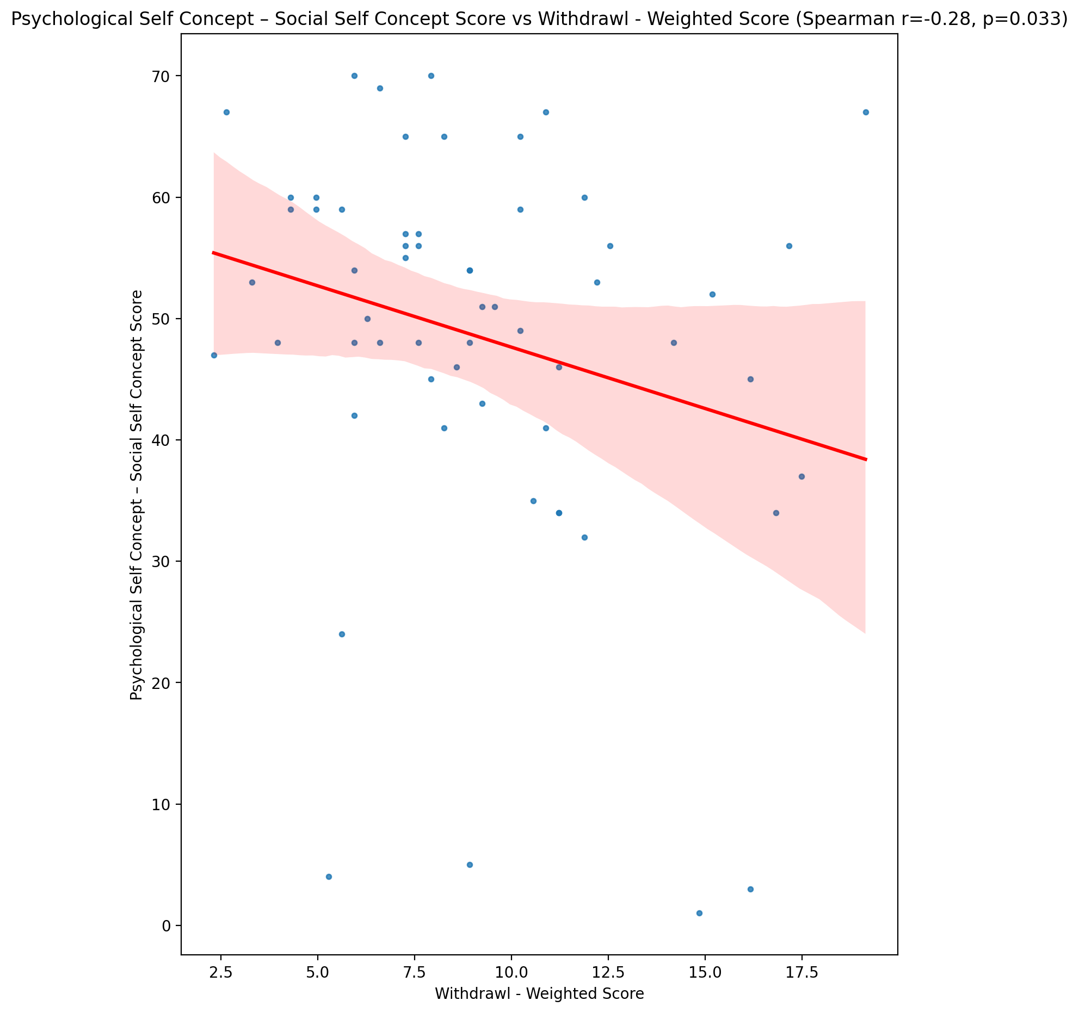

## Real Self Concept Total Score vs Withdrawl - Weighted Score

Test: spearman; statistic: -0.5047768259545615; p-value: 4.5642300203283925e-05;

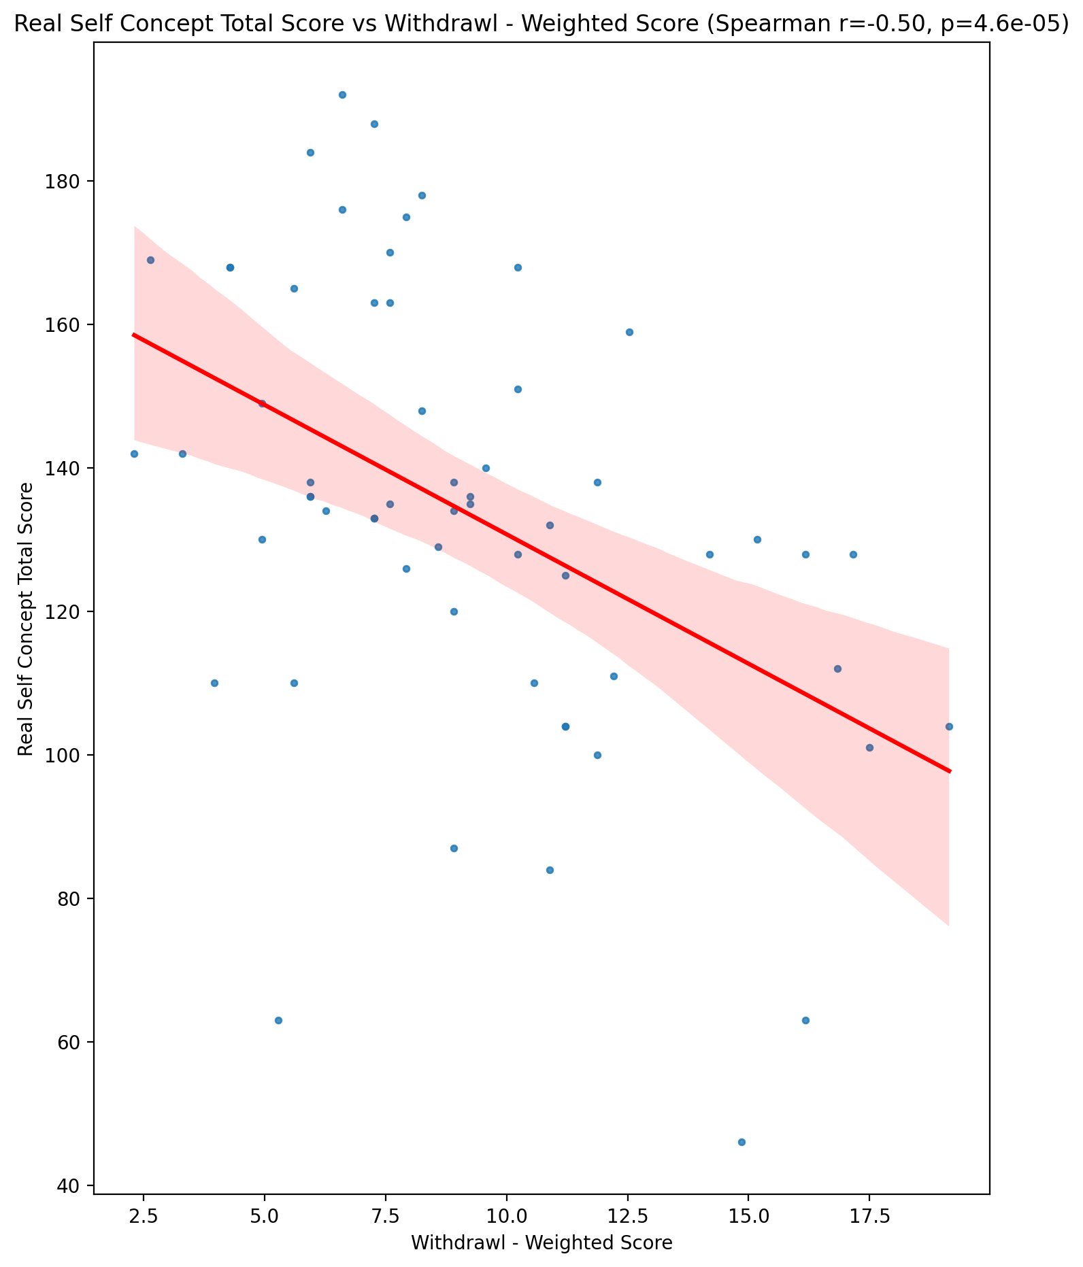

## Ideal Self Concept Total Score vs Withdrawl - Weighted Score

Test: spearman; statistic: -0.21226401369700243; p-value: 0.10652803683159671;

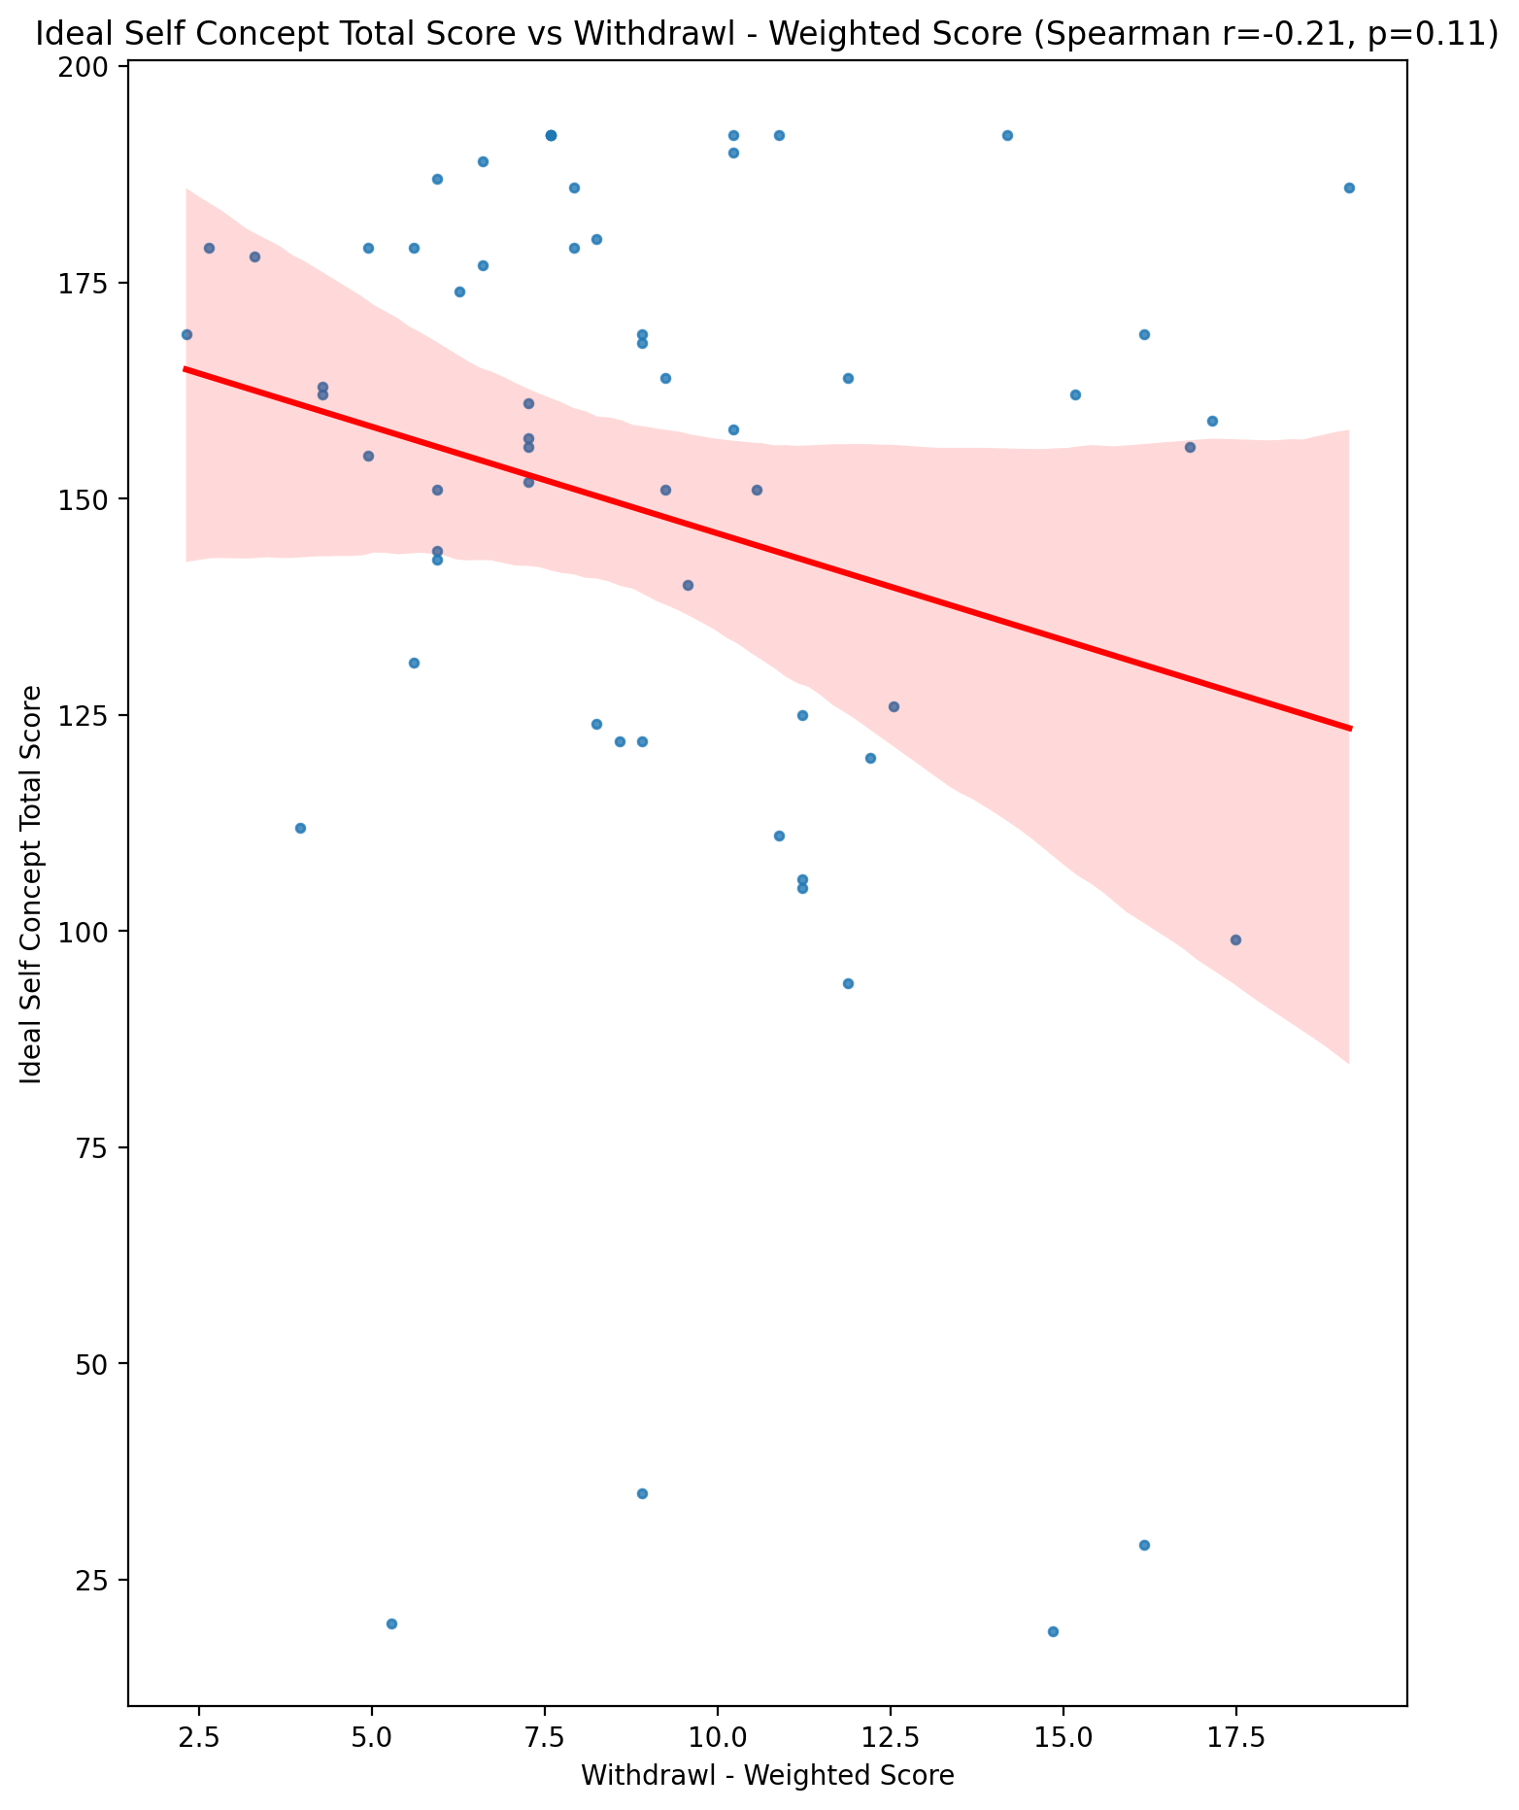

## Social Self Concept Total Score vs Withdrawl - Weighted Score

Test: spearman; statistic: -0.19076456975938874; p-value: 0.14782207716354798;

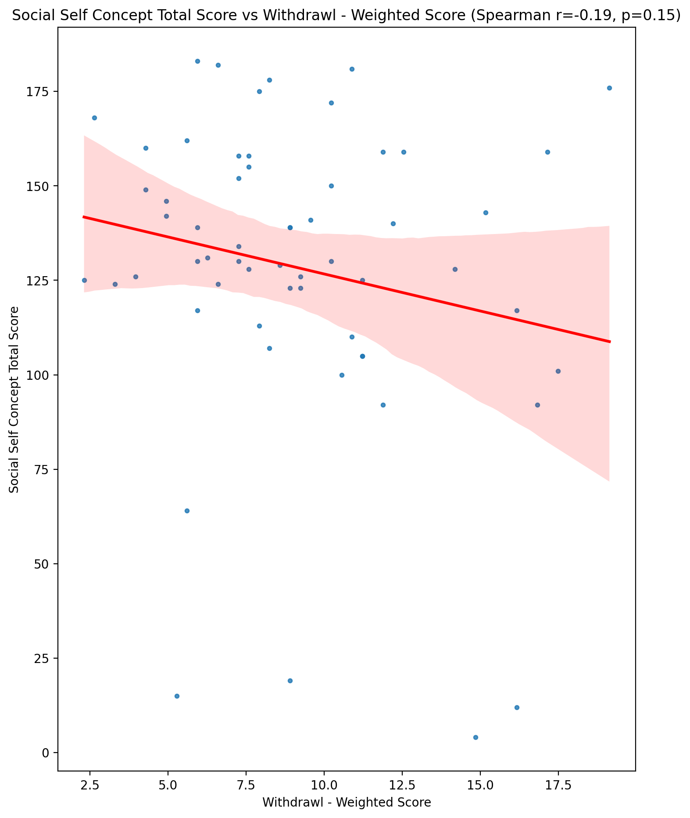

## Ideal Self Concept Total Category vs Withdrawl - Weighted Score

Test: None; statistic: None; p-value: None; Test not run: unsupported type combination.



## Perceived Social Stress Score vs Withdrawl - Weighted Score

Test: spearman; statistic: 0.3287681272092055; p-value: 0.011009770535084682;

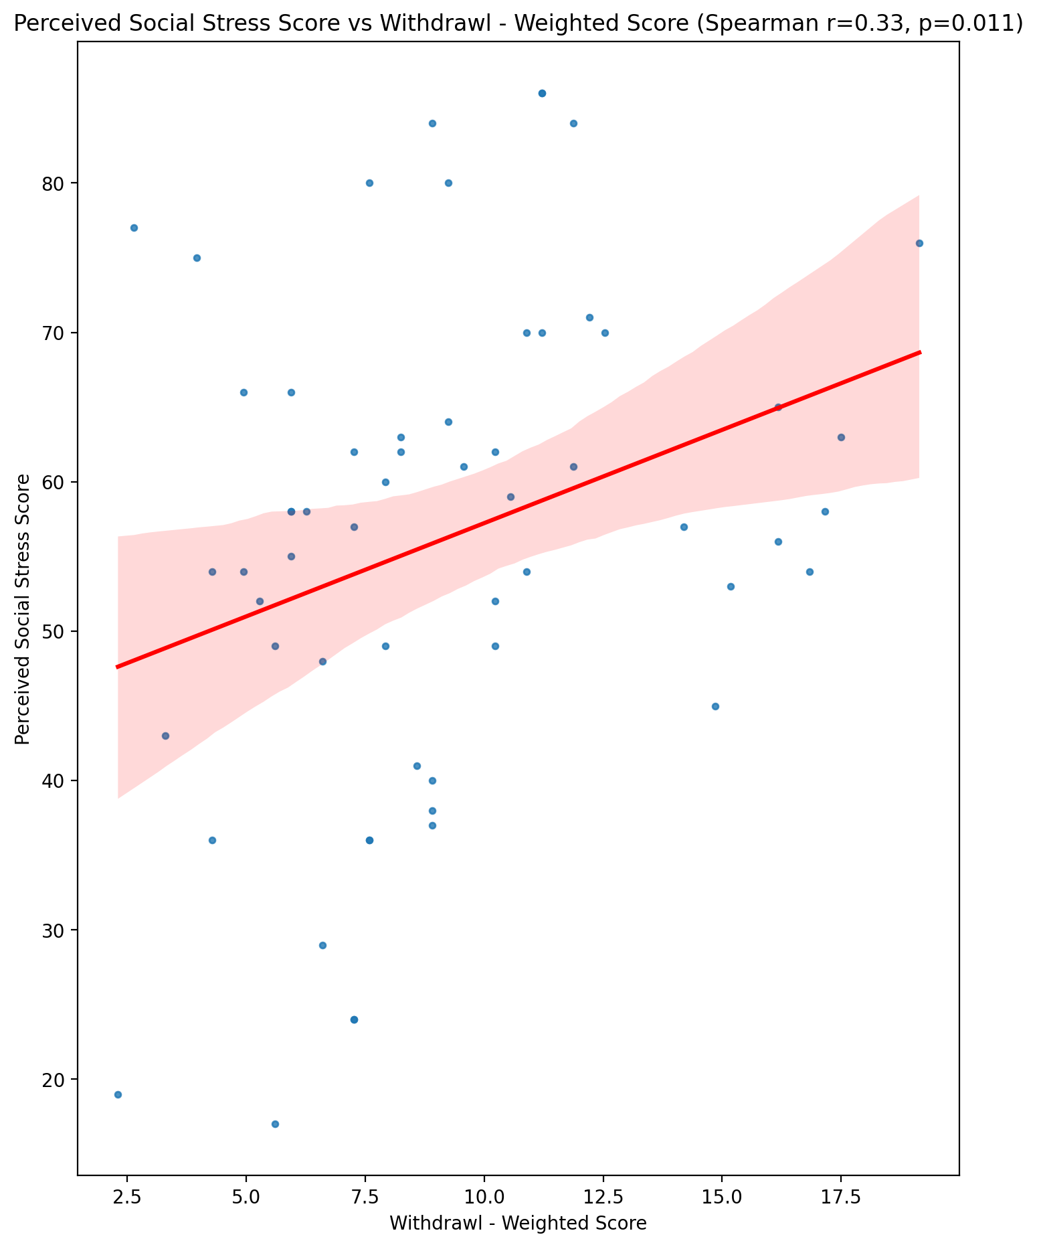

## Perceived Social Stress Category vs Withdrawl - Weighted Score

Test: None; statistic: None; p-value: None; Test not run: unsupported type combination.



## Emotional Support - Raw Score vs Occupational & Relationship Consequences - Weighted Score

Test: spearman; statistic: -0.3260220500949069; p-value: 0.011738618948395027;

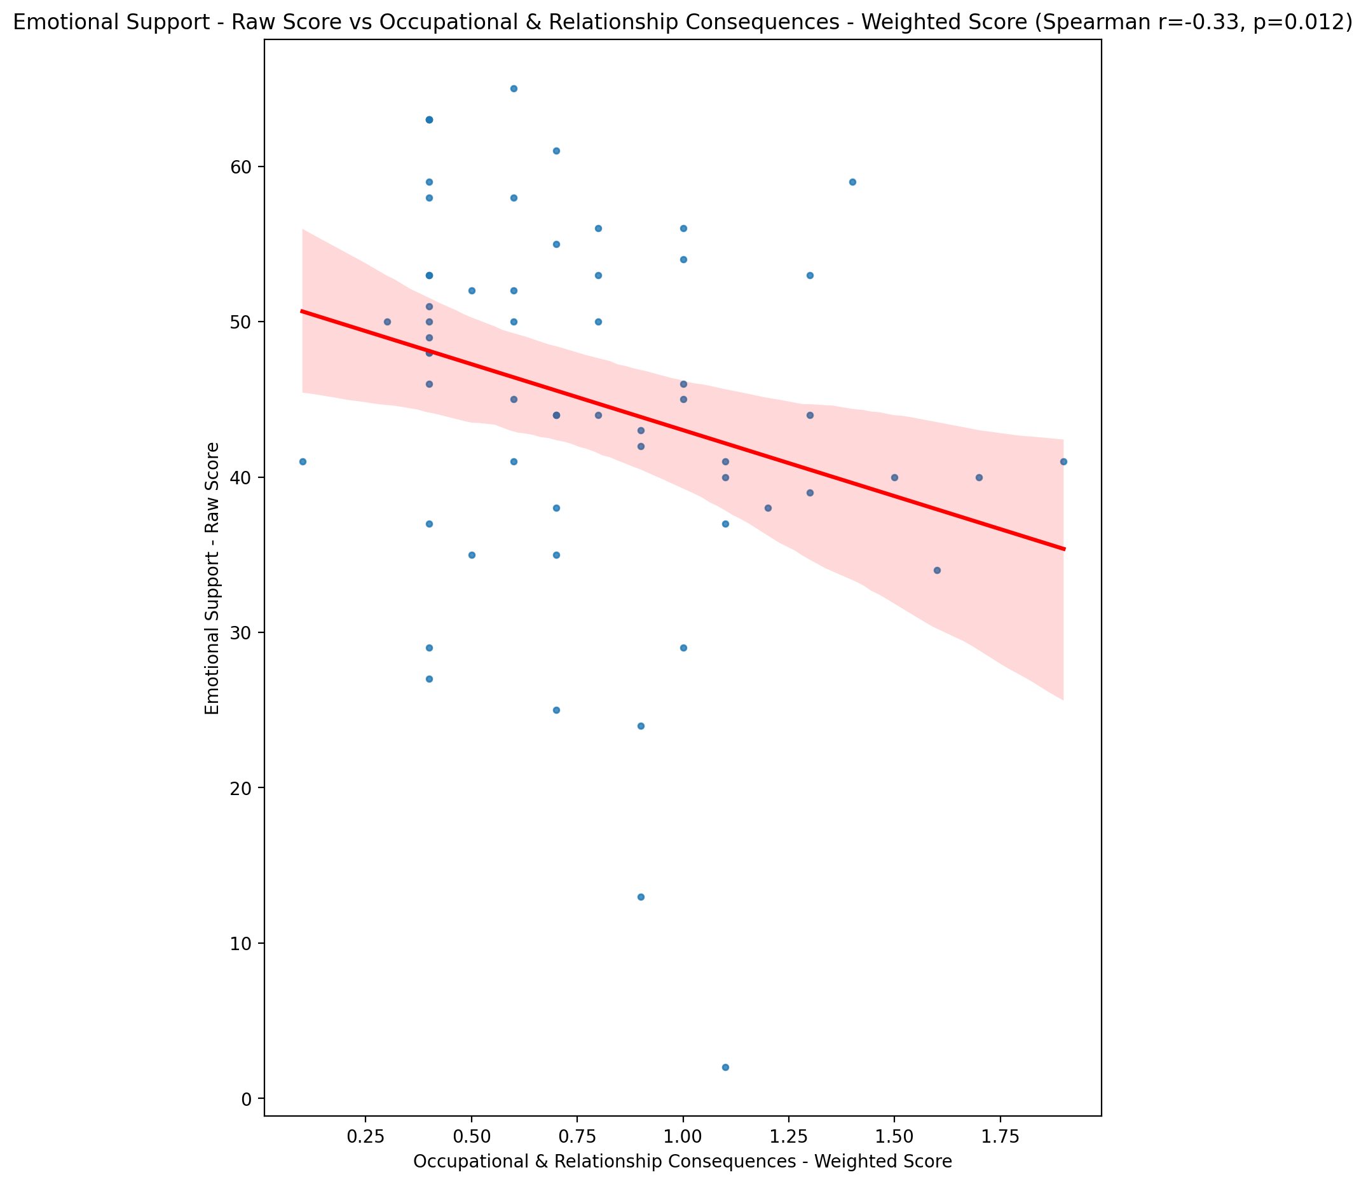

## Informational Support - Raw Score vs Occupational & Relationship Consequences - Weighted Score

Test: spearman; statistic: -0.25150433709493963; p-value: 0.05466634337490762;

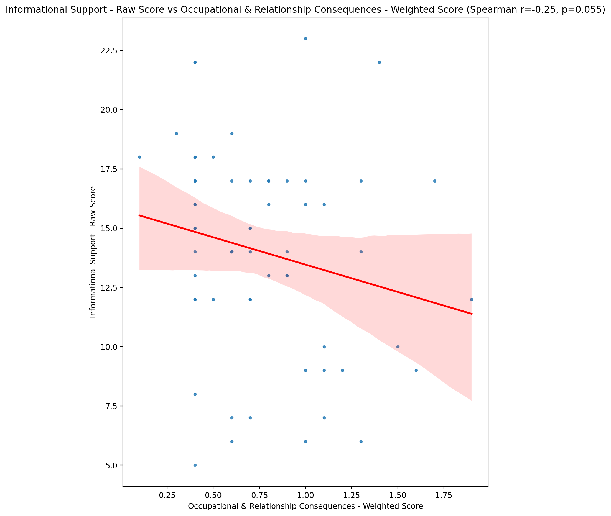

## Instrumental Support - Raw Score vs Occupational & Relationship Consequences - Weighted Score

Test: spearman; statistic: -0.2828246240310647; p-value: 0.029971843801167807;

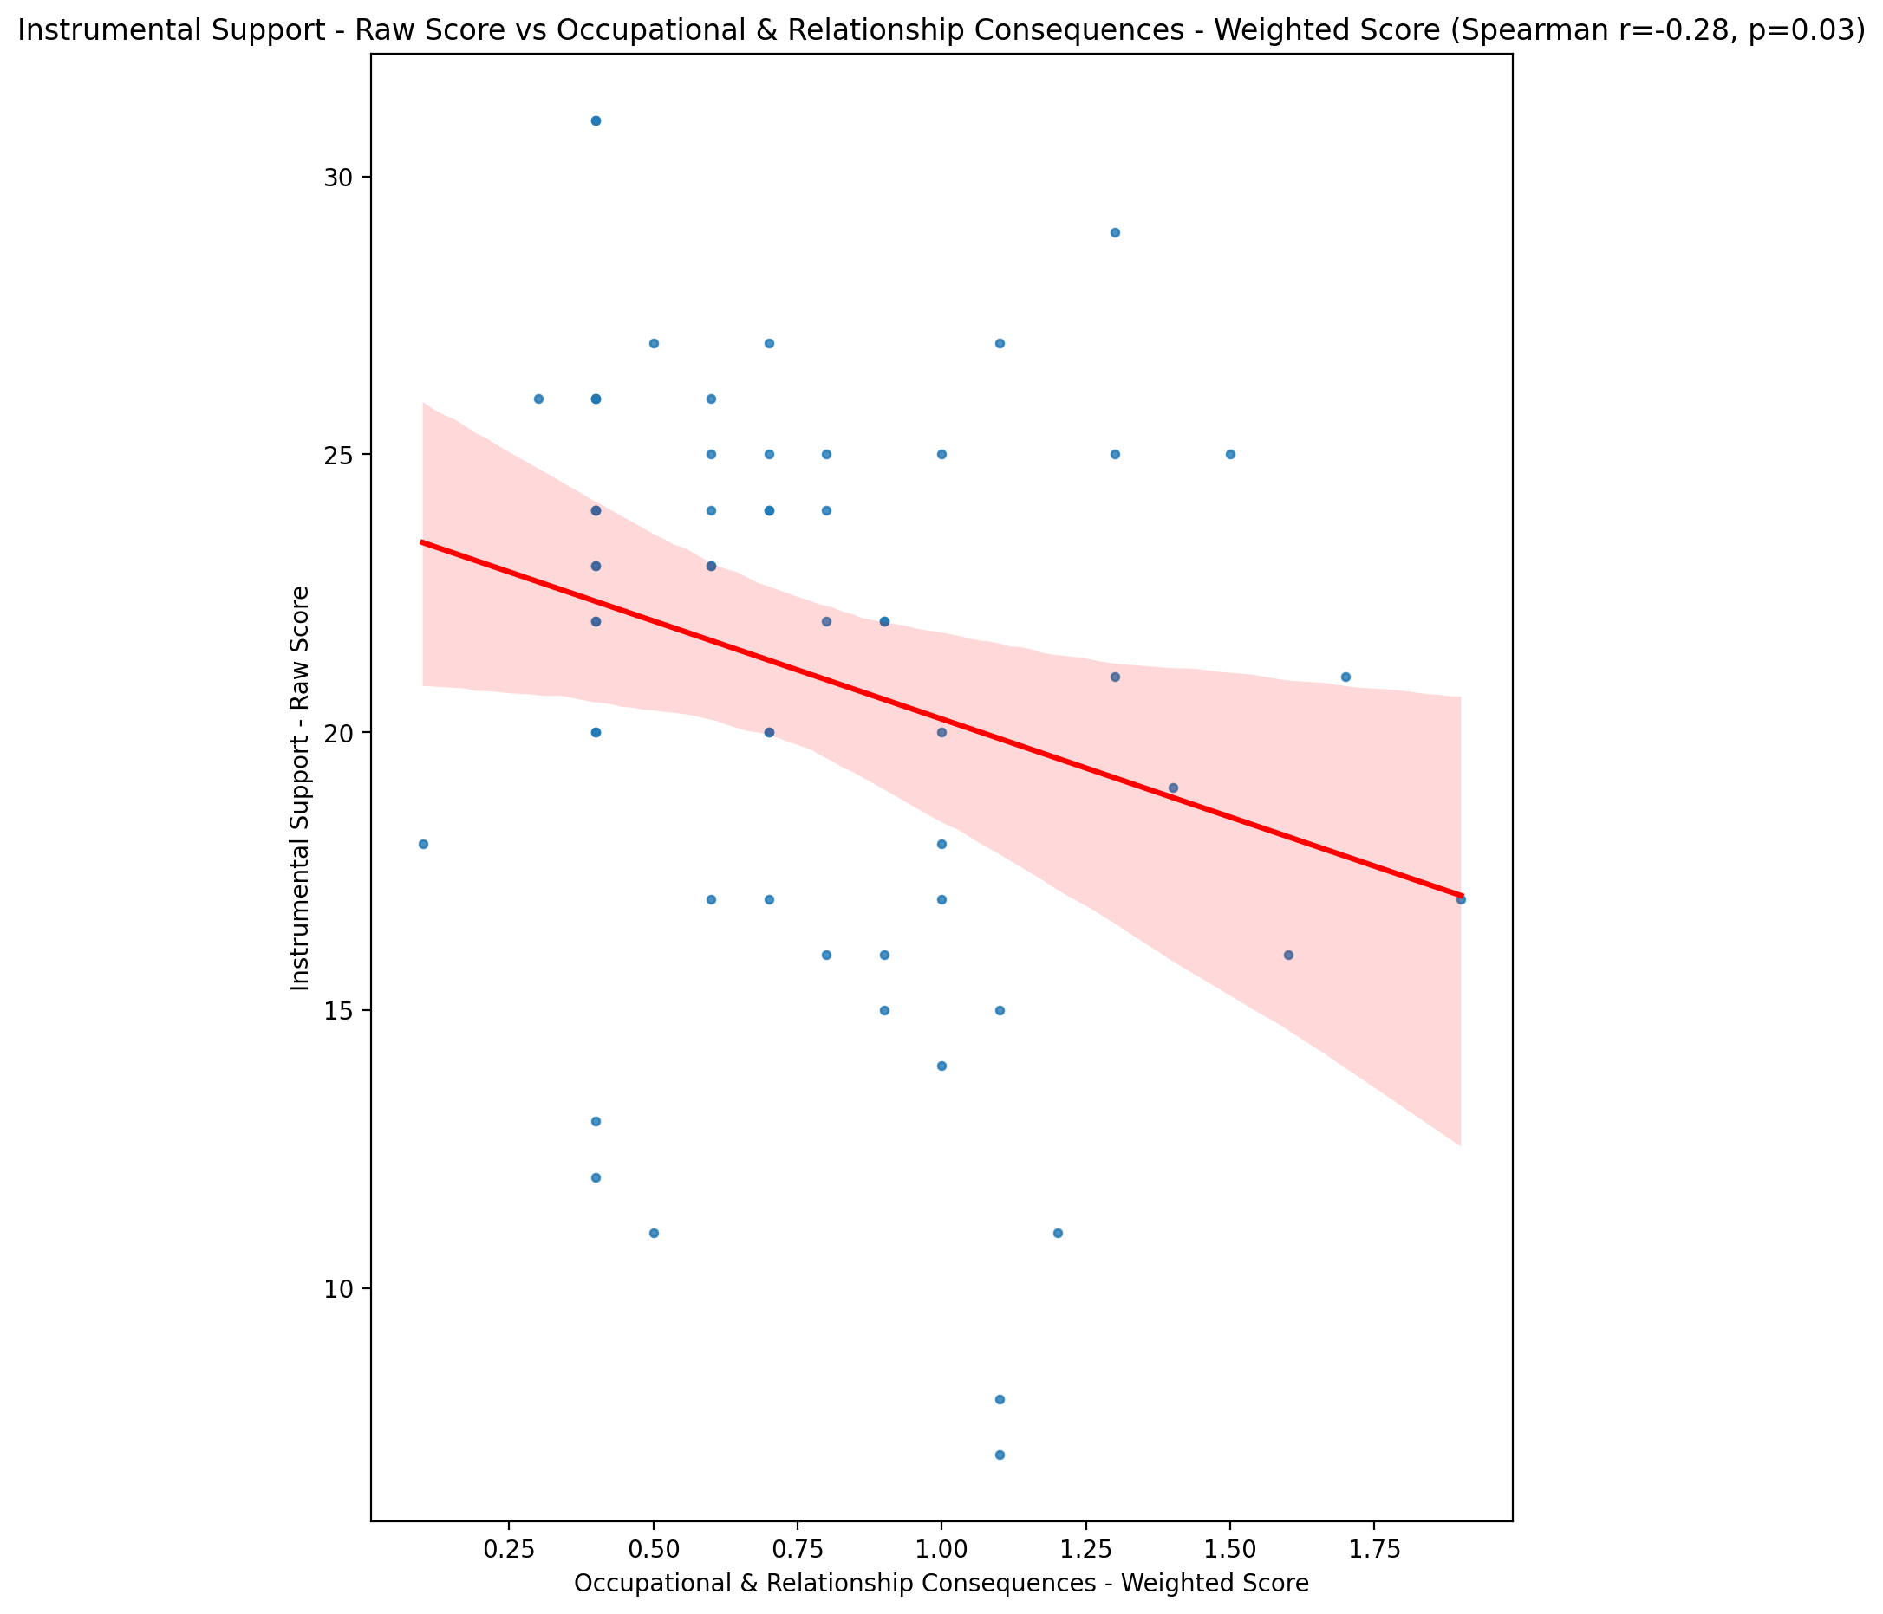

## Emotional Support - T Score vs Occupational & Relationship Consequences - Weighted Score

Test: spearman; statistic: -0.3210531782636944; p-value: 0.013163640923997385;

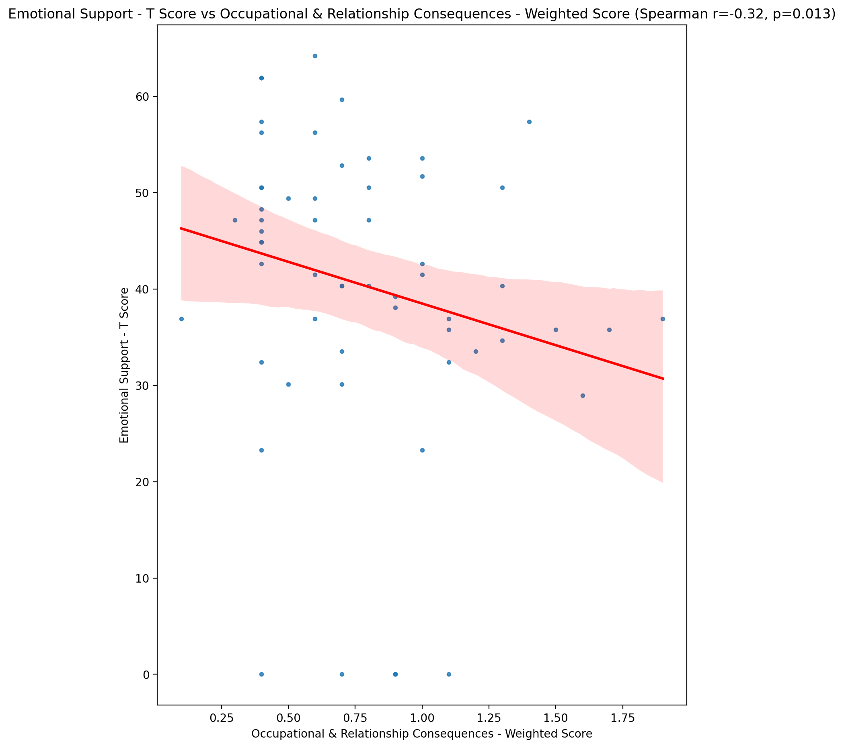

## Informational Support - T Score vs Occupational & Relationship Consequences - Weighted Score

Test: spearman; statistic: -0.2501355337978137; p-value: 0.0560413240878798;

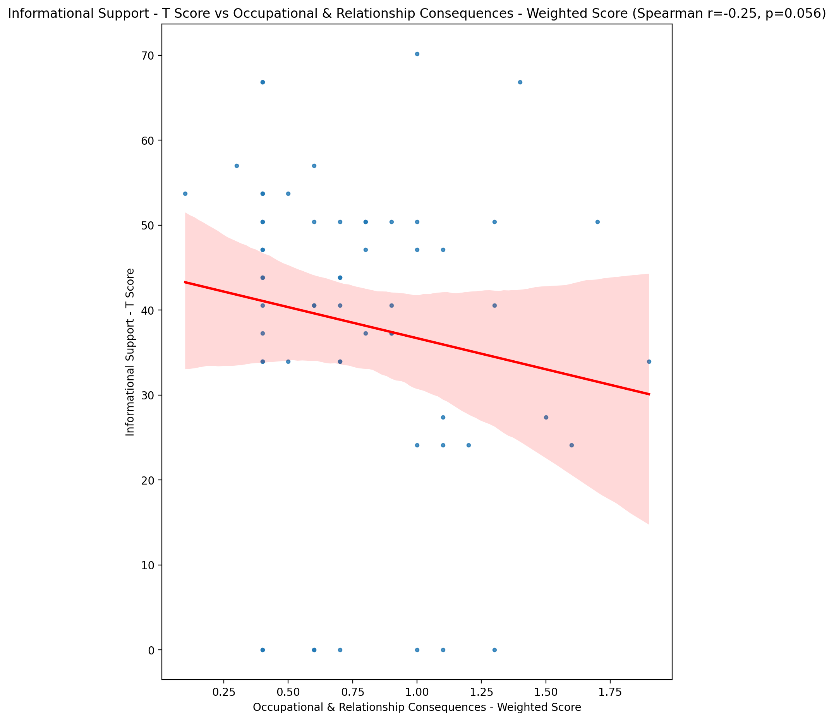

## Instrumental Support - T Score vs Occupational & Relationship Consequences - Weighted Score

Test: spearman; statistic: -0.2739443186741241; p-value: 0.03577008943812326;

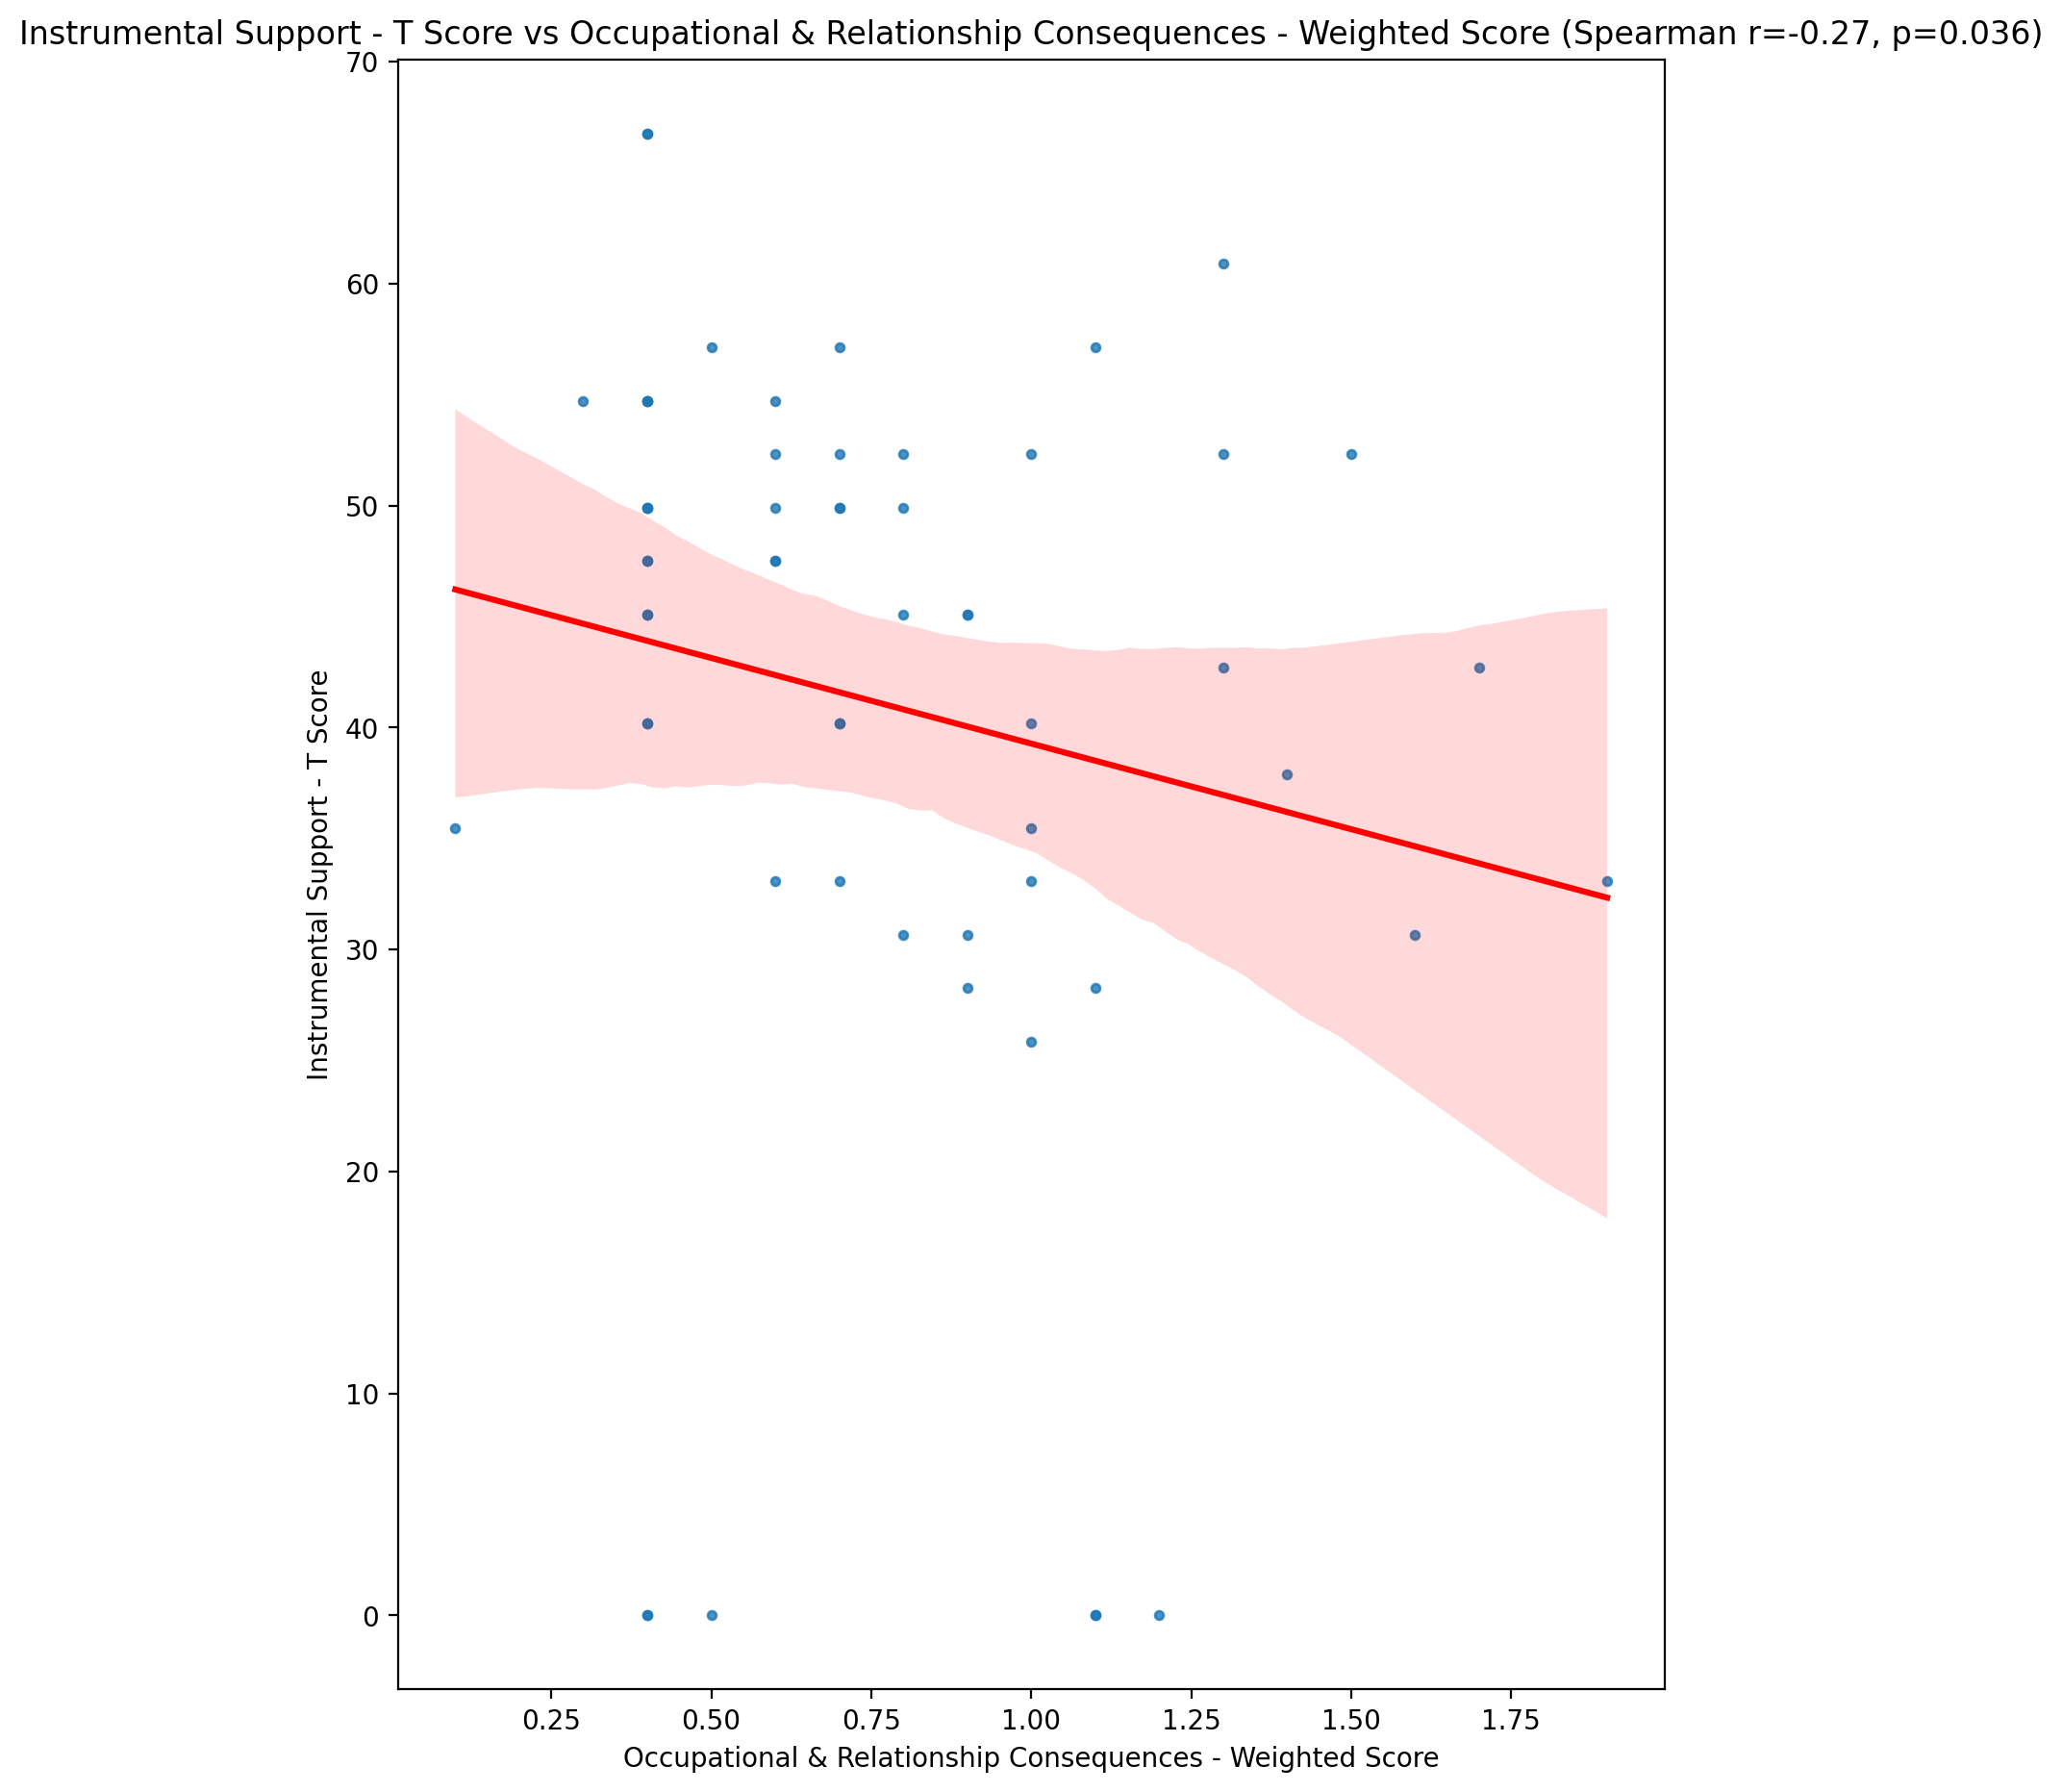

## Perceived Social Support Total T Score vs Occupational & Relationship Consequences - Weighted Score

Test: spearman; statistic: -0.3277434082438921; p-value: 0.011277033906955662;

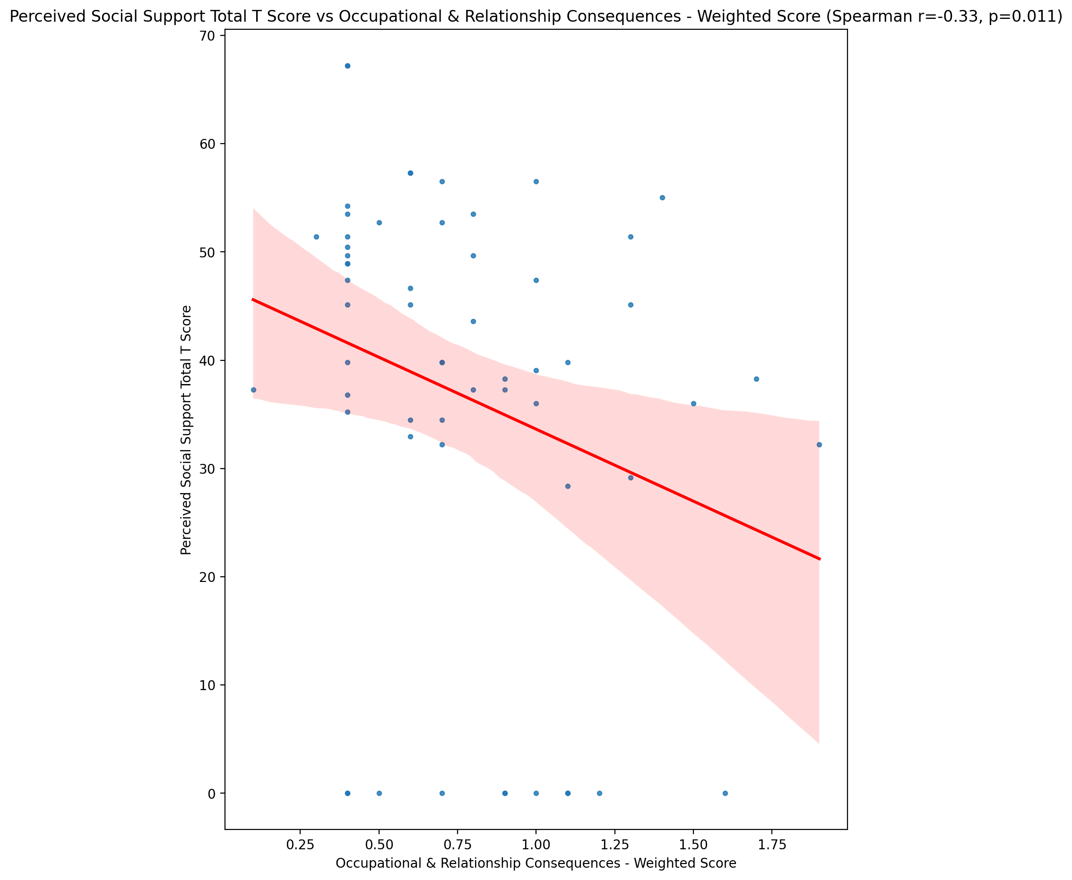

## Emotional Support - Rank vs Occupational & Relationship Consequences - Weighted Score

Test: None; statistic: None; p-value: None; Test not run: unsupported type combination.



## Informational Support - Rank vs Occupational & Relationship Consequences - Weighted Score

Test: None; statistic: None; p-value: None; Test not run: unsupported type combination.



## Instrumental Support - Rank vs Occupational & Relationship Consequences - Weighted Score

Test: None; statistic: None; p-value: None; Test not run: unsupported type combination.



## Perceived Social Support TOTAL - Rank vs Occupational & Relationship Consequences - Weighted Score

Test: None; statistic: None; p-value: None; Test not run: unsupported type combination.



## Power Self Concept - Real Self Concept Score vs Occupational & Relationship Consequences - Weighted Score

Test: spearman; statistic: -0.13638948944978654; p-value: 0.30299337424420064;

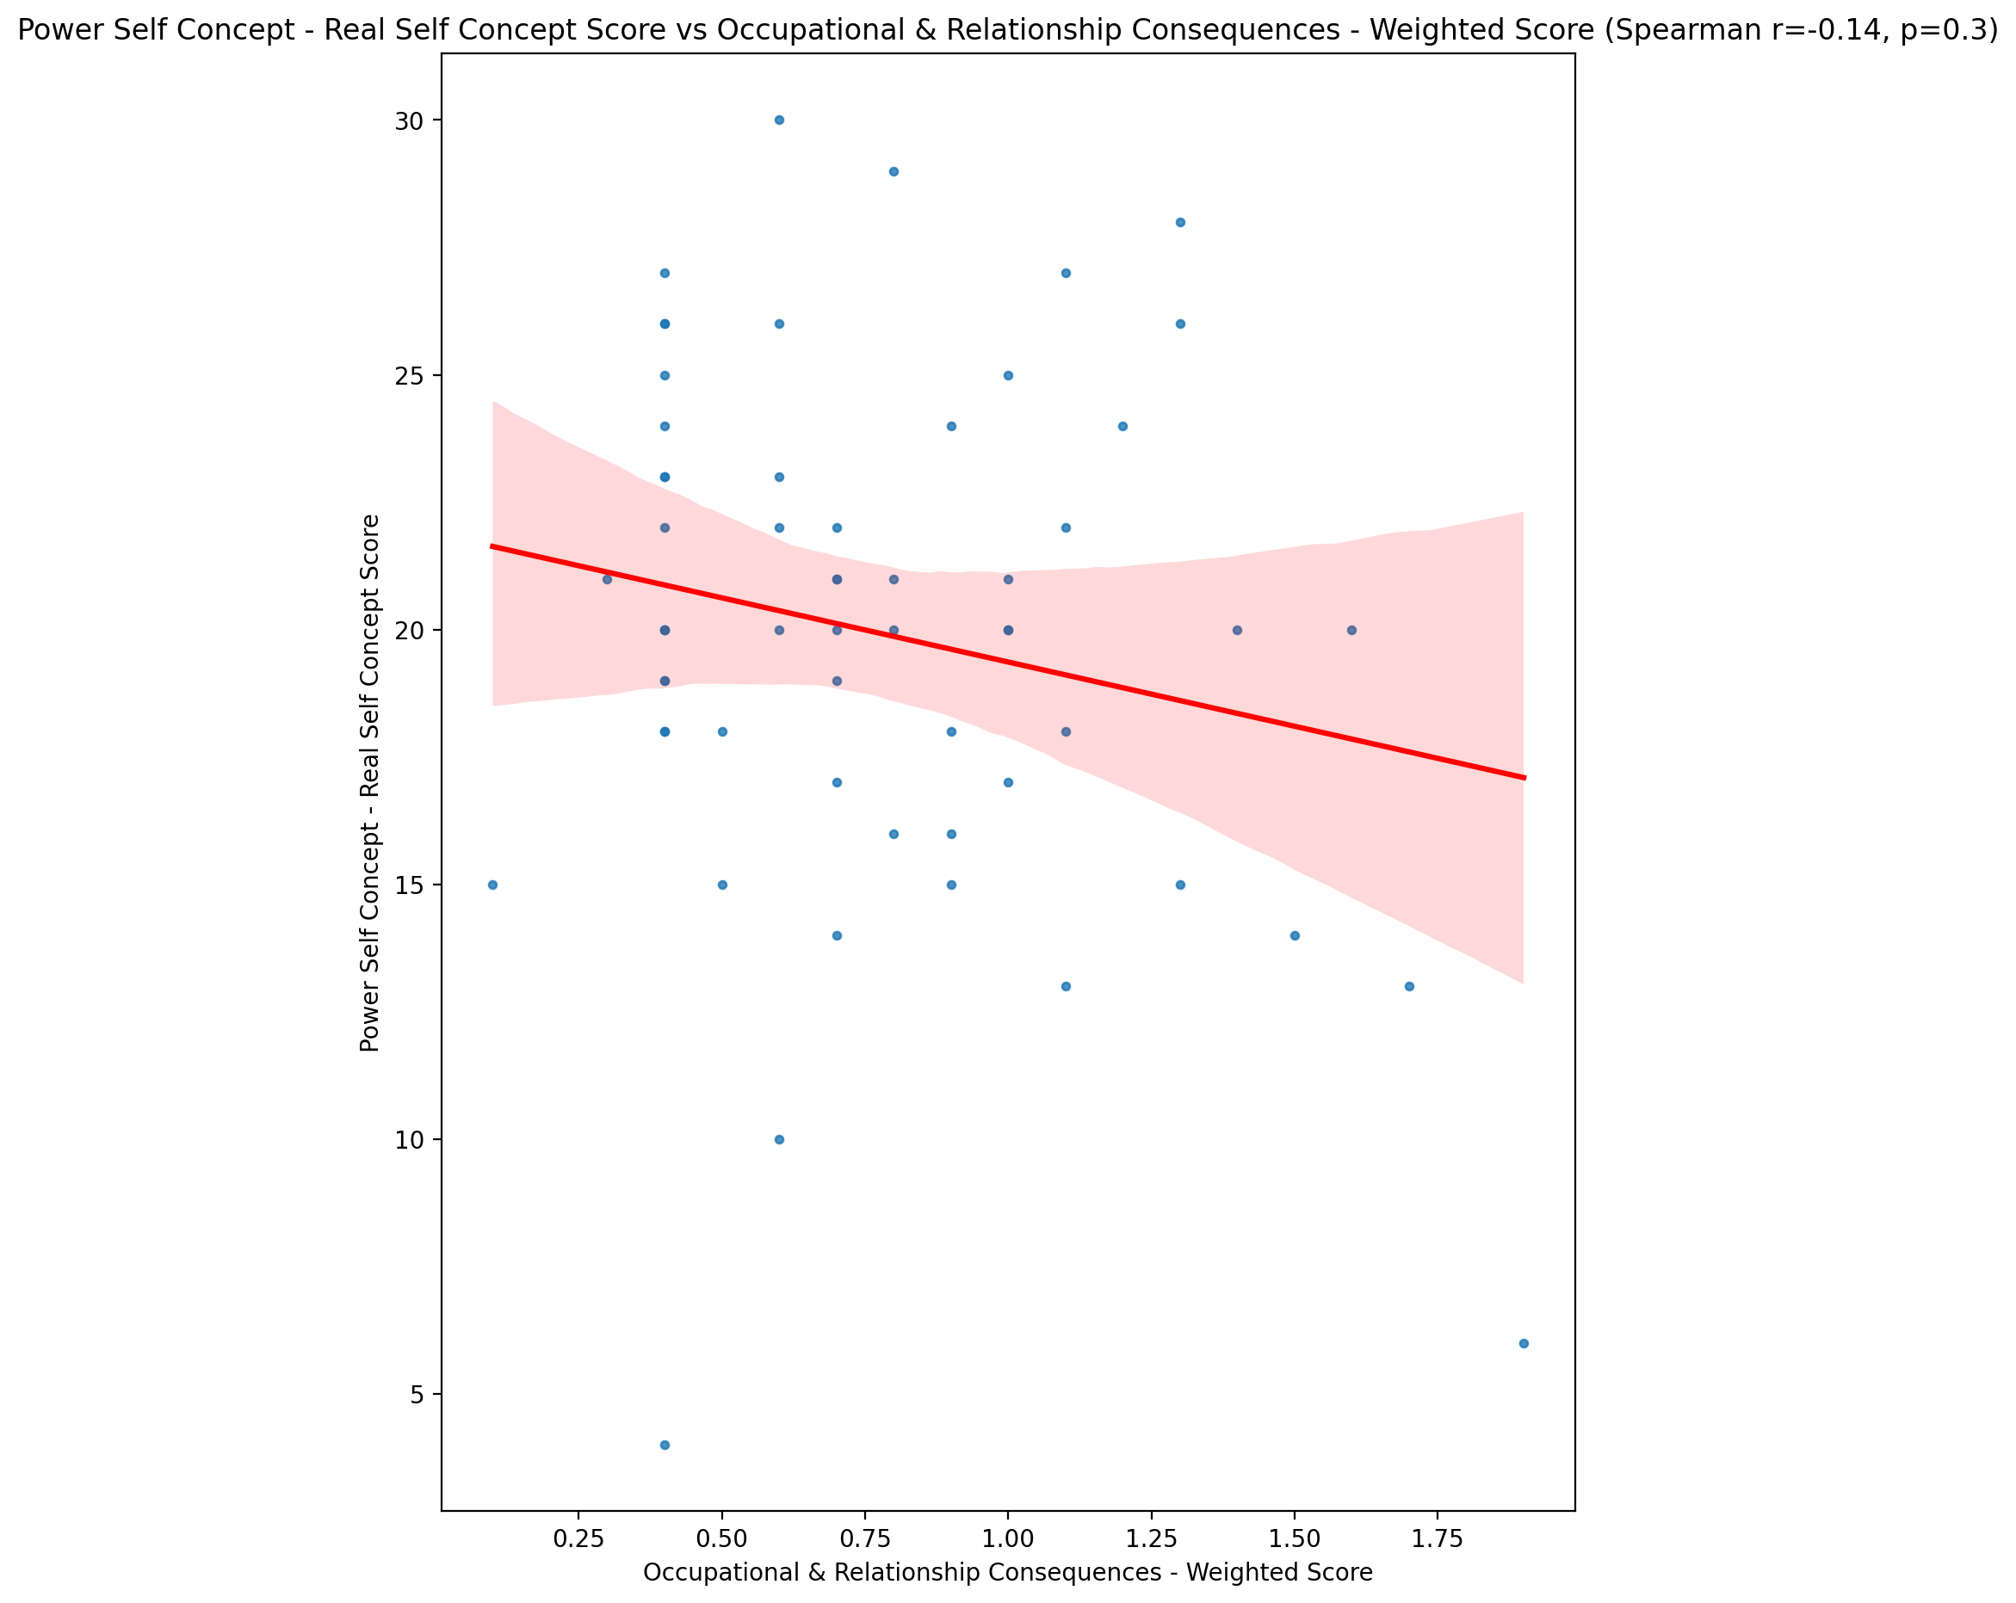

## Power Self Concept - Ideal Self Concept score vs Occupational & Relationship Consequences - Weighted Score

Test: spearman; statistic: -0.2706393626615261; p-value: 0.038153156079394894;

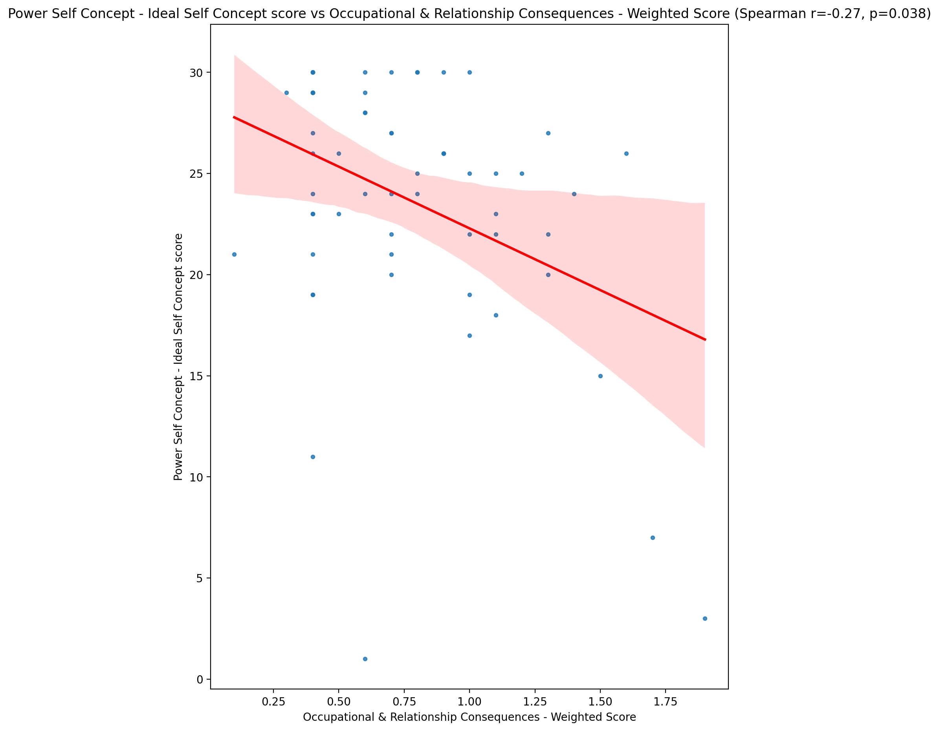

## Power Self Concept – Social Self Concept Score vs Occupational & Relationship Consequences - Weighted Score

Test: spearman; statistic: -0.03642980726315595; p-value: 0.7841411381470763;

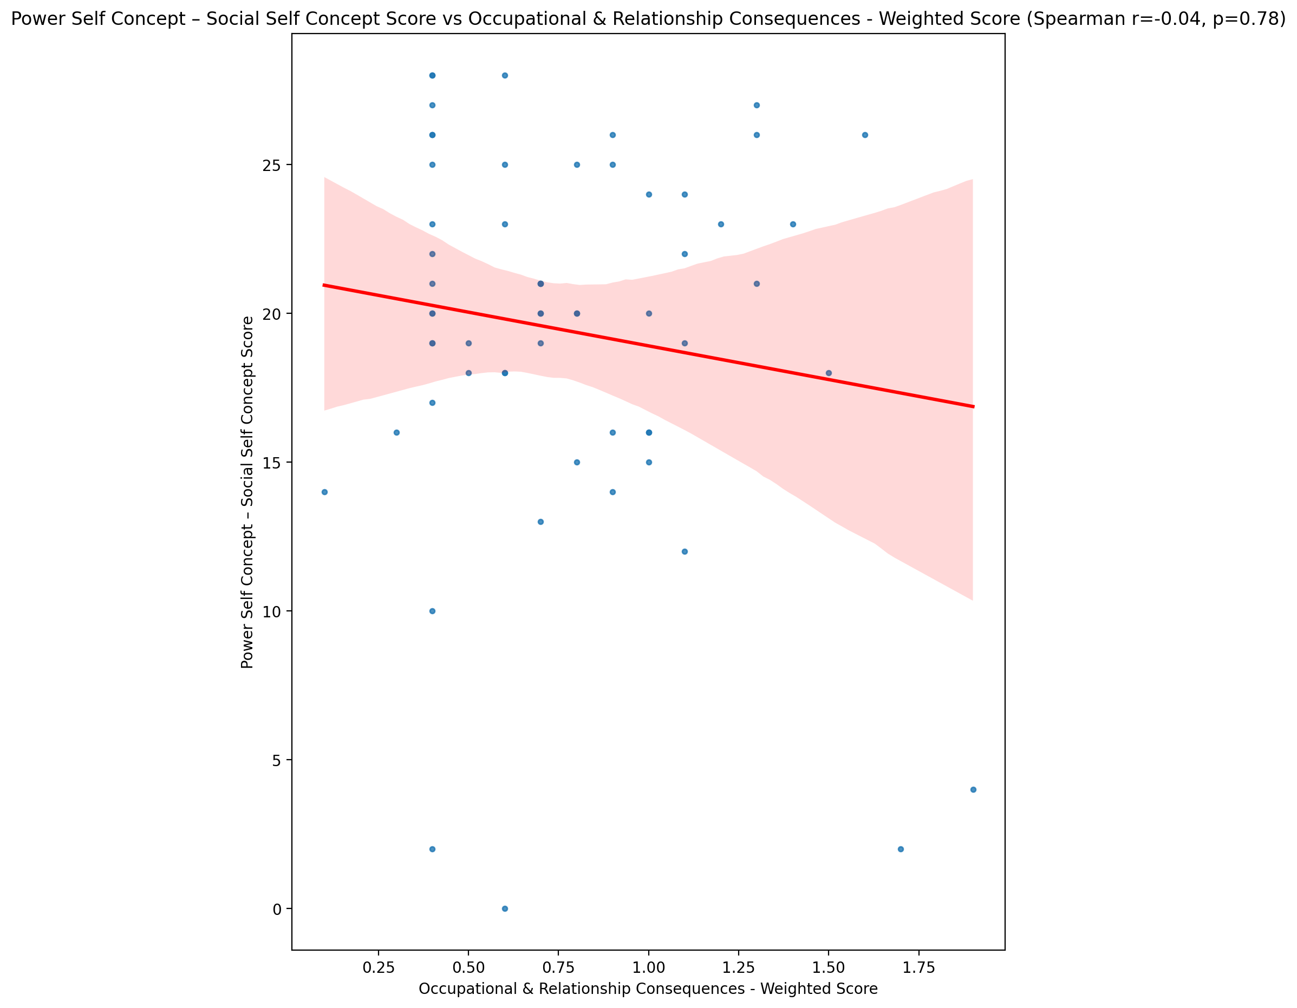

## Social Self Concept - Real Self Concept Score vs Occupational & Relationship Consequences - Weighted Score

Test: spearman; statistic: -0.2877226468375078; p-value: 0.027125330825481058;

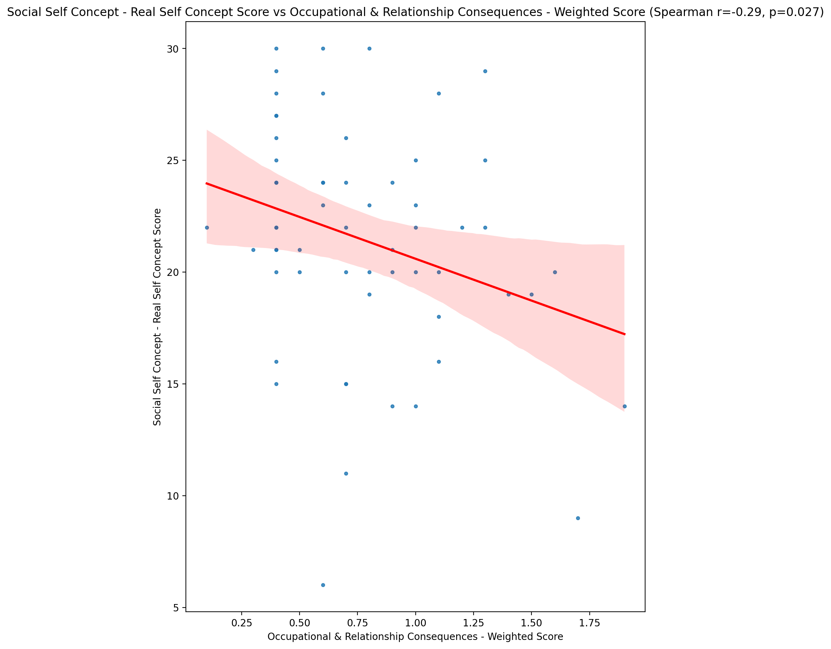

## Social Self Concept – Social Self Concept Score vs Occupational & Relationship Consequences - Weighted Score

Test: spearman; statistic: -0.13632247956722443; p-value: 0.30323323757390575;

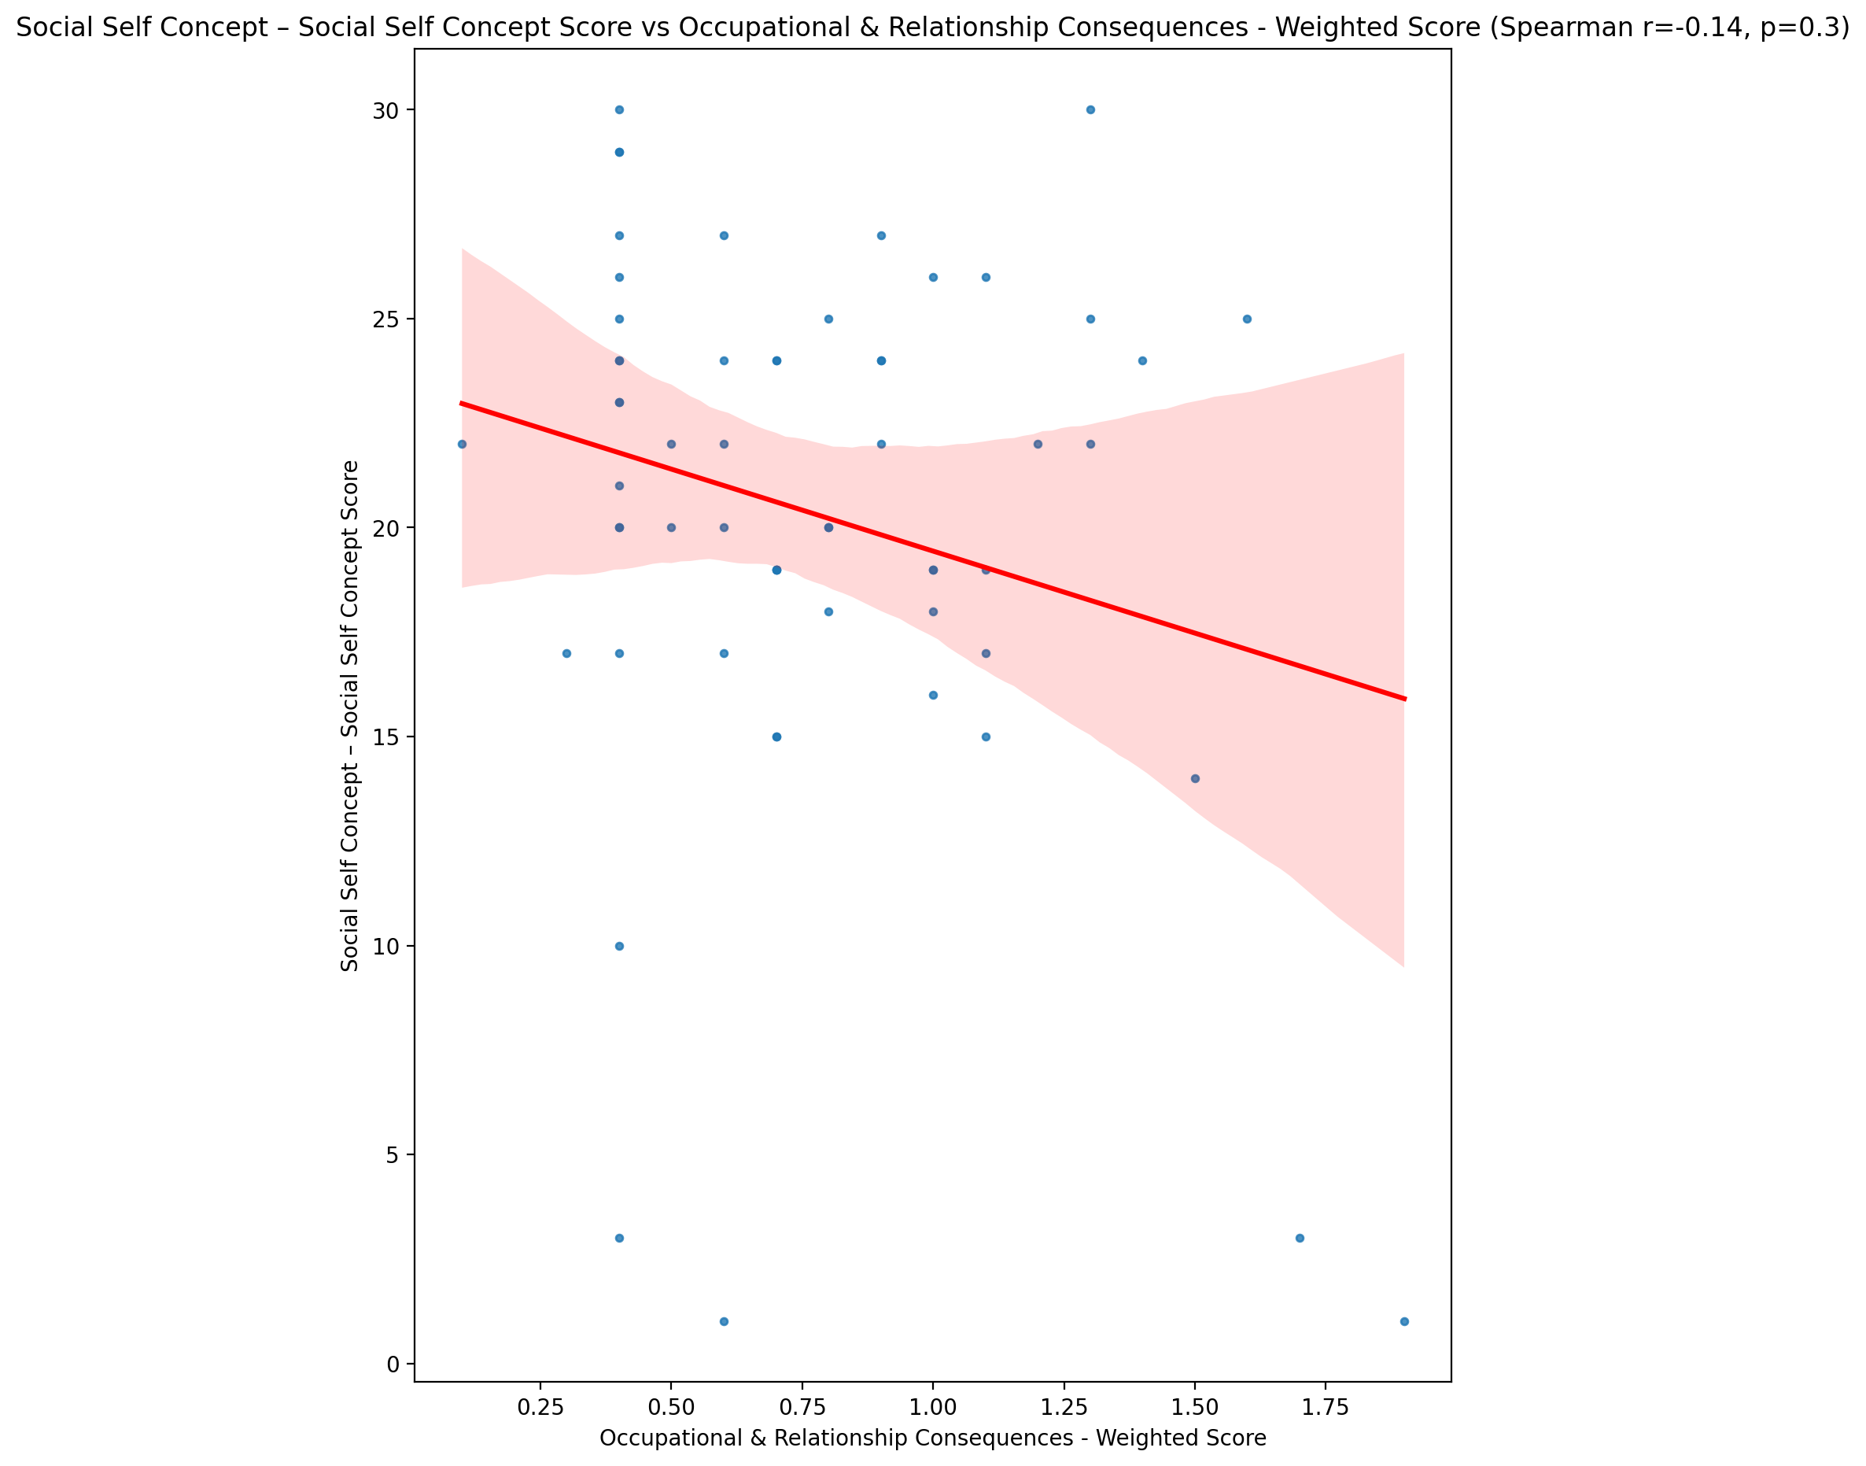

## Ability Self Concept - Real Self Concept Score vs Occupational & Relationship Consequences - Weighted Score

Test: spearman; statistic: -0.24761616929634198; p-value: 0.05864527579382614;

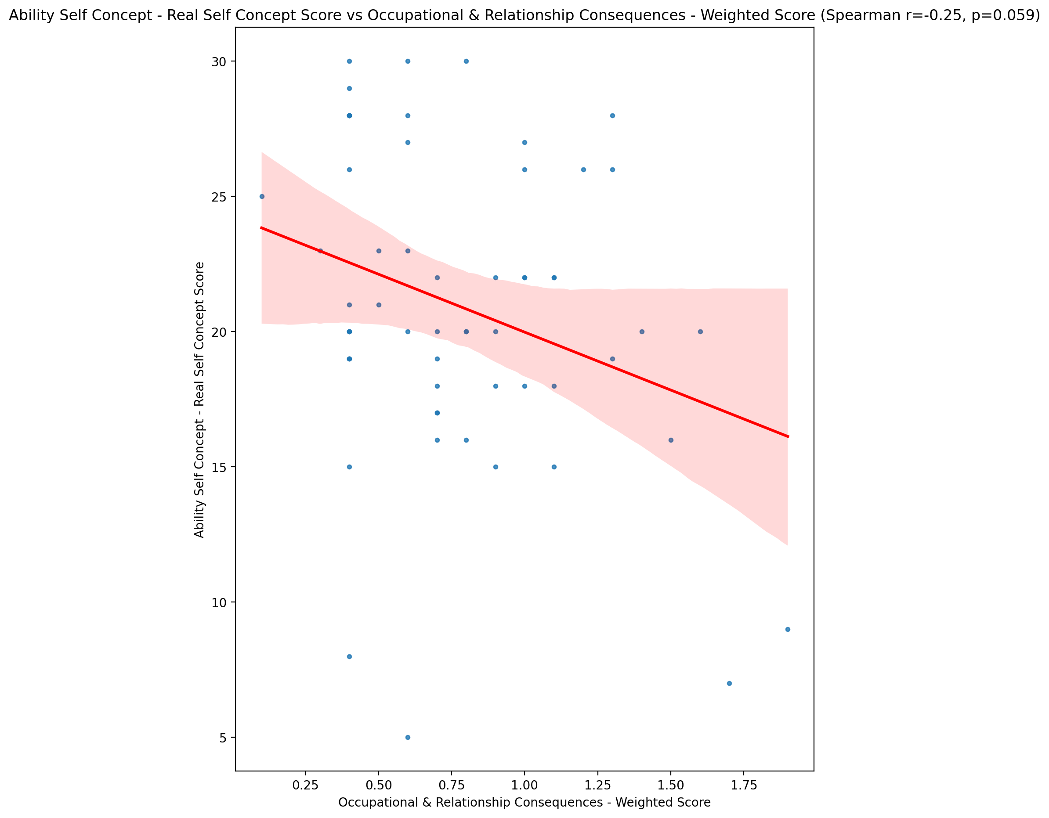

## Ability Self Concept - Ideal Self Concept Score vs Occupational & Relationship Consequences - Weighted Score

Test: spearman; statistic: -0.28104328897886344; p-value: 0.031067203631433695;

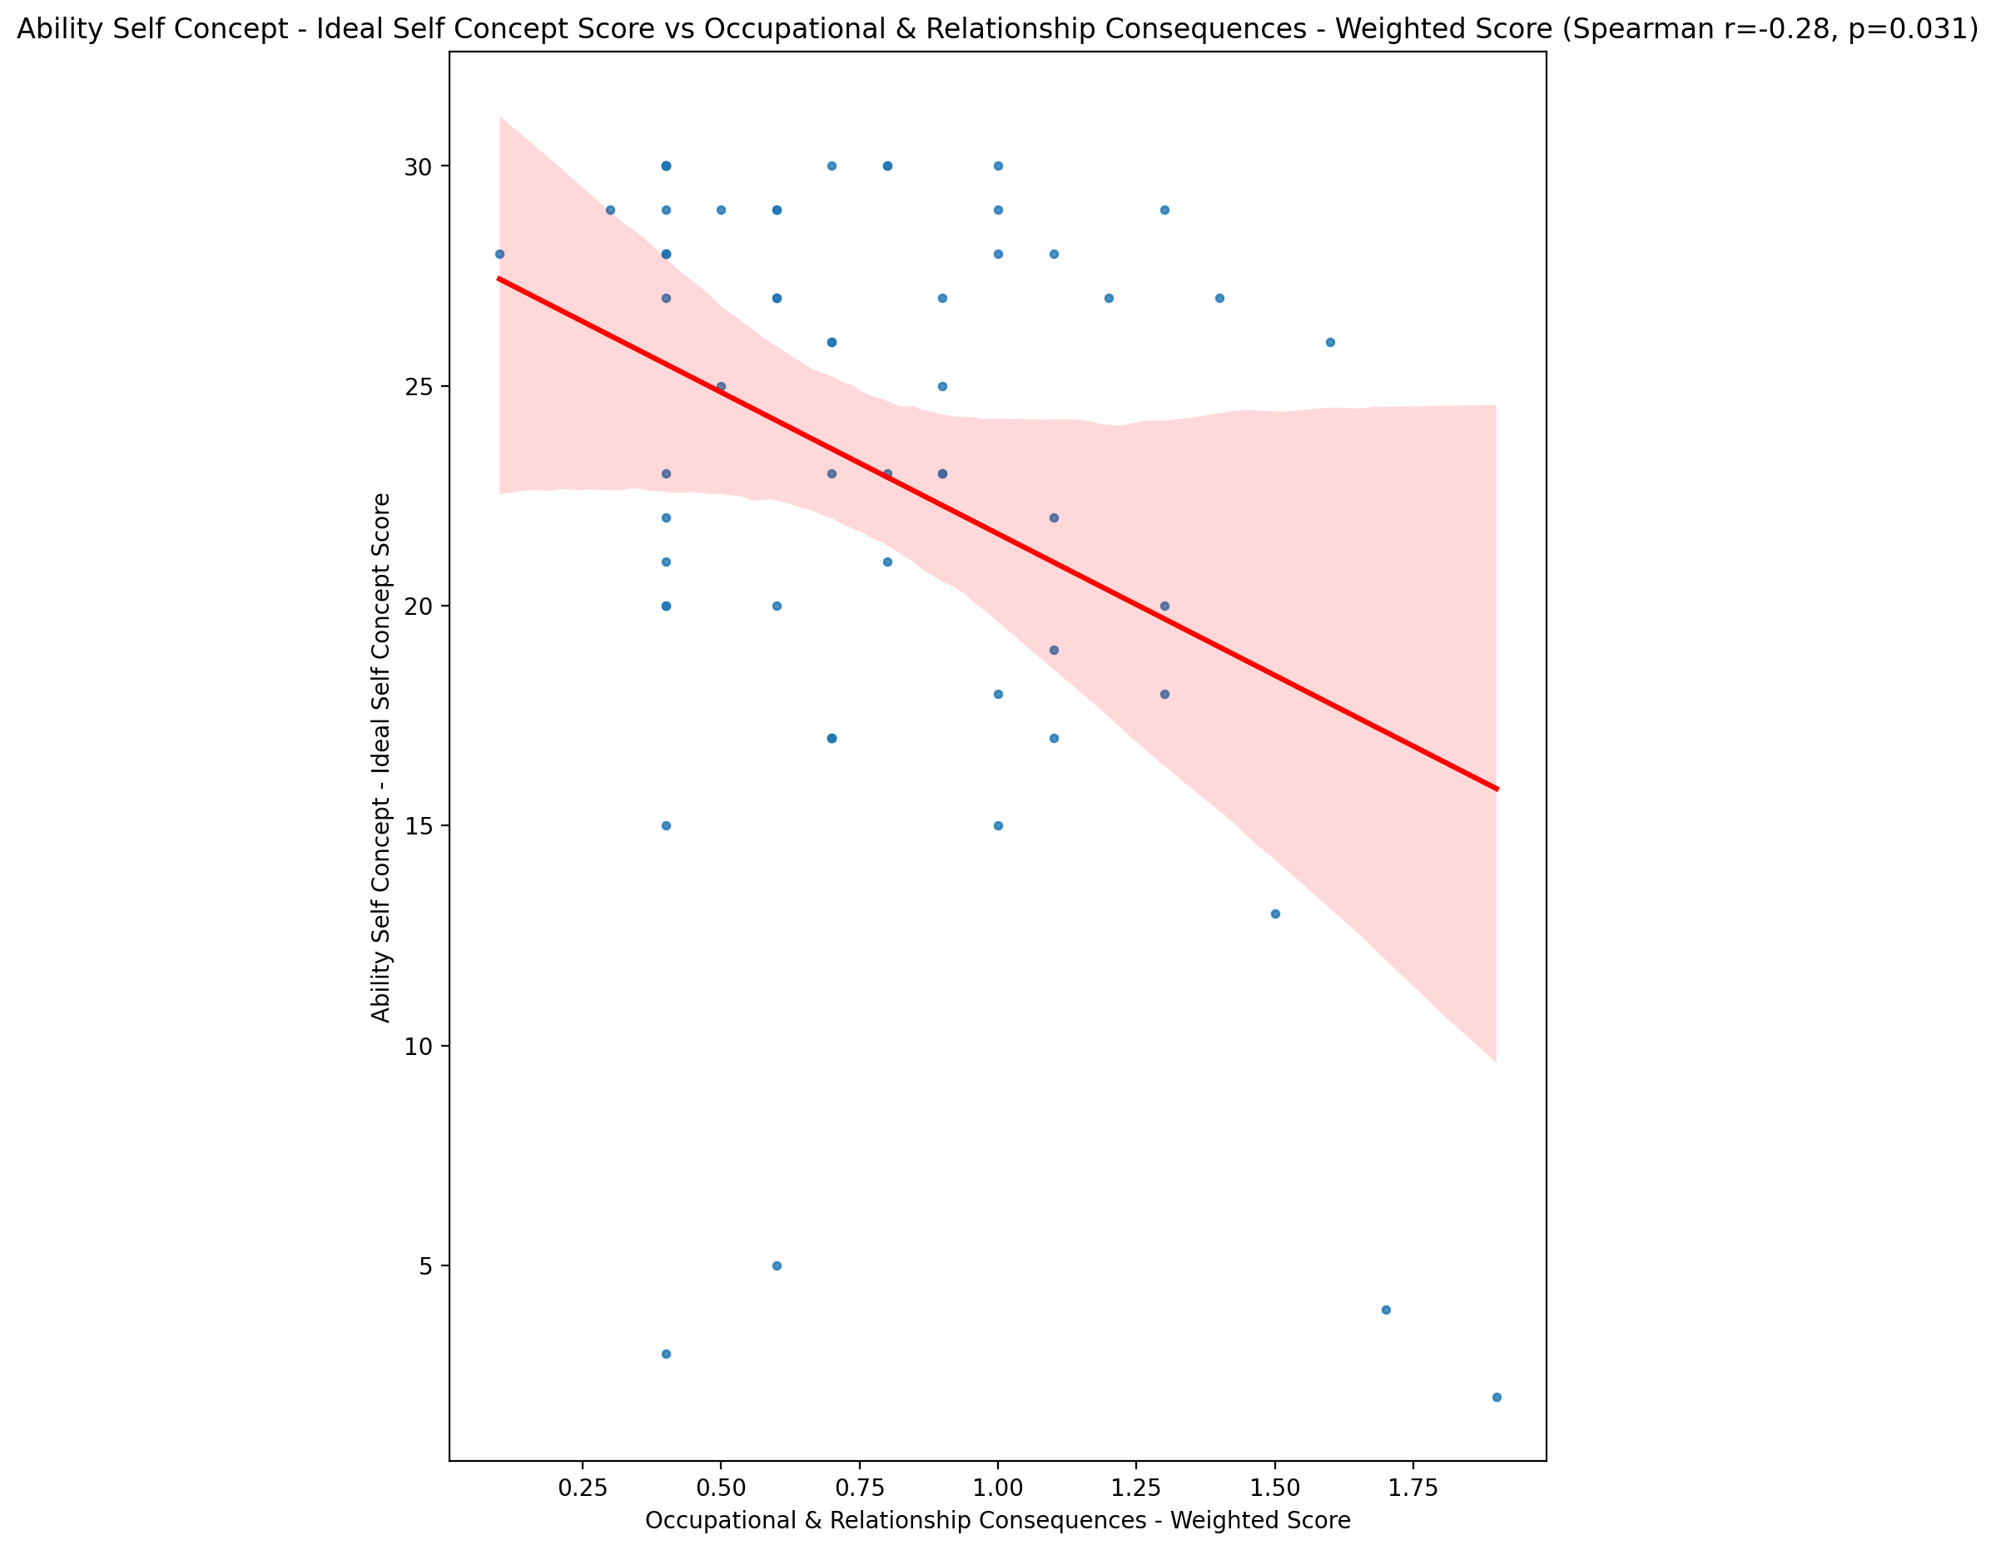

## Ability Self Concept – Social Self Concept Score vs Occupational & Relationship Consequences - Weighted Score

Test: spearman; statistic: -0.0886913320210593; p-value: 0.5041379383567481;

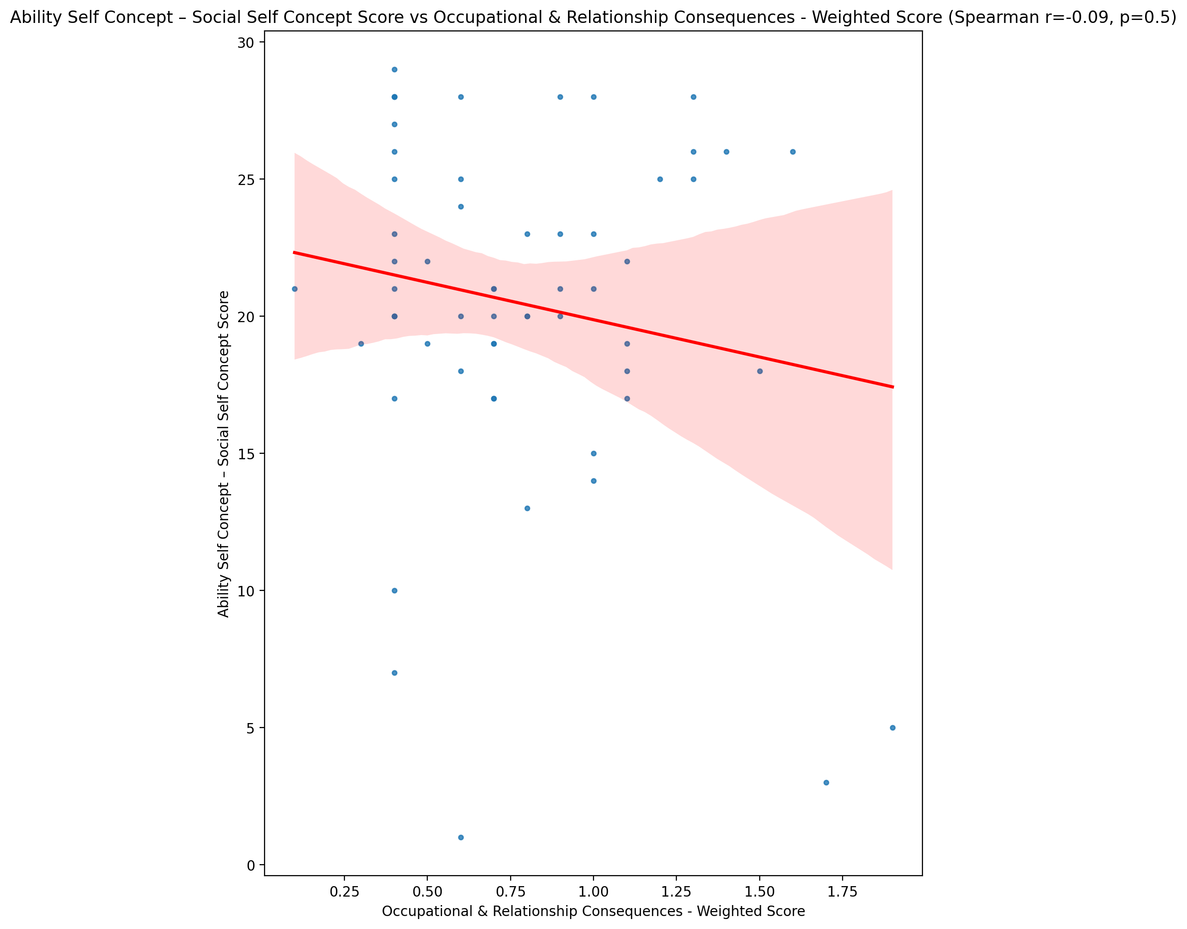

## Physical Self Concept - Real Self Concept Score vs Occupational & Relationship Consequences - Weighted Score

Test: spearman; statistic: -0.25189065228723106; p-value: 0.05428327967847835;

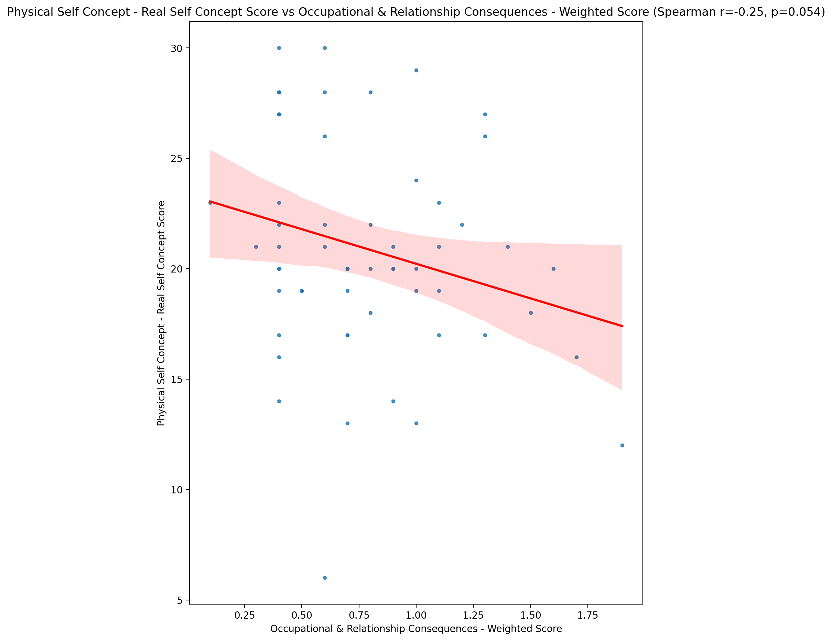

## Physical Self Concept – Ideal Self Concept Score vs Occupational & Relationship Consequences - Weighted Score

Test: spearman; statistic: -0.2856200032285607; p-value: 0.028318171095694736;

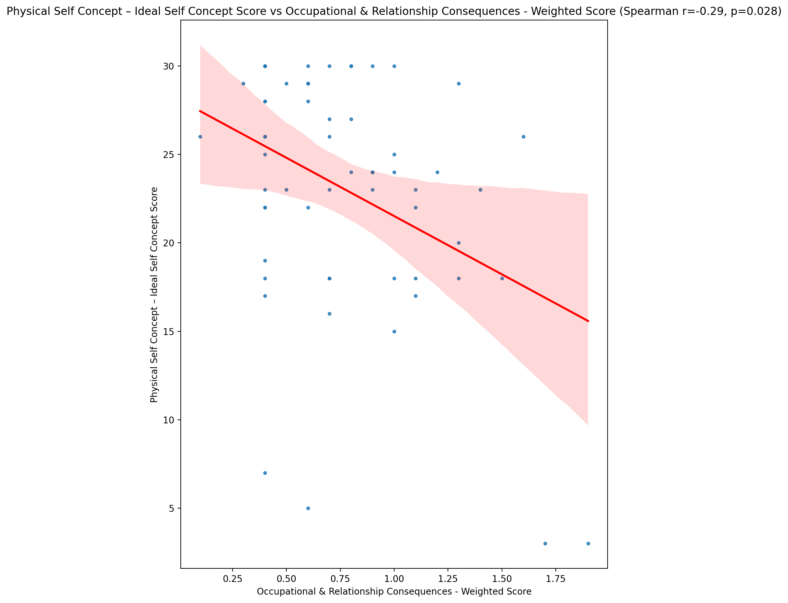

## Physical Self Concept – Social Self Concept Score vs Occupational & Relationship Consequences - Weighted Score

Test: spearman; statistic: -0.1582115788406436; p-value: 0.23138458155087016;

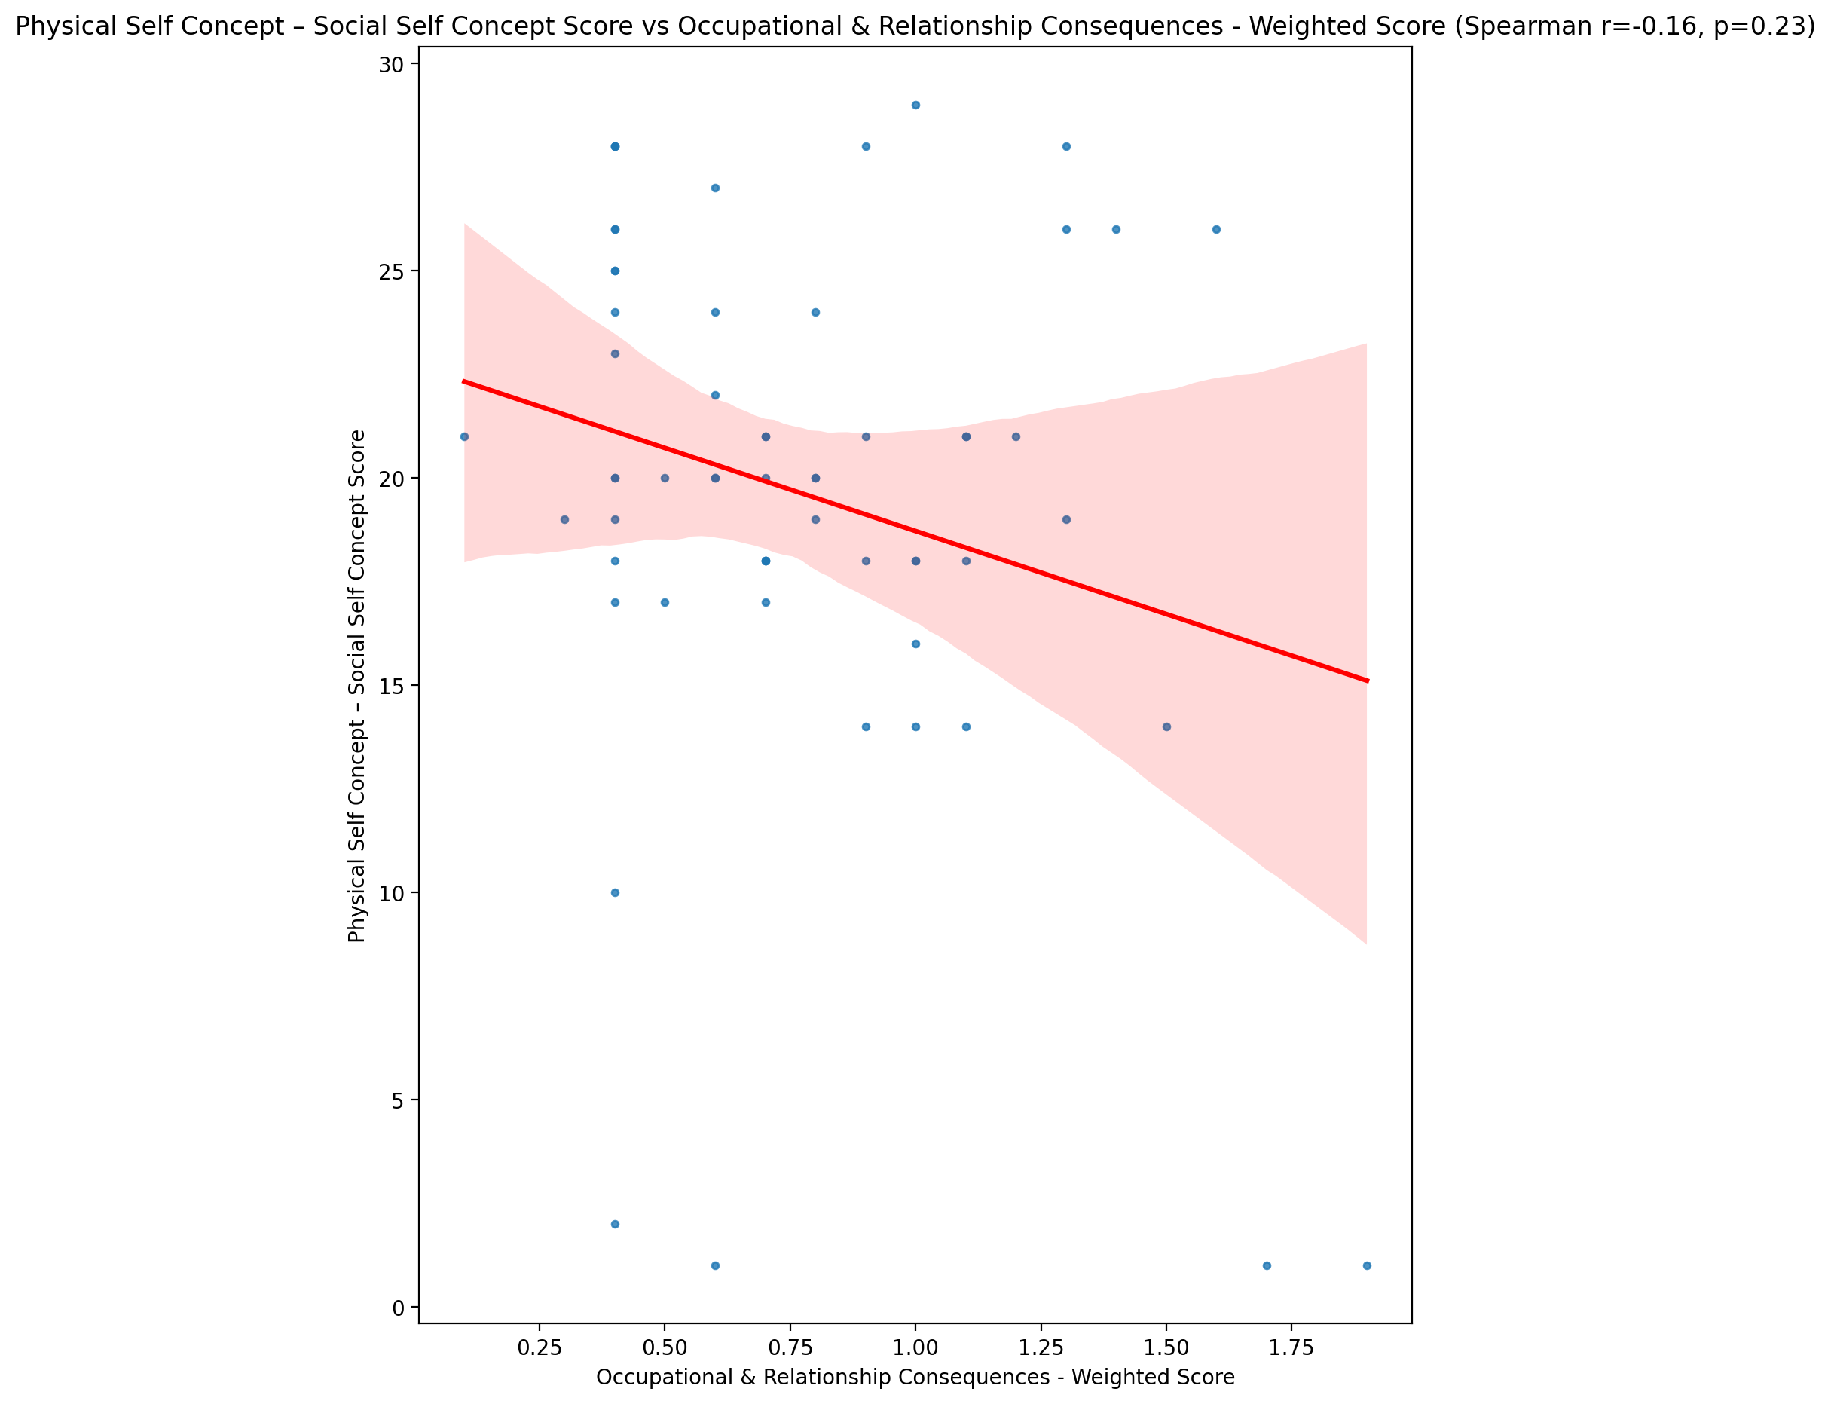

## Psychological Self Concept - Real Self Concept Score vs Occupational & Relationship Consequences - Weighted Score

Test: spearman; statistic: -0.31307761870590817; p-value: 0.01576205244691859;

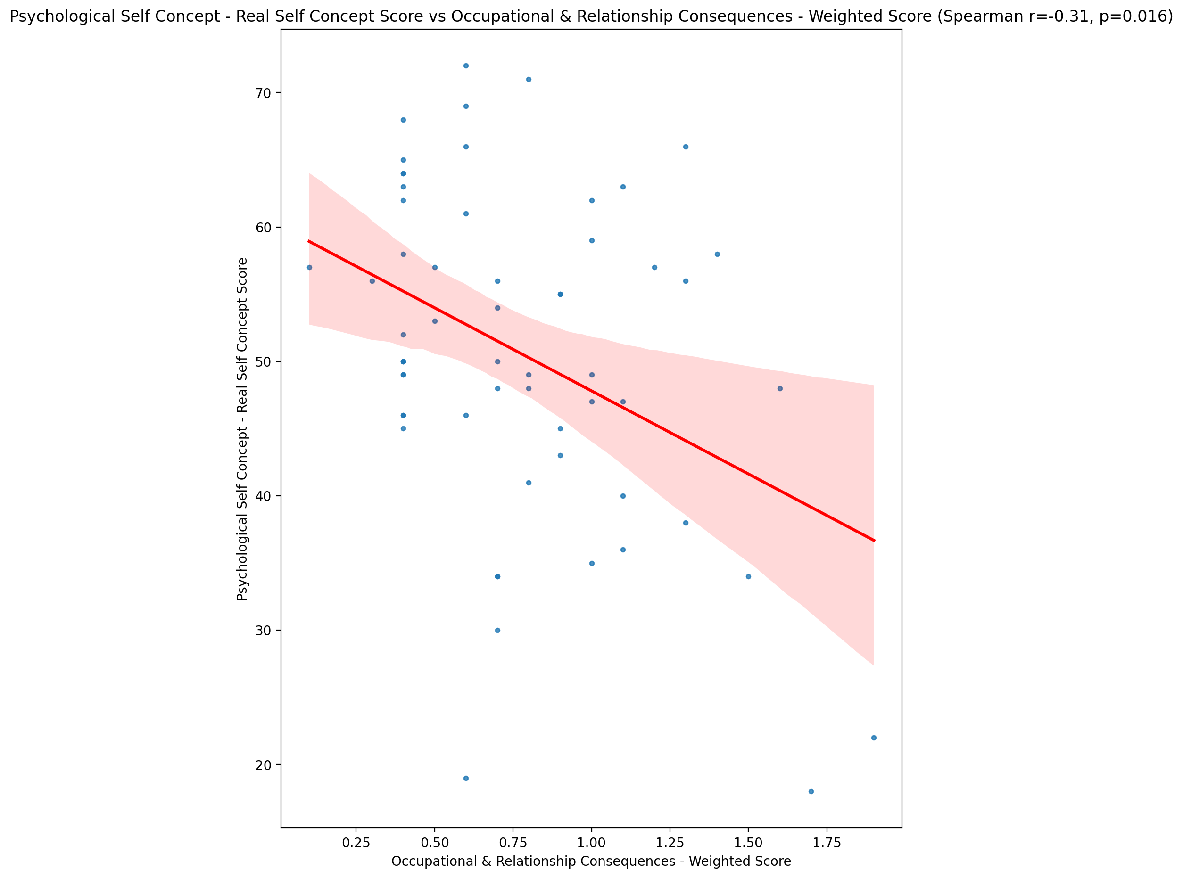

## Psychological Self Concept – Ideal Self Concept Score vs Occupational & Relationship Consequences - Weighted Score

Test: spearman; statistic: -0.2607244084174373; p-value: 0.046102366278529566;

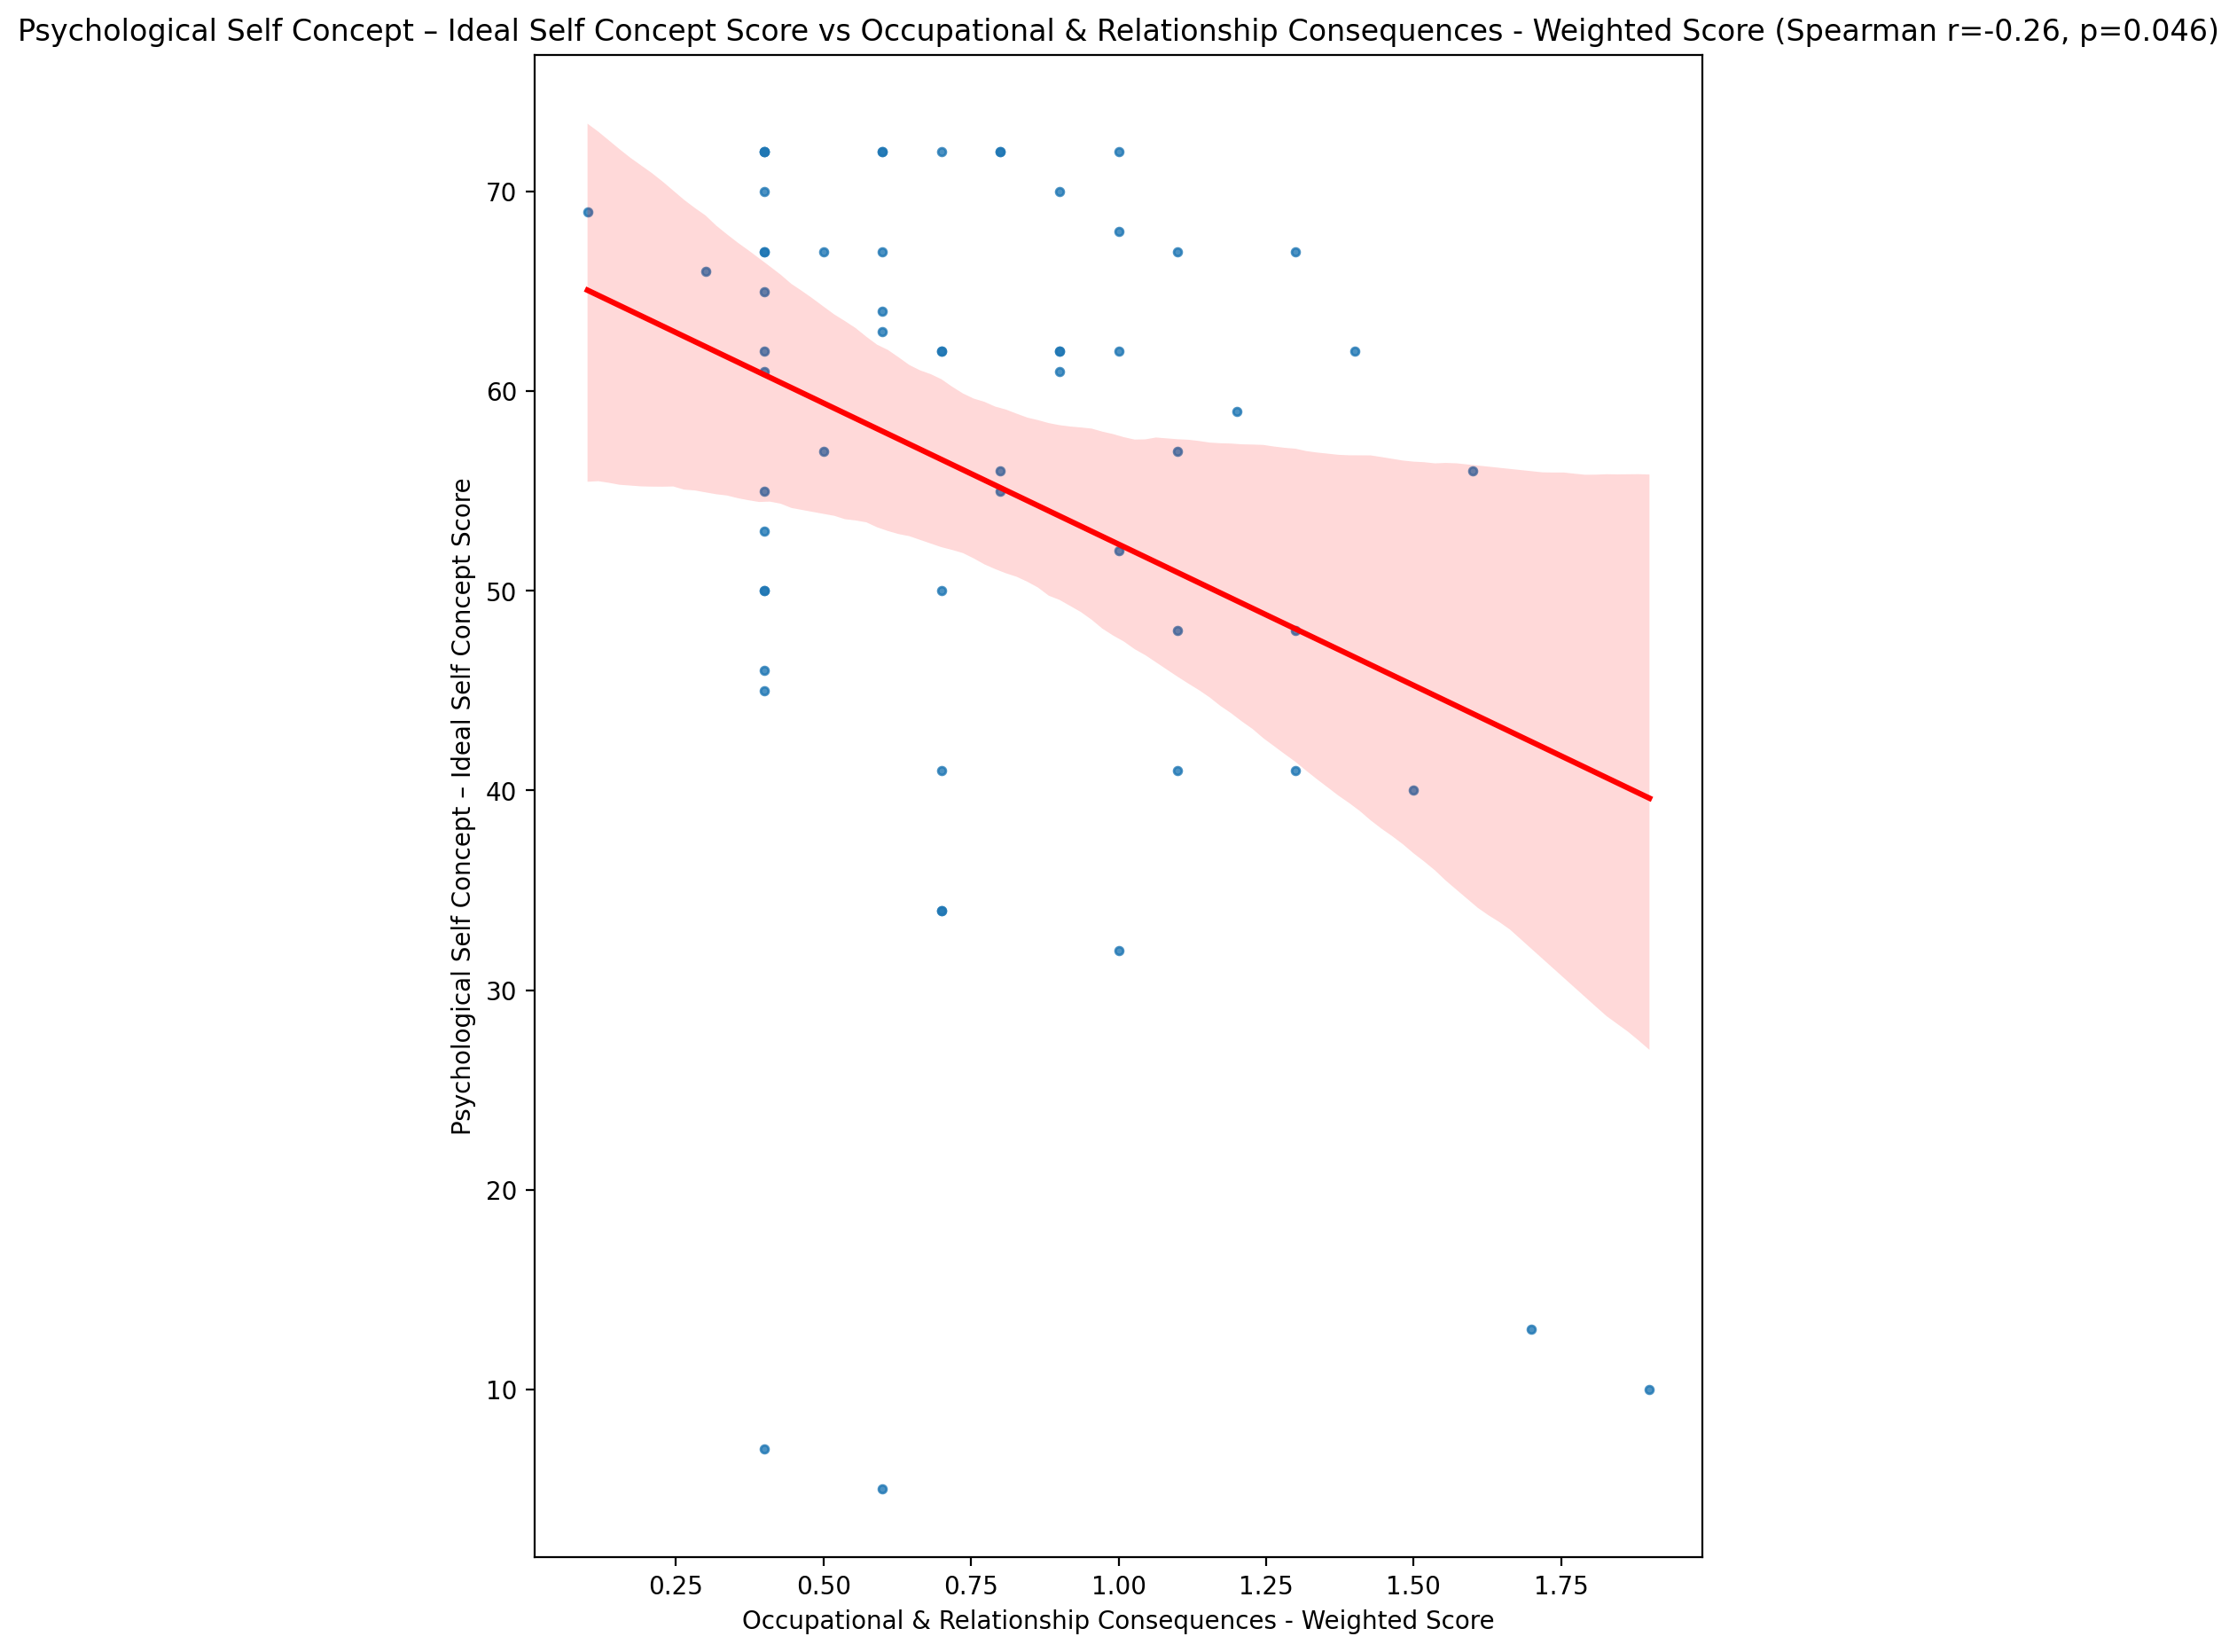

## Psychological Self Concept – Social Self Concept Score vs Occupational & Relationship Consequences - Weighted Score

Test: spearman; statistic: -0.13203431167116084; p-value: 0.3188382180365428;

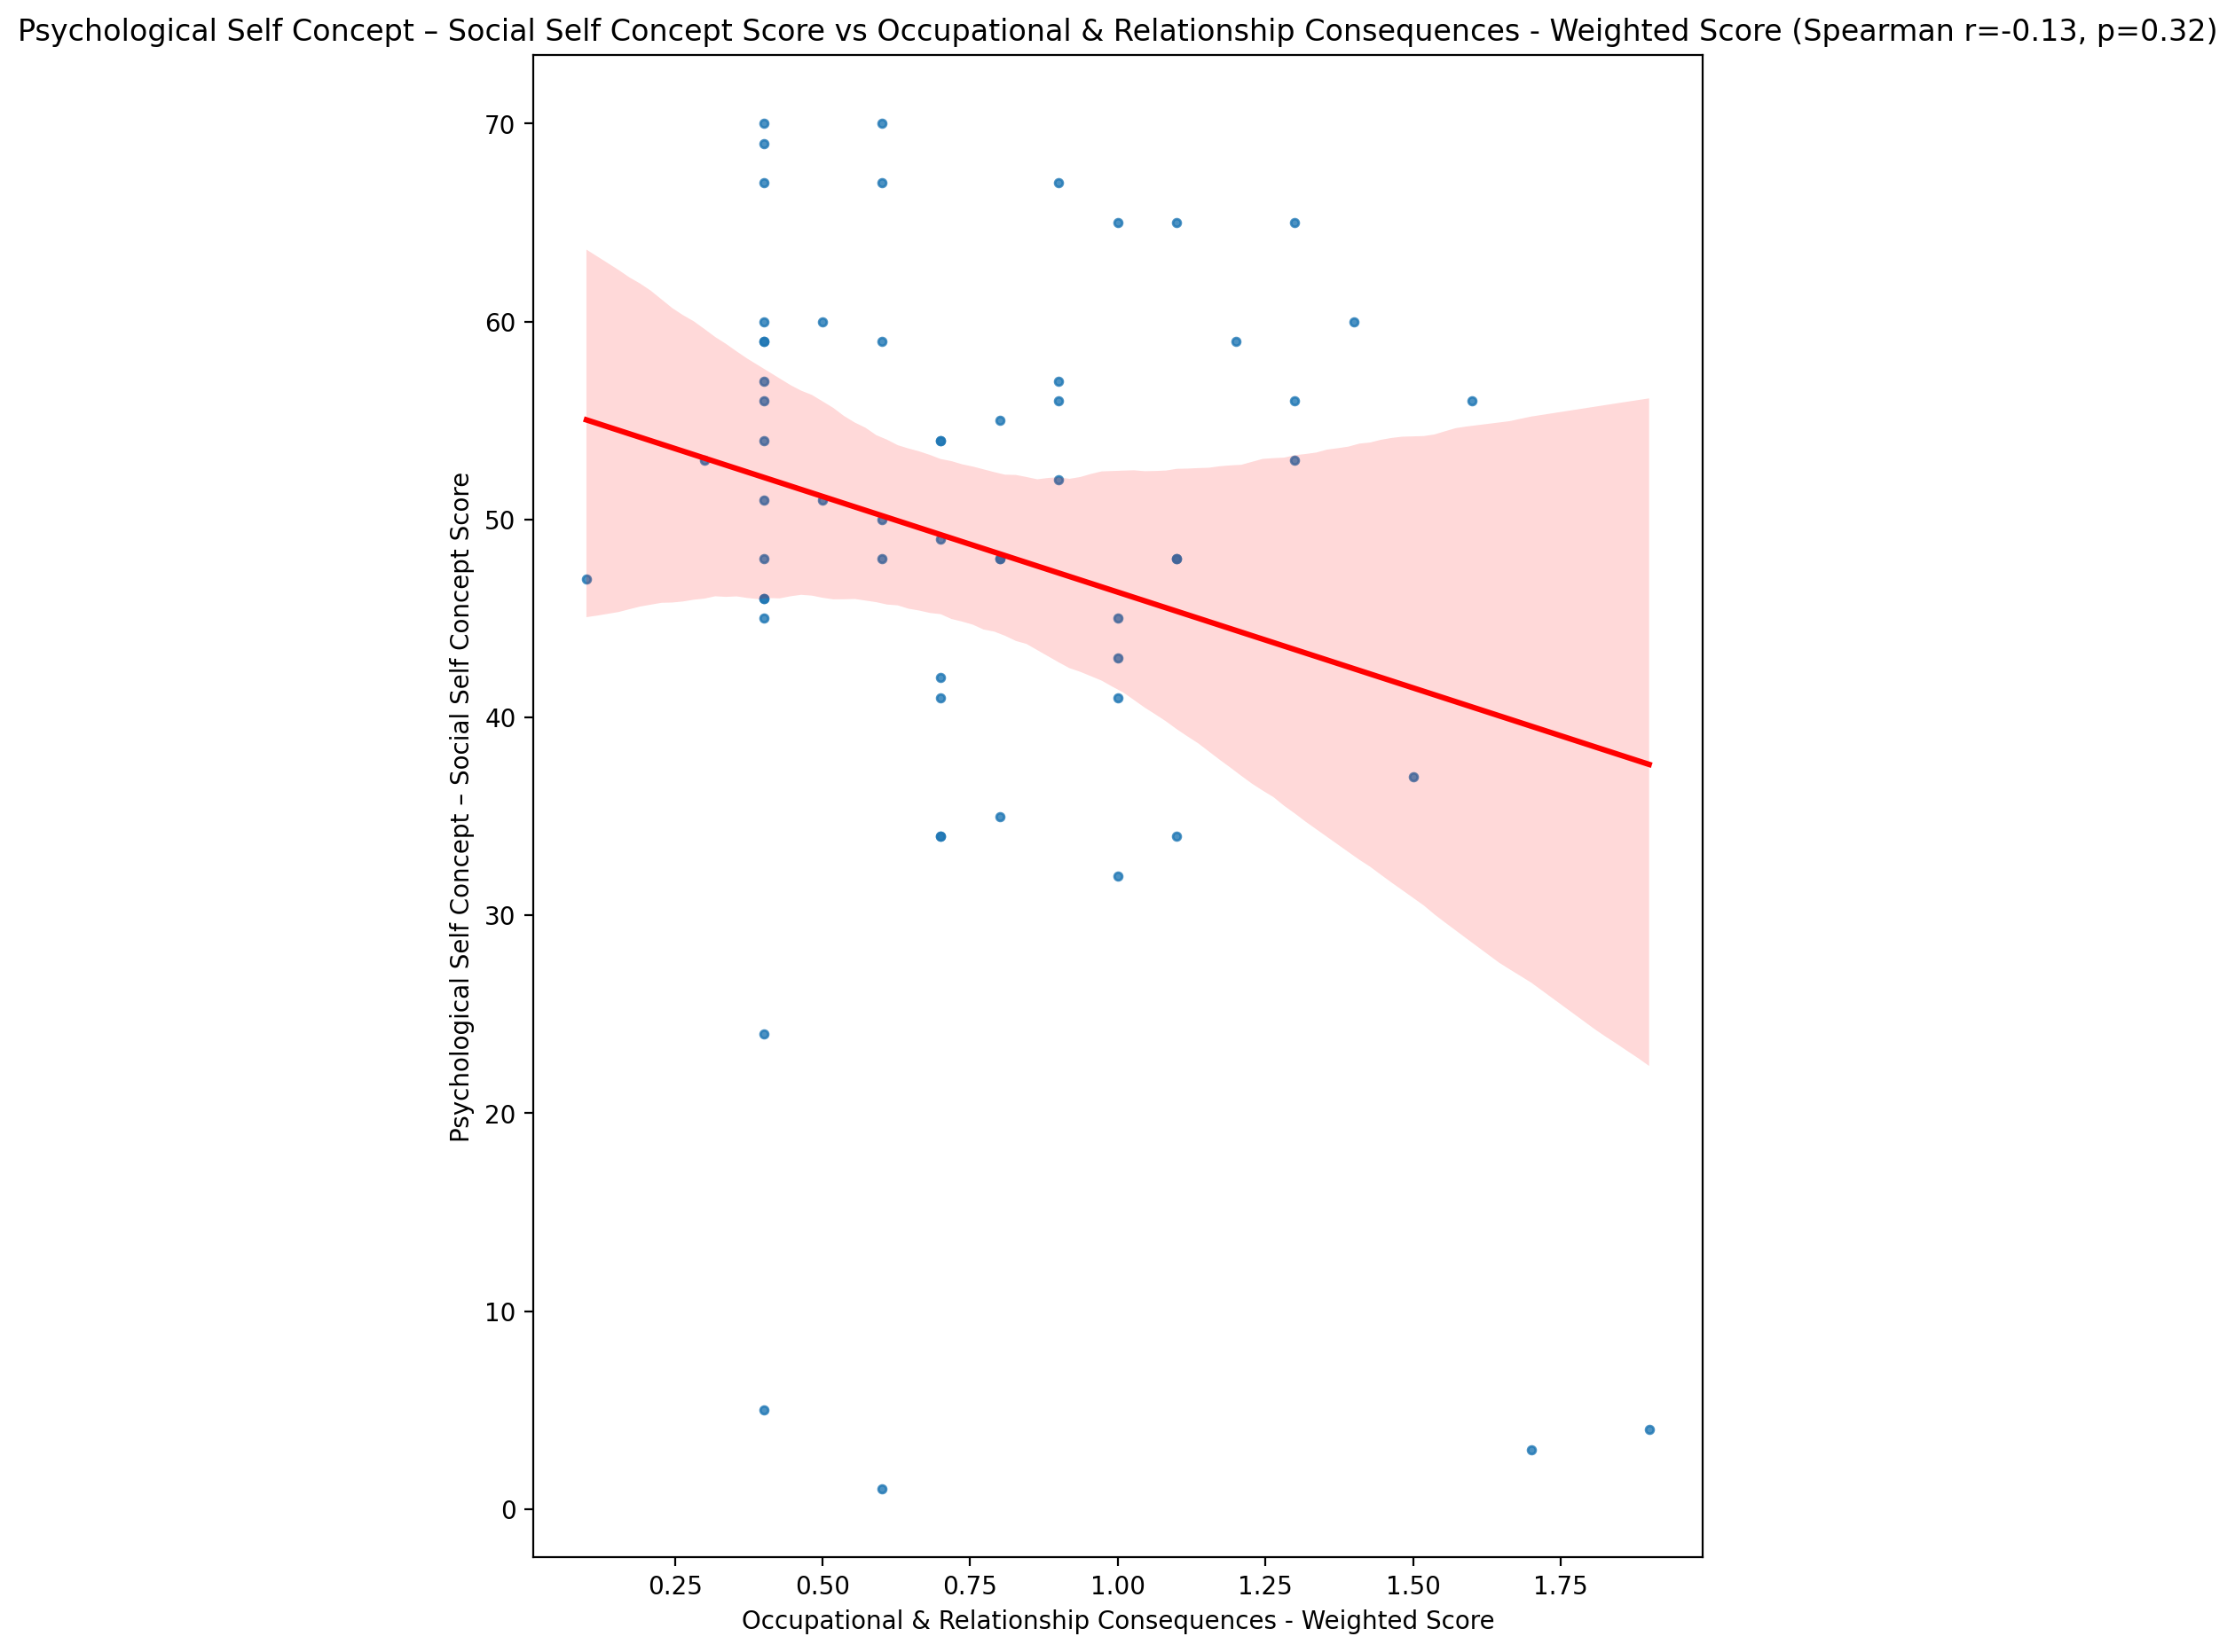

## Real Self Concept Total Score vs Occupational & Relationship Consequences - Weighted Score

Test: spearman; statistic: -0.29350743514748323; p-value: 0.02405937491521981;

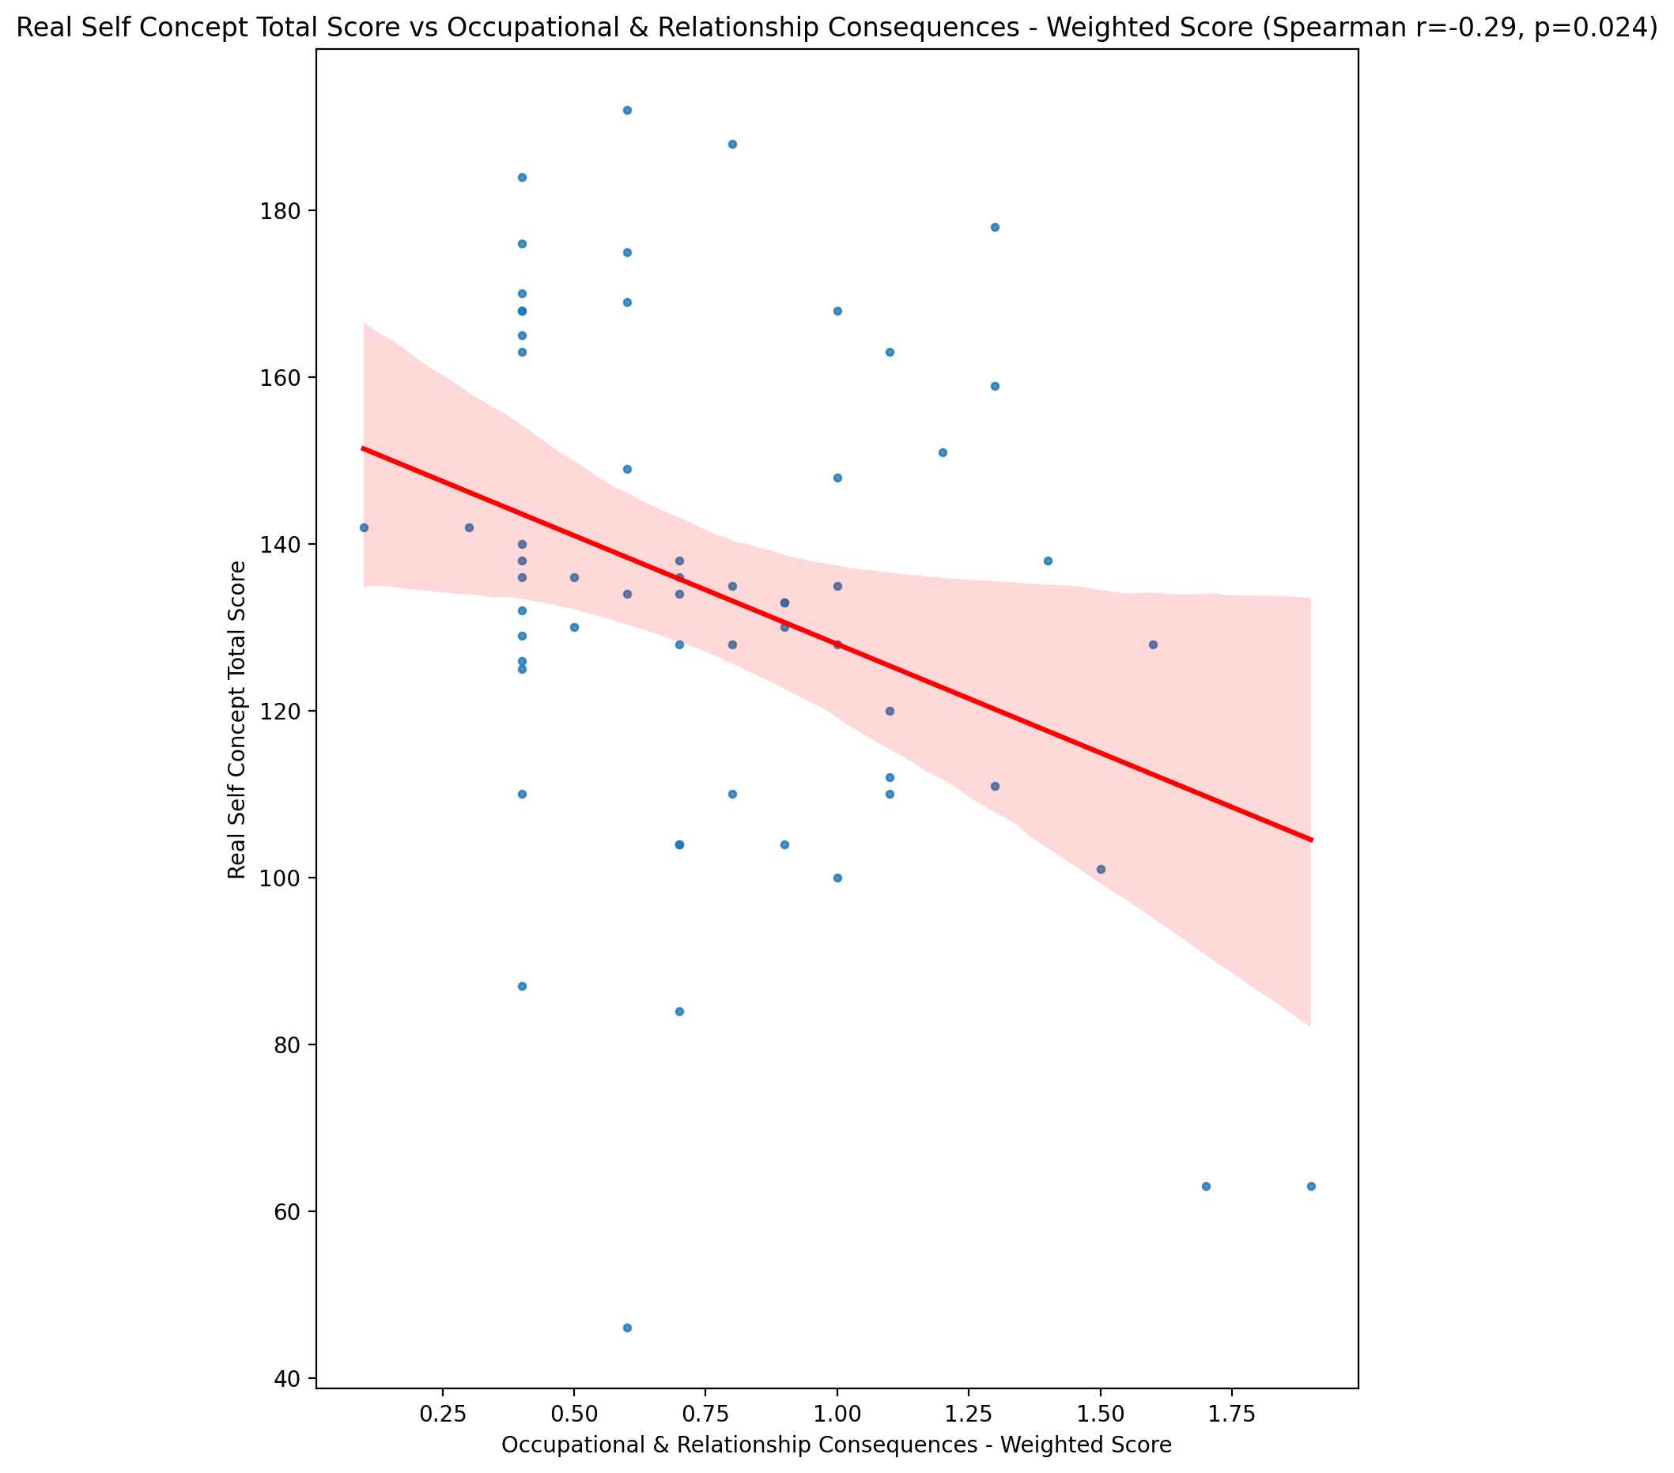

## Ideal Self Concept Total Score vs Occupational & Relationship Consequences - Weighted Score

Test: spearman; statistic: -0.27882374961607237; p-value: 0.032478617880859394;

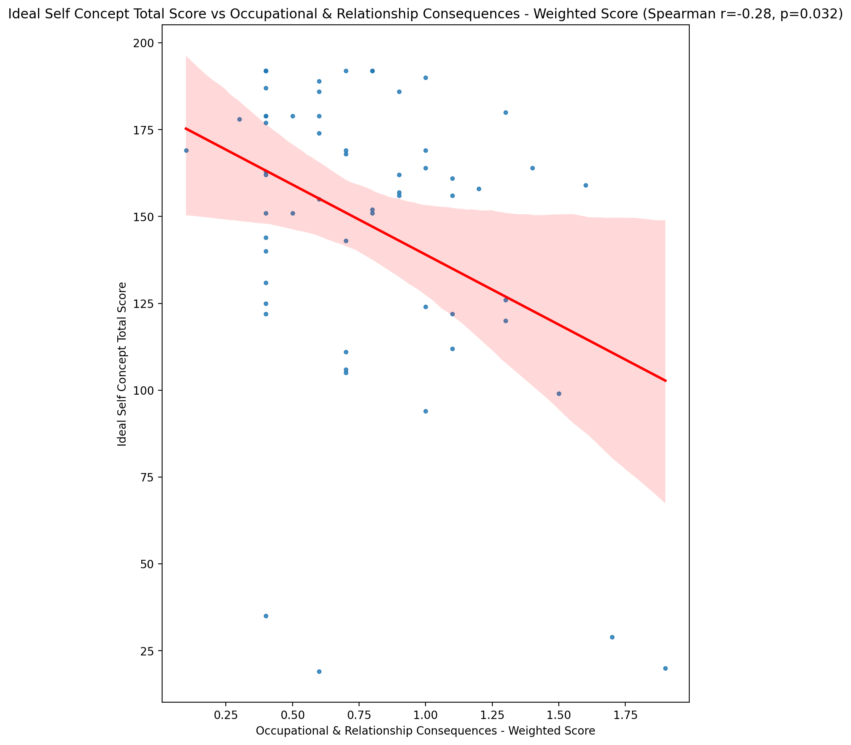

## Social Self Concept Total Score vs Occupational & Relationship Consequences - Weighted Score

Test: spearman; statistic: -0.12774418022208497; p-value: 0.33495313286022643;

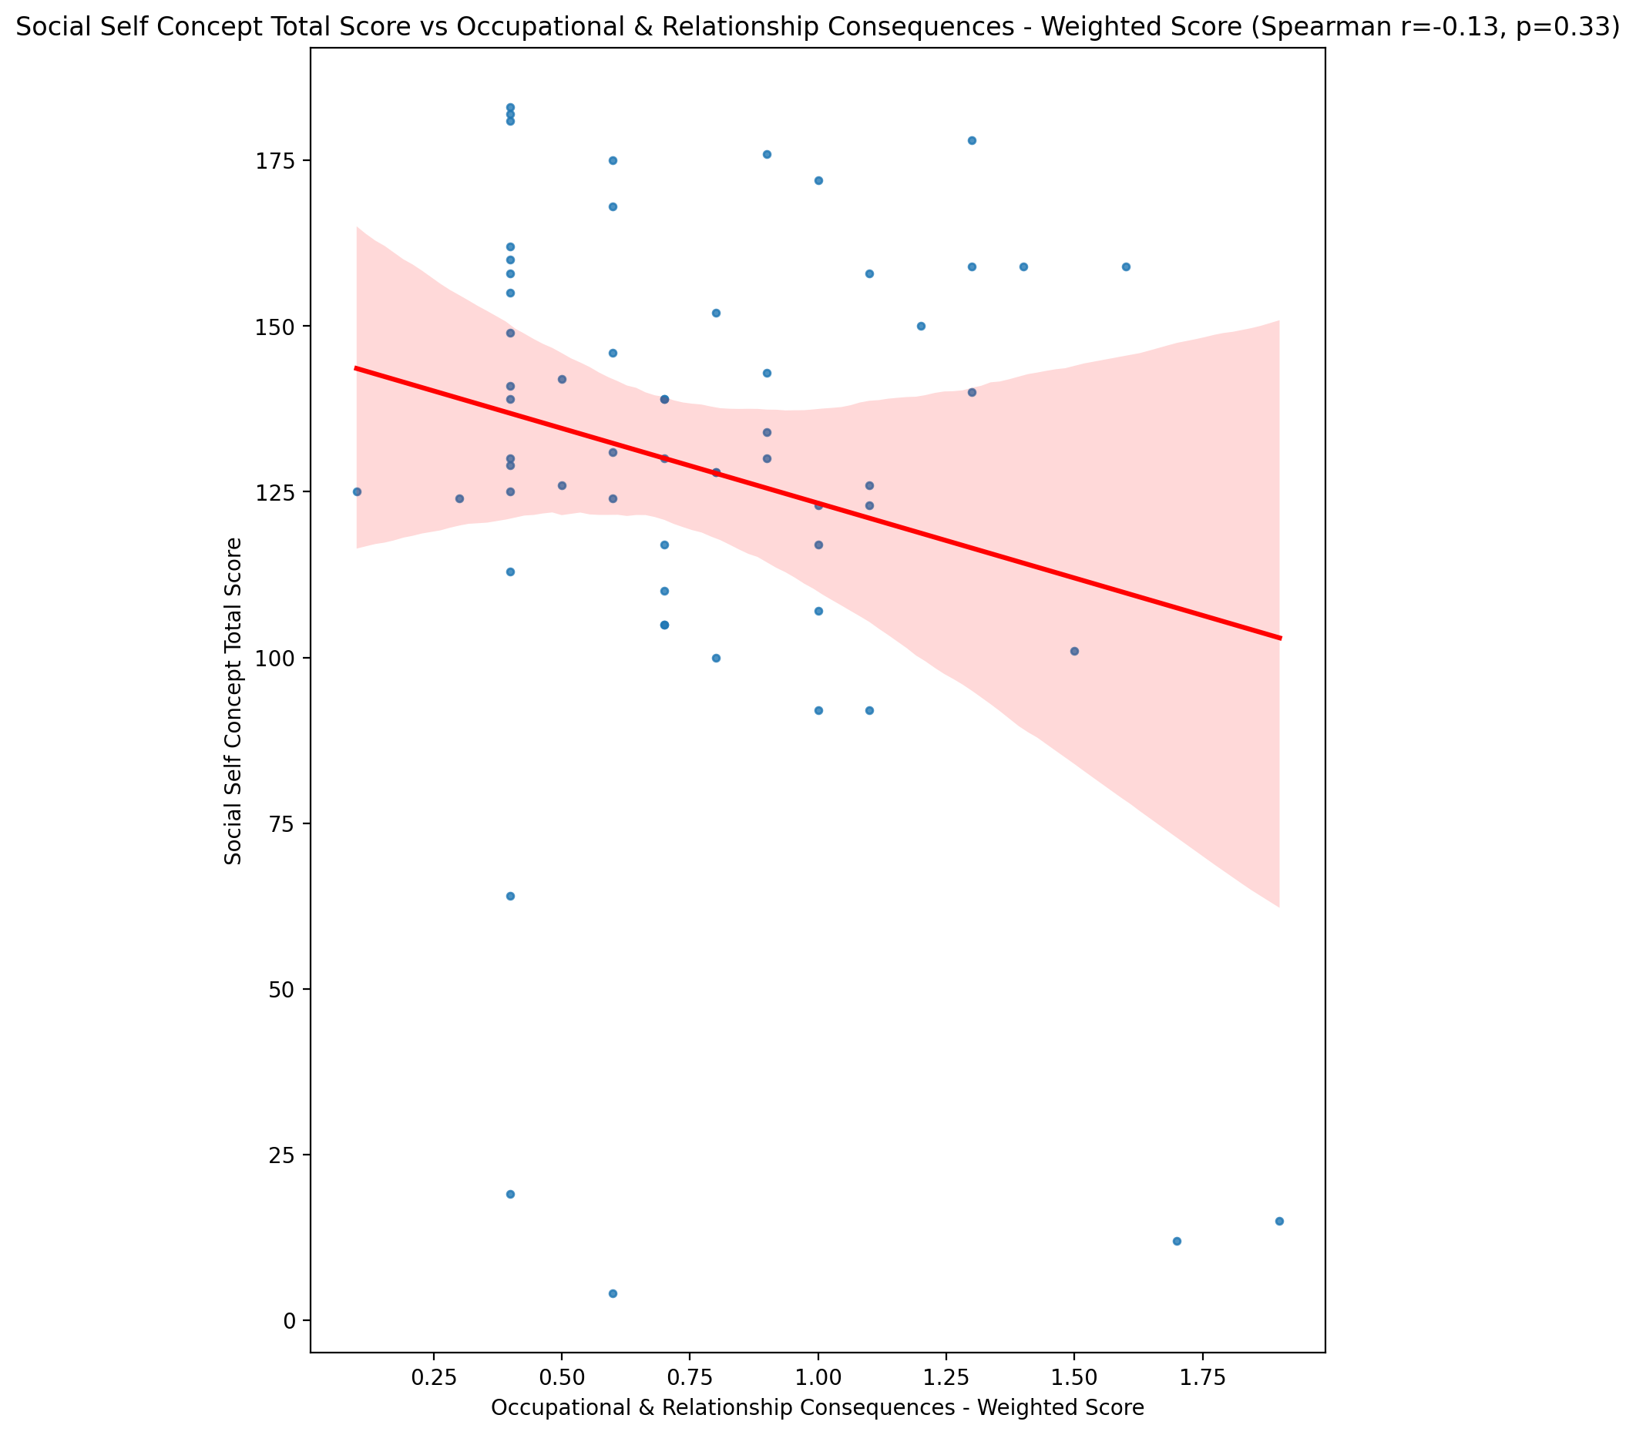

## Ideal Self Concept Total Category vs Occupational & Relationship Consequences - Weighted Score

Test: None; statistic: None; p-value: None; Test not run: unsupported type combination.



## Perceived Social Stress Score vs Occupational & Relationship Consequences - Weighted Score

Test: spearman; statistic: 0.3620837123728717; p-value: 0.00483211864550597;

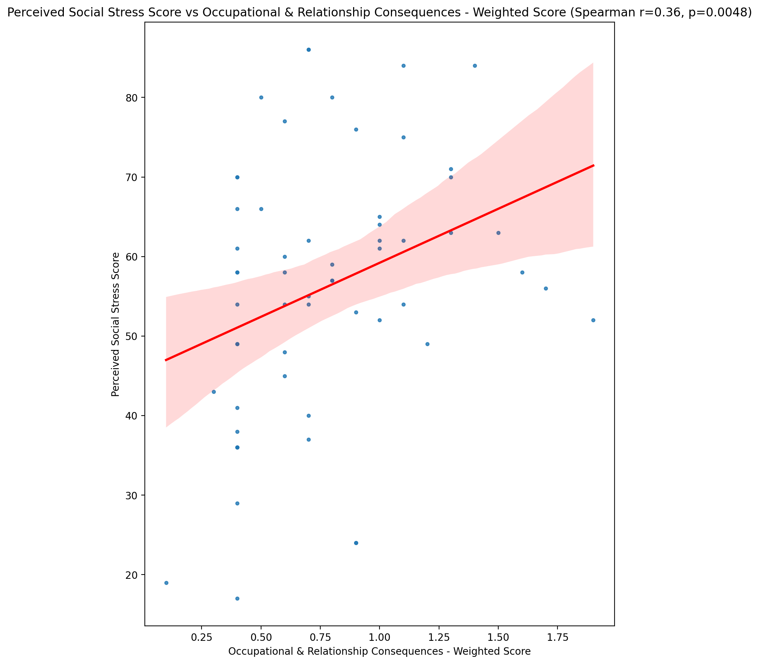

## Perceived Social Stress Category vs Occupational & Relationship Consequences - Weighted Score

Test: None; statistic: None; p-value: None; Test not run: unsupported type combination.



## Emotional Support - Raw Score vs Compulsive Behaviour - Weighted Score

Test: spearman; statistic: -0.20733762904590747; p-value: 0.11509693215782638;

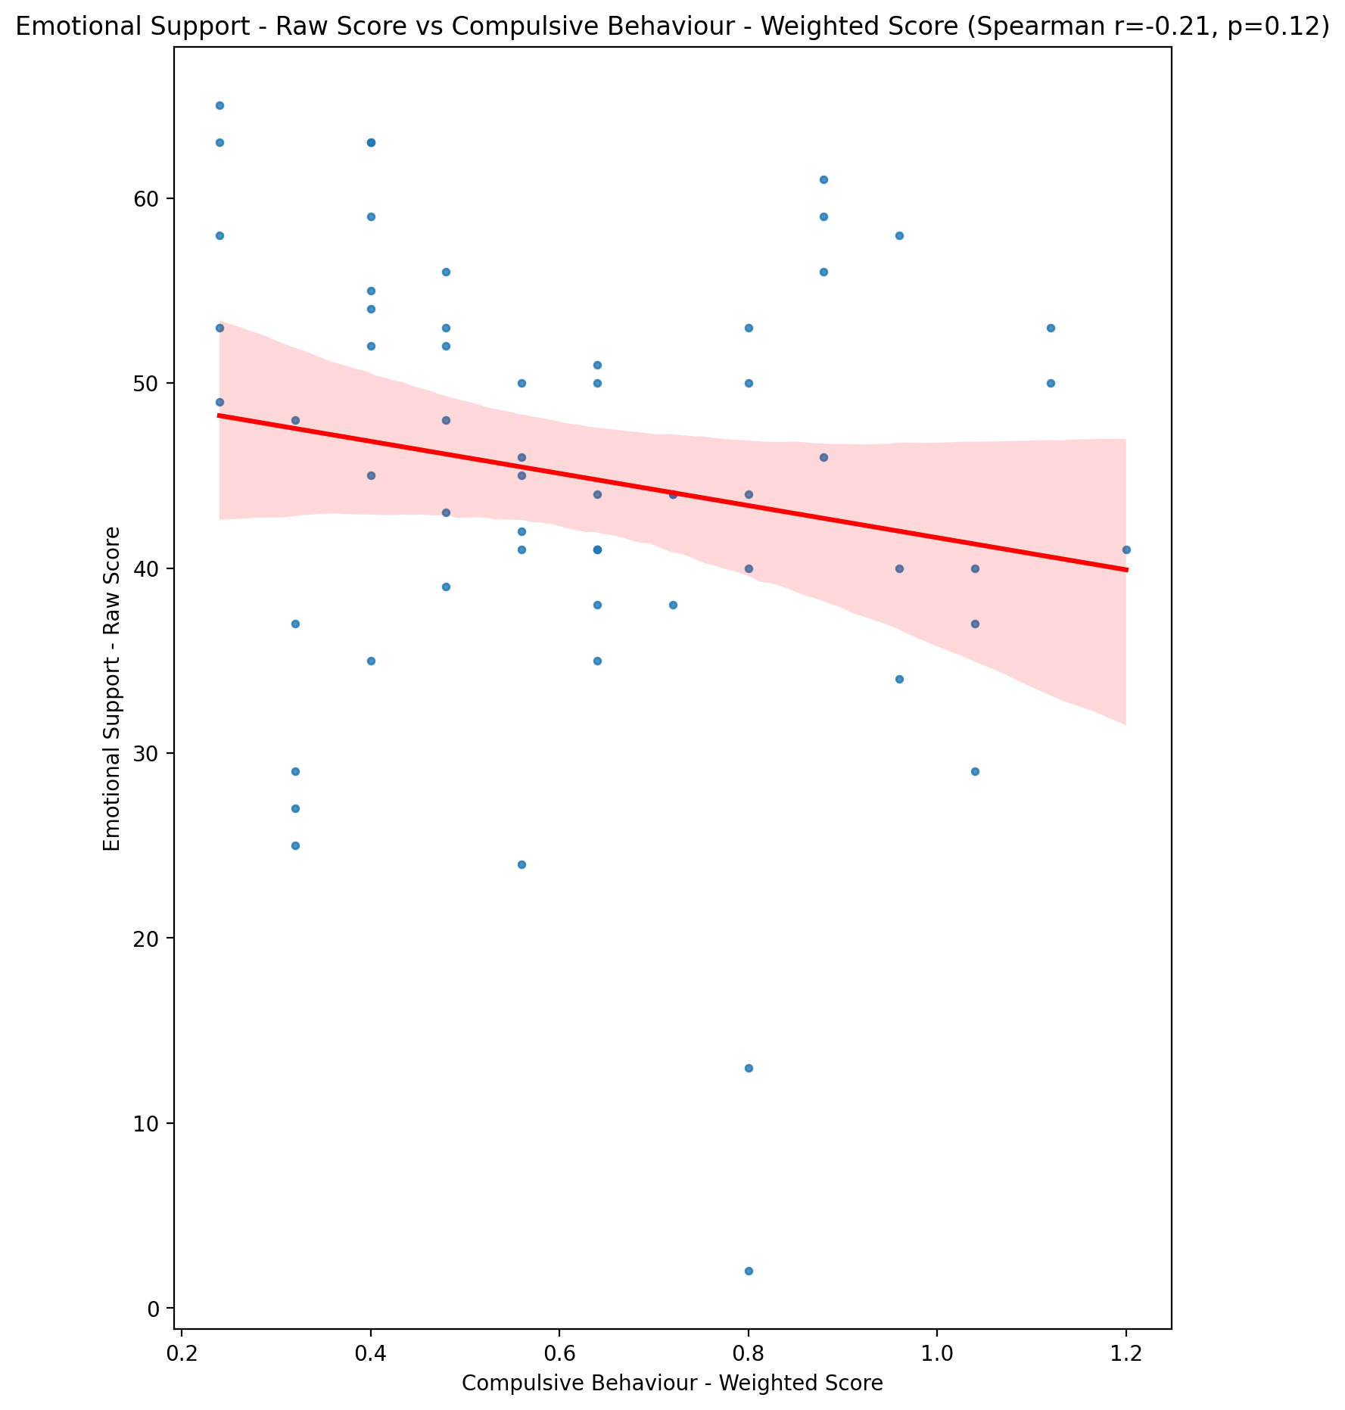

## Informational Support - Raw Score vs Compulsive Behaviour - Weighted Score

Test: spearman; statistic: -0.16591716676087995; p-value: 0.2091551784850914;

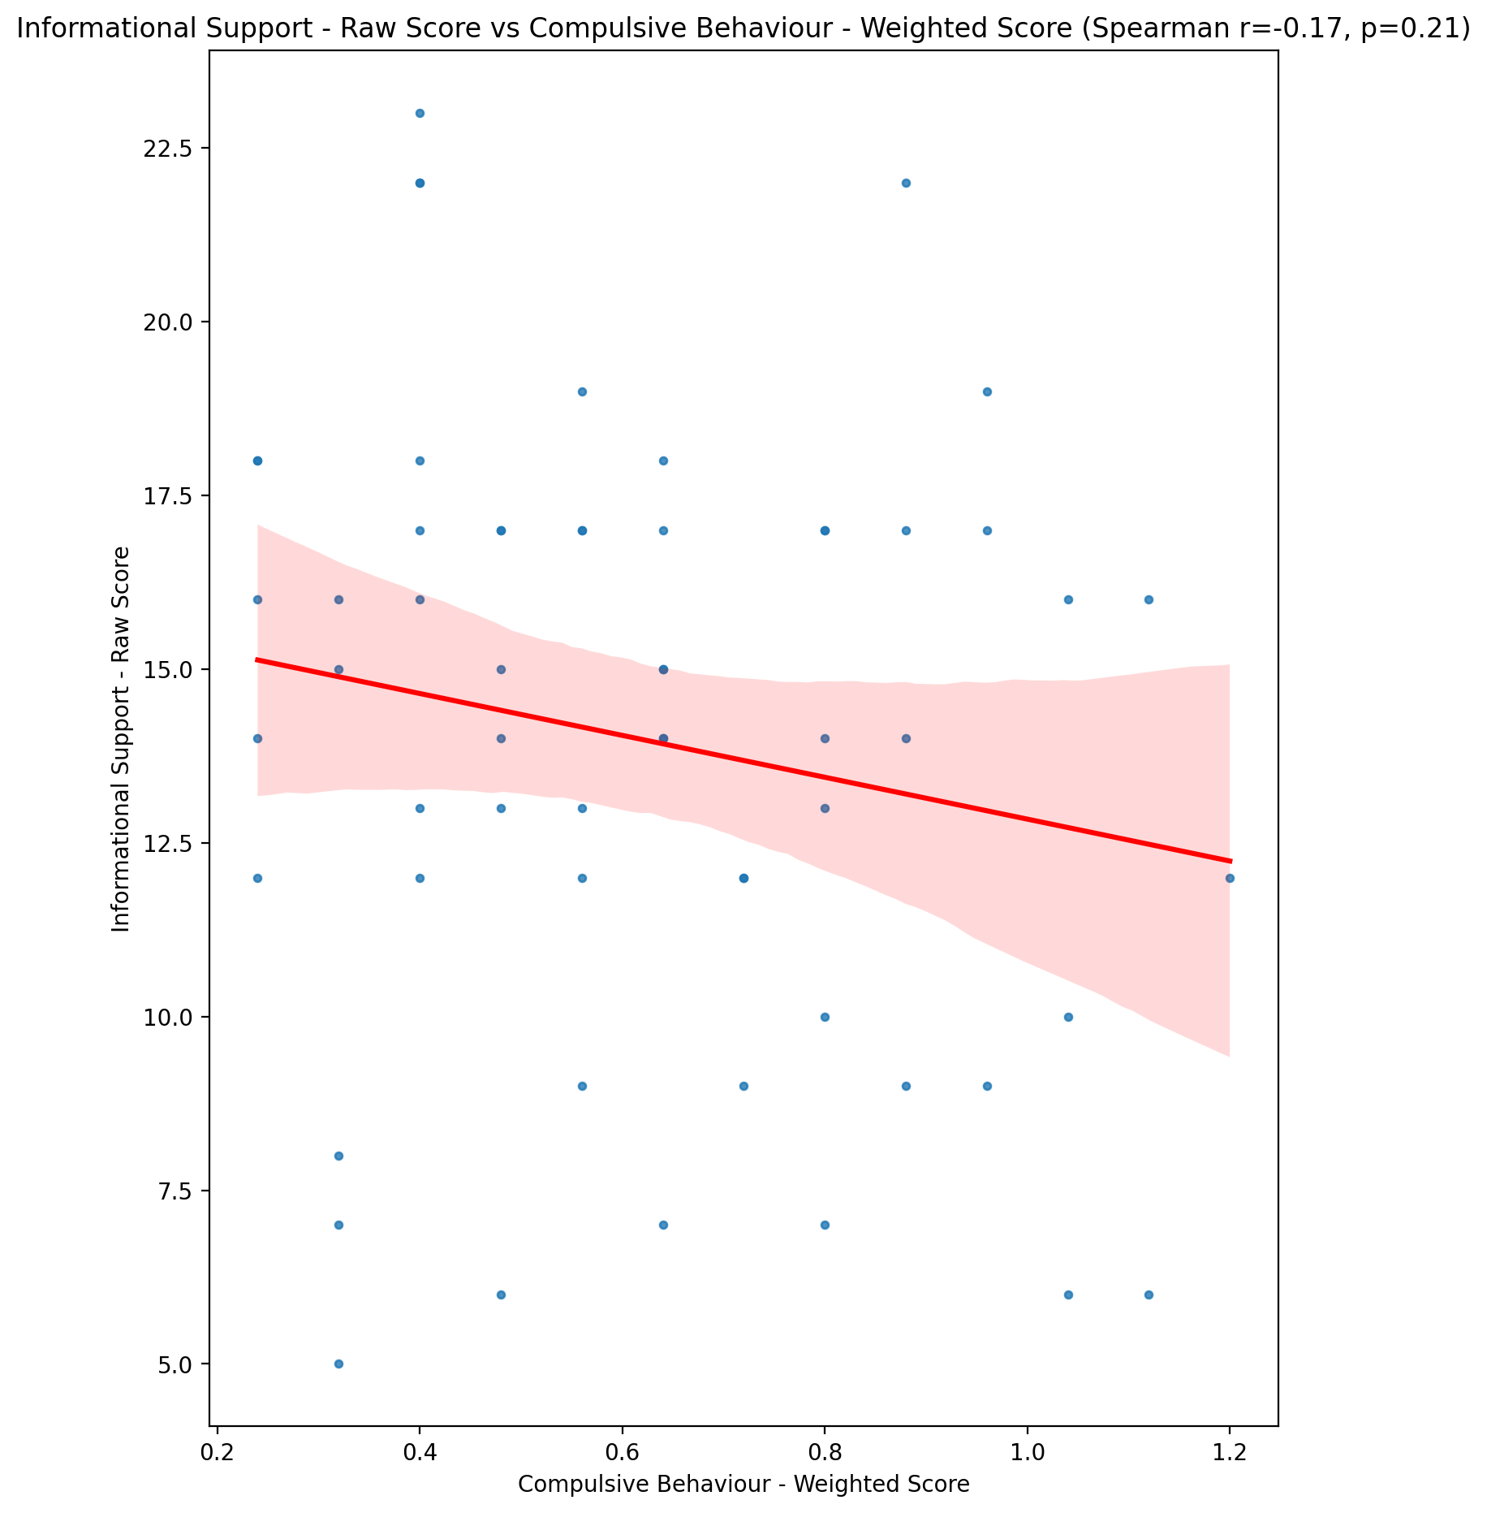

## Instrumental Support - Raw Score vs Compulsive Behaviour - Weighted Score

Test: spearman; statistic: -0.22177290122730076; p-value: 0.09138913638656687;

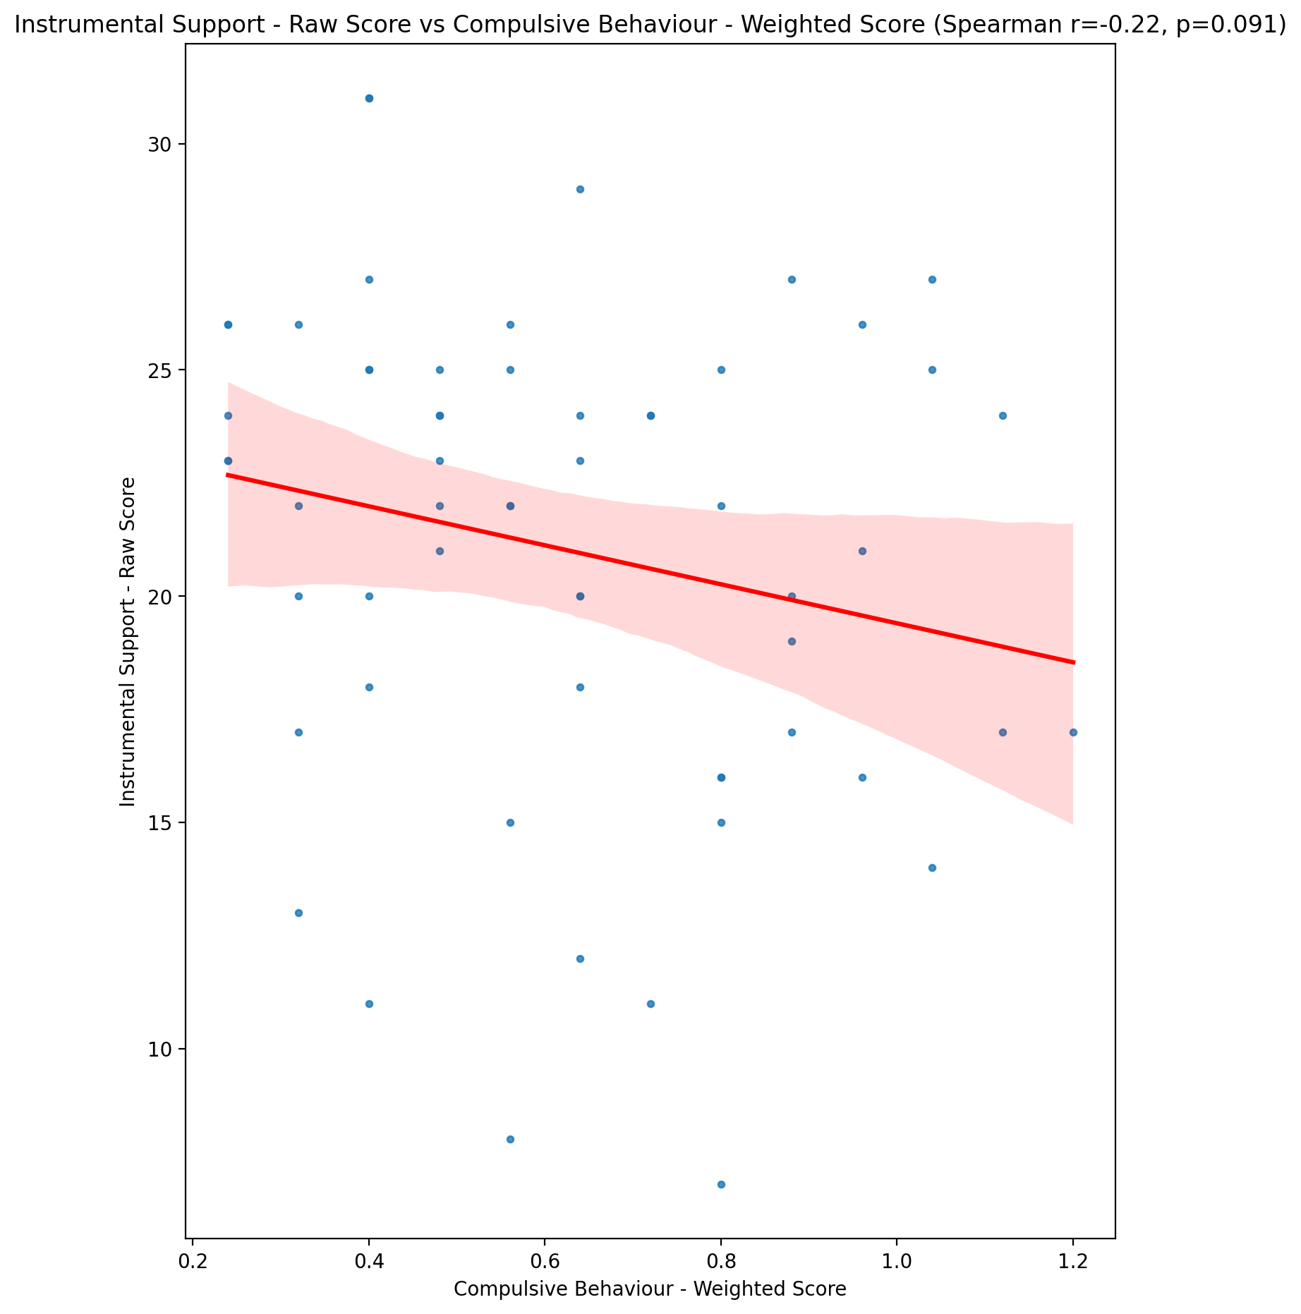

## Emotional Support - T Score vs Compulsive Behaviour - Weighted Score

Test: spearman; statistic: -0.2011384876189177; p-value: 0.1266177443198528;

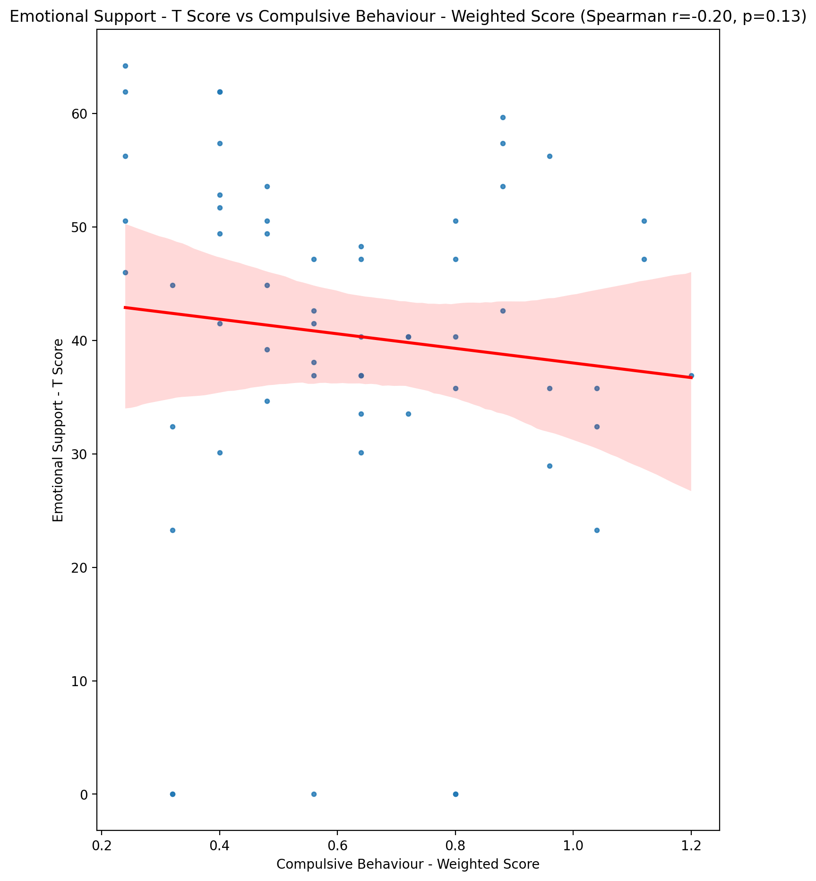

## Informational Support - T Score vs Compulsive Behaviour - Weighted Score

Test: spearman; statistic: -0.16180800744624887; p-value: 0.22081431168892773;

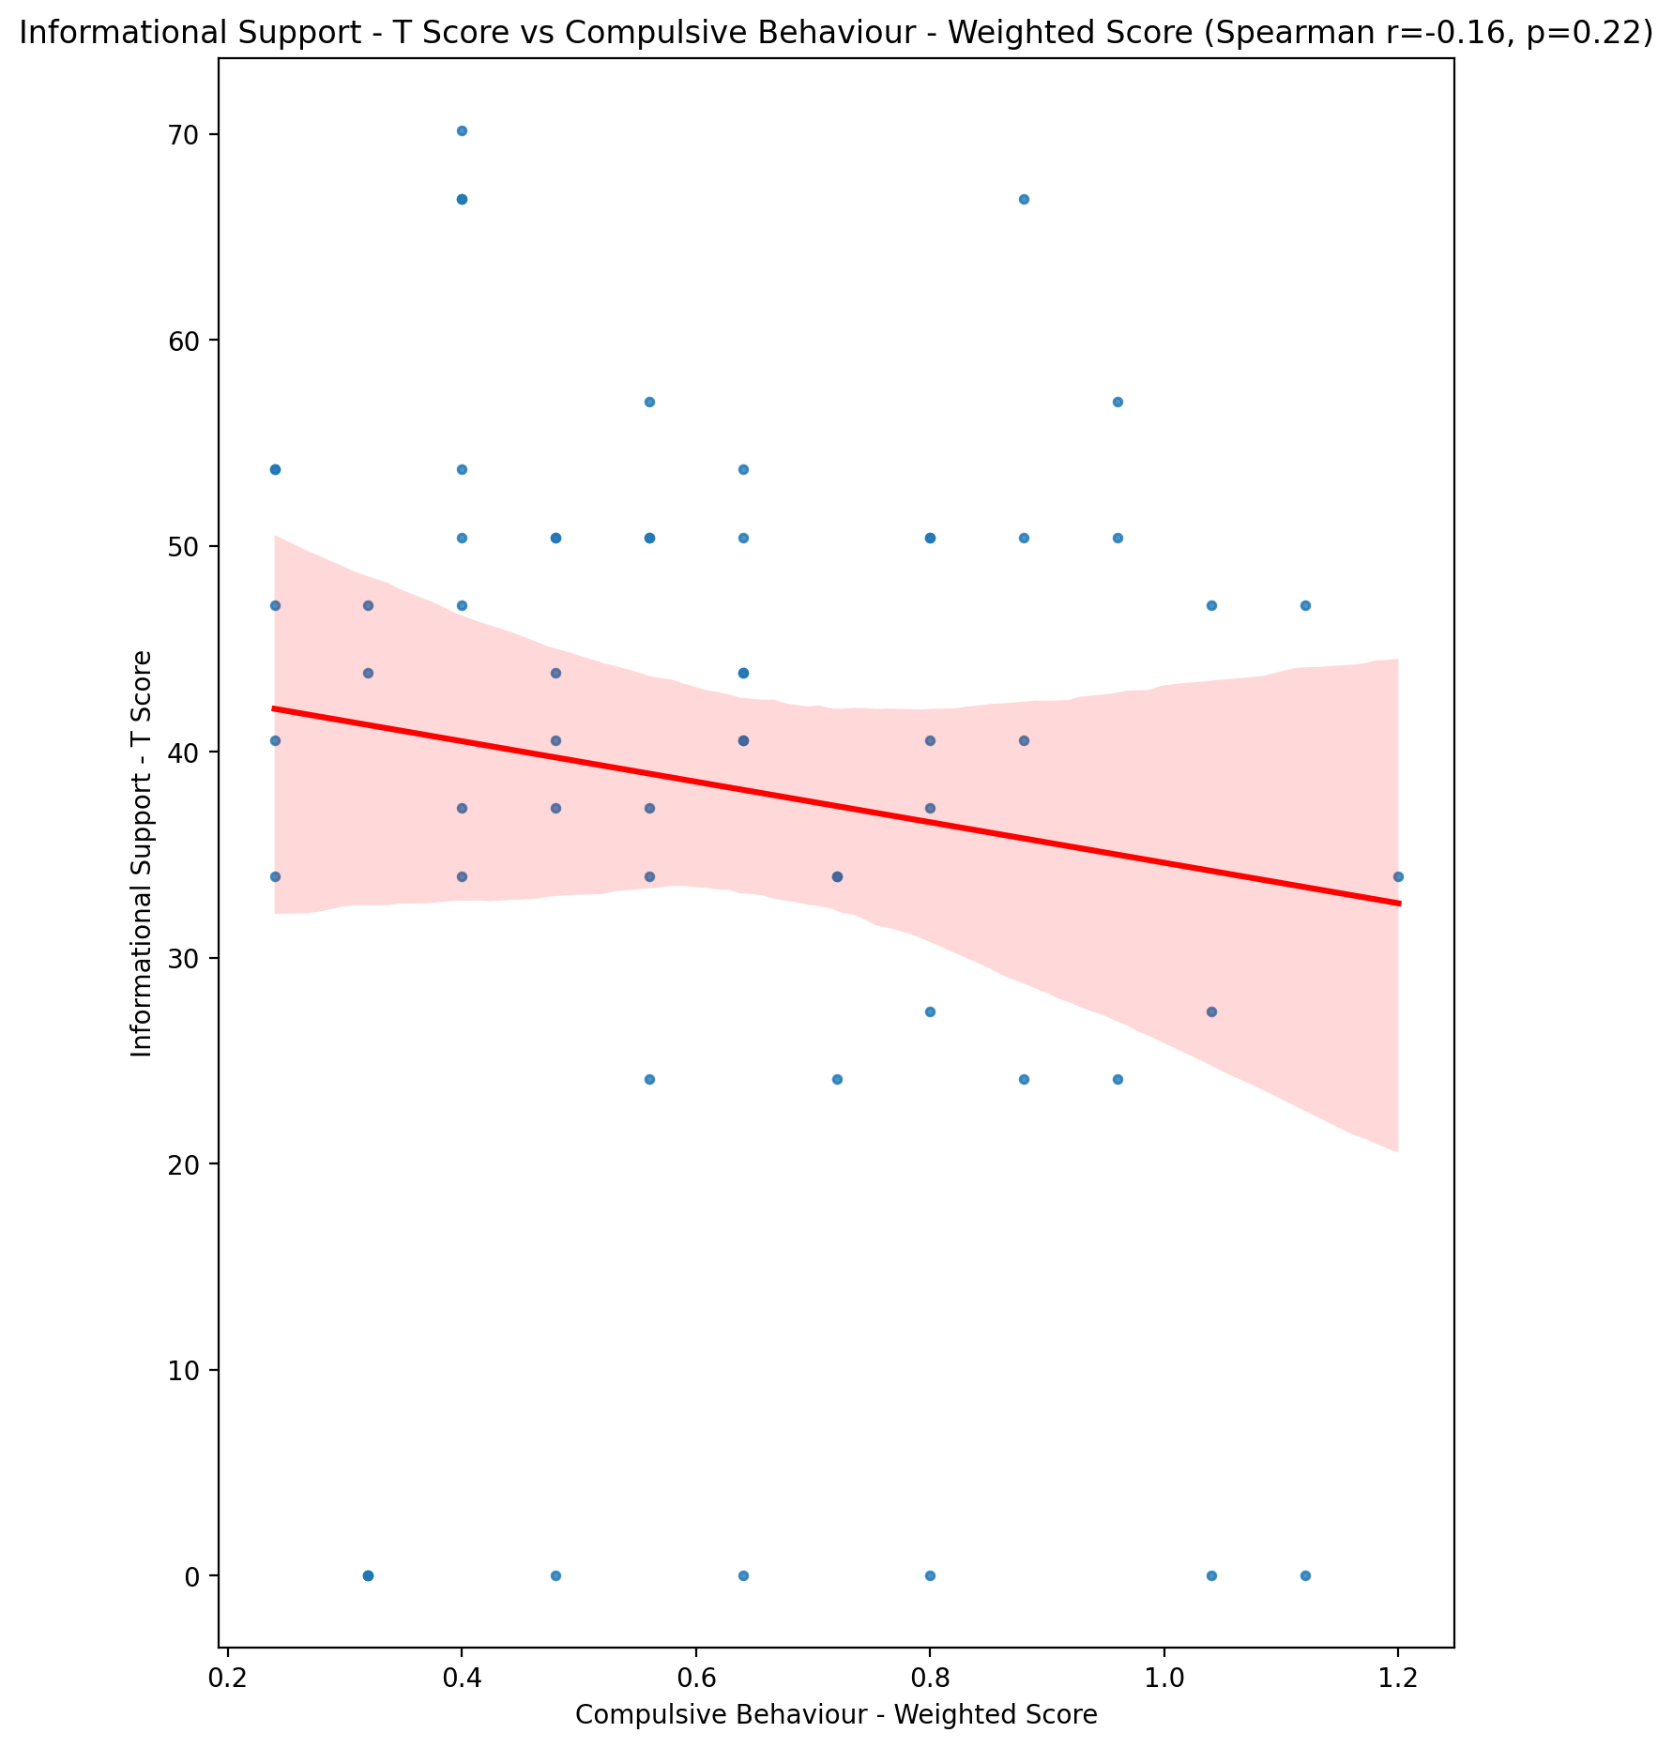

## Instrumental Support - T Score vs Compulsive Behaviour - Weighted Score

Test: spearman; statistic: -0.21723080593692645; p-value: 0.09839577468074212;

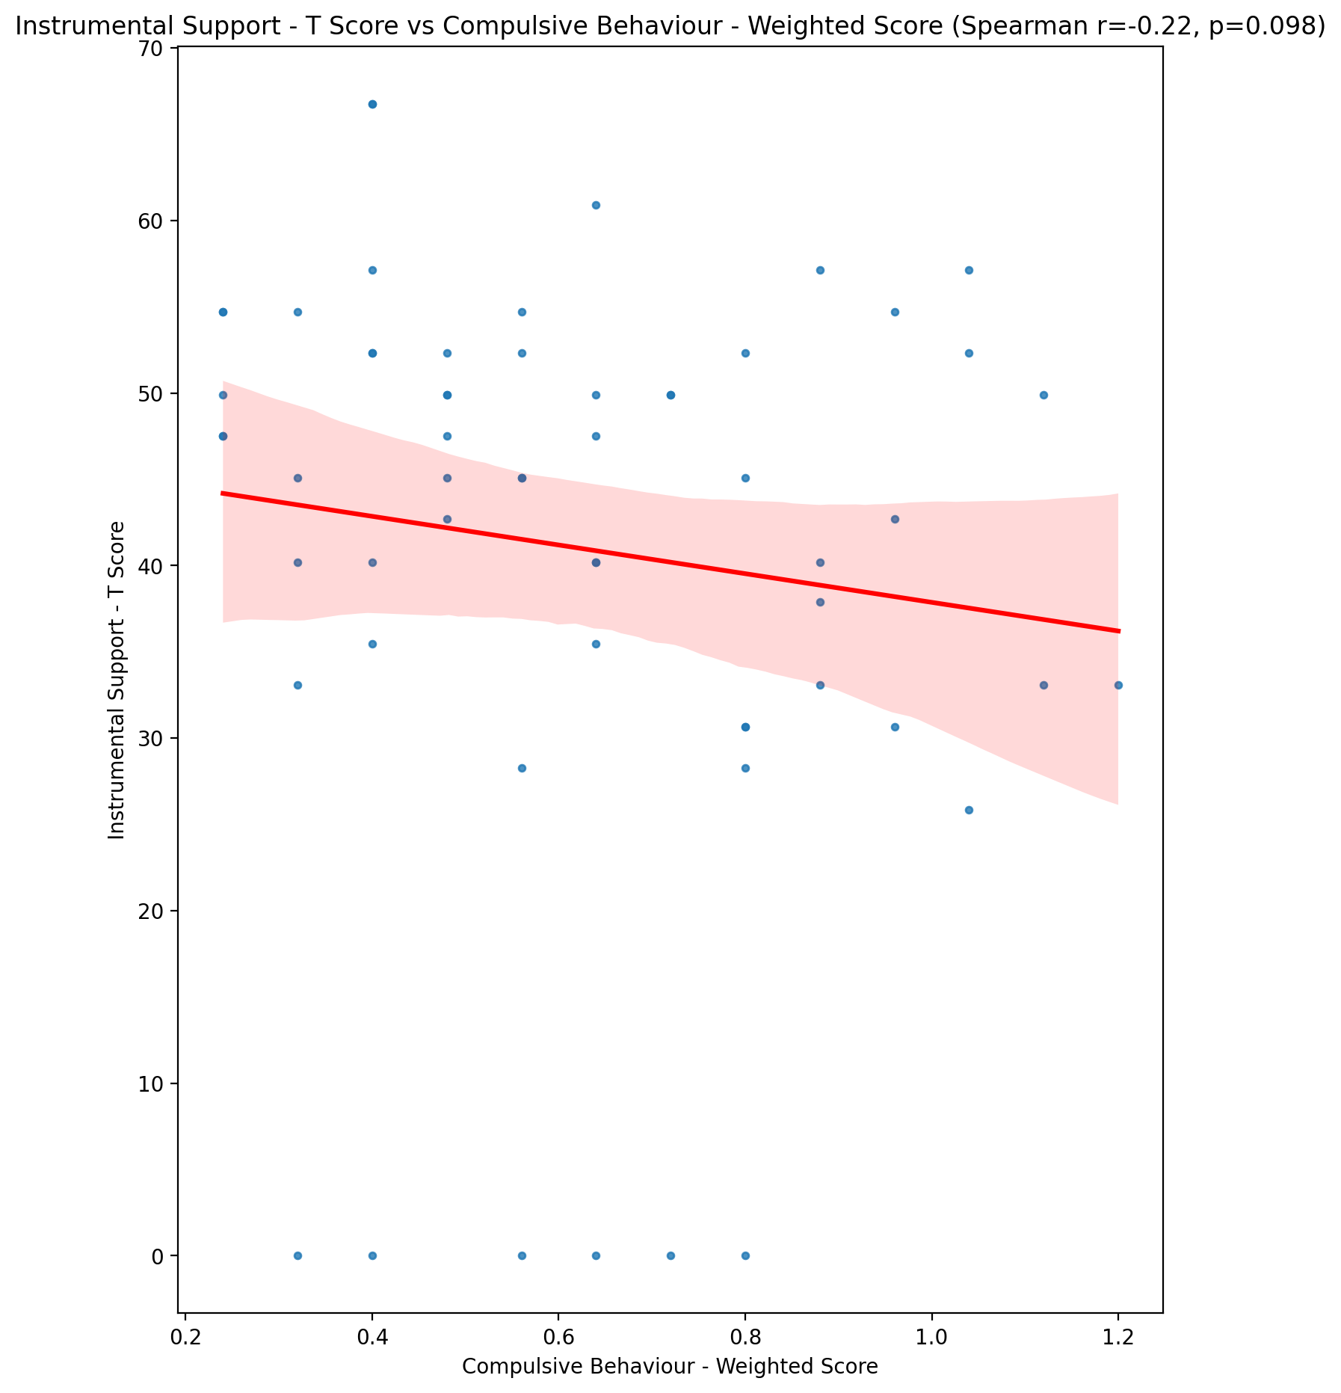

## Perceived Social Support Total T Score vs Compulsive Behaviour - Weighted Score

Test: spearman; statistic: -0.250478879463382; p-value: 0.05569382264449527;

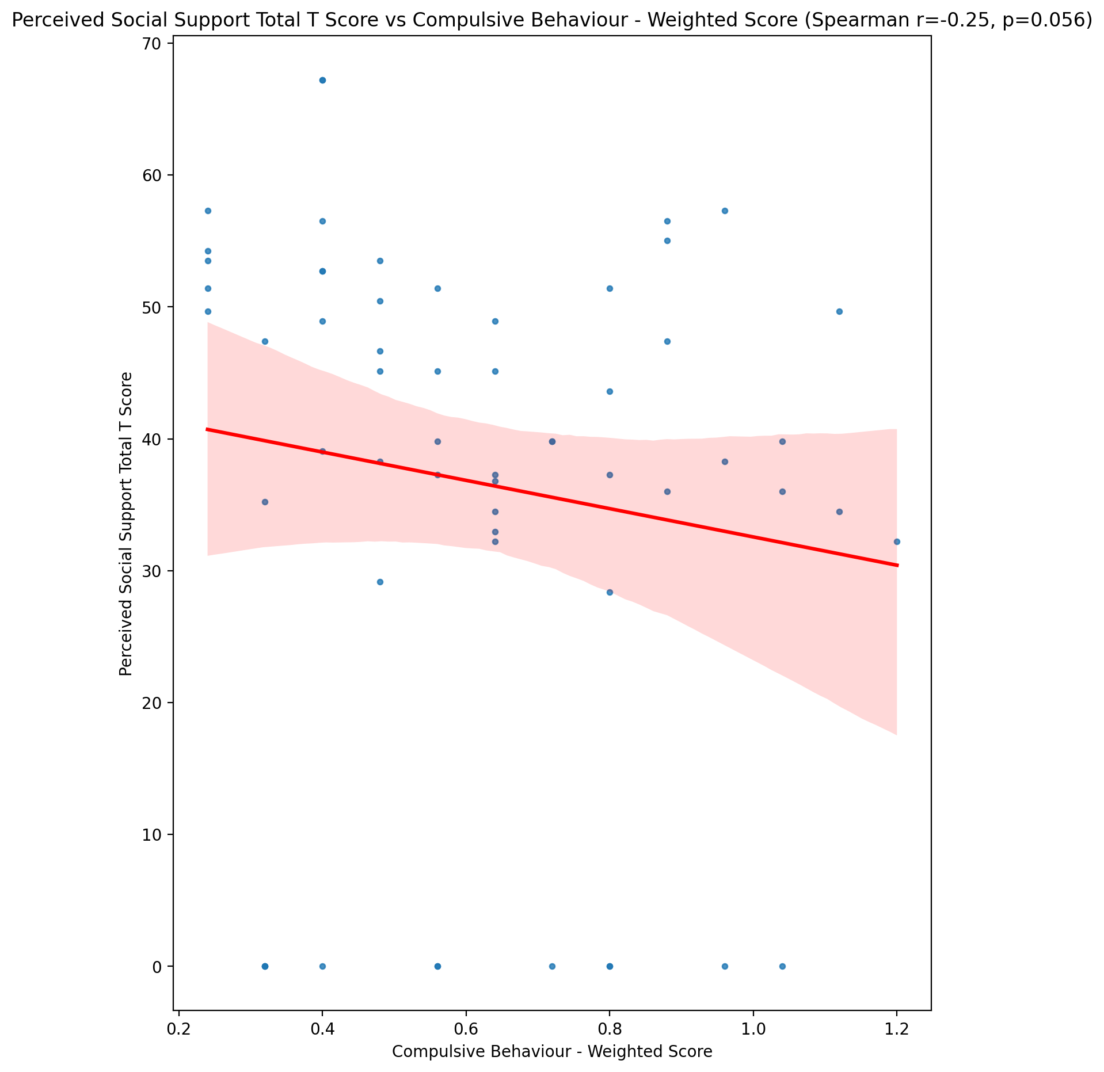

## Emotional Support - Rank vs Compulsive Behaviour - Weighted Score

Test: None; statistic: None; p-value: None; Test not run: unsupported type combination.



## Informational Support - Rank vs Compulsive Behaviour - Weighted Score

Test: None; statistic: None; p-value: None; Test not run: unsupported type combination.



## Instrumental Support - Rank vs Compulsive Behaviour - Weighted Score

Test: None; statistic: None; p-value: None; Test not run: unsupported type combination.



## Perceived Social Support TOTAL - Rank vs Compulsive Behaviour - Weighted Score

Test: None; statistic: None; p-value: None; Test not run: unsupported type combination.



## Power Self Concept - Real Self Concept Score vs Compulsive Behaviour - Weighted Score

Test: spearman; statistic: -0.27572601458197377; p-value: 0.034537512813787884;

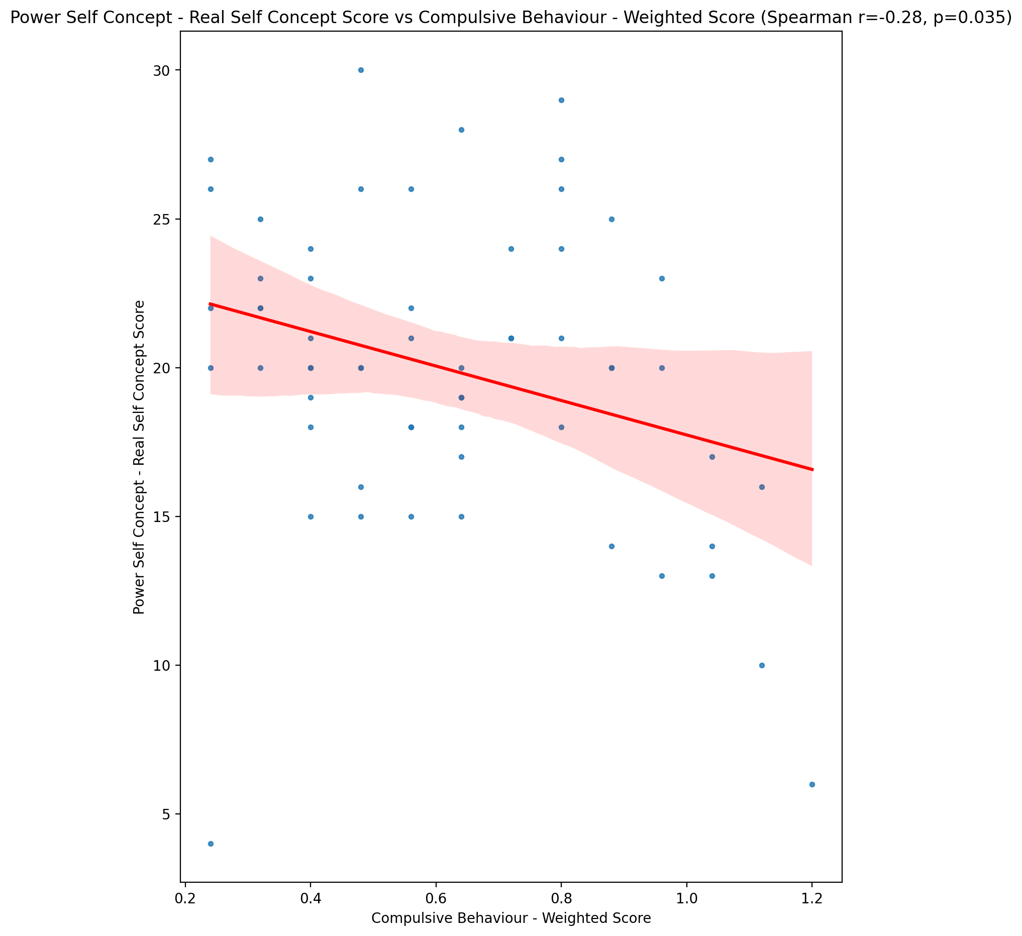

## Power Self Concept - Ideal Self Concept score vs Compulsive Behaviour - Weighted Score

Test: spearman; statistic: -0.32702742737326707; p-value: 0.011467084221851071;

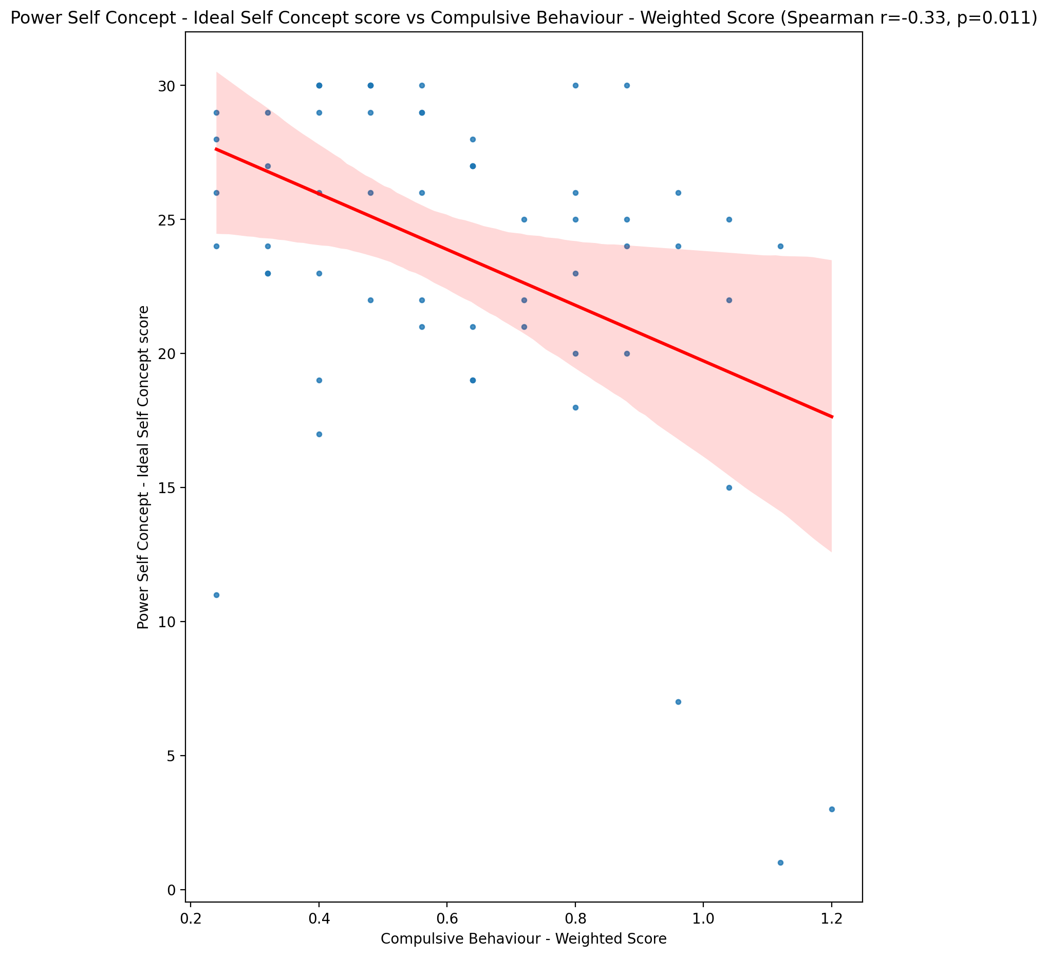

## Power Self Concept – Social Self Concept Score vs Compulsive Behaviour - Weighted Score

Test: spearman; statistic: -0.1985555932899617; p-value: 0.13166793204551067;

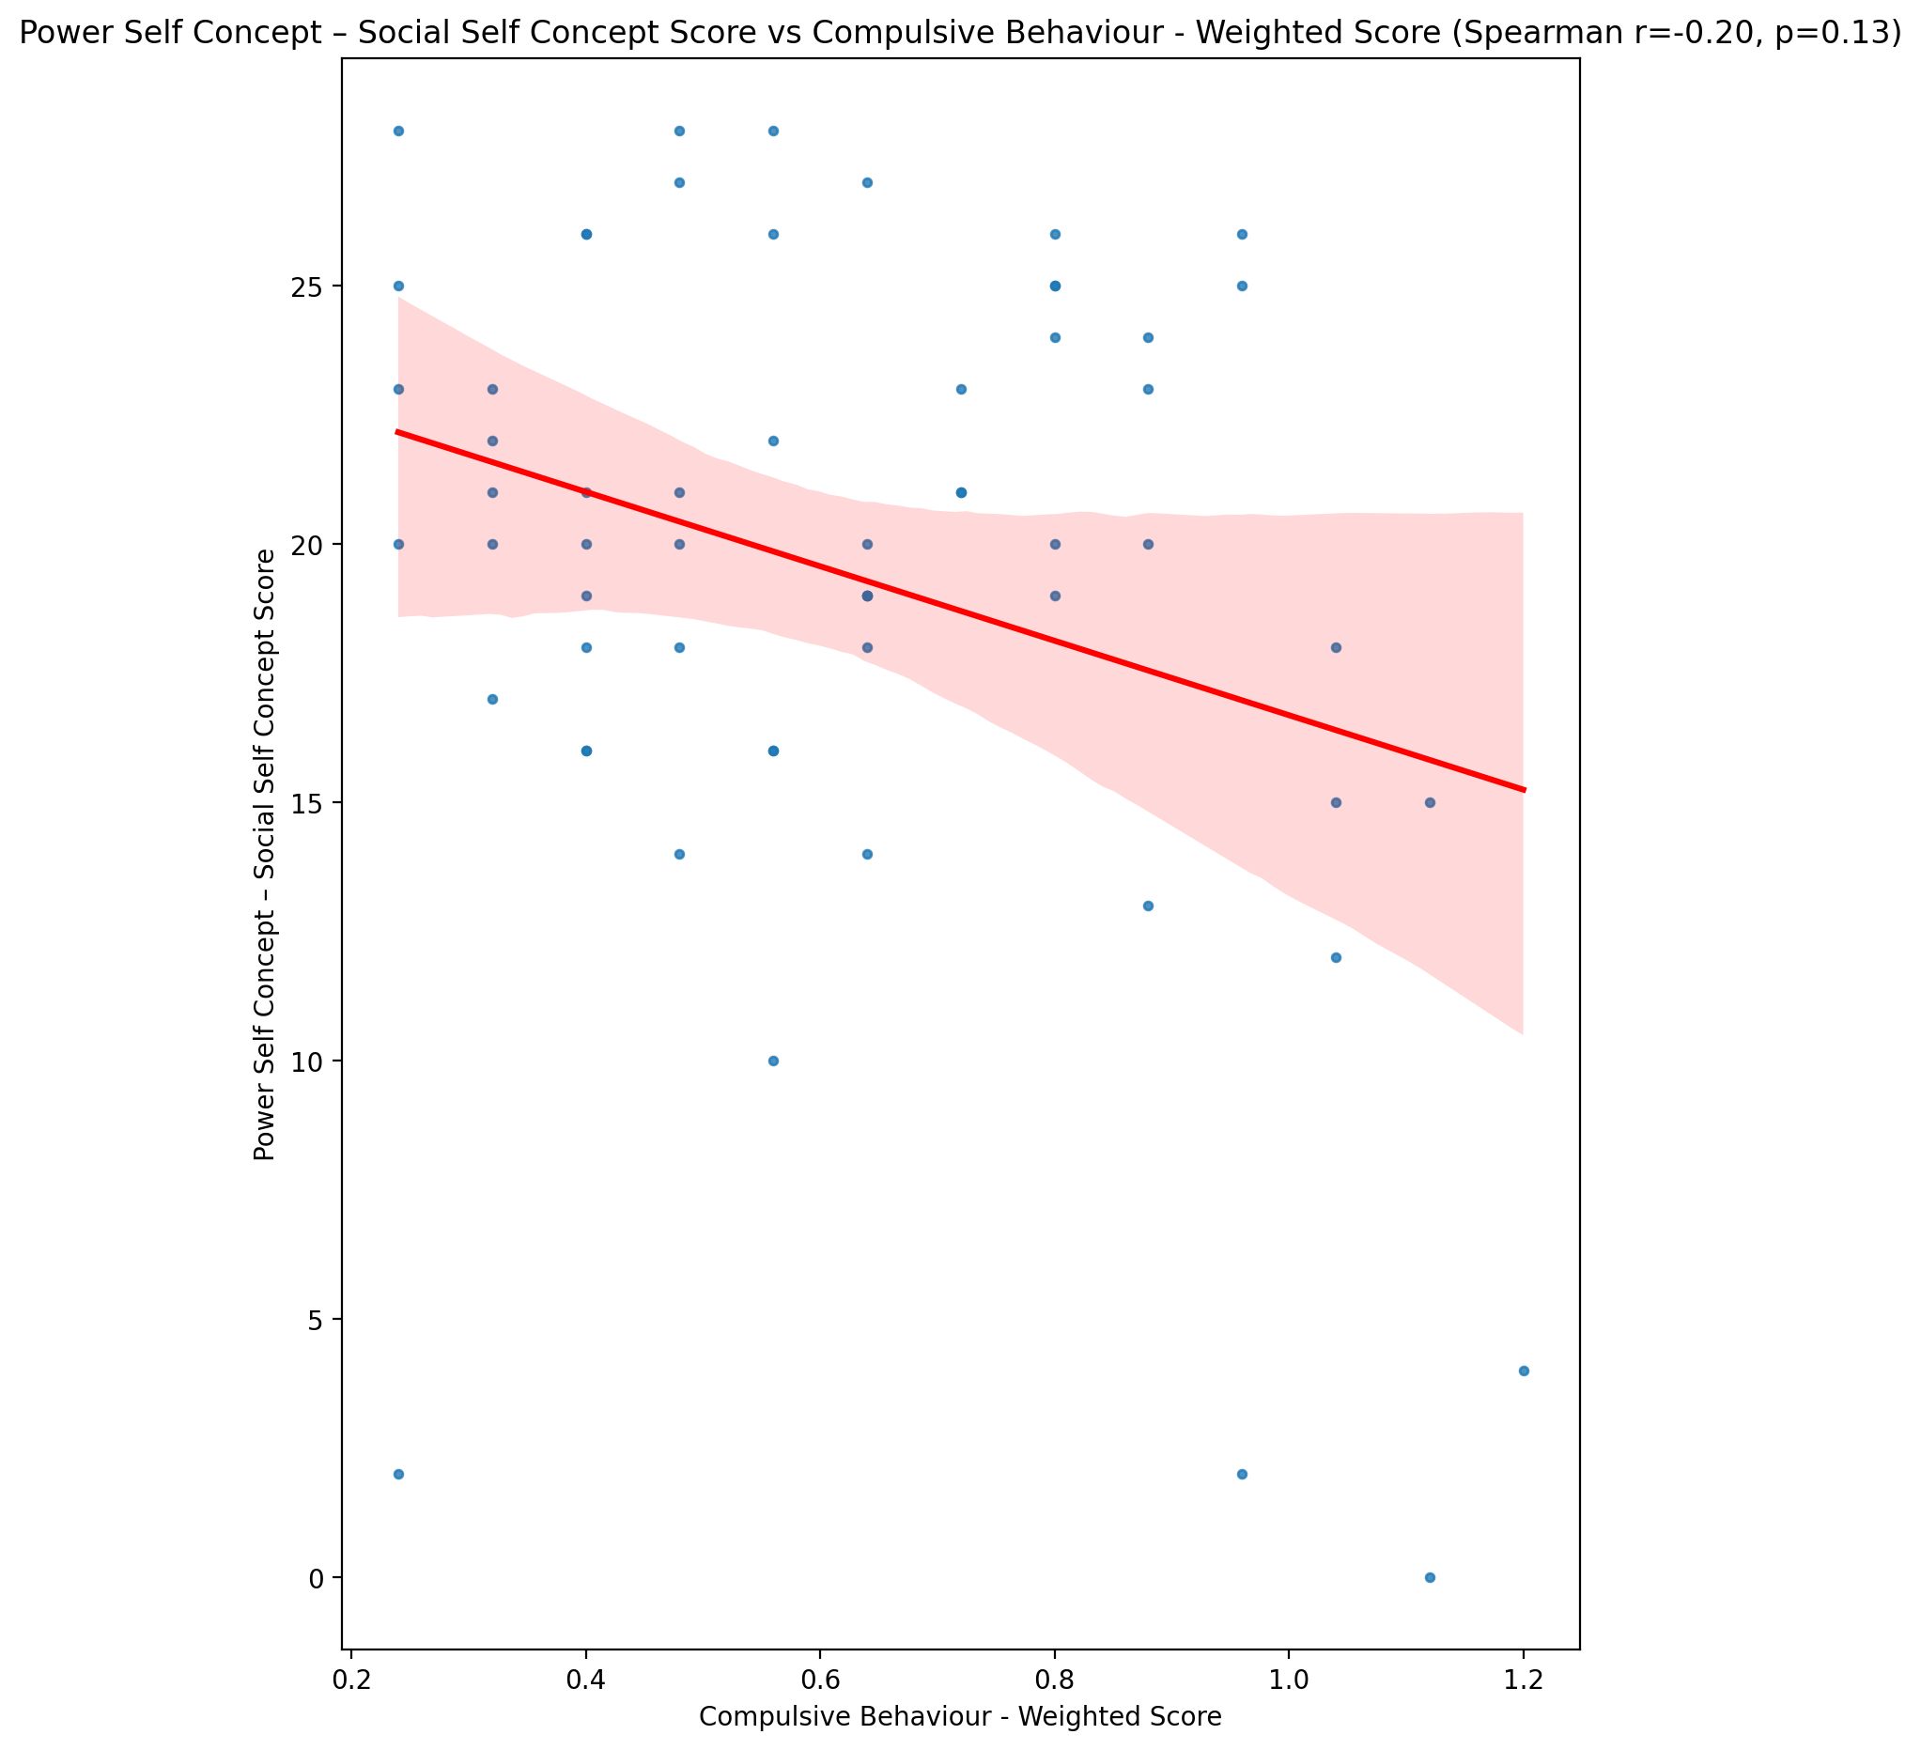

## Social Self Concept - Real Self Concept Score vs Compulsive Behaviour - Weighted Score

Test: spearman; statistic: -0.31178874990889116; p-value: 0.016220693805421488;

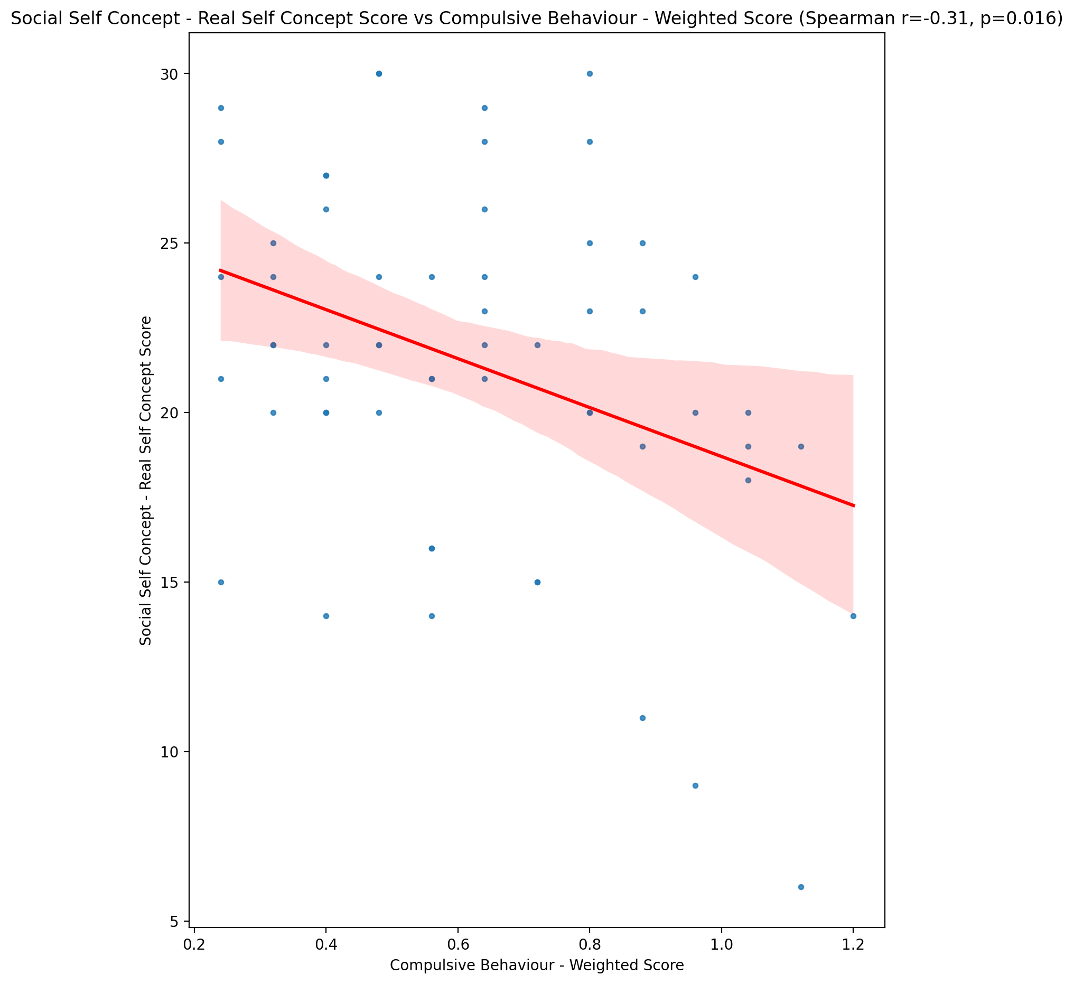

## Social Self Concept – Social Self Concept Score vs Compulsive Behaviour - Weighted Score

Test: spearman; statistic: -0.23379738303200245; p-value: 0.07471697510356752;

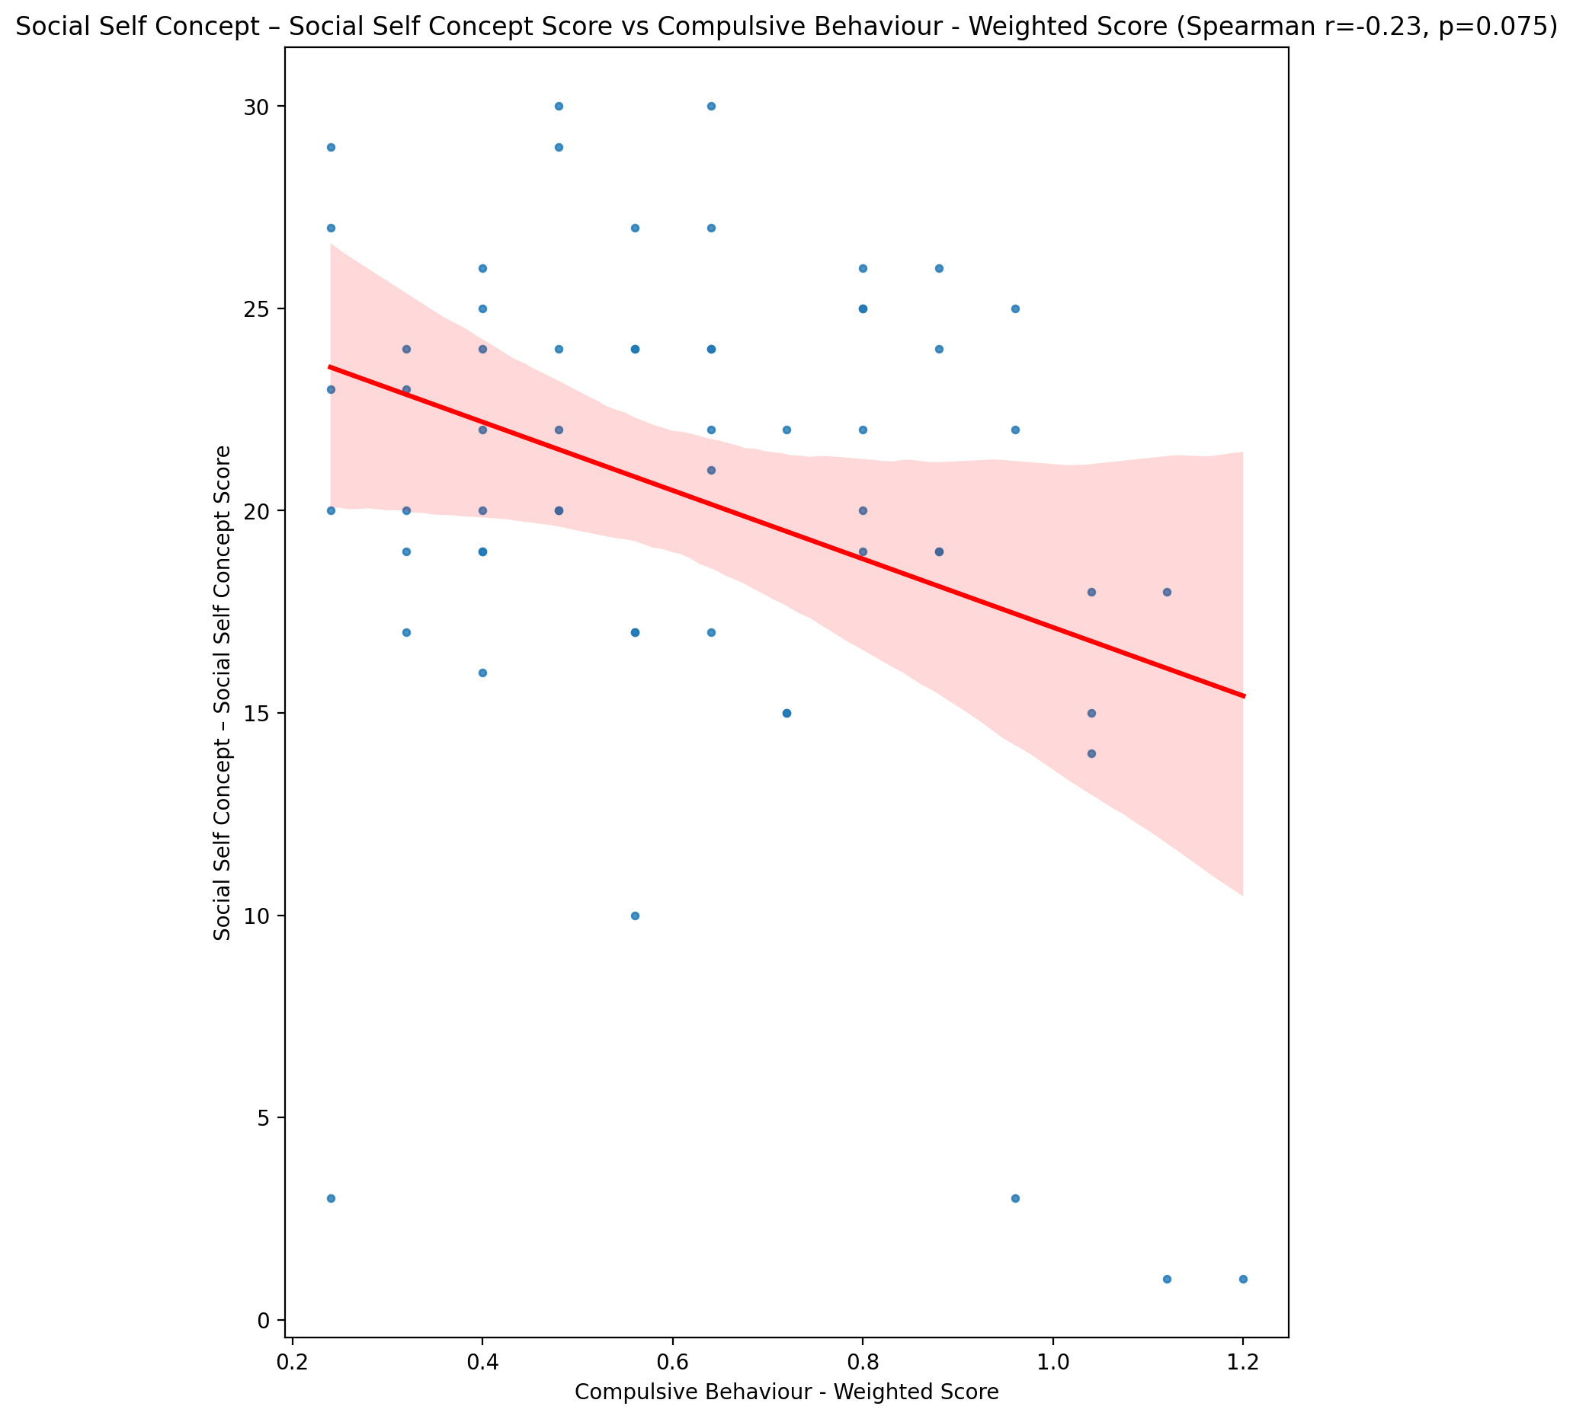

## Ability Self Concept - Real Self Concept Score vs Compulsive Behaviour - Weighted Score

Test: spearman; statistic: -0.28230490886852166; p-value: 0.030288031086583848;

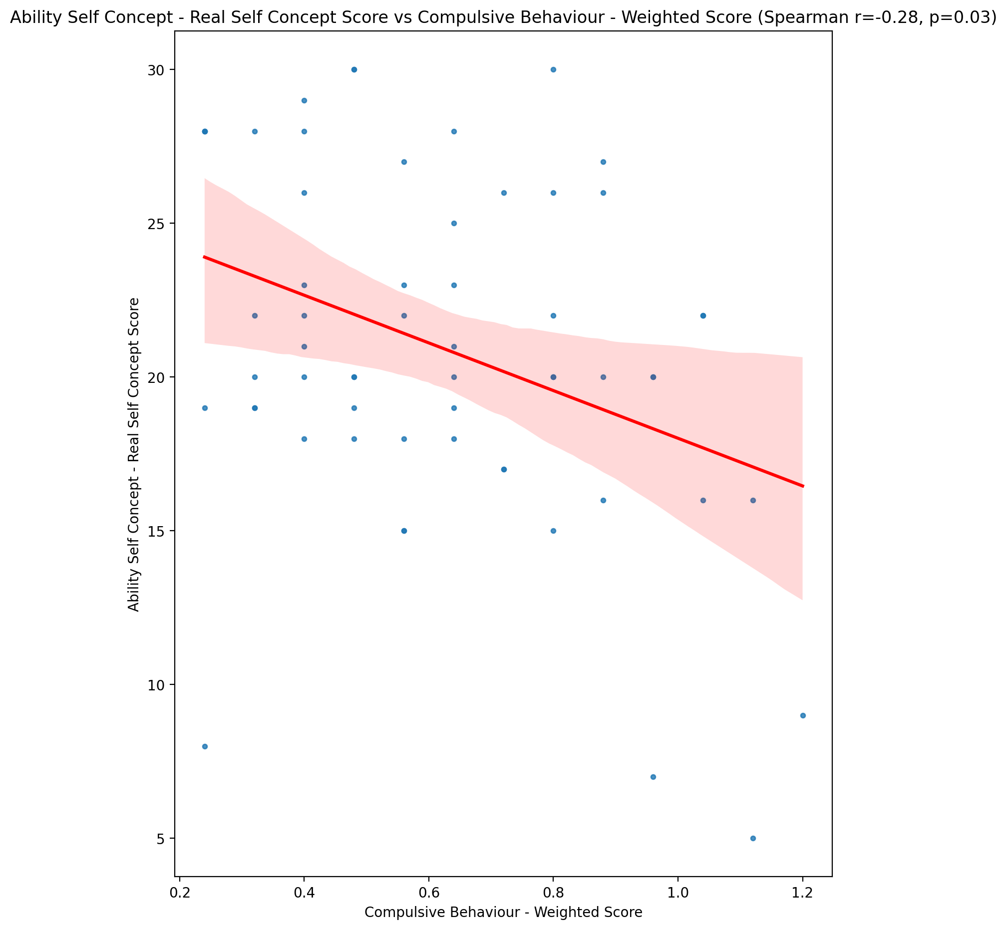

## Ability Self Concept - Ideal Self Concept Score vs Compulsive Behaviour - Weighted Score

Test: spearman; statistic: -0.25258946072315863; p-value: 0.05359589244013672;

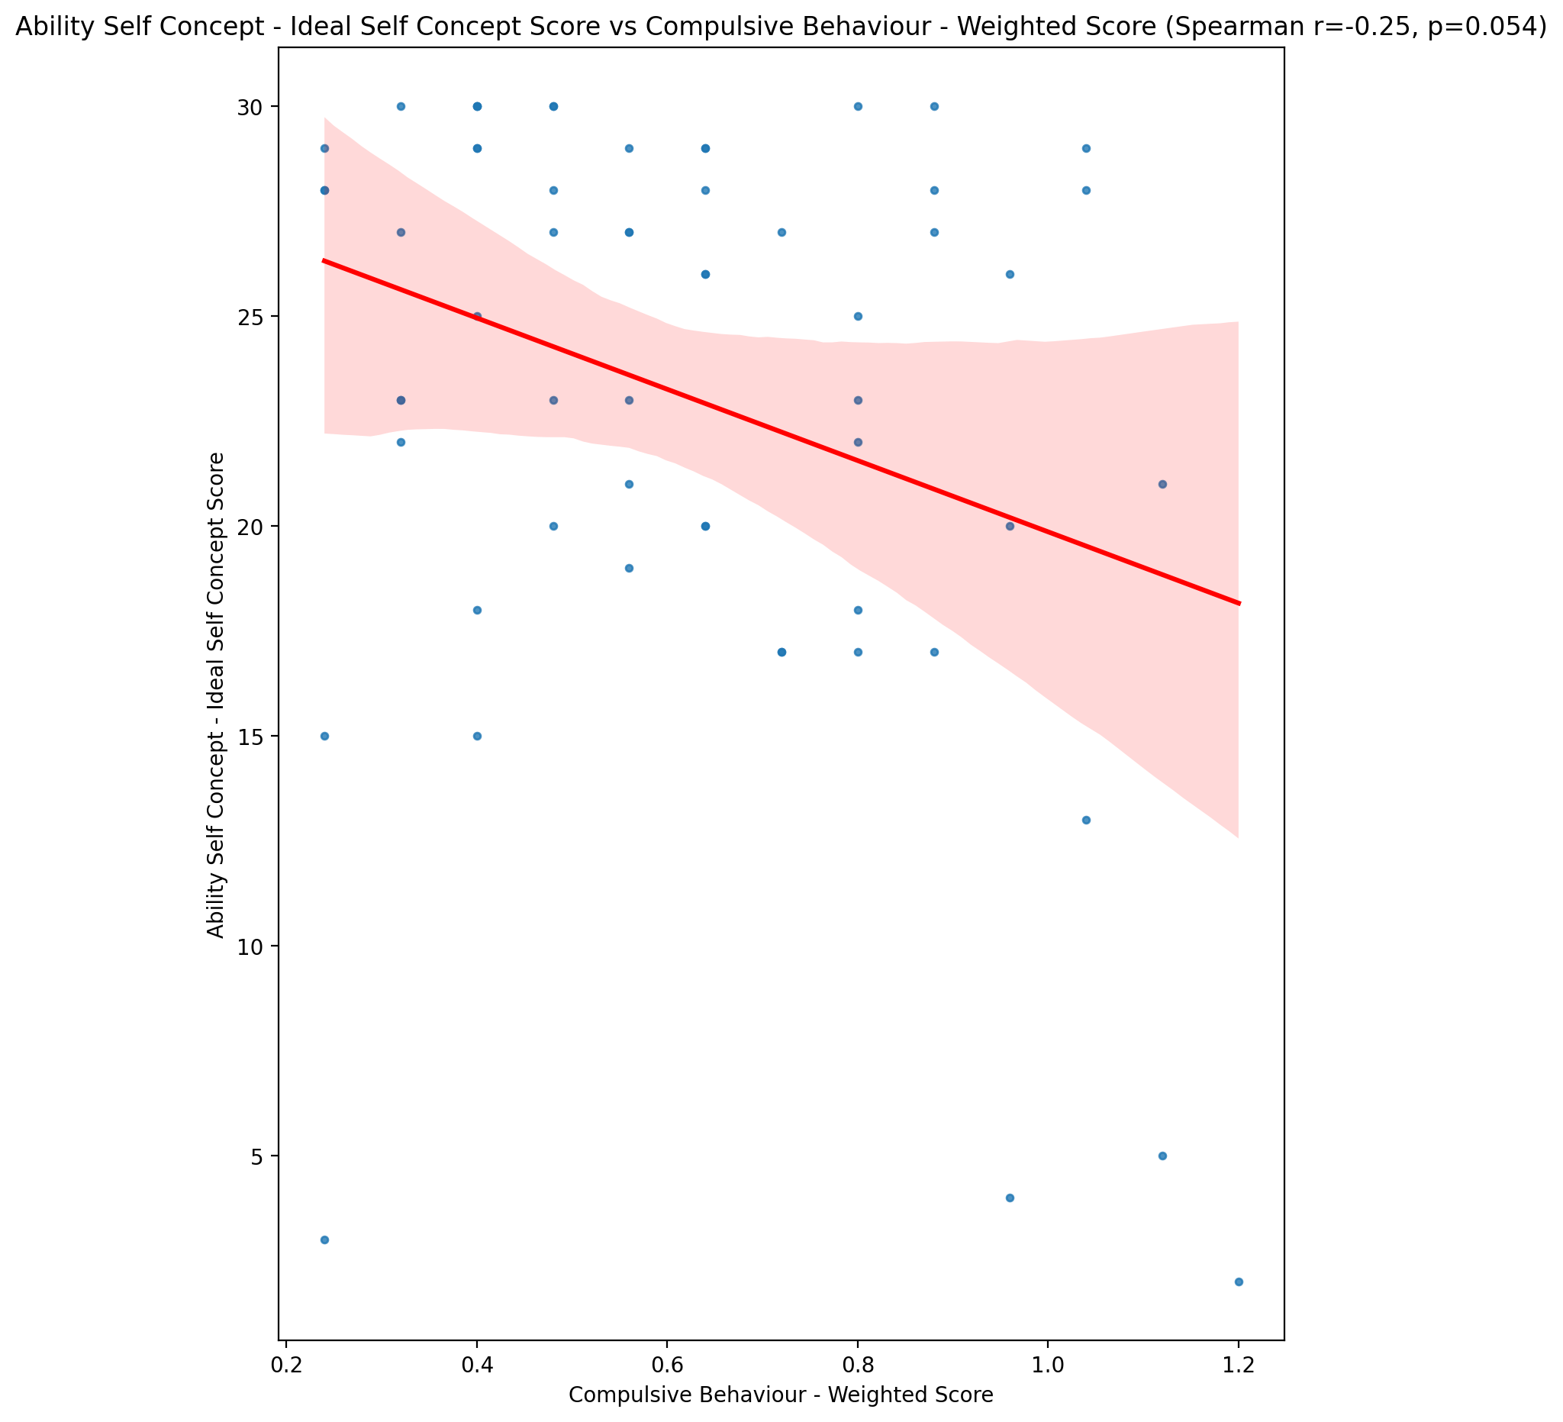

## Ability Self Concept – Social Self Concept Score vs Compulsive Behaviour - Weighted Score

Test: spearman; statistic: -0.2025660460935217; p-value: 0.12389024560968558;

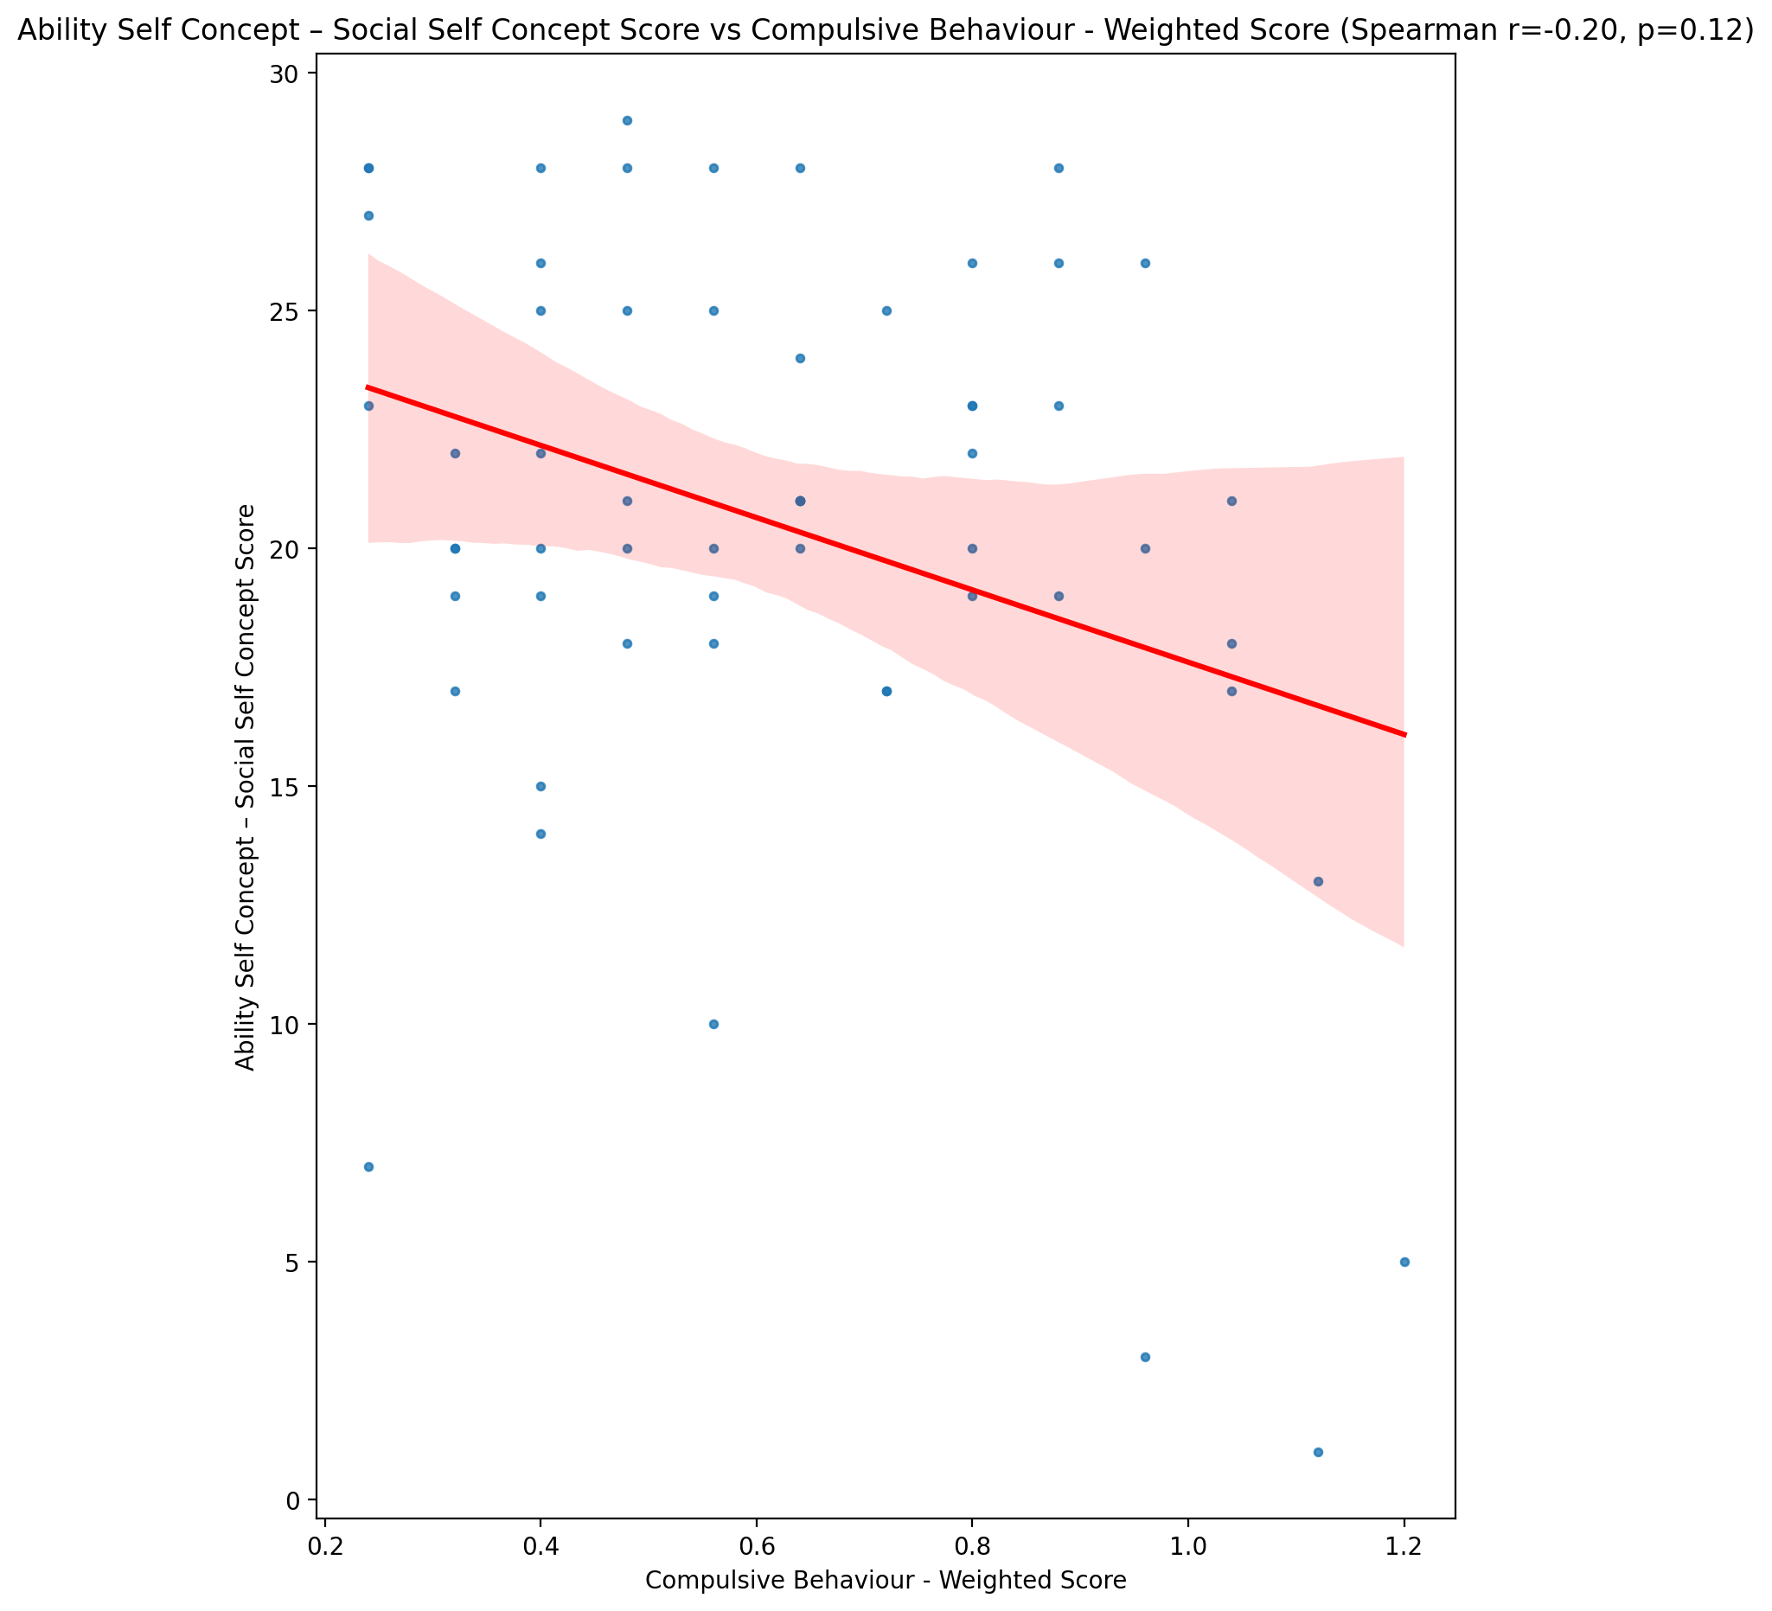

## Physical Self Concept - Real Self Concept Score vs Compulsive Behaviour - Weighted Score

Test: spearman; statistic: -0.25548822765197393; p-value: 0.050819646771397706;

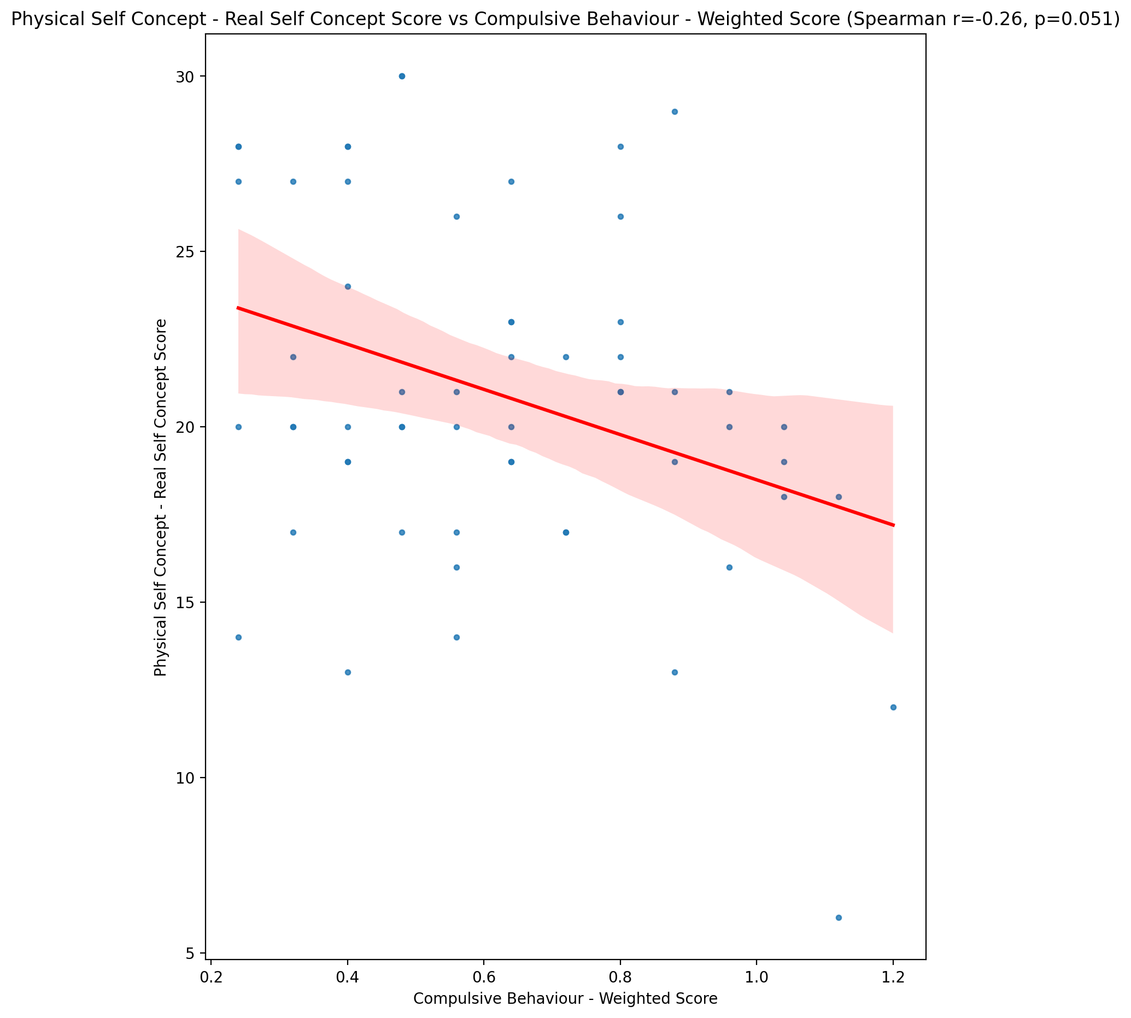

## Physical Self Concept – Ideal Self Concept Score vs Compulsive Behaviour - Weighted Score

Test: spearman; statistic: -0.22764684997950008; p-value: 0.08291395165000313;

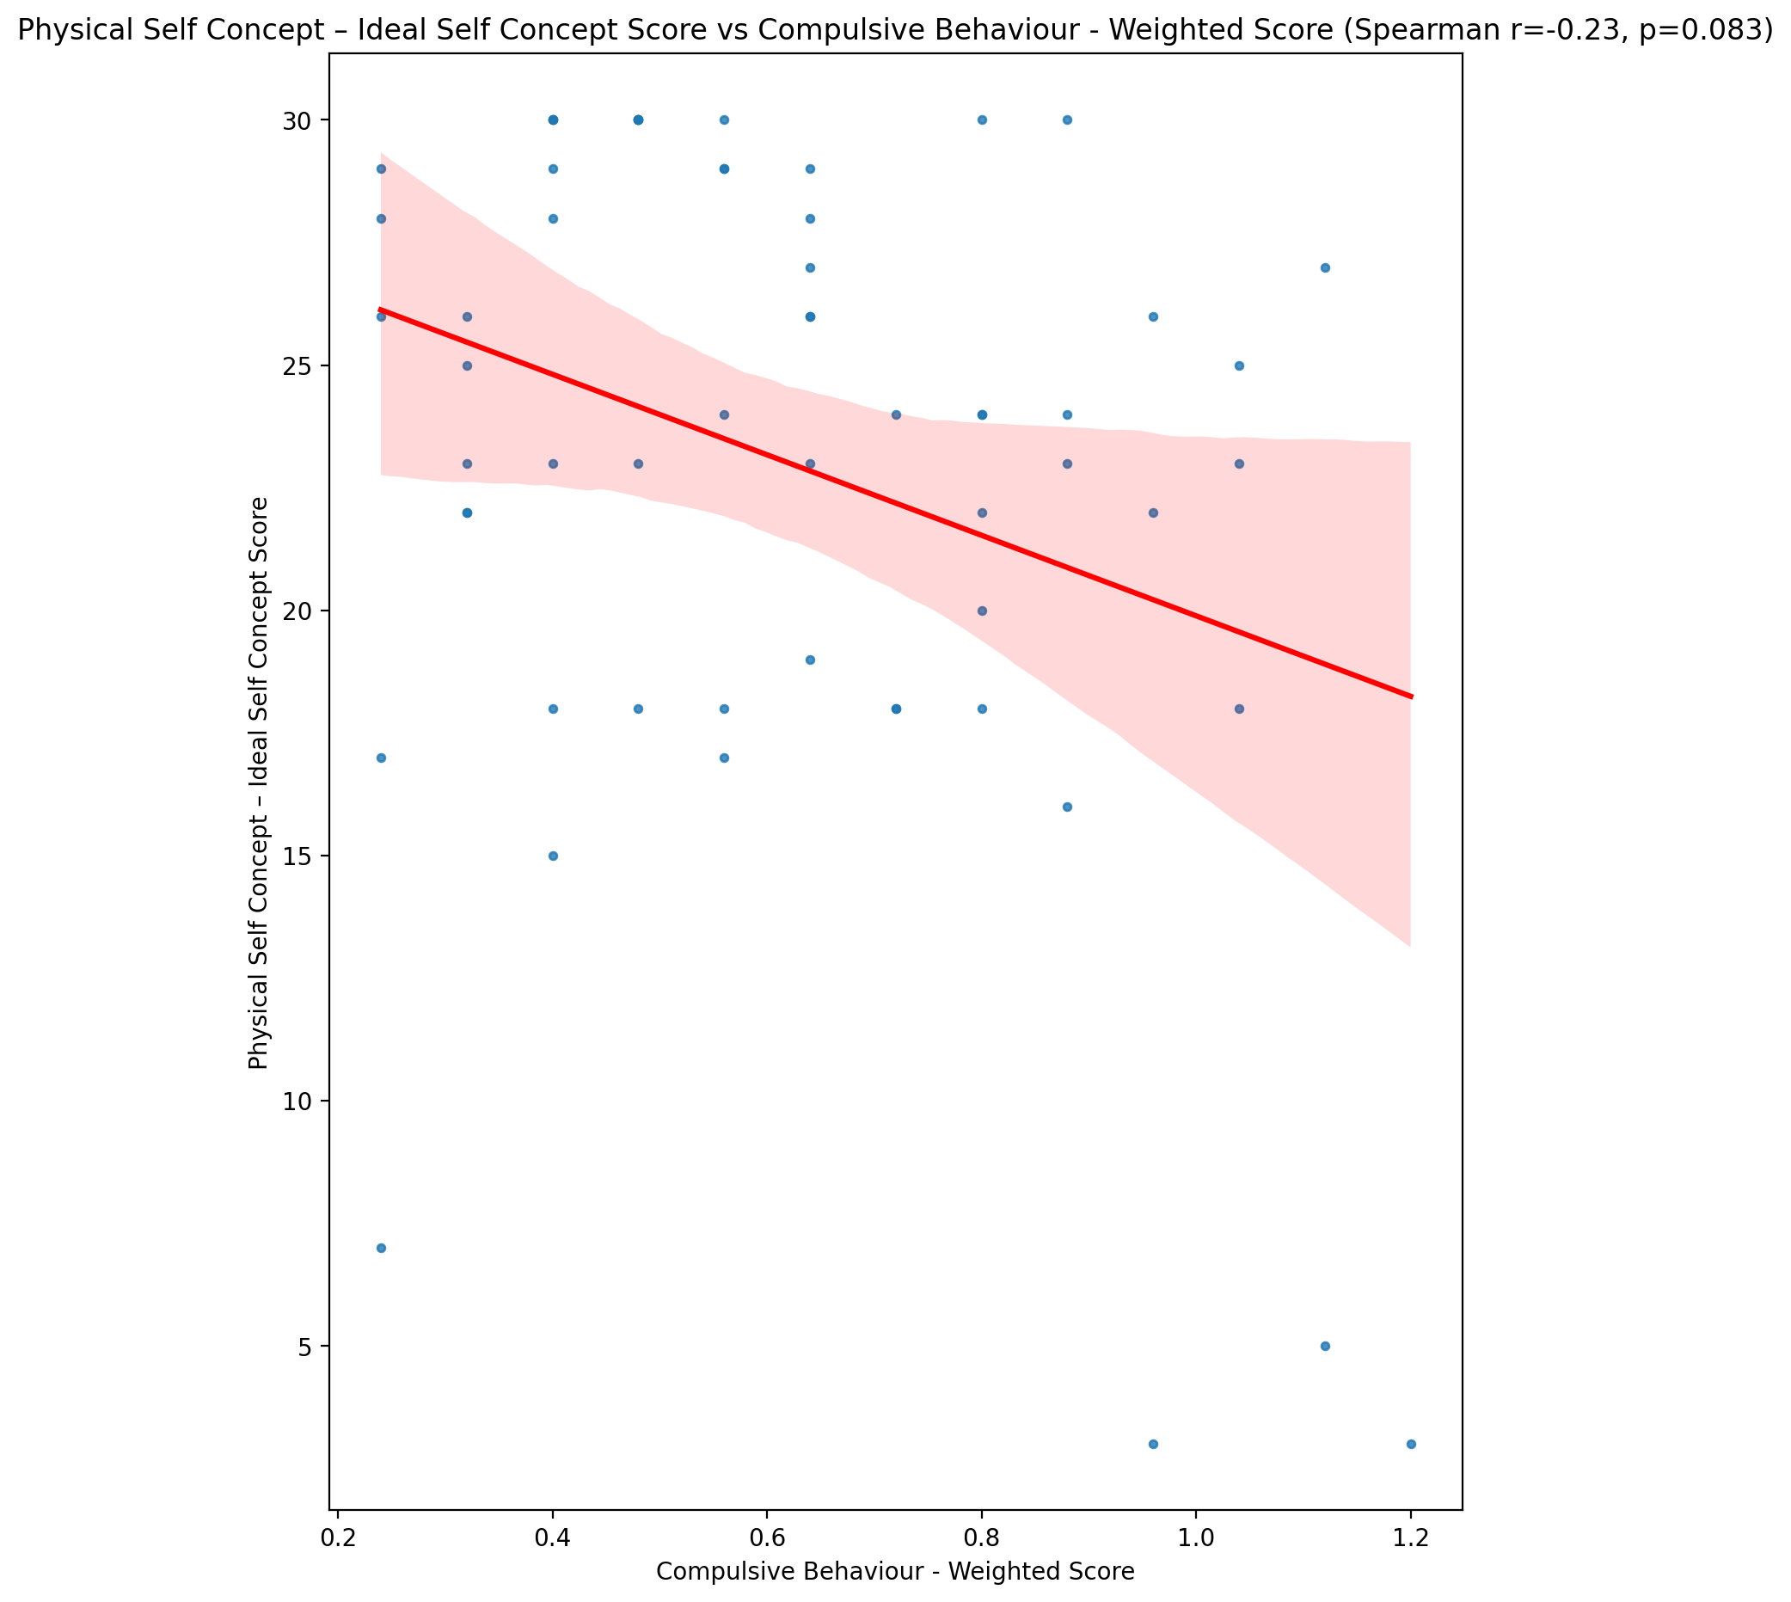

## Physical Self Concept – Social Self Concept Score vs Compulsive Behaviour - Weighted Score

Test: spearman; statistic: -0.15396182114415752; p-value: 0.2443196703333972;

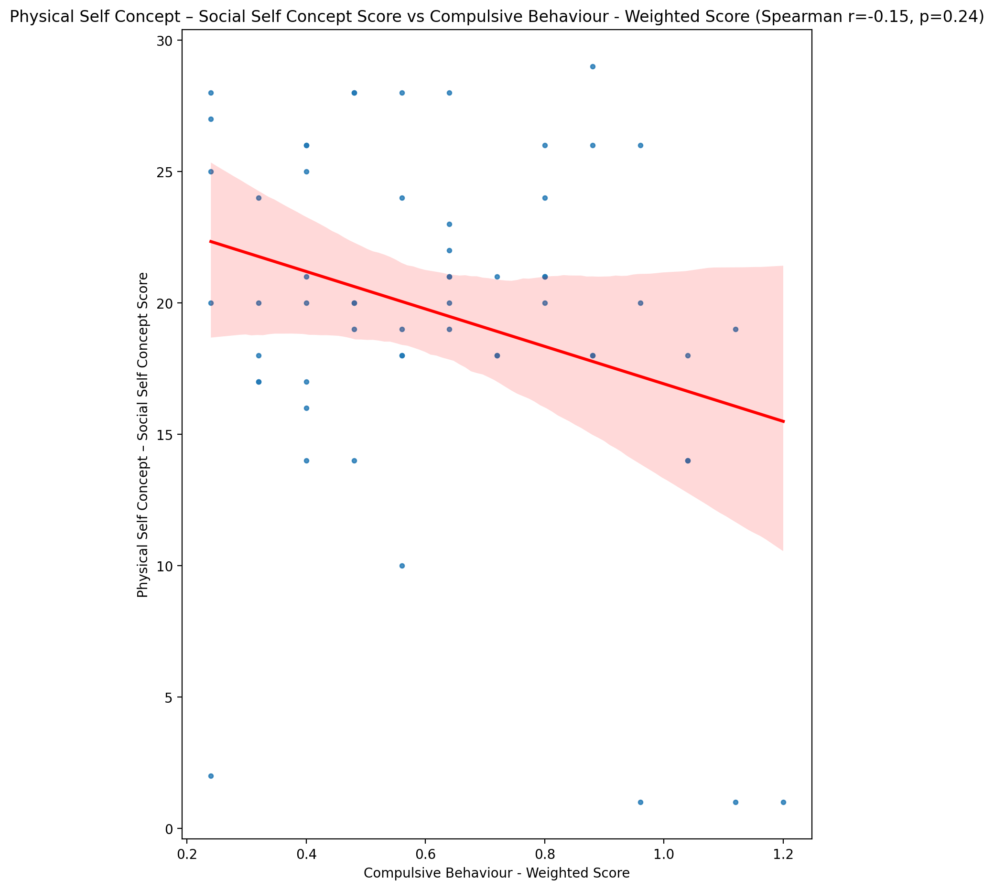

## Psychological Self Concept - Real Self Concept Score vs Compulsive Behaviour - Weighted Score

Test: spearman; statistic: -0.39529399334155185; p-value: 0.001944327610536804;

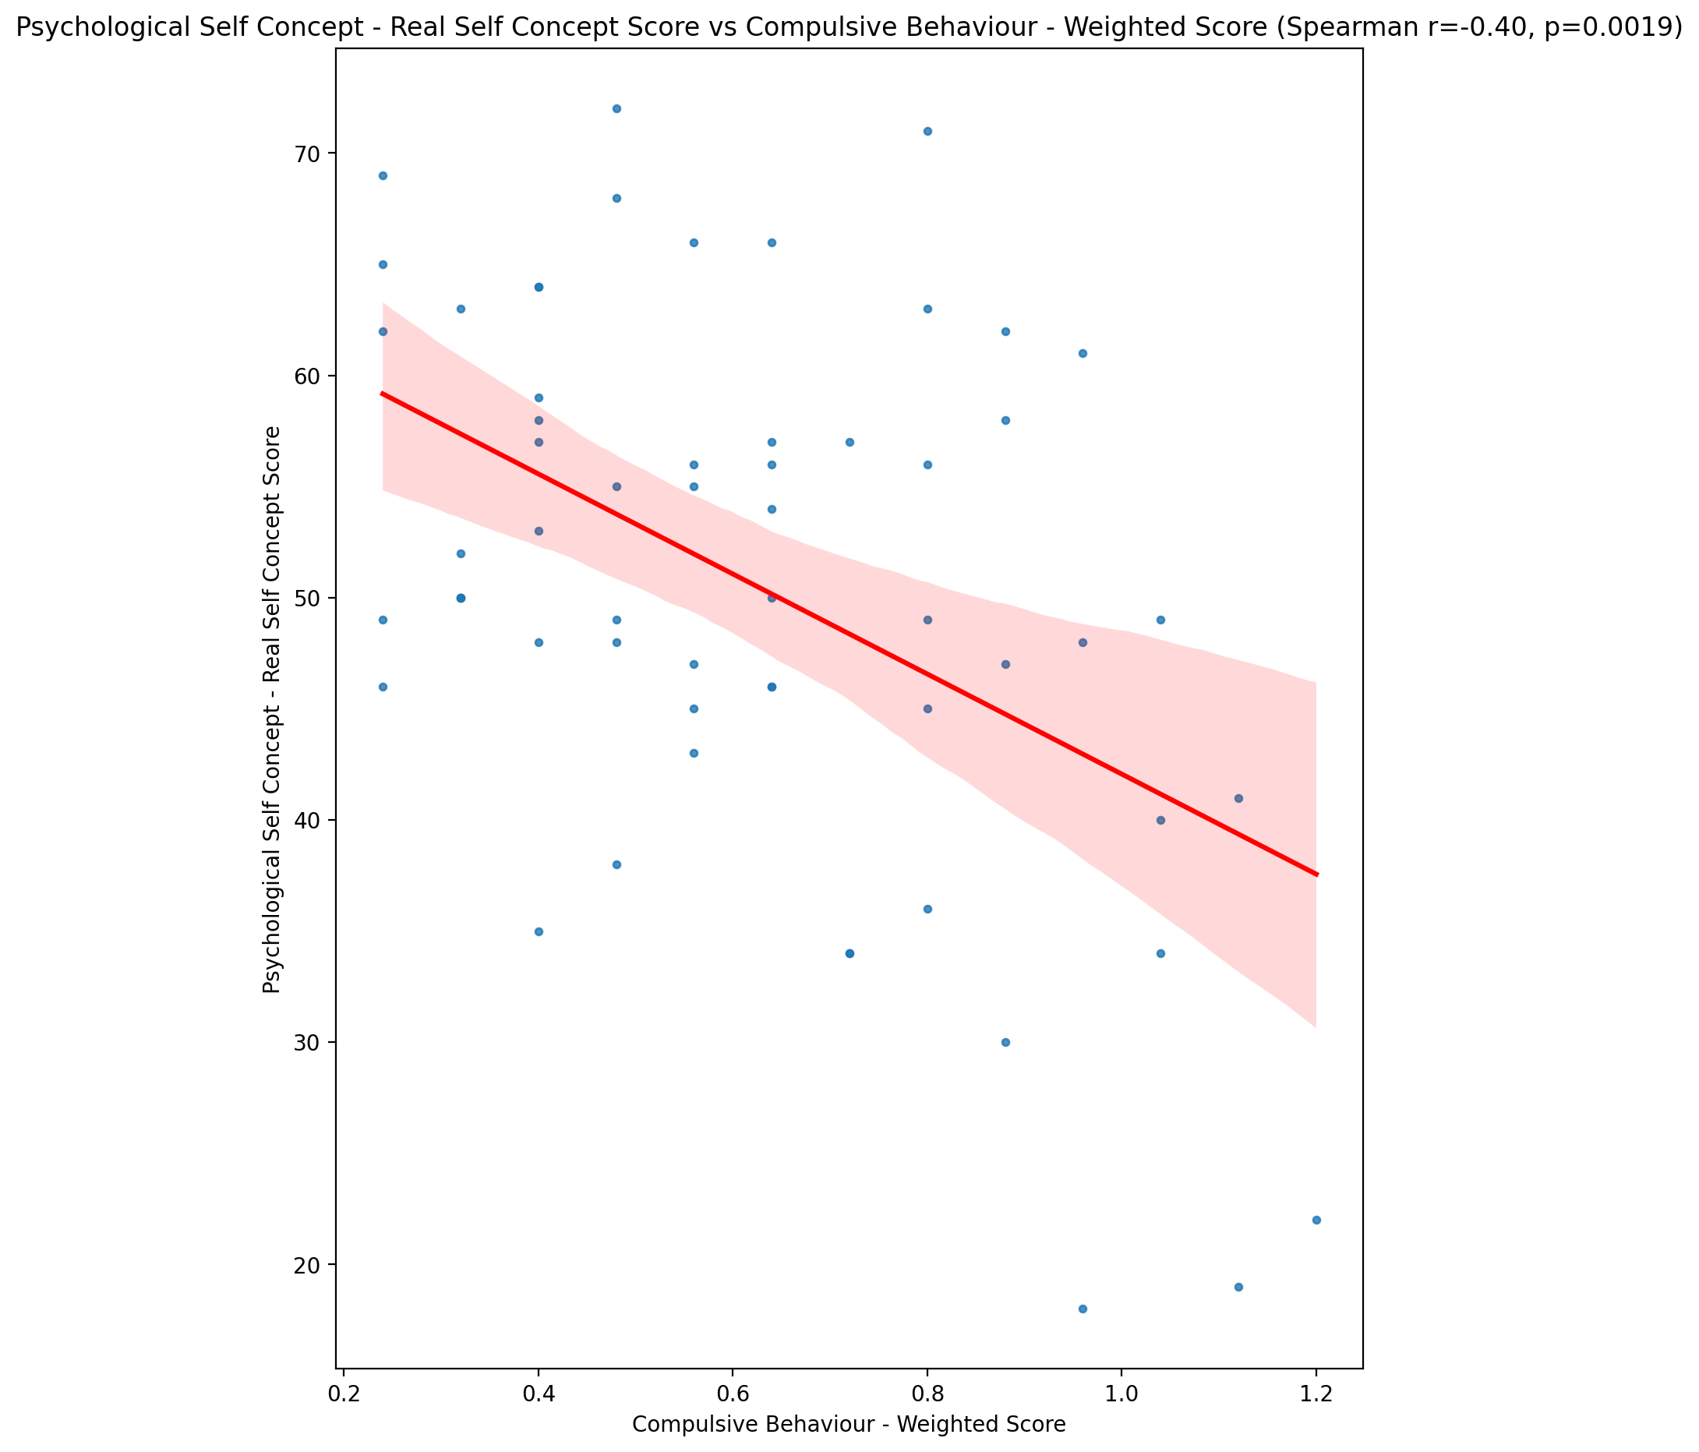

## Psychological Self Concept – Ideal Self Concept Score vs Compulsive Behaviour - Weighted Score

Test: spearman; statistic: -0.22398626173648722; p-value: 0.08811938749349195;

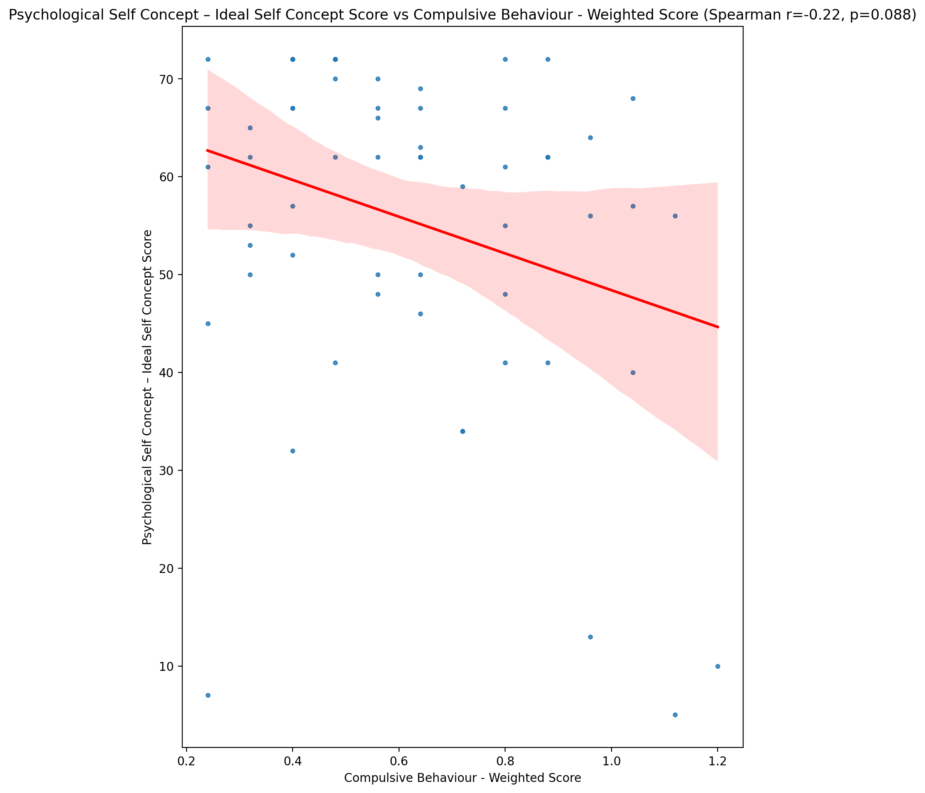

## Psychological Self Concept – Social Self Concept Score vs Compulsive Behaviour - Weighted Score

Test: spearman; statistic: -0.27349158908147364; p-value: 0.036089039959584304;

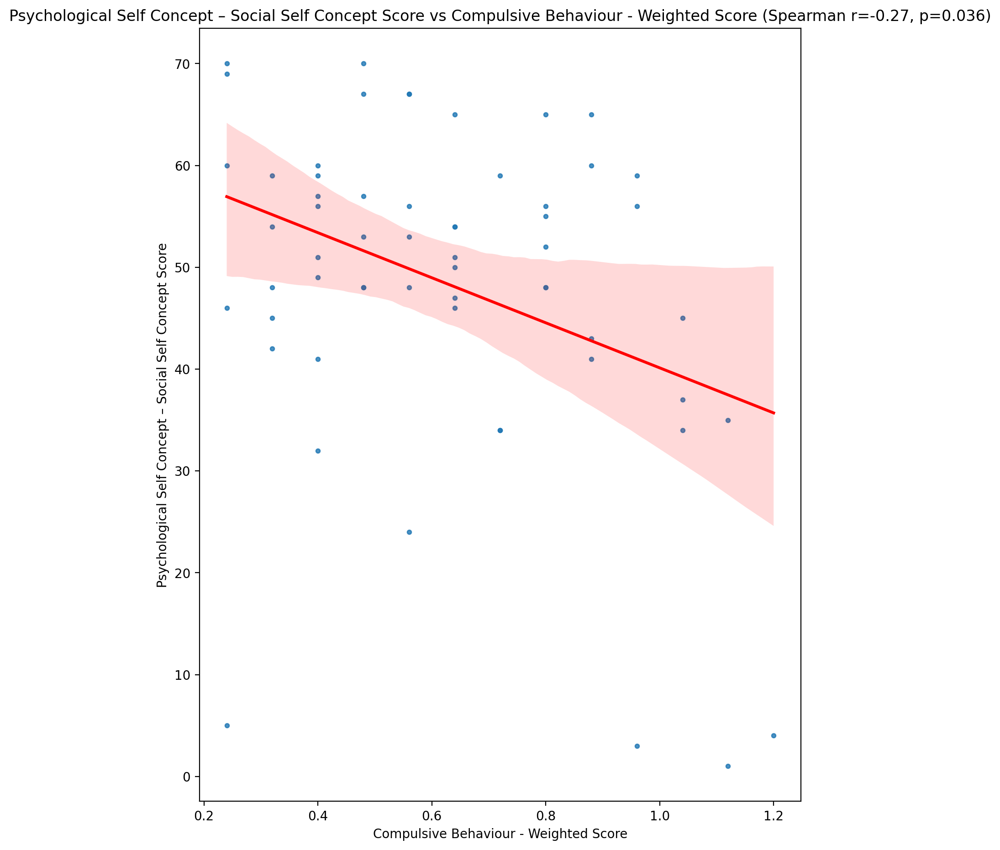

## Real Self Concept Total Score vs Compulsive Behaviour - Weighted Score

Test: spearman; statistic: -0.3252687481189899; p-value: 0.011945693539138044;

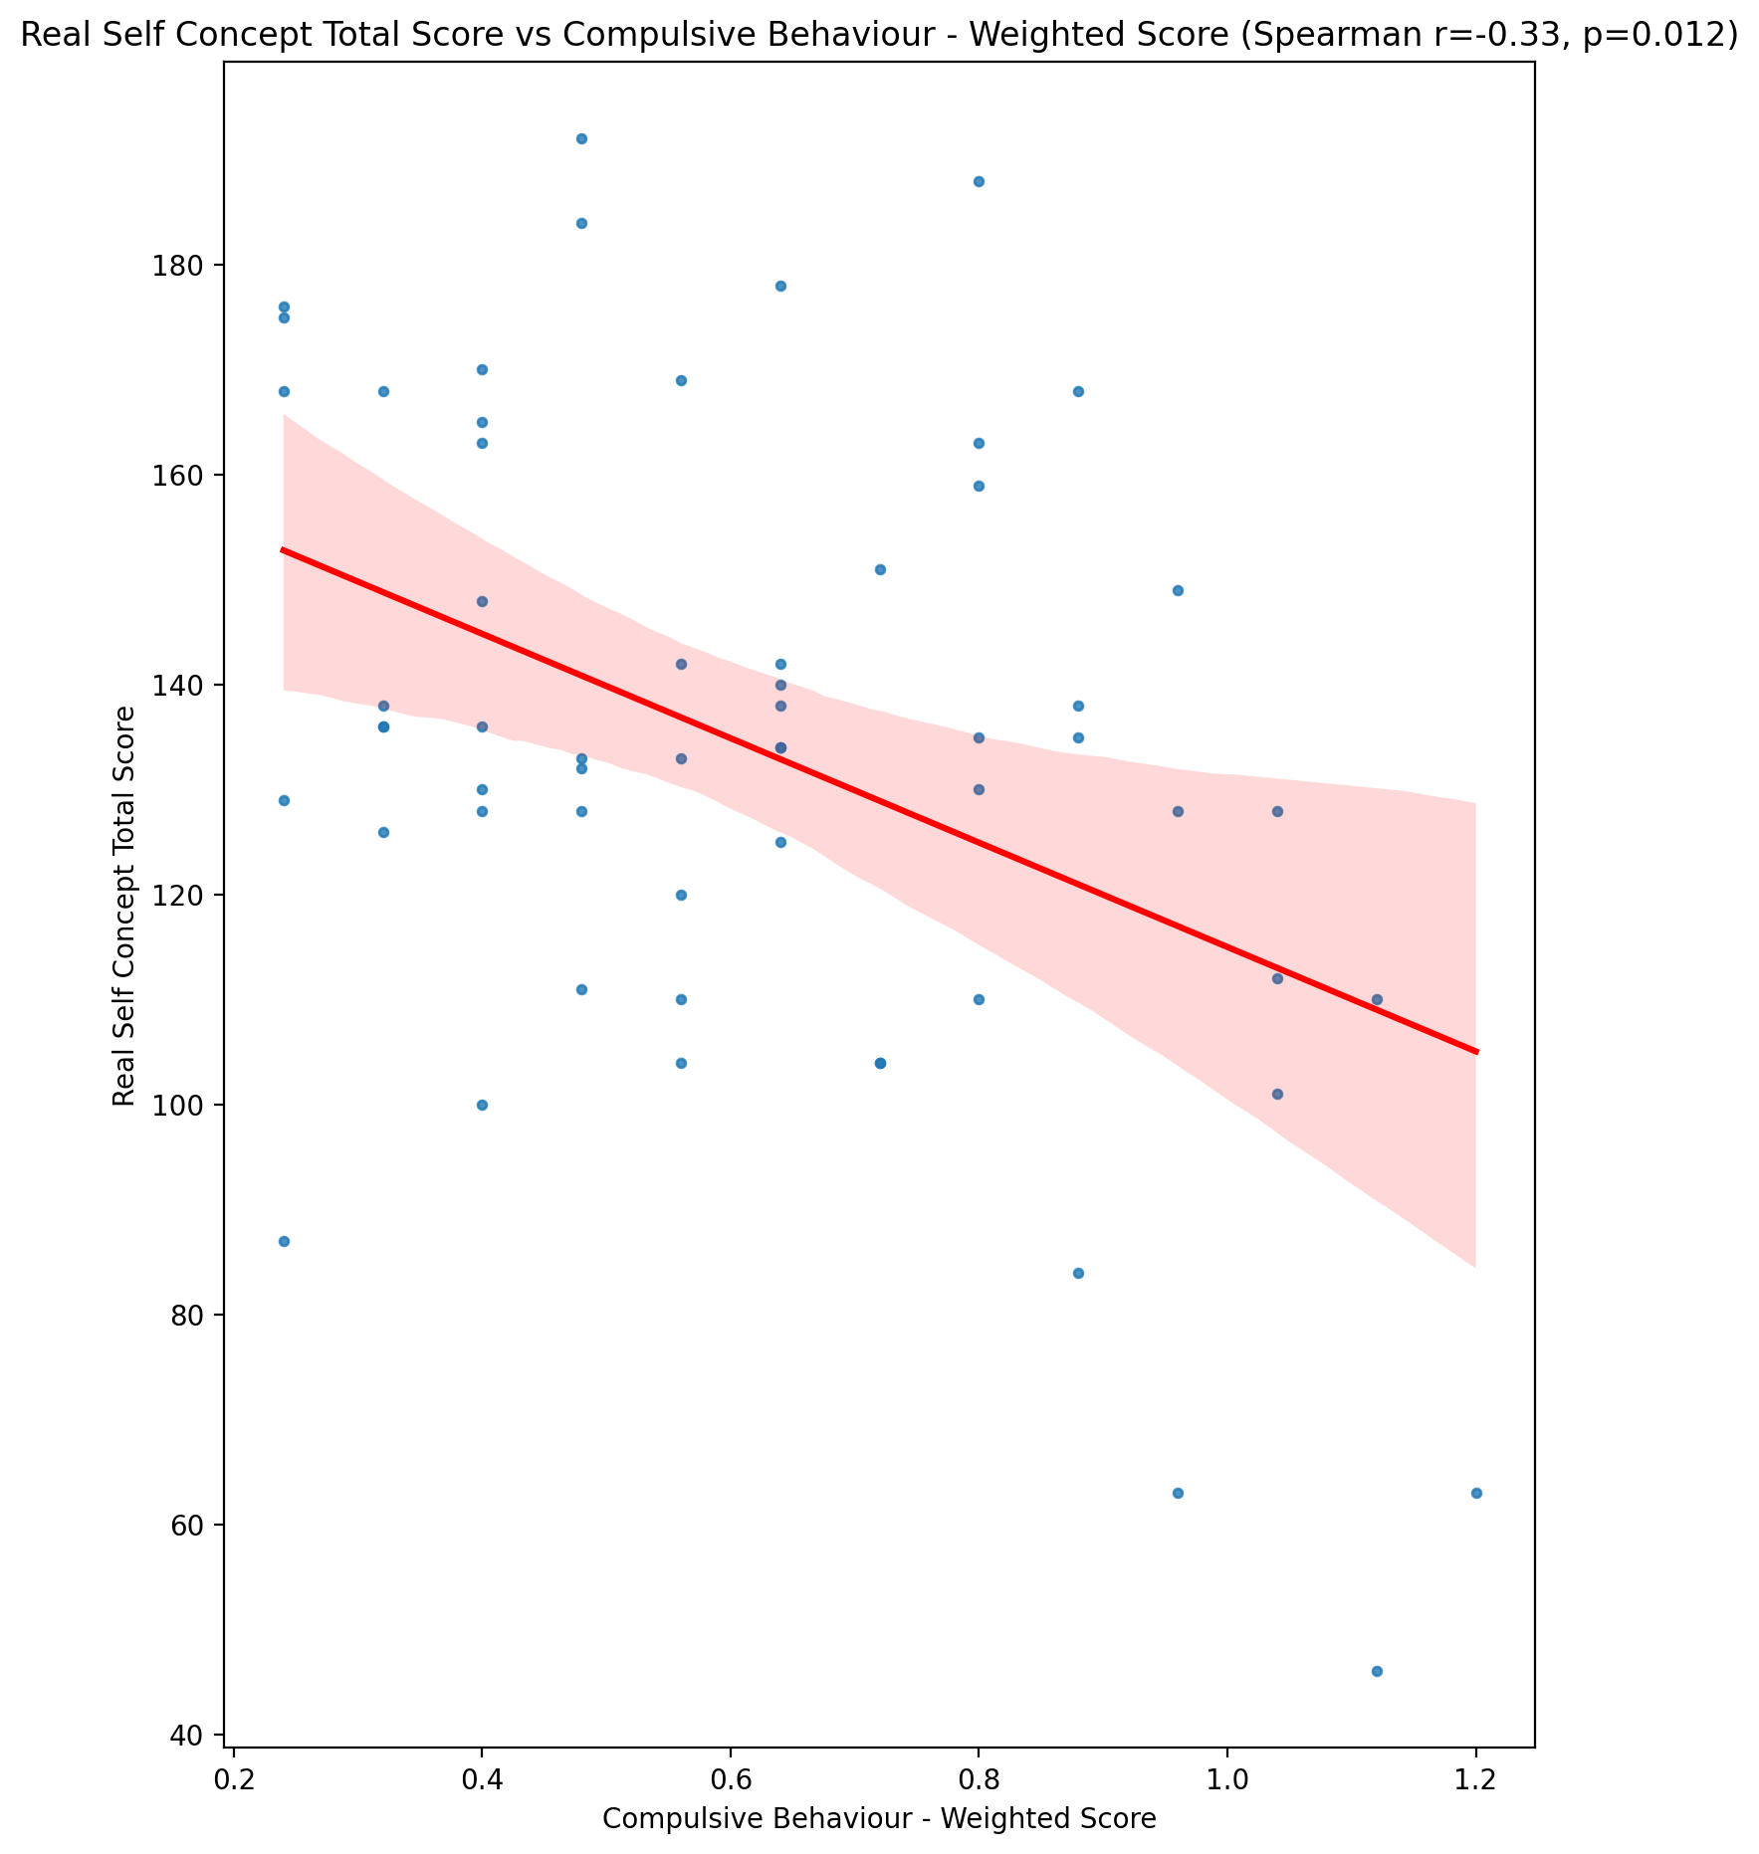

## Ideal Self Concept Total Score vs Compulsive Behaviour - Weighted Score

Test: spearman; statistic: -0.2559144090295135; p-value: 0.05042154713763933;

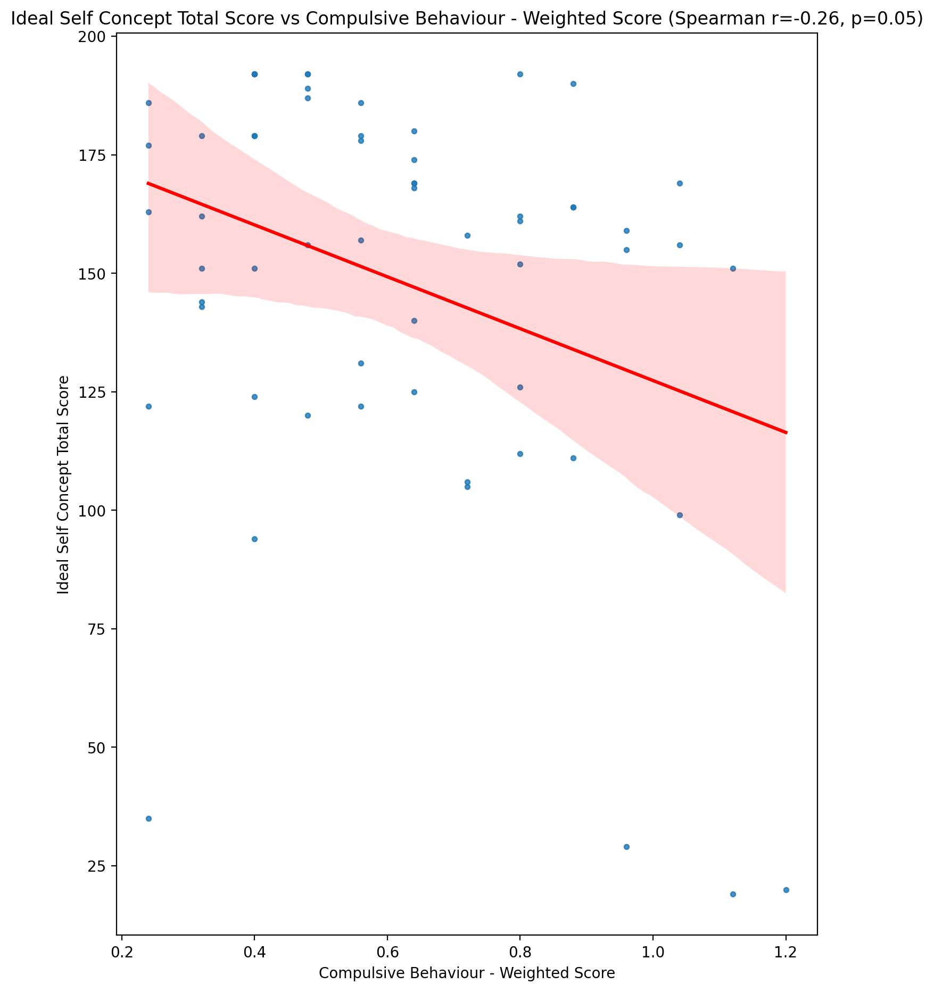

## Social Self Concept Total Score vs Compulsive Behaviour - Weighted Score

Test: spearman; statistic: -0.25421963734205477; p-value: 0.05201983673248275;

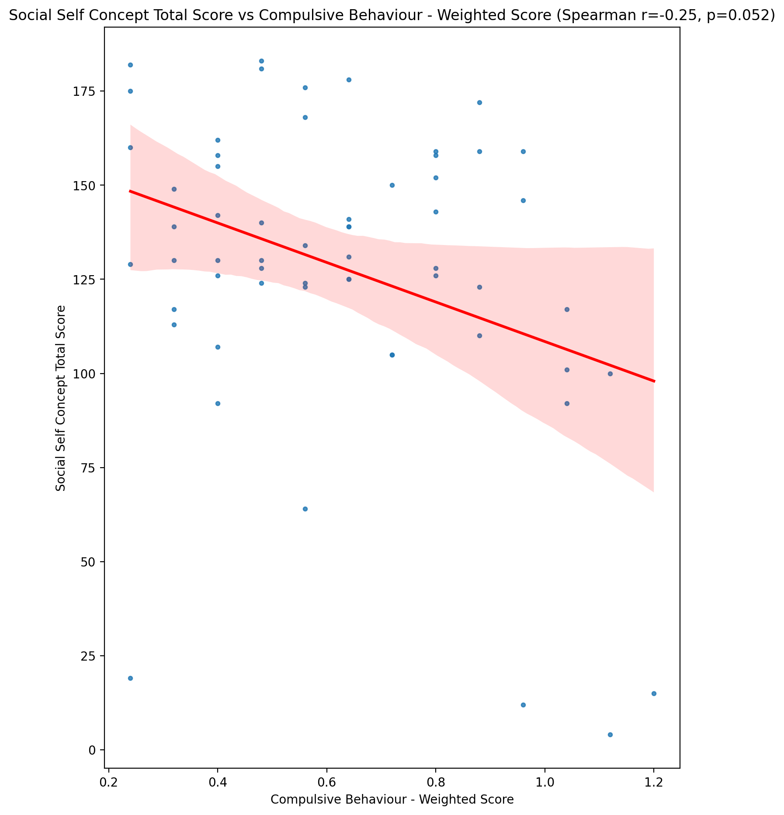

## Ideal Self Concept Total Category vs Compulsive Behaviour - Weighted Score

Test: None; statistic: None; p-value: None; Test not run: unsupported type combination.



## Perceived Social Stress Score vs Compulsive Behaviour - Weighted Score

Test: spearman; statistic: 0.2100416627279927; p-value: 0.11033052633024948;

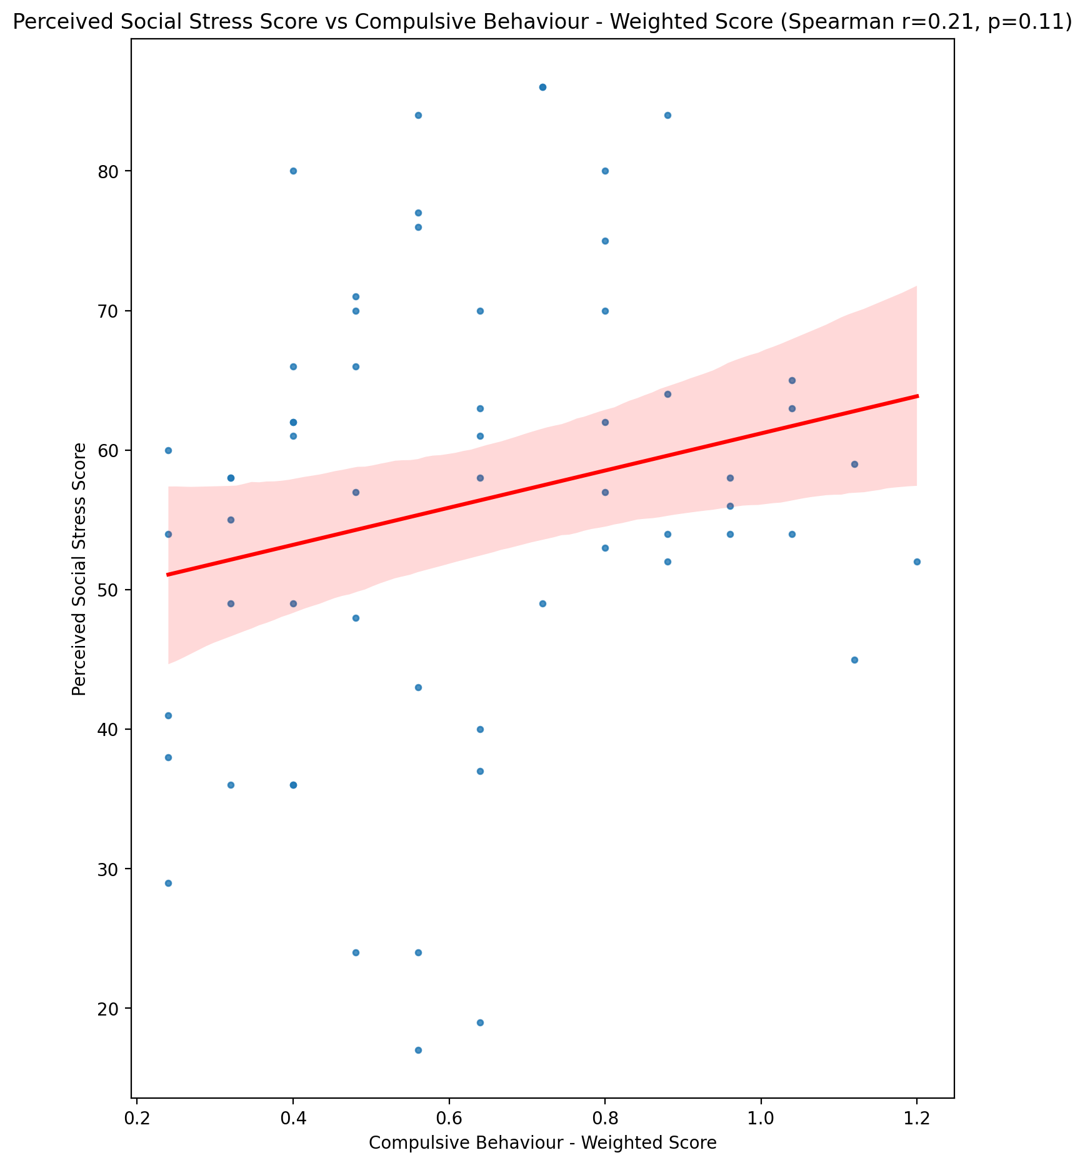

## Perceived Social Stress Category vs Compulsive Behaviour - Weighted Score

Test: None; statistic: None; p-value: None; Test not run: unsupported type combination.



## Emotional Support - Raw Score vs Obsession with Internet - Weighted Score

Test: spearman; statistic: -0.12132954453890155; p-value: 0.3599828435707494;

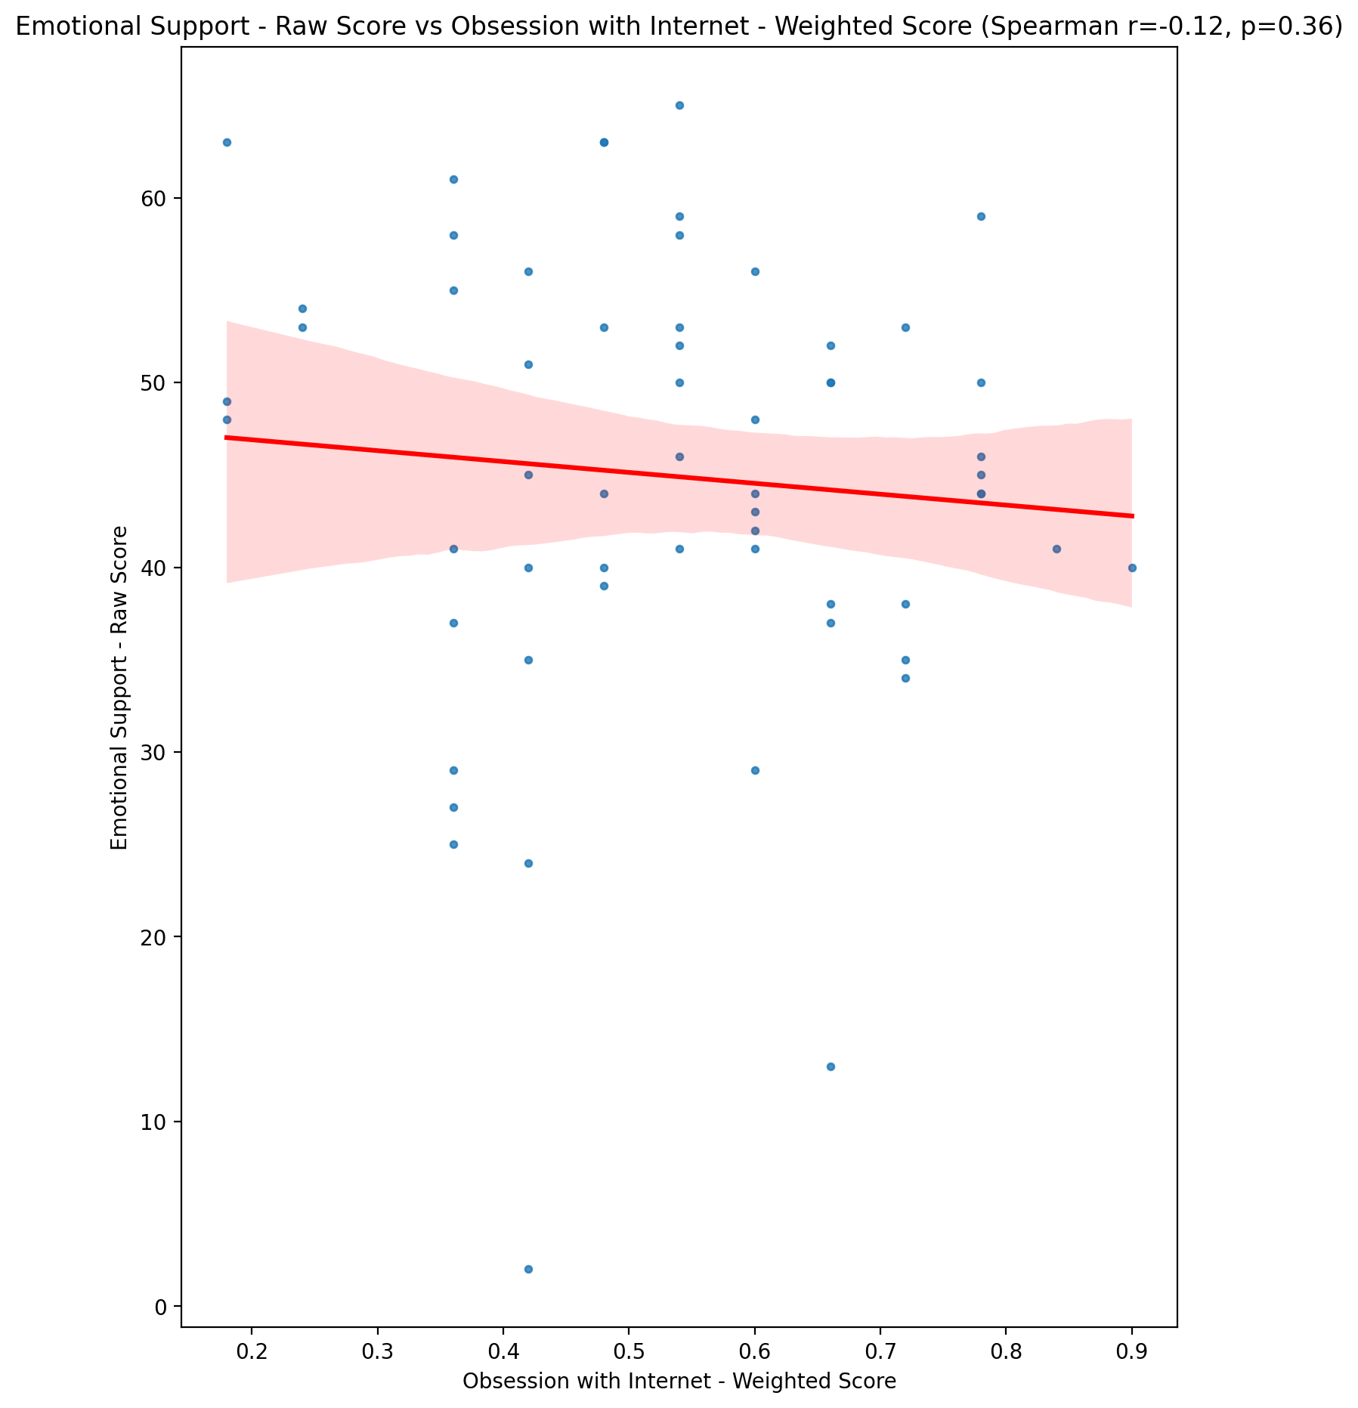

## Informational Support - Raw Score vs Obsession with Internet - Weighted Score

Test: spearman; statistic: -0.0847175618094659; p-value: 0.5235040623786278;

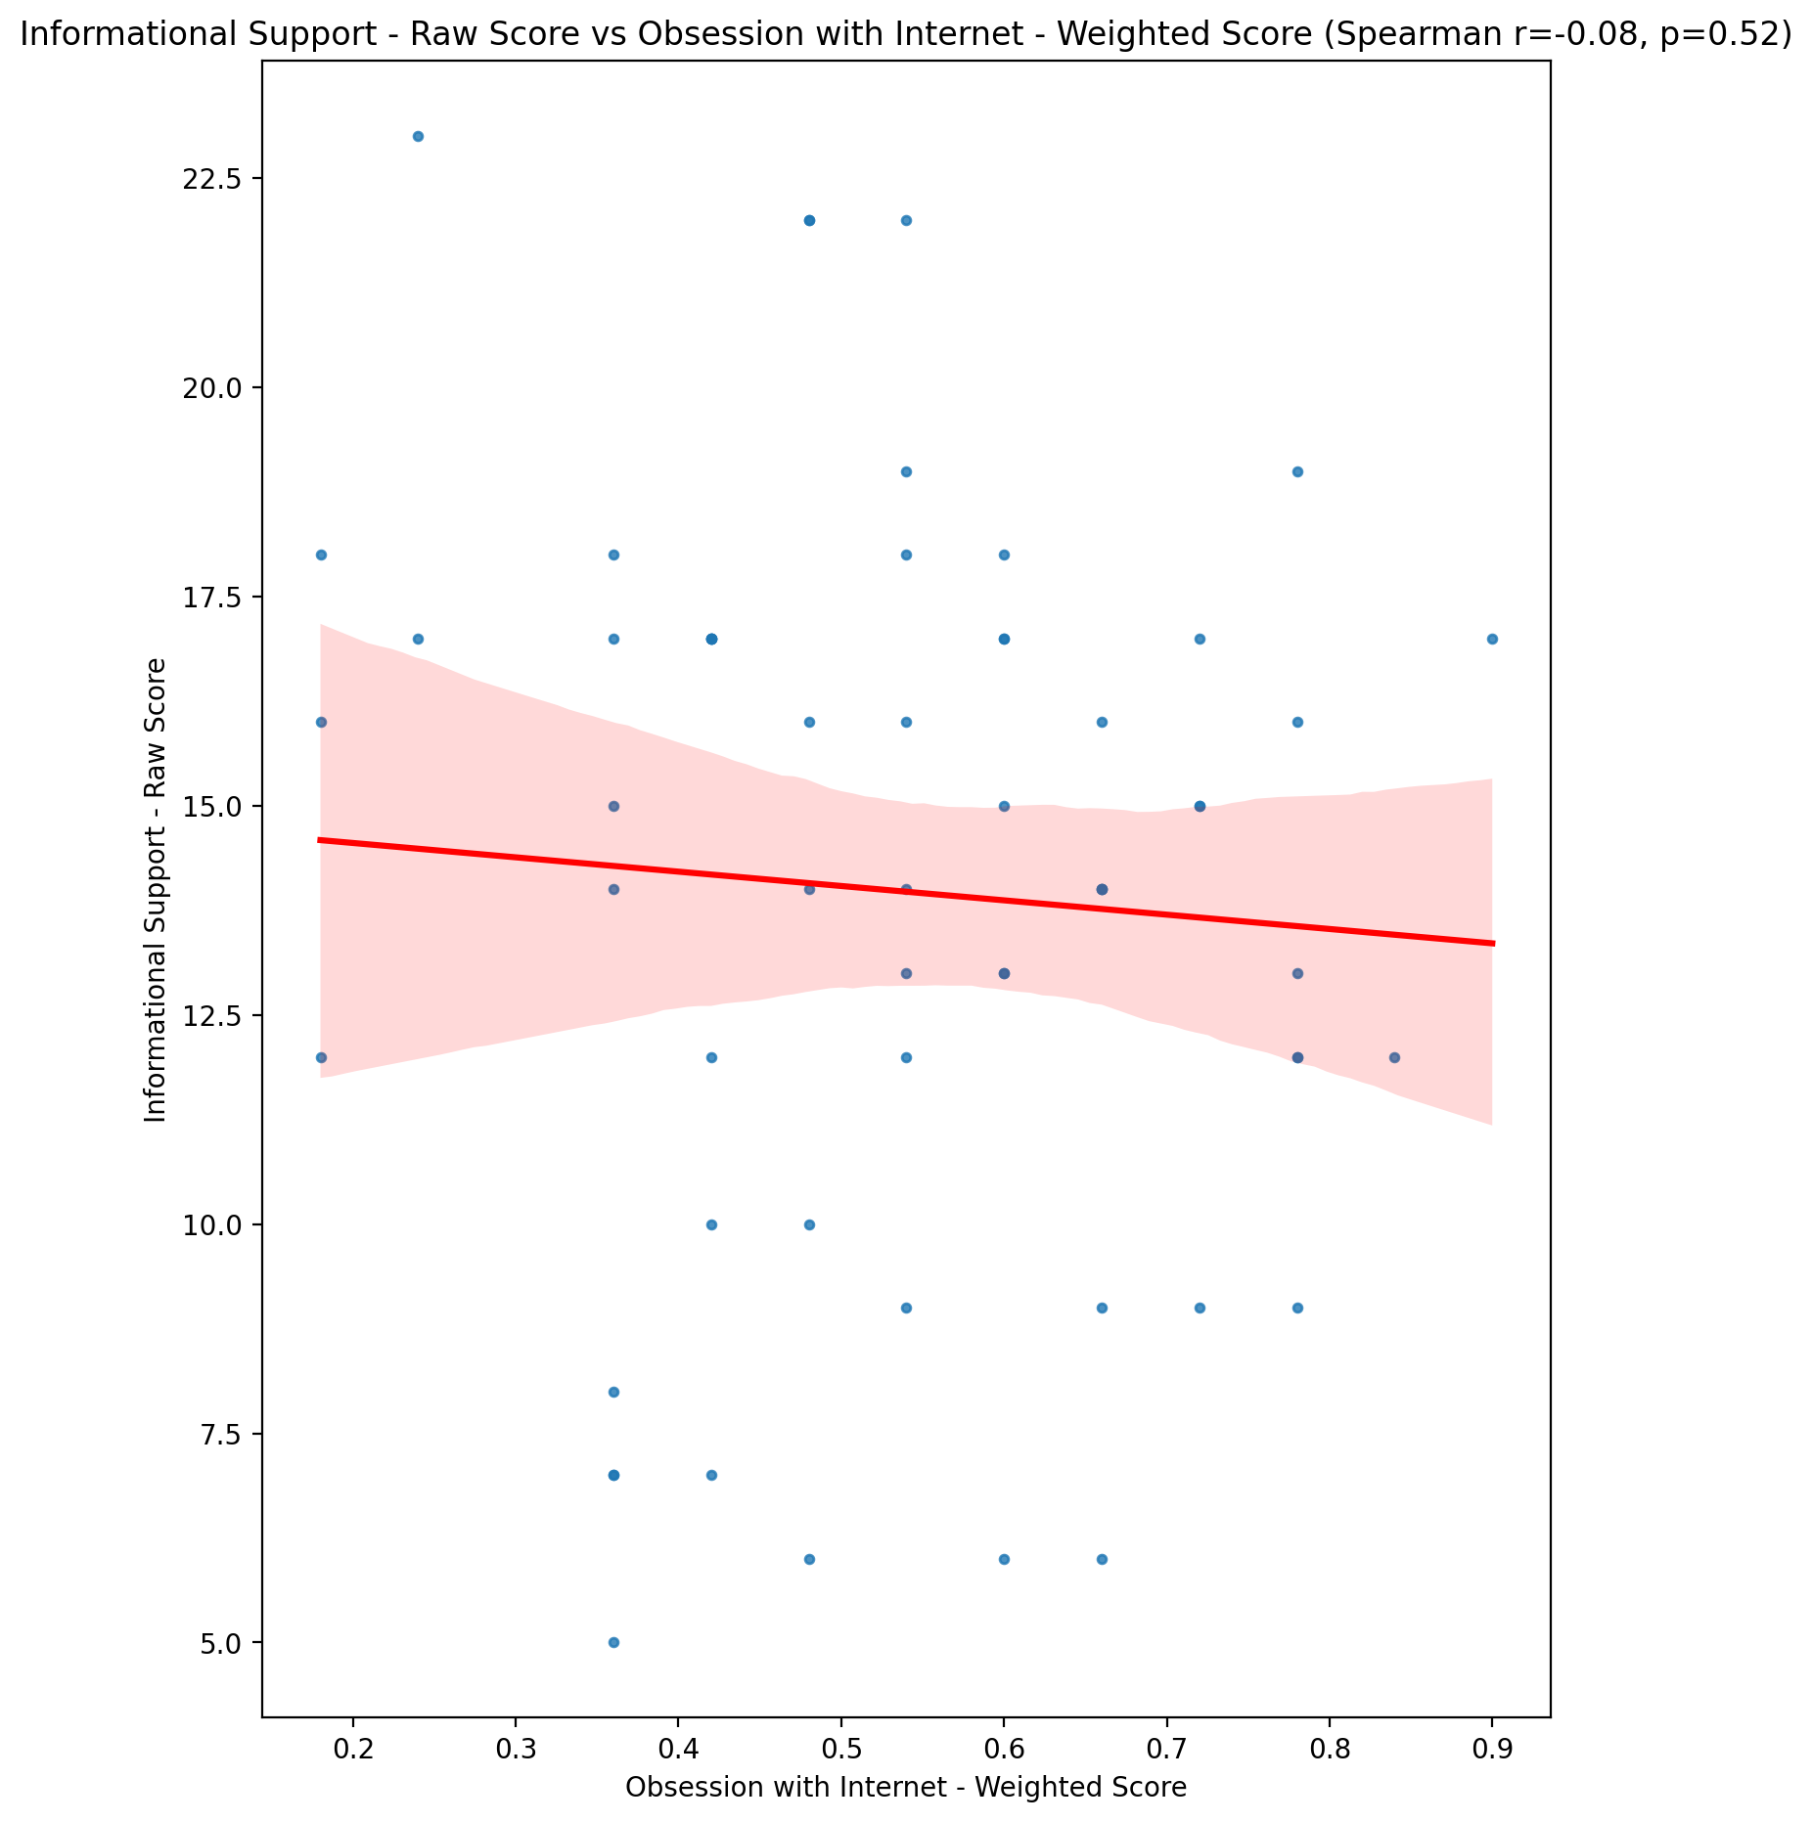

## Instrumental Support - Raw Score vs Obsession with Internet - Weighted Score

Test: spearman; statistic: -0.22904501802144334; p-value: 0.08099095741977974;

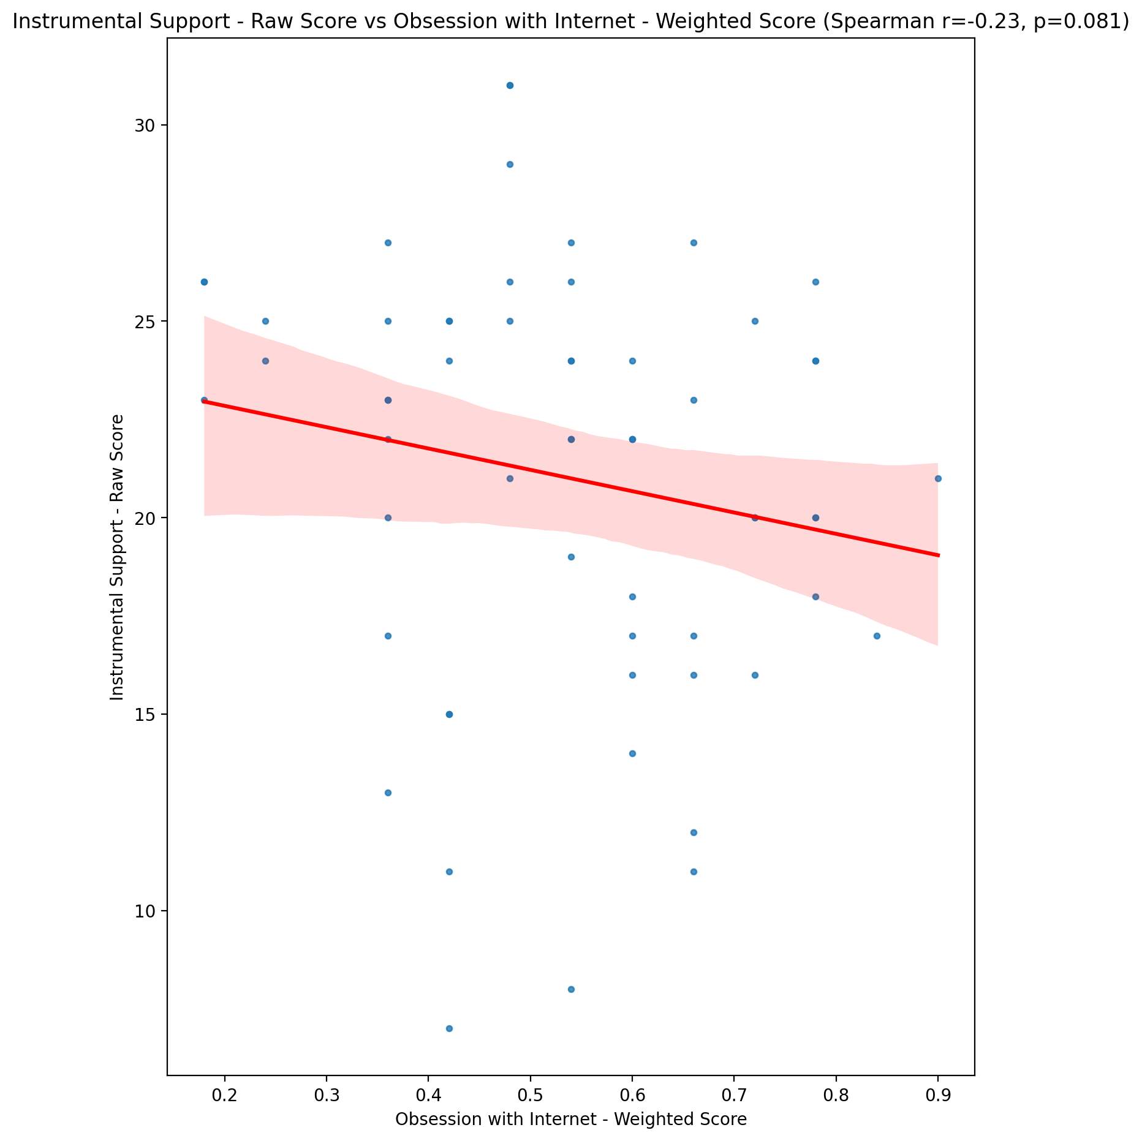

## Emotional Support - T Score vs Obsession with Internet - Weighted Score

Test: spearman; statistic: -0.11842218000141554; p-value: 0.3716940131864309;

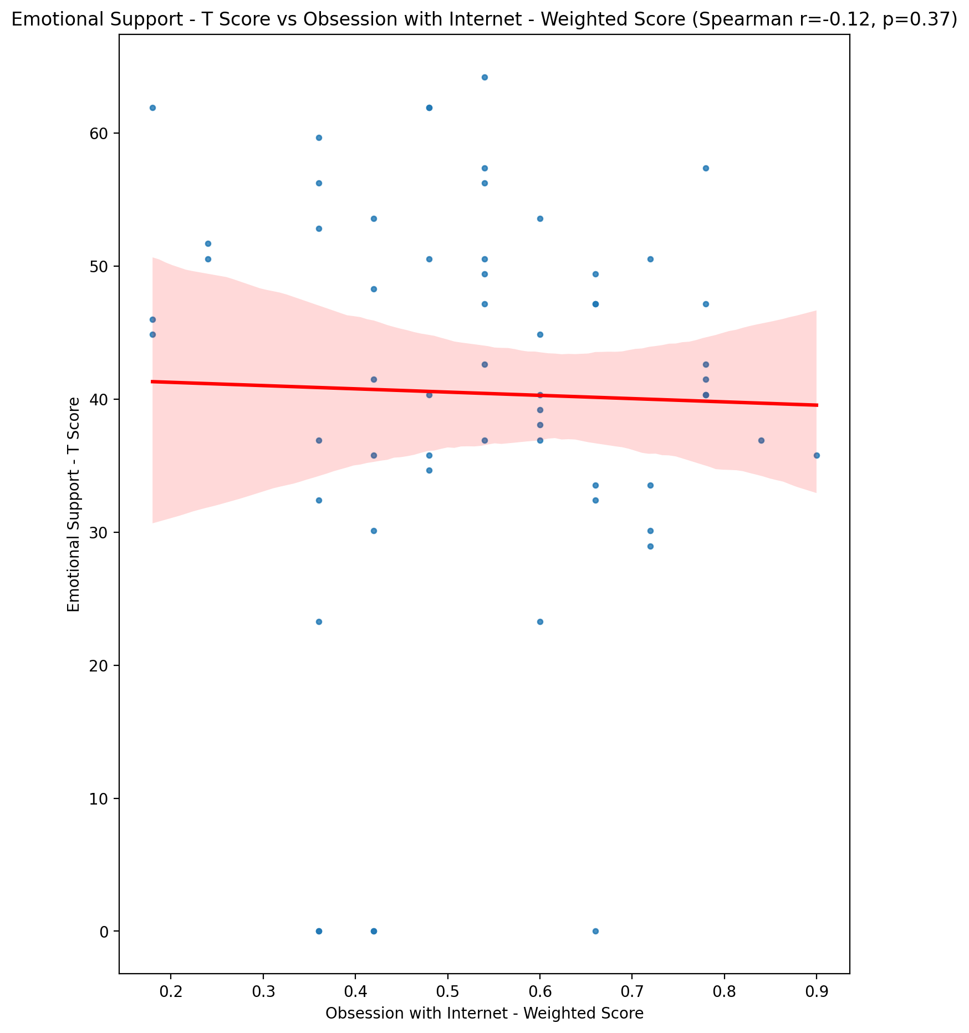

## Informational Support - T Score vs Obsession with Internet - Weighted Score

Test: spearman; statistic: -0.07860468746888877; p-value: 0.5540029766498347;

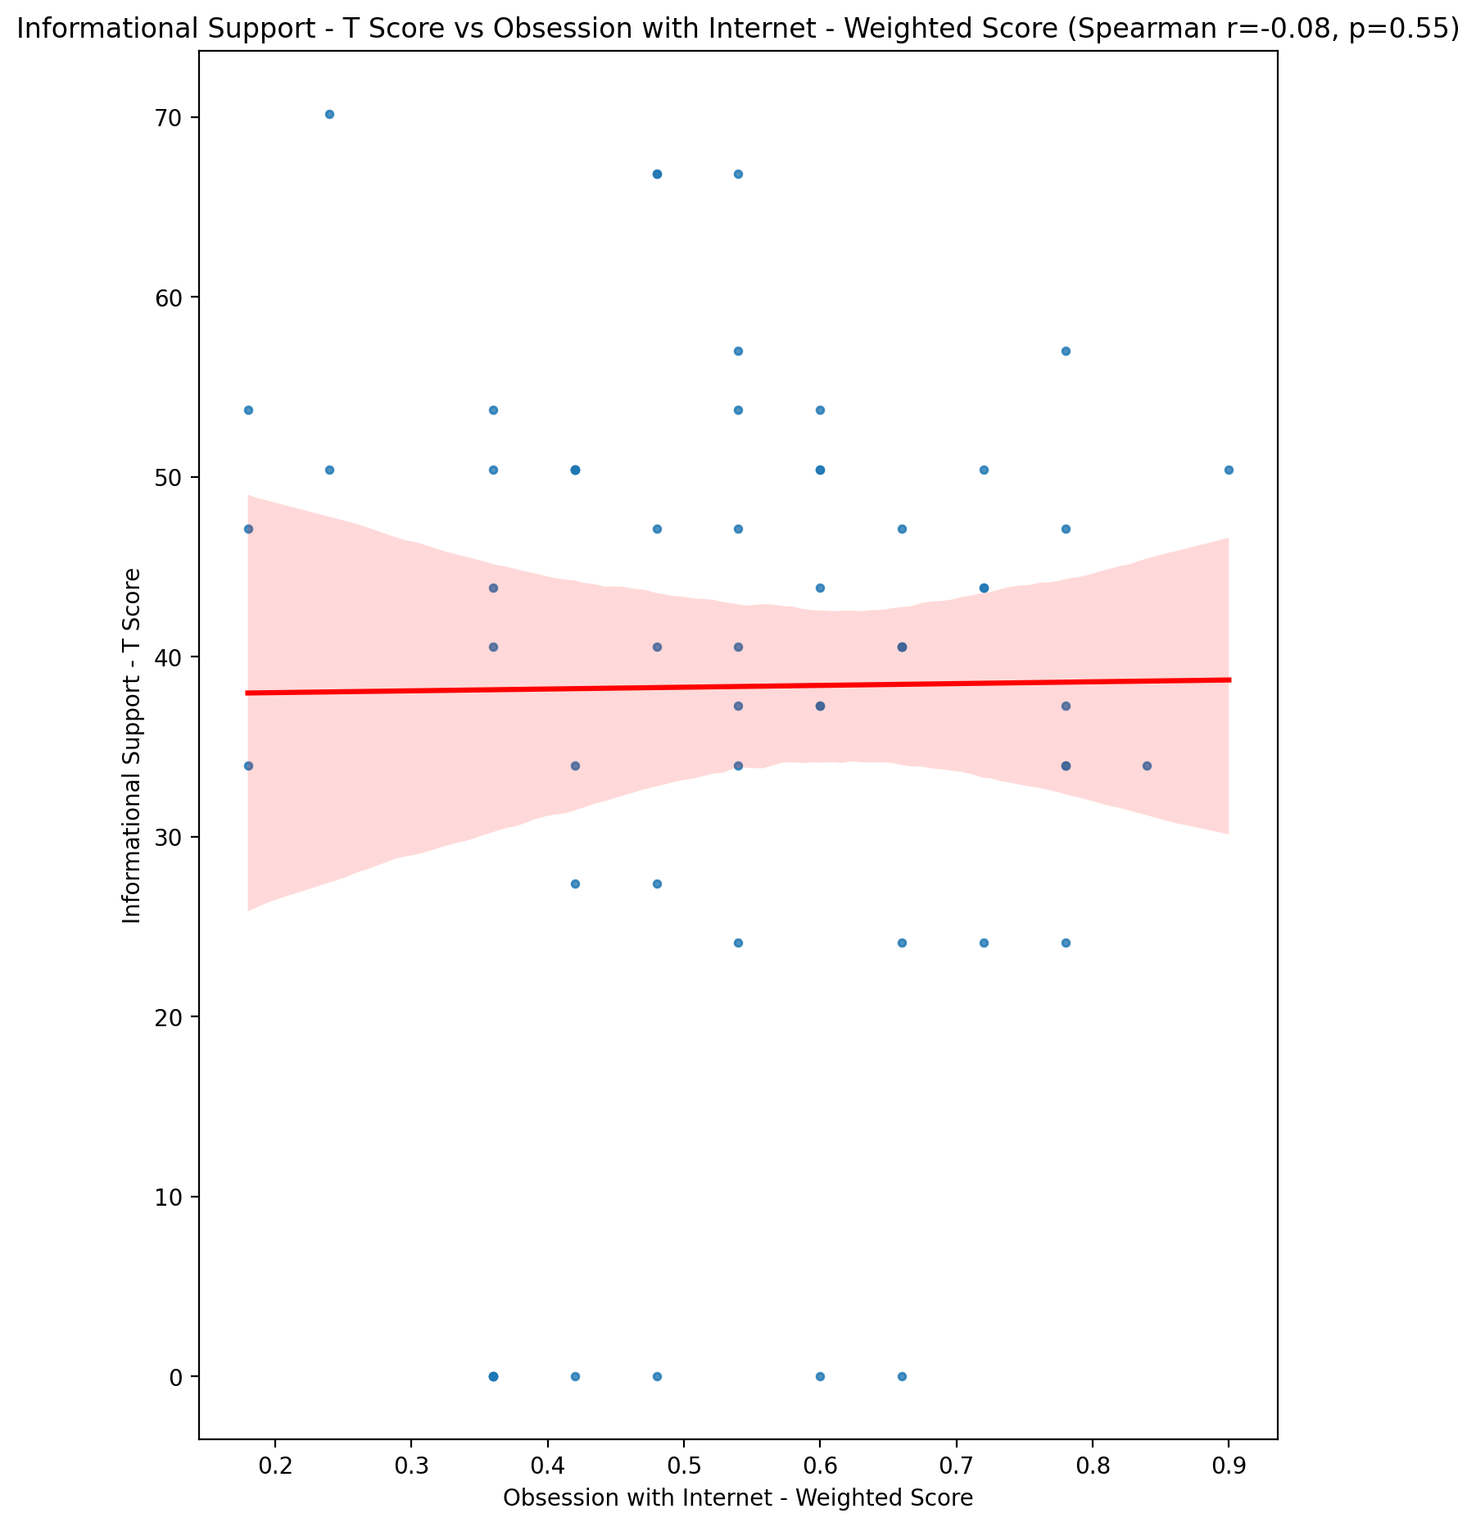

## Instrumental Support - T Score vs Obsession with Internet - Weighted Score

Test: spearman; statistic: -0.22929220596281266; p-value: 0.08065467928555597;

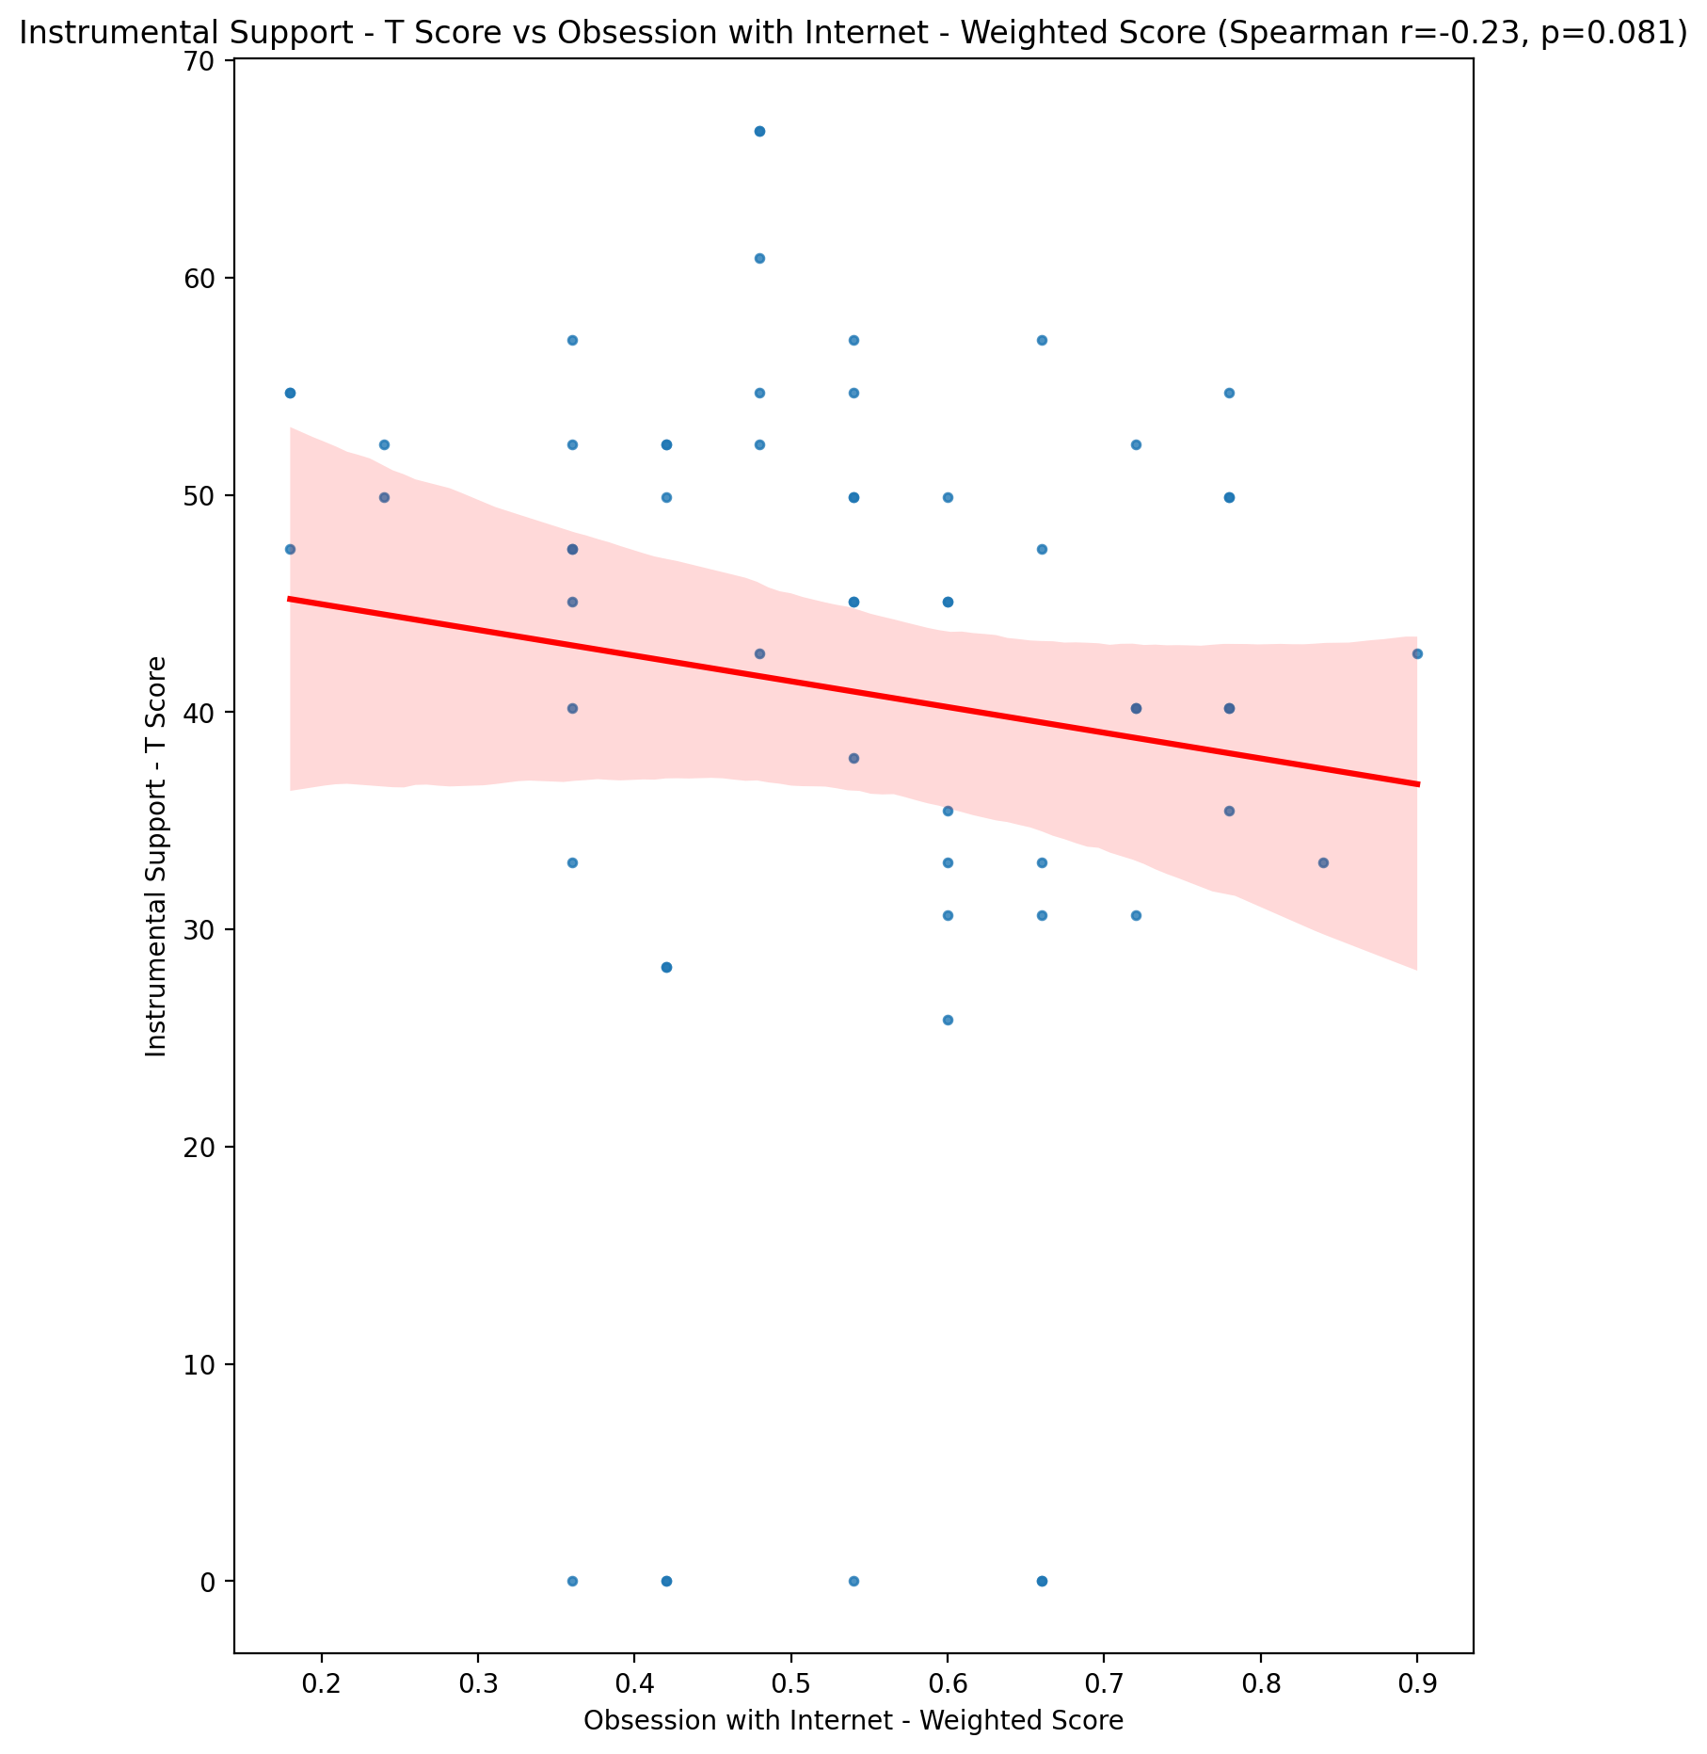

## Perceived Social Support Total T Score vs Obsession with Internet - Weighted Score

Test: spearman; statistic: -0.18076045822174283; p-value: 0.17066942455415163;

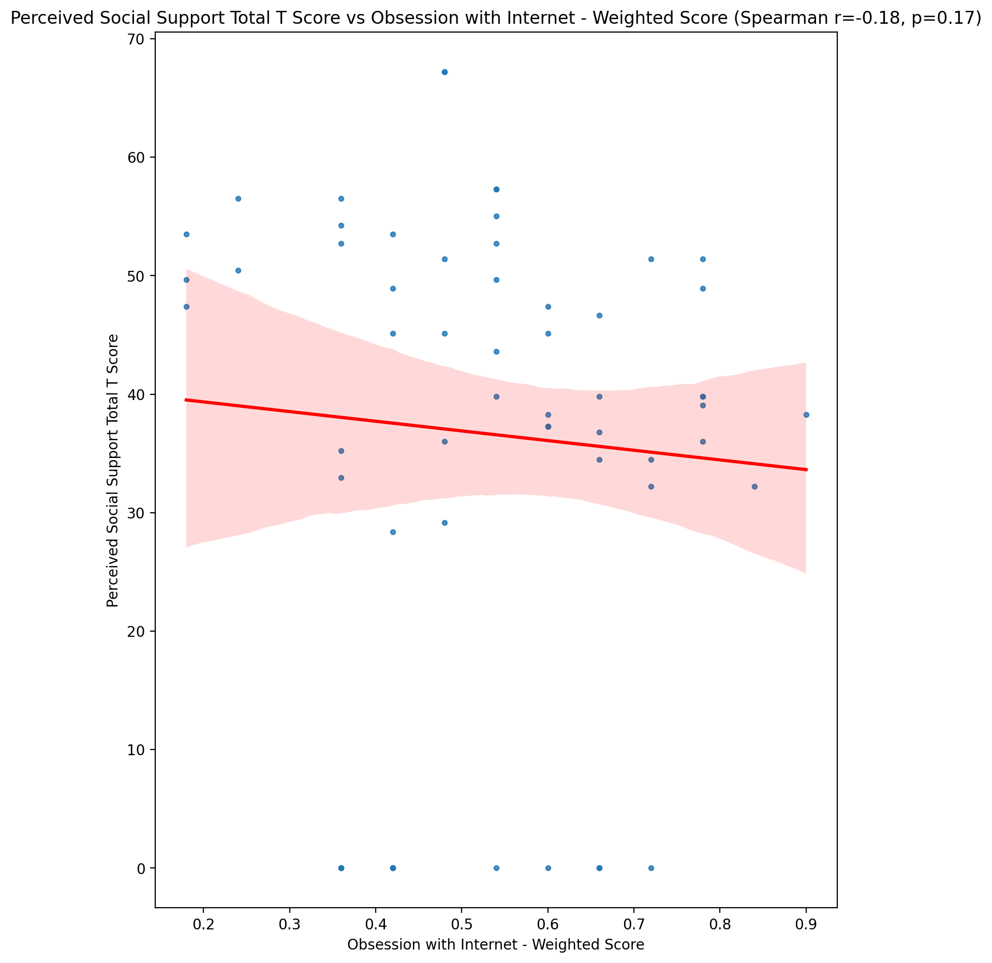

## Emotional Support - Rank vs Obsession with Internet - Weighted Score

Test: None; statistic: None; p-value: None; Test not run: unsupported type combination.



## Informational Support - Rank vs Obsession with Internet - Weighted Score

Test: None; statistic: None; p-value: None; Test not run: unsupported type combination.



## Instrumental Support - Rank vs Obsession with Internet - Weighted Score

Test: None; statistic: None; p-value: None; Test not run: unsupported type combination.



## Perceived Social Support TOTAL - Rank vs Obsession with Internet - Weighted Score

Test: None; statistic: None; p-value: None; Test not run: unsupported type combination.



## Power Self Concept - Real Self Concept Score vs Obsession with Internet - Weighted Score

Test: spearman; statistic: -0.1794743624333148; p-value: 0.17378373336033143;

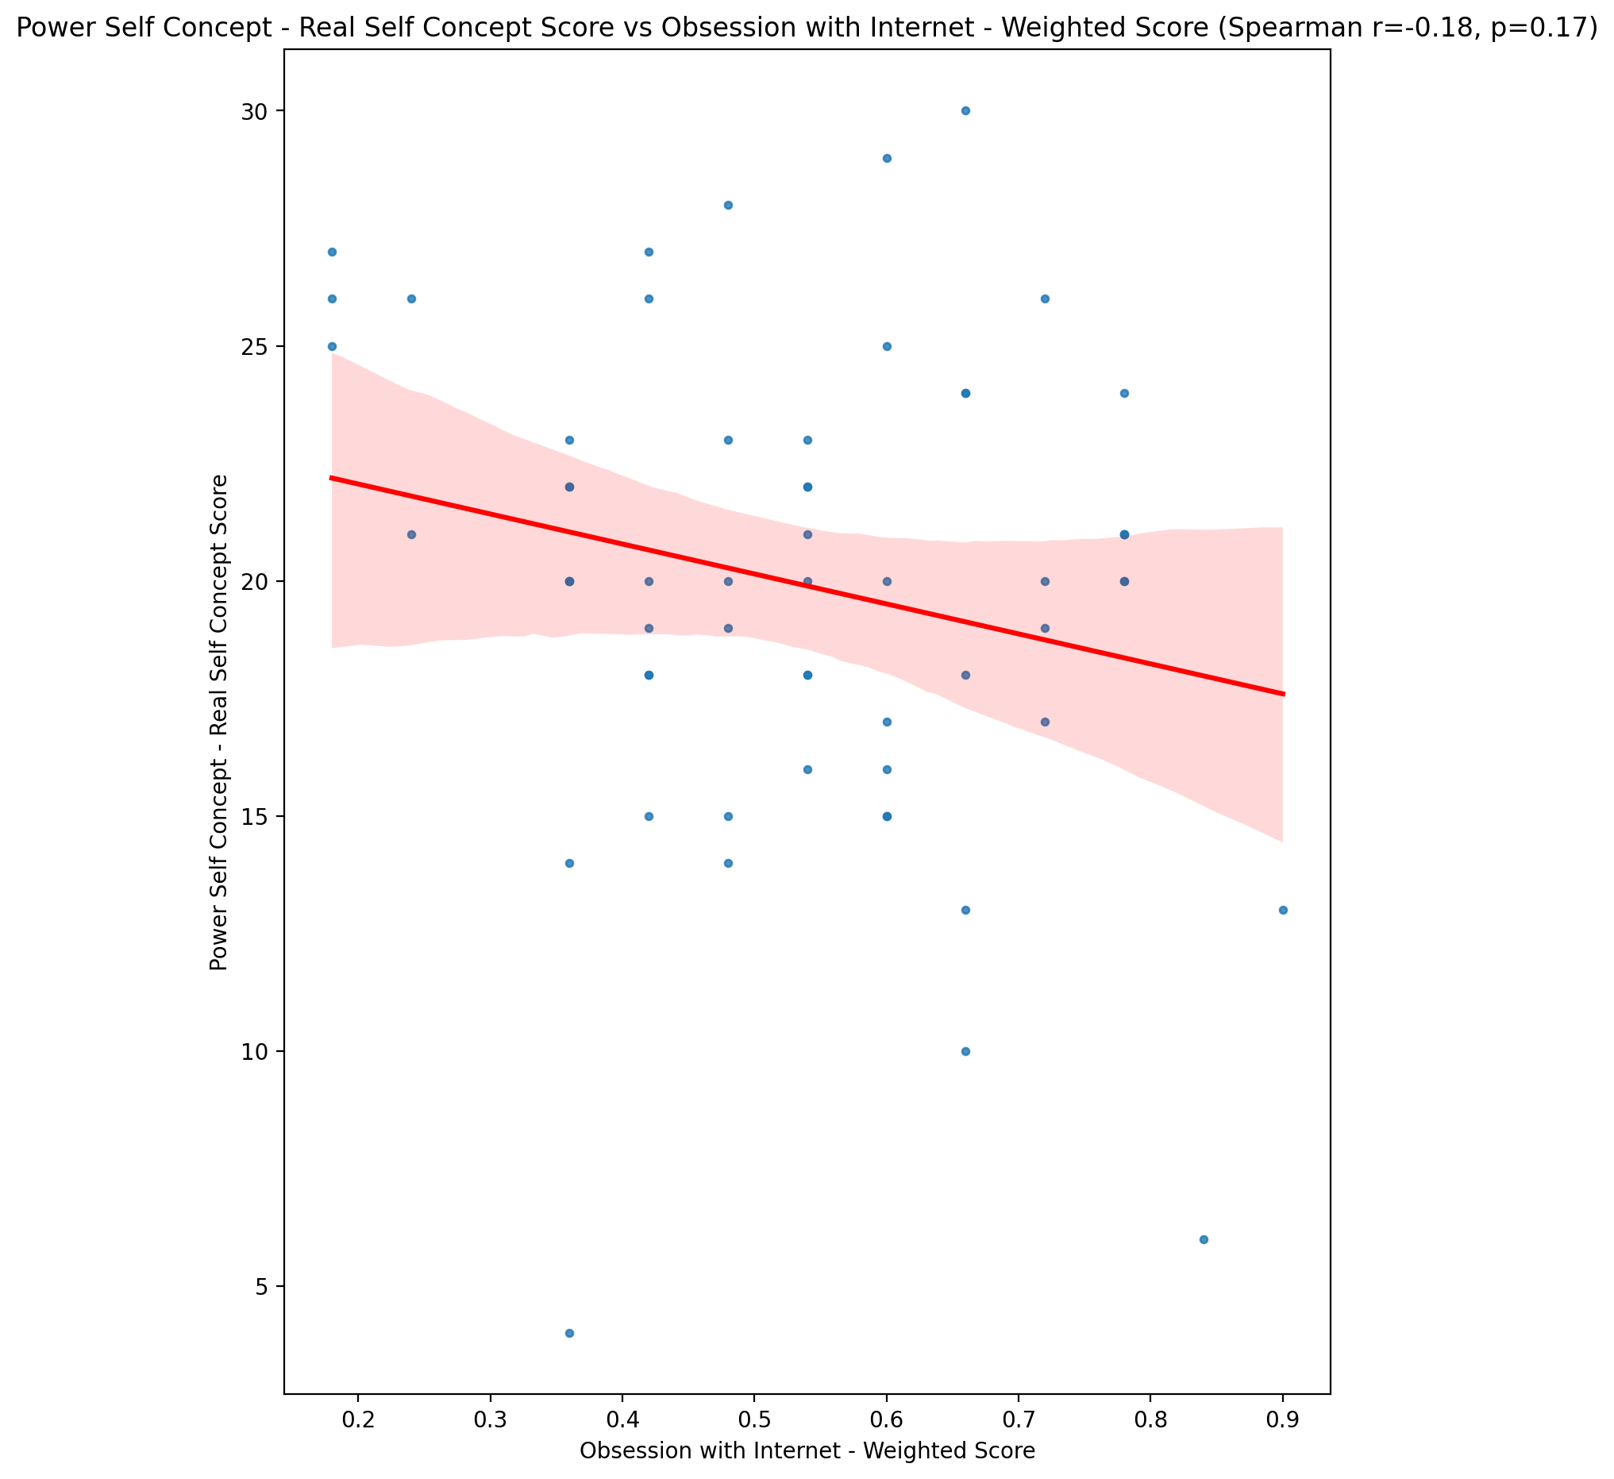

## Power Self Concept - Ideal Self Concept score vs Obsession with Internet - Weighted Score

Test: spearman; statistic: -0.15275925179676395; p-value: 0.248067951813523;

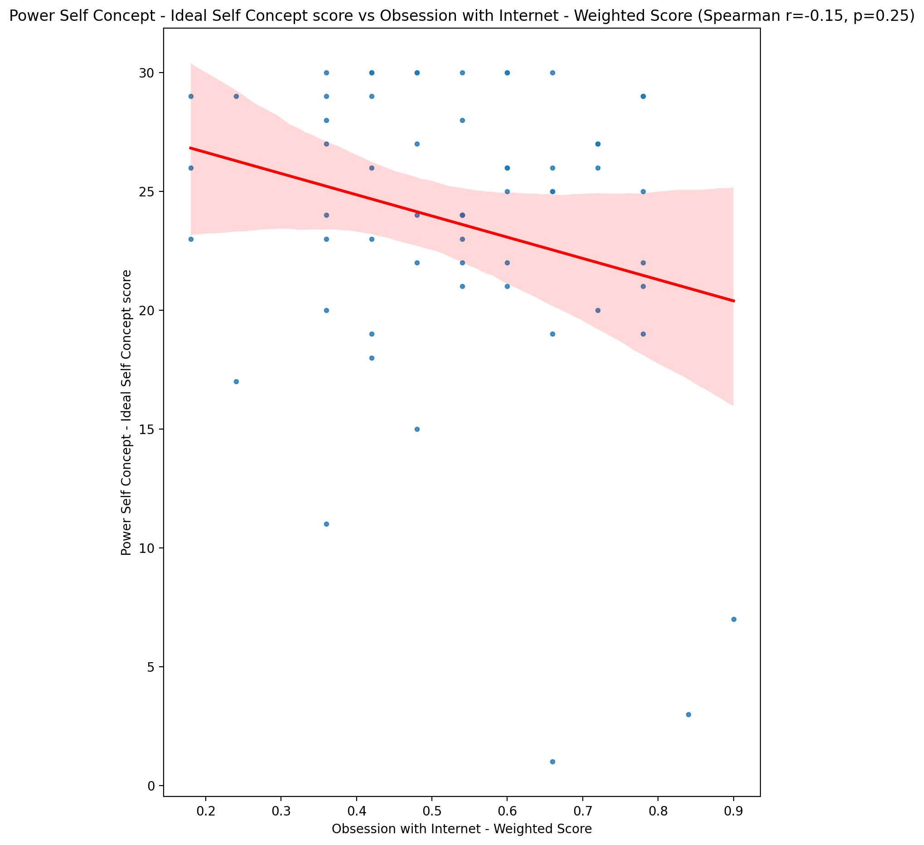

## Power Self Concept – Social Self Concept Score vs Obsession with Internet - Weighted Score

Test: spearman; statistic: -0.17488391051460728; p-value: 0.18523648084041286;

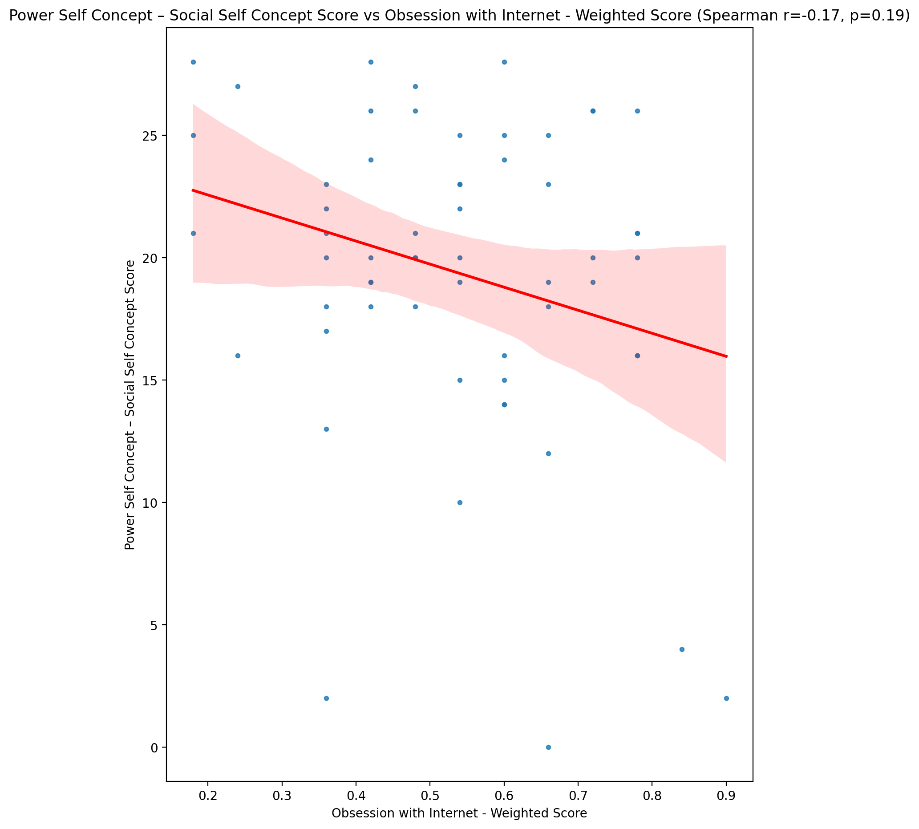

## Social Self Concept - Real Self Concept Score vs Obsession with Internet - Weighted Score

Test: spearman; statistic: -0.17082325949518734; p-value: 0.19581194442073707;

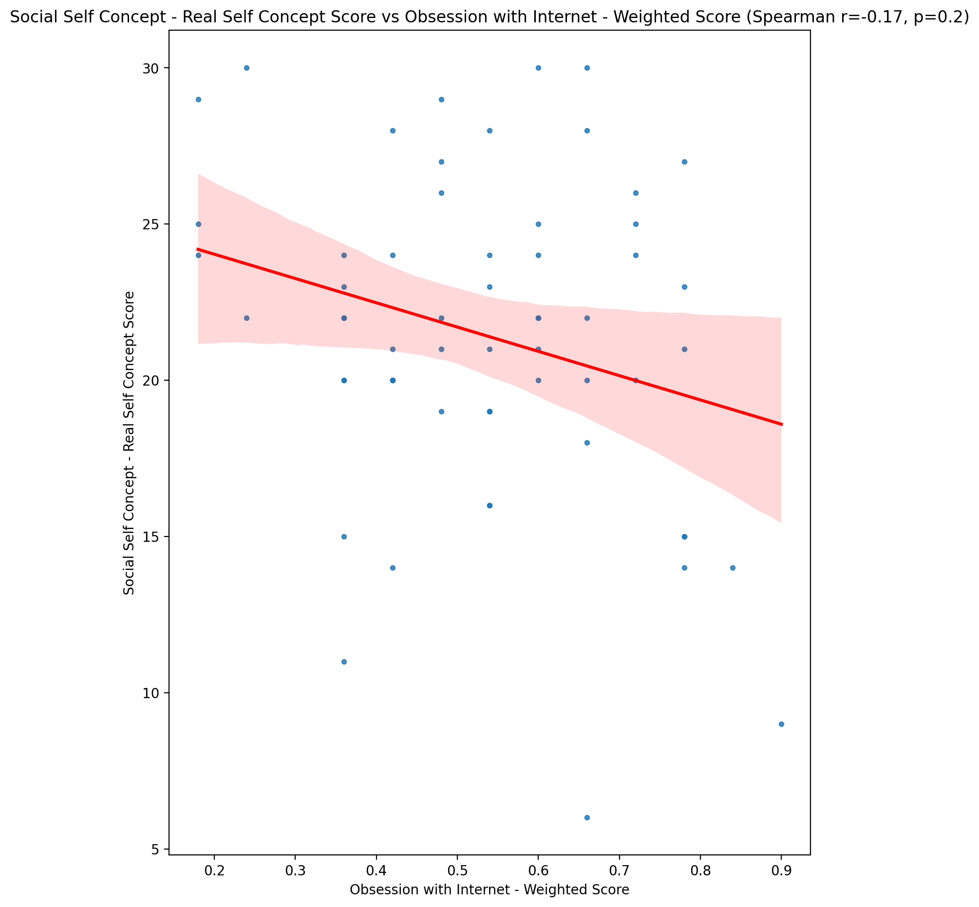

## Social Self Concept – Social Self Concept Score vs Obsession with Internet - Weighted Score

Test: spearman; statistic: -0.16623710327082586; p-value: 0.2082659802771406;

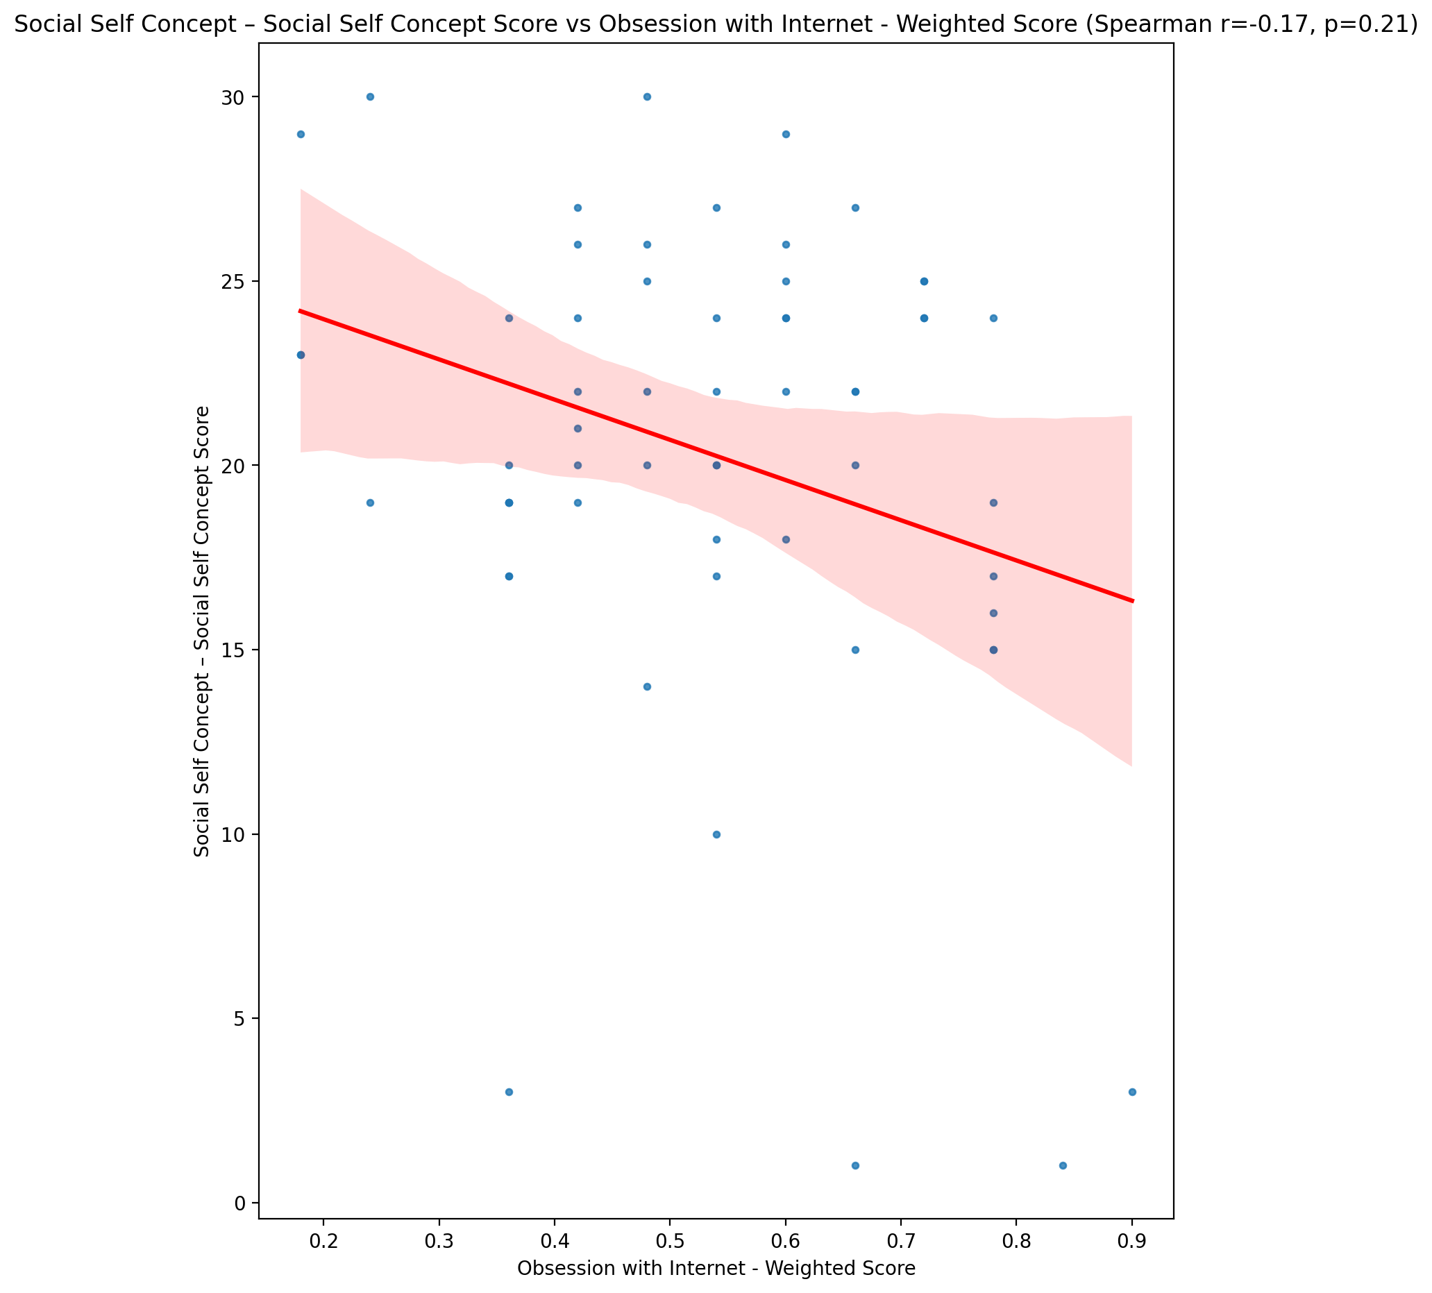

## Ability Self Concept - Real Self Concept Score vs Obsession with Internet - Weighted Score

Test: spearman; statistic: -0.1502378363127206; p-value: 0.2560535669833141;

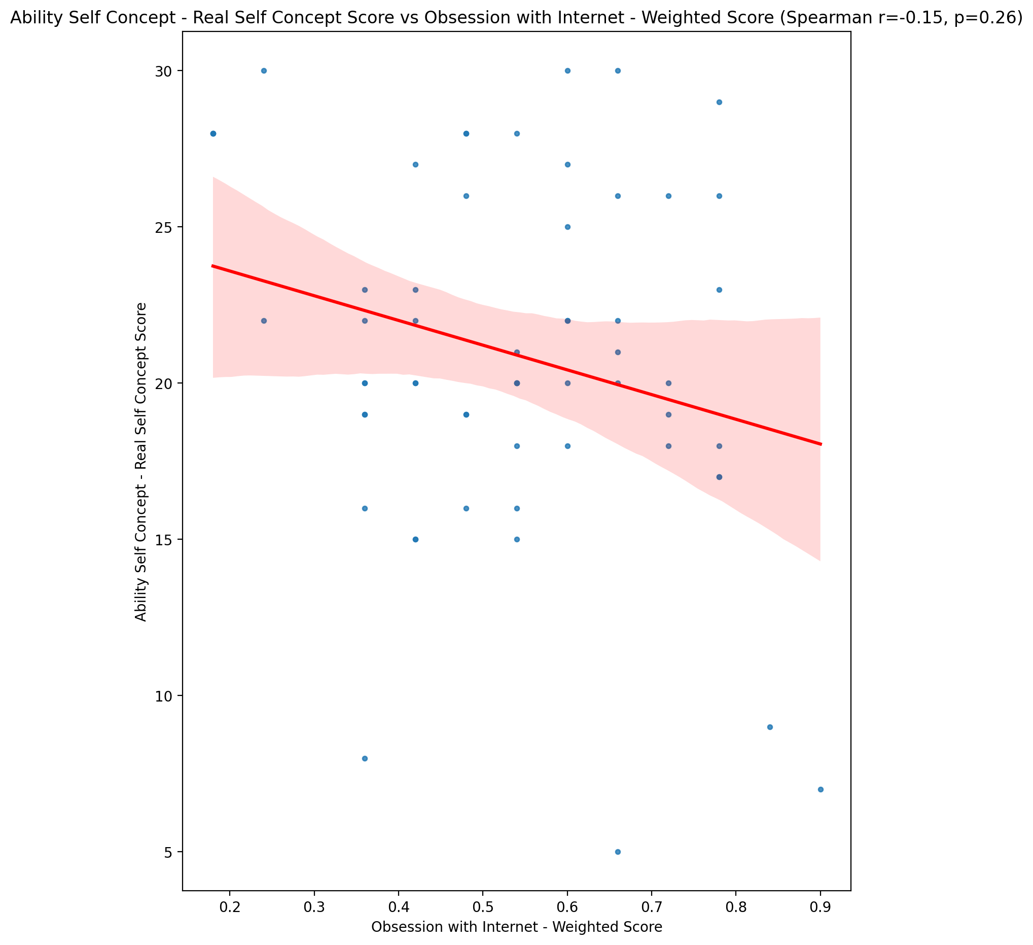

## Ability Self Concept - Ideal Self Concept Score vs Obsession with Internet - Weighted Score

Test: spearman; statistic: -0.17276265231748691; p-value: 0.1907085338280812;

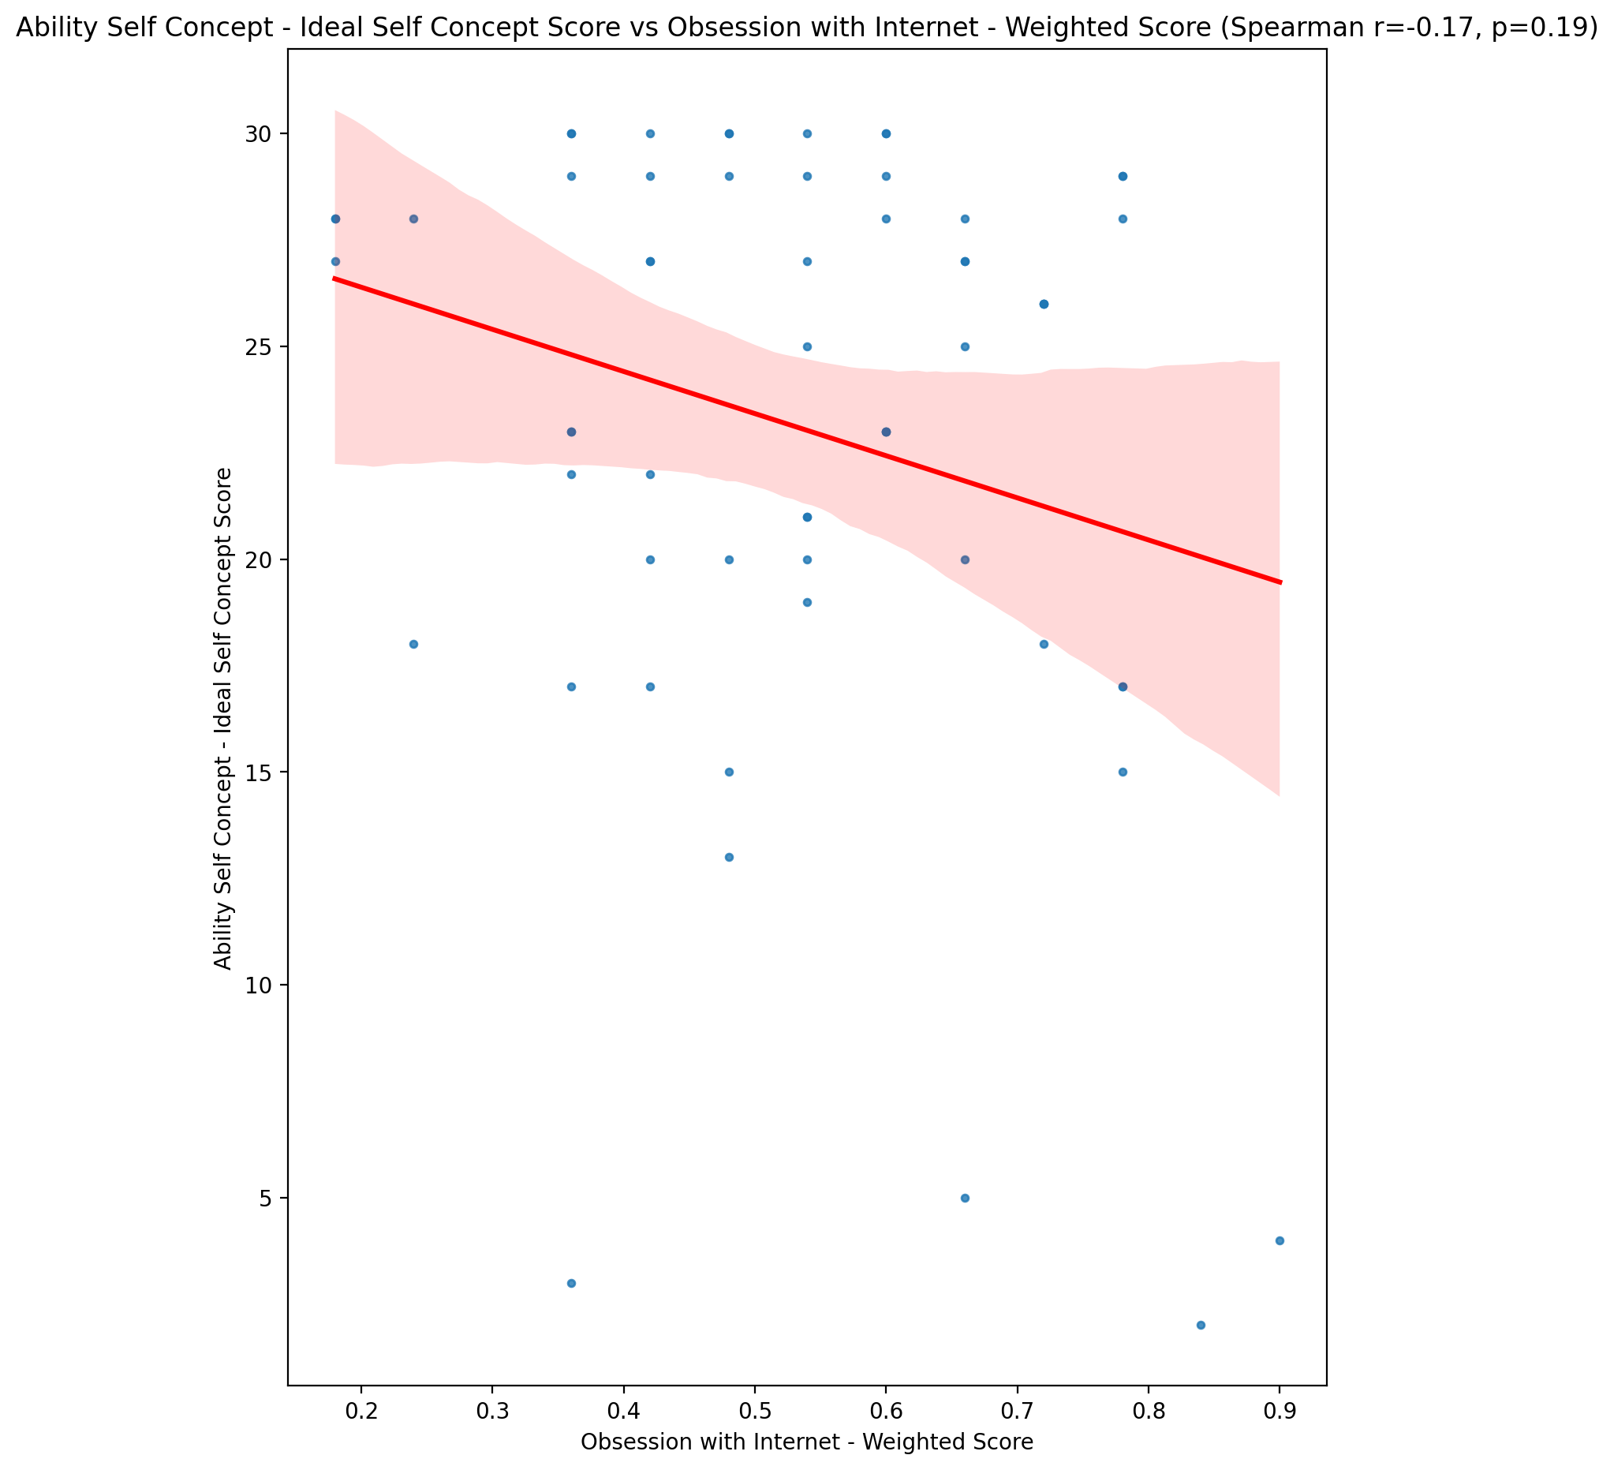

## Ability Self Concept – Social Self Concept Score vs Obsession with Internet - Weighted Score

Test: spearman; statistic: -0.15685101867711515; p-value: 0.23547314219774504;

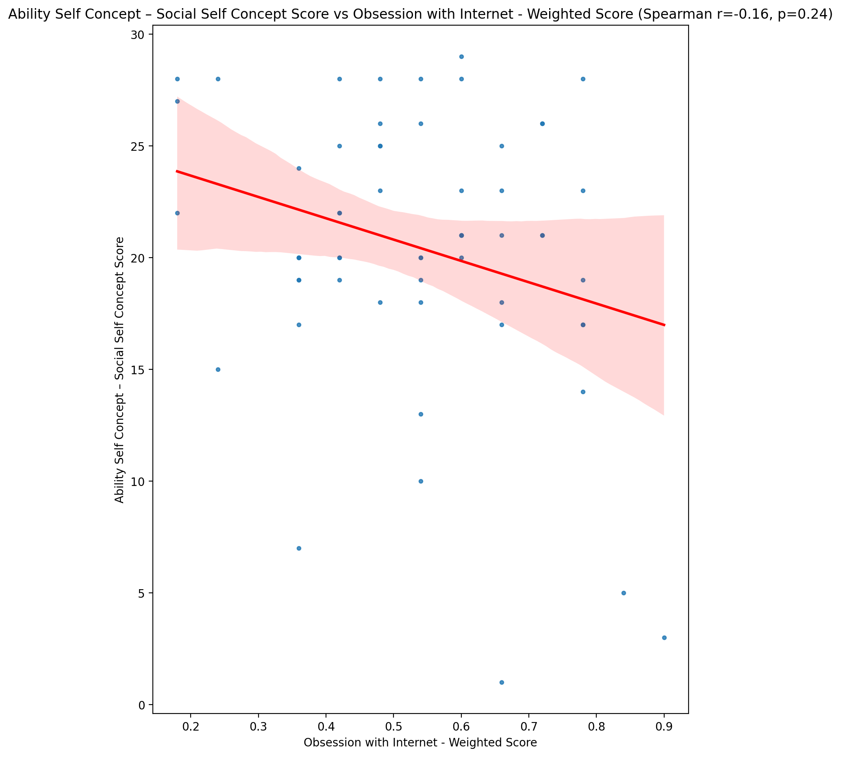

## Physical Self Concept - Real Self Concept Score vs Obsession with Internet - Weighted Score

Test: spearman; statistic: -0.21638760486795774; p-value: 0.09974126880808742;

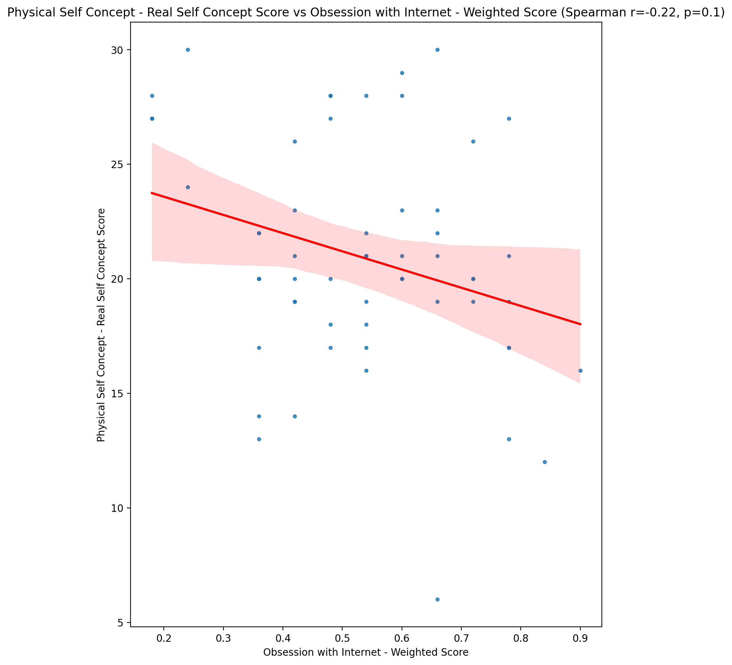

## Physical Self Concept – Ideal Self Concept Score vs Obsession with Internet - Weighted Score

Test: spearman; statistic: -0.1578295140333036; p-value: 0.2325277184457201;

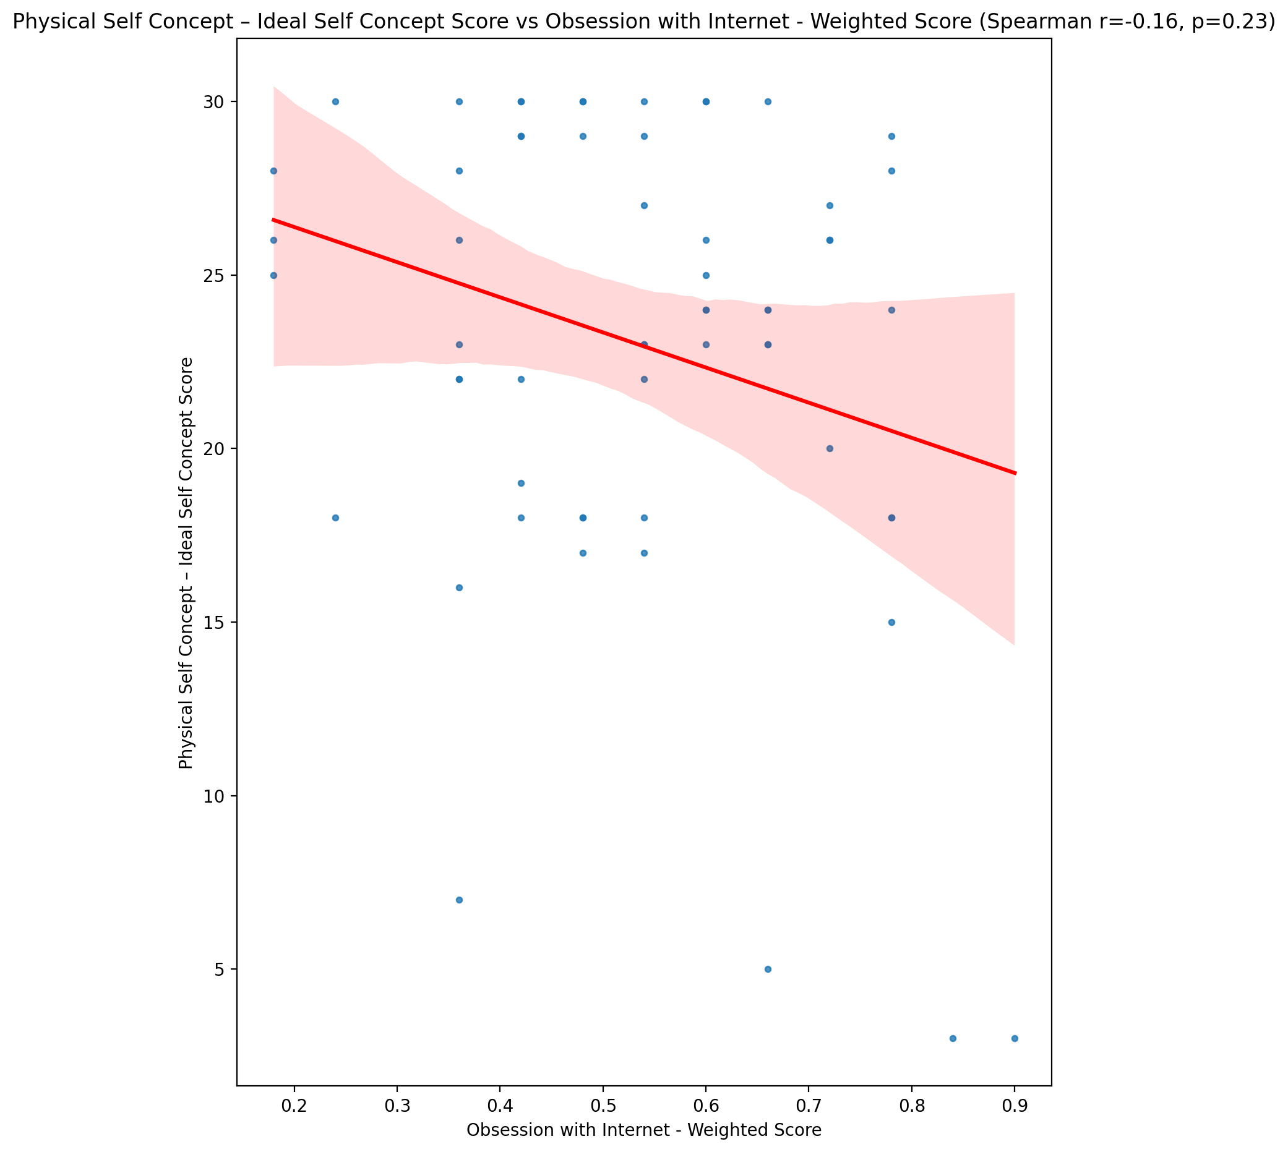

## Physical Self Concept – Social Self Concept Score vs Obsession with Internet - Weighted Score

Test: spearman; statistic: -0.18958438281579082; p-value: 0.1503923697950966;

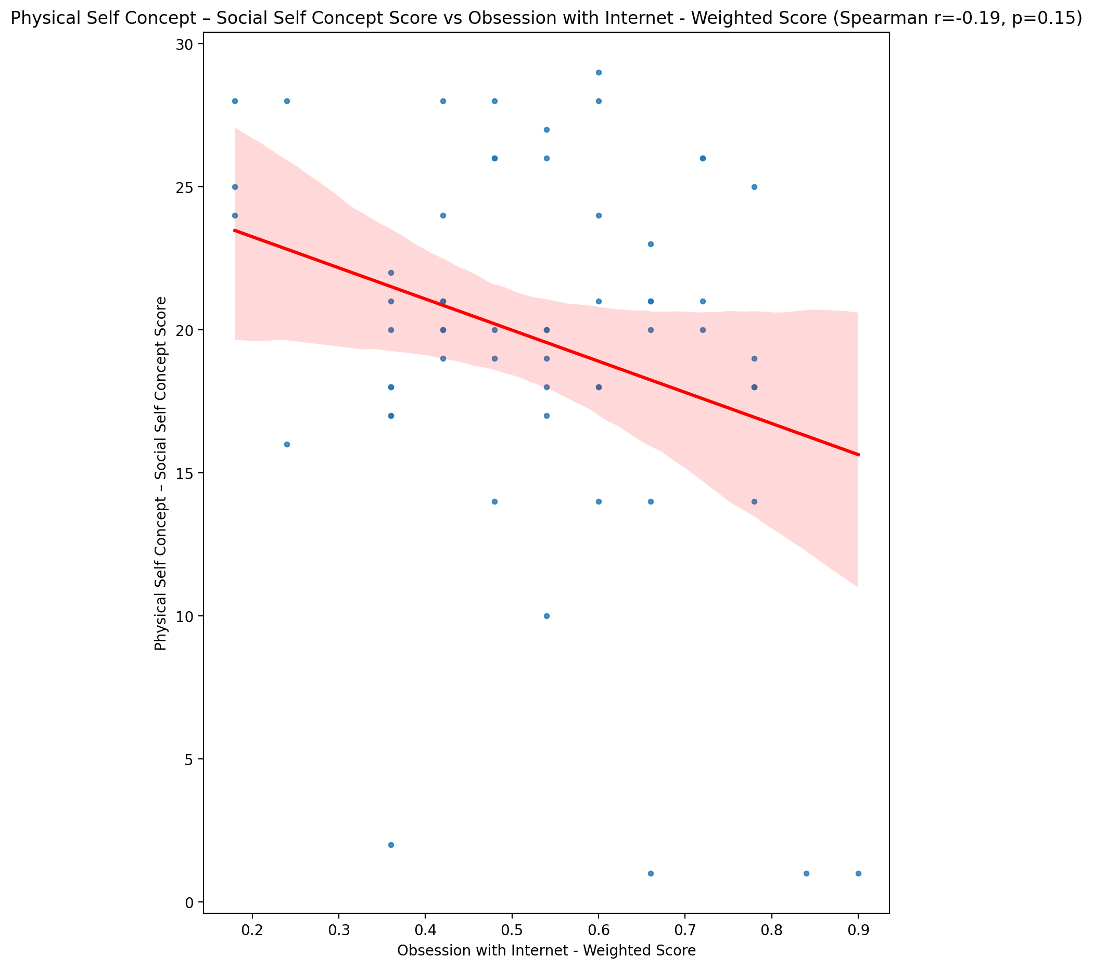

## Psychological Self Concept - Real Self Concept Score vs Obsession with Internet - Weighted Score

Test: spearman; statistic: -0.24342895937289935; p-value: 0.06318869811755788;

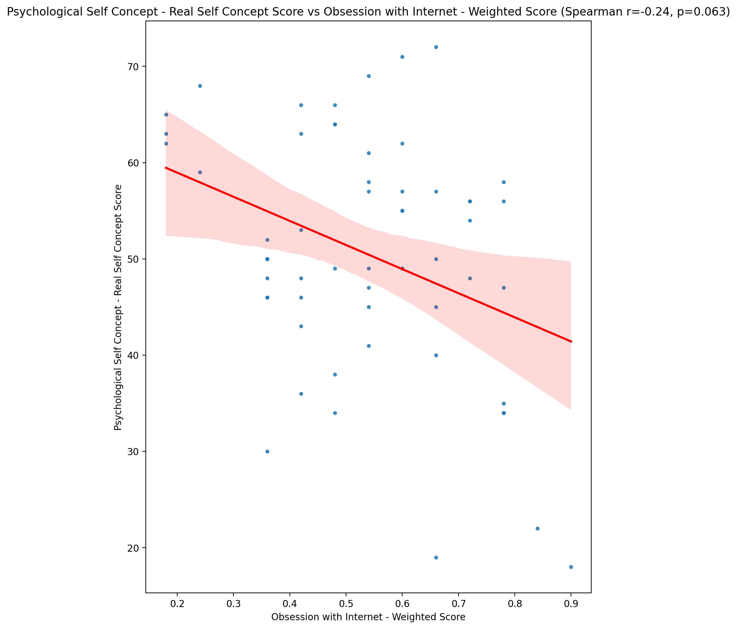

## Psychological Self Concept – Ideal Self Concept Score vs Obsession with Internet - Weighted Score

Test: spearman; statistic: -0.18505089374839523; p-value: 0.16057449042506736;

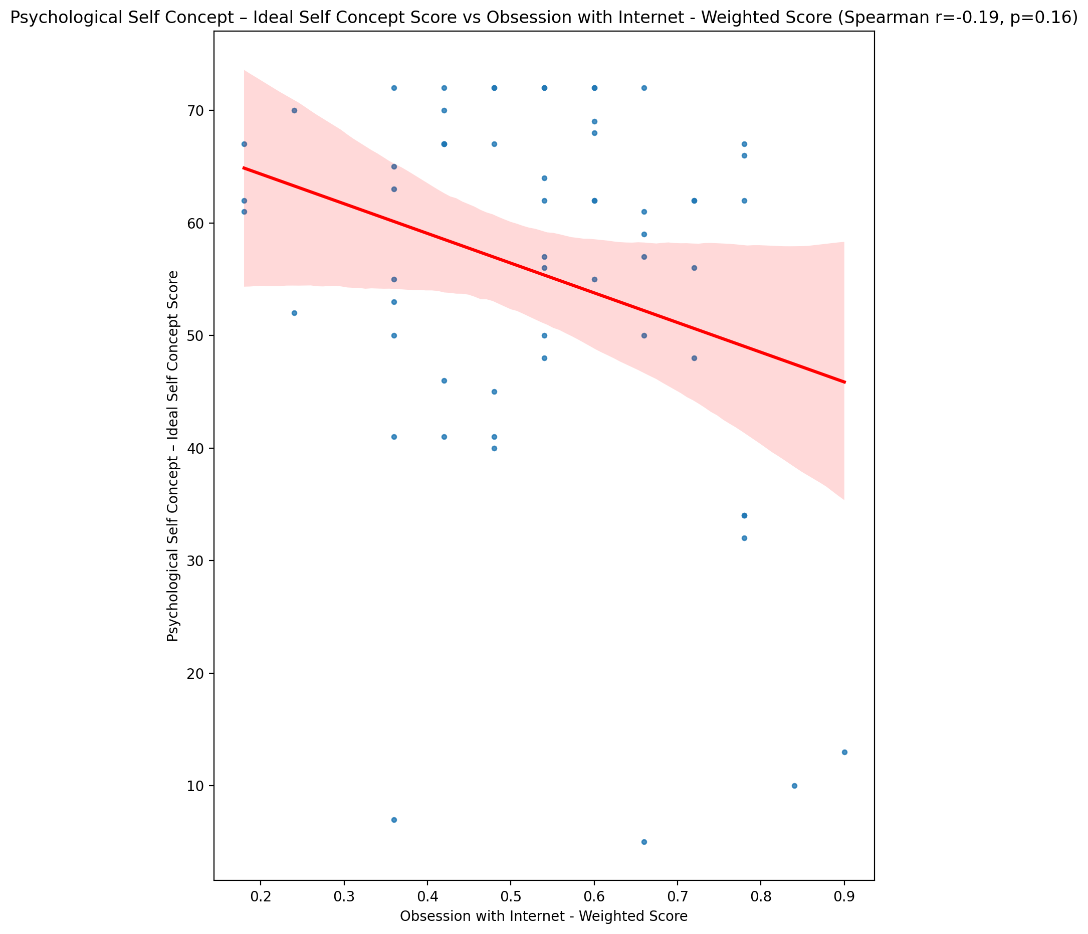

## Psychological Self Concept – Social Self Concept Score vs Obsession with Internet - Weighted Score

Test: spearman; statistic: -0.24225522003765895; p-value: 0.0645118639588118;

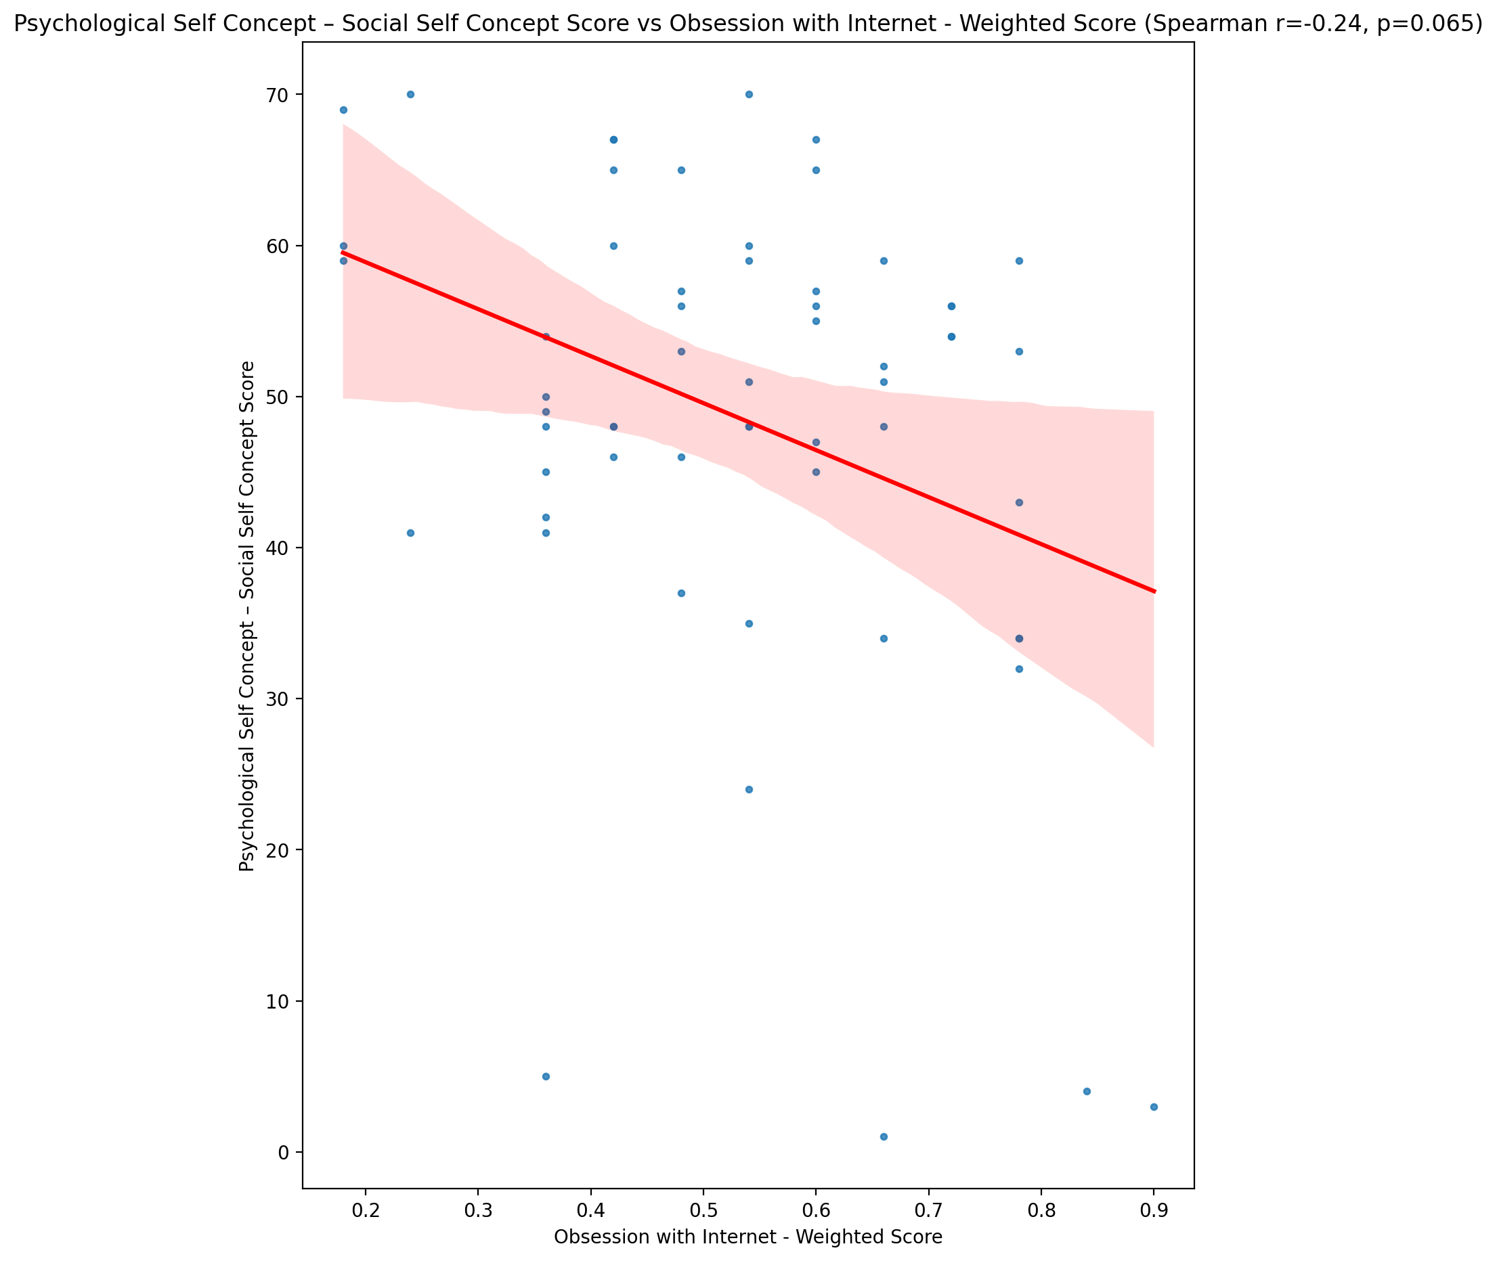

## Real Self Concept Total Score vs Obsession with Internet - Weighted Score

Test: spearman; statistic: -0.19065606984794845; p-value: 0.14805700283937037;

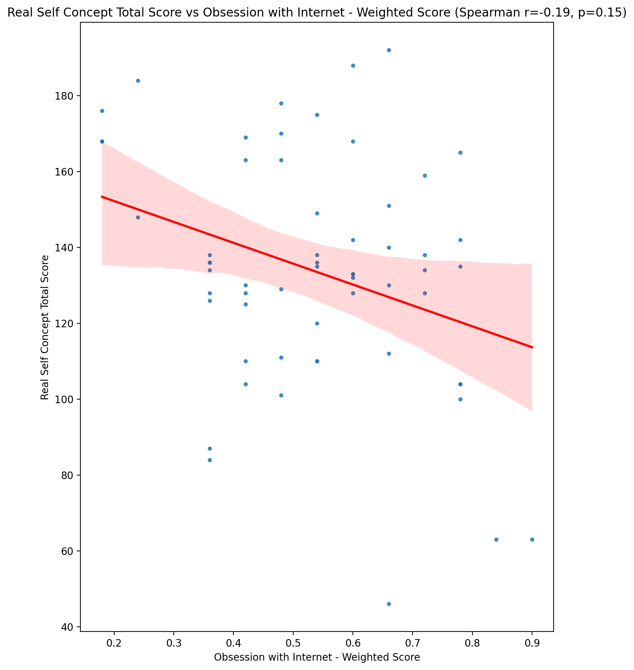

## Ideal Self Concept Total Score vs Obsession with Internet - Weighted Score

Test: spearman; statistic: -0.18050594690520672; p-value: 0.17128247635276597;

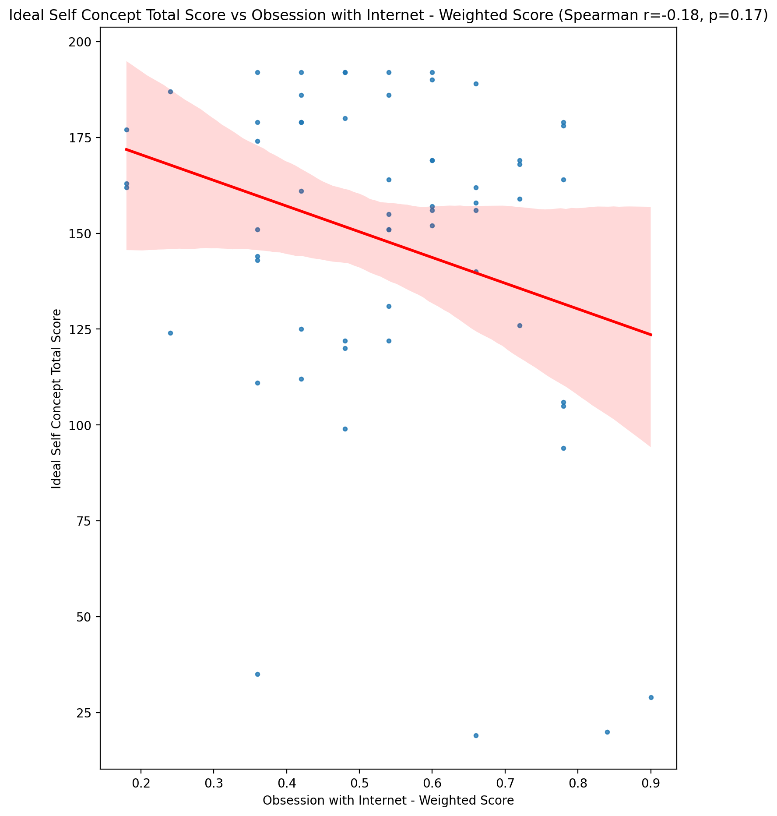

## Social Self Concept Total Score vs Obsession with Internet - Weighted Score

Test: spearman; statistic: -0.22776342631789062; p-value: 0.08275225286995934;

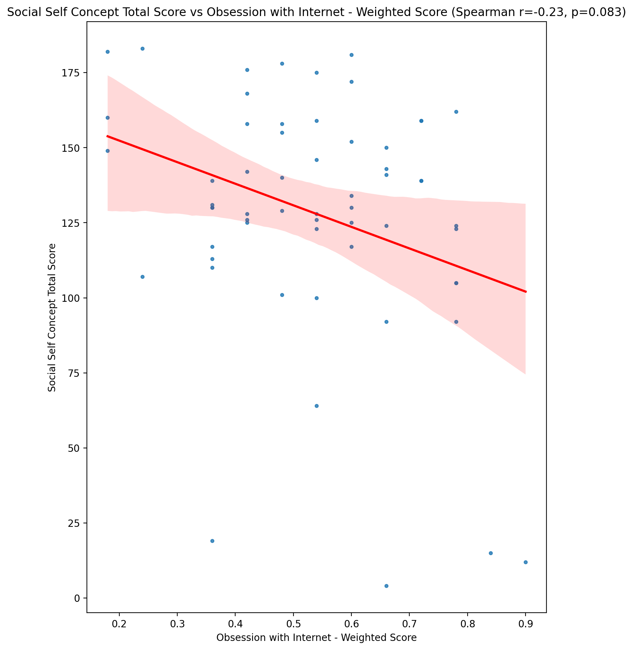

## Ideal Self Concept Total Category vs Obsession with Internet - Weighted Score

Test: None; statistic: None; p-value: None; Test not run: unsupported type combination.



## Perceived Social Stress Score vs Obsession with Internet - Weighted Score

Test: spearman; statistic: -0.03520895108686524; p-value: 0.7912092390366422;

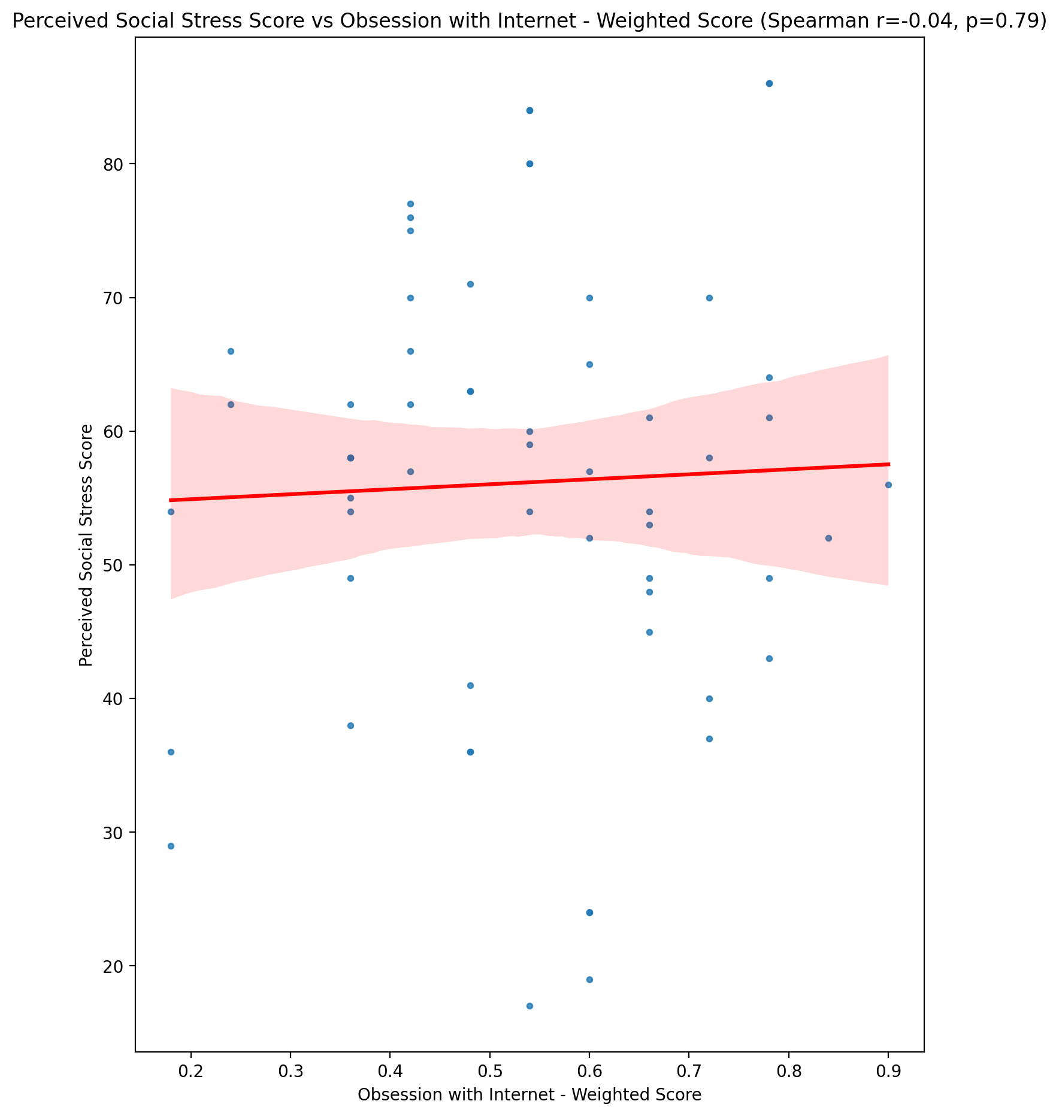

## Perceived Social Stress Category vs Obsession with Internet - Weighted Score

Test: None; statistic: None; p-value: None; Test not run: unsupported type combination.



## Emotional Support - Raw Score vs Internet as a Source of Recreation - Weighted Score

Test: spearman; statistic: 0.016453987858784984; p-value: 0.9015610117347737;

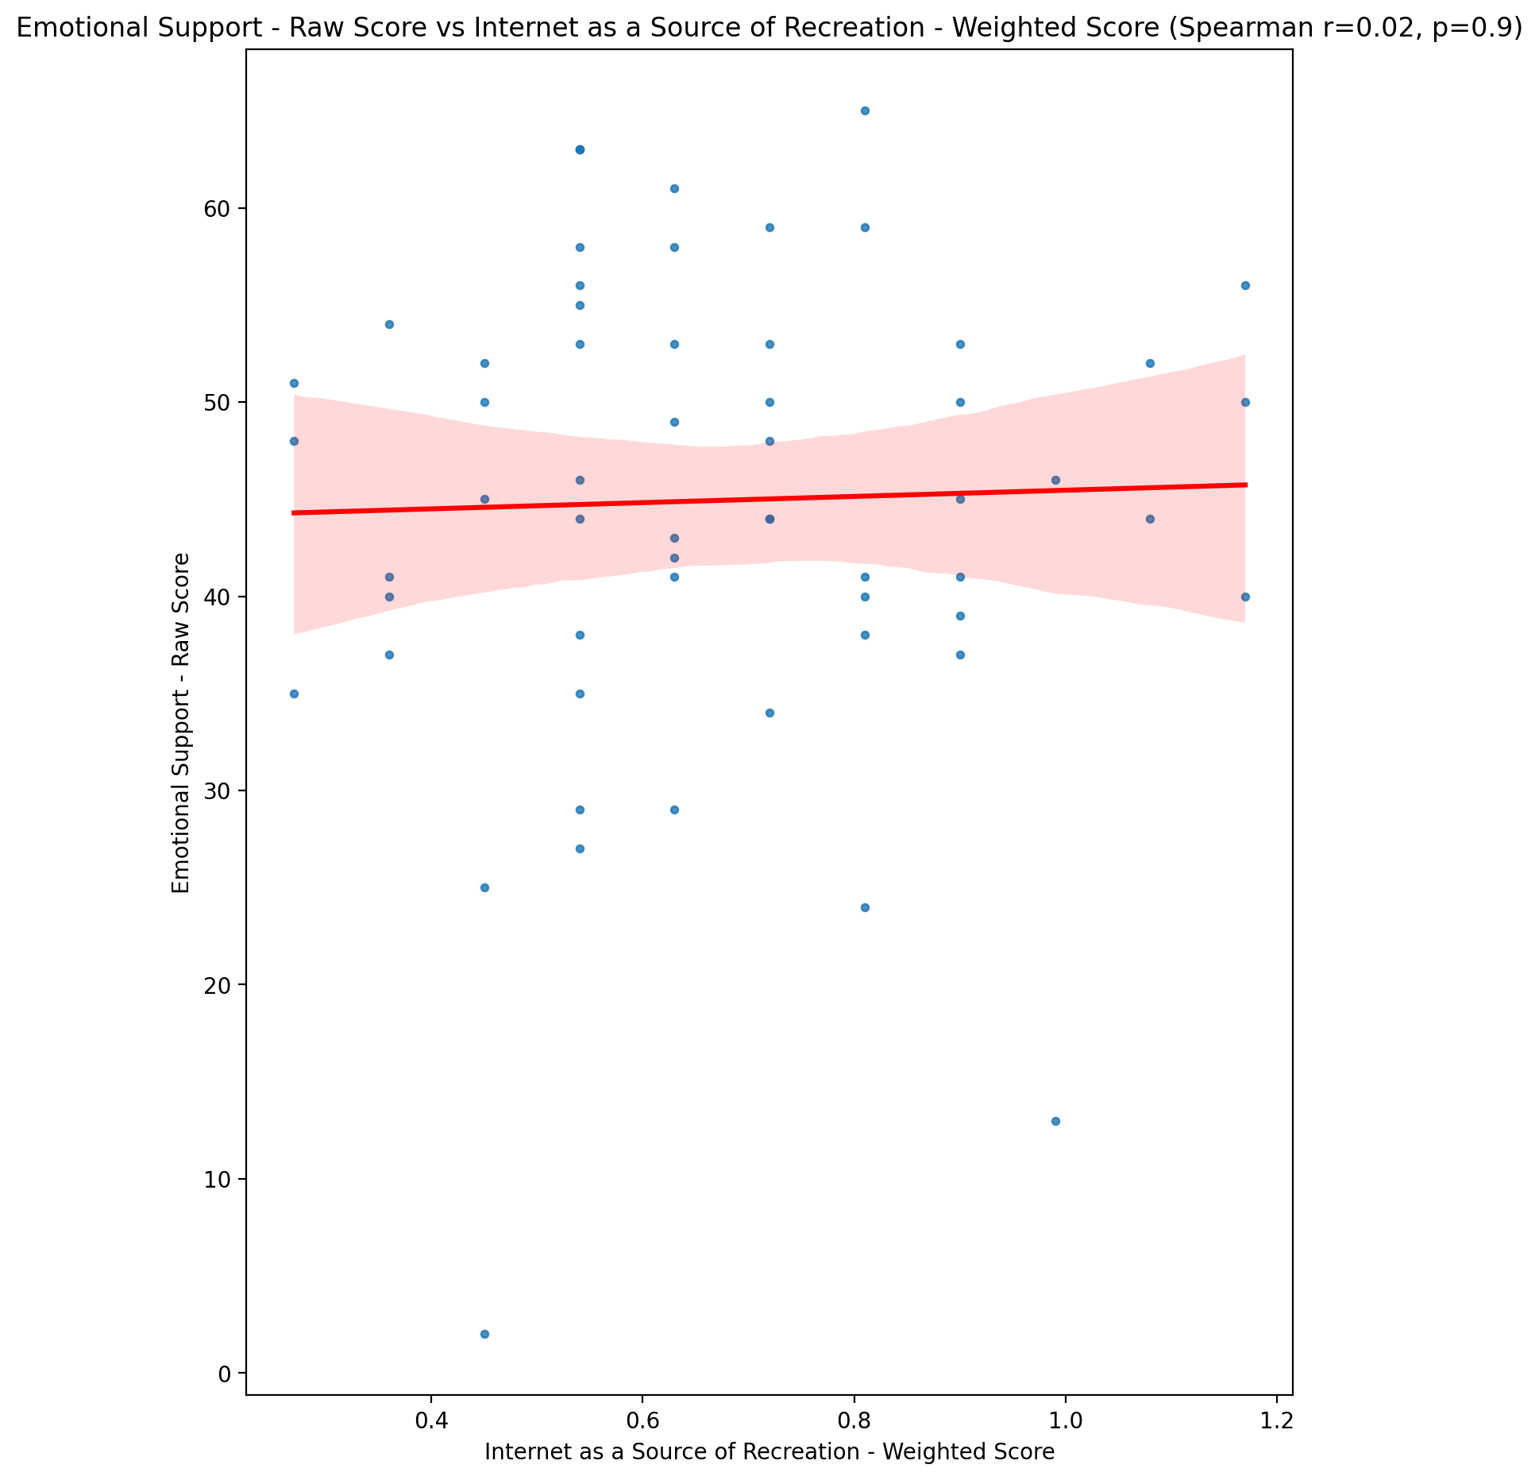

## Informational Support - Raw Score vs Internet as a Source of Recreation - Weighted Score

Test: spearman; statistic: 0.08097302579570287; p-value: 0.5420868015450828;

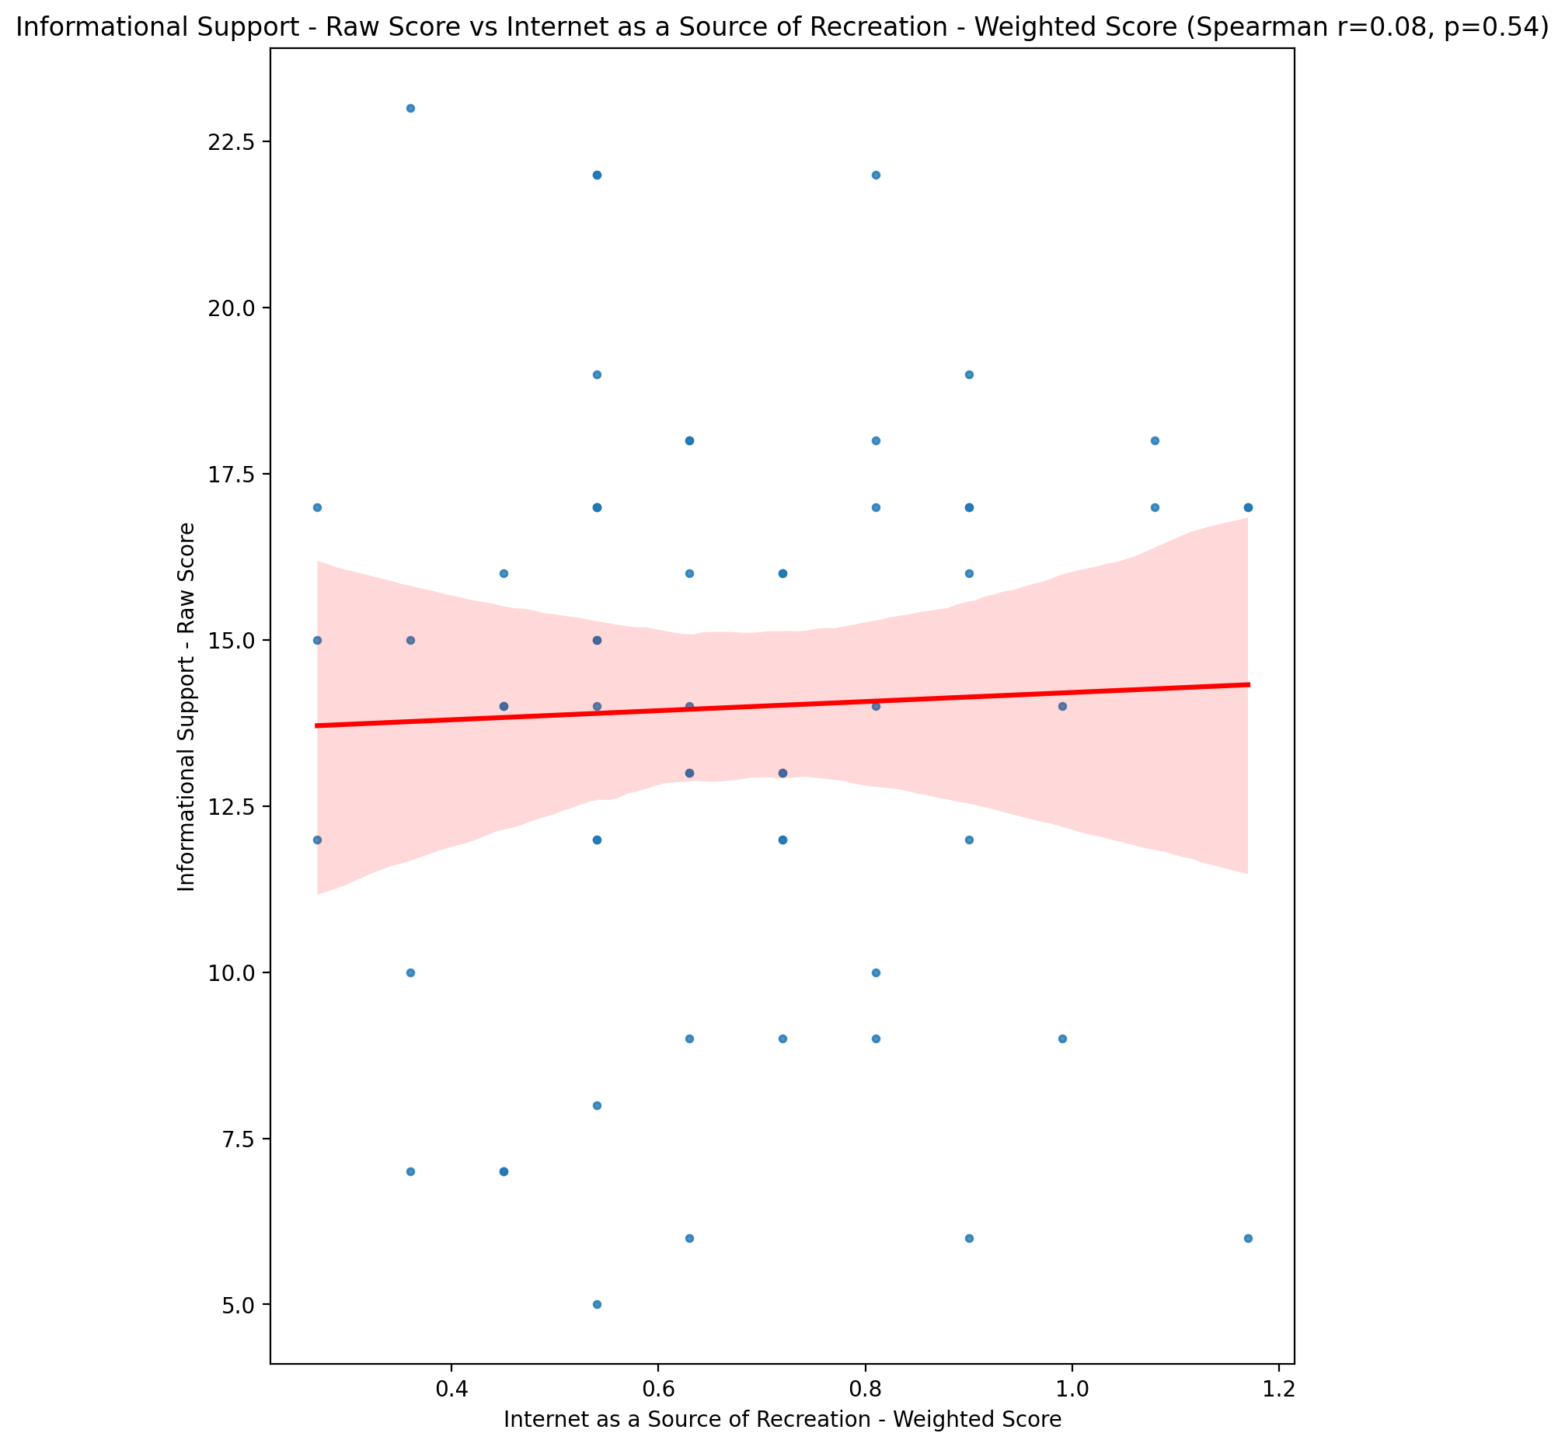

## Instrumental Support - Raw Score vs Internet as a Source of Recreation - Weighted Score

Test: spearman; statistic: -0.08184429588392261; p-value: 0.5377345867552382;

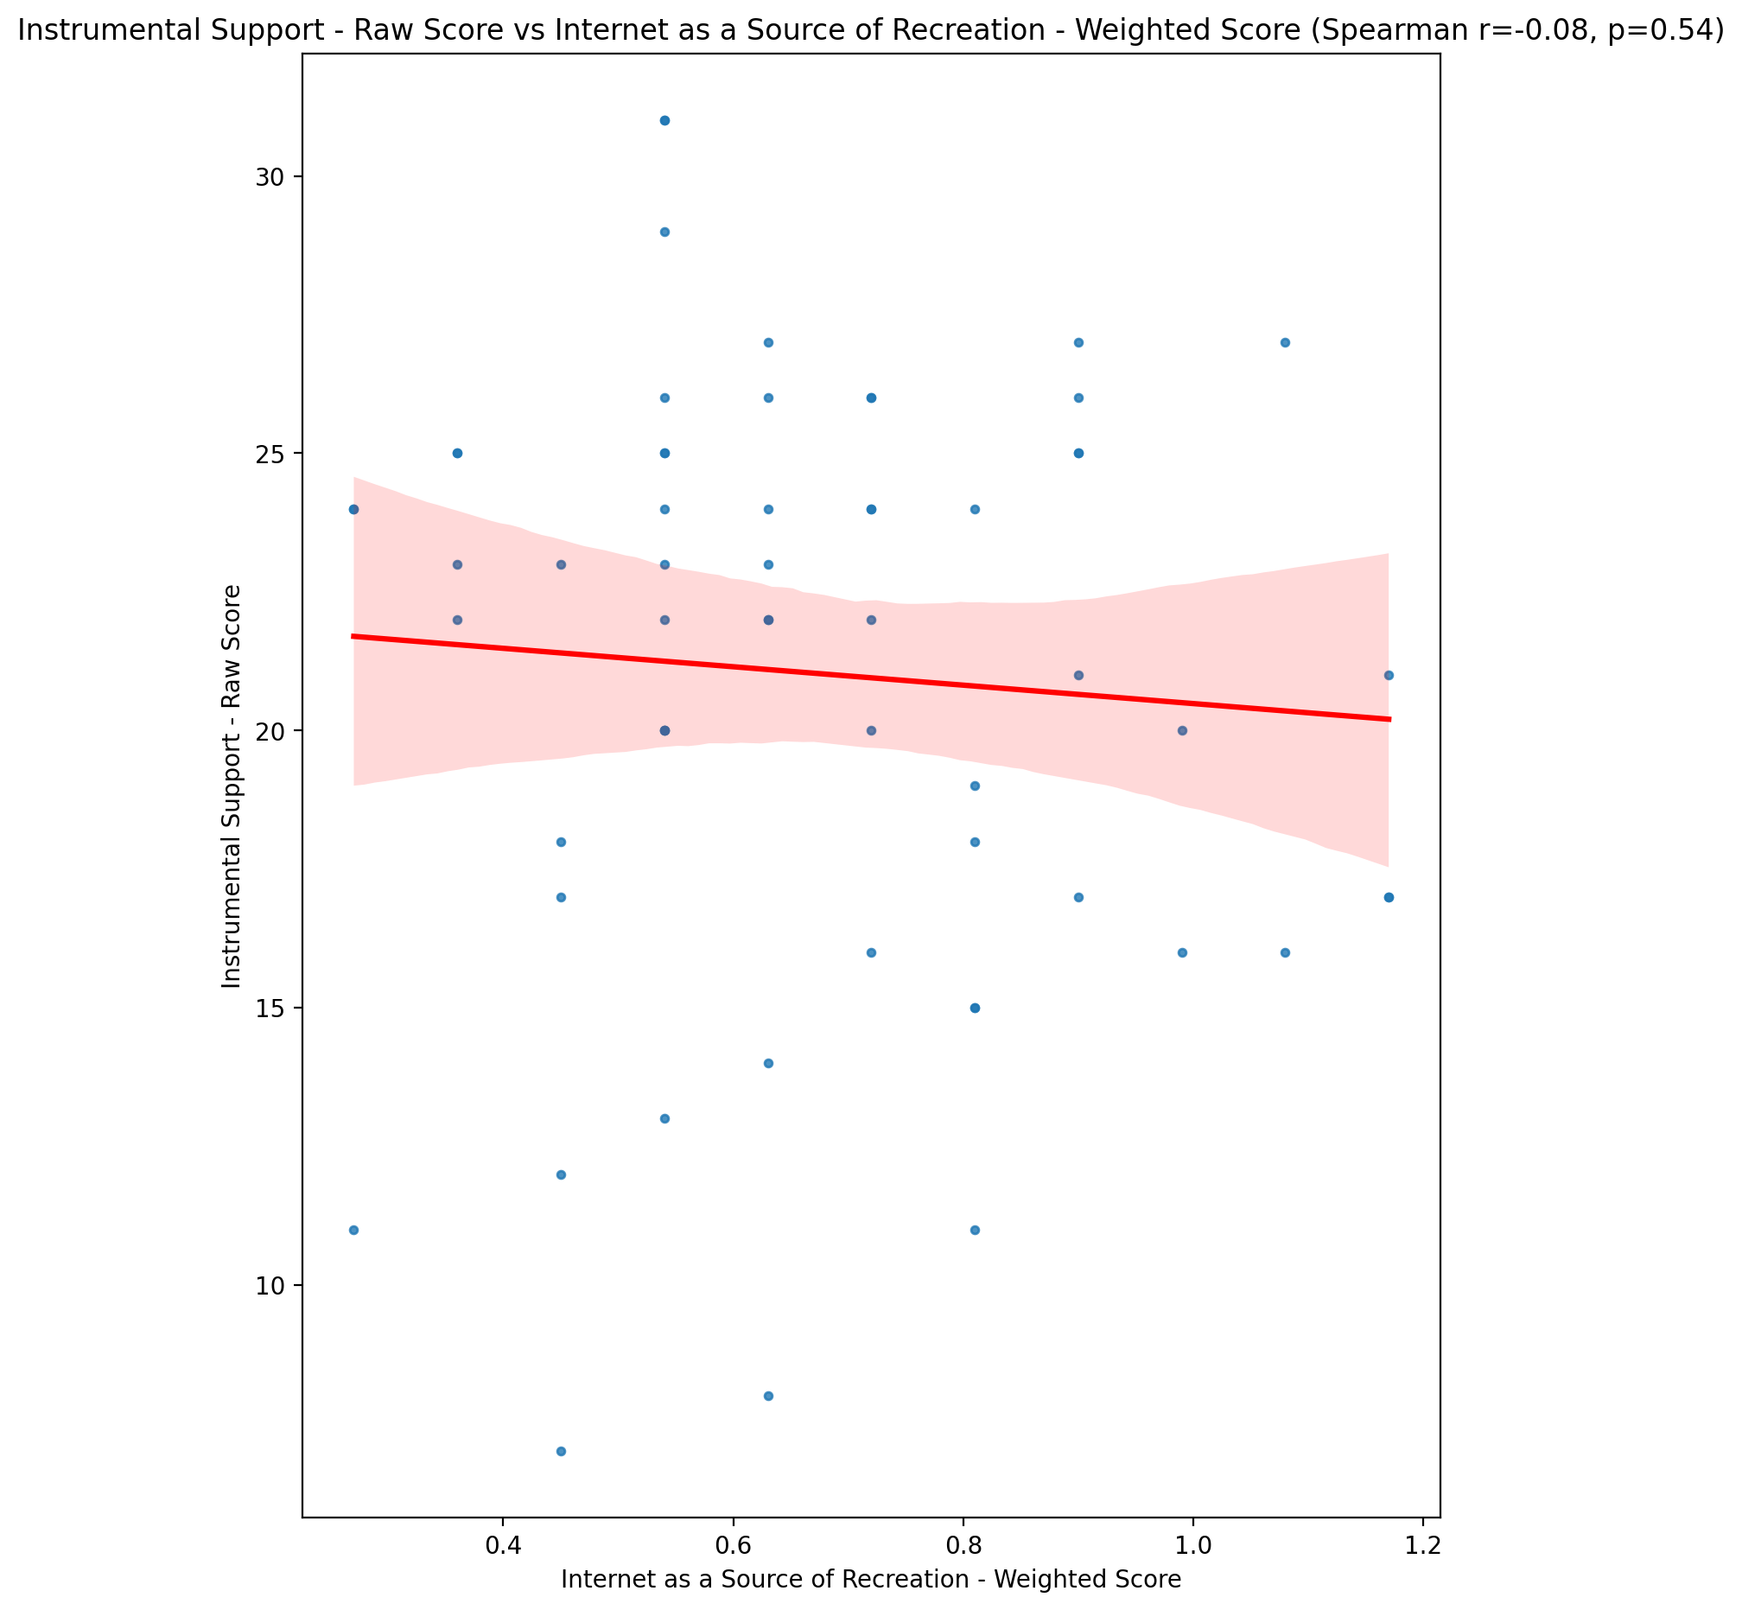

## Emotional Support - T Score vs Internet as a Source of Recreation - Weighted Score

Test: spearman; statistic: 0.01796445524817236; p-value: 0.8925754683656892;

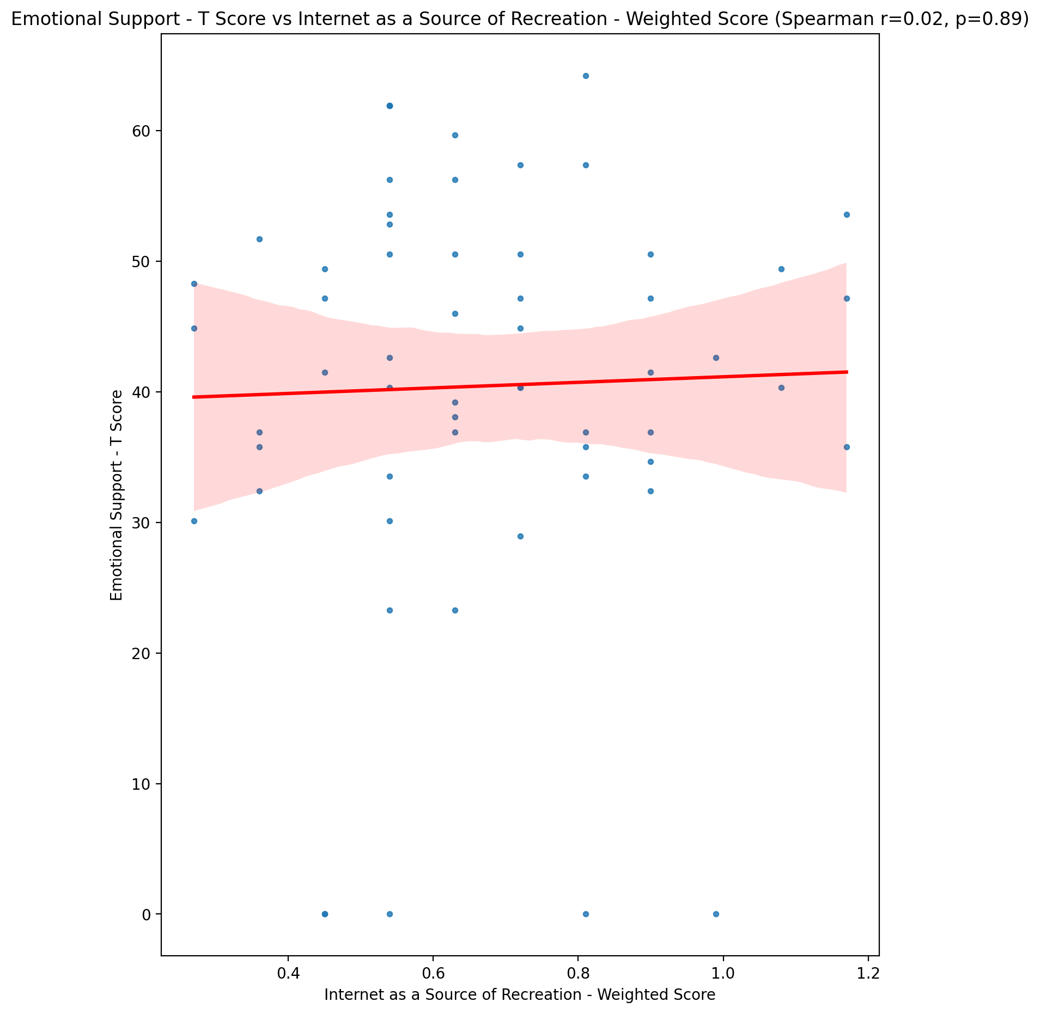

## Informational Support - T Score vs Internet as a Source of Recreation - Weighted Score

Test: spearman; statistic: 0.09098375430122728; p-value: 0.49313564647102015;

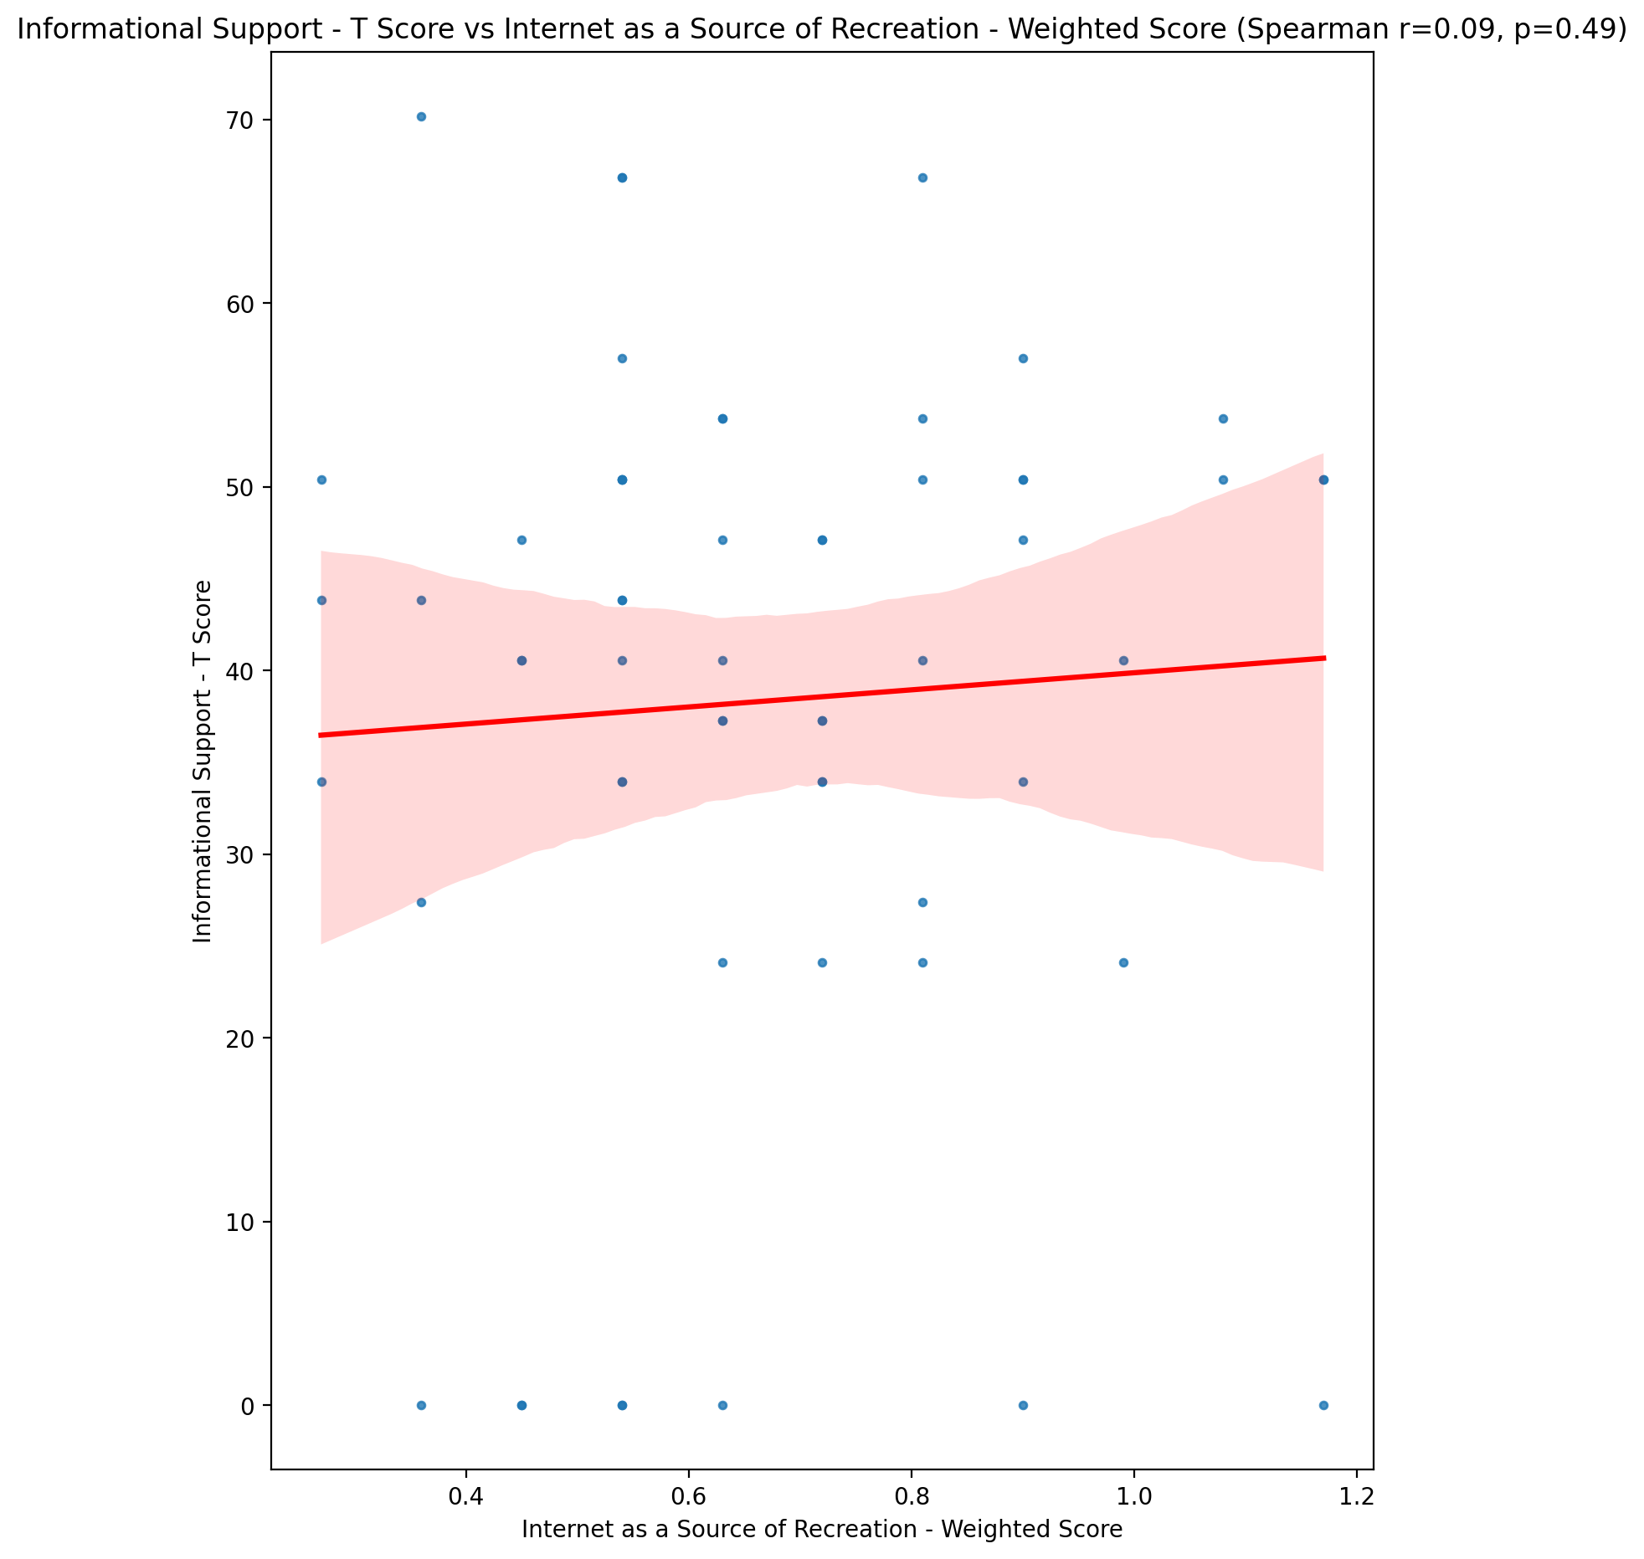

## Instrumental Support - T Score vs Internet as a Source of Recreation - Weighted Score

Test: spearman; statistic: -0.08148583752743822; p-value: 0.5395231072217401;

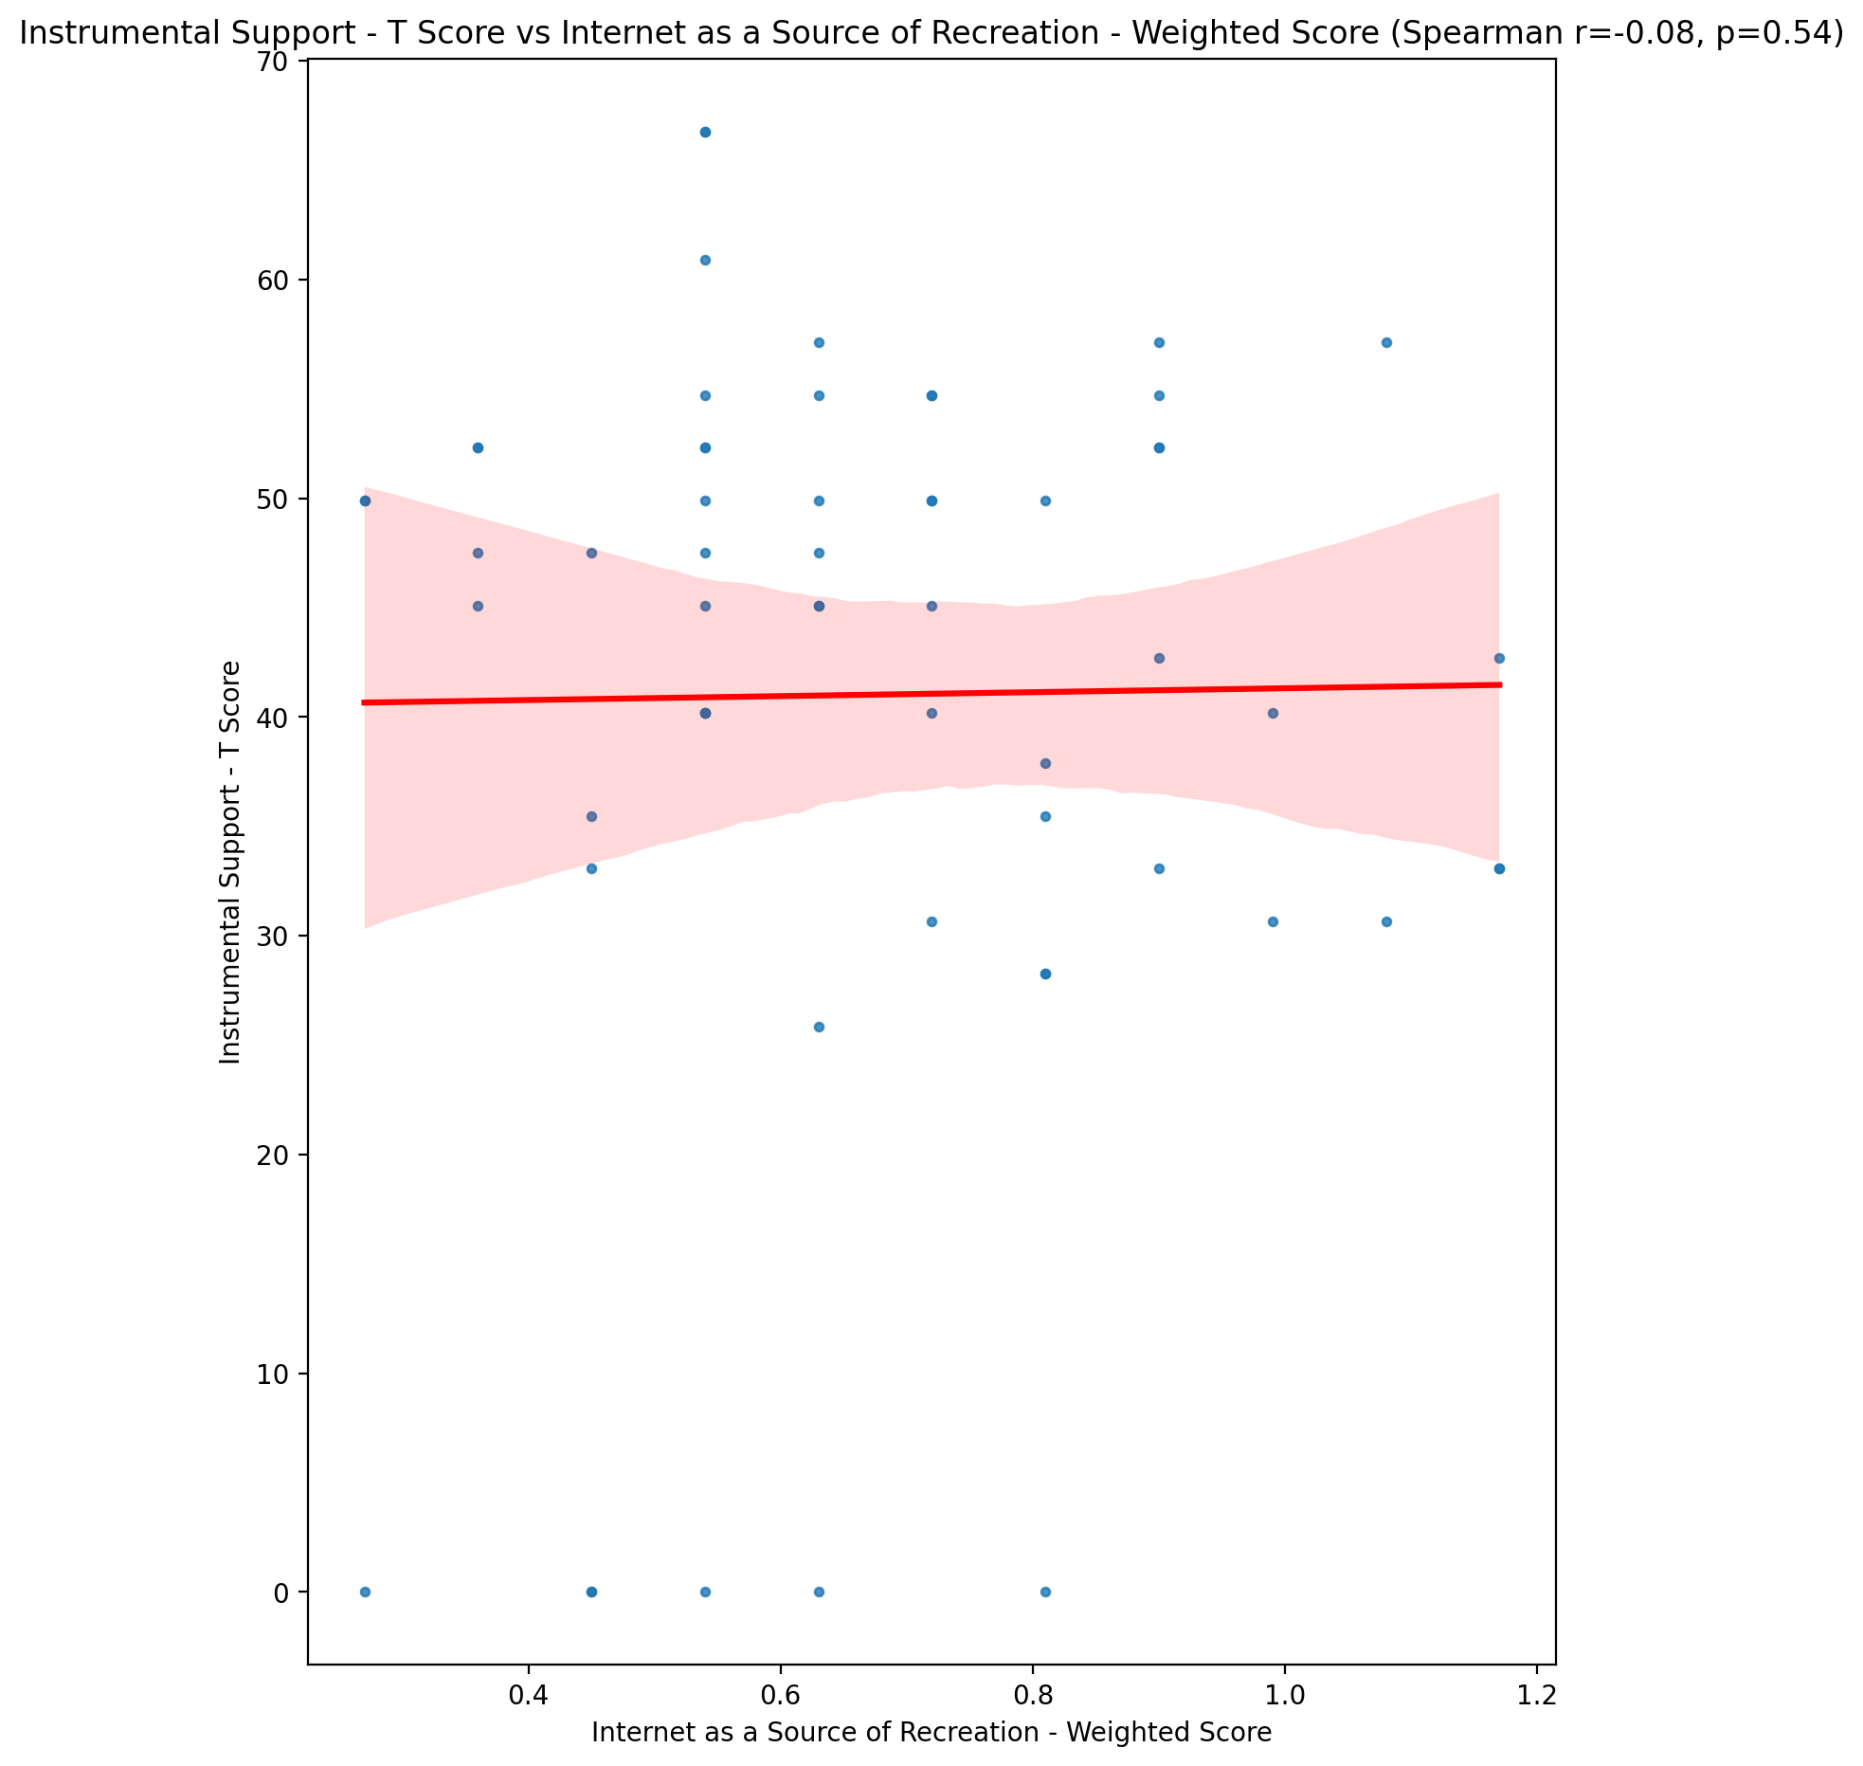

## Perceived Social Support Total T Score vs Internet as a Source of Recreation - Weighted Score

Test: spearman; statistic: -0.013926084101260708; p-value: 0.9166260765161393;

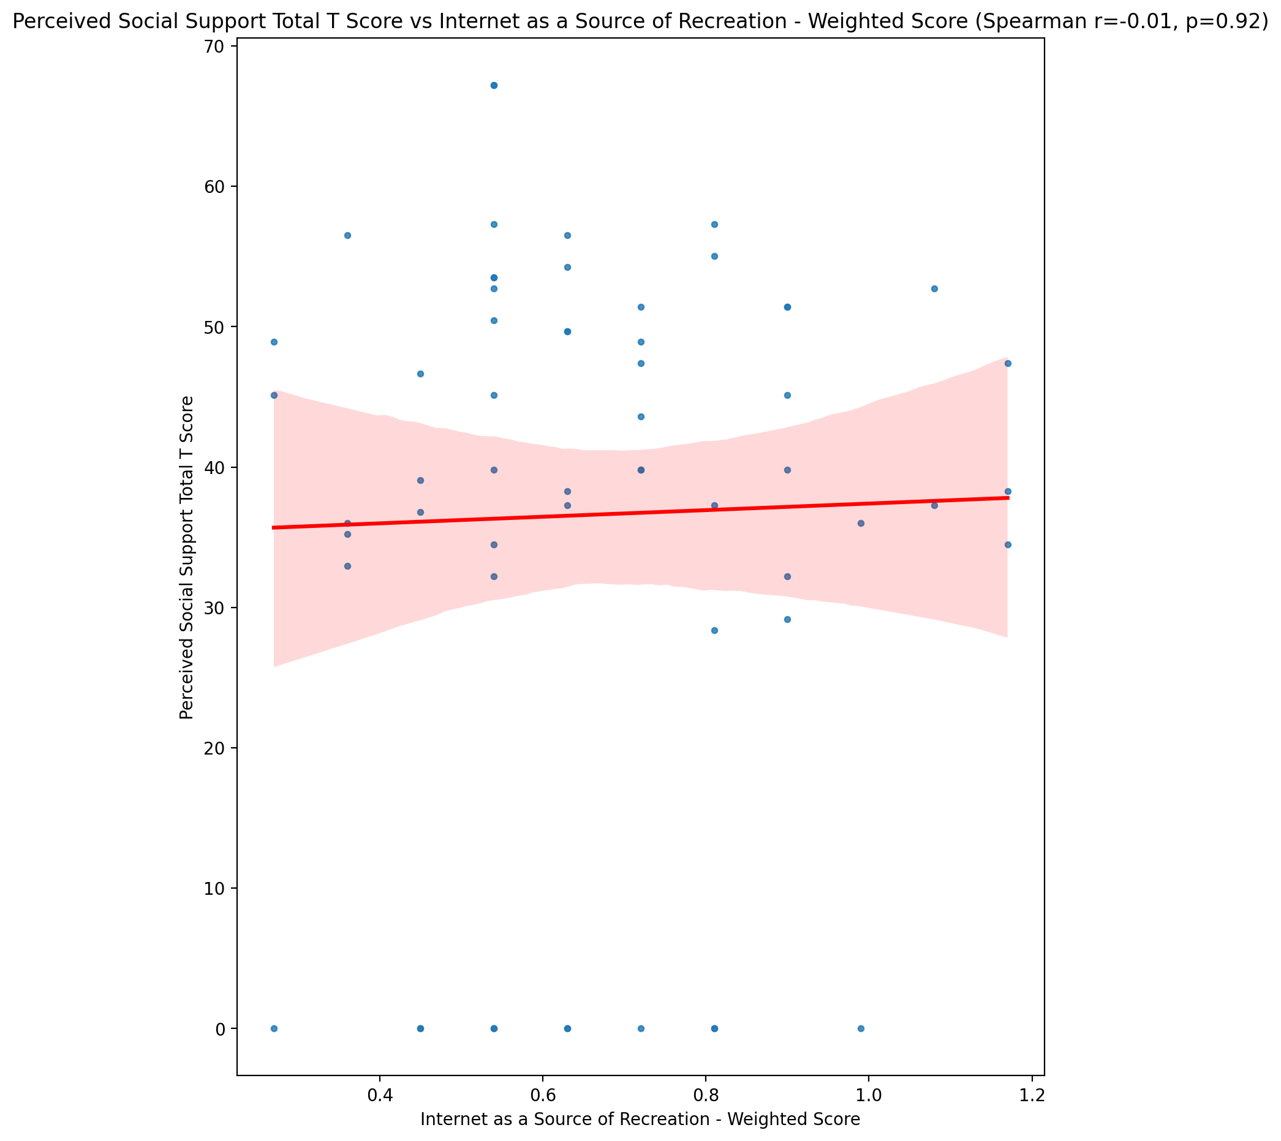

## Emotional Support - Rank vs Internet as a Source of Recreation - Weighted Score

Test: None; statistic: None; p-value: None; Test not run: unsupported type combination.



## Informational Support - Rank vs Internet as a Source of Recreation - Weighted Score

Test: None; statistic: None; p-value: None; Test not run: unsupported type combination.



## Instrumental Support - Rank vs Internet as a Source of Recreation - Weighted Score

Test: None; statistic: None; p-value: None; Test not run: unsupported type combination.



## Perceived Social Support TOTAL - Rank vs Internet as a Source of Recreation - Weighted Score

Test: None; statistic: None; p-value: None; Test not run: unsupported type combination.



## Power Self Concept - Real Self Concept Score vs Internet as a Source of Recreation - Weighted Score

Test: spearman; statistic: 0.013807486934504178; p-value: 0.9173336154691321;

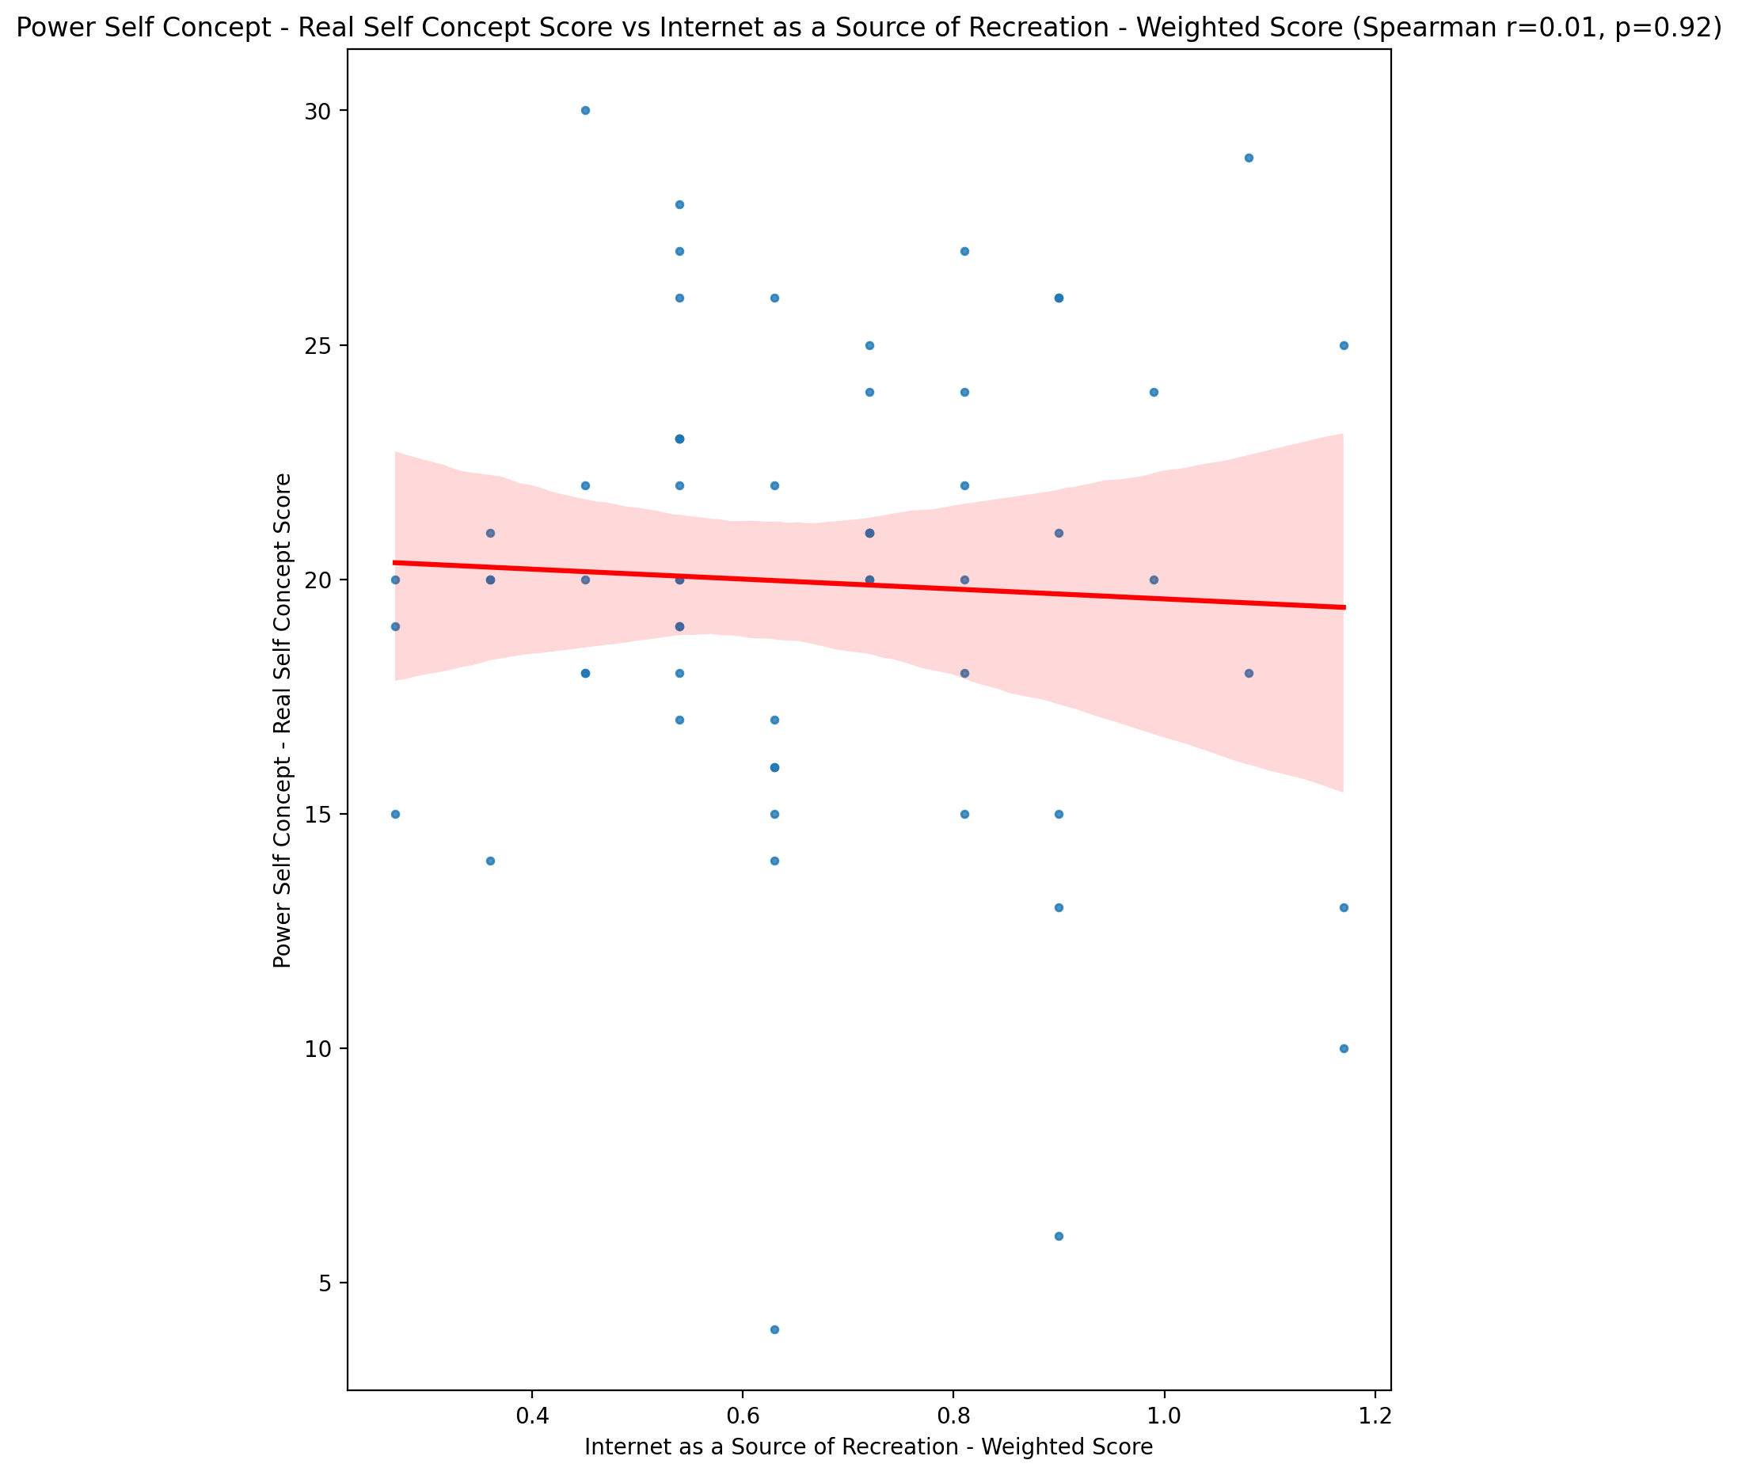

## Power Self Concept - Ideal Self Concept score vs Internet as a Source of Recreation - Weighted Score

Test: spearman; statistic: -0.09605554685307788; p-value: 0.4692461154242463;

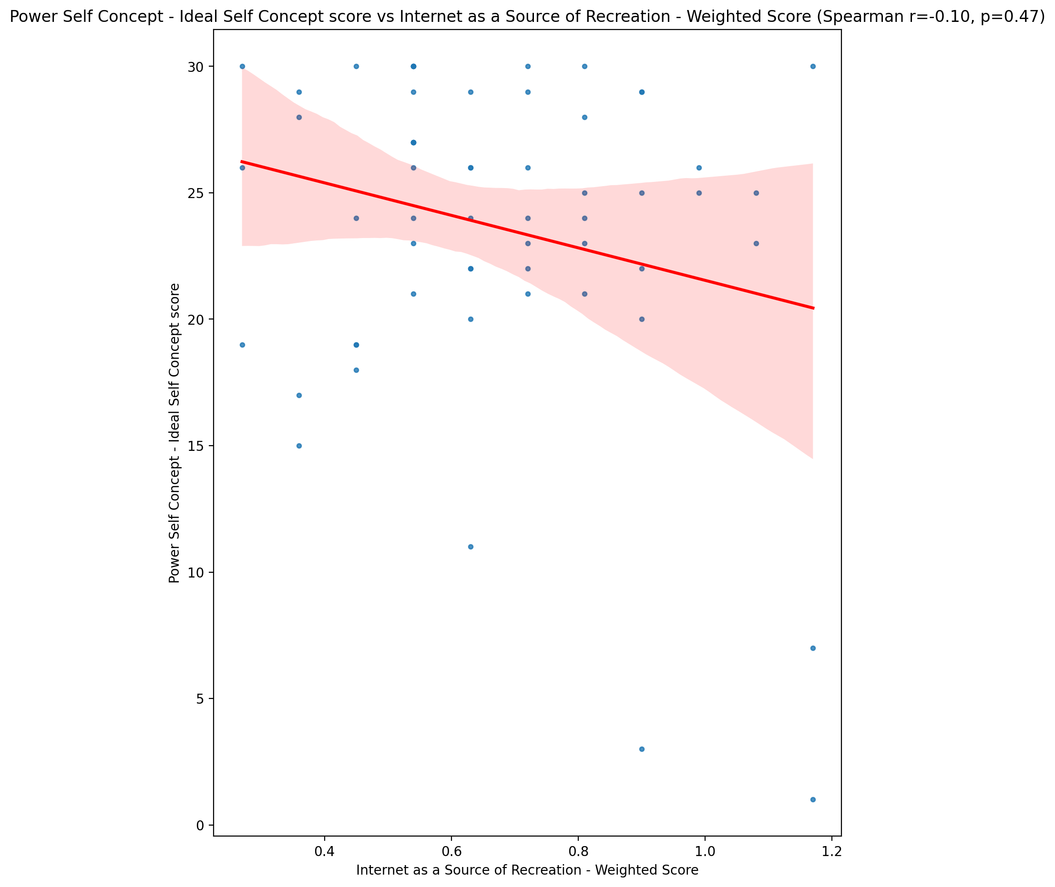

## Power Self Concept – Social Self Concept Score vs Internet as a Source of Recreation - Weighted Score

Test: spearman; statistic: 0.07063412303147938; p-value: 0.5949980330402362;

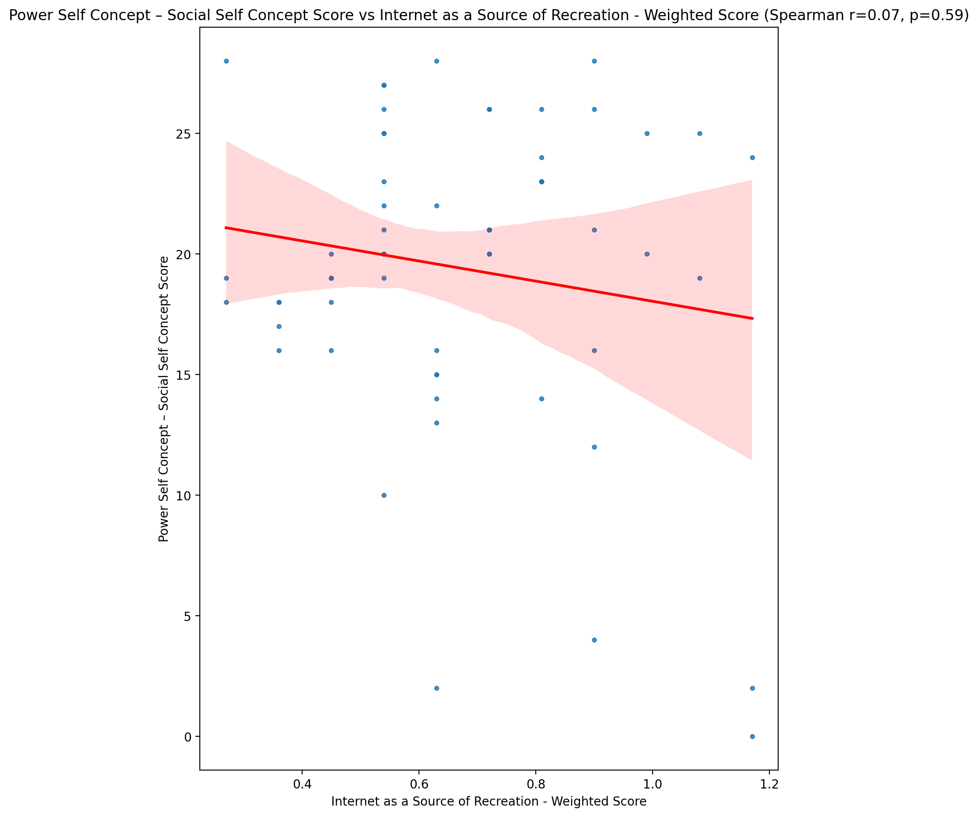

## Social Self Concept - Real Self Concept Score vs Internet as a Source of Recreation - Weighted Score

Test: spearman; statistic: -0.10572814870023843; p-value: 0.4254657326186493;

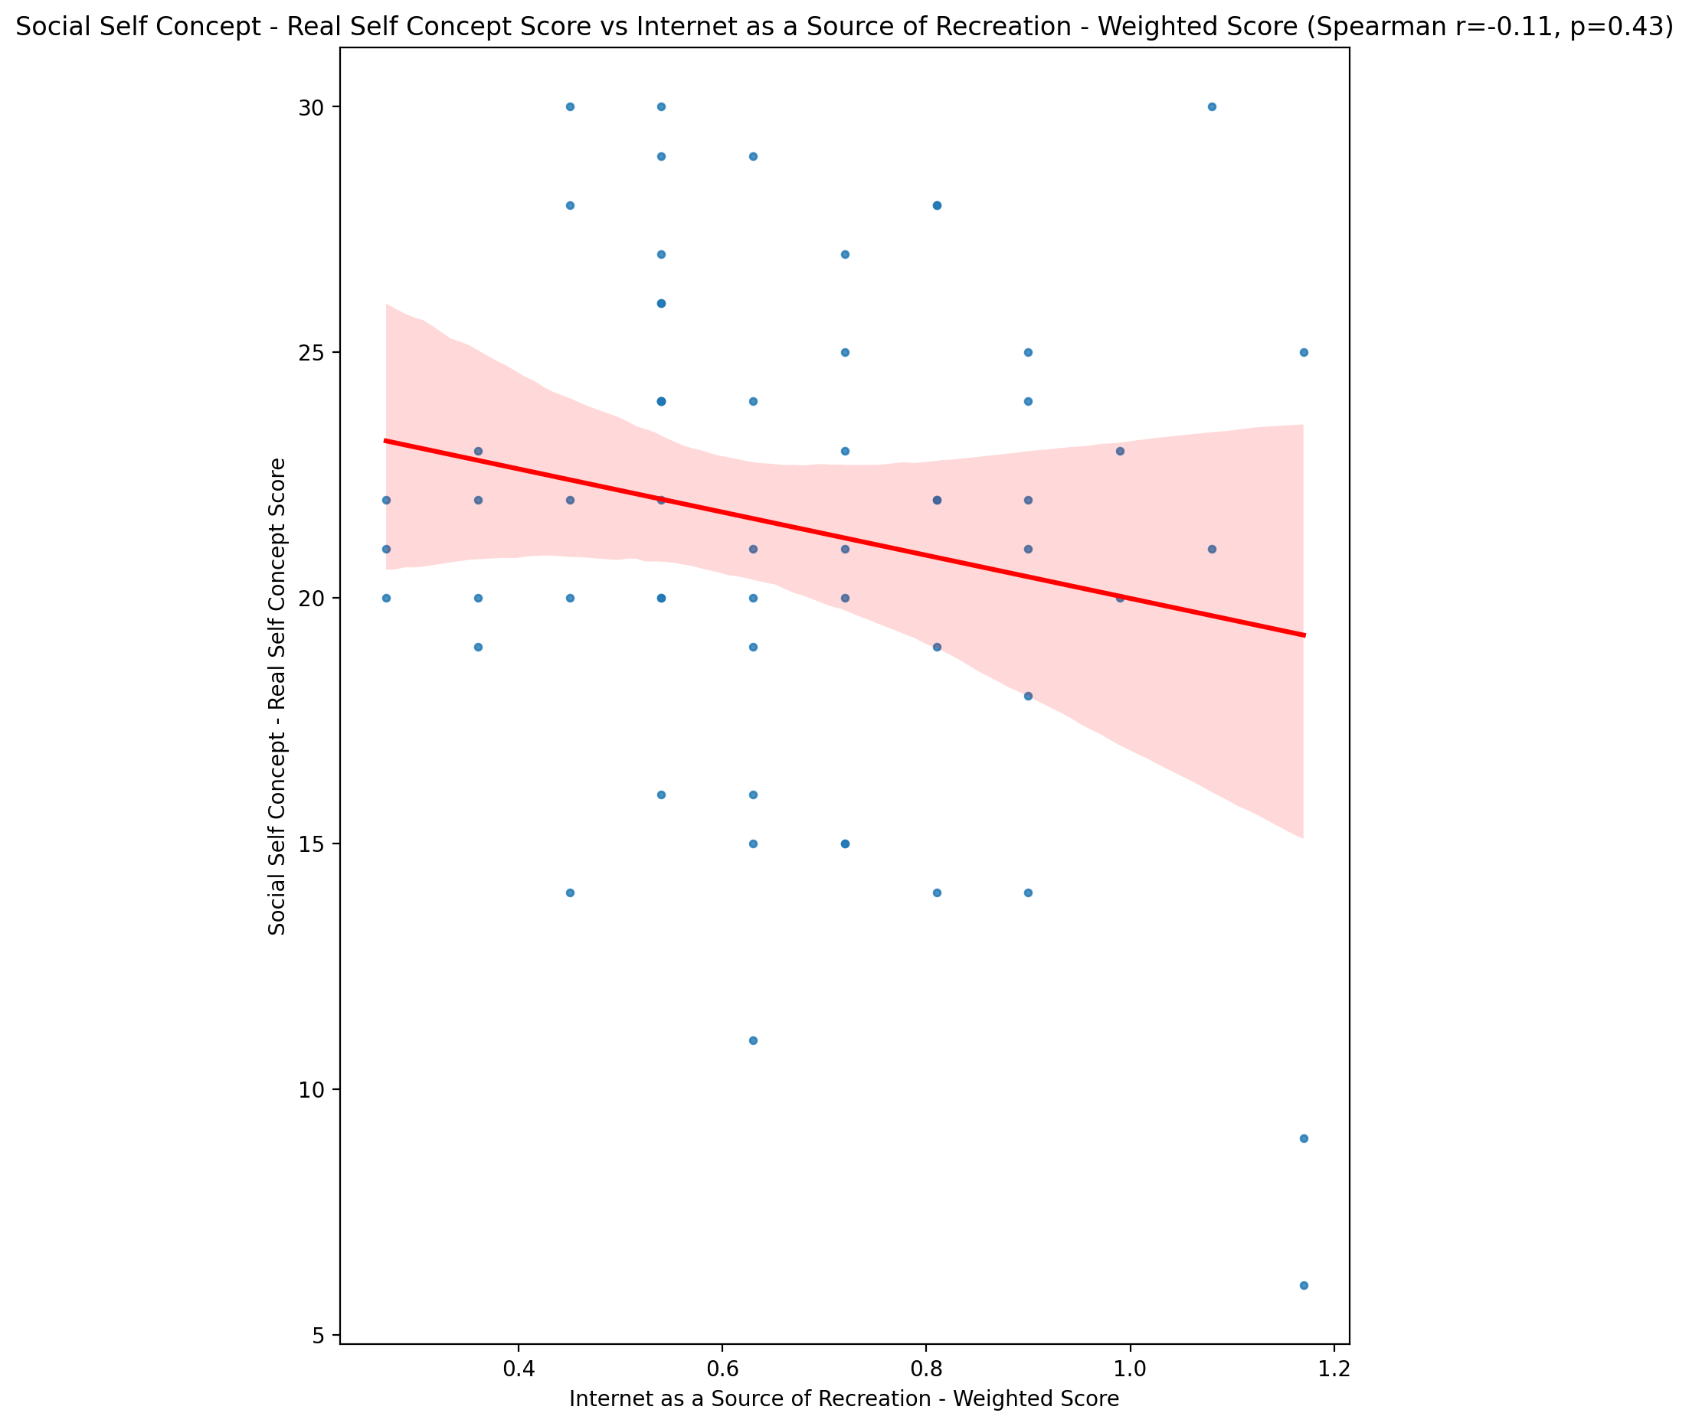

## Social Self Concept – Social Self Concept Score vs Internet as a Source of Recreation - Weighted Score

Test: spearman; statistic: -0.009600891074080697; p-value: 0.942466938739782;

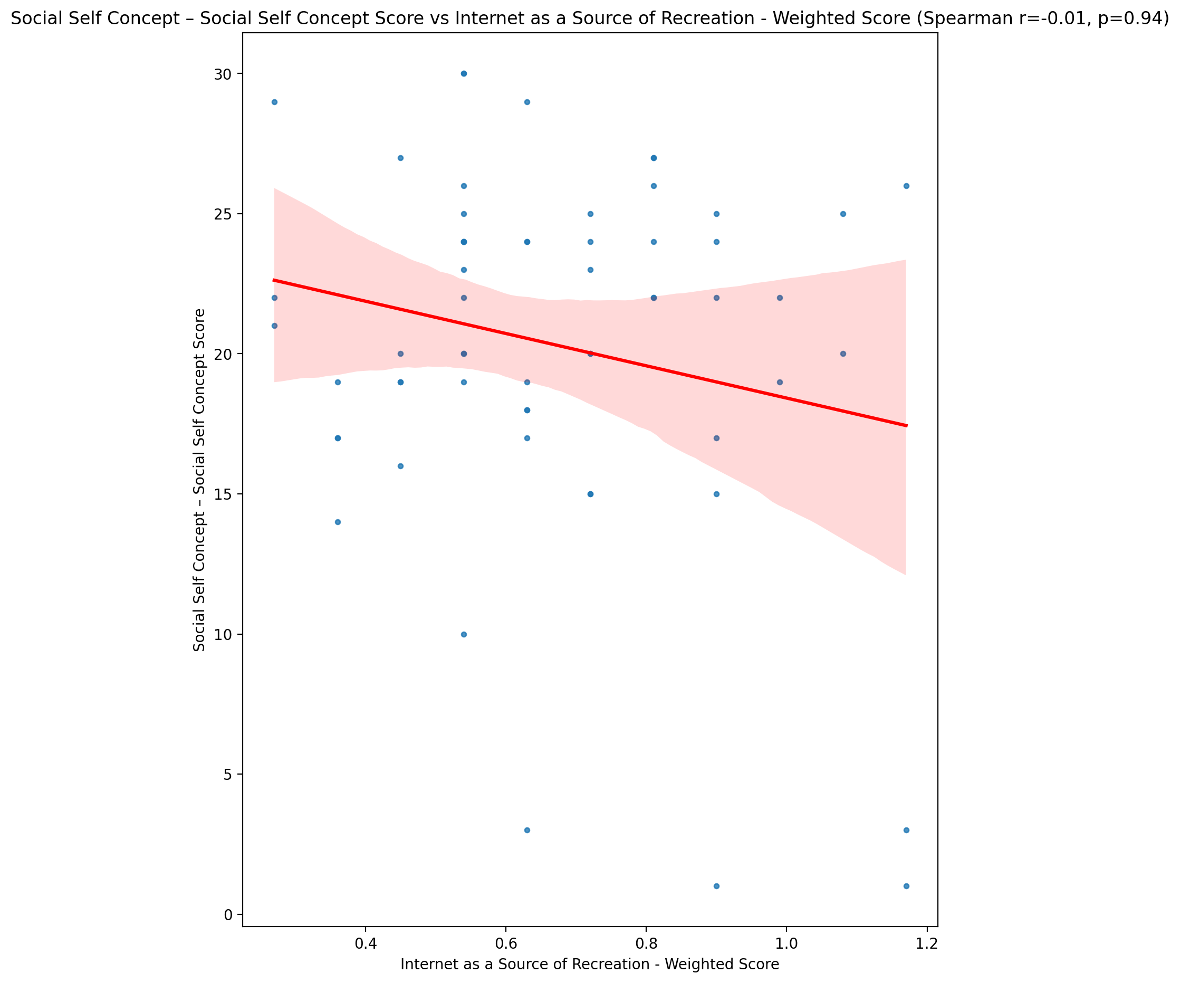

## Ability Self Concept - Real Self Concept Score vs Internet as a Source of Recreation - Weighted Score

Test: spearman; statistic: 0.03311060094835281; p-value: 0.8033963904269315;

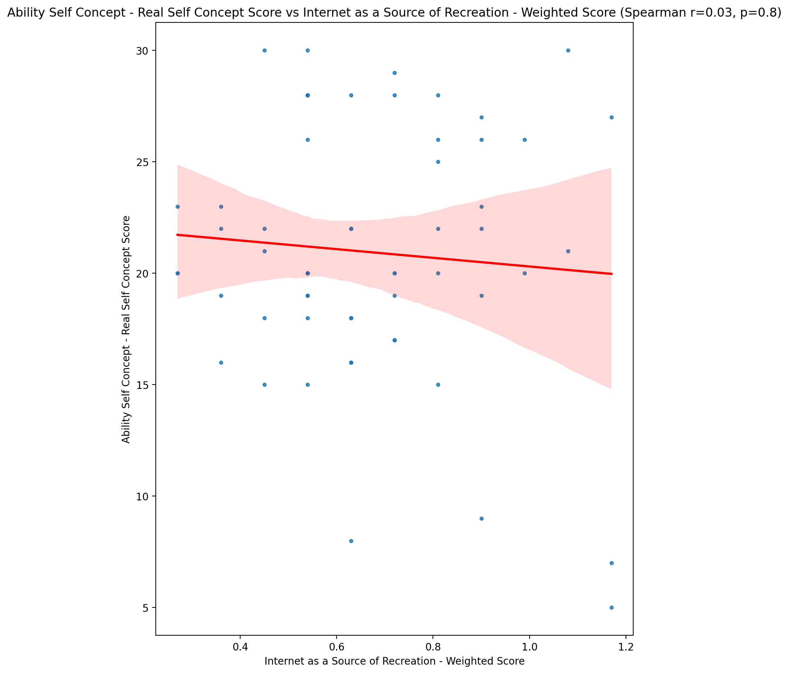

## Ability Self Concept - Ideal Self Concept Score vs Internet as a Source of Recreation - Weighted Score

Test: spearman; statistic: -0.0984369855441392; p-value: 0.45824775329795553;

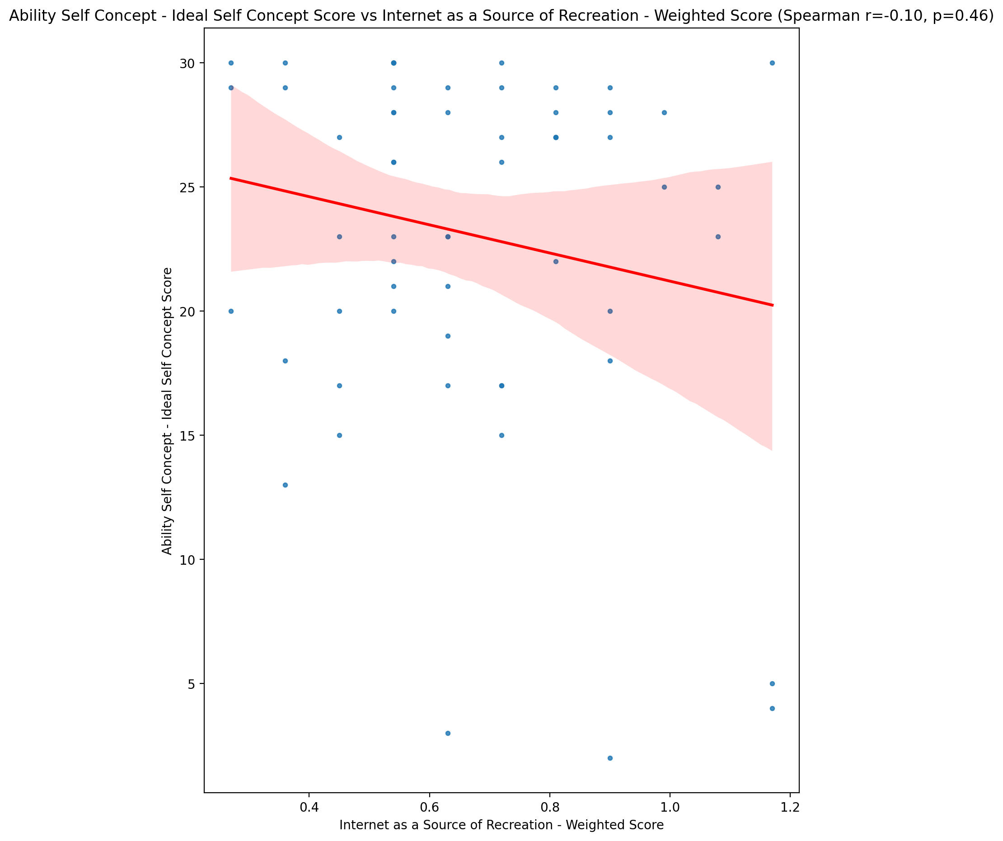

## Ability Self Concept – Social Self Concept Score vs Internet as a Source of Recreation - Weighted Score

Test: spearman; statistic: 0.09129652381424681; p-value: 0.4916443047098844;

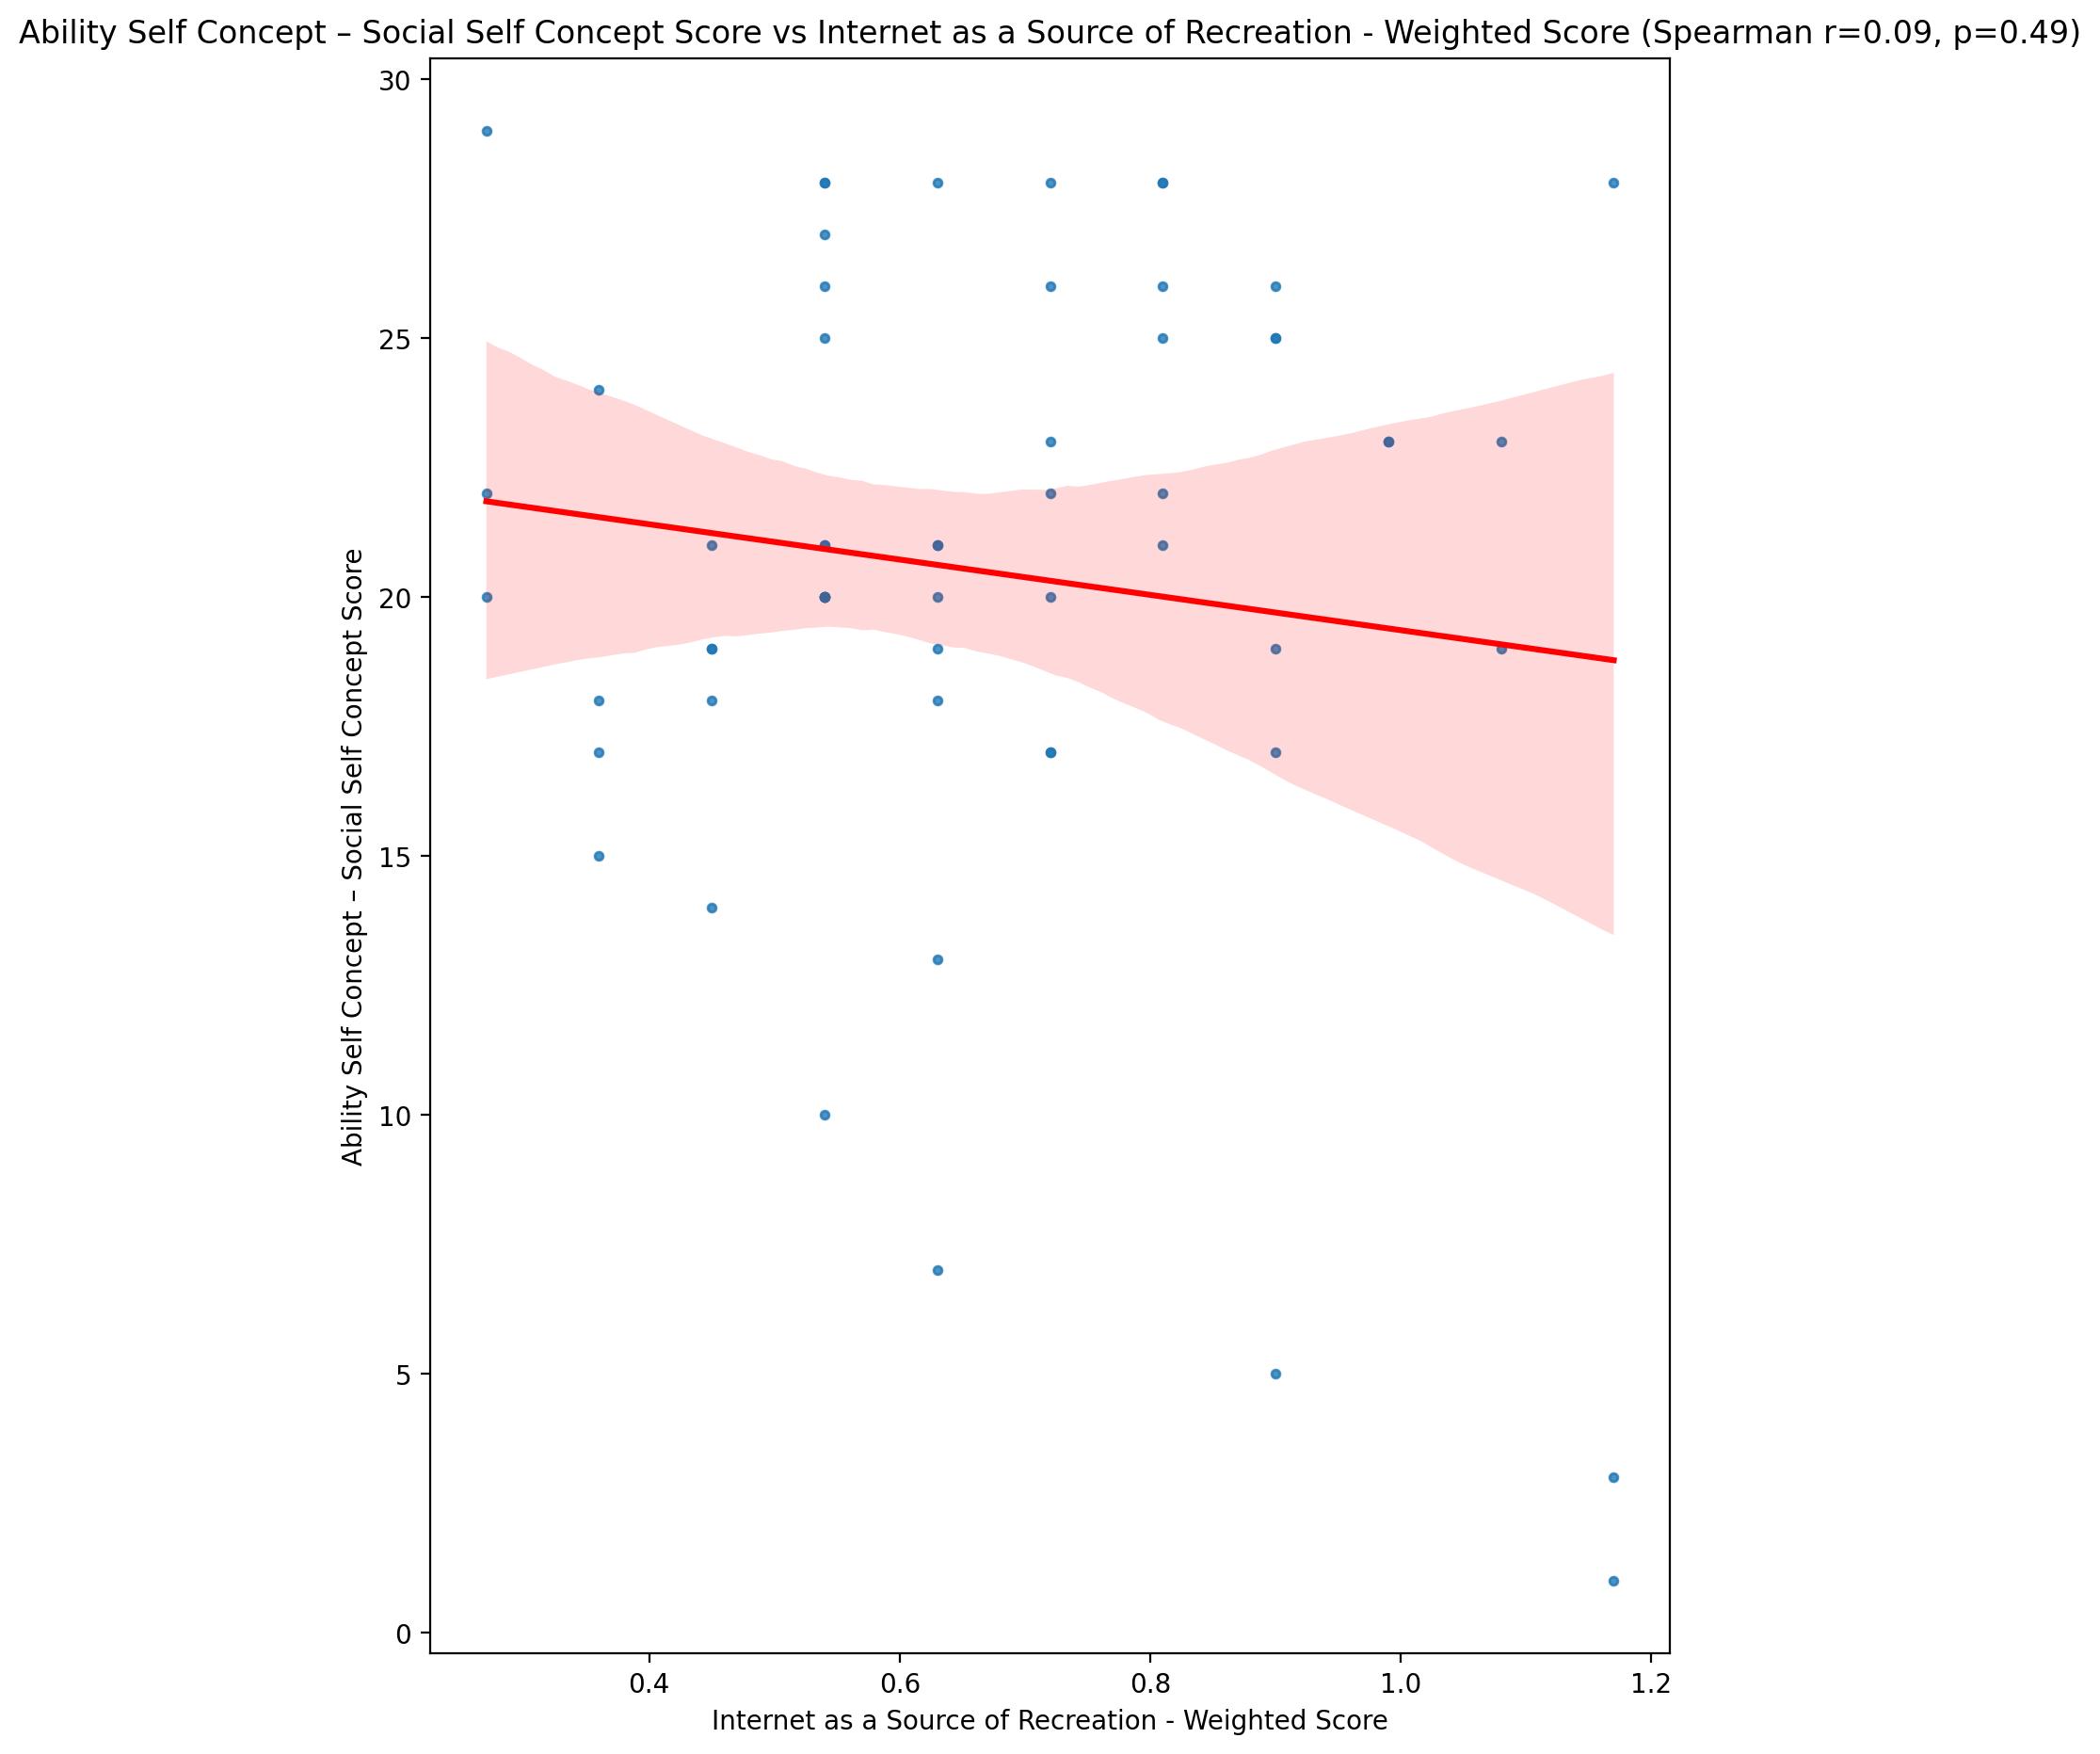

## Physical Self Concept - Real Self Concept Score vs Internet as a Source of Recreation - Weighted Score

Test: spearman; statistic: -0.04745240075293412; p-value: 0.7211731690536372;

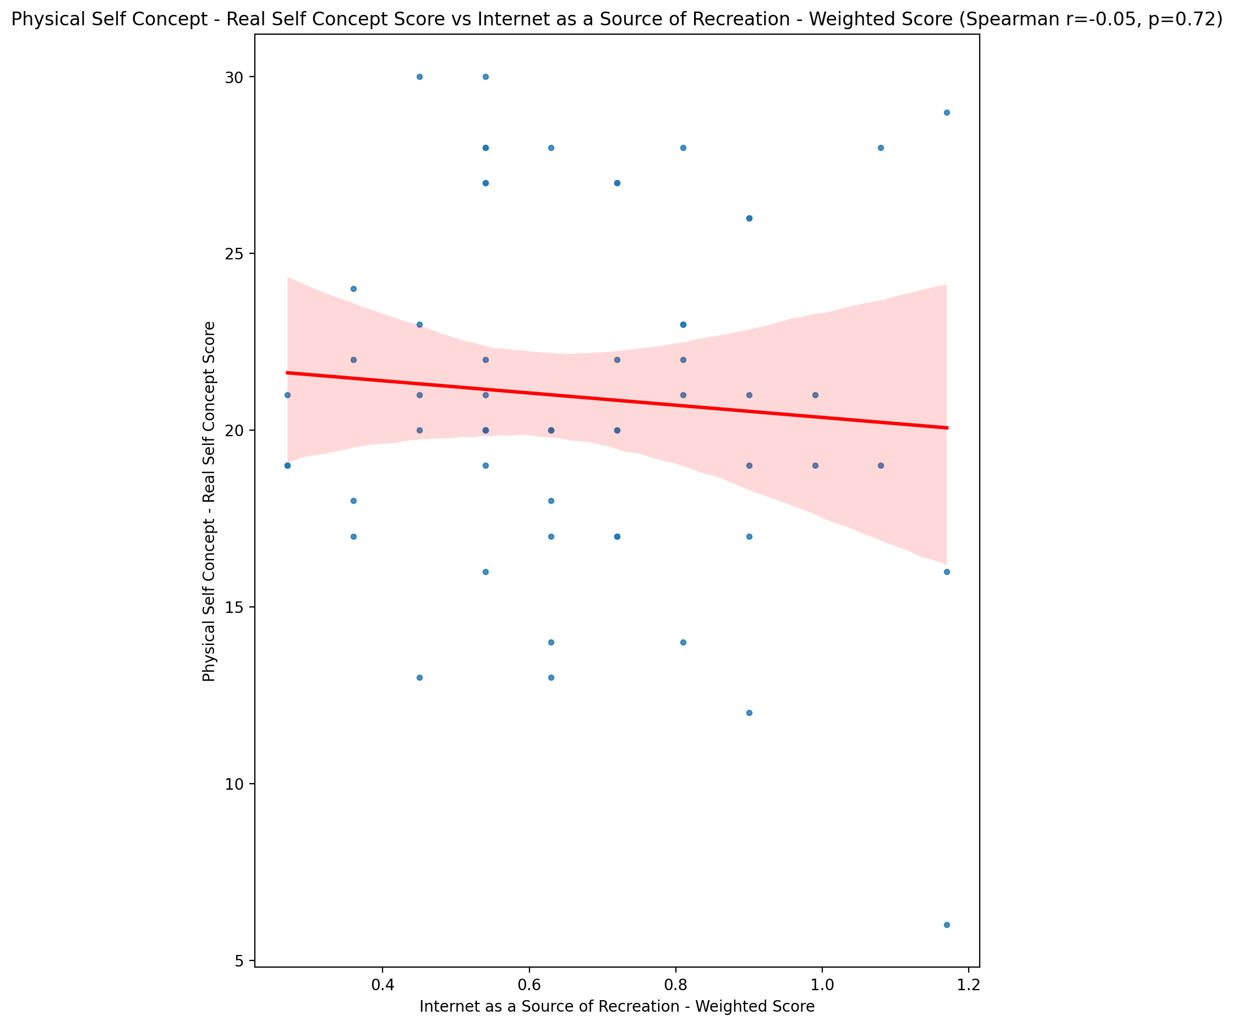

## Physical Self Concept – Ideal Self Concept Score vs Internet as a Source of Recreation - Weighted Score

Test: spearman; statistic: -0.13450598771264793; p-value: 0.30978220214993285;

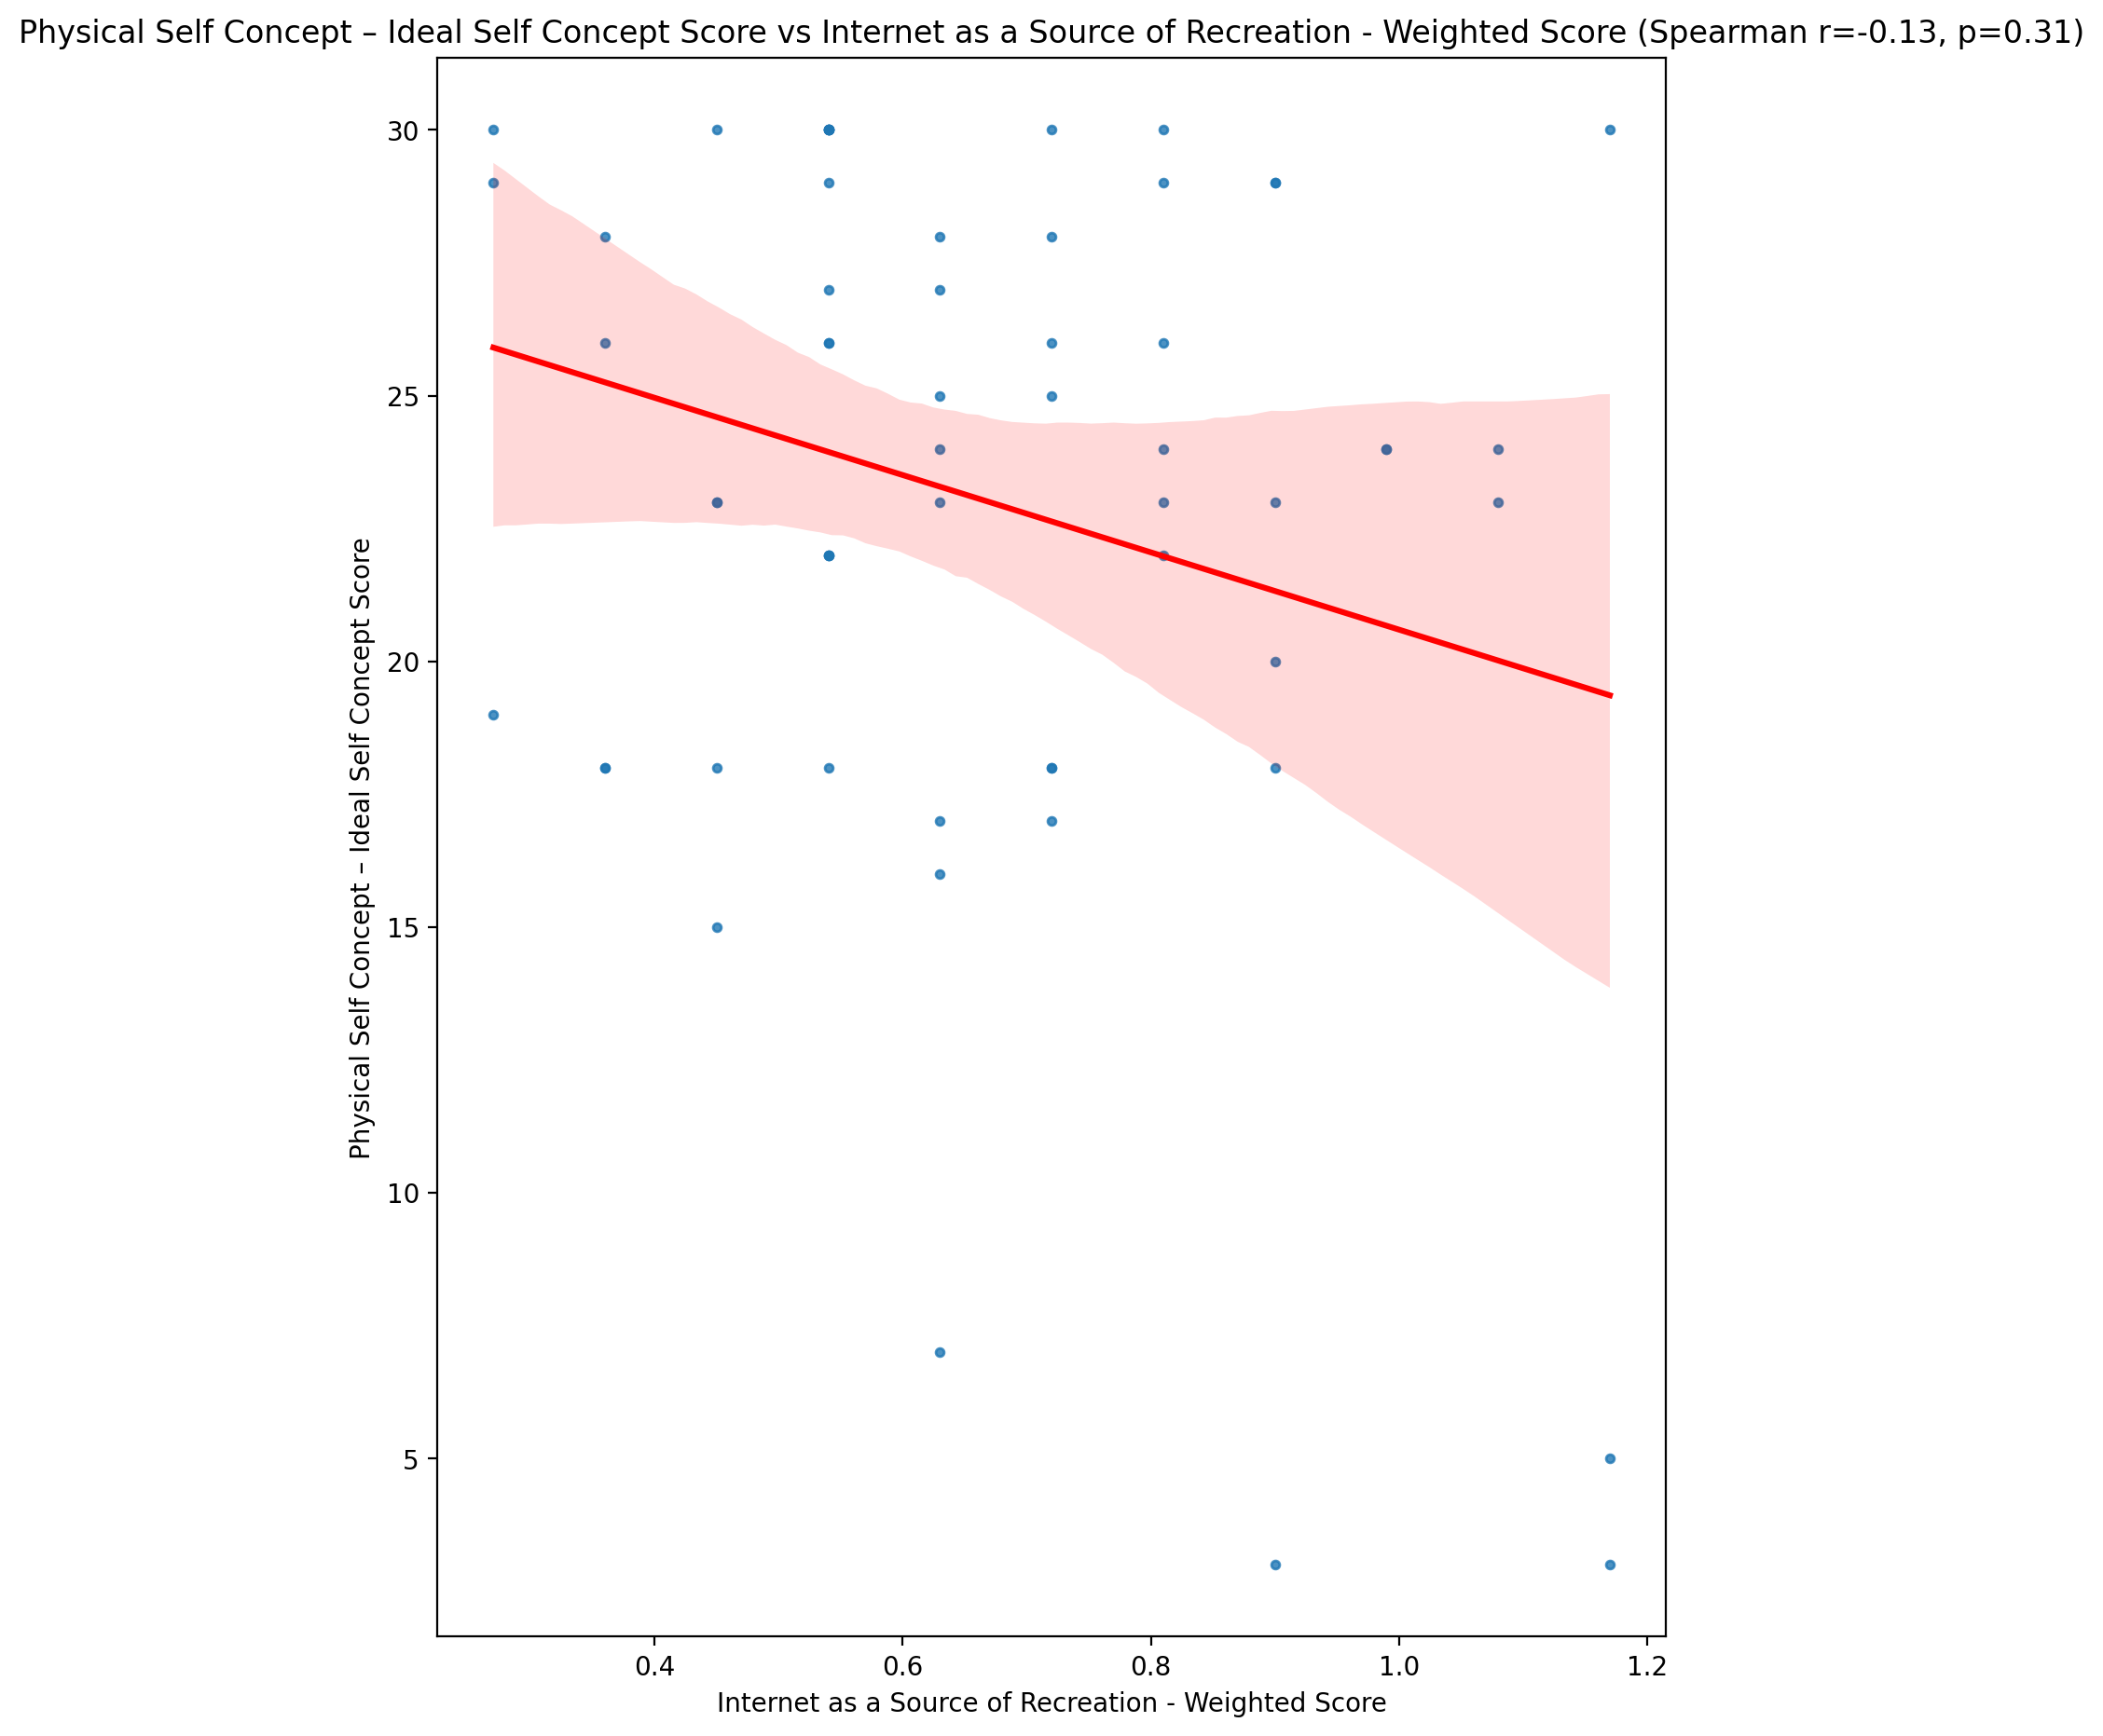

## Physical Self Concept – Social Self Concept Score vs Internet as a Source of Recreation - Weighted Score

Test: spearman; statistic: 0.0042204555112462135; p-value: 0.9746918029981984;

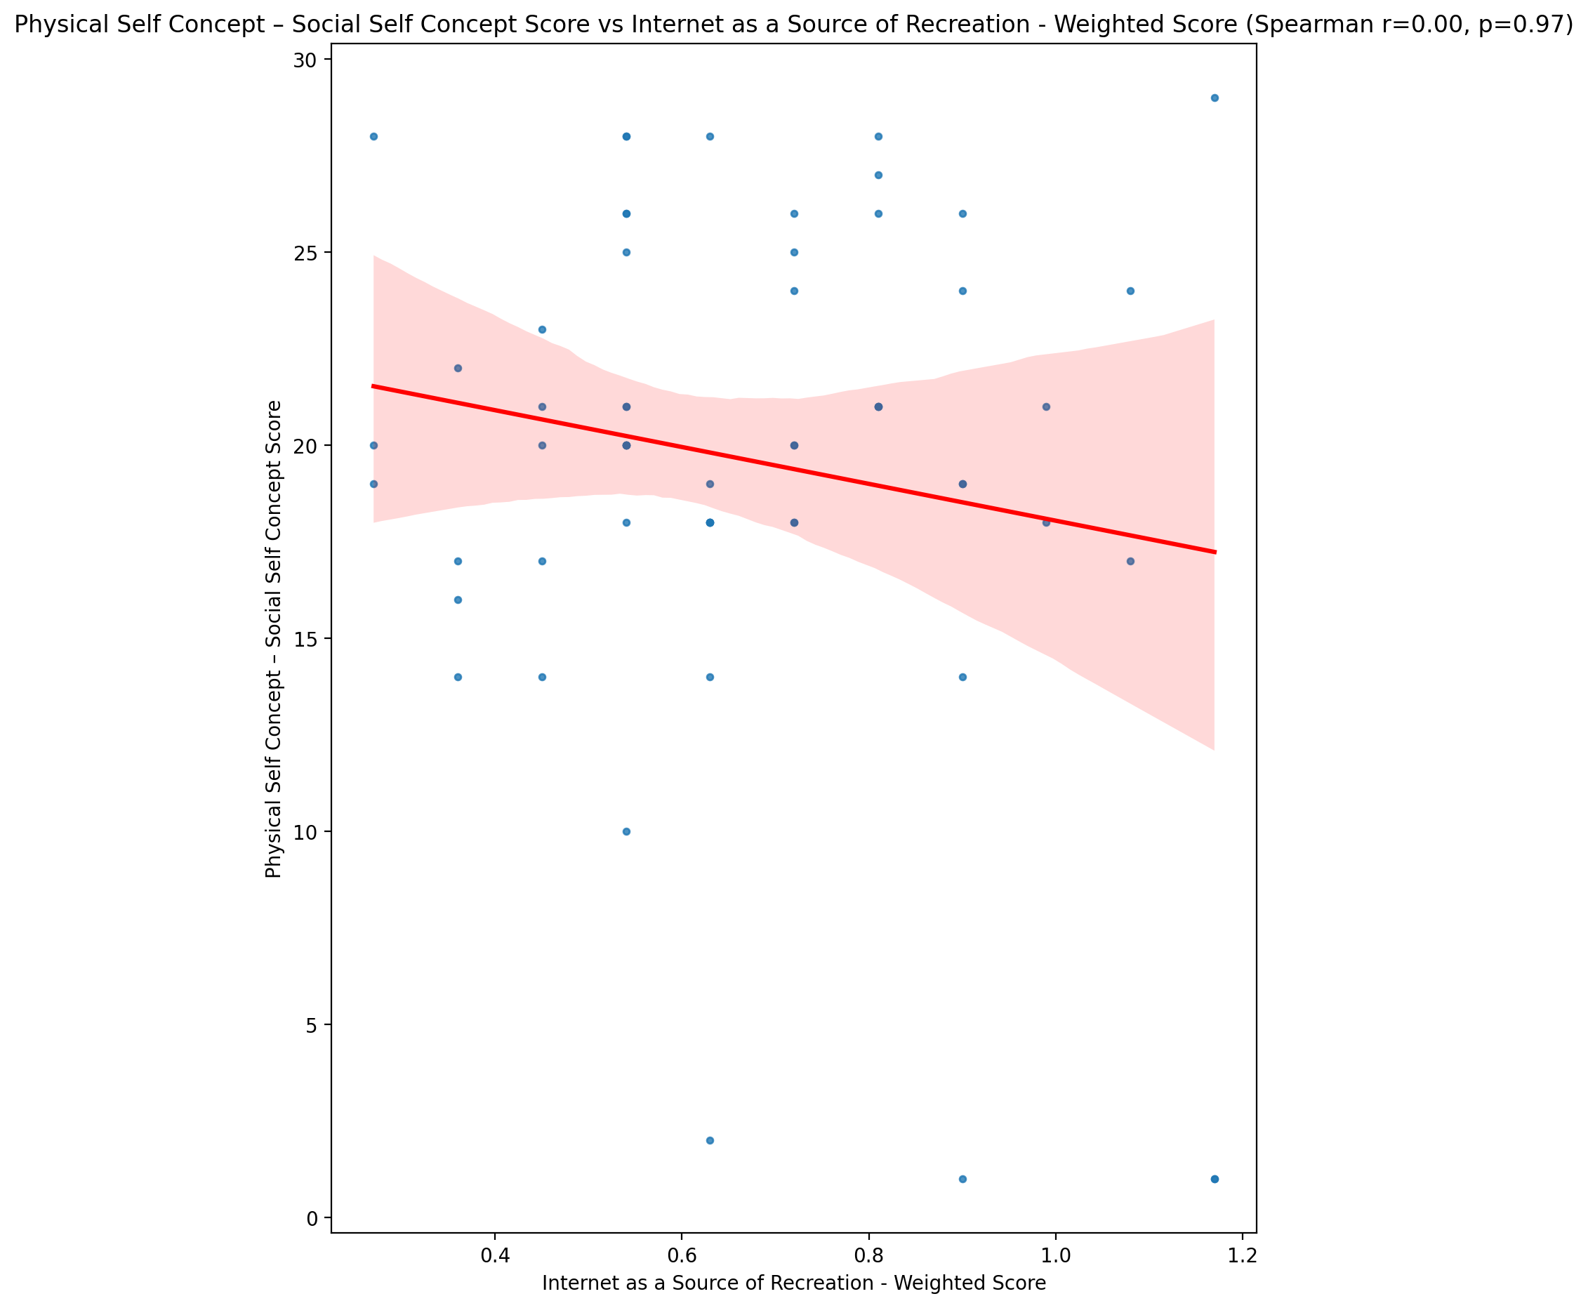

## Psychological Self Concept - Real Self Concept Score vs Internet as a Source of Recreation - Weighted Score

Test: spearman; statistic: -0.02885992807567472; p-value: 0.8282243752116708;

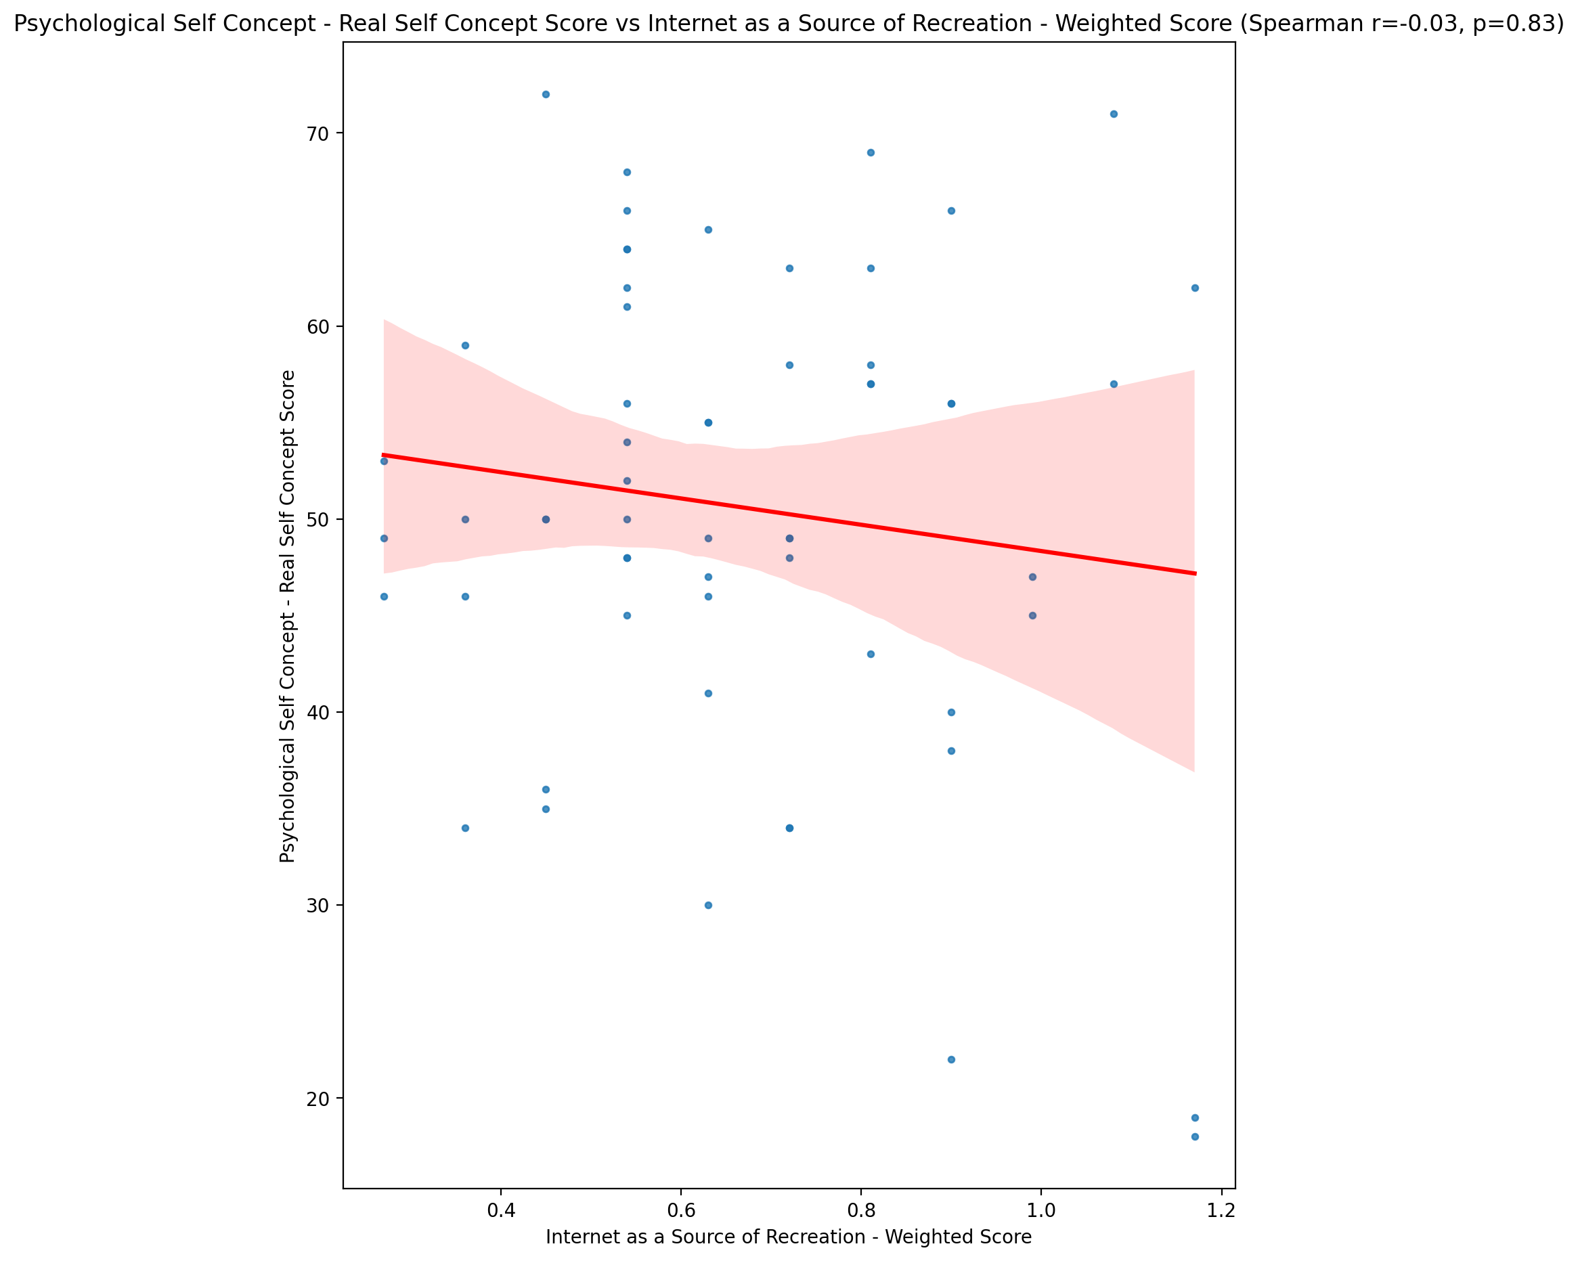

## Psychological Self Concept – Ideal Self Concept Score vs Internet as a Source of Recreation - Weighted Score

Test: spearman; statistic: -0.09889216148596136; p-value: 0.45616172622049944;

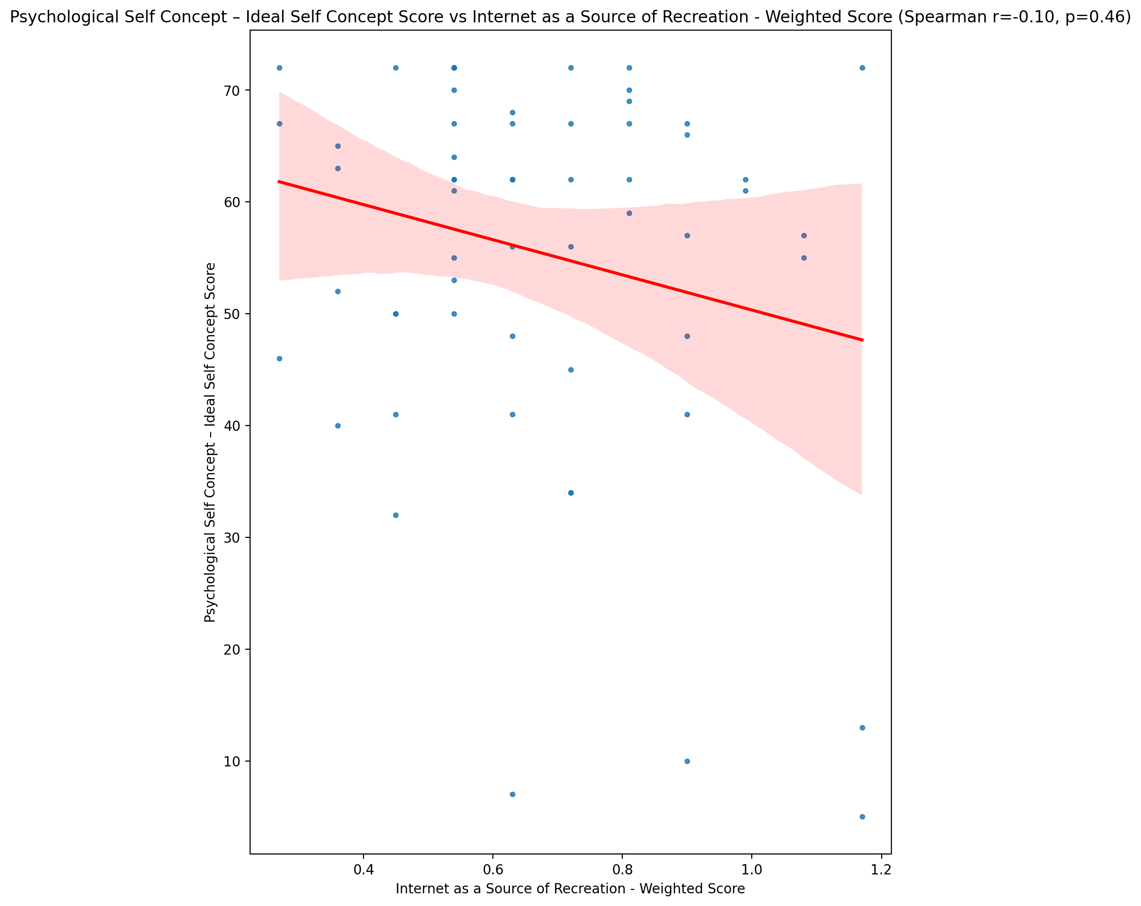

## Psychological Self Concept – Social Self Concept Score vs Internet as a Source of Recreation - Weighted Score

Test: spearman; statistic: 0.025464294900973485; p-value: 0.8481801174314939;

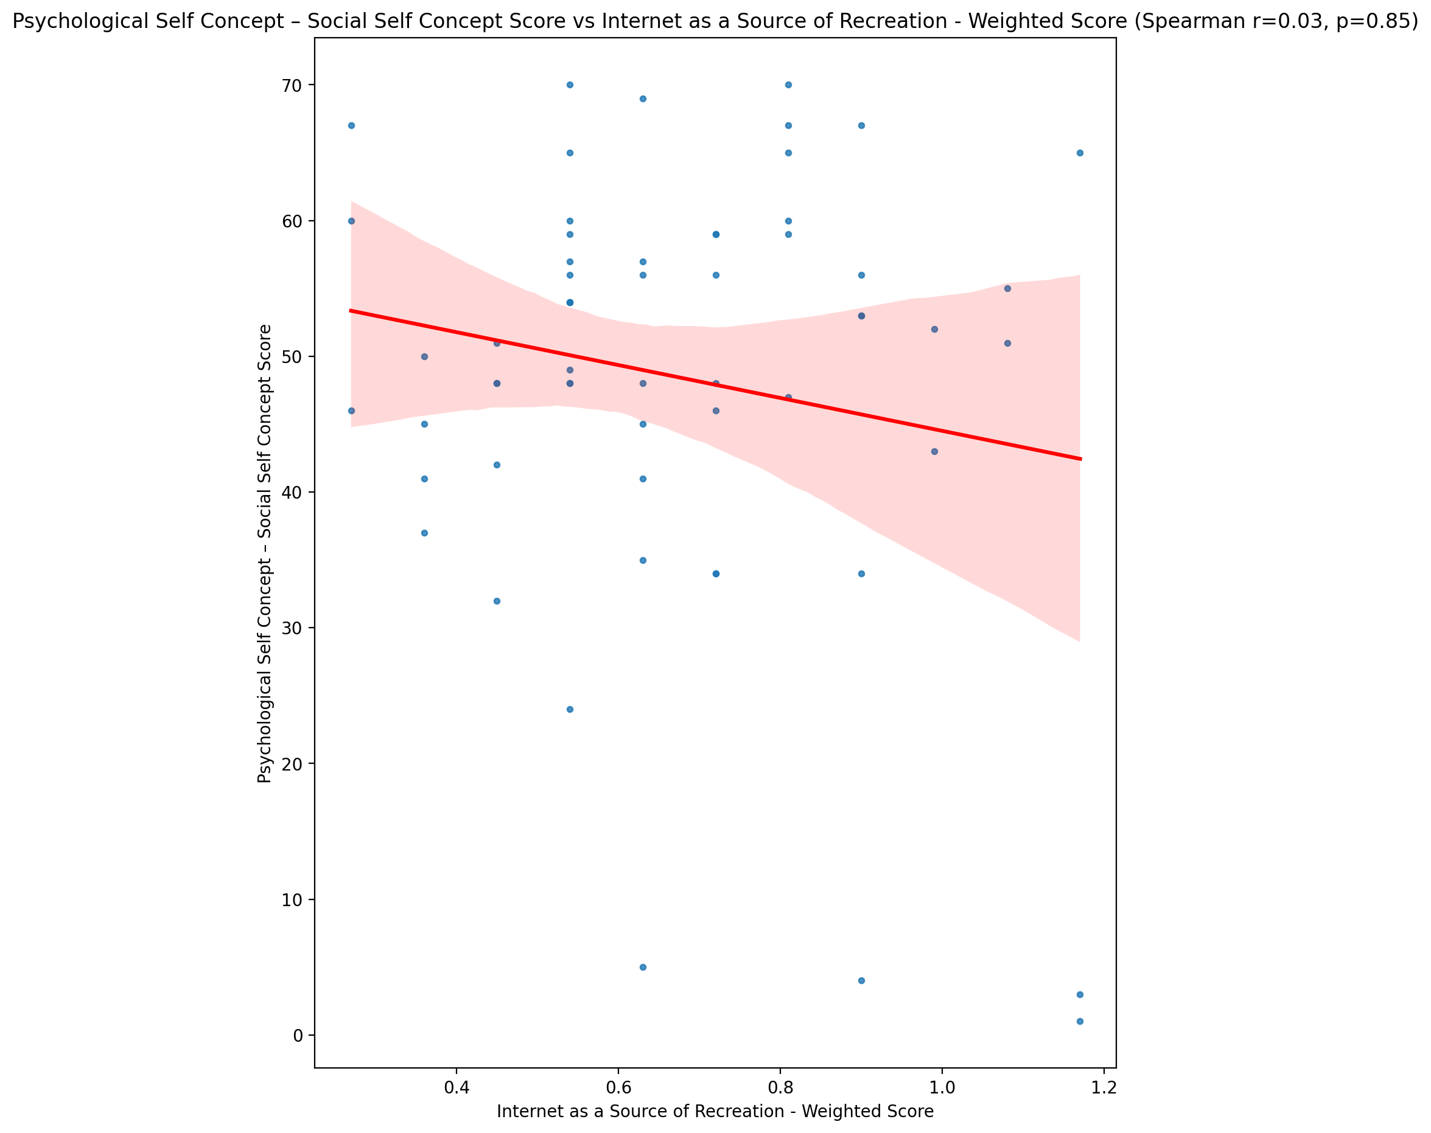

## Real Self Concept Total Score vs Internet as a Source of Recreation - Weighted Score

Test: spearman; statistic: 0.006904025048570293; p-value: 0.9586109538959744;

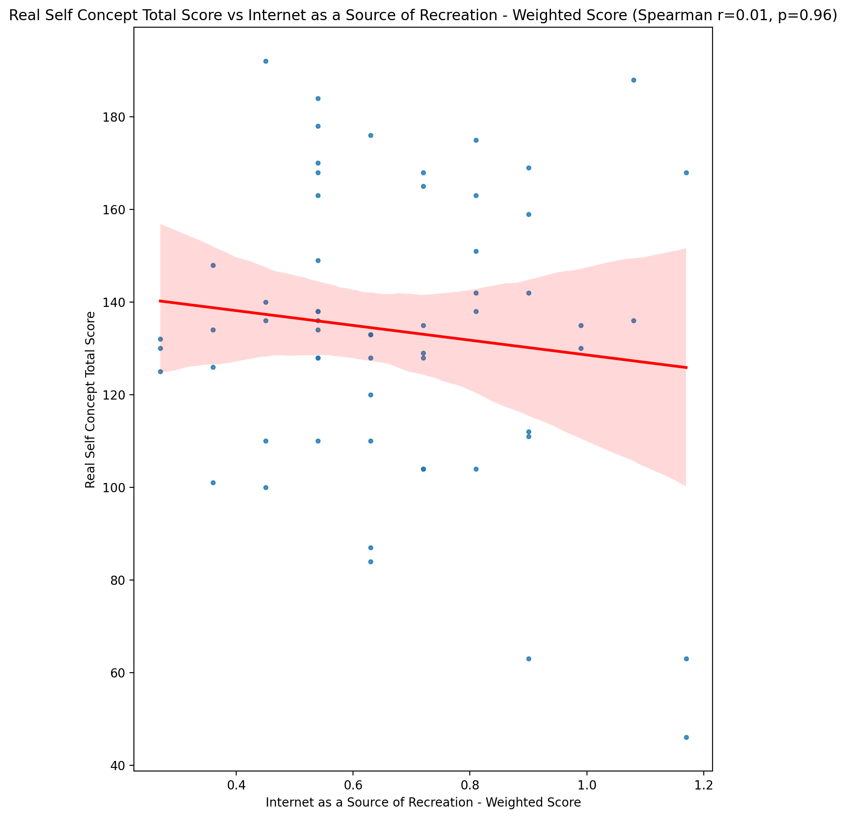

## Ideal Self Concept Total Score vs Internet as a Source of Recreation - Weighted Score

Test: spearman; statistic: -0.12363183197433529; p-value: 0.3508709378351721;

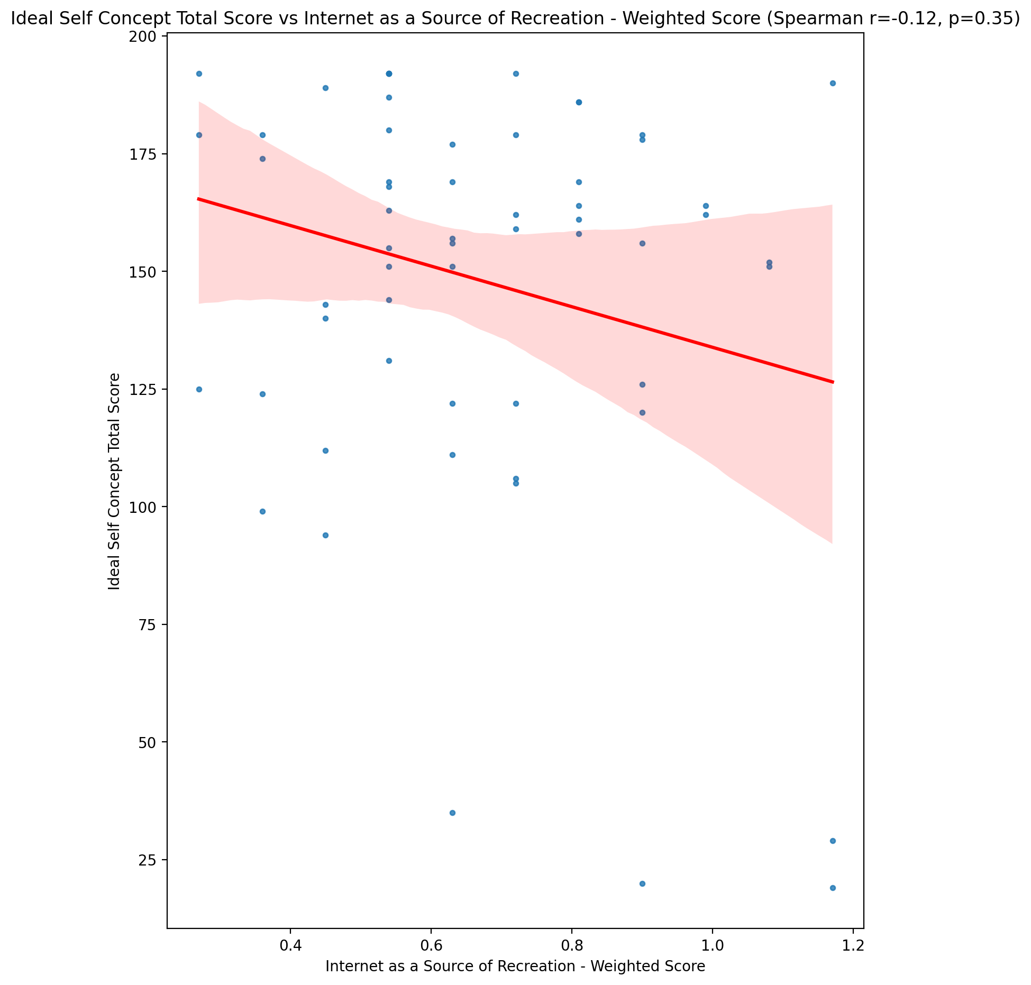

## Social Self Concept Total Score vs Internet as a Source of Recreation - Weighted Score

Test: spearman; statistic: 0.03256521563550518; p-value: 0.8065717317626815;

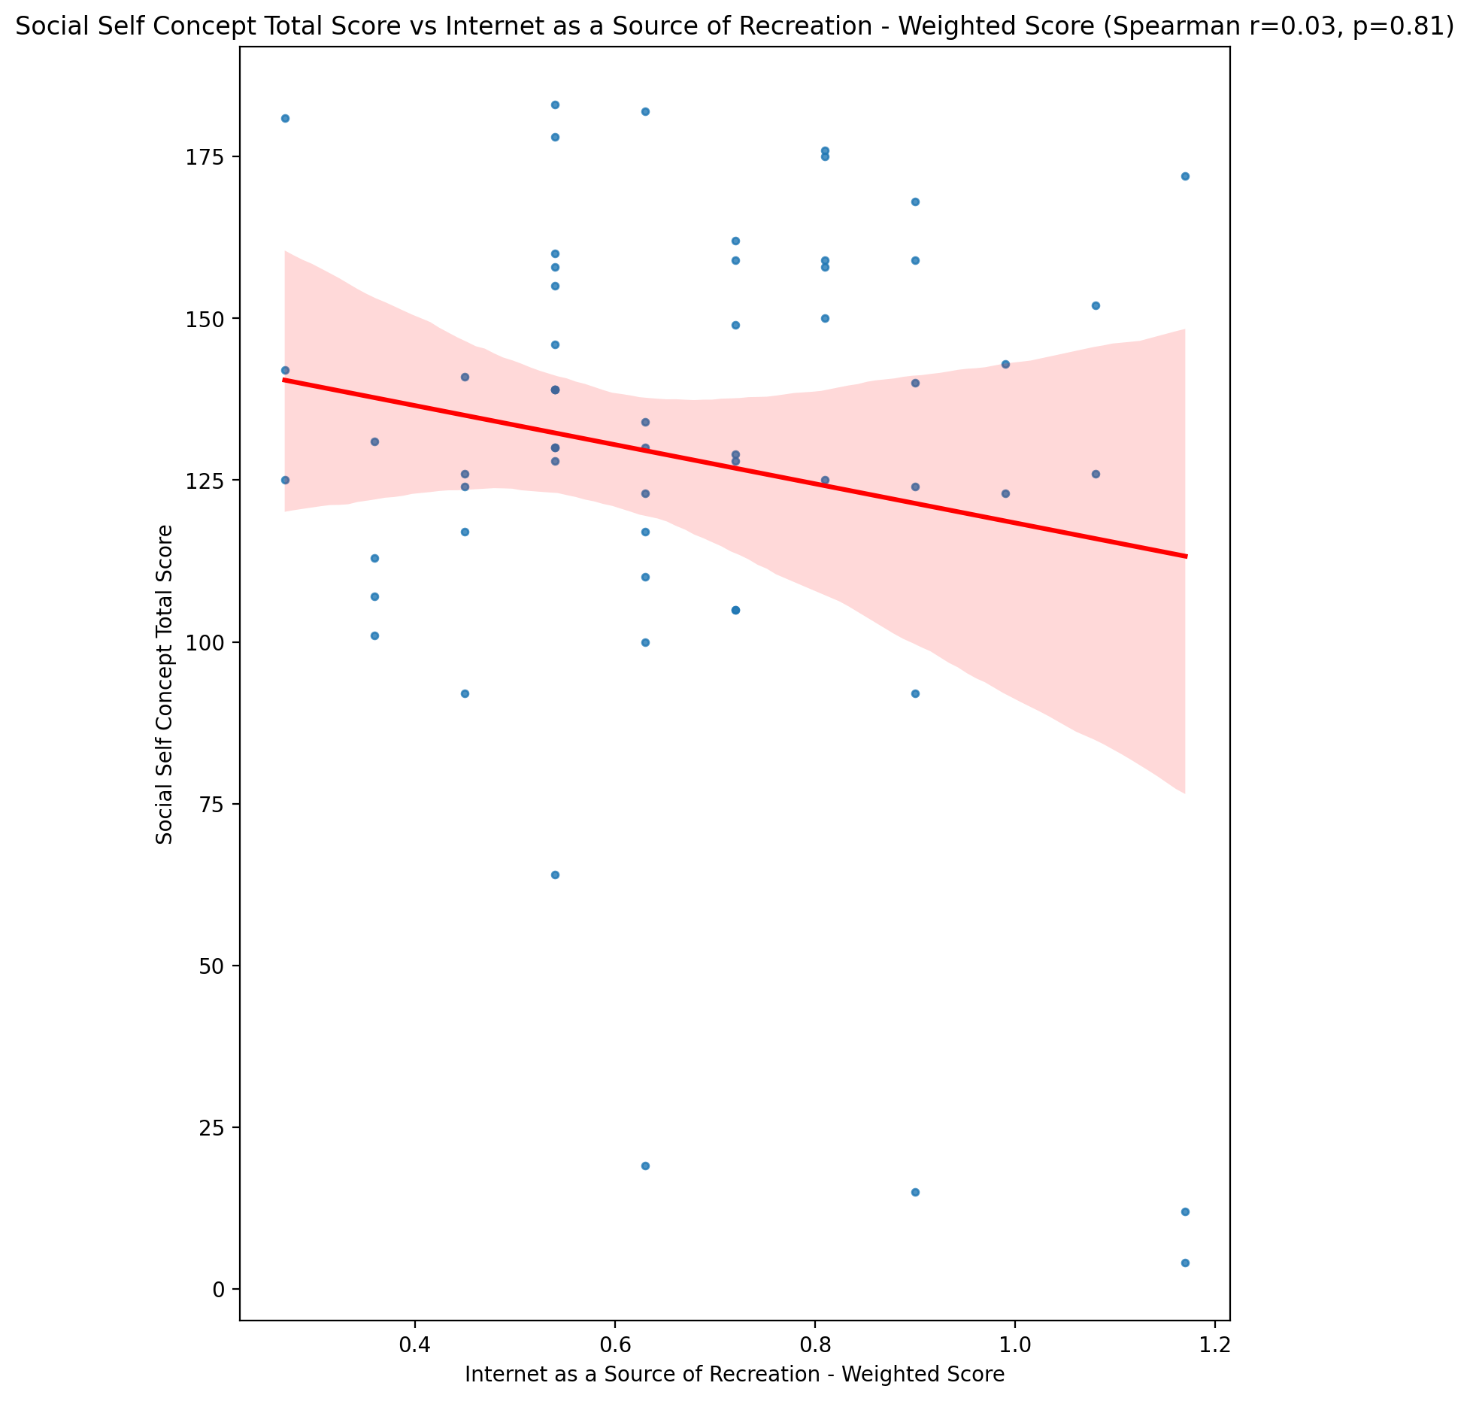

## Ideal Self Concept Total Category vs Internet as a Source of Recreation - Weighted Score

Test: None; statistic: None; p-value: None; Test not run: unsupported type combination.



## Perceived Social Stress Score vs Internet as a Source of Recreation - Weighted Score

Test: spearman; statistic: -0.003703233126398059; p-value: 0.9777925217106456;

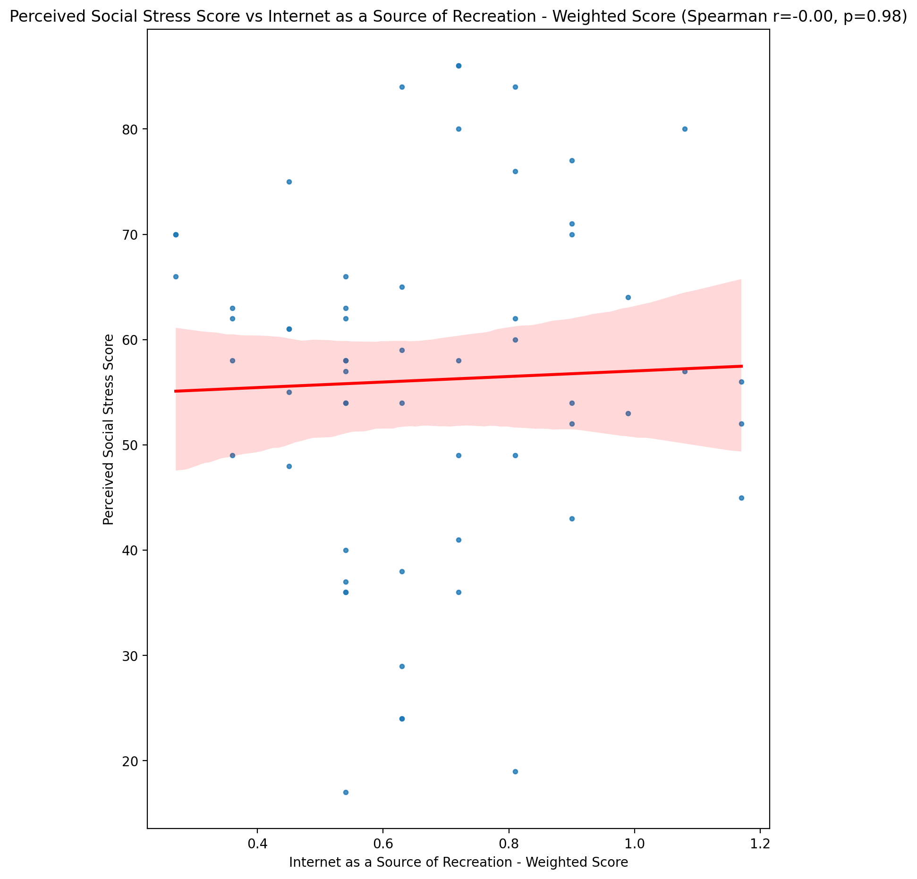

## Perceived Social Stress Category vs Internet as a Source of Recreation - Weighted Score

Test: None; statistic: None; p-value: None; Test not run: unsupported type combination.



## Emotional Support - Raw Score vs Enhanced Socialization - Weighted Score

Test: spearman; statistic: 0.05937601715903143; p-value: 0.655082960634235;

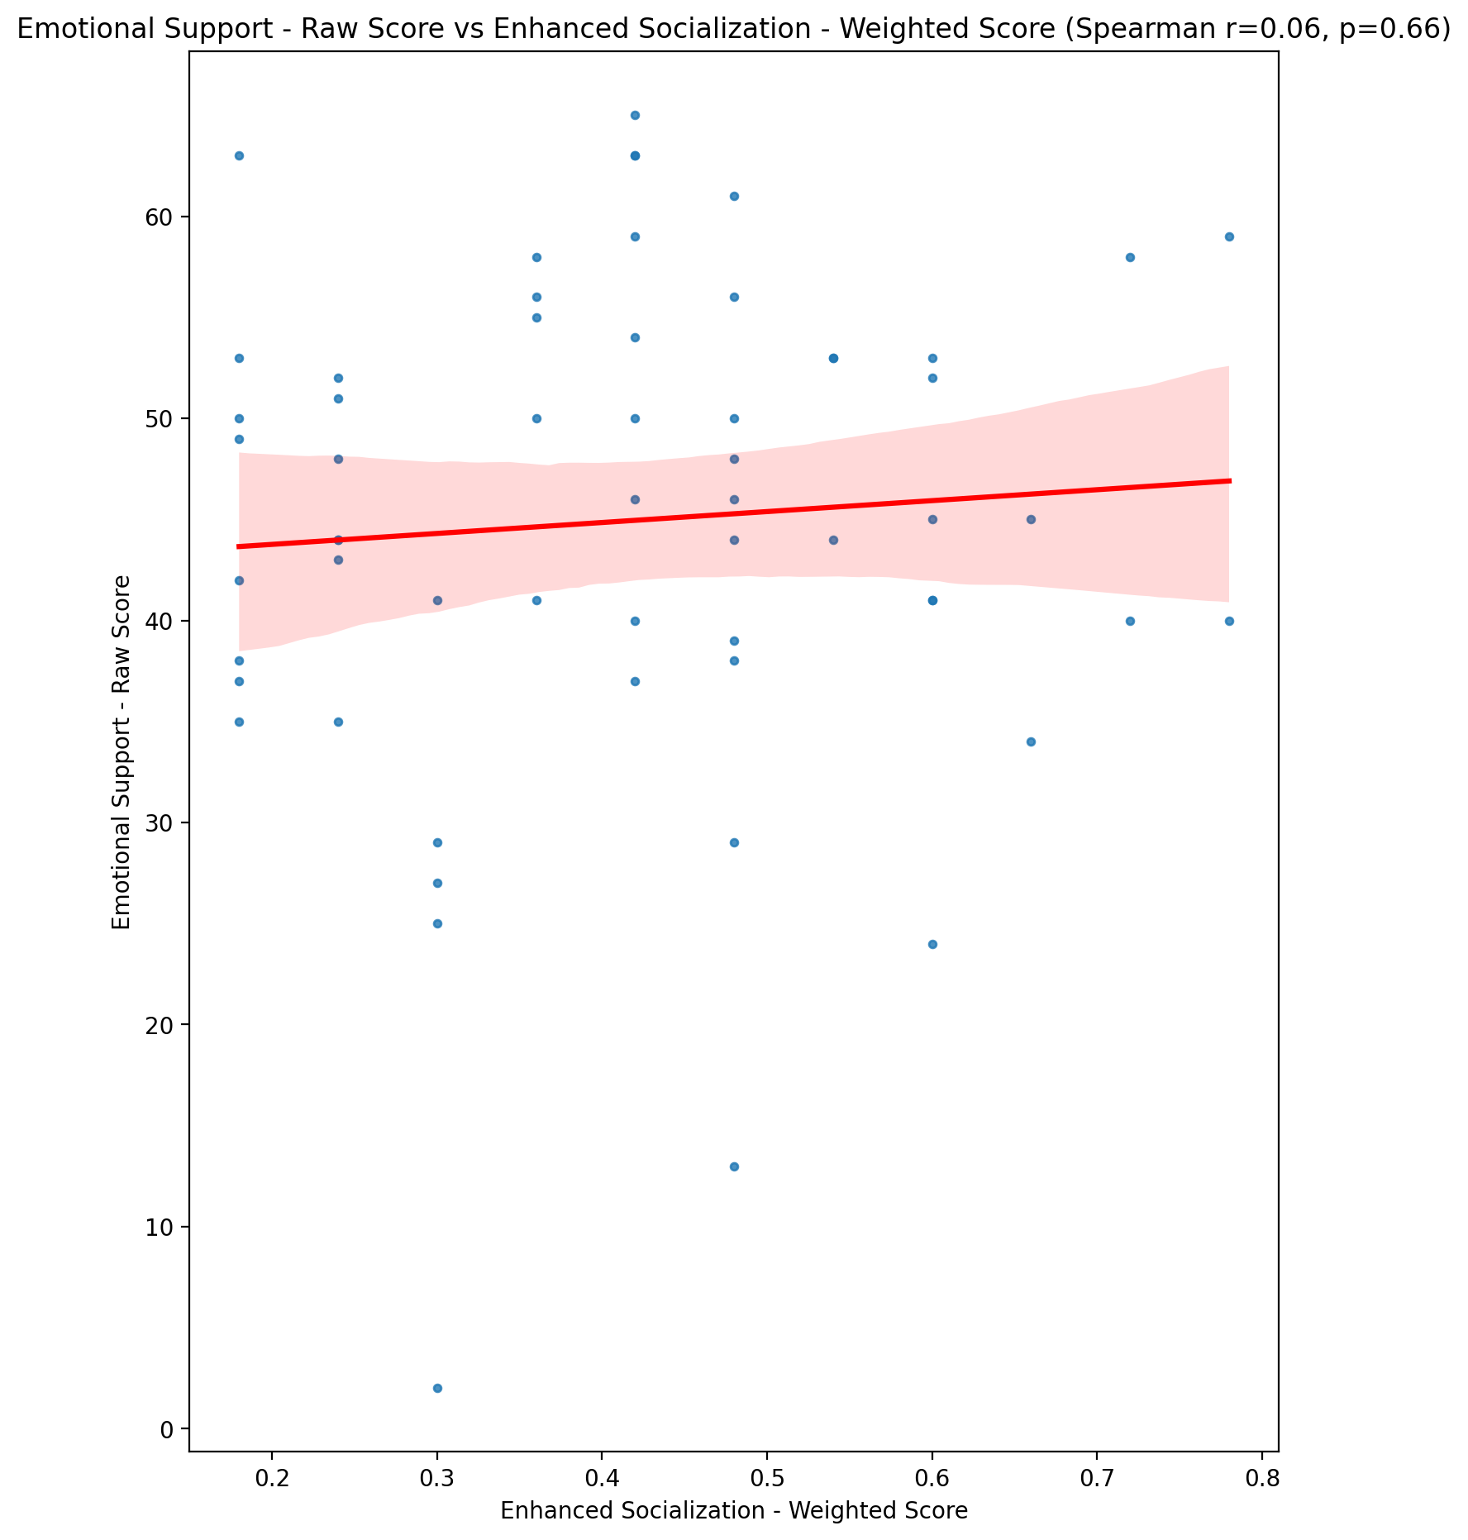

## Informational Support - Raw Score vs Enhanced Socialization - Weighted Score

Test: spearman; statistic: 0.10302599467573333; p-value: 0.43745660852280177;

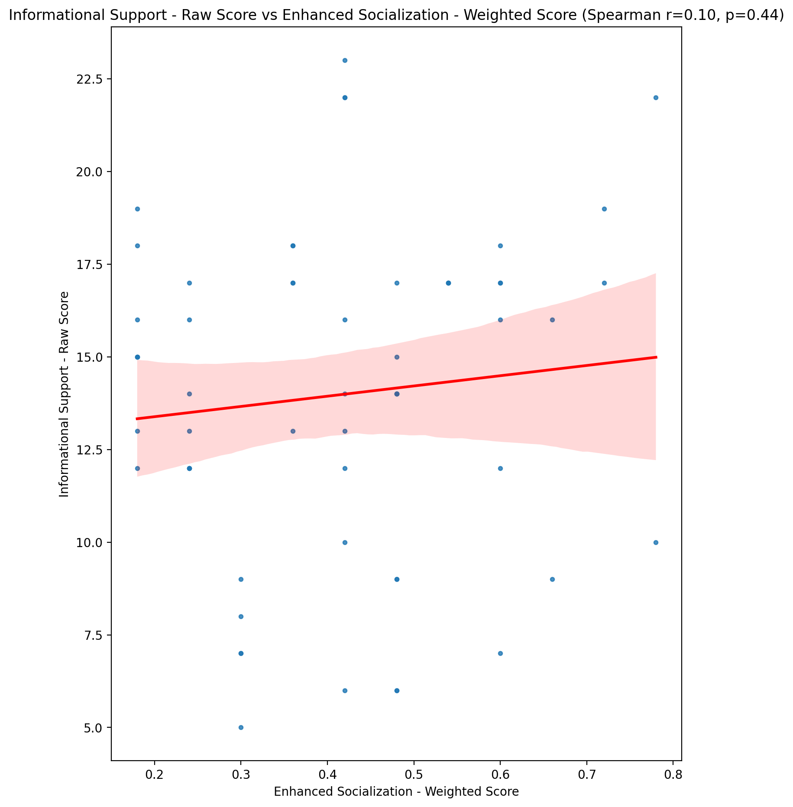

## Instrumental Support - Raw Score vs Enhanced Socialization - Weighted Score

Test: spearman; statistic: -0.11697722577639953; p-value: 0.3775990045111858;

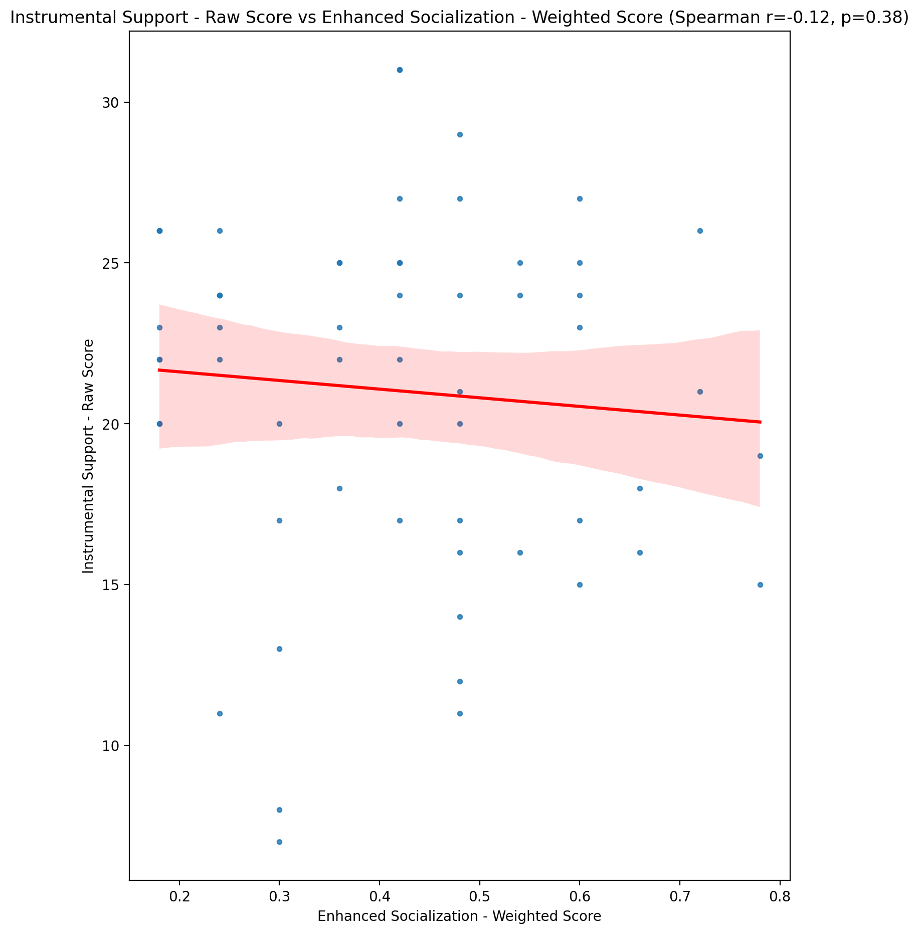

## Emotional Support - T Score vs Enhanced Socialization - Weighted Score

Test: spearman; statistic: 0.06066085836102158; p-value: 0.6481051102481576;

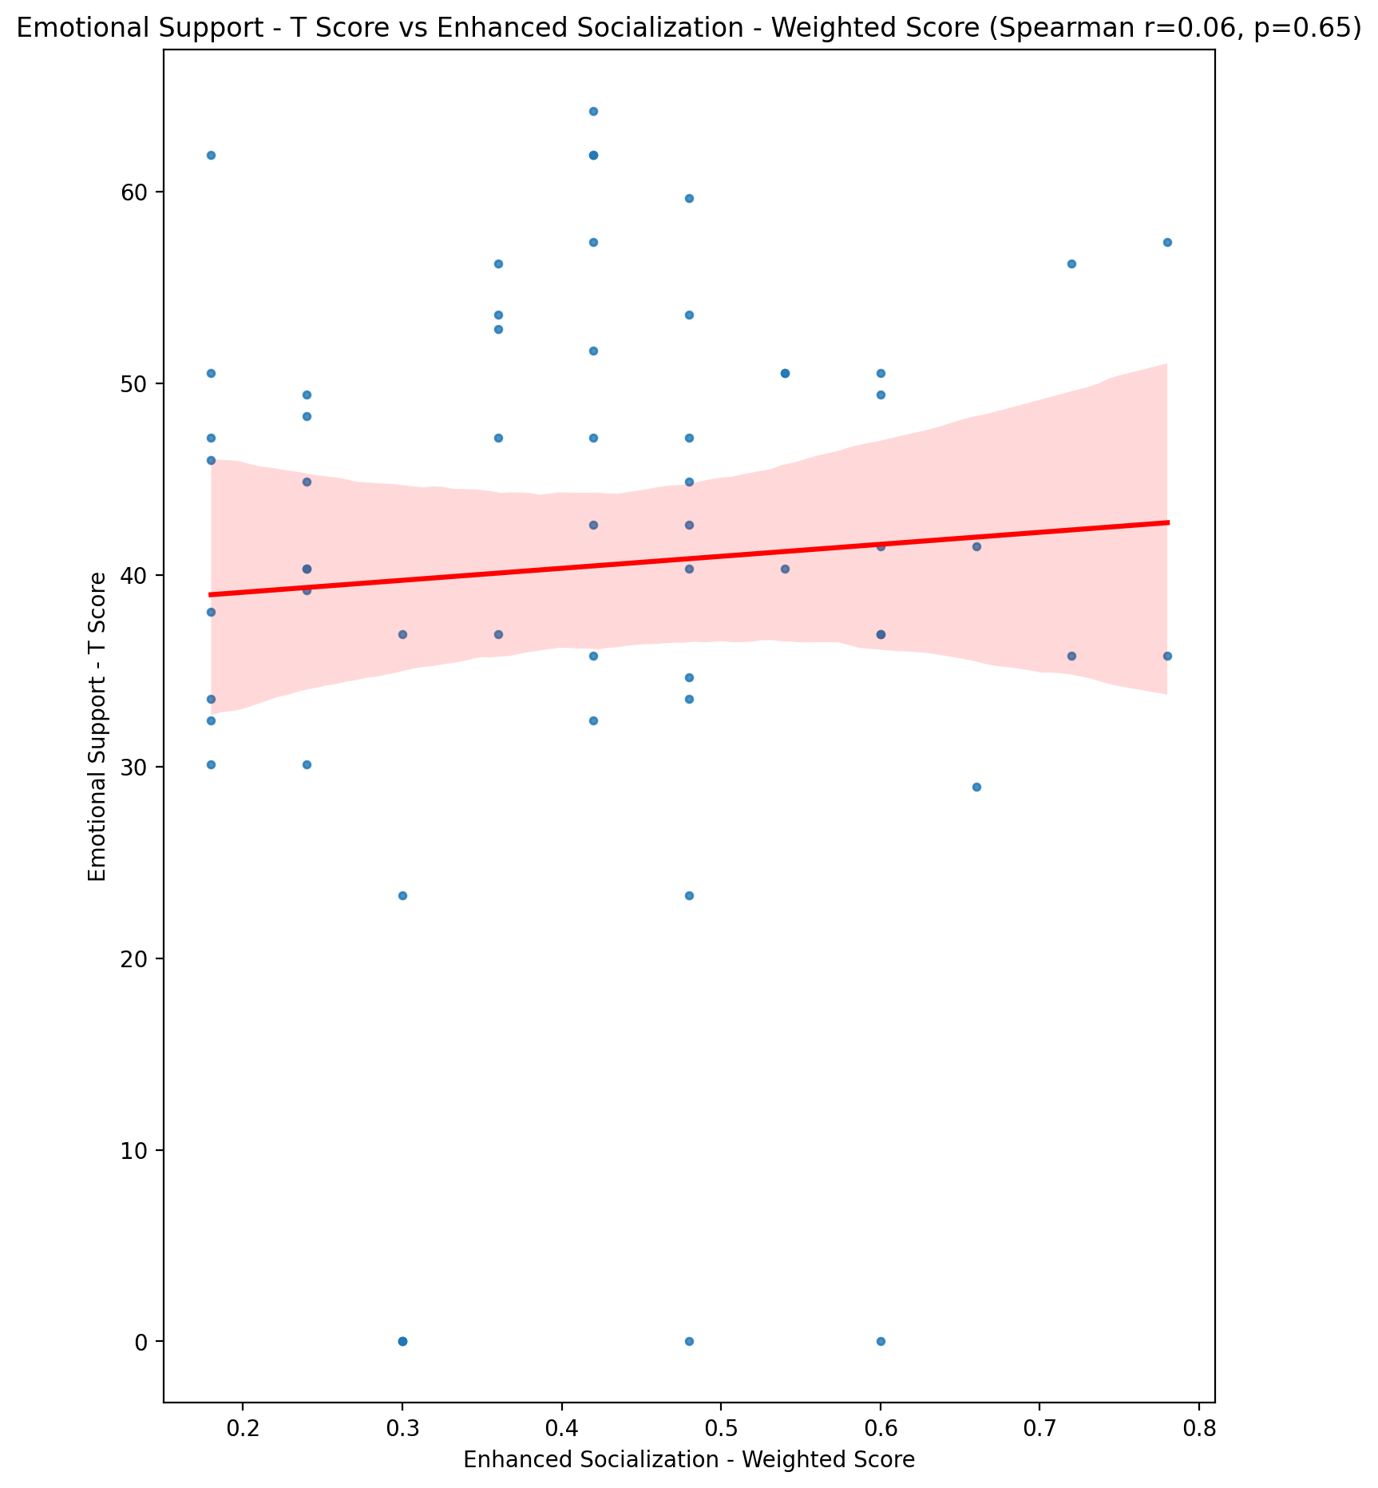

## Informational Support - T Score vs Enhanced Socialization - Weighted Score

Test: spearman; statistic: 0.10514022004613219; p-value: 0.4280586576862101;

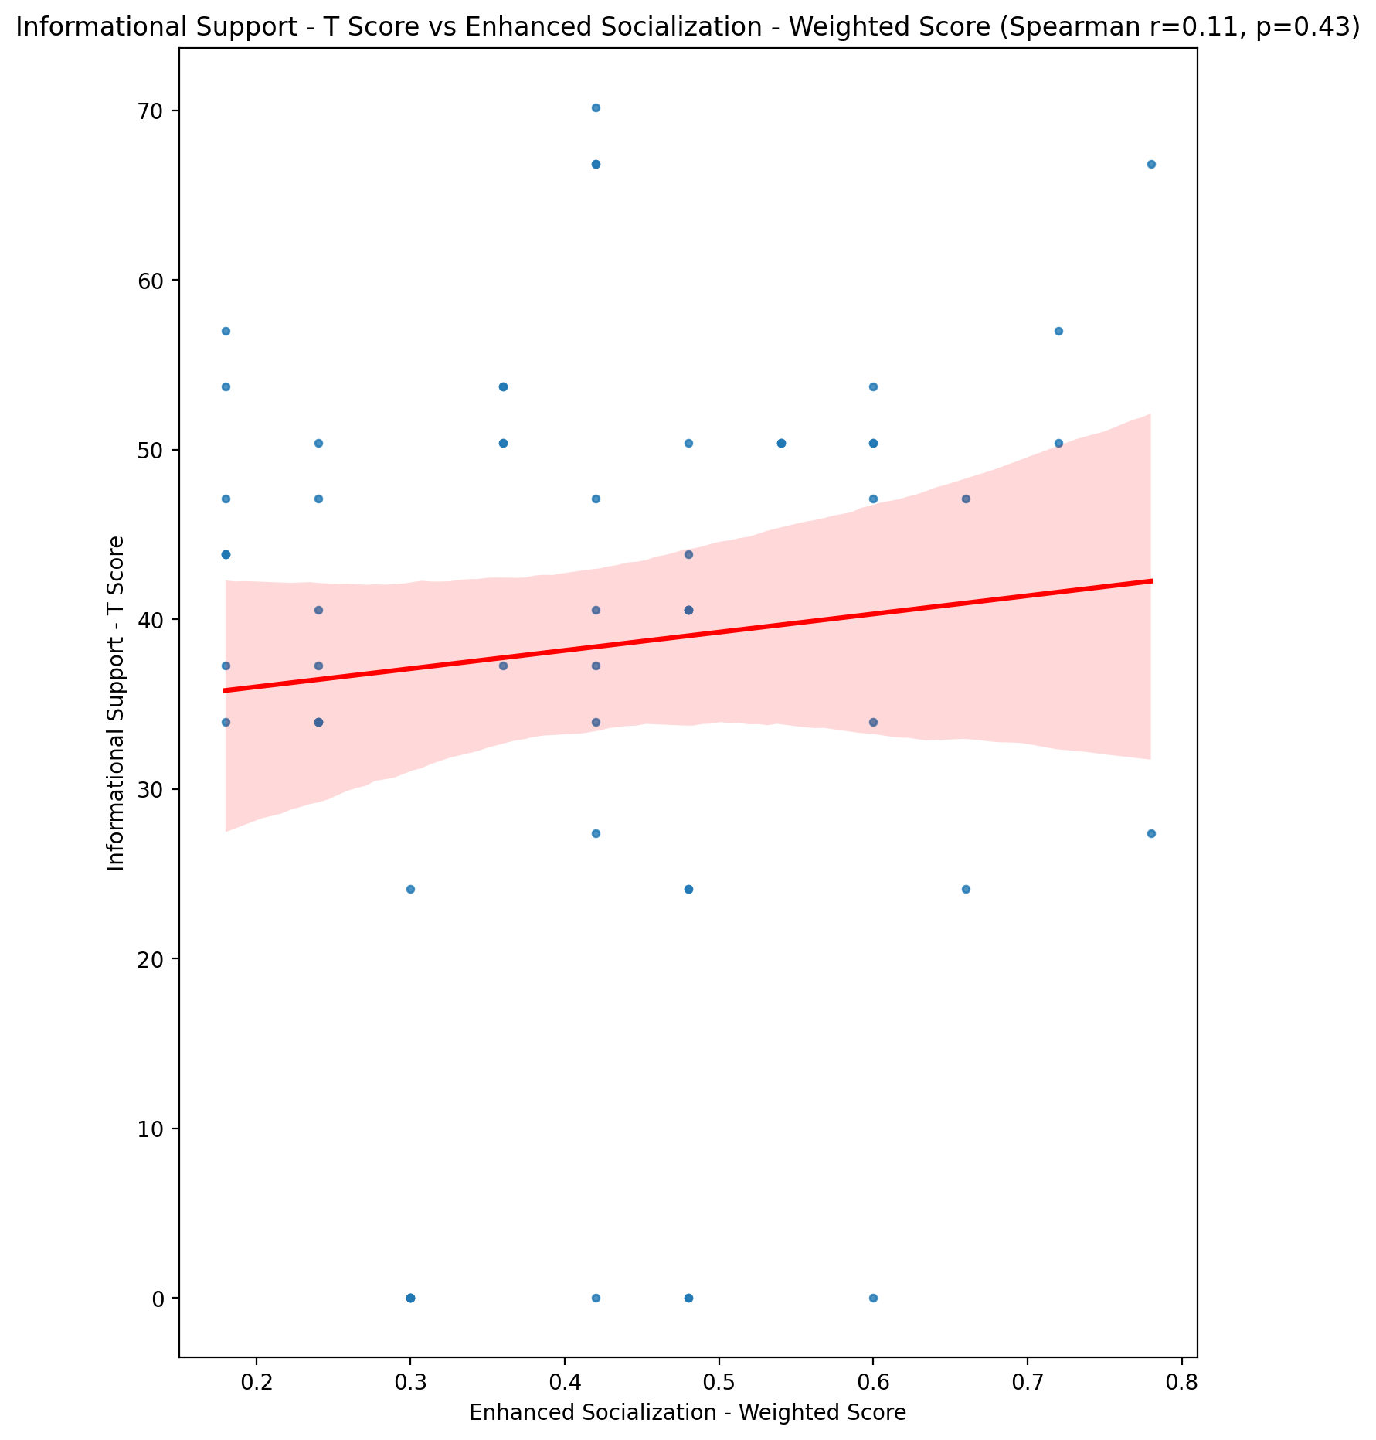

## Instrumental Support - T Score vs Enhanced Socialization - Weighted Score

Test: spearman; statistic: -0.11894075688189032; p-value: 0.3695884519037158;

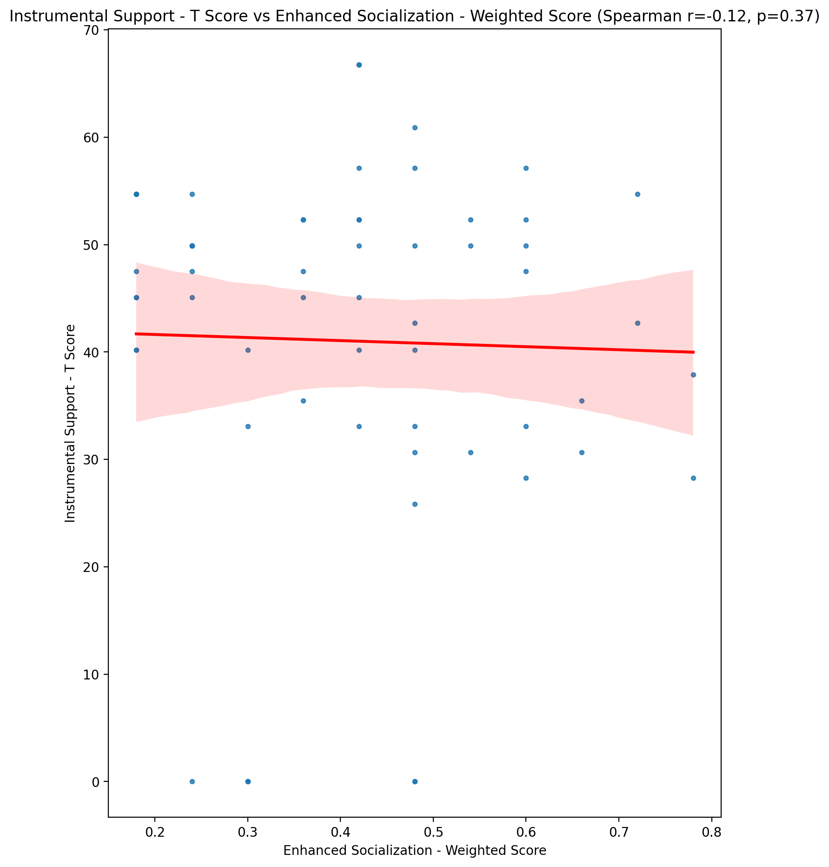

## Perceived Social Support Total T Score vs Enhanced Socialization - Weighted Score

Test: spearman; statistic: 0.004137205875331072; p-value: 0.9751908558743911;

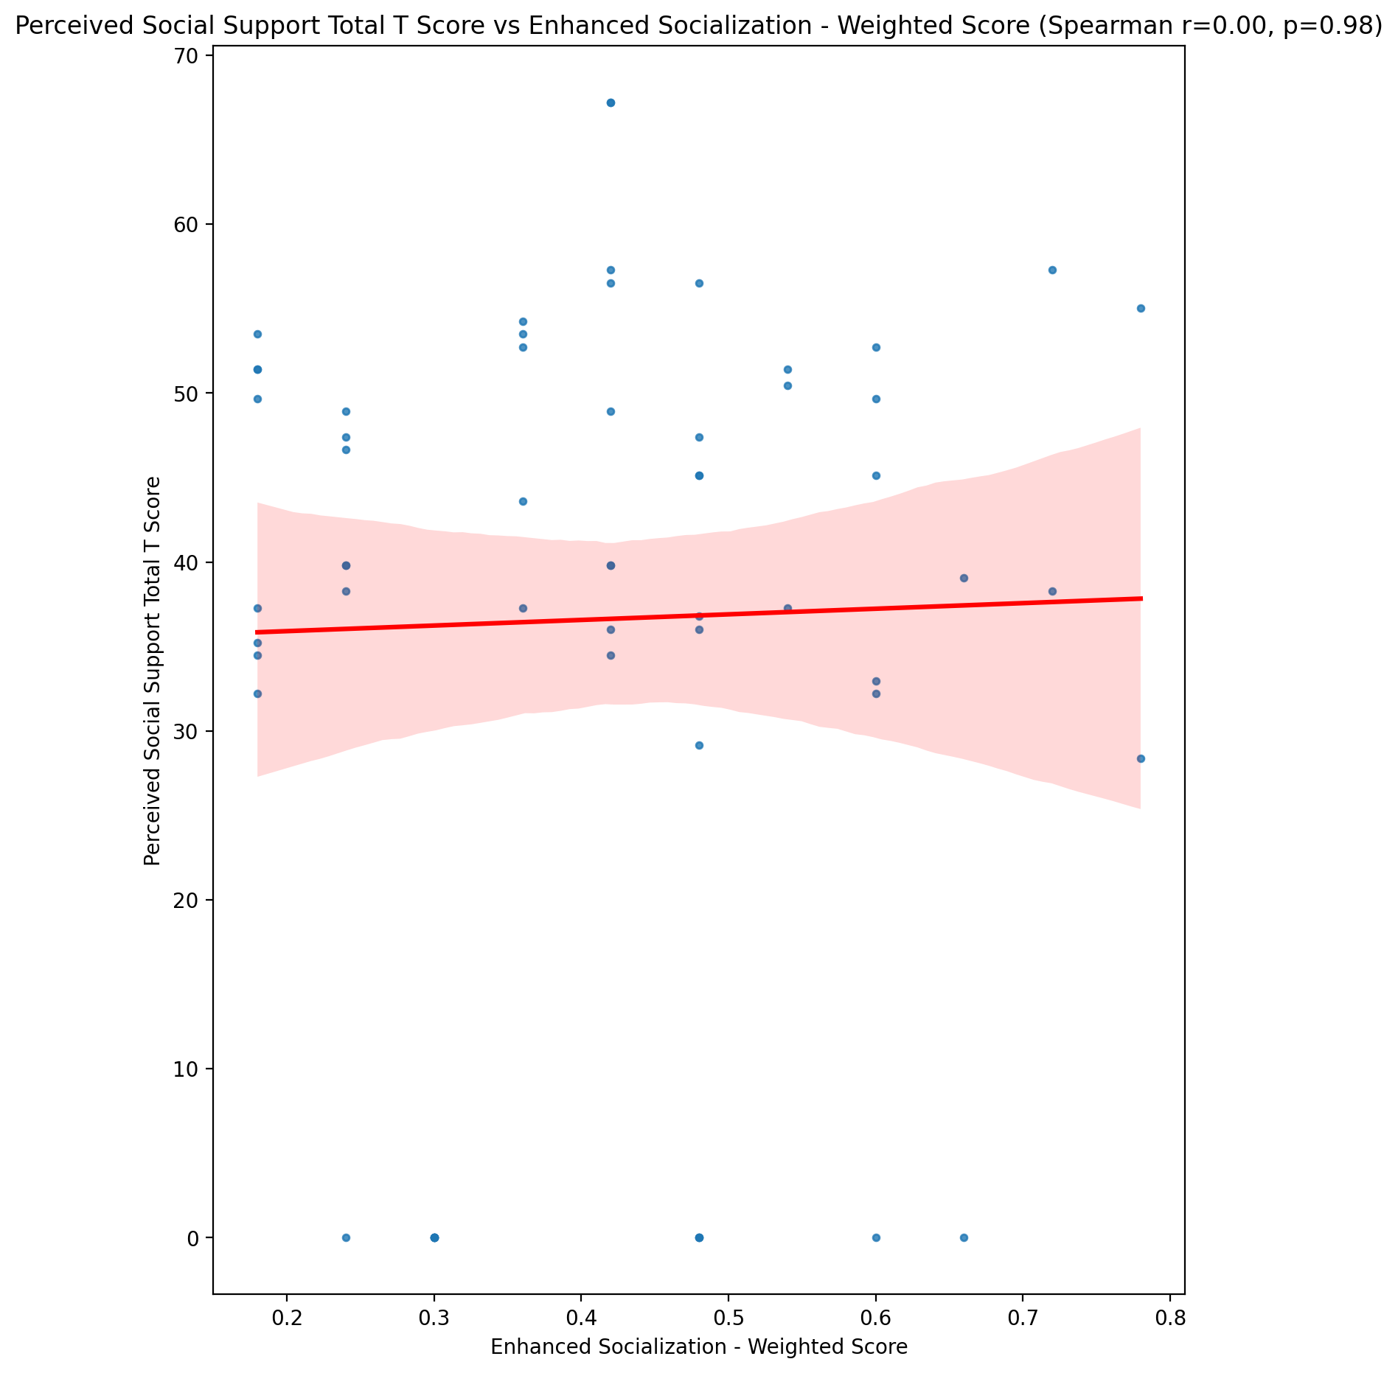

## Emotional Support - Rank vs Enhanced Socialization - Weighted Score

Test: None; statistic: None; p-value: None; Test not run: unsupported type combination.



## Informational Support - Rank vs Enhanced Socialization - Weighted Score

Test: None; statistic: None; p-value: None; Test not run: unsupported type combination.



## Instrumental Support - Rank vs Enhanced Socialization - Weighted Score

Test: None; statistic: None; p-value: None; Test not run: unsupported type combination.



## Perceived Social Support TOTAL - Rank vs Enhanced Socialization - Weighted Score

Test: None; statistic: None; p-value: None; Test not run: unsupported type combination.



## Power Self Concept - Real Self Concept Score vs Enhanced Socialization - Weighted Score

Test: spearman; statistic: 0.0012115924568210131; p-value: 0.9927335296884163;

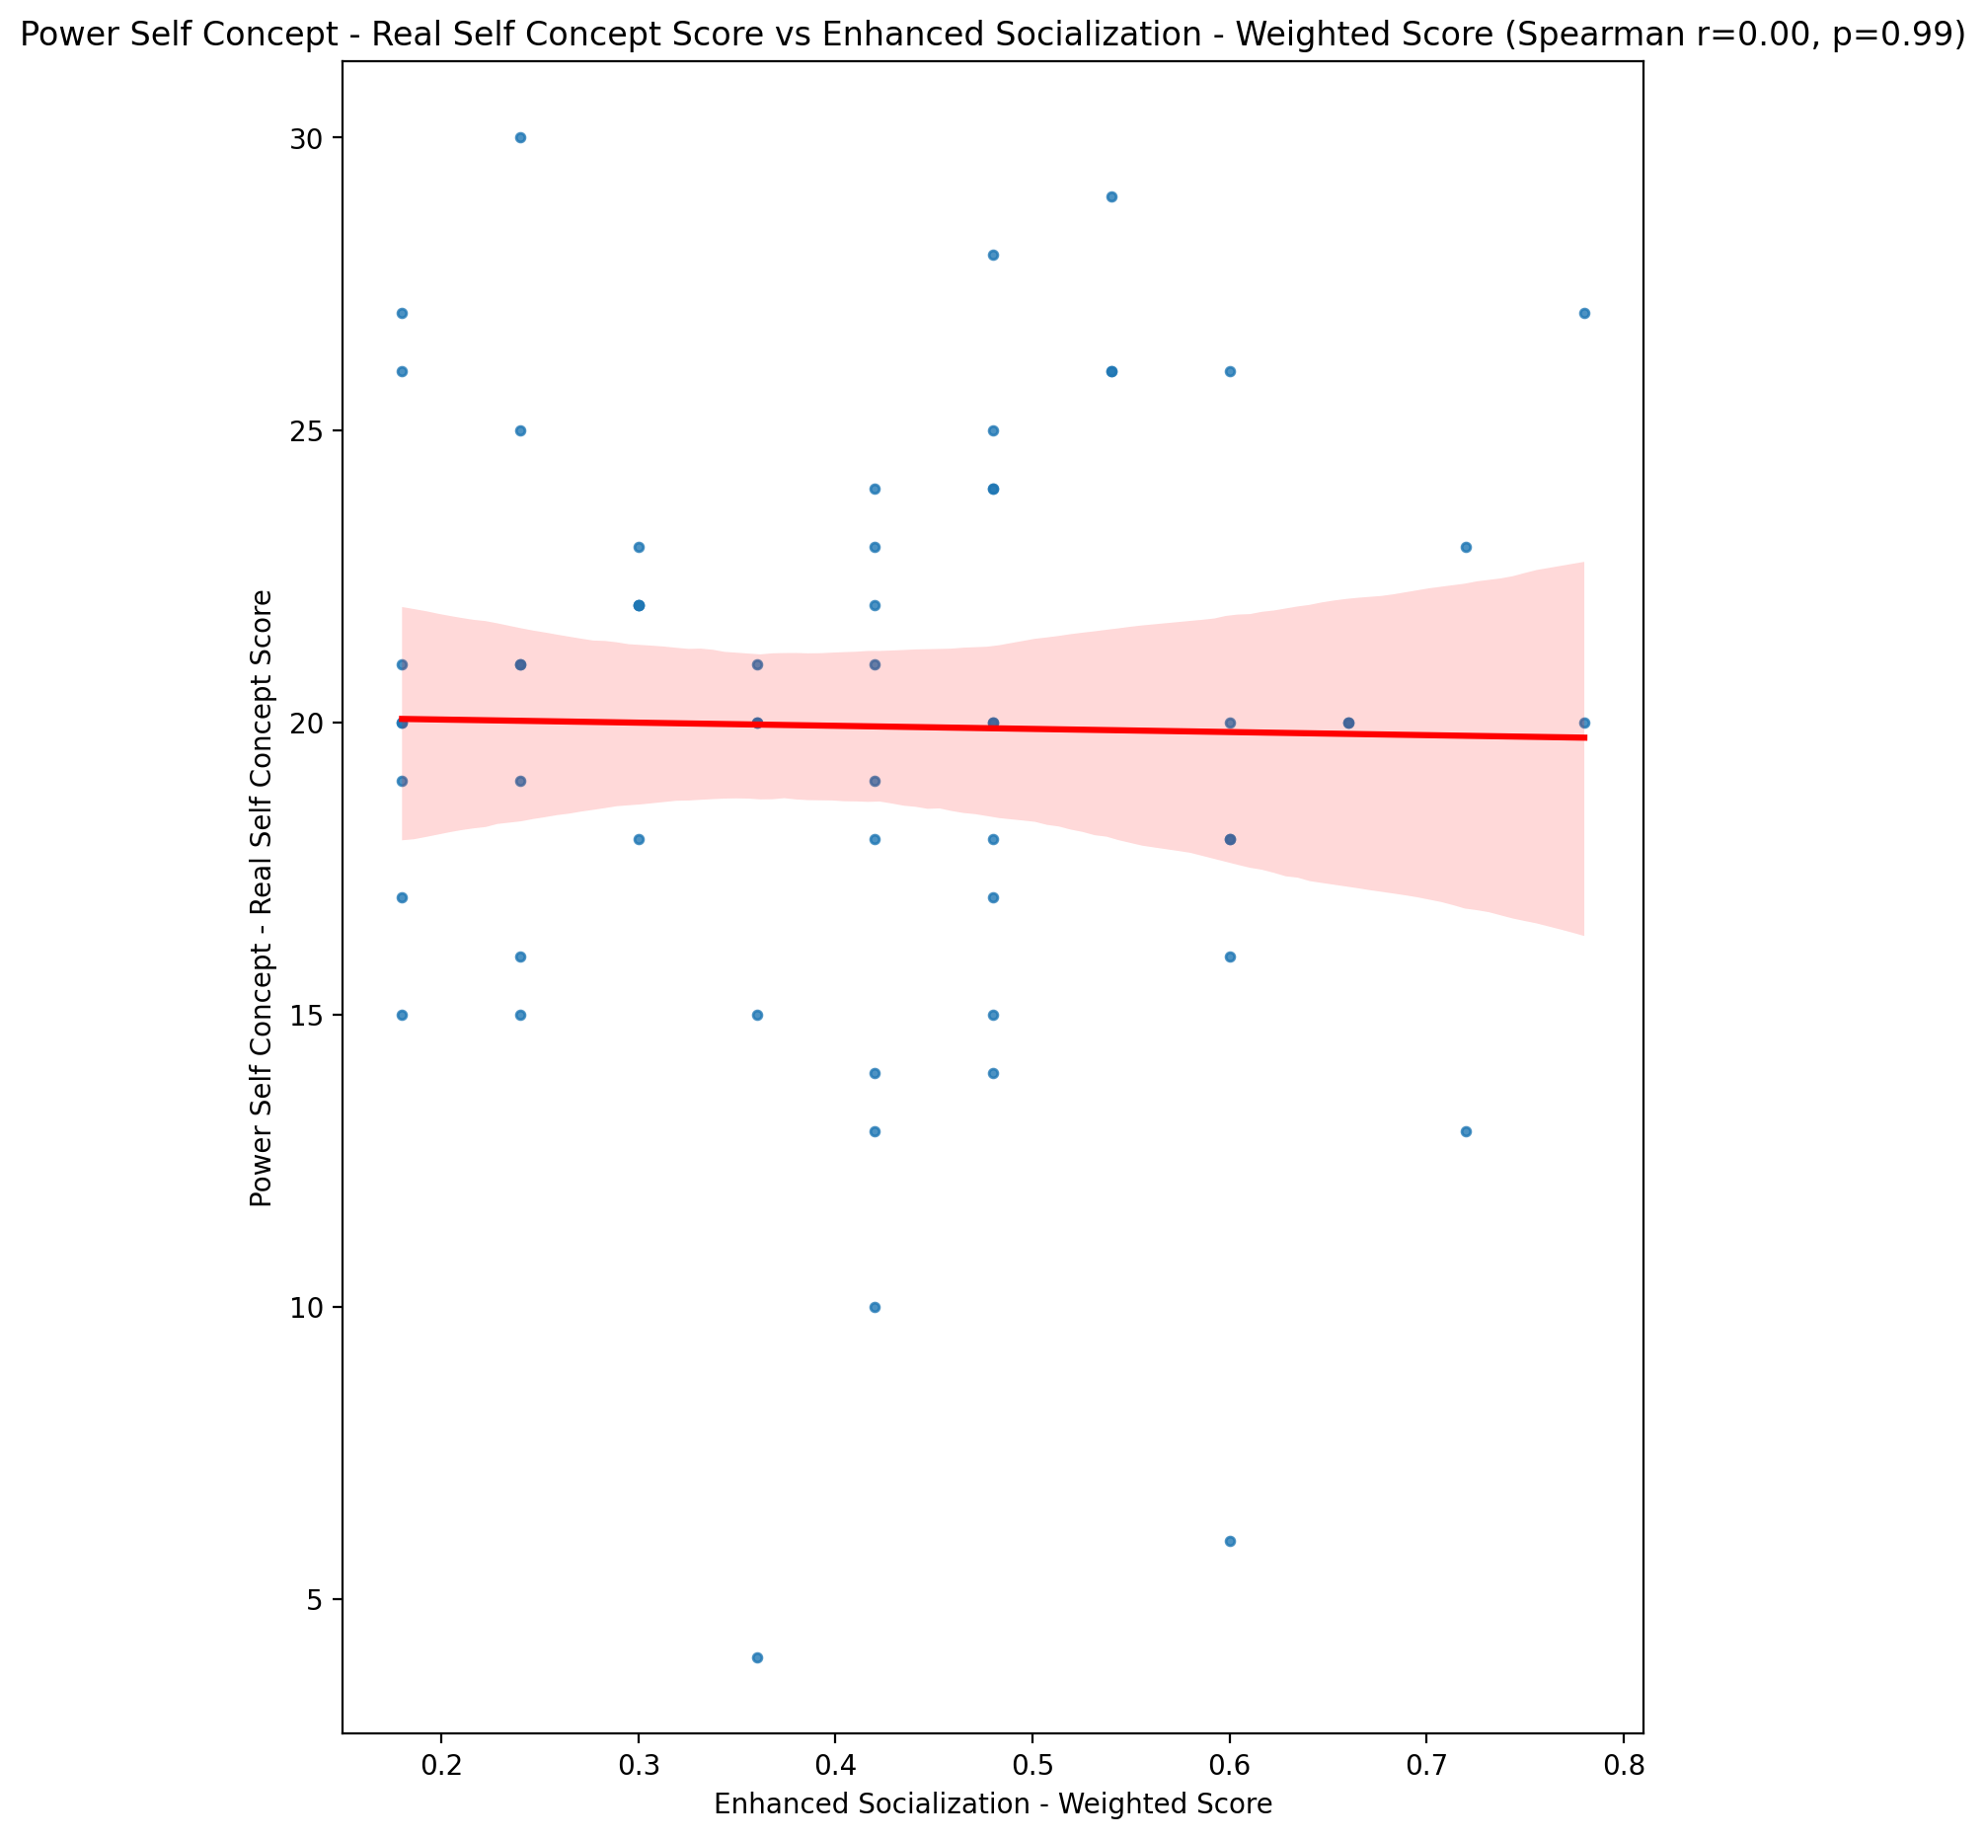

## Power Self Concept - Ideal Self Concept score vs Enhanced Socialization - Weighted Score

Test: spearman; statistic: -0.15733115007955067; p-value: 0.23402467610228686;

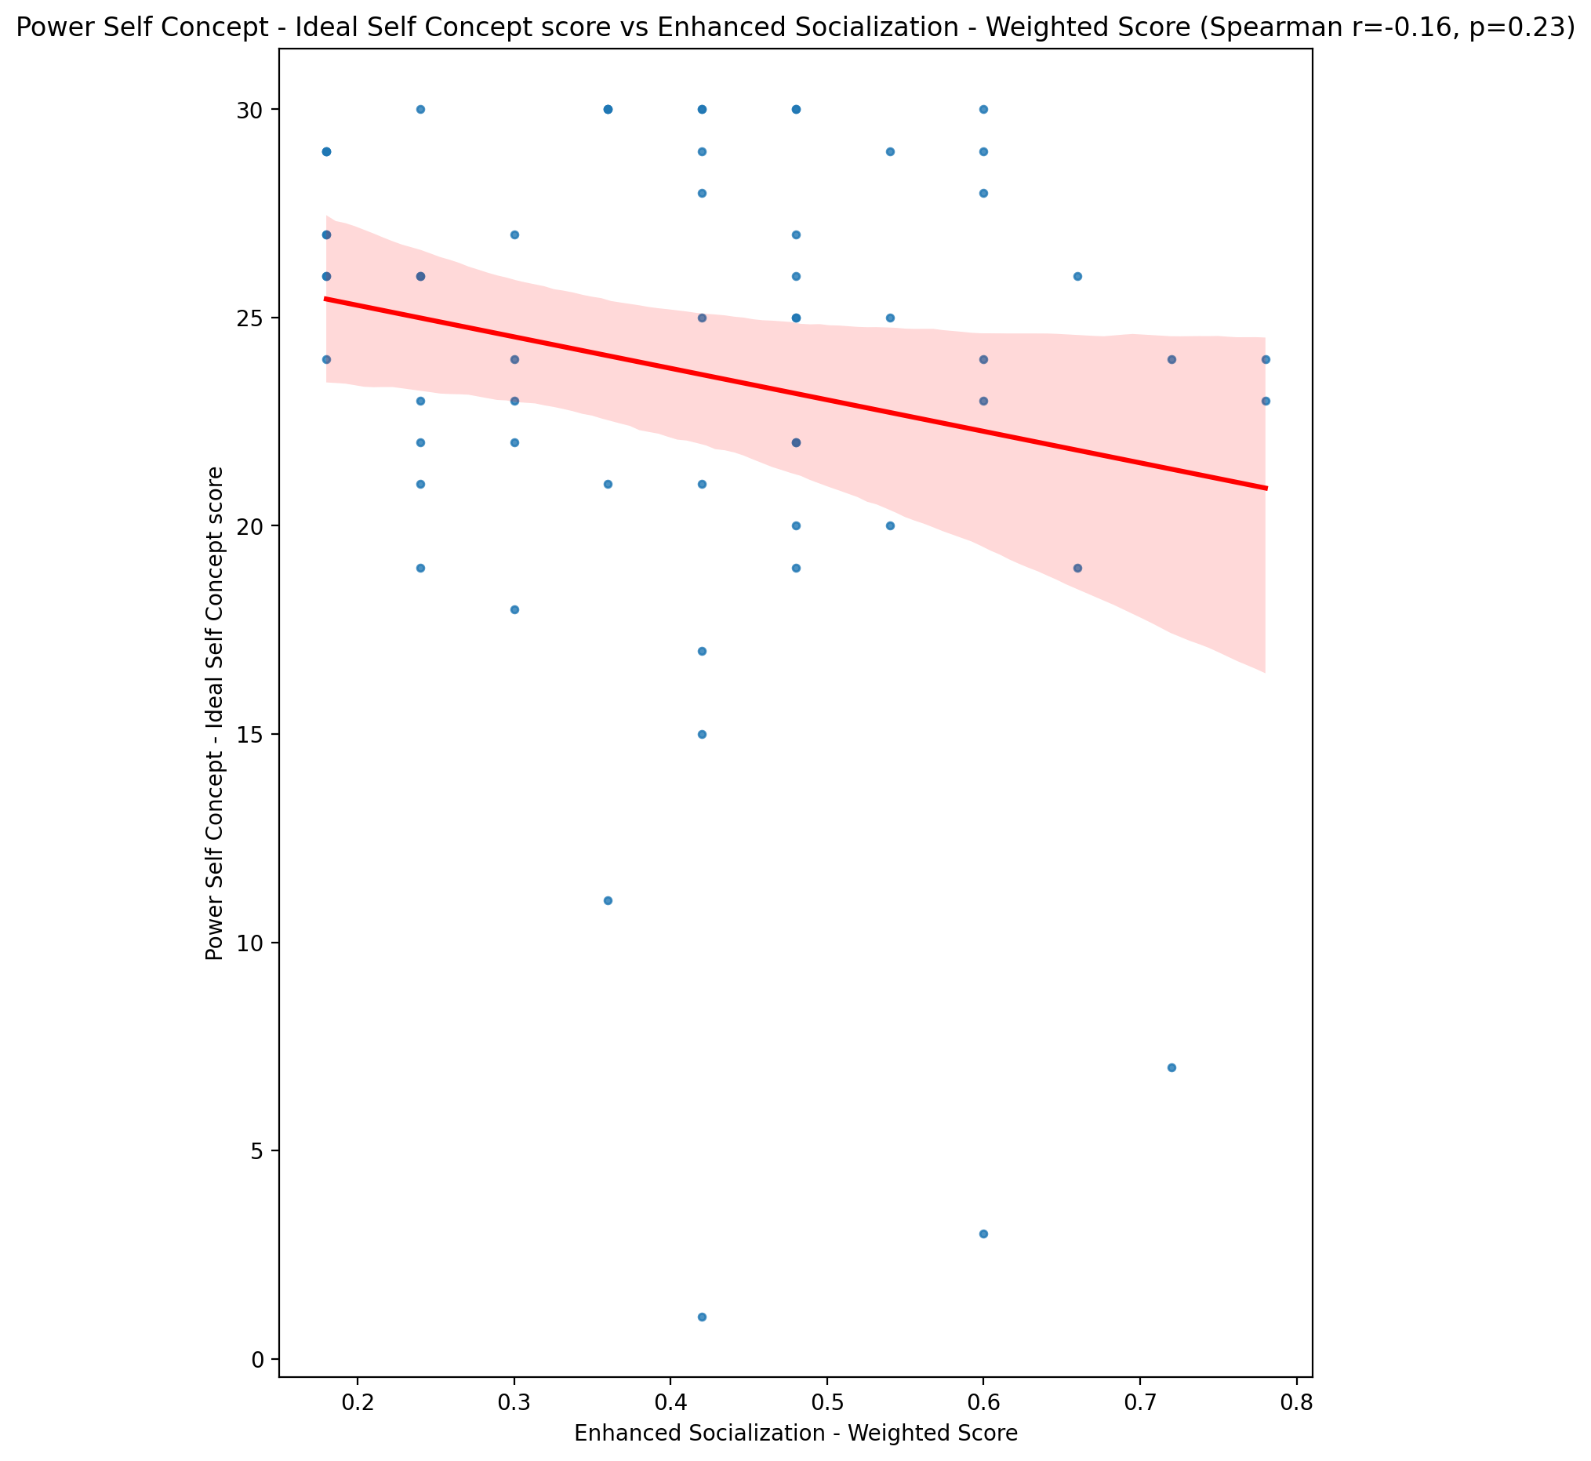

## Power Self Concept – Social Self Concept Score vs Enhanced Socialization - Weighted Score

Test: spearman; statistic: 0.16844695086819594; p-value: 0.20219695677958535;

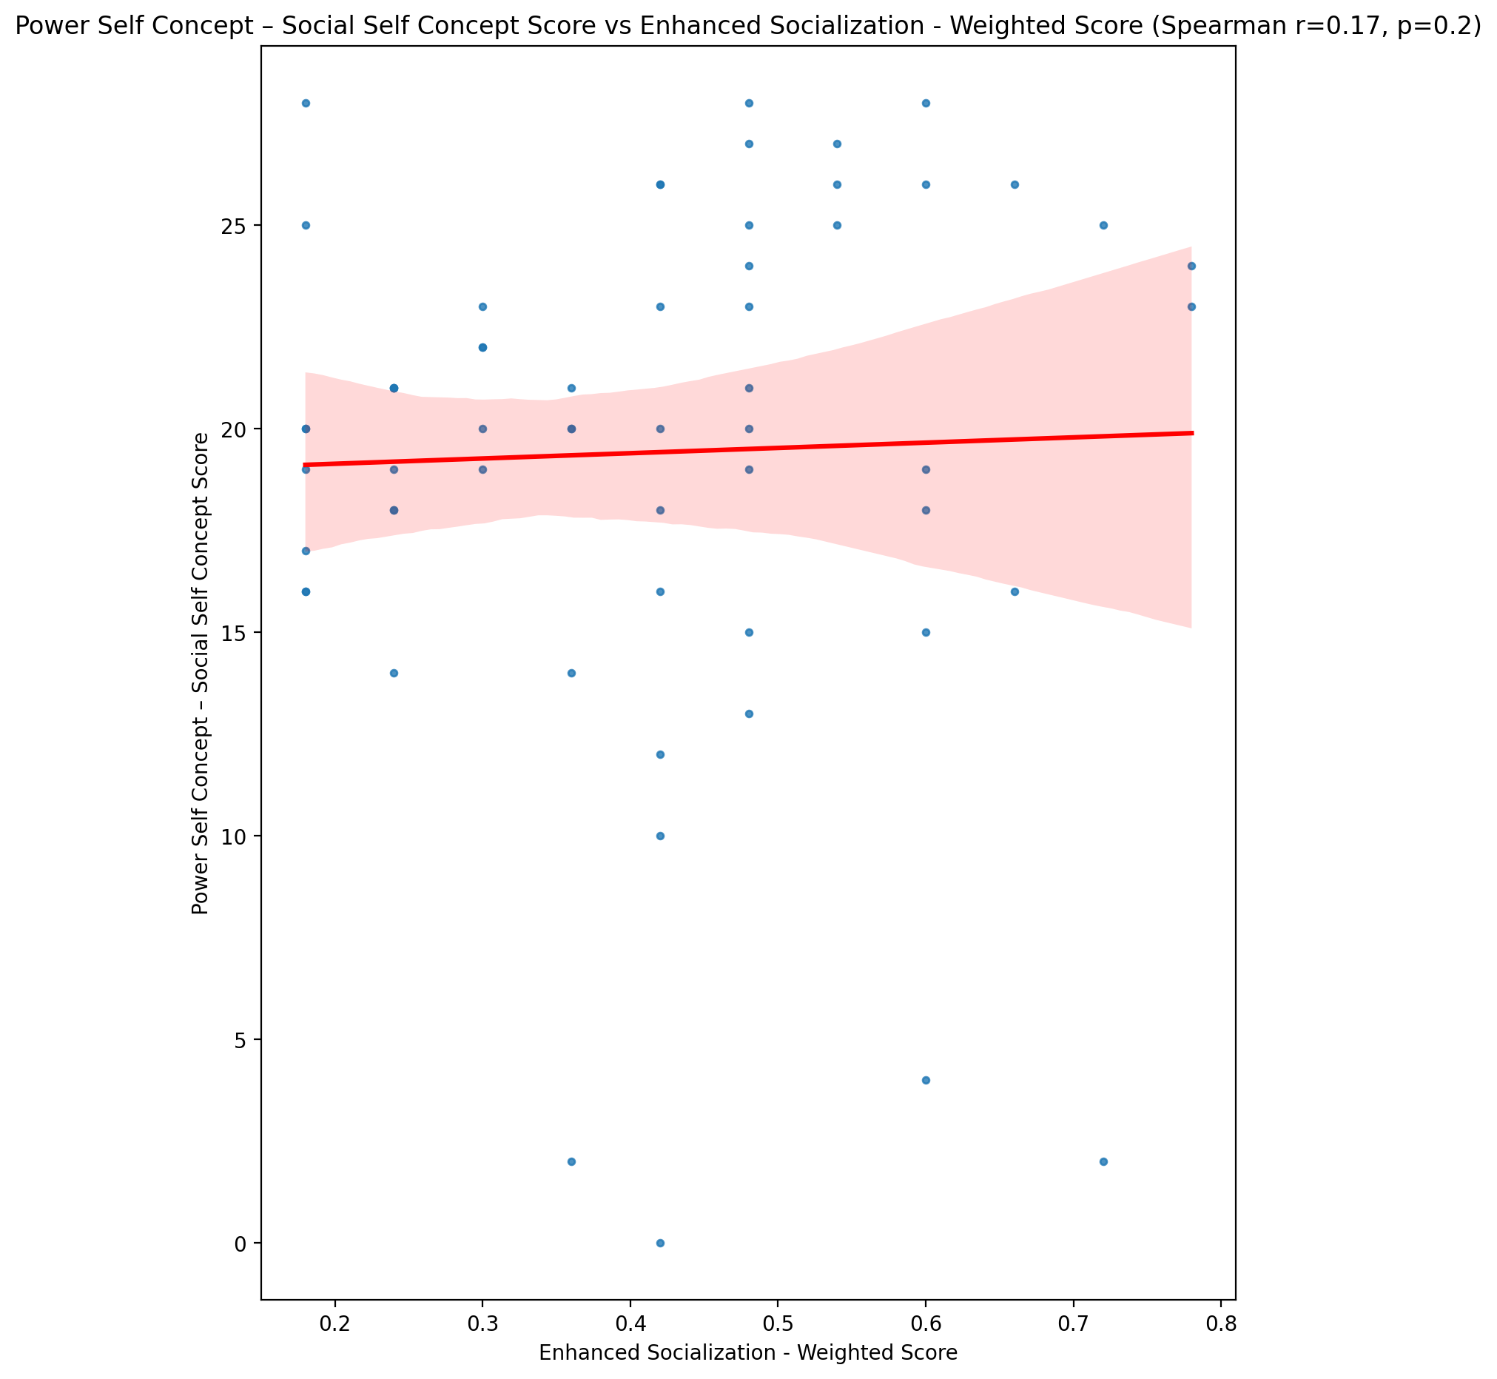

## Social Self Concept - Real Self Concept Score vs Enhanced Socialization - Weighted Score

Test: spearman; statistic: -0.08269648006528078; p-value: 0.5334943010686454;

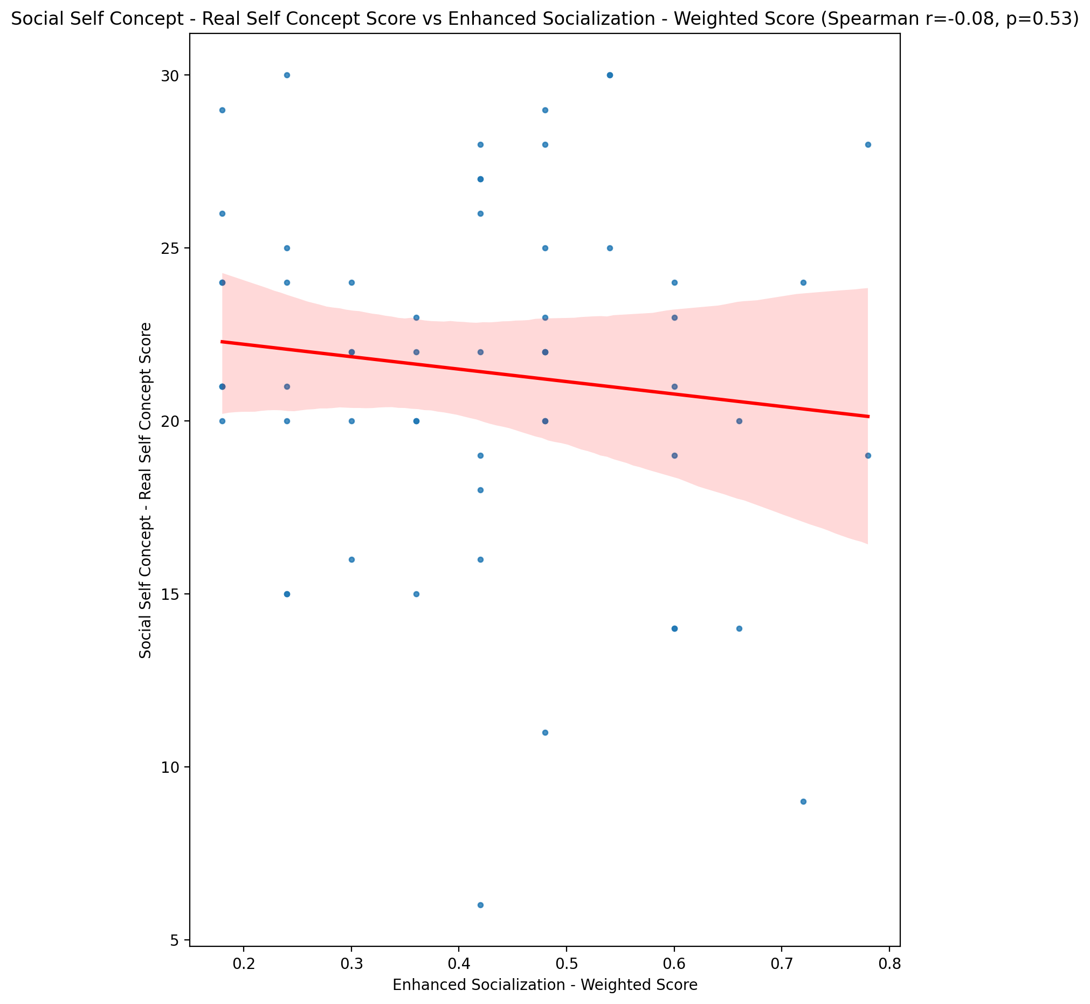

## Social Self Concept – Social Self Concept Score vs Enhanced Socialization - Weighted Score

Test: spearman; statistic: 0.1072144577234994; p-value: 0.4189506613253089;

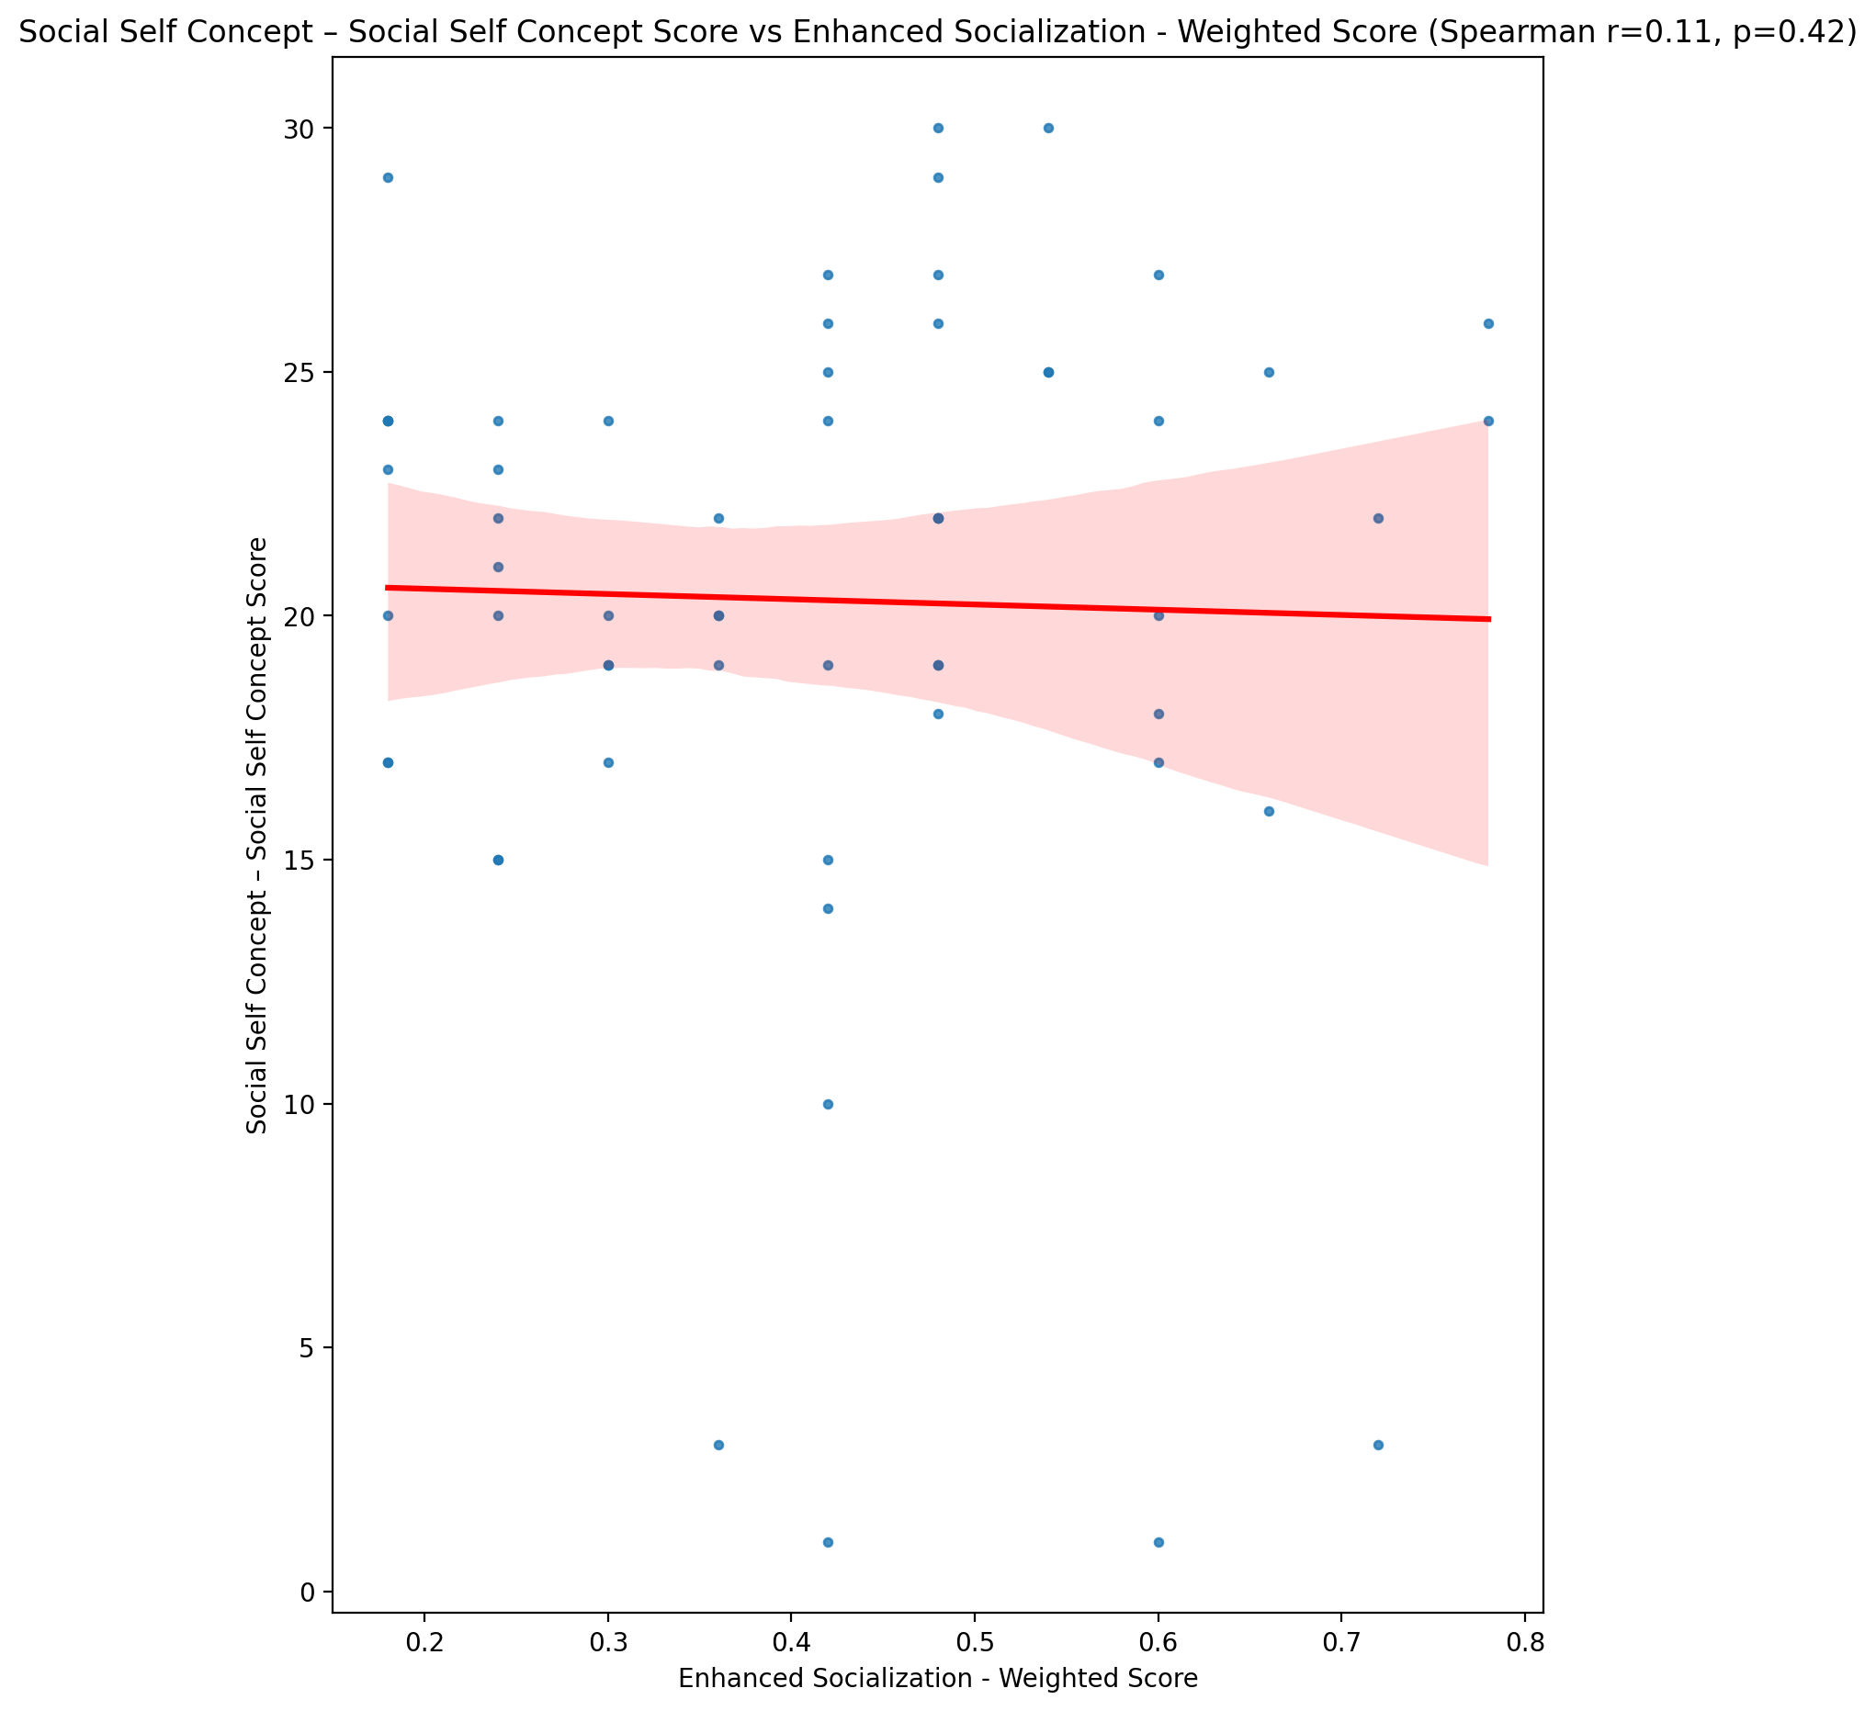

## Ability Self Concept - Real Self Concept Score vs Enhanced Socialization - Weighted Score

Test: spearman; statistic: -0.010984841349838558; p-value: 0.9341908331746998;

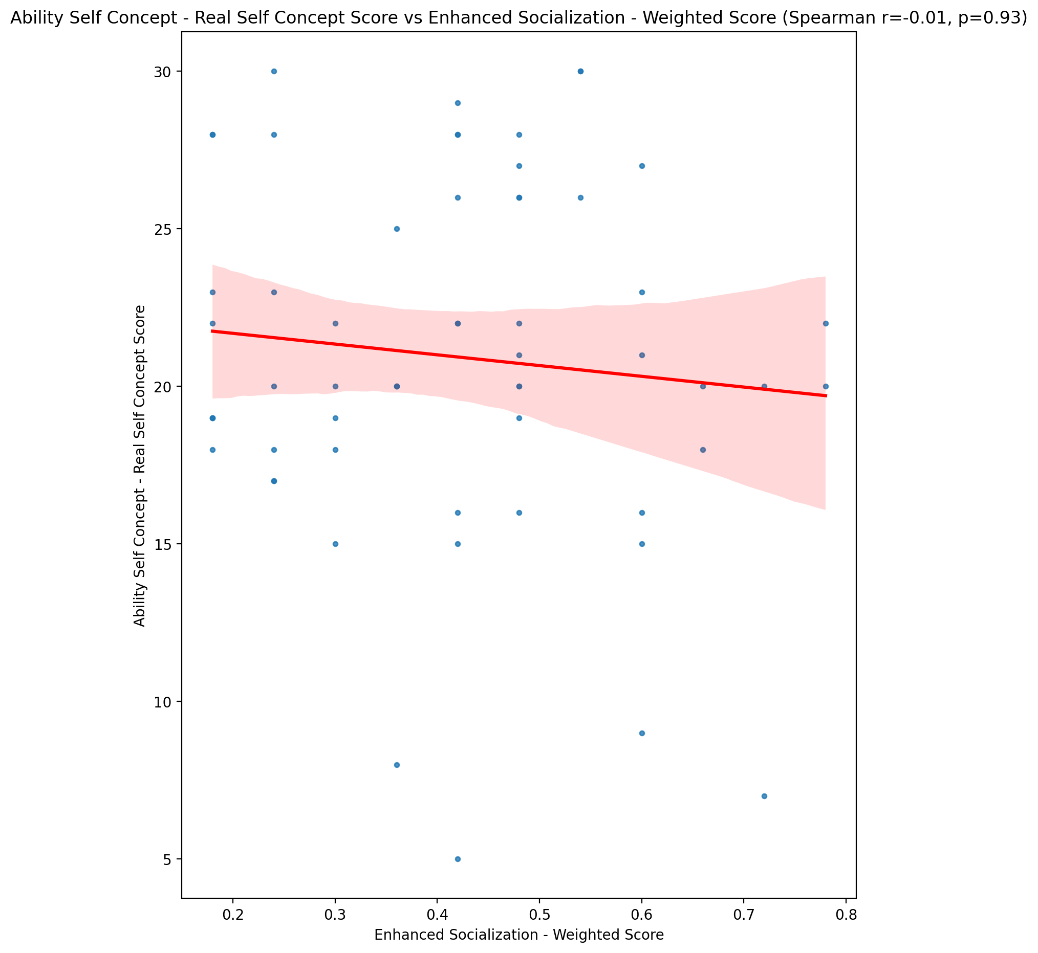

## Ability Self Concept - Ideal Self Concept Score vs Enhanced Socialization - Weighted Score

Test: spearman; statistic: -0.10878697039435205; p-value: 0.412120341338994;

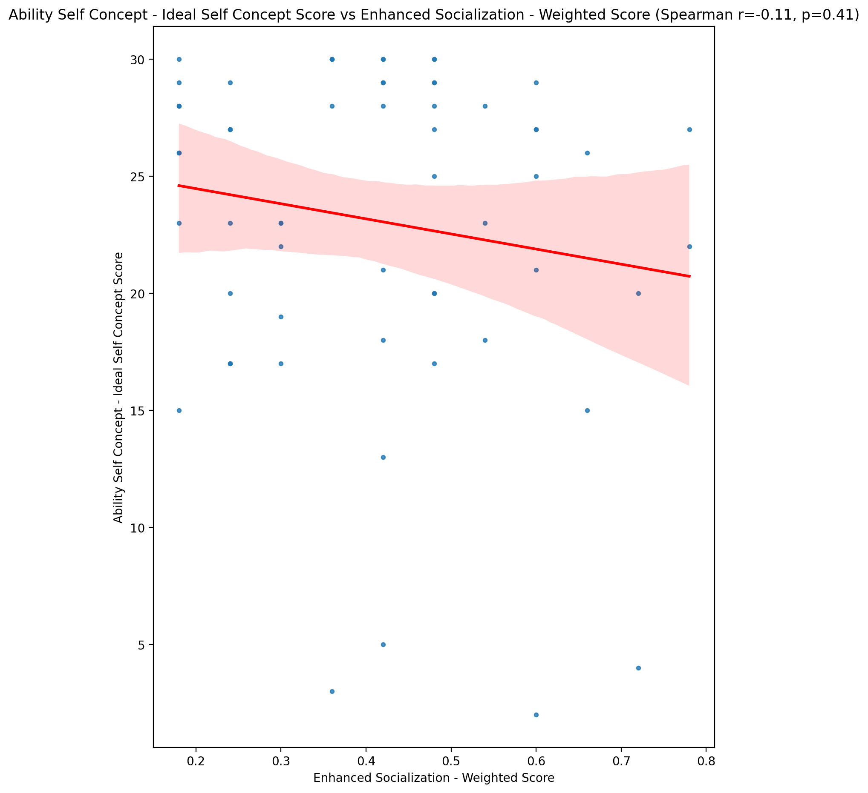

## Ability Self Concept – Social Self Concept Score vs Enhanced Socialization - Weighted Score

Test: spearman; statistic: 0.1554303444906712; p-value: 0.2397951756048421;

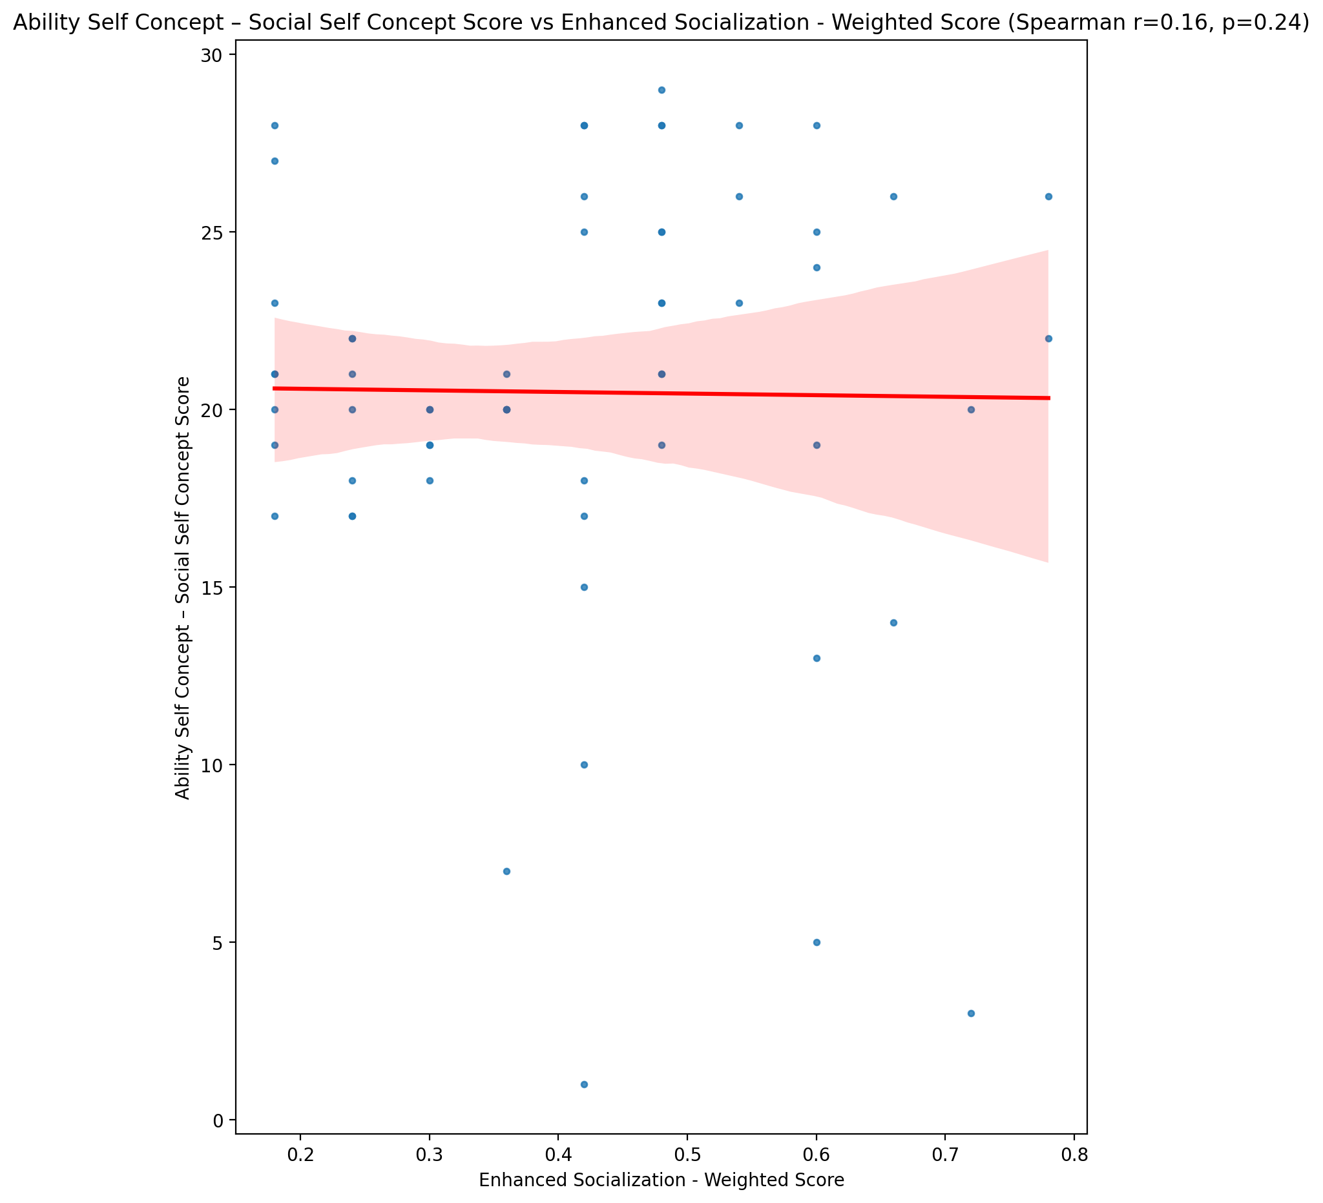

## Physical Self Concept - Real Self Concept Score vs Enhanced Socialization - Weighted Score

Test: spearman; statistic: -0.012672322455076997; p-value: 0.9241090407320212;

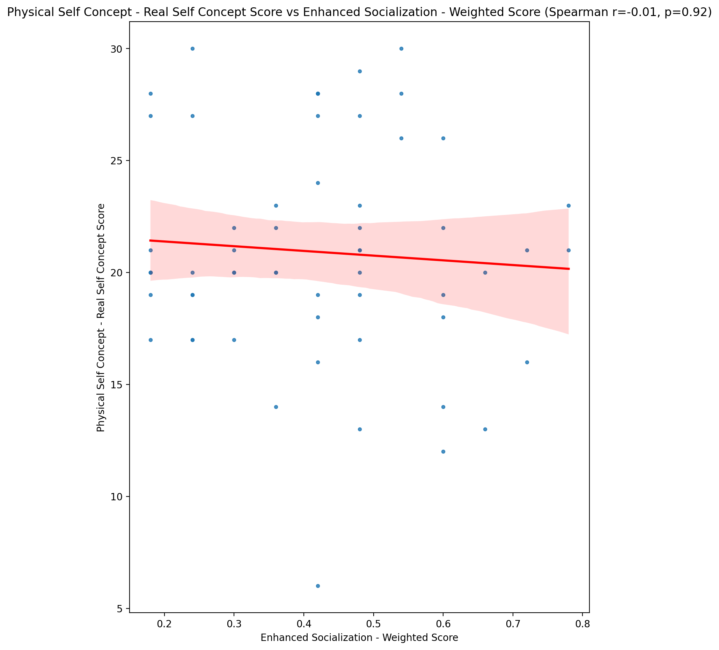

## Physical Self Concept – Ideal Self Concept Score vs Enhanced Socialization - Weighted Score

Test: spearman; statistic: -0.07603687676495202; p-value: 0.5670621338160808;

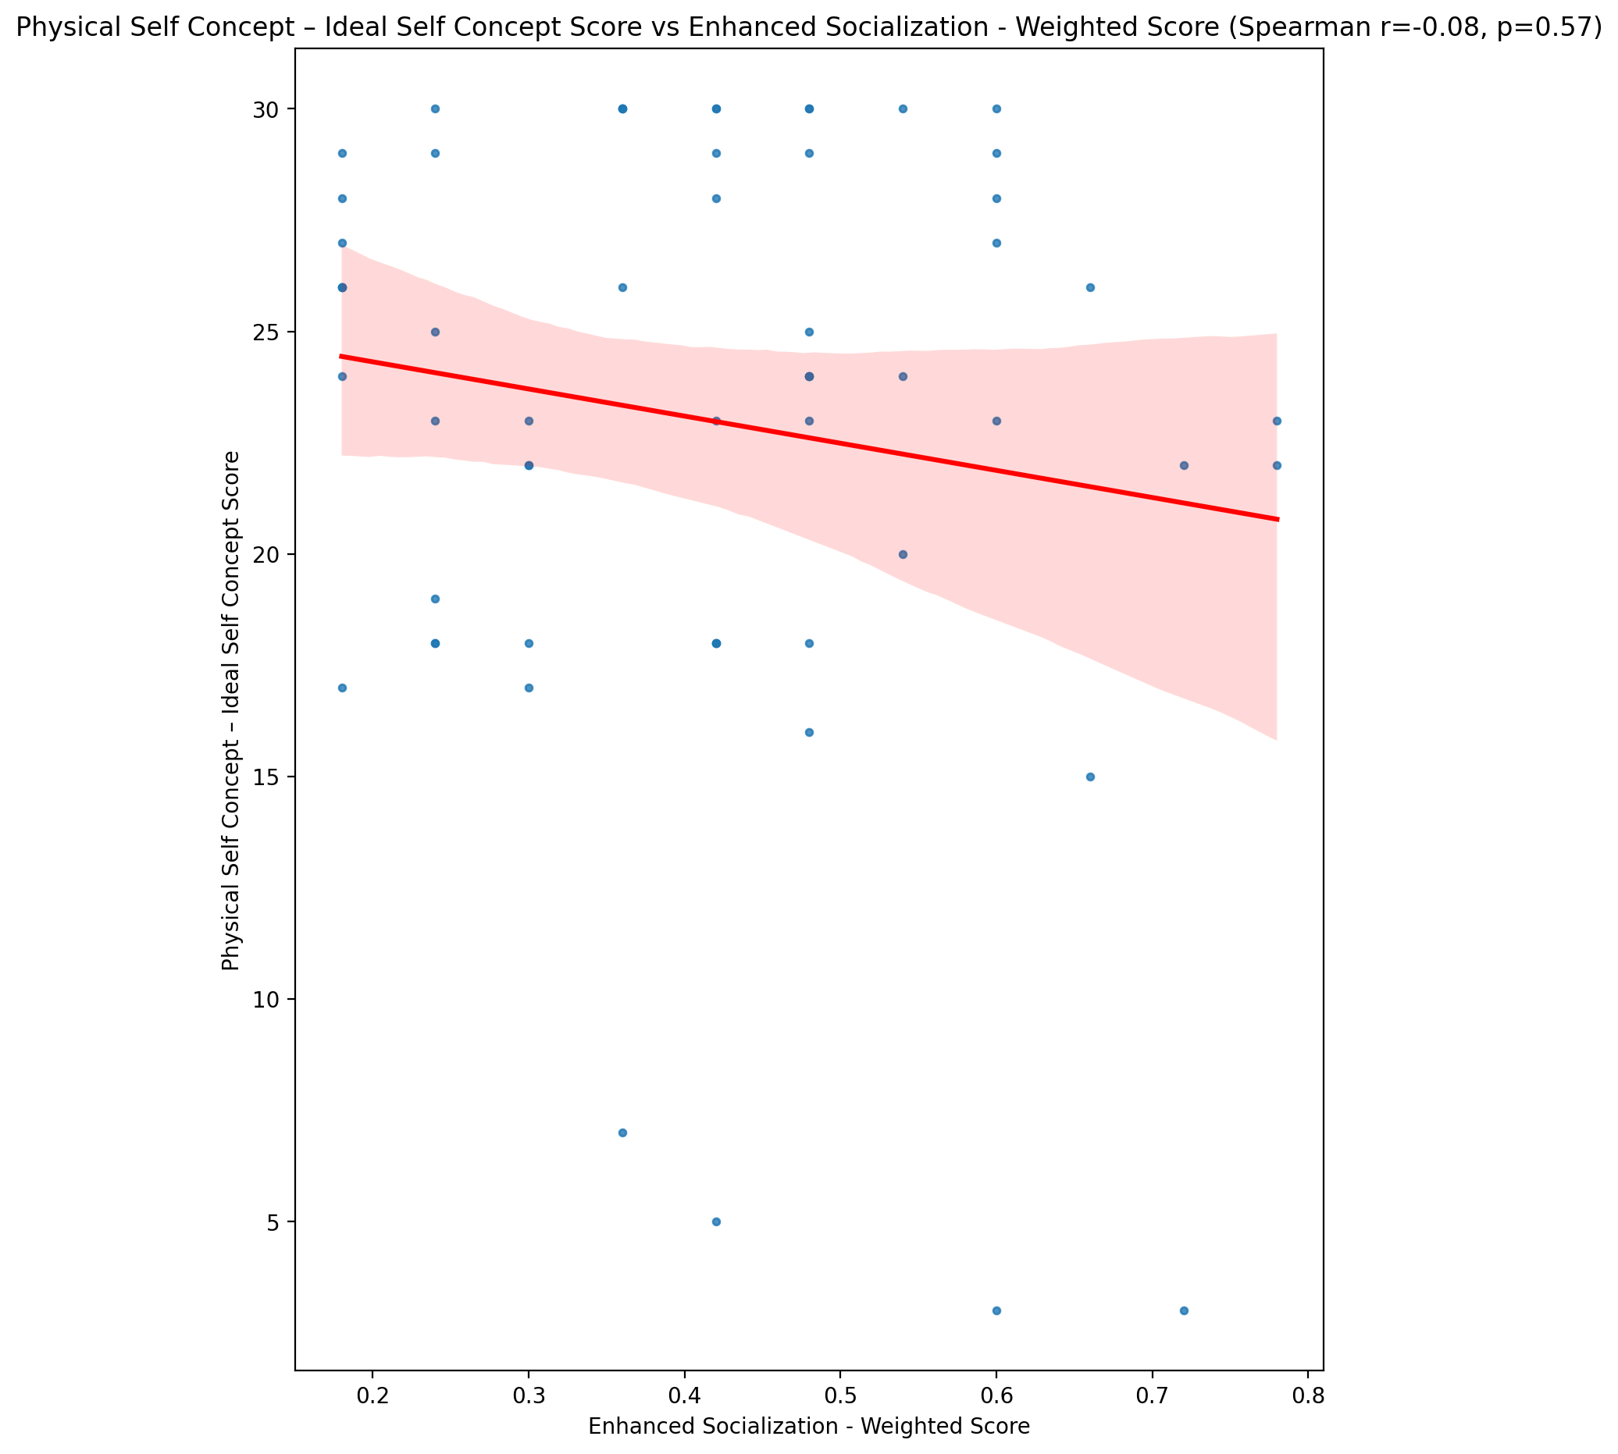

## Physical Self Concept – Social Self Concept Score vs Enhanced Socialization - Weighted Score

Test: spearman; statistic: 0.1451600822598312; p-value: 0.27265810900734216;

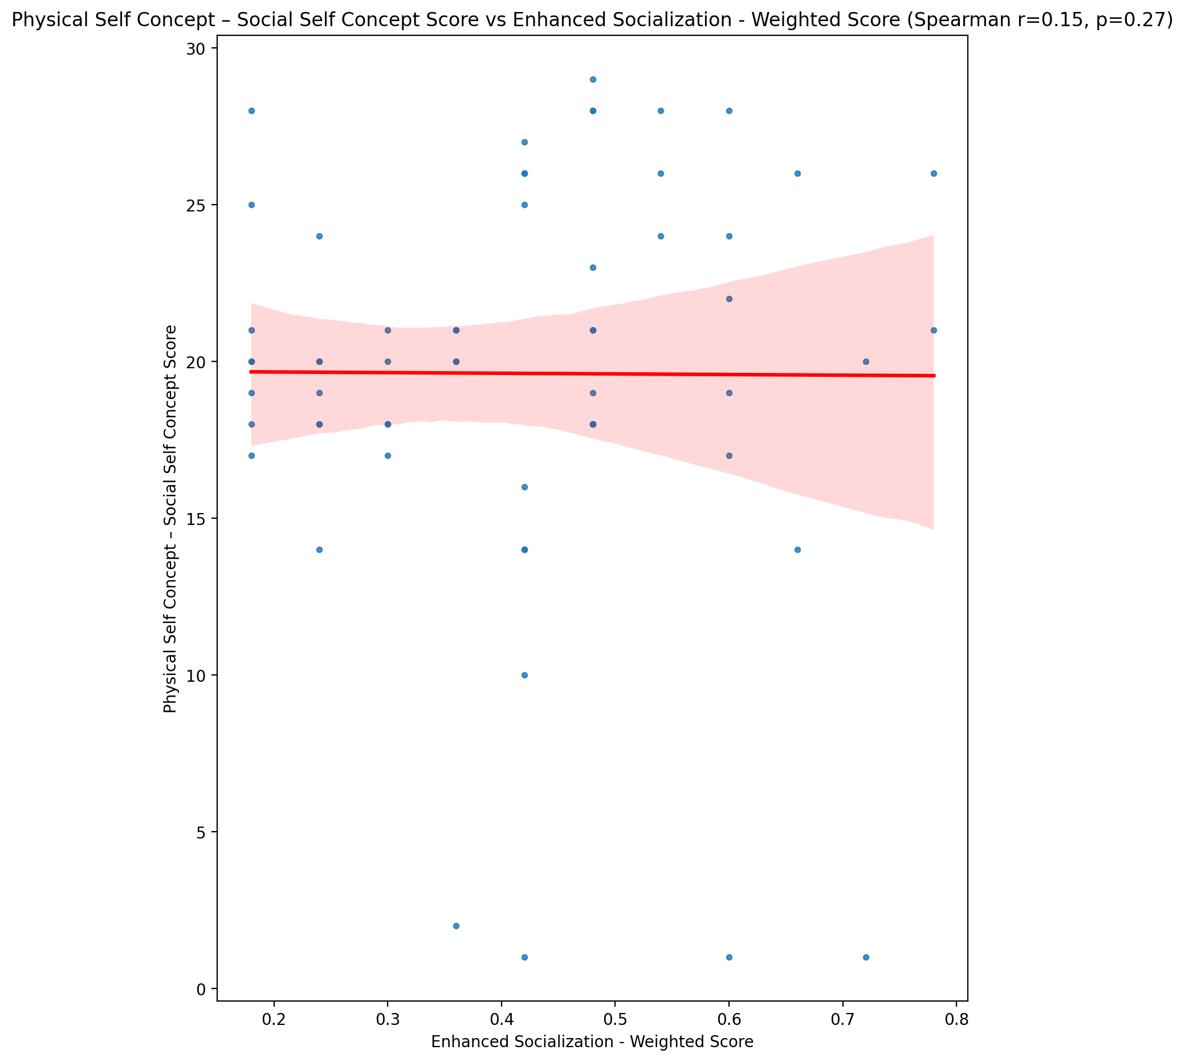

## Psychological Self Concept - Real Self Concept Score vs Enhanced Socialization - Weighted Score

Test: spearman; statistic: -0.06997287444352492; p-value: 0.5984587104519912;

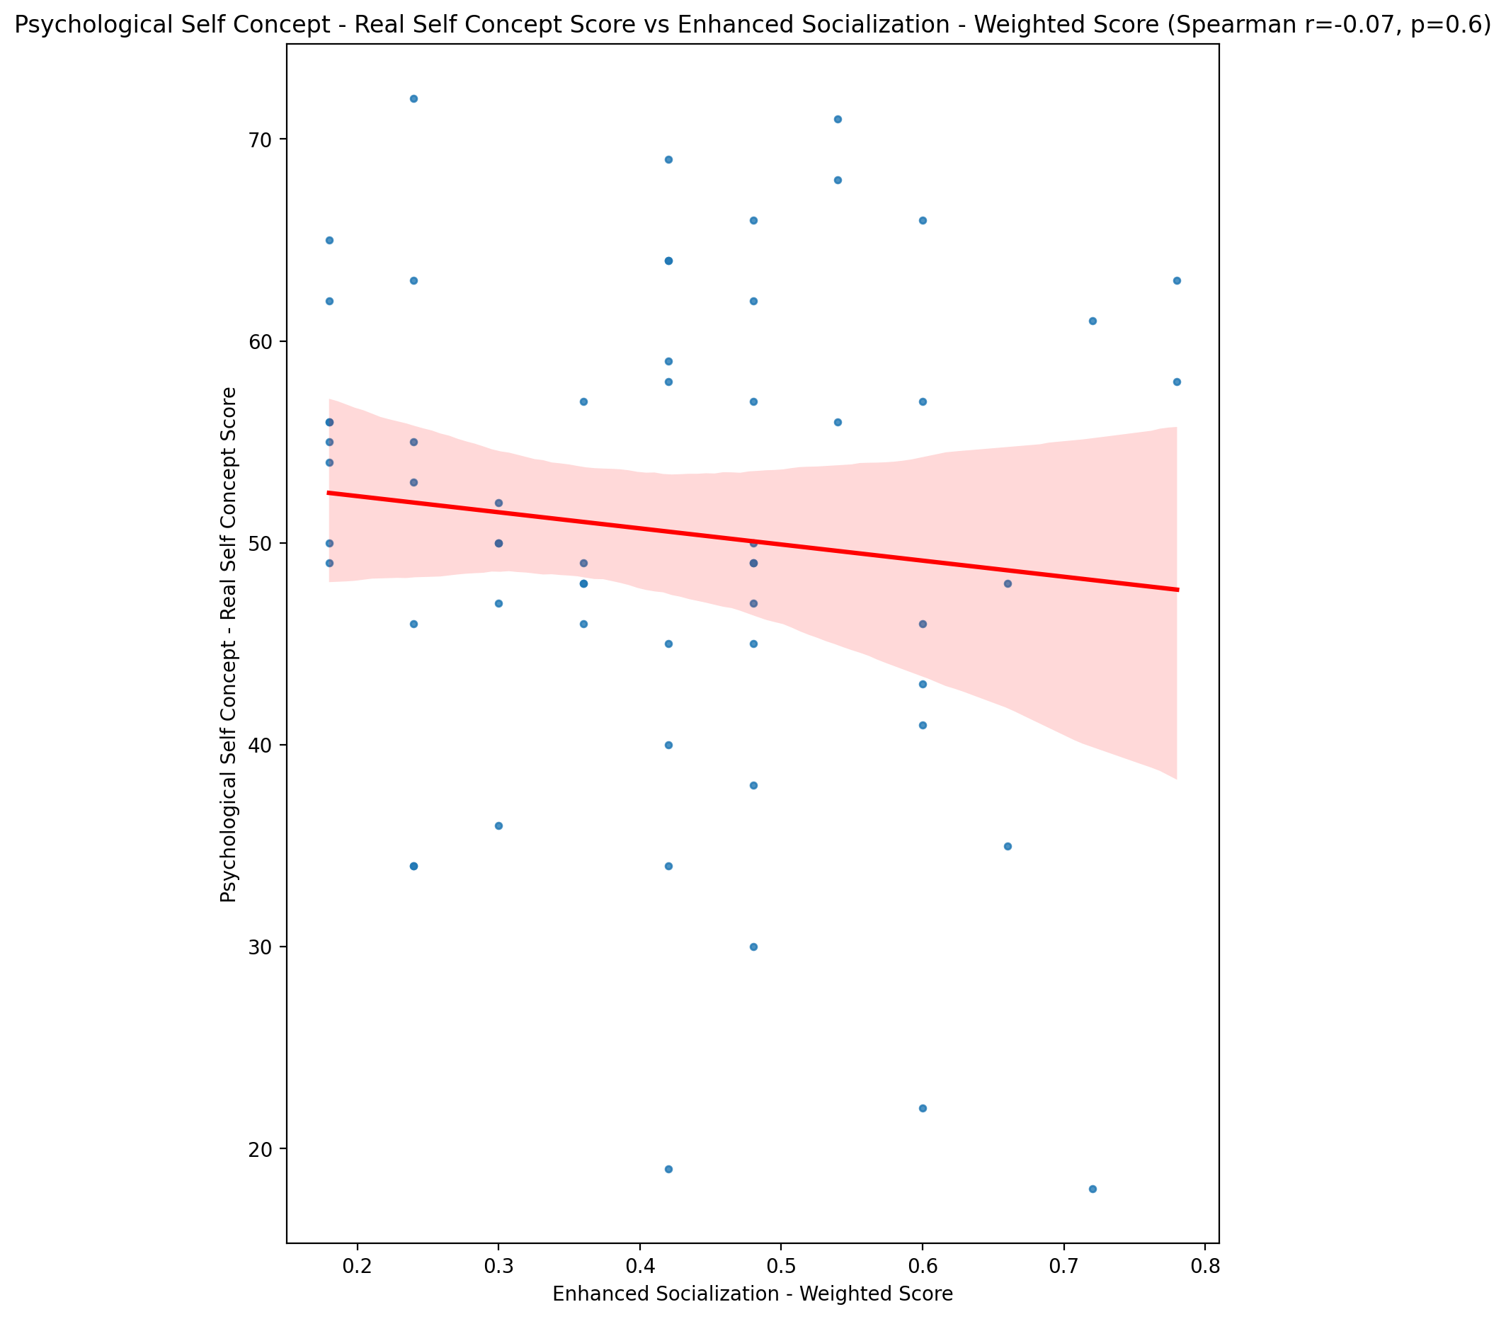

## Psychological Self Concept – Ideal Self Concept Score vs Enhanced Socialization - Weighted Score

Test: spearman; statistic: -0.025019785093153217; p-value: 0.8507997588454392;

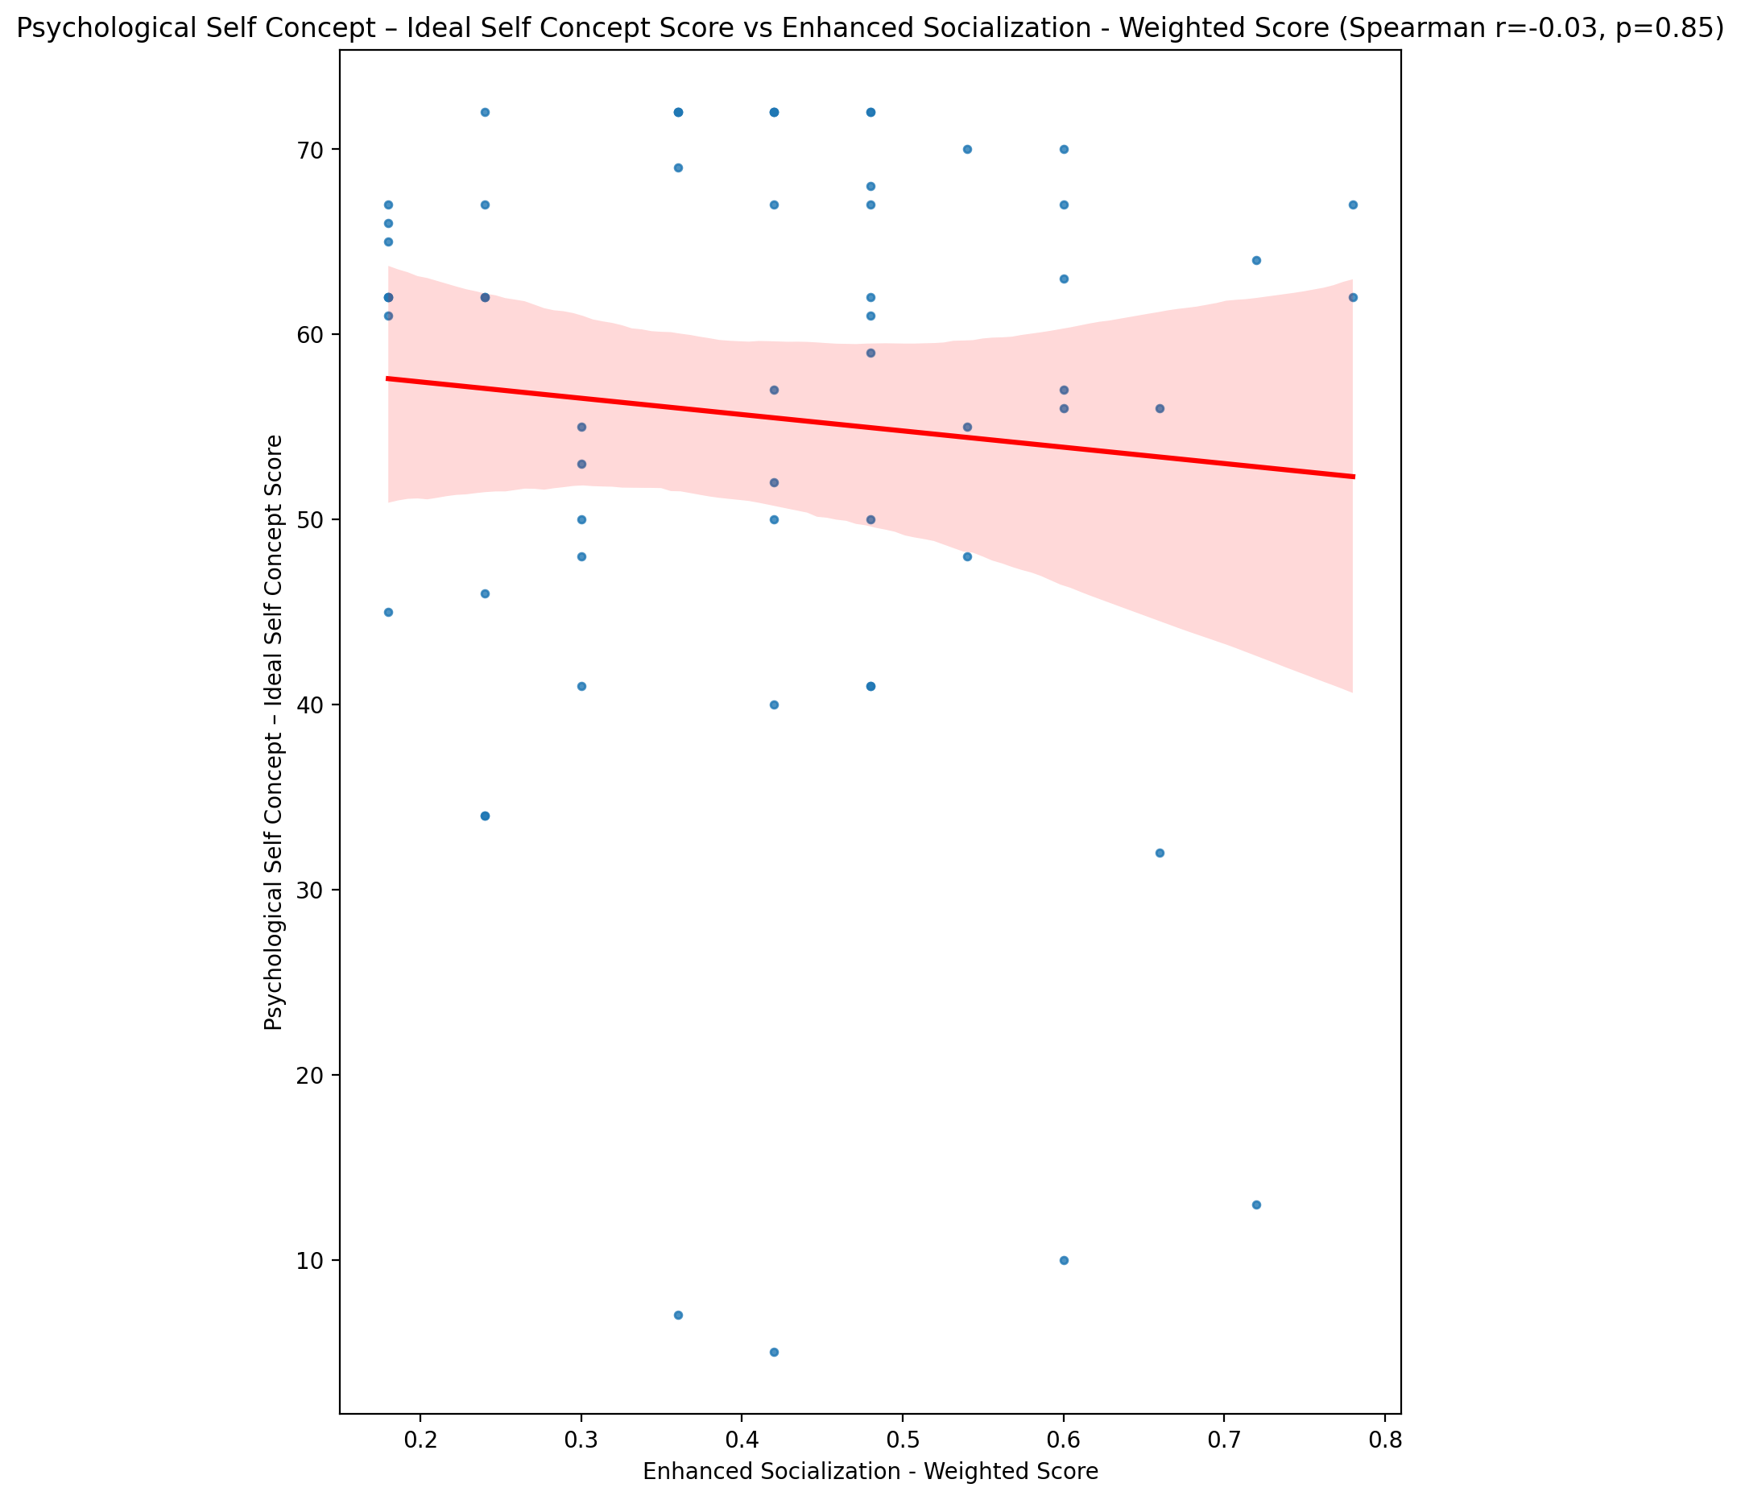

## Psychological Self Concept – Social Self Concept Score vs Enhanced Socialization - Weighted Score

Test: spearman; statistic: 0.08902033118040352; p-value: 0.5025512258371112;

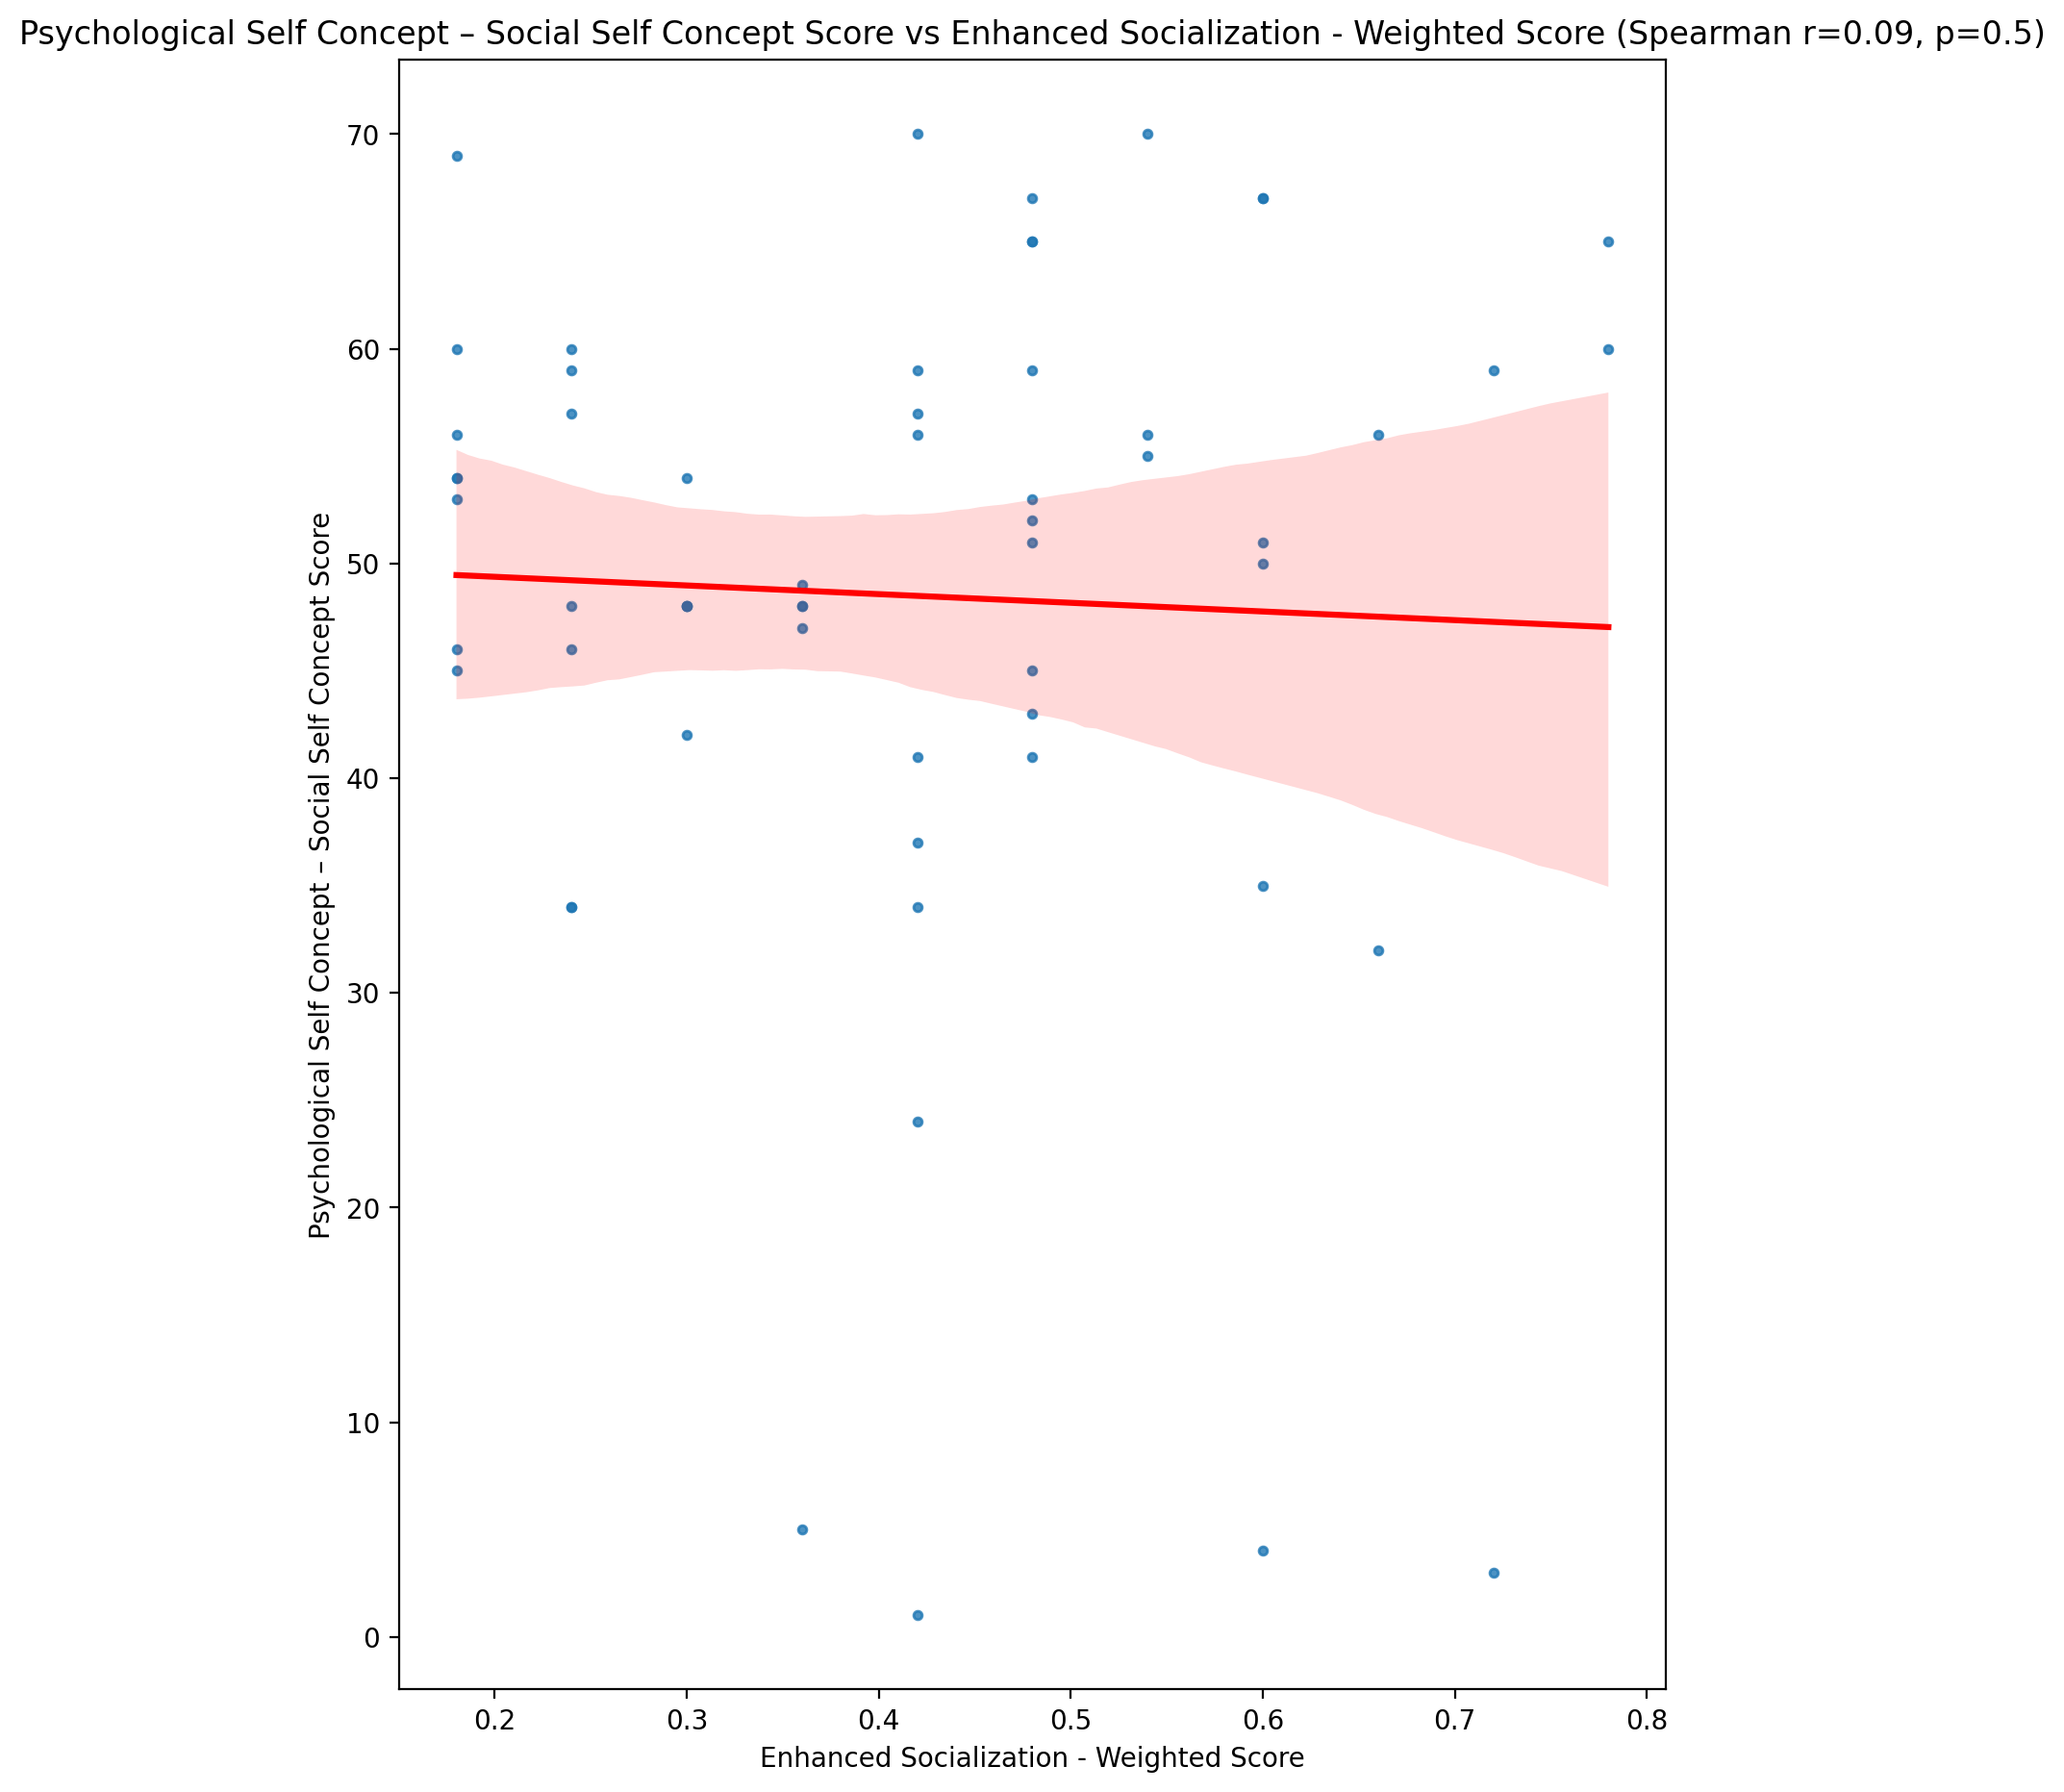

## Real Self Concept Total Score vs Enhanced Socialization - Weighted Score

Test: spearman; statistic: -0.0305327216593296; p-value: 0.8184322816072569;

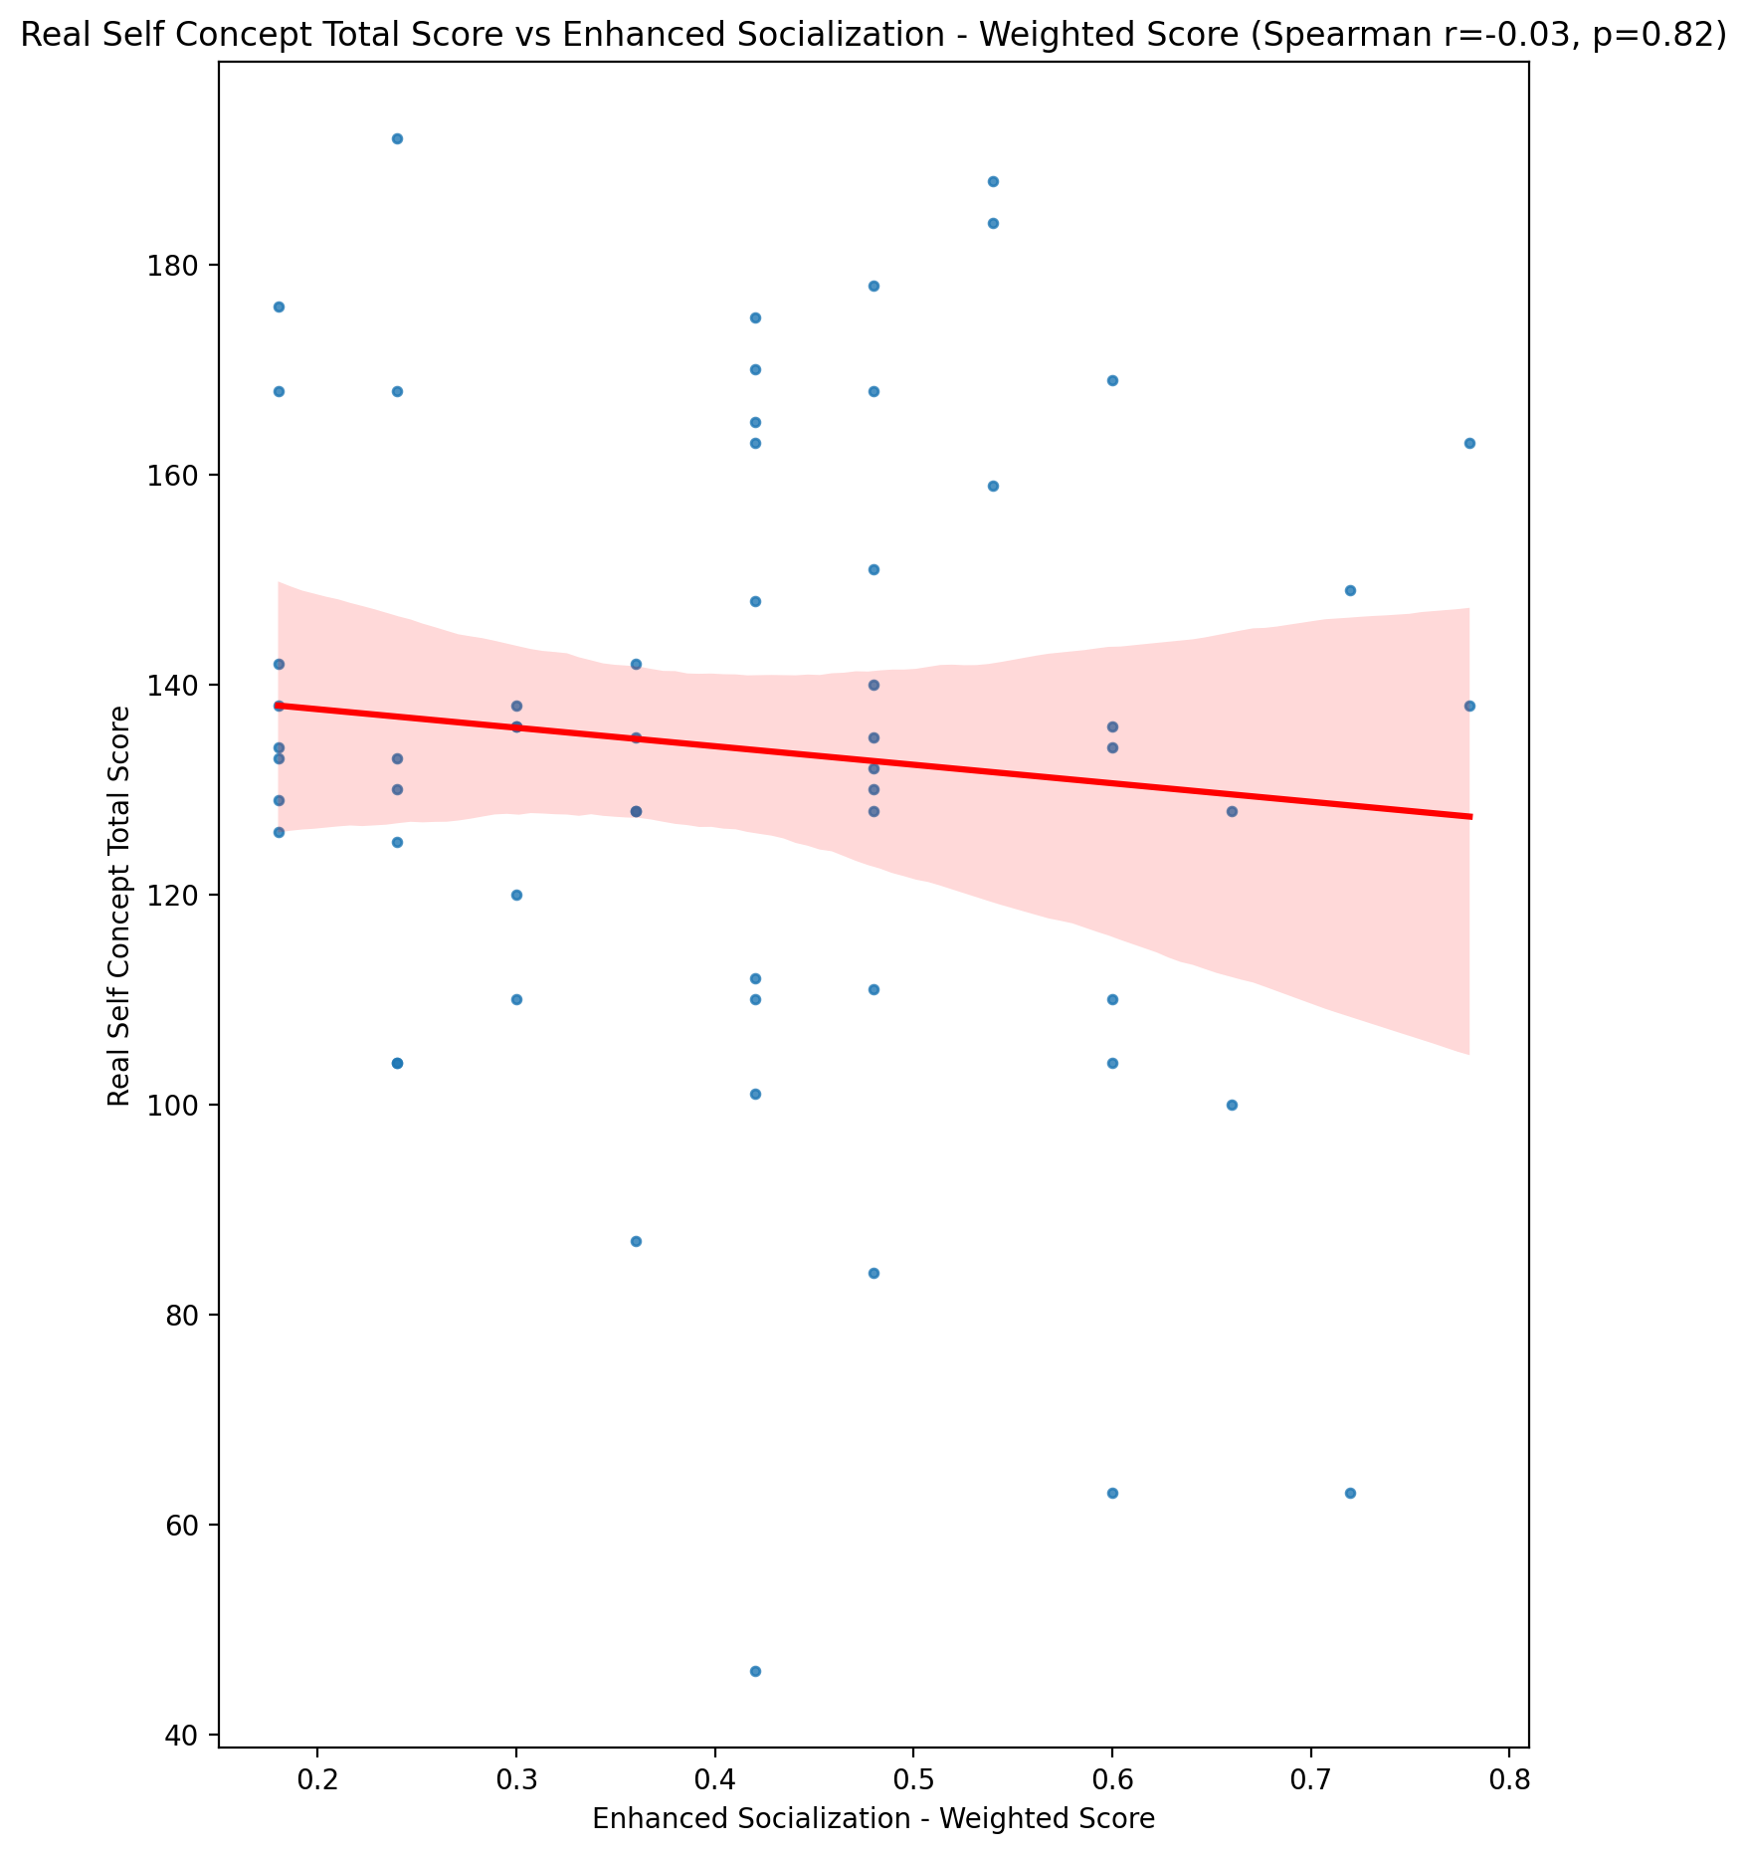

## Ideal Self Concept Total Score vs Enhanced Socialization - Weighted Score

Test: spearman; statistic: -0.0696000495541076; p-value: 0.6004138186699493;

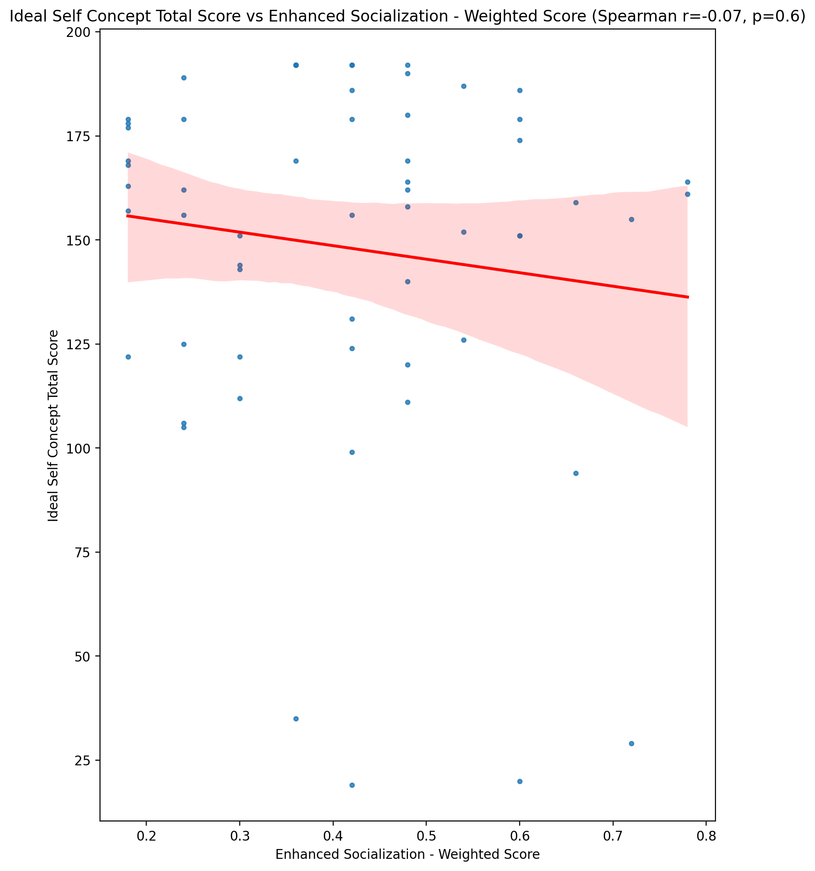

## Social Self Concept Total Score vs Enhanced Socialization - Weighted Score

Test: spearman; statistic: 0.14413138540514078; p-value: 0.2761074103318718;

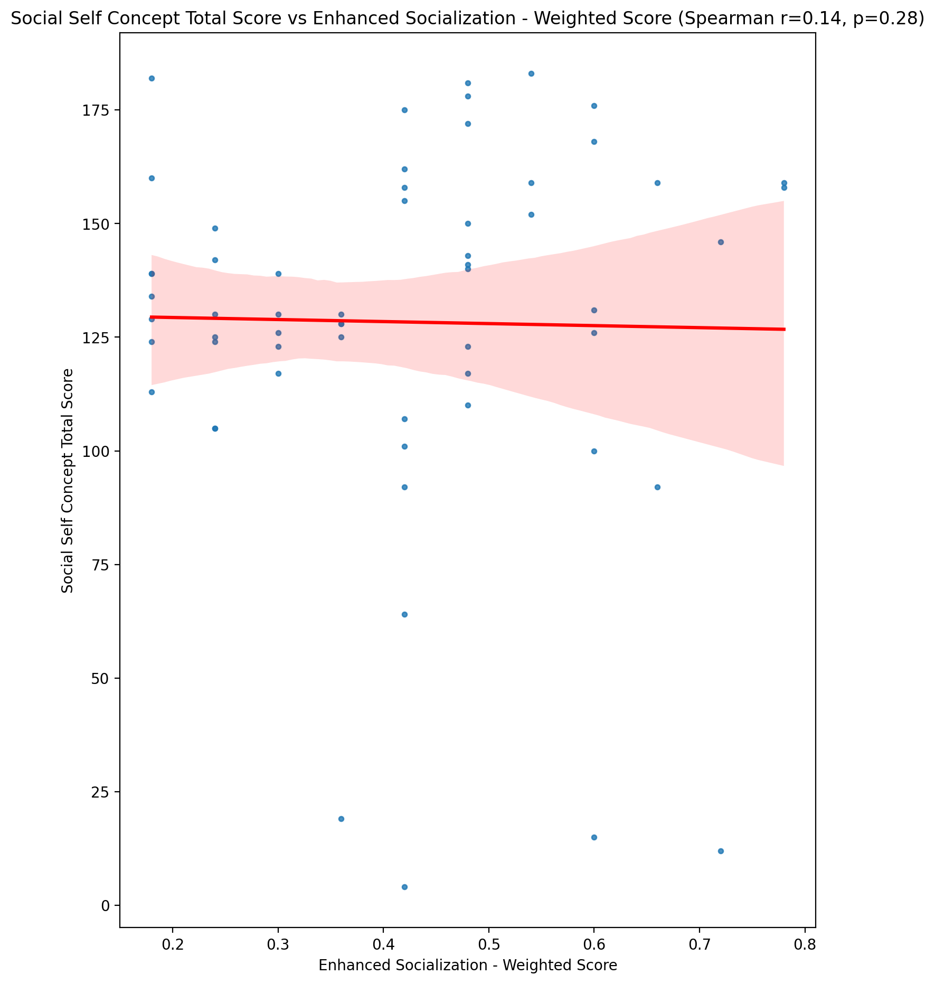

## Ideal Self Concept Total Category vs Enhanced Socialization - Weighted Score

Test: None; statistic: None; p-value: None; Test not run: unsupported type combination.



## Perceived Social Stress Score vs Enhanced Socialization - Weighted Score

Test: spearman; statistic: 0.3545480404011339; p-value: 0.005865814845673005;

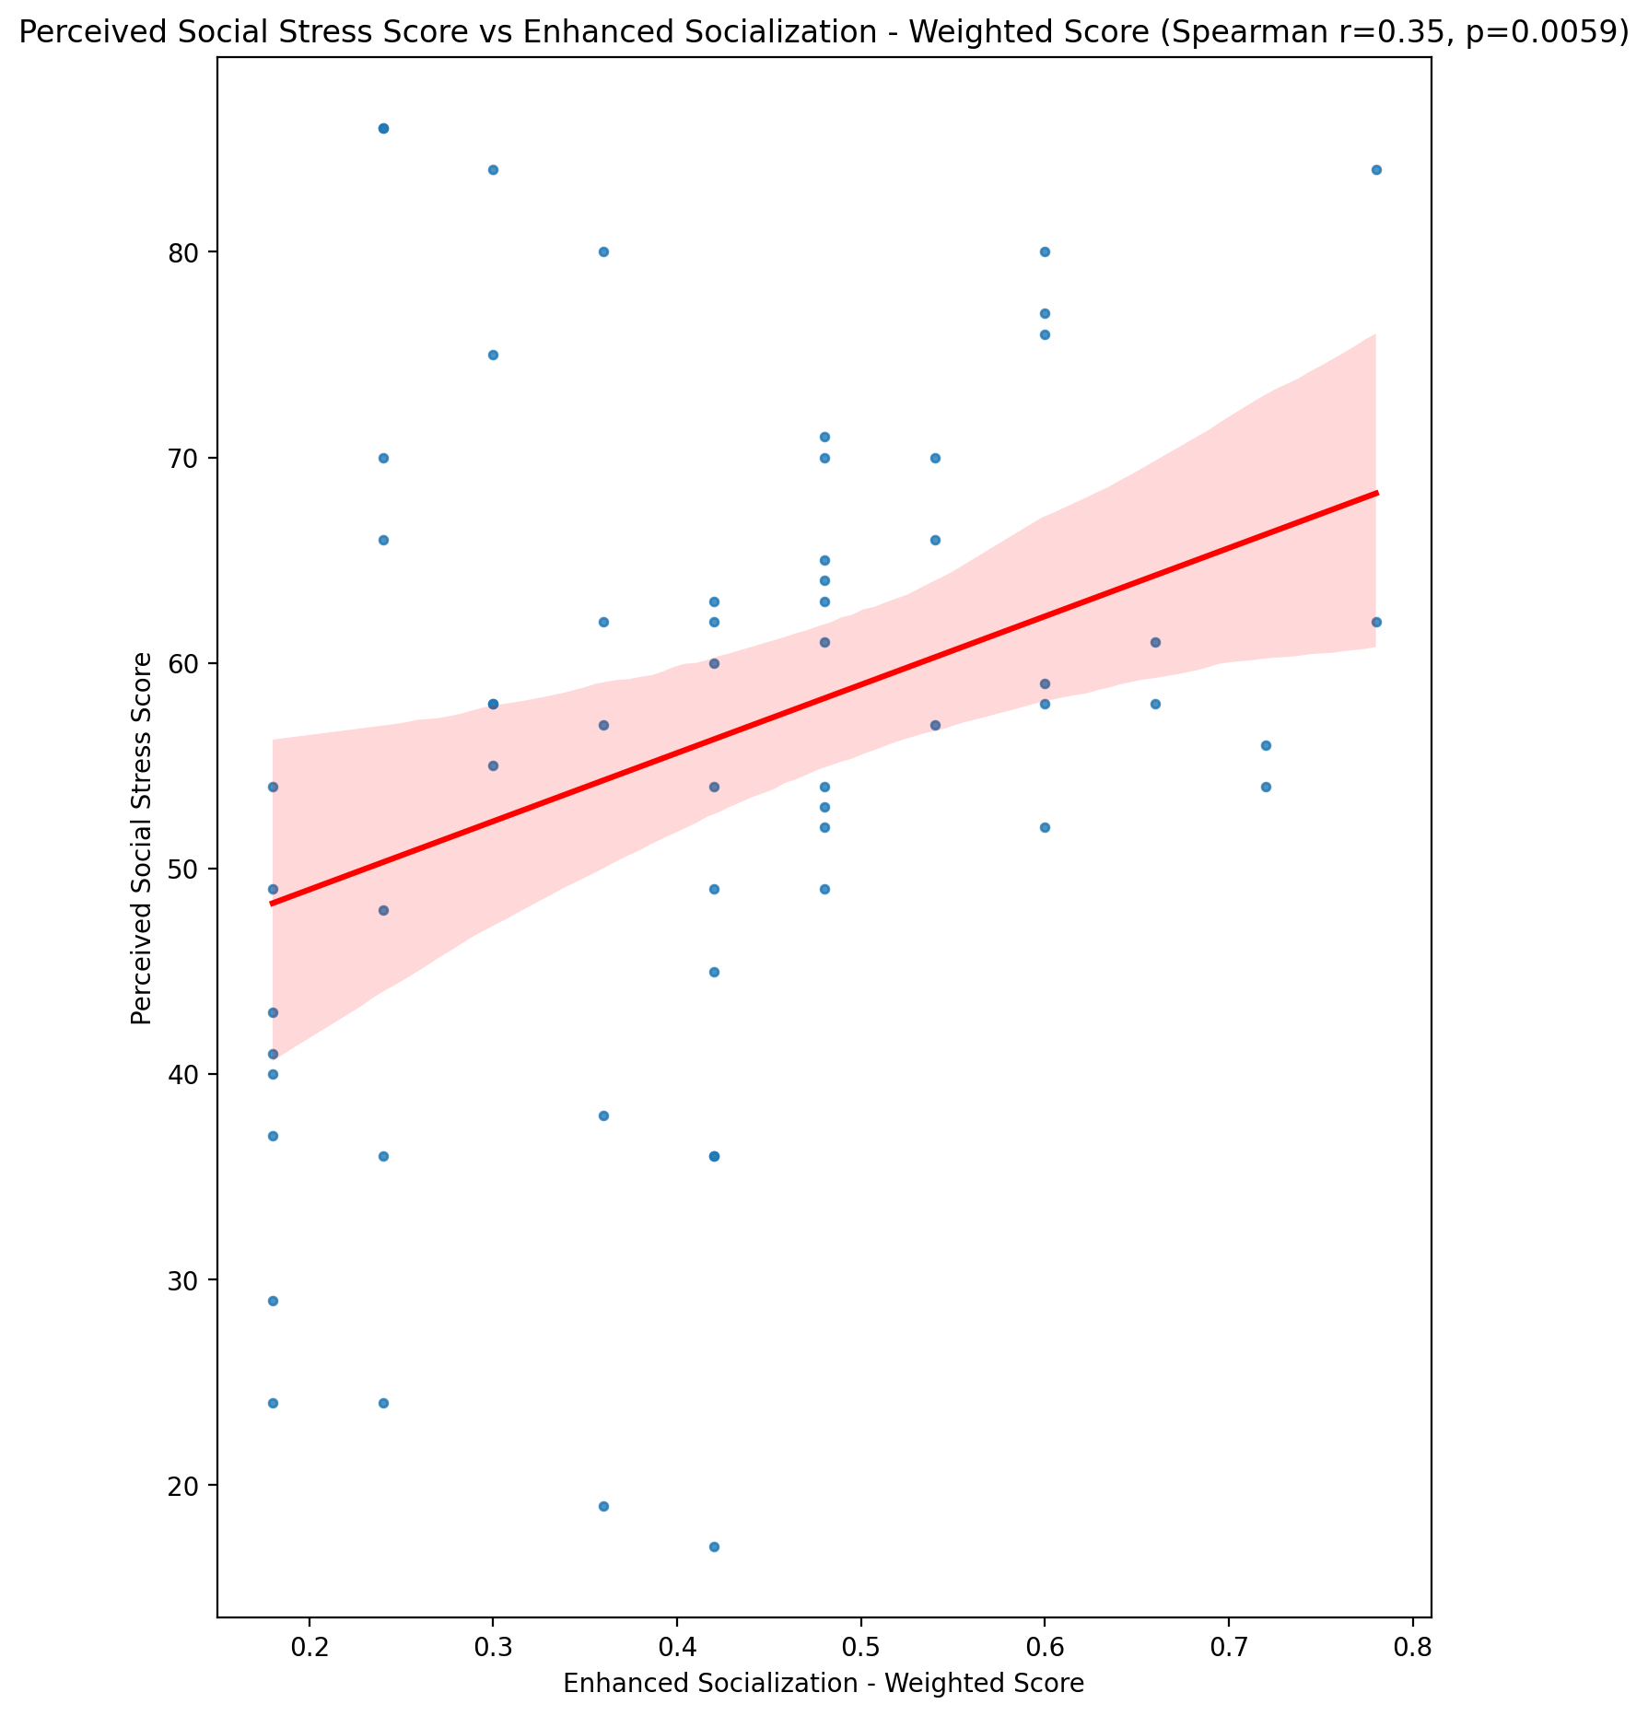

## Perceived Social Stress Category vs Enhanced Socialization - Weighted Score

Test: None; statistic: None; p-value: None; Test not run: unsupported type combination.



## Emotional Support - Raw Score vs Perceived Control of Internet Use - Weighted Score

Test: spearman; statistic: -0.07185090503570181; p-value: 0.5886533053776111;

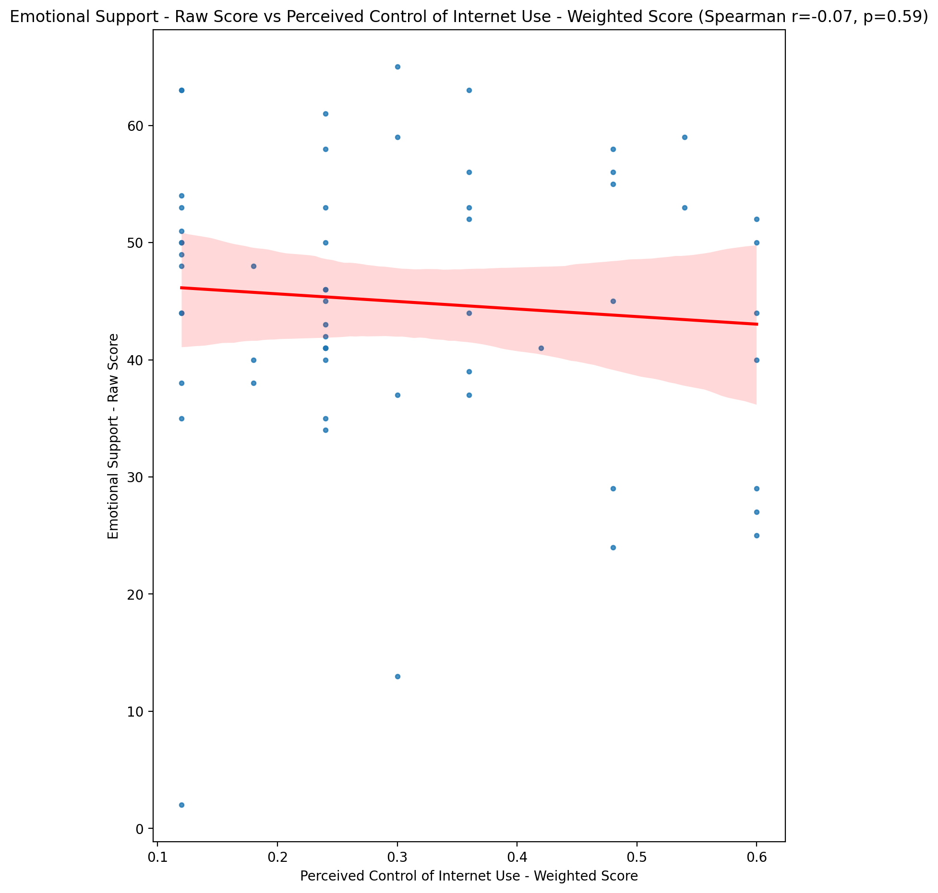

## Informational Support - Raw Score vs Perceived Control of Internet Use - Weighted Score

Test: spearman; statistic: -0.11707528666838359; p-value: 0.3771964952960559;

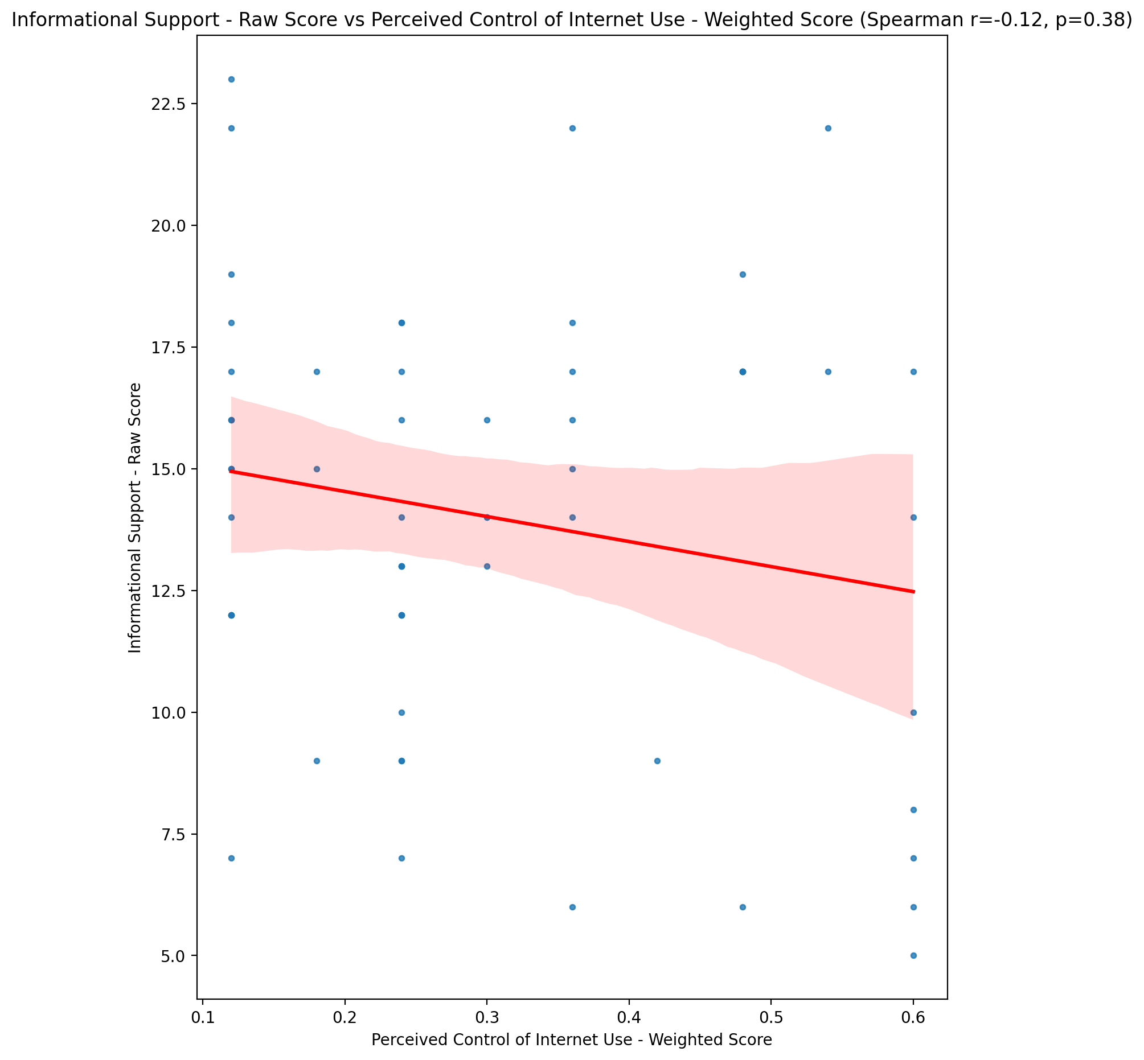

## Instrumental Support - Raw Score vs Perceived Control of Internet Use - Weighted Score

Test: spearman; statistic: -0.20421444922730667; p-value: 0.12079658421642474;

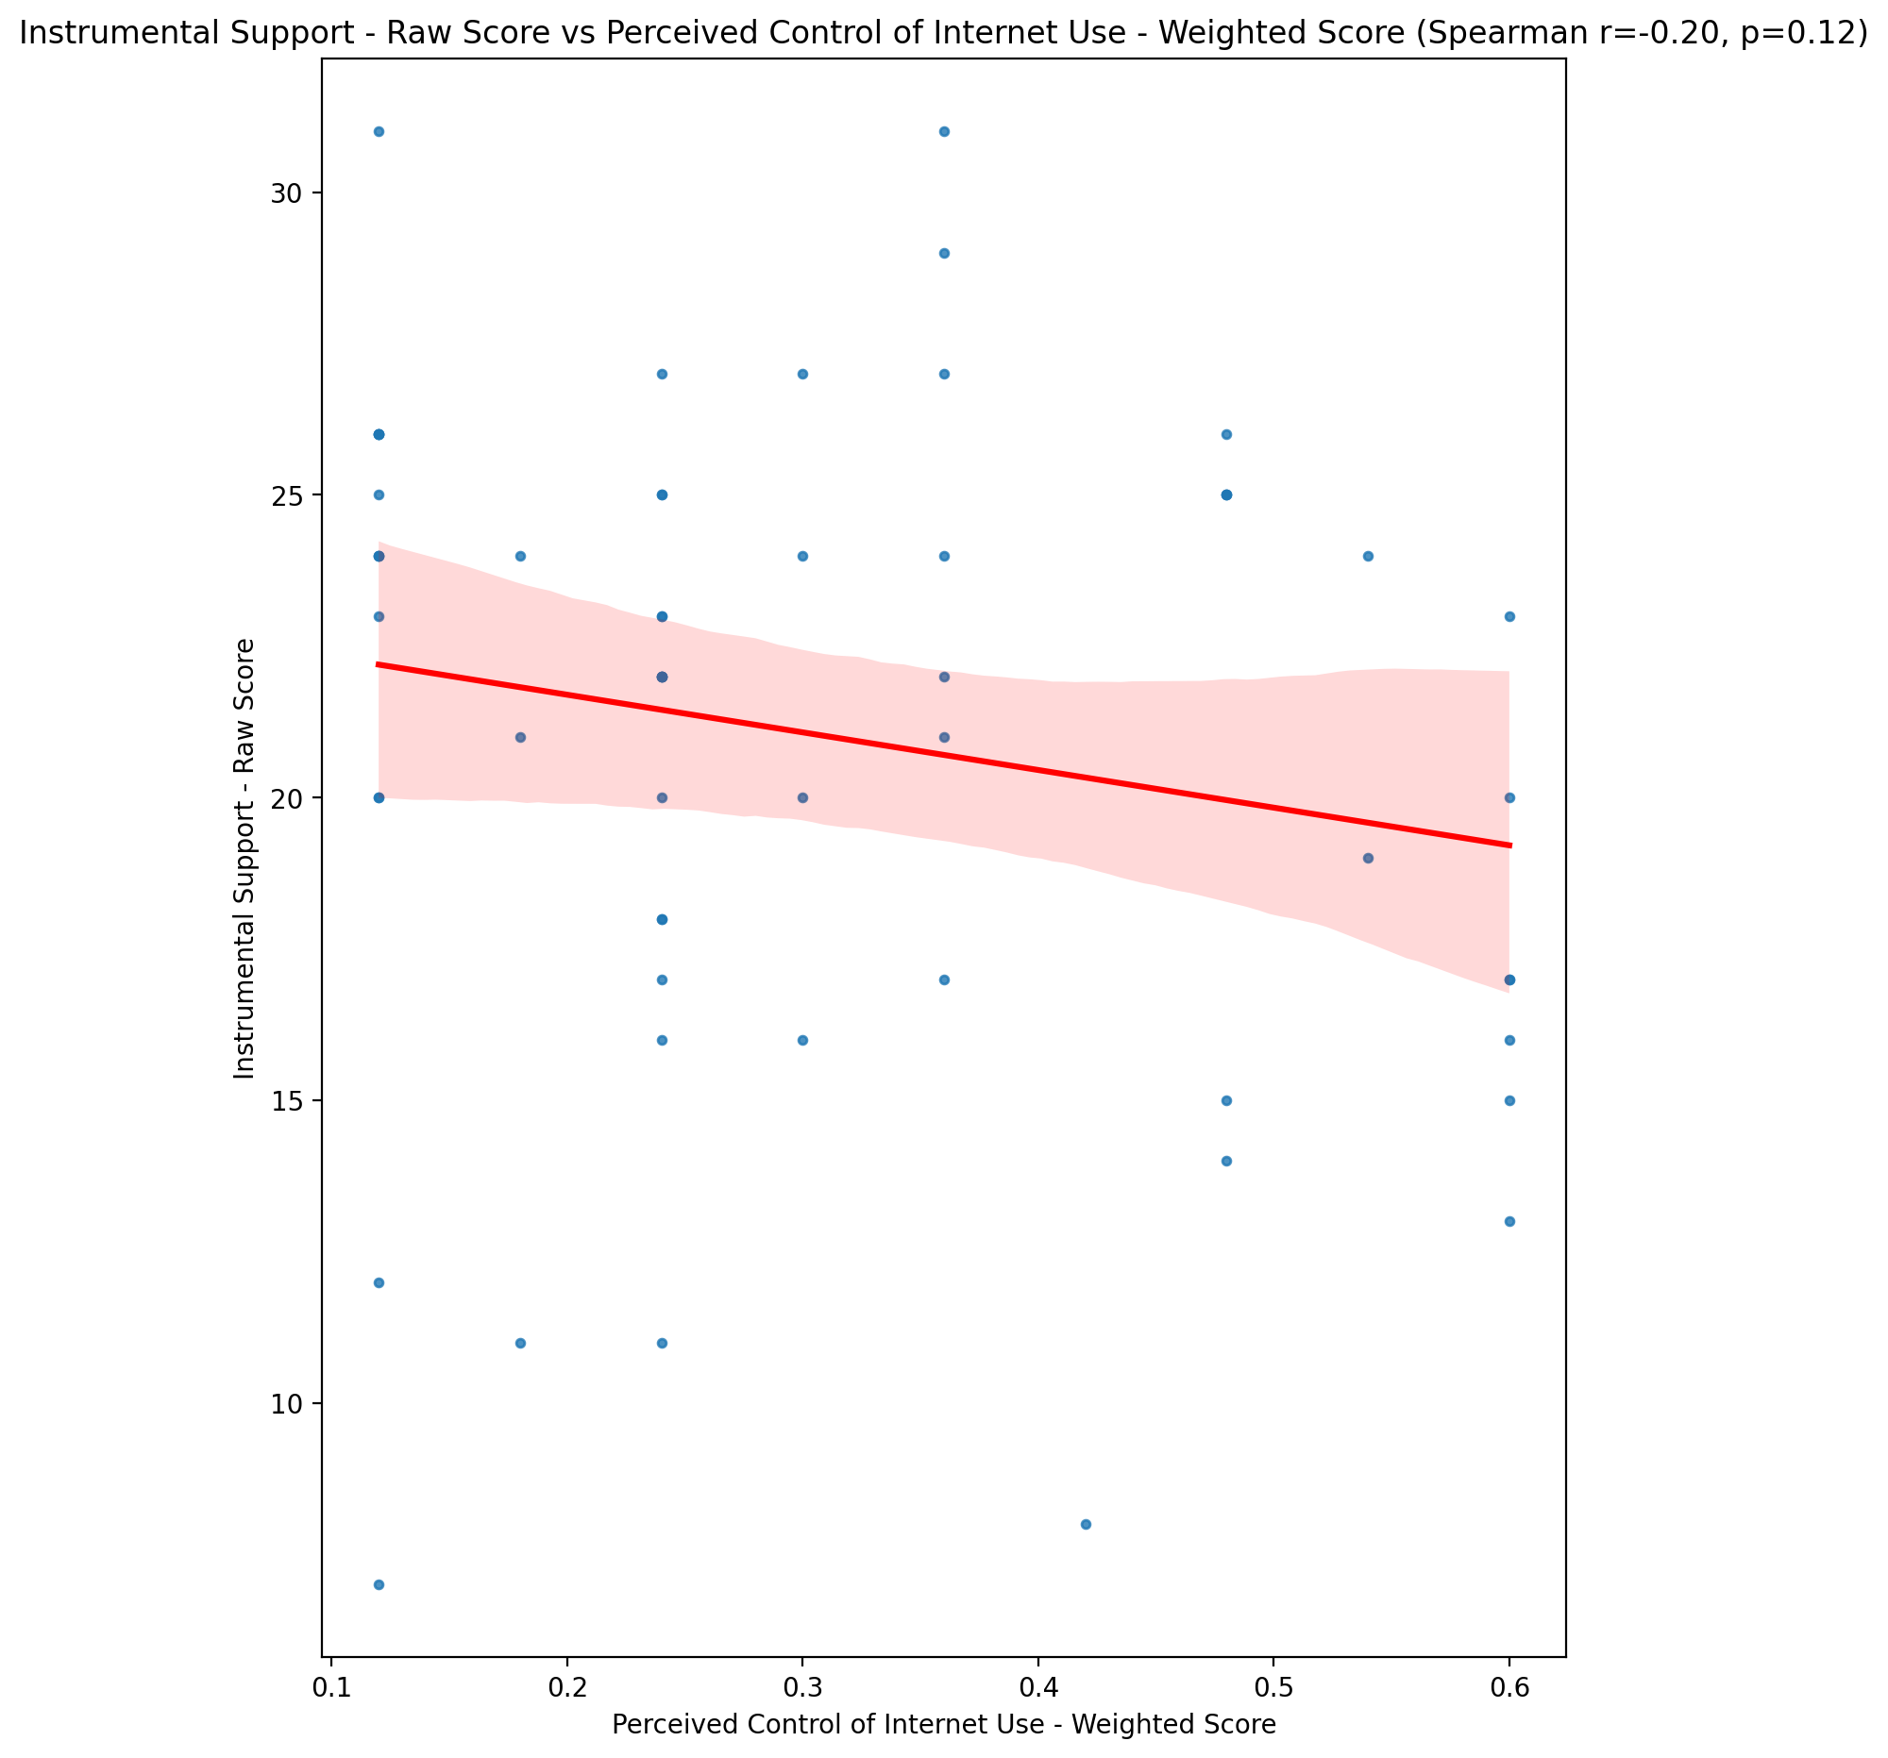

## Emotional Support - T Score vs Perceived Control of Internet Use - Weighted Score

Test: spearman; statistic: -0.0789281409632302; p-value: 0.5523682053453591;

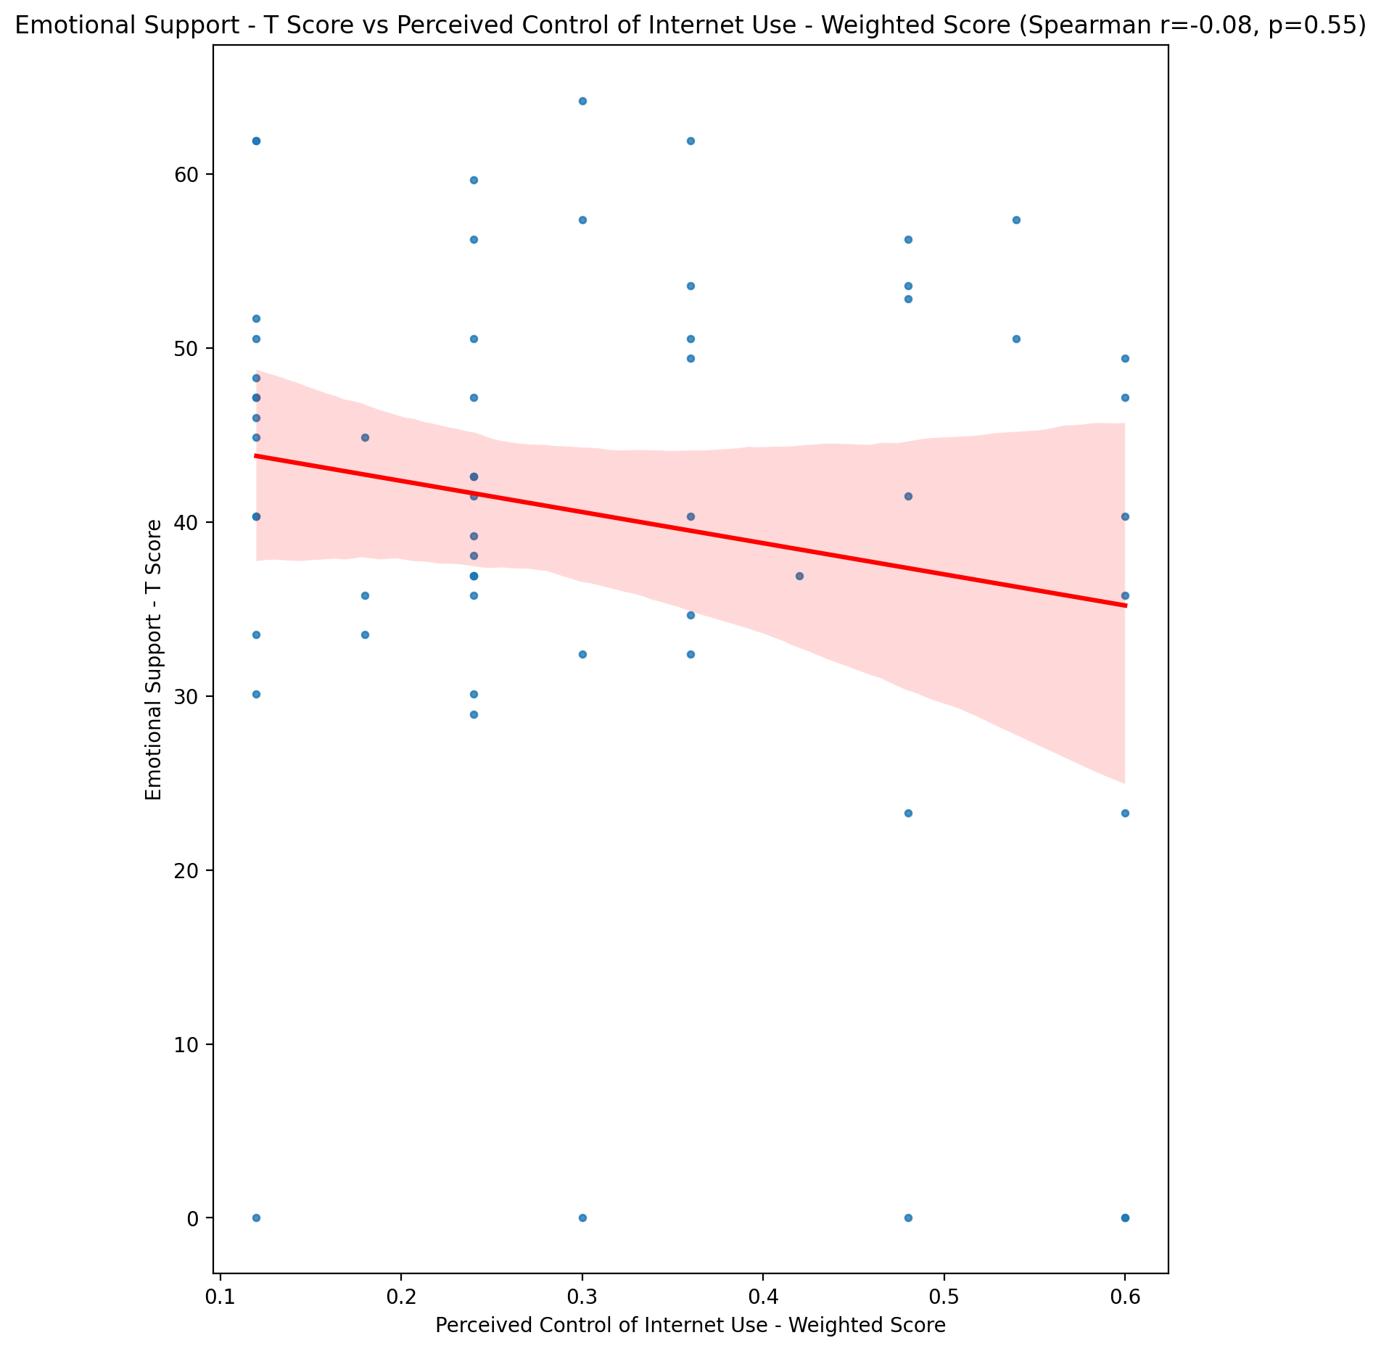

## Informational Support - T Score vs Perceived Control of Internet Use - Weighted Score

Test: spearman; statistic: -0.11227199573515625; p-value: 0.39721404018894124;

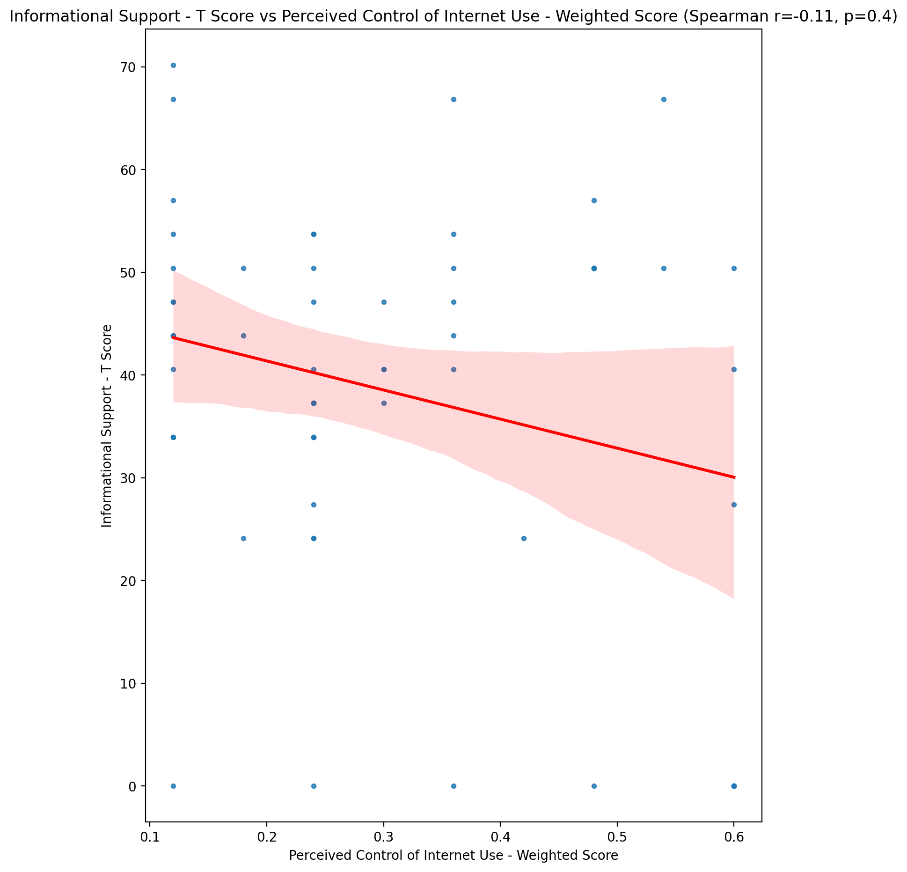

## Instrumental Support - T Score vs Perceived Control of Internet Use - Weighted Score

Test: spearman; statistic: -0.20828441539506717; p-value: 0.11341041744540499;

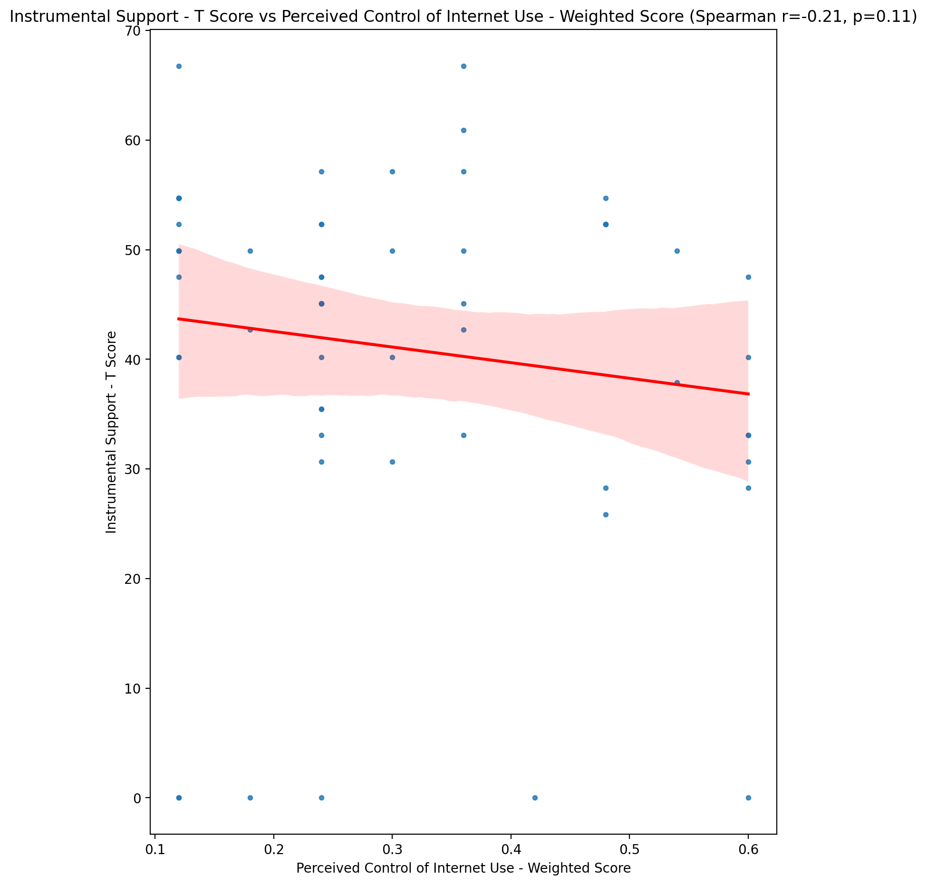

## Perceived Social Support Total T Score vs Perceived Control of Internet Use - Weighted Score

Test: spearman; statistic: -0.14775536569099668; p-value: 0.26408391269734005;

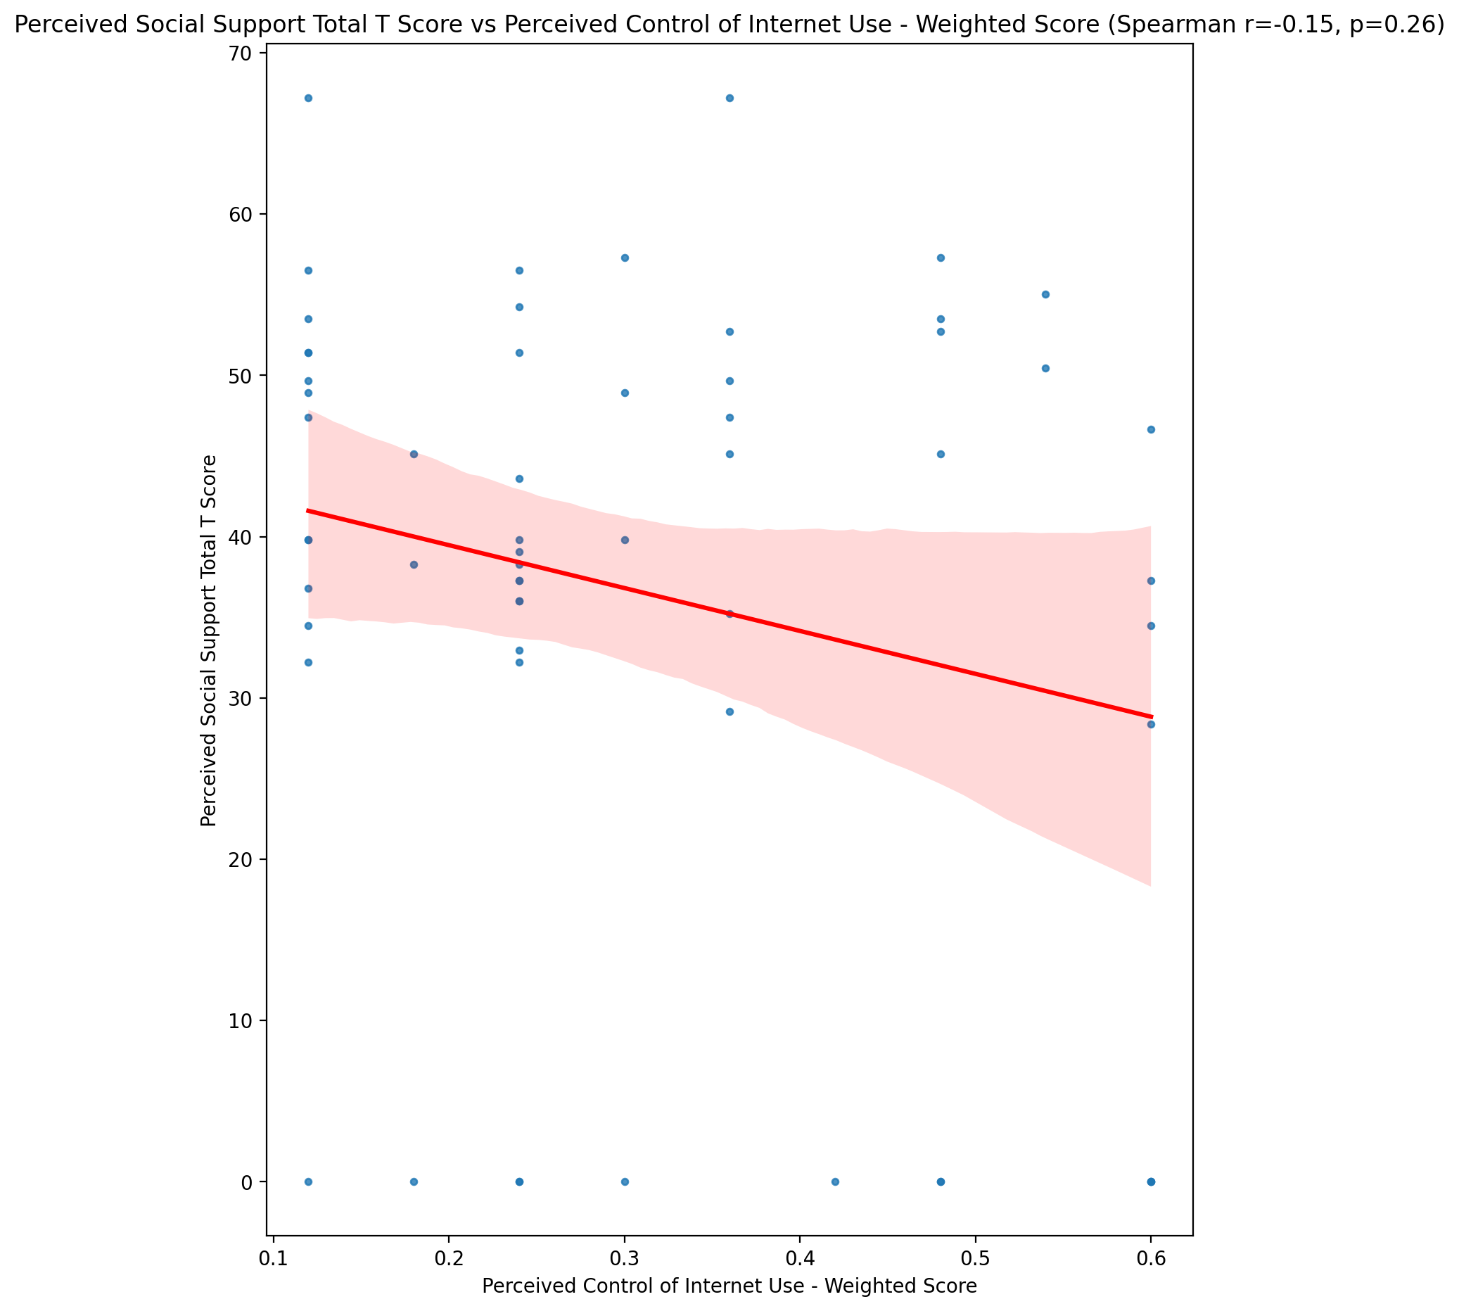

## Emotional Support - Rank vs Perceived Control of Internet Use - Weighted Score

Test: None; statistic: None; p-value: None; Test not run: unsupported type combination.



## Informational Support - Rank vs Perceived Control of Internet Use - Weighted Score

Test: None; statistic: None; p-value: None; Test not run: unsupported type combination.



## Instrumental Support - Rank vs Perceived Control of Internet Use - Weighted Score

Test: None; statistic: None; p-value: None; Test not run: unsupported type combination.



## Perceived Social Support TOTAL - Rank vs Perceived Control of Internet Use - Weighted Score

Test: None; statistic: None; p-value: None; Test not run: unsupported type combination.



## Power Self Concept - Real Self Concept Score vs Perceived Control of Internet Use - Weighted Score

Test: spearman; statistic: 0.21719719031569593; p-value: 0.0984491436268585;

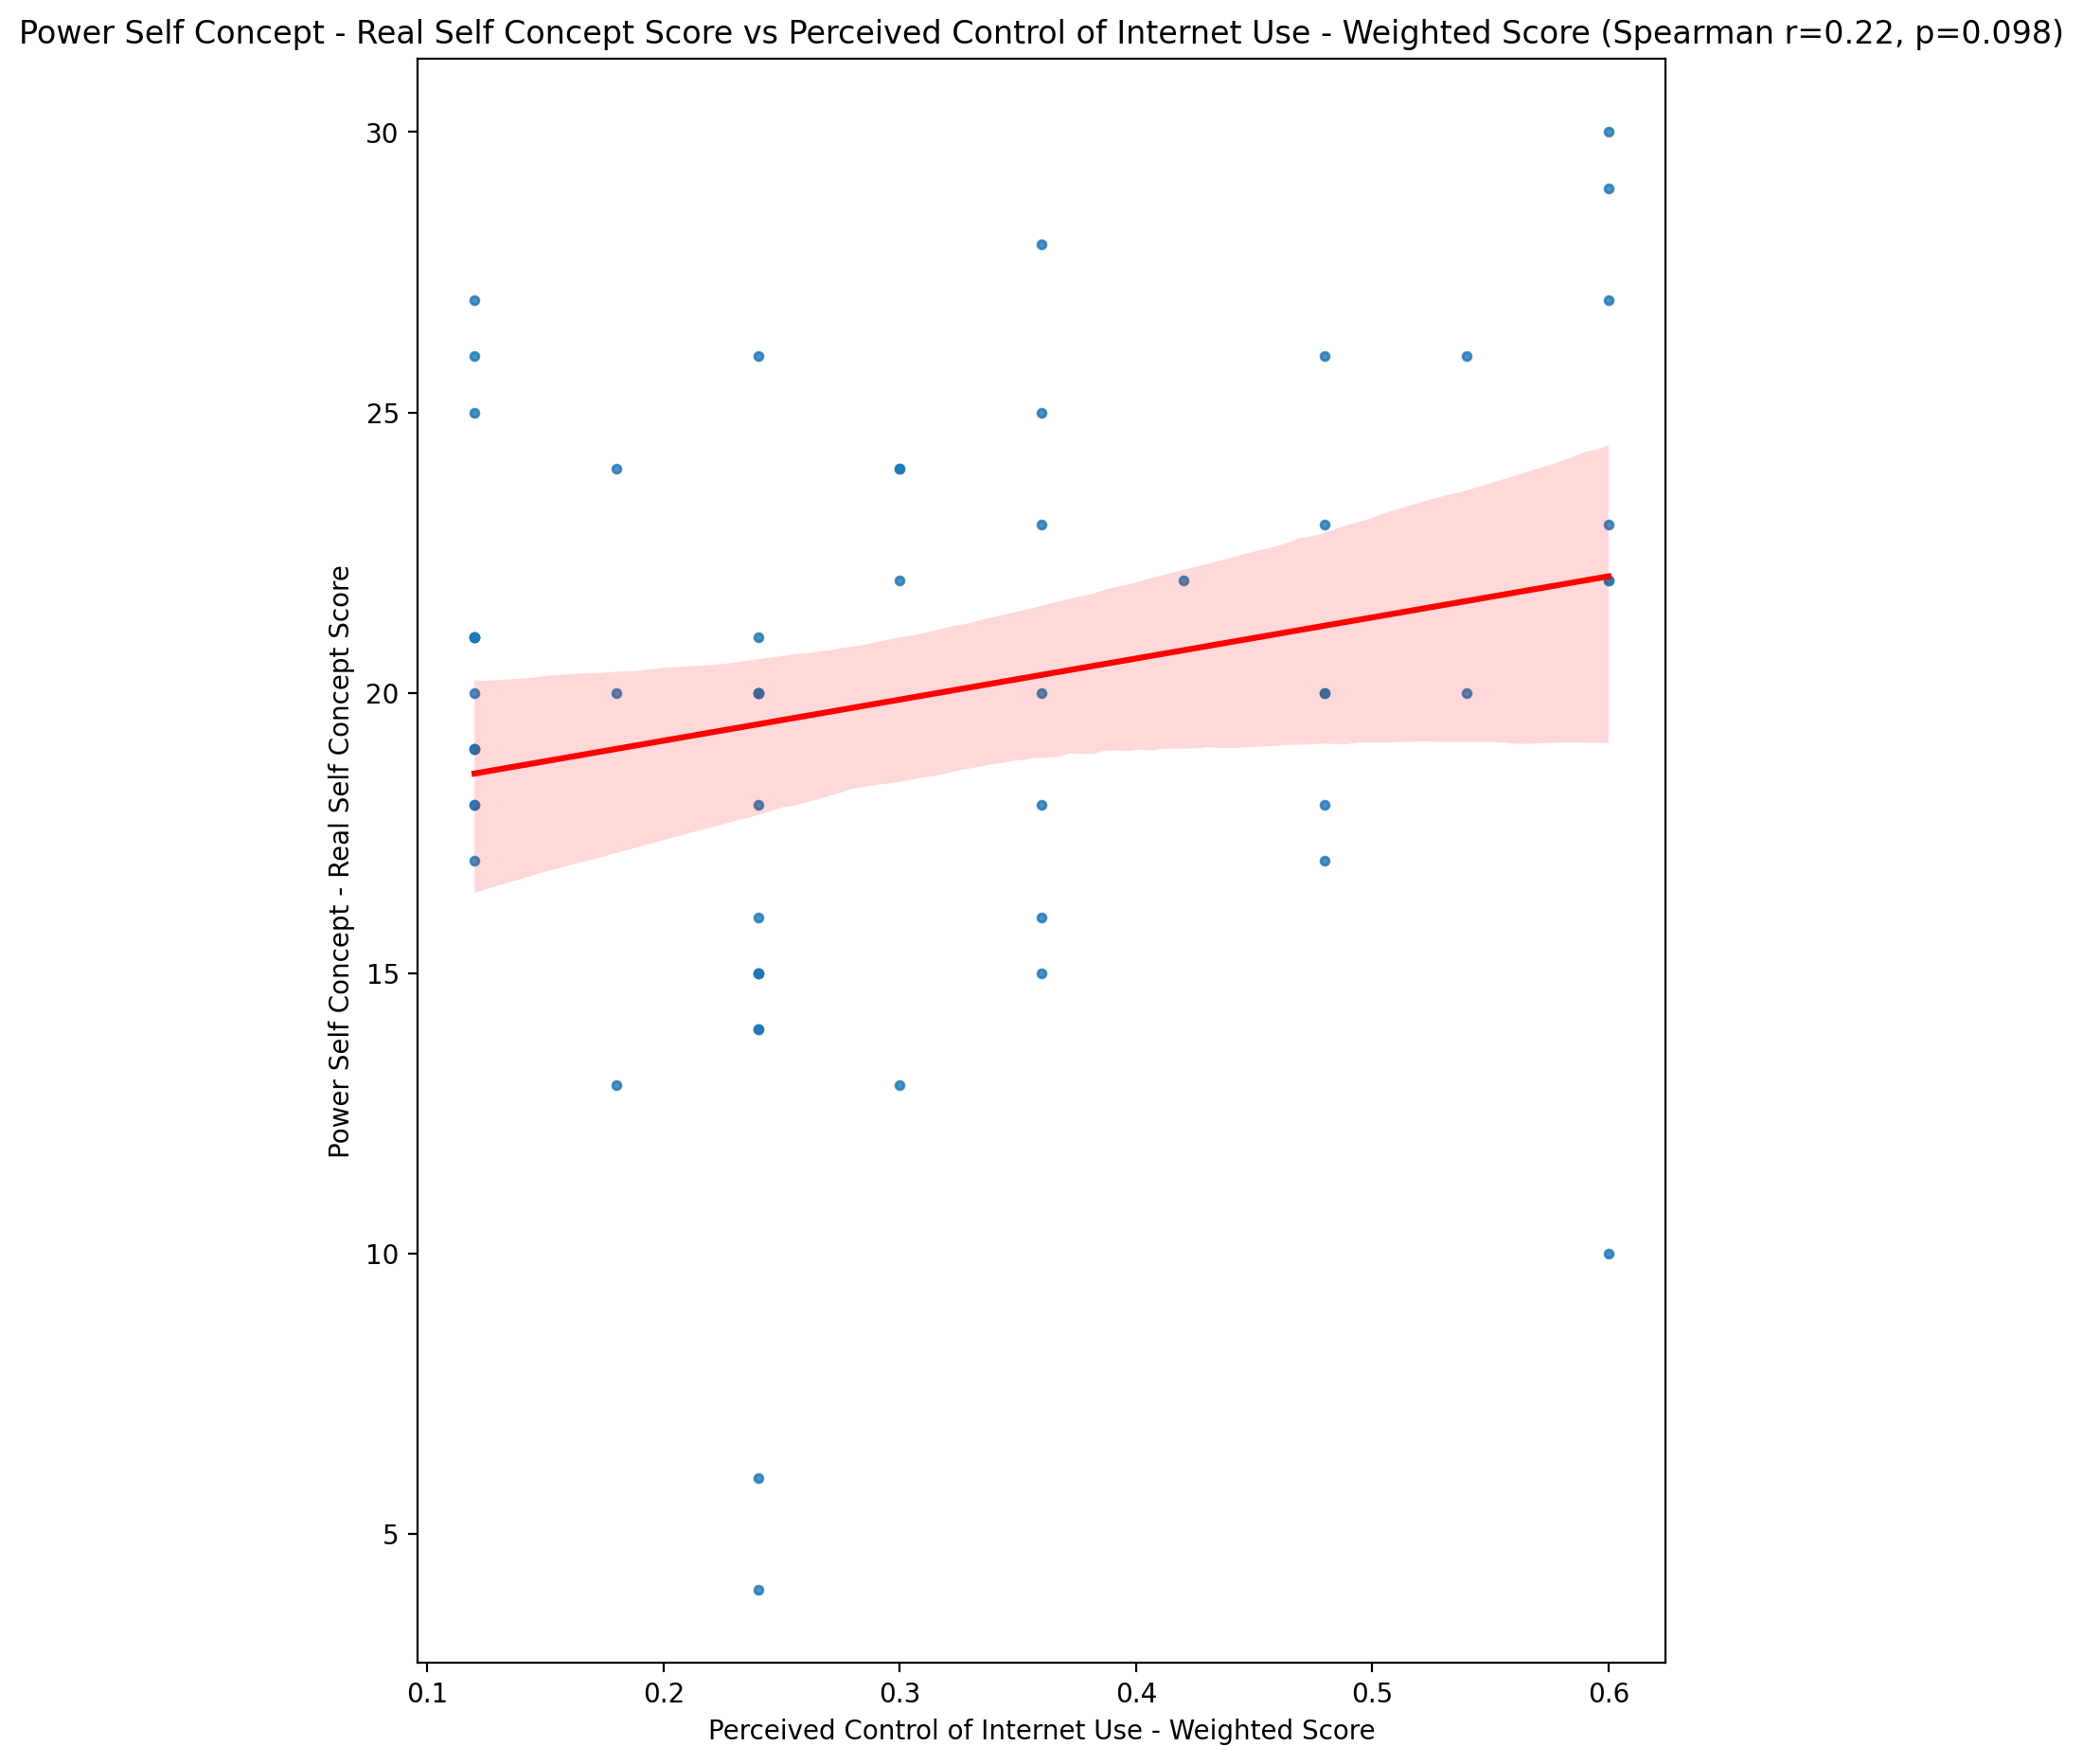

## Power Self Concept - Ideal Self Concept score vs Perceived Control of Internet Use - Weighted Score

Test: spearman; statistic: 0.19806938414080238; p-value: 0.13263535035403487;

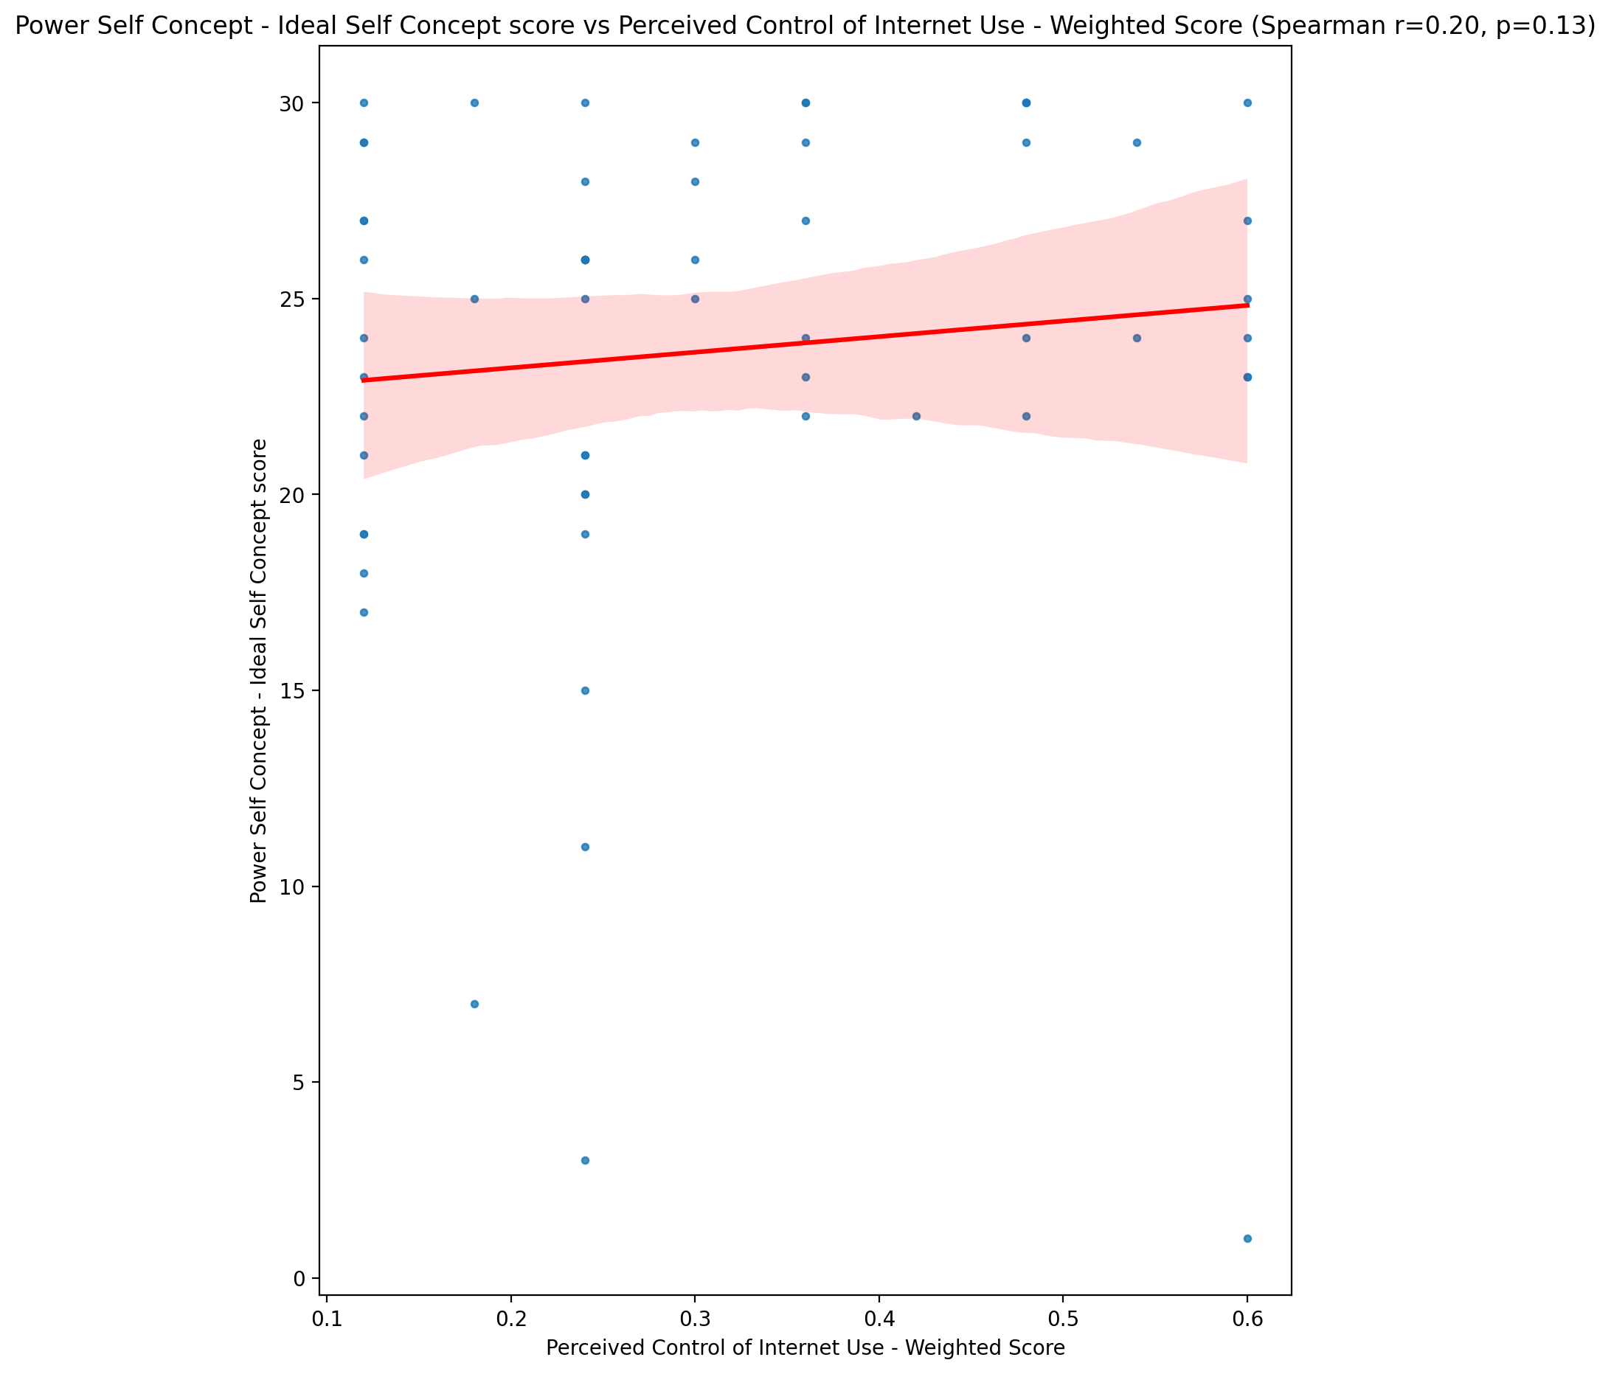

## Power Self Concept – Social Self Concept Score vs Perceived Control of Internet Use - Weighted Score

Test: spearman; statistic: 0.1934583305621347; p-value: 0.14207802817154372;

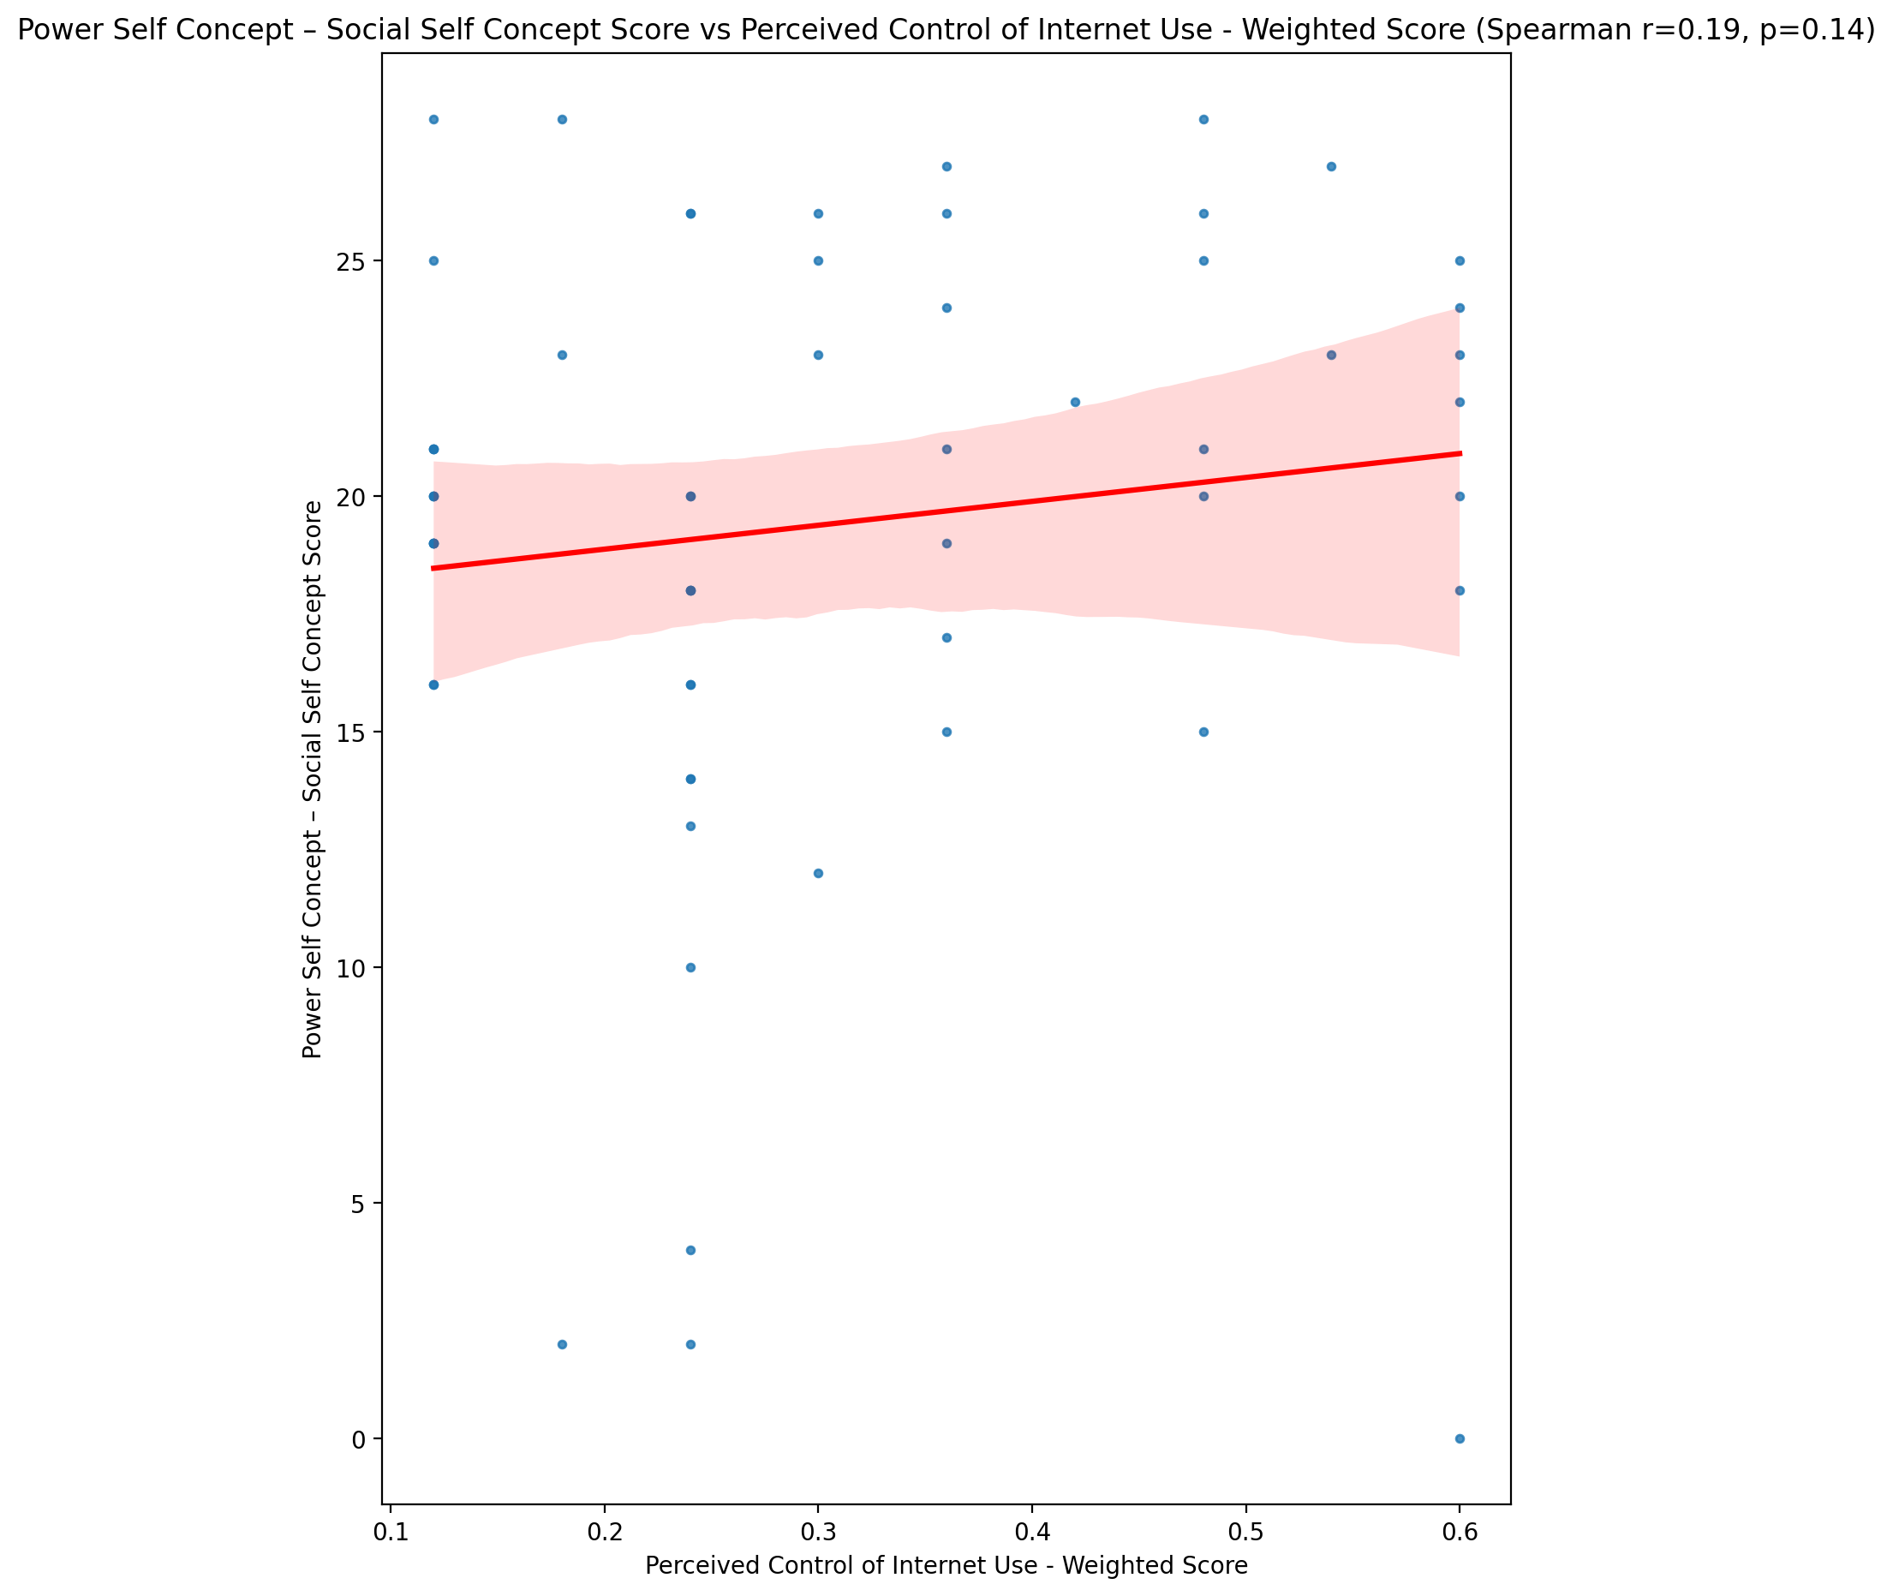

## Social Self Concept - Real Self Concept Score vs Perceived Control of Internet Use - Weighted Score

Test: spearman; statistic: 0.06177898268828461; p-value: 0.6420570444118925;

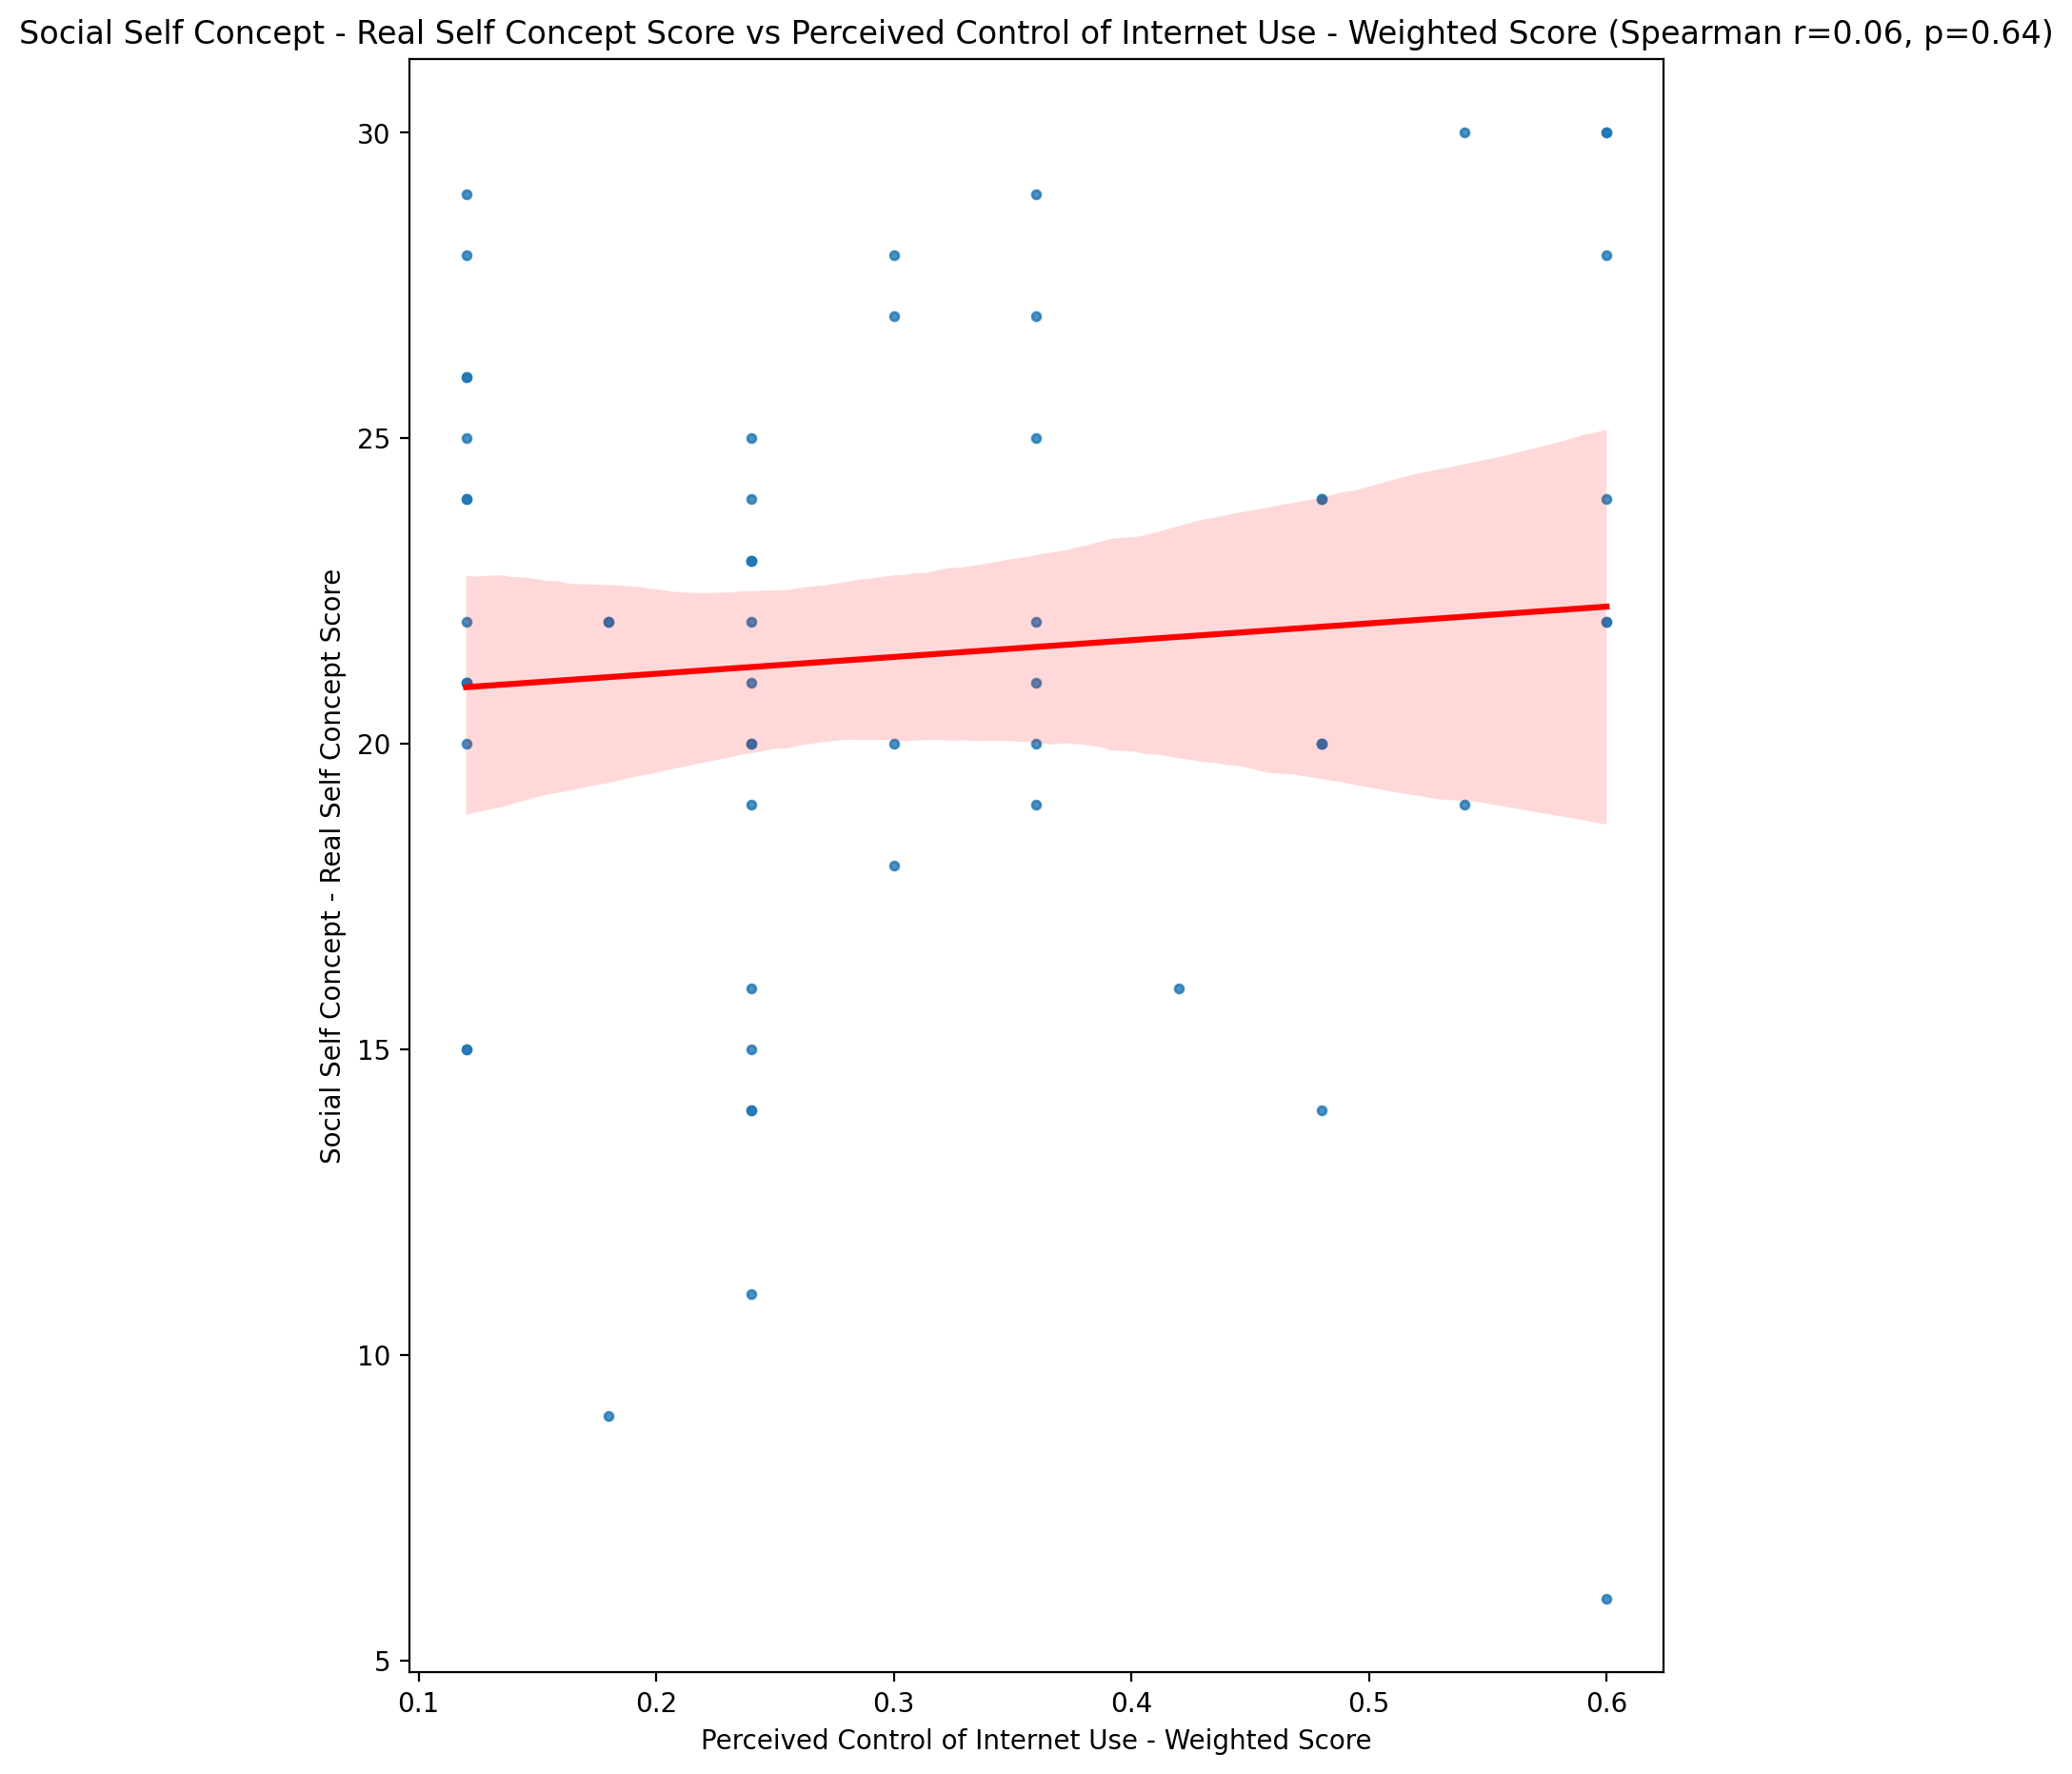

## Social Self Concept – Social Self Concept Score vs Perceived Control of Internet Use - Weighted Score

Test: spearman; statistic: 0.0754297359265798; p-value: 0.5701707330635212;

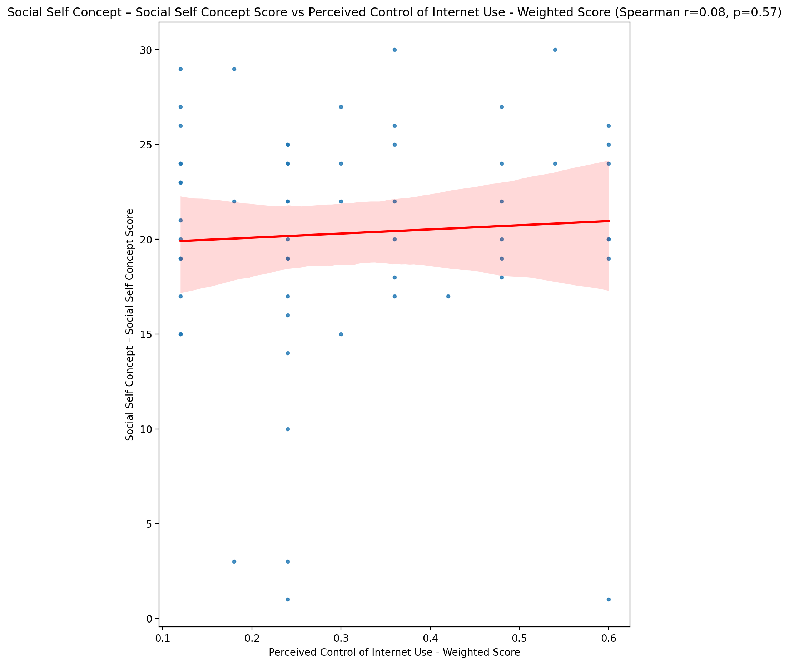

## Ability Self Concept - Real Self Concept Score vs Perceived Control of Internet Use - Weighted Score

Test: spearman; statistic: 0.11303226895632594; p-value: 0.3940047540117657;

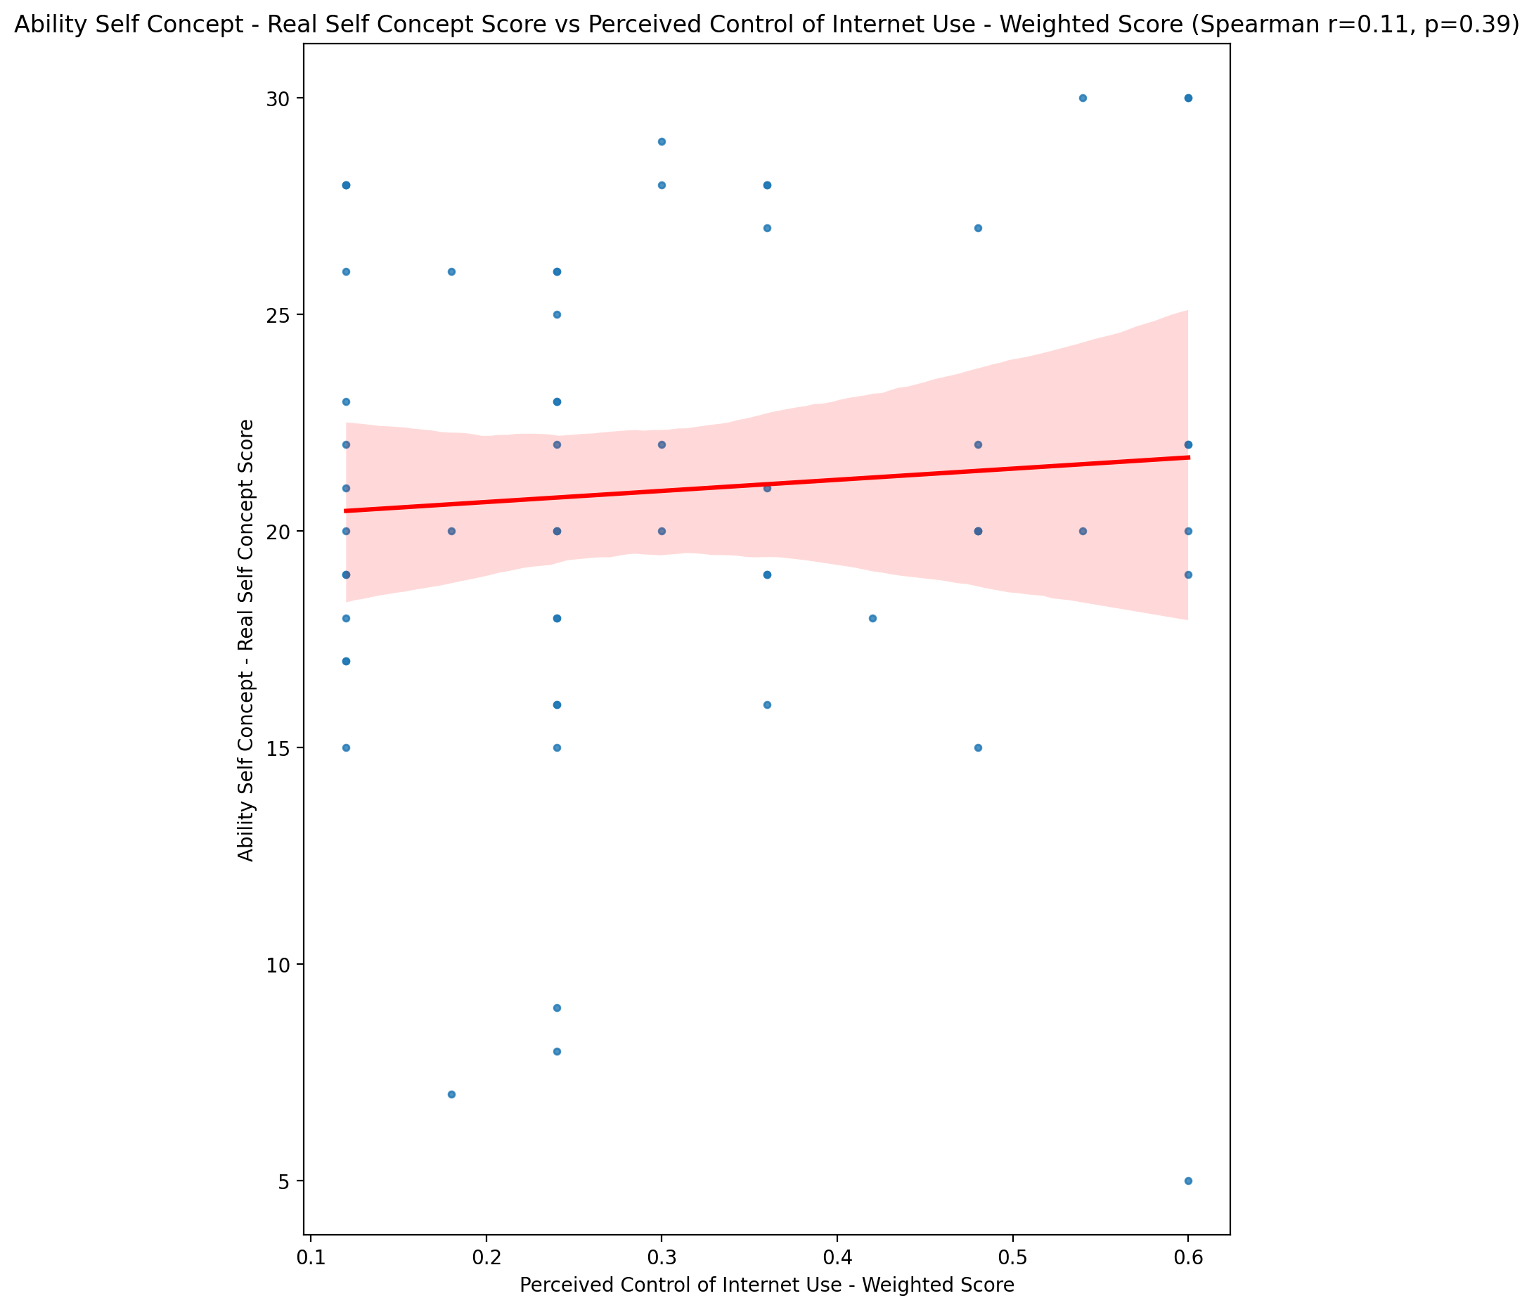

## Ability Self Concept - Ideal Self Concept Score vs Perceived Control of Internet Use - Weighted Score

Test: spearman; statistic: 0.14463180669301687; p-value: 0.2744258571398722;

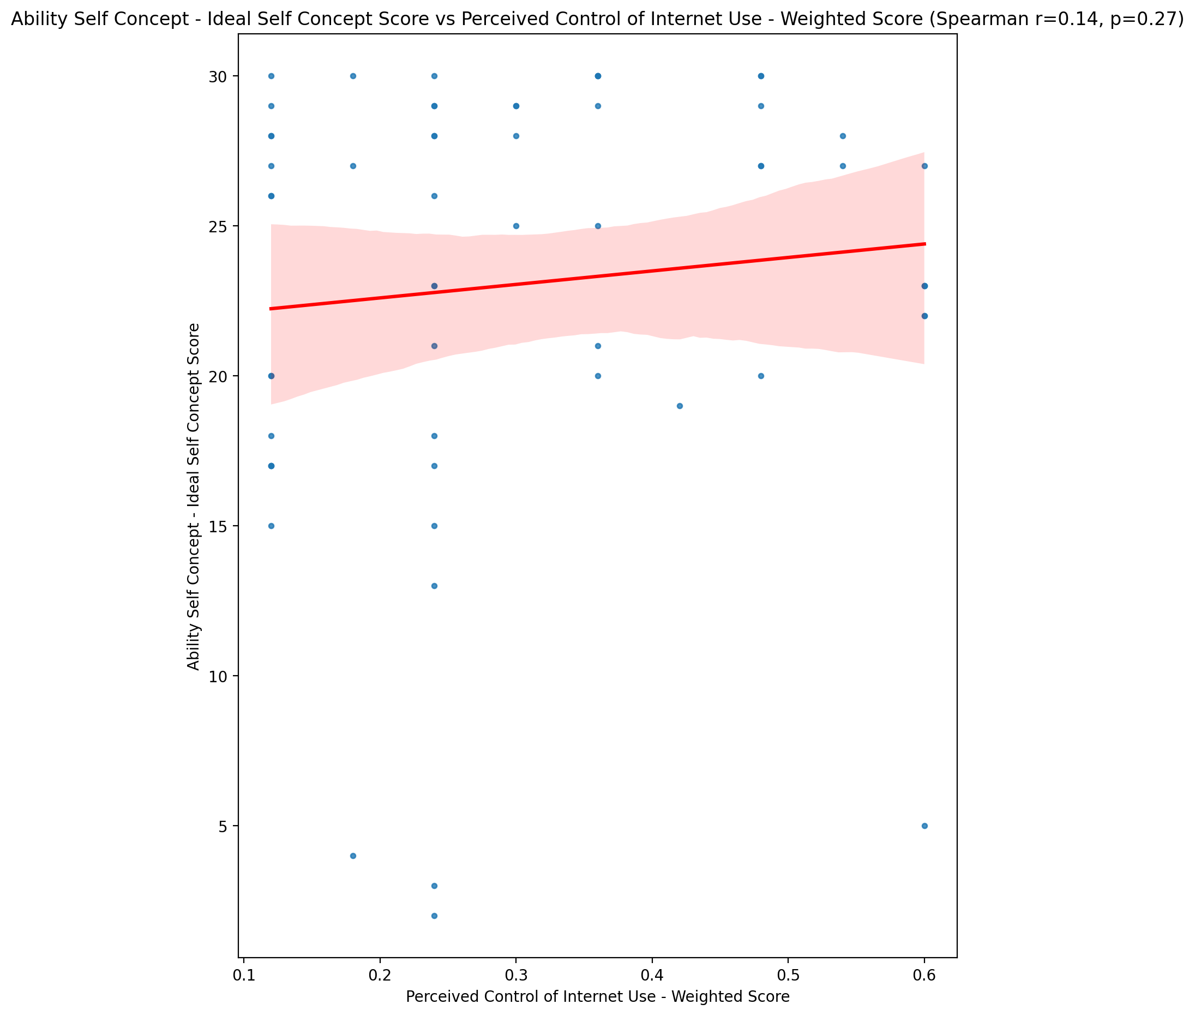

## Ability Self Concept – Social Self Concept Score vs Perceived Control of Internet Use - Weighted Score

Test: spearman; statistic: 0.02808389710294041; p-value: 0.8327759917942923;

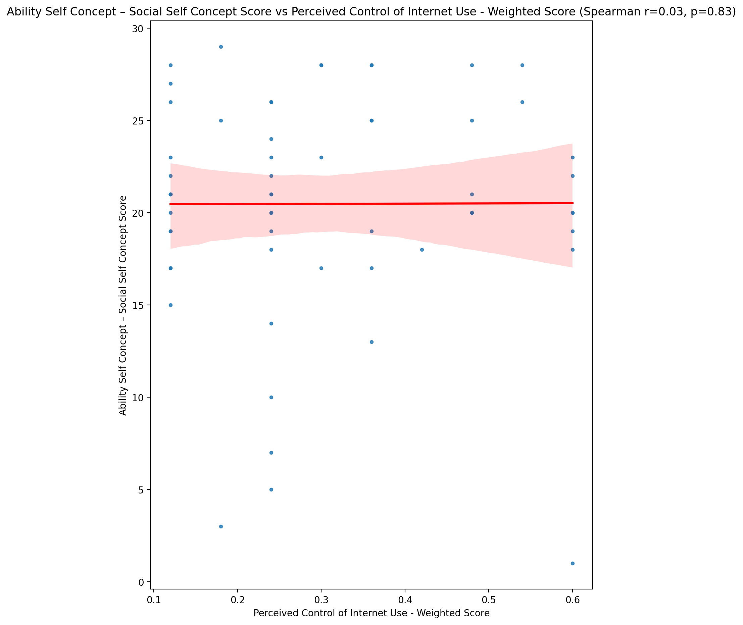

## Physical Self Concept - Real Self Concept Score vs Perceived Control of Internet Use - Weighted Score

Test: spearman; statistic: 0.055756094869296155; p-value: 0.6748990470165812;

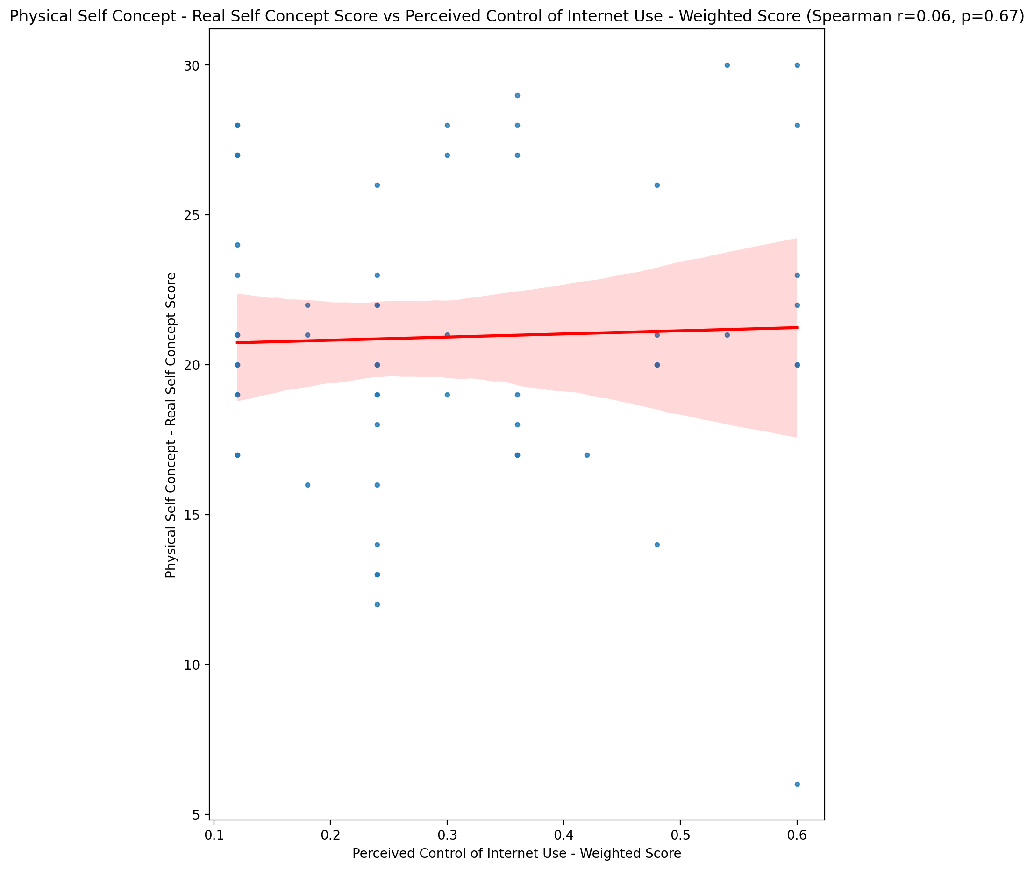

## Physical Self Concept – Ideal Self Concept Score vs Perceived Control of Internet Use - Weighted Score

Test: spearman; statistic: 0.14645038073921304; p-value: 0.26837237512644224;

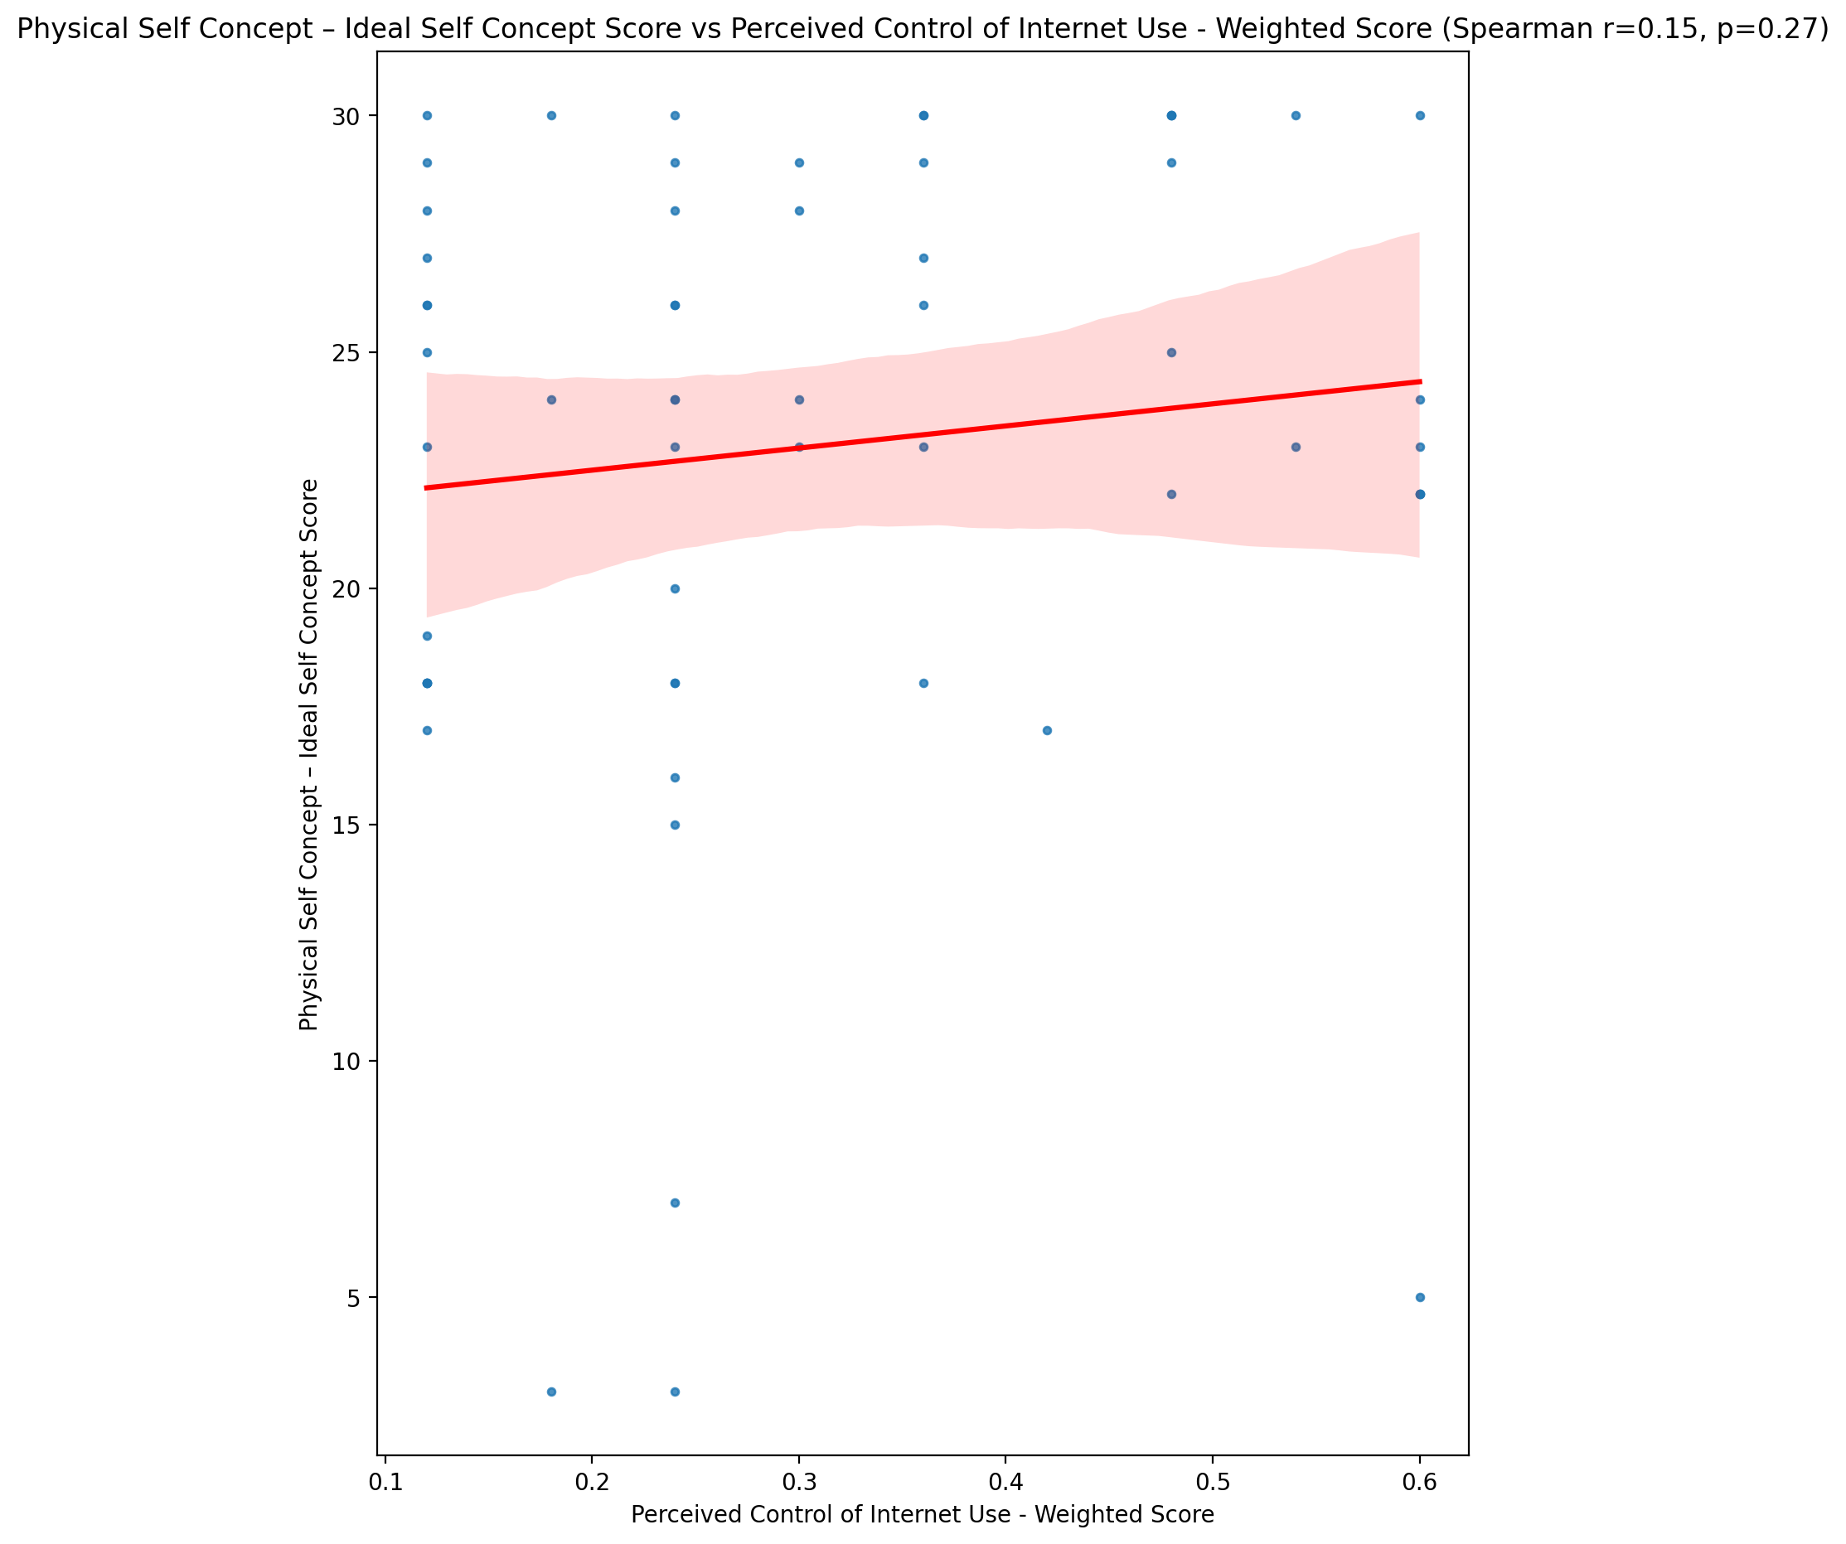

## Physical Self Concept – Social Self Concept Score vs Perceived Control of Internet Use - Weighted Score

Test: spearman; statistic: 0.0211170161675364; p-value: 0.8738658317937458;

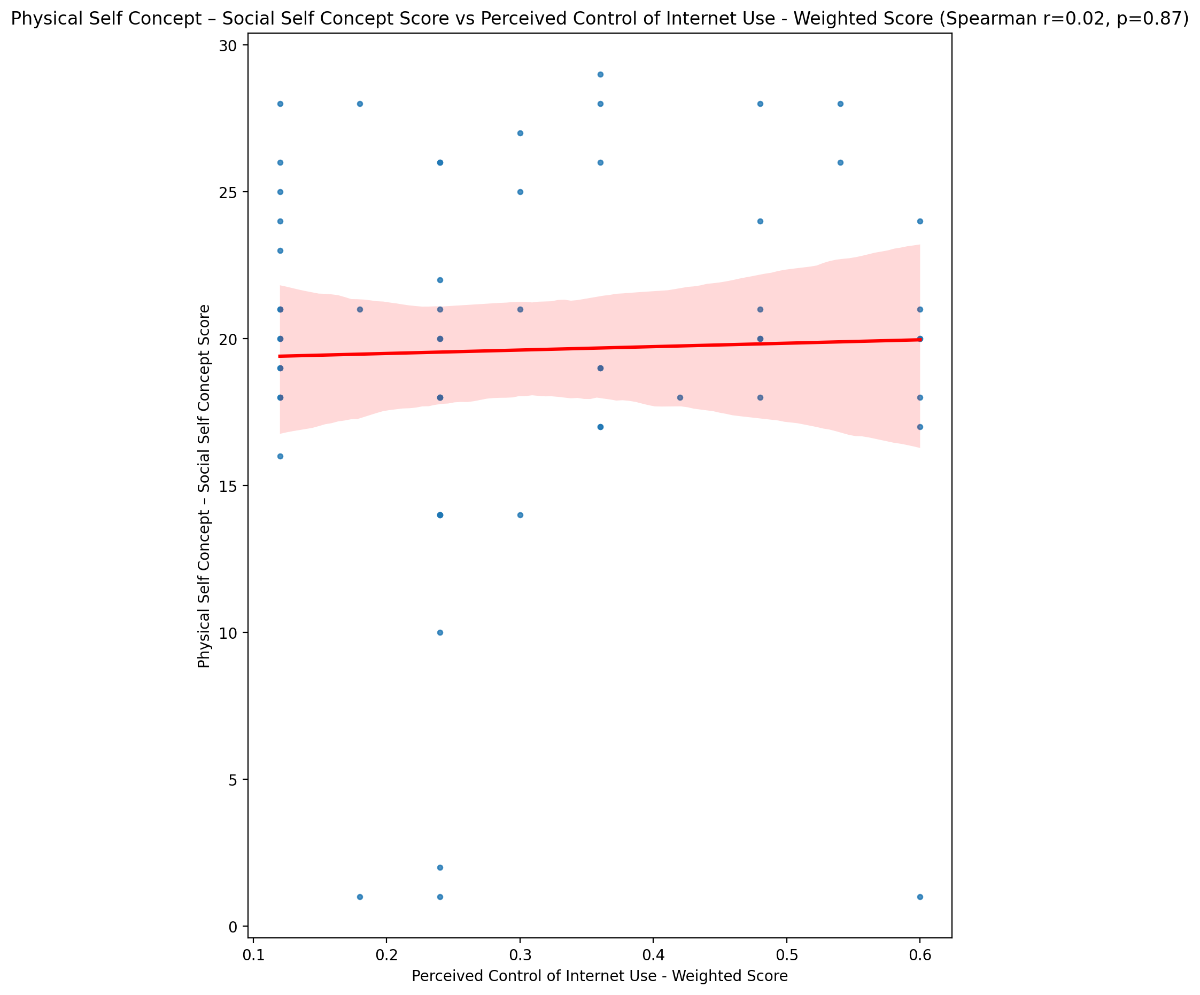

## Psychological Self Concept - Real Self Concept Score vs Perceived Control of Internet Use - Weighted Score

Test: spearman; statistic: 0.16263545620515182; p-value: 0.21843083193841548;

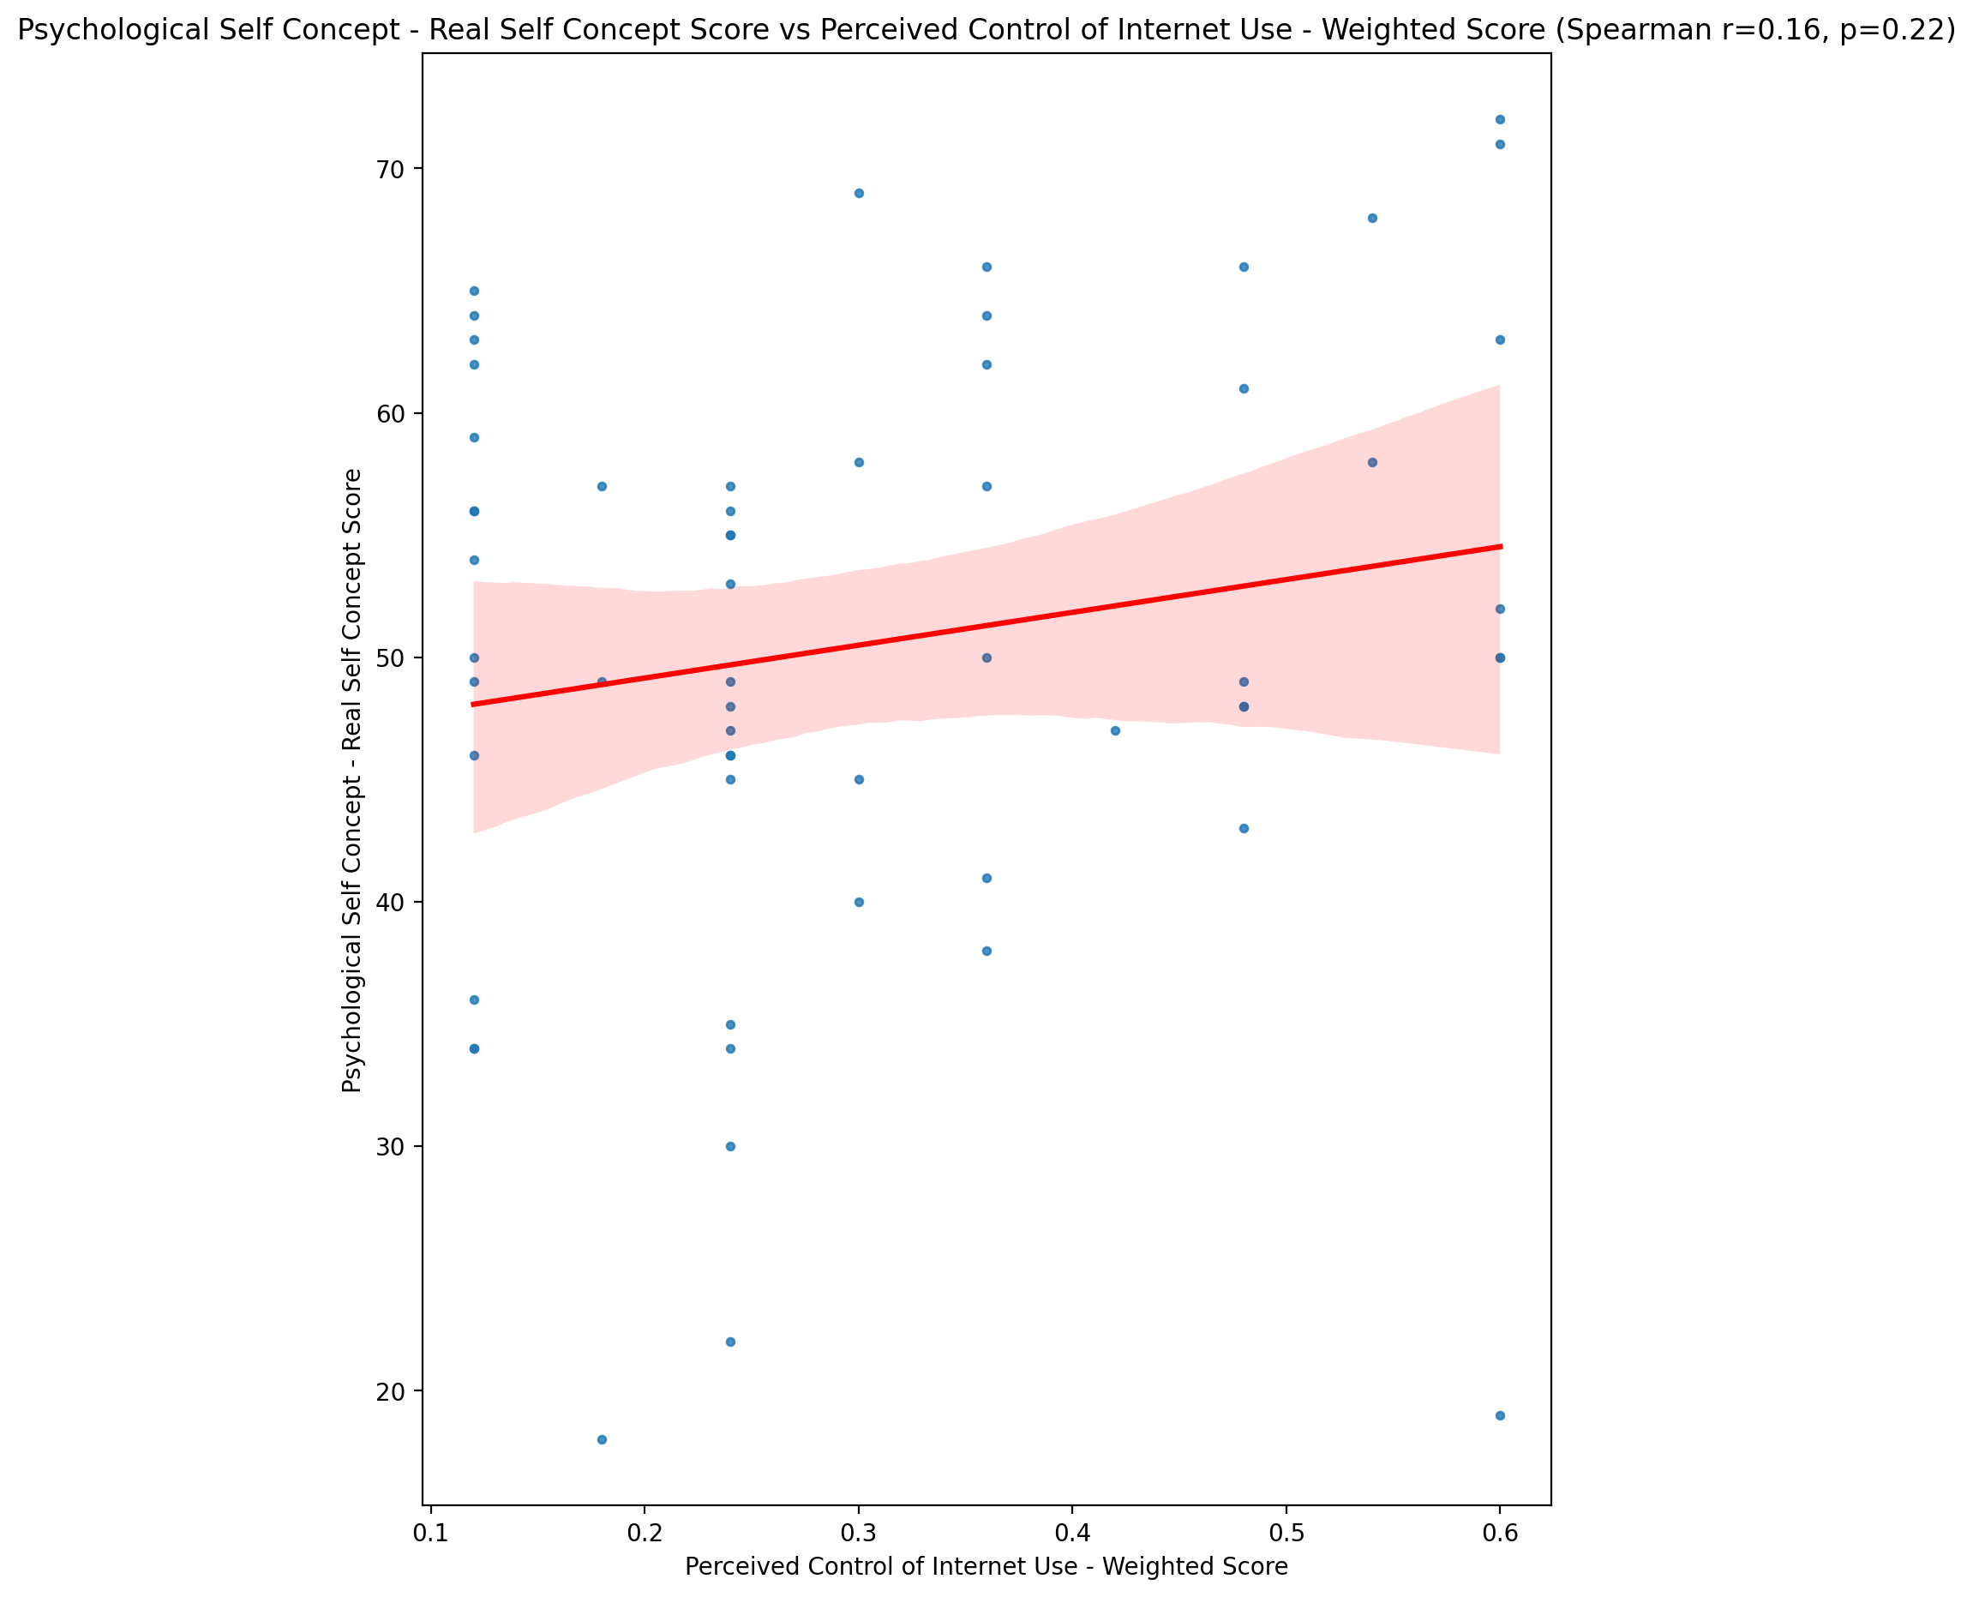

## Psychological Self Concept – Ideal Self Concept Score vs Perceived Control of Internet Use - Weighted Score

Test: spearman; statistic: 0.237415182261327; p-value: 0.07020496693657942;

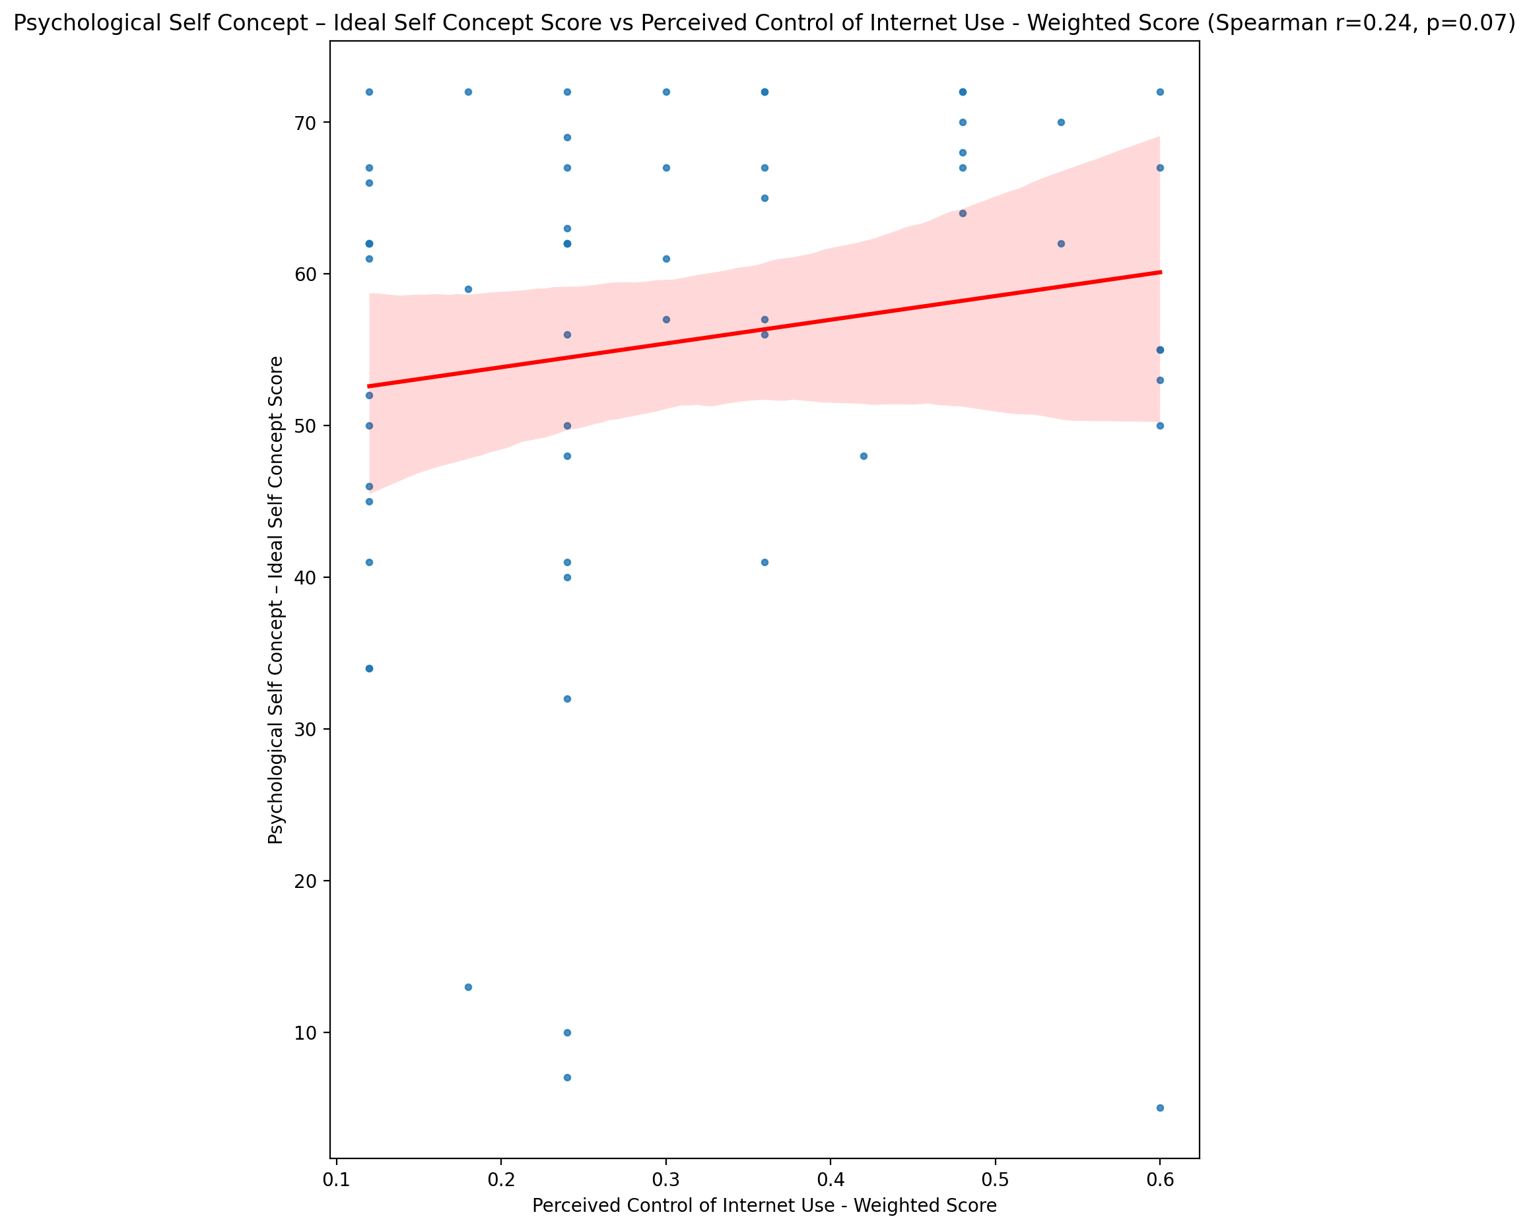

## Psychological Self Concept – Social Self Concept Score vs Perceived Control of Internet Use - Weighted Score

Test: spearman; statistic: 0.11141534539181473; p-value: 0.4008484807924574;

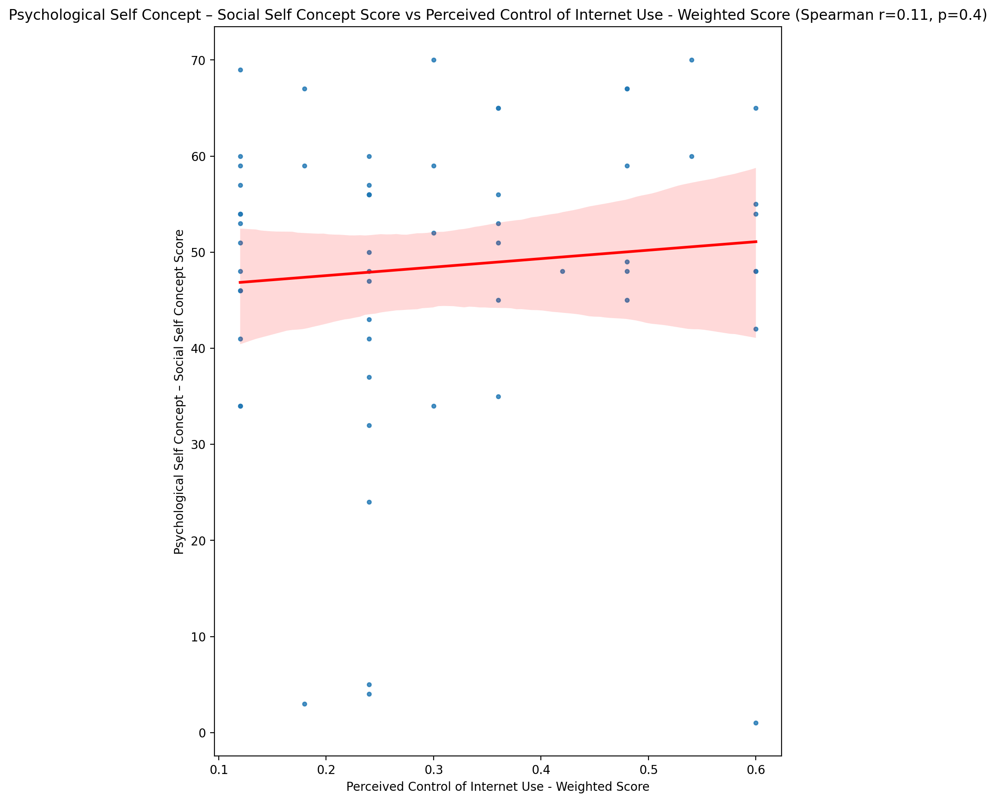

## Real Self Concept Total Score vs Perceived Control of Internet Use - Weighted Score

Test: spearman; statistic: 0.13263145352917213; p-value: 0.3166350385248555;

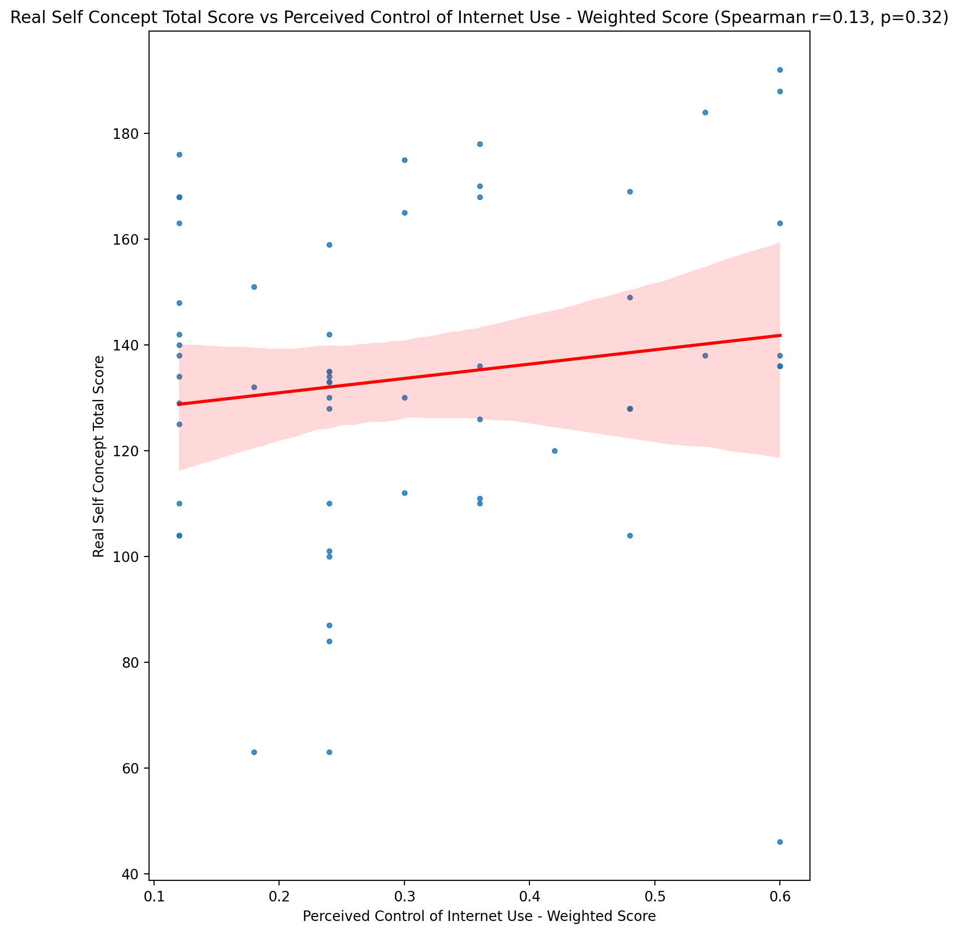

## Ideal Self Concept Total Score vs Perceived Control of Internet Use - Weighted Score

Test: spearman; statistic: 0.1861131455502966; p-value: 0.15814439890476598;

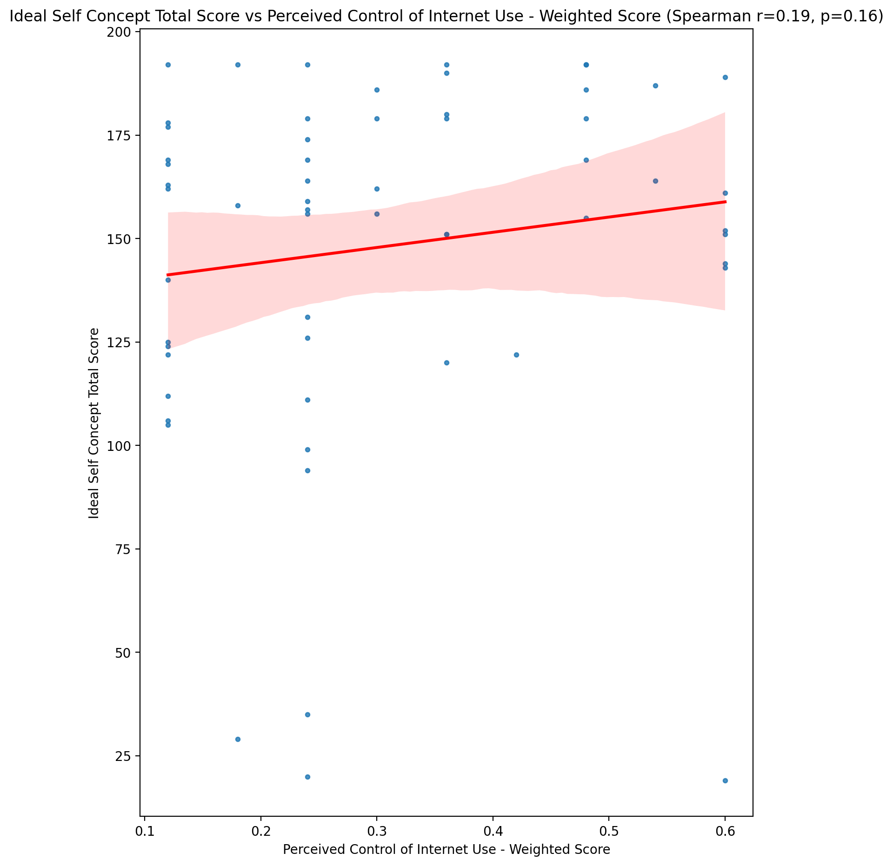

## Social Self Concept Total Score vs Perceived Control of Internet Use - Weighted Score

Test: spearman; statistic: 0.09995231070001613; p-value: 0.4513233794438991;

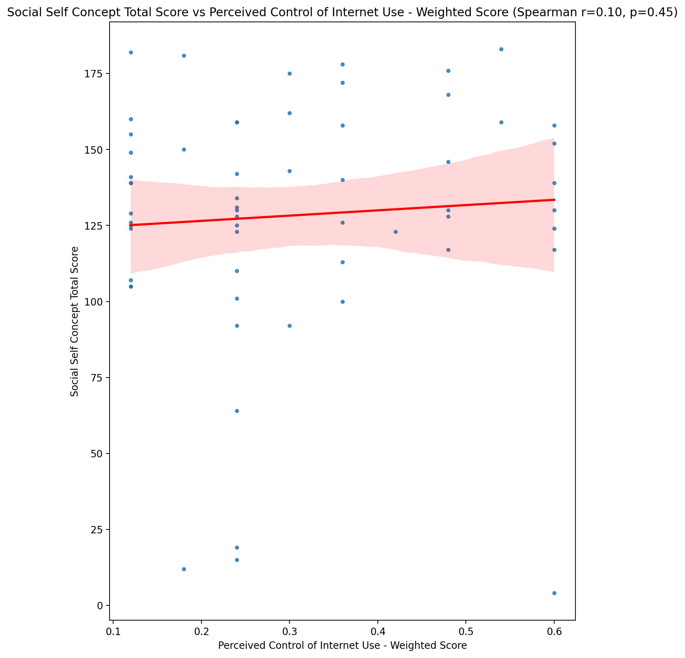

## Ideal Self Concept Total Category vs Perceived Control of Internet Use - Weighted Score

Test: None; statistic: None; p-value: None; Test not run: unsupported type combination.



## Perceived Social Stress Score vs Perceived Control of Internet Use - Weighted Score

Test: spearman; statistic: 0.1717491922386978; p-value: 0.19336337975766416;

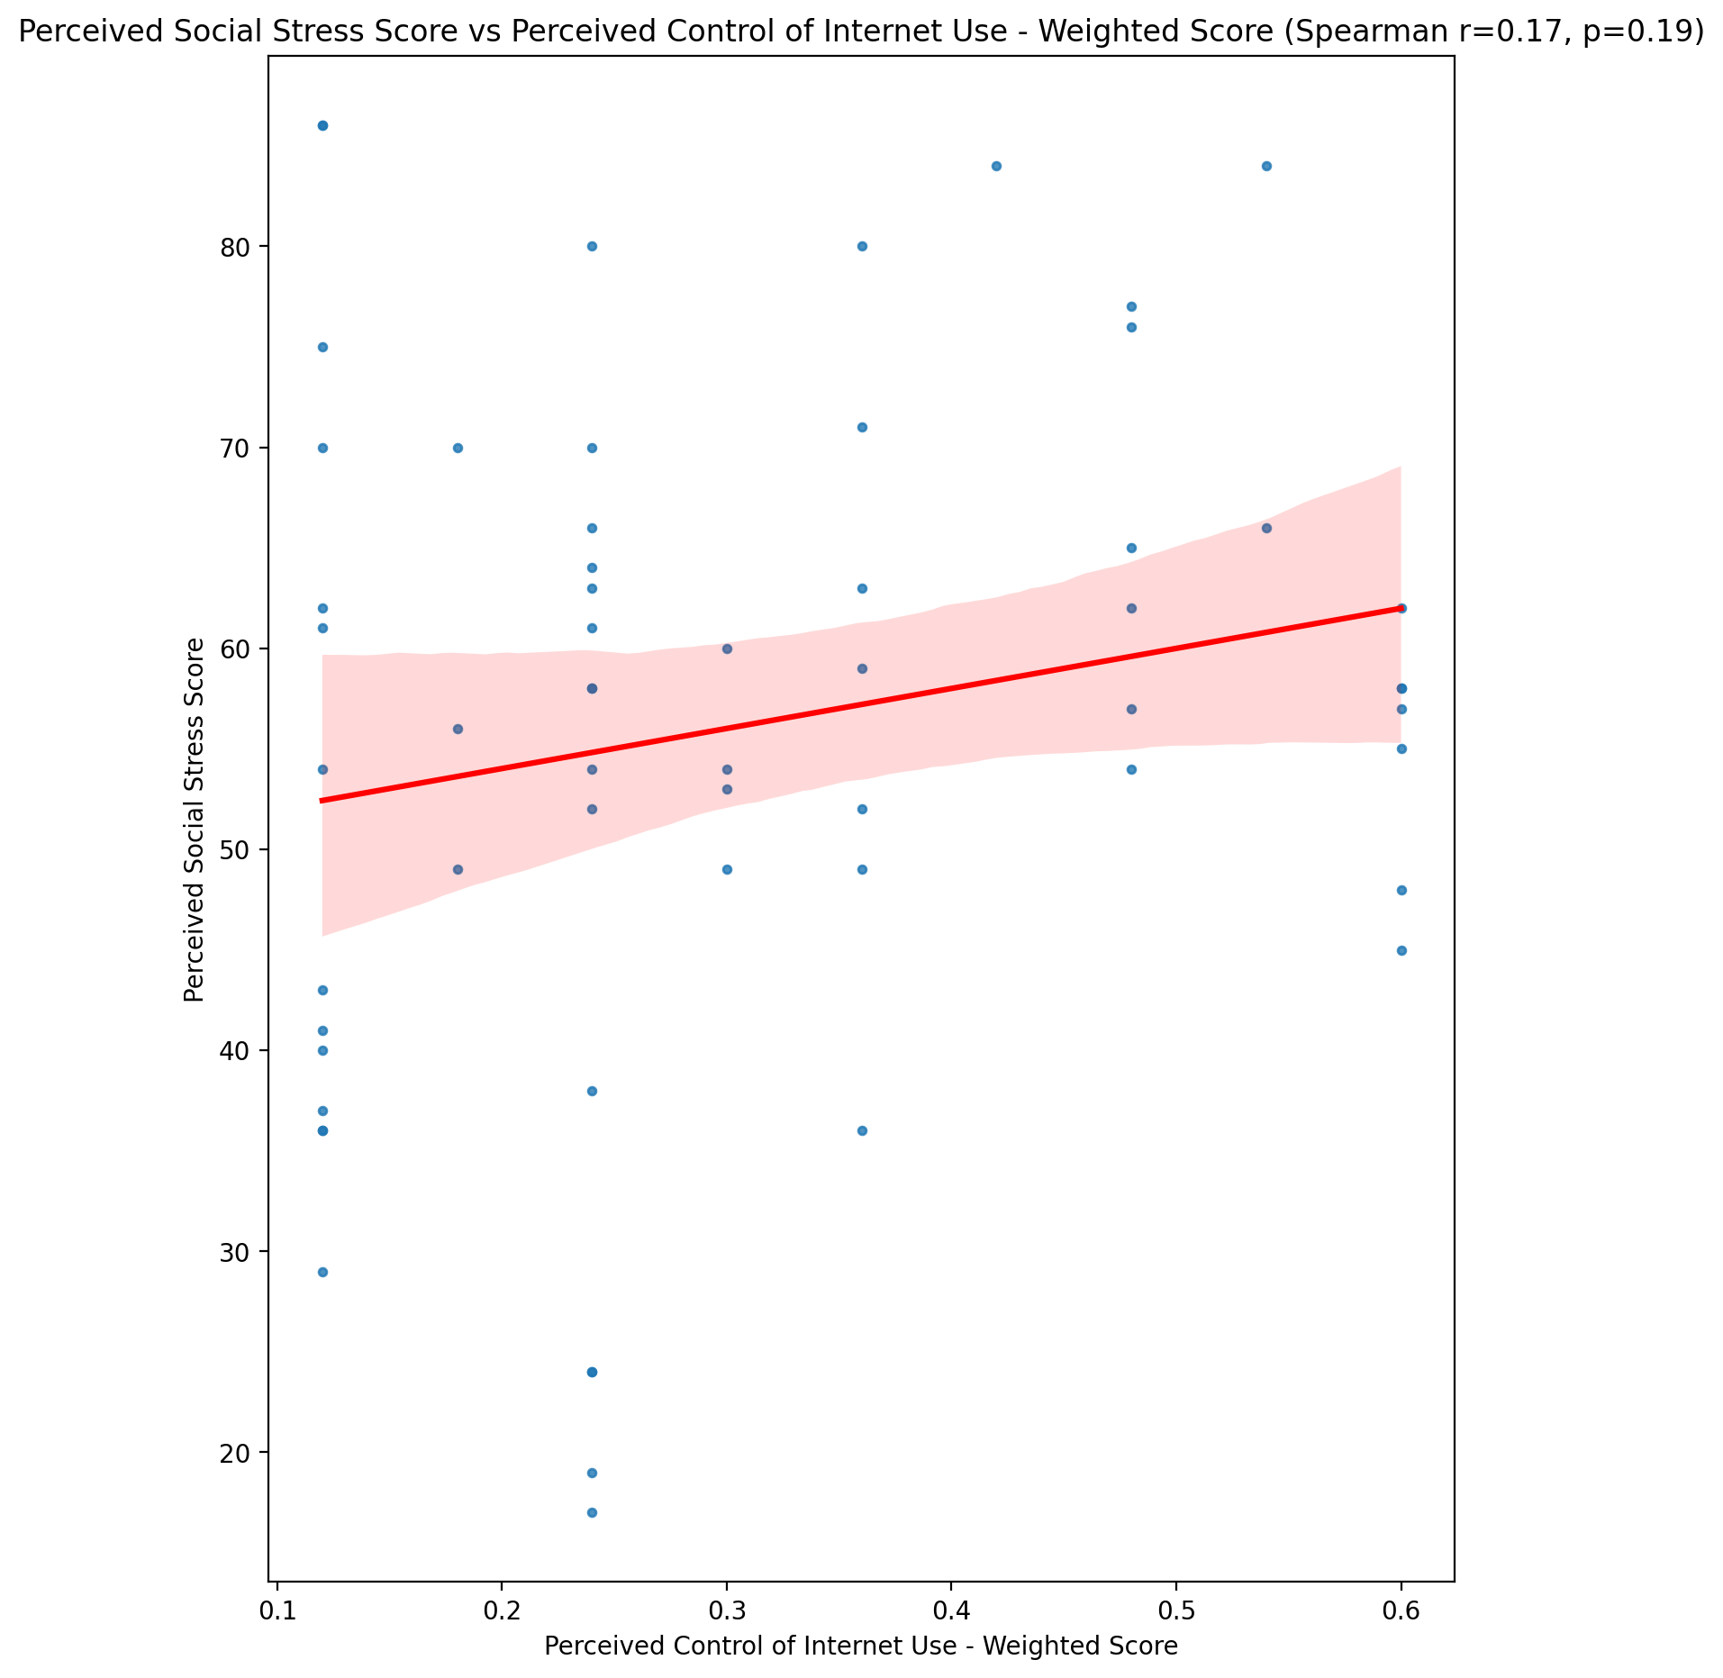

## Perceived Social Stress Category vs Perceived Control of Internet Use - Weighted Score

Test: None; statistic: None; p-value: None; Test not run: unsupported type combination.



## Emotional Support - Raw Score vs Internet Usage Total Score (Weighted)

Test: spearman; statistic: -0.12233828548983358; p-value: 0.3559728290700829;

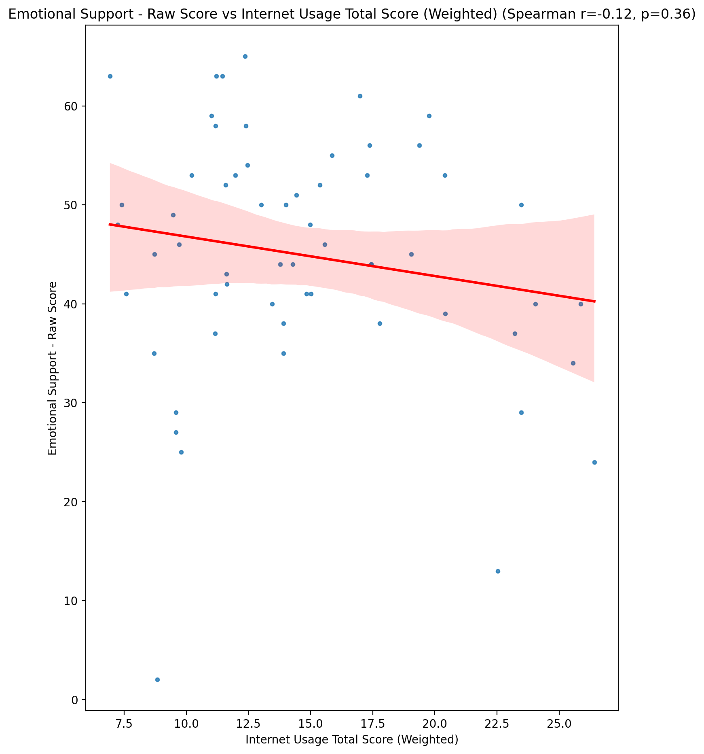

## Informational Support - Raw Score vs Internet Usage Total Score (Weighted)

Test: spearman; statistic: -0.07581615571555651; p-value: 0.5681913244921983;

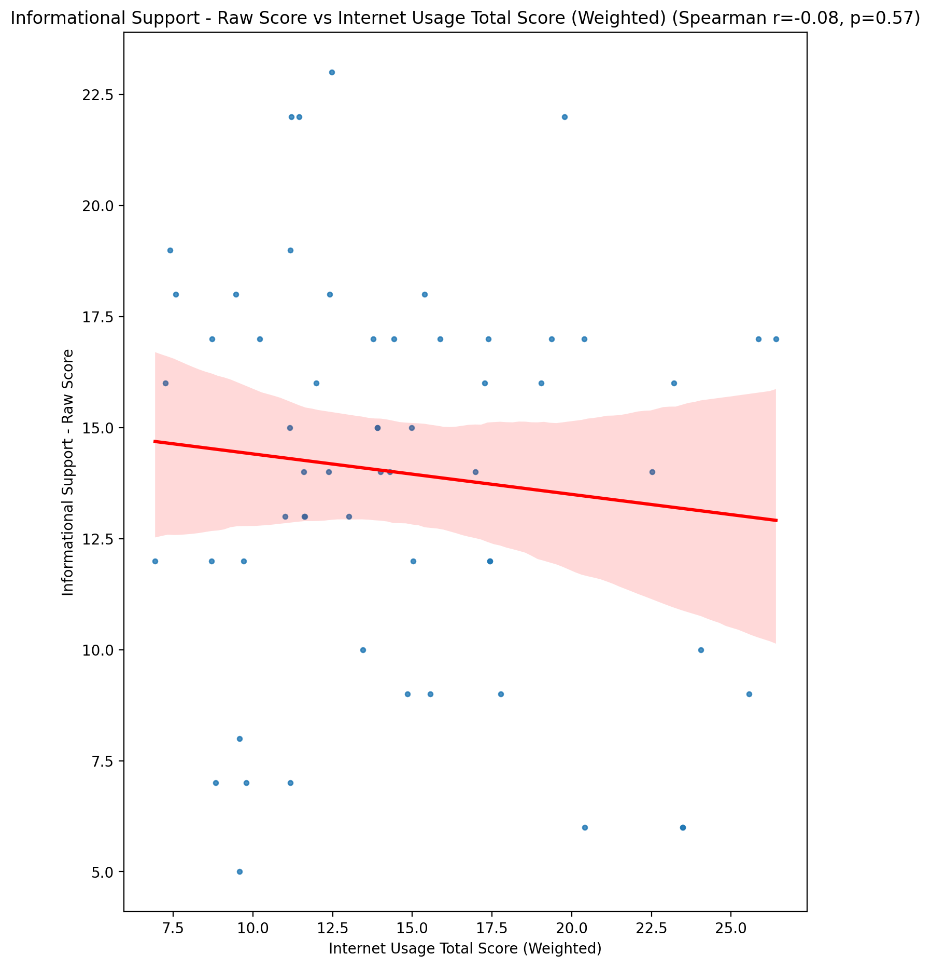

## Instrumental Support - Raw Score vs Internet Usage Total Score (Weighted)

Test: spearman; statistic: -0.12415977998814907; p-value: 0.3488016844652766;

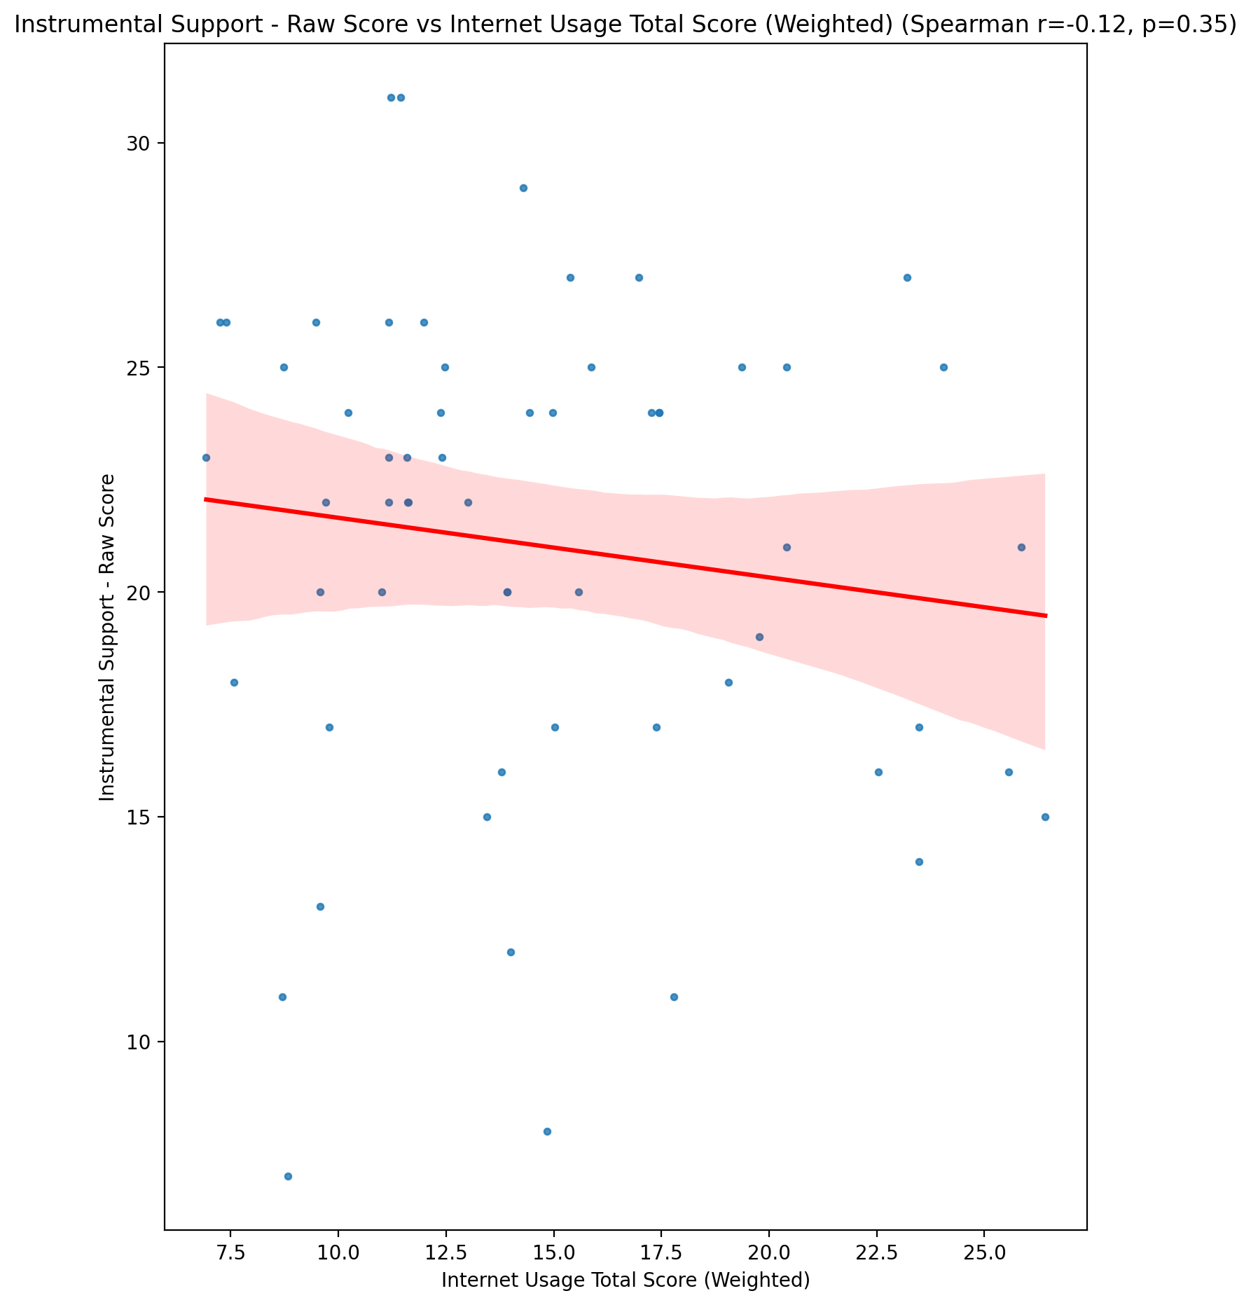

## Emotional Support - T Score vs Internet Usage Total Score (Weighted)

Test: spearman; statistic: -0.12032601117181418; p-value: 0.3639994343198468;

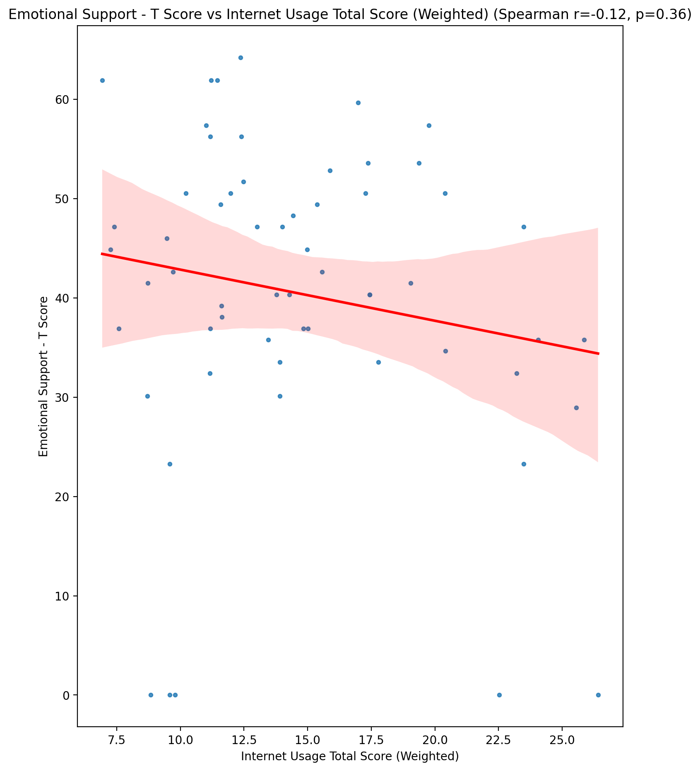

## Informational Support - T Score vs Internet Usage Total Score (Weighted)

Test: spearman; statistic: -0.06492386309704597; p-value: 0.6251705211982055;

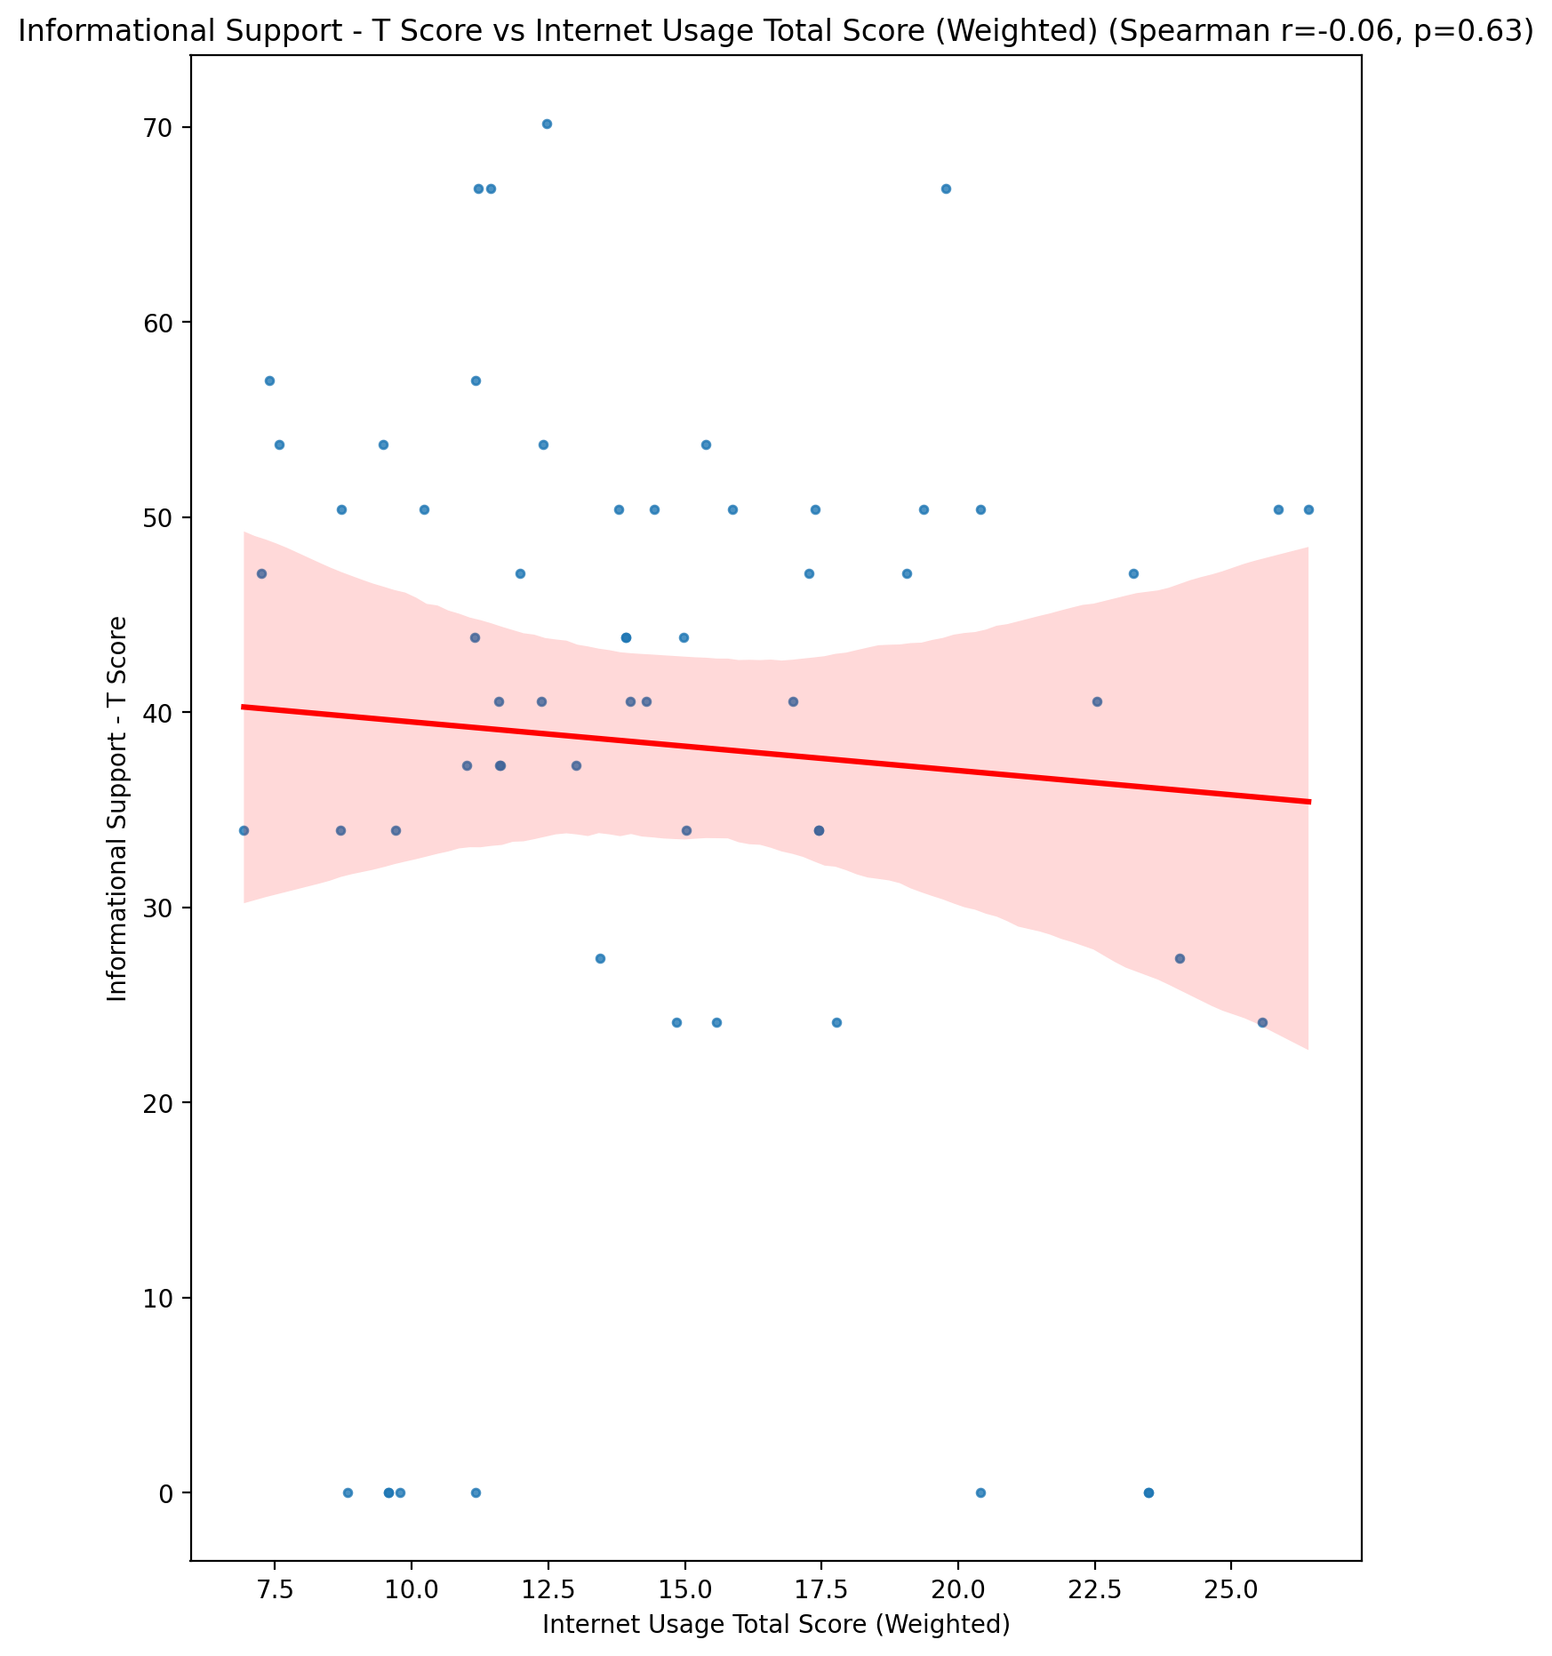

## Instrumental Support - T Score vs Internet Usage Total Score (Weighted)

Test: spearman; statistic: -0.12432445493440514; p-value: 0.34815780031604204;

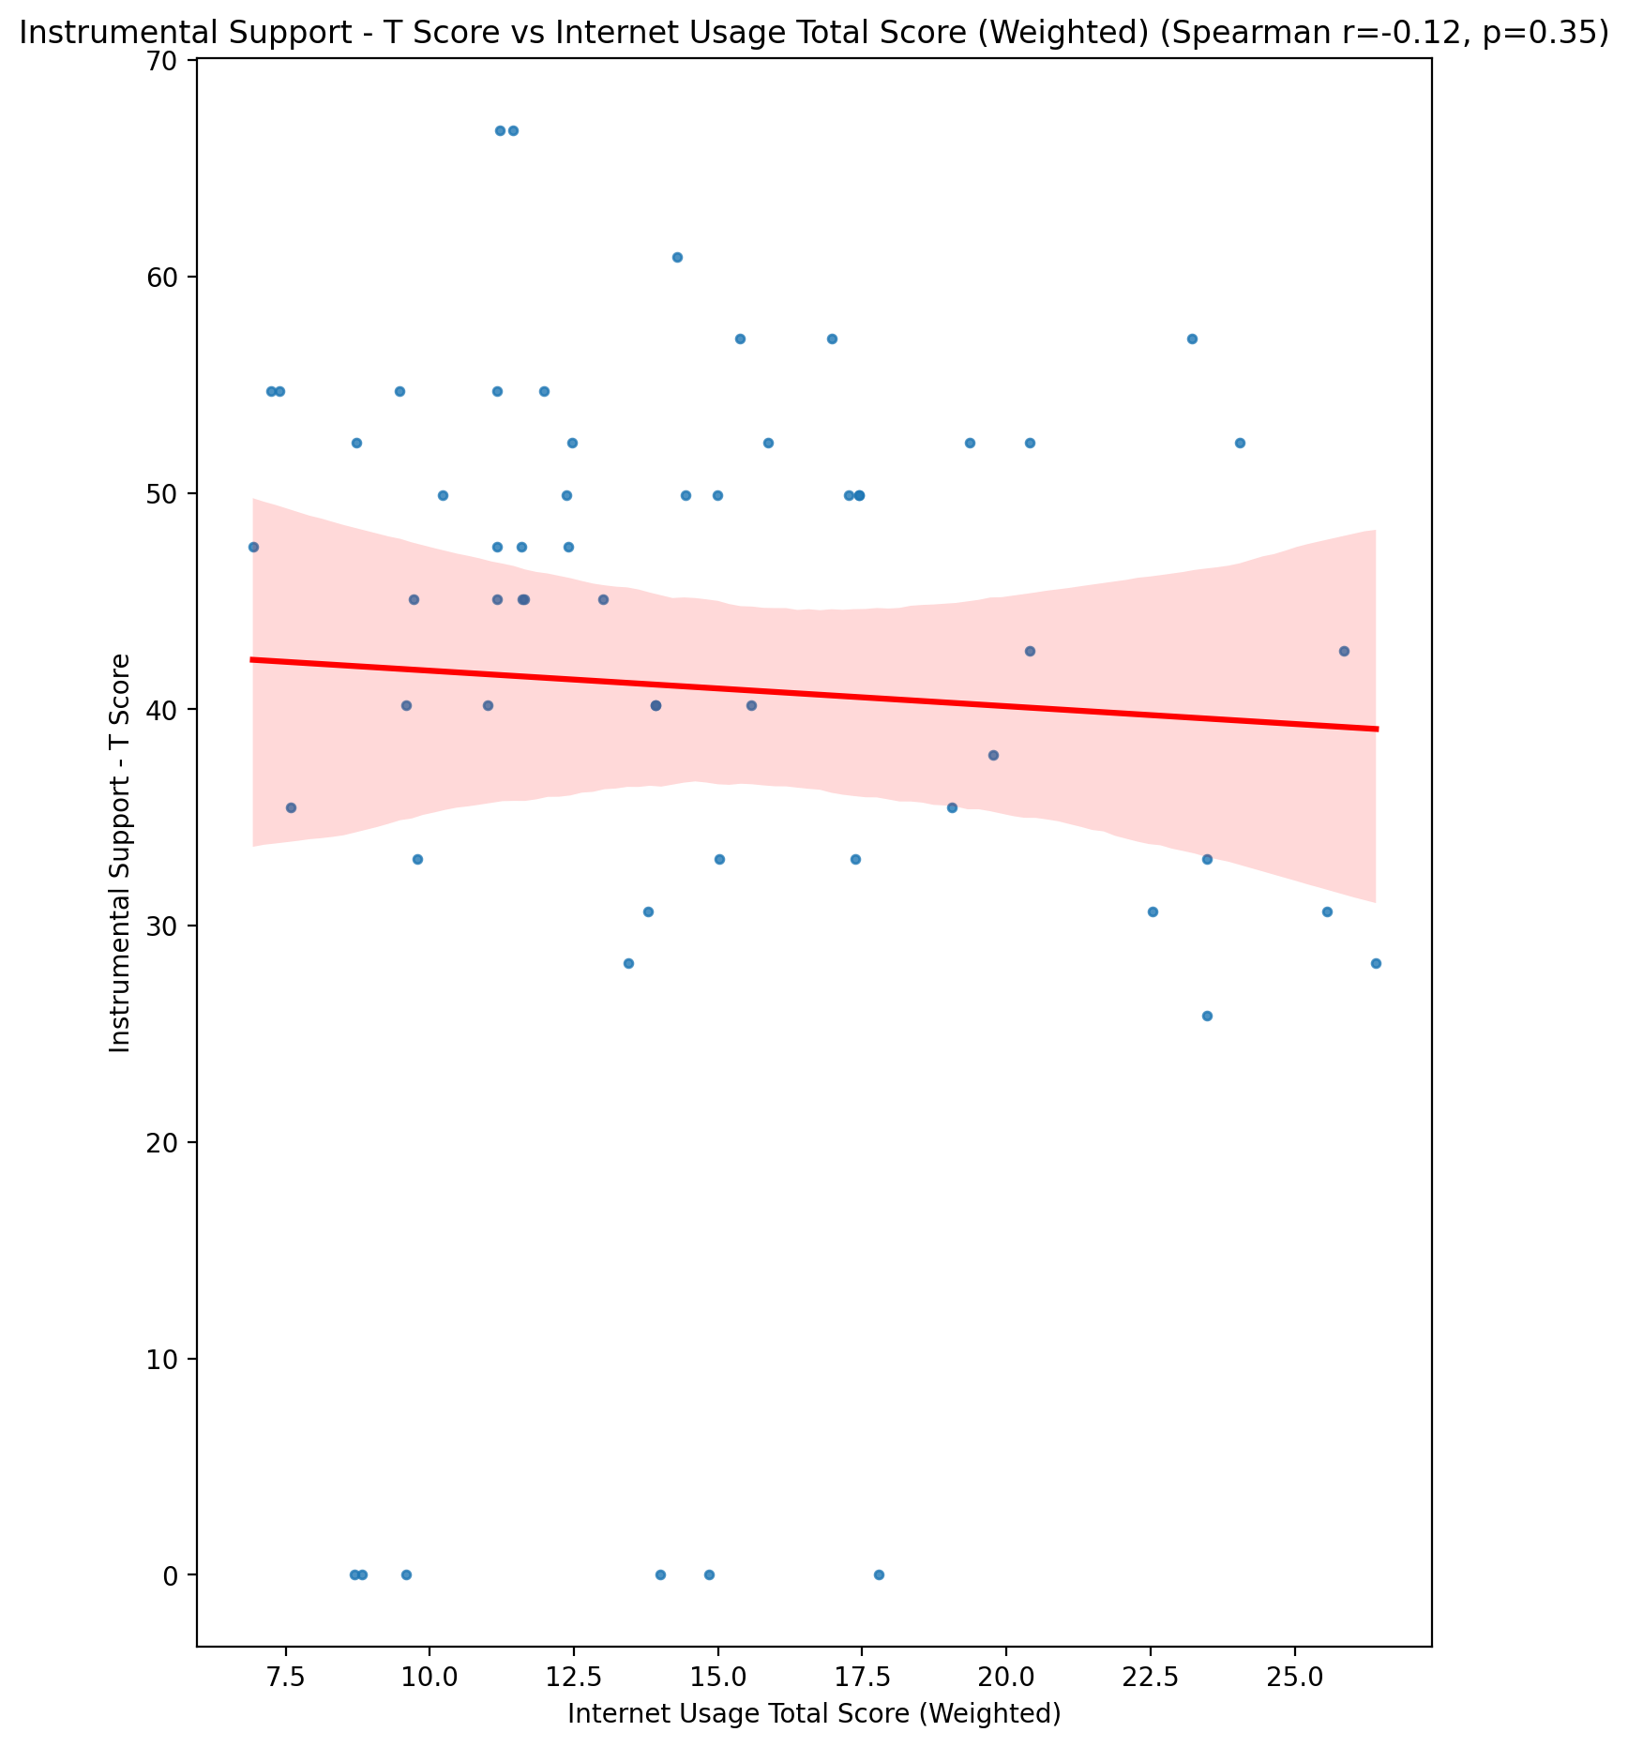

## Perceived Social Support Total T Score vs Internet Usage Total Score (Weighted)

Test: spearman; statistic: -0.1510694869306873; p-value: 0.25340065075207324;

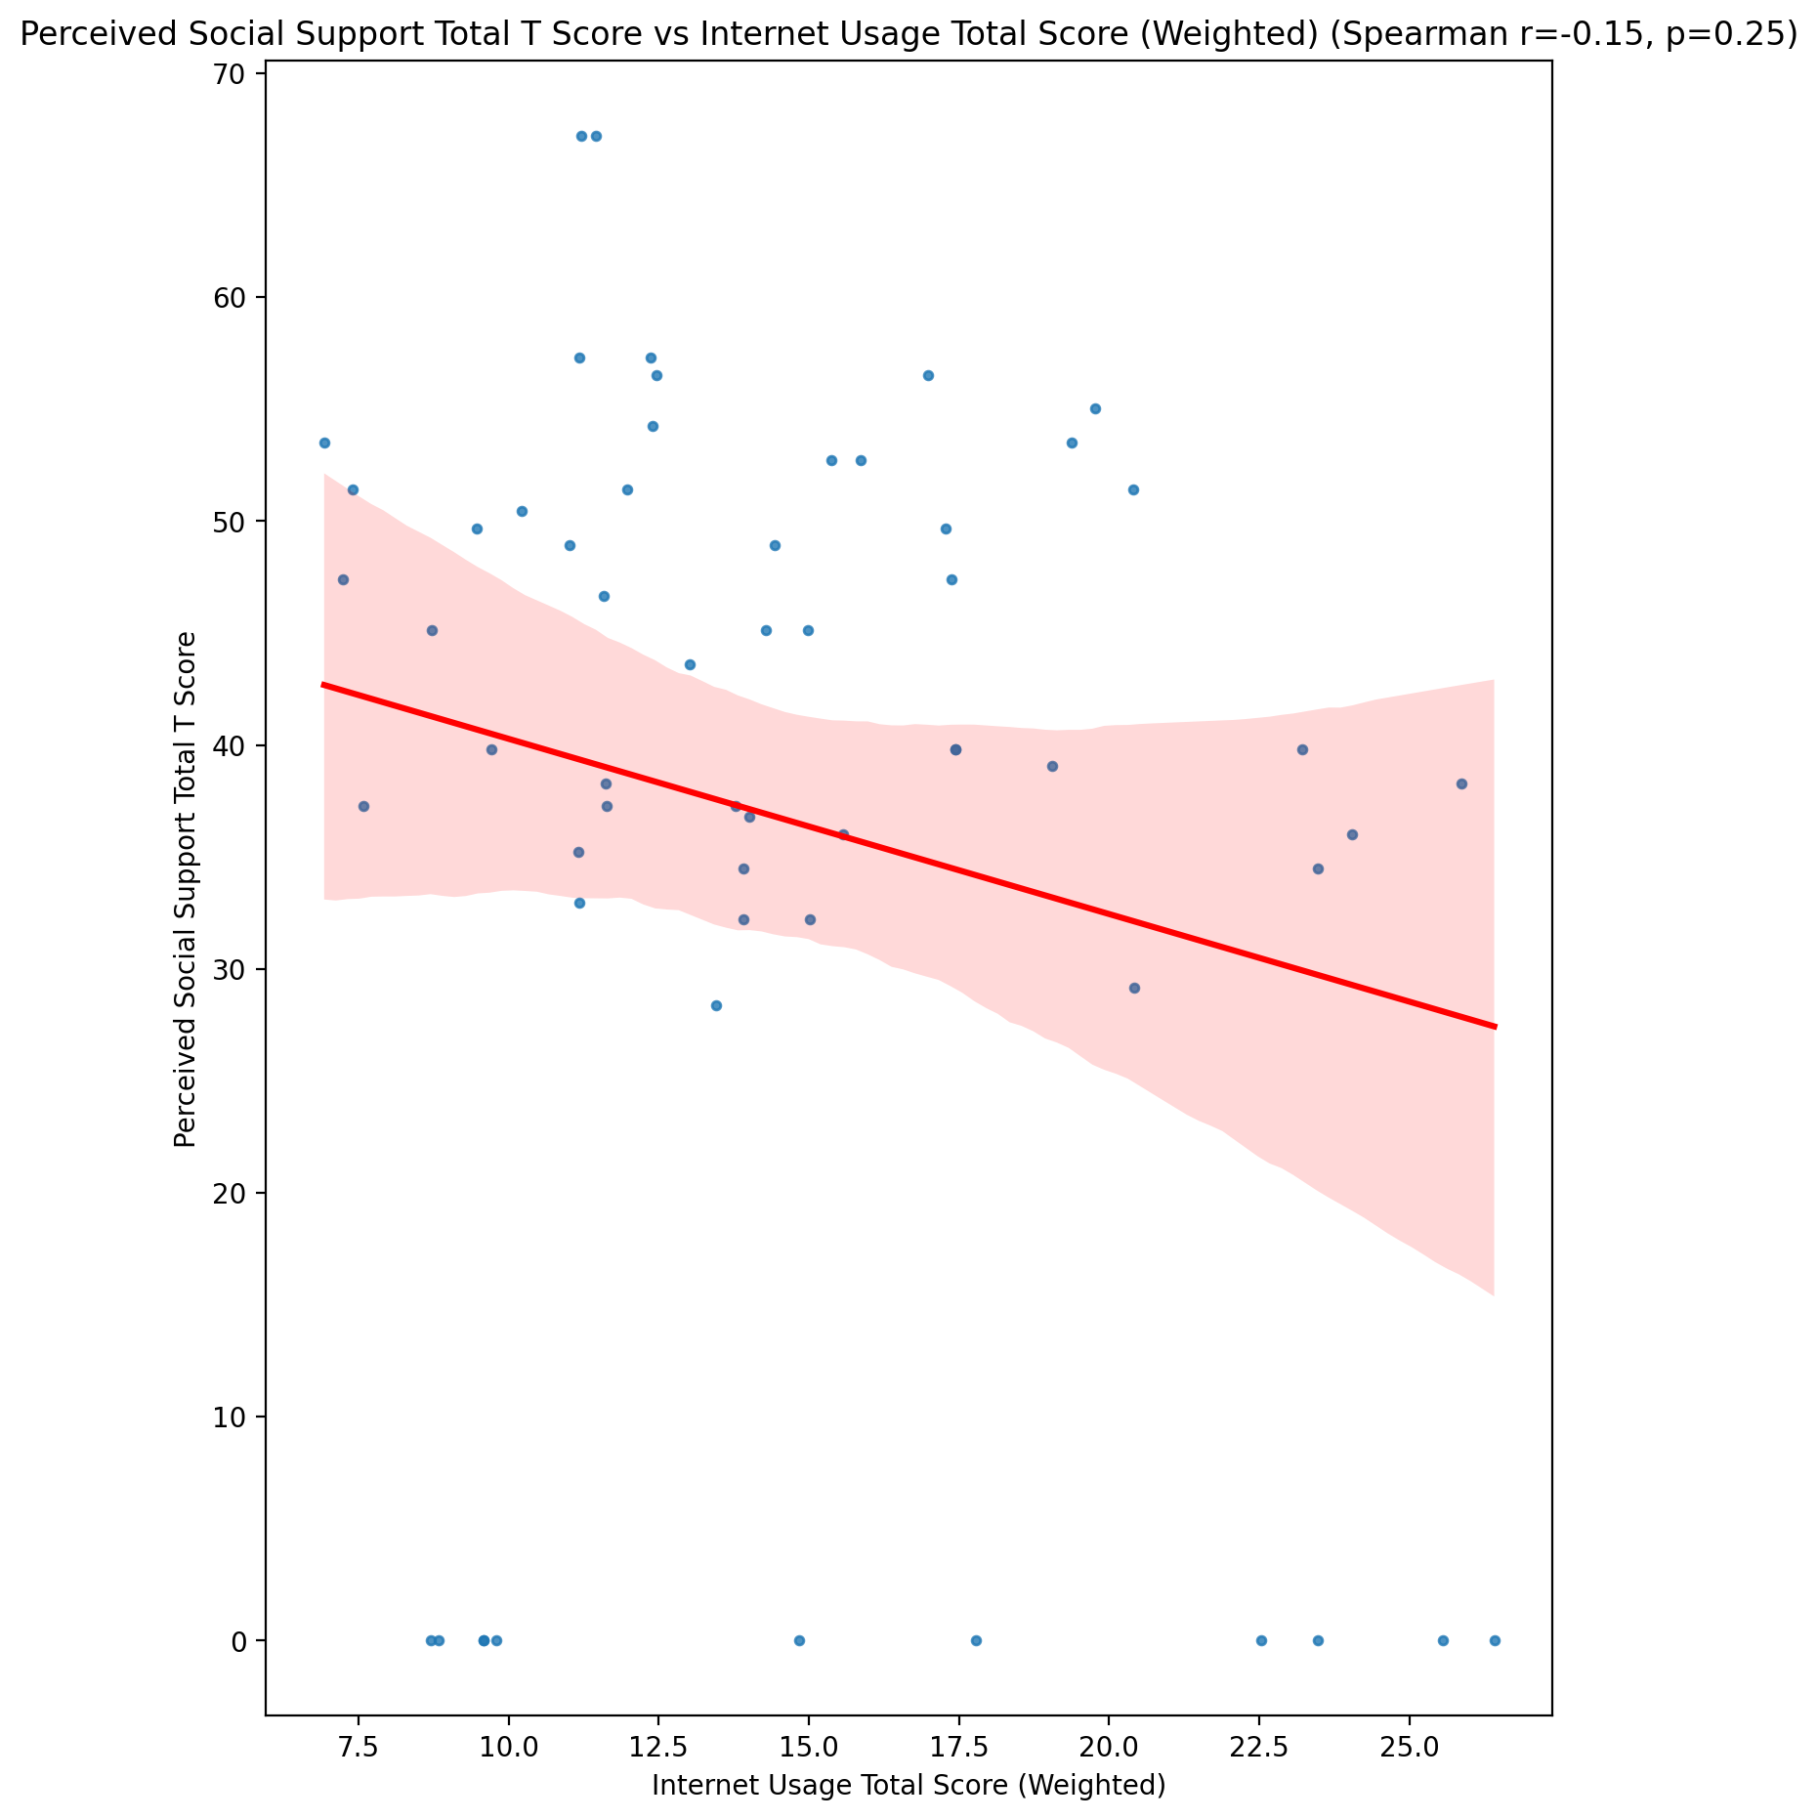

## Emotional Support - Rank vs Internet Usage Total Score (Weighted)

Test: None; statistic: None; p-value: None; Test not run: unsupported type combination.



## Informational Support - Rank vs Internet Usage Total Score (Weighted)

Test: None; statistic: None; p-value: None; Test not run: unsupported type combination.



## Instrumental Support - Rank vs Internet Usage Total Score (Weighted)

Test: None; statistic: None; p-value: None; Test not run: unsupported type combination.



## Perceived Social Support TOTAL - Rank vs Internet Usage Total Score (Weighted)

Test: None; statistic: None; p-value: None; Test not run: unsupported type combination.



## Power Self Concept - Real Self Concept Score vs Internet Usage Total Score (Weighted)

Test: spearman; statistic: -0.3251026169797098; p-value: 0.01199178305400759;

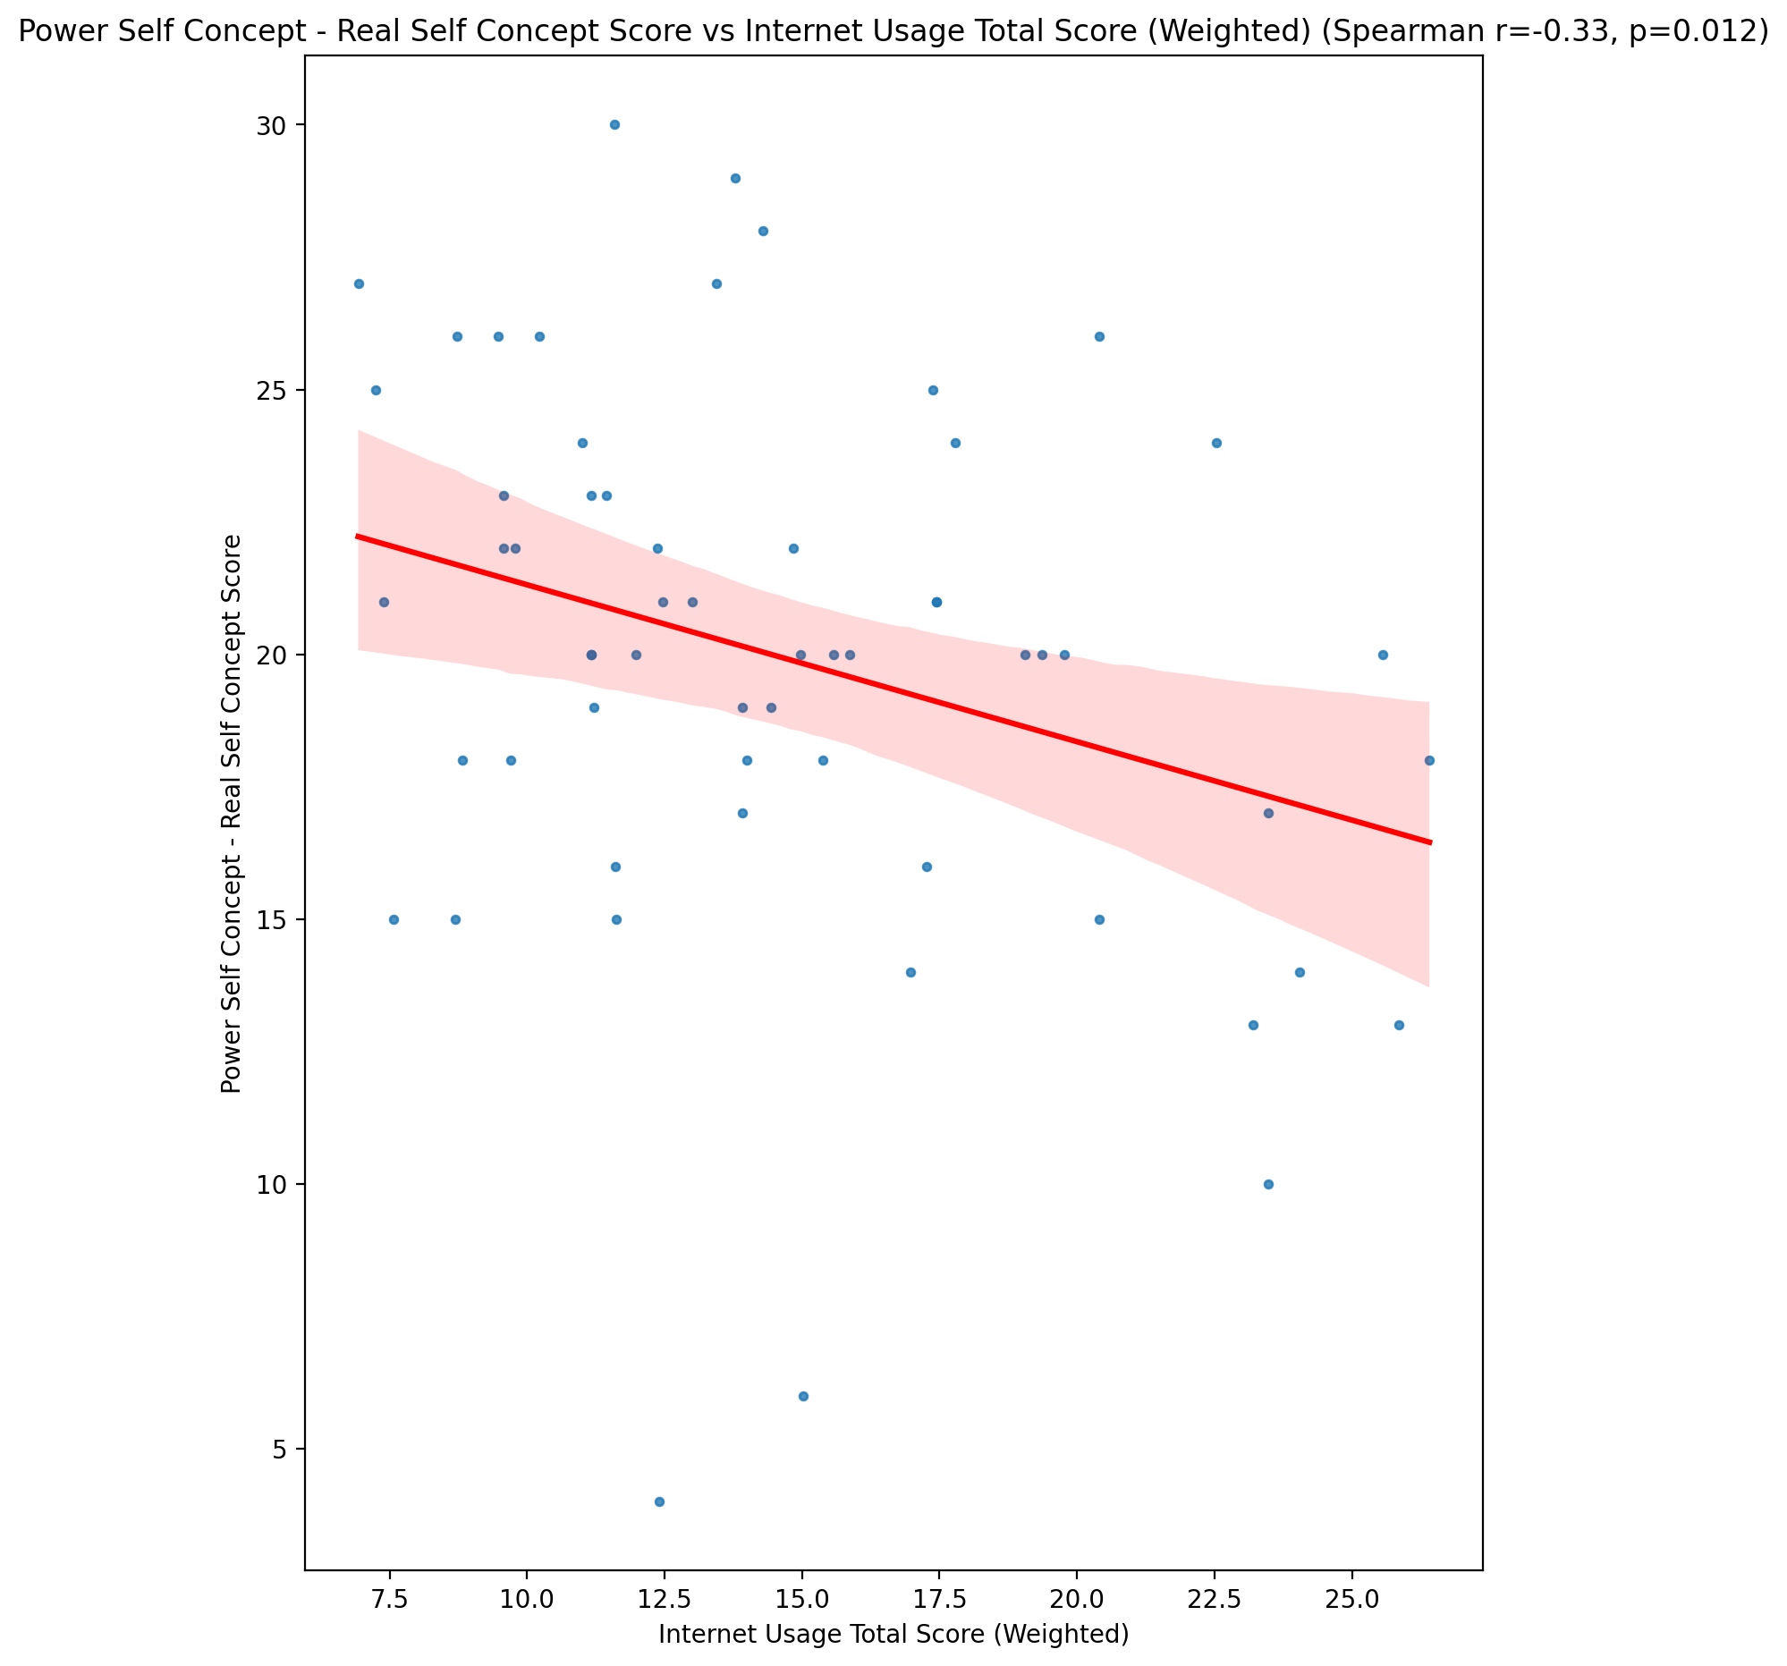

## Power Self Concept - Ideal Self Concept score vs Internet Usage Total Score (Weighted)

Test: spearman; statistic: -0.24635302509130114; p-value: 0.05998716278987477;

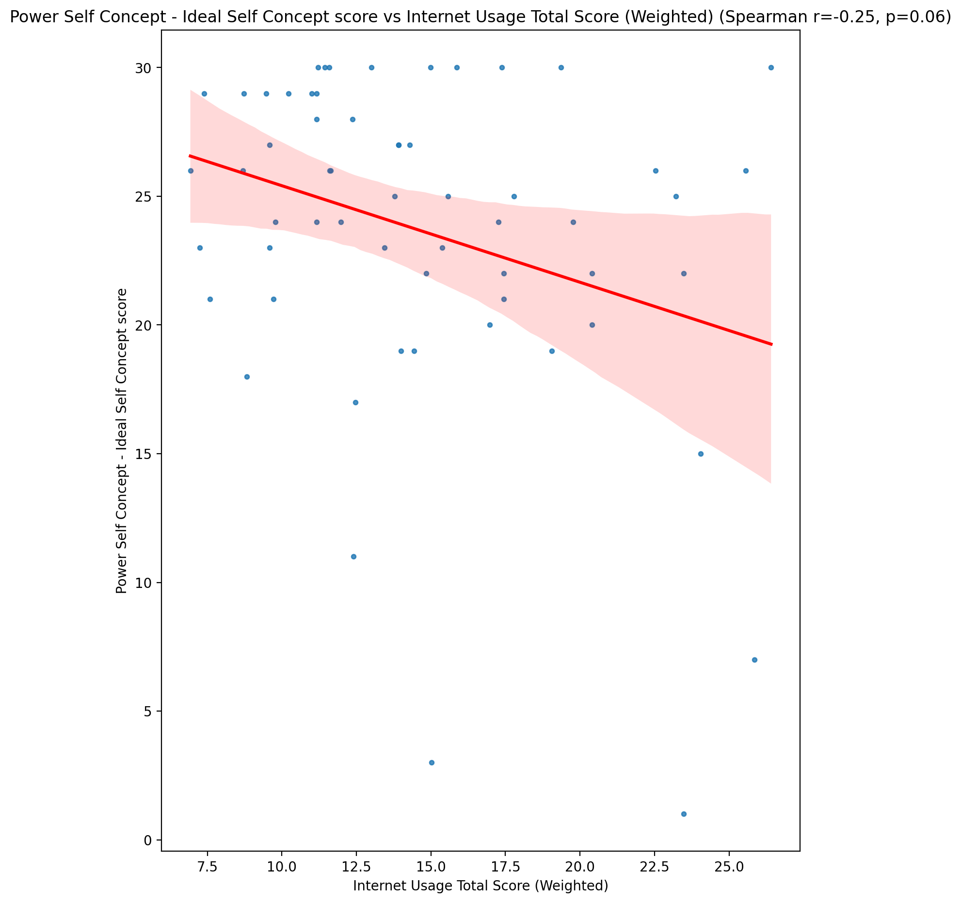

## Power Self Concept – Social Self Concept Score vs Internet Usage Total Score (Weighted)

Test: spearman; statistic: -0.0820433223791498; p-value: 0.536742801090859;

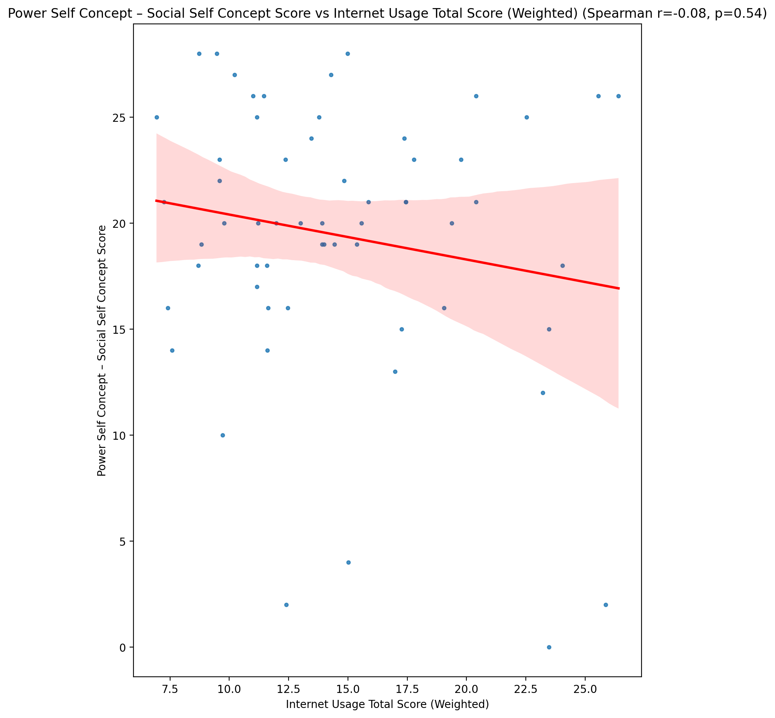

## Social Self Concept - Real Self Concept Score vs Internet Usage Total Score (Weighted)

Test: spearman; statistic: -0.4853561950009568; p-value: 9.768407436119942e-05;

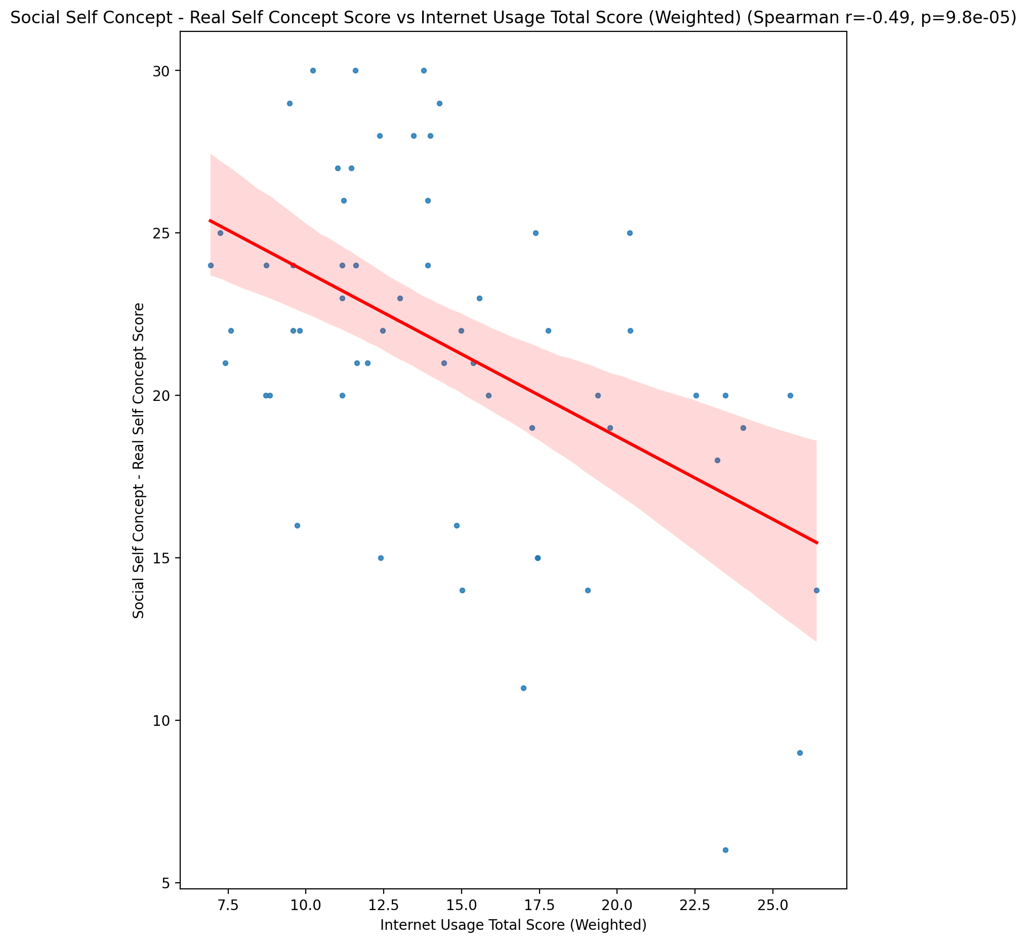

## Social Self Concept – Social Self Concept Score vs Internet Usage Total Score (Weighted)

Test: spearman; statistic: -0.19024262154757338; p-value: 0.14895475253132479;

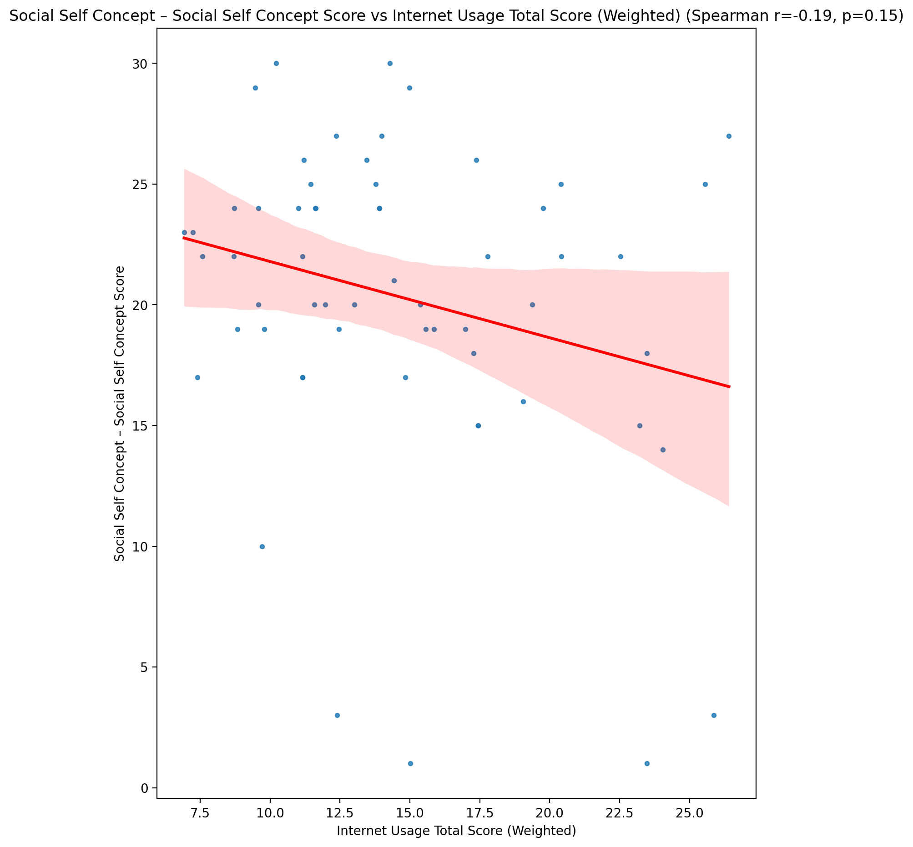

## Ability Self Concept - Real Self Concept Score vs Internet Usage Total Score (Weighted)

Test: spearman; statistic: -0.4069246031990334; p-value: 0.001381880094315141;

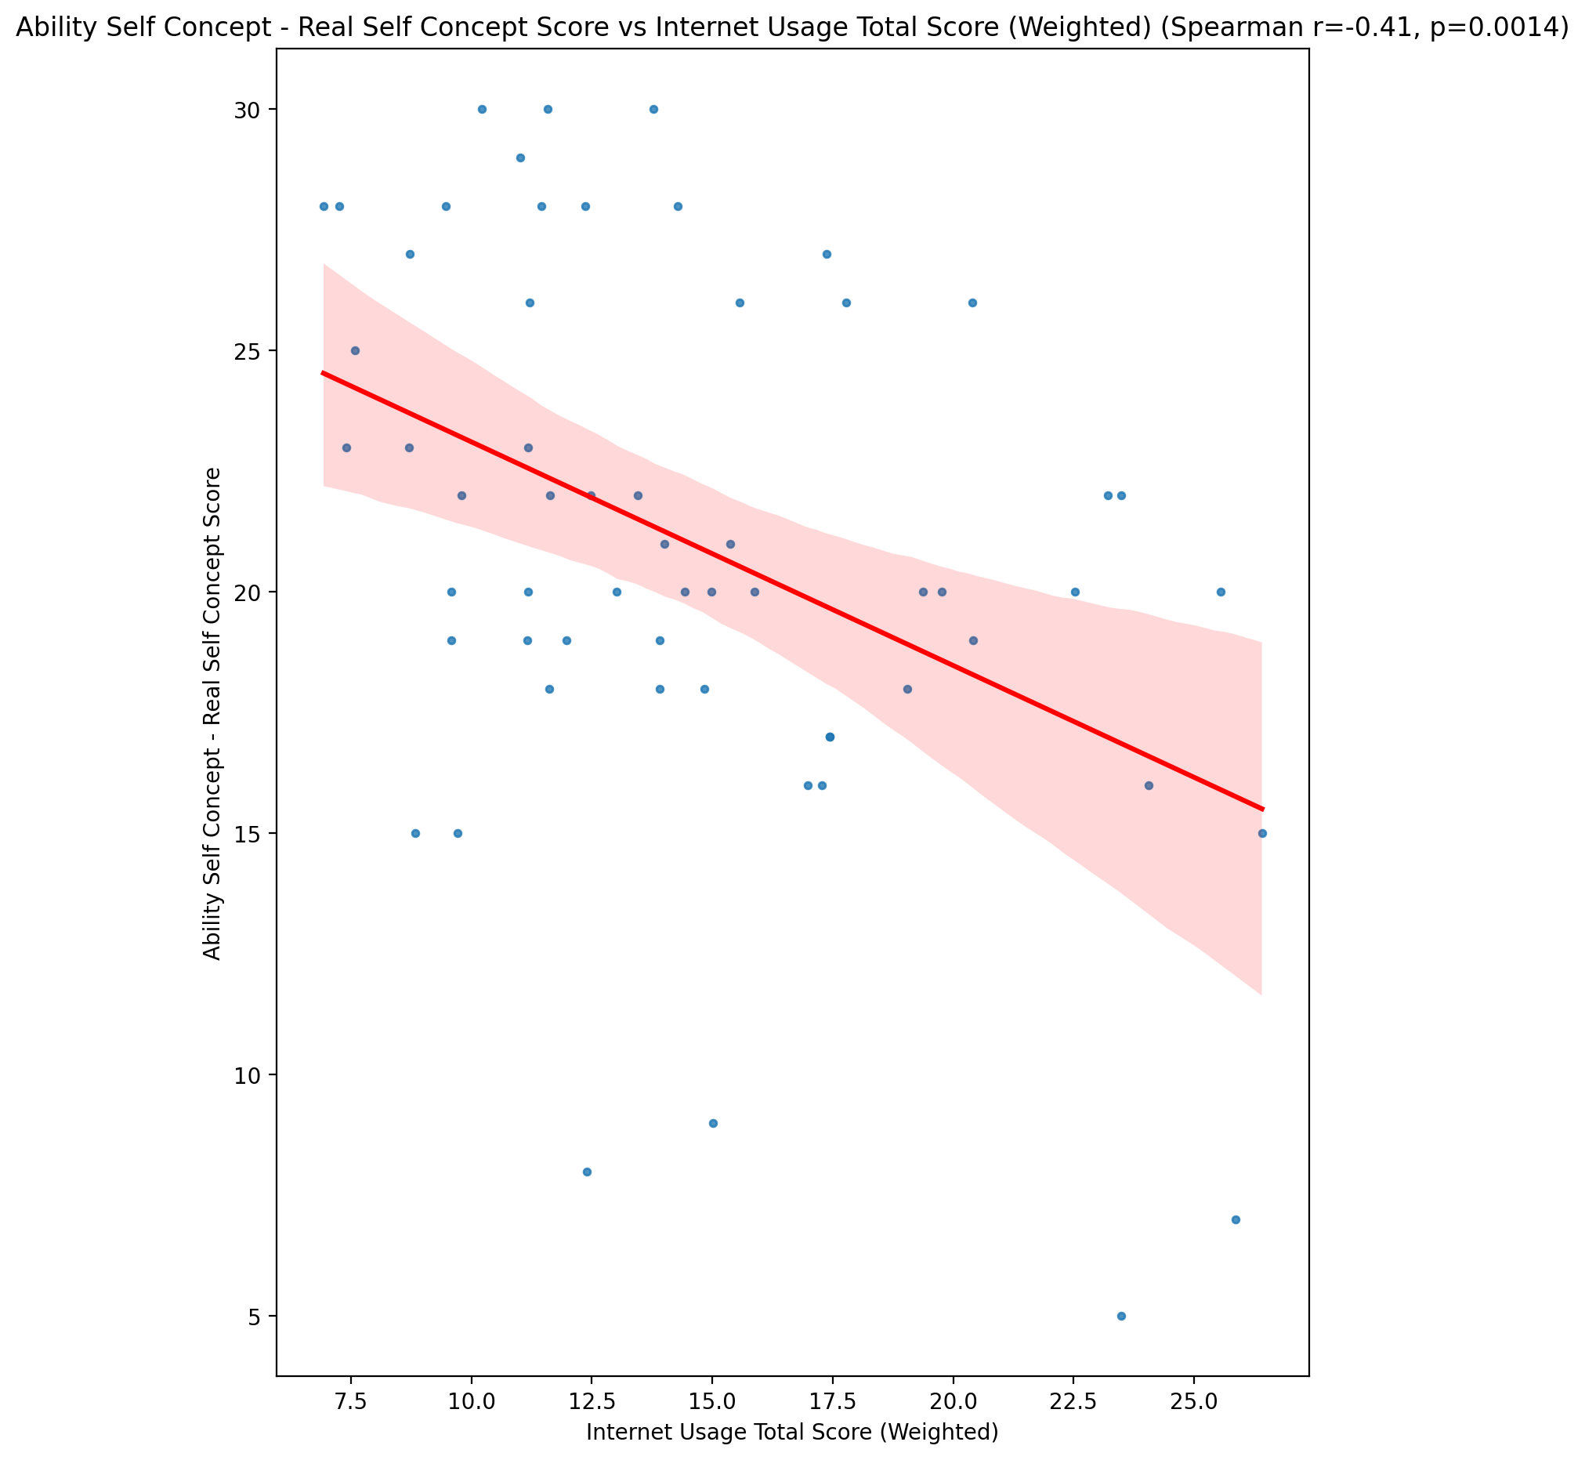

## Ability Self Concept - Ideal Self Concept Score vs Internet Usage Total Score (Weighted)

Test: spearman; statistic: -0.254079444673569; p-value: 0.05215387474470132;

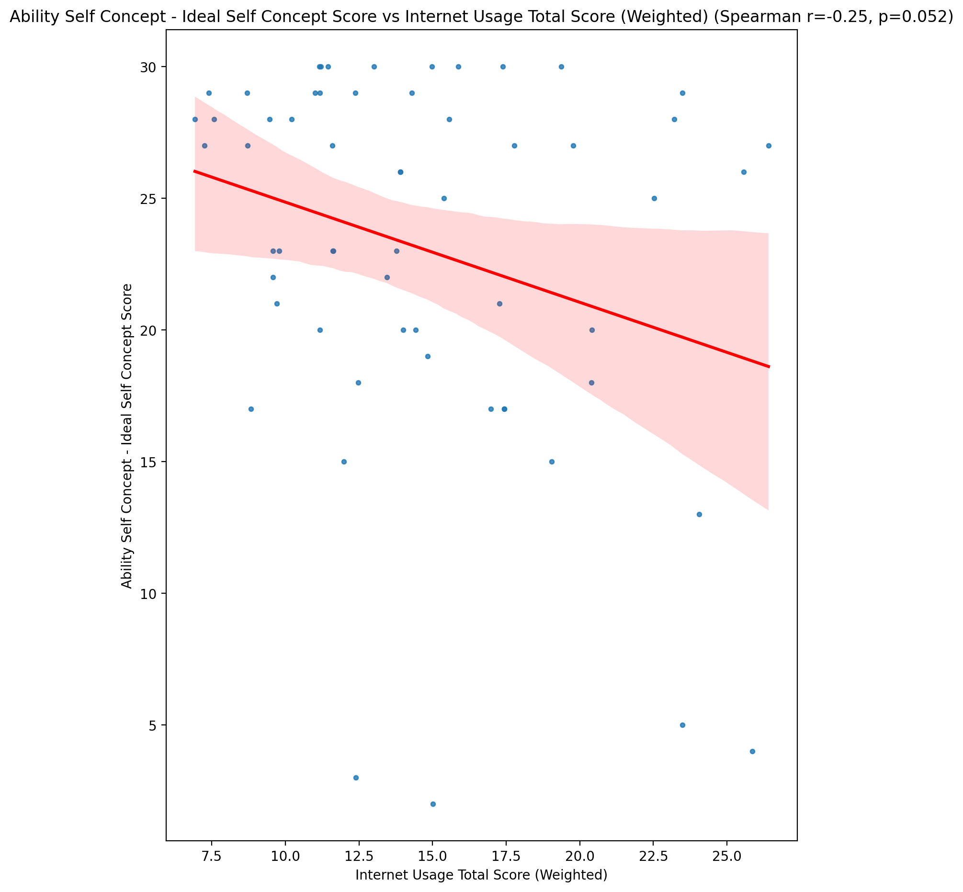

## Ability Self Concept – Social Self Concept Score vs Internet Usage Total Score (Weighted)

Test: spearman; statistic: -0.12004413798921985; p-value: 0.36513250491781435;

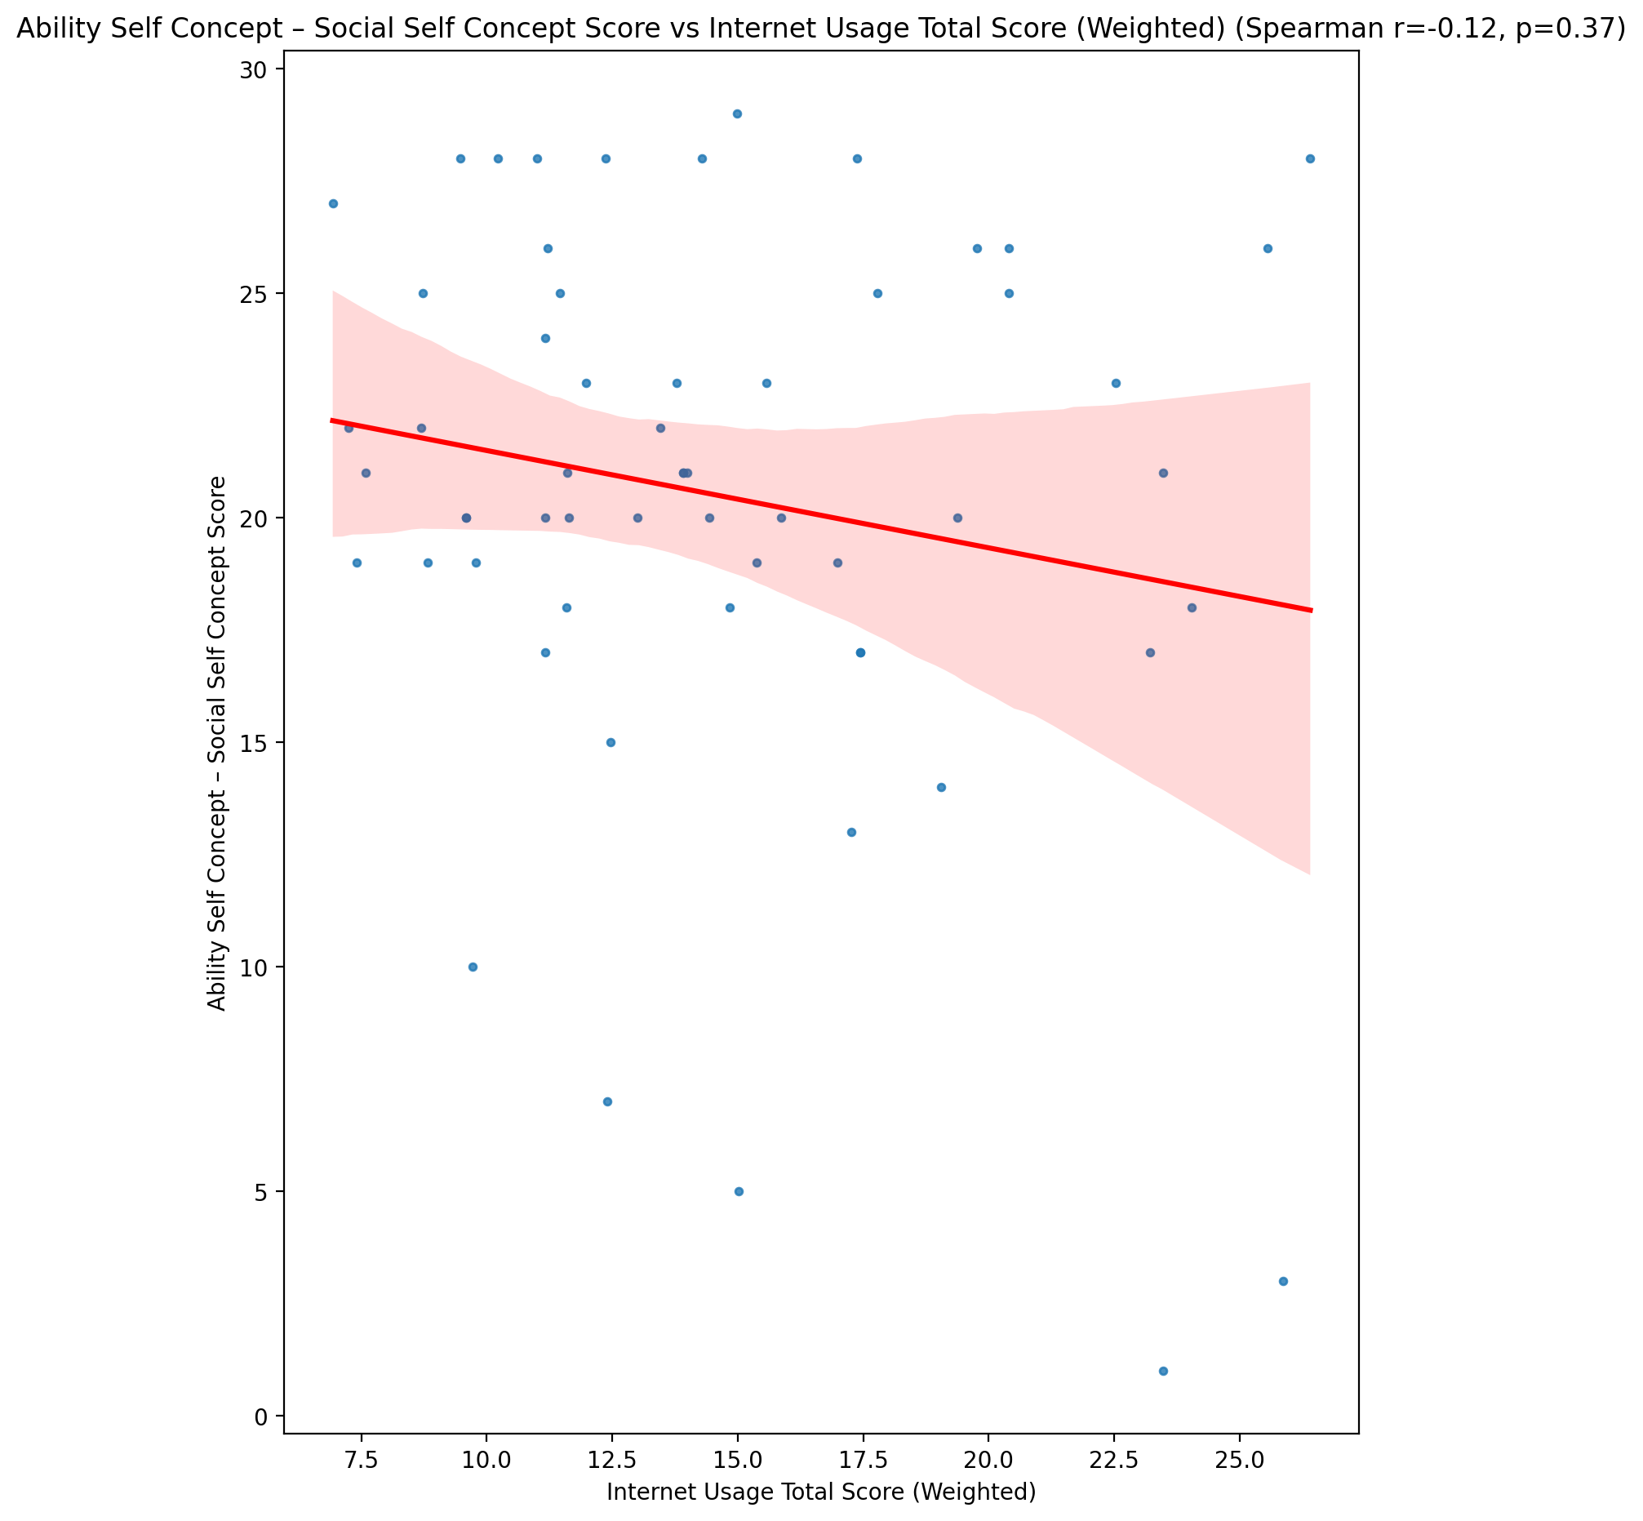

## Physical Self Concept - Real Self Concept Score vs Internet Usage Total Score (Weighted)

Test: spearman; statistic: -0.46046241212109046; p-value: 0.00024289197932098795;

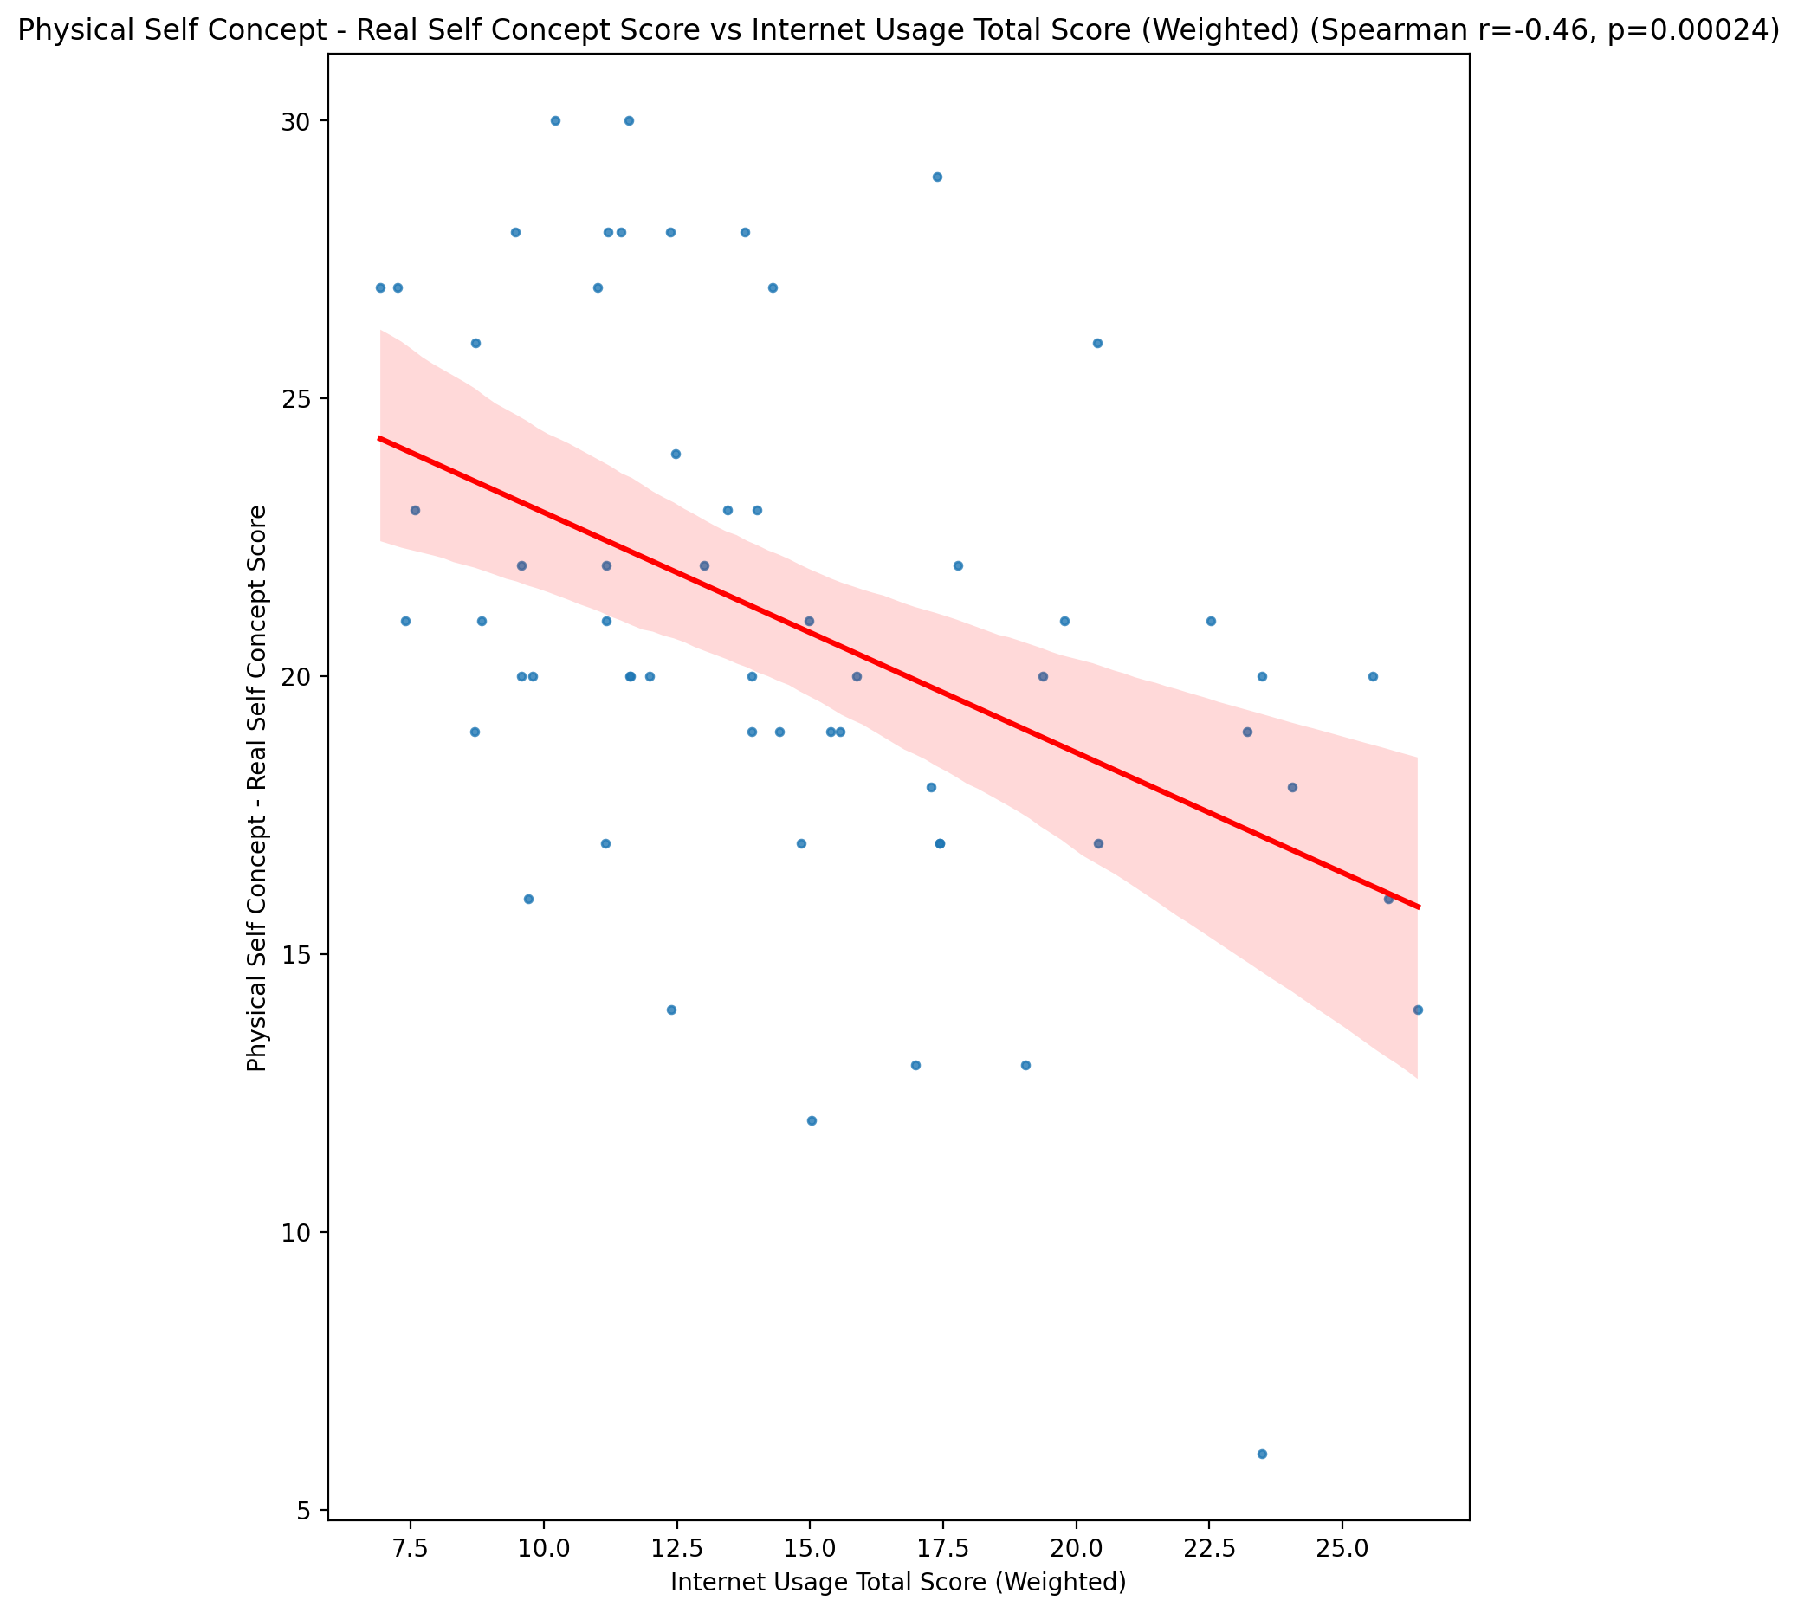

## Physical Self Concept – Ideal Self Concept Score vs Internet Usage Total Score (Weighted)

Test: spearman; statistic: -0.24673934431510314; p-value: 0.05957415592464951;

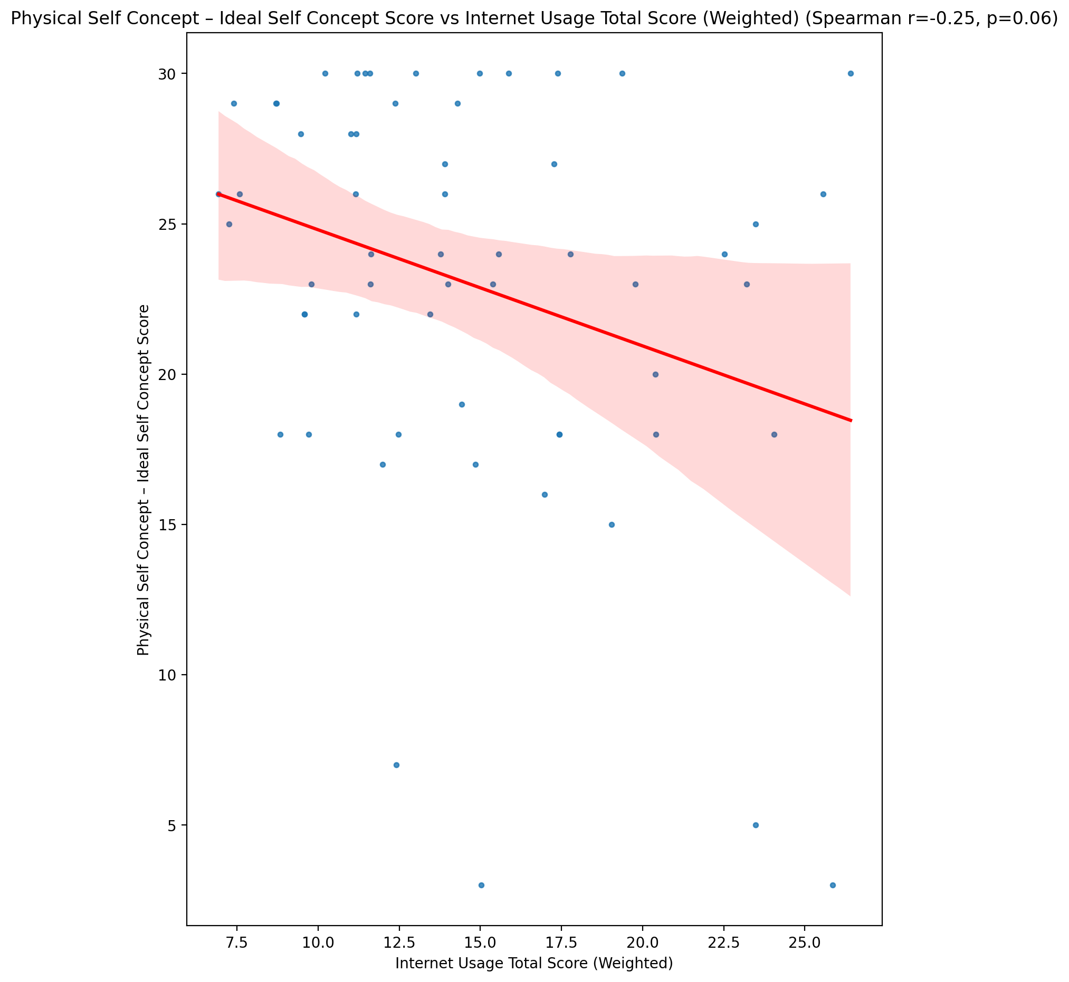

## Physical Self Concept – Social Self Concept Score vs Internet Usage Total Score (Weighted)

Test: spearman; statistic: -0.17768515619825145; p-value: 0.17818478082465622;

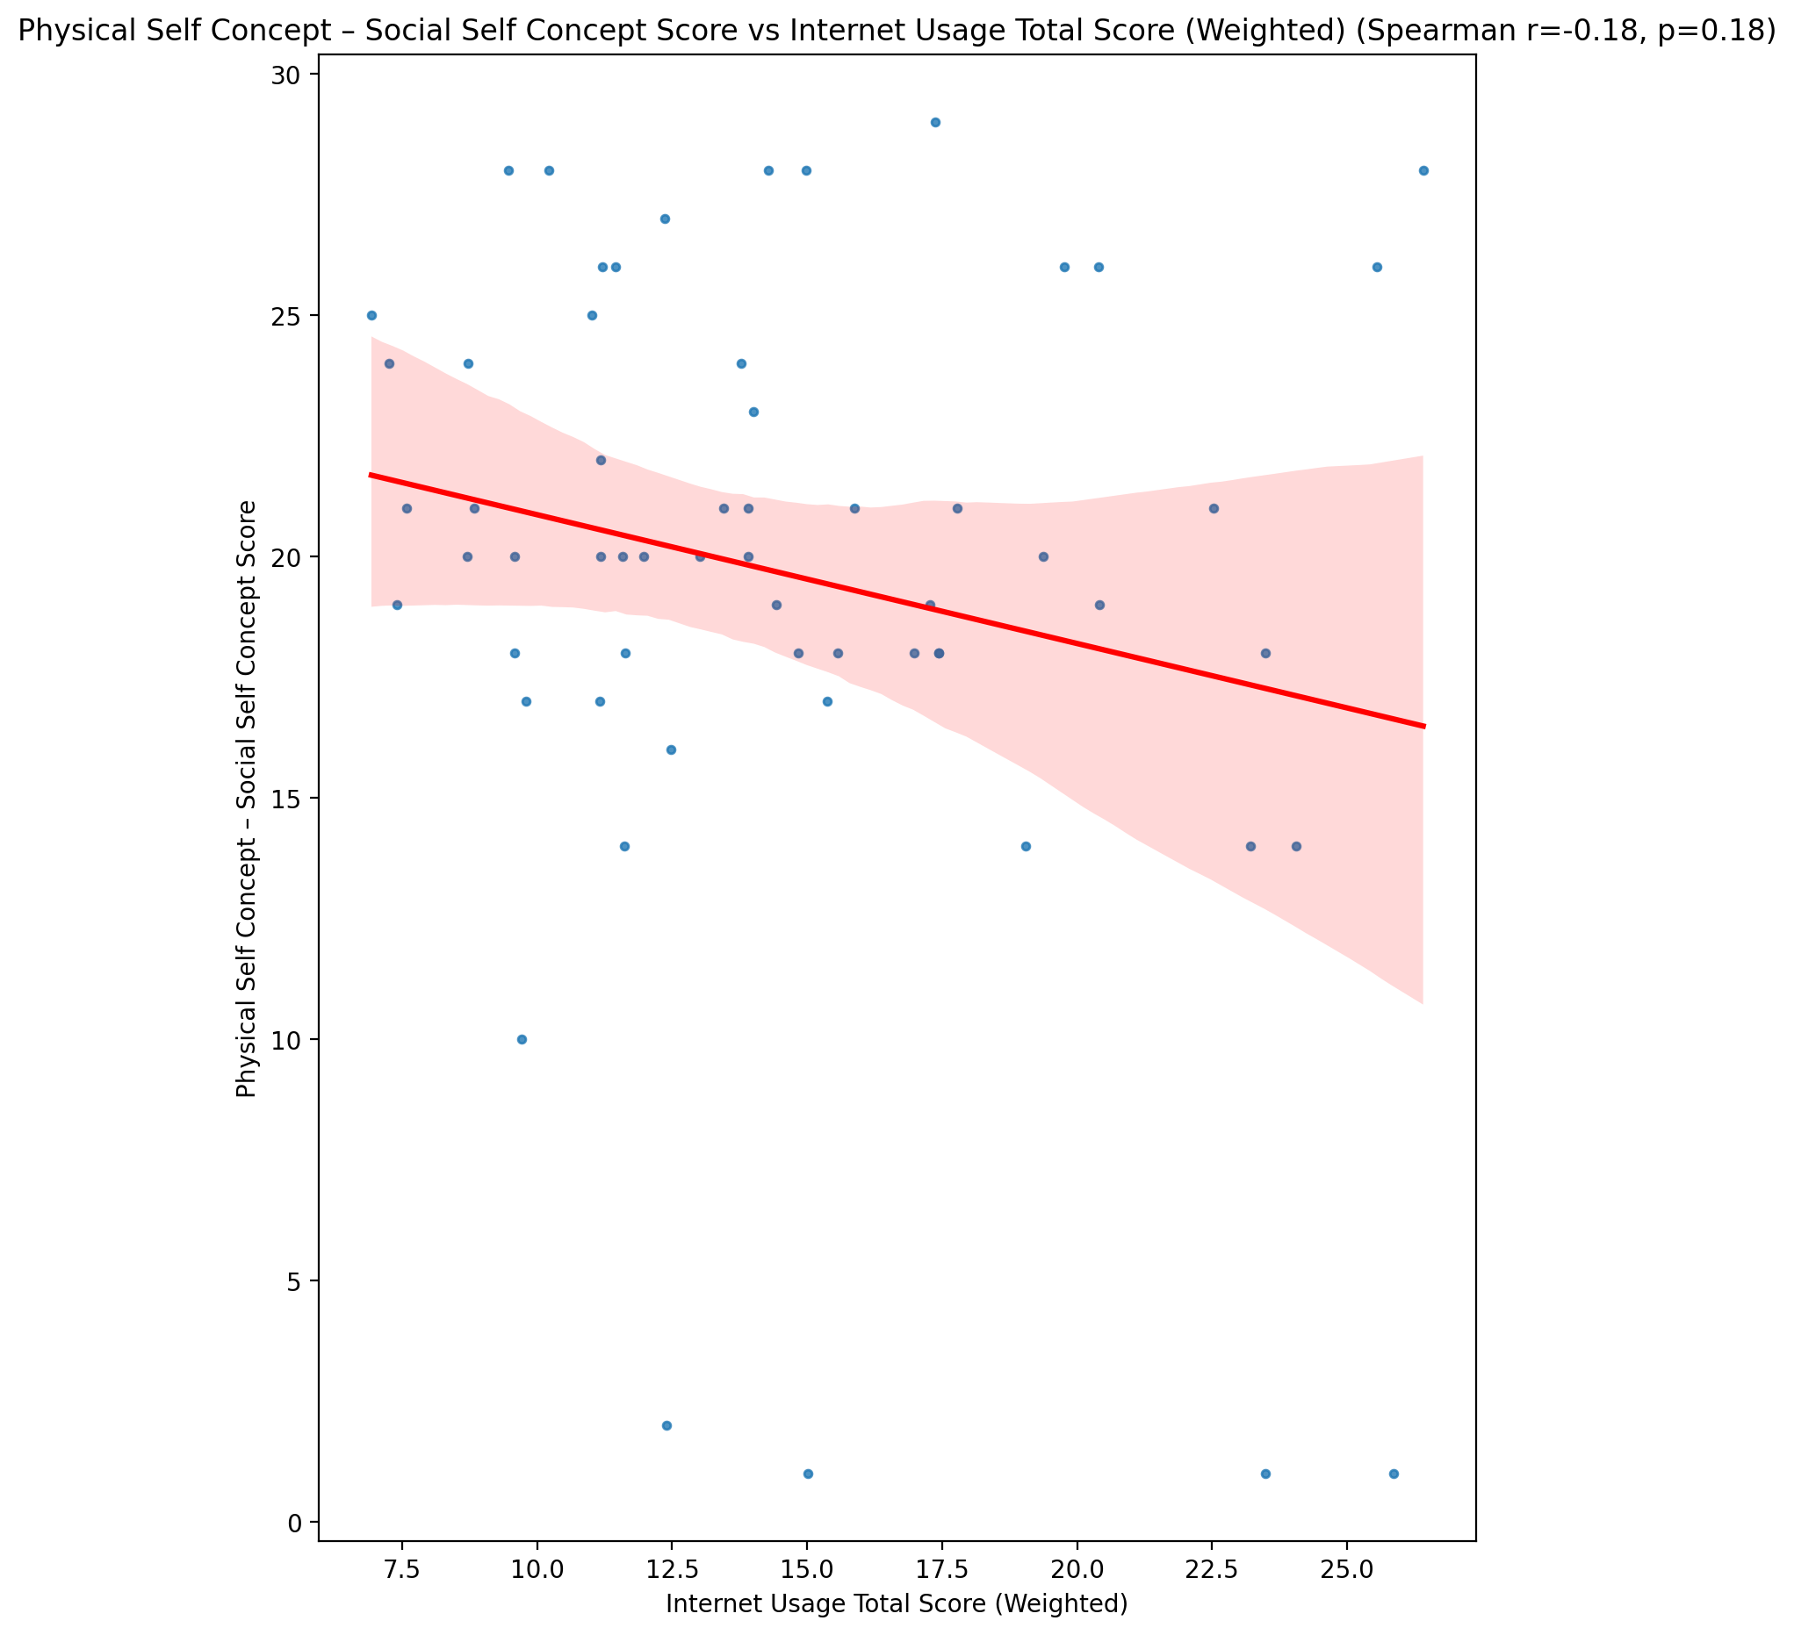

## Psychological Self Concept - Real Self Concept Score vs Internet Usage Total Score (Weighted)

Test: spearman; statistic: -0.5311244414886861; p-value: 1.5057254636599607e-05;

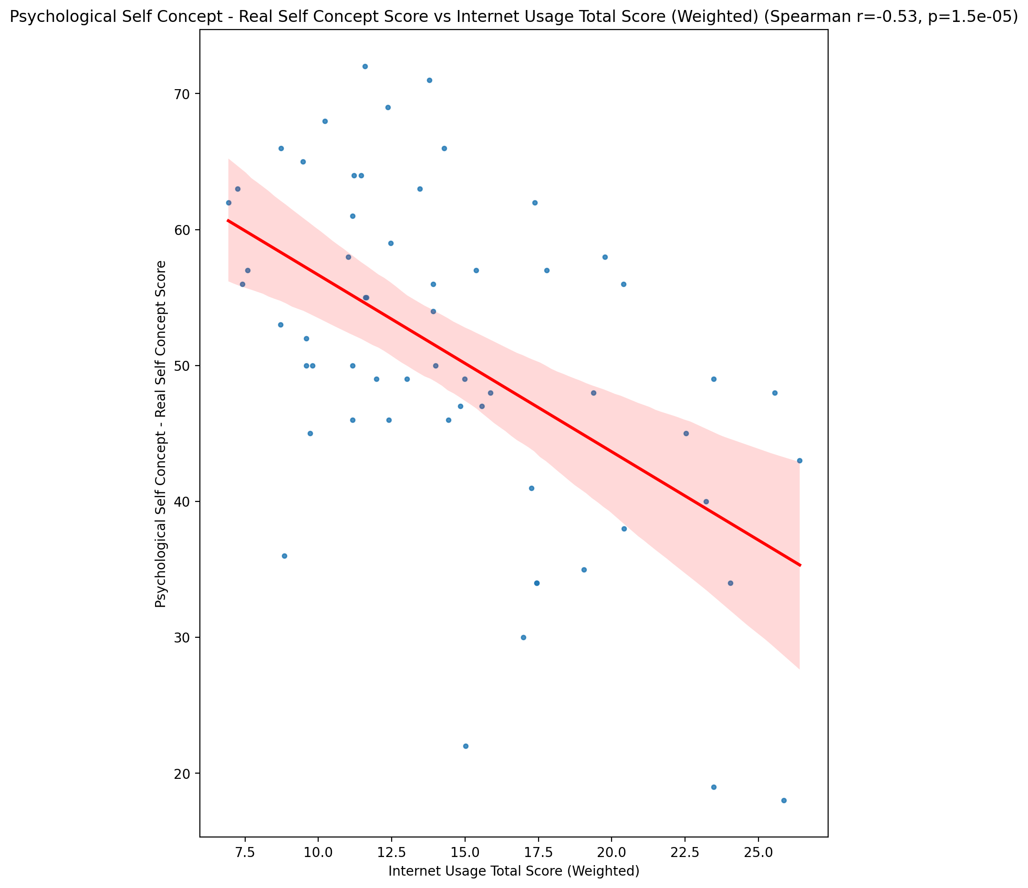

## Psychological Self Concept – Ideal Self Concept Score vs Internet Usage Total Score (Weighted)

Test: spearman; statistic: -0.27728157976055157; p-value: 0.033490444711404645;

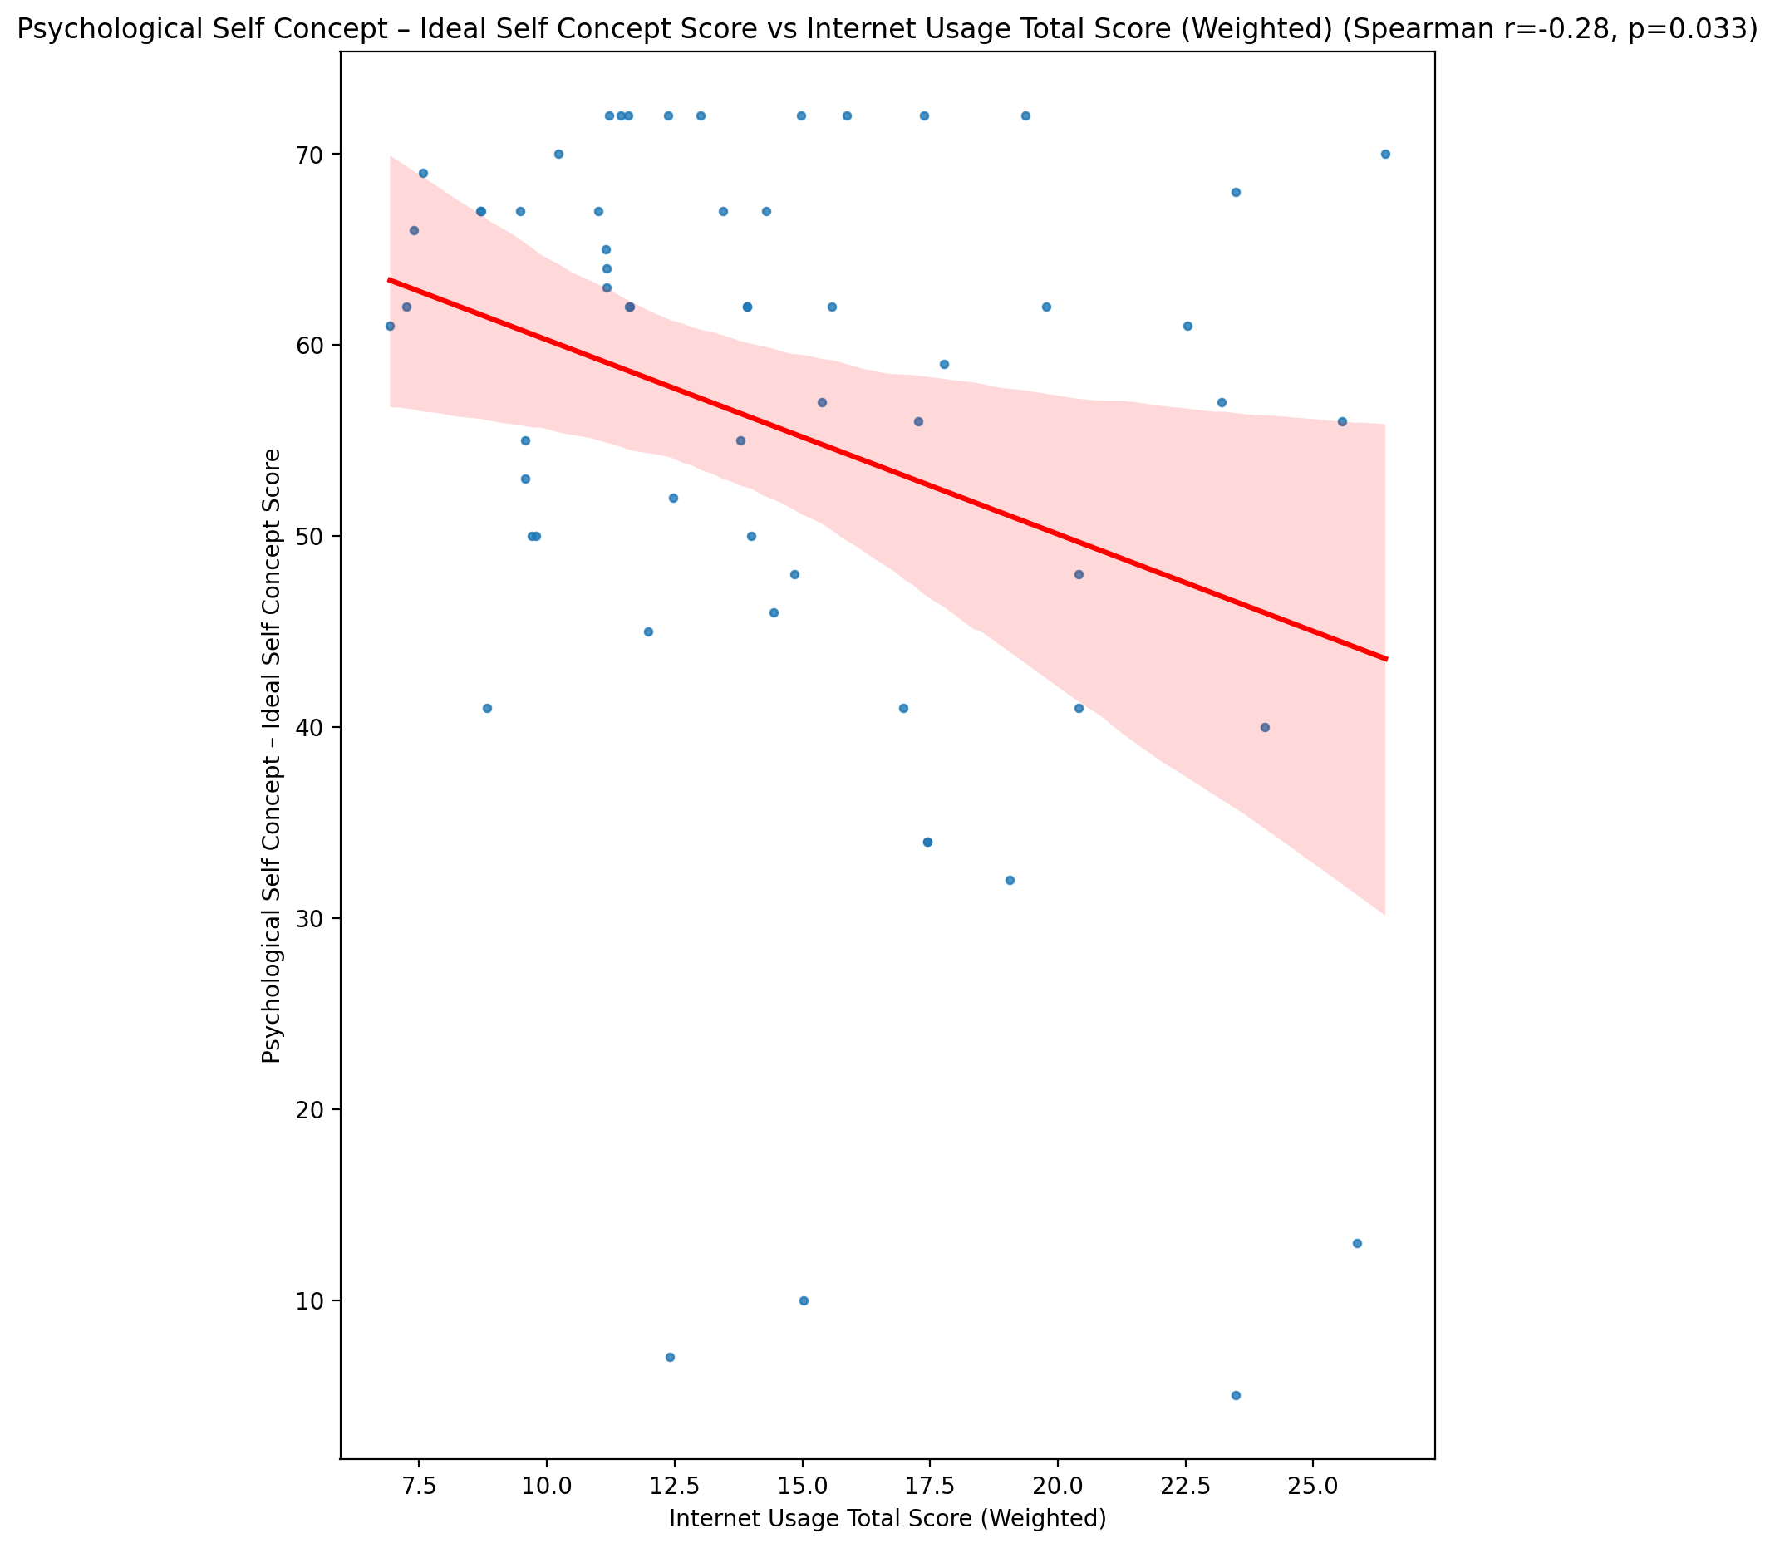

## Psychological Self Concept – Social Self Concept Score vs Internet Usage Total Score (Weighted)

Test: spearman; statistic: -0.29416430526883613; p-value: 0.023730495039958797;

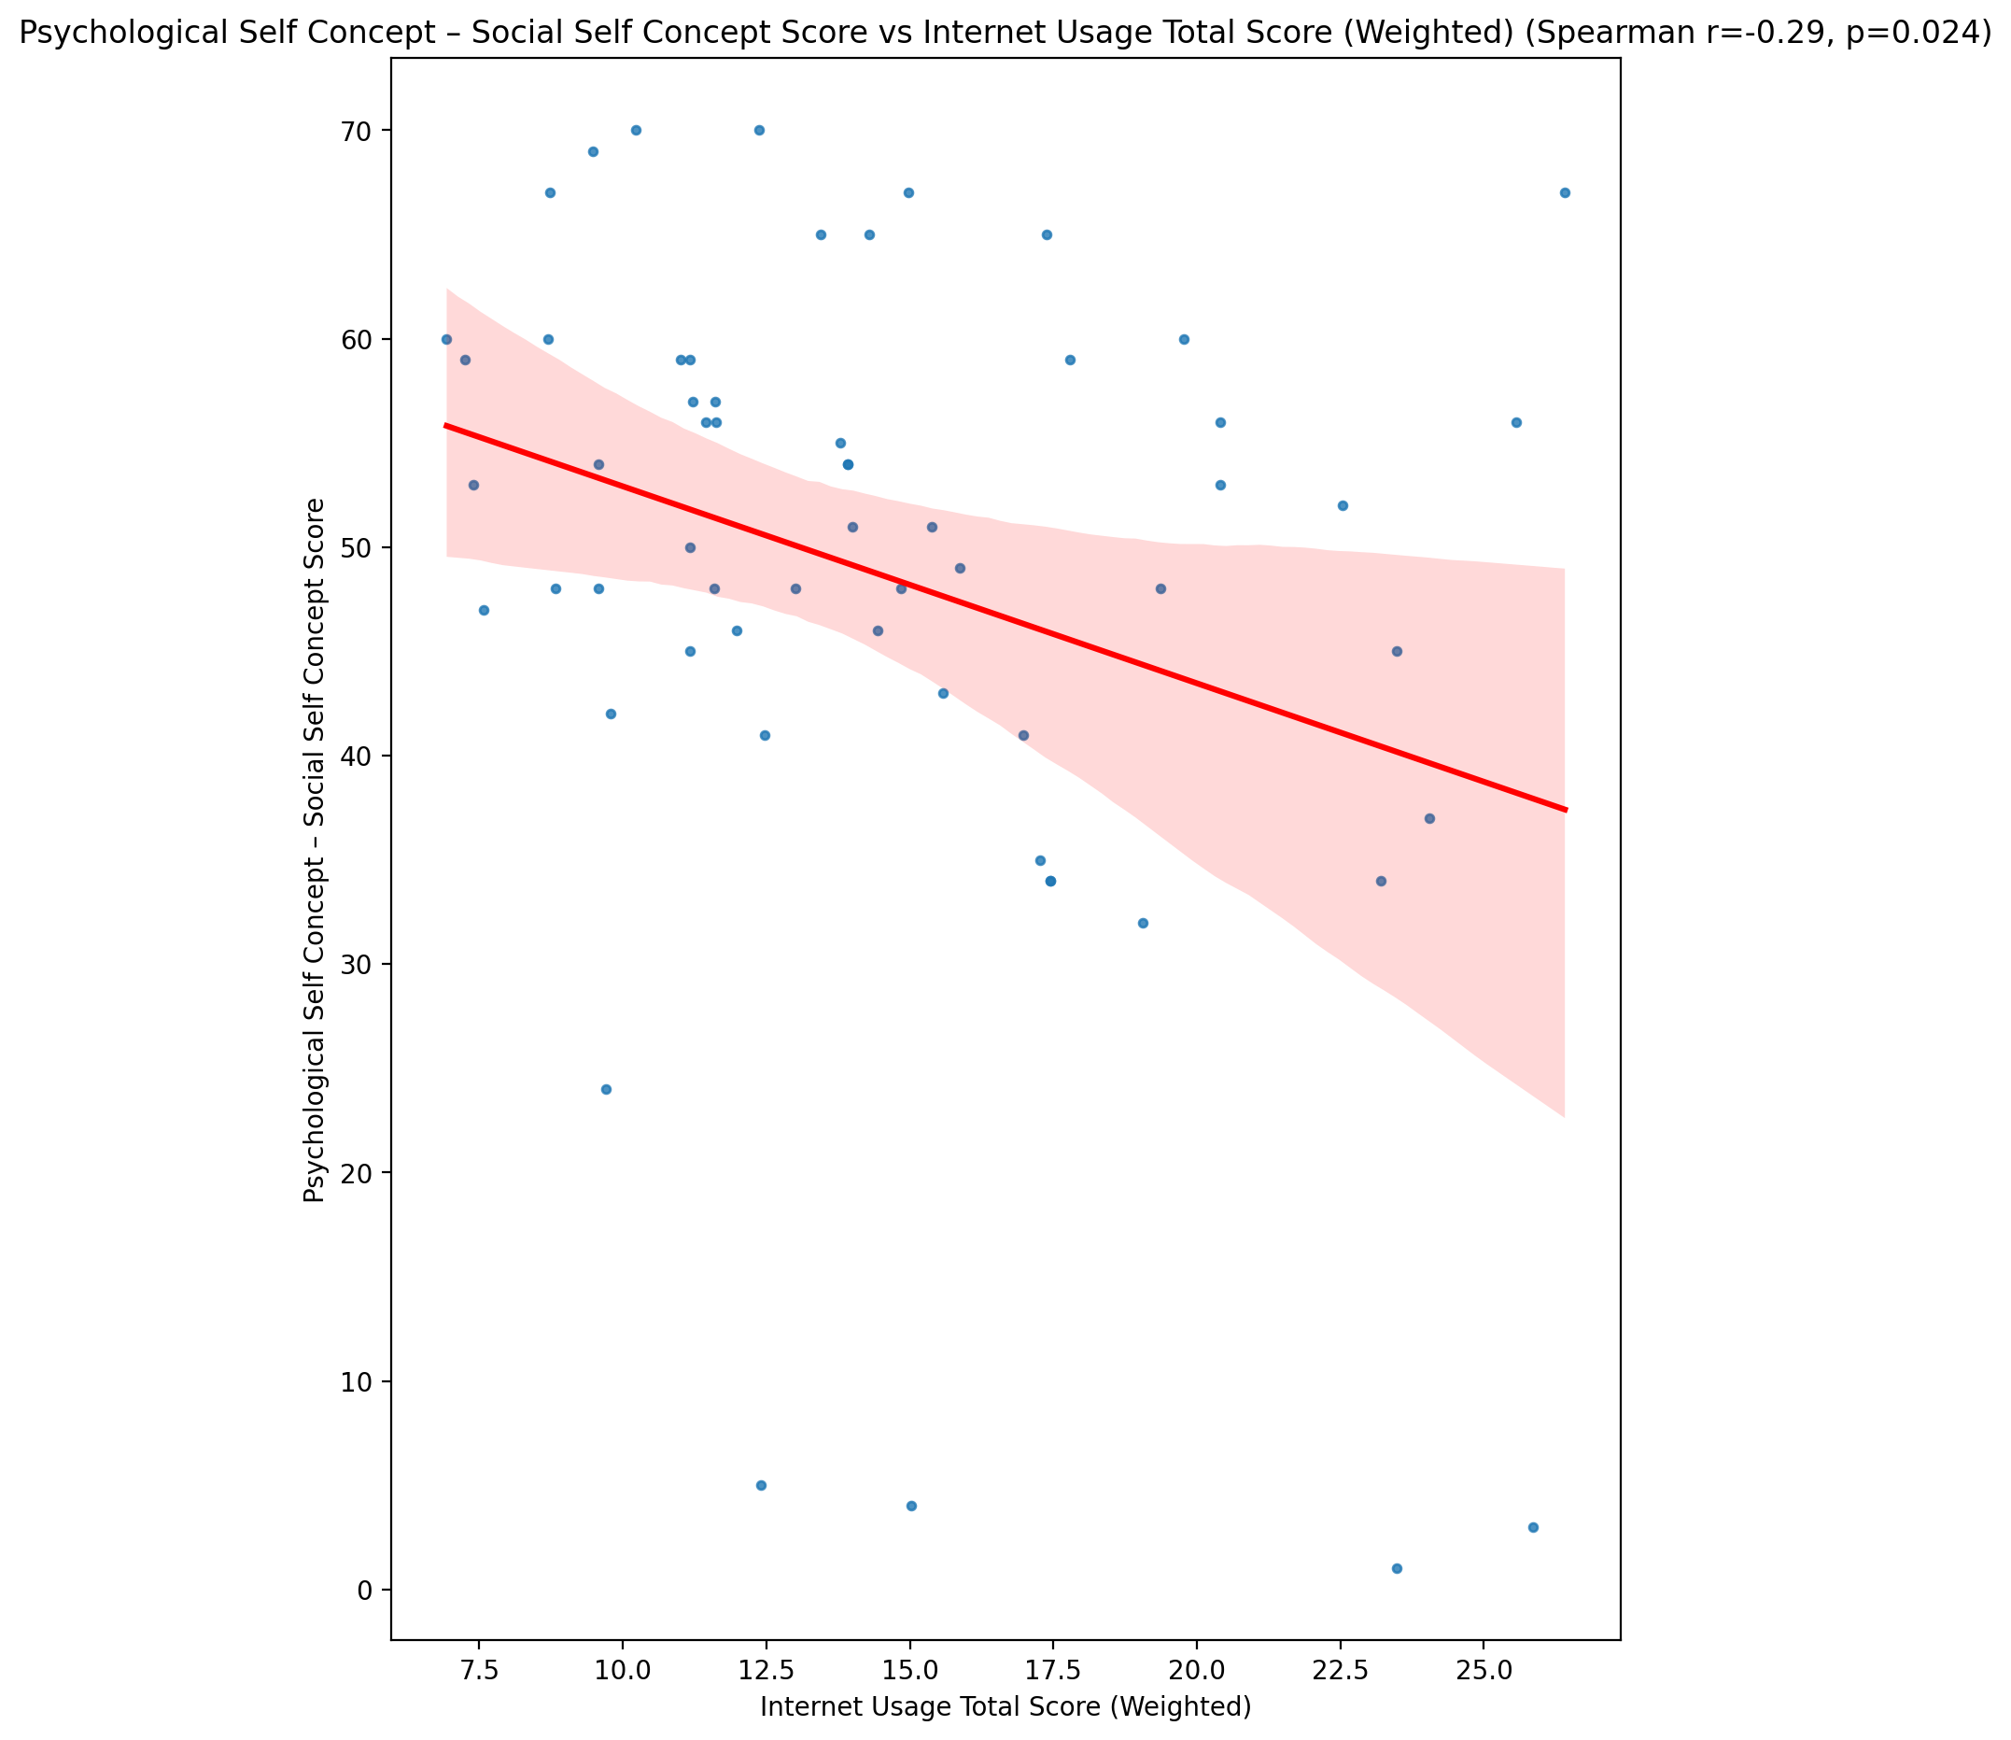

## Real Self Concept Total Score vs Internet Usage Total Score (Weighted)

Test: spearman; statistic: -0.5109360481982307; p-value: 3.550764366765226e-05;

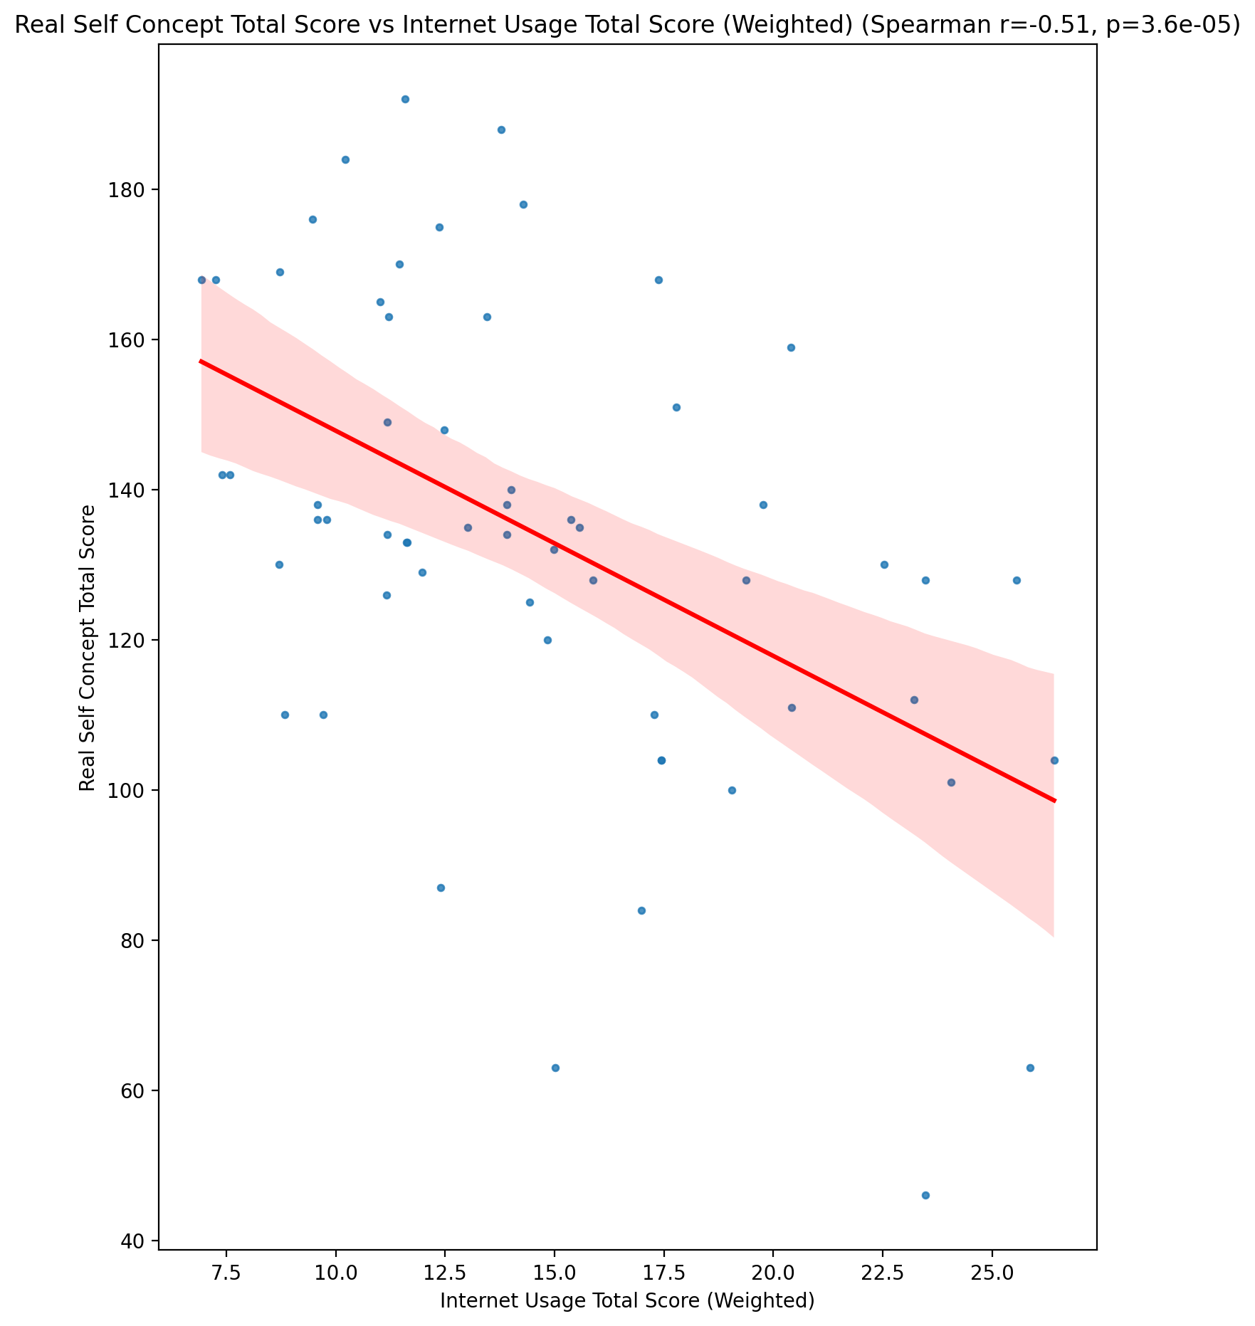

## Ideal Self Concept Total Score vs Internet Usage Total Score (Weighted)

Test: spearman; statistic: -0.26570345960909963; p-value: 0.04195568158747671;

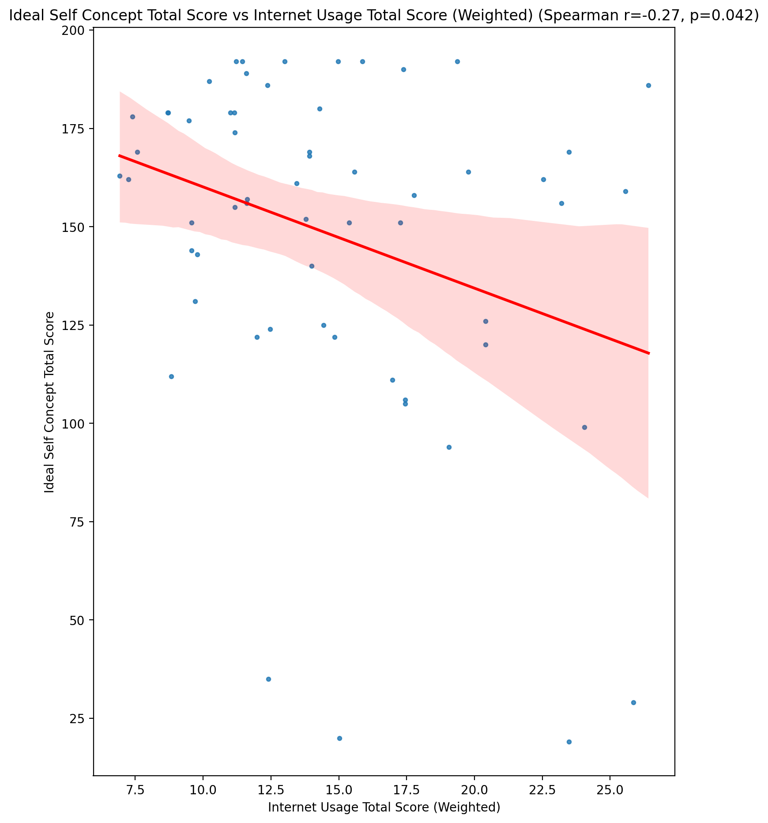

## Social Self Concept Total Score vs Internet Usage Total Score (Weighted)

Test: spearman; statistic: -0.21868331641401173; p-value: 0.09611114117514218;

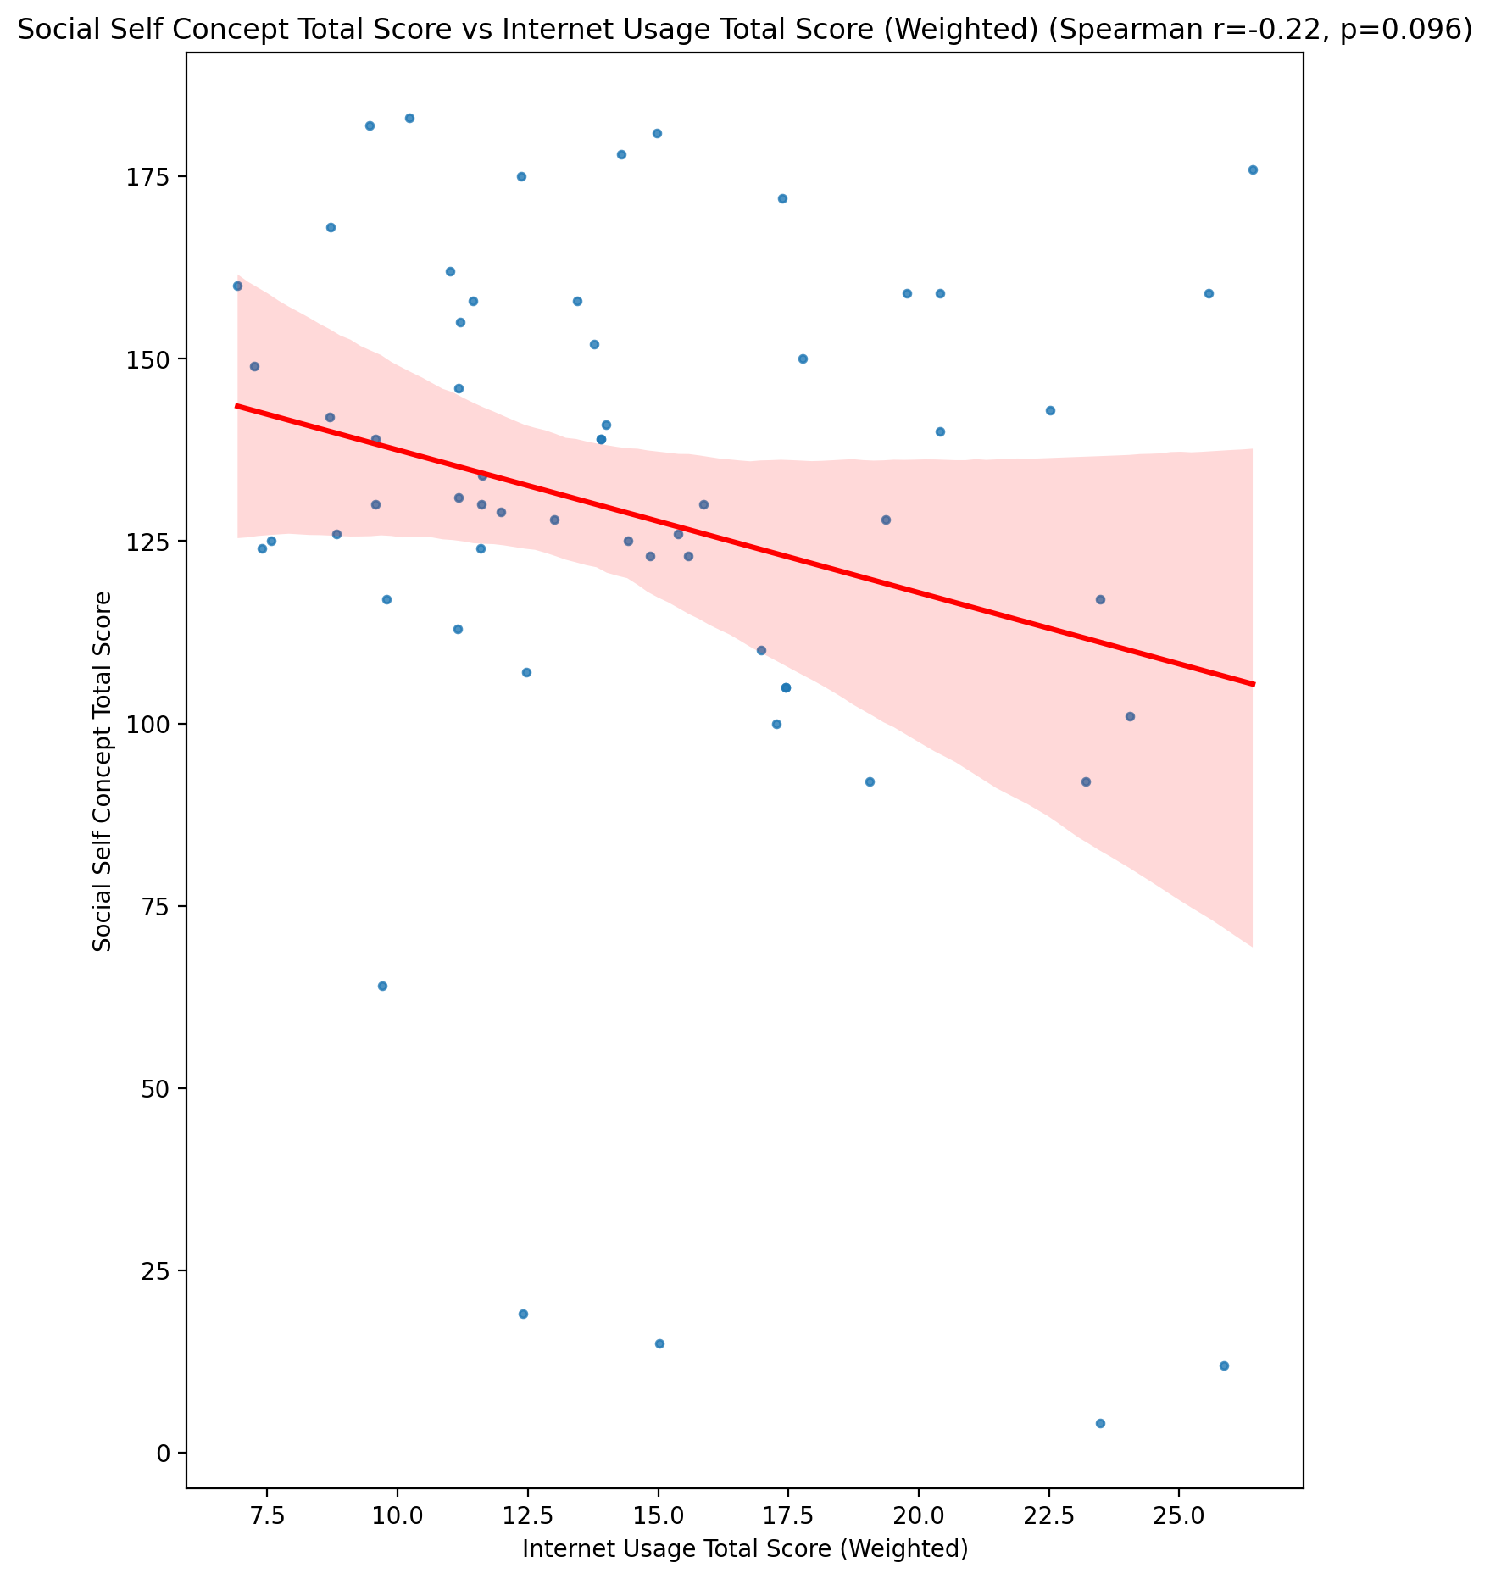

## Ideal Self Concept Total Category vs Internet Usage Total Score (Weighted)

Test: None; statistic: None; p-value: None; Test not run: unsupported type combination.



## Perceived Social Stress Score vs Internet Usage Total Score (Weighted)

Test: spearman; statistic: 0.35718678429937745; p-value: 0.00548367998288469;

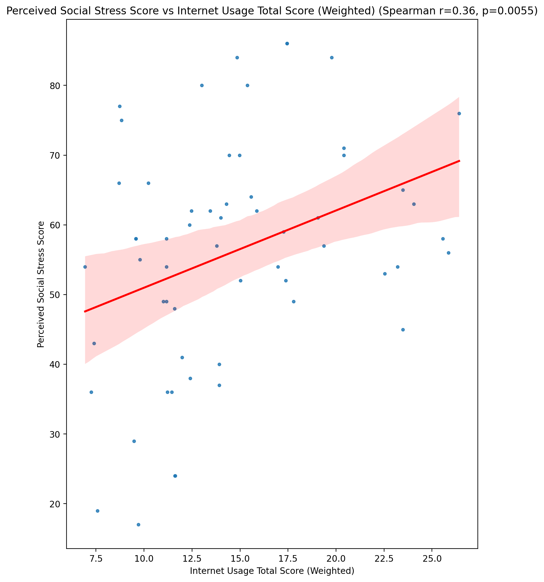

## Perceived Social Stress Category vs Internet Usage Total Score (Weighted)

Test: None; statistic: None; p-value: None; Test not run: unsupported type combination.



## Emotional Support - Raw Score vs Functional Impairment - Category

Test: anova; statistic: 0.47331931416604367; p-value: 0.7021254194374793;

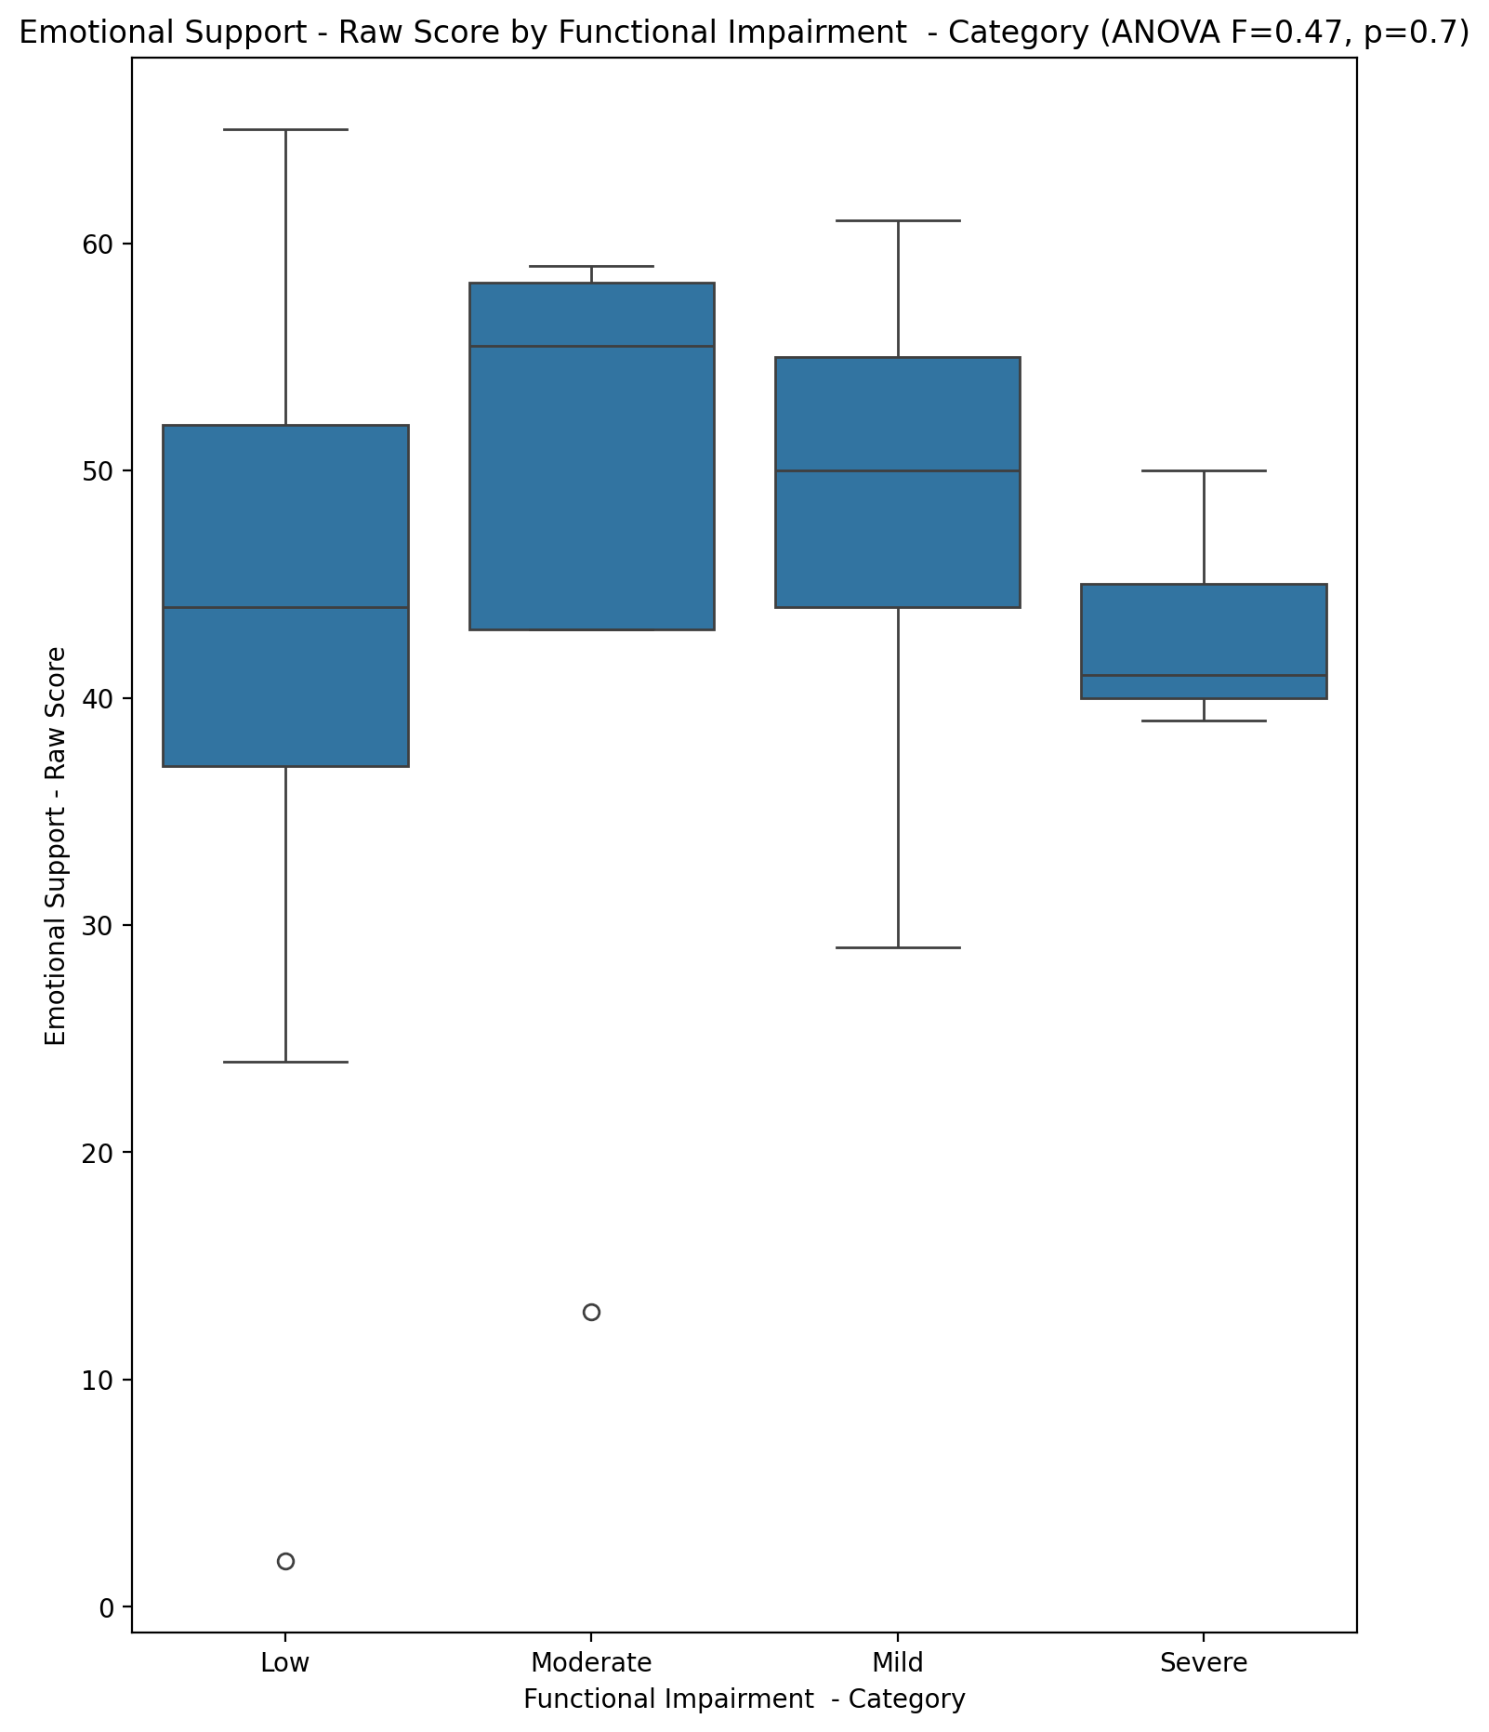

## Informational Support - Raw Score vs Functional Impairment - Category

Test: anova; statistic: 0.9733647379263363; p-value: 0.4119811607323527;

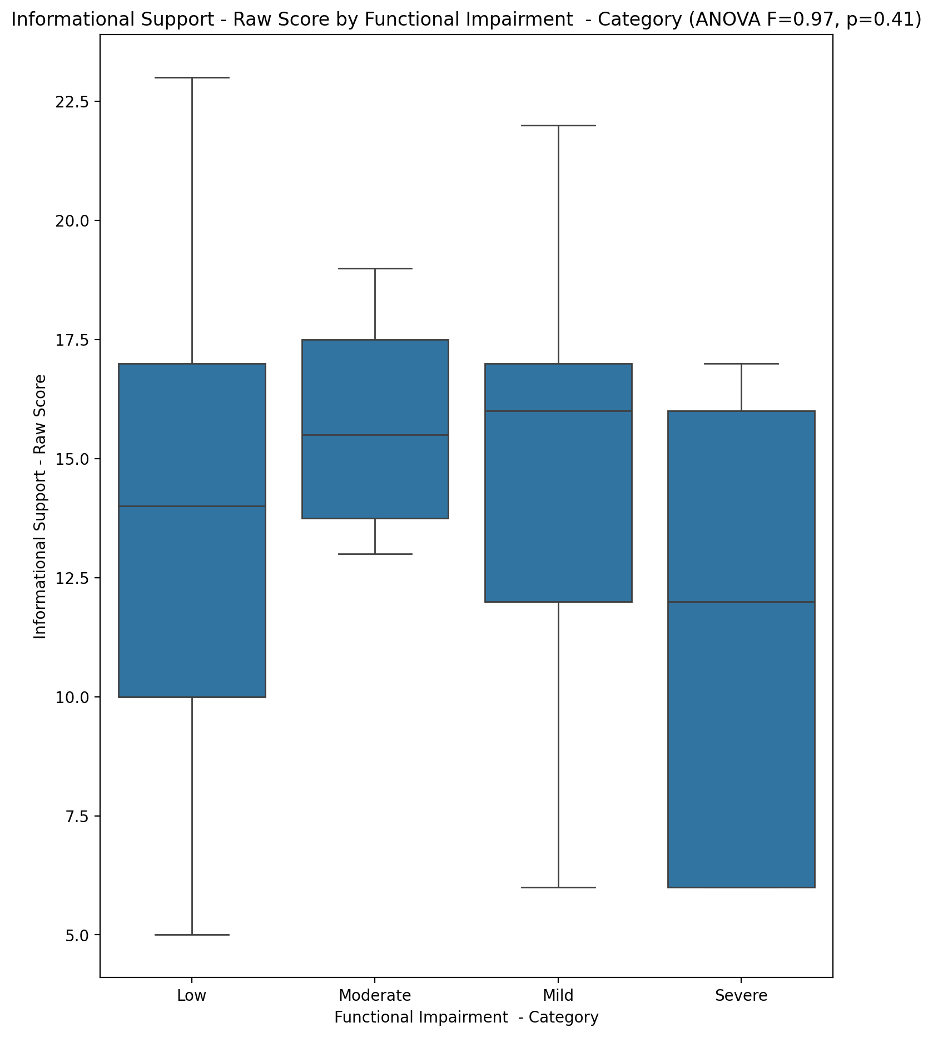

## Instrumental Support - Raw Score vs Functional Impairment - Category

Test: anova; statistic: 0.3506274118770967; p-value: 0.7888327613337736;

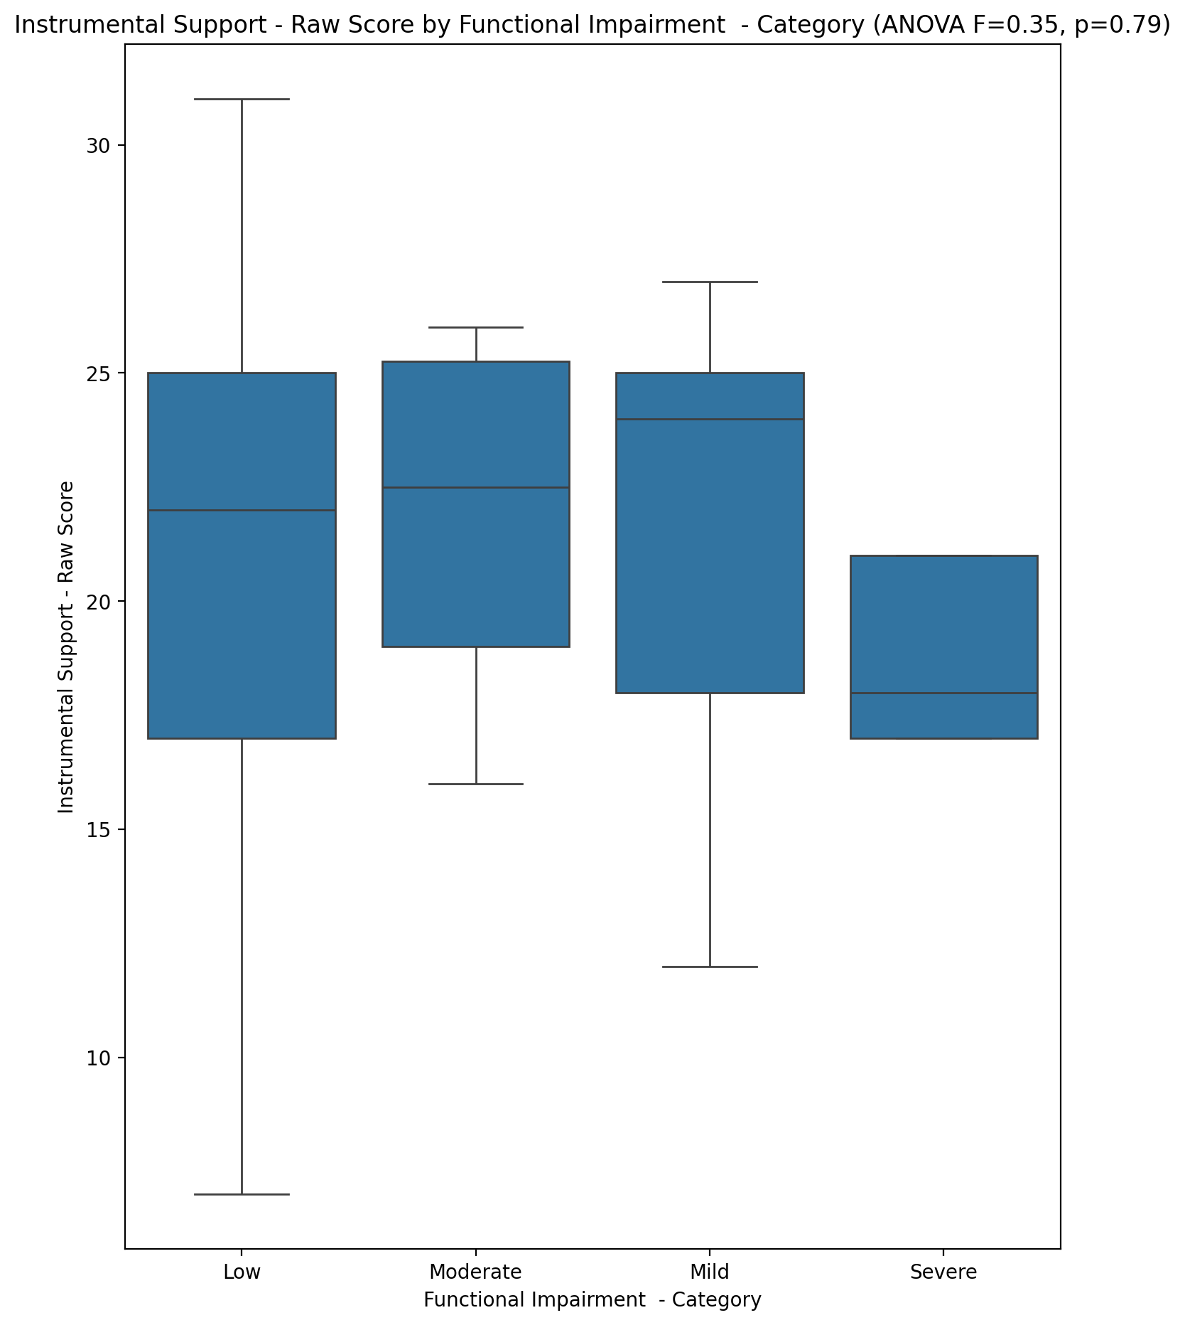

## Emotional Support - T Score vs Functional Impairment - Category

Test: anova; statistic: 0.5345913727895434; p-value: 0.6605092602655664;

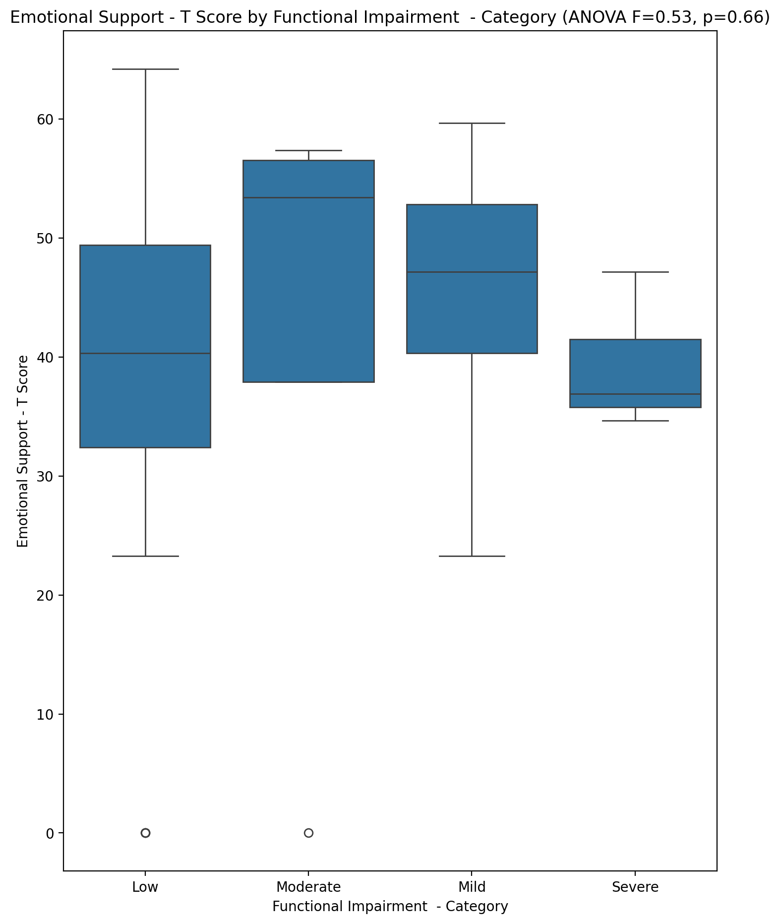

## Informational Support - T Score vs Functional Impairment - Category

Test: anova; statistic: 1.1579166408284696; p-value: 0.33414033449875596;

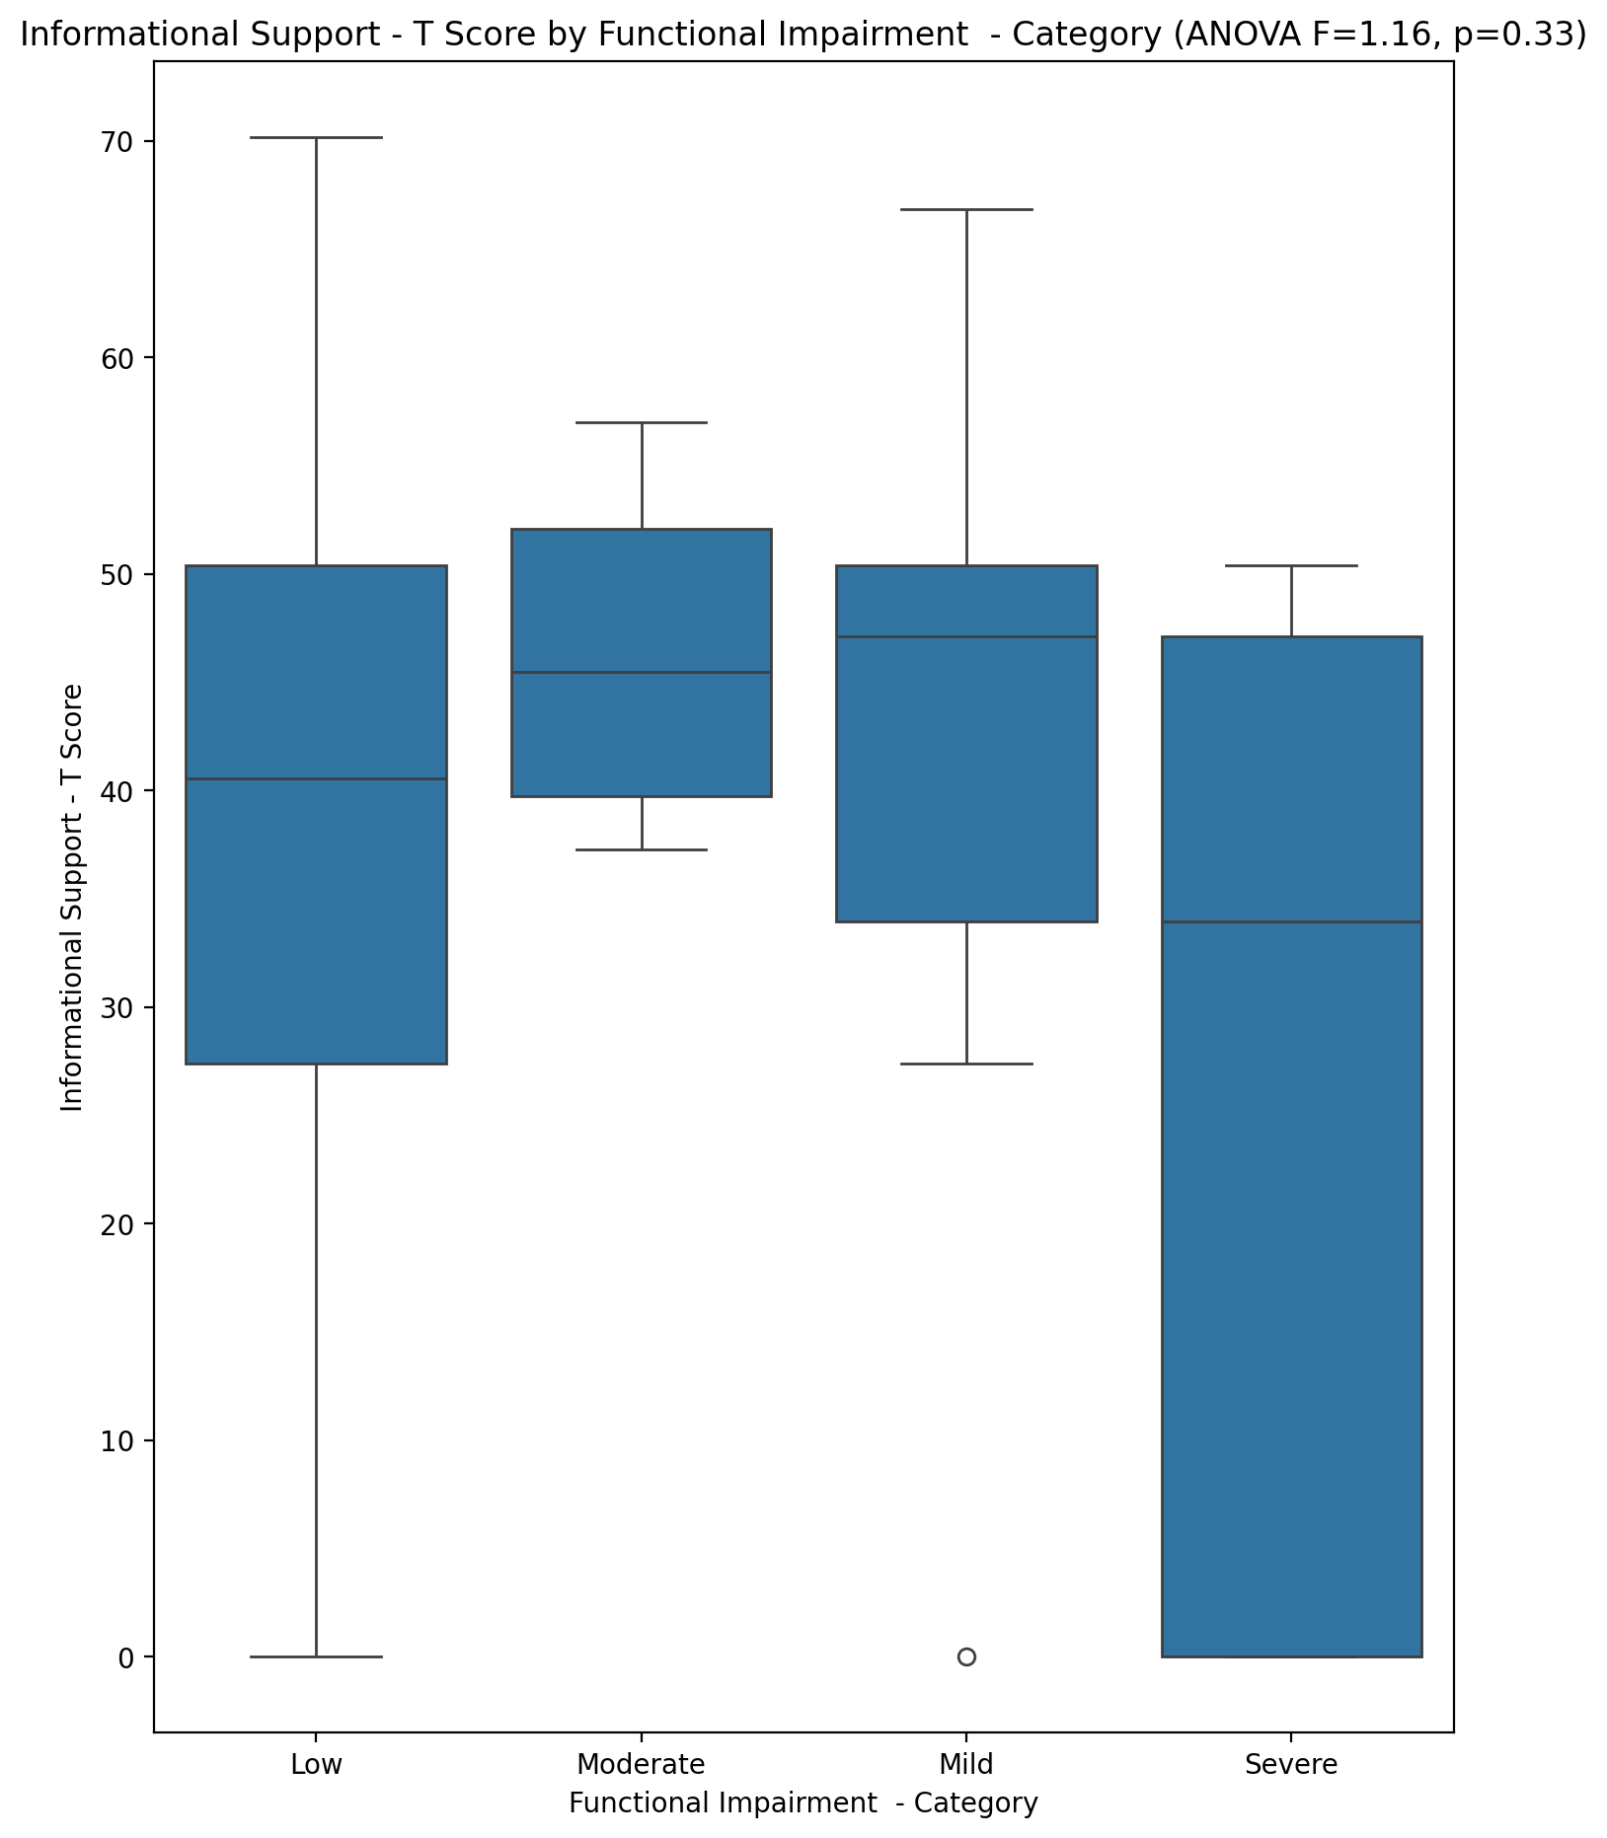

## Instrumental Support - T Score vs Functional Impairment - Category

Test: anova; statistic: 0.17062901995083965; p-value: 0.9157800172417785;

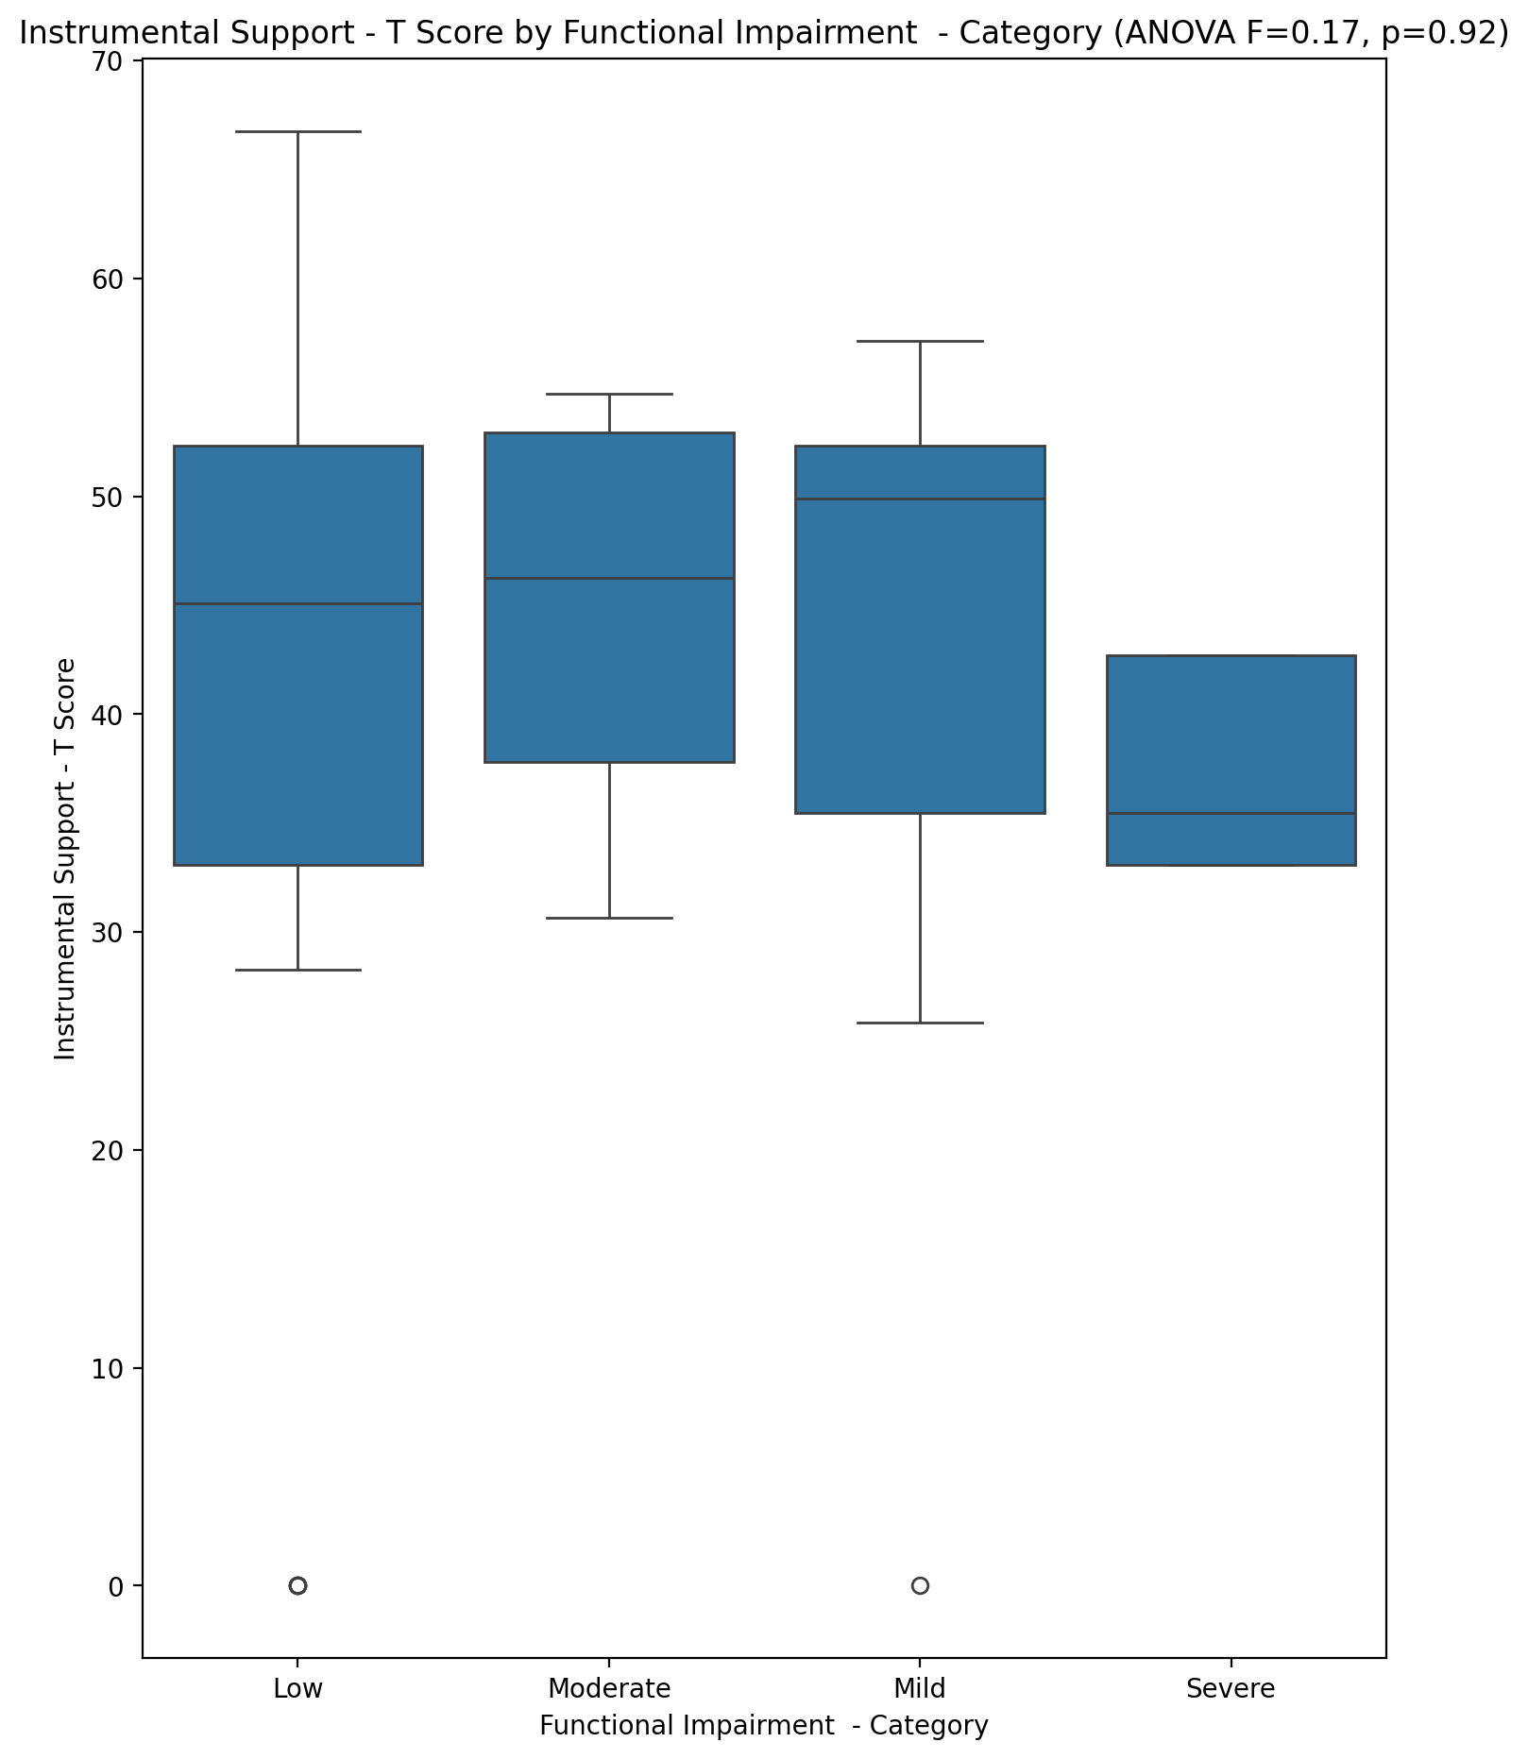

## Perceived Social Support Total T Score vs Functional Impairment - Category

Test: anova; statistic: 0.5120743182321688; p-value: 0.6756396512555101;

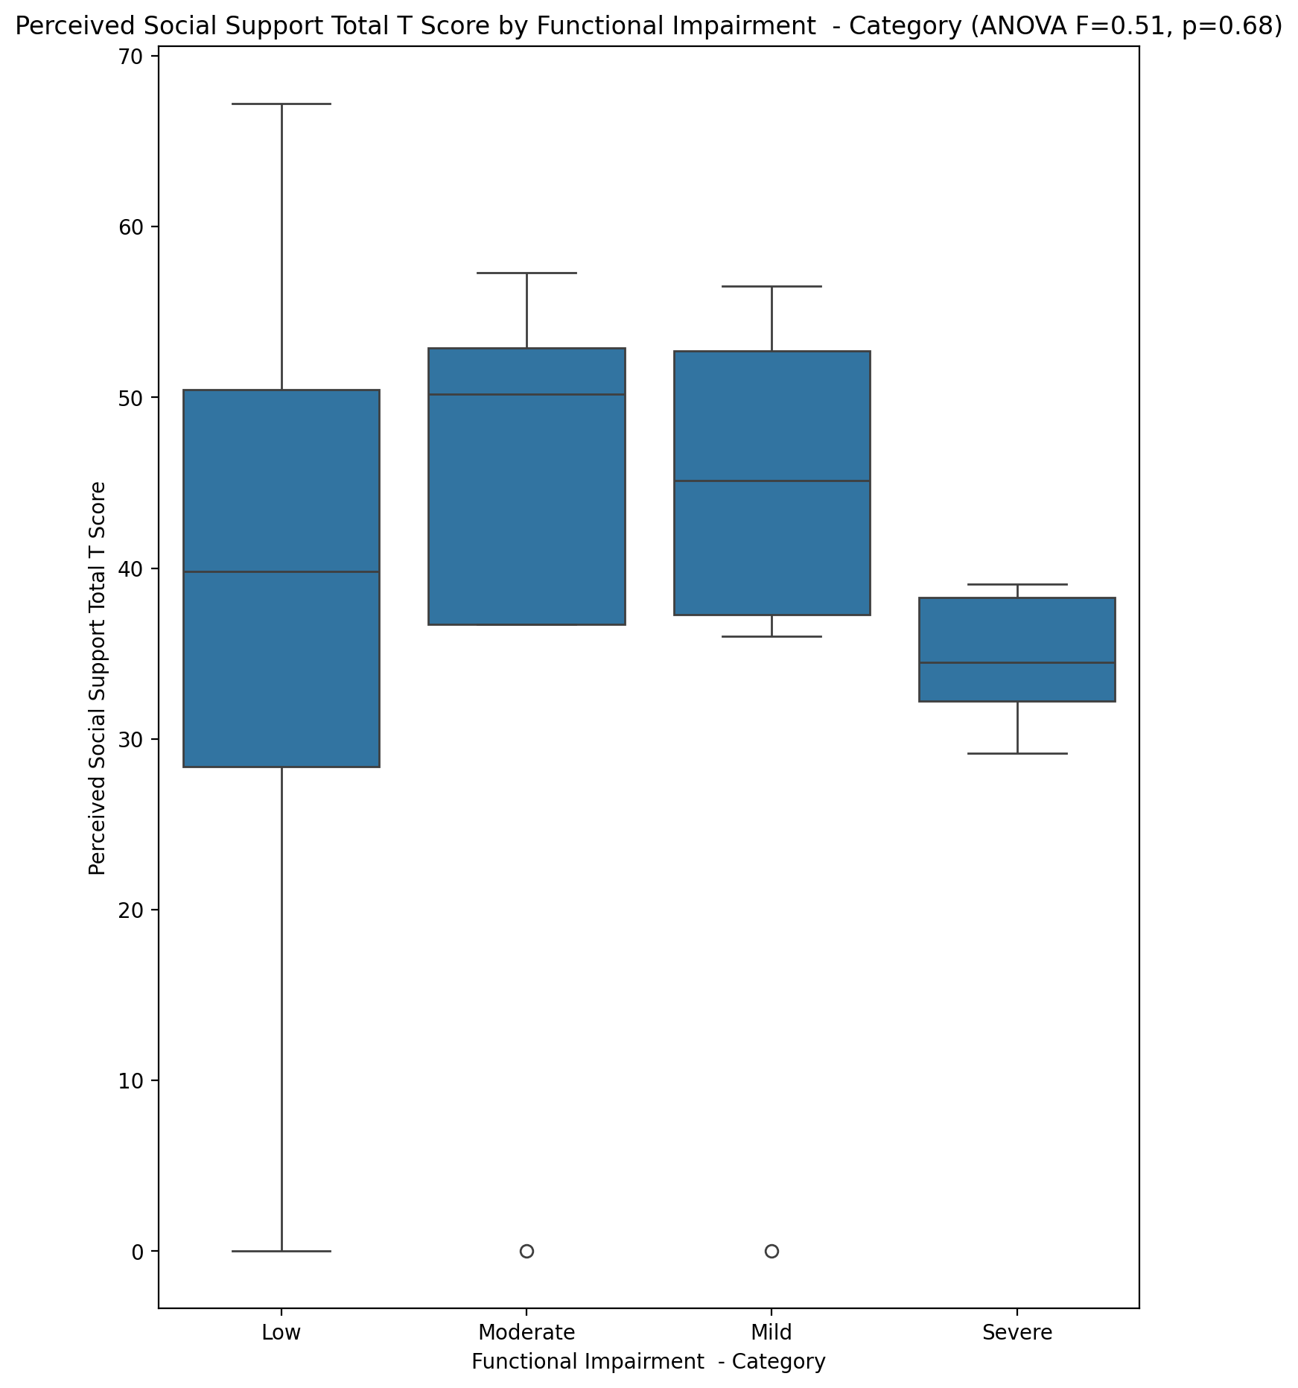

## Emotional Support - Rank vs Functional Impairment - Category

Test: chi2; statistic: 8.162293247293249; p-value: 0.5178774527113222;

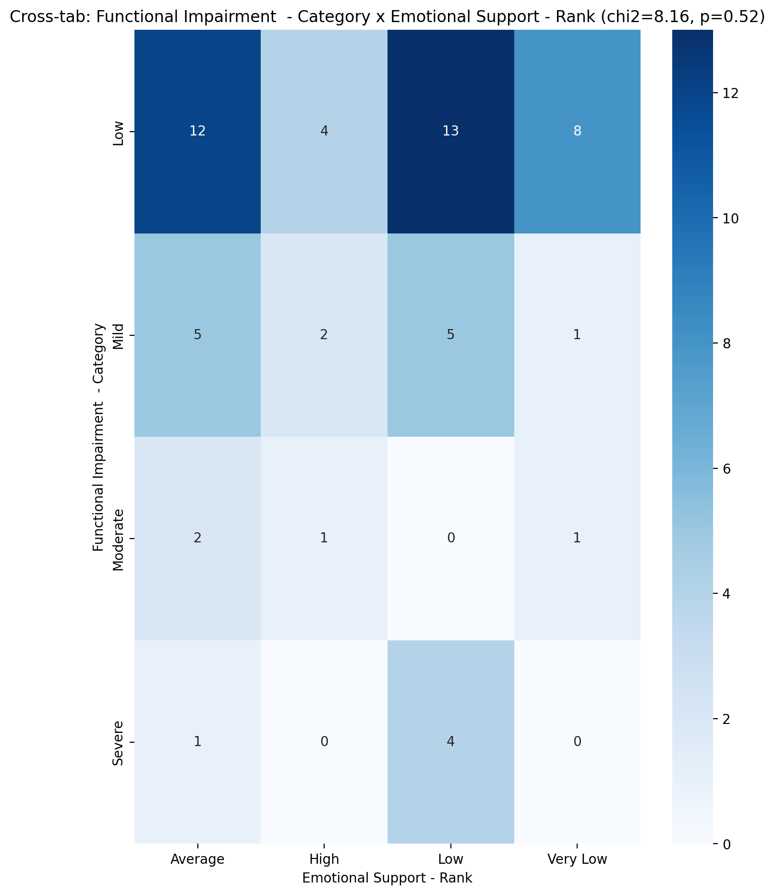

## Informational Support - Rank vs Functional Impairment - Category

Test: chi2; statistic: 6.2780637143795035; p-value: 0.9014211300840859;

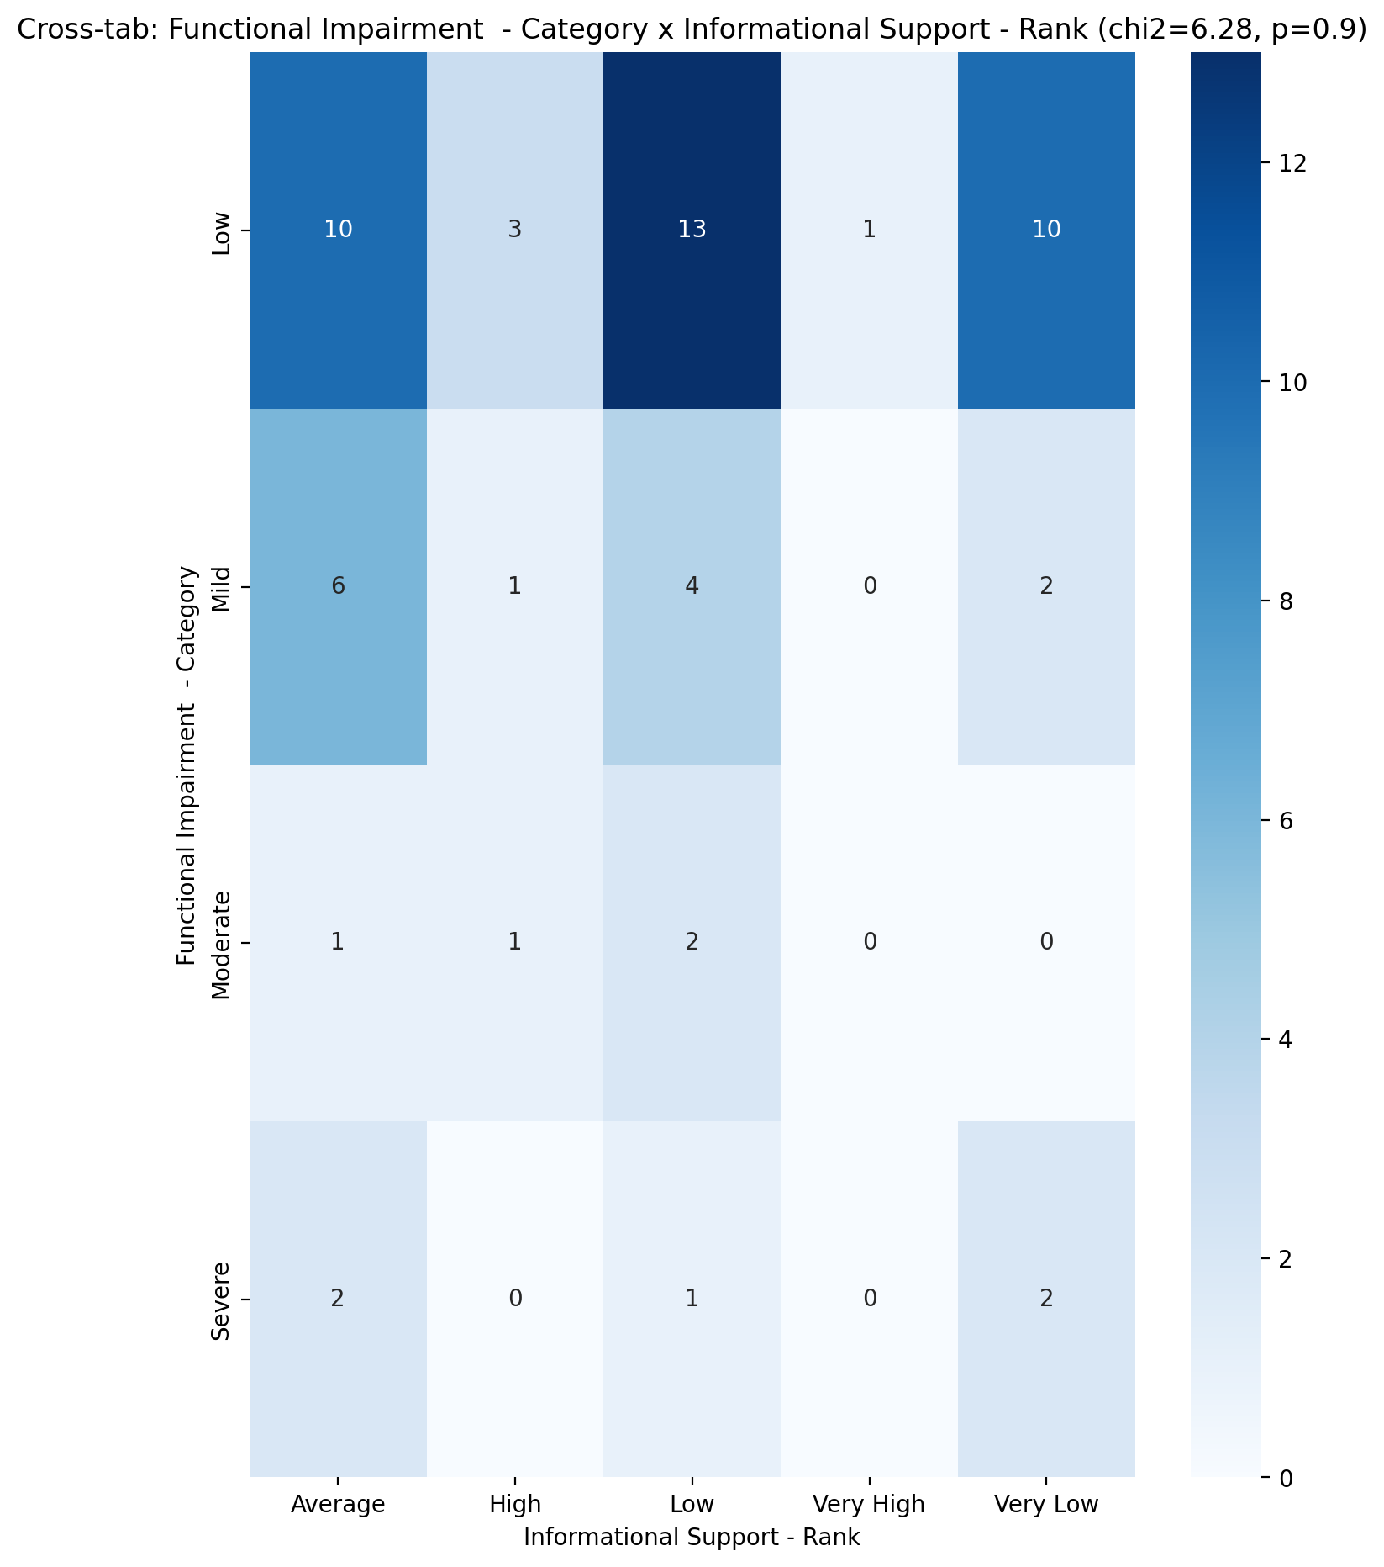

## Instrumental Support - Rank vs Functional Impairment - Category

Test: chi2; statistic: 19.230254292754296; p-value: 0.023304735486572505;

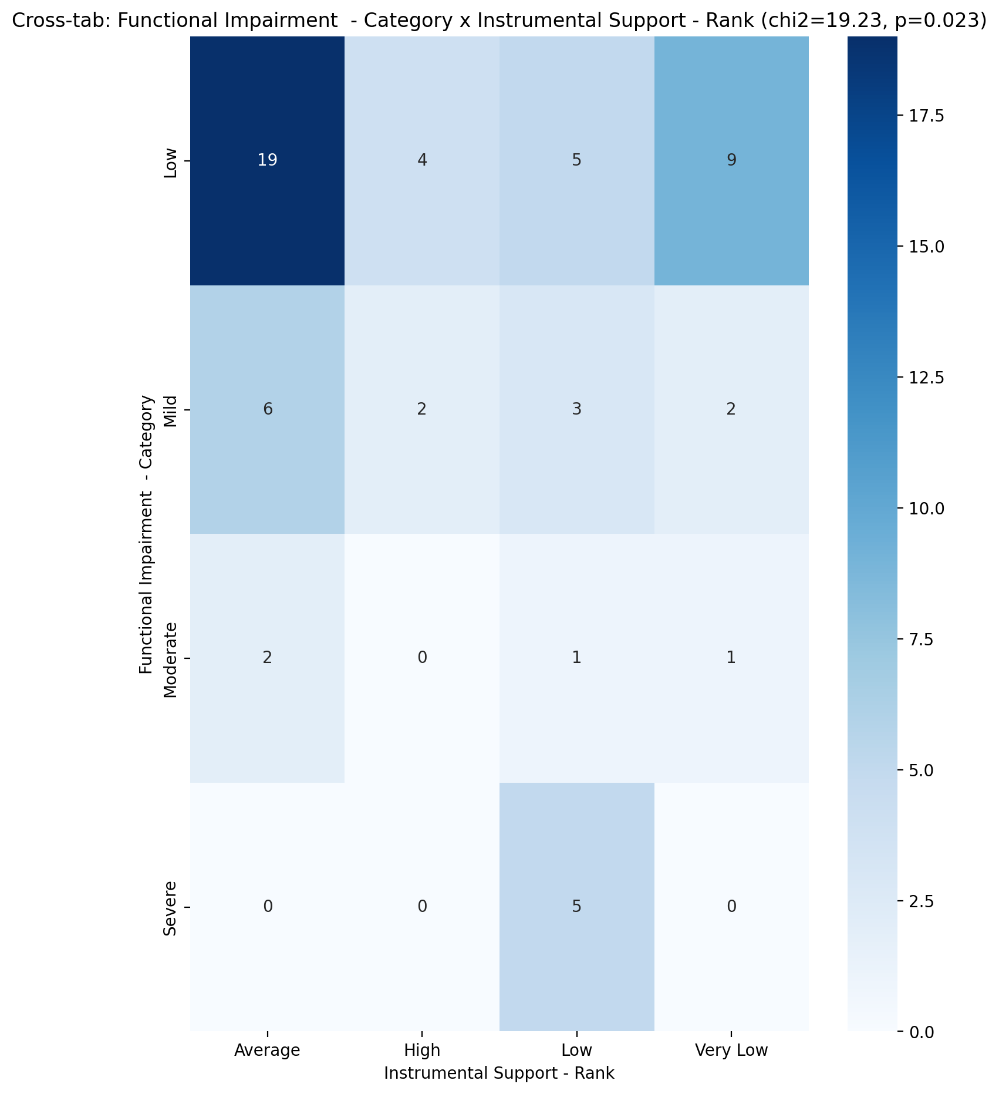

## Perceived Social Support TOTAL - Rank vs Functional Impairment - Category

Test: chi2; statistic: 12.73283998226306; p-value: 0.17507224348899472;

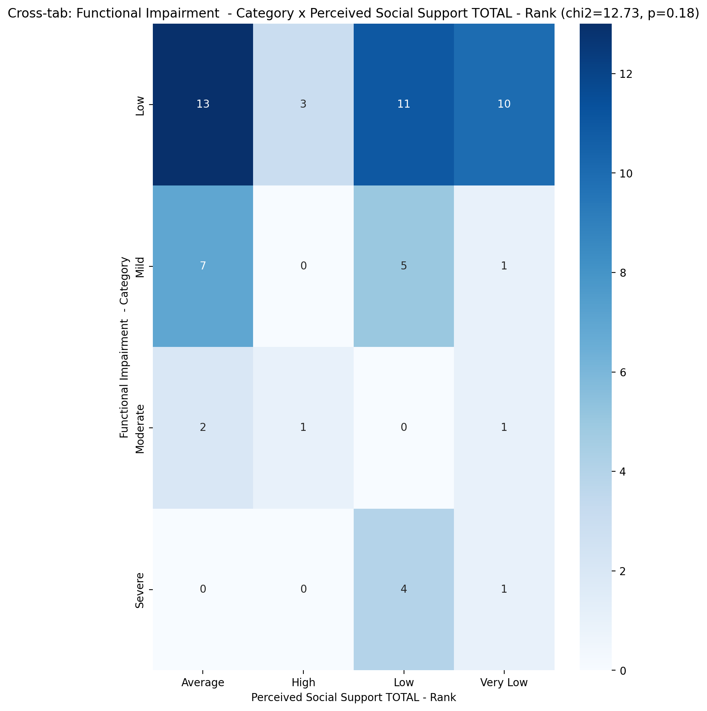

## Power Self Concept - Real Self Concept Score vs Functional Impairment - Category

Test: anova; statistic: 5.9180524665852365; p-value: 0.0014207938707410175;

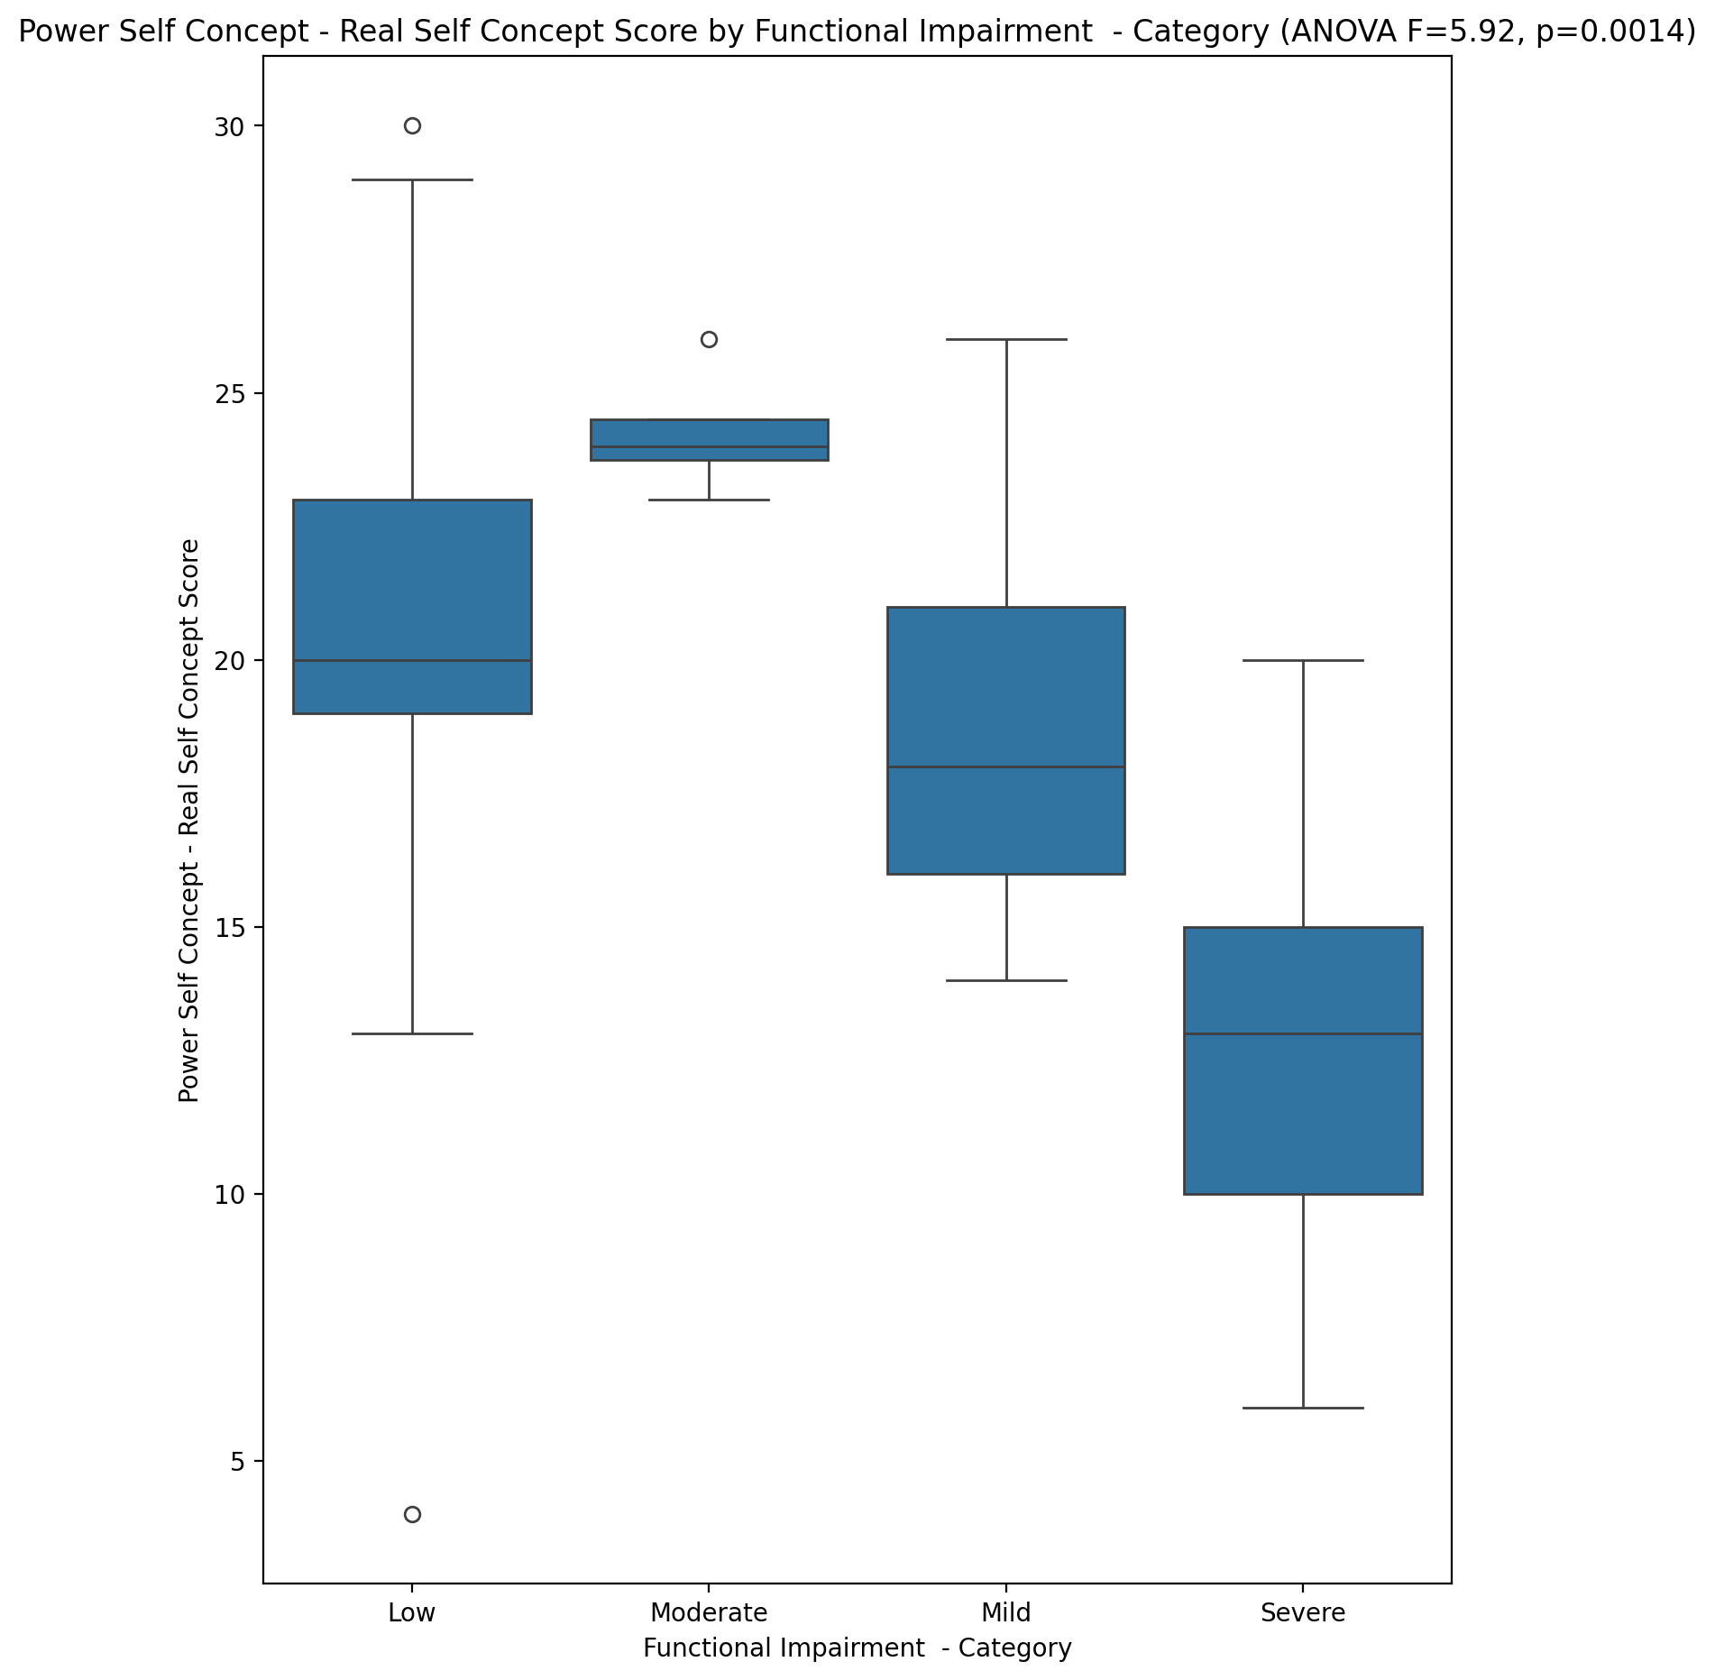

## Power Self Concept - Ideal Self Concept score vs Functional Impairment - Category

Test: anova; statistic: 14.461040430751378; p-value: 4.6152205188422415e-07;

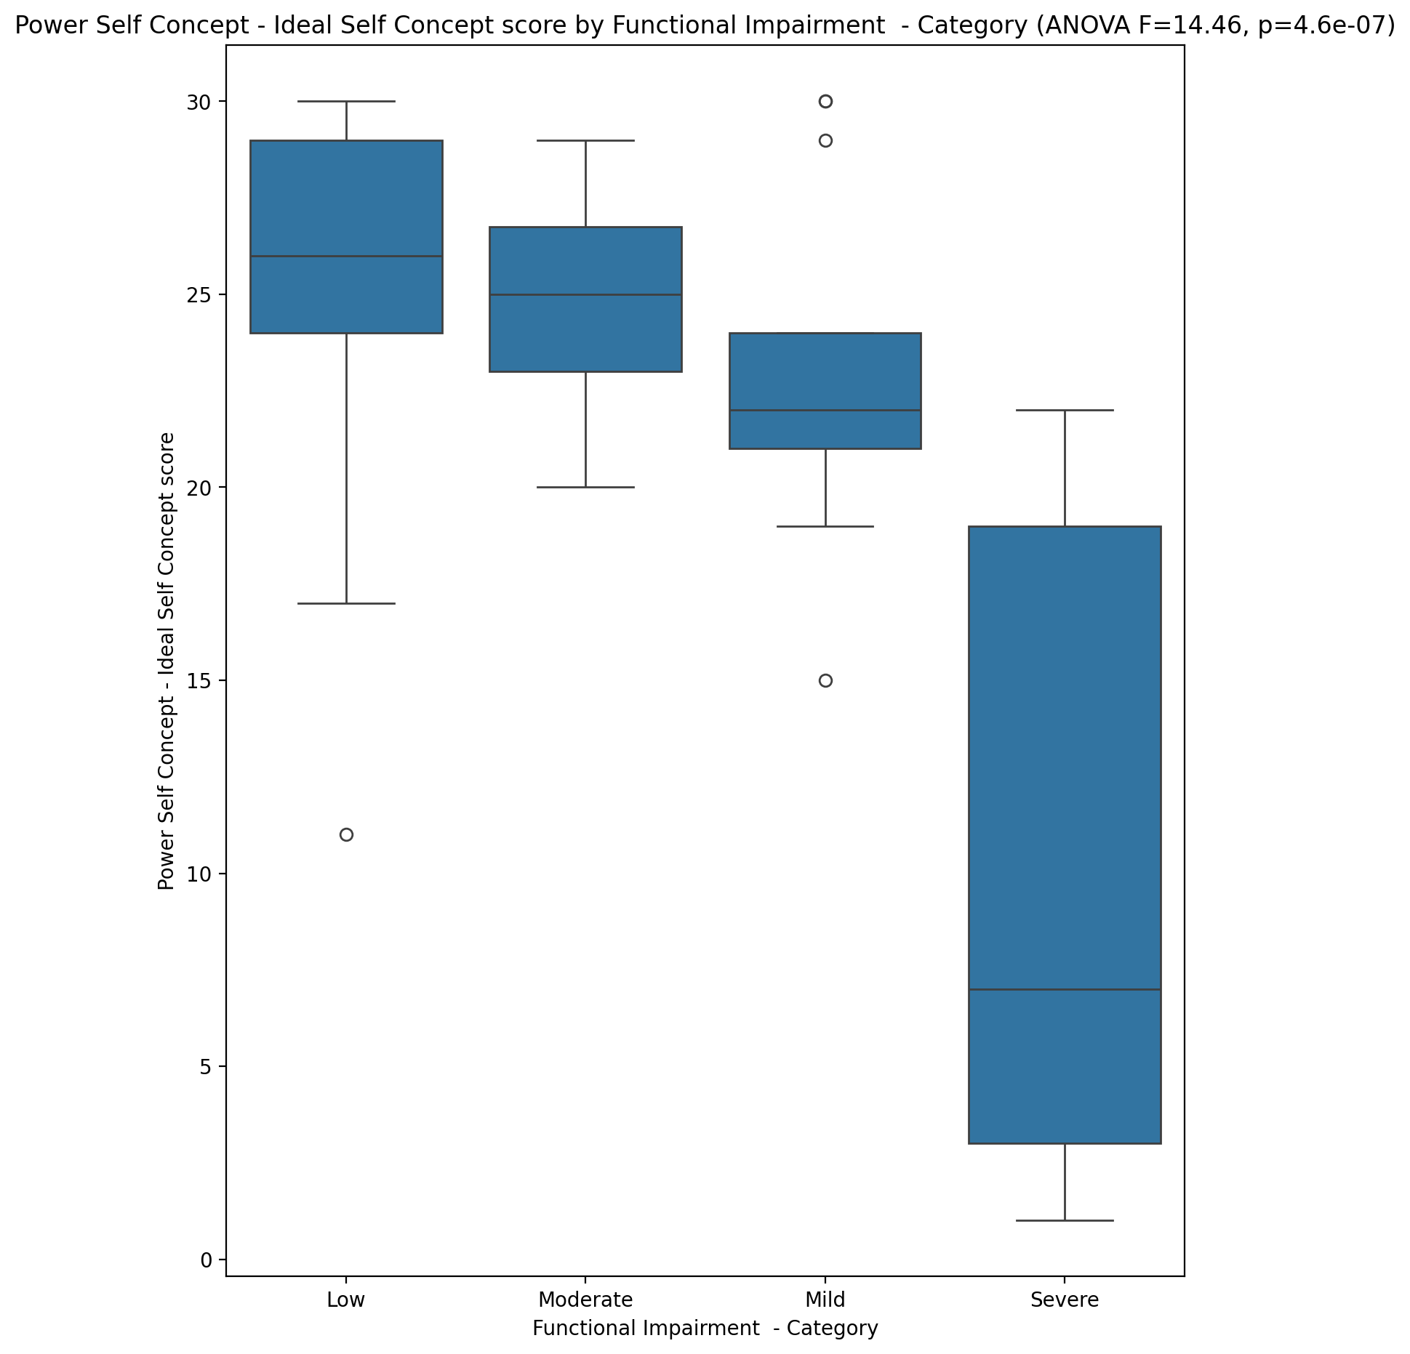

## Power Self Concept – Social Self Concept Score vs Functional Impairment - Category

Test: anova; statistic: 8.686776398284186; p-value: 8.214609126715456e-05;

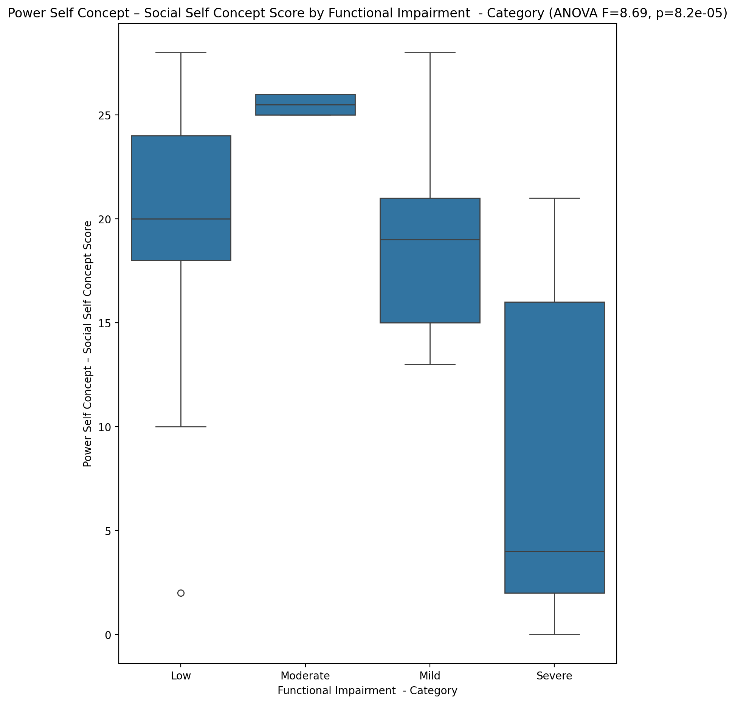

## Social Self Concept - Real Self Concept Score vs Functional Impairment - Category

Test: anova; statistic: 8.46782587460686; p-value: 0.00010194320959990512;

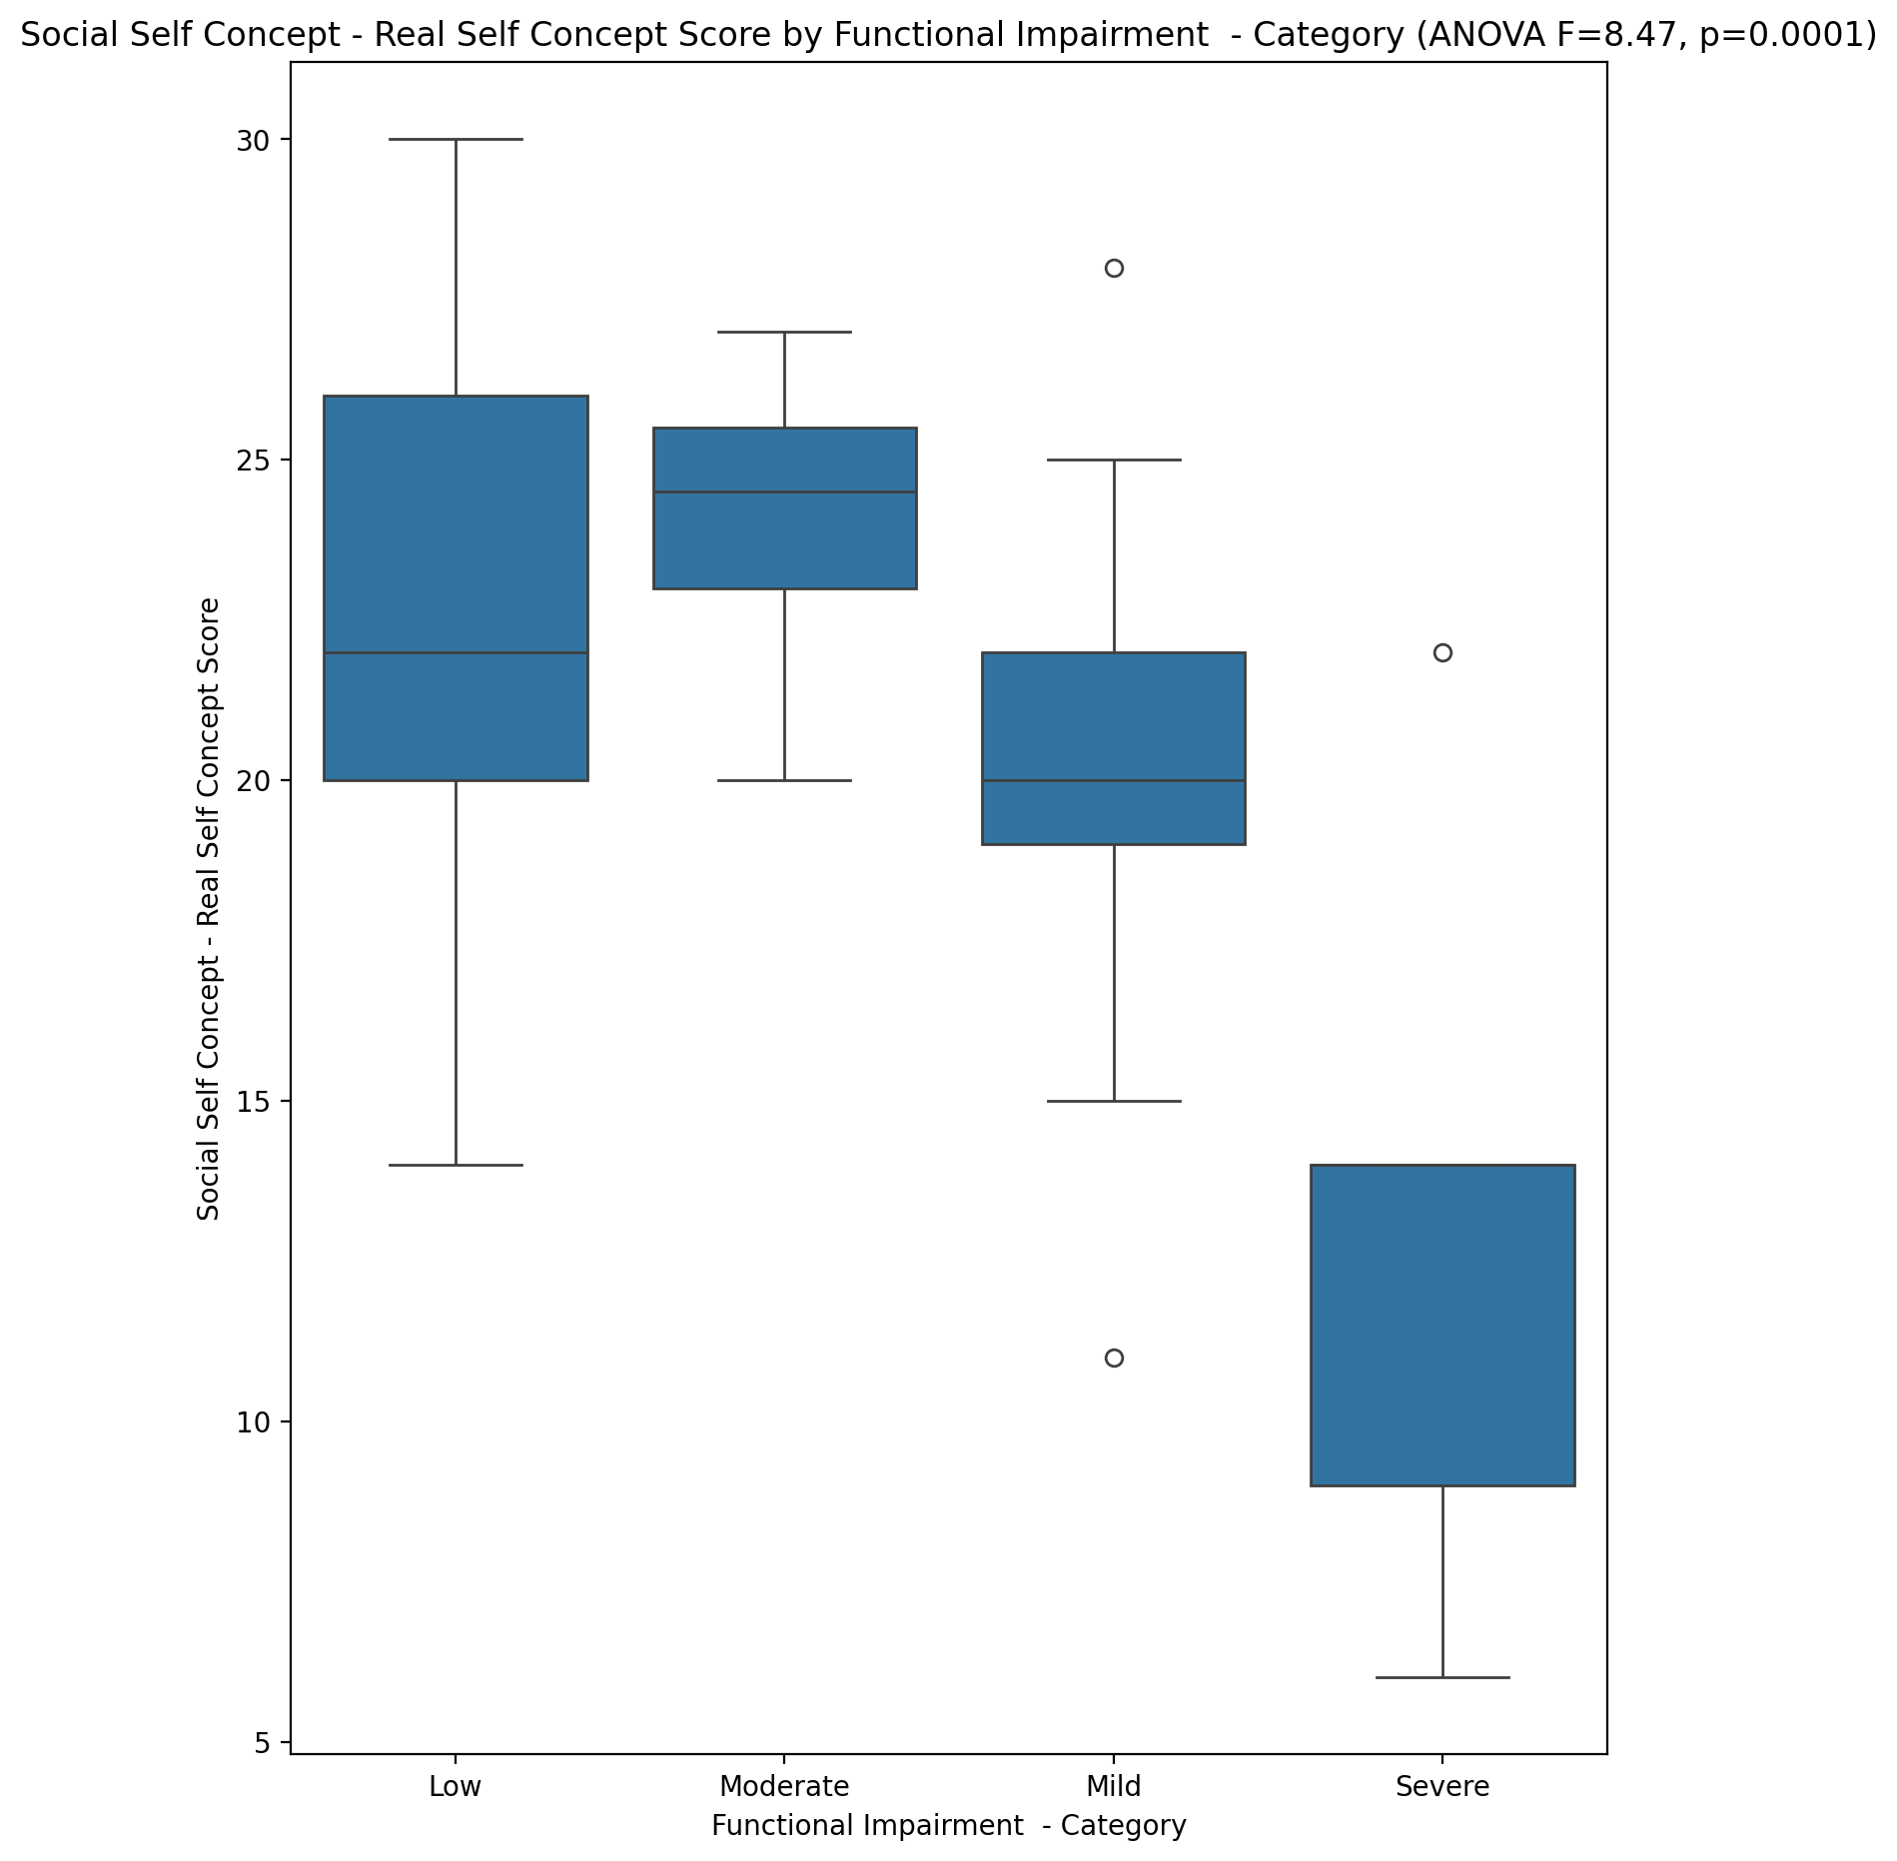

## Social Self Concept – Social Self Concept Score vs Functional Impairment - Category

Test: anova; statistic: 8.676852239598345; p-value: 8.29511596314867e-05;

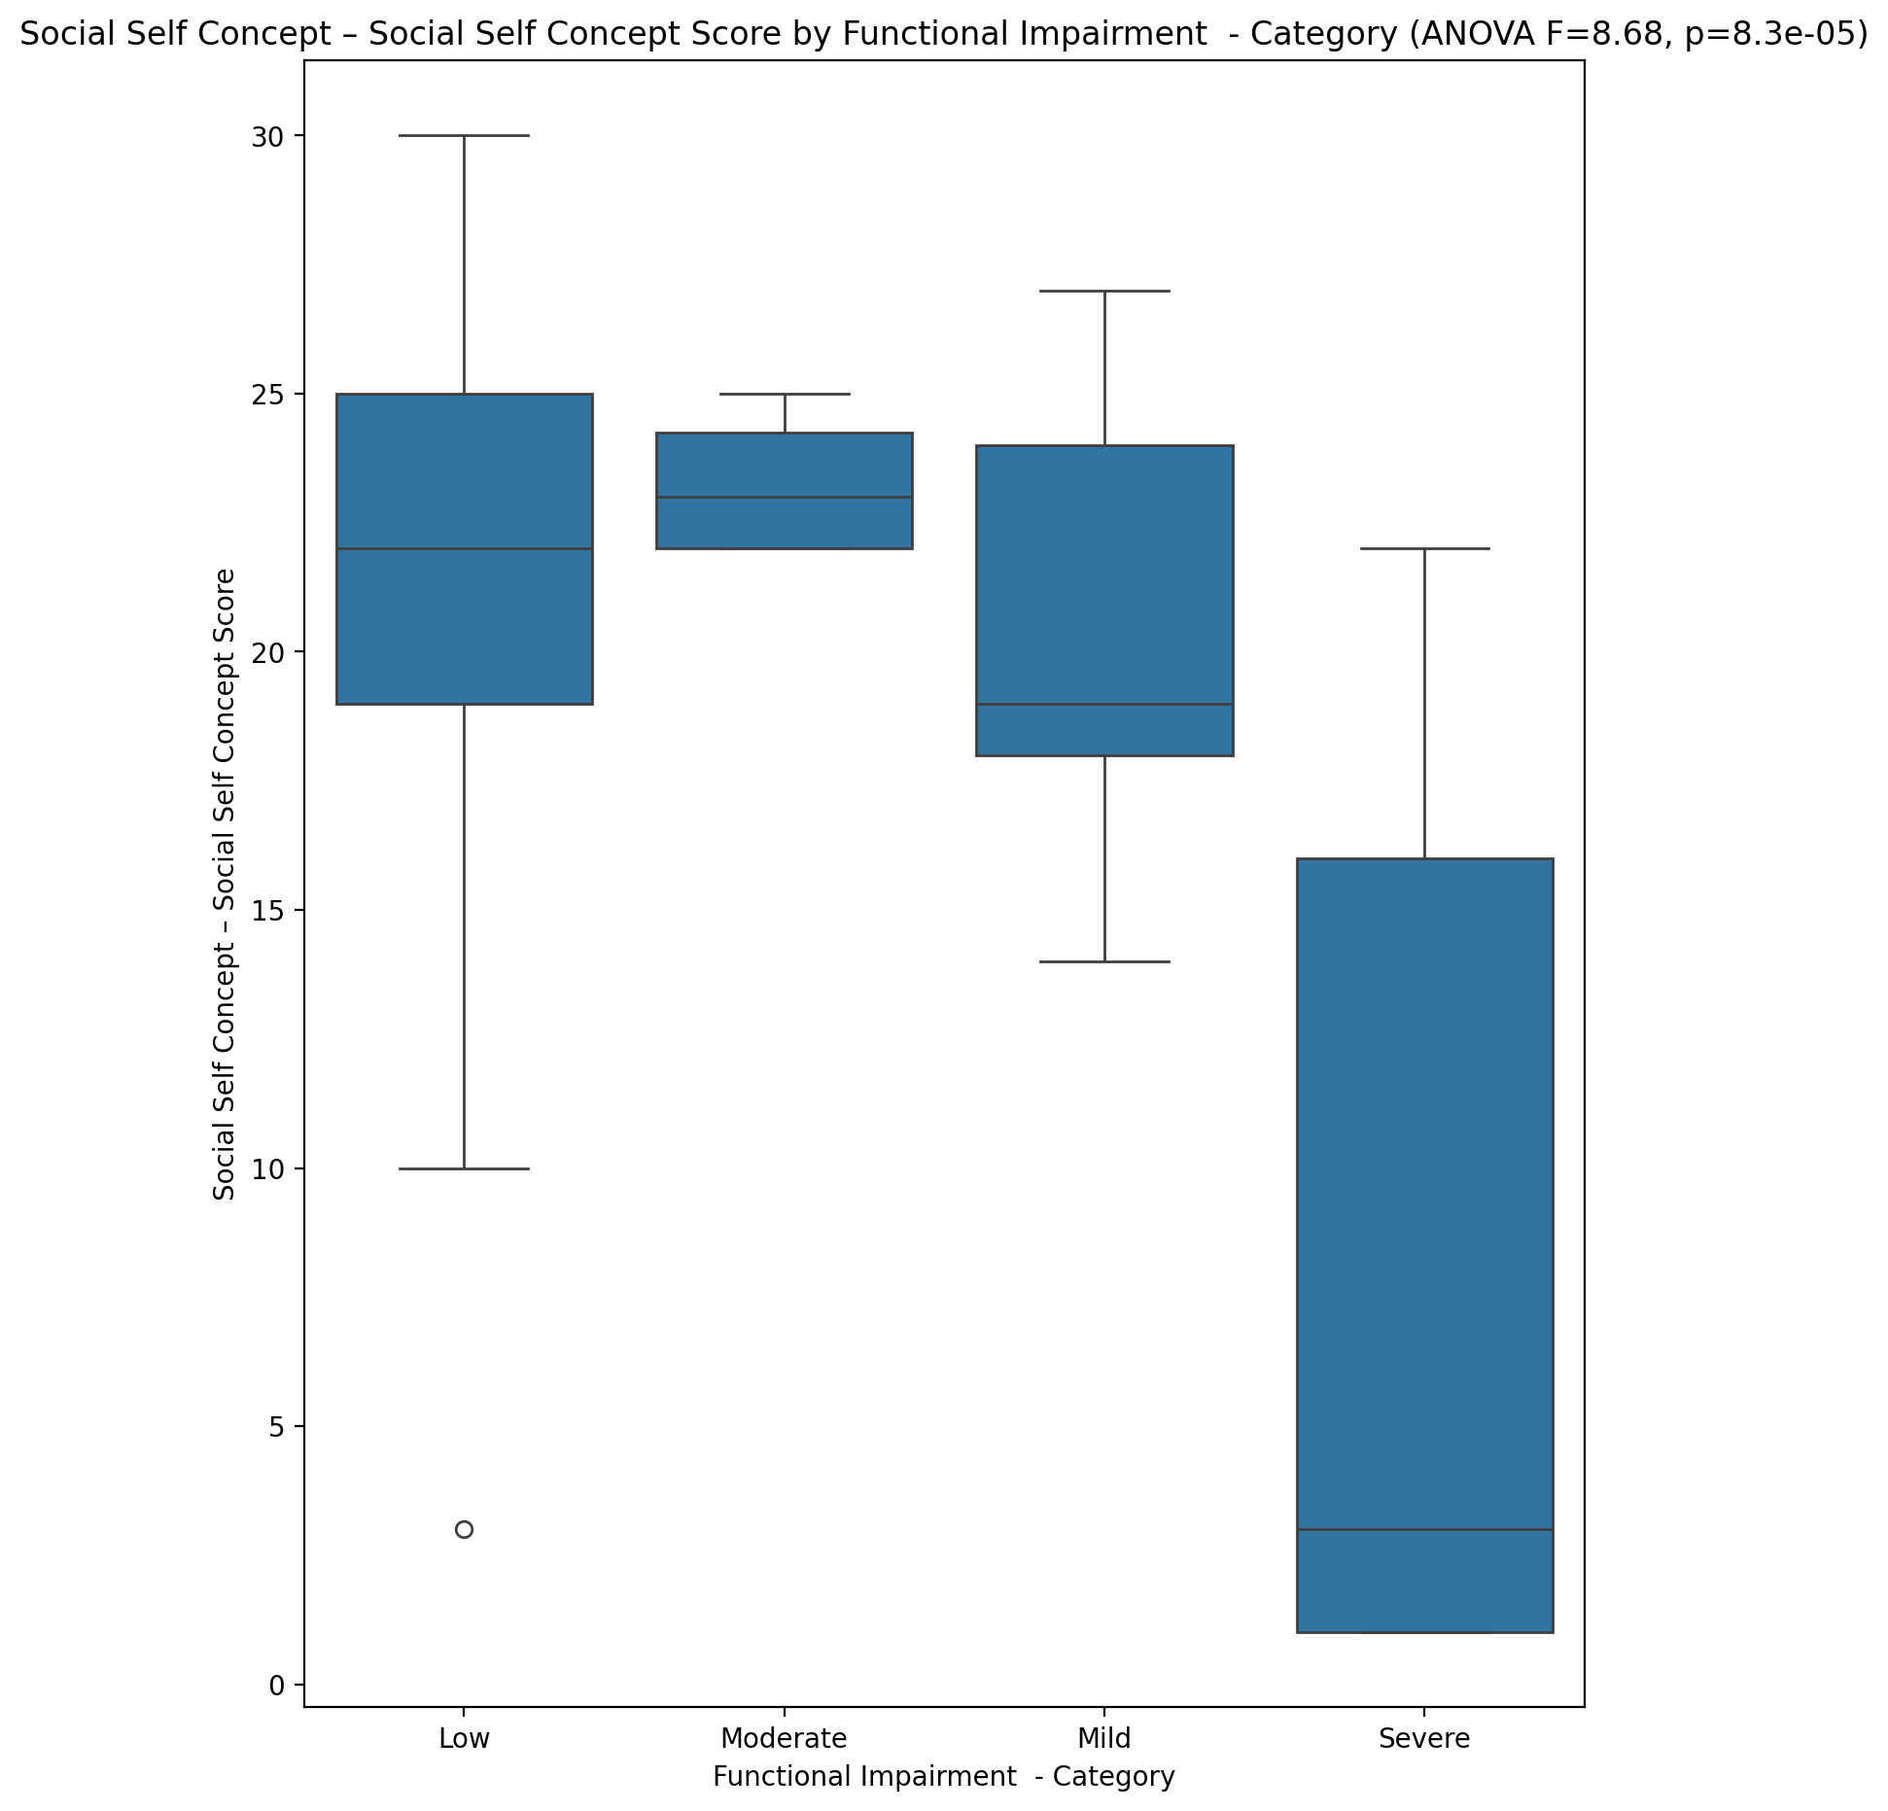

## Ability Self Concept - Real Self Concept Score vs Functional Impairment - Category

Test: anova; statistic: 7.195759335646468; p-value: 0.0003689199825960967;

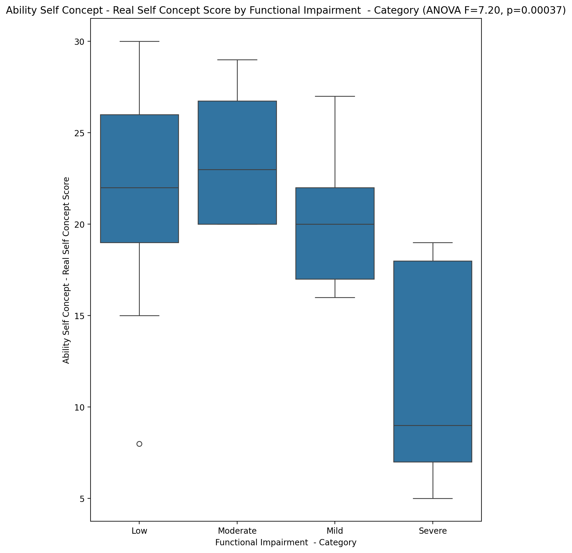

## Ability Self Concept - Ideal Self Concept Score vs Functional Impairment - Category

Test: anova; statistic: 10.868265868338852; p-value: 1.0378673470799224e-05;

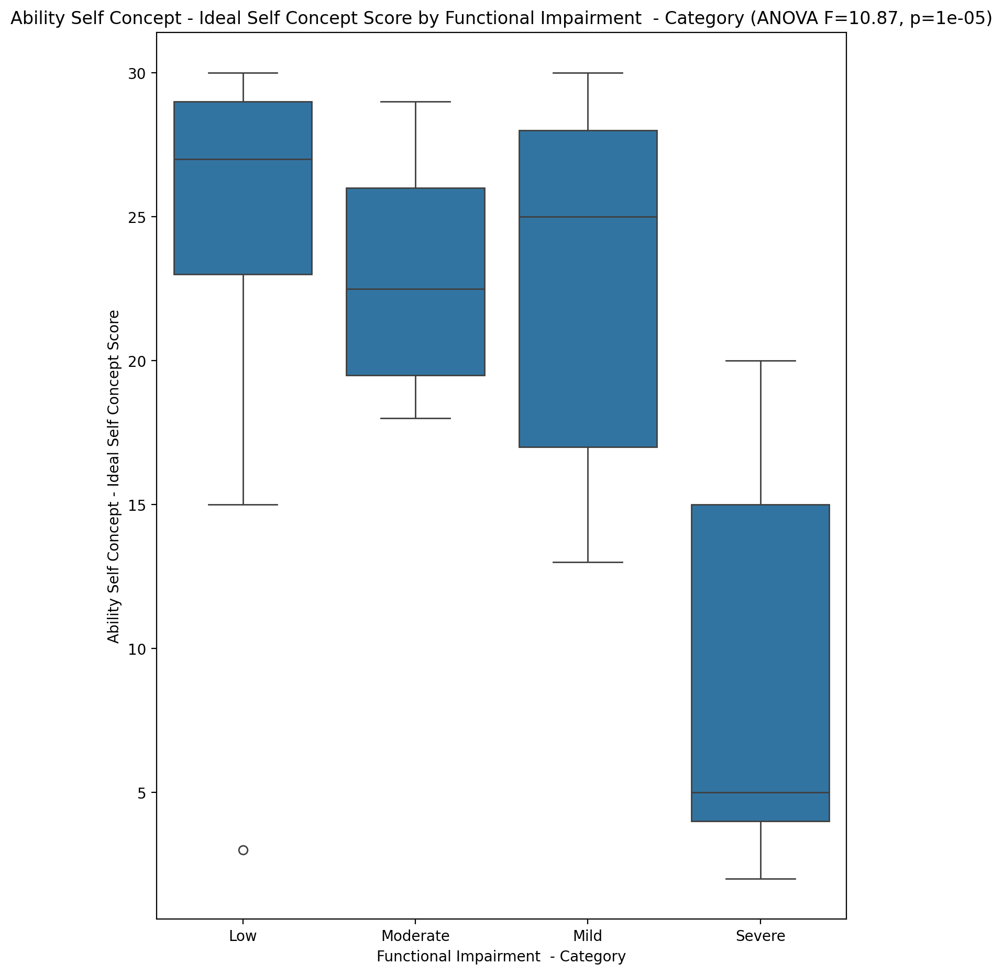

## Ability Self Concept – Social Self Concept Score vs Functional Impairment - Category

Test: anova; statistic: 8.549303060168516; p-value: 9.405542306587288e-05;

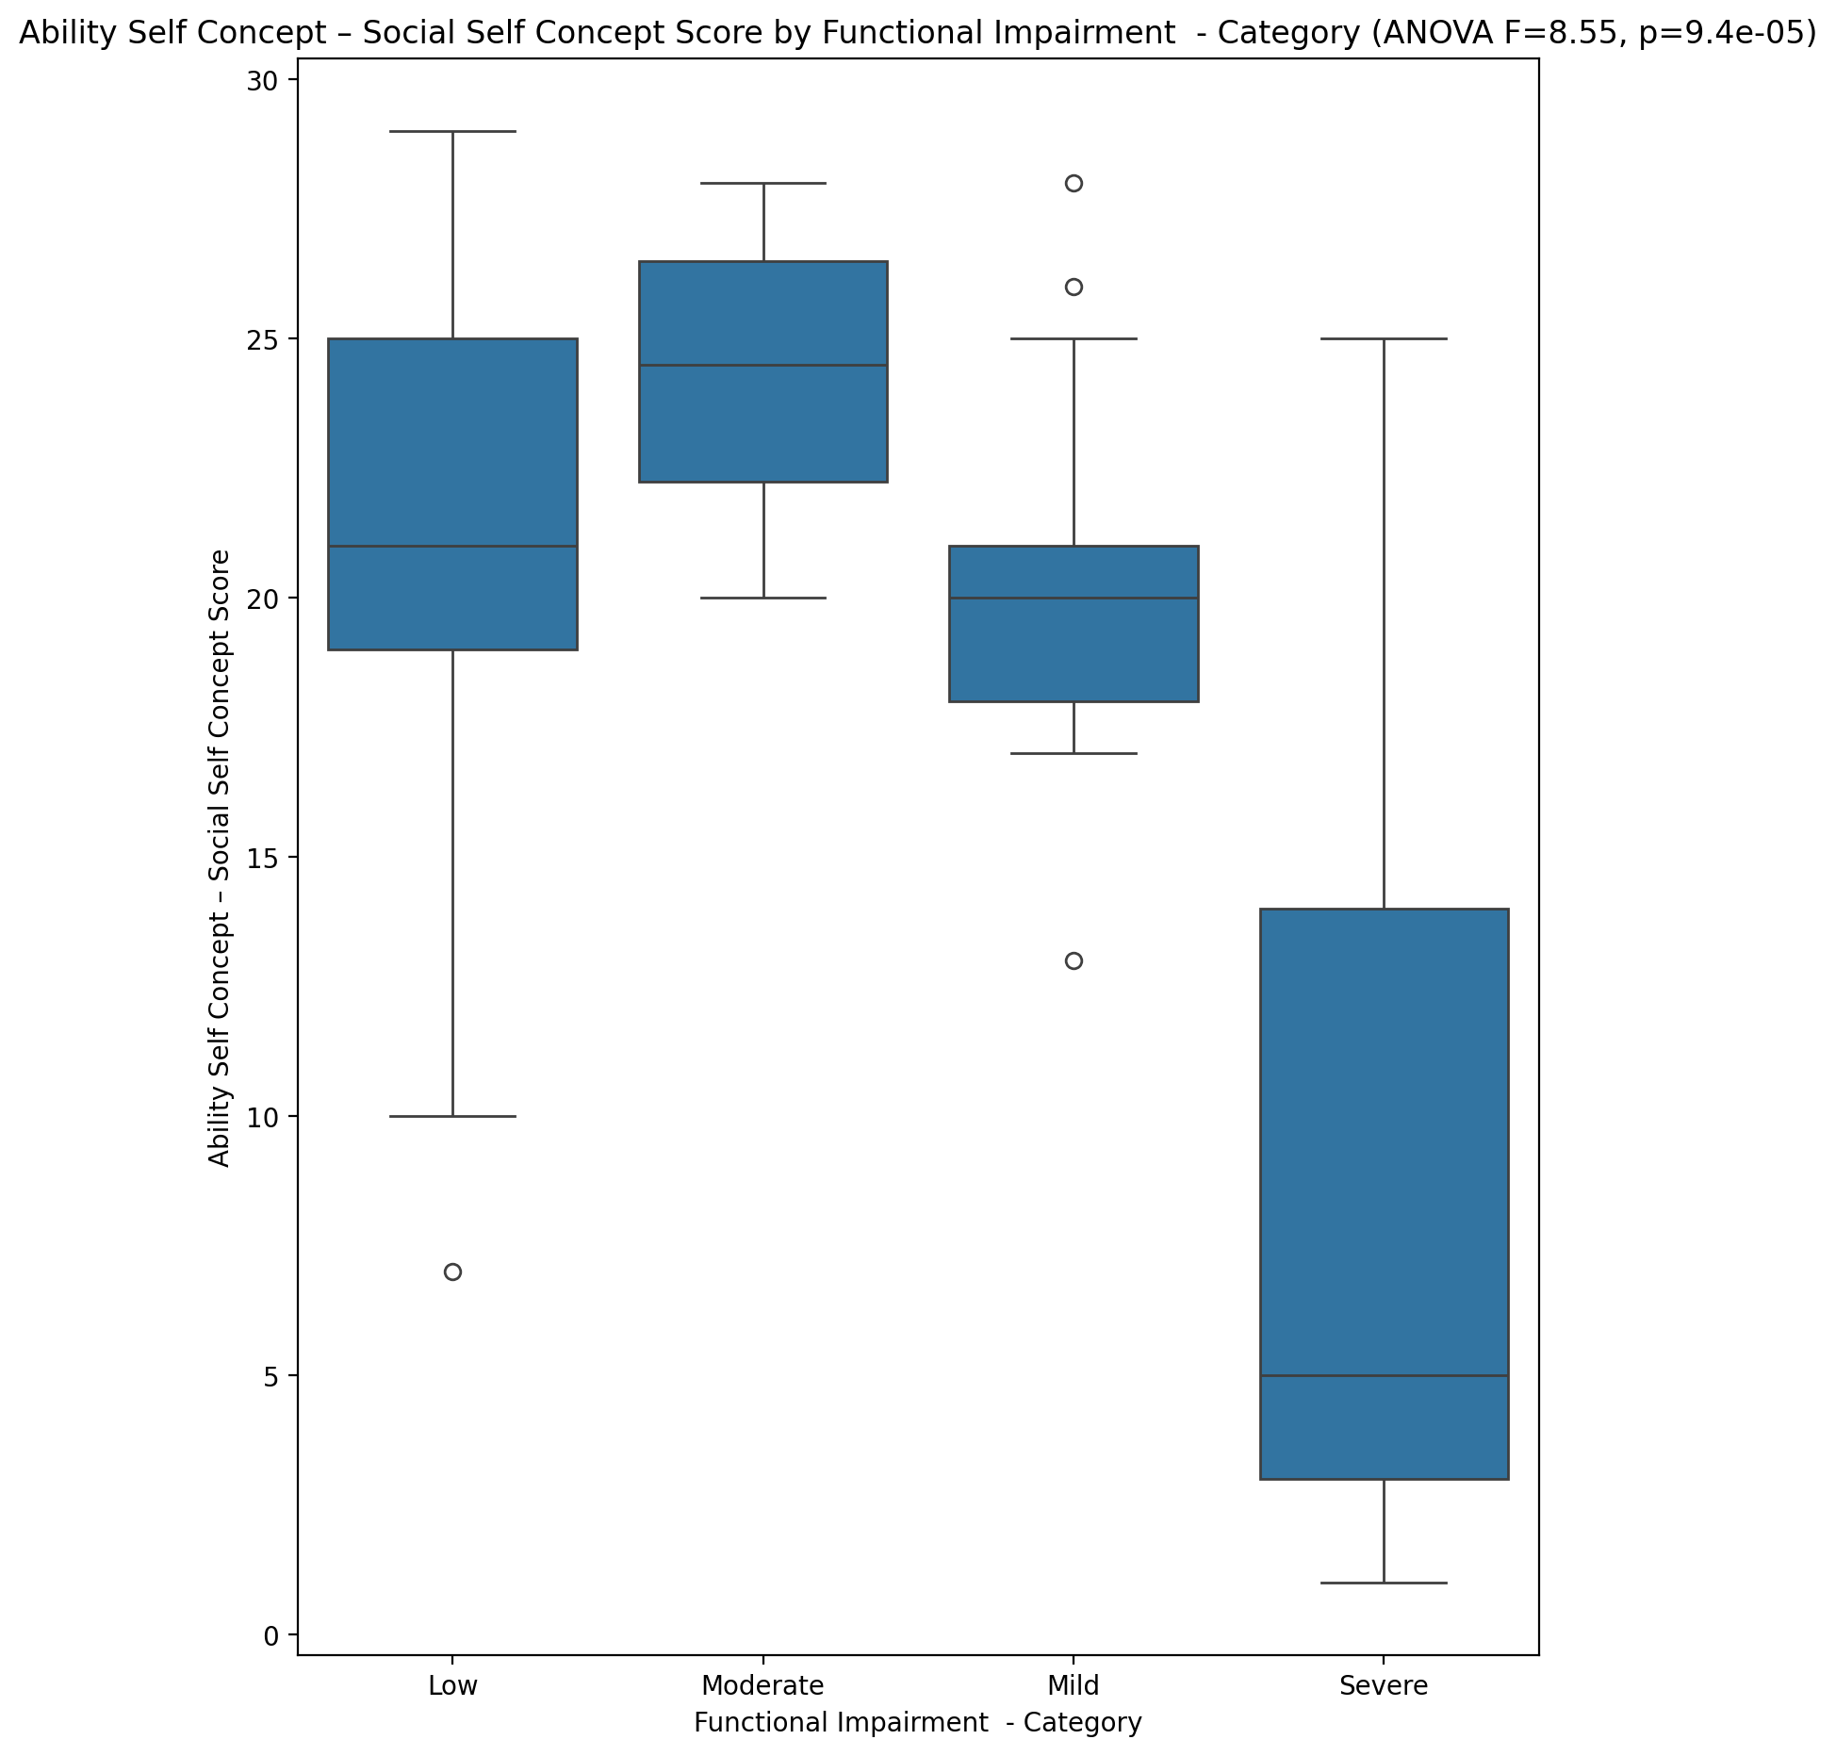

## Physical Self Concept - Real Self Concept Score vs Functional Impairment - Category

Test: anova; statistic: 7.4478142258931905; p-value: 0.0002846763315135402;

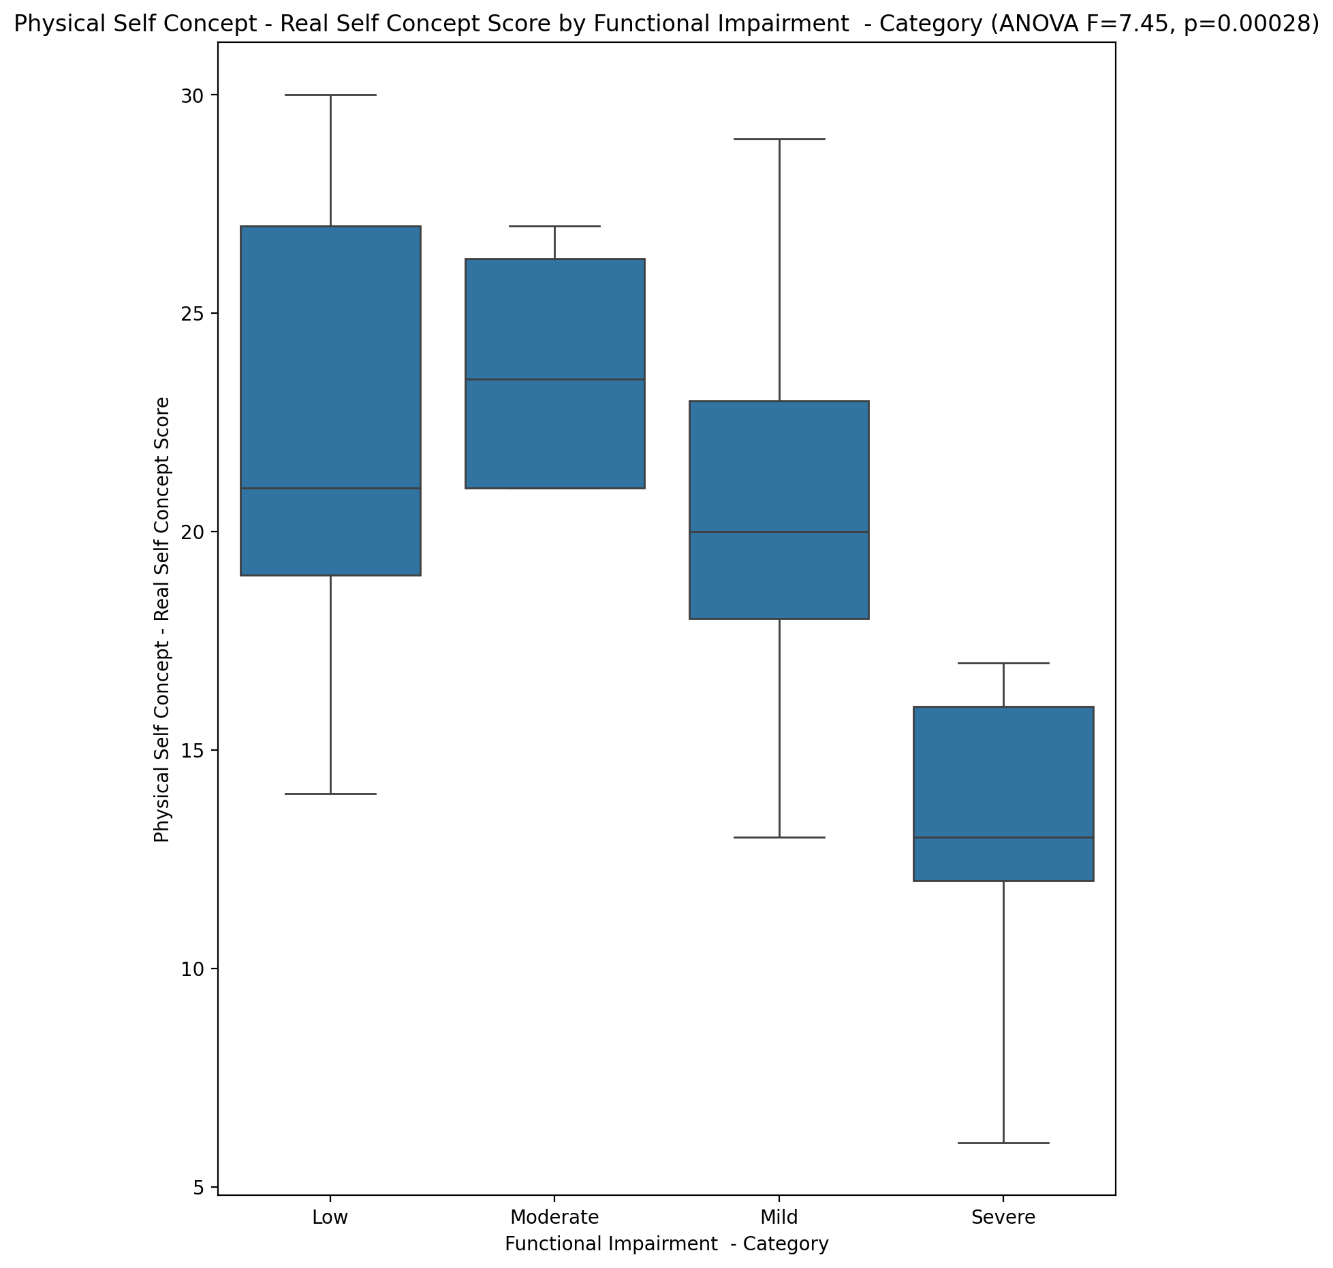

## Physical Self Concept – Ideal Self Concept Score vs Functional Impairment - Category

Test: anova; statistic: 13.768577744014816; p-value: 8.194264654030475e-07;

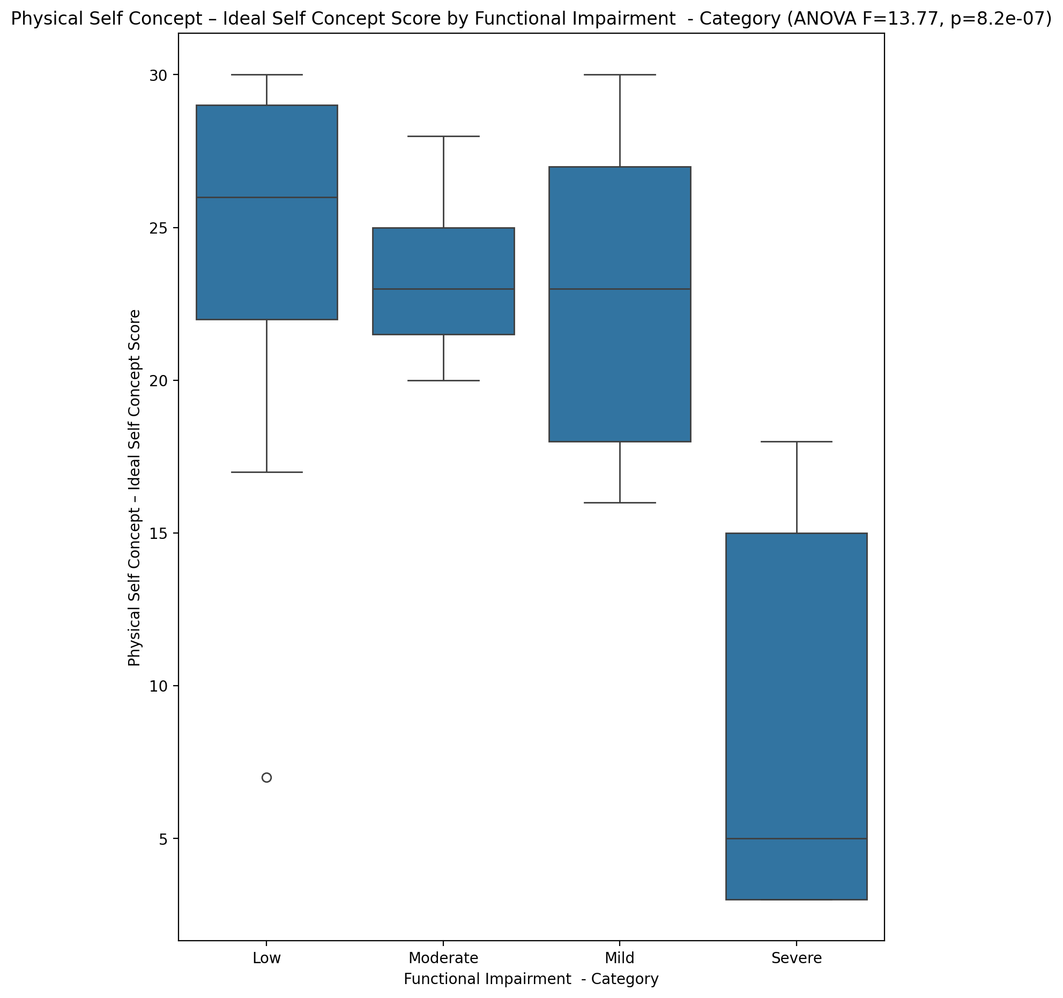

## Physical Self Concept – Social Self Concept Score vs Functional Impairment - Category

Test: anova; statistic: 9.887696898358328; p-value: 2.5830101529565186e-05;

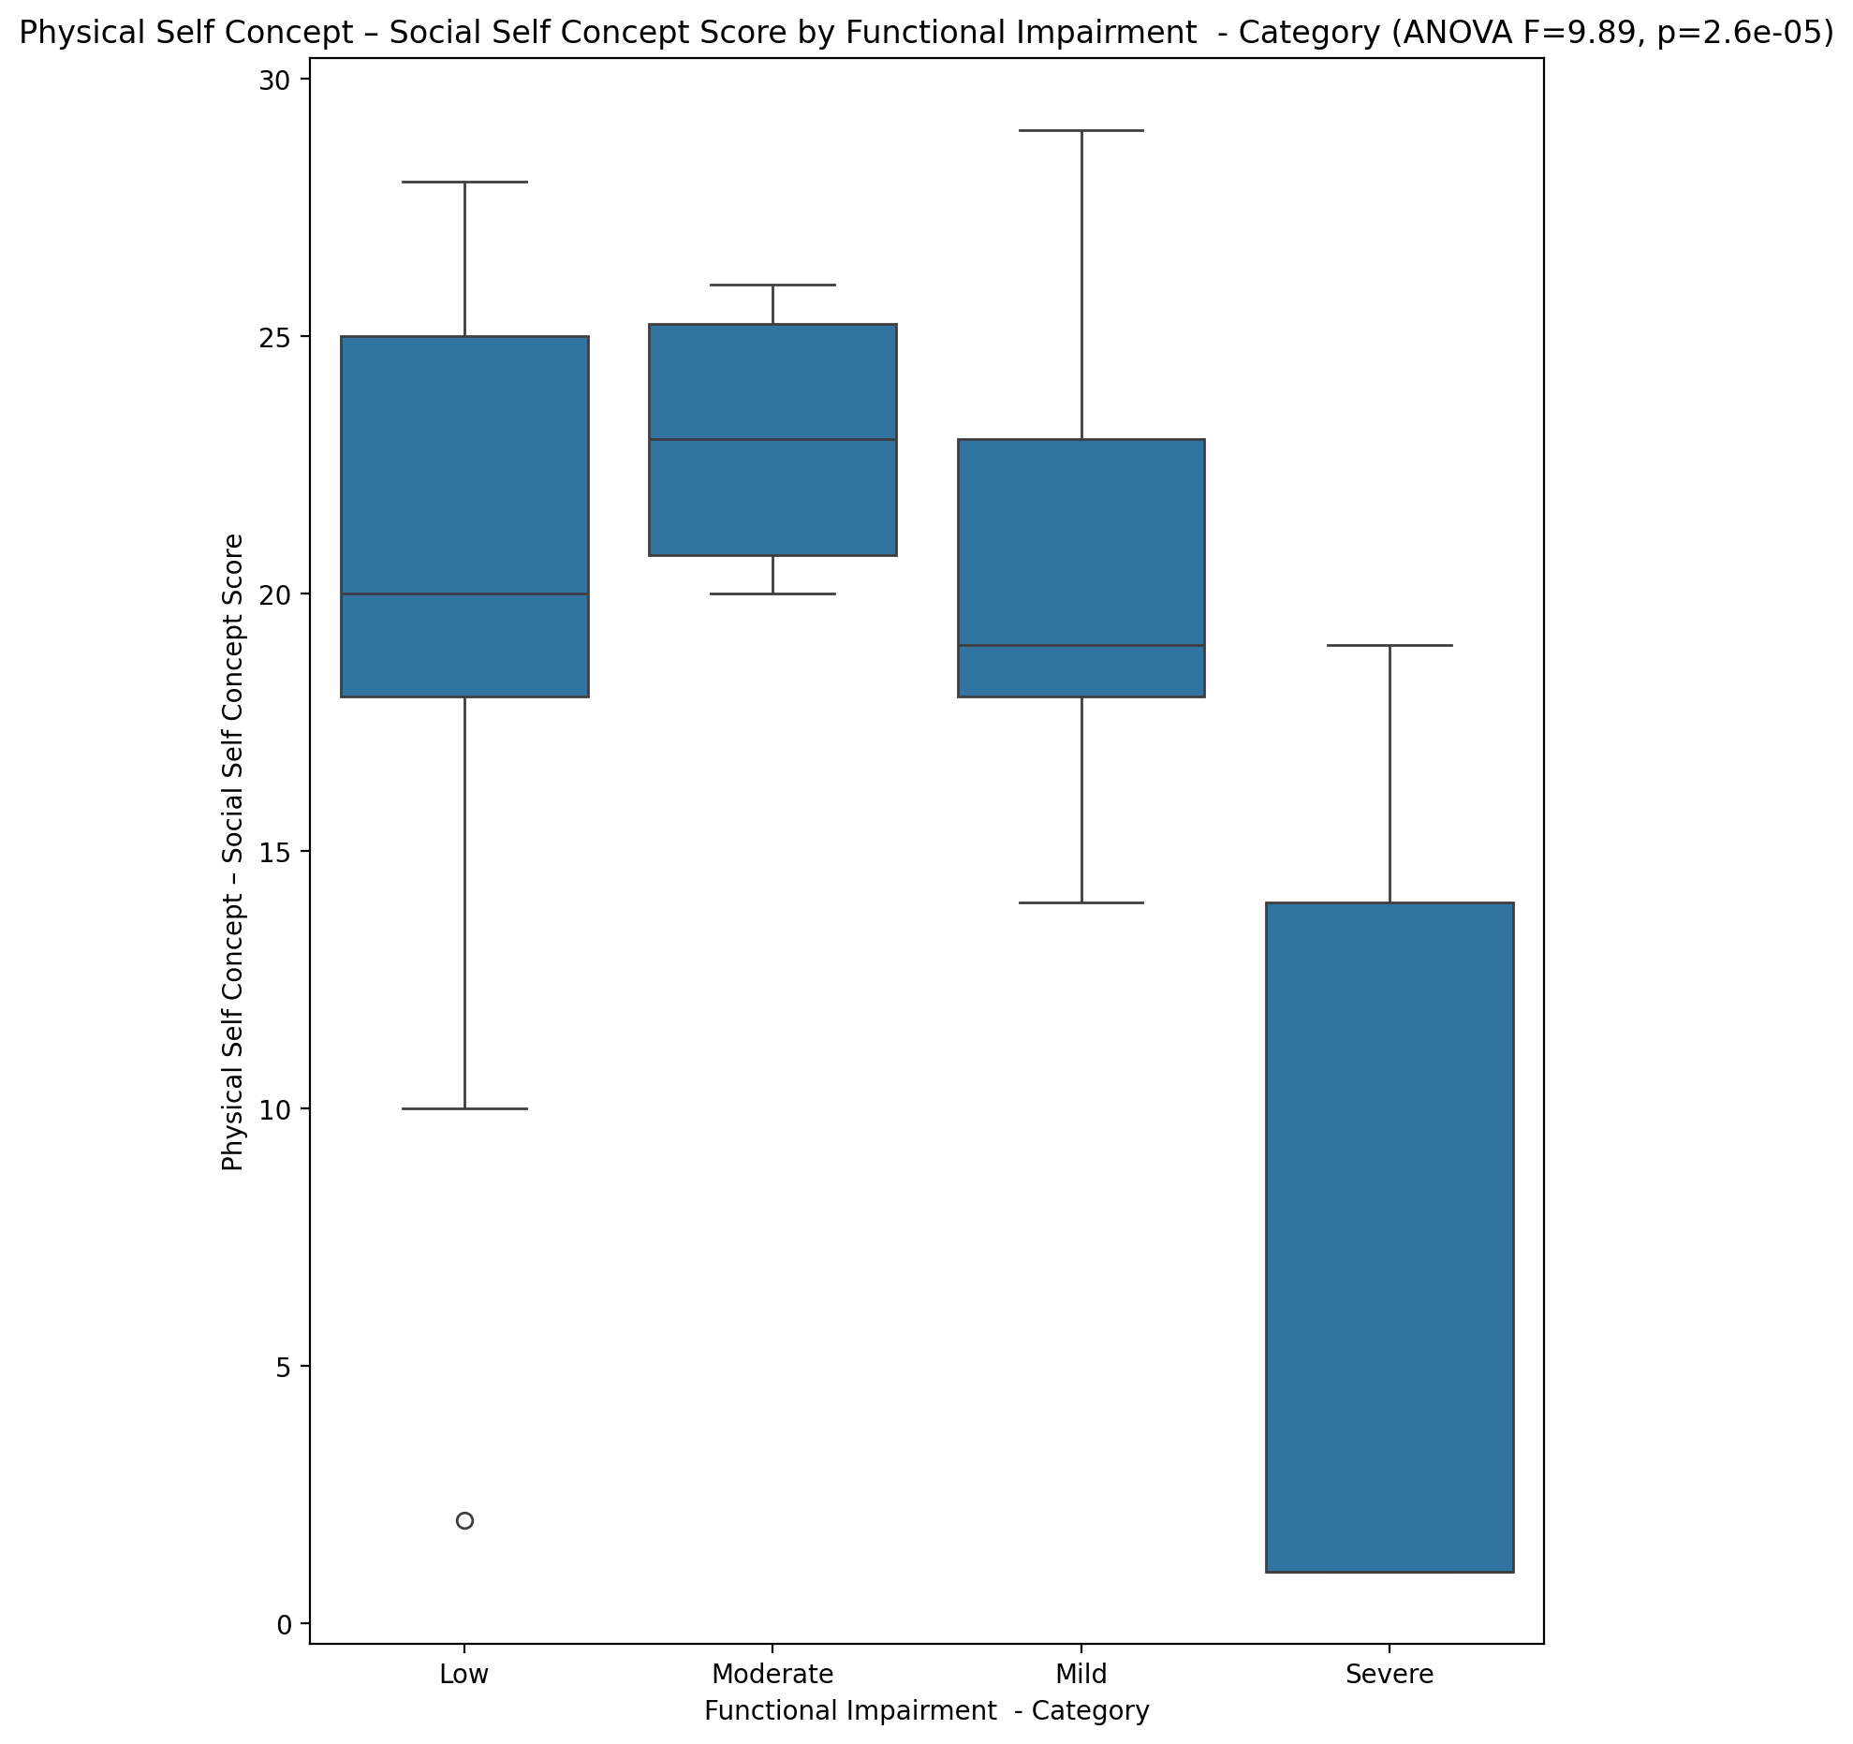

## Psychological Self Concept - Real Self Concept Score vs Functional Impairment - Category

Test: anova; statistic: 12.82184160094197; p-value: 1.8313048076725286e-06;

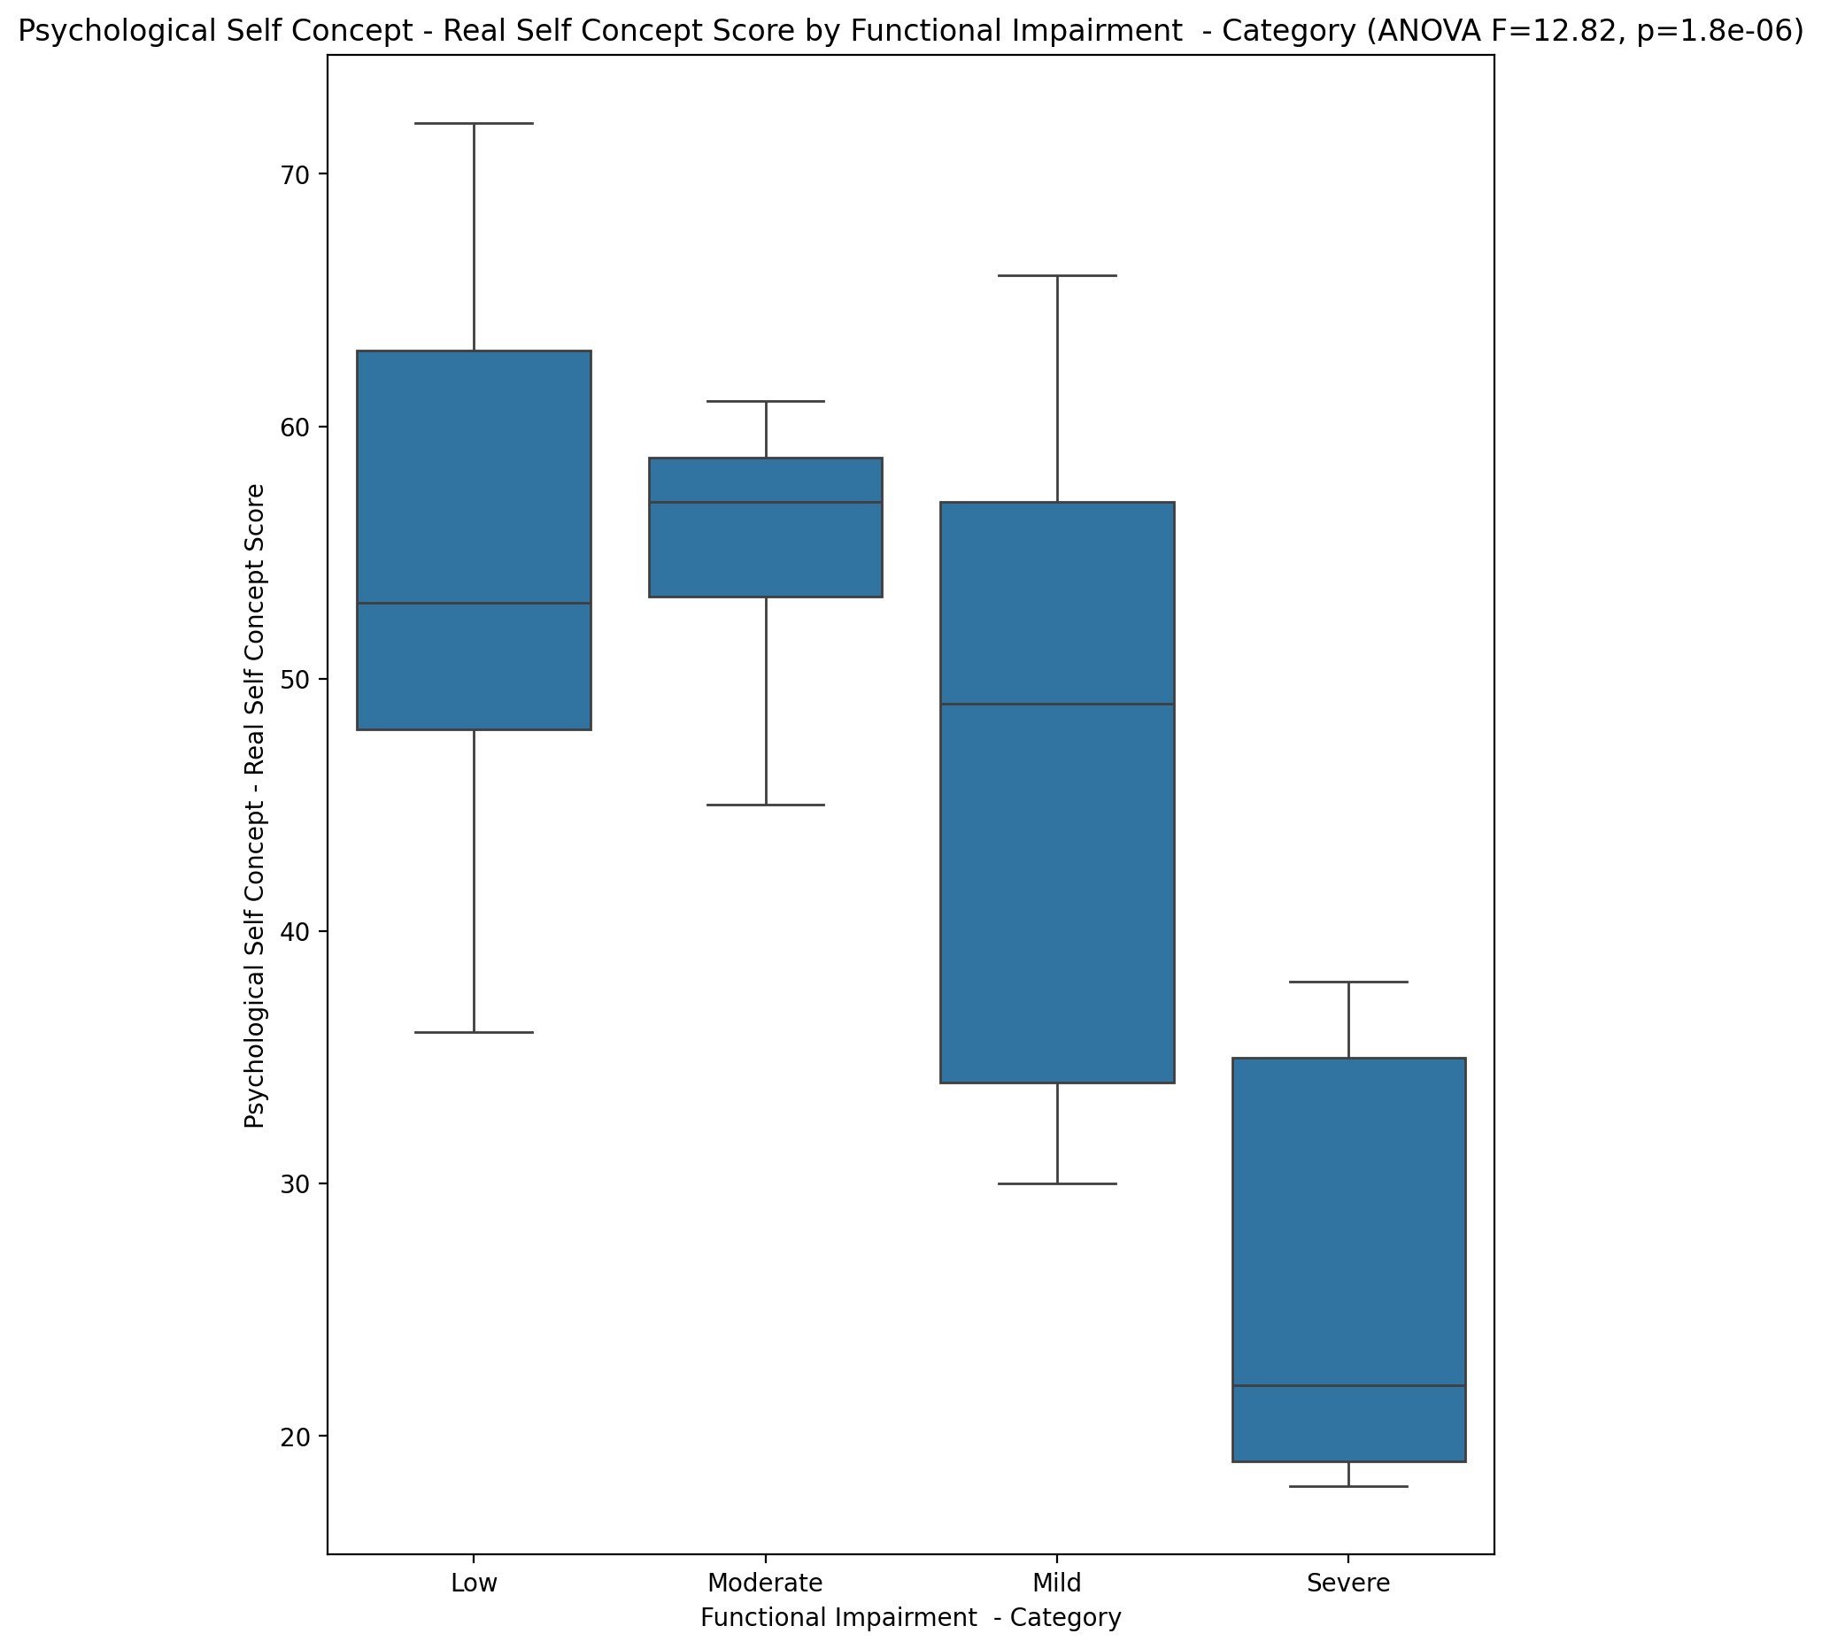

## Psychological Self Concept – Ideal Self Concept Score vs Functional Impairment - Category

Test: anova; statistic: 13.863350152825983; p-value: 7.569853895561298e-07;

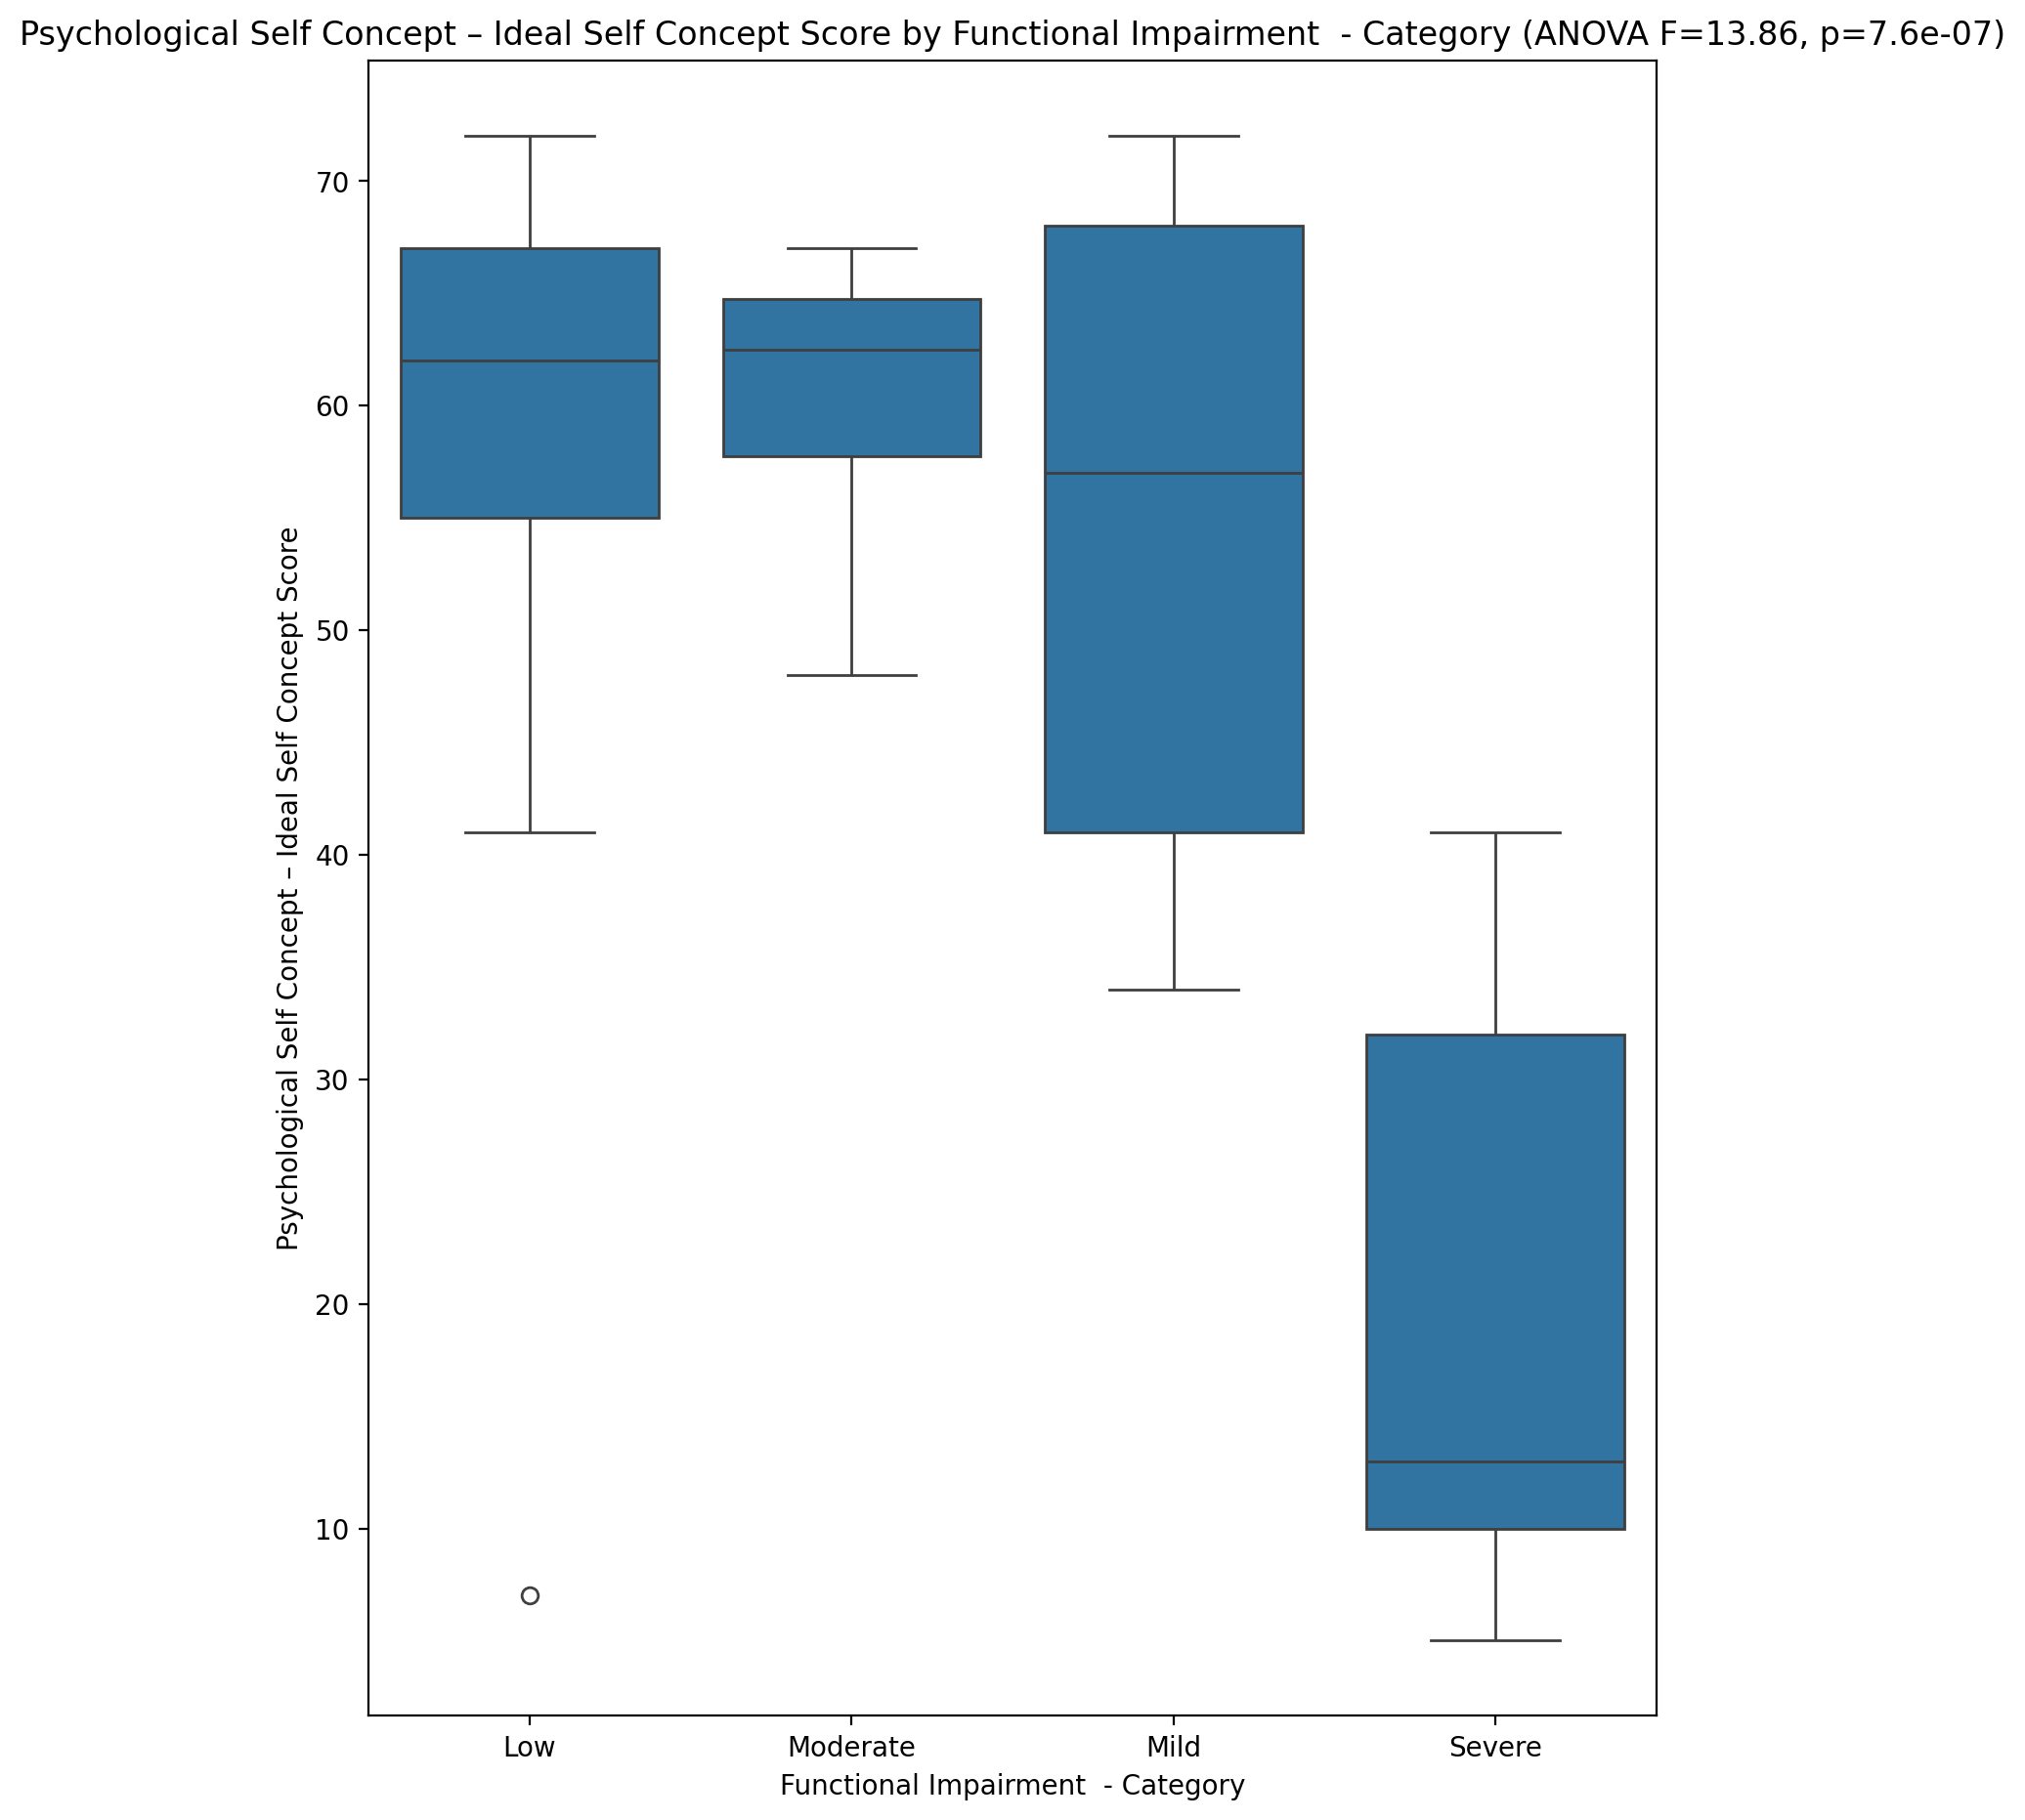

## Psychological Self Concept – Social Self Concept Score vs Functional Impairment - Category

Test: anova; statistic: 9.939657737831416; p-value: 2.459391429363129e-05;

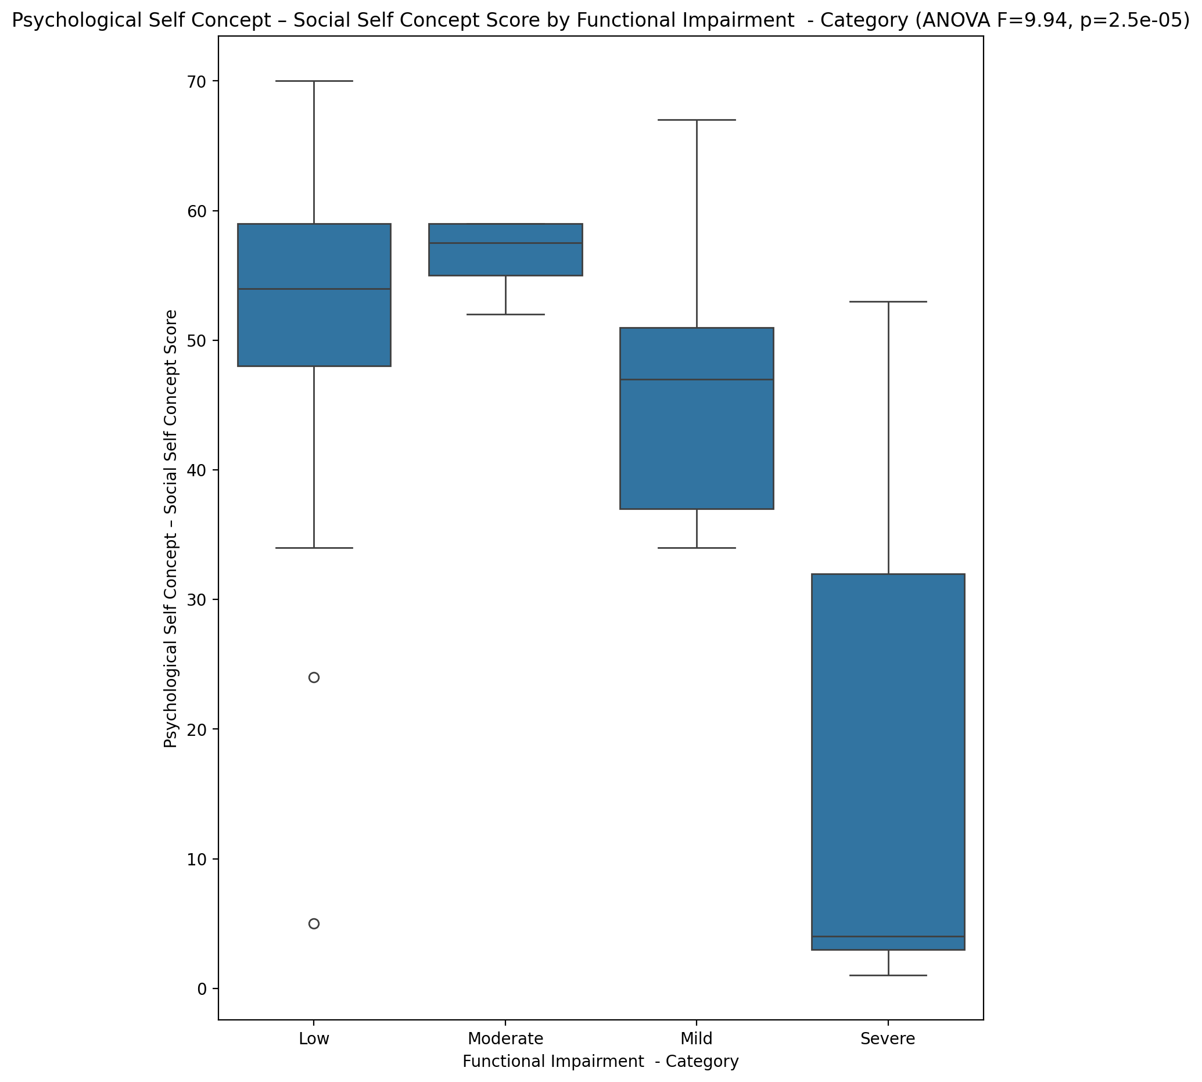

## Real Self Concept Total Score vs Functional Impairment - Category

Test: anova; statistic: 10.996440984117589; p-value: 9.231901692179151e-06;

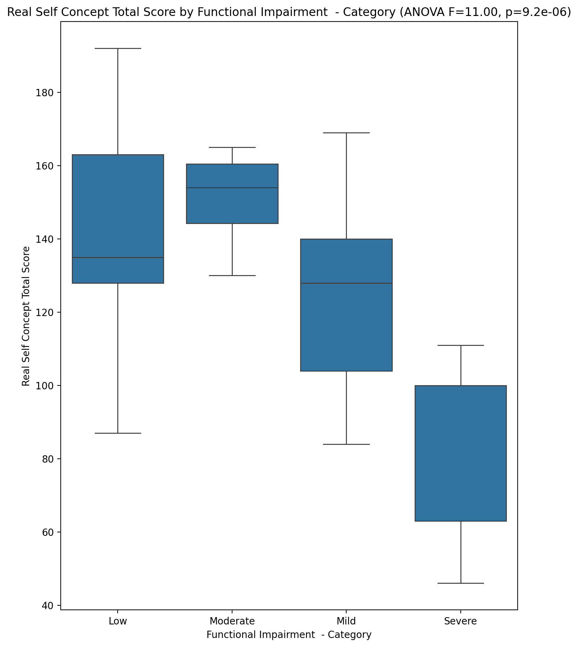

## Ideal Self Concept Total Score vs Functional Impairment - Category

Test: anova; statistic: 14.750104077618676; p-value: 3.6441495422990596e-07;

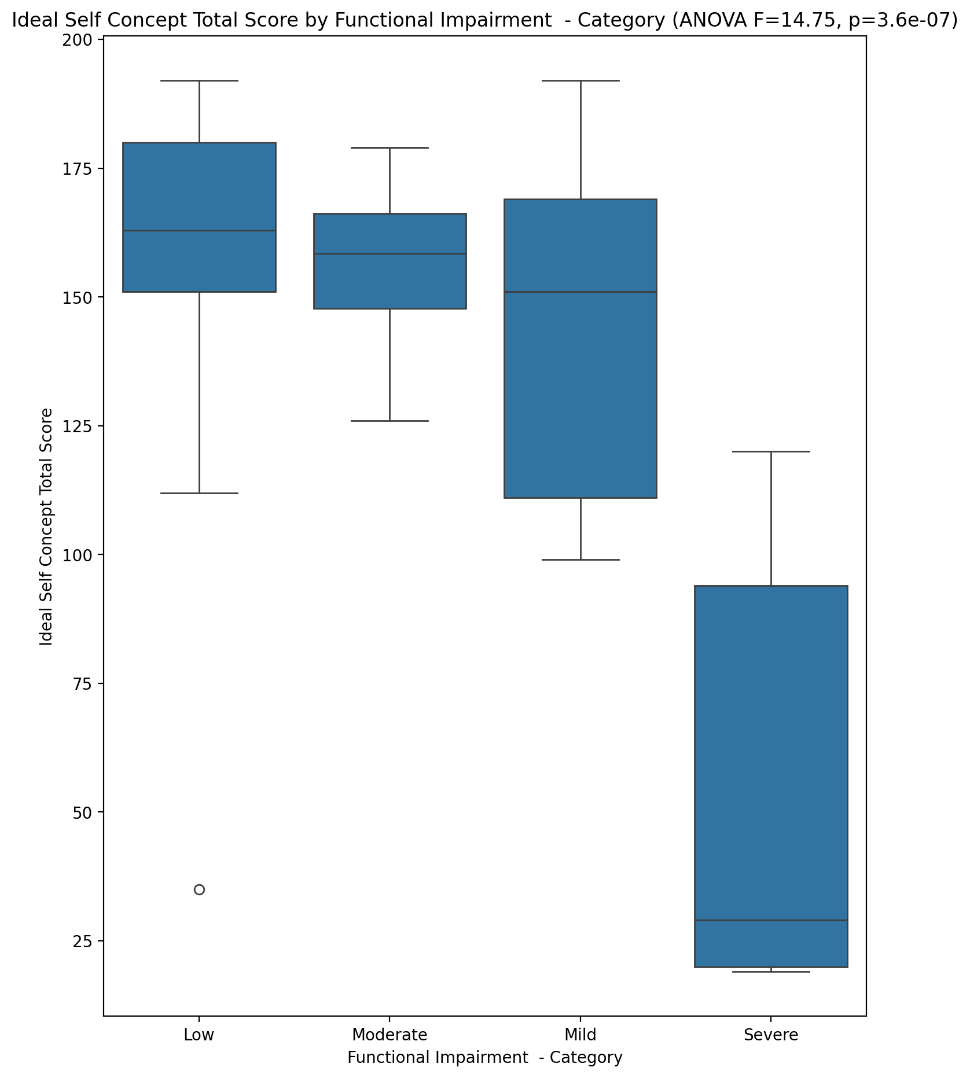

## Social Self Concept Total Score vs Functional Impairment - Category

Test: anova; statistic: 10.090990274195192; p-value: 2.1330496923863102e-05;

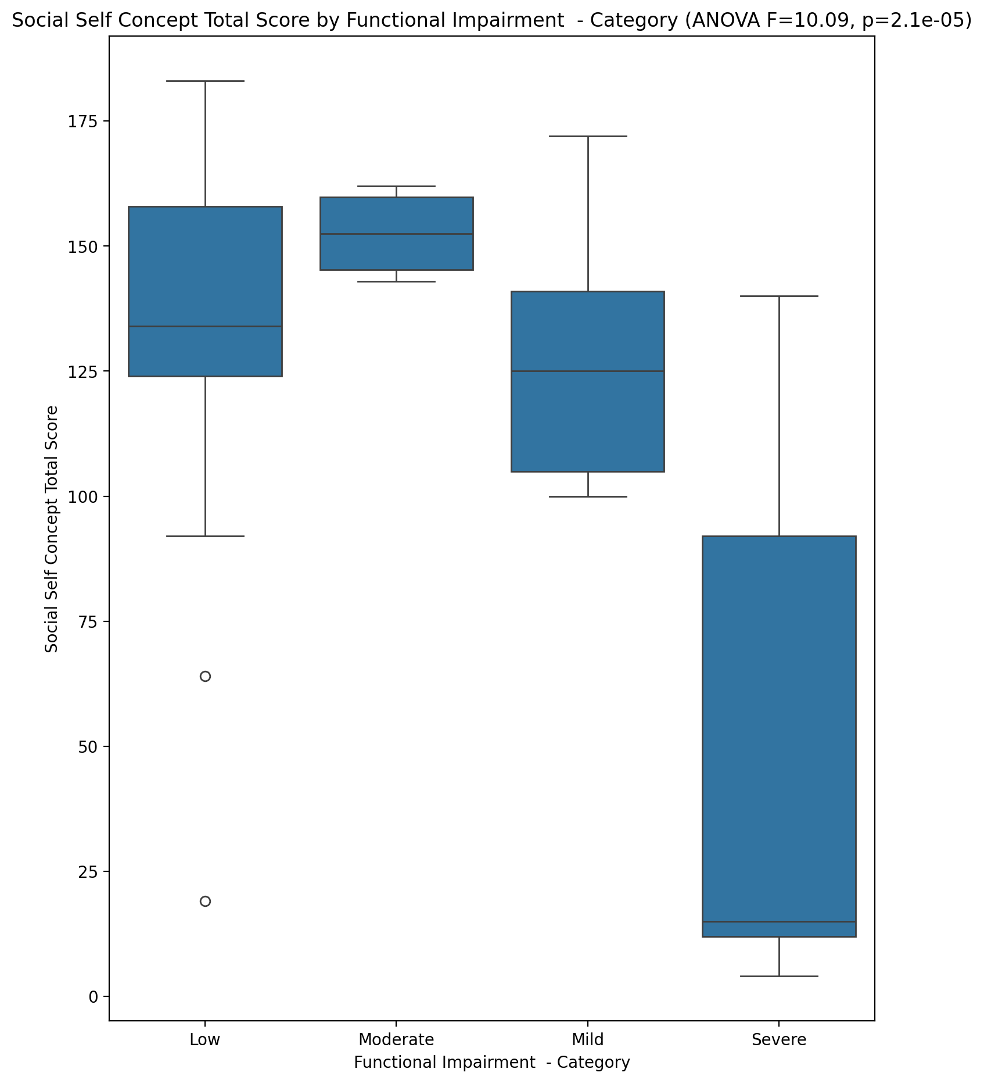

## Ideal Self Concept Total Category vs Functional Impairment - Category

Test: chi2; statistic: 28.197266145583455; p-value: 8.625566266668031e-05;

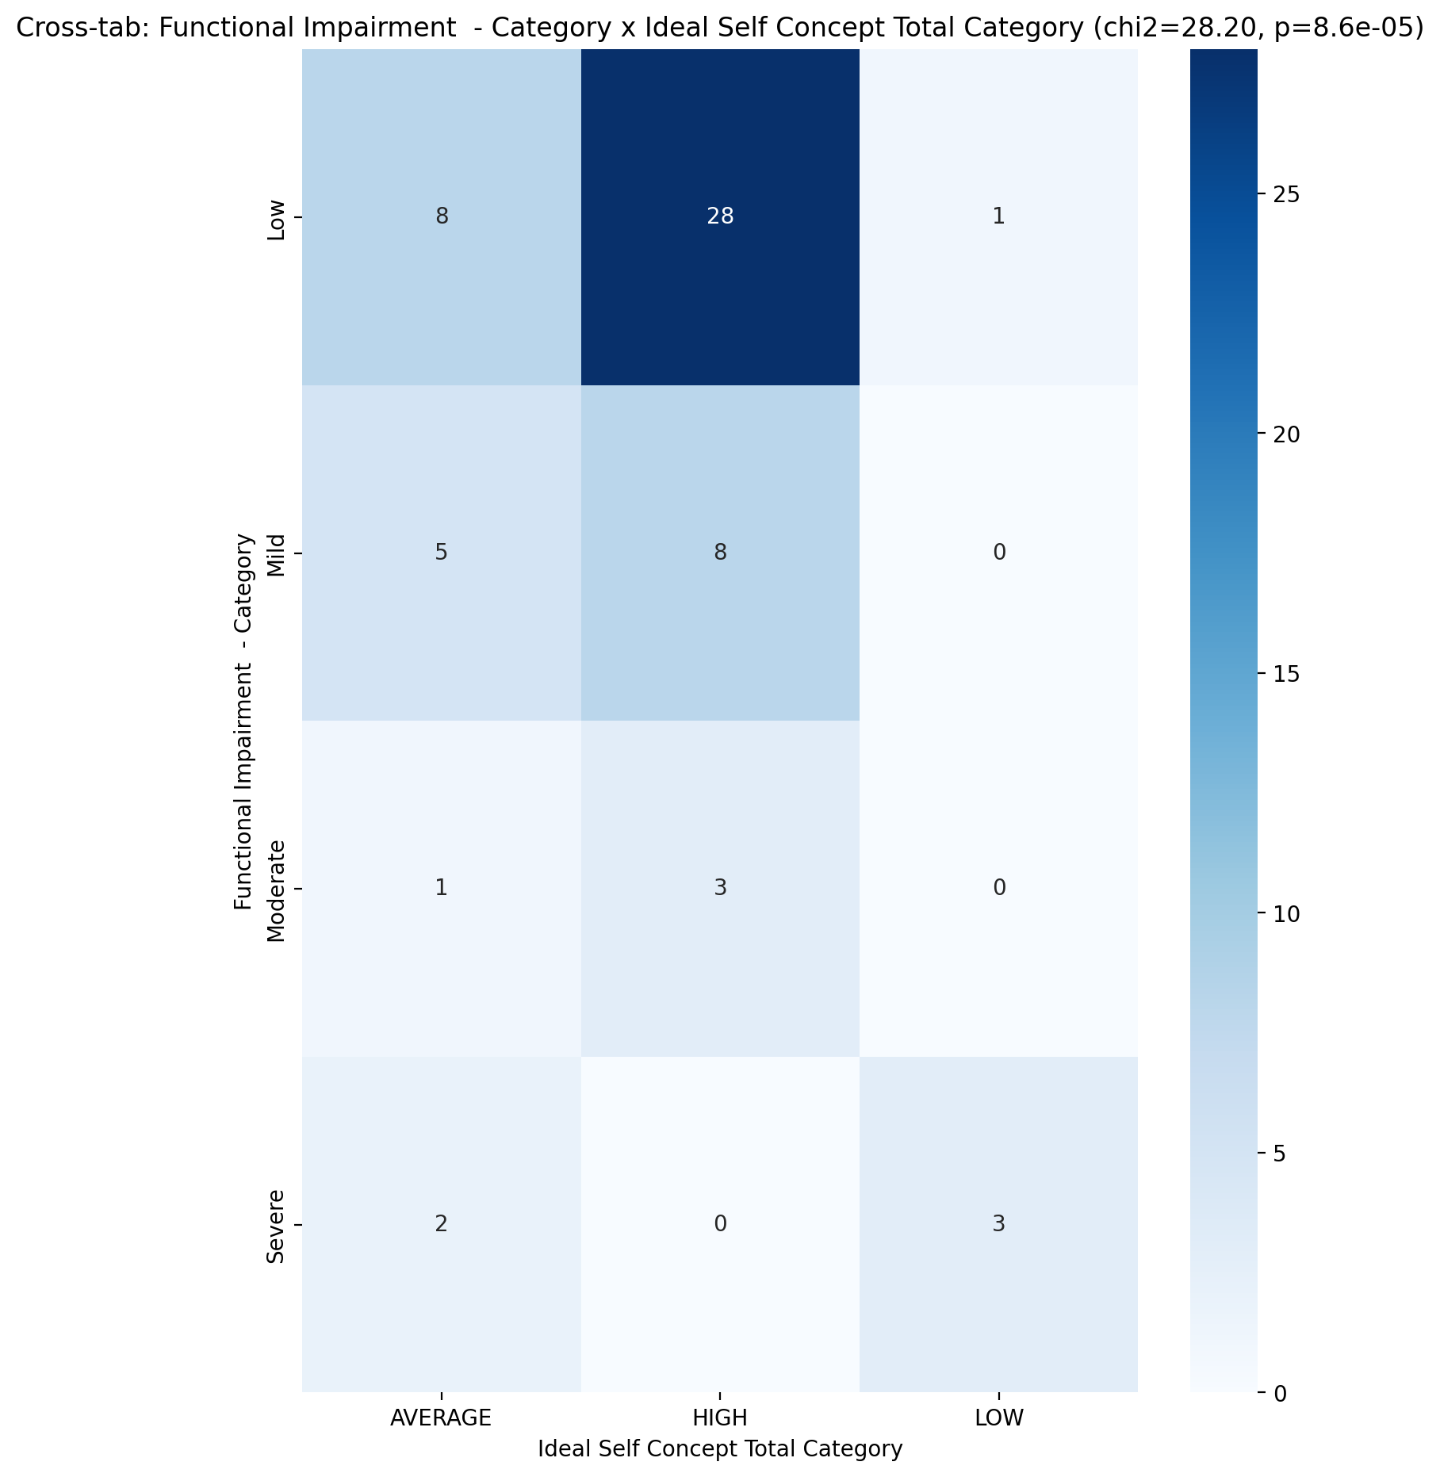

## Perceived Social Stress Score vs Functional Impairment - Category

Test: anova; statistic: 1.911059021091771; p-value: 0.13849344913144662;

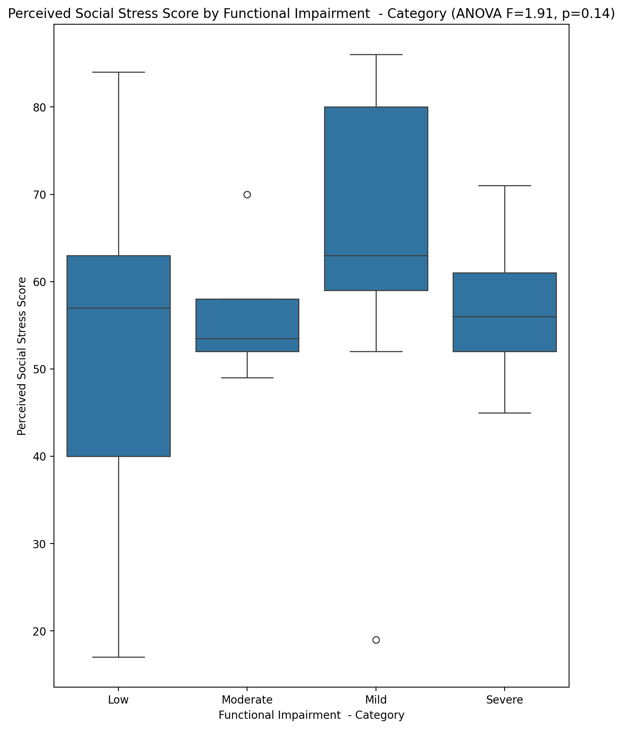

## Perceived Social Stress Category vs Functional Impairment - Category

Test: chi2; statistic: 9.21491683991684; p-value: 0.1618471813988504;

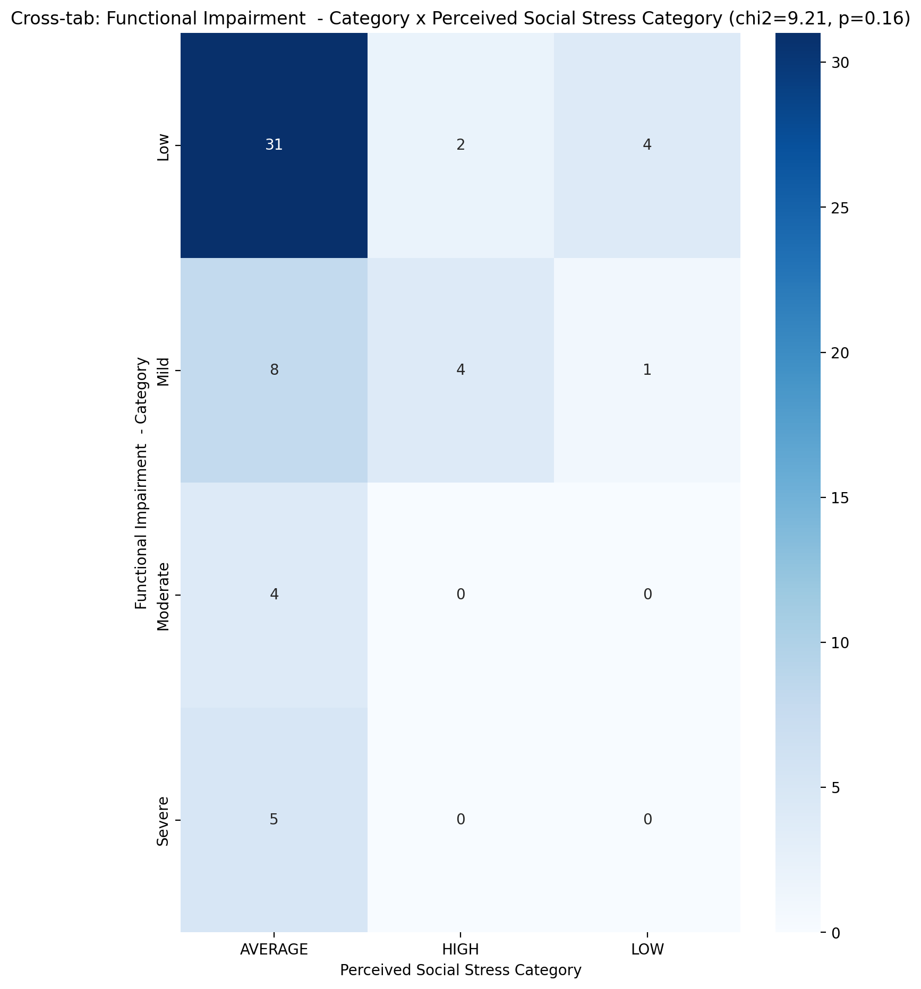

## Emotional Support - Raw Score vs Withdrawl – Category

Test: anova; statistic: 1.8407015143159675; p-value: 0.15050338917720393;

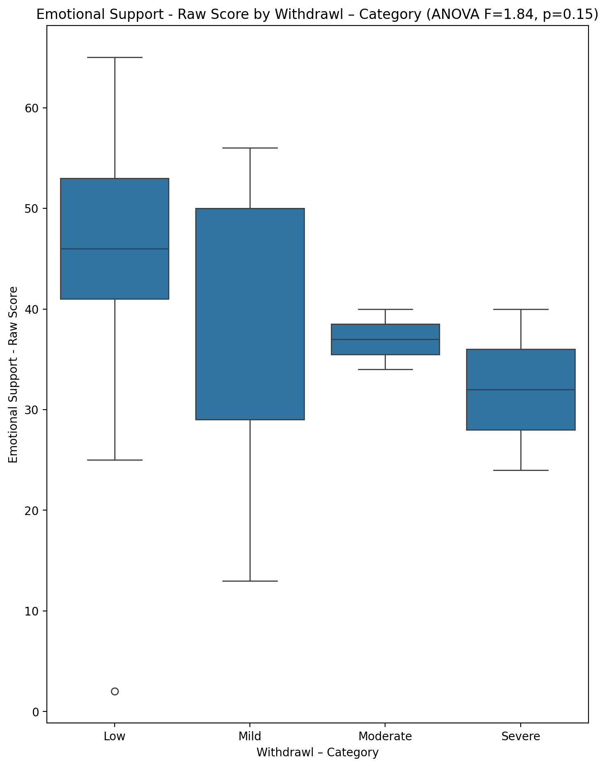

## Informational Support - Raw Score vs Withdrawl – Category

Test: anova; statistic: 1.2550310611598894; p-value: 0.2988261490118676;

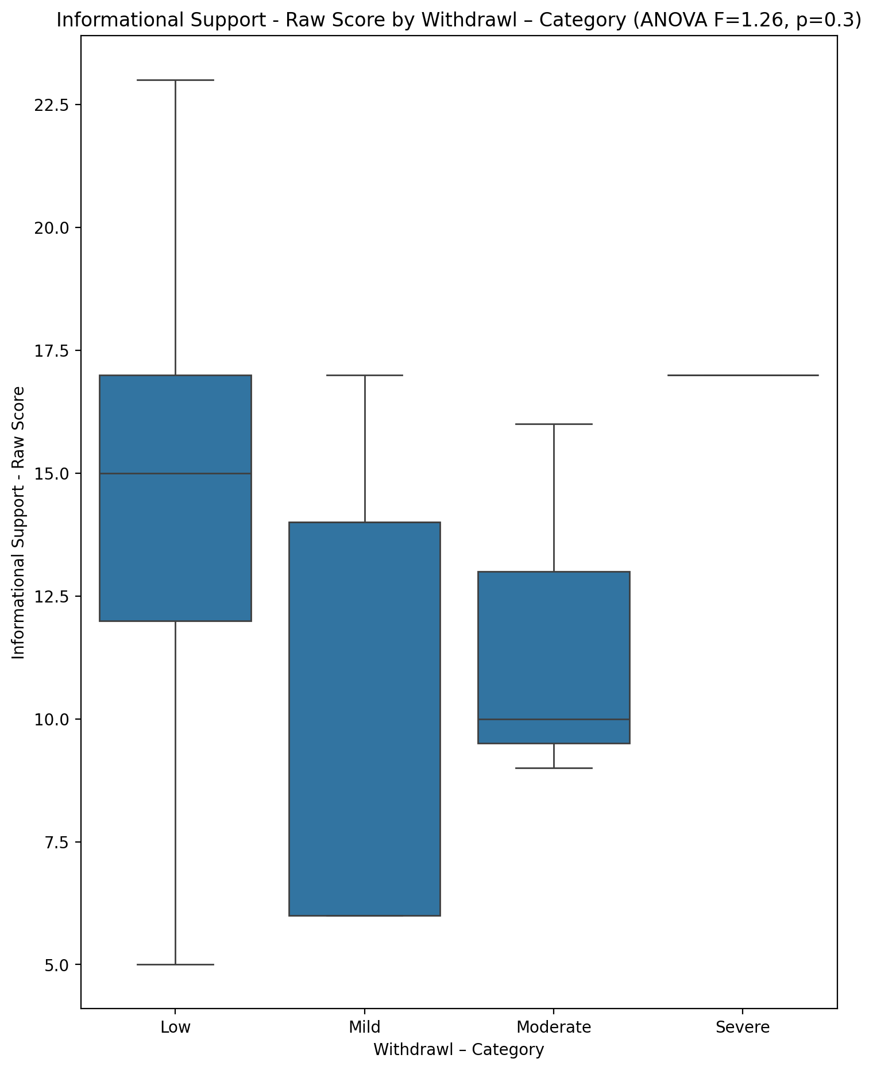

## Instrumental Support - Raw Score vs Withdrawl – Category

Test: anova; statistic: 1.4951397255765217; p-value: 0.22601543385683628;

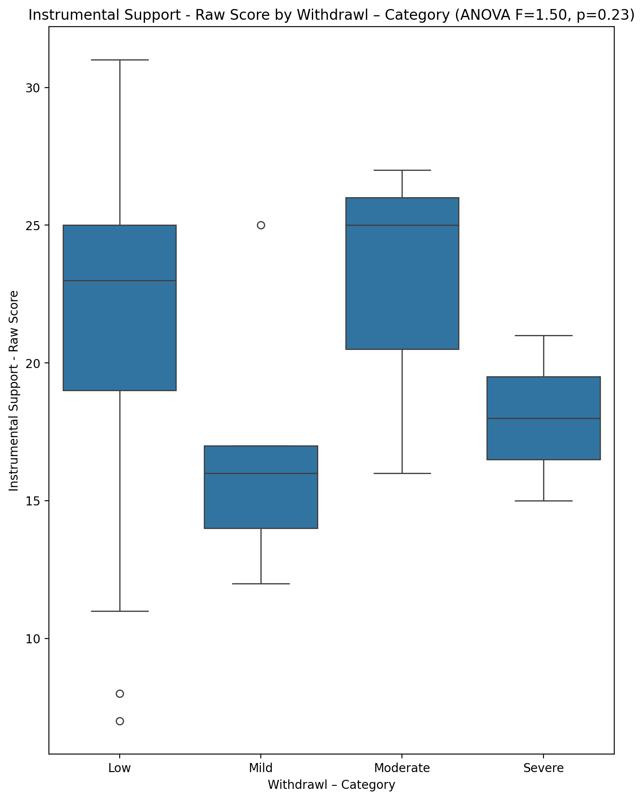

## Emotional Support - T Score vs Withdrawl – Category

Test: anova; statistic: 2.3090605544320306; p-value: 0.0864569754747128;

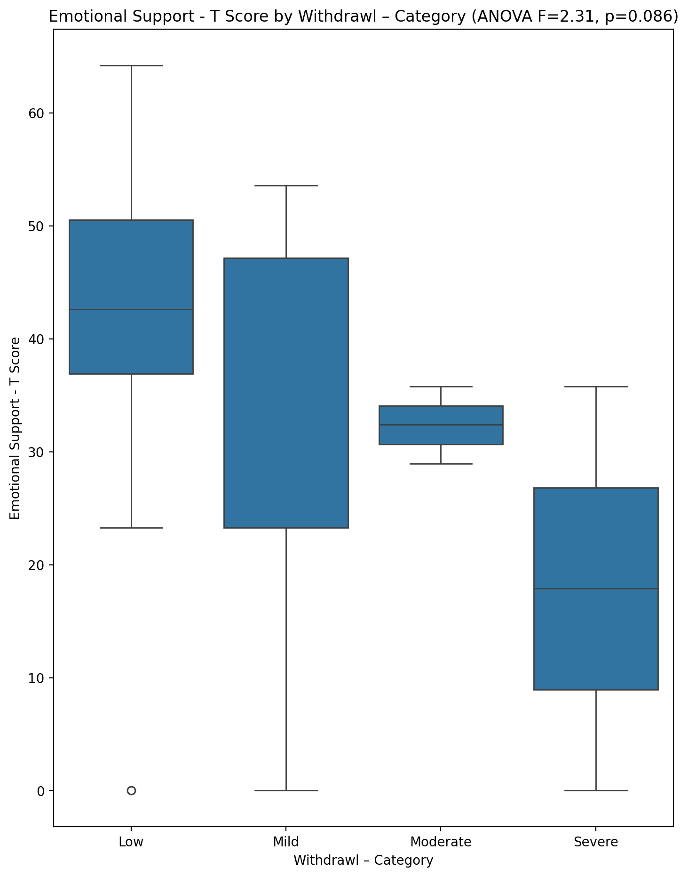

## Informational Support - T Score vs Withdrawl – Category

Test: anova; statistic: 1.1297642538277926; p-value: 0.3450774331732426;

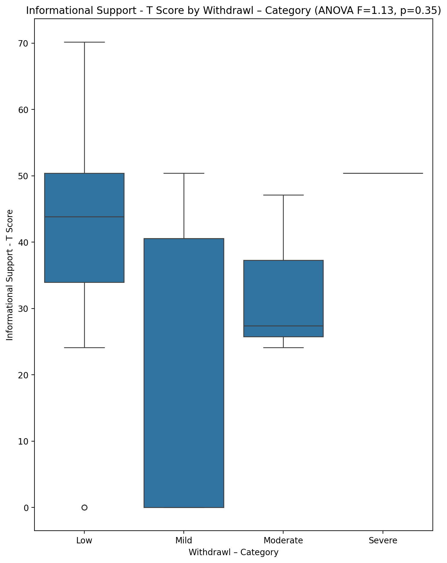

## Instrumental Support - T Score vs Withdrawl – Category

Test: anova; statistic: 1.2267048392016593; p-value: 0.30874981645960264;

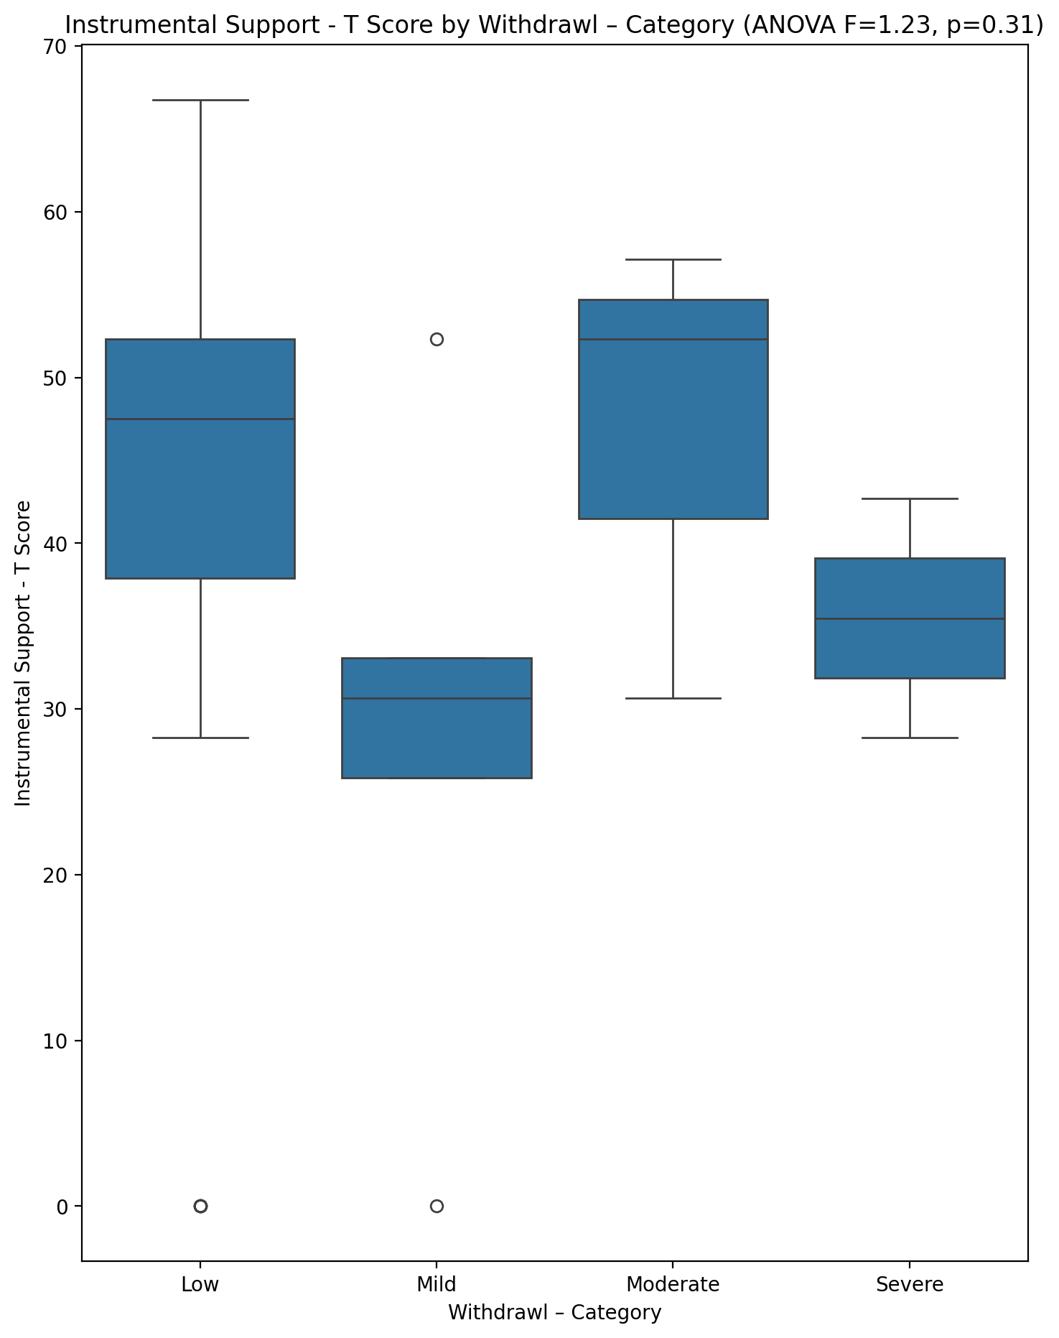

## Perceived Social Support Total T Score vs Withdrawl – Category

Test: anova; statistic: 1.8123047599769817; p-value: 0.1556369576492123;

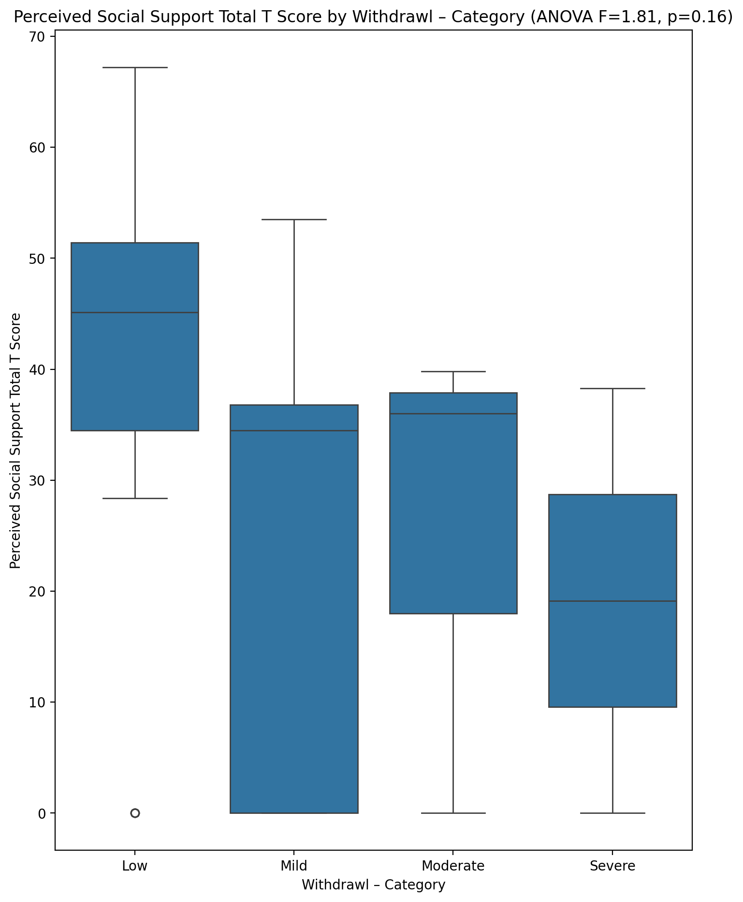

## Emotional Support - Rank vs Withdrawl – Category

Test: chi2; statistic: 10.783463203463203; p-value: 0.2908440024554078;

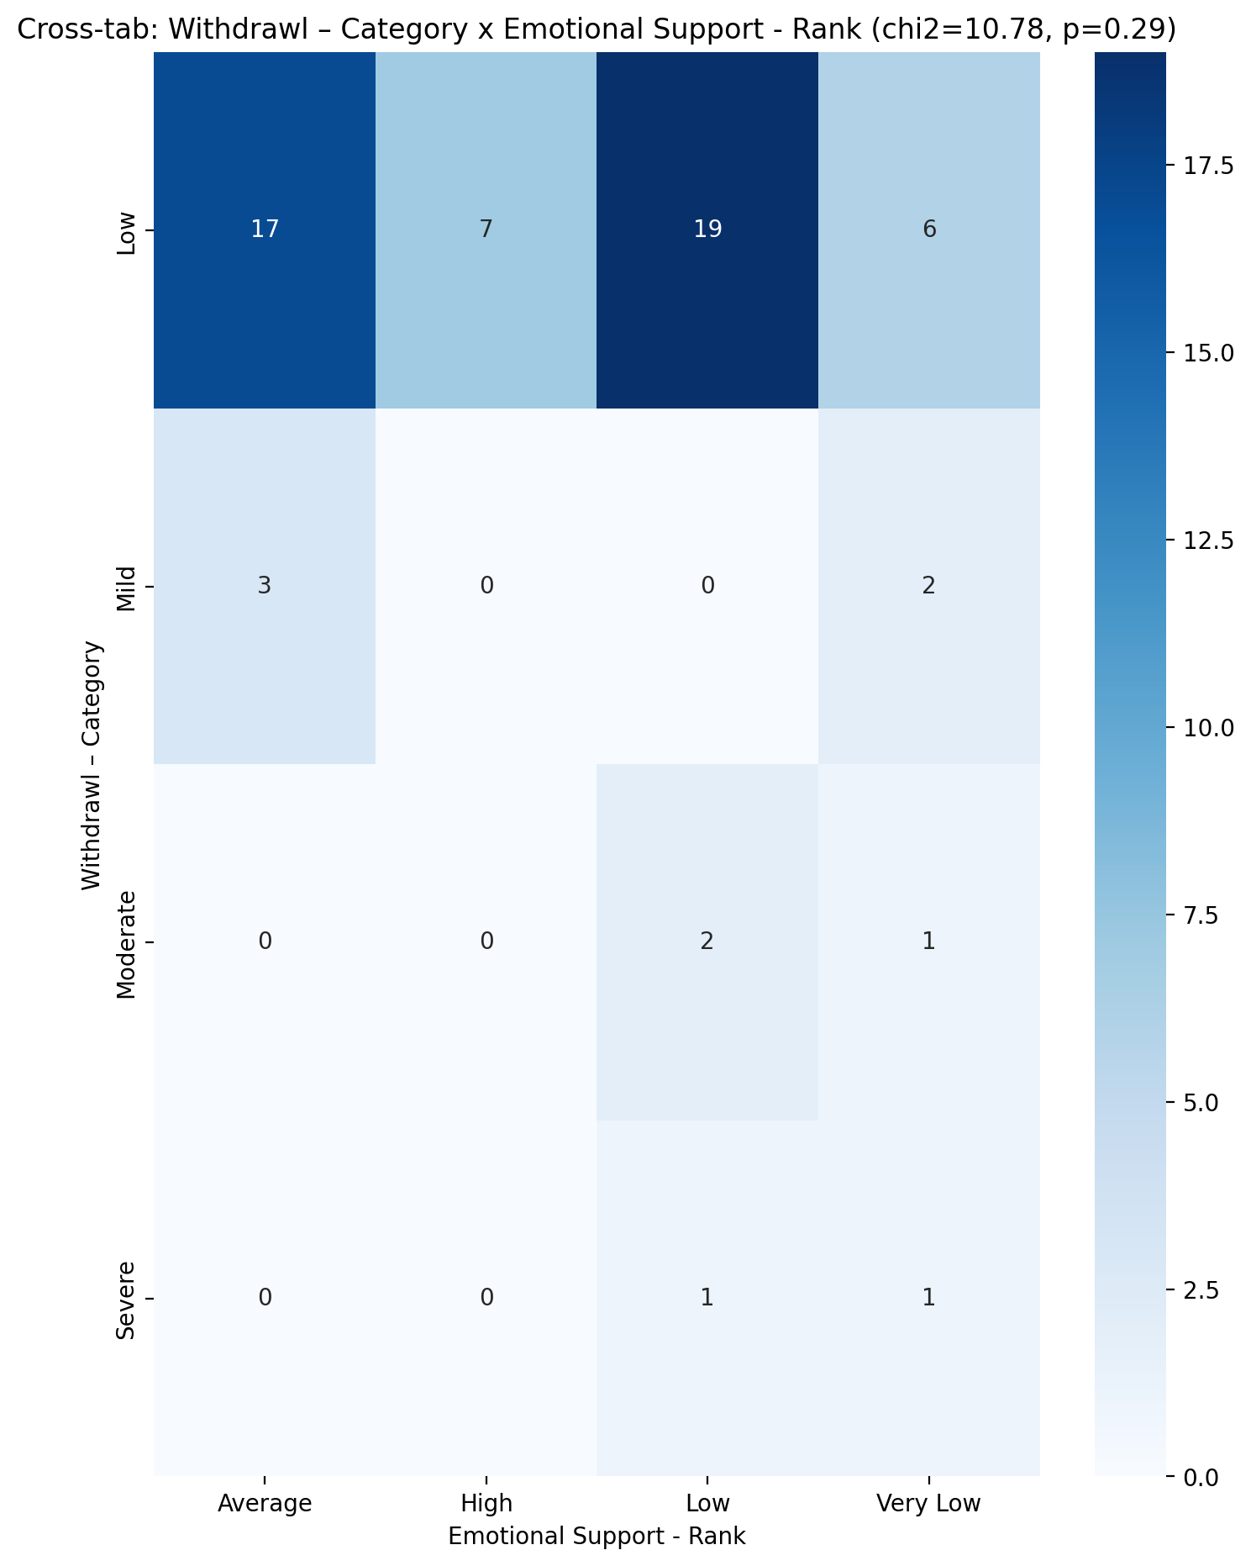

## Informational Support - Rank vs Withdrawl – Category

Test: chi2; statistic: 9.807199631732393; p-value: 0.6328704522499682;

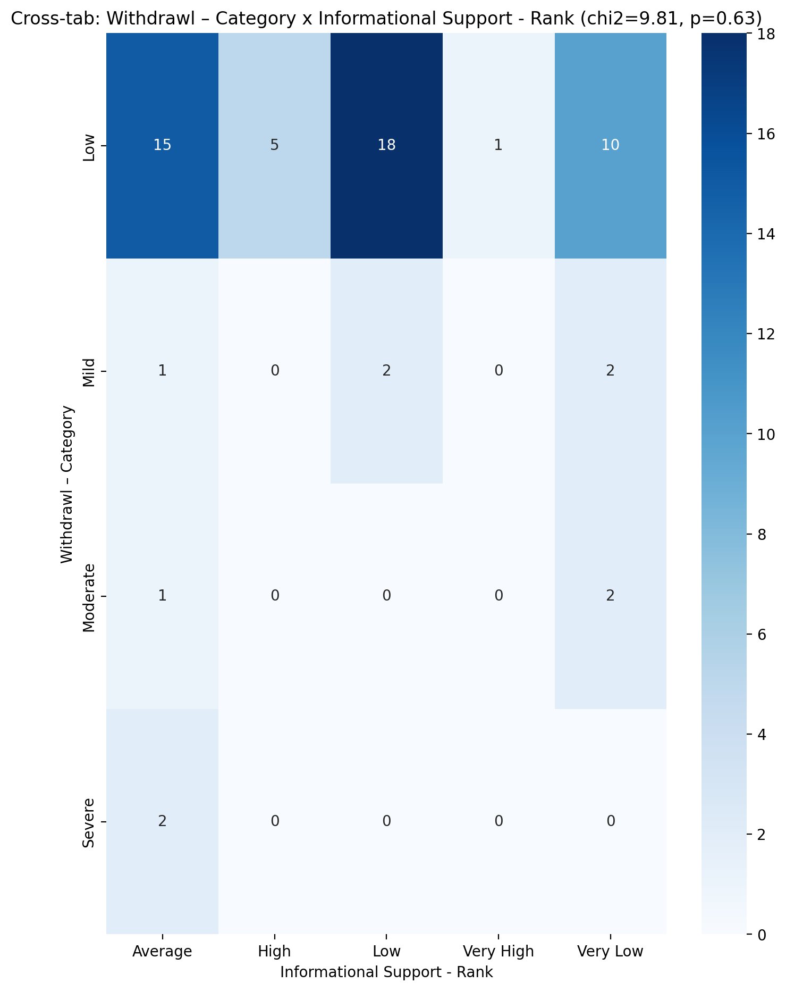

## Instrumental Support - Rank vs Withdrawl – Category

Test: chi2; statistic: 11.531205233416117; p-value: 0.2410455376946295;

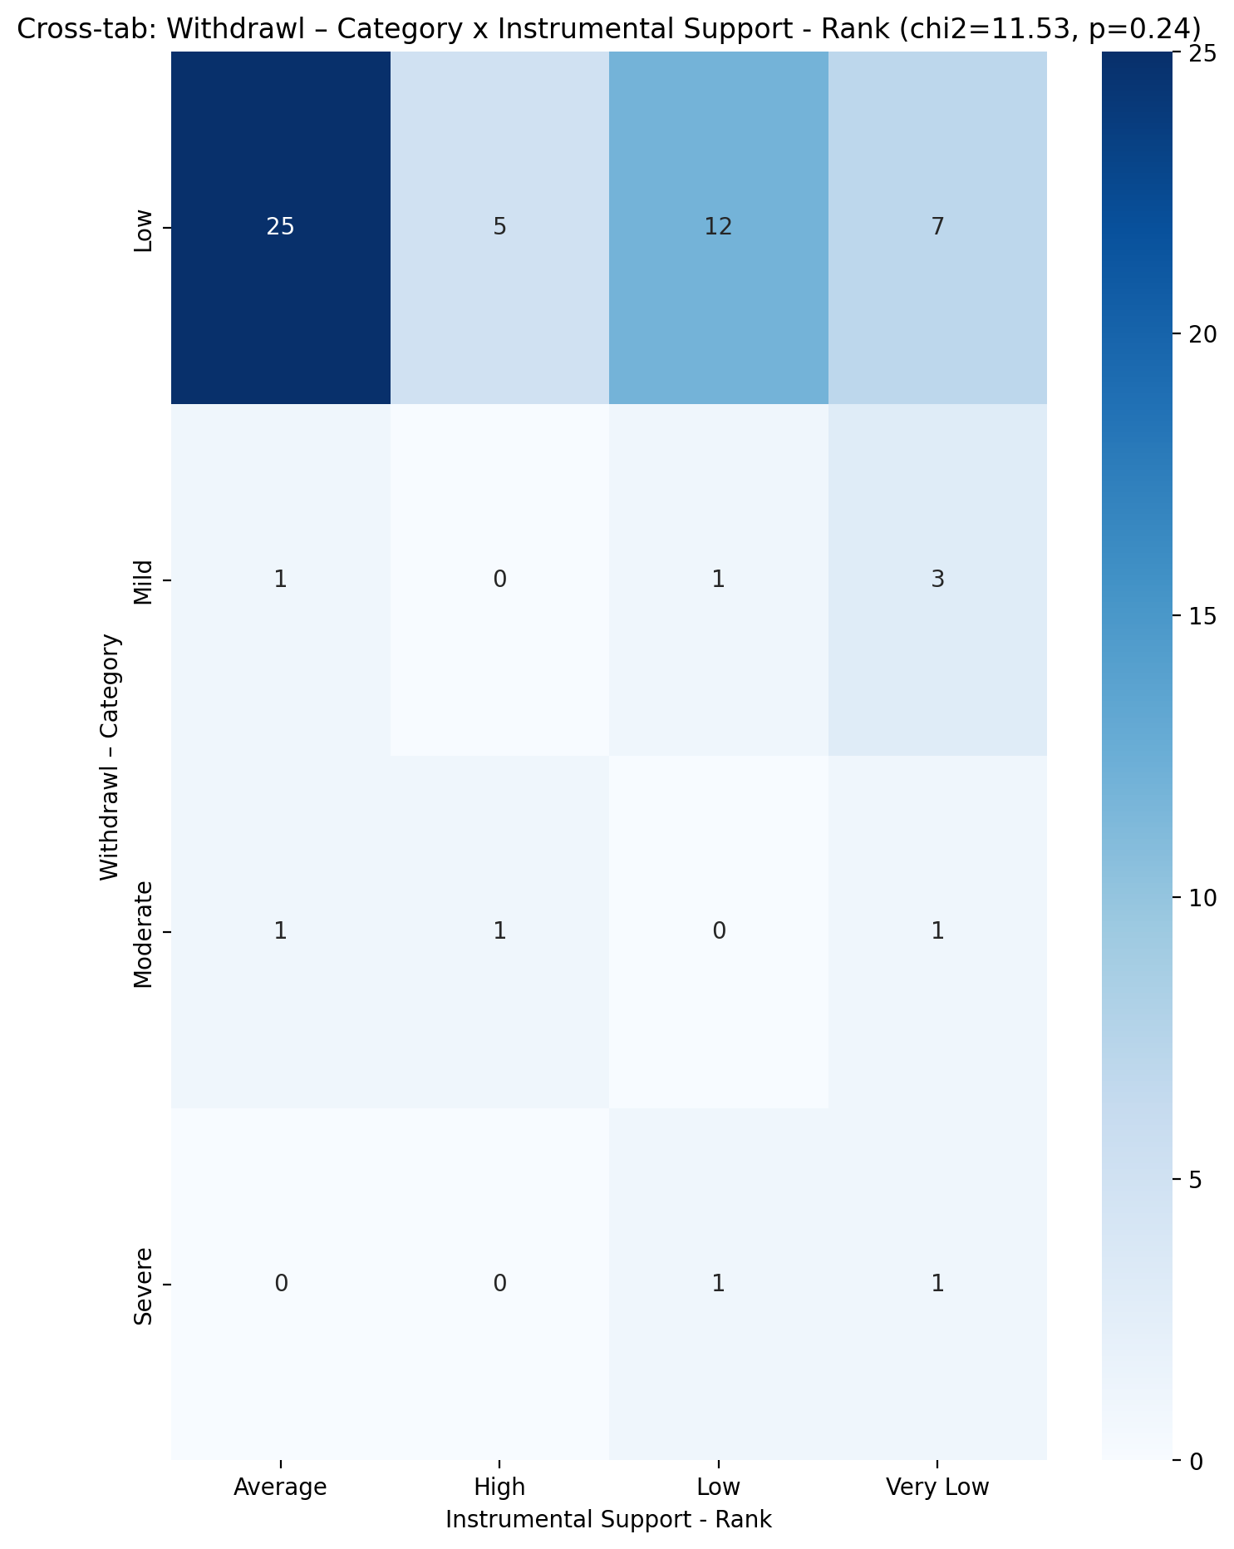

## Perceived Social Support TOTAL - Rank vs Withdrawl – Category

Test: chi2; statistic: 6.718480804909376; p-value: 0.6664029217524428;

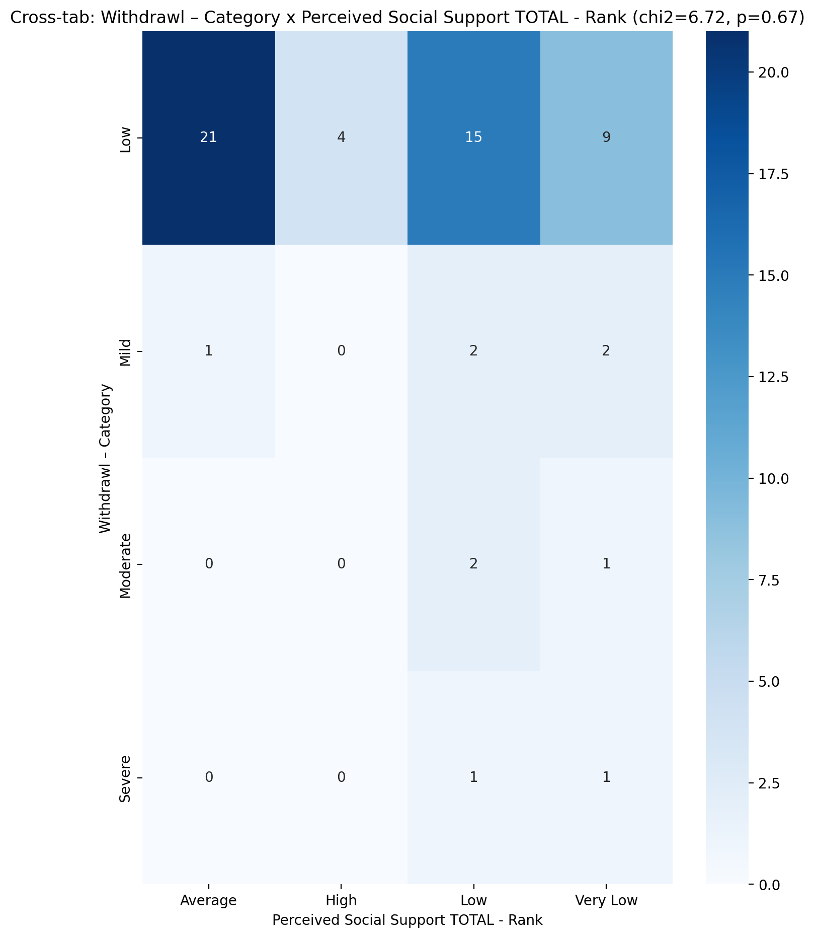

## Power Self Concept - Real Self Concept Score vs Withdrawl – Category

Test: anova; statistic: 1.819417447462134; p-value: 0.15433514586537106;

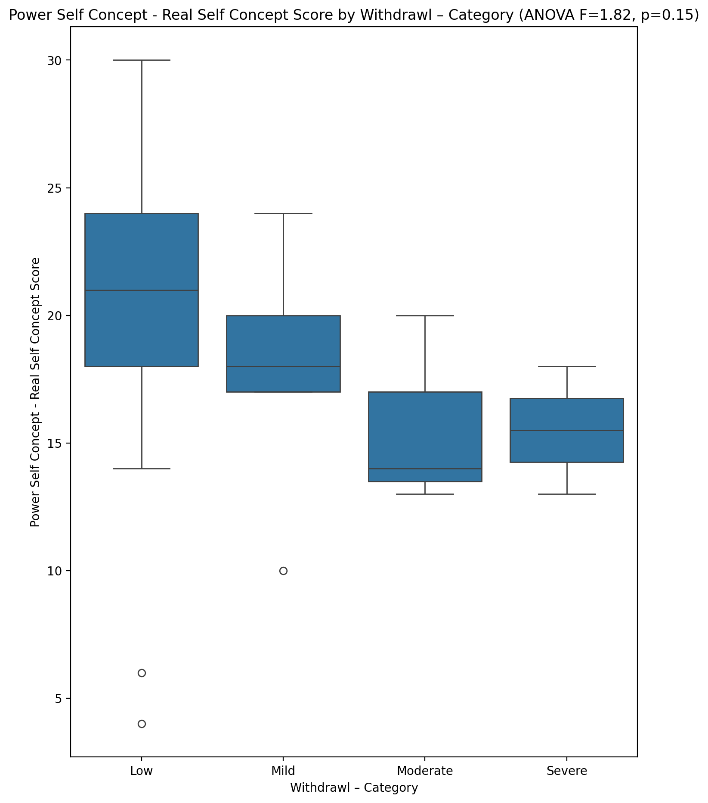

## Power Self Concept - Ideal Self Concept score vs Withdrawl – Category

Test: anova; statistic: 1.4545183210001844; p-value: 0.23700859059238163;

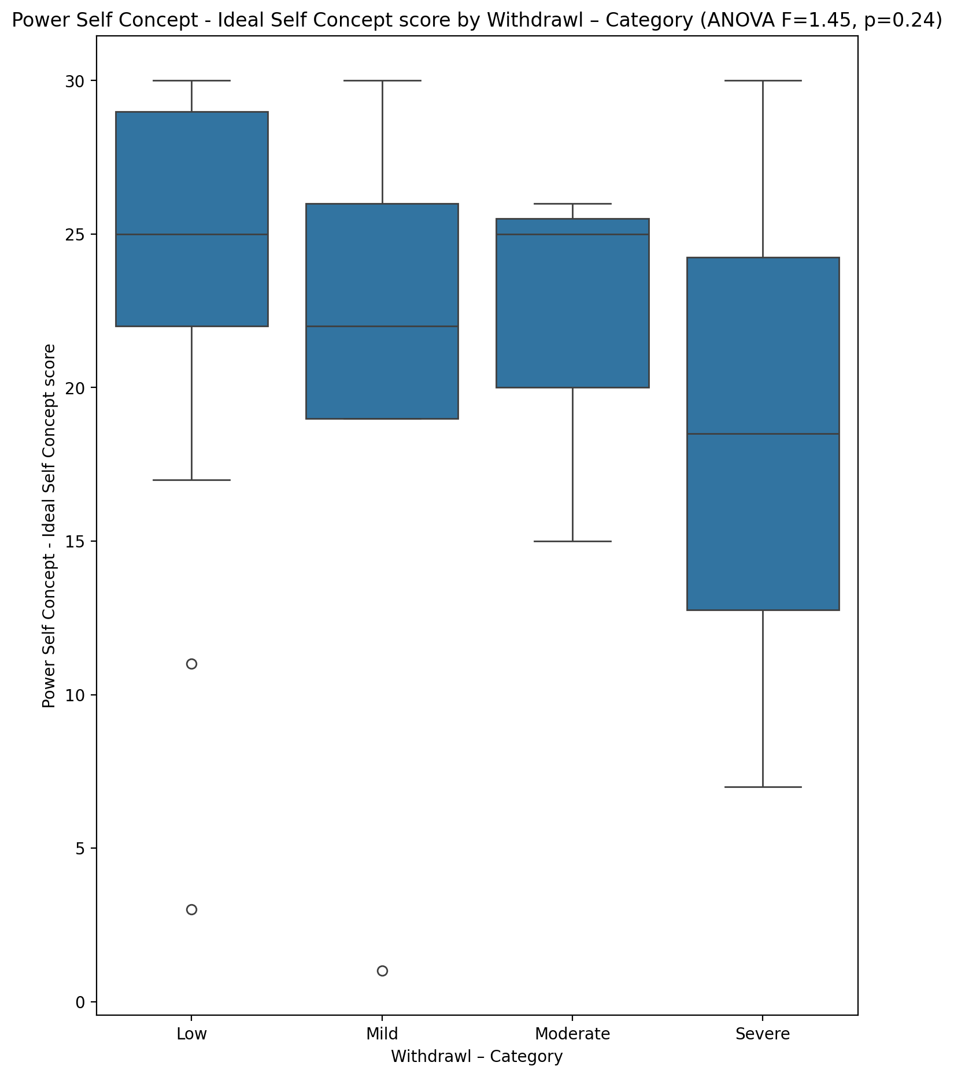

## Power Self Concept – Social Self Concept Score vs Withdrawl – Category

Test: anova; statistic: 1.2076620040742856; p-value: 0.3155932081708057;

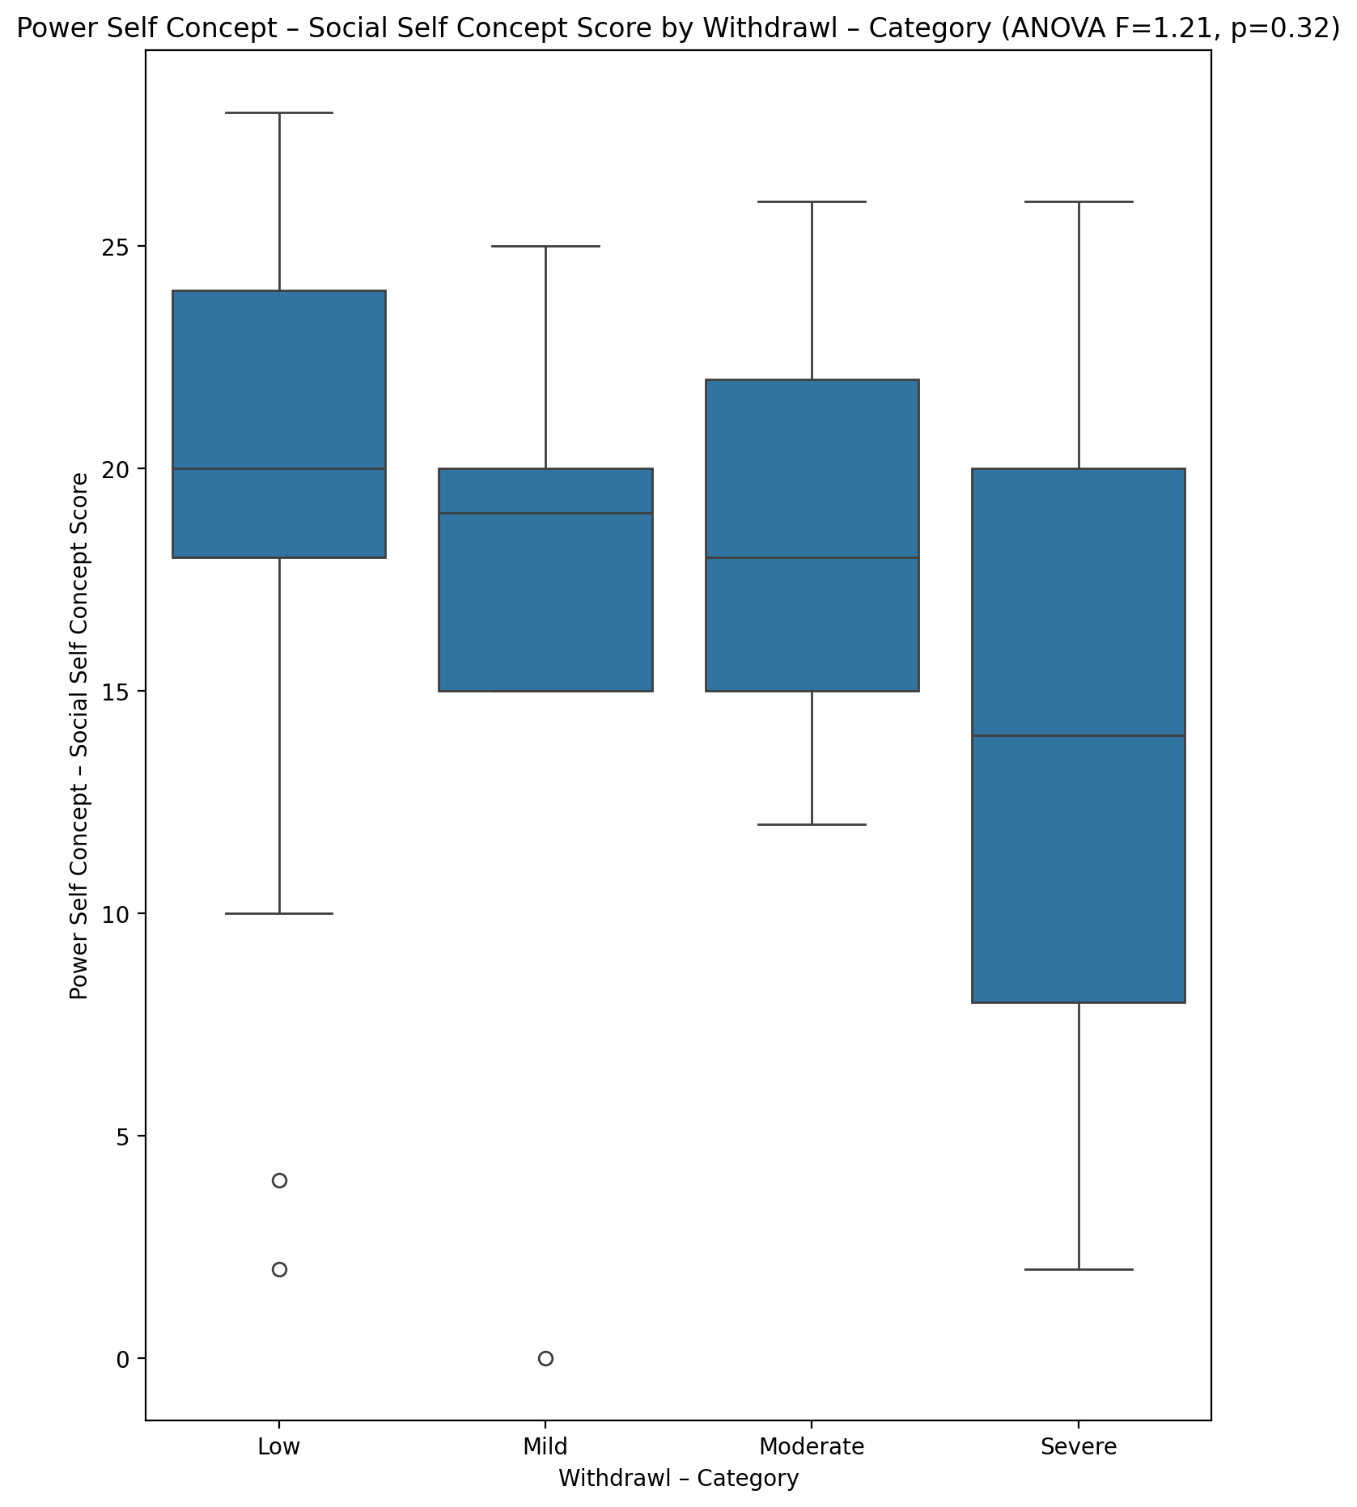

## Social Self Concept - Real Self Concept Score vs Withdrawl – Category

Test: anova; statistic: 4.098990381867005; p-value: 0.01070966583537138;

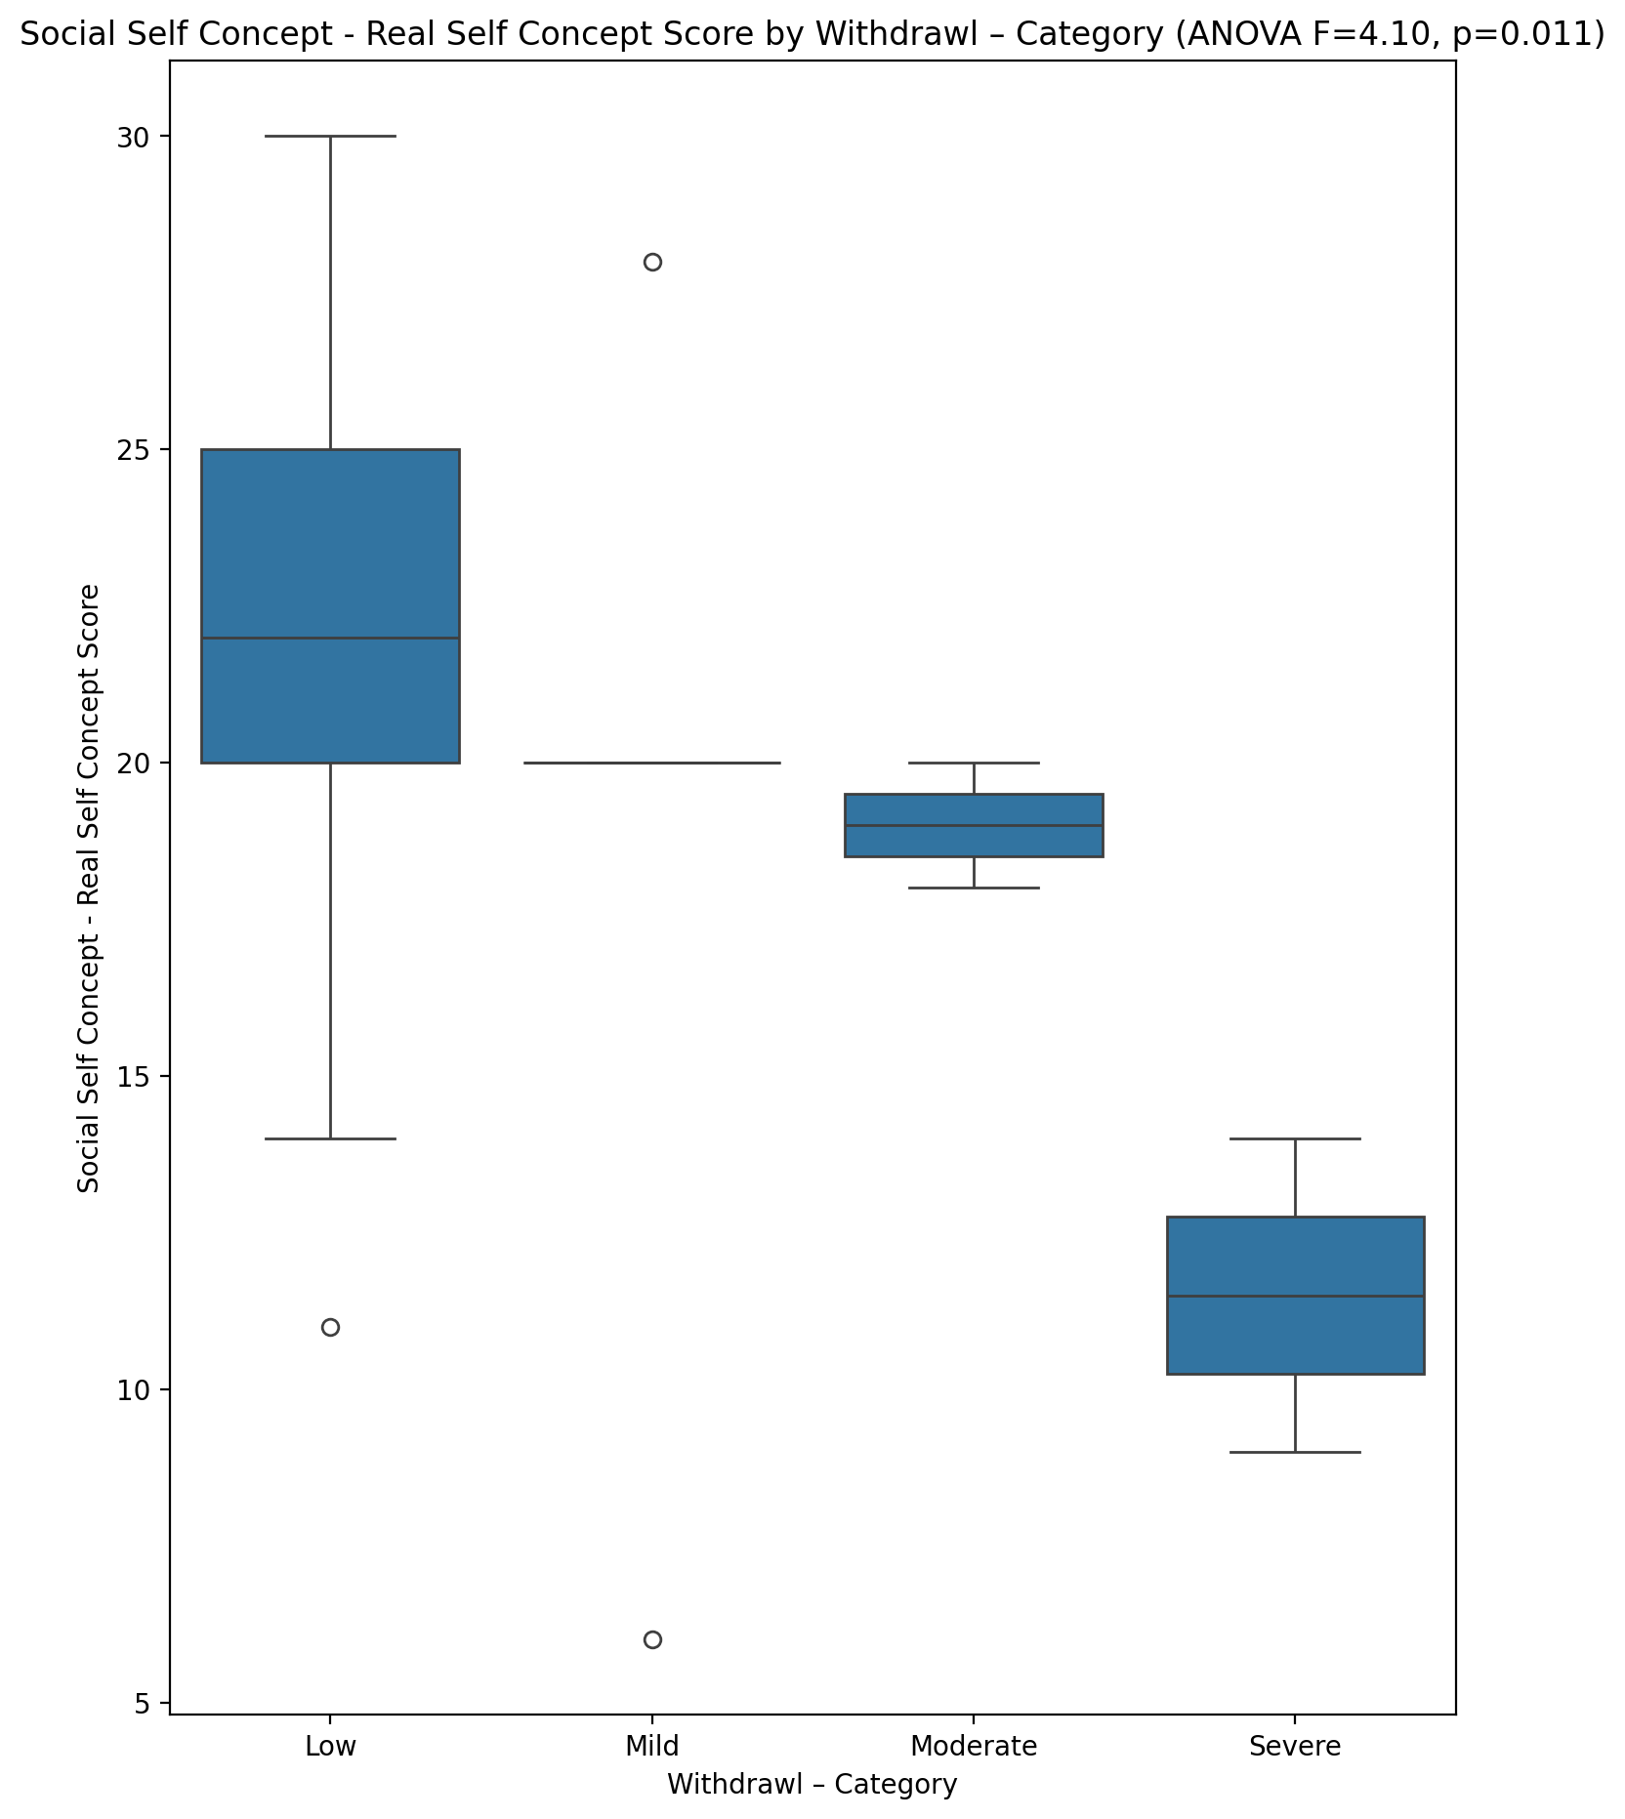

## Social Self Concept – Social Self Concept Score vs Withdrawl – Category

Test: anova; statistic: 1.0214114307865994; p-value: 0.39028561195131656;

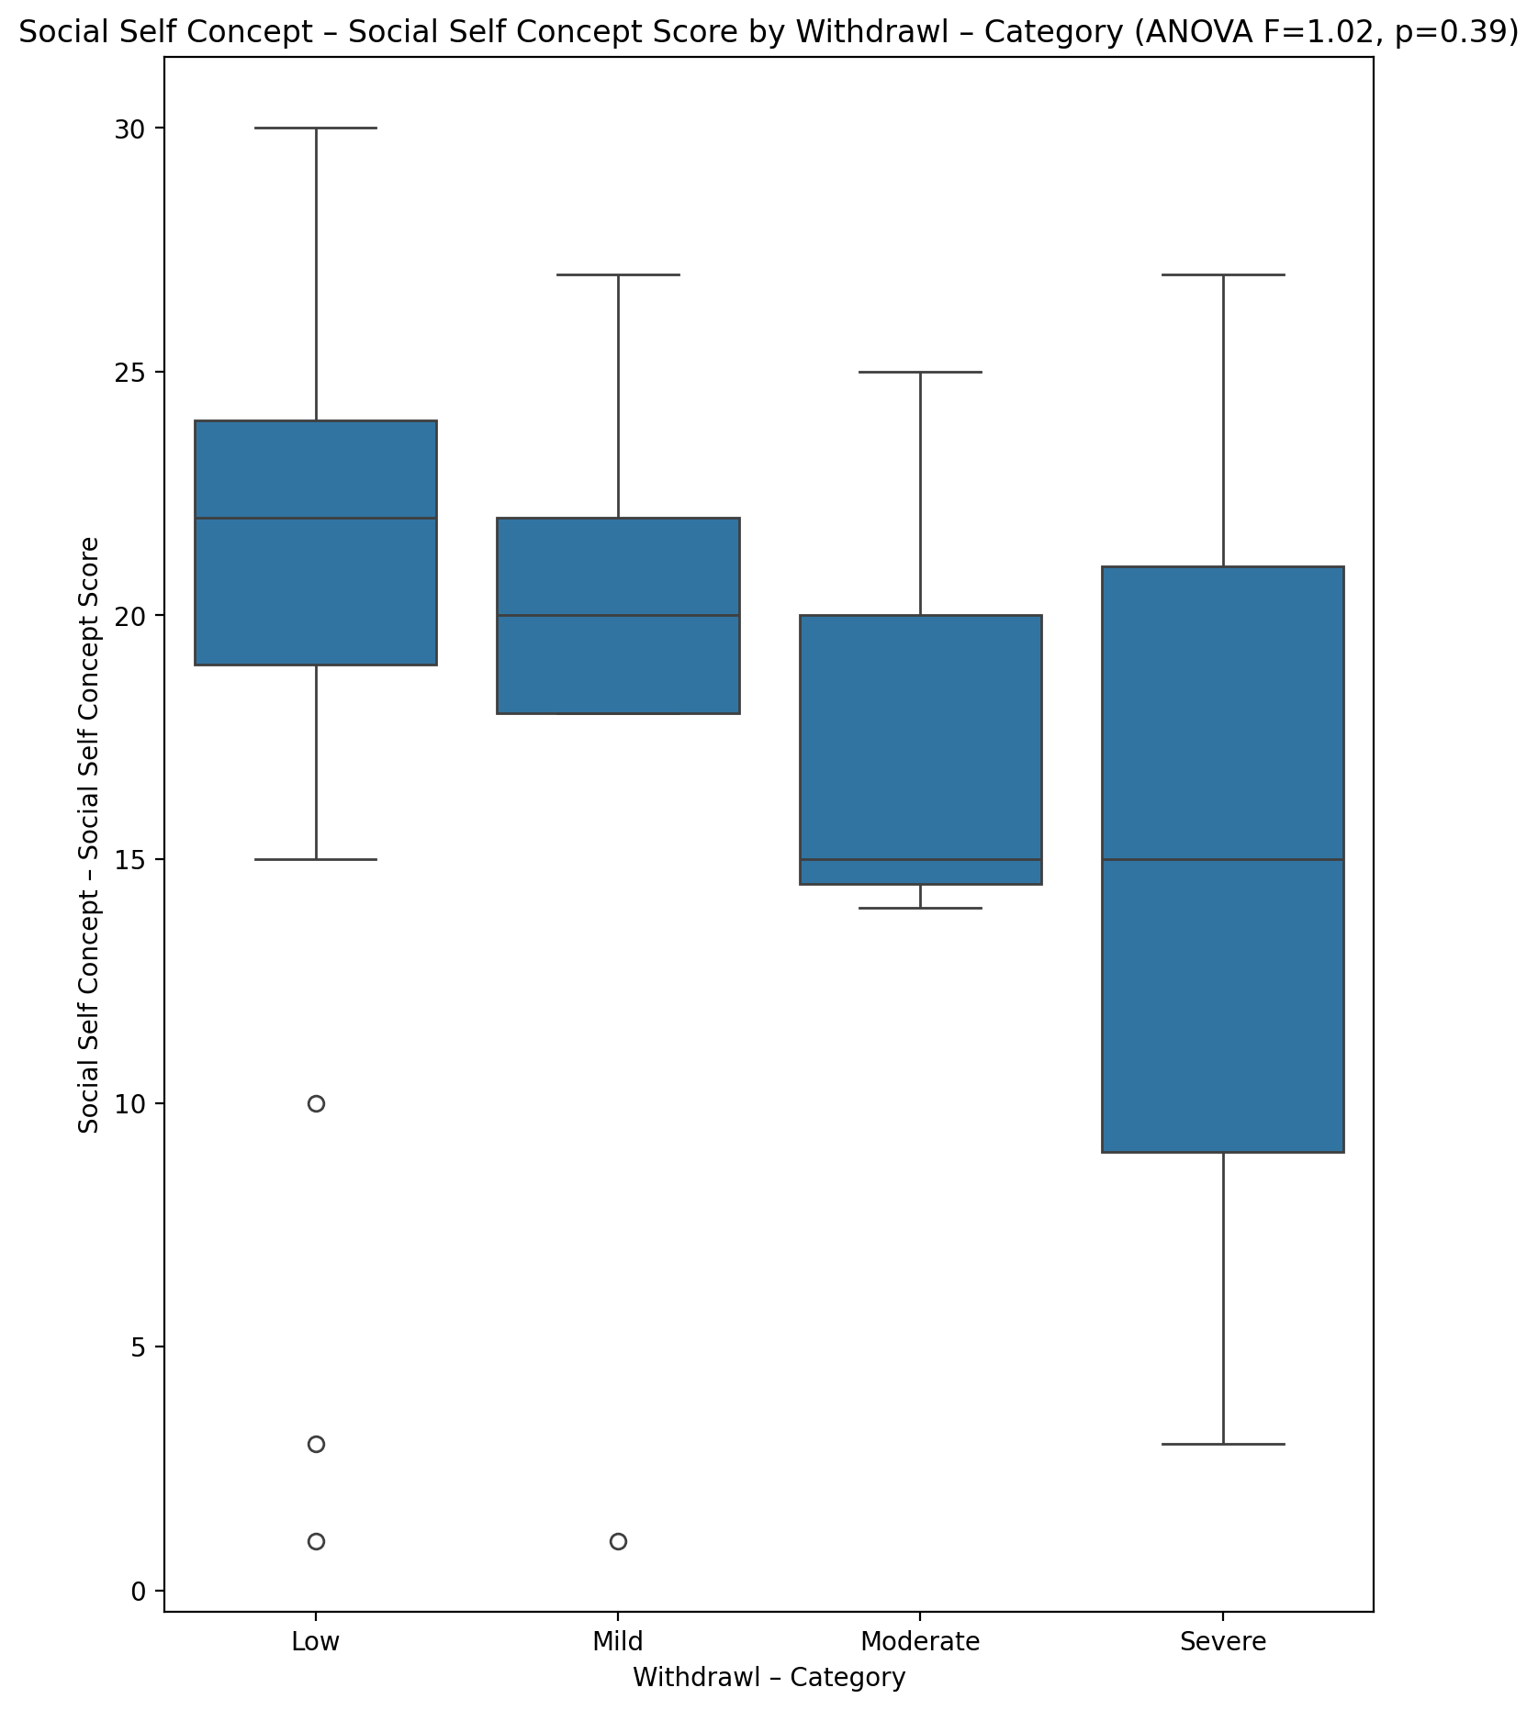

## Ability Self Concept - Real Self Concept Score vs Withdrawl – Category

Test: anova; statistic: 3.500003636270861; p-value: 0.02134609999011914;

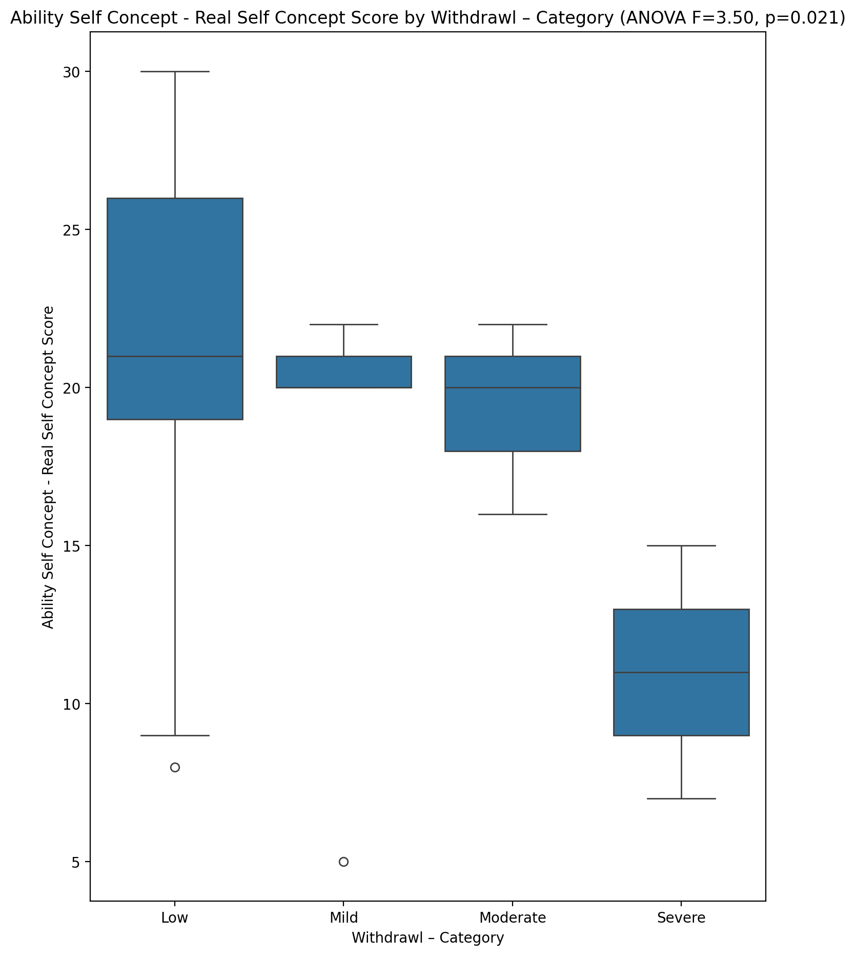

## Ability Self Concept - Ideal Self Concept Score vs Withdrawl – Category

Test: anova; statistic: 0.8951176745717211; p-value: 0.44958285684181987;

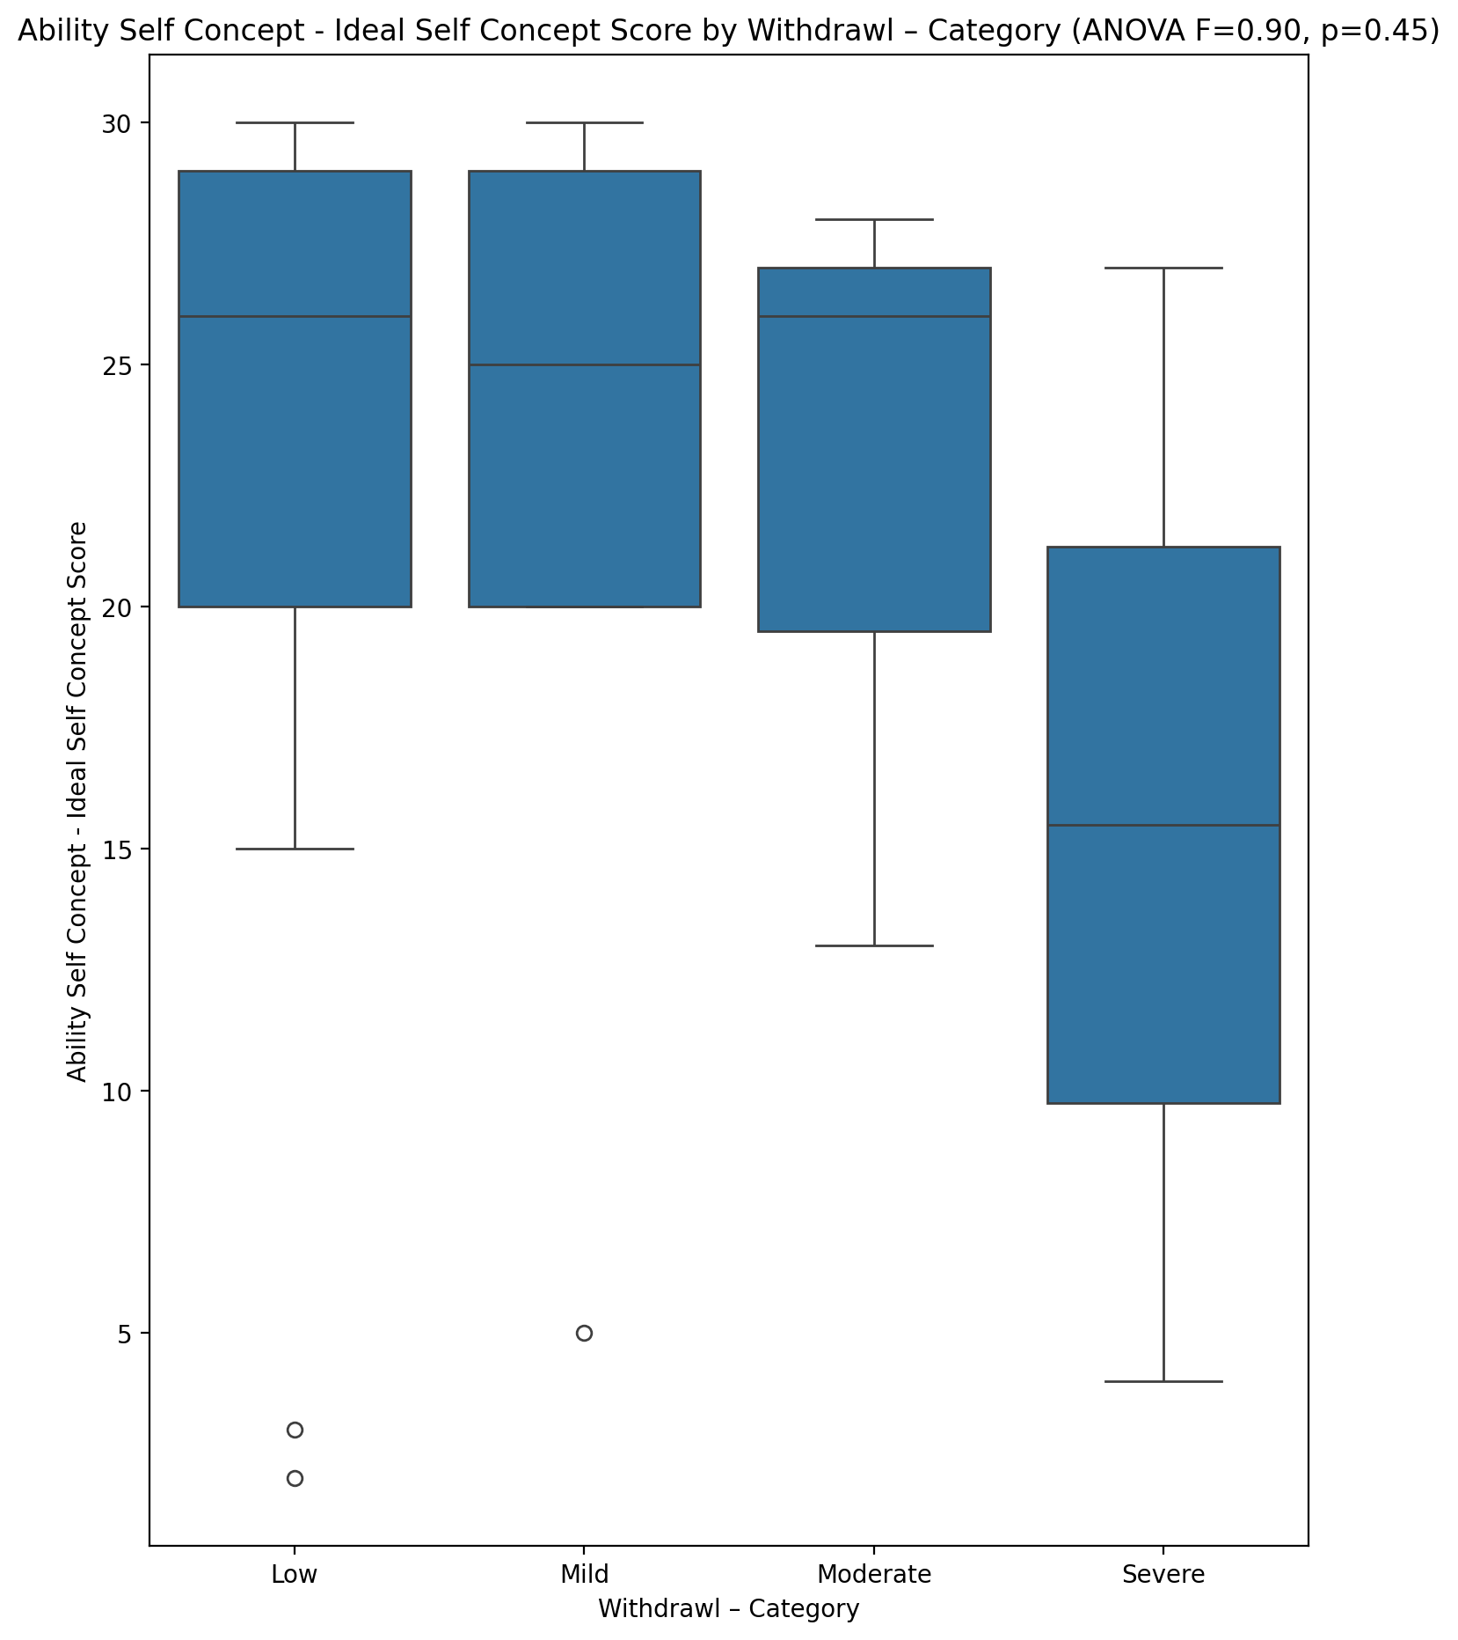

## Ability Self Concept – Social Self Concept Score vs Withdrawl – Category

Test: anova; statistic: 1.0548086285491383; p-value: 0.37581149061790814;

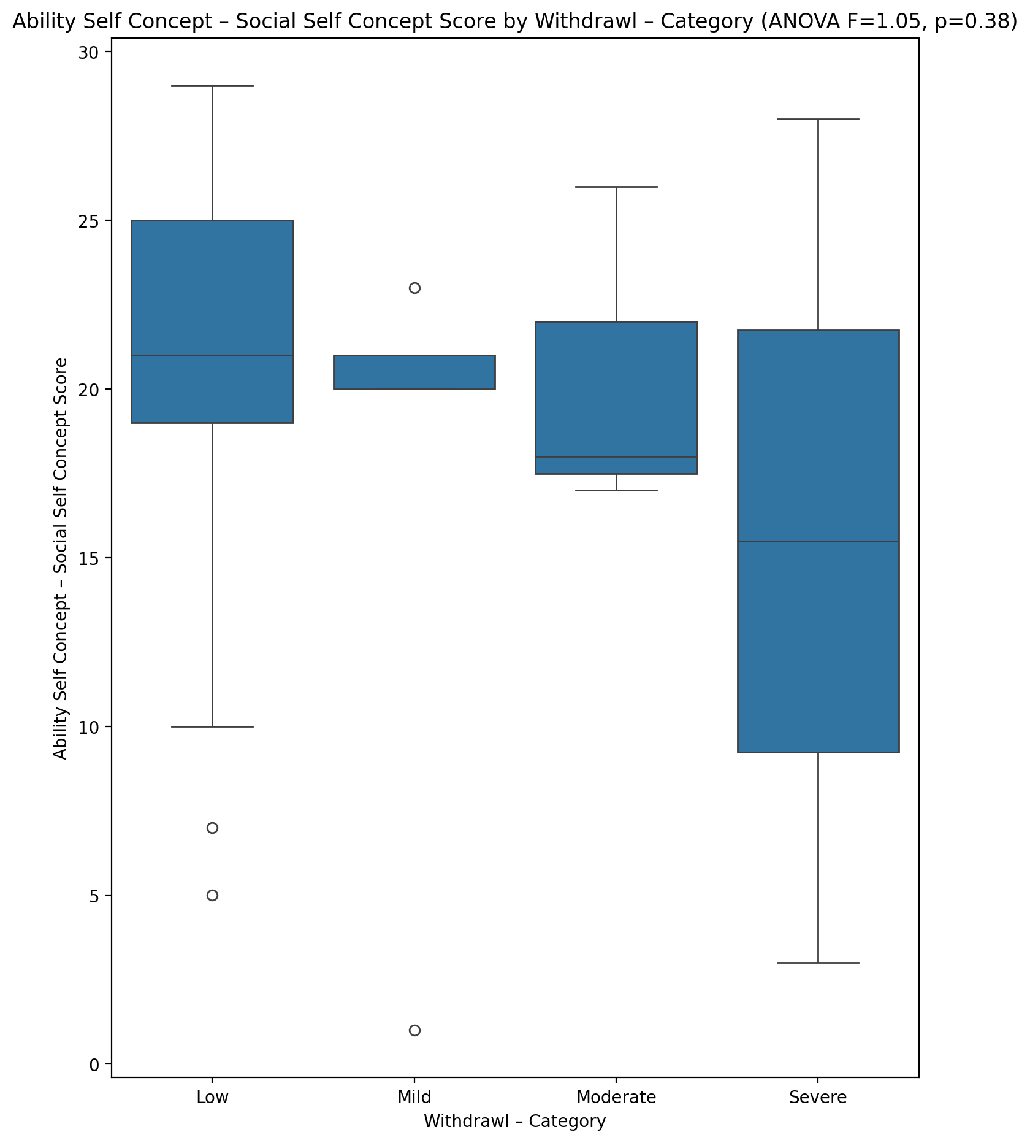

## Physical Self Concept - Real Self Concept Score vs Withdrawl – Category

Test: anova; statistic: 2.126419143883641; p-value: 0.10733199996413018;

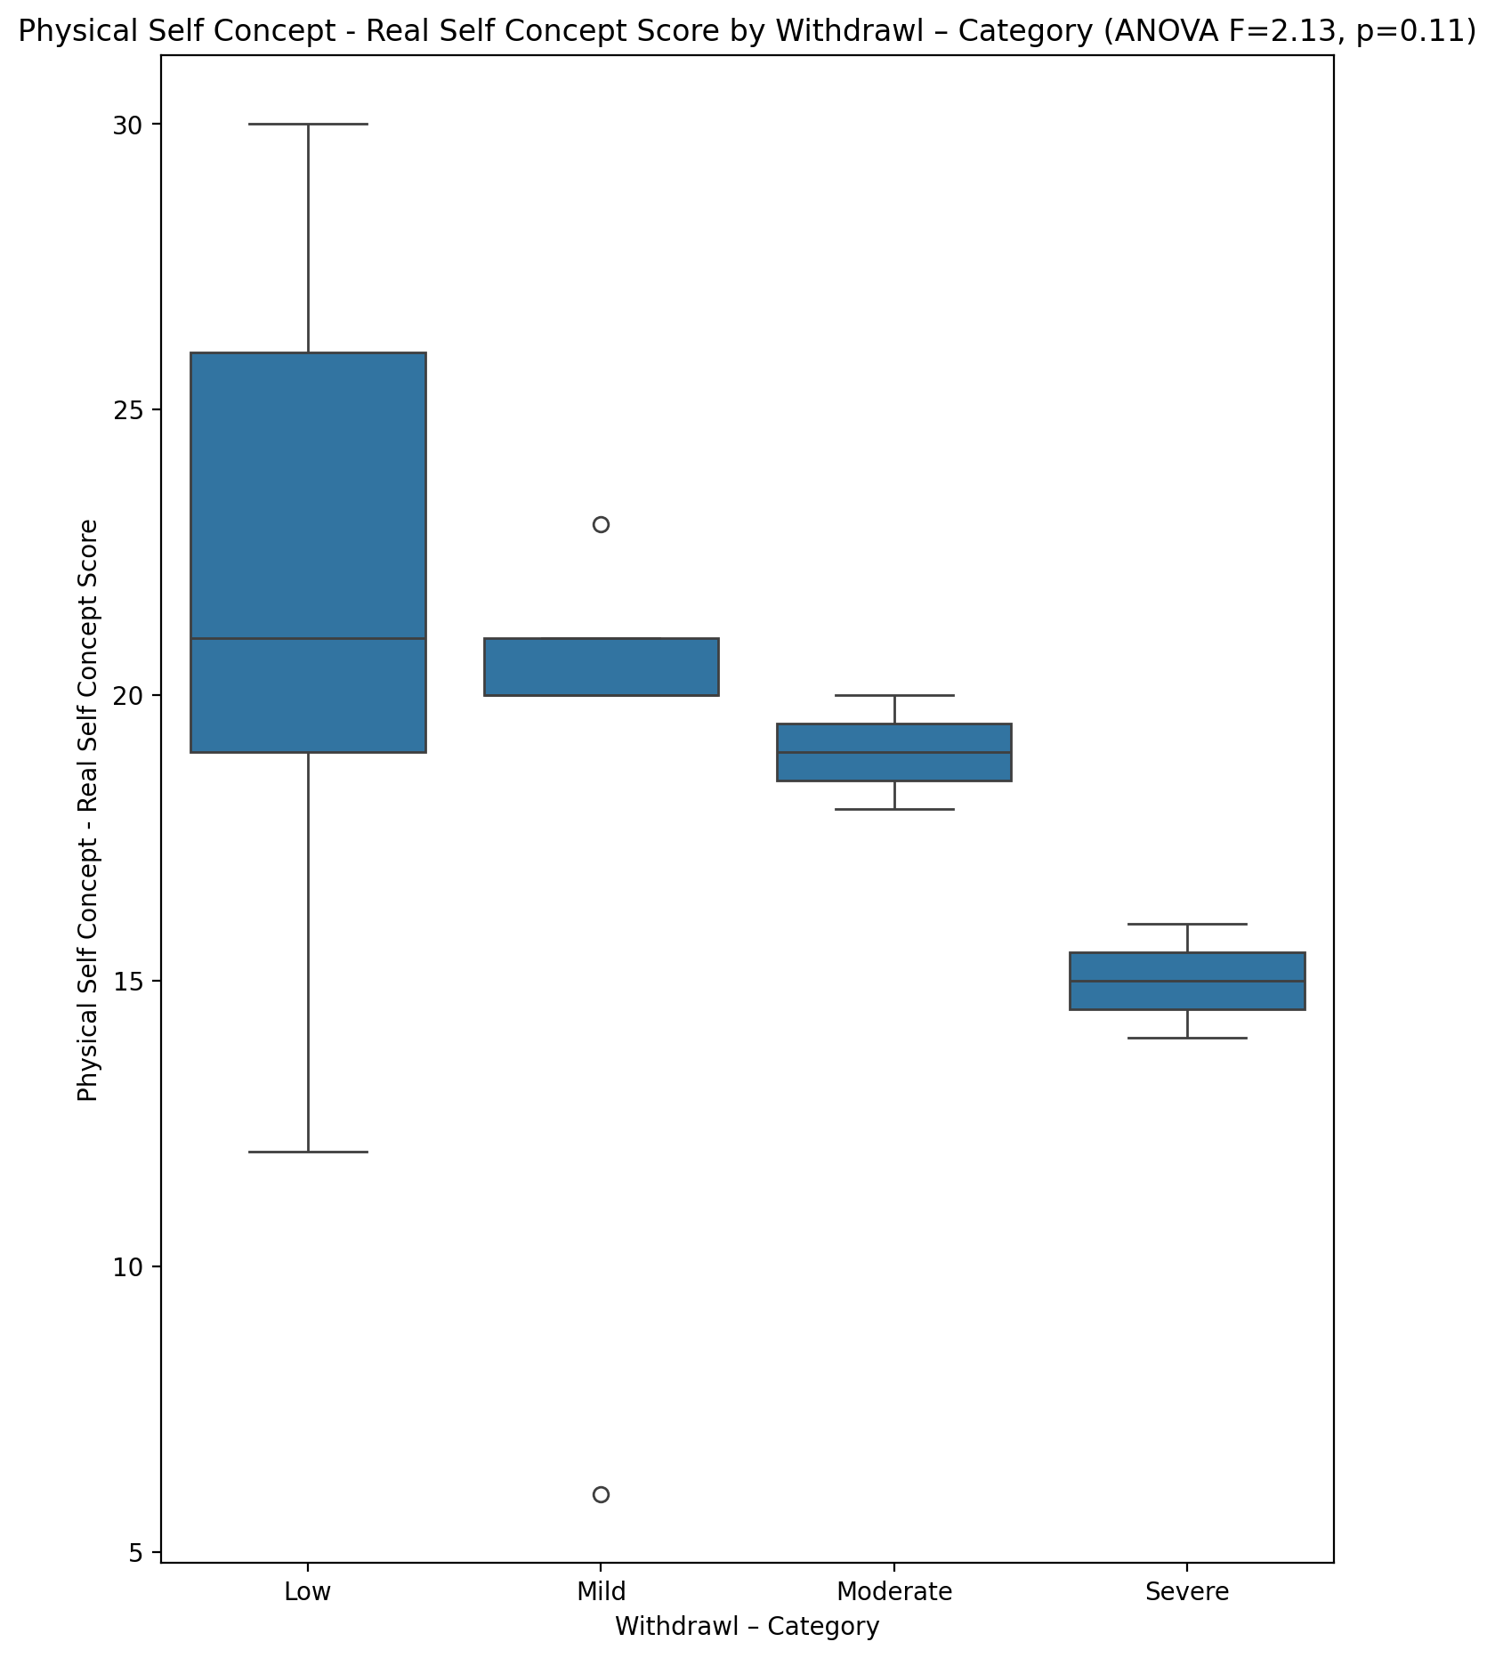

## Physical Self Concept – Ideal Self Concept Score vs Withdrawl – Category

Test: anova; statistic: 0.8042277210271704; p-value: 0.4969022202462098;

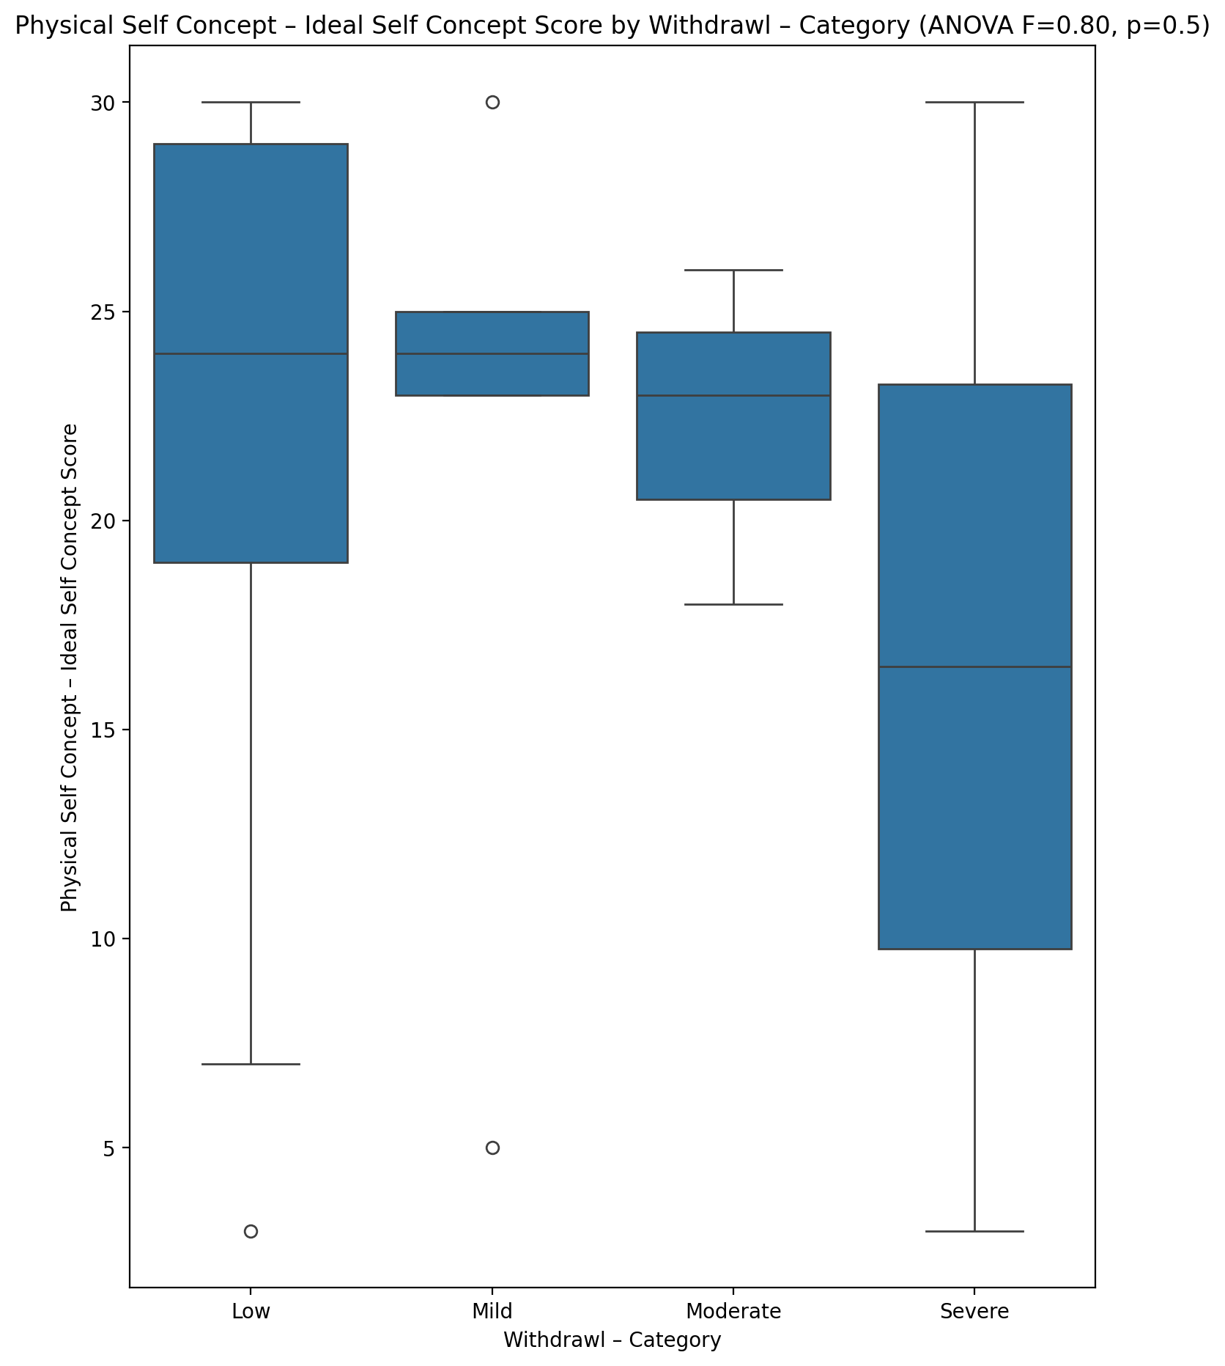

## Physical Self Concept – Social Self Concept Score vs Withdrawl – Category

Test: anova; statistic: 0.9776327671174901; p-value: 0.4100116348930506;

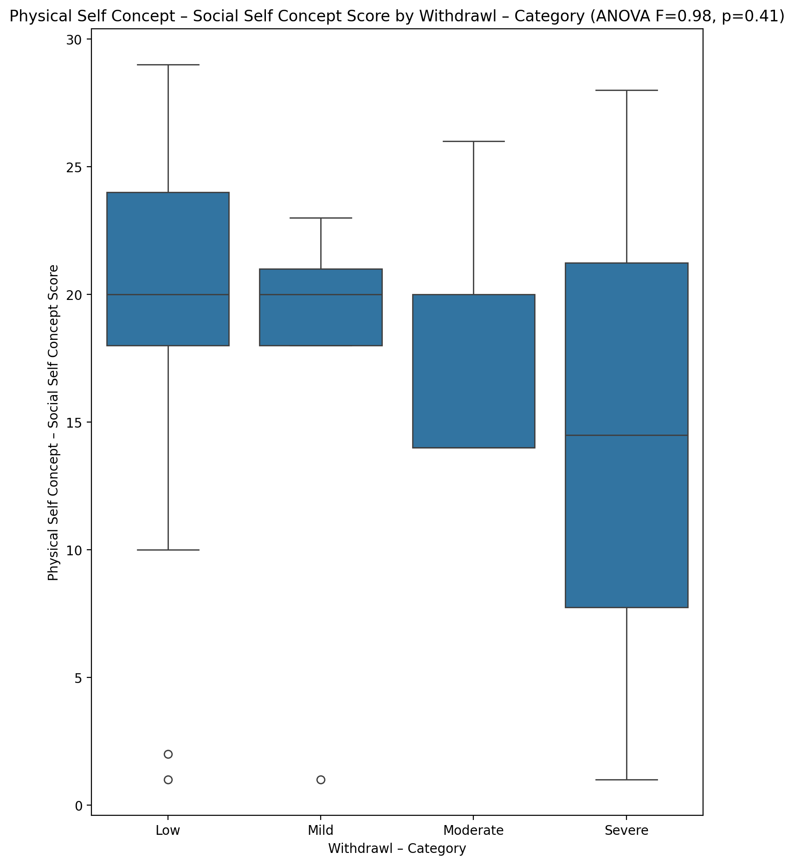

## Psychological Self Concept - Real Self Concept Score vs Withdrawl – Category

Test: anova; statistic: 4.380312060905756; p-value: 0.007777271709468897;

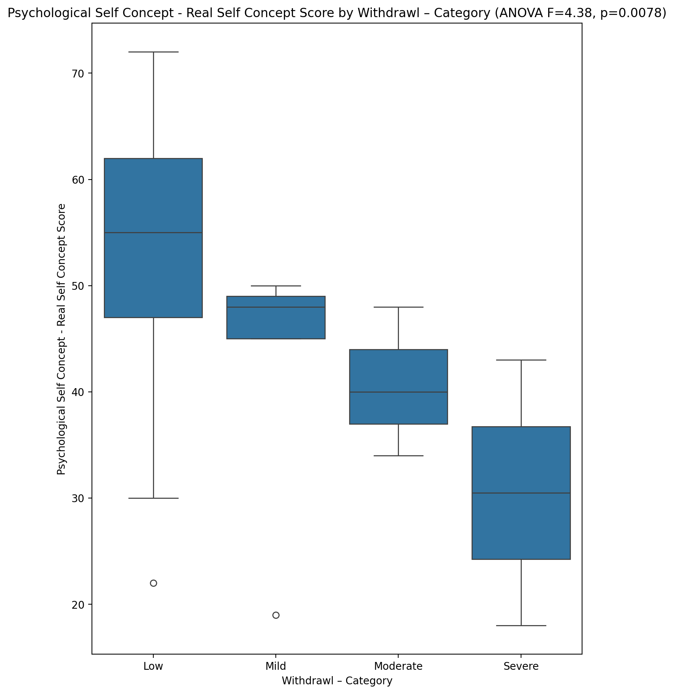

## Psychological Self Concept – Ideal Self Concept Score vs Withdrawl – Category

Test: anova; statistic: 0.739292884409022; p-value: 0.5331546951486285;

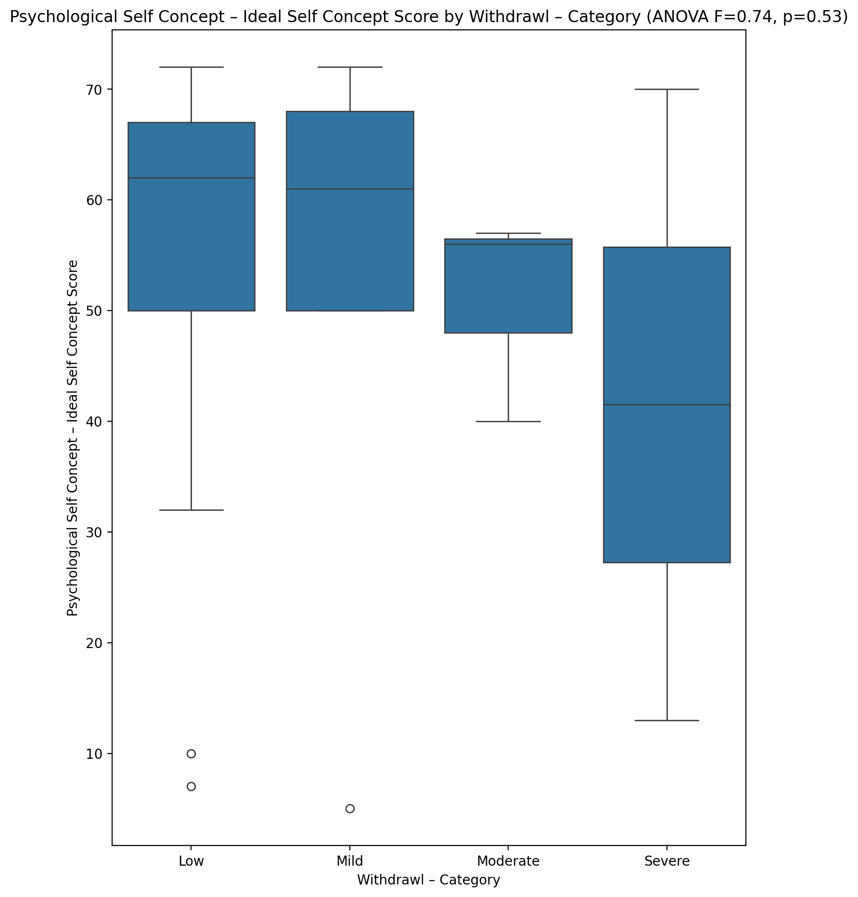

## Psychological Self Concept – Social Self Concept Score vs Withdrawl – Category

Test: anova; statistic: 1.4153888308453566; p-value: 0.24808237361792407;

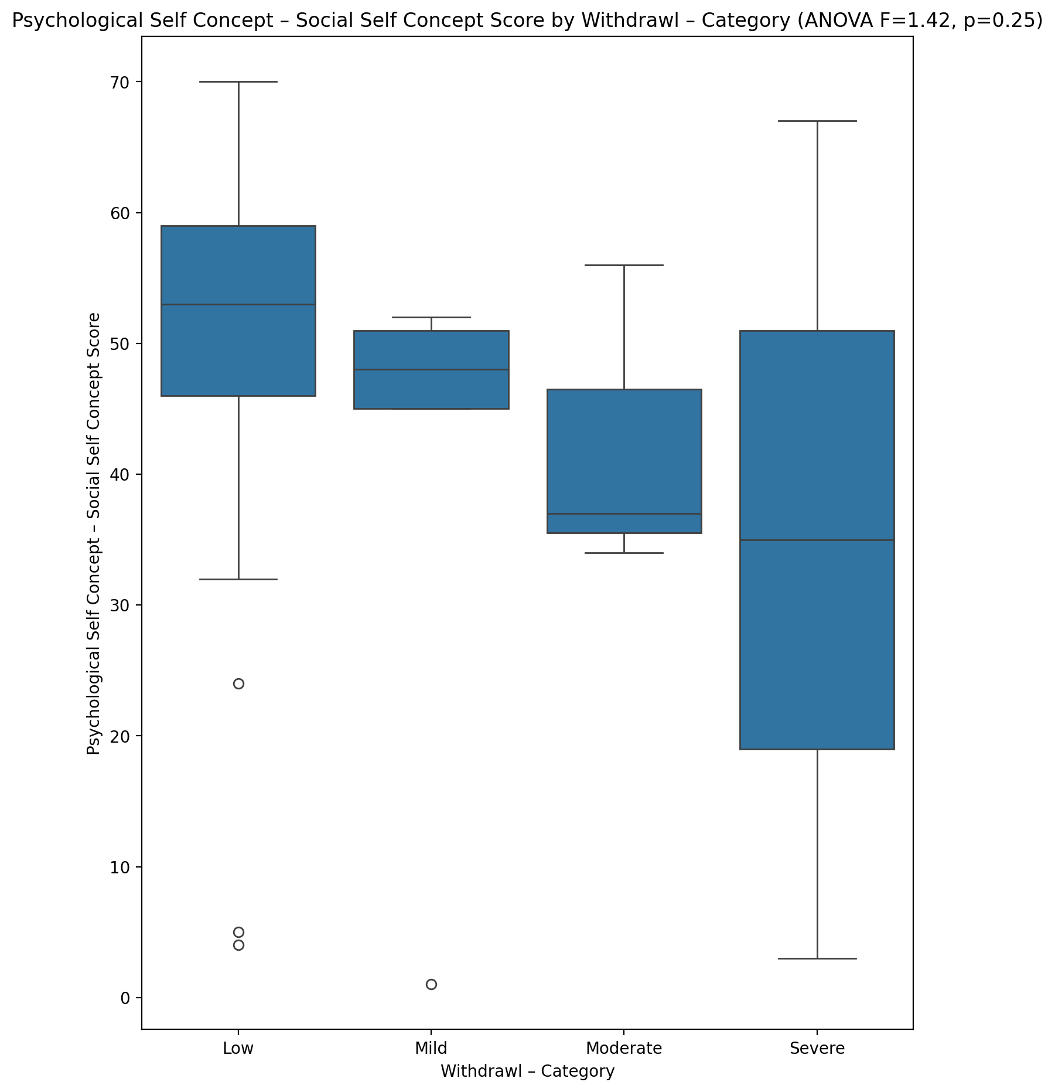

## Real Self Concept Total Score vs Withdrawl – Category

Test: anova; statistic: 3.83998868324701; p-value: 0.014411224642920321;

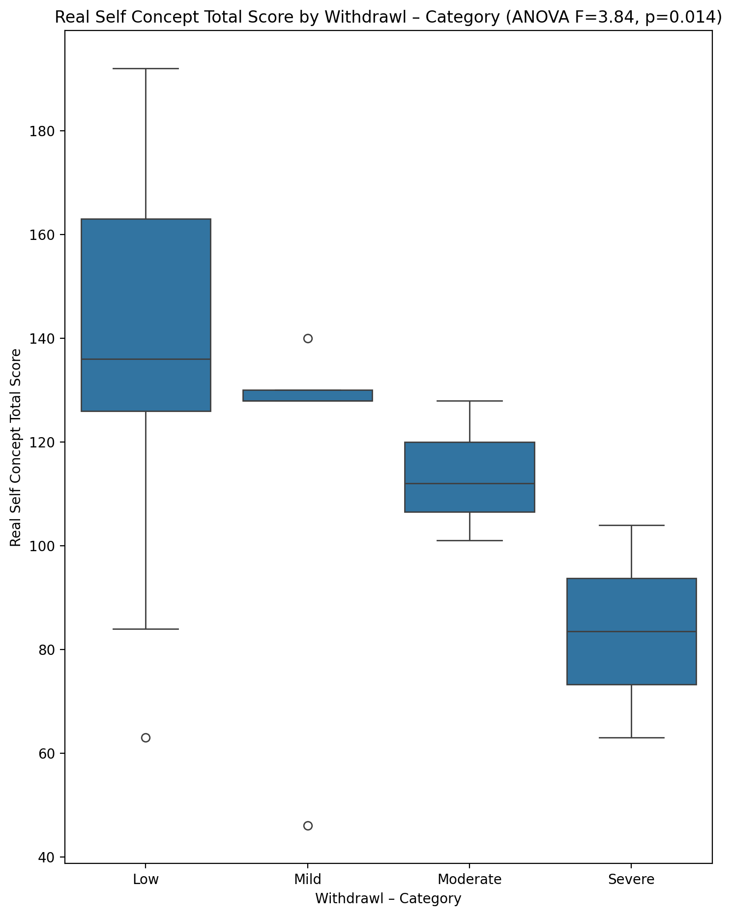

## Ideal Self Concept Total Score vs Withdrawl – Category

Test: anova; statistic: 0.8859343005138067; p-value: 0.4541843017436016;

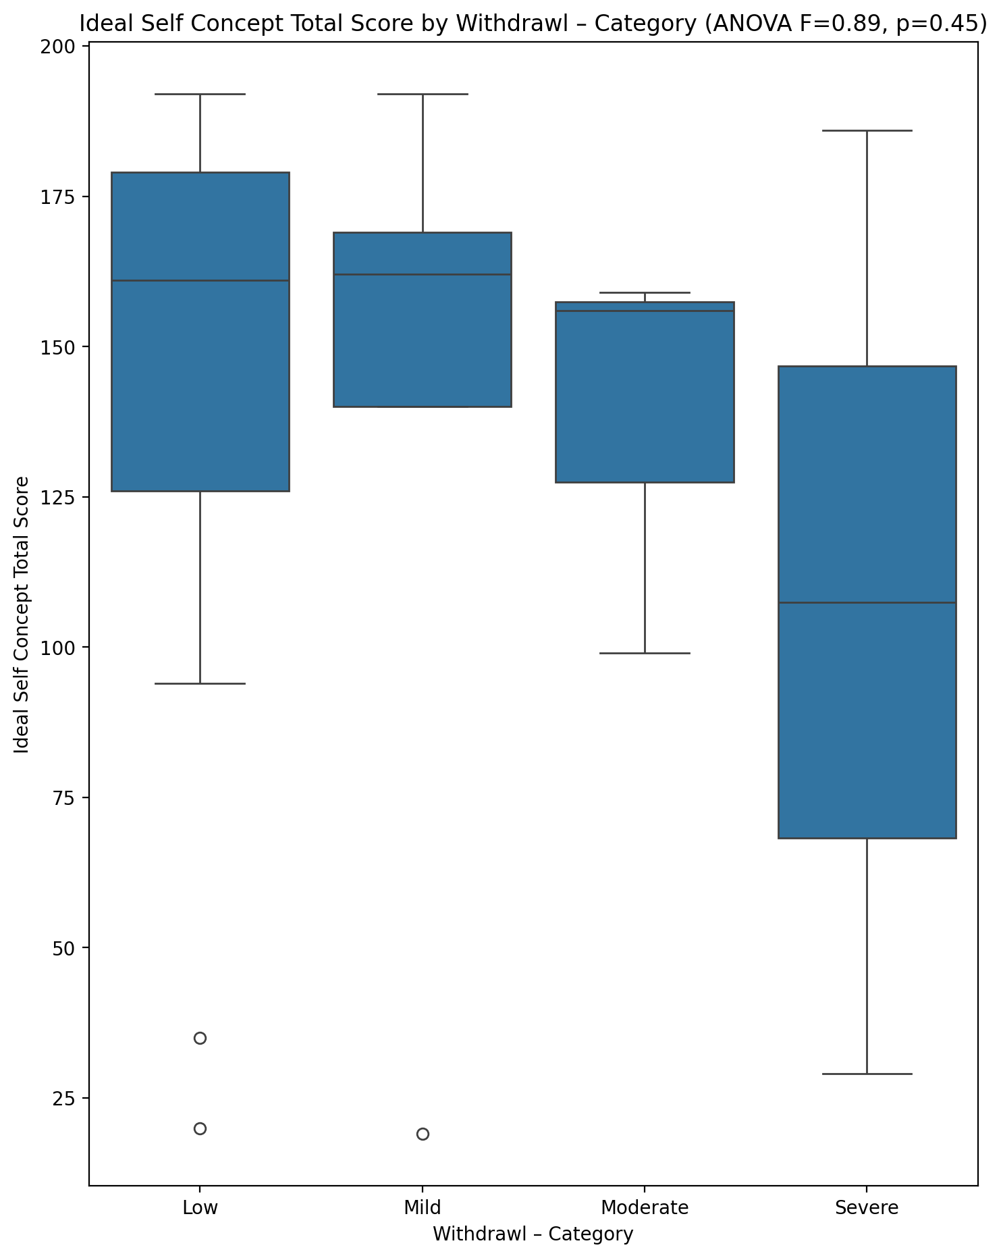

## Social Self Concept Total Score vs Withdrawl – Category

Test: anova; statistic: 1.2519467576310483; p-value: 0.29989202573480217;

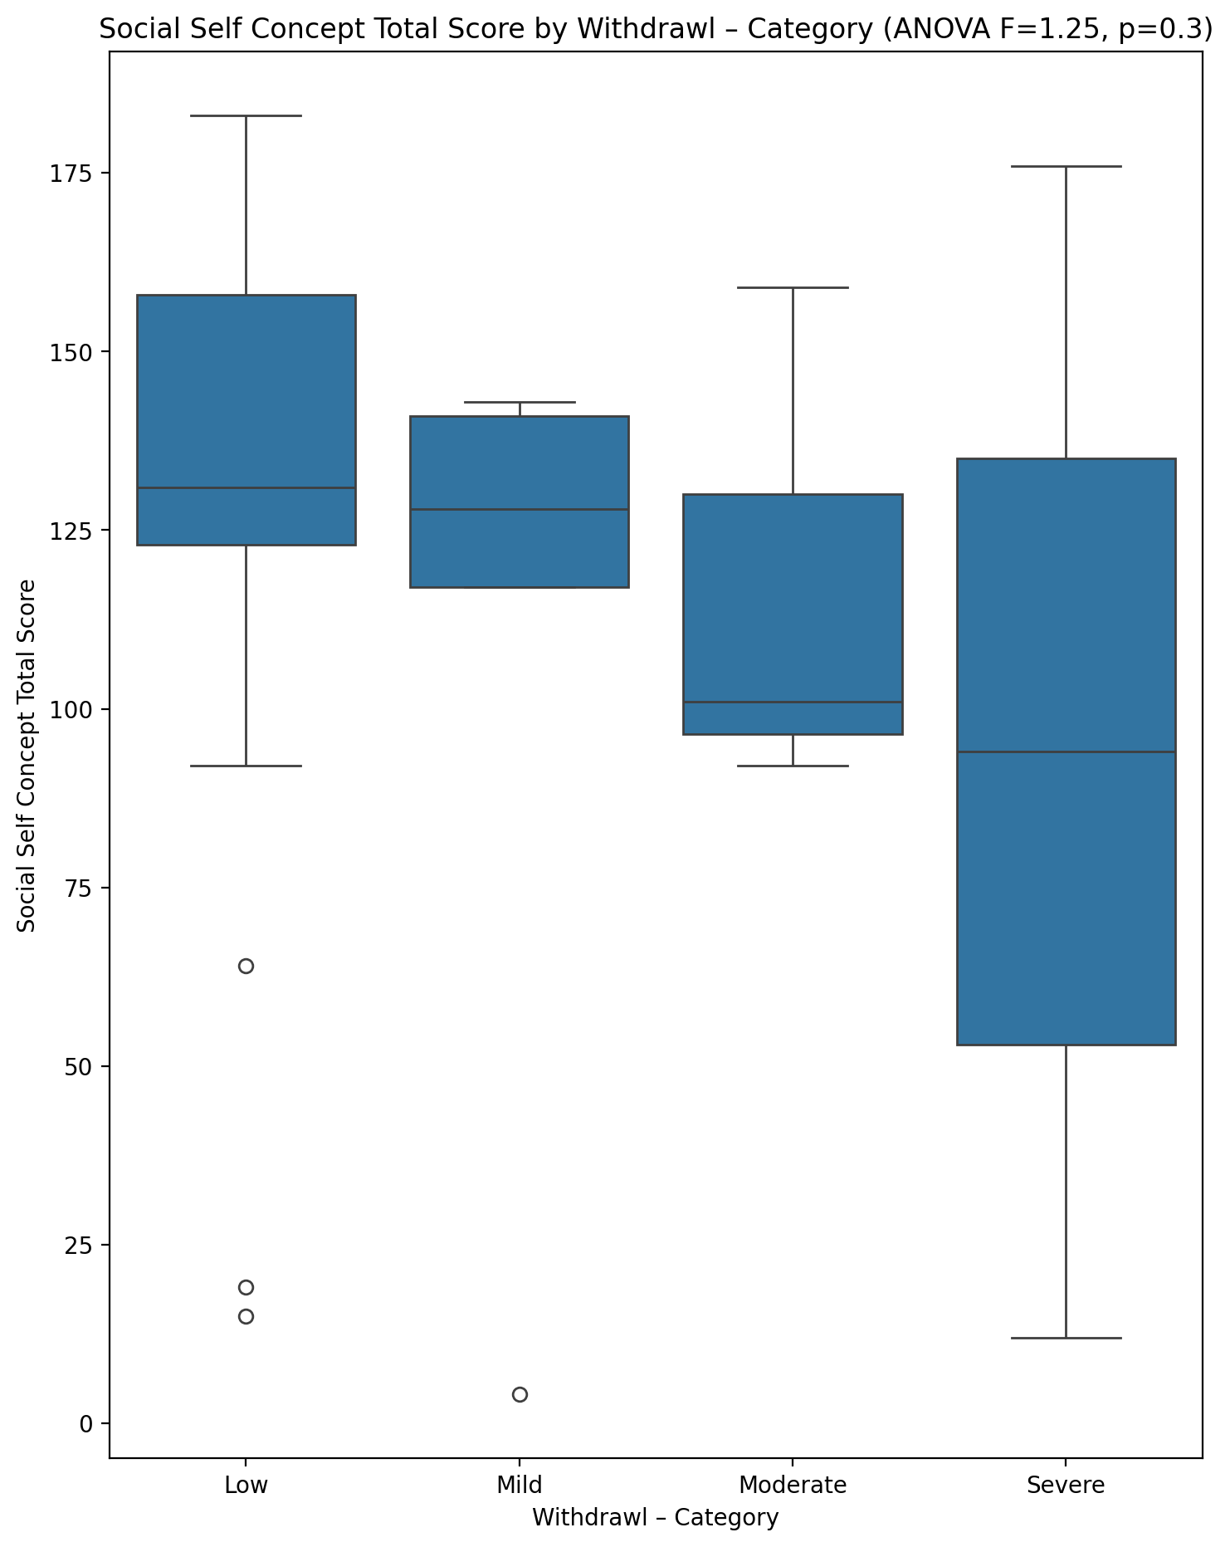

## Ideal Self Concept Total Category vs Withdrawl – Category

Test: chi2; statistic: 8.363993546136403; p-value: 0.21263035956722867;

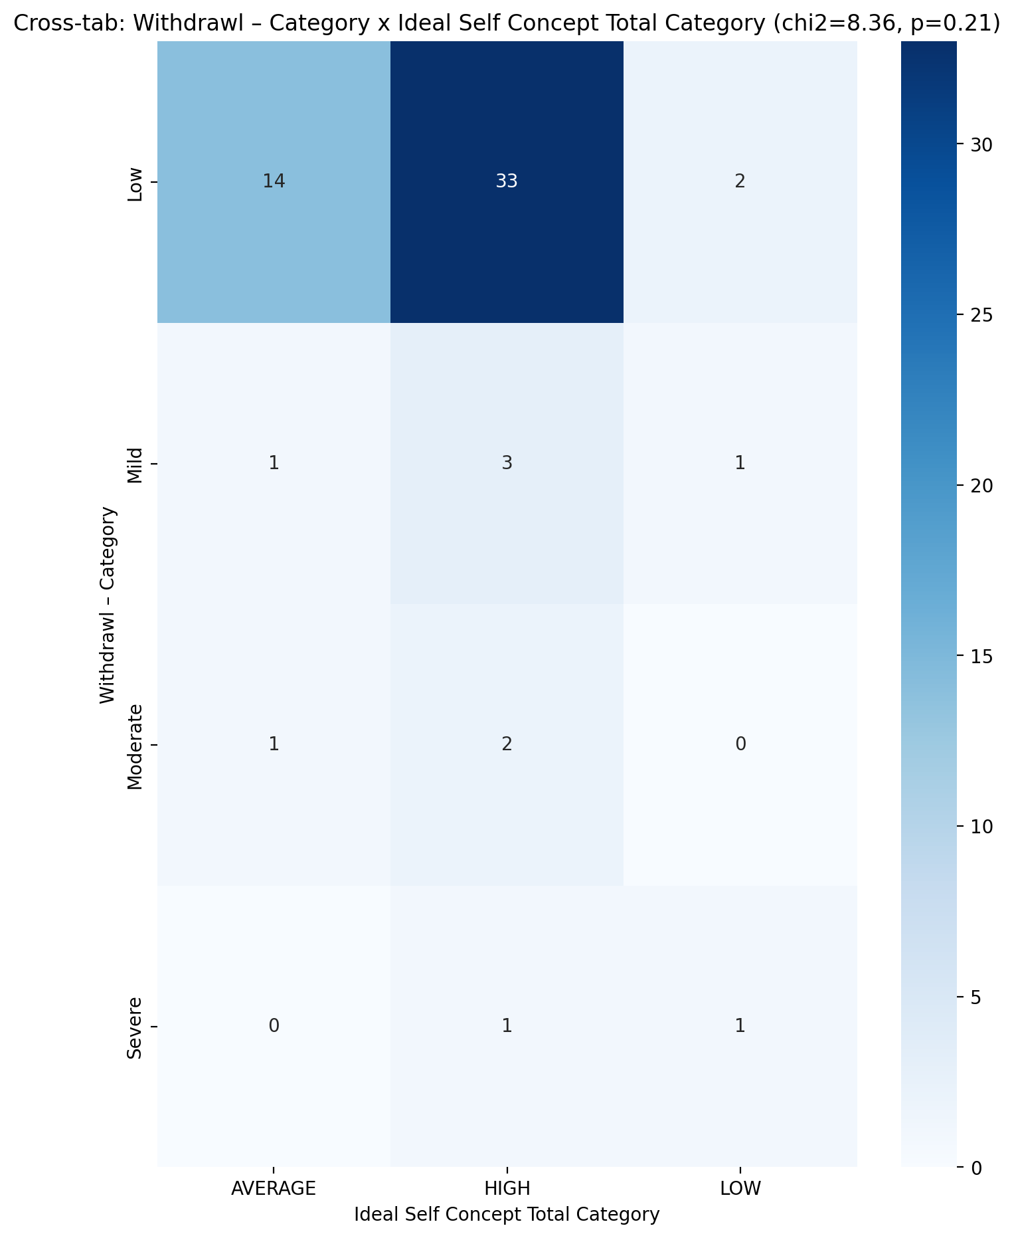

## Perceived Social Stress Score vs Withdrawl – Category

Test: anova; statistic: 0.2624075545903595; p-value: 0.8521712076299033;

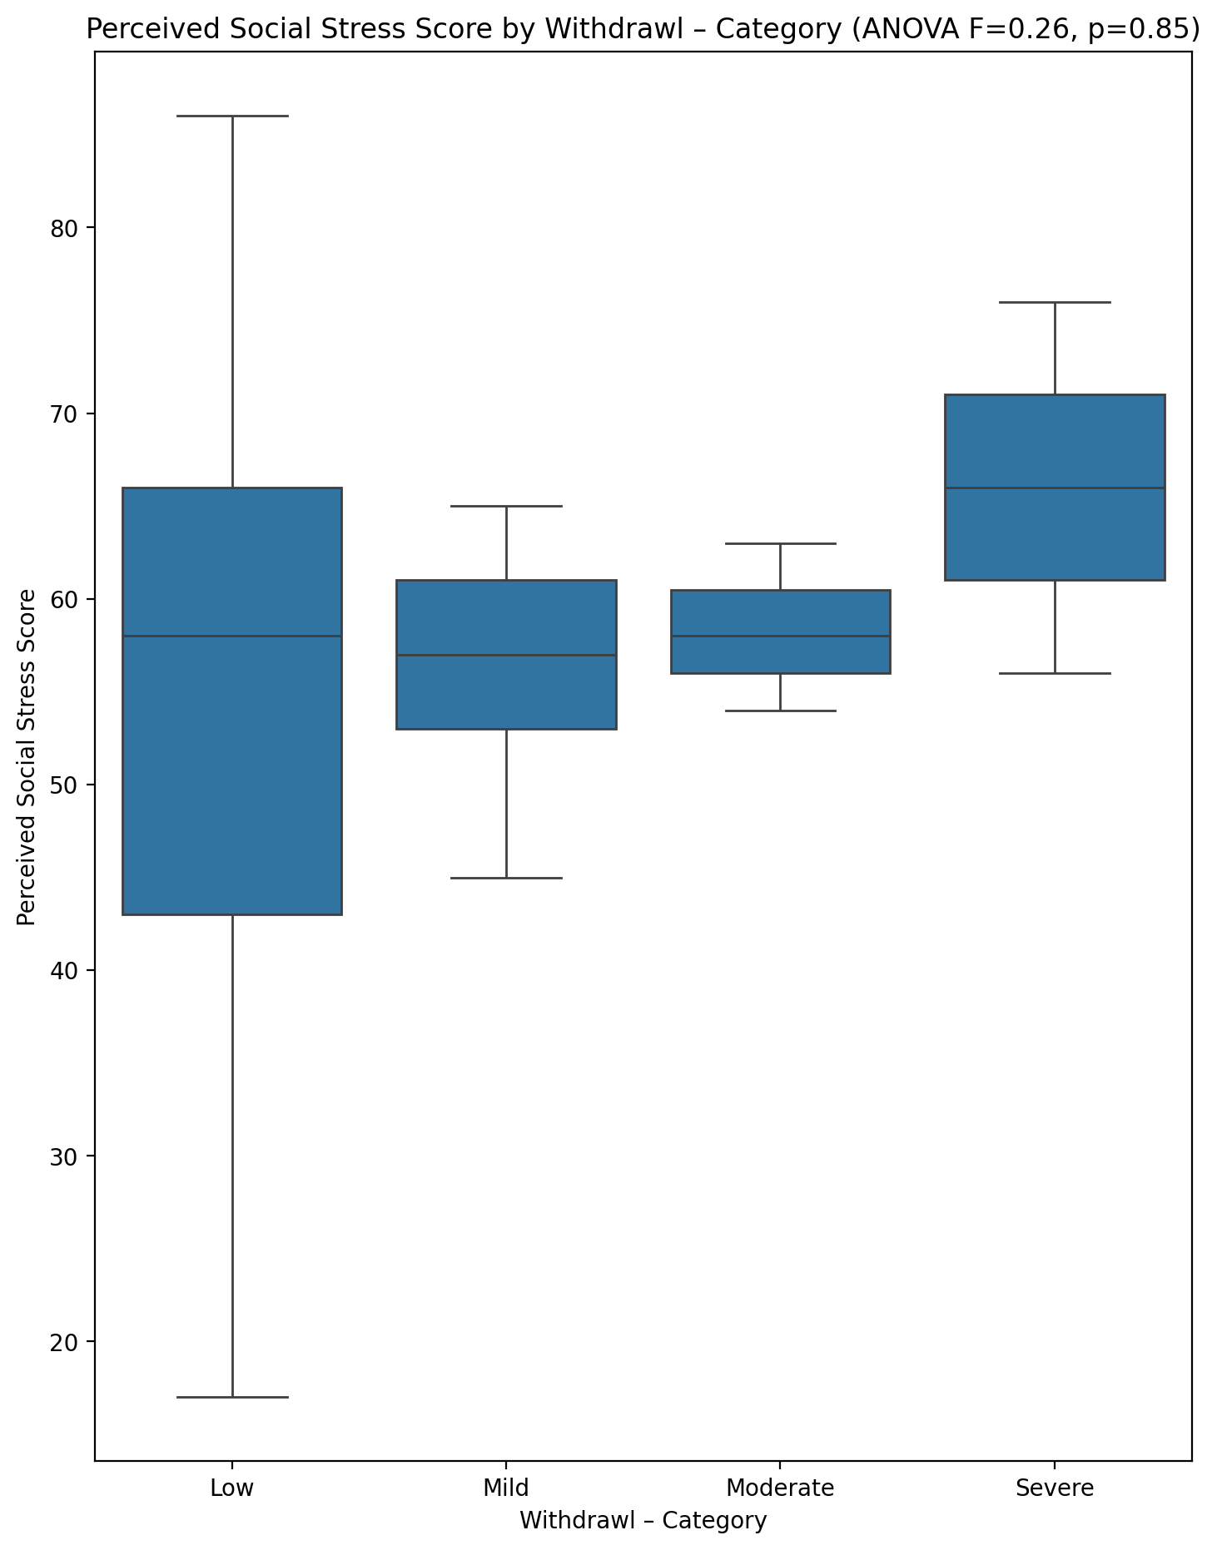

## Perceived Social Stress Category vs Withdrawl – Category

Test: chi2; statistic: 2.7593537414965983; p-value: 0.8383874554992352;

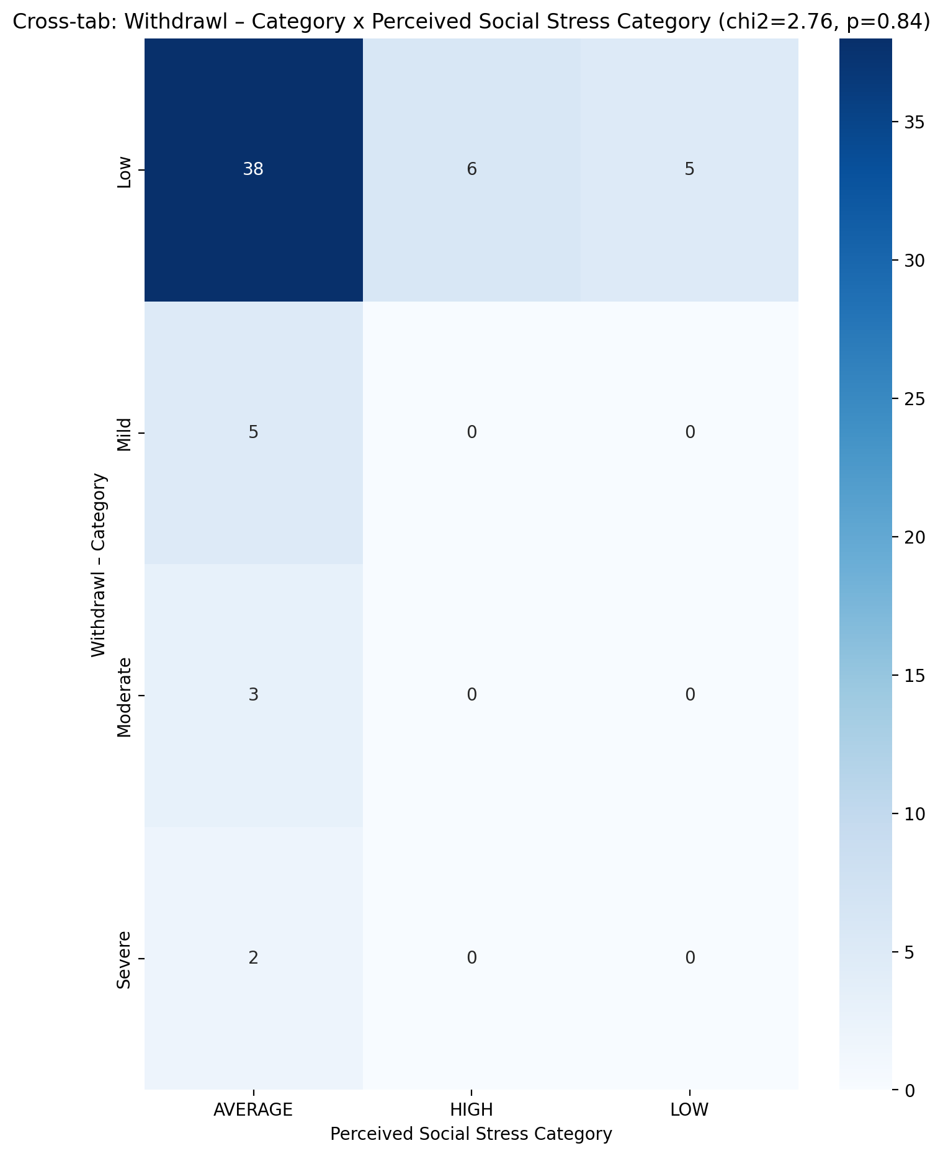

## Emotional Support - Raw Score vs Occupational & Relationship Consequences – Category

Test: anova; statistic: 0.7110185397014989; p-value: 0.5495789243234801;

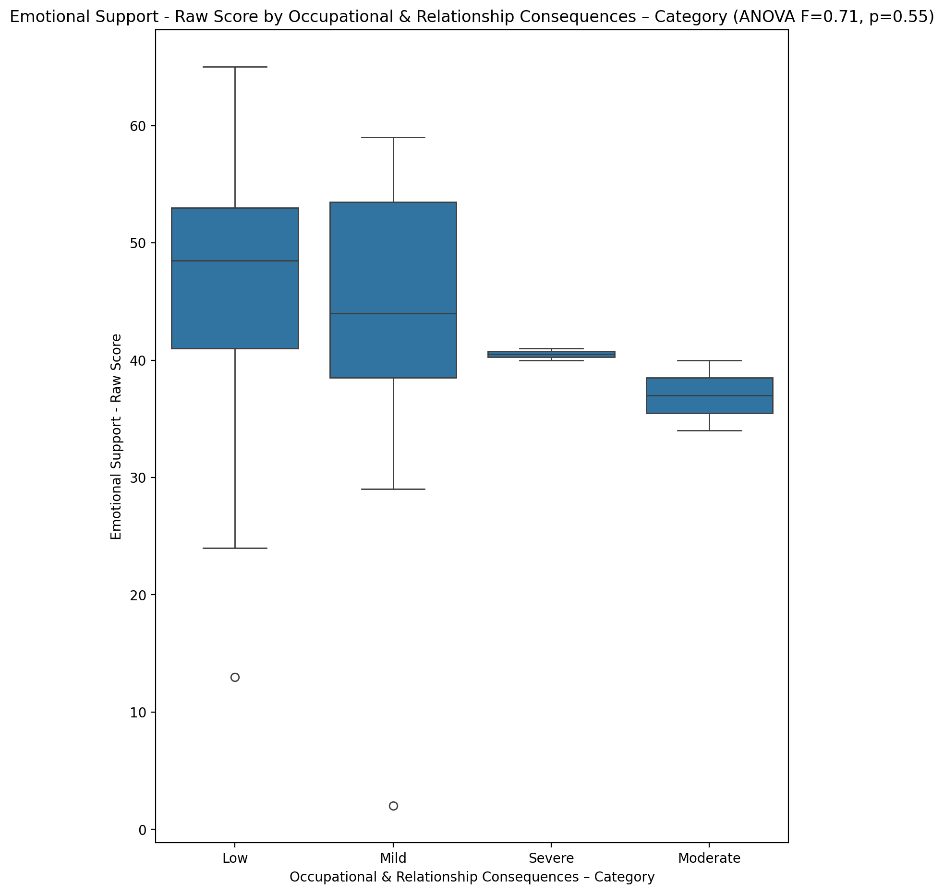

## Informational Support - Raw Score vs Occupational & Relationship Consequences – Category

Test: anova; statistic: 0.9472070373476764; p-value: 0.42423447539288084;

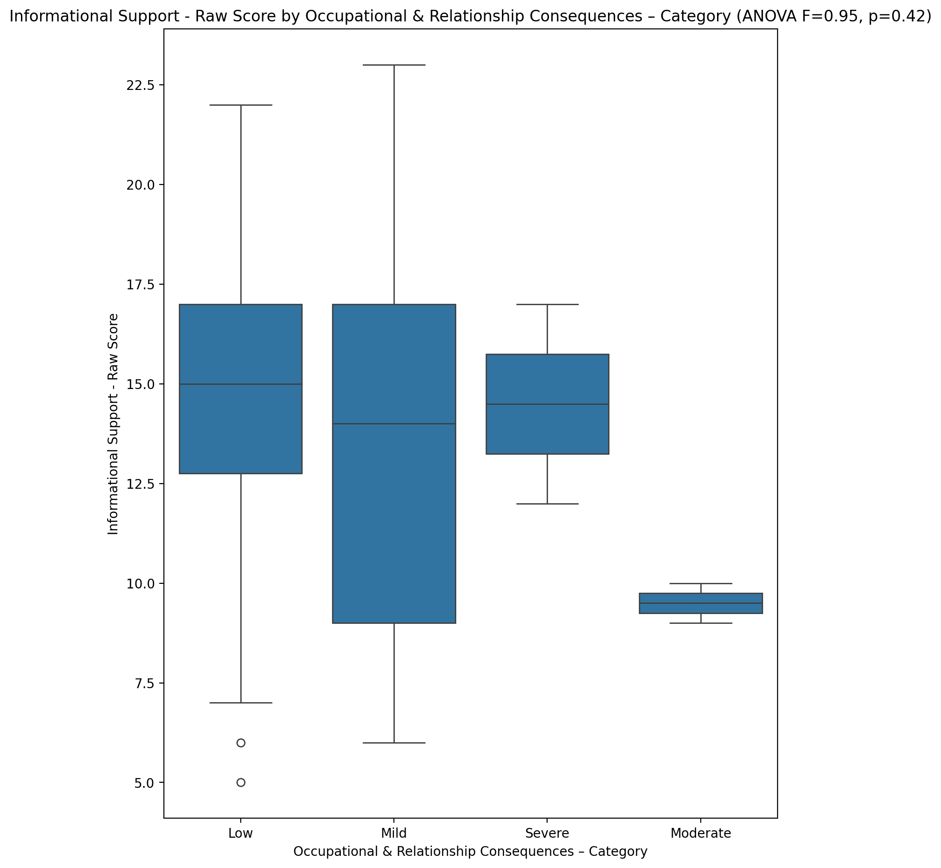

## Instrumental Support - Raw Score vs Occupational & Relationship Consequences – Category

Test: anova; statistic: 1.4288902883724384; p-value: 0.24420654316229212;

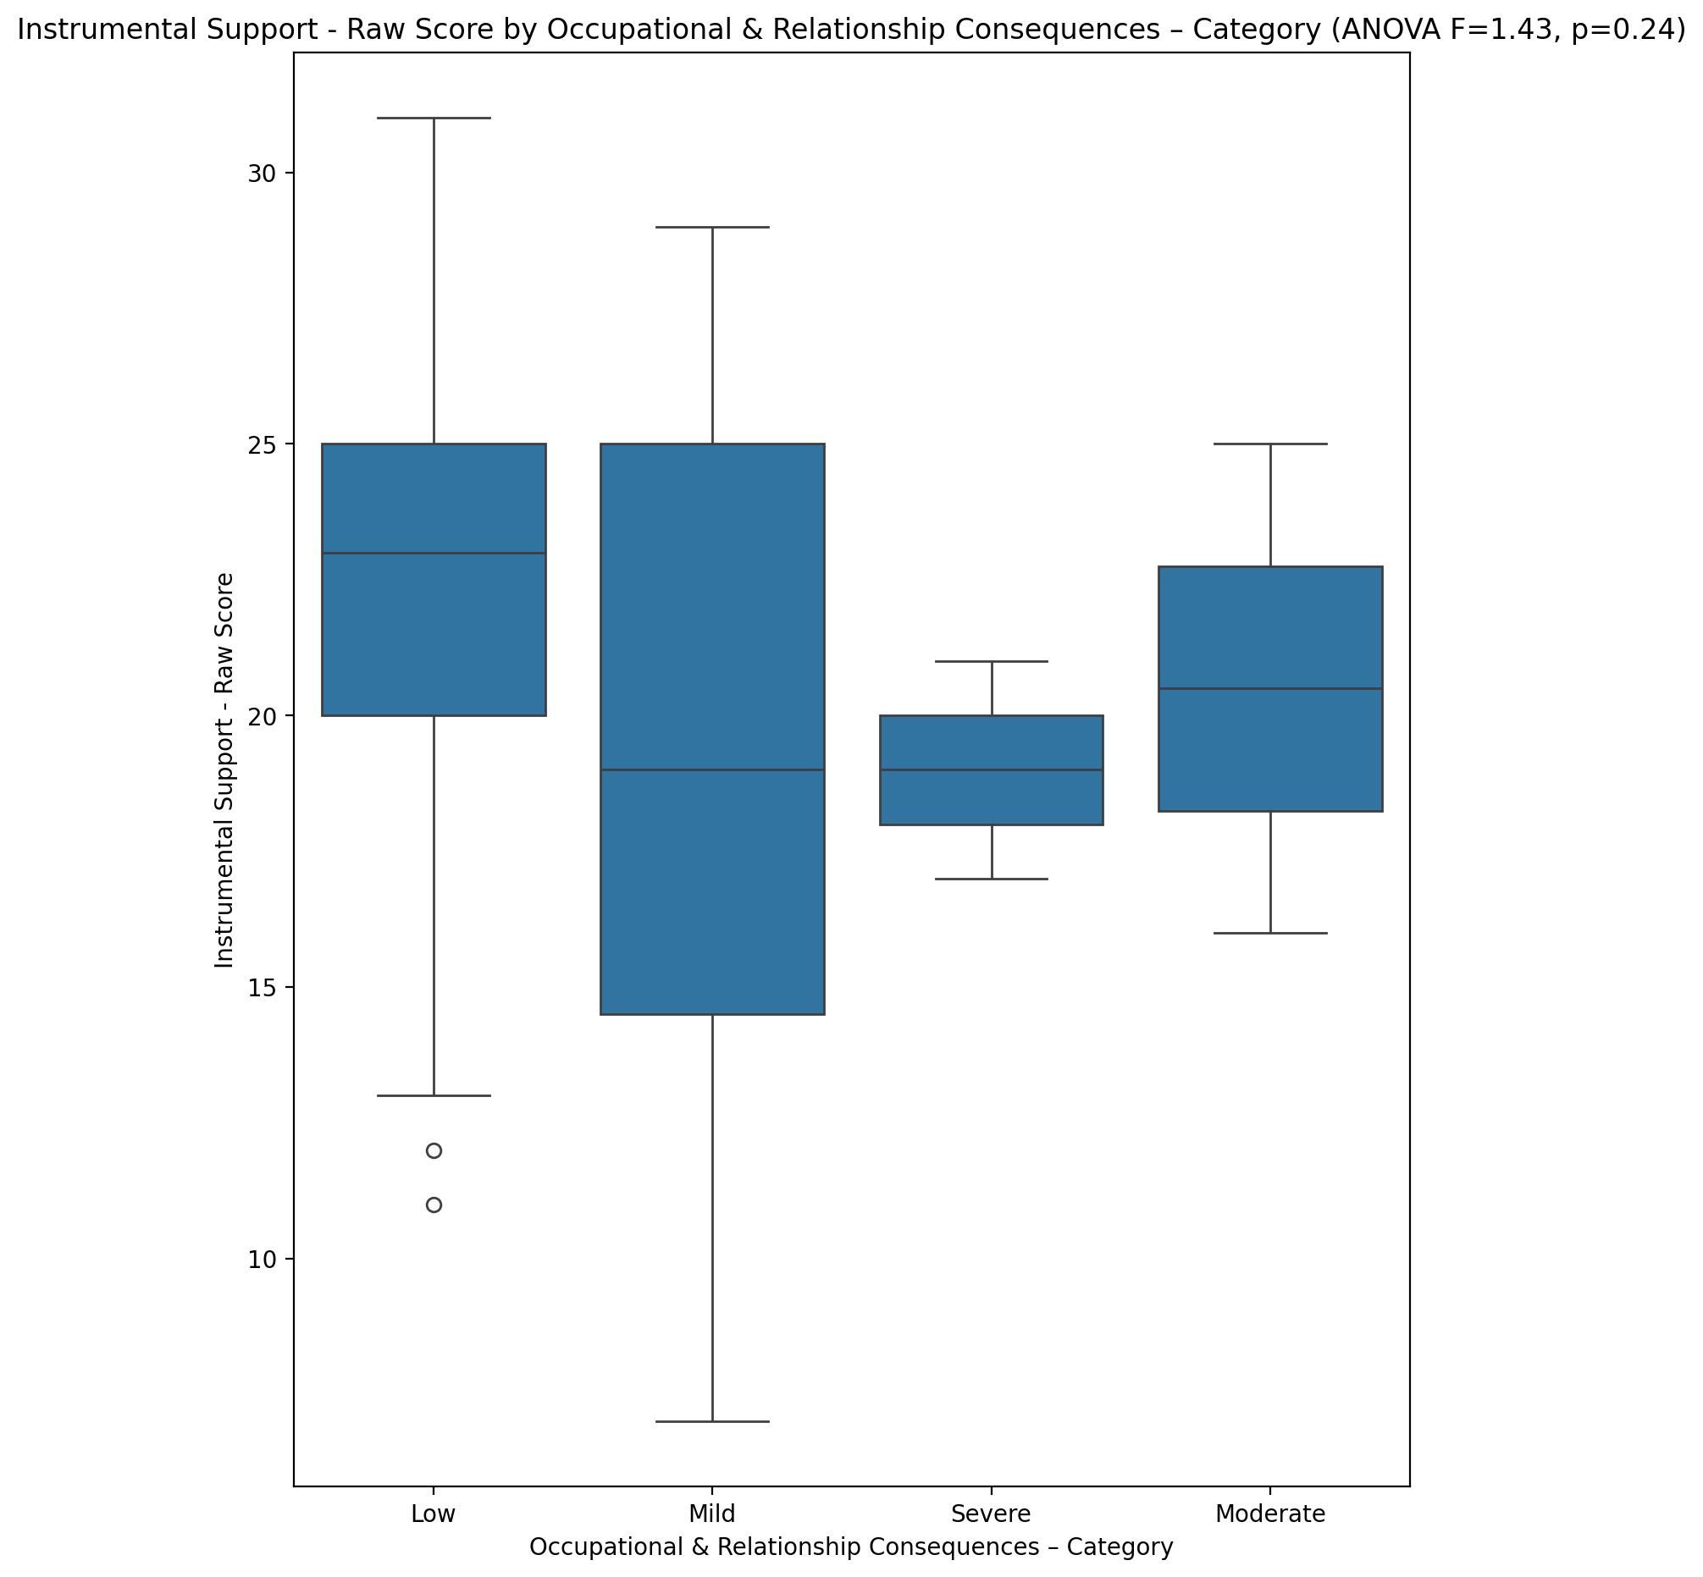

## Emotional Support - T Score vs Occupational & Relationship Consequences – Category

Test: anova; statistic: 0.2877600468047655; p-value: 0.8340348773730402;

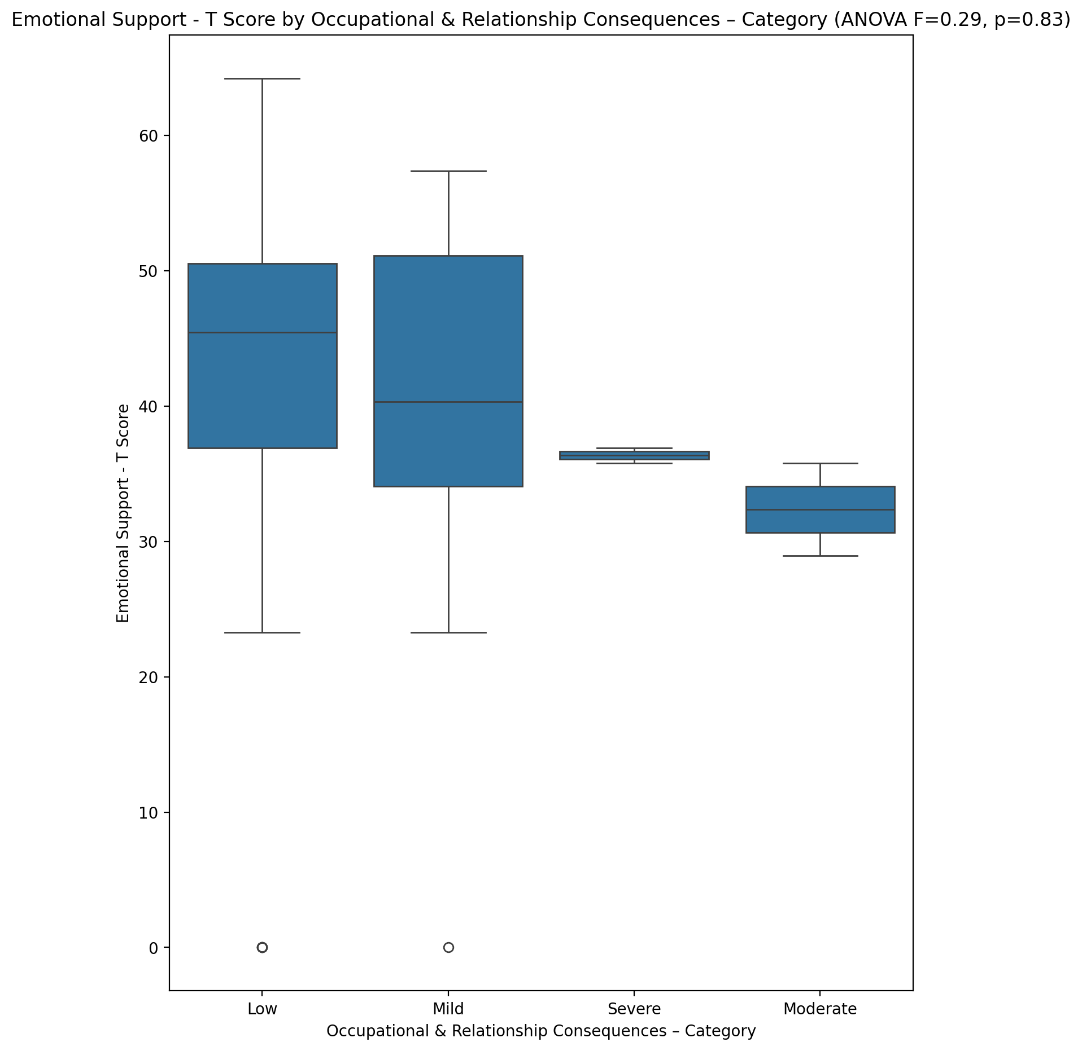

## Informational Support - T Score vs Occupational & Relationship Consequences – Category

Test: anova; statistic: 0.5533860569808151; p-value: 0.6480355427951028;

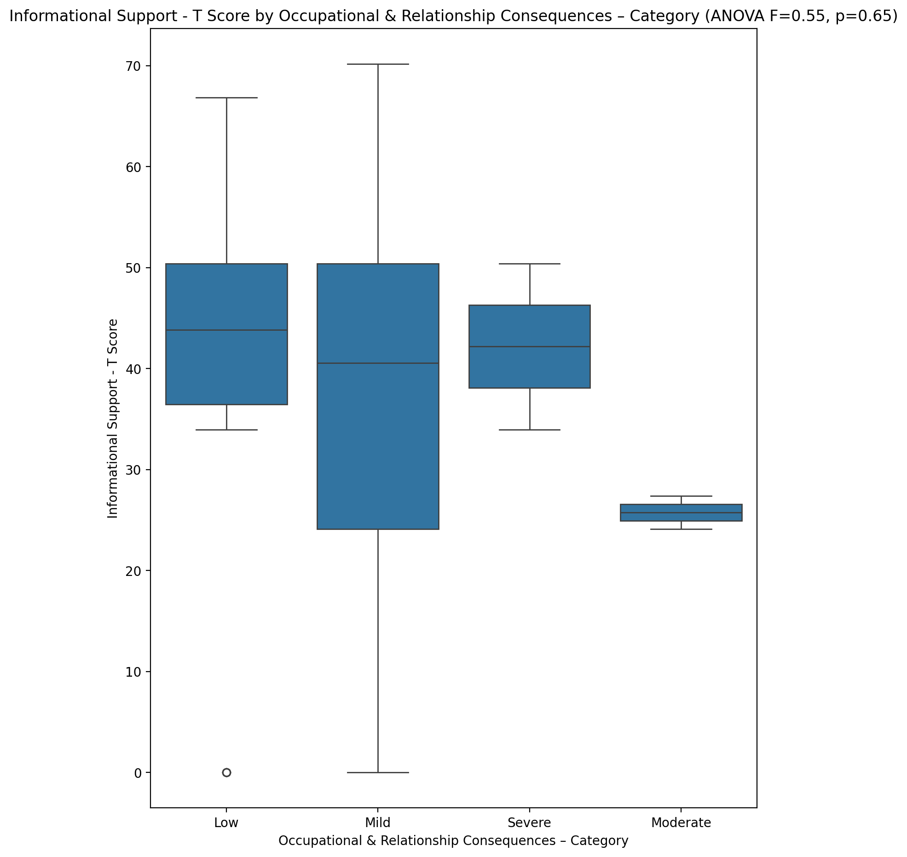

## Instrumental Support - T Score vs Occupational & Relationship Consequences – Category

Test: anova; statistic: 1.0242622320964963; p-value: 0.3890308780140388;

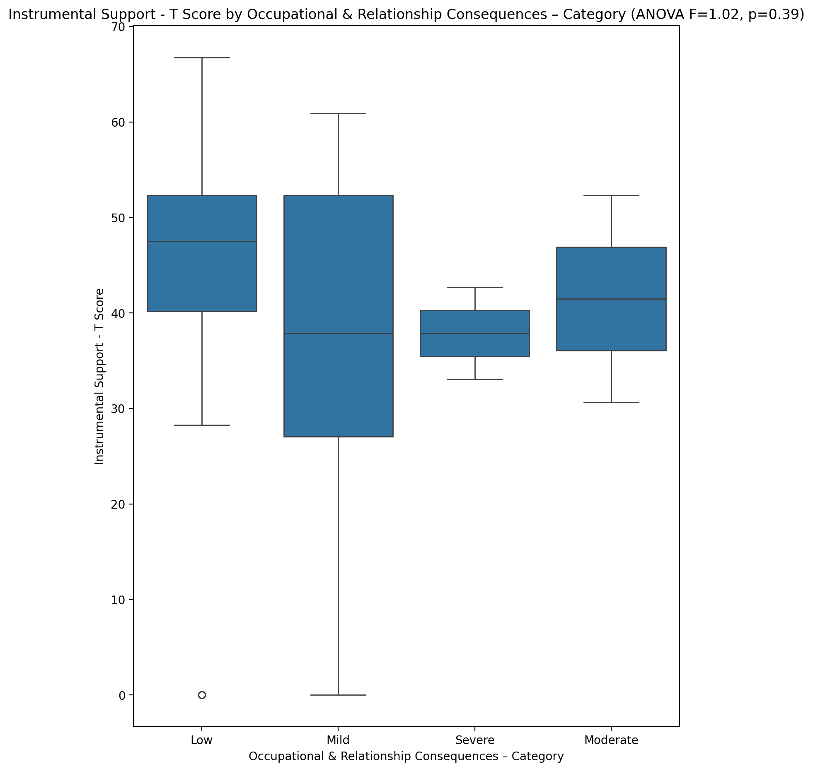

## Perceived Social Support Total T Score vs Occupational & Relationship Consequences – Category

Test: anova; statistic: 1.079852678039573; p-value: 0.3652767073272322;

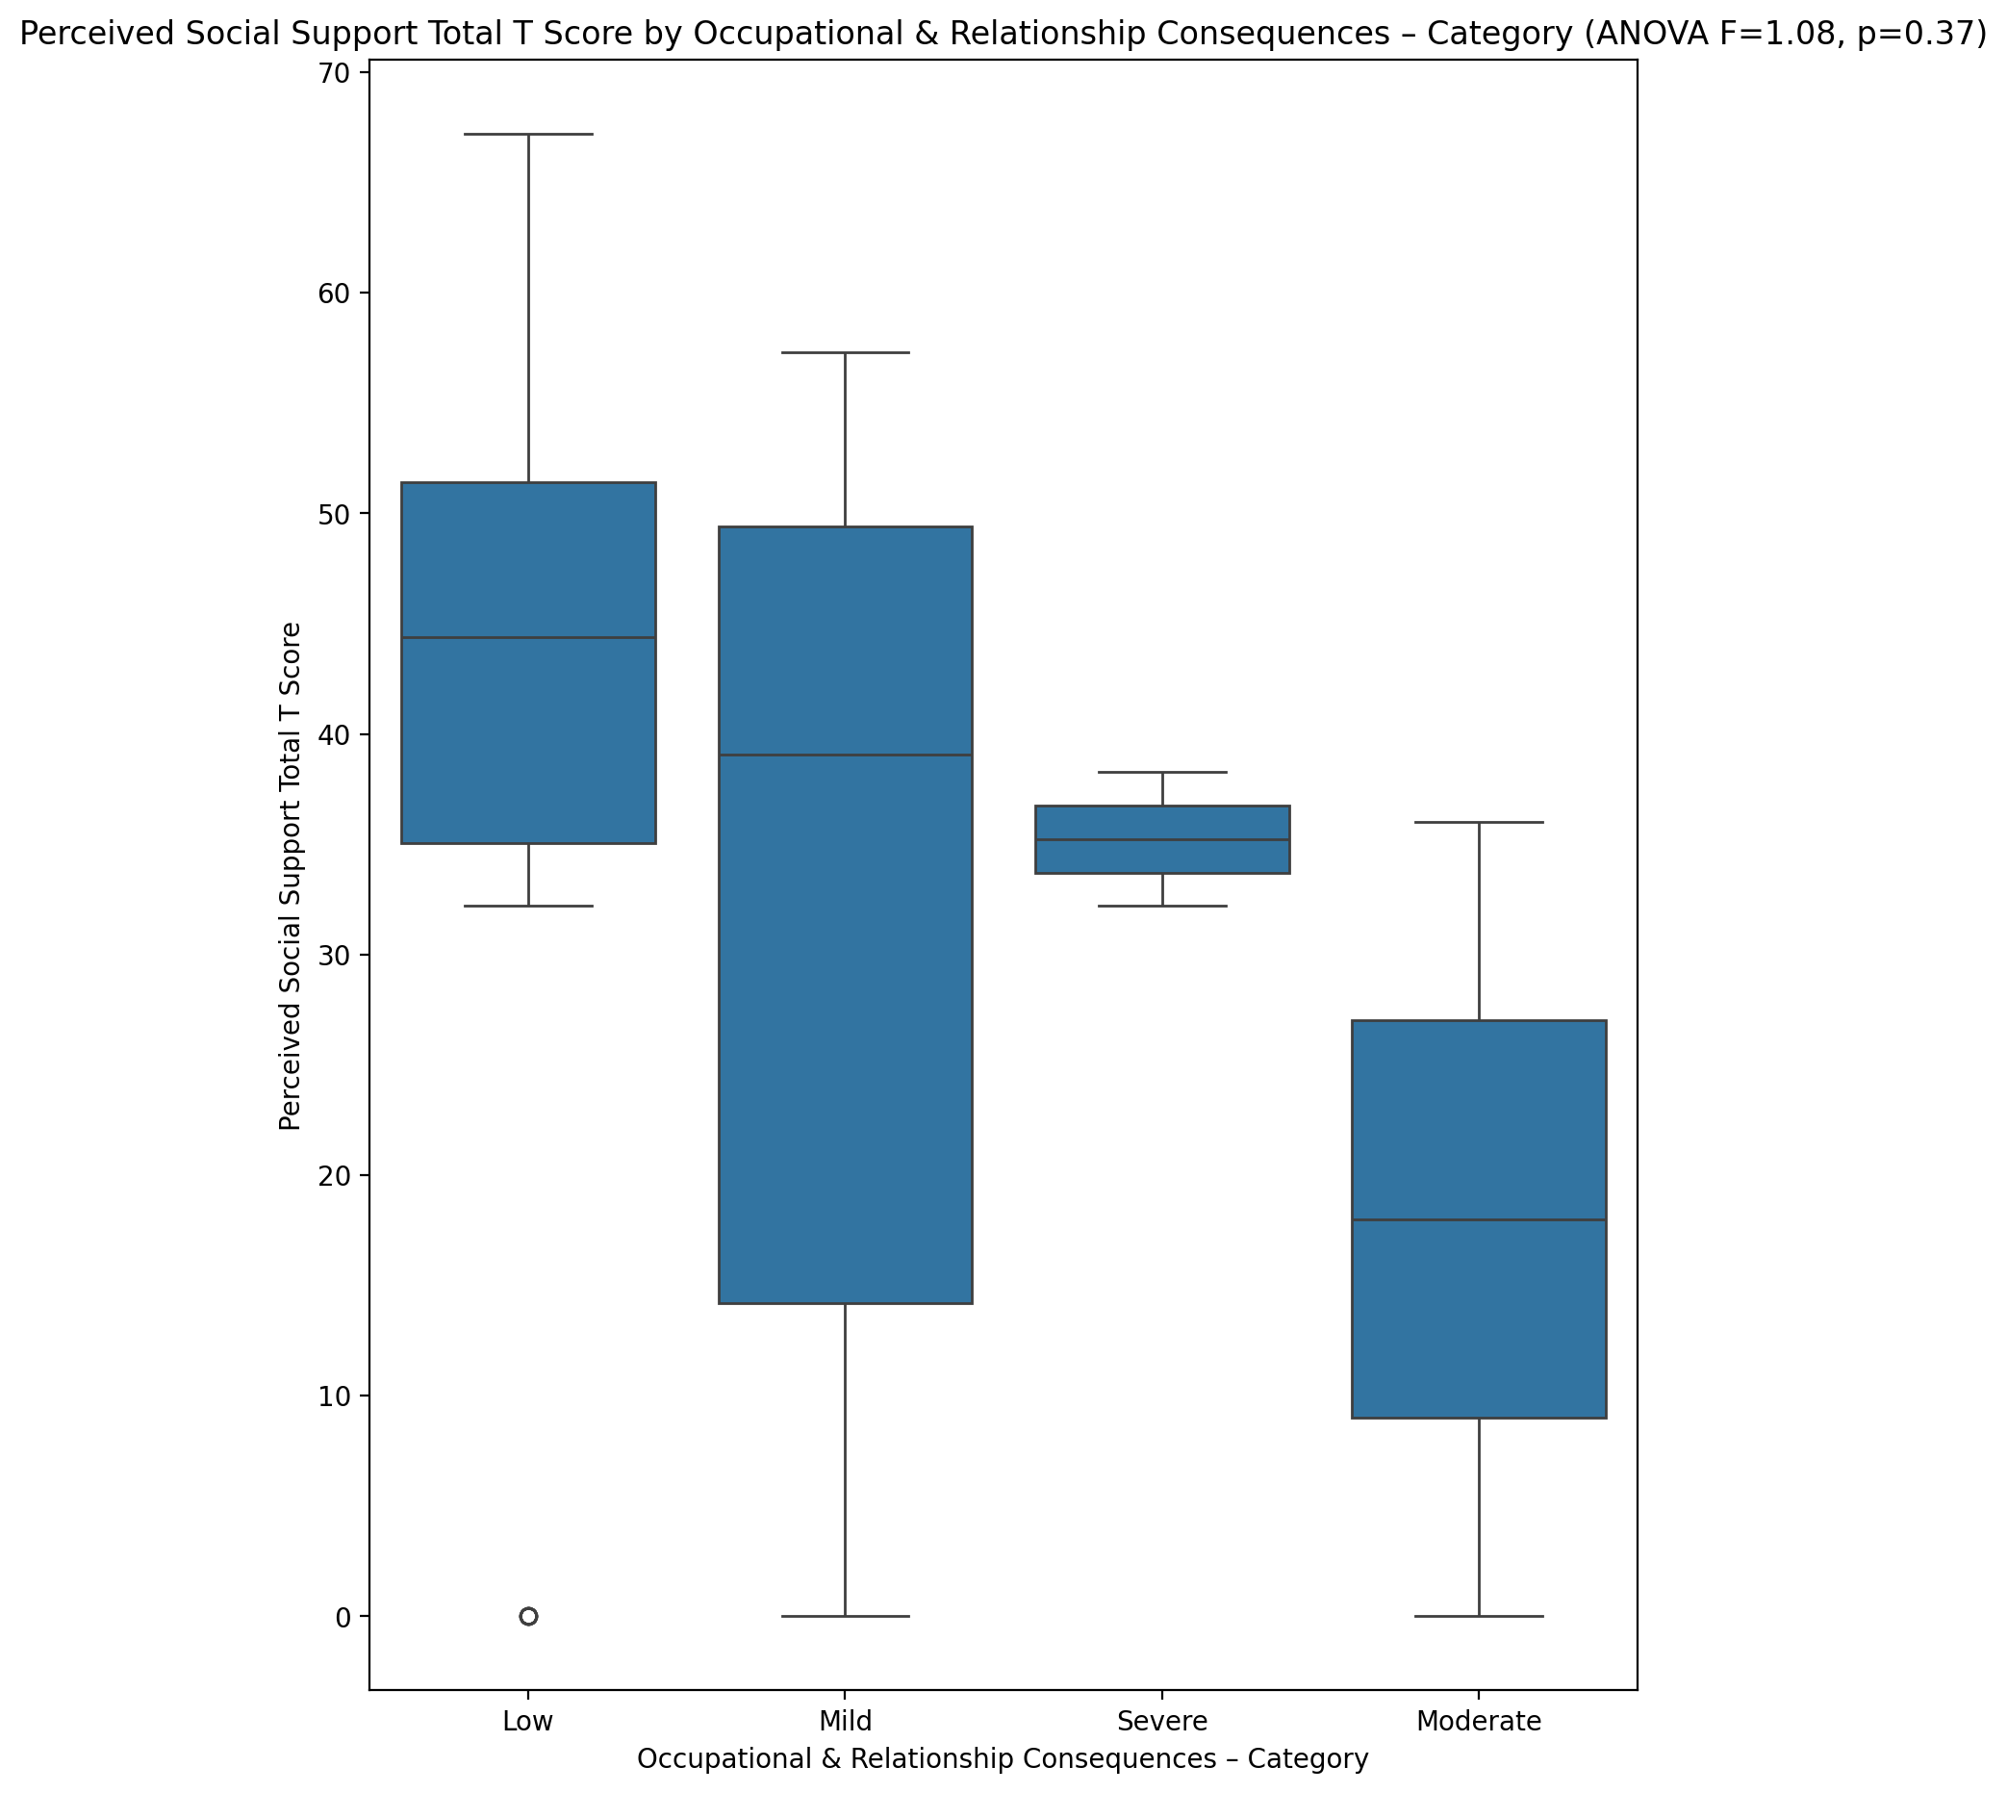

## Emotional Support - Rank vs Occupational & Relationship Consequences – Category

Test: chi2; statistic: 9.184588744588744; p-value: 0.4204125955754974;

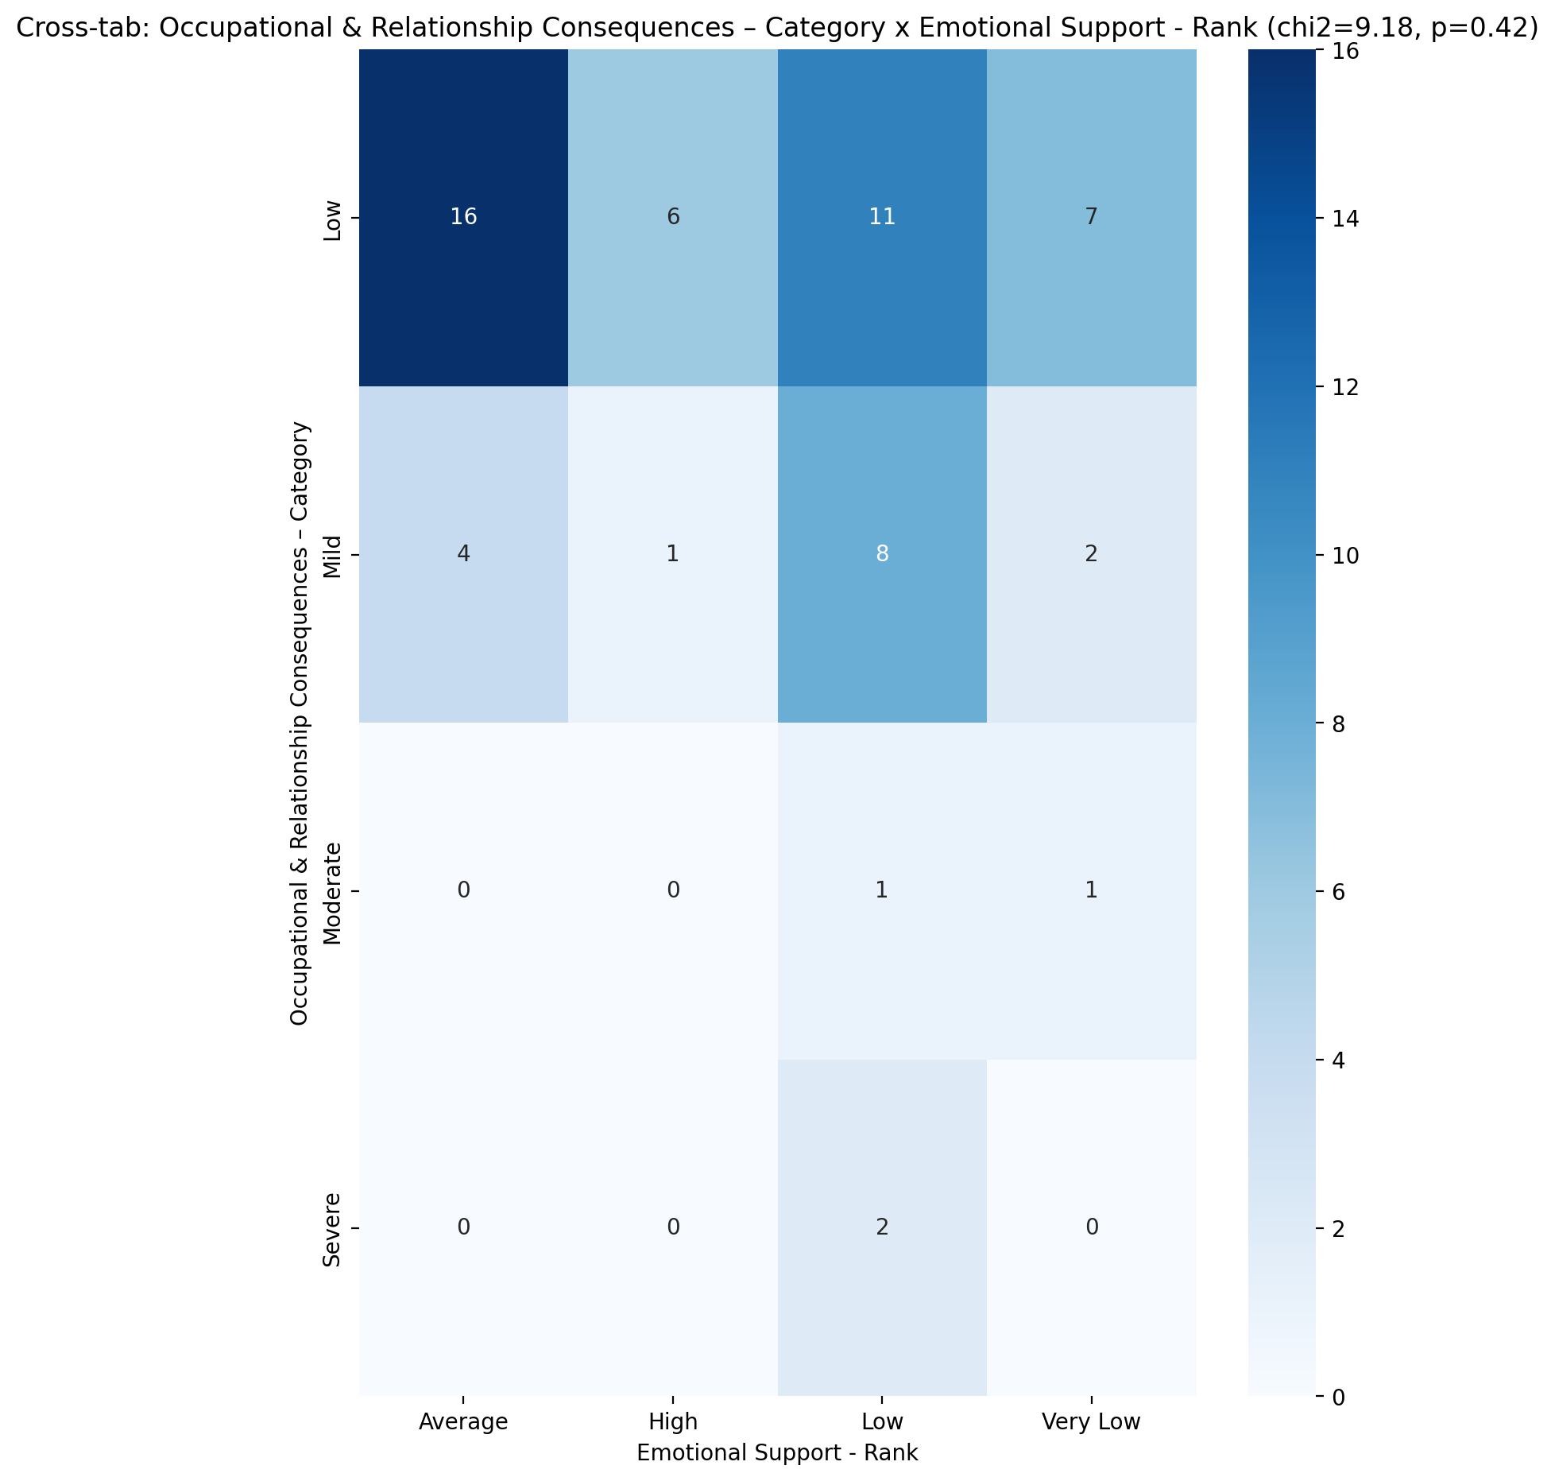

## Informational Support - Rank vs Occupational & Relationship Consequences – Category

Test: chi2; statistic: 21.2115350877193; p-value: 0.0473673429720847;

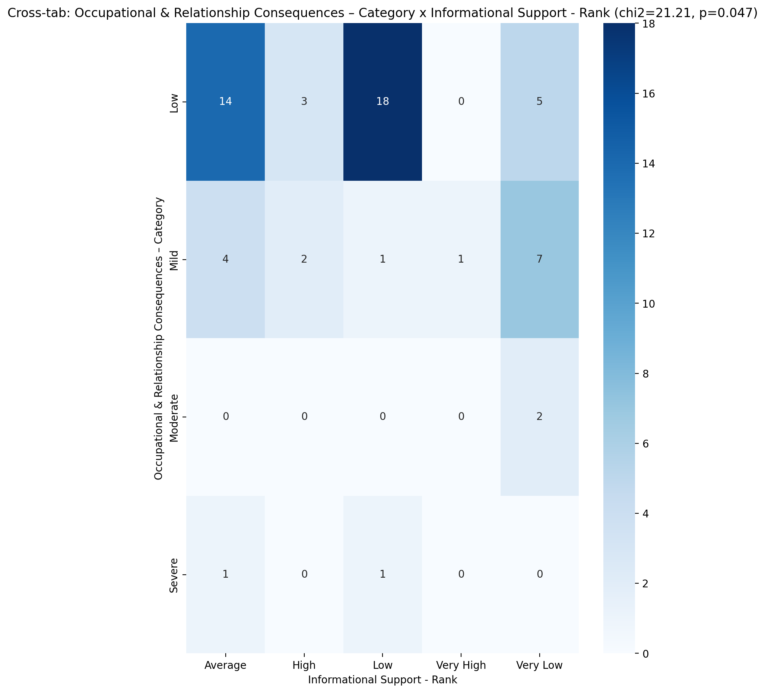

## Instrumental Support - Rank vs Occupational & Relationship Consequences – Category

Test: chi2; statistic: 14.550992063492064; p-value: 0.10403104709221098;

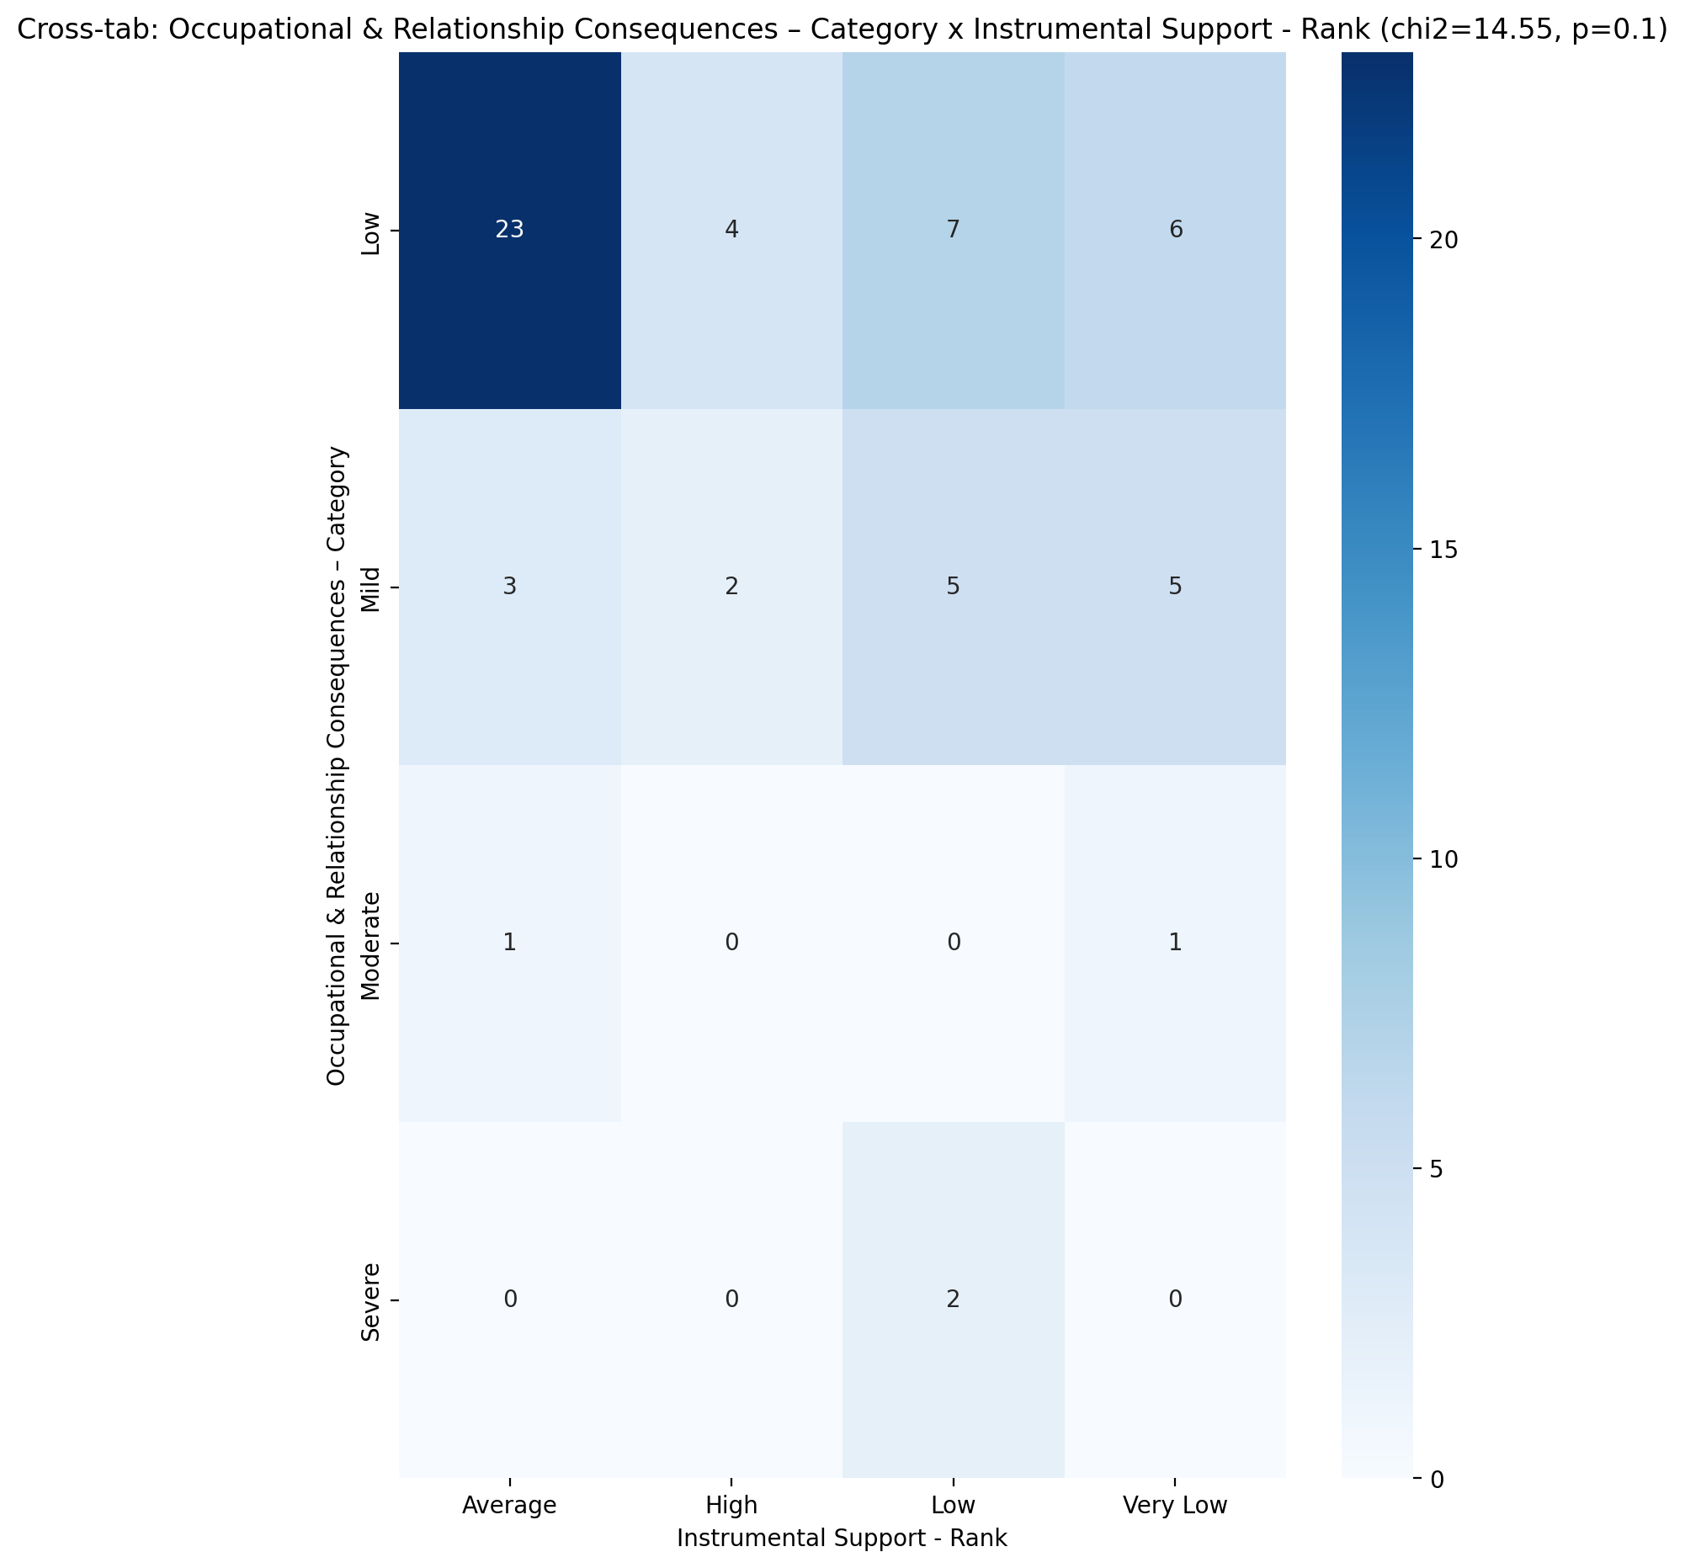

## Perceived Social Support TOTAL - Rank vs Occupational & Relationship Consequences – Category

Test: chi2; statistic: 9.994070512820514; p-value: 0.35096545256910916;

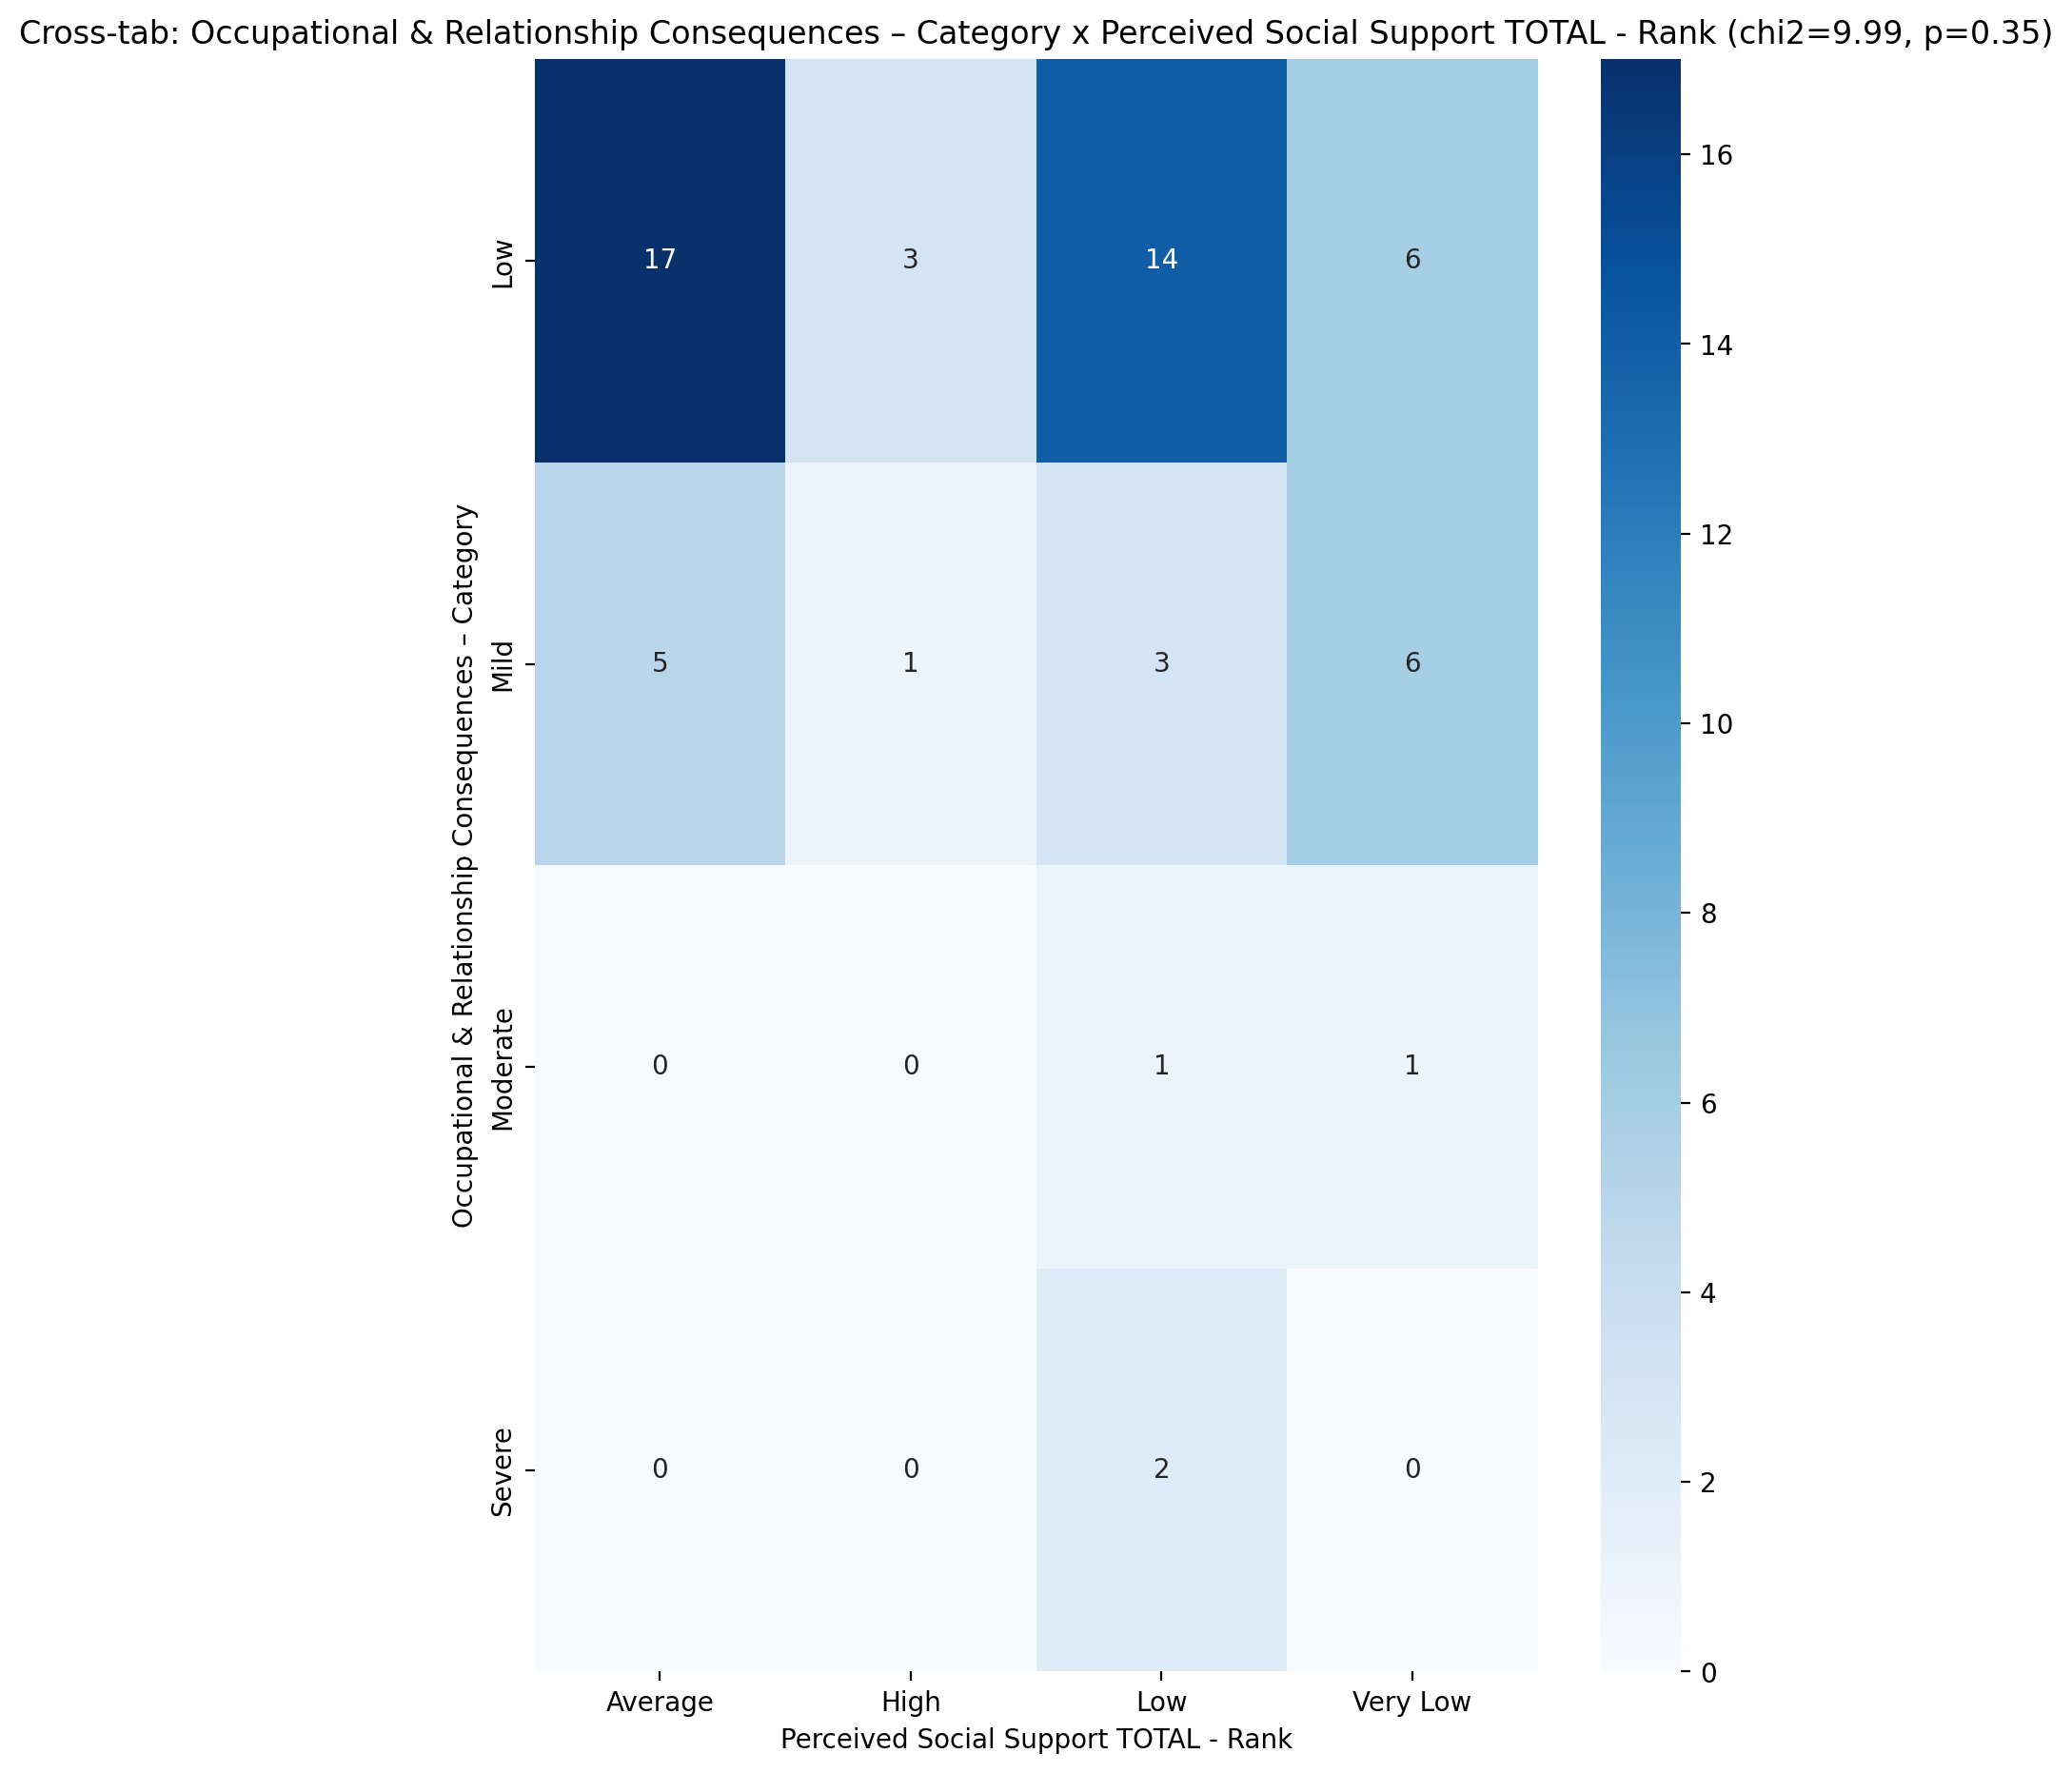

## Power Self Concept - Real Self Concept Score vs Occupational & Relationship Consequences – Category

Test: anova; statistic: 3.807080554512234; p-value: 0.01496746898717294;

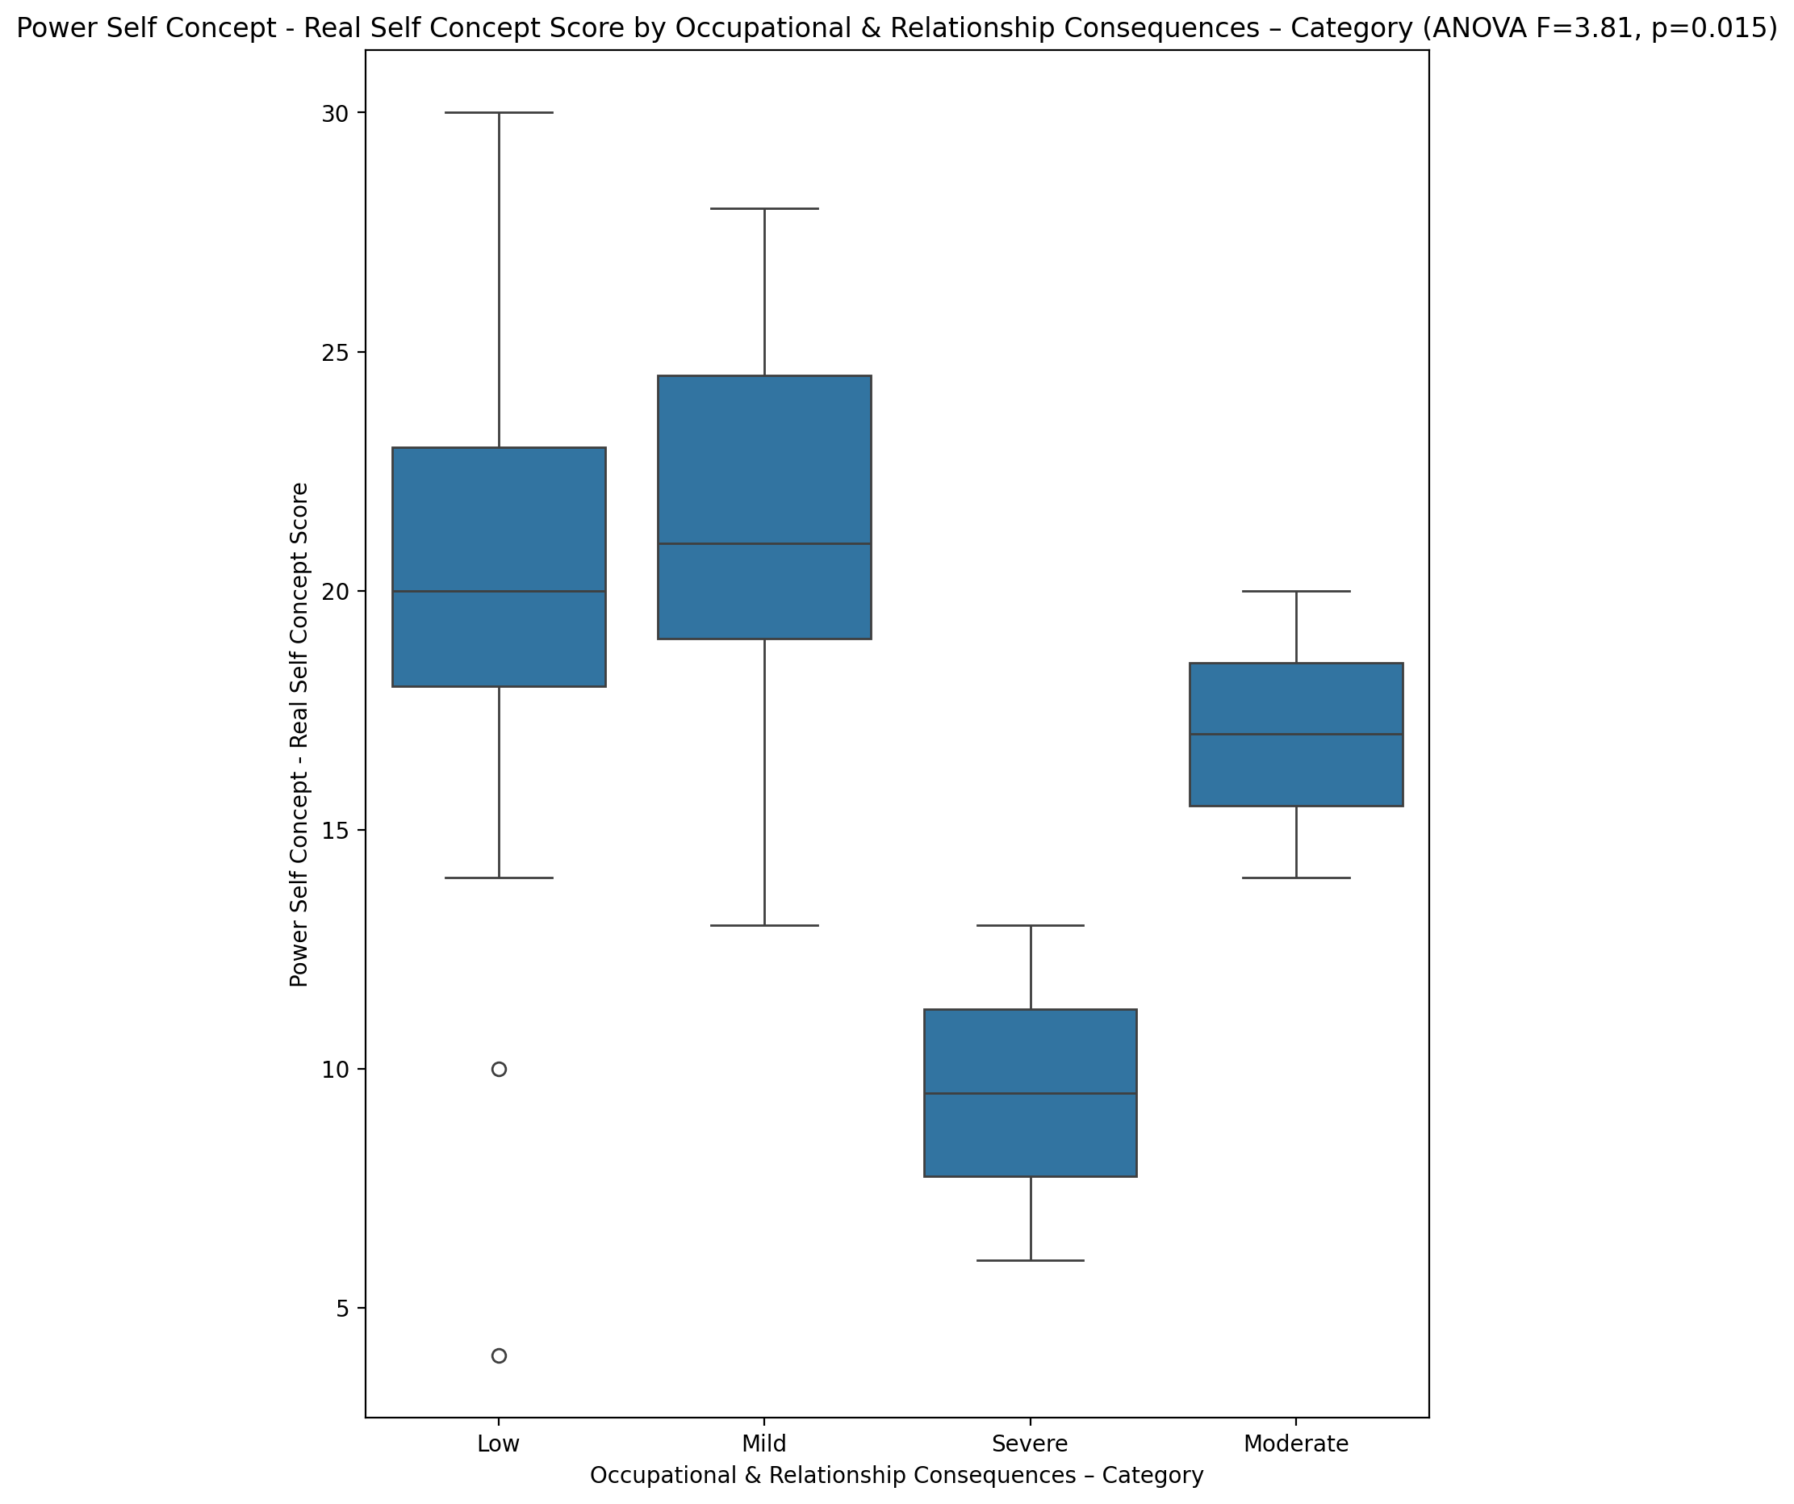

## Power Self Concept - Ideal Self Concept score vs Occupational & Relationship Consequences – Category

Test: anova; statistic: 9.762573006527822; p-value: 2.9077780175385683e-05;

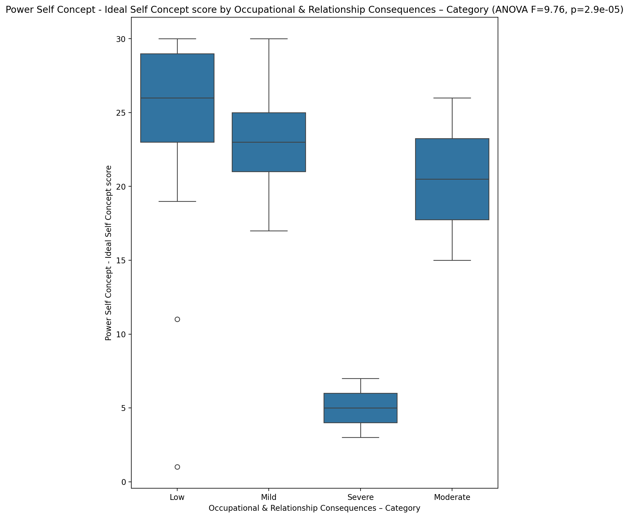

## Power Self Concept – Social Self Concept Score vs Occupational & Relationship Consequences – Category

Test: anova; statistic: 6.025899391315505; p-value: 0.001265109598082203;

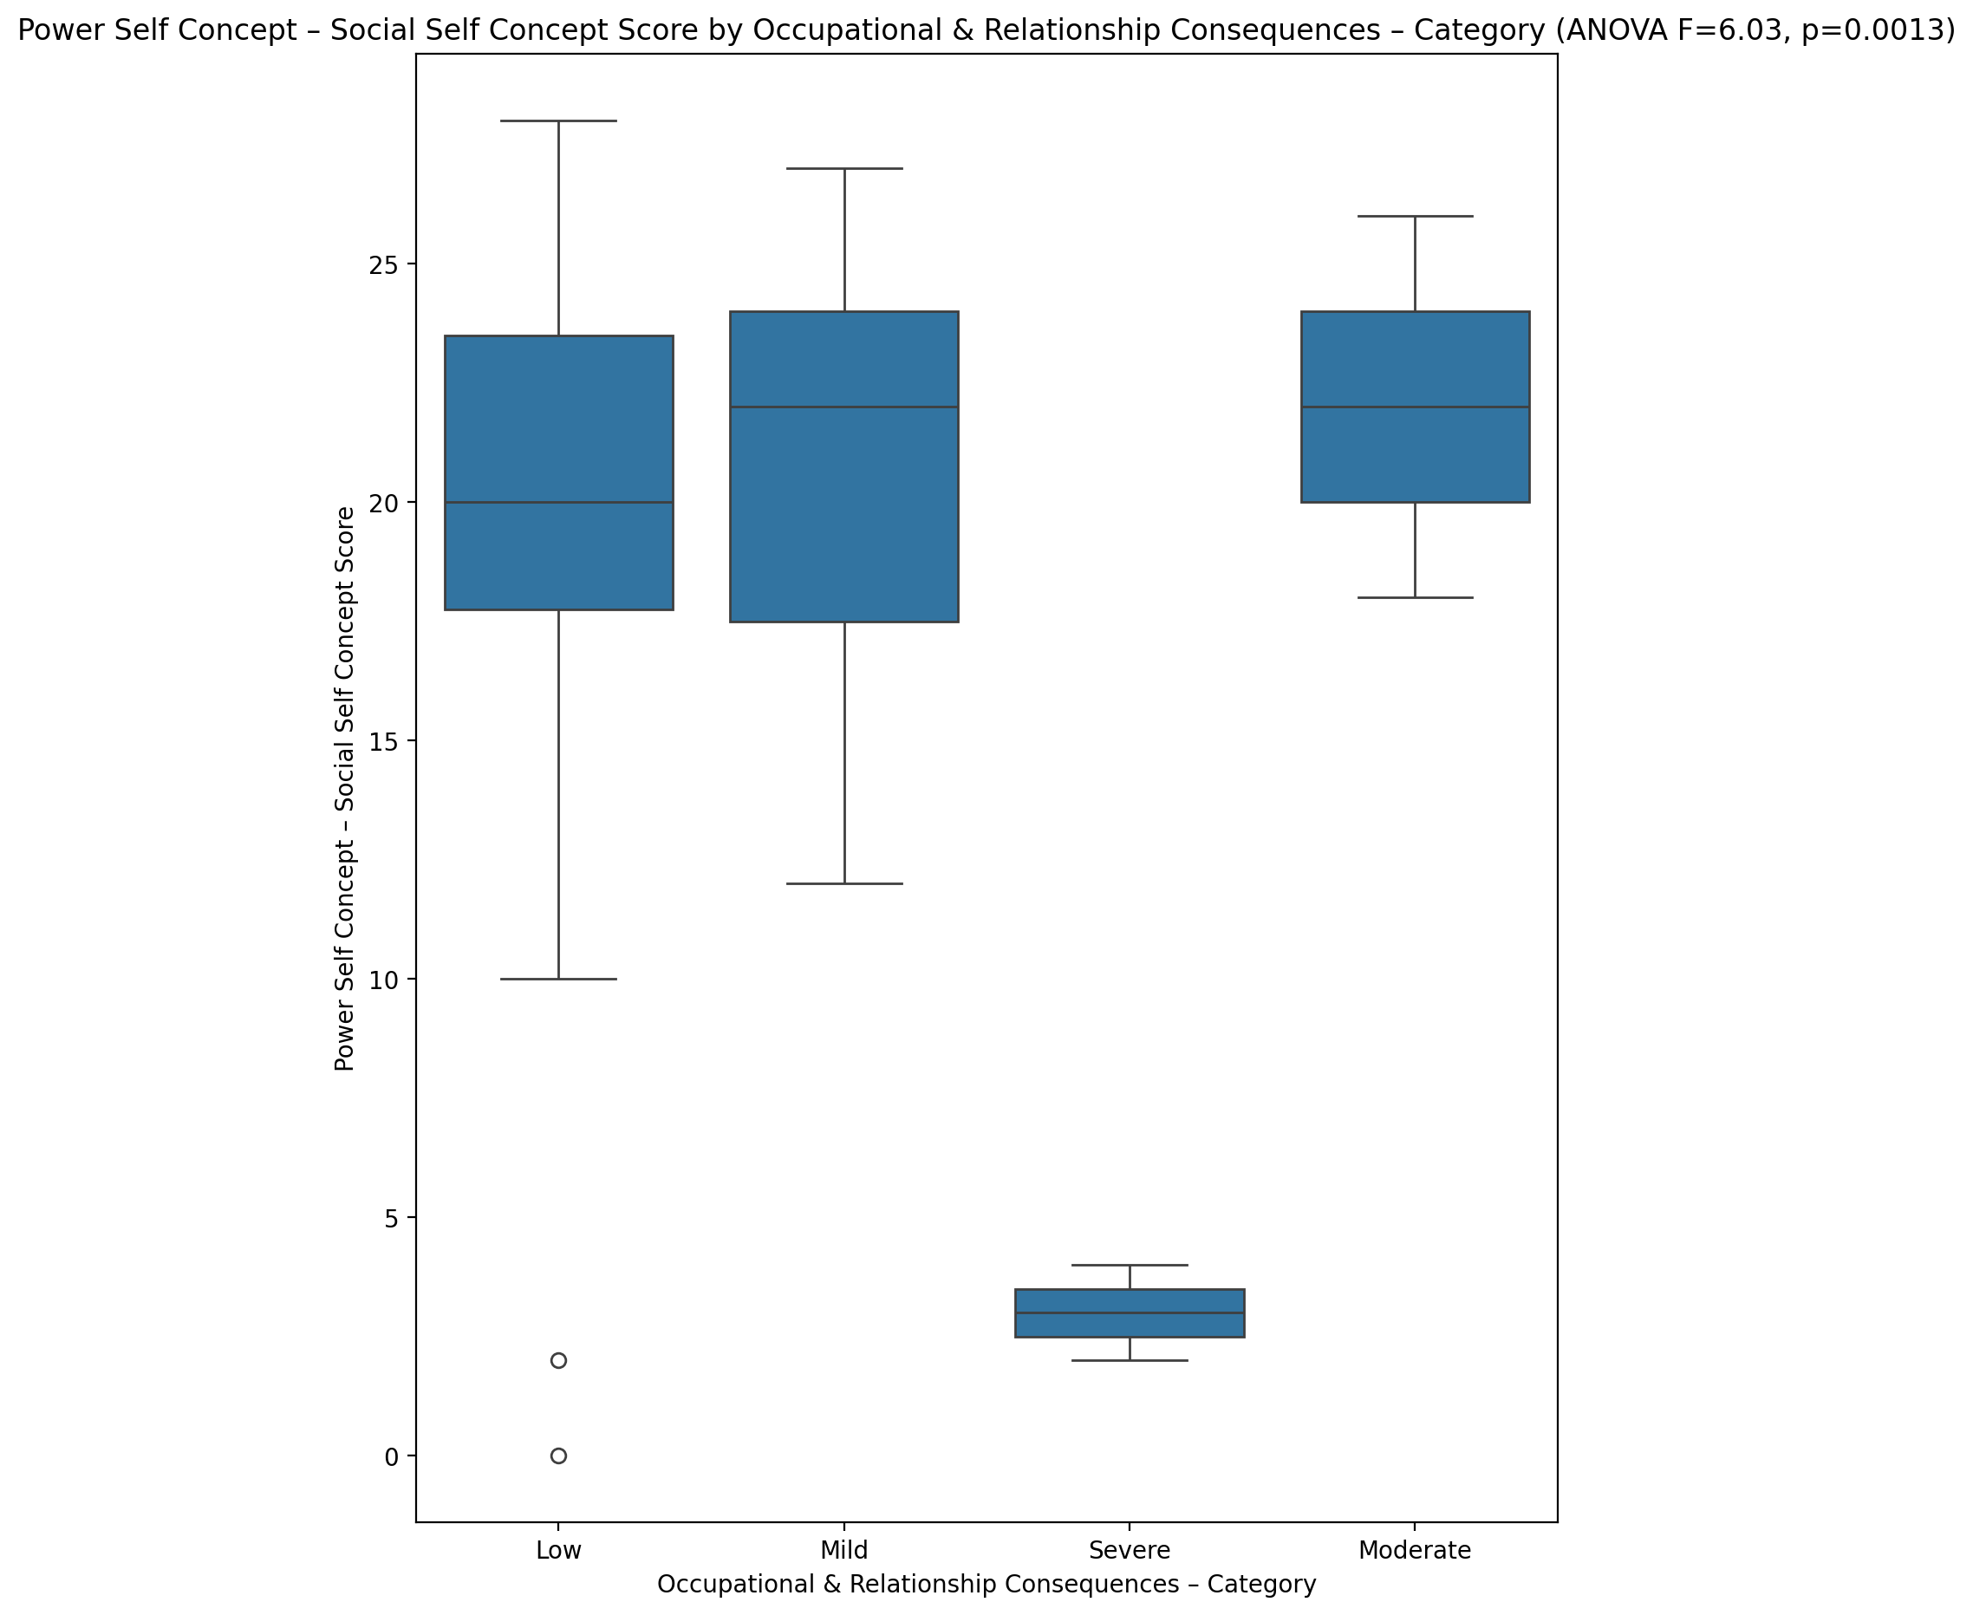

## Social Self Concept - Real Self Concept Score vs Occupational & Relationship Consequences – Category

Test: anova; statistic: 2.955579782716174; p-value: 0.04031356867037154;

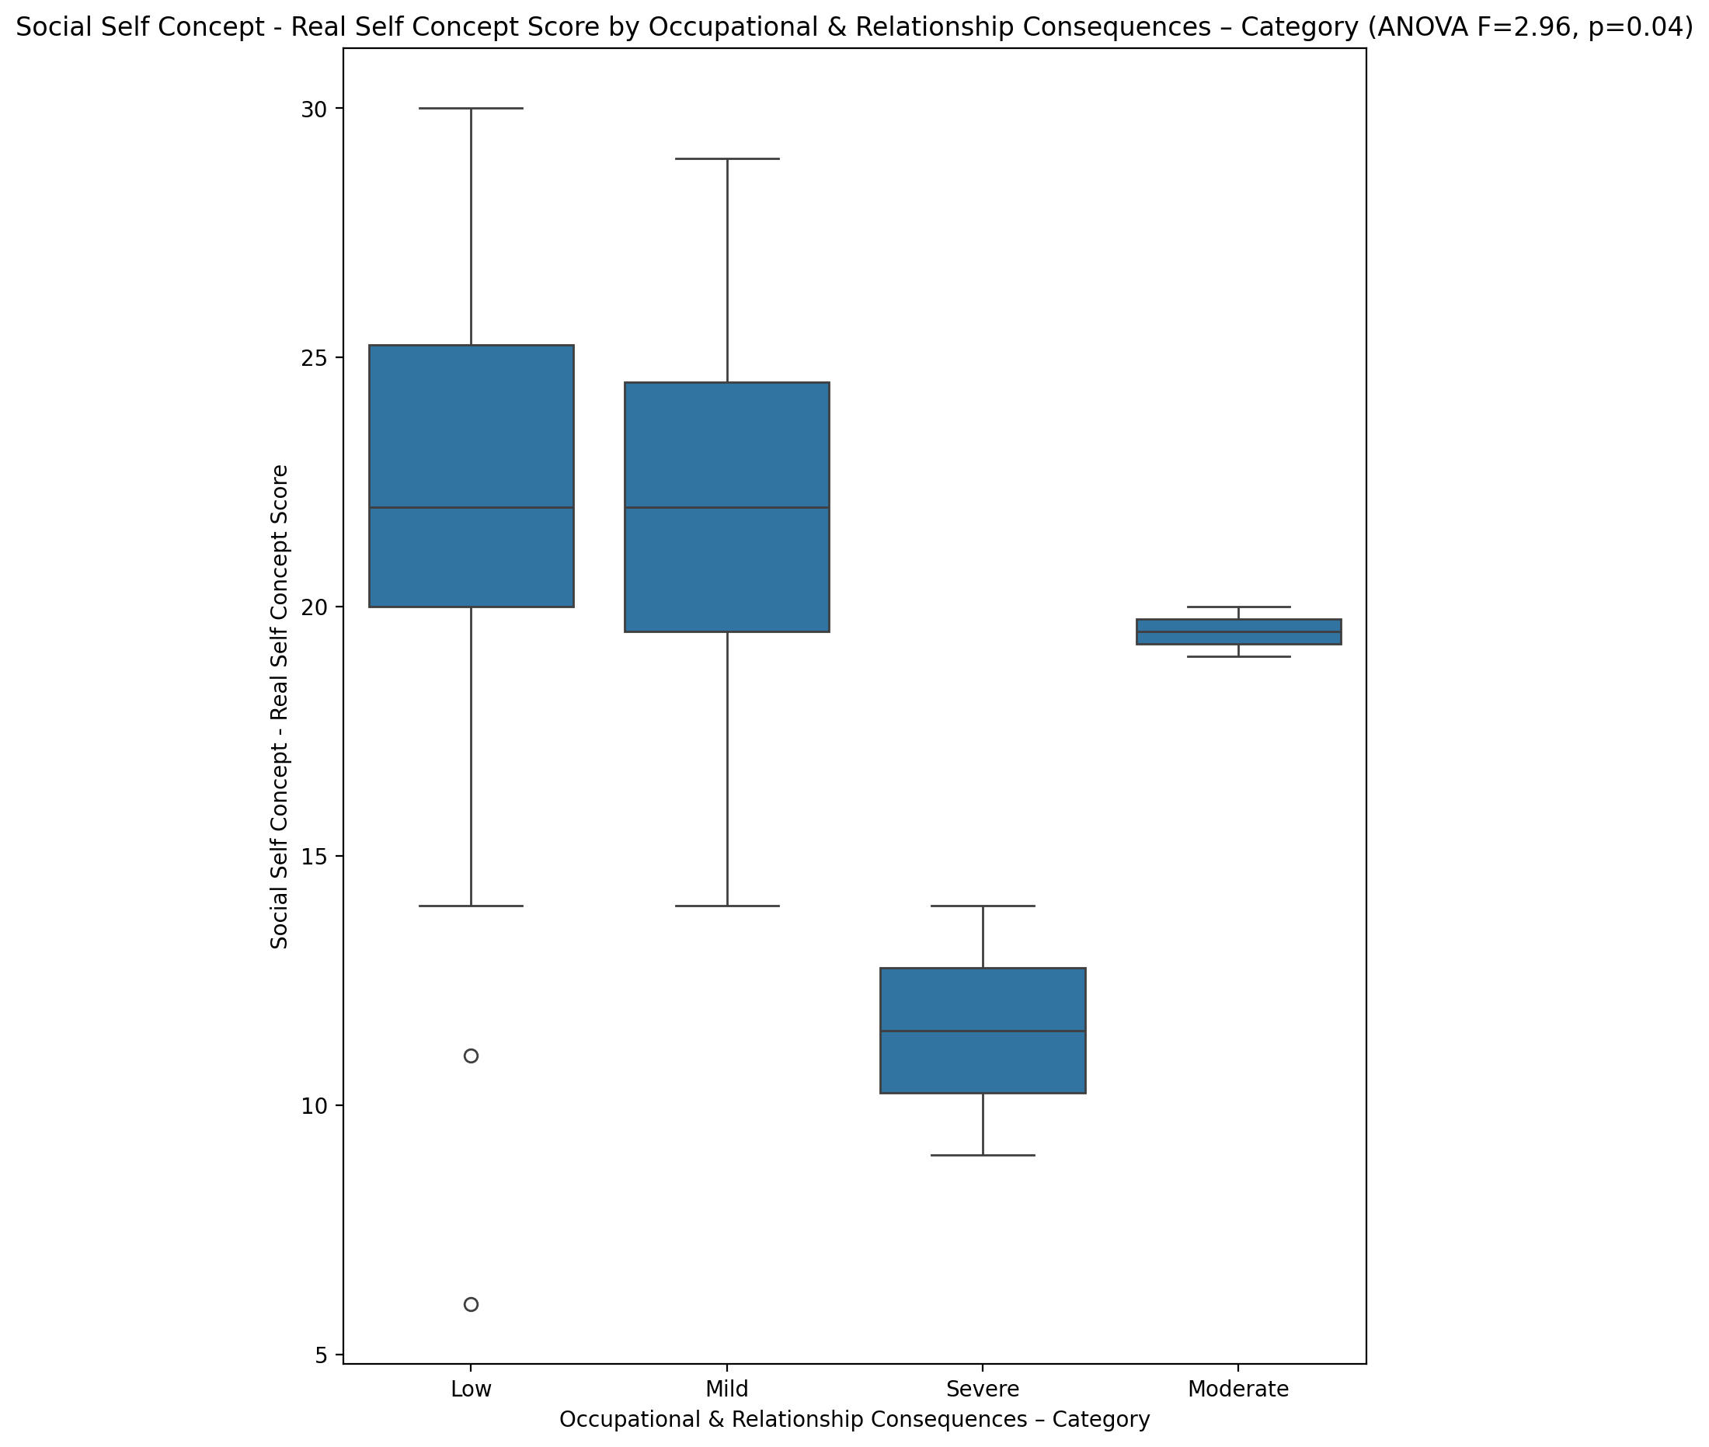

## Social Self Concept – Social Self Concept Score vs Occupational & Relationship Consequences – Category

Test: anova; statistic: 7.317421475056019; p-value: 0.000325441072952291;

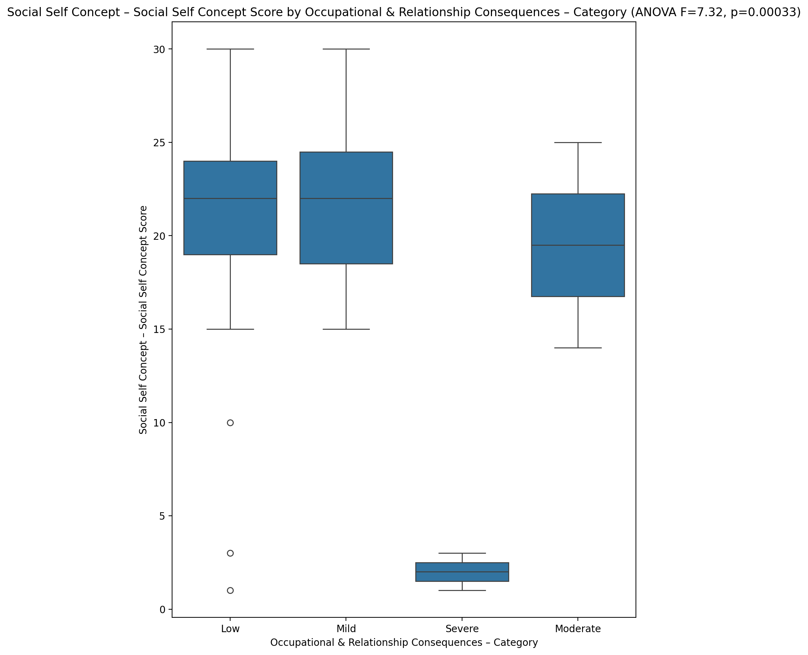

## Ability Self Concept - Real Self Concept Score vs Occupational & Relationship Consequences – Category

Test: anova; statistic: 4.685354905533093; p-value: 0.005514238402084958;

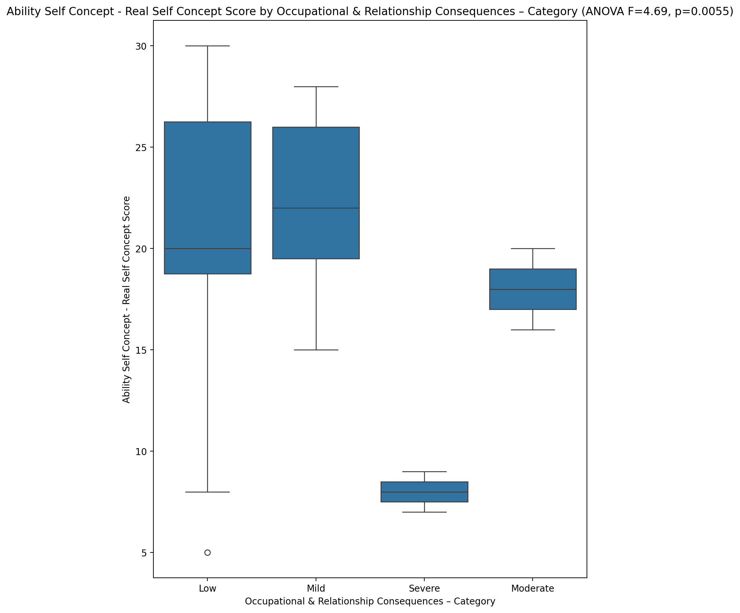

## Ability Self Concept - Ideal Self Concept Score vs Occupational & Relationship Consequences – Category

Test: anova; statistic: 7.939894775022935; p-value: 0.000172699524958548;

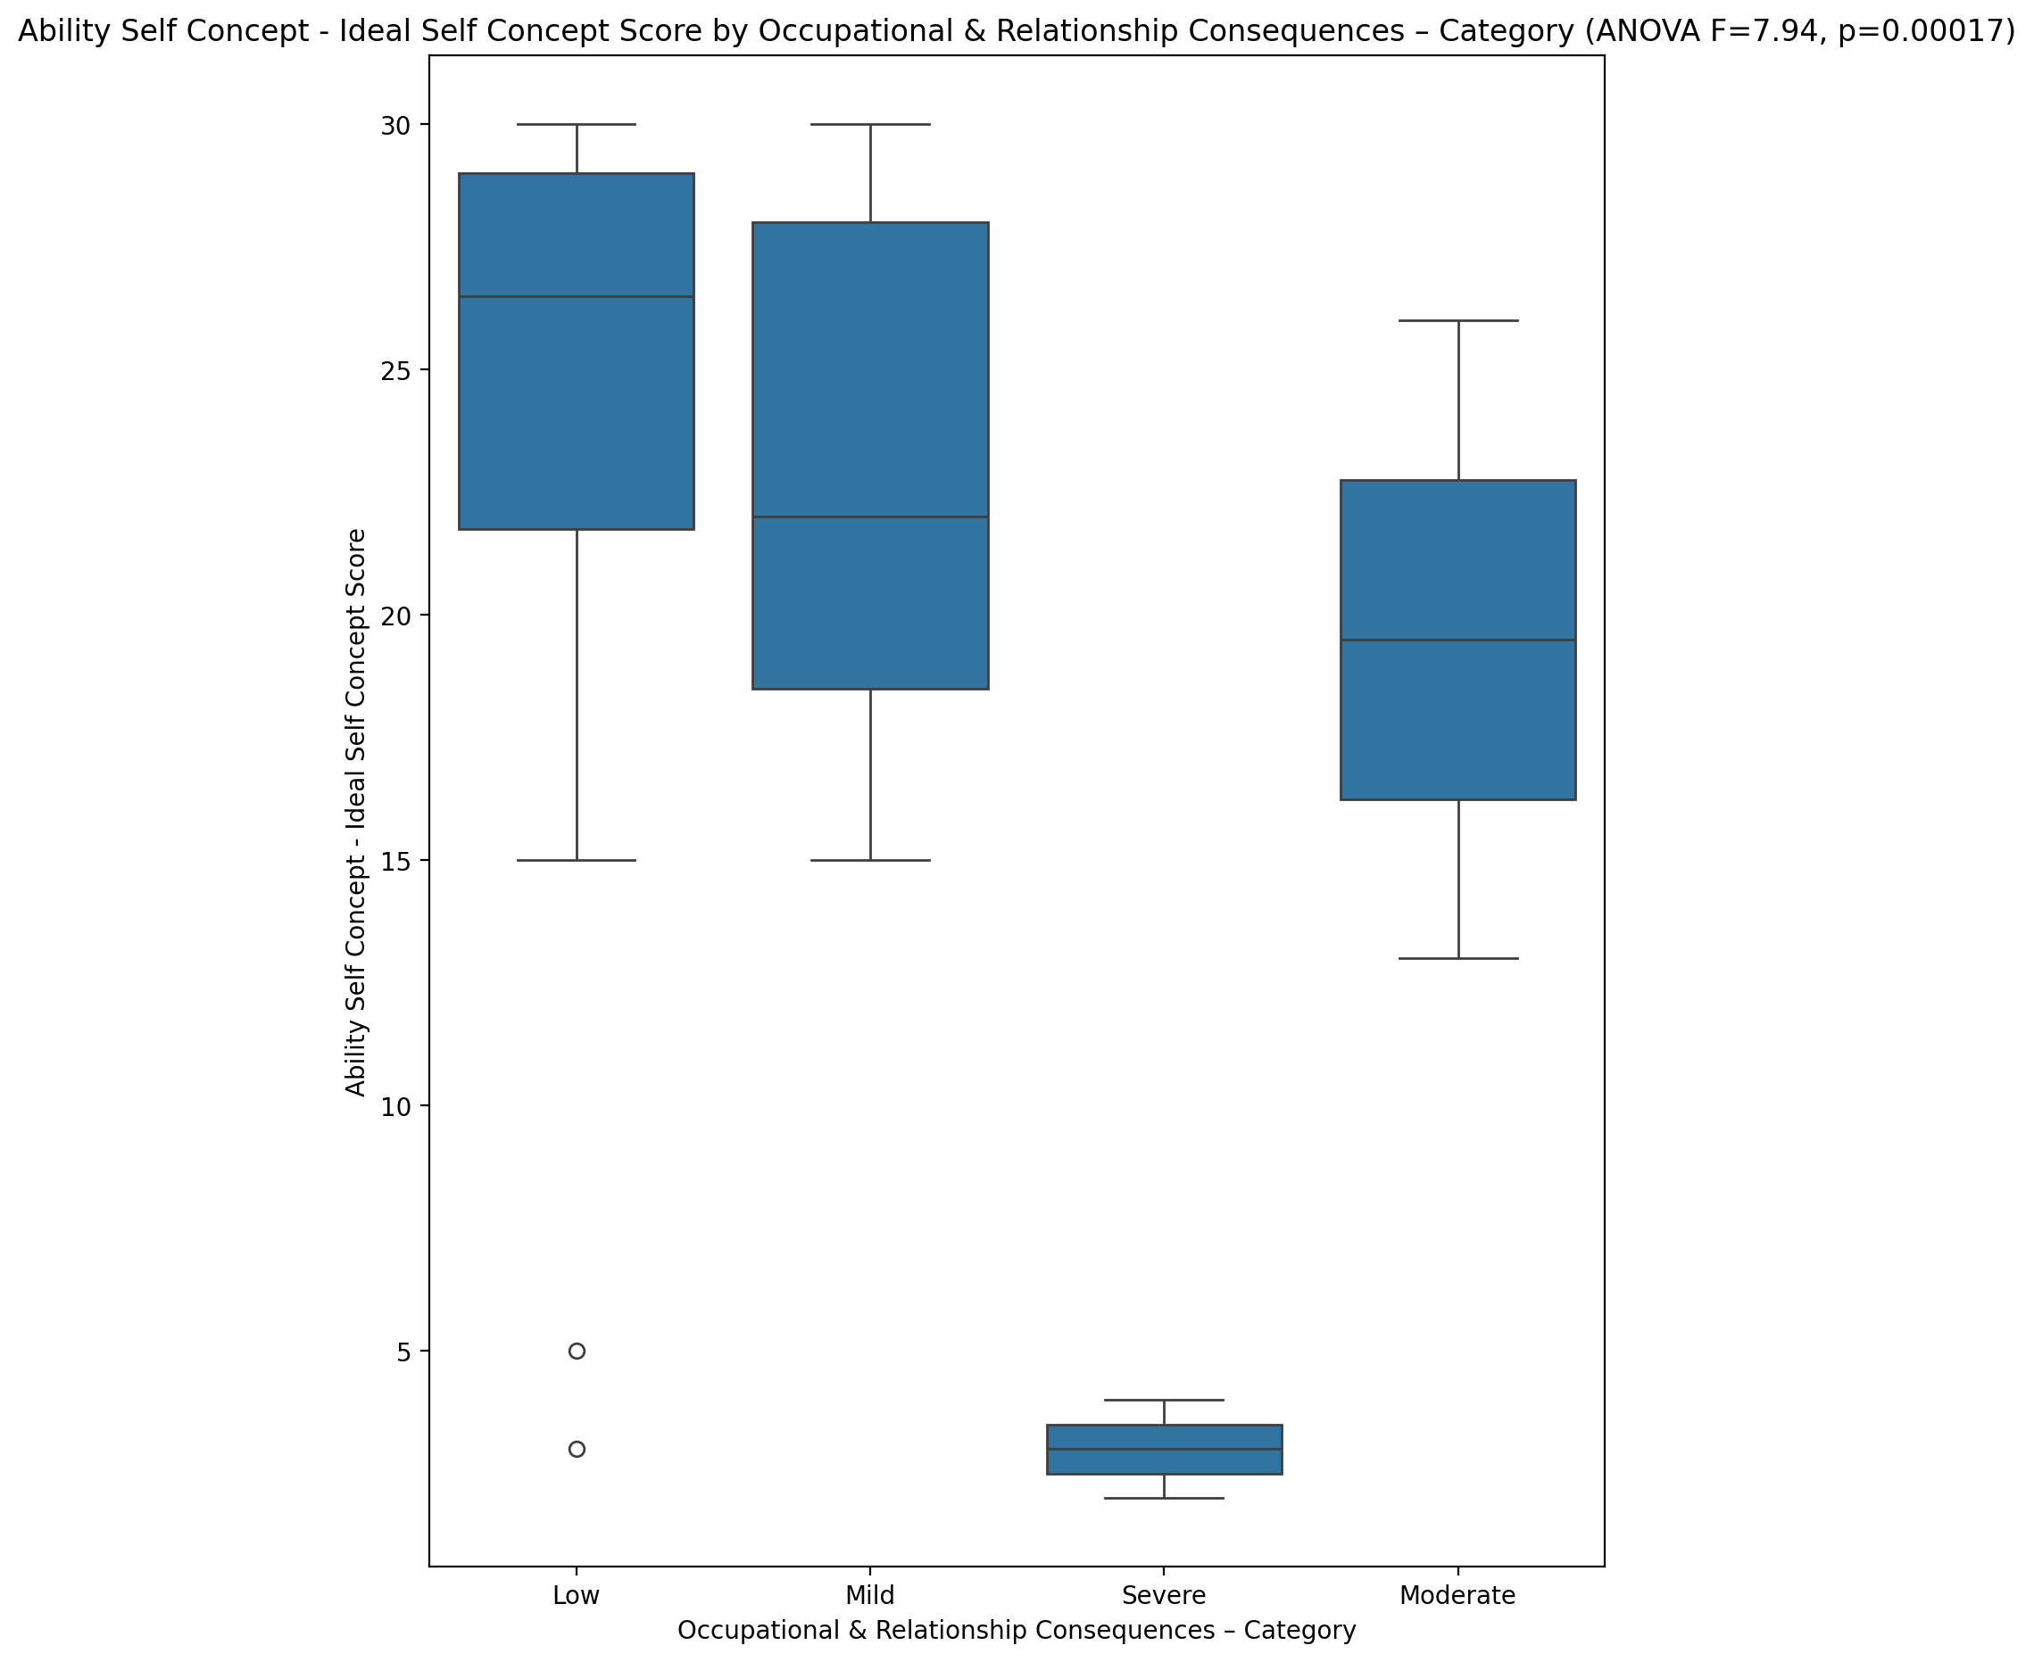

## Ability Self Concept – Social Self Concept Score vs Occupational & Relationship Consequences – Category

Test: anova; statistic: 6.5772160269404285; p-value: 0.0007035366008257879;

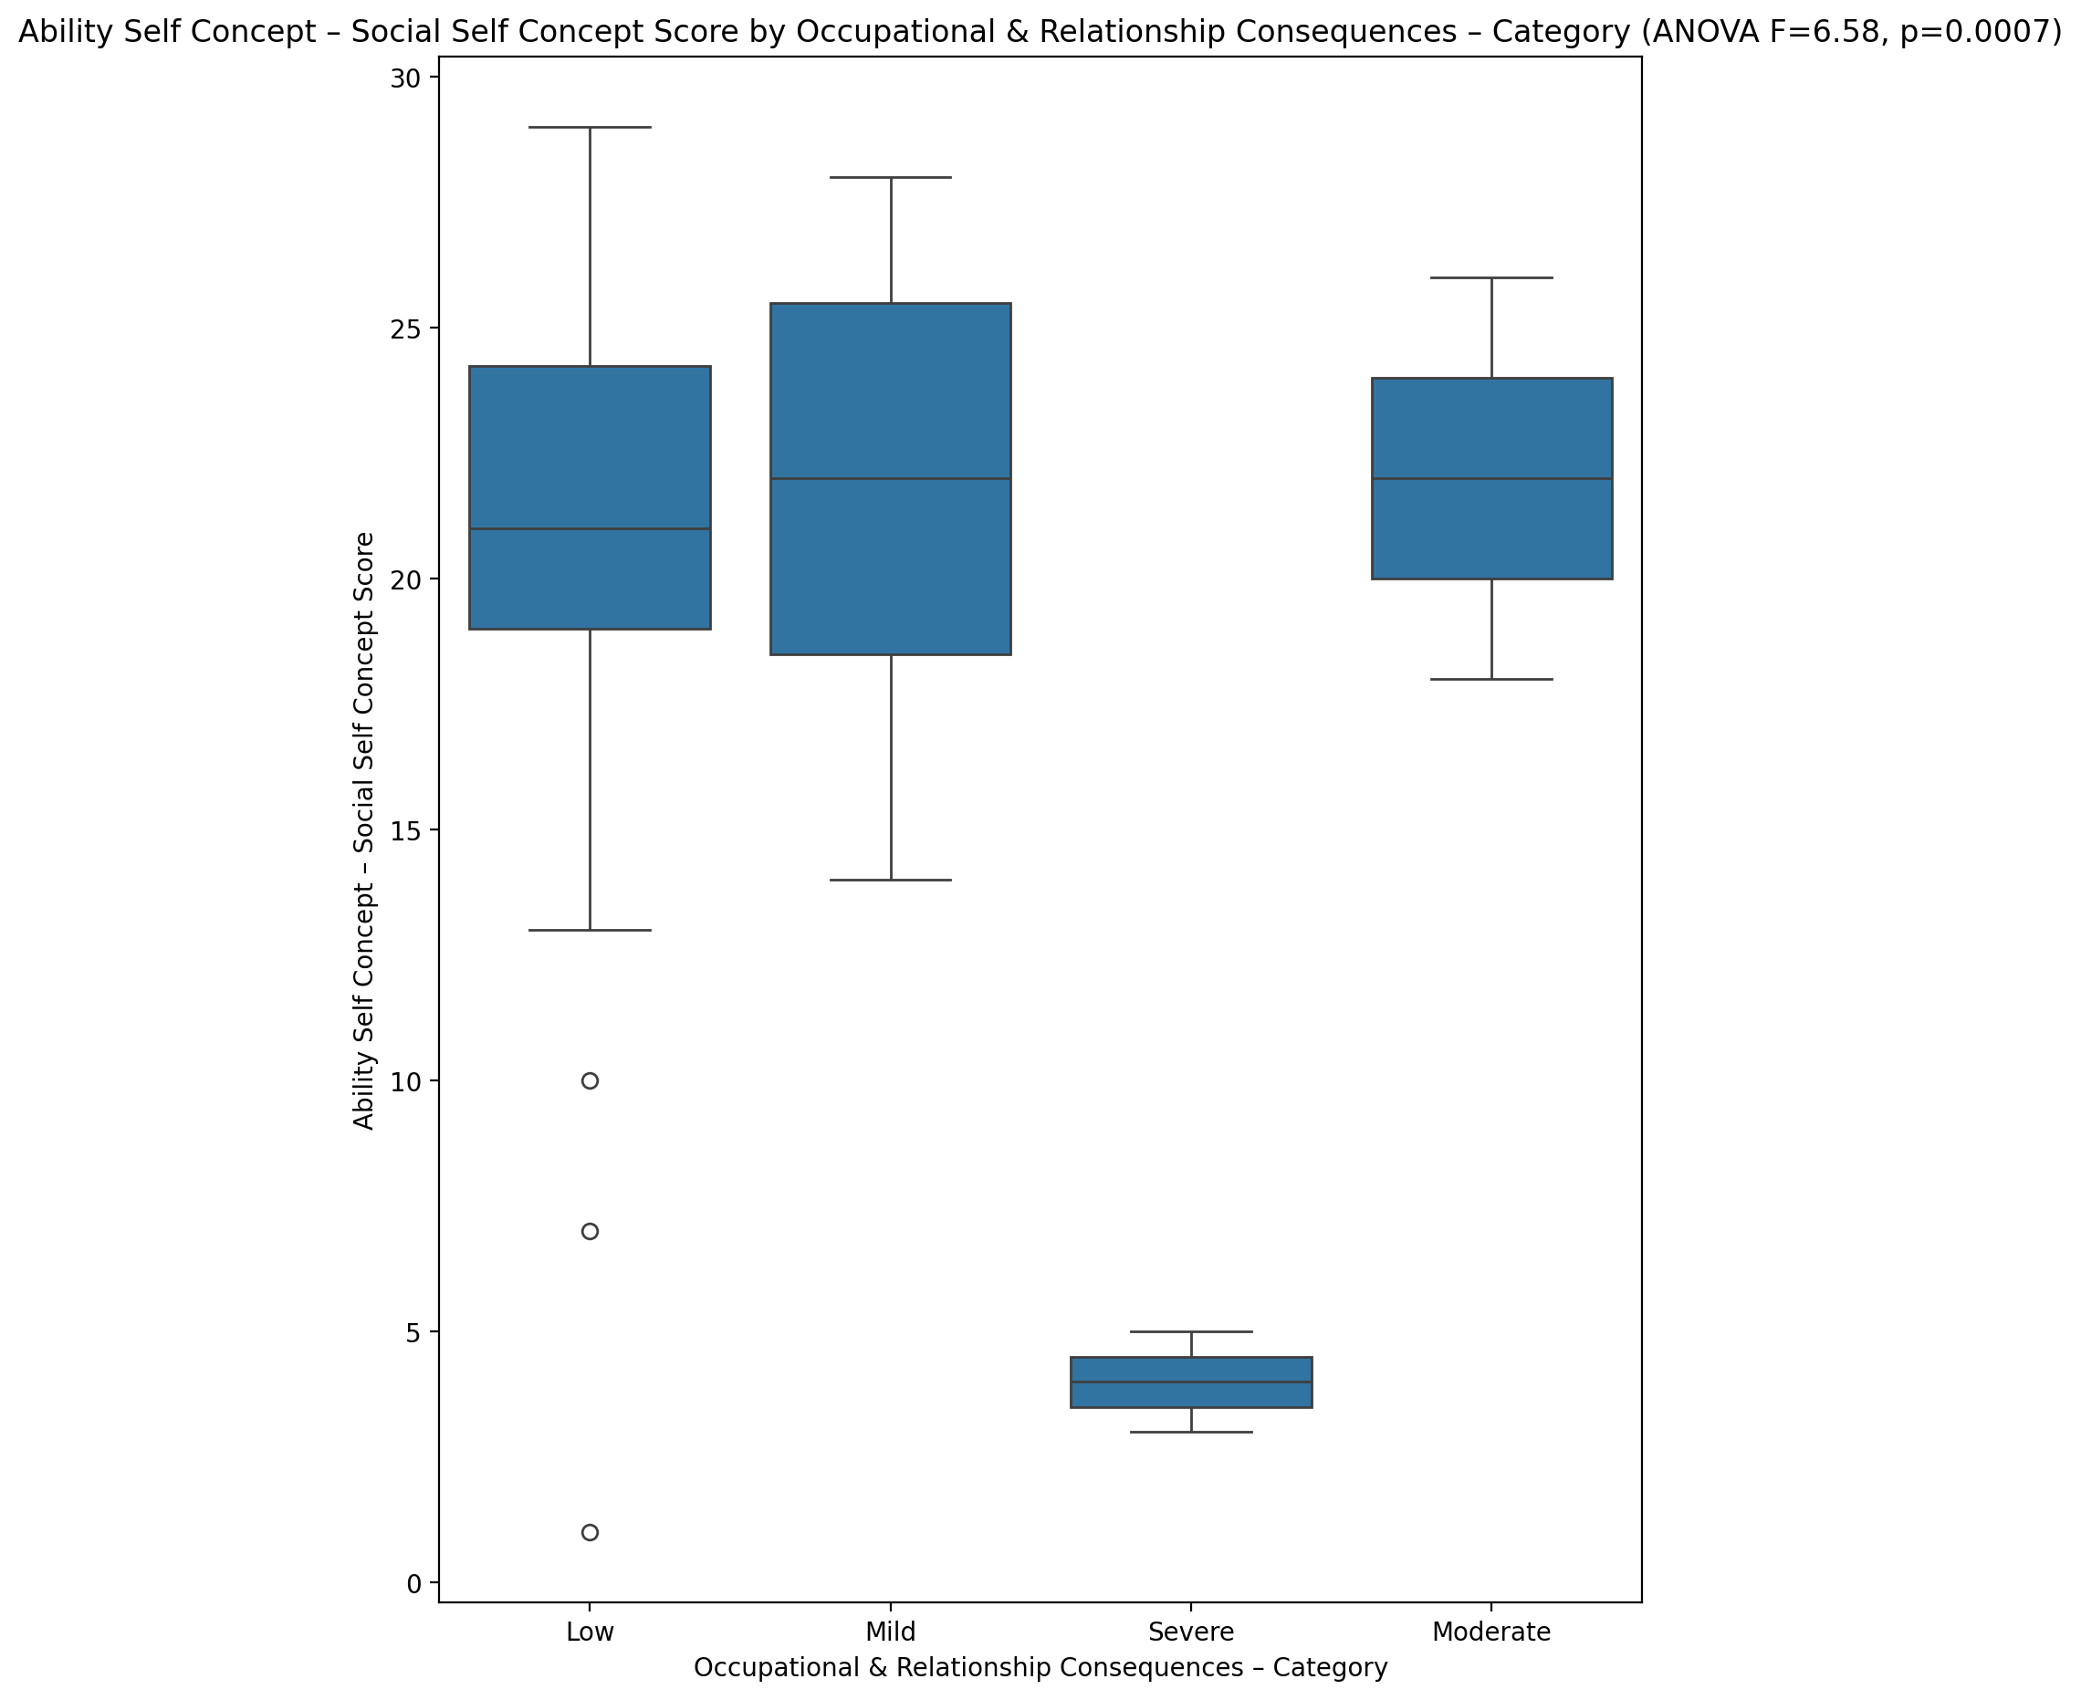

## Physical Self Concept - Real Self Concept Score vs Occupational & Relationship Consequences – Category

Test: anova; statistic: 1.5479750244455432; p-value: 0.21245063750293627;

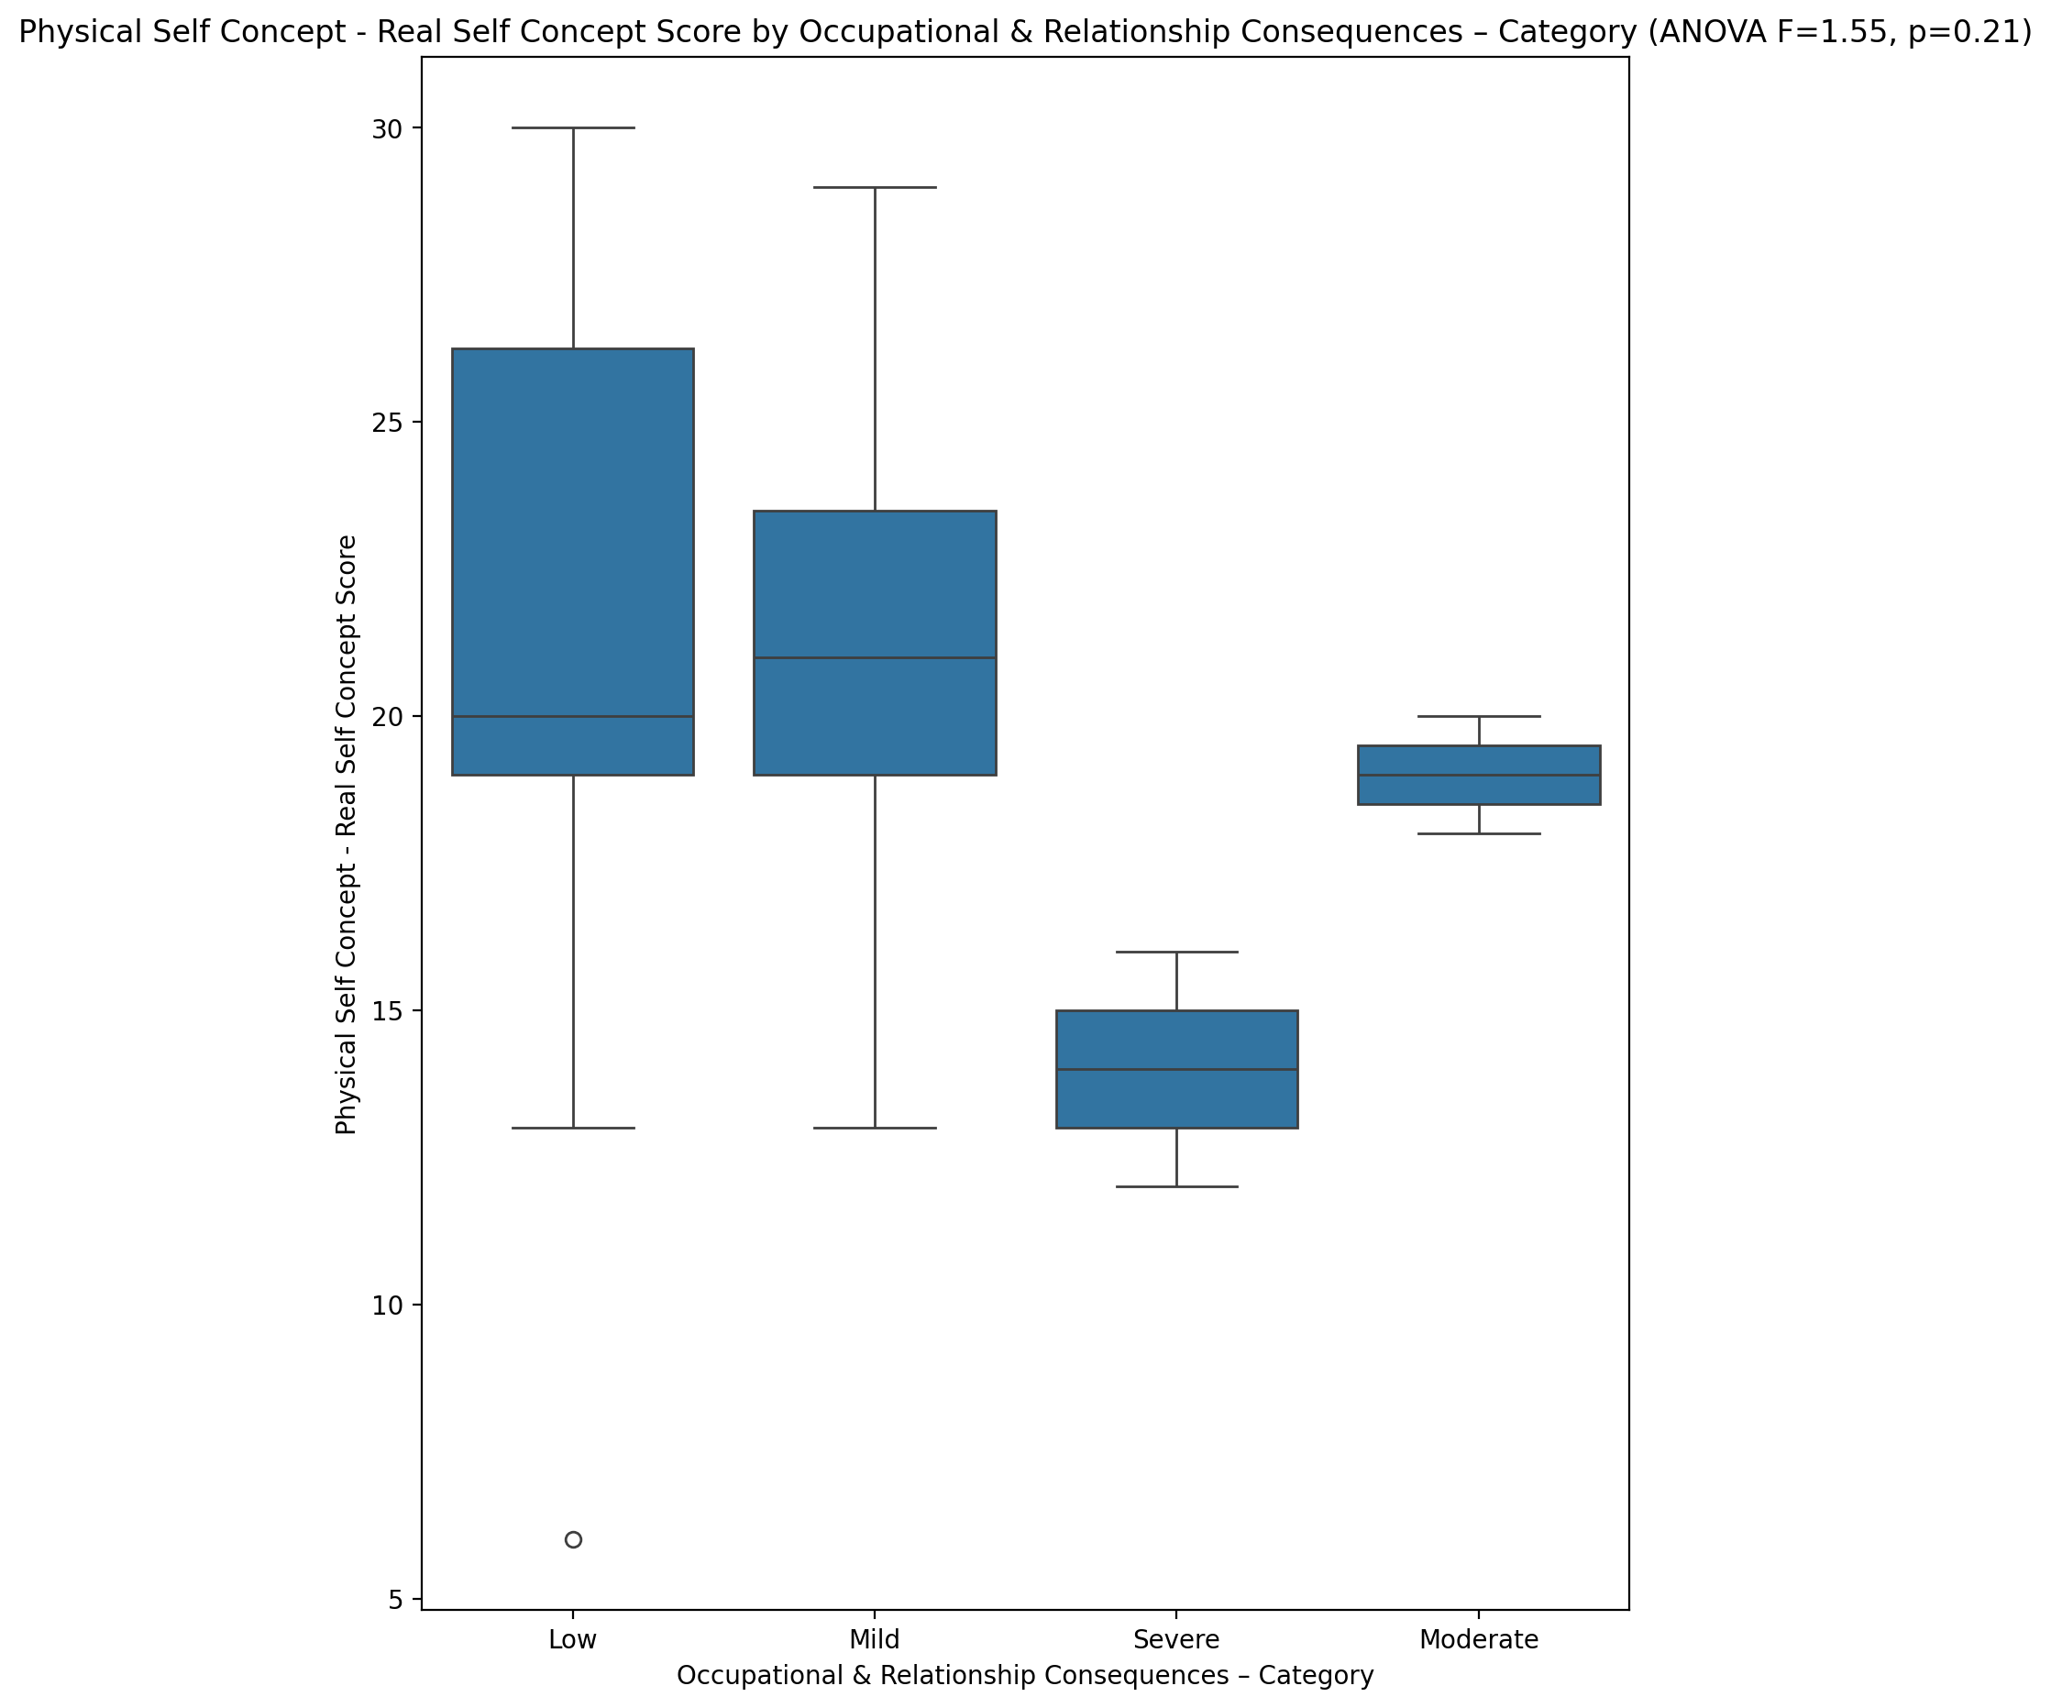

## Physical Self Concept – Ideal Self Concept Score vs Occupational & Relationship Consequences – Category

Test: anova; statistic: 9.820093209163653; p-value: 2.7535328335032082e-05;

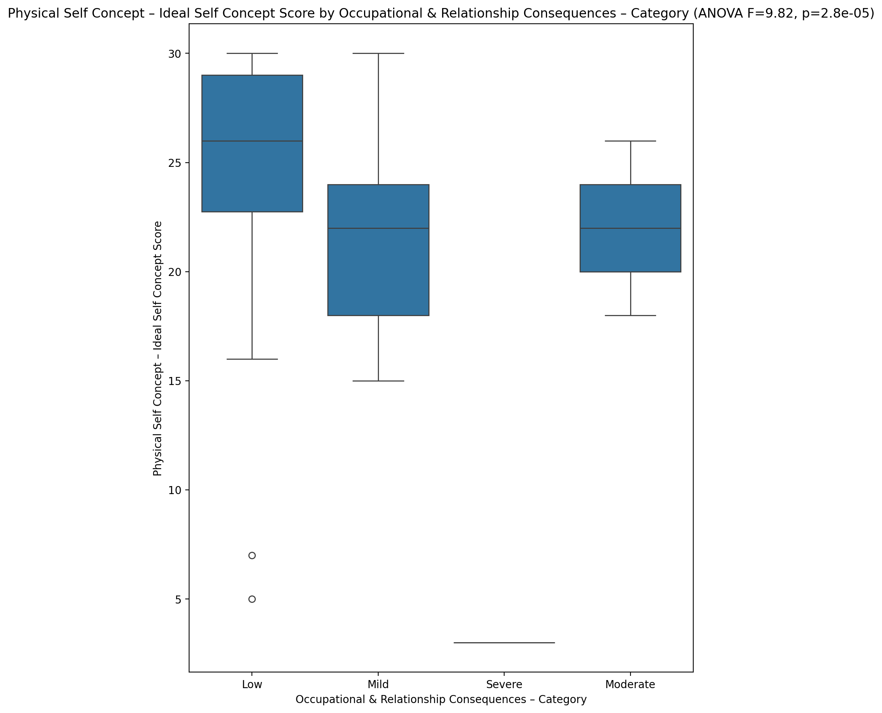

## Physical Self Concept – Social Self Concept Score vs Occupational & Relationship Consequences – Category

Test: anova; statistic: 7.549970429309903; p-value: 0.000256444934645178;

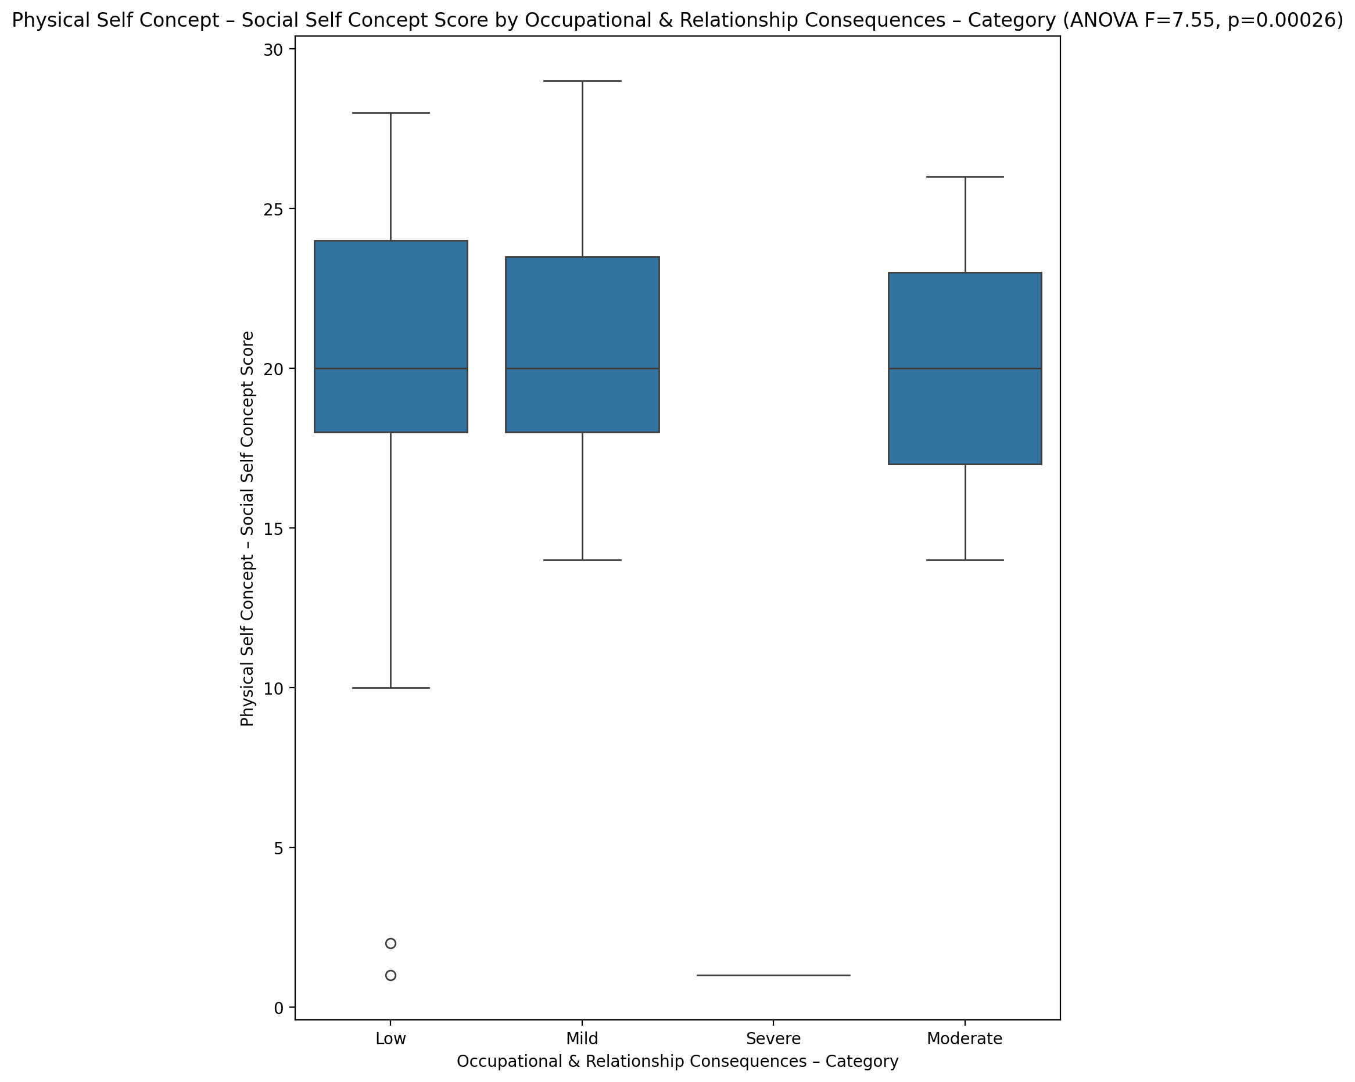

## Psychological Self Concept - Real Self Concept Score vs Occupational & Relationship Consequences – Category

Test: anova; statistic: 5.9636061461435865; p-value: 0.0013527551568134105;

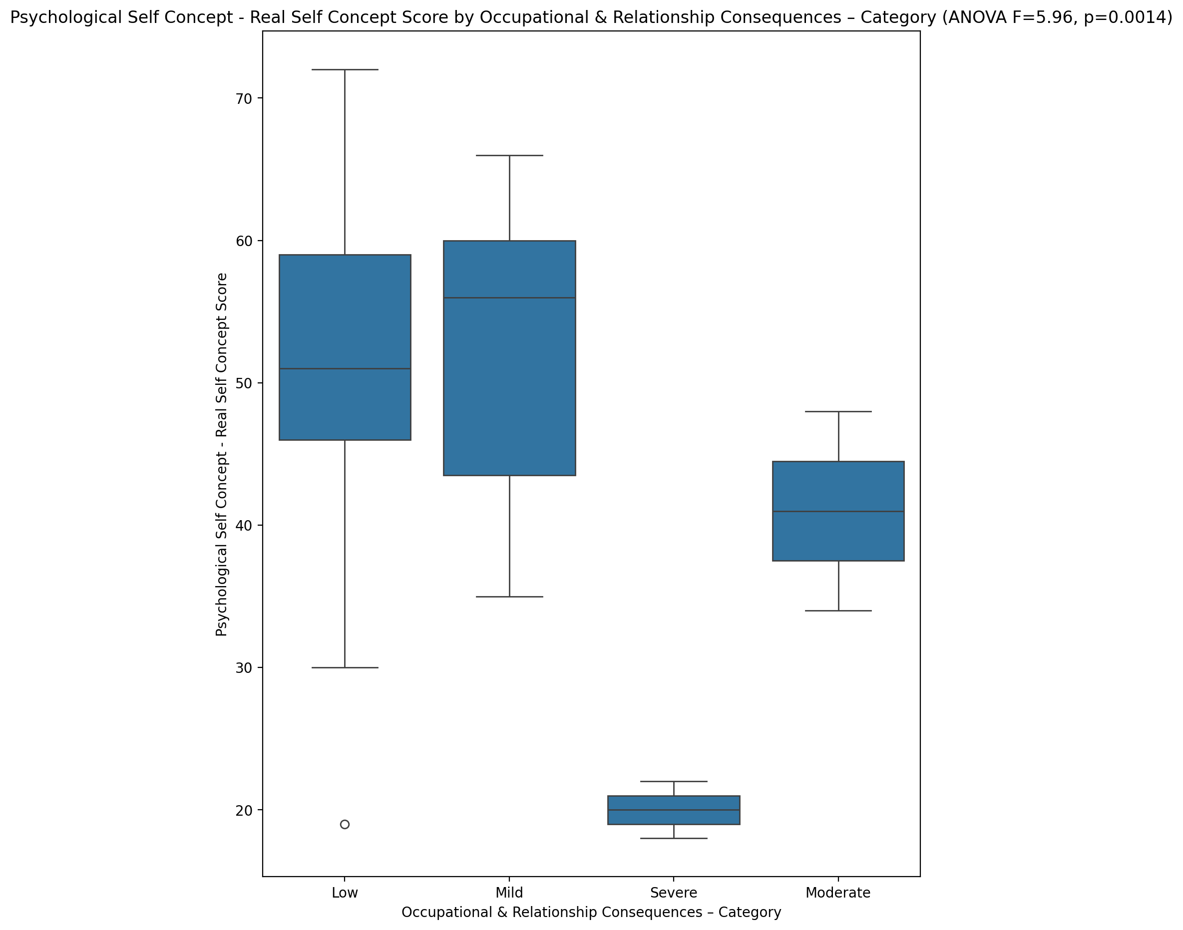

## Psychological Self Concept – Ideal Self Concept Score vs Occupational & Relationship Consequences – Category

Test: anova; statistic: 6.435699944308282; p-value: 0.0008170576631151125;

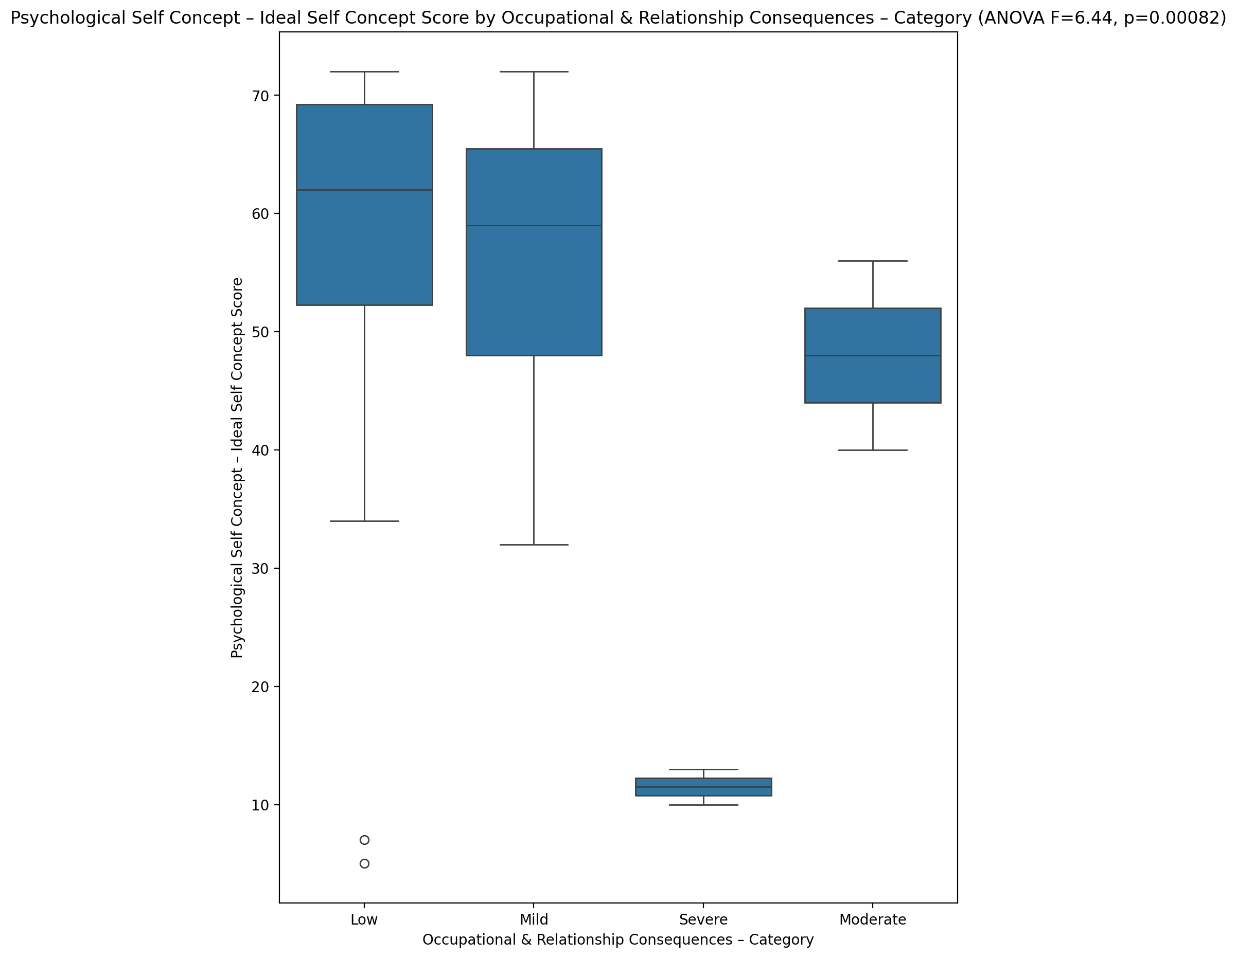

## Psychological Self Concept – Social Self Concept Score vs Occupational & Relationship Consequences – Category

Test: anova; statistic: 7.373098682703915; p-value: 0.000307343288827716;

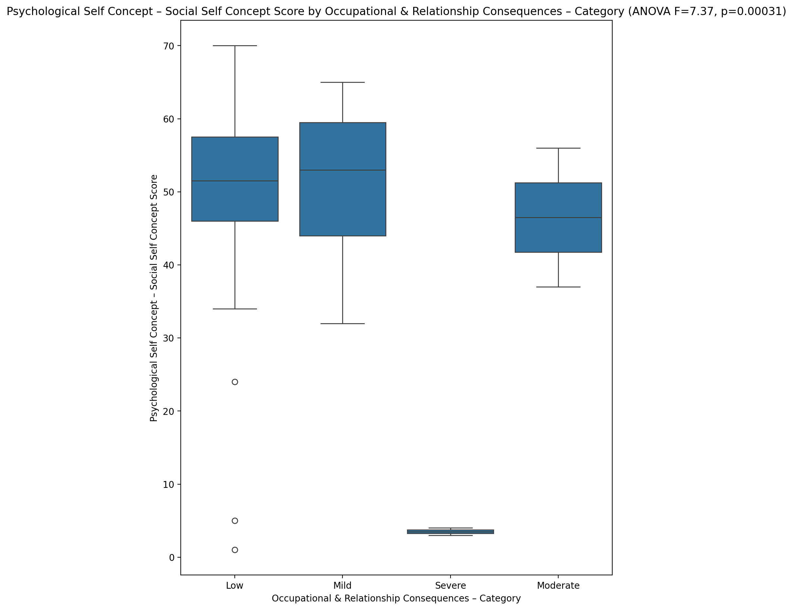

## Real Self Concept Total Score vs Occupational & Relationship Consequences – Category

Test: anova; statistic: 4.77745576540927; p-value: 0.00497360285760967;

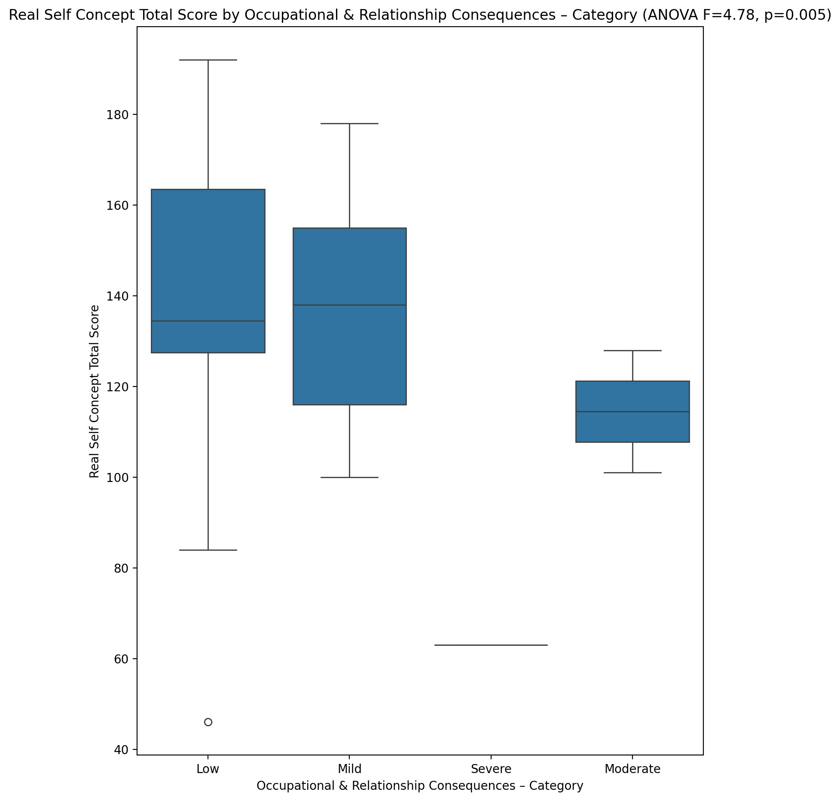

## Ideal Self Concept Total Score vs Occupational & Relationship Consequences – Category

Test: anova; statistic: 8.579042136280654; p-value: 9.133595512244559e-05;

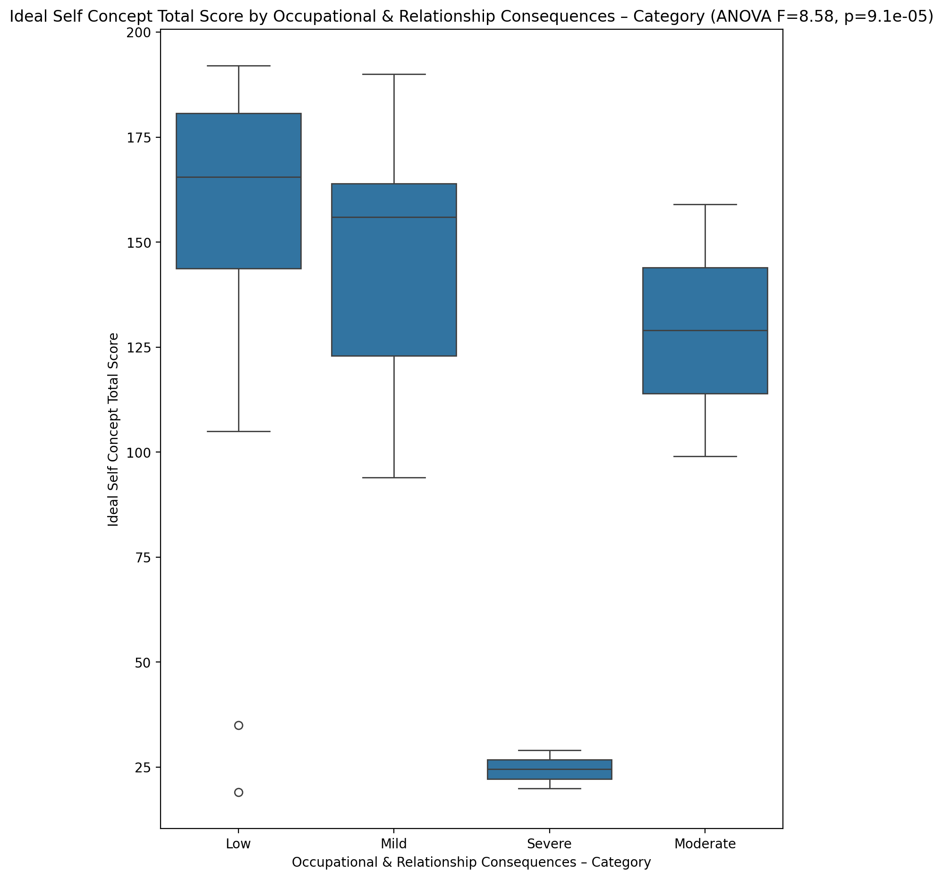

## Social Self Concept Total Score vs Occupational & Relationship Consequences – Category

Test: anova; statistic: 7.628185276795589; p-value: 0.00023679465651035337;

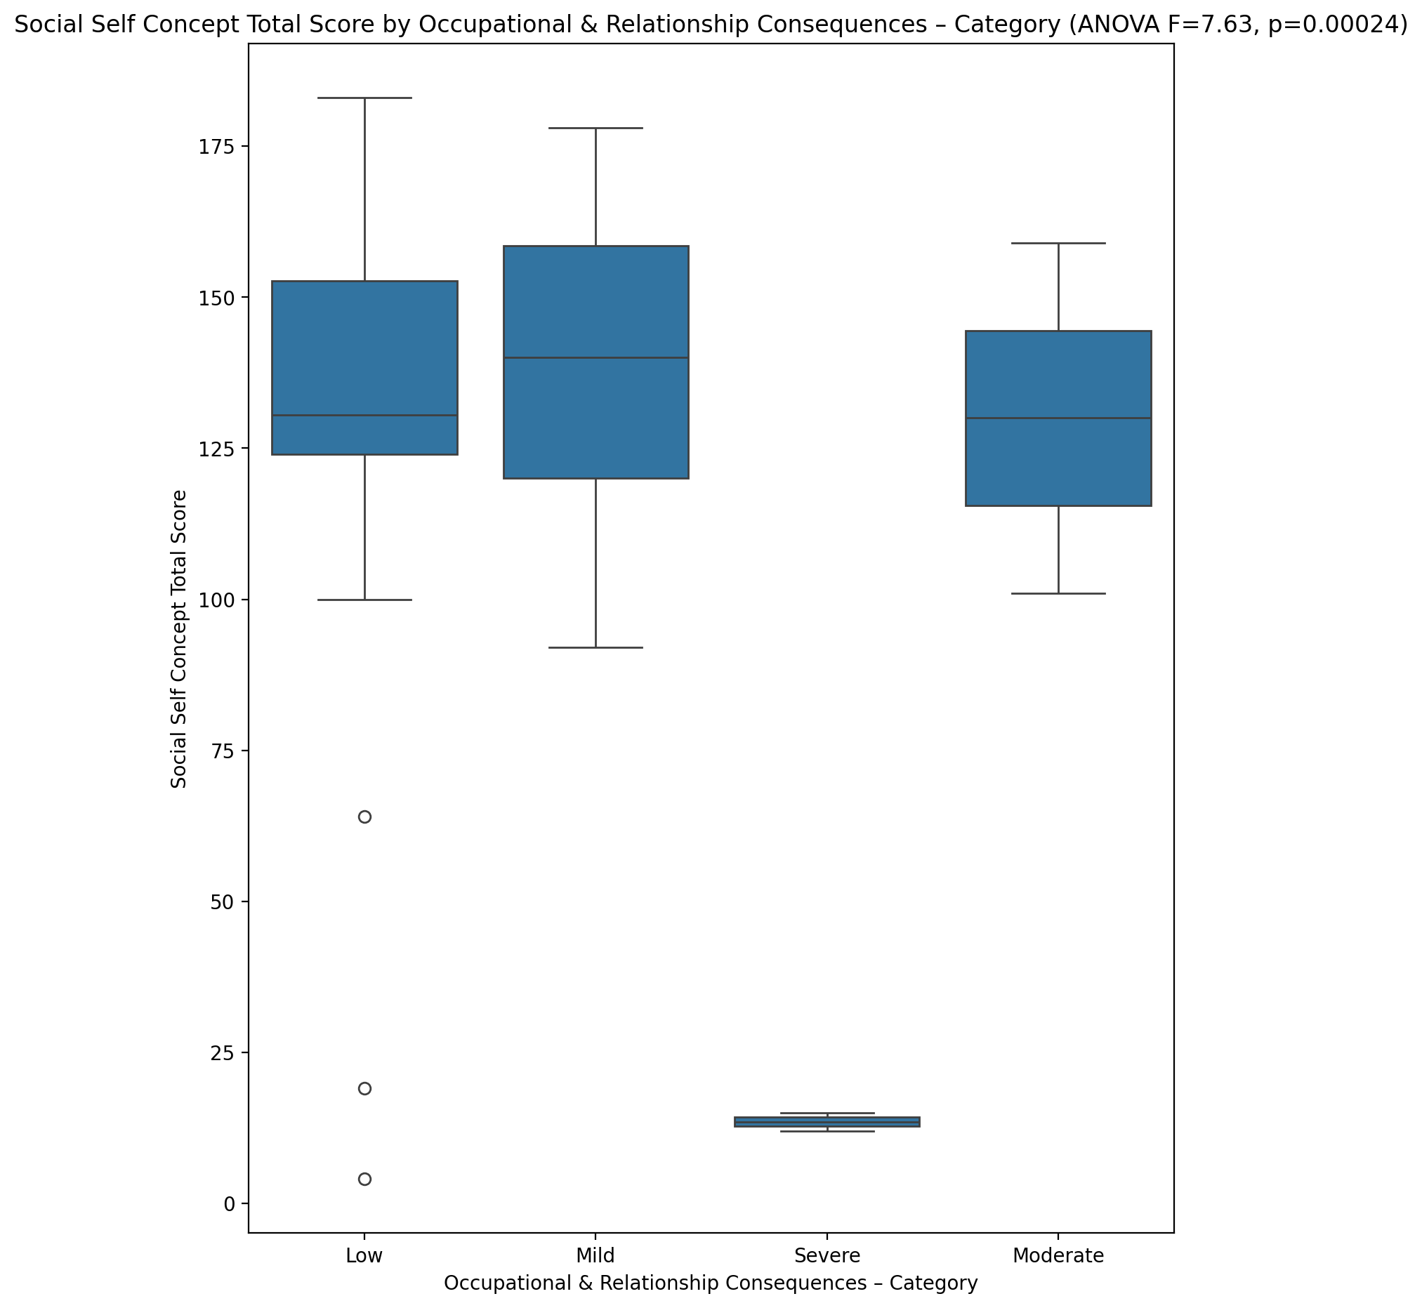

## Ideal Self Concept Total Category vs Occupational & Relationship Consequences – Category

Test: chi2; statistic: 30.868629807692308; p-value: 2.6855944495434333e-05;

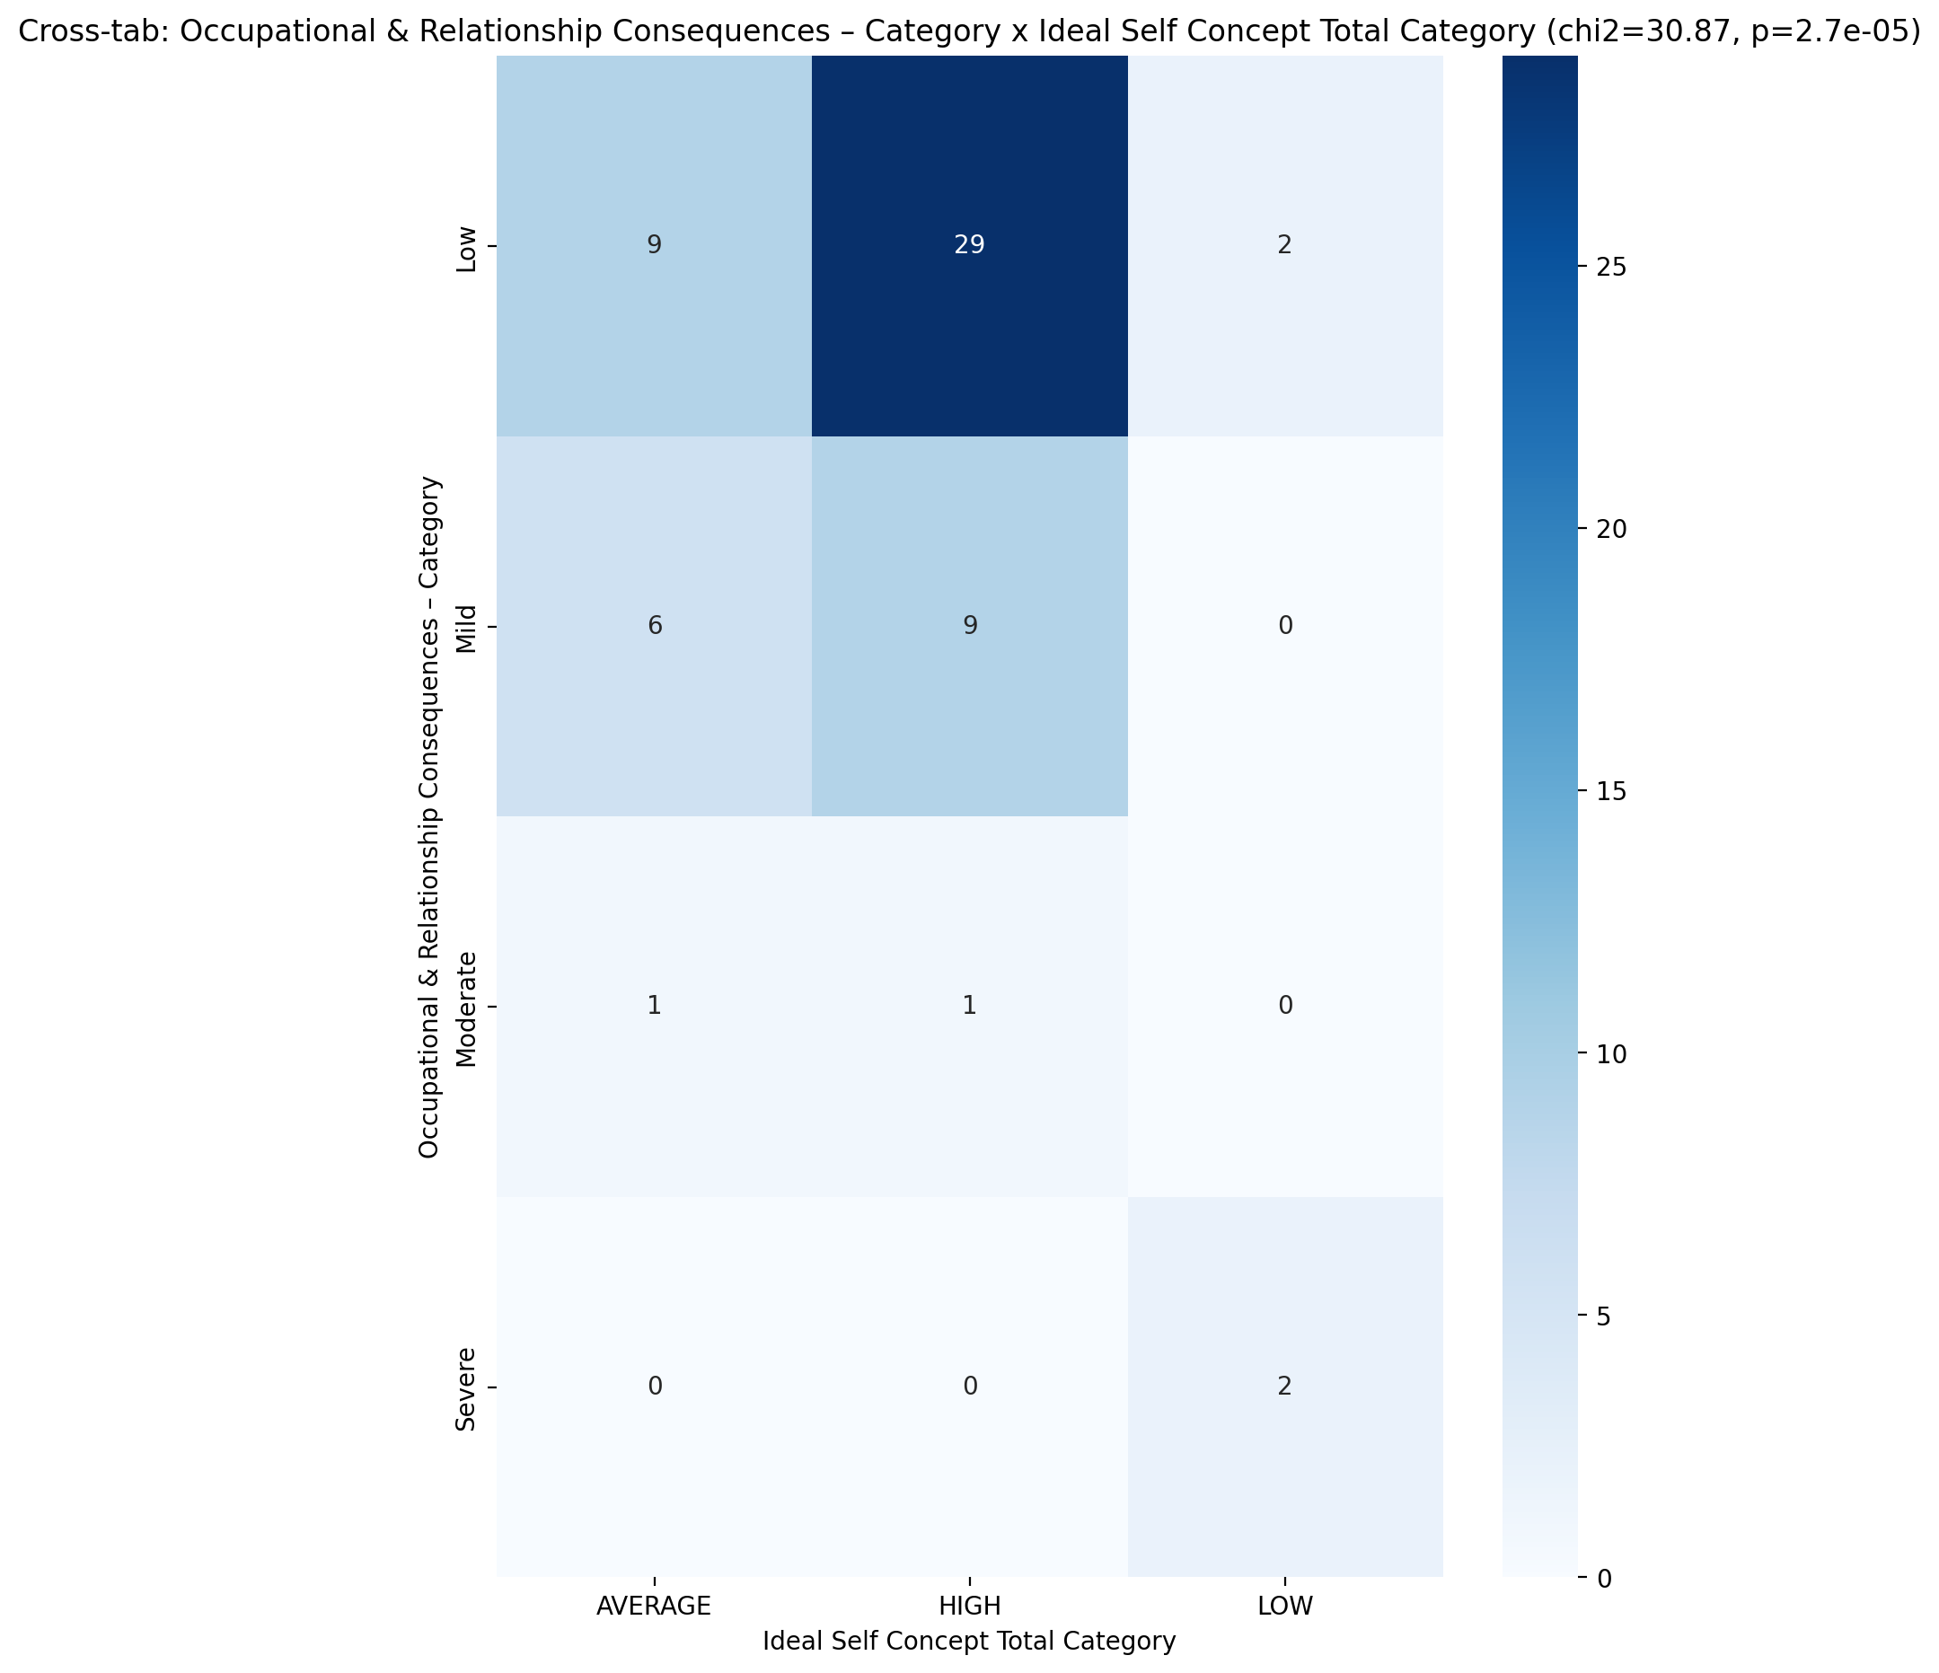

## Perceived Social Stress Score vs Occupational & Relationship Consequences – Category

Test: anova; statistic: 2.0280433786596737; p-value: 0.12059115062736009;

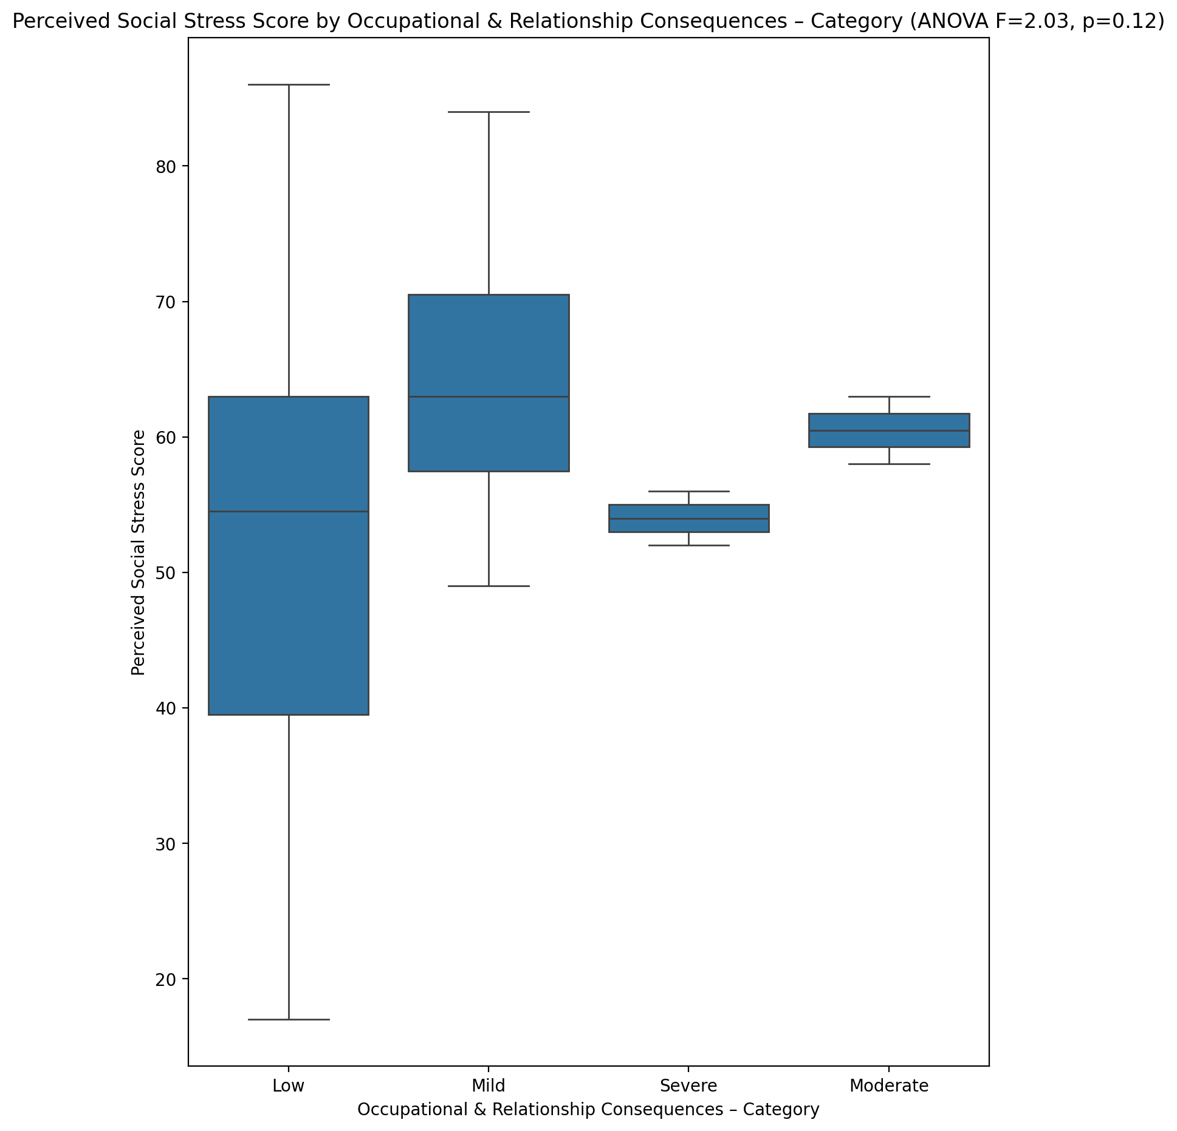

## Perceived Social Stress Category vs Occupational & Relationship Consequences – Category

Test: chi2; statistic: 3.2265625; p-value: 0.7799206233447012;

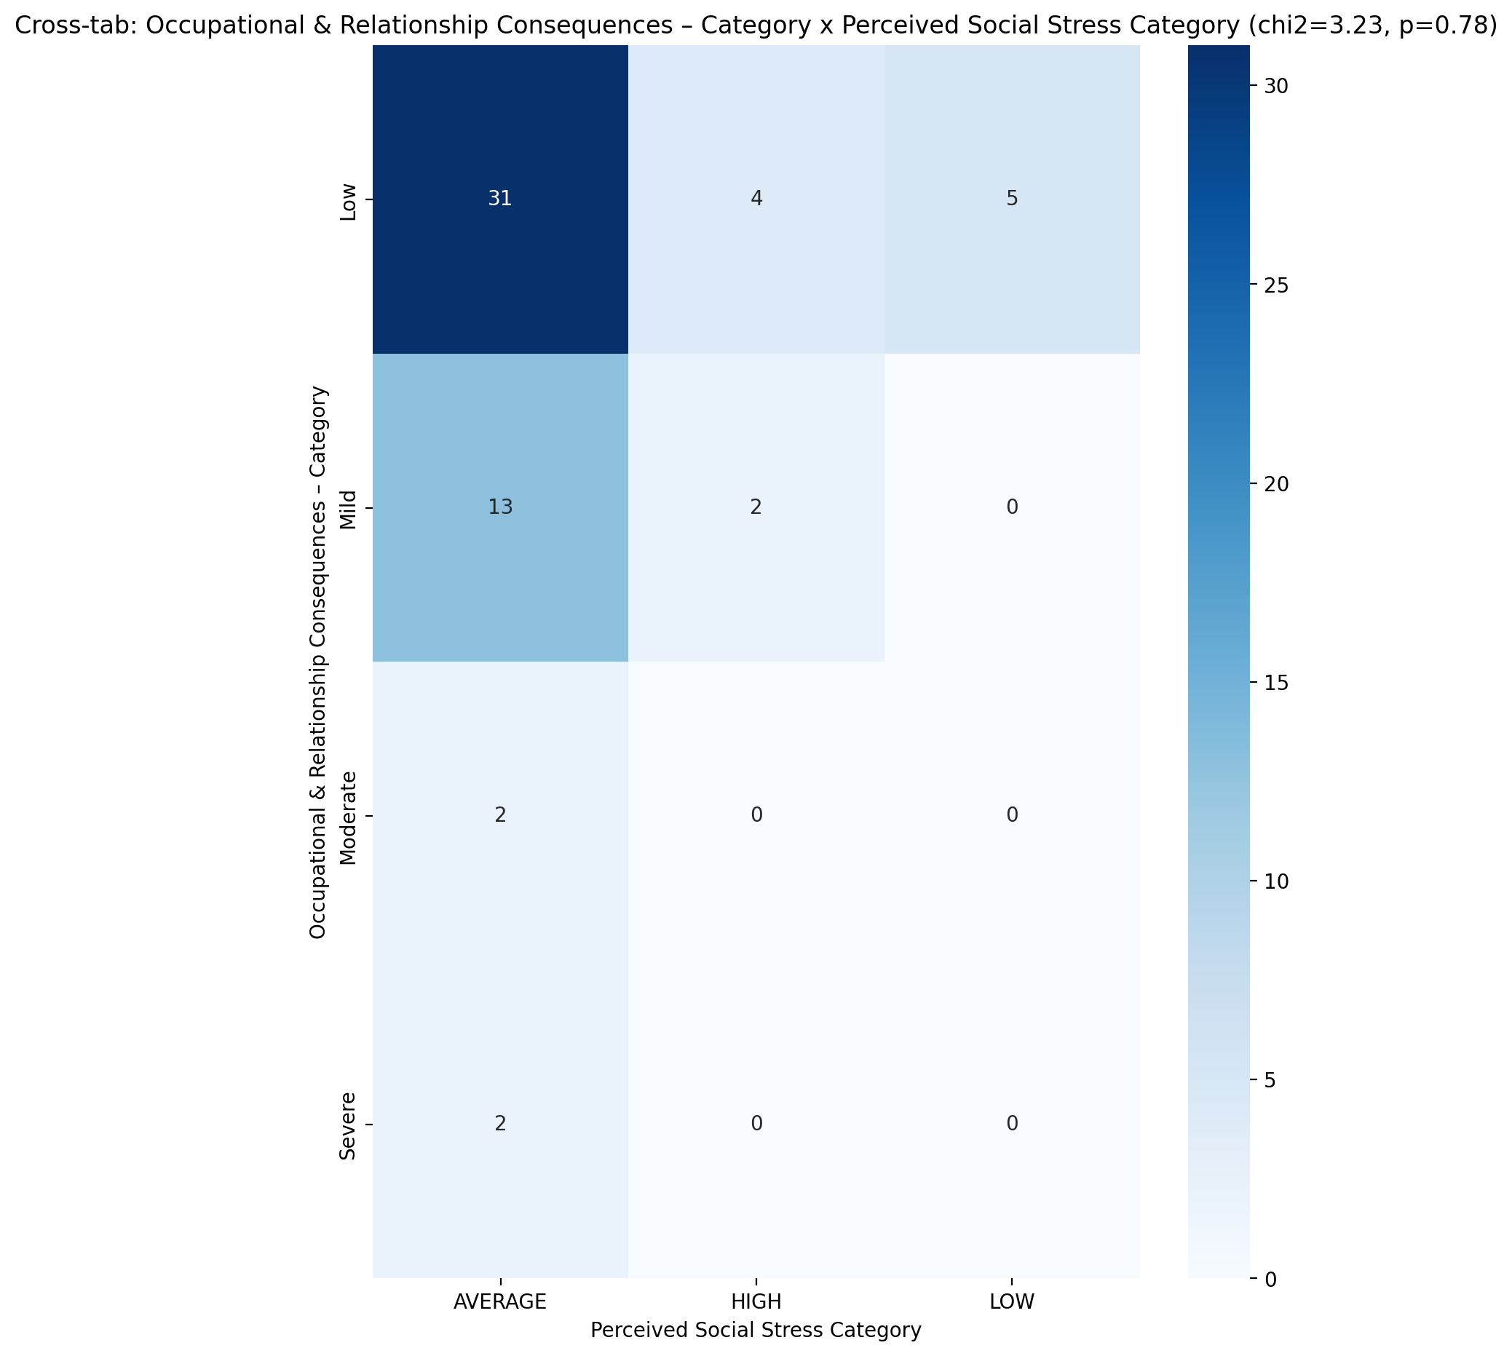

## Emotional Support - Raw Score vs Compulsive Behaviour – Category

Test: anova; statistic: 2.4491011830697587; p-value: 0.07325291109642101;

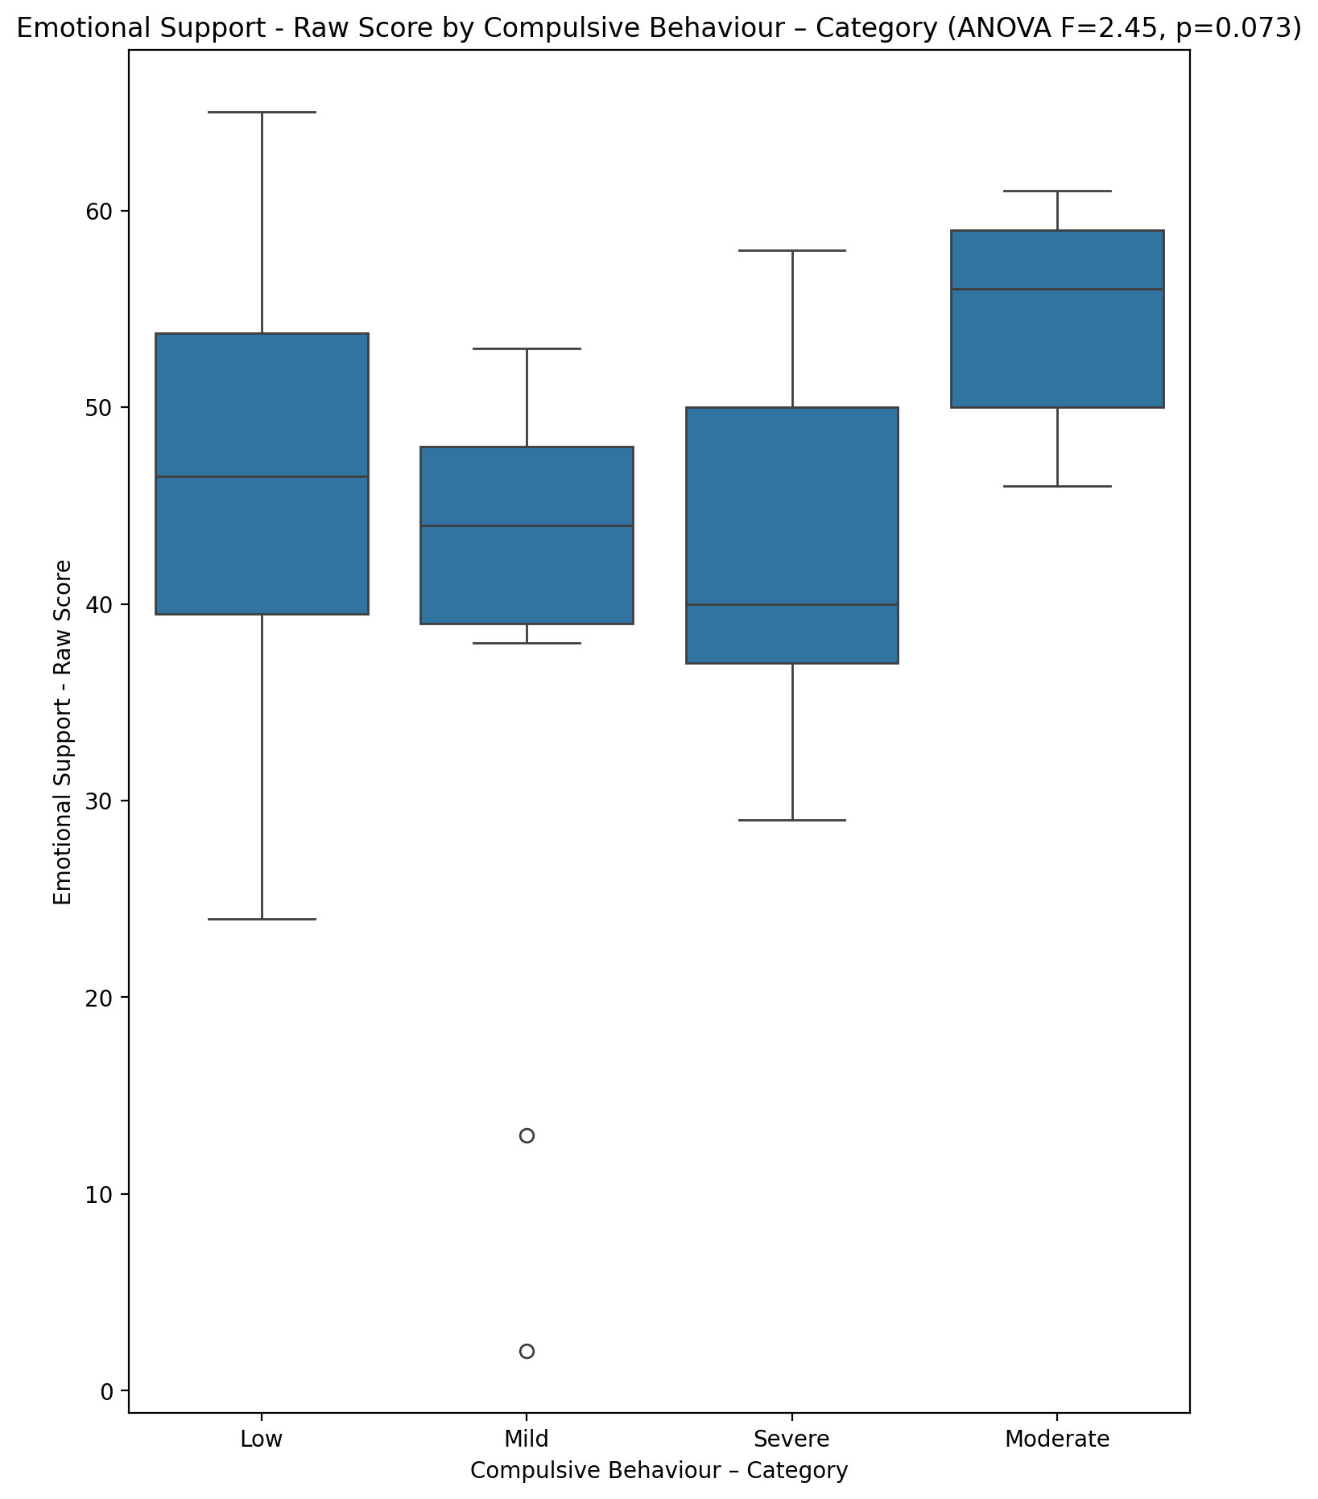

## Informational Support - Raw Score vs Compulsive Behaviour – Category

Test: anova; statistic: 0.9865695673773313; p-value: 0.40591454107629554;

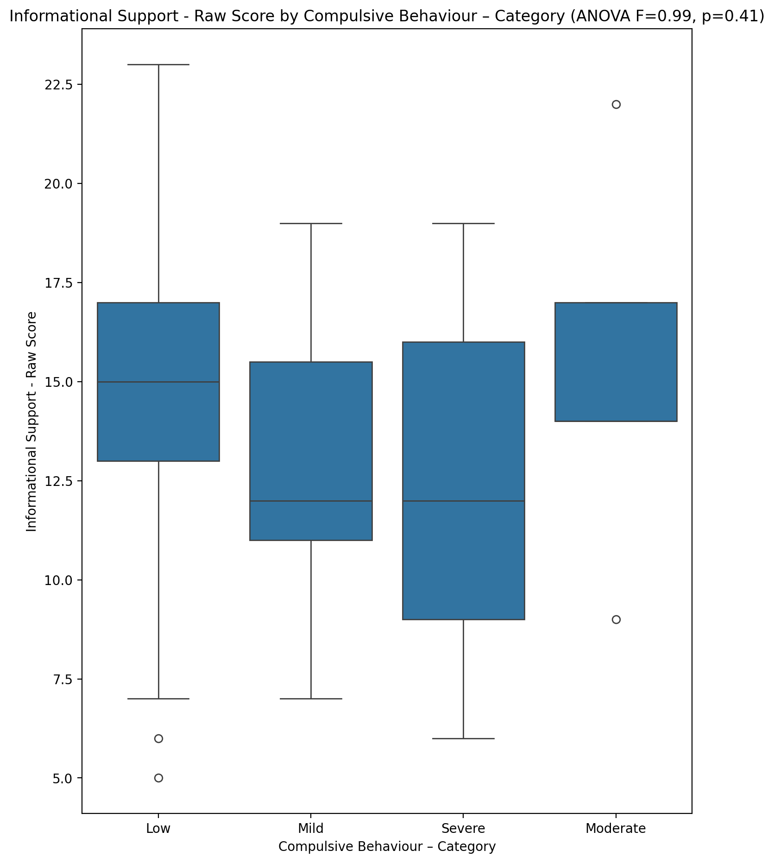

## Instrumental Support - Raw Score vs Compulsive Behaviour – Category

Test: anova; statistic: 1.2735911665039892; p-value: 0.29248678266070877;

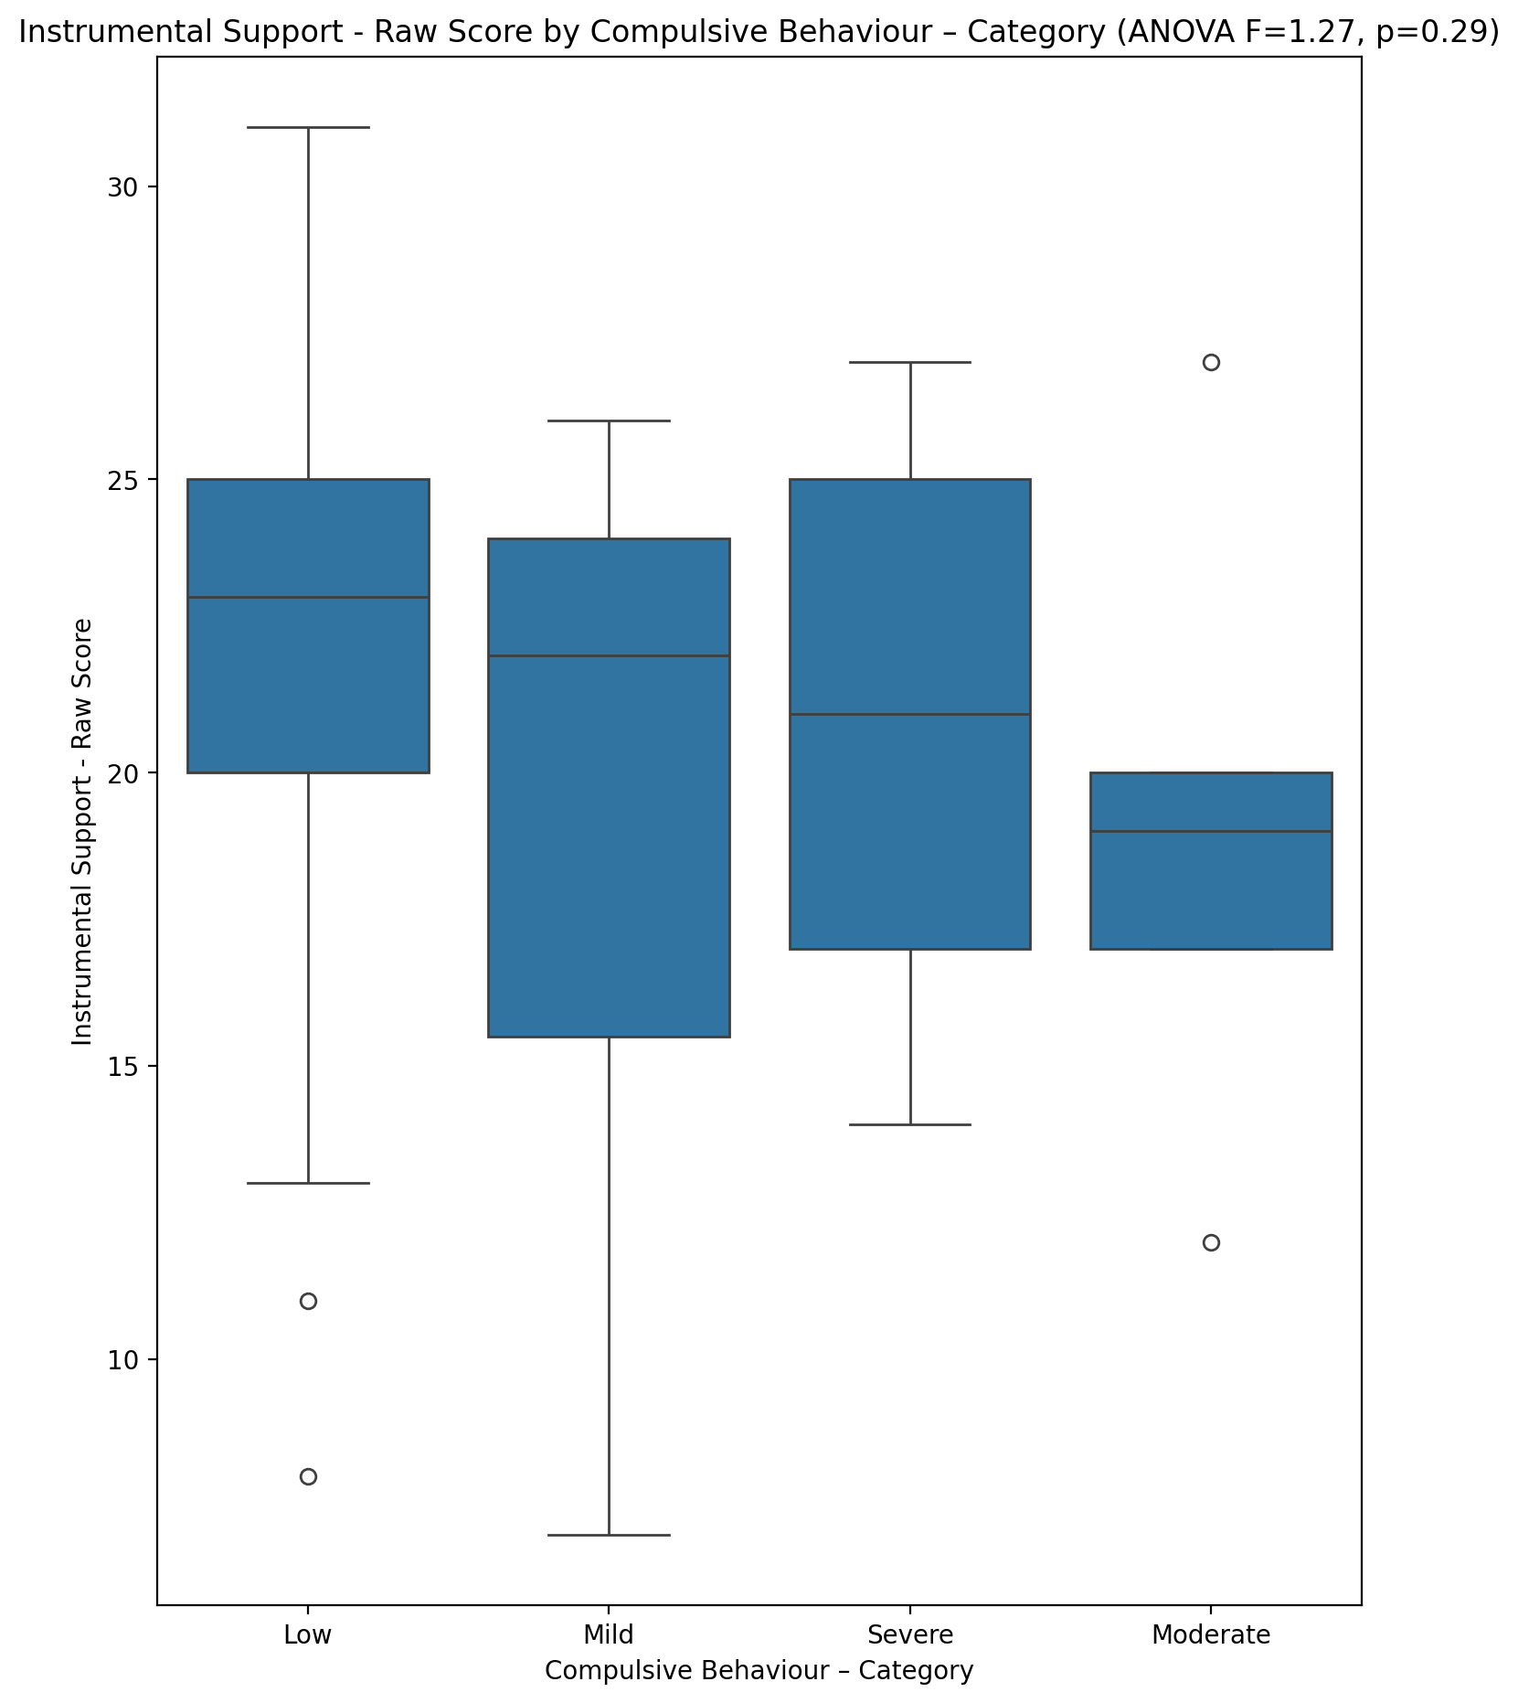

## Emotional Support - T Score vs Compulsive Behaviour – Category

Test: anova; statistic: 1.5718443485671612; p-value: 0.20658406148865013;

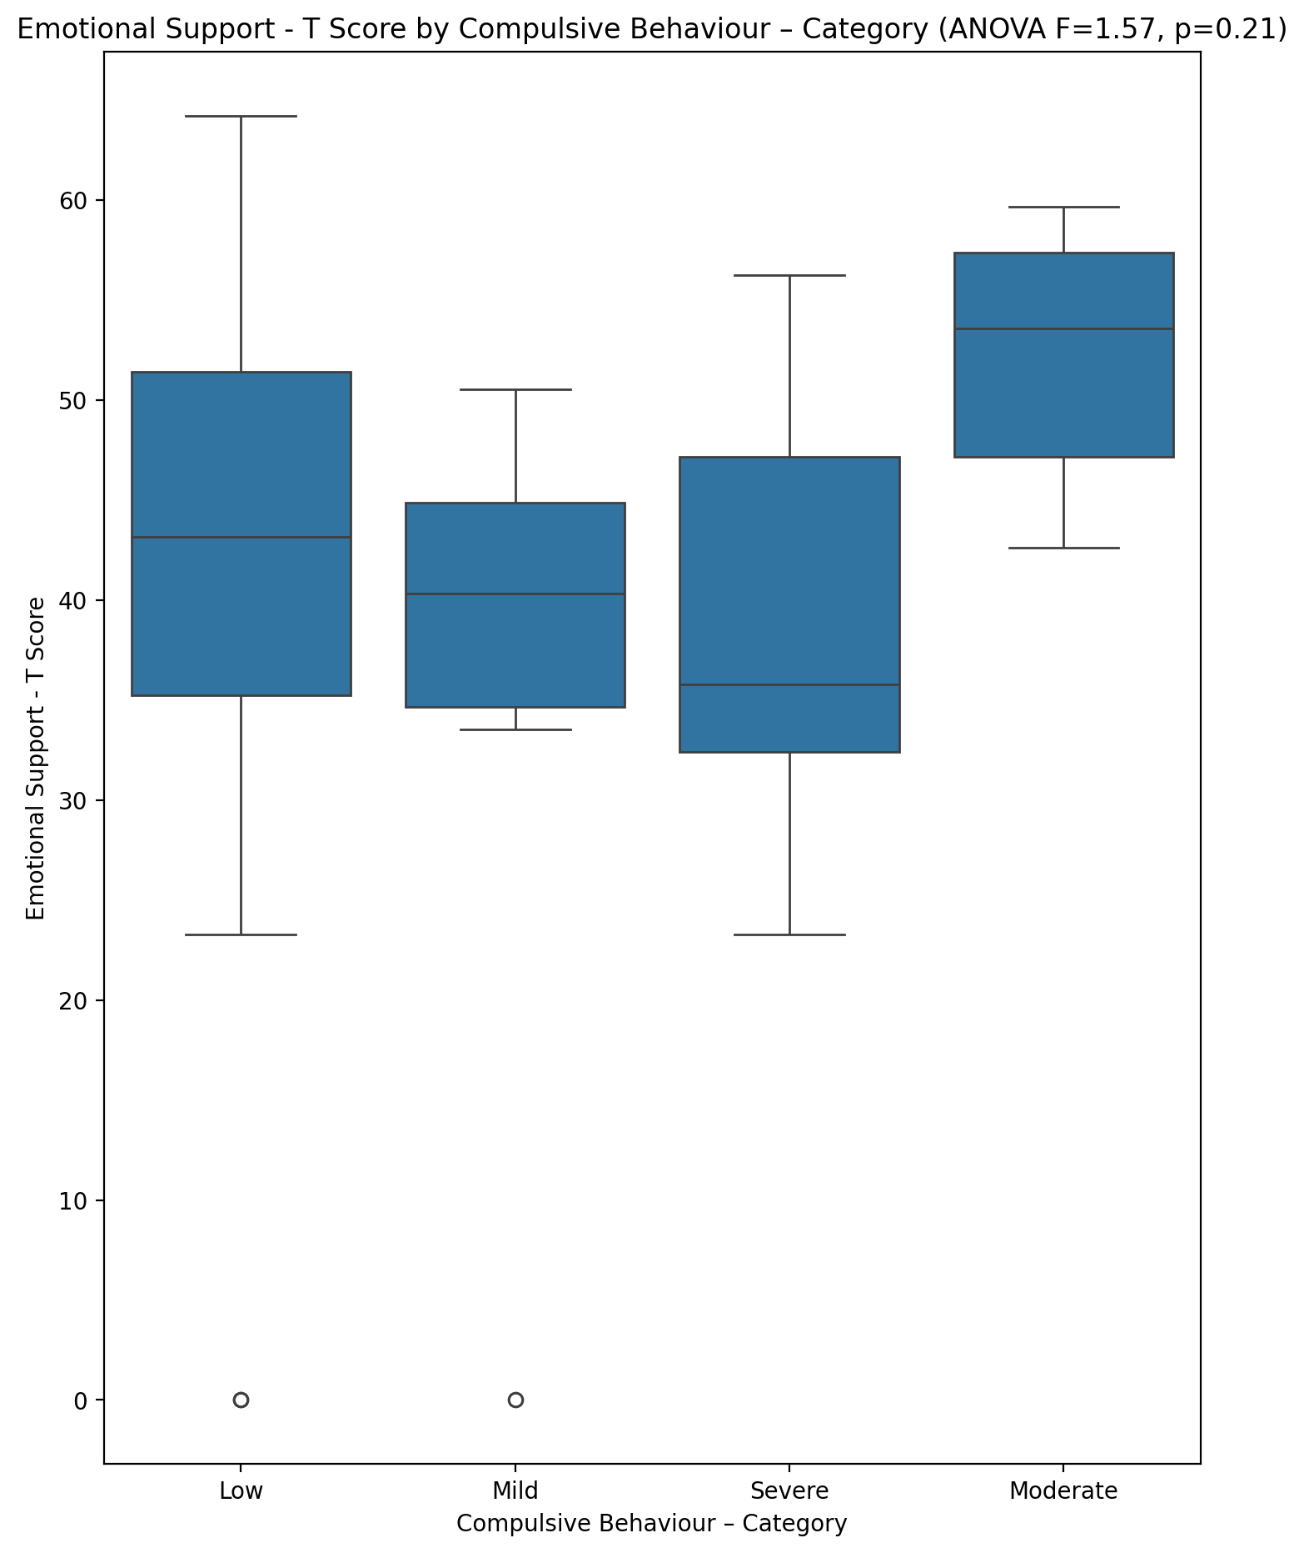

## Informational Support - T Score vs Compulsive Behaviour – Category

Test: anova; statistic: 0.7284123763252126; p-value: 0.5394293055600812;

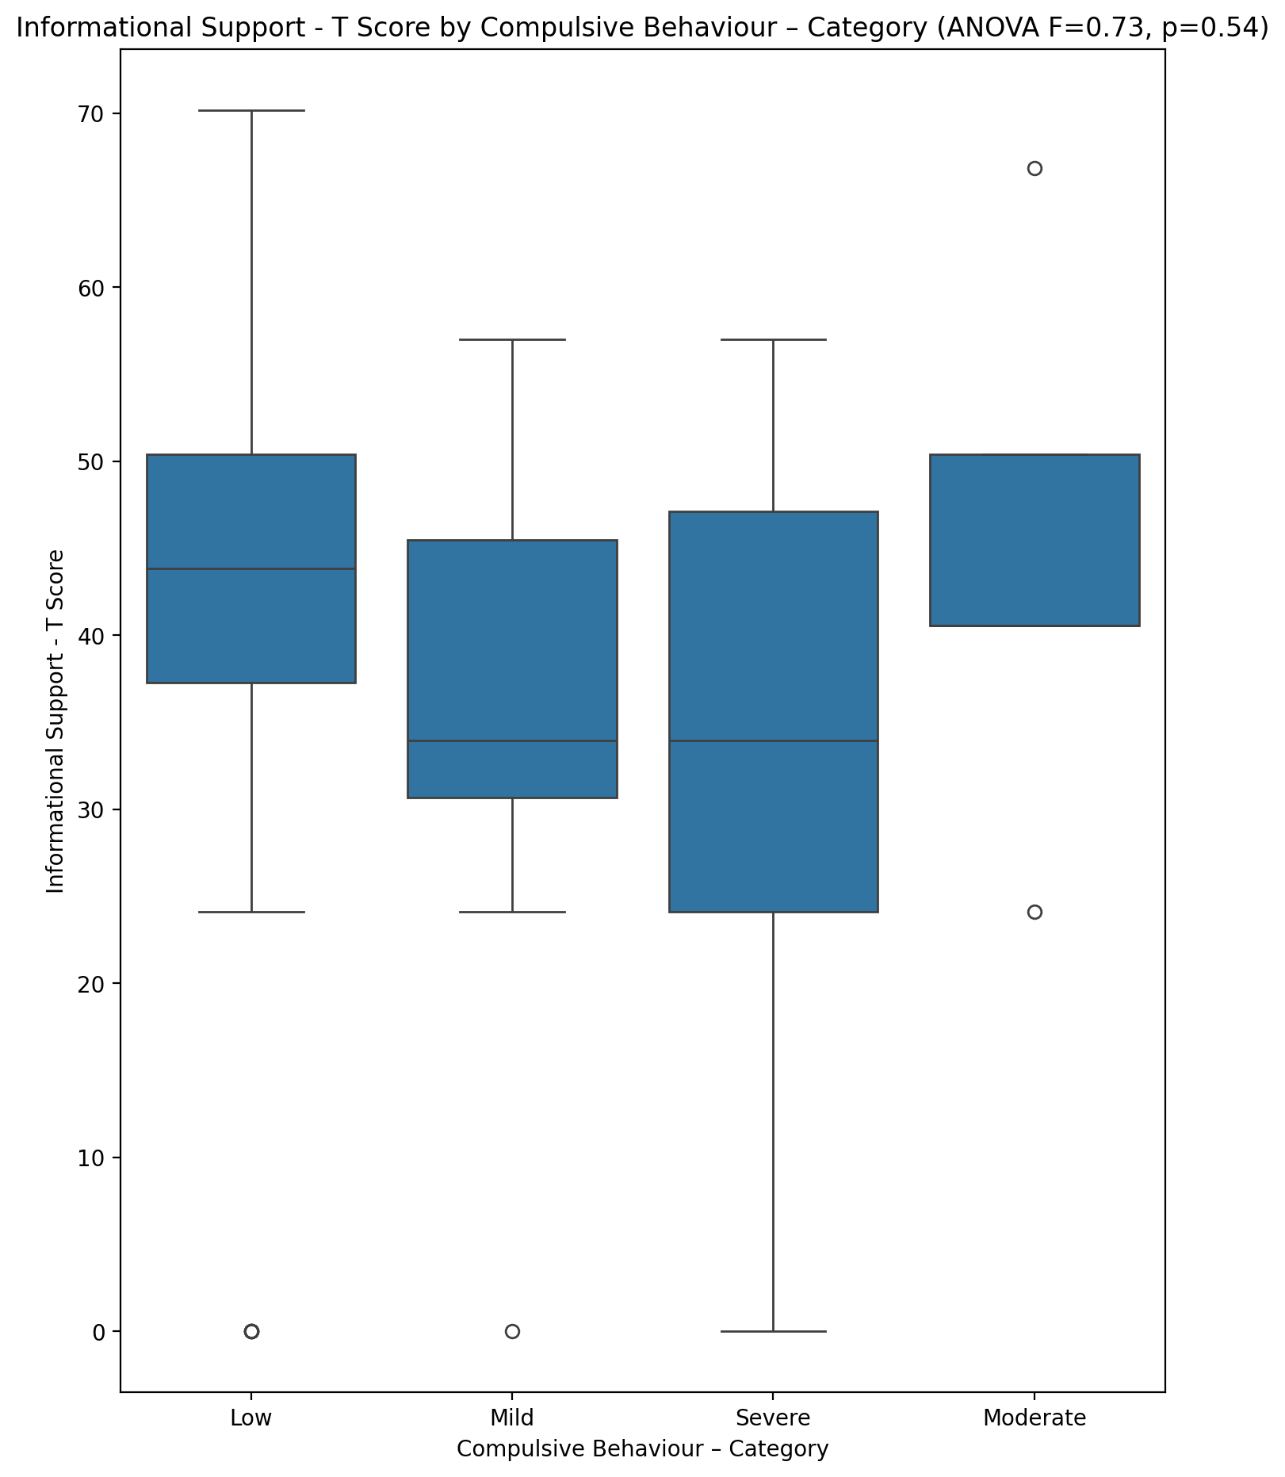

## Instrumental Support - T Score vs Compulsive Behaviour – Category

Test: anova; statistic: 1.0775526121366923; p-value: 0.36623296430420965;

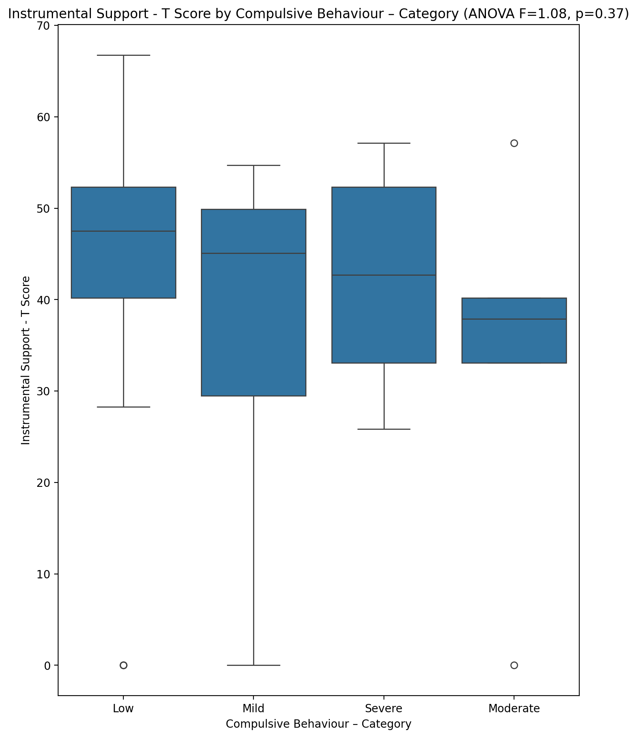

## Perceived Social Support Total T Score vs Compulsive Behaviour – Category

Test: anova; statistic: 1.088856741714749; p-value: 0.361555000463108;

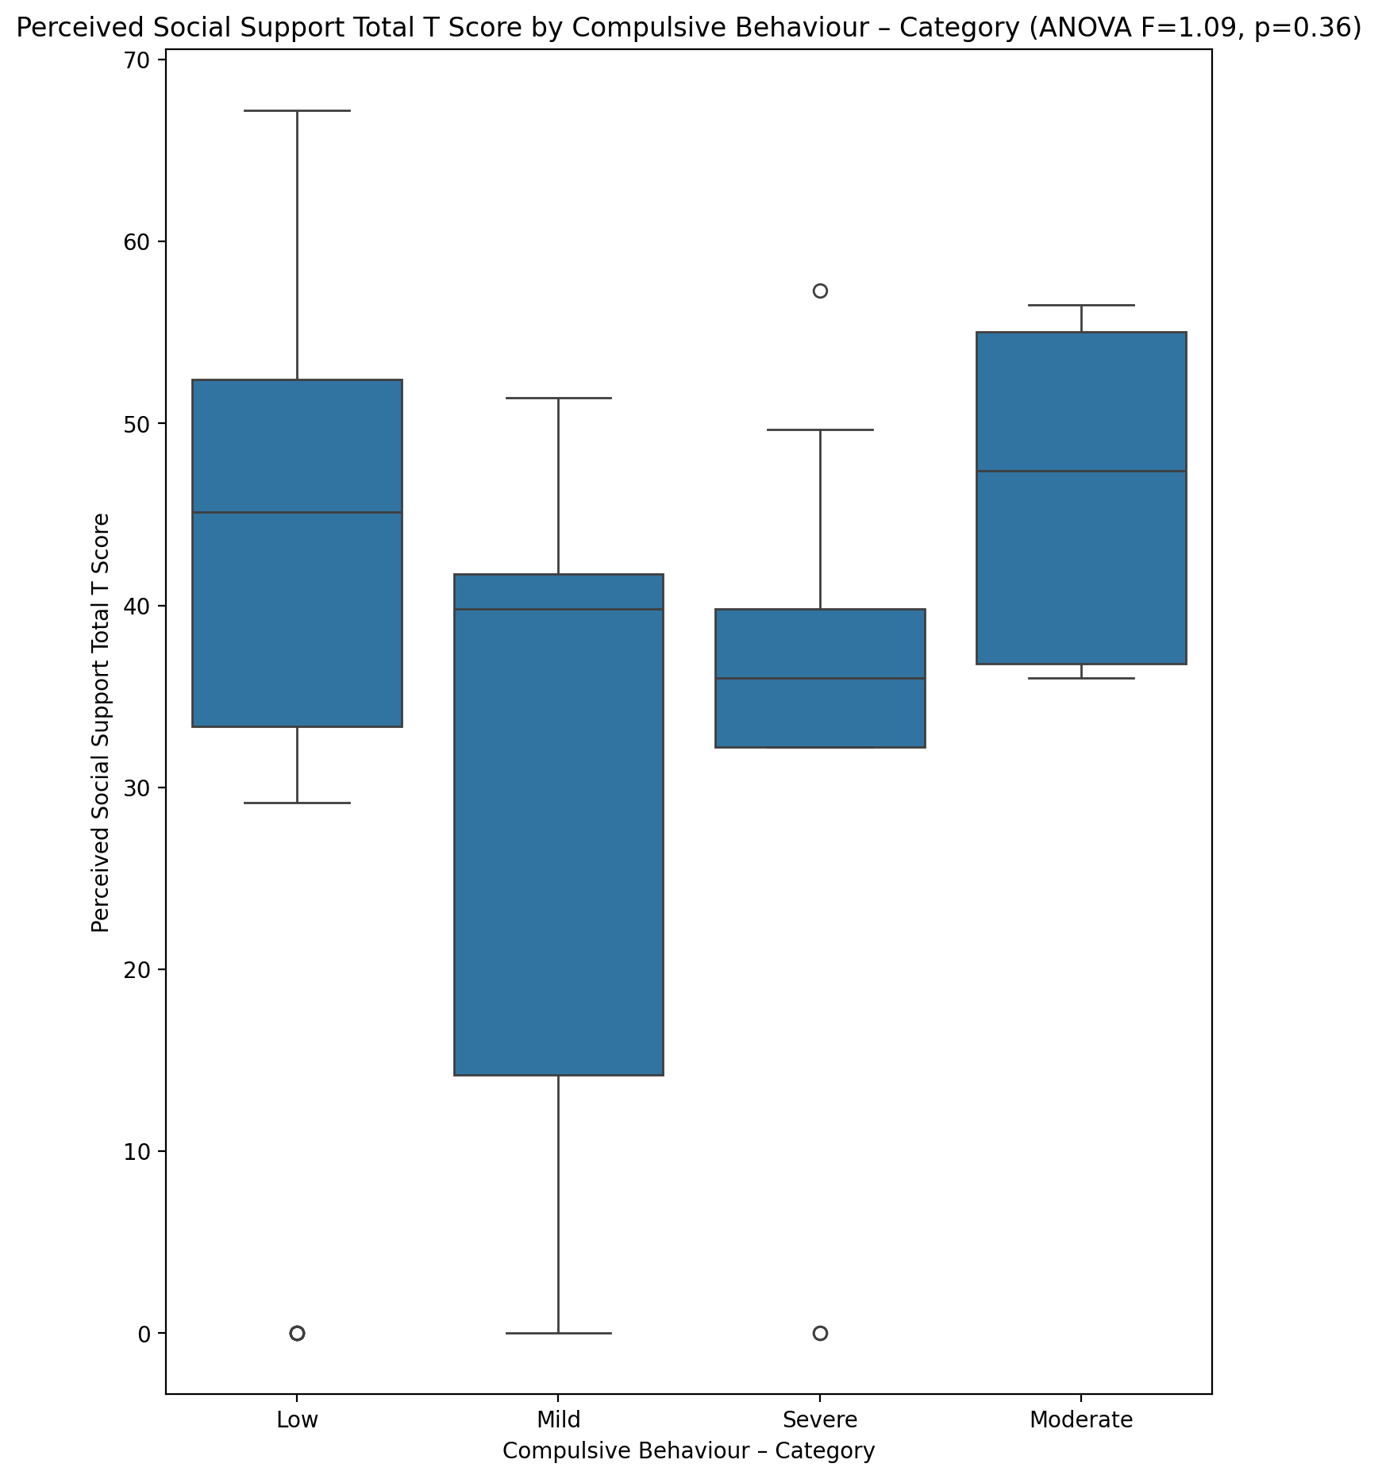

## Emotional Support - Rank vs Compulsive Behaviour – Category

Test: chi2; statistic: 8.797843291586608; p-value: 0.45614059651573935;

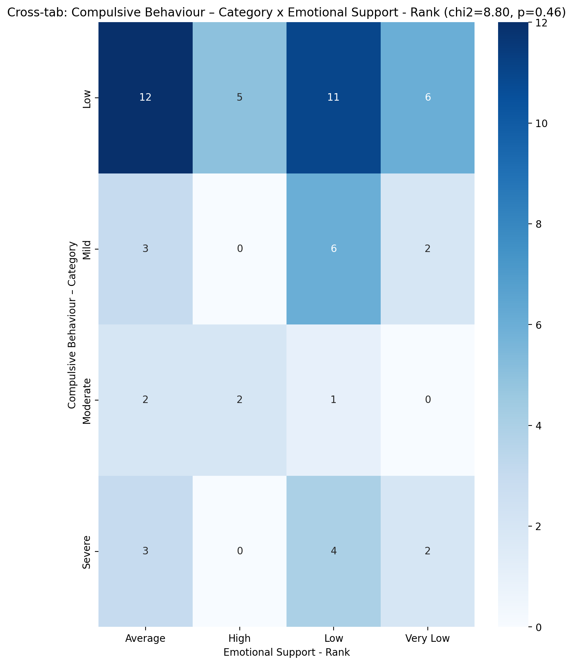

## Informational Support - Rank vs Compulsive Behaviour – Category

Test: chi2; statistic: 7.289453044375645; p-value: 0.8379075134919737;

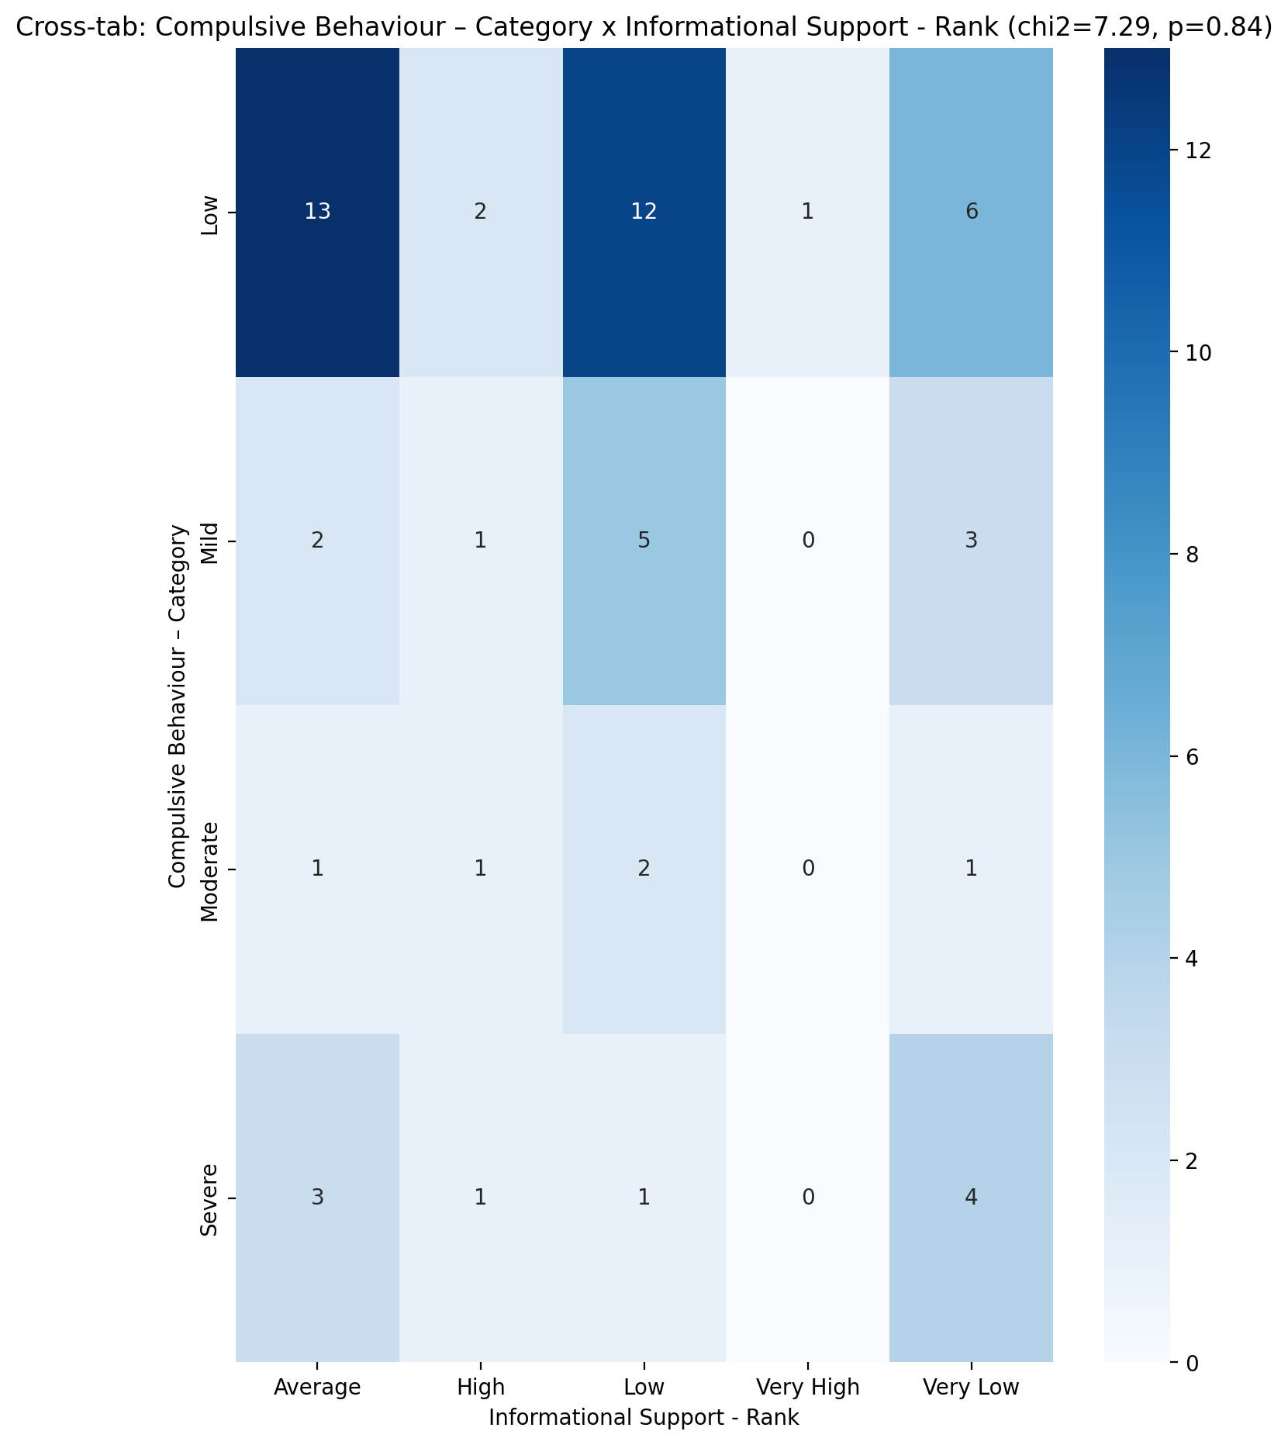

## Instrumental Support - Rank vs Compulsive Behaviour – Category

Test: chi2; statistic: 15.23619953031718; p-value: 0.08464897343007248;

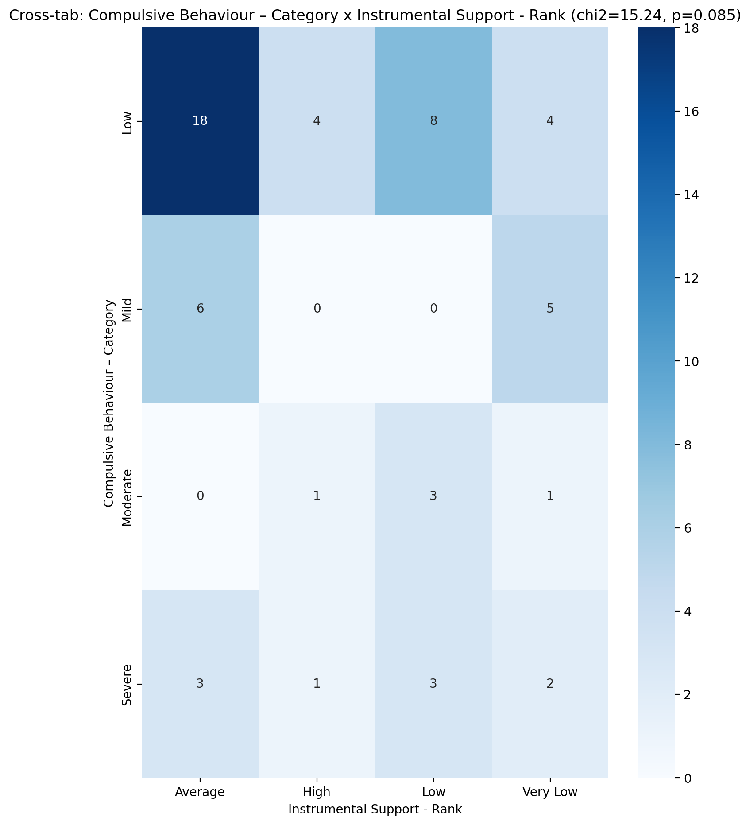

## Perceived Social Support TOTAL - Rank vs Compulsive Behaviour – Category

Test: chi2; statistic: 10.807420835255058; p-value: 0.28914064531815065;

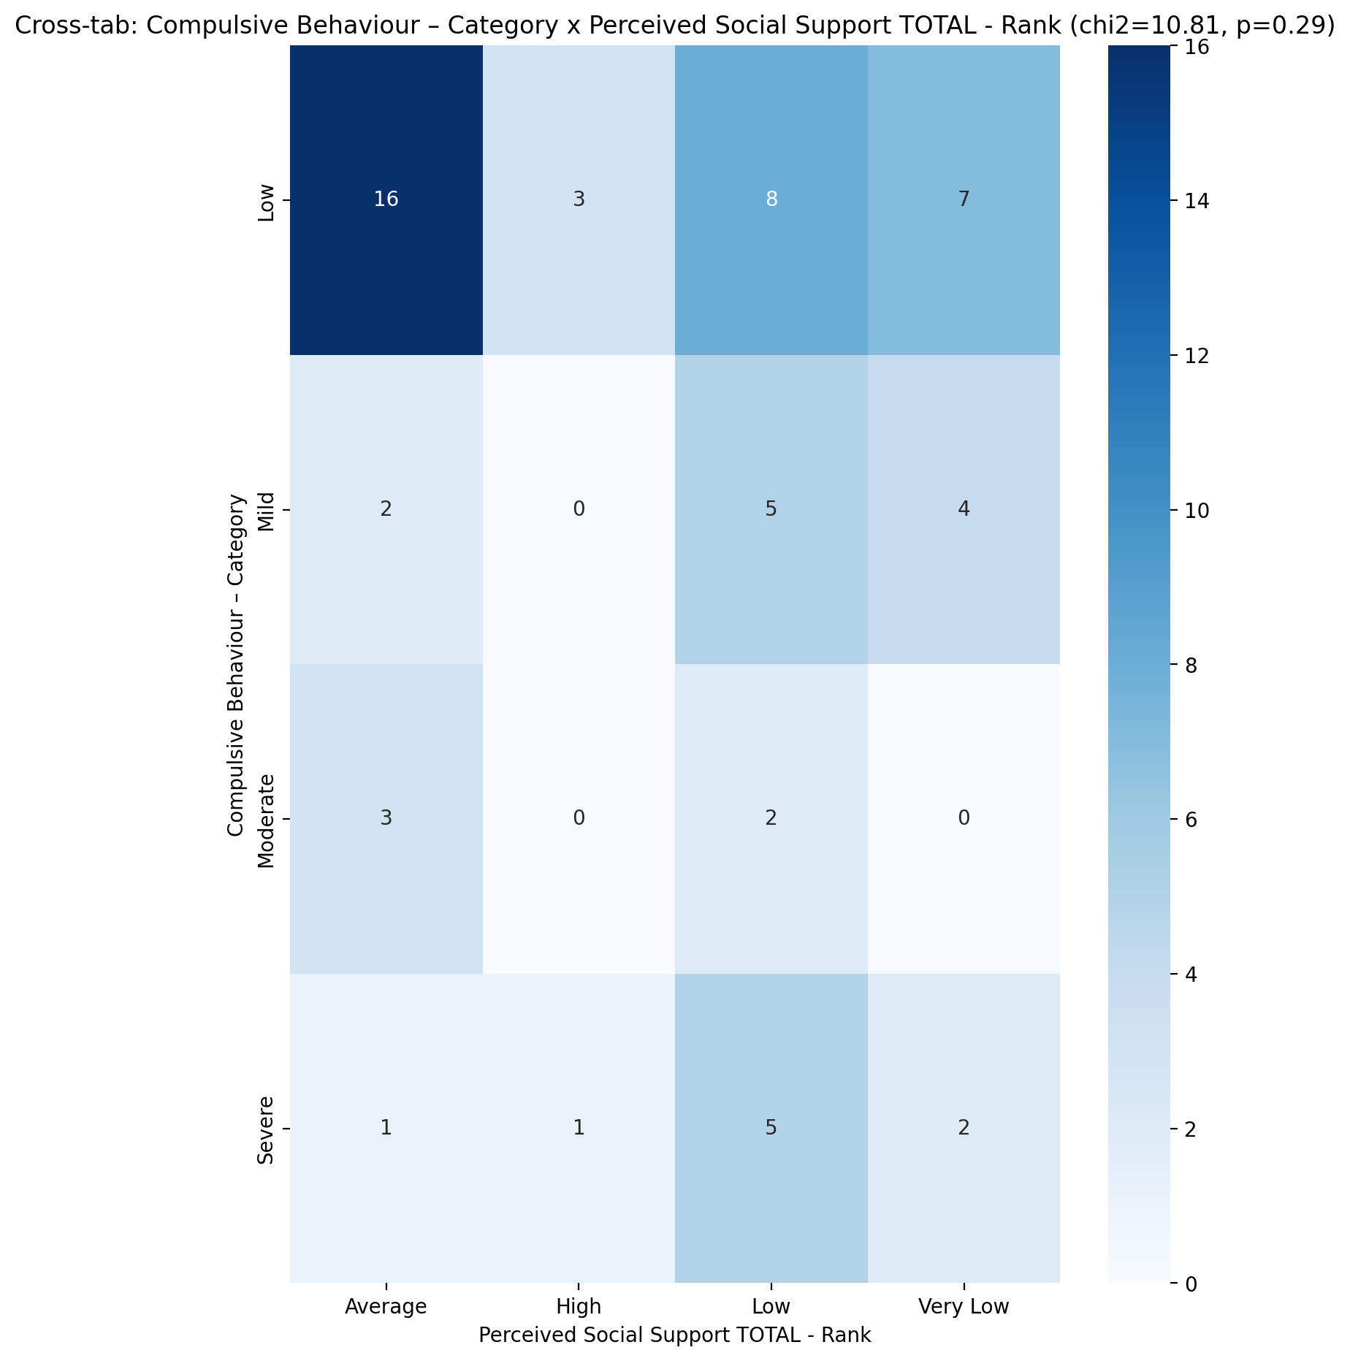

## Power Self Concept - Real Self Concept Score vs Compulsive Behaviour – Category

Test: anova; statistic: 5.4049437977452754; p-value: 0.002482090387537735;

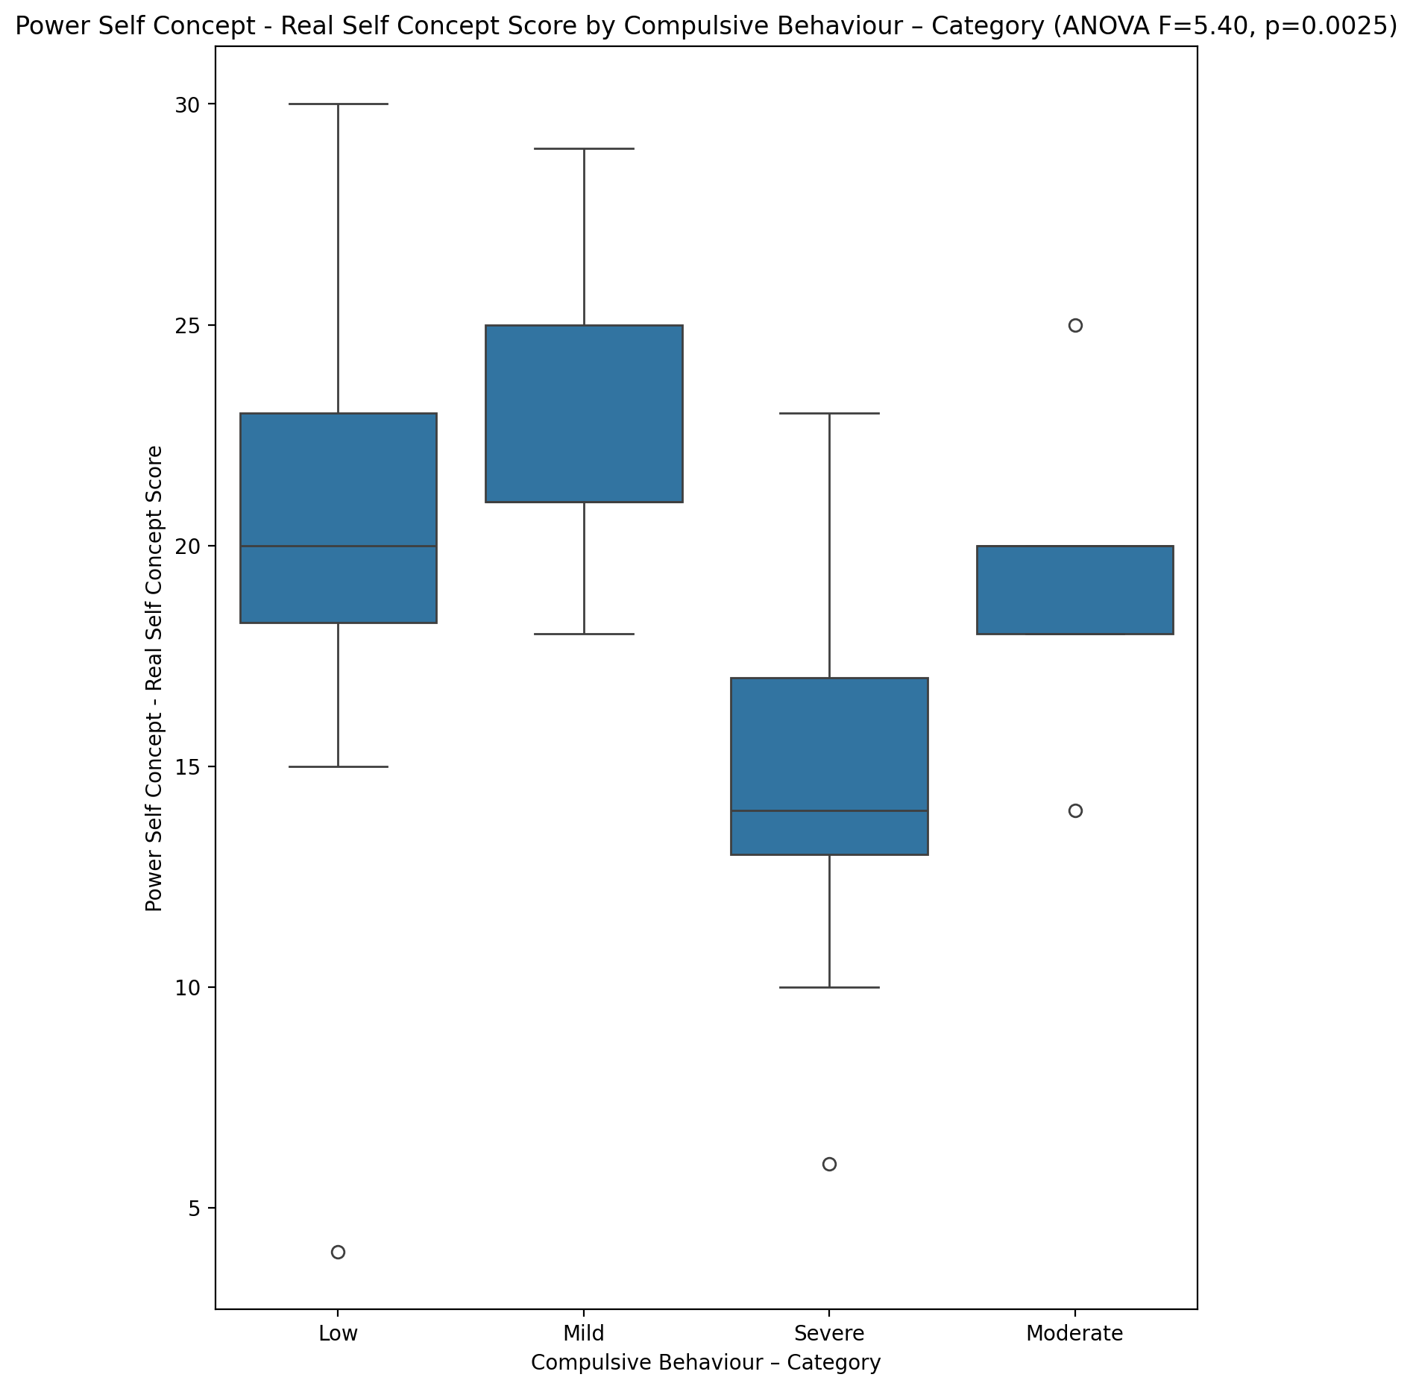

## Power Self Concept - Ideal Self Concept score vs Compulsive Behaviour – Category

Test: anova; statistic: 6.624258937687526; p-value: 0.0006695128933196515;

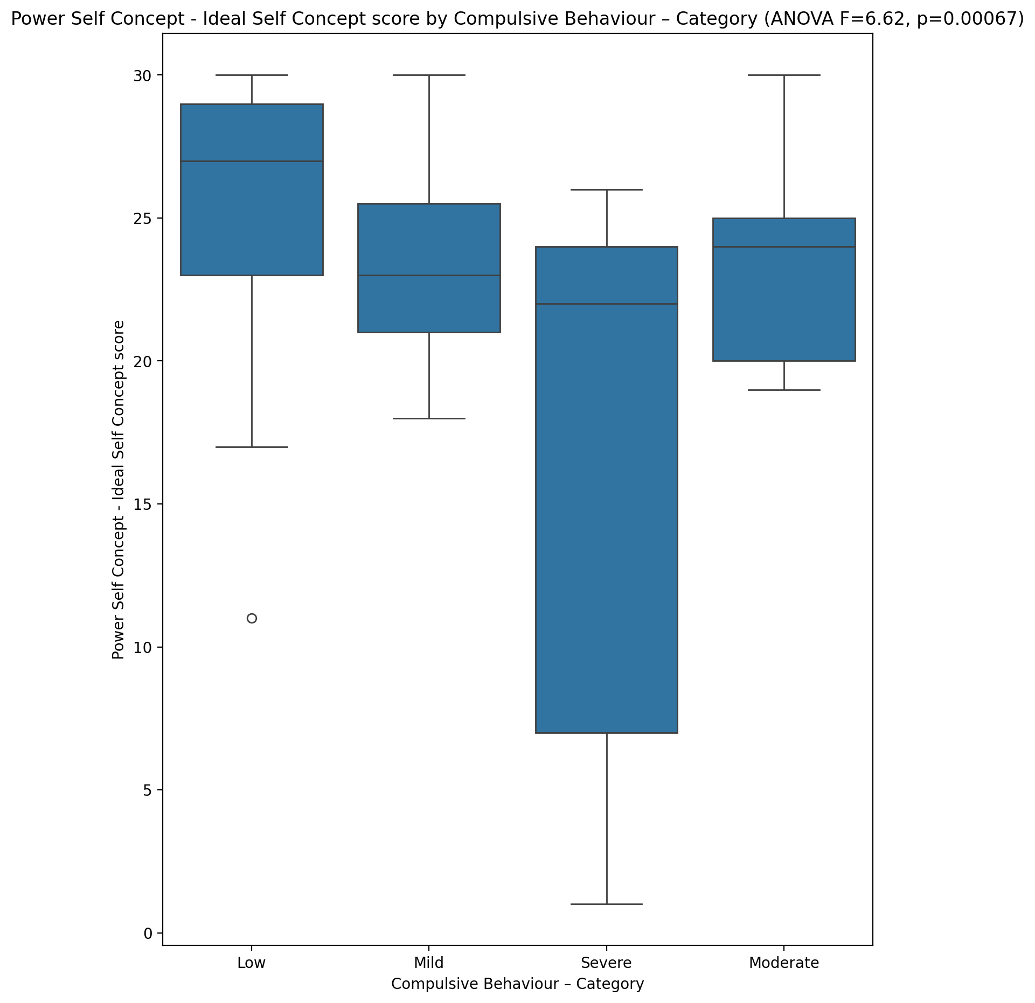

## Power Self Concept – Social Self Concept Score vs Compulsive Behaviour – Category

Test: anova; statistic: 4.22062710632611; p-value: 0.009323018105284027;

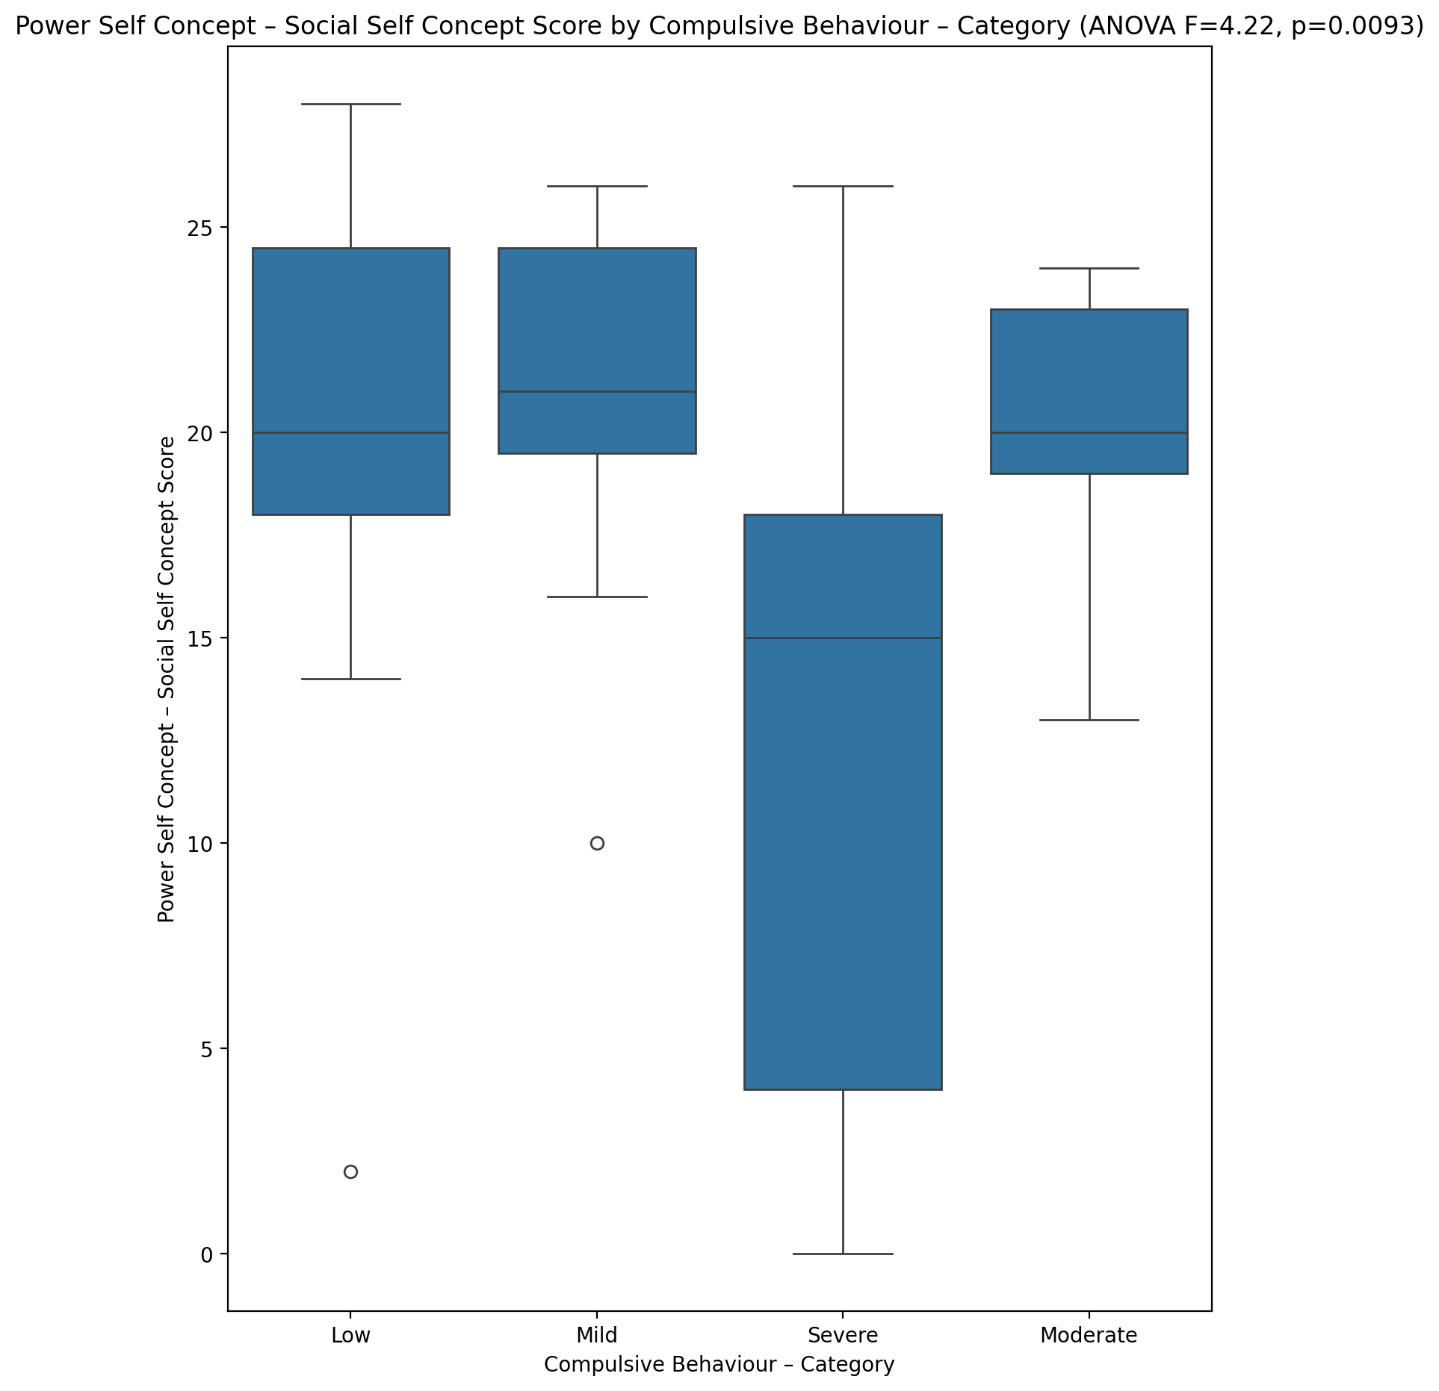

## Social Self Concept - Real Self Concept Score vs Compulsive Behaviour – Category

Test: anova; statistic: 3.988590671482349; p-value: 0.012151092622747755;

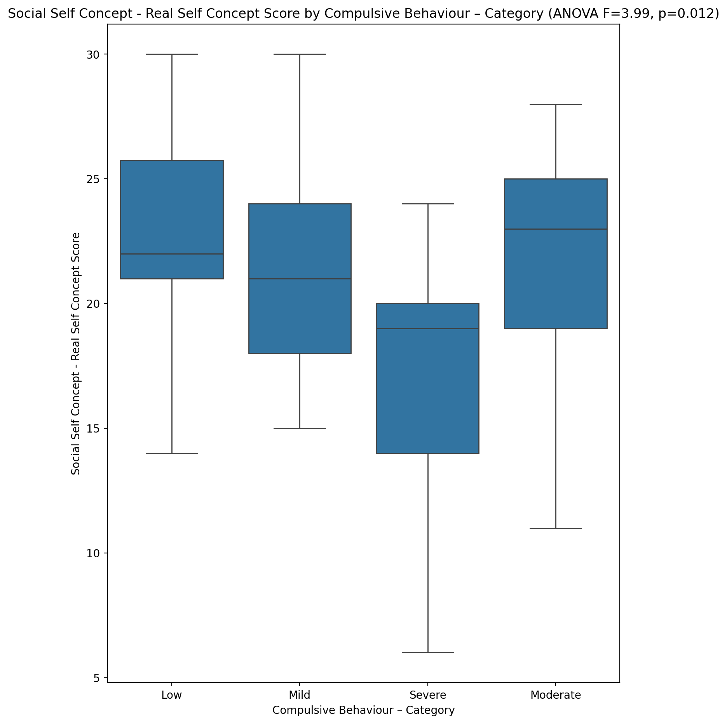

## Social Self Concept – Social Self Concept Score vs Compulsive Behaviour – Category

Test: anova; statistic: 6.309954231120238; p-value: 0.0009337668512515562;

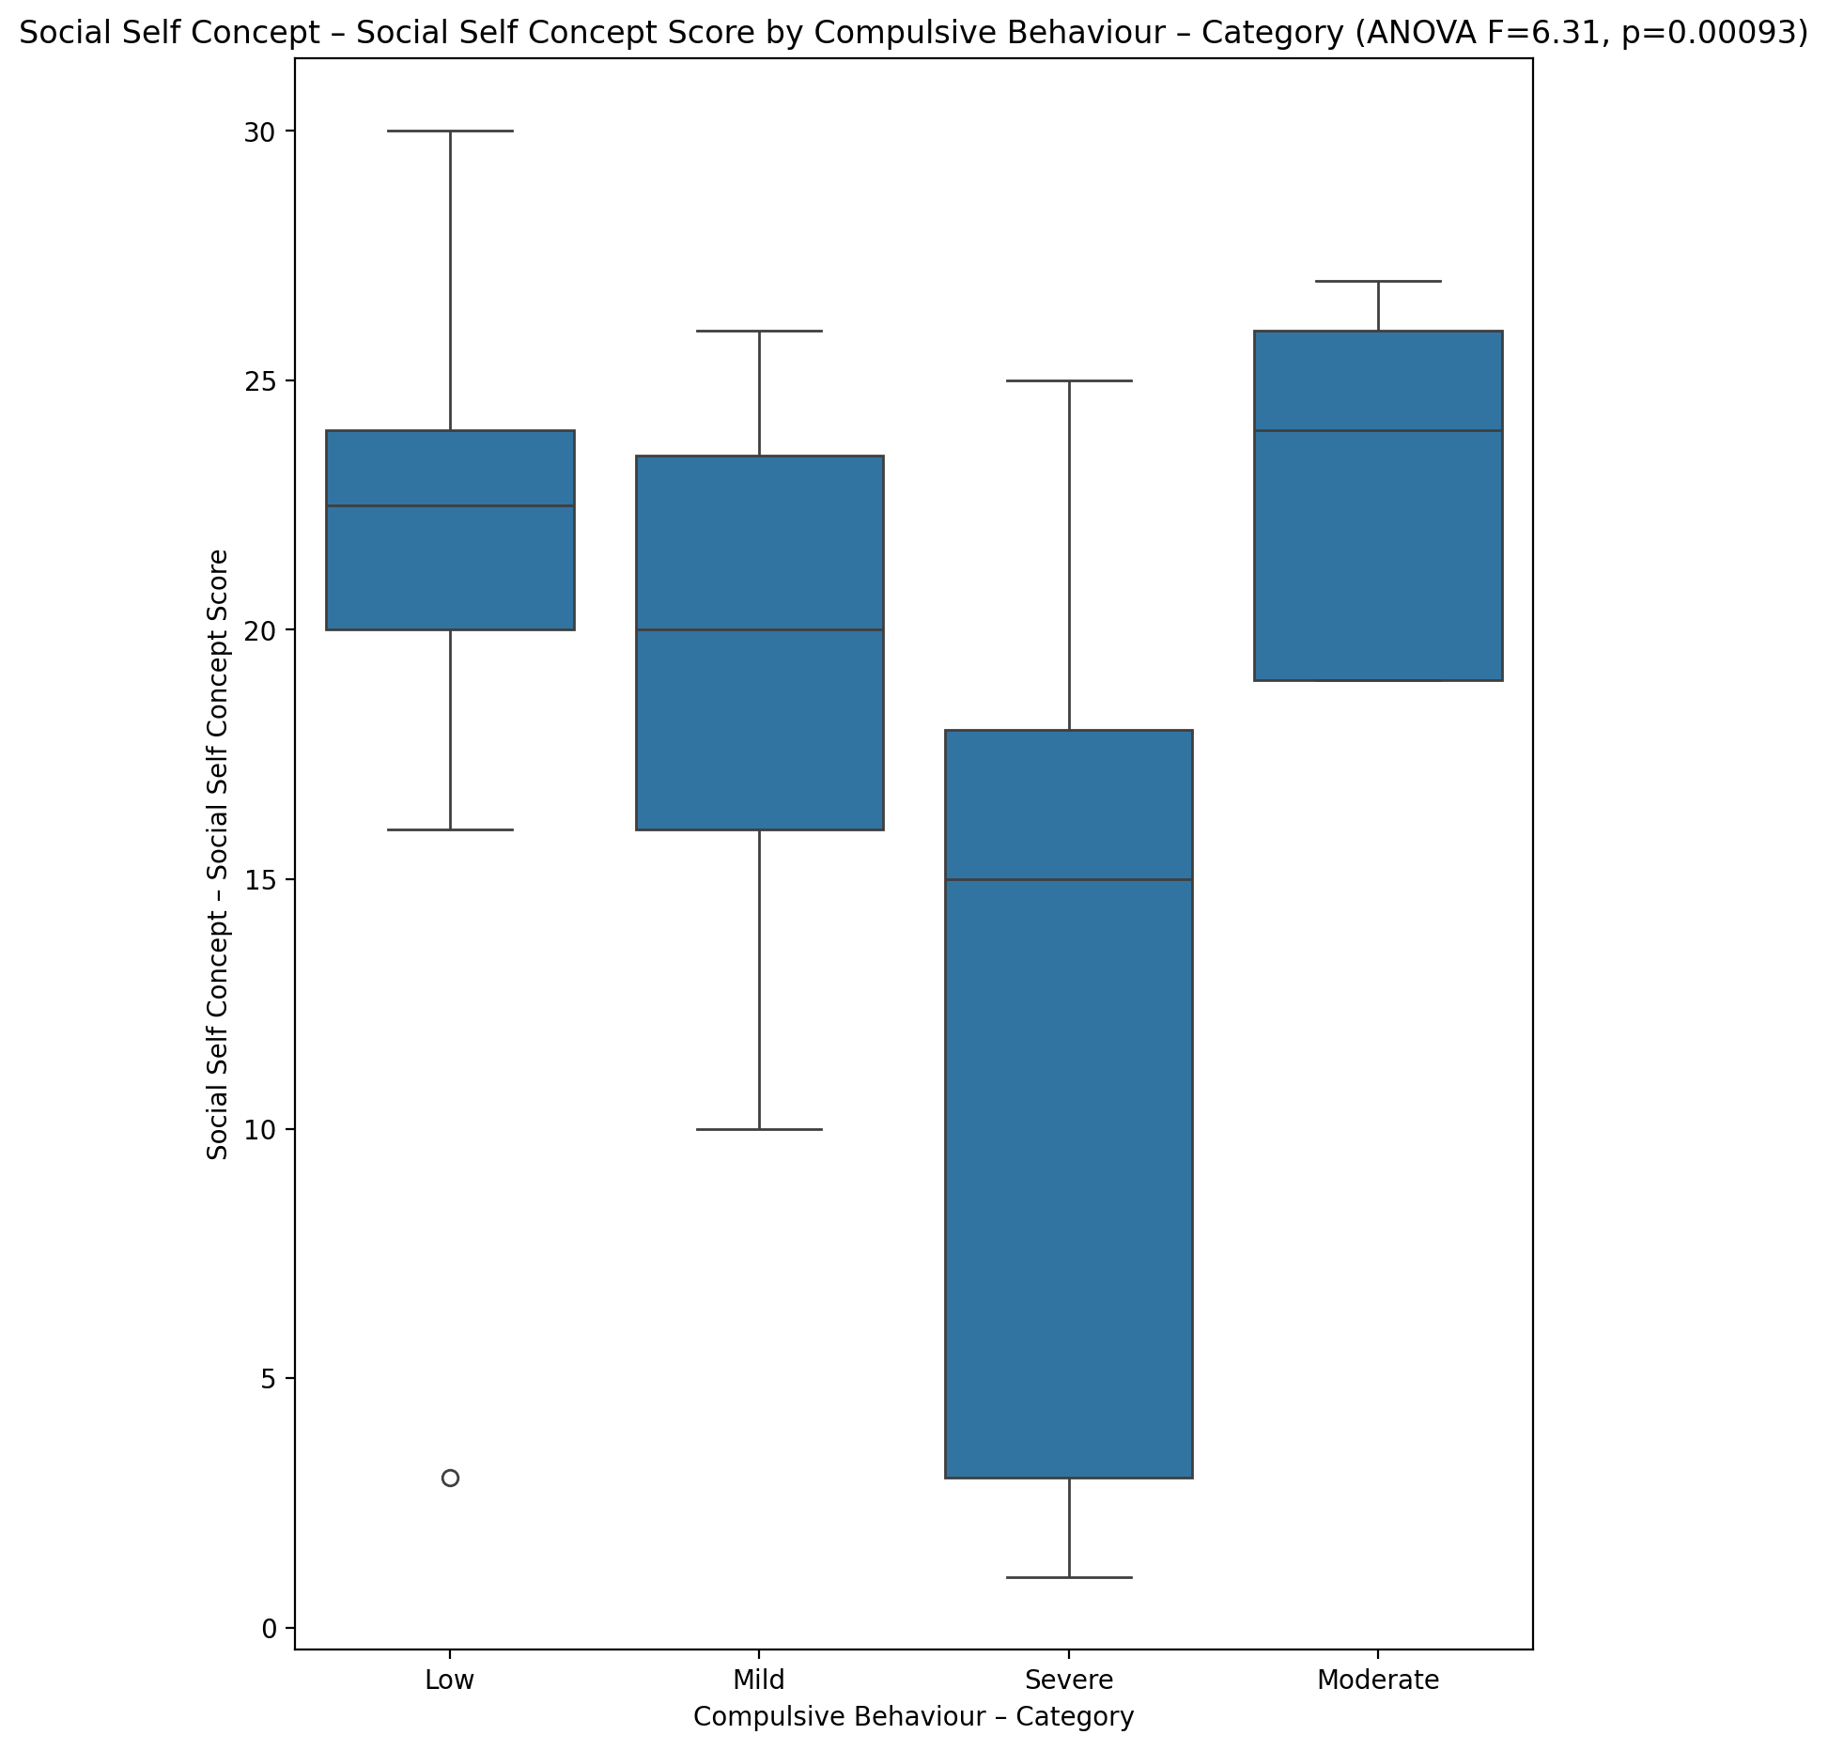

## Ability Self Concept - Real Self Concept Score vs Compulsive Behaviour – Category

Test: anova; statistic: 4.4551695371068405; p-value: 0.007145784087025827;

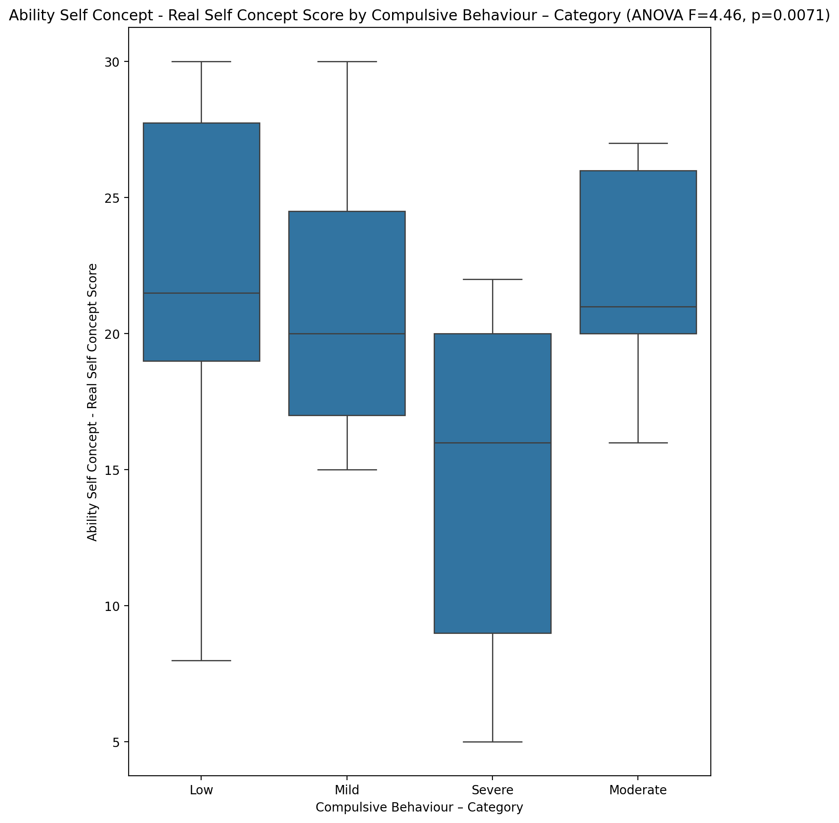

## Ability Self Concept - Ideal Self Concept Score vs Compulsive Behaviour – Category

Test: anova; statistic: 3.9582058723206757; p-value: 0.01258168220761784;

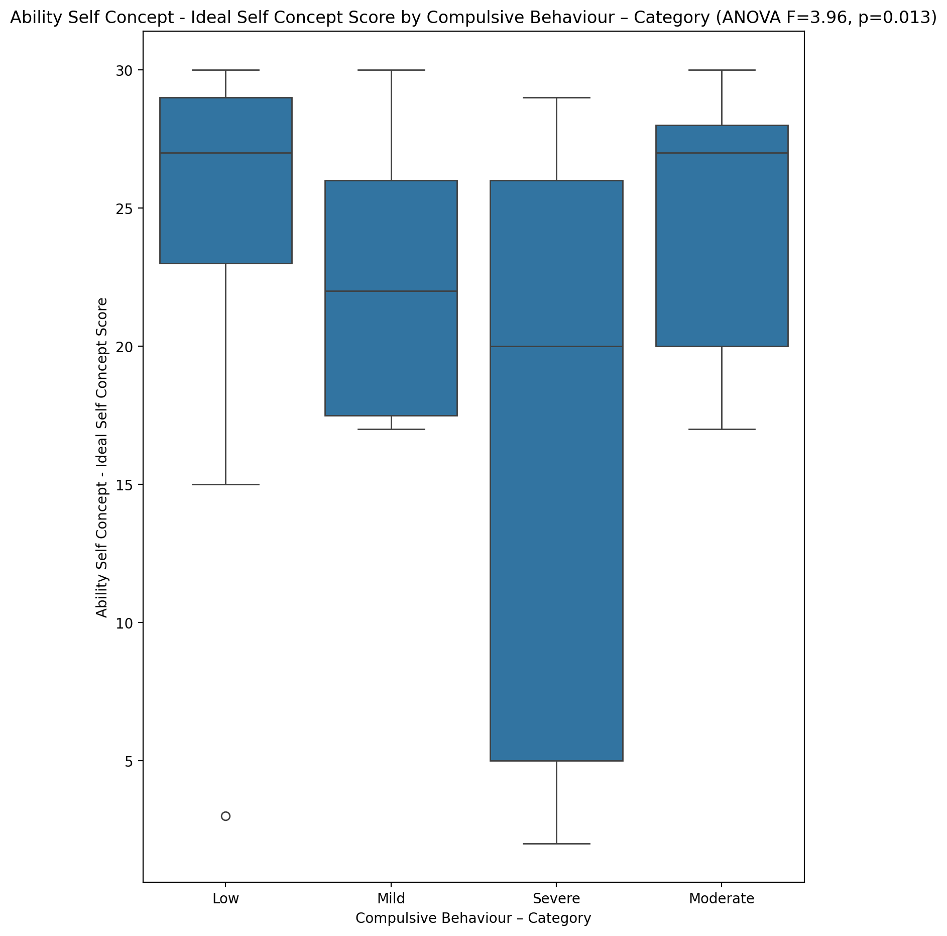

## Ability Self Concept – Social Self Concept Score vs Compulsive Behaviour – Category

Test: anova; statistic: 5.786155088590618; p-value: 0.001638401534061355;

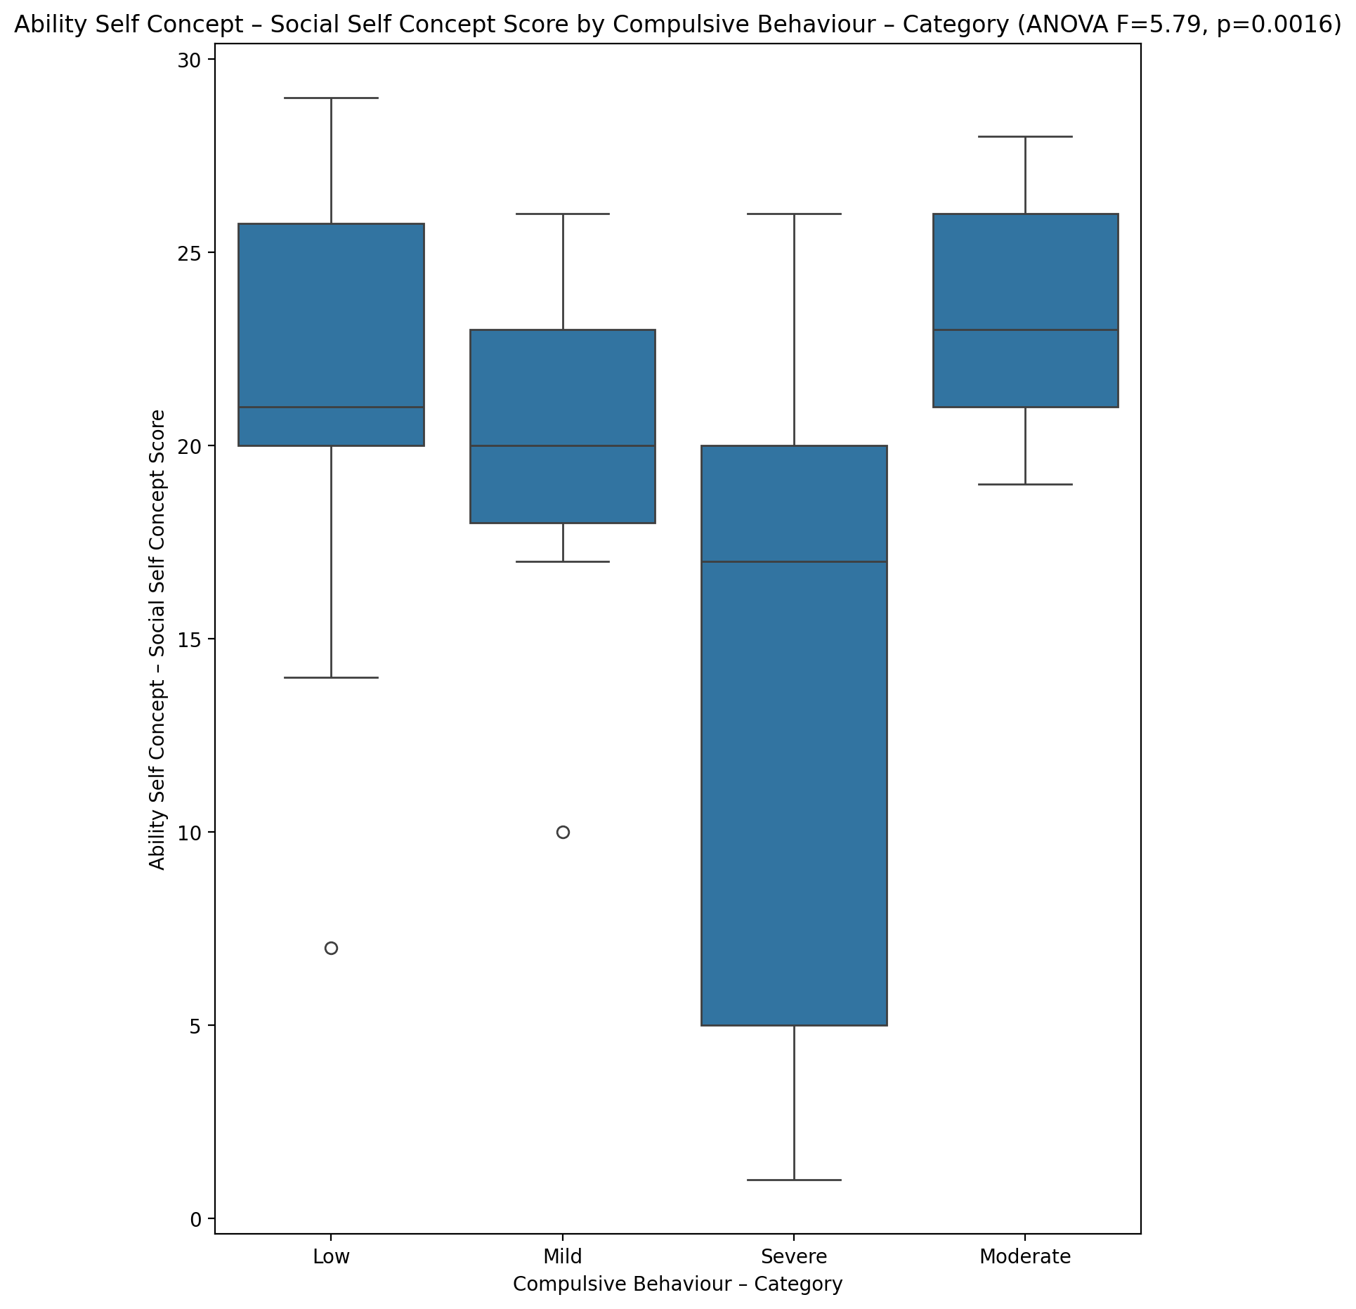

## Physical Self Concept - Real Self Concept Score vs Compulsive Behaviour – Category

Test: anova; statistic: 3.0401356775295; p-value: 0.03650517921842189;

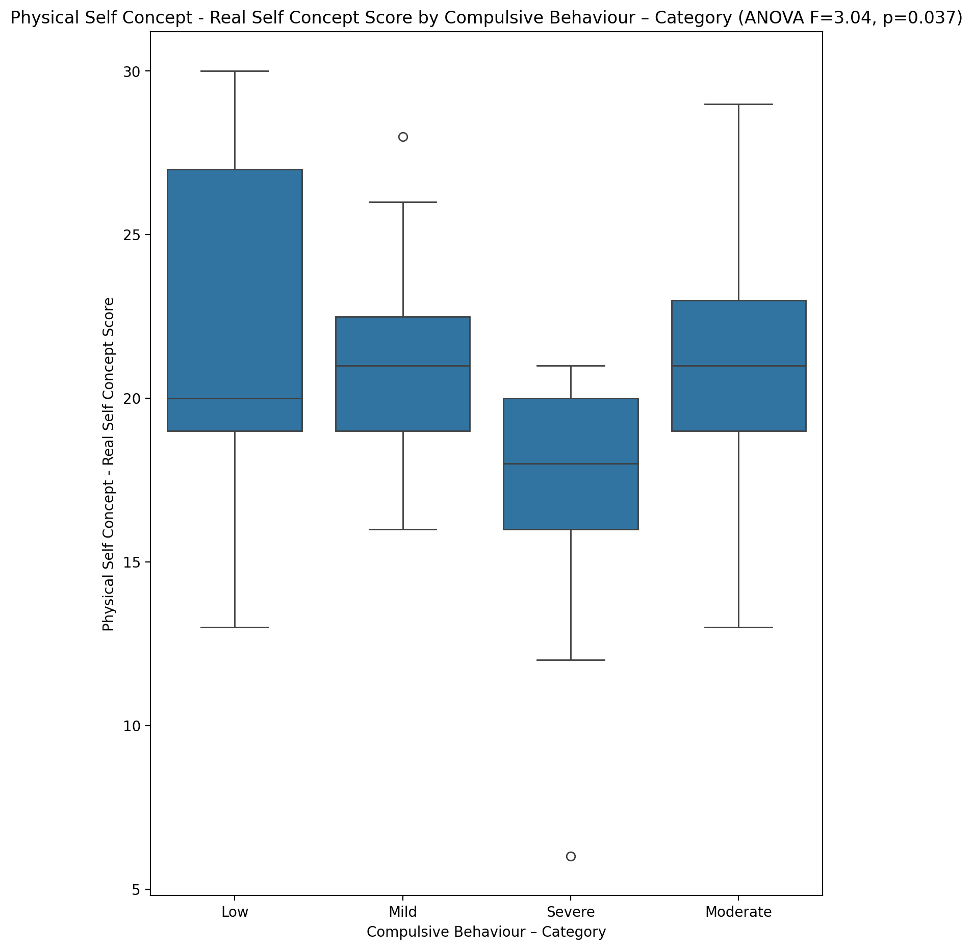

## Physical Self Concept – Ideal Self Concept Score vs Compulsive Behaviour – Category

Test: anova; statistic: 3.883595177562323; p-value: 0.013706582388585074;

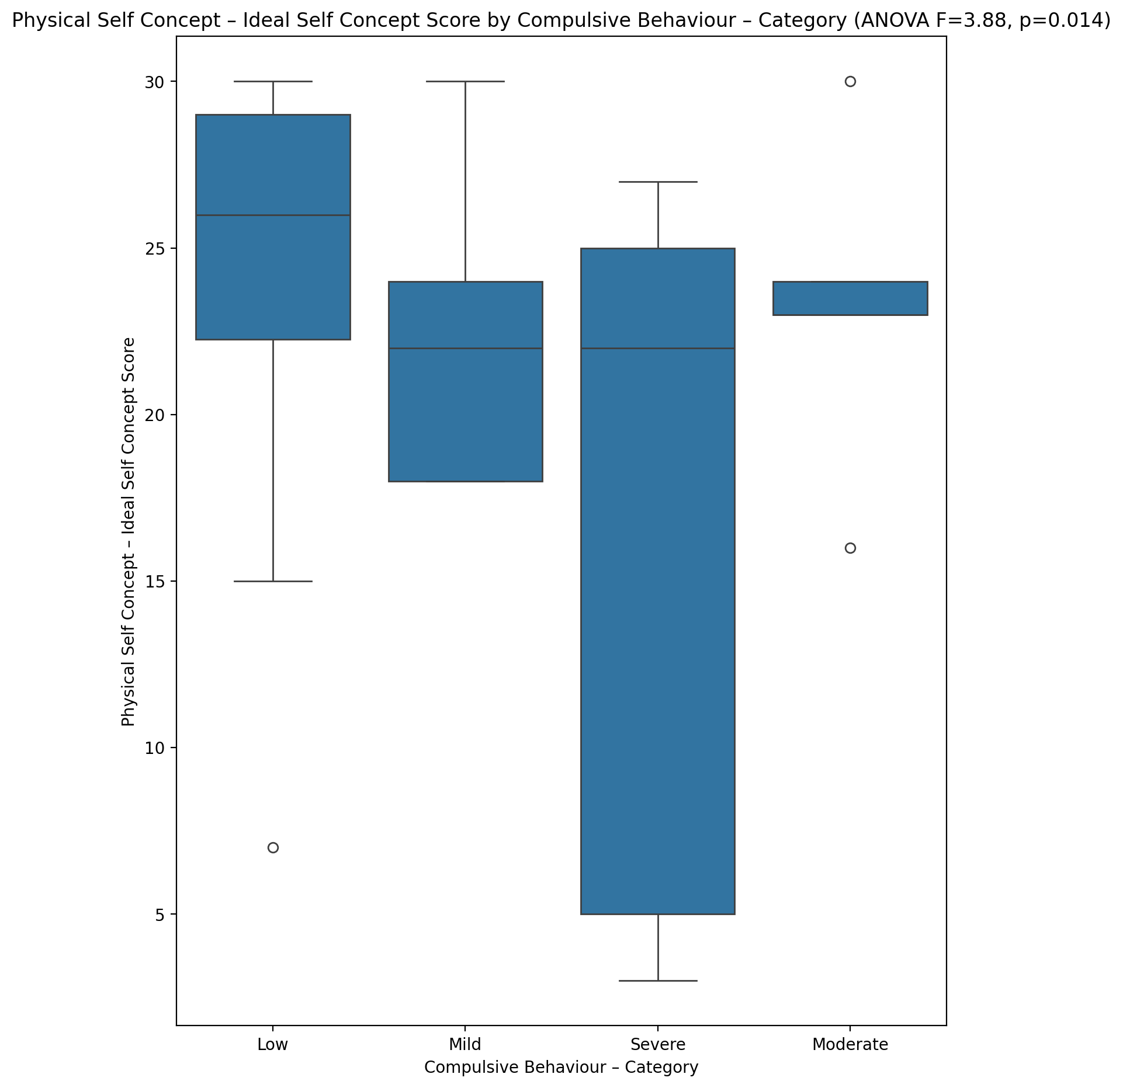

## Physical Self Concept – Social Self Concept Score vs Compulsive Behaviour – Category

Test: anova; statistic: 5.170903213389273; p-value: 0.0032113757159414366;

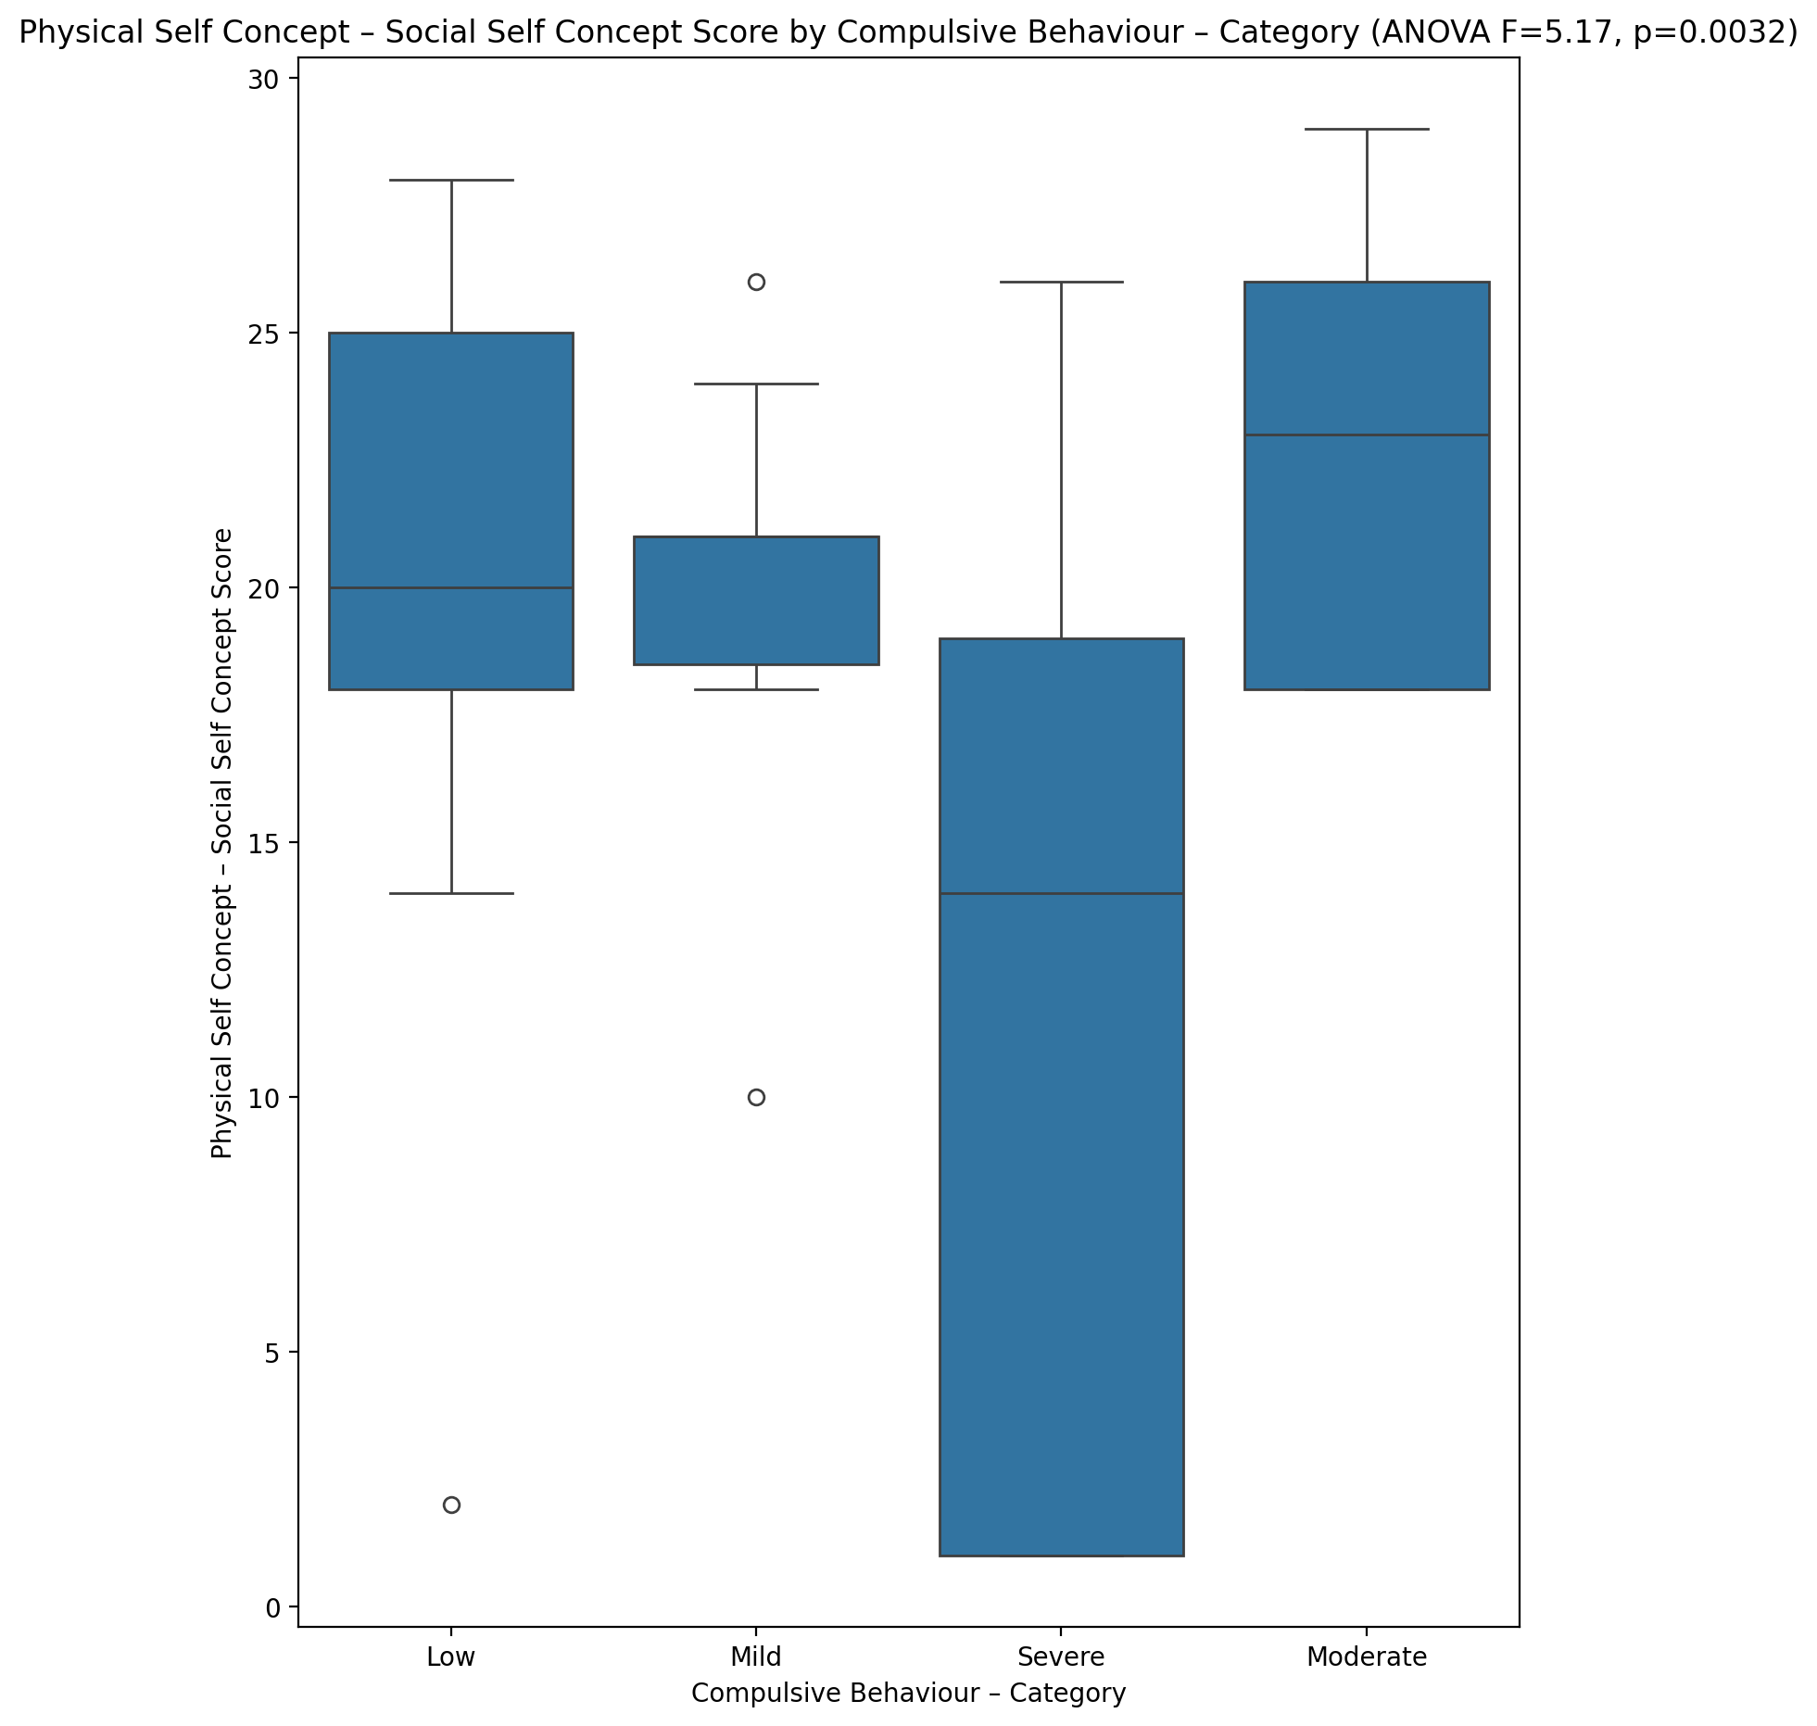

## Psychological Self Concept - Real Self Concept Score vs Compulsive Behaviour – Category

Test: anova; statistic: 6.350317254720497; p-value: 0.0008945384218054073;

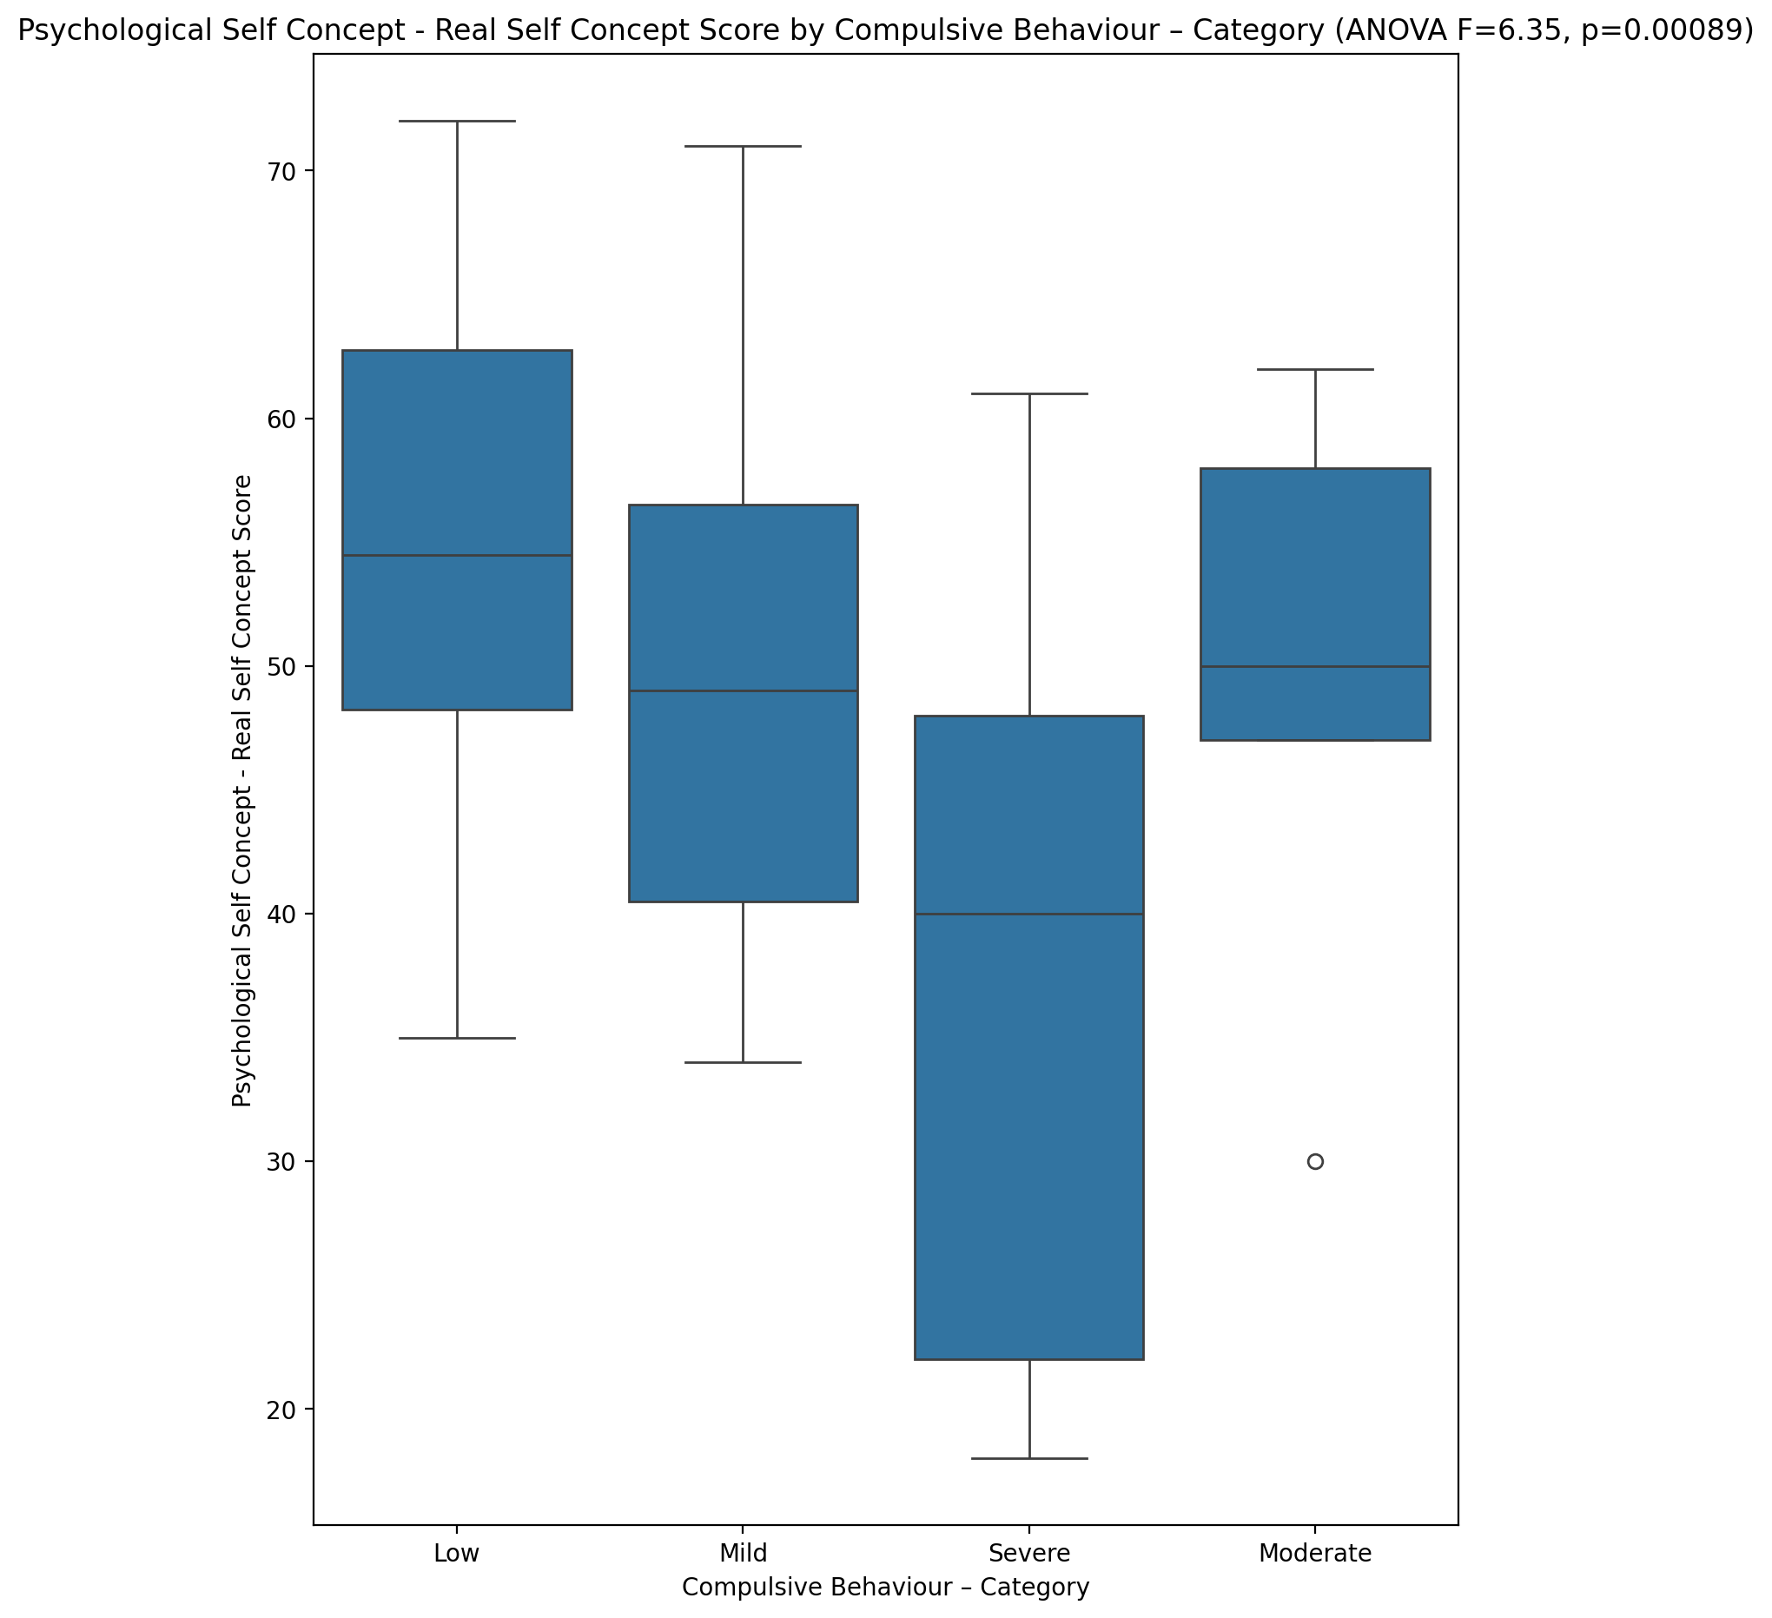

## Psychological Self Concept – Ideal Self Concept Score vs Compulsive Behaviour – Category

Test: anova; statistic: 3.4707506896963647; p-value: 0.02208352558094015;

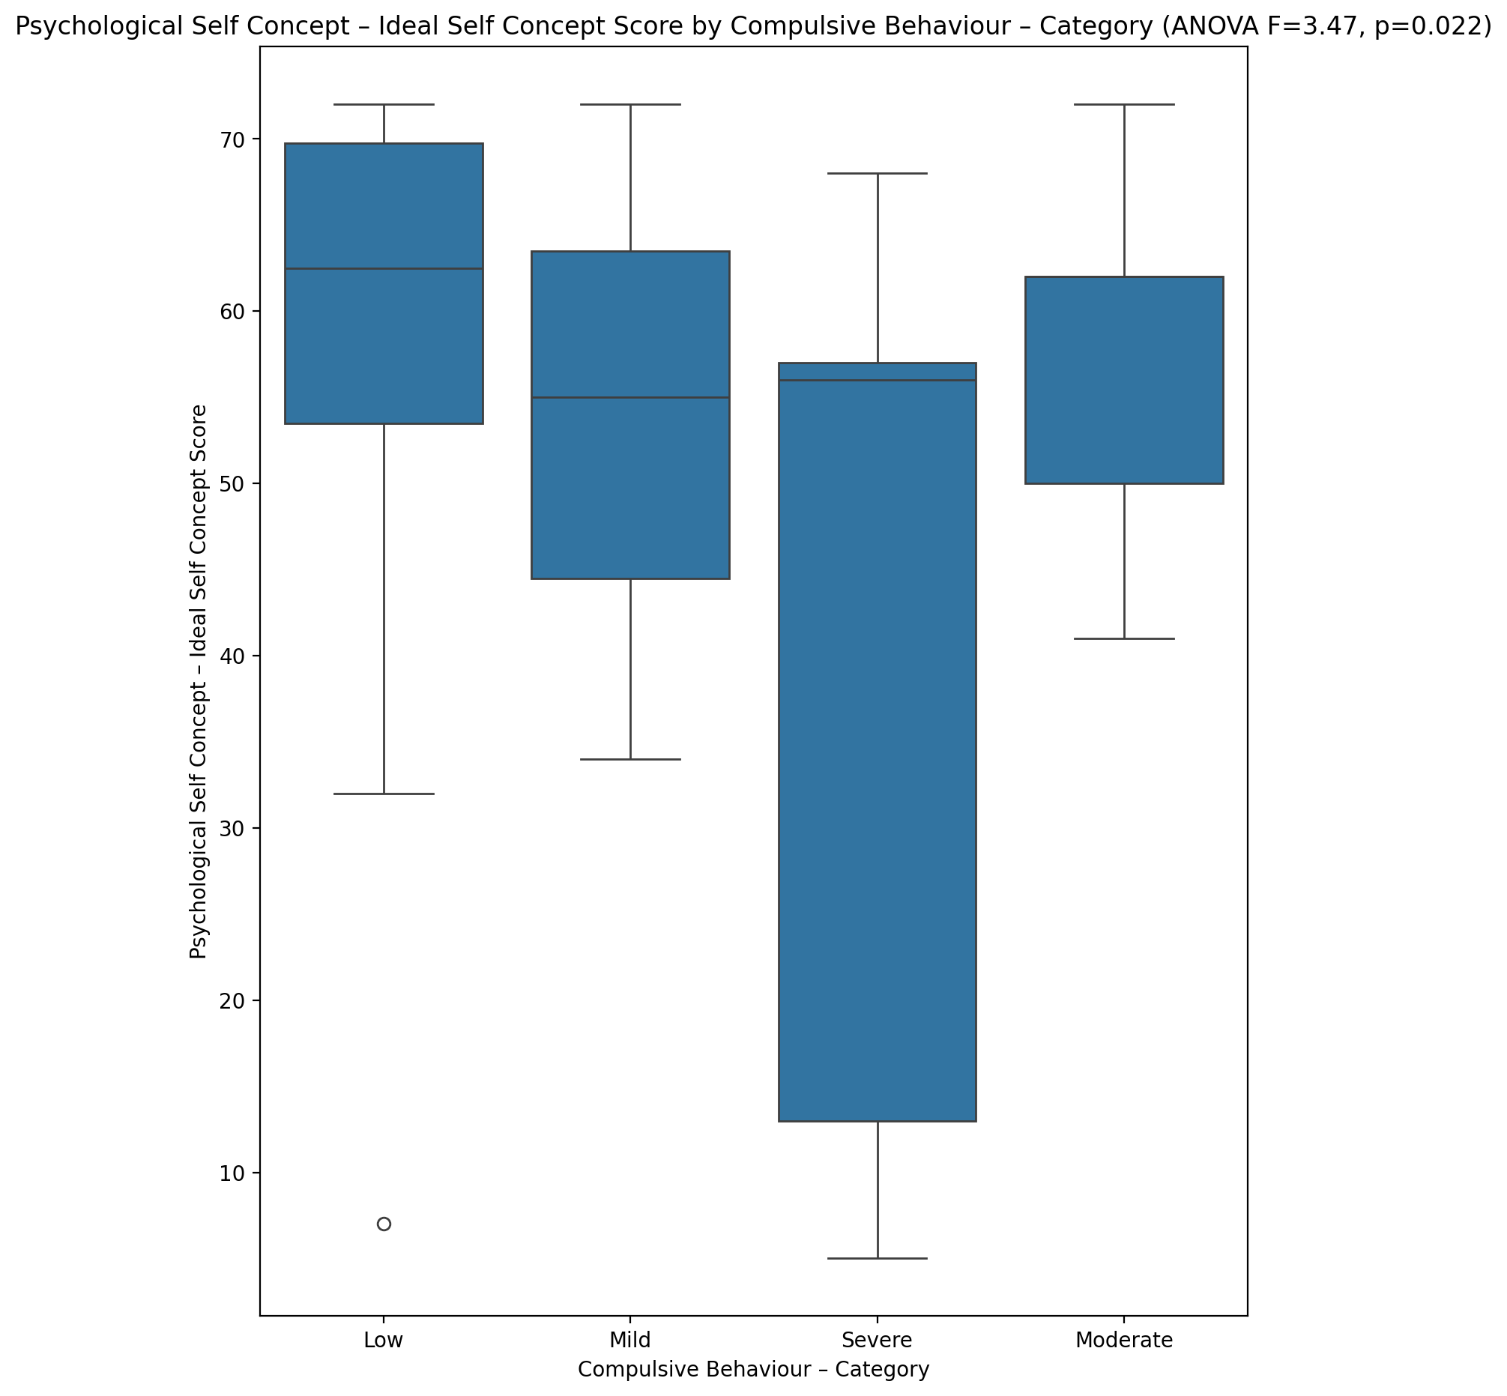

## Psychological Self Concept – Social Self Concept Score vs Compulsive Behaviour – Category

Test: anova; statistic: 6.021288459668517; p-value: 0.0012713917650558685;

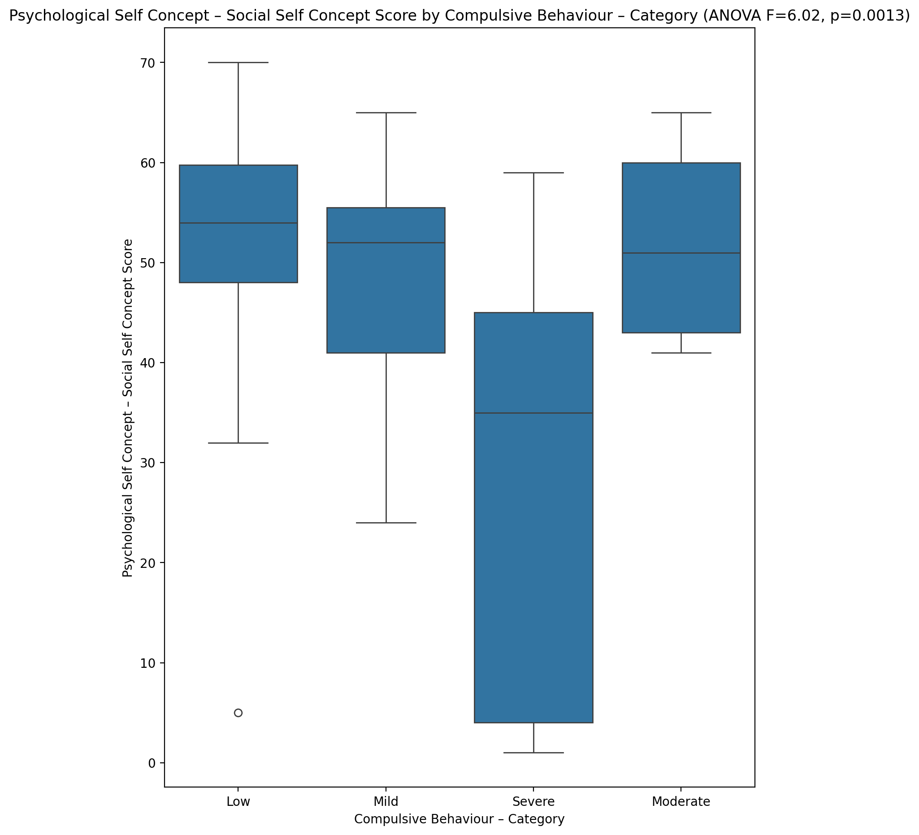

## Real Self Concept Total Score vs Compulsive Behaviour – Category

Test: anova; statistic: 5.520890948190618; p-value: 0.0021862978527420534;

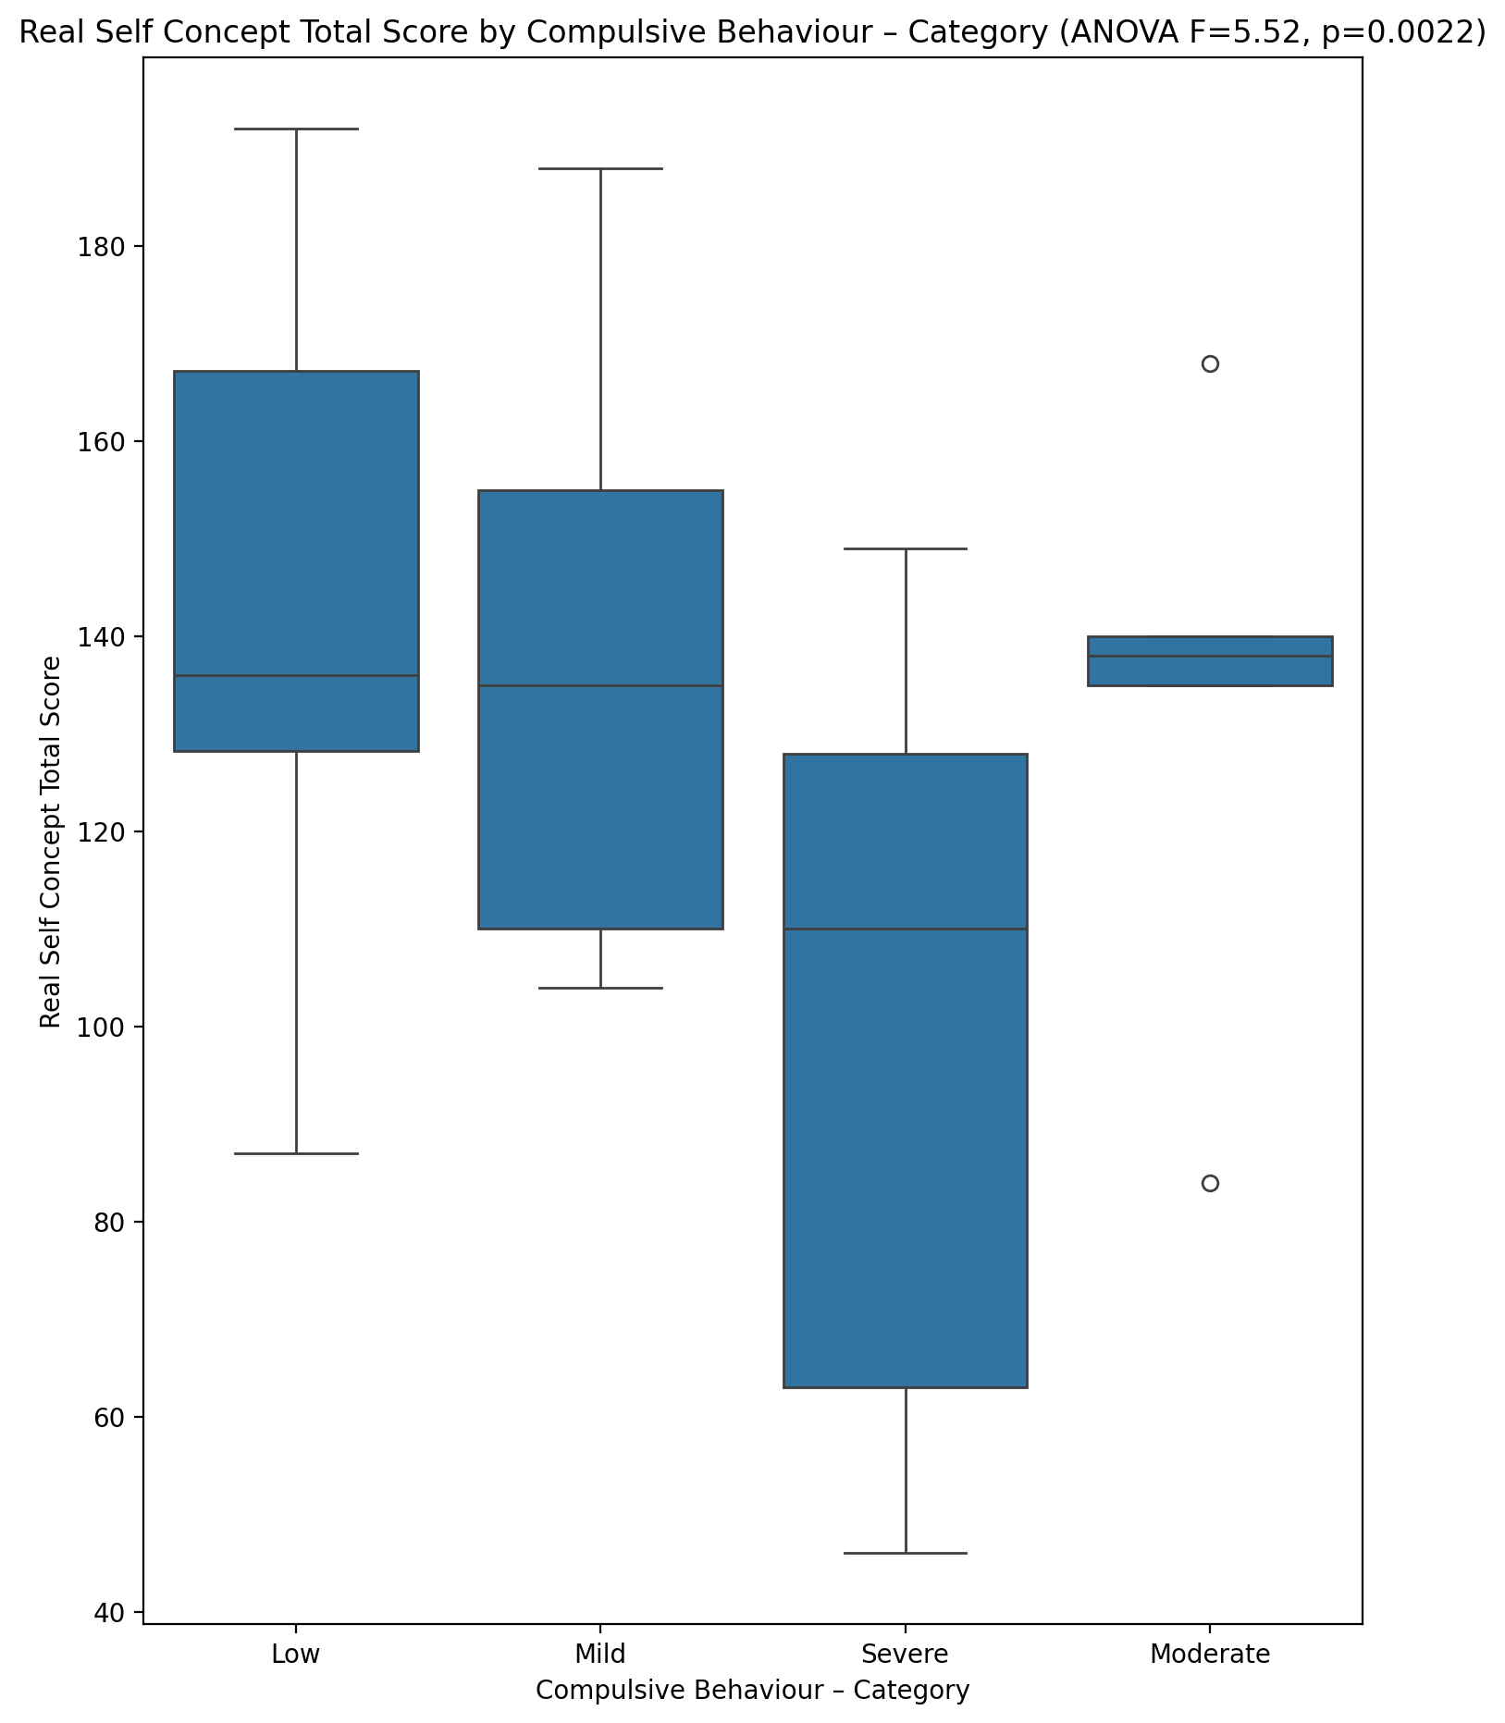

## Ideal Self Concept Total Score vs Compulsive Behaviour – Category

Test: anova; statistic: 4.433520344728005; p-value: 0.007322806404697566;

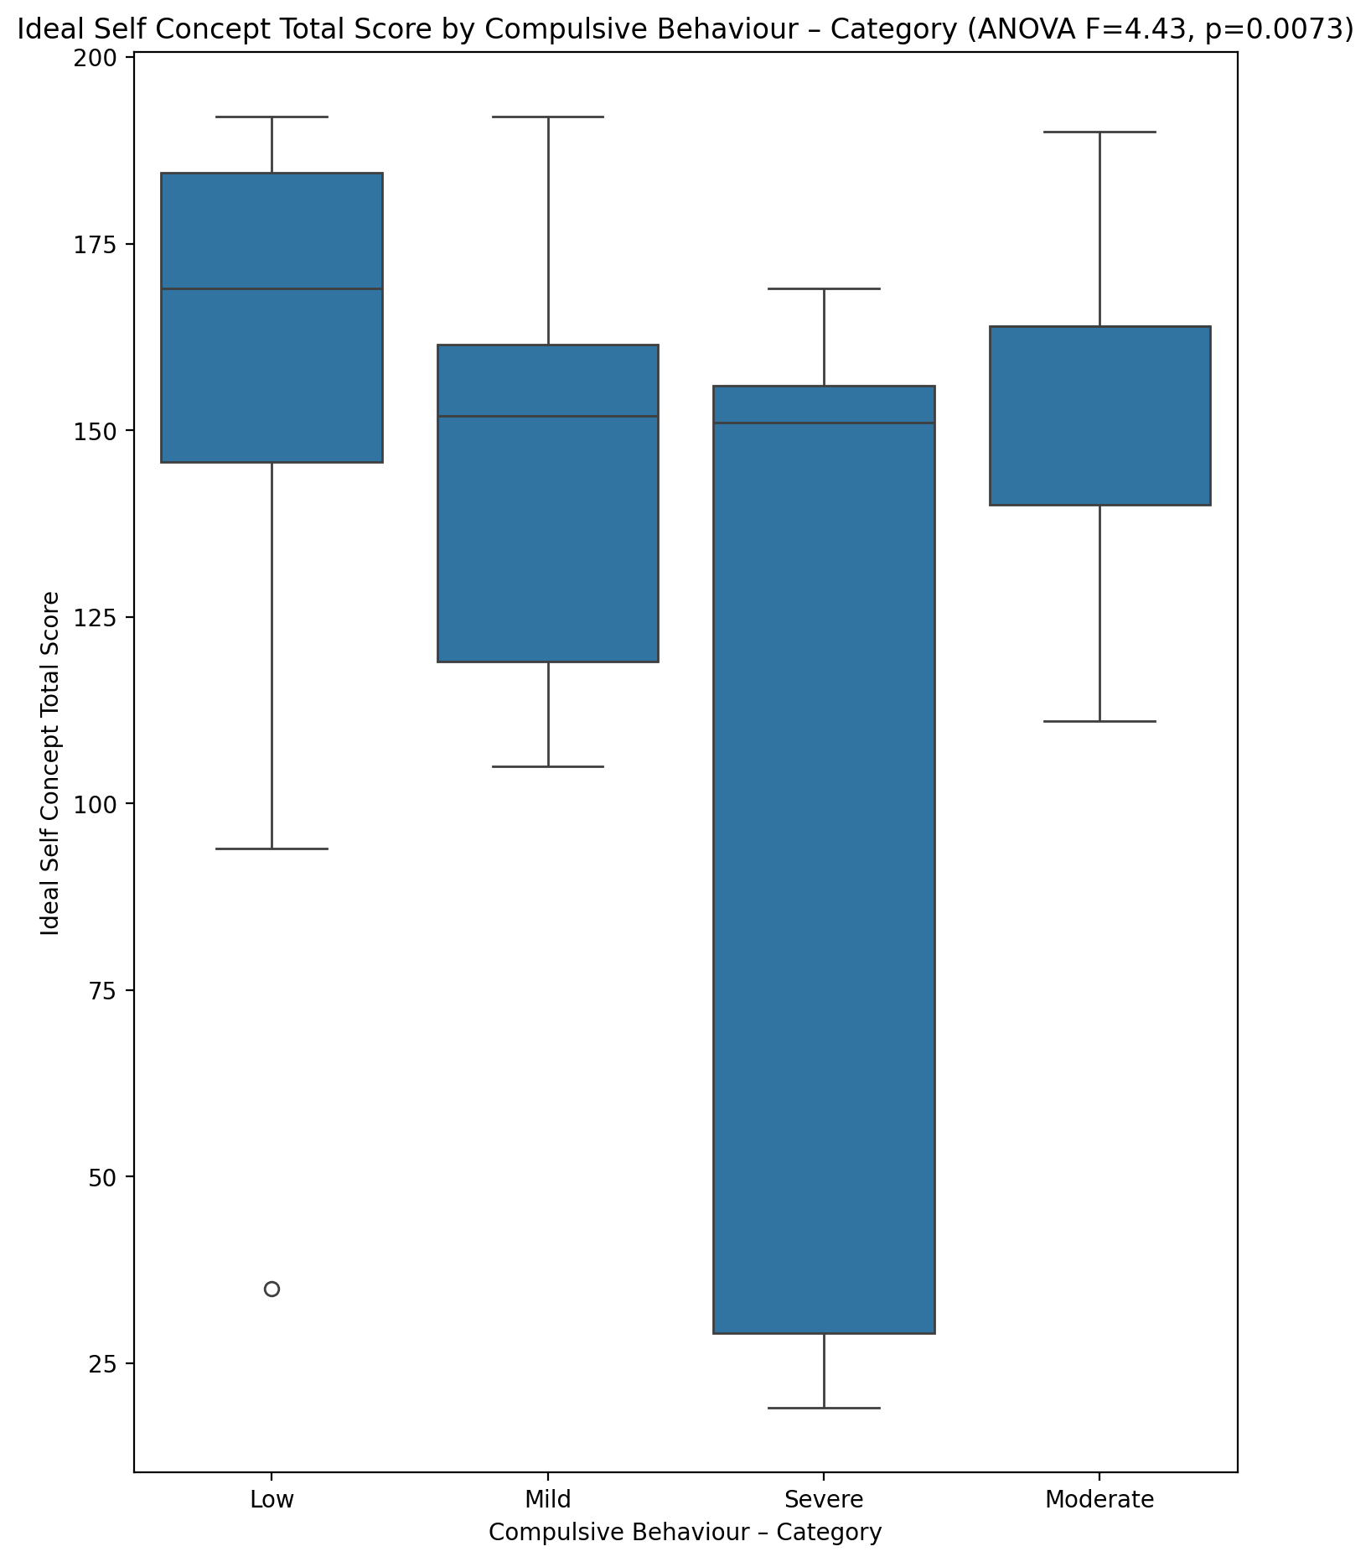

## Social Self Concept Total Score vs Compulsive Behaviour – Category

Test: anova; statistic: 5.910756216504547; p-value: 0.0014320149816260798;

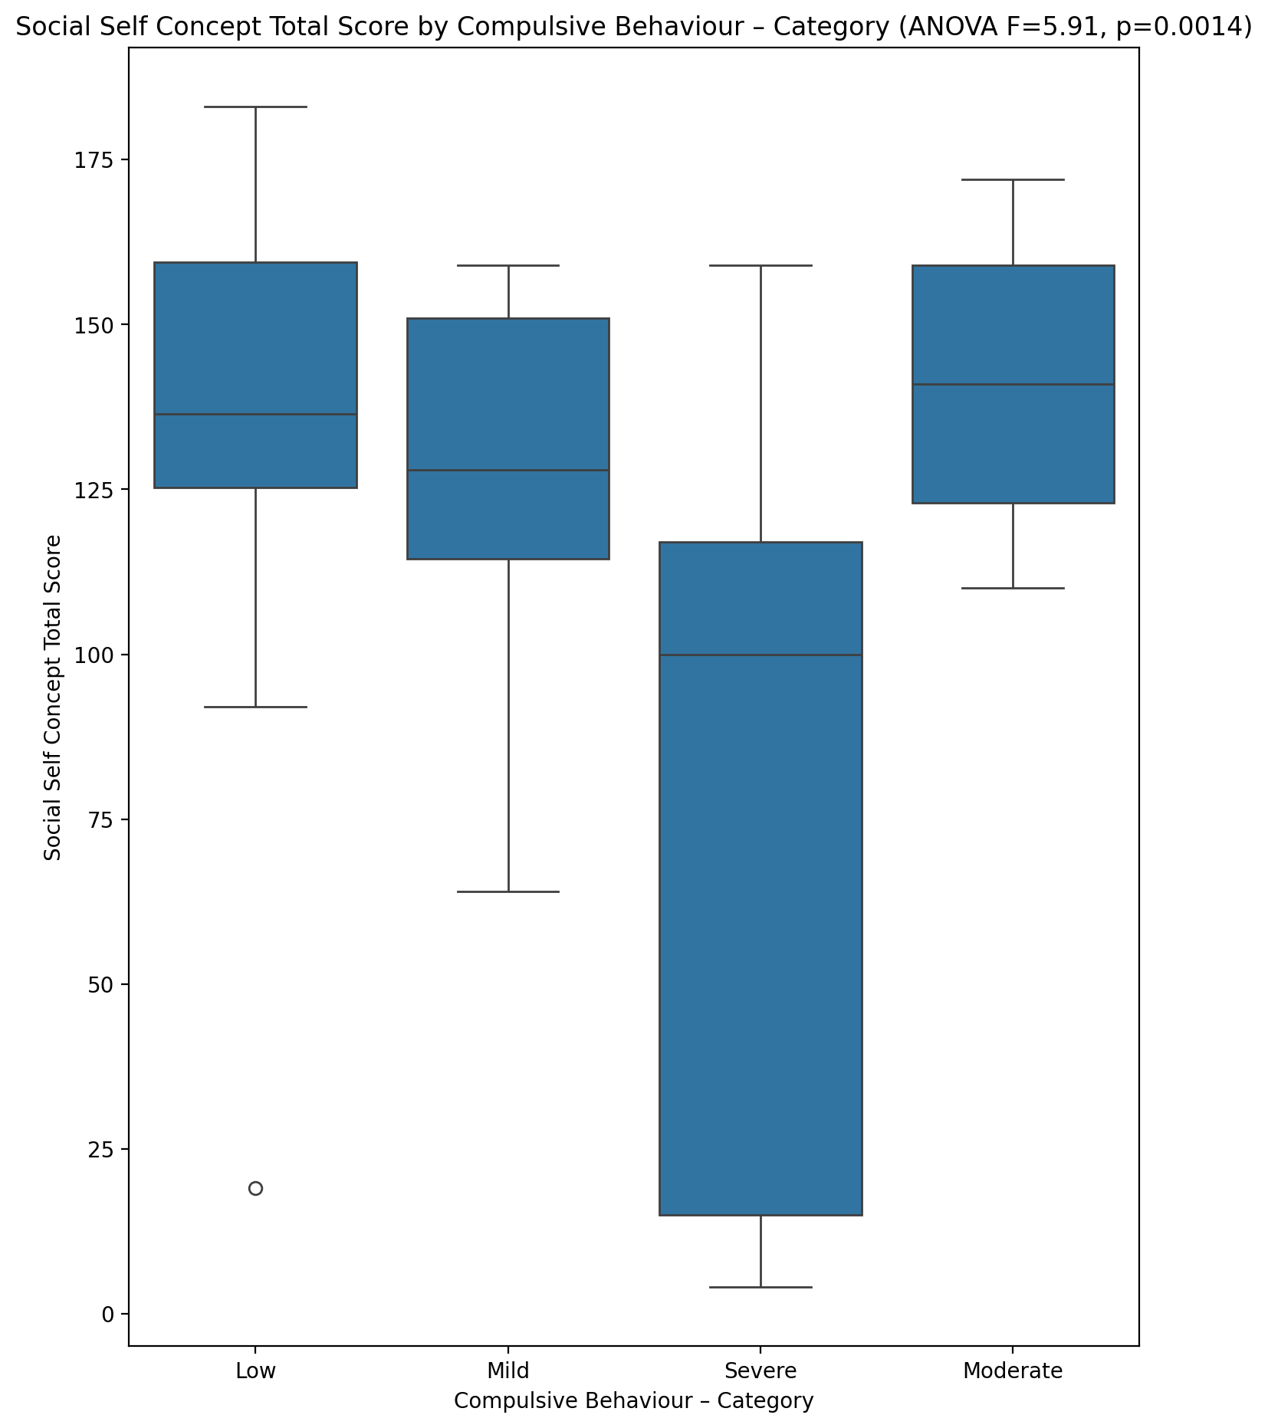

## Ideal Self Concept Total Category vs Compulsive Behaviour – Category

Test: chi2; statistic: 14.551009720127364; p-value: 0.024051550652703438;

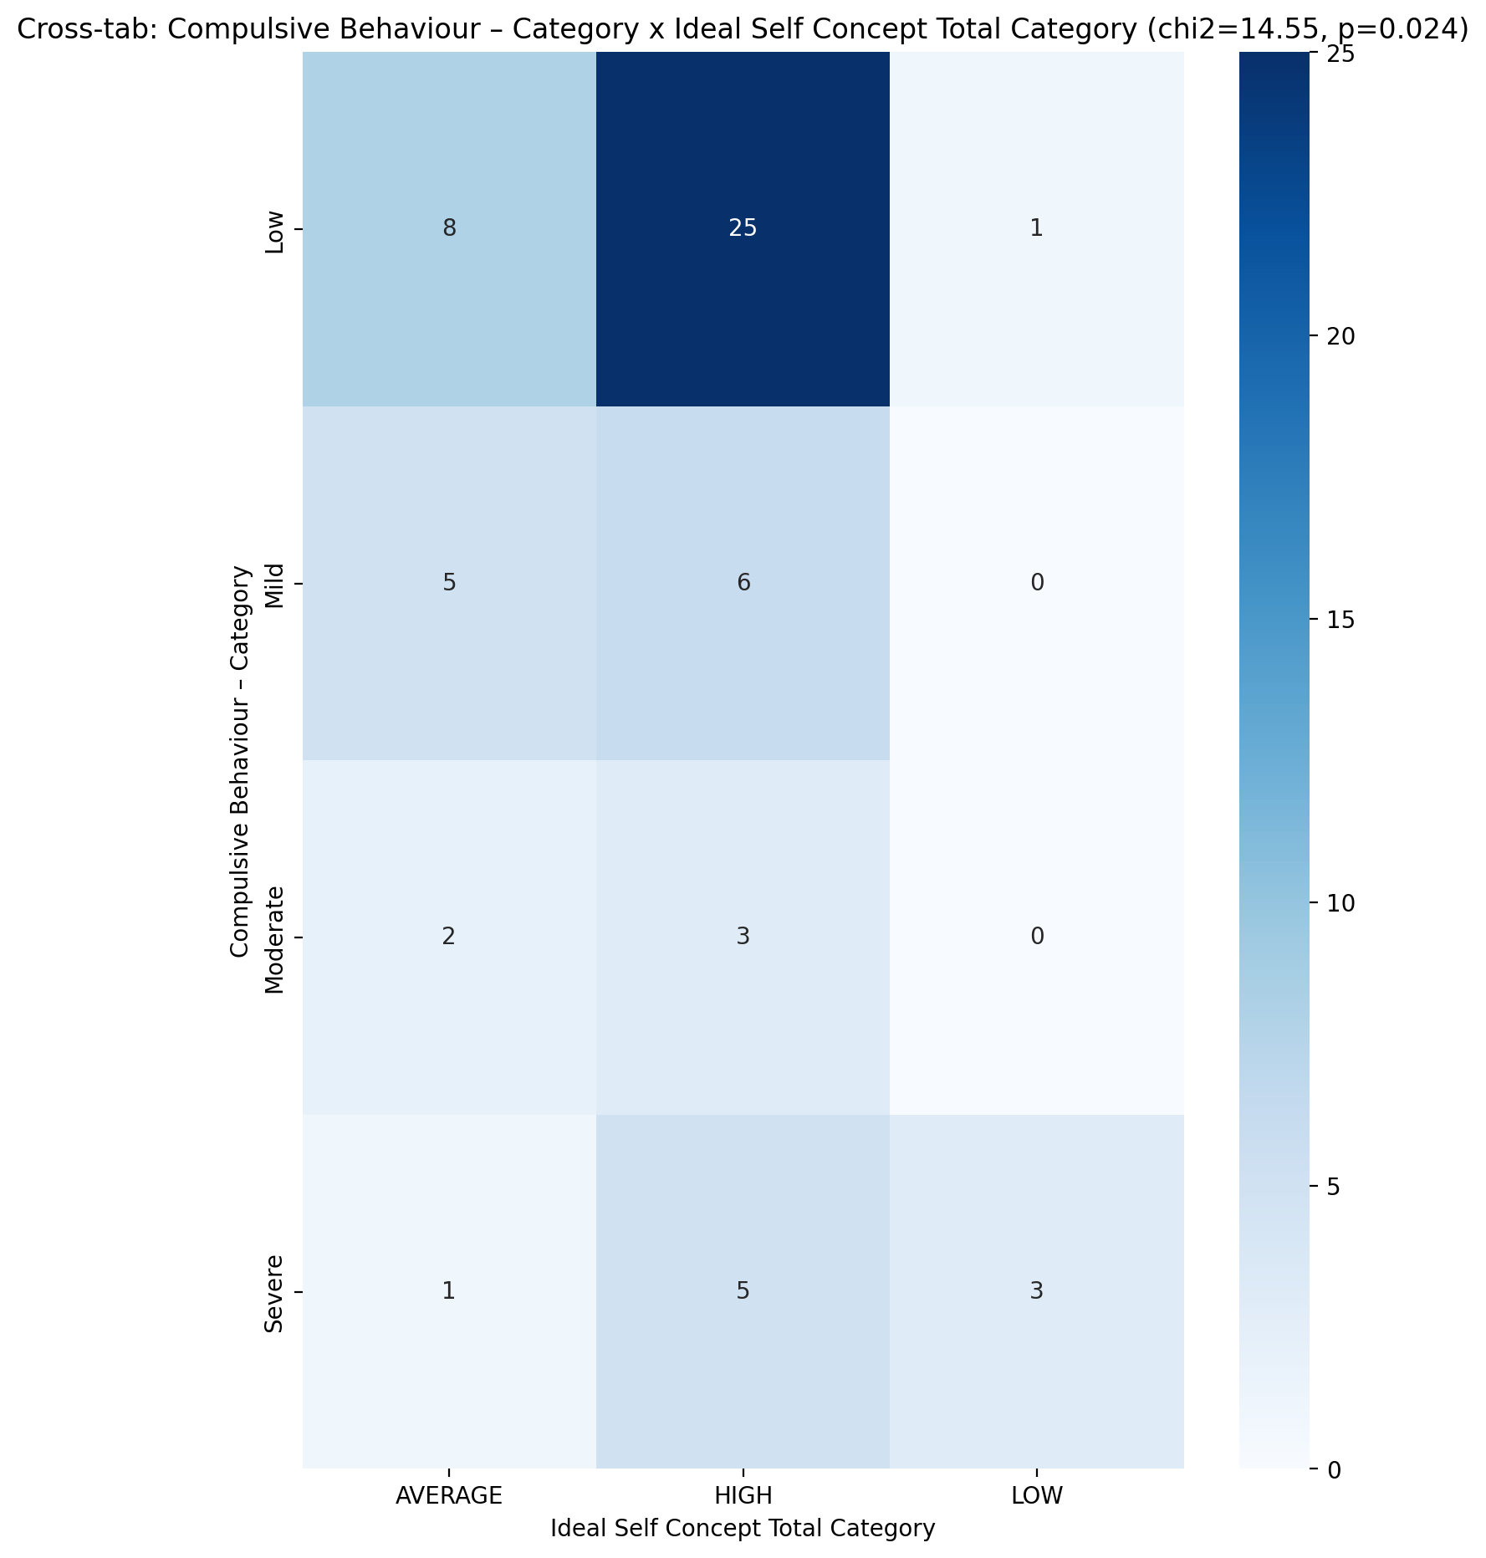

## Perceived Social Stress Score vs Compulsive Behaviour – Category

Test: anova; statistic: 1.020825822022443; p-value: 0.3905438053504876;

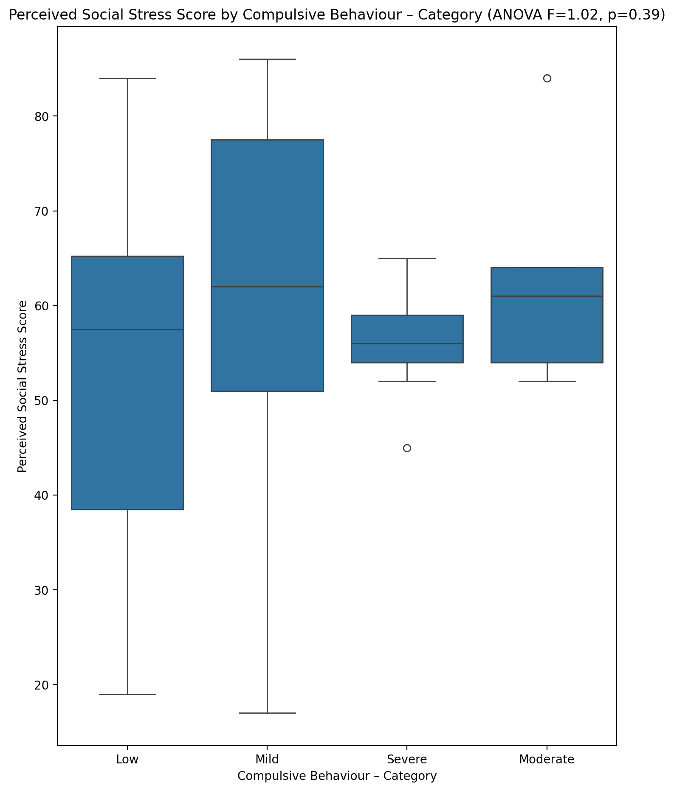

## Perceived Social Stress Category vs Compulsive Behaviour – Category

Test: chi2; statistic: 7.609001782531195; p-value: 0.26817048211854105;

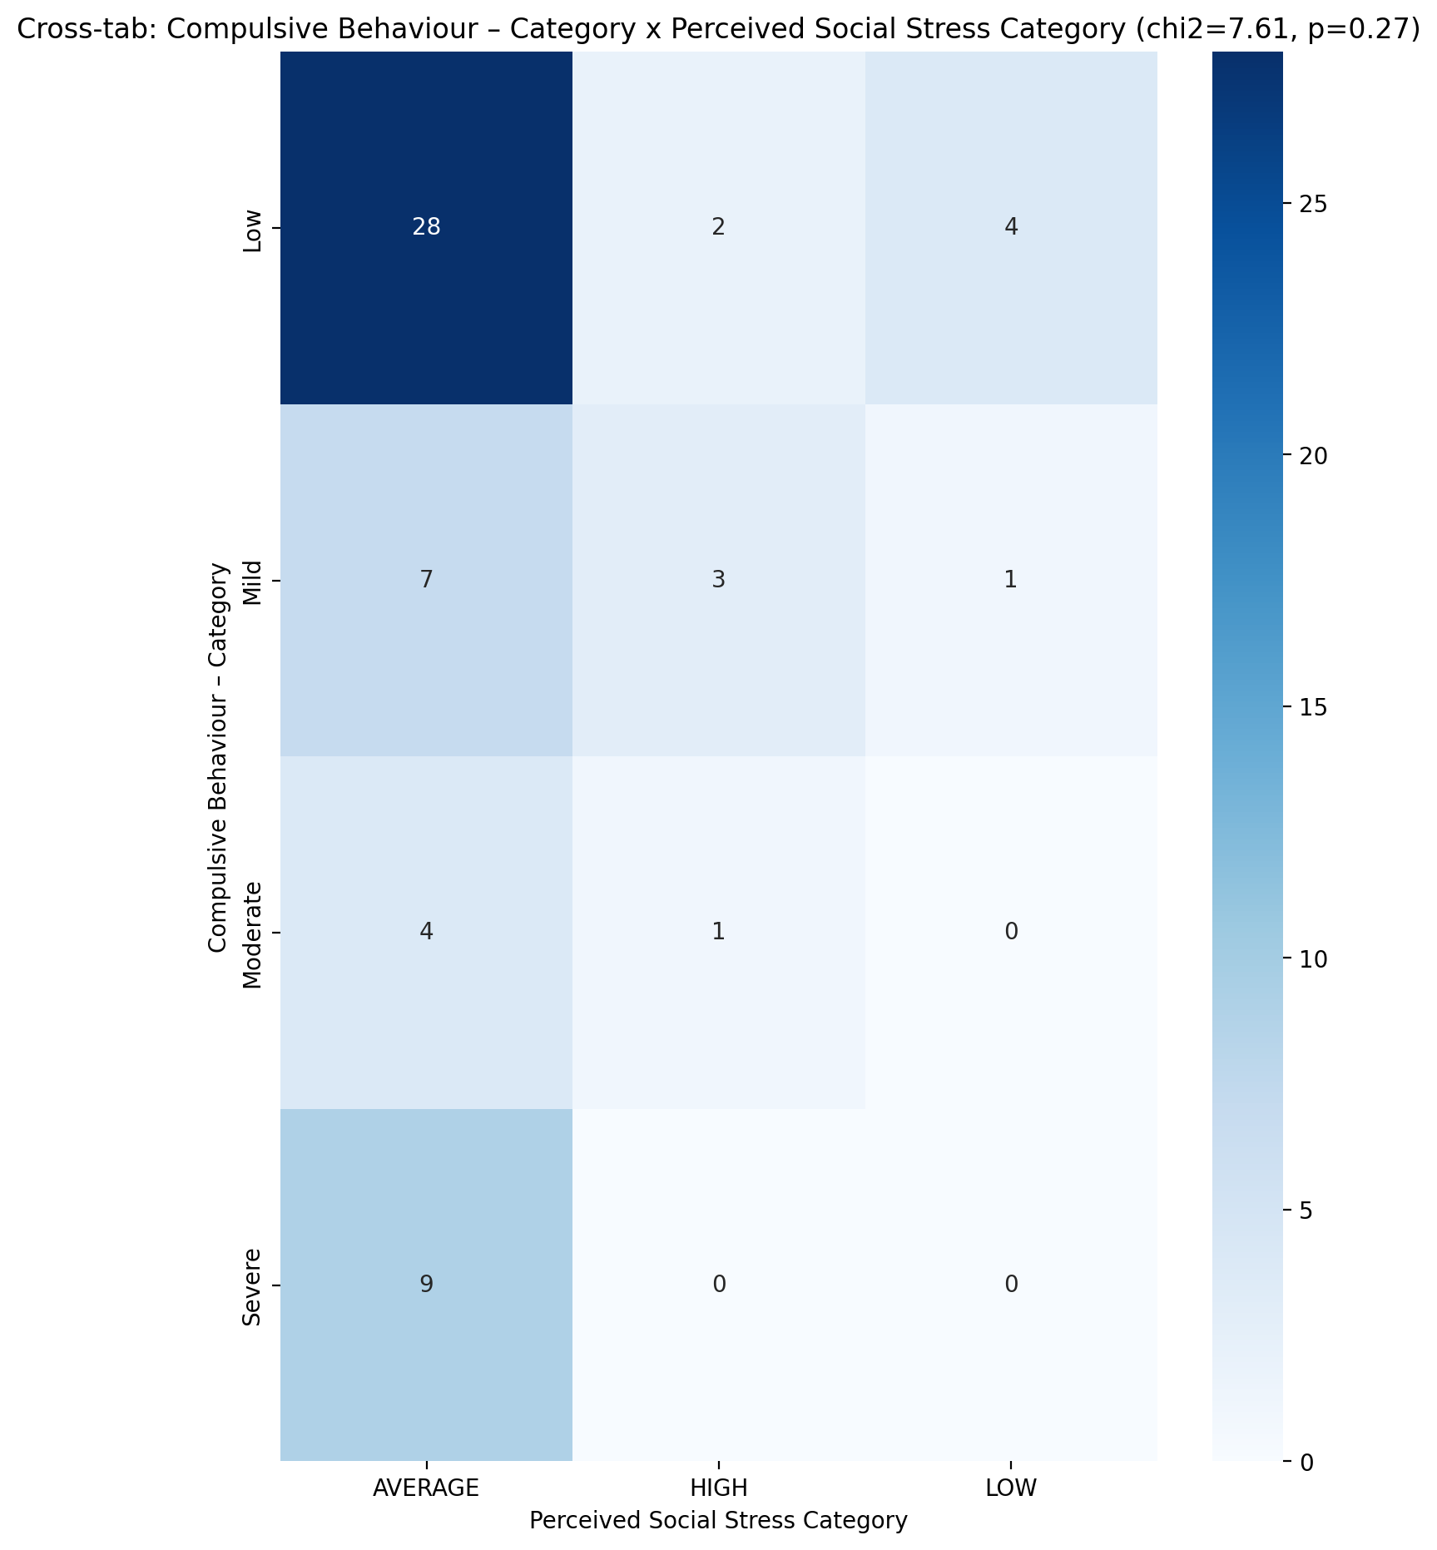

## Emotional Support - Raw Score vs Obsession with Internet – Category

Test: anova; statistic: 2.0973876949724652; p-value: 0.11108604210481457;

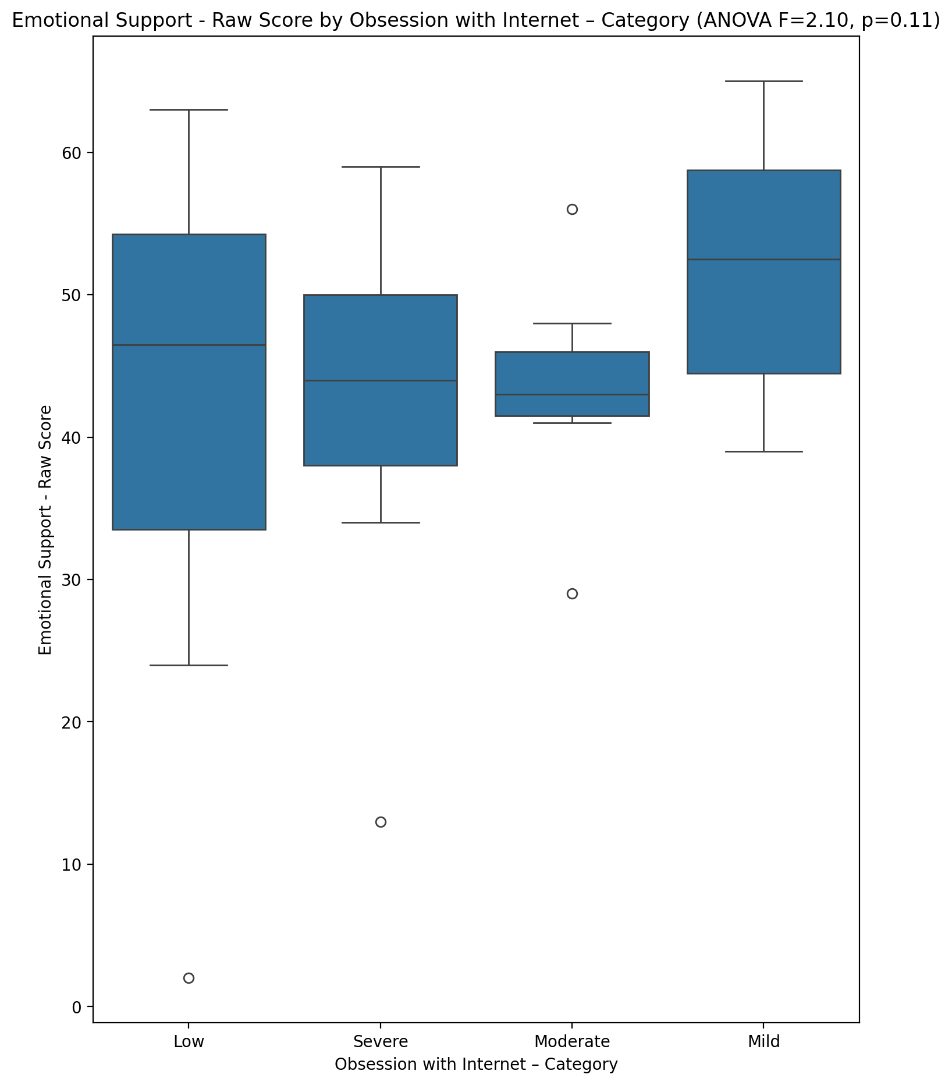

## Informational Support - Raw Score vs Obsession with Internet – Category

Test: anova; statistic: 0.5399784423959095; p-value: 0.6569192025077946;

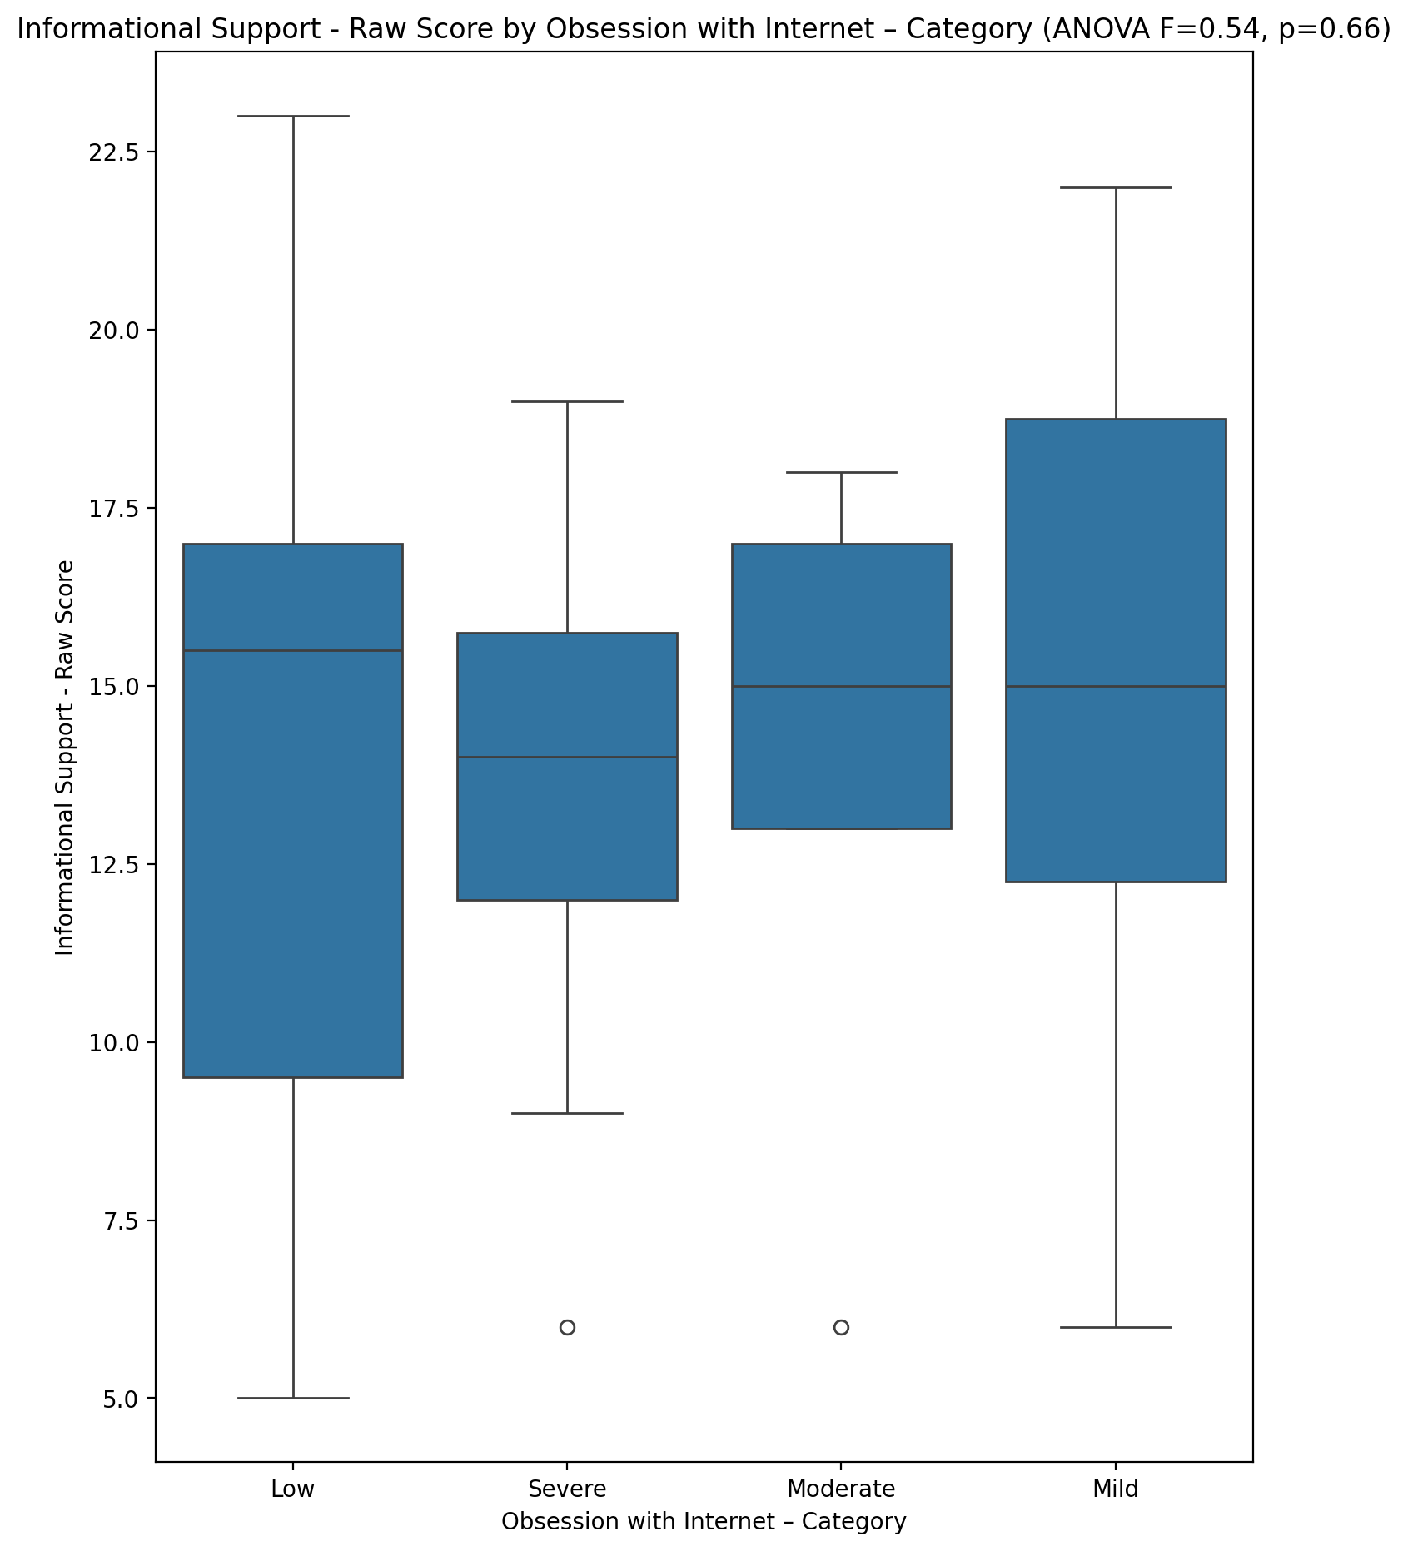

## Instrumental Support - Raw Score vs Obsession with Internet – Category

Test: anova; statistic: 2.11726826552317; p-value: 0.10850142512081884;

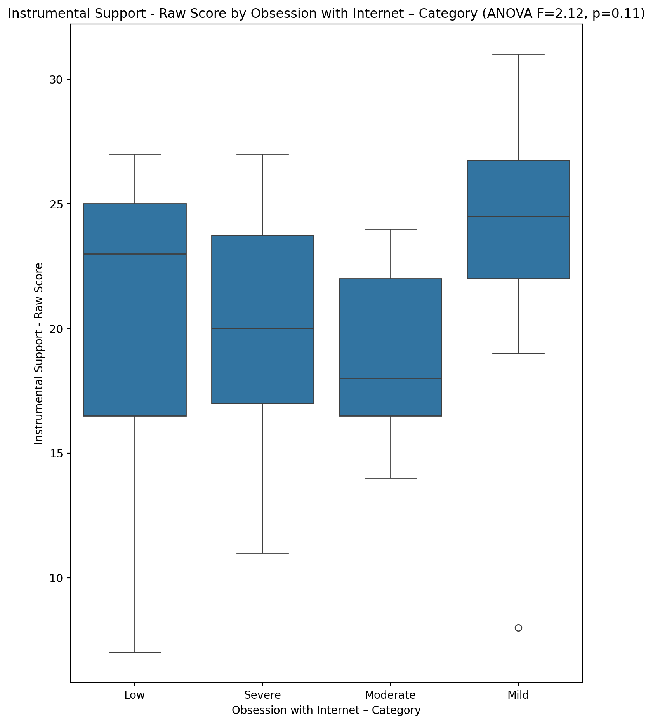

## Emotional Support - T Score vs Obsession with Internet – Category

Test: anova; statistic: 2.136085739863472; p-value: 0.10611033406850424;

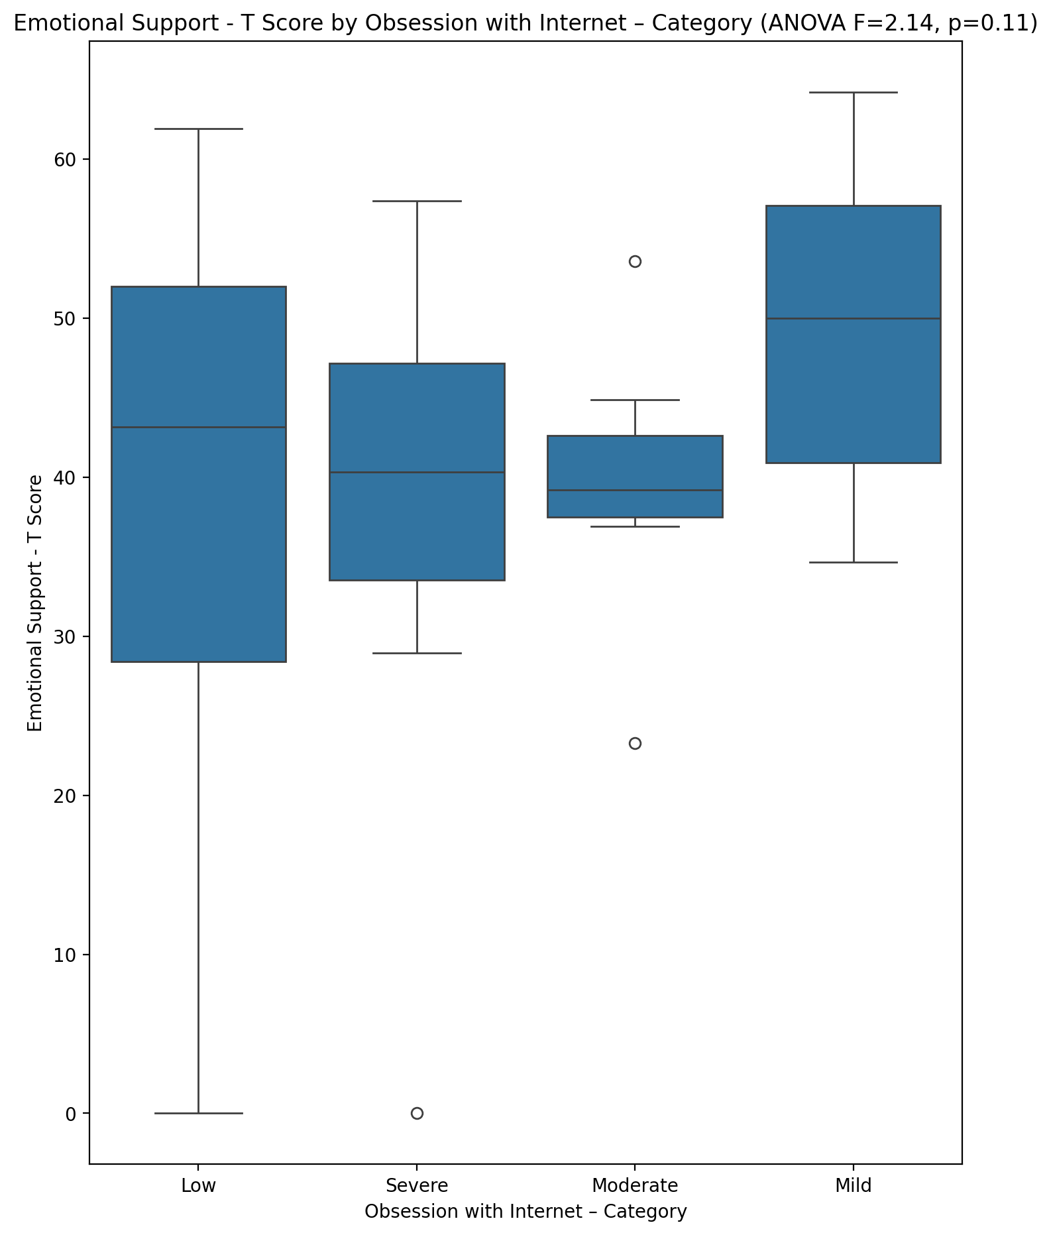

## Informational Support - T Score vs Obsession with Internet – Category

Test: anova; statistic: 0.5422650059216851; p-value: 0.6553989443243637;

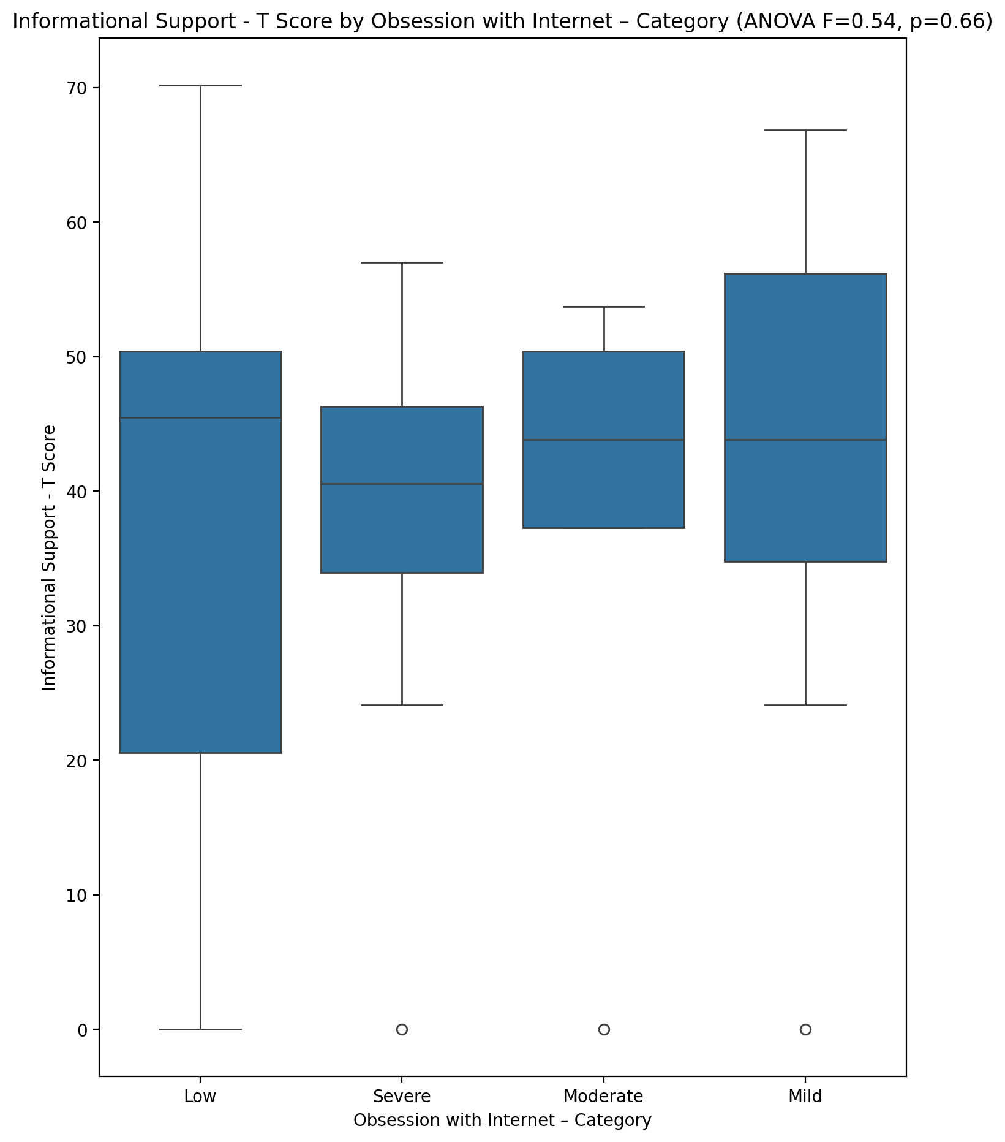

## Instrumental Support - T Score vs Obsession with Internet – Category

Test: anova; statistic: 1.4121939320238435; p-value: 0.24900810014080682;

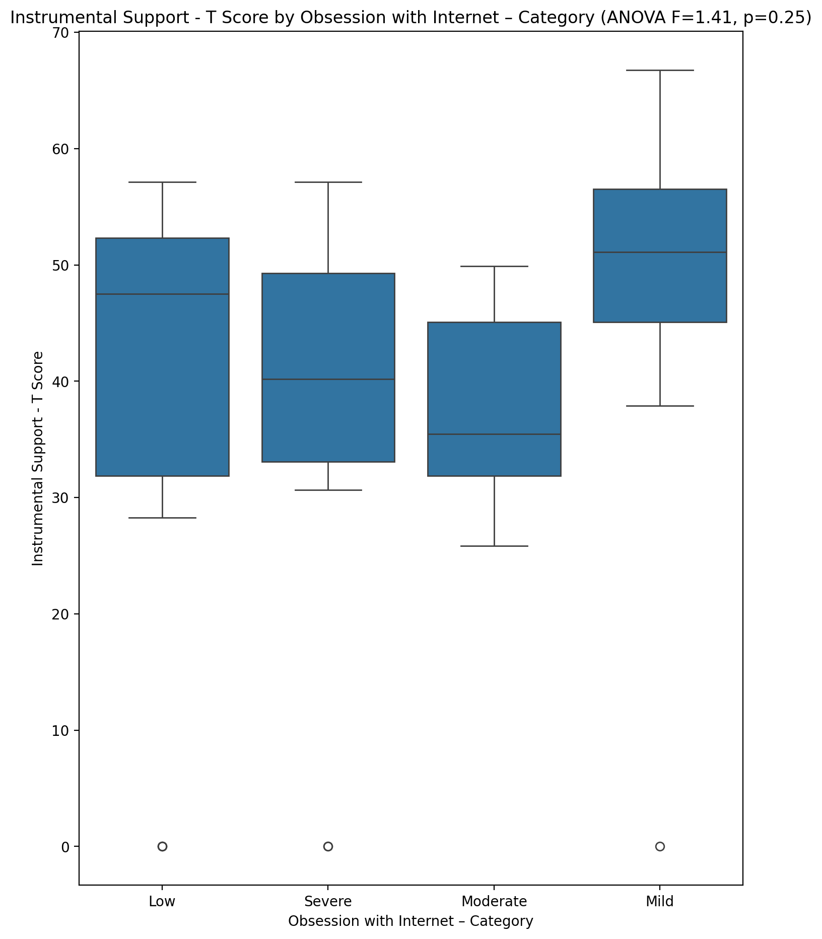

## Perceived Social Support Total T Score vs Obsession with Internet – Category

Test: anova; statistic: 1.6210531438974165; p-value: 0.19498179202753904;

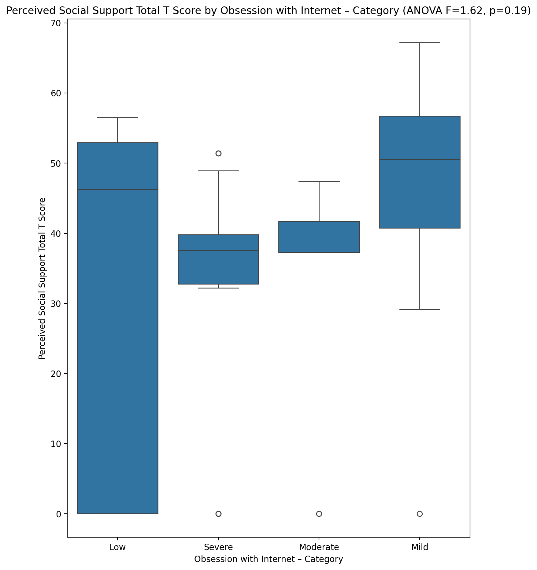

## Emotional Support - Rank vs Obsession with Internet – Category

Test: chi2; statistic: 12.82273964131107; p-value: 0.17079251282554264;

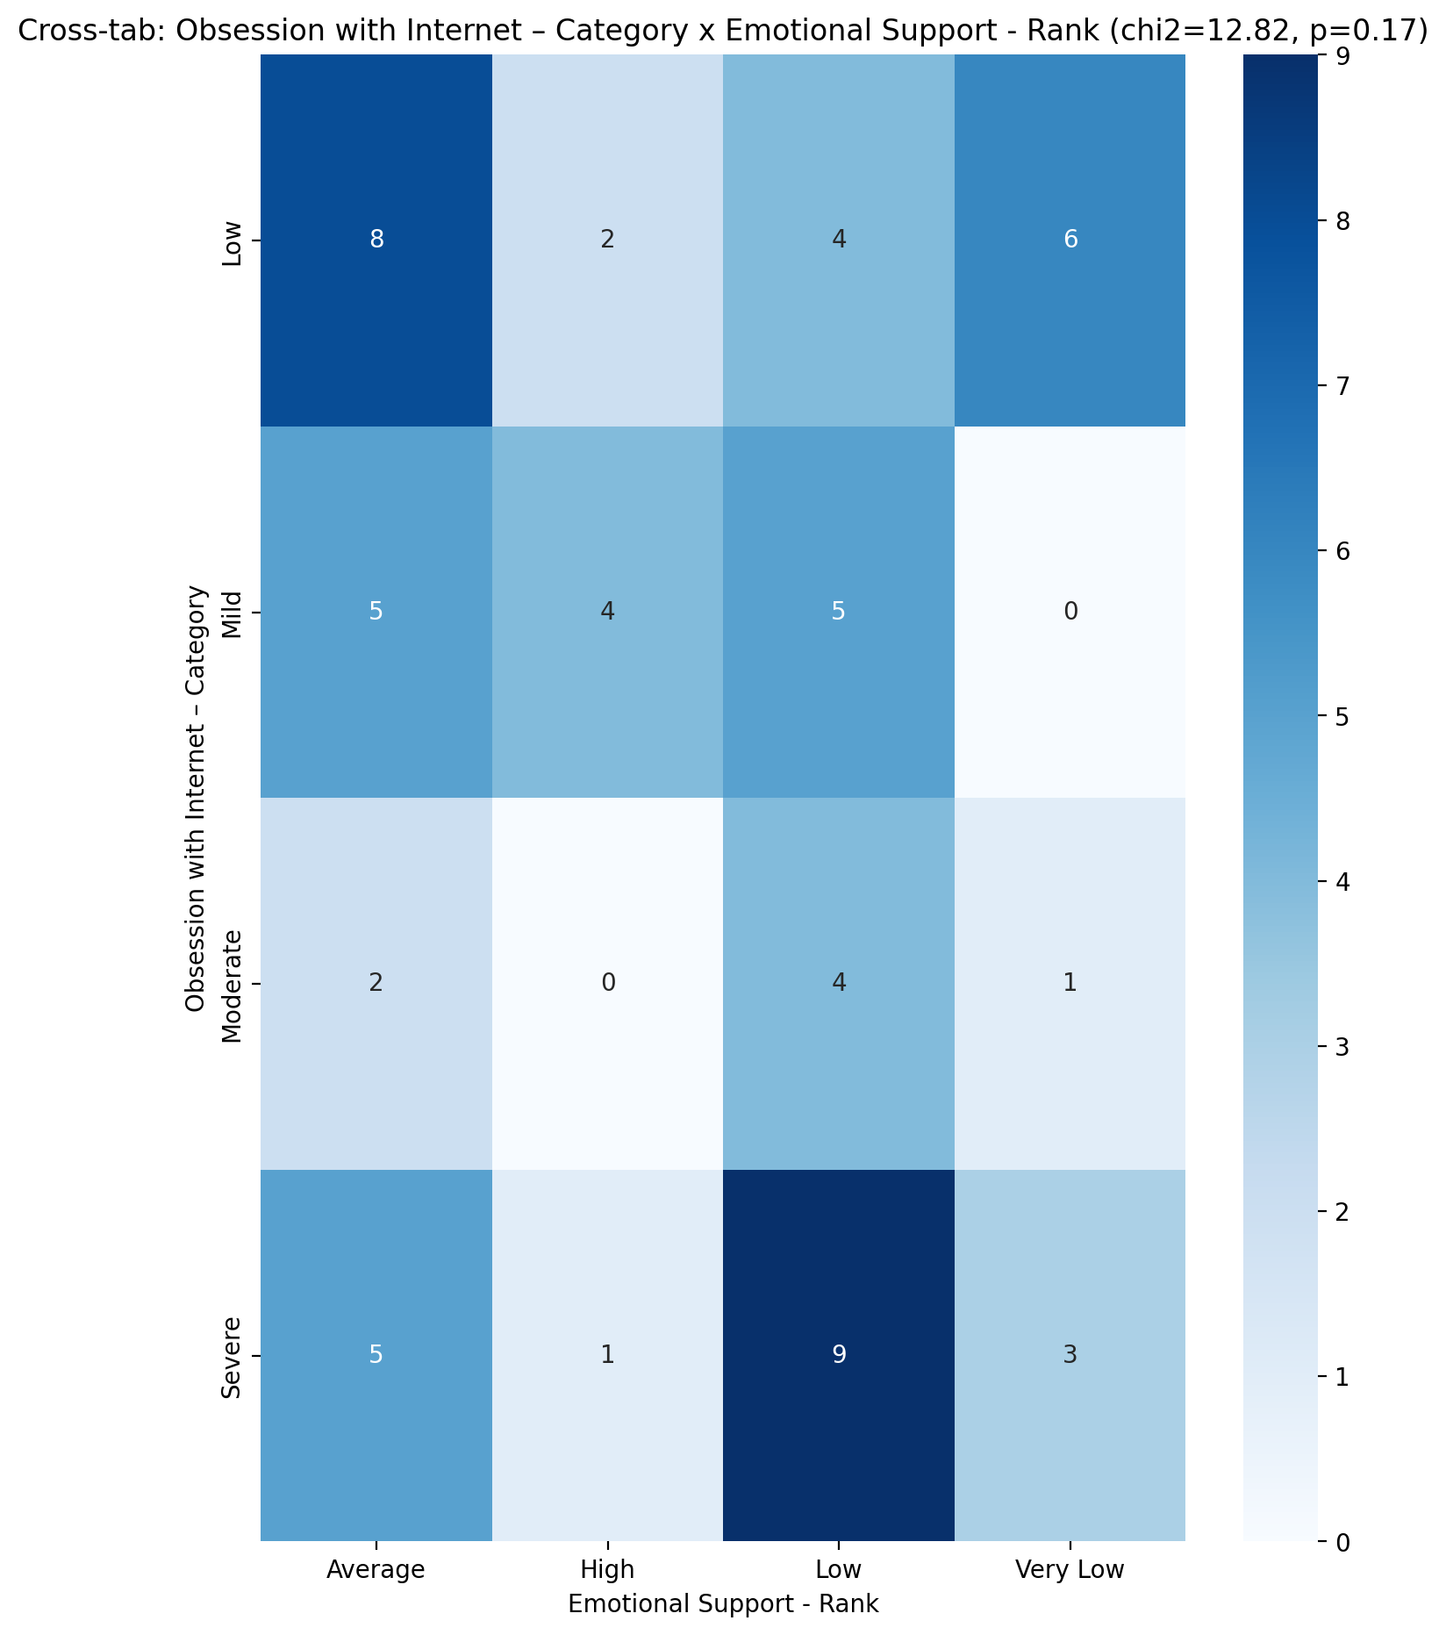

## Informational Support - Rank vs Obsession with Internet – Category

Test: chi2; statistic: 16.858797589211125; p-value: 0.15498652051930312;

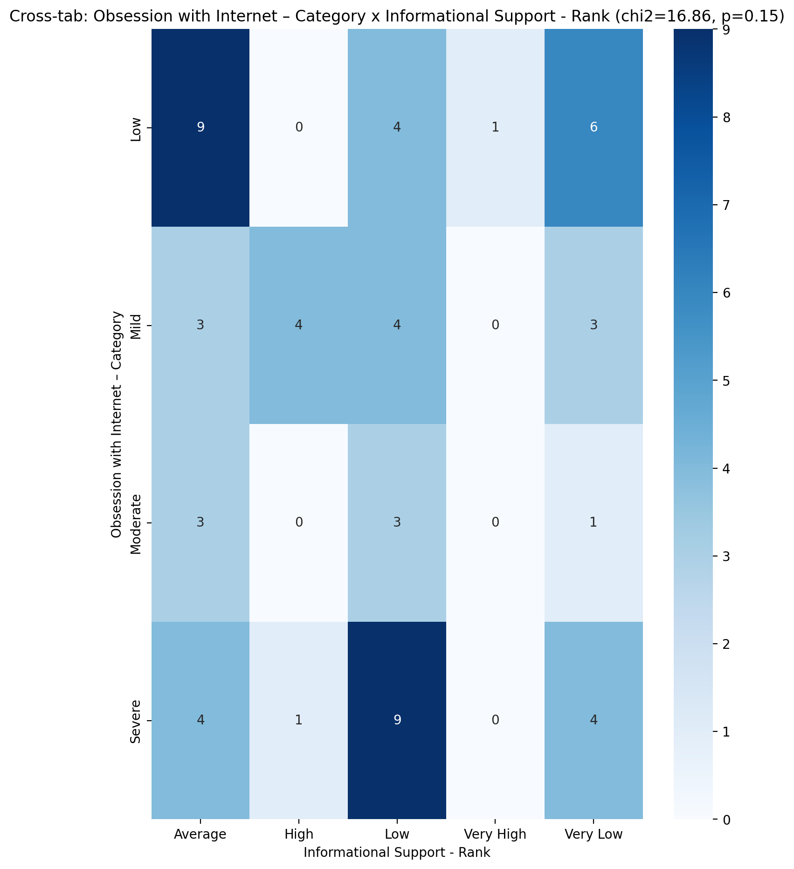

## Instrumental Support - Rank vs Obsession with Internet – Category

Test: chi2; statistic: 15.618189930293106; p-value: 0.07529571550014375;

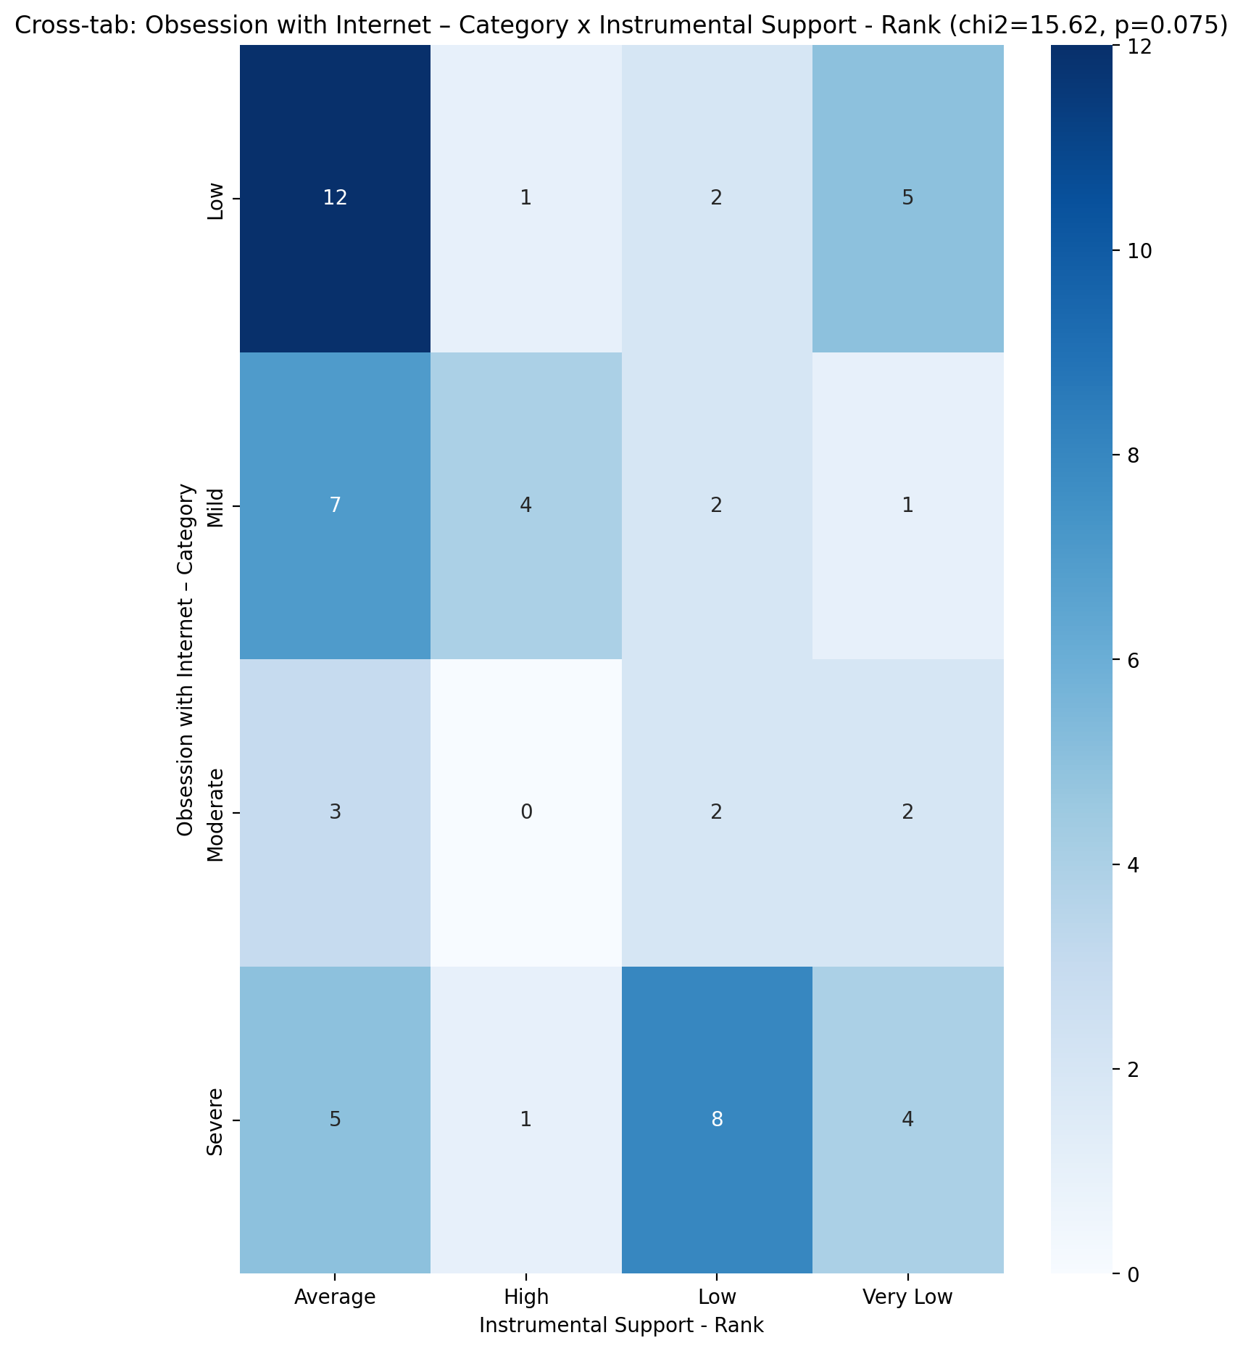

## Perceived Social Support TOTAL - Rank vs Obsession with Internet – Category

Test: chi2; statistic: 27.18076756576757; p-value: 0.0013056202852399128;

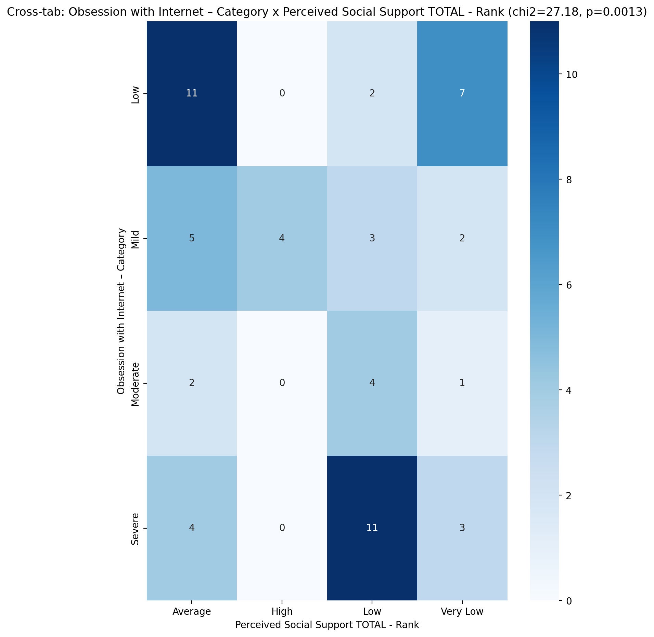

## Power Self Concept - Real Self Concept Score vs Obsession with Internet – Category

Test: anova; statistic: 0.22995399307328587; p-value: 0.8751425608143173;

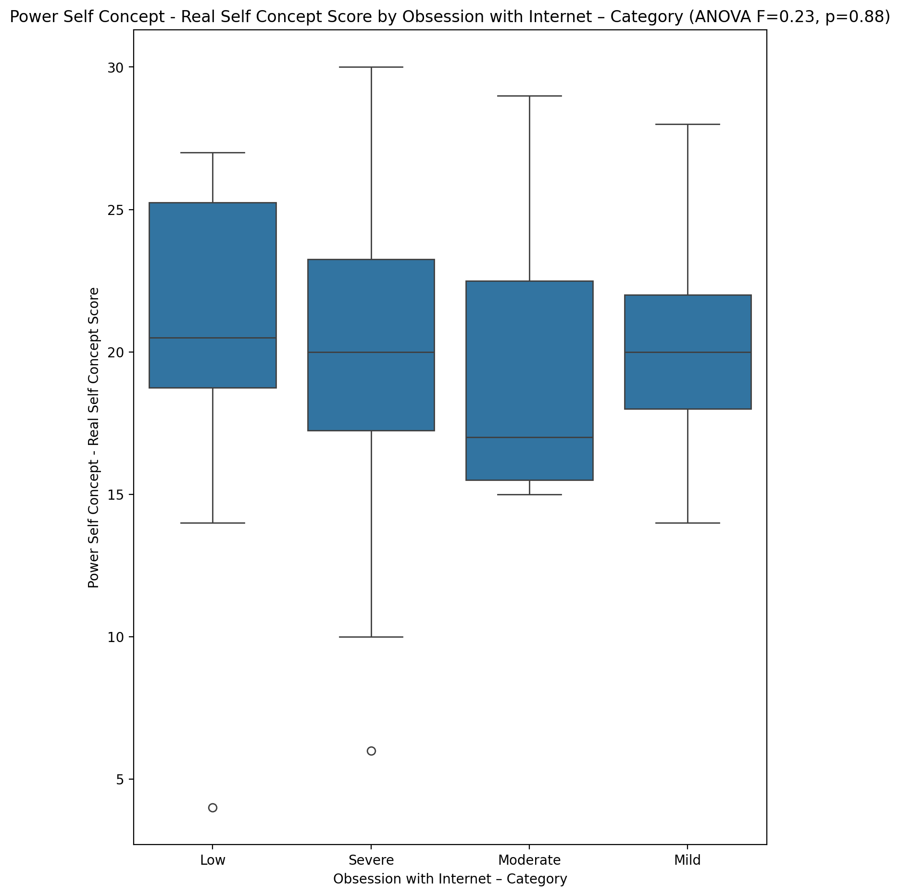

## Power Self Concept - Ideal Self Concept score vs Obsession with Internet – Category

Test: anova; statistic: 1.4455172496157245; p-value: 0.23951315092958328;

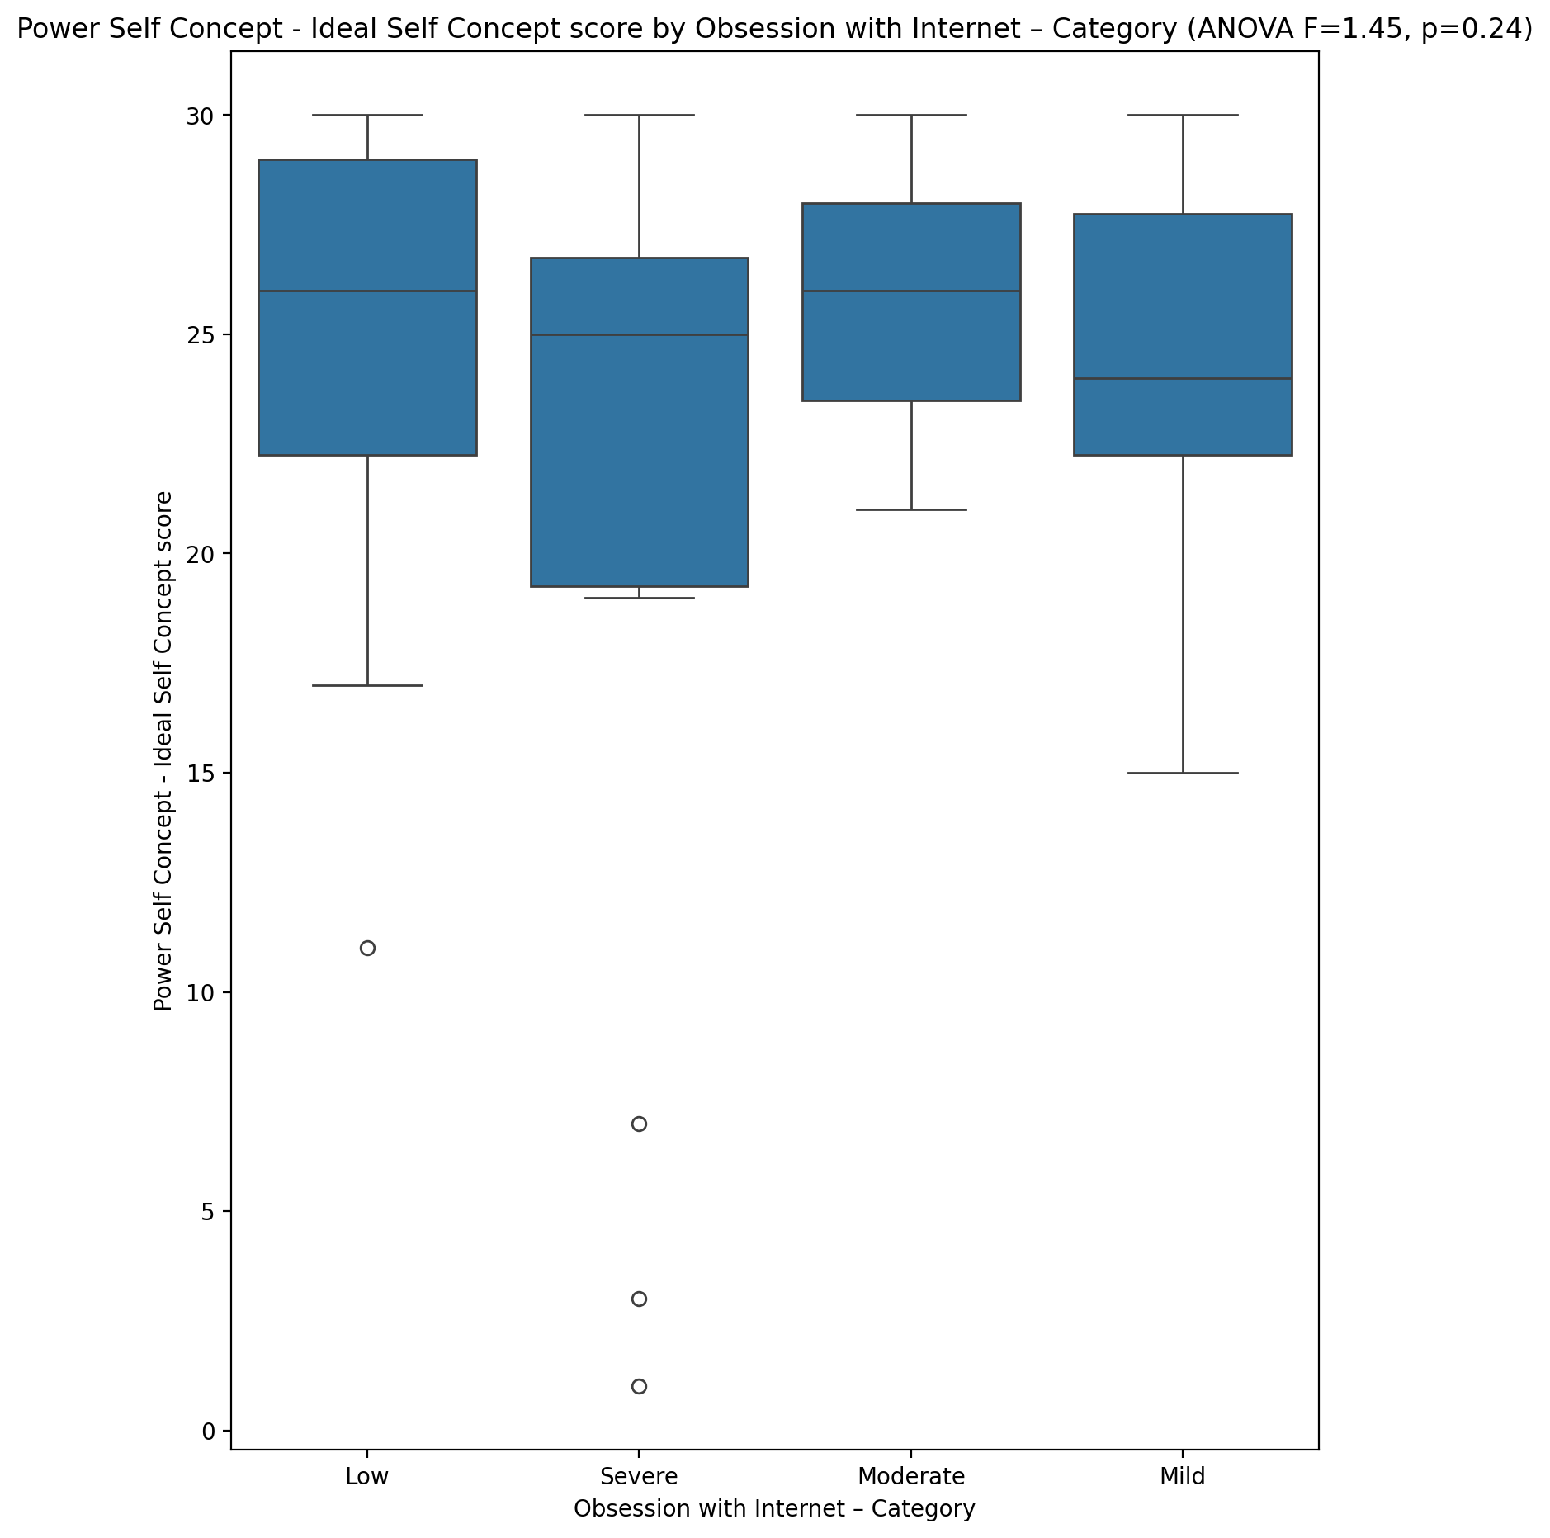

## Power Self Concept – Social Self Concept Score vs Obsession with Internet – Category

Test: anova; statistic: 0.8816209546097256; p-value: 0.45635938557601197;

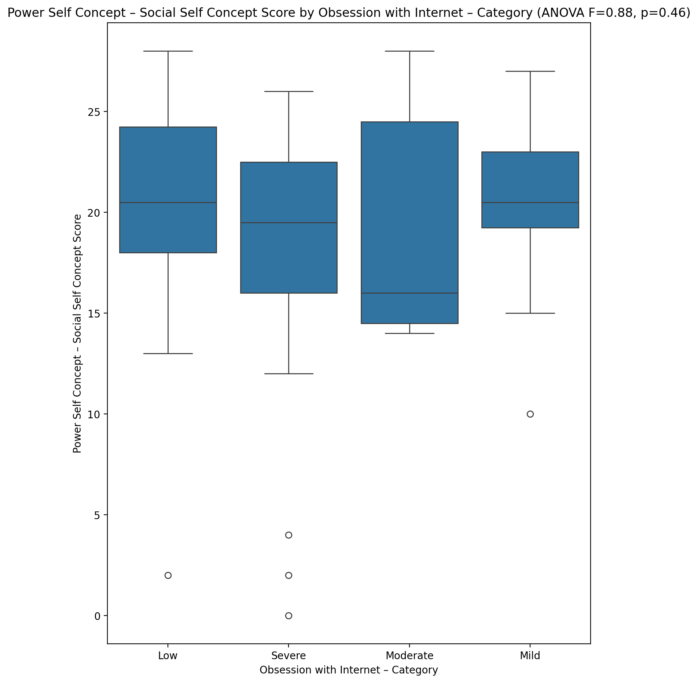

## Social Self Concept - Real Self Concept Score vs Obsession with Internet – Category

Test: anova; statistic: 1.027746635678837; p-value: 0.3875021728691883;

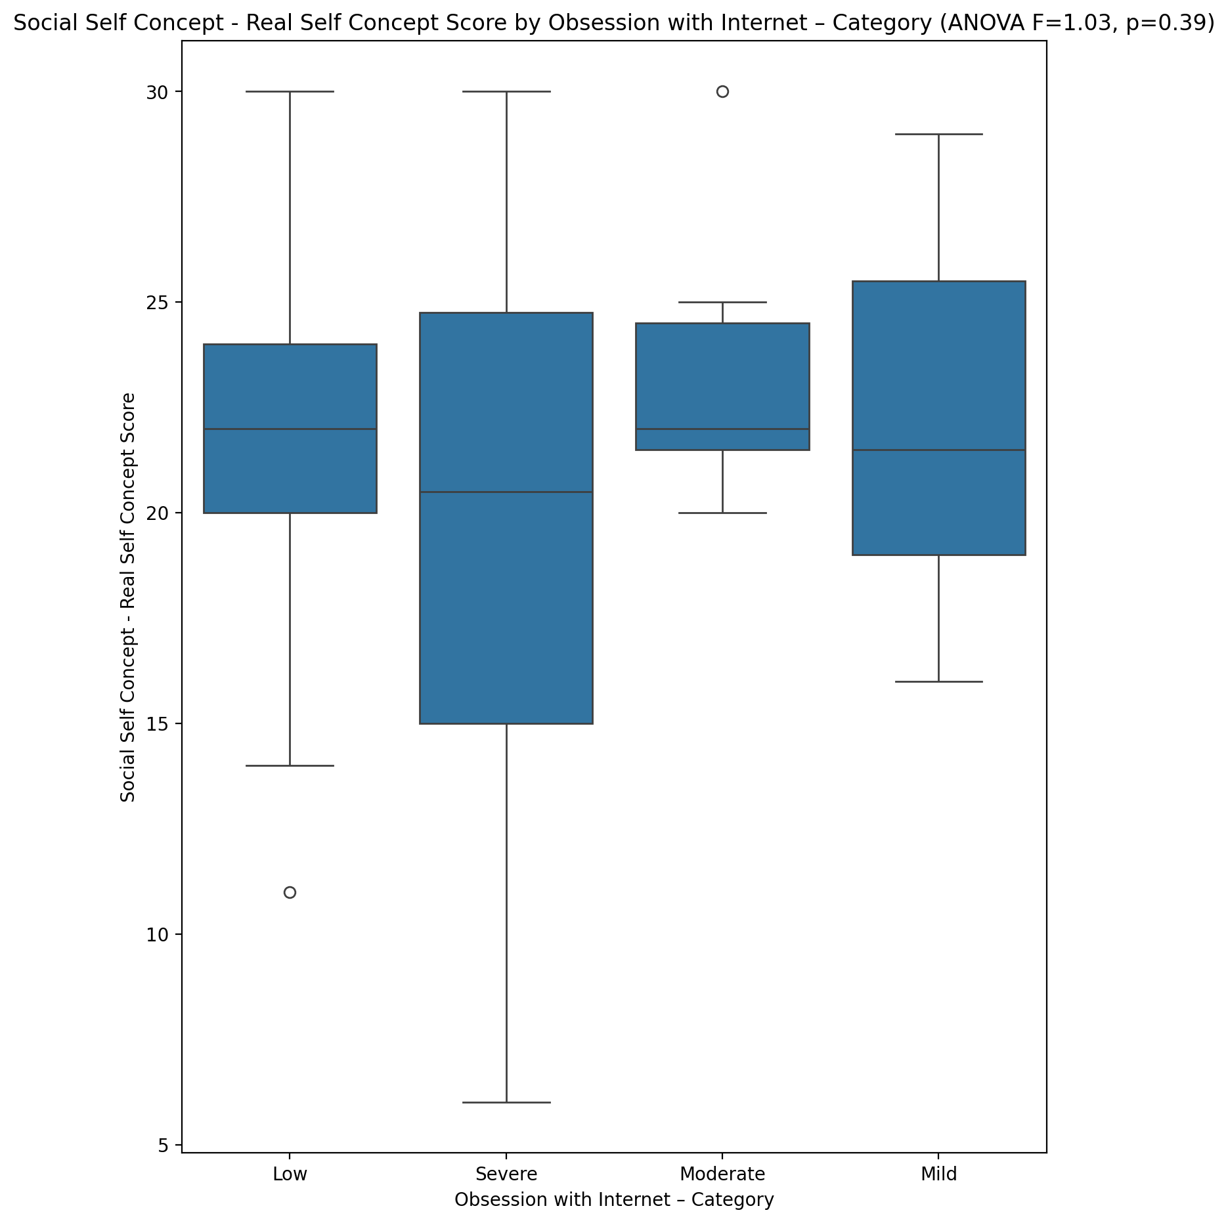

## Social Self Concept – Social Self Concept Score vs Obsession with Internet – Category

Test: anova; statistic: 2.135214676640695; p-value: 0.10621984757056721;

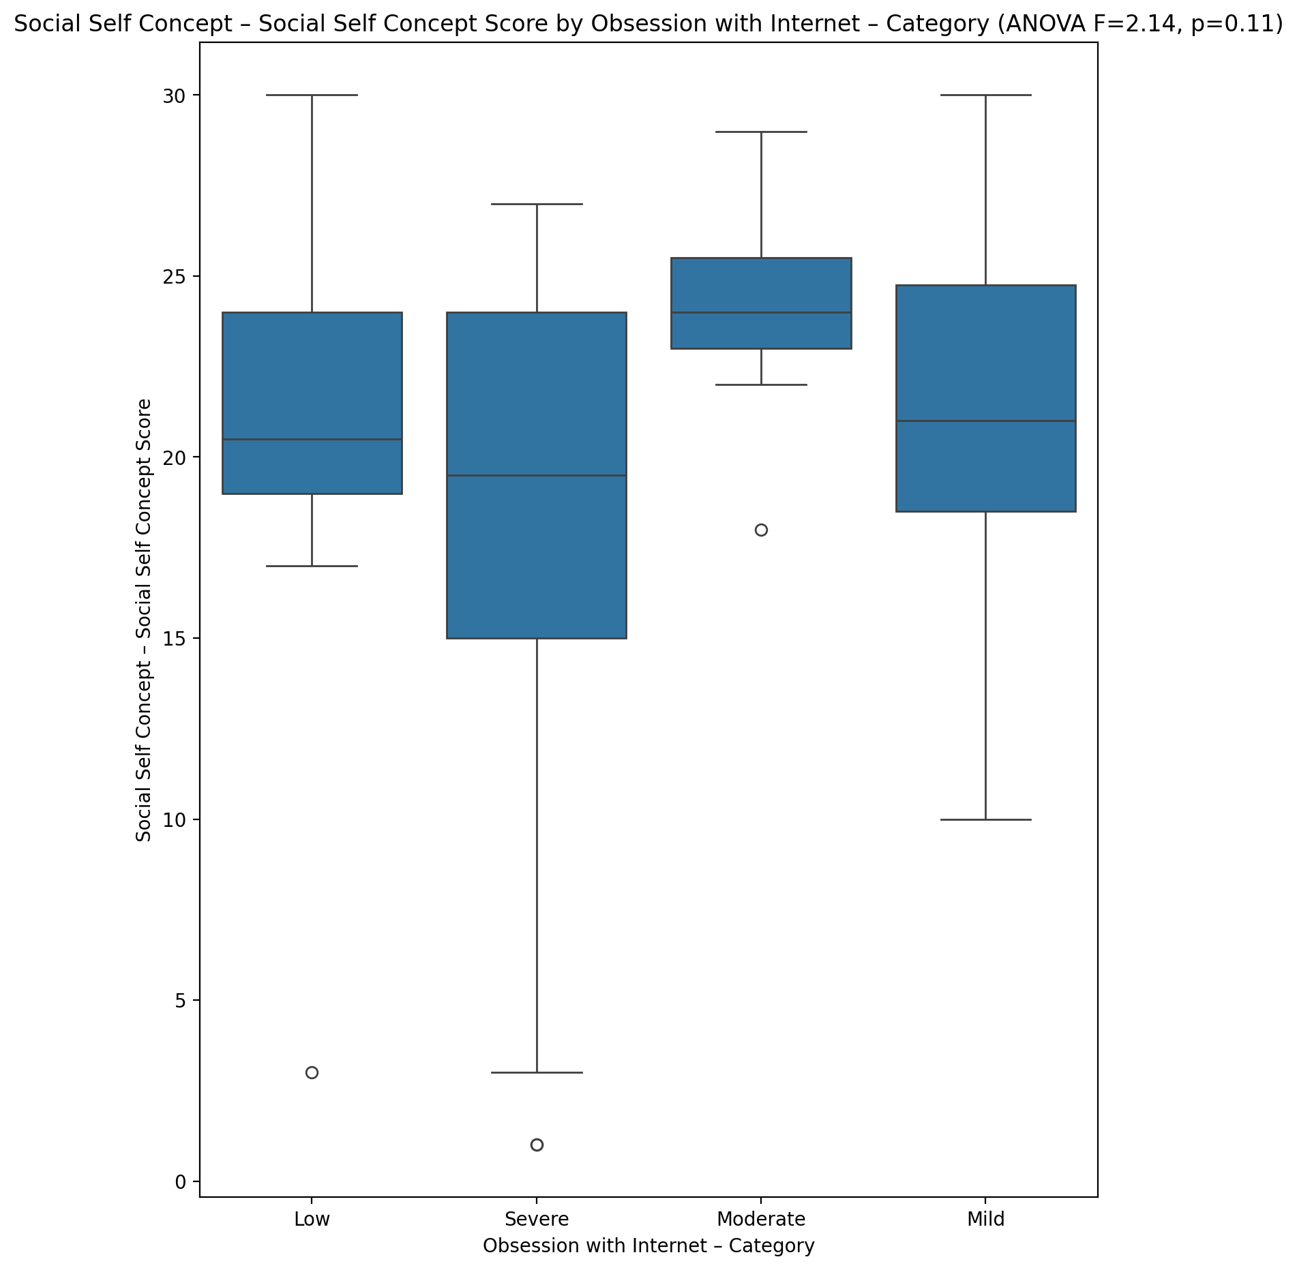

## Ability Self Concept - Real Self Concept Score vs Obsession with Internet – Category

Test: anova; statistic: 0.7960609378684852; p-value: 0.501349113869197;

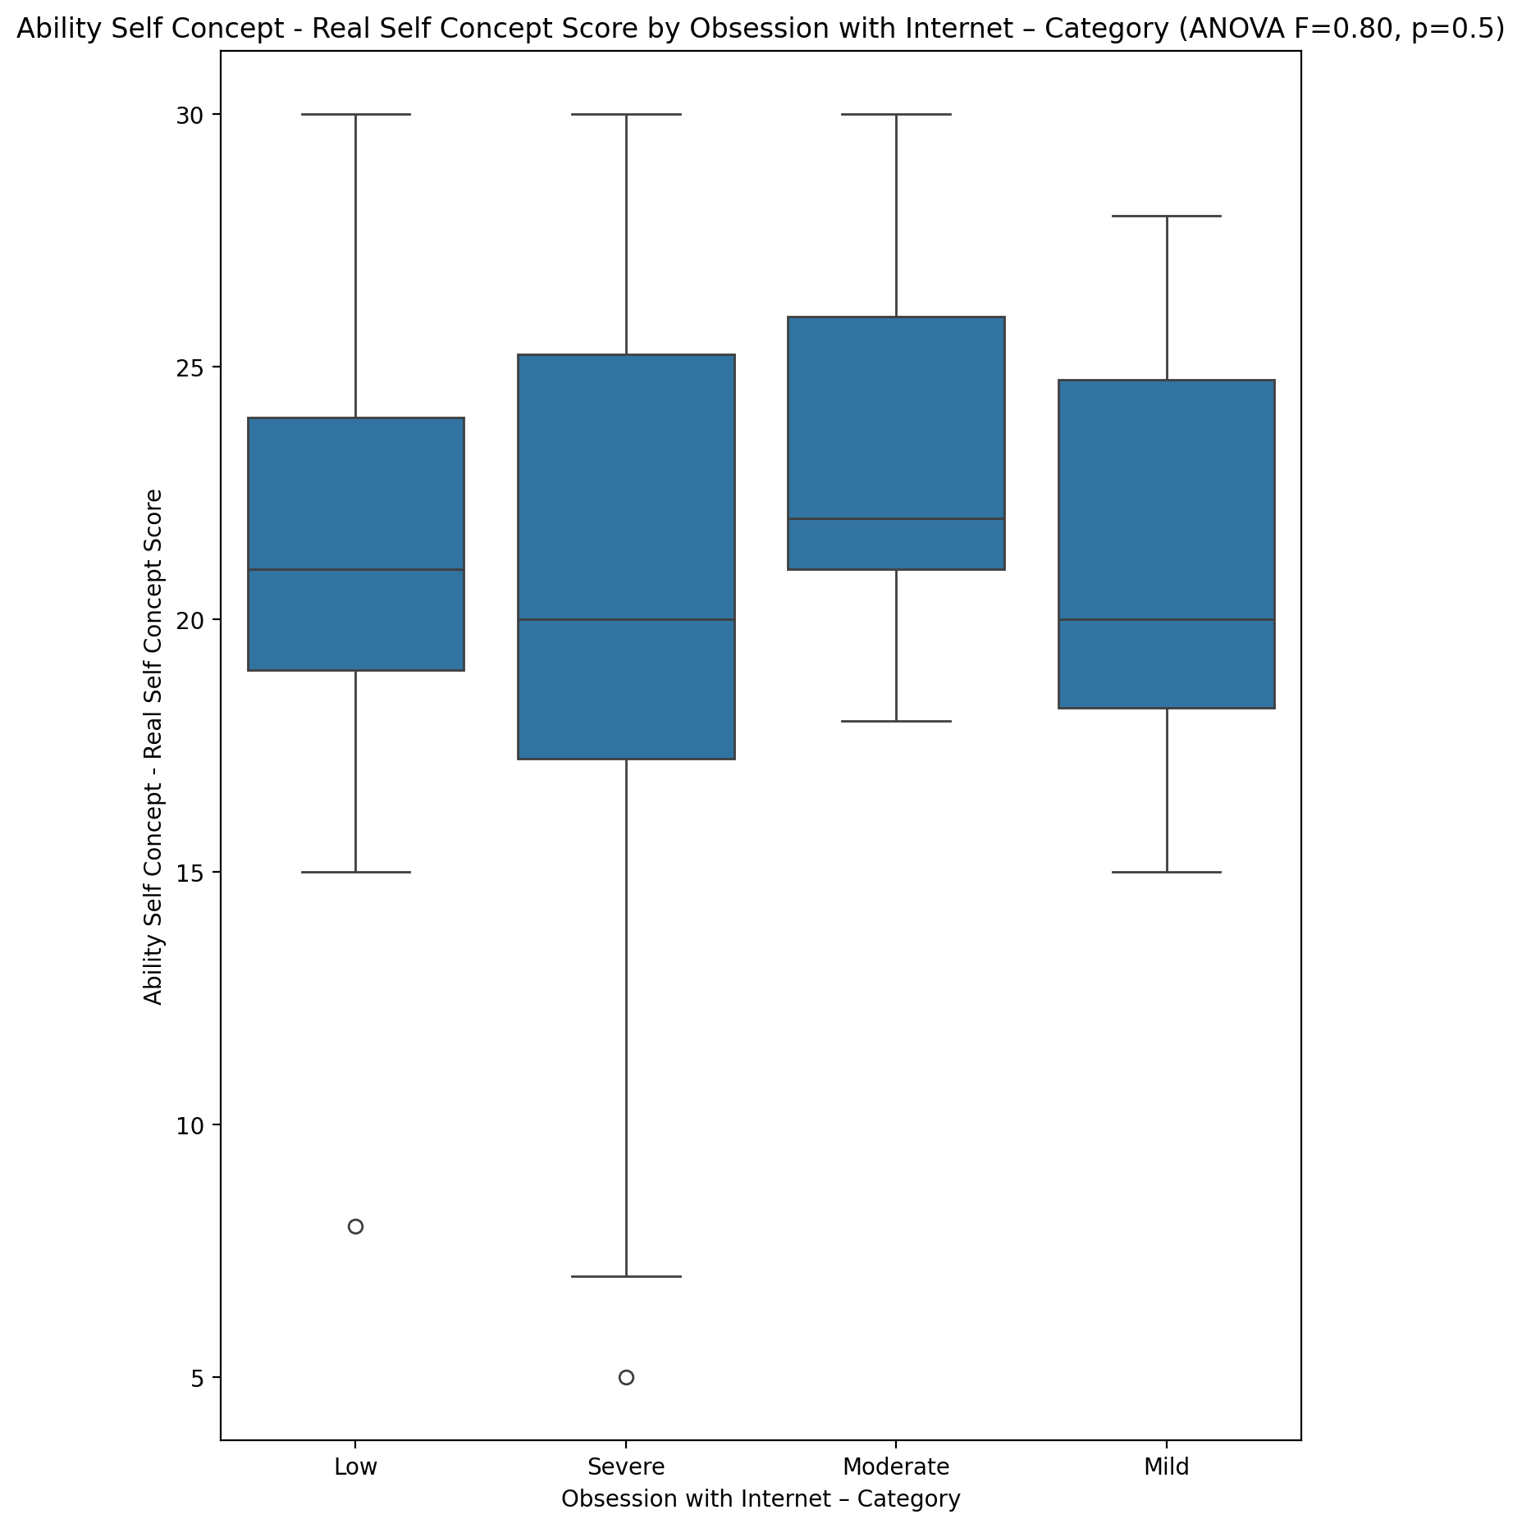

## Ability Self Concept - Ideal Self Concept Score vs Obsession with Internet – Category

Test: anova; statistic: 1.4935624582211022; p-value: 0.22643296481240402;

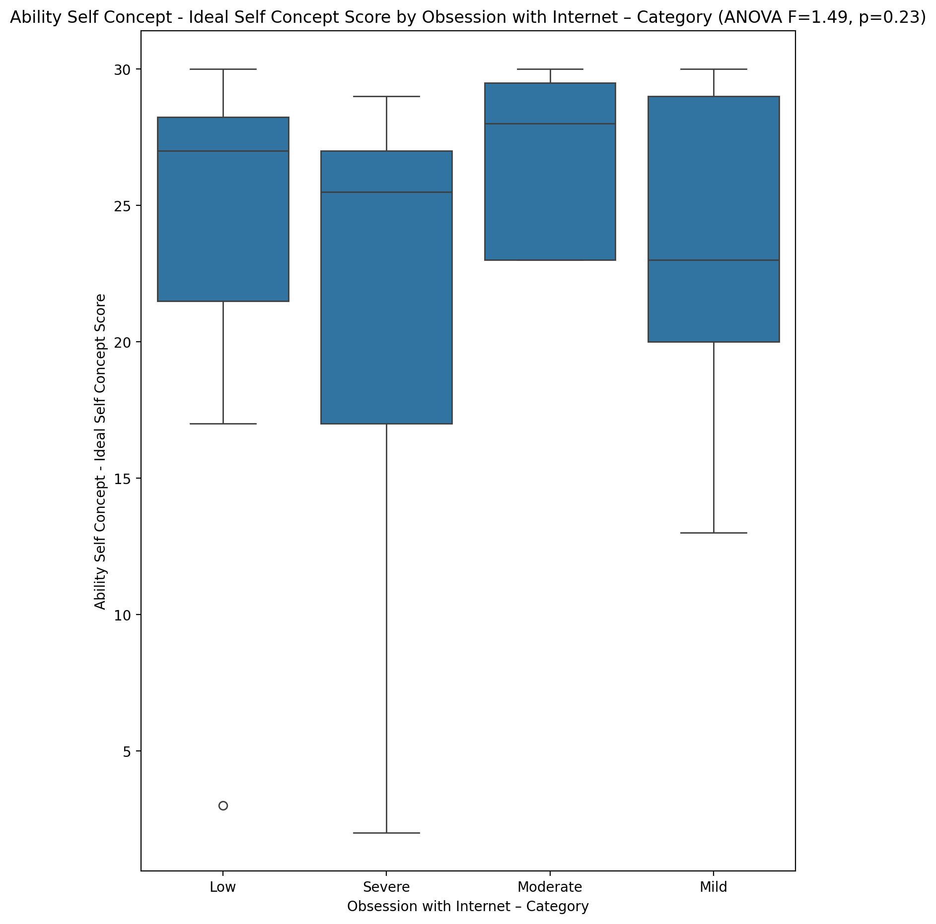

## Ability Self Concept – Social Self Concept Score vs Obsession with Internet – Category

Test: anova; statistic: 1.639702441193088; p-value: 0.1907525548617156;

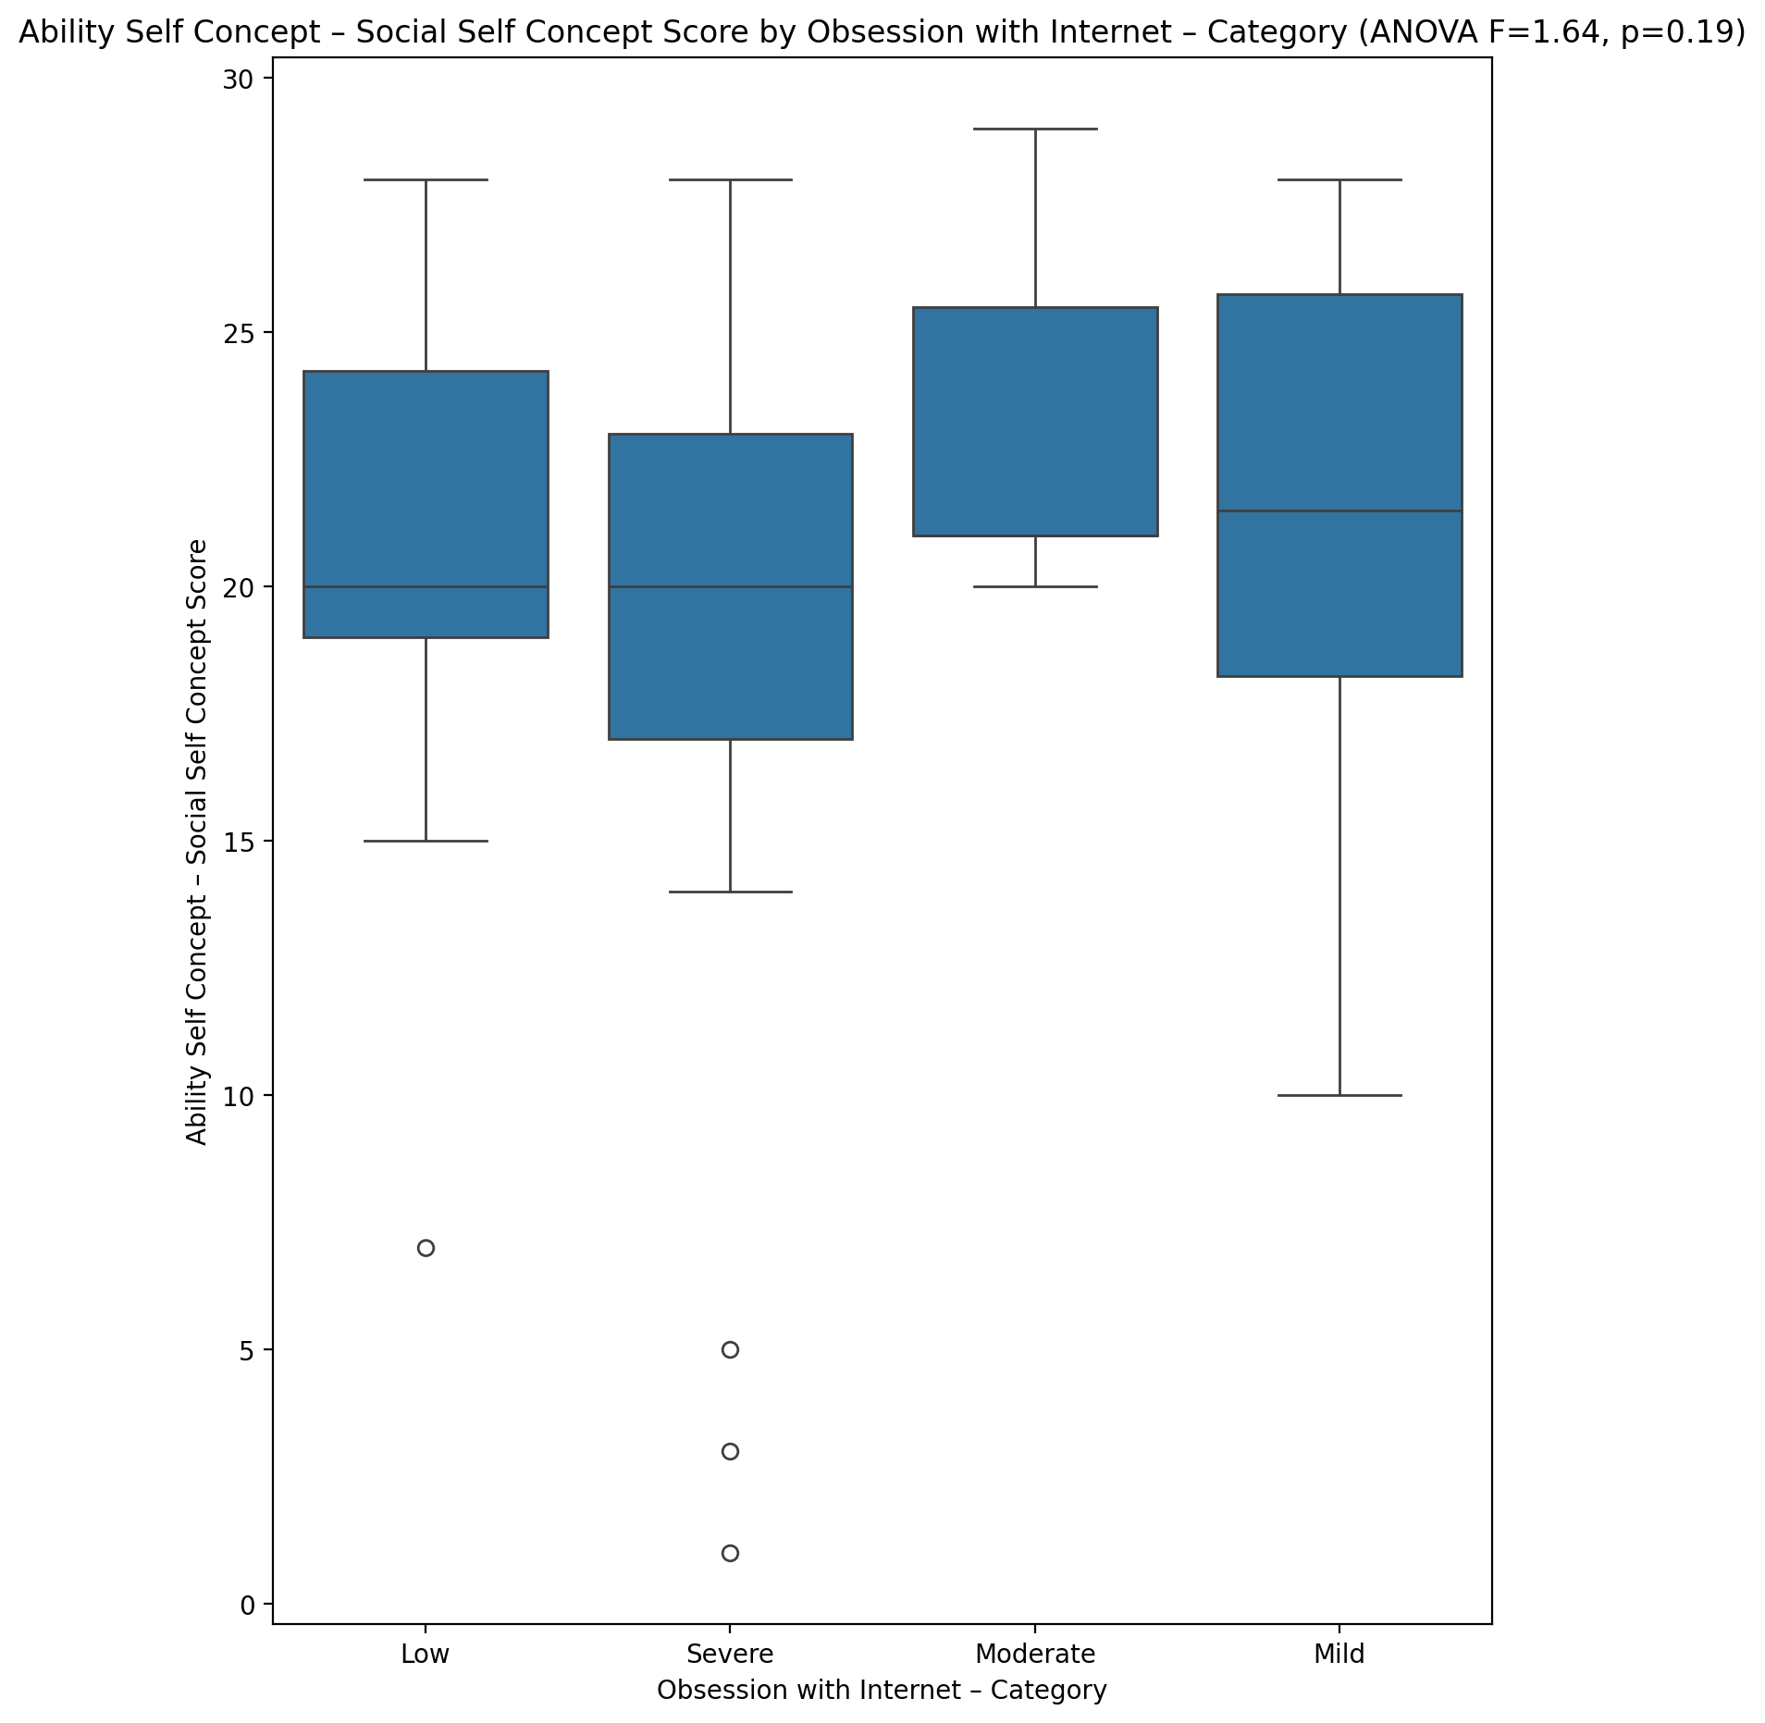

## Physical Self Concept - Real Self Concept Score vs Obsession with Internet – Category

Test: anova; statistic: 1.1388760339097863; p-value: 0.3415020502417684;

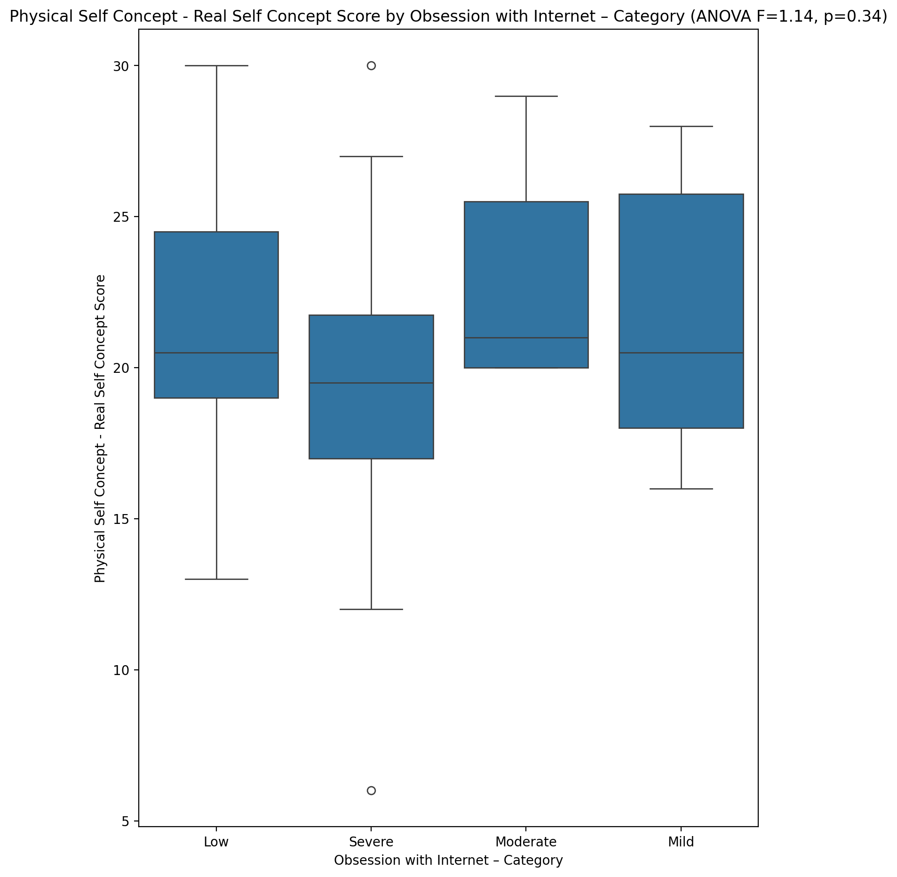

## Physical Self Concept – Ideal Self Concept Score vs Obsession with Internet – Category

Test: anova; statistic: 1.6330885677128455; p-value: 0.19224209785716326;

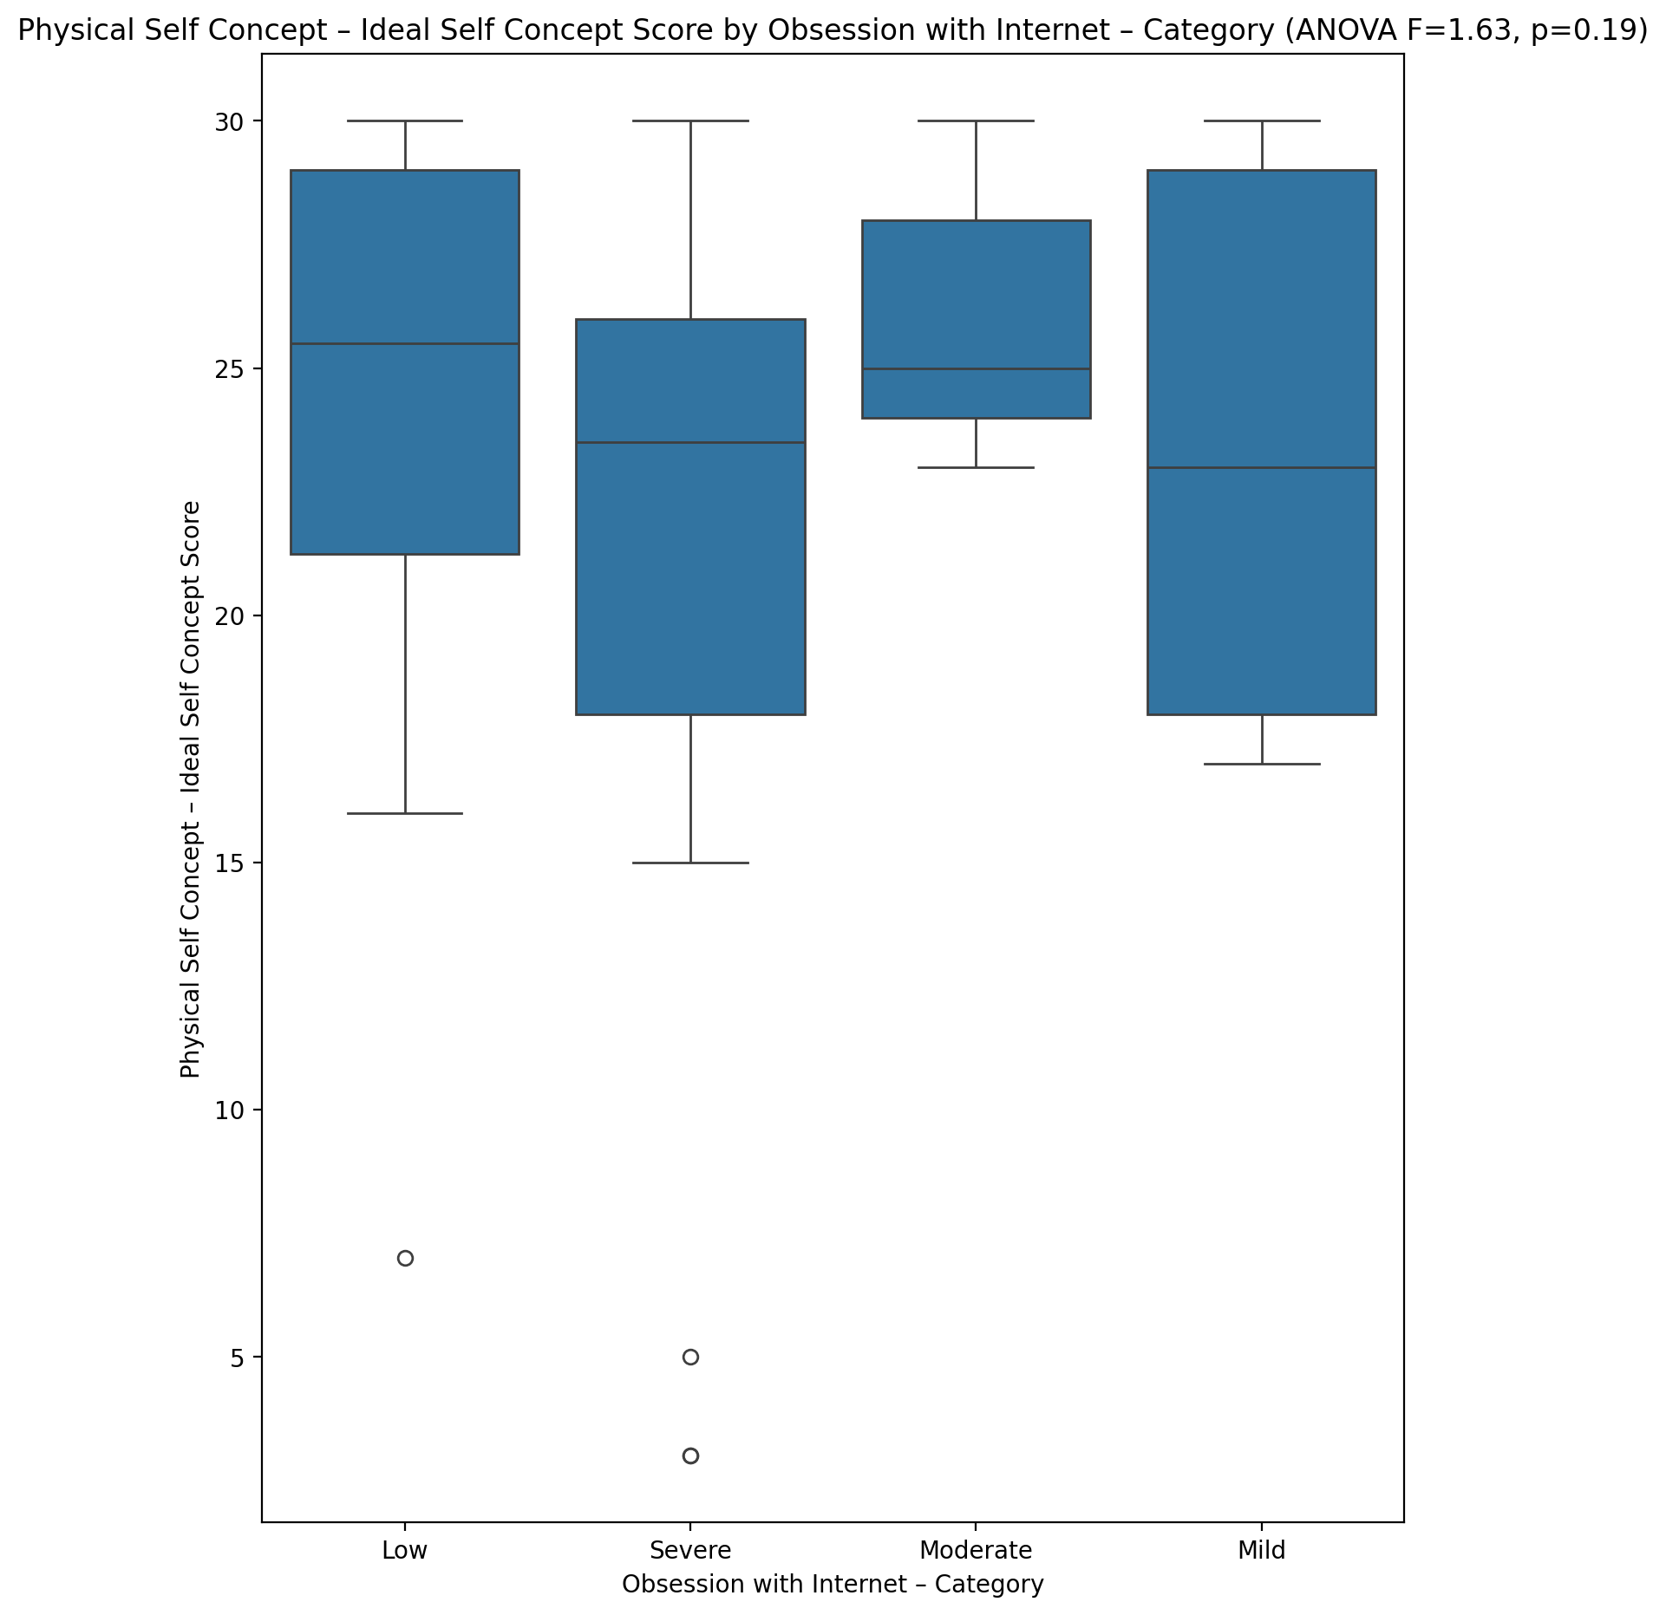

## Physical Self Concept – Social Self Concept Score vs Obsession with Internet – Category

Test: anova; statistic: 1.4378642937041366; p-value: 0.24166255335468606;

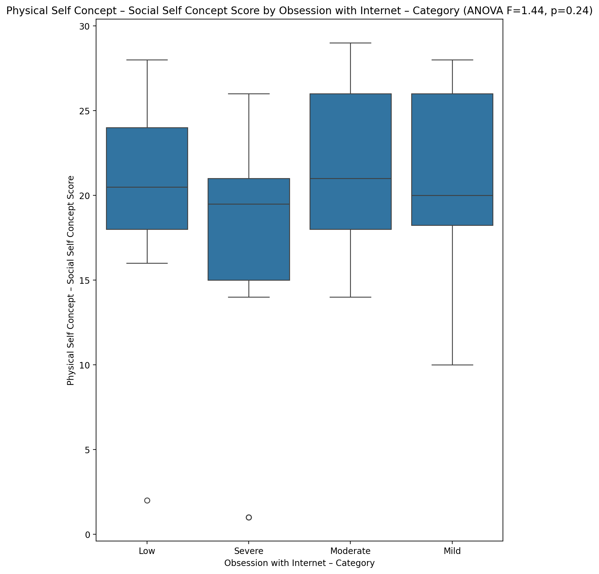

## Psychological Self Concept - Real Self Concept Score vs Obsession with Internet – Category

Test: anova; statistic: 2.5294245013653978; p-value: 0.06661586628856764;

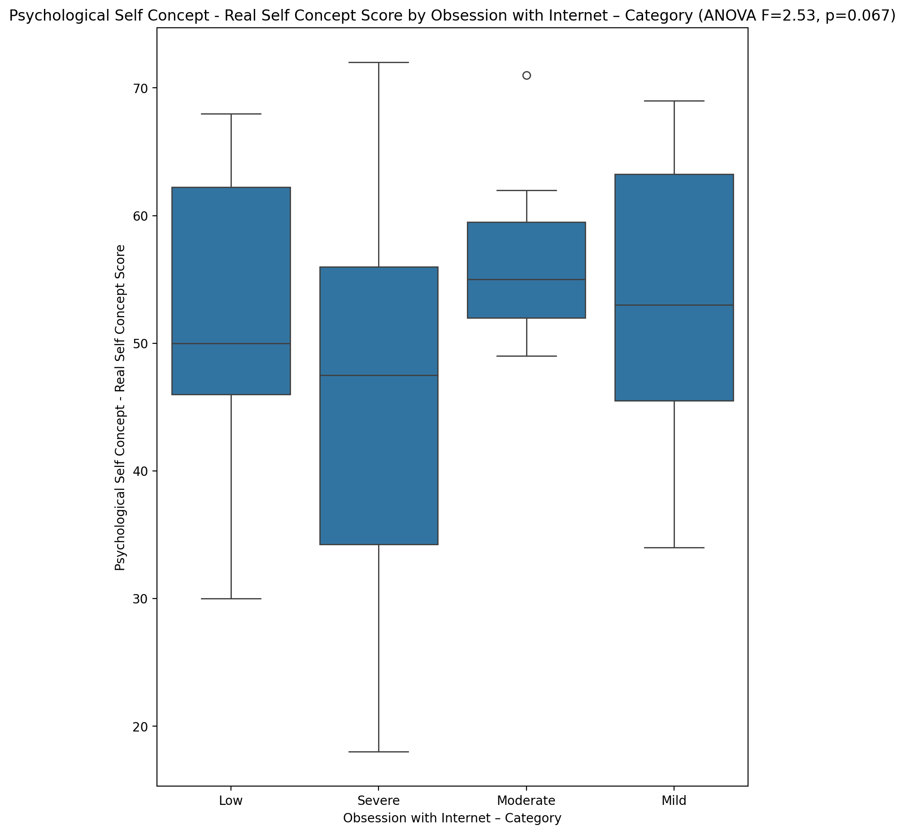

## Psychological Self Concept – Ideal Self Concept Score vs Obsession with Internet – Category

Test: anova; statistic: 2.803481279076612; p-value: 0.048210324123239084;

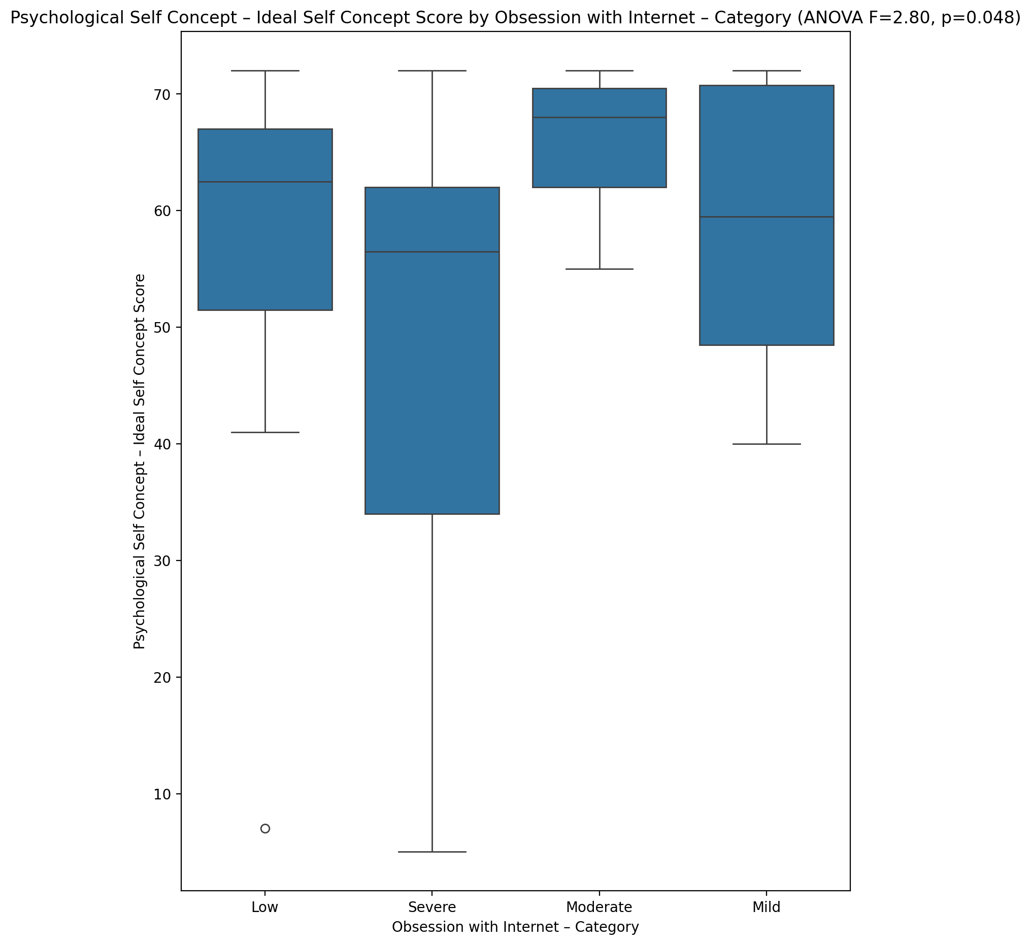

## Psychological Self Concept – Social Self Concept Score vs Obsession with Internet – Category

Test: anova; statistic: 2.606485051128975; p-value: 0.0608188559334543;

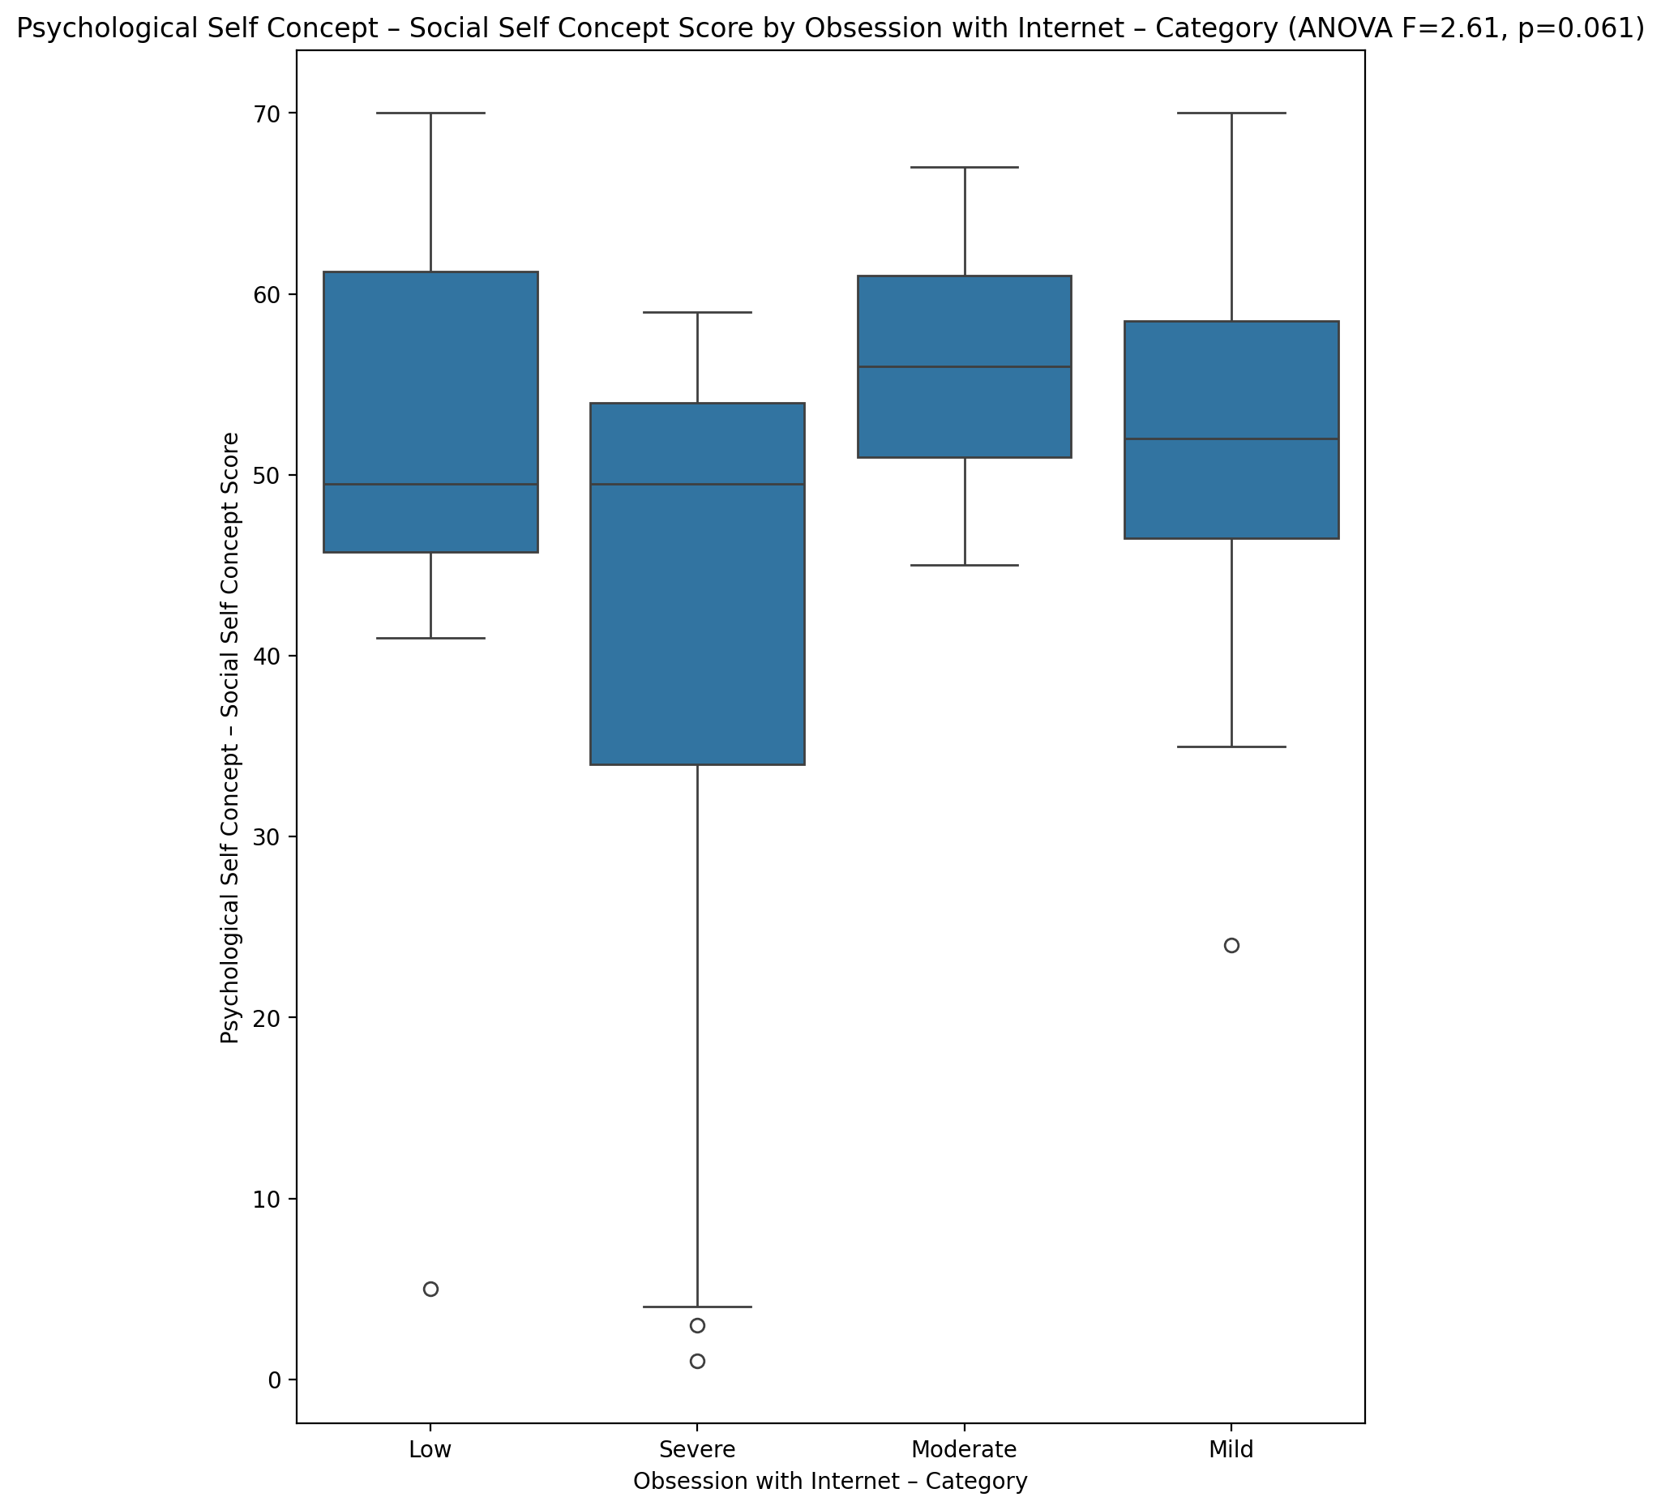

## Real Self Concept Total Score vs Obsession with Internet – Category

Test: anova; statistic: 1.3484226036736193; p-value: 0.2681902042290991;

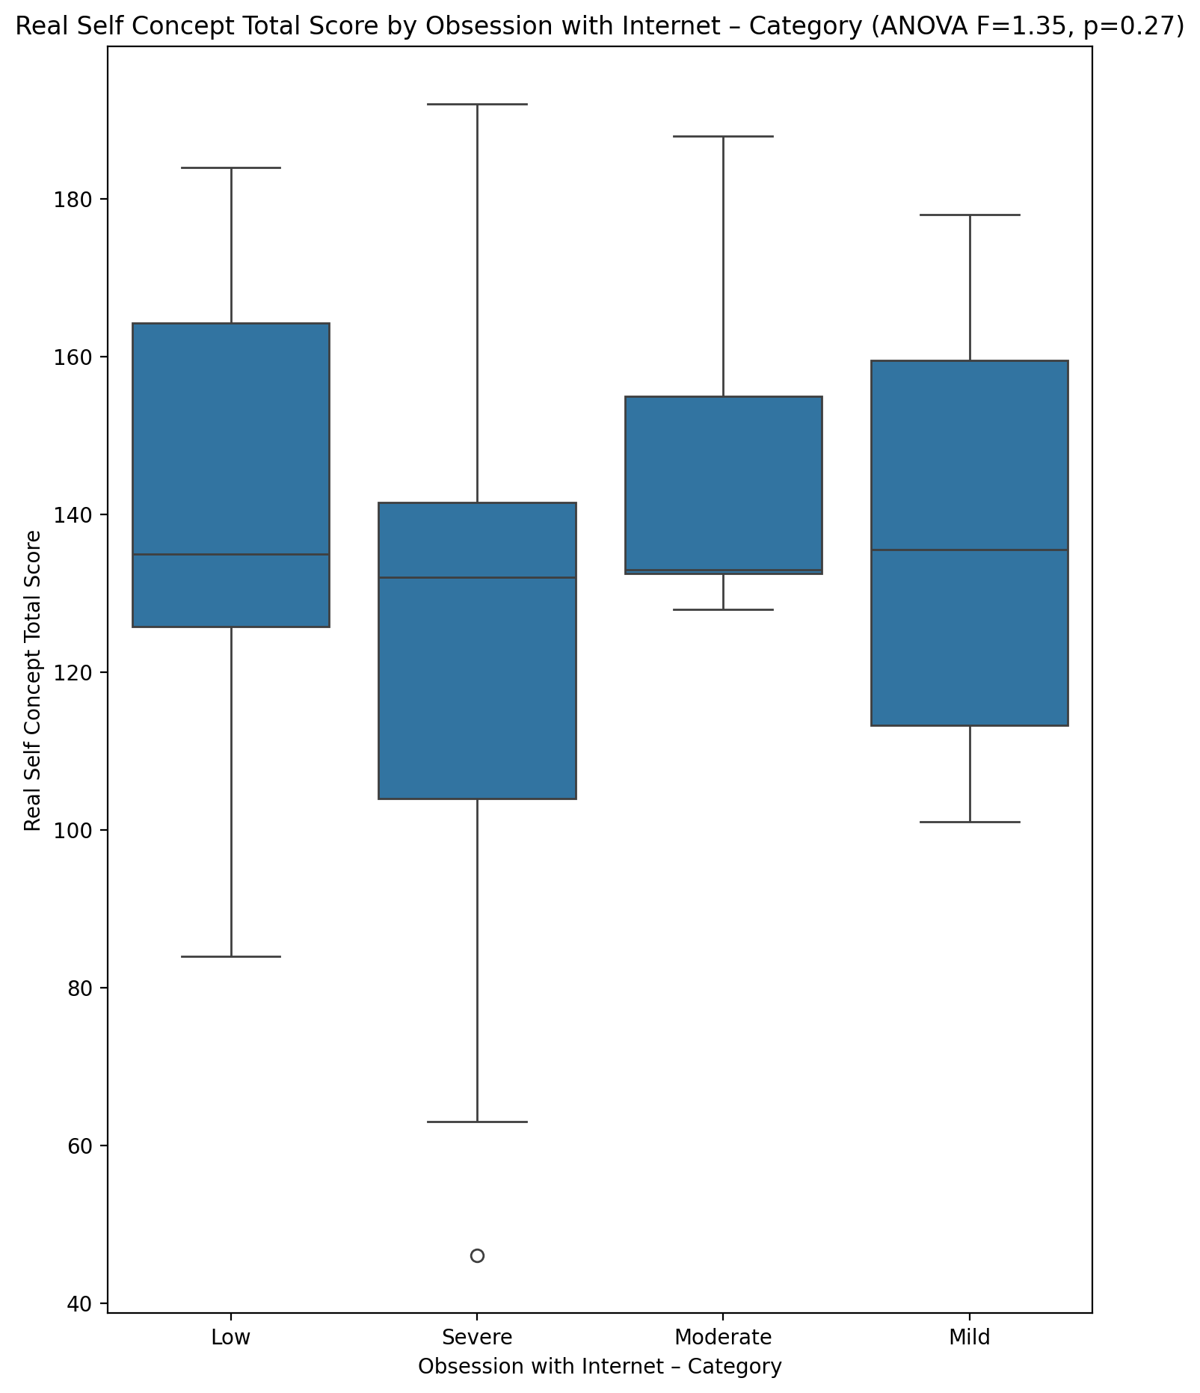

## Ideal Self Concept Total Score vs Obsession with Internet – Category

Test: anova; statistic: 2.1011134709750787; p-value: 0.11059703100993962;

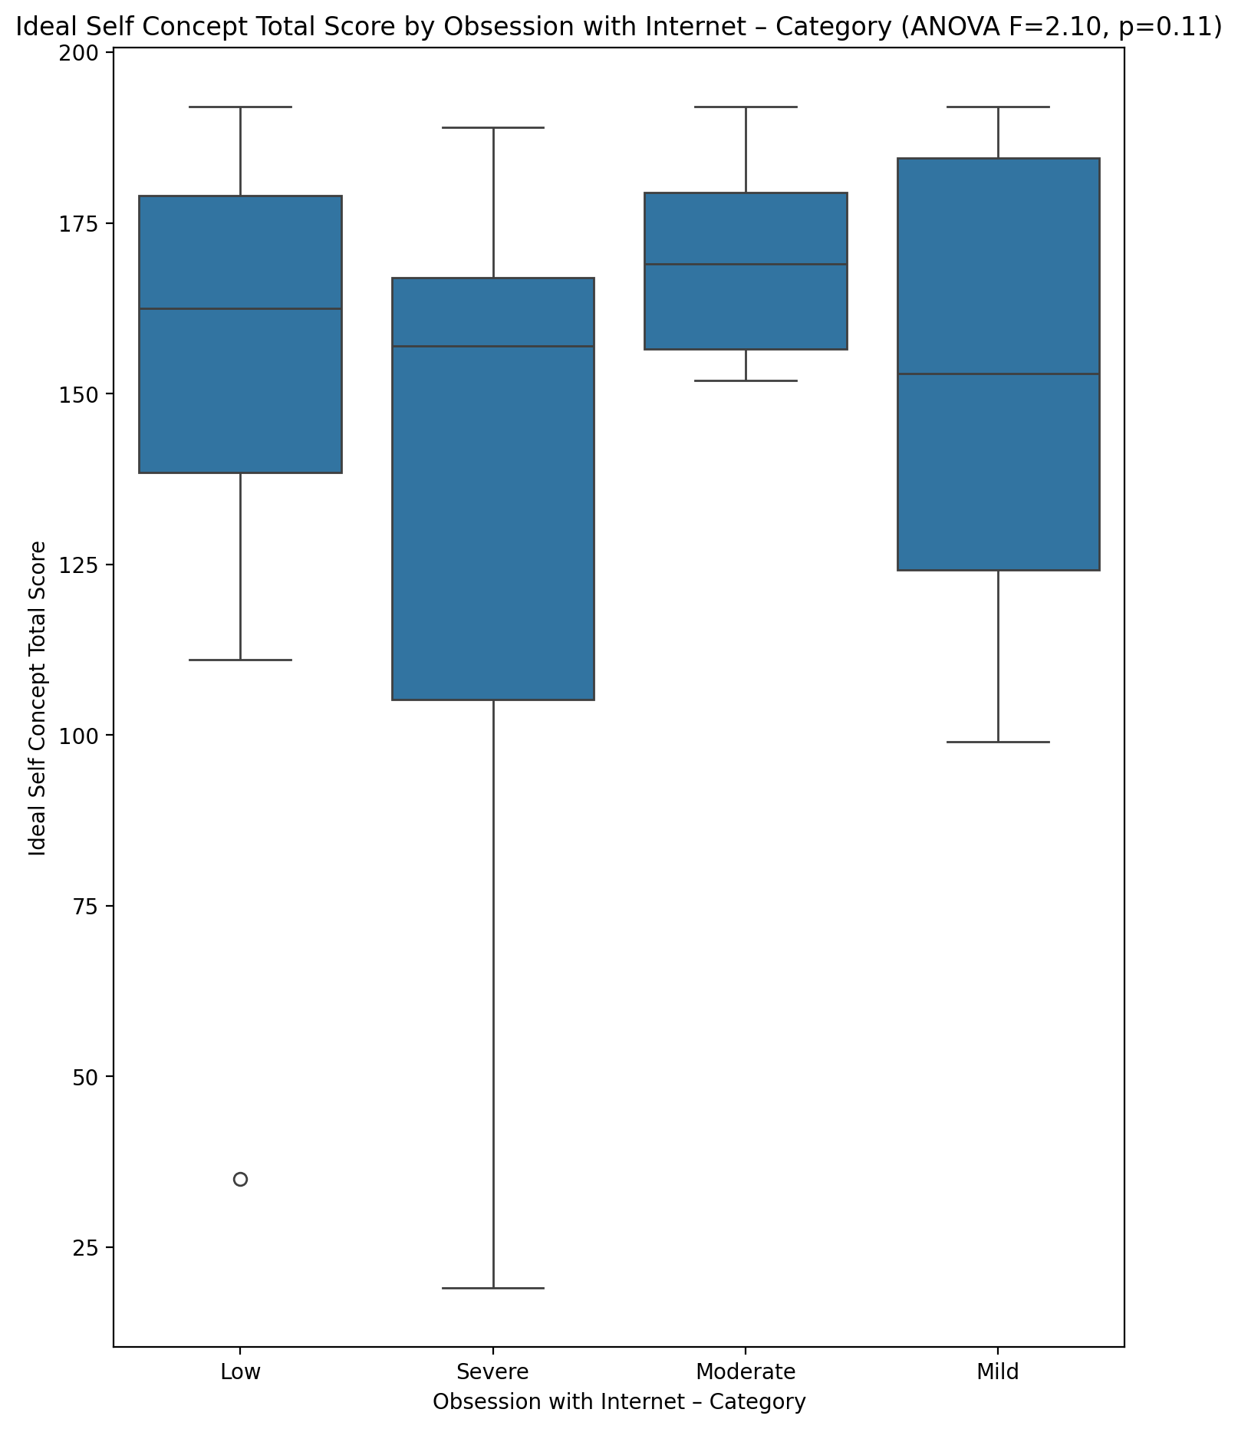

## Social Self Concept Total Score vs Obsession with Internet – Category

Test: anova; statistic: 1.9166332459423243; p-value: 0.13758351024601254;

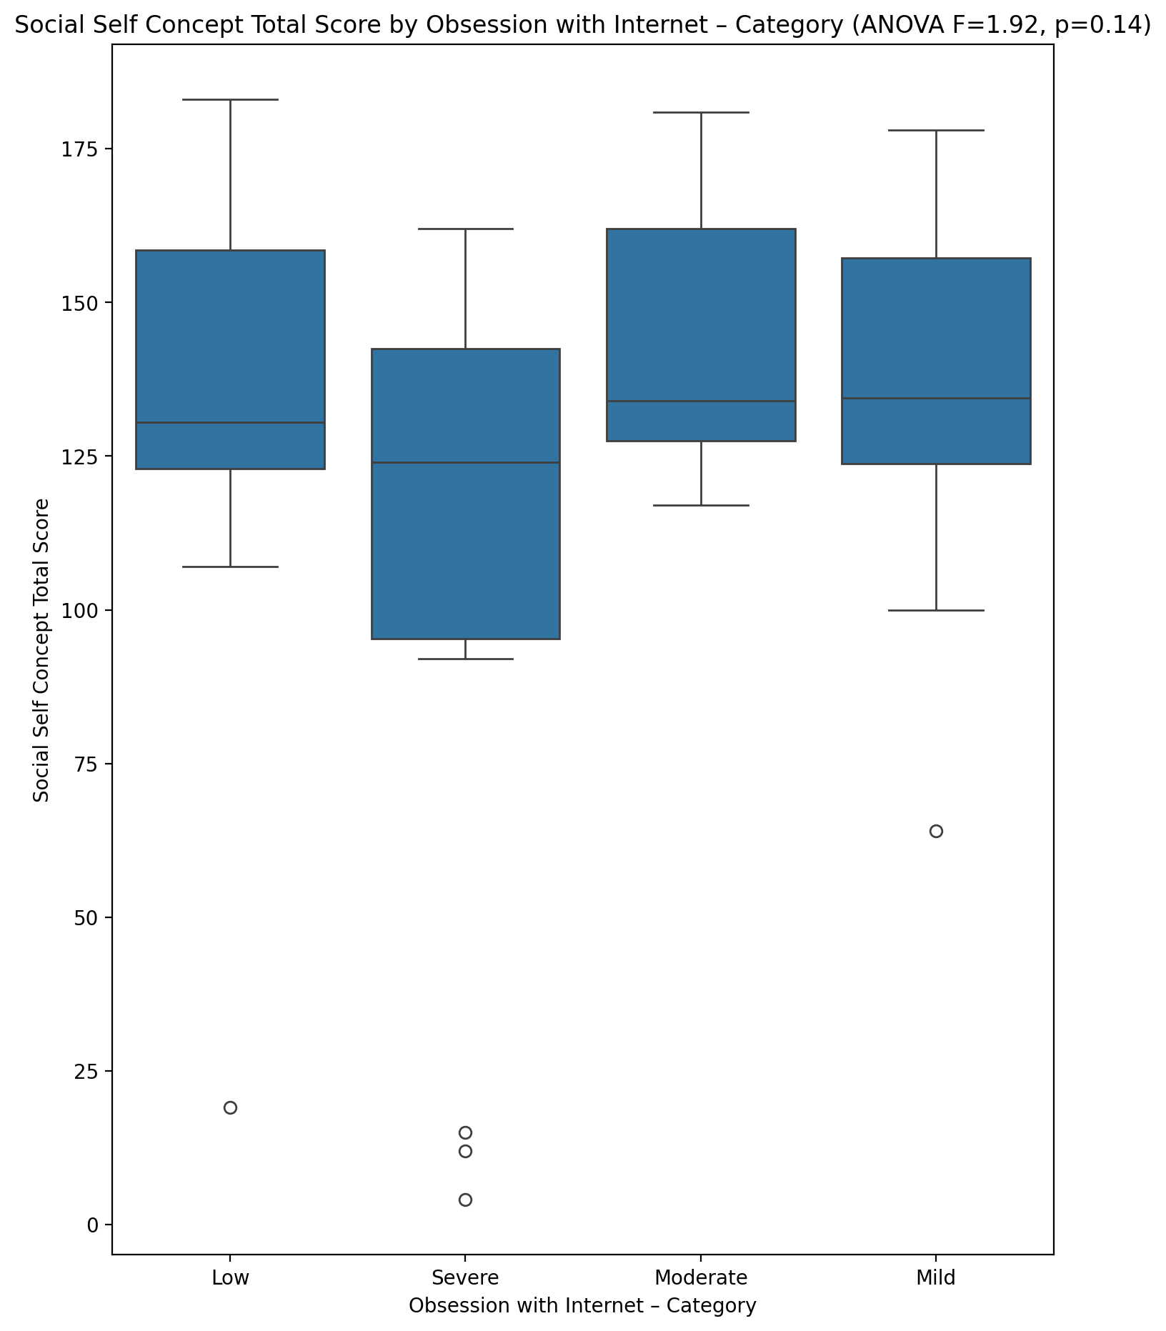

## Ideal Self Concept Total Category vs Obsession with Internet – Category

Test: chi2; statistic: 7.986731786731786; p-value: 0.239076981847778;

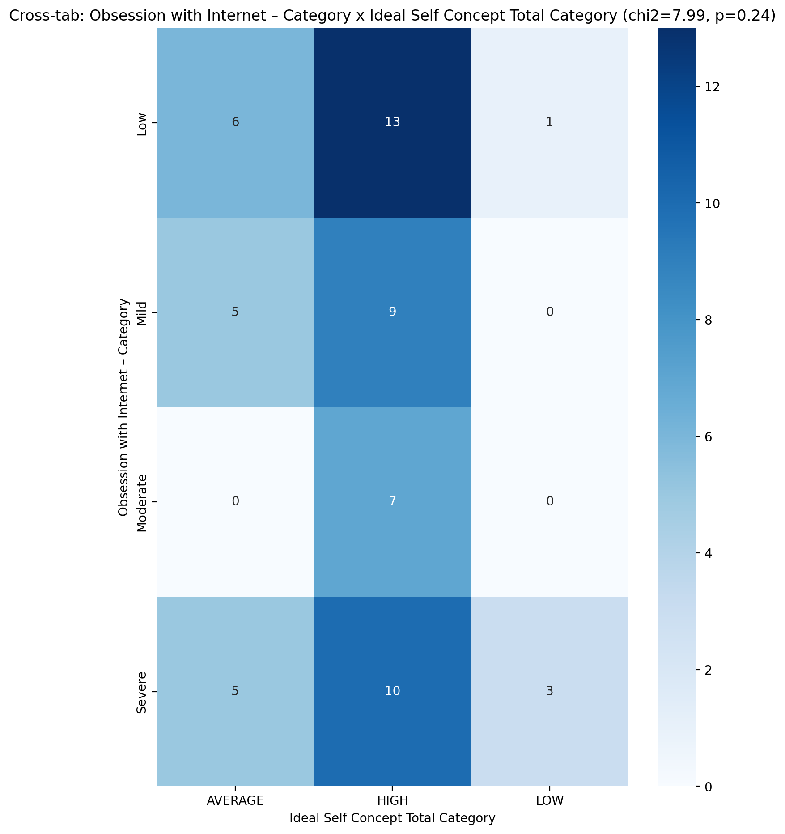

## Perceived Social Stress Score vs Obsession with Internet – Category

Test: anova; statistic: 1.460115045391863; p-value: 0.23546399515892777;

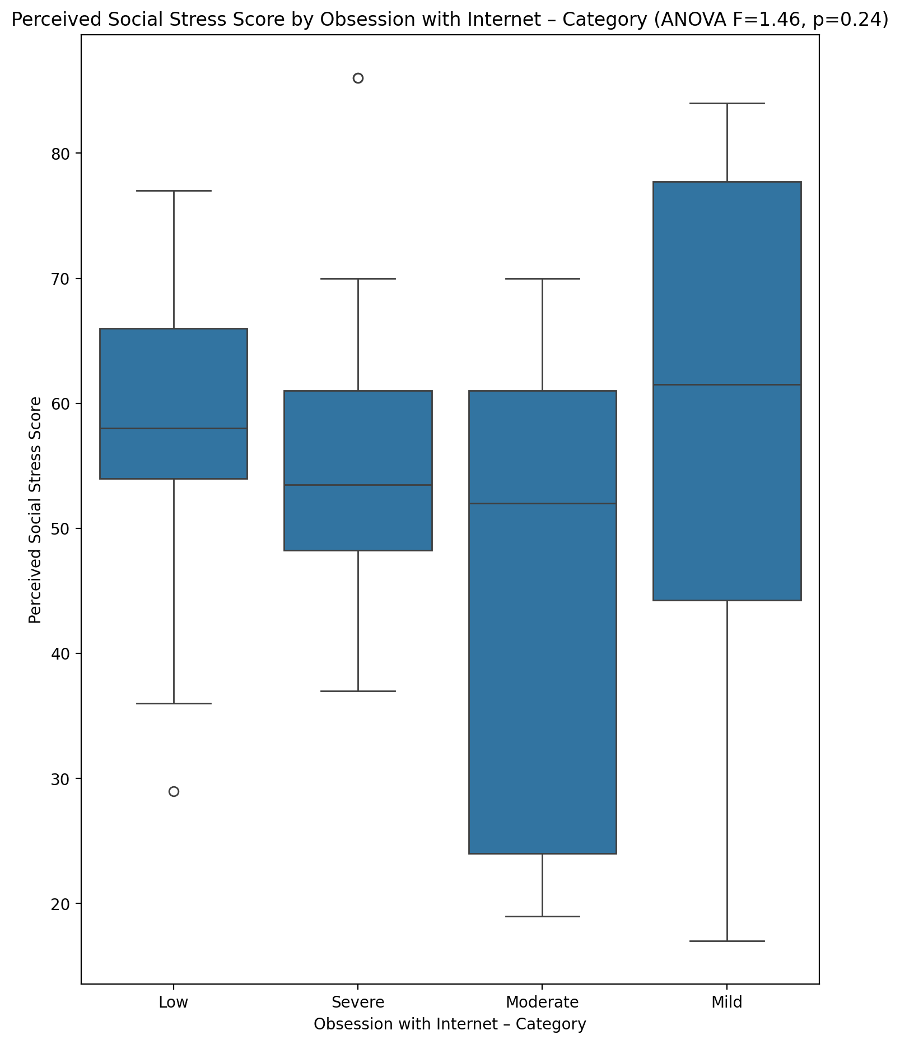

## Perceived Social Stress Category vs Obsession with Internet – Category

Test: chi2; statistic: 20.616636904761908; p-value: 0.0021493304613195907;

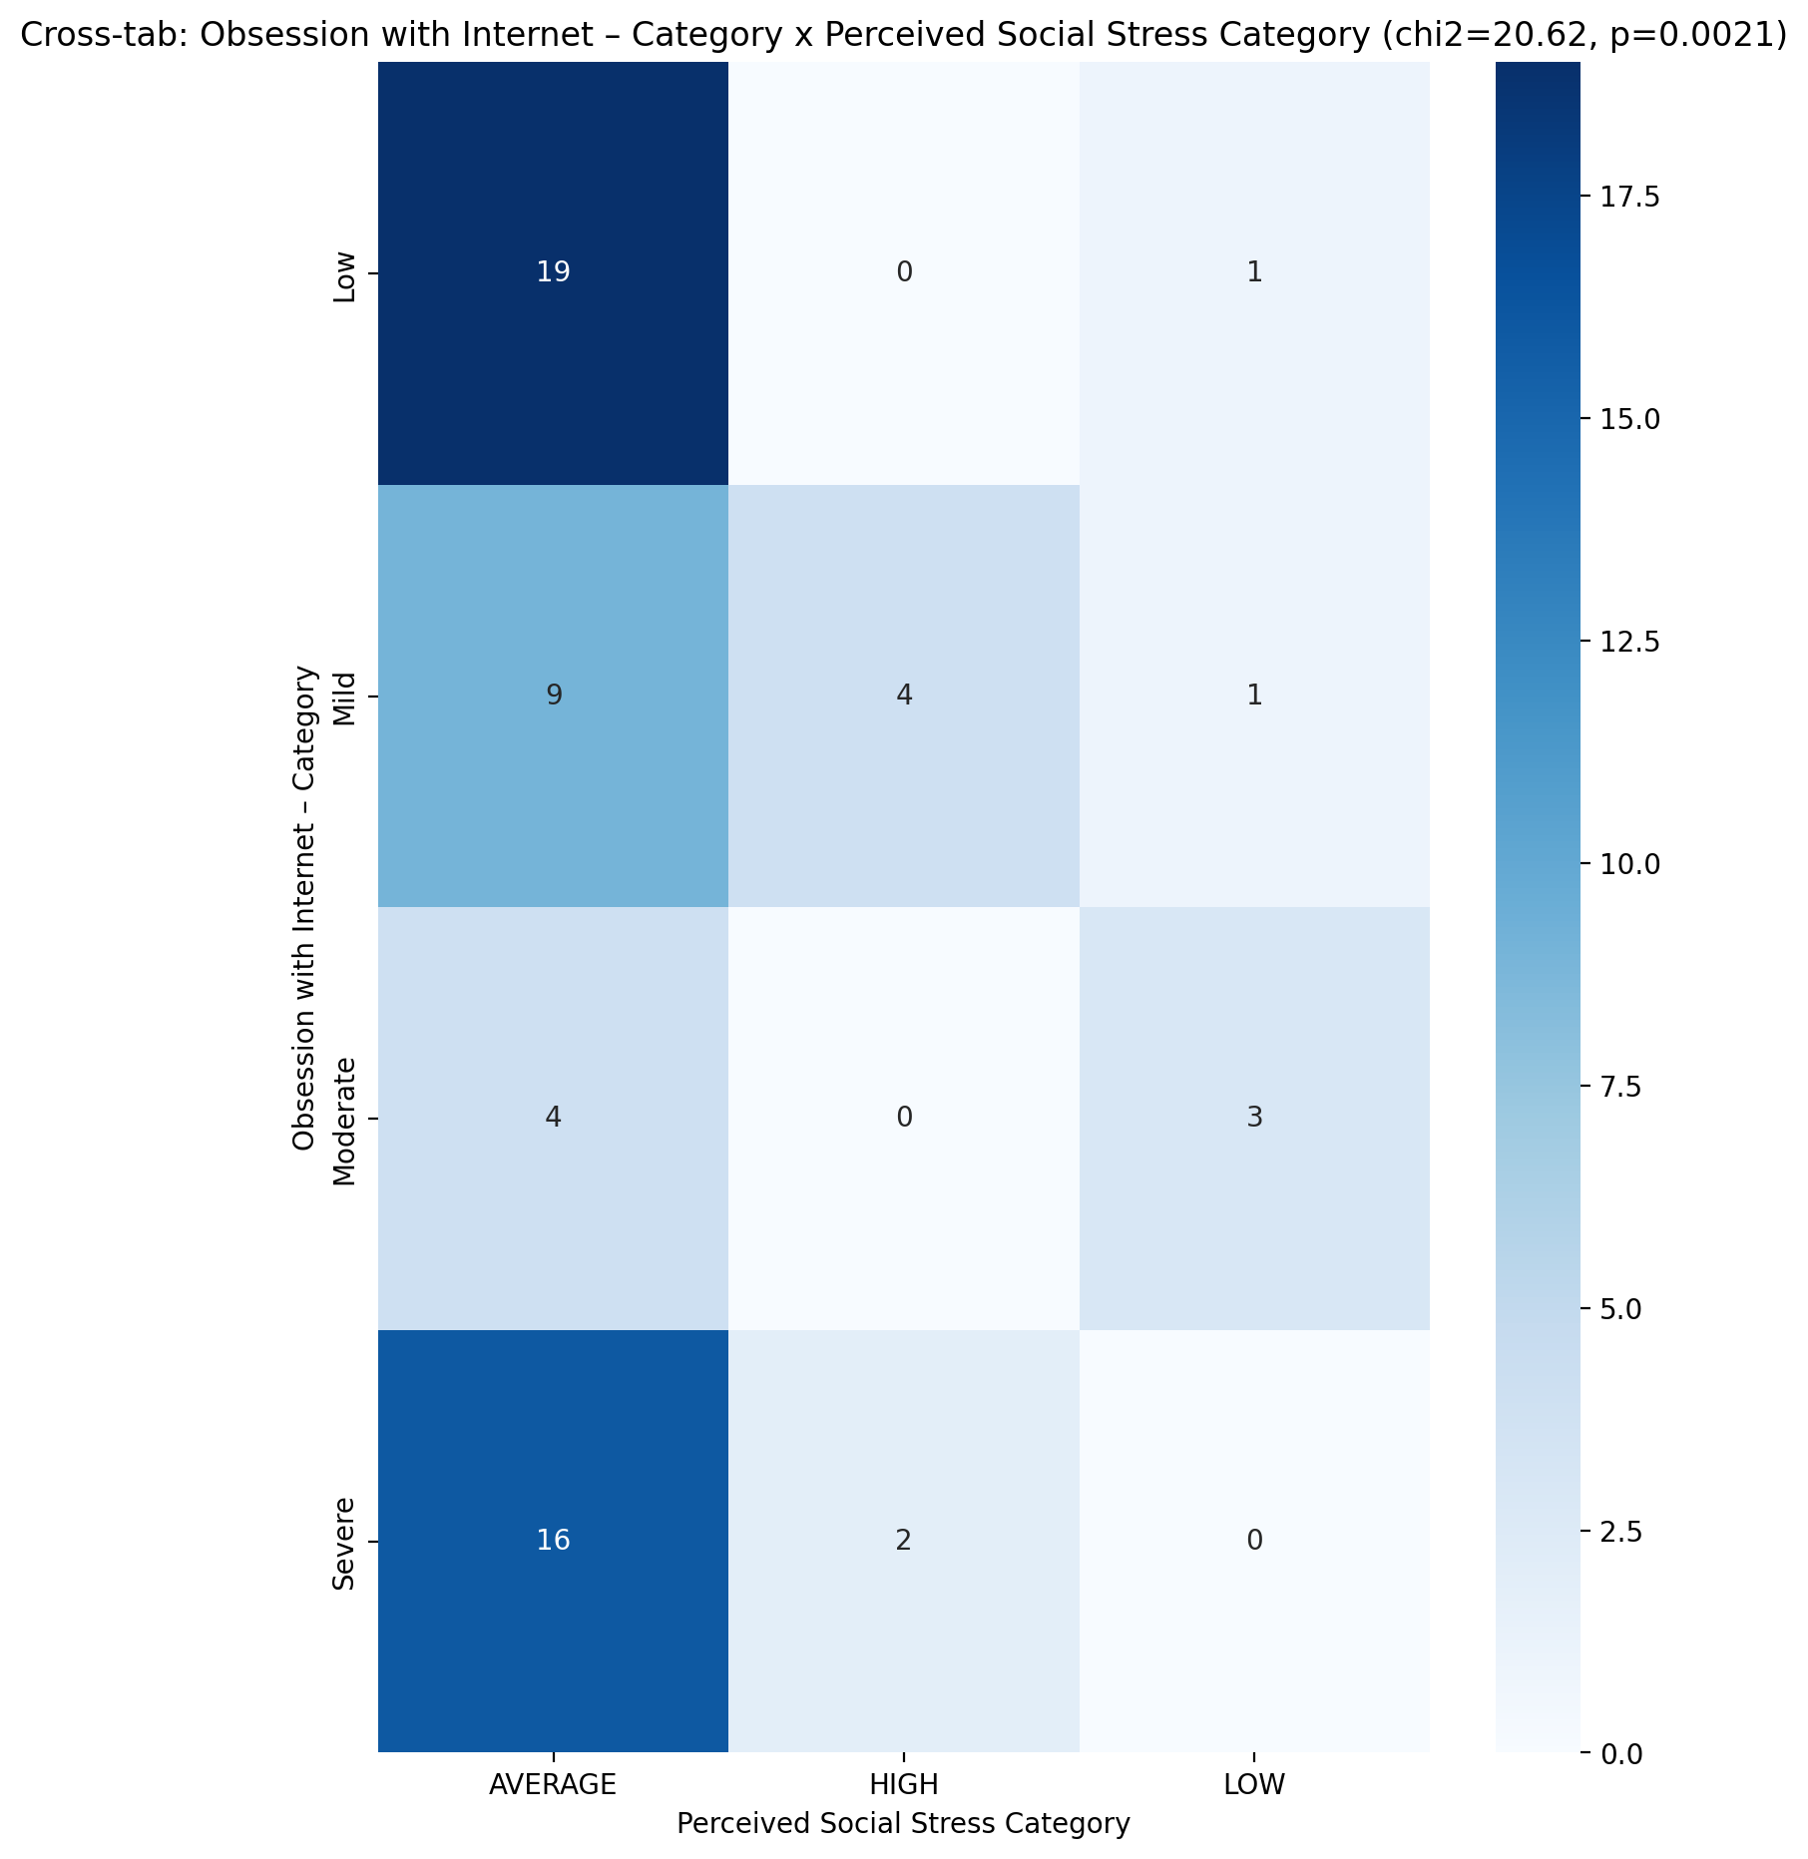

## Emotional Support - Raw Score vs Internet as a Source of Recreation – Category

Test: anova; statistic: 0.09134054226729578; p-value: 0.9645124931239997;

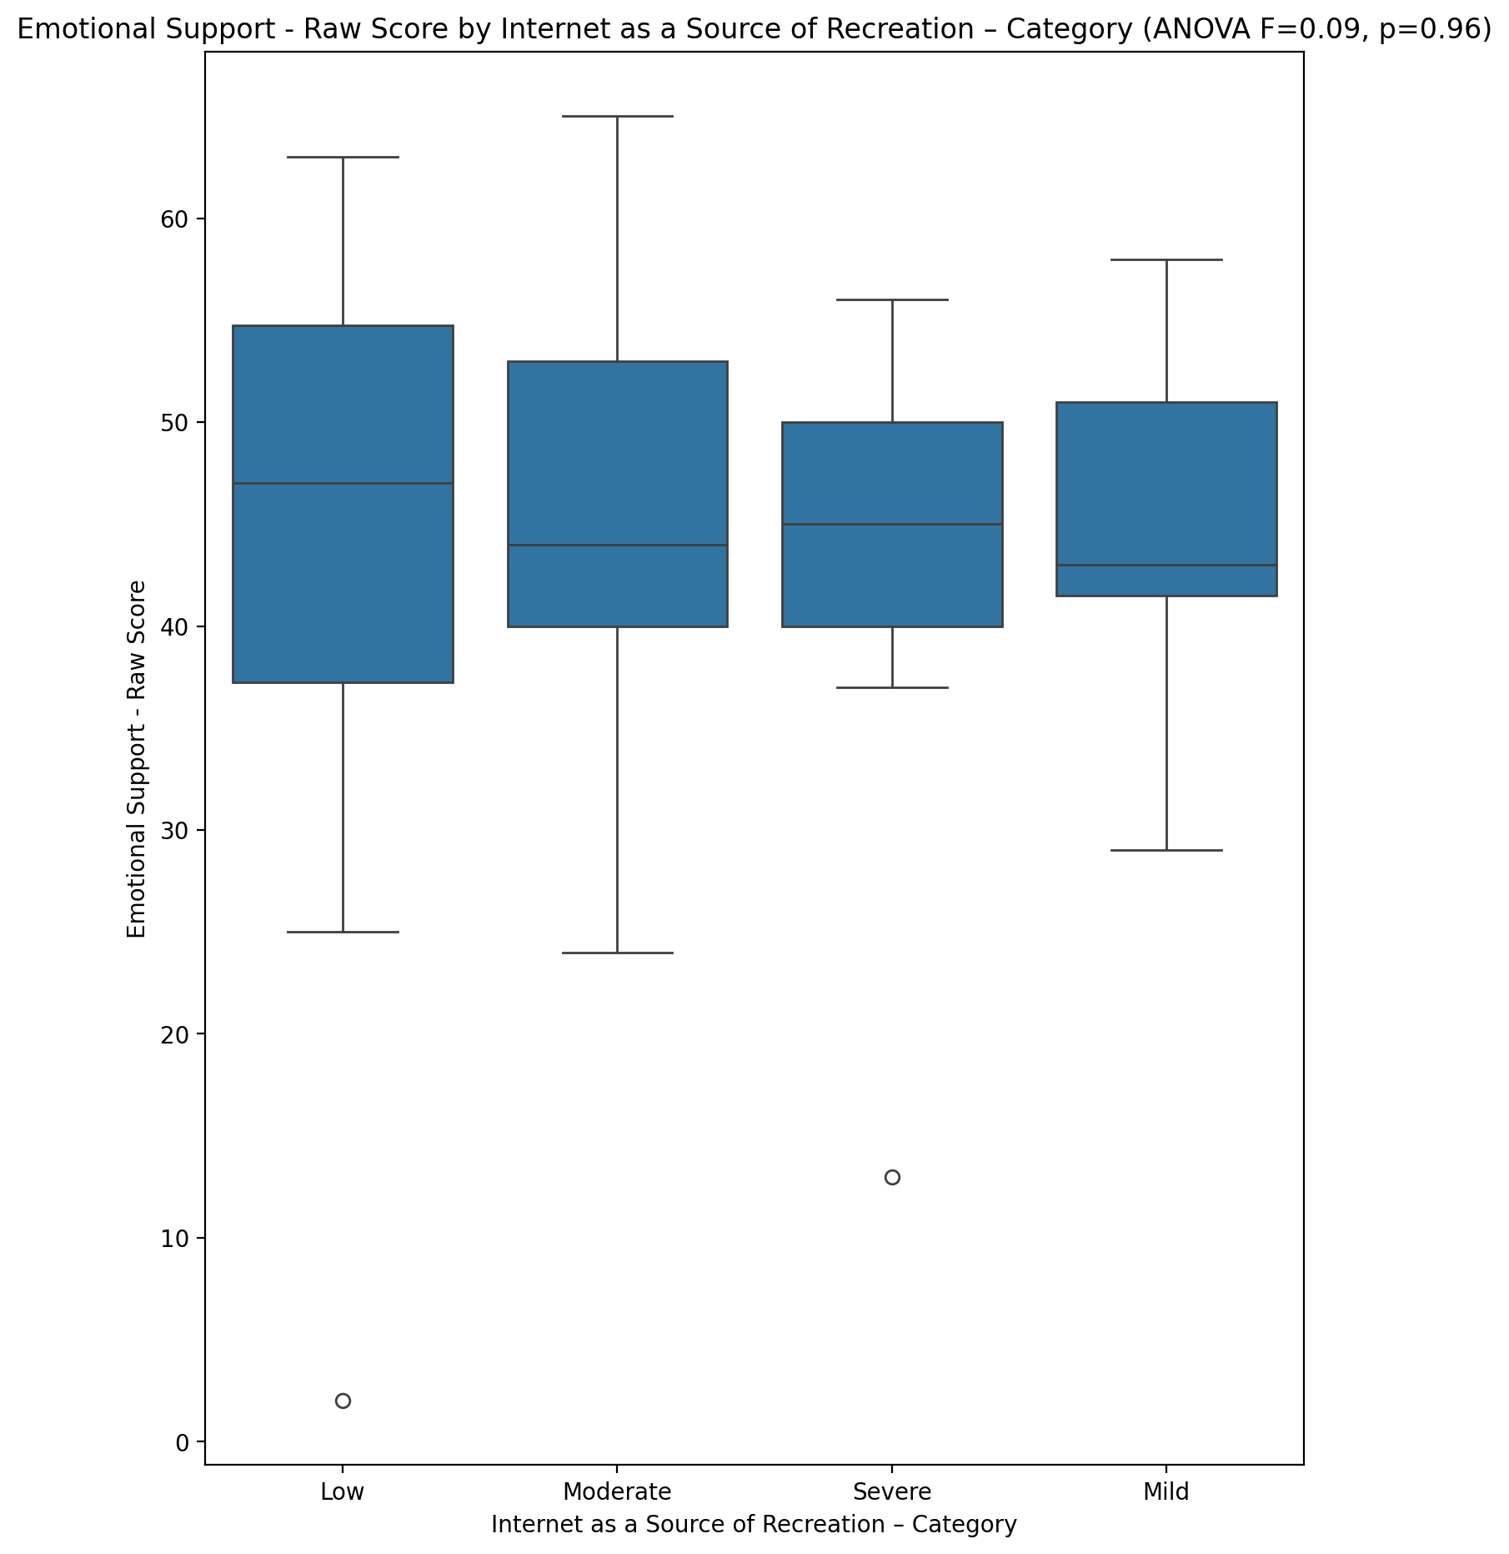

## Informational Support - Raw Score vs Internet as a Source of Recreation – Category

Test: anova; statistic: 0.07378708091008455; p-value: 0.9738088302448736;

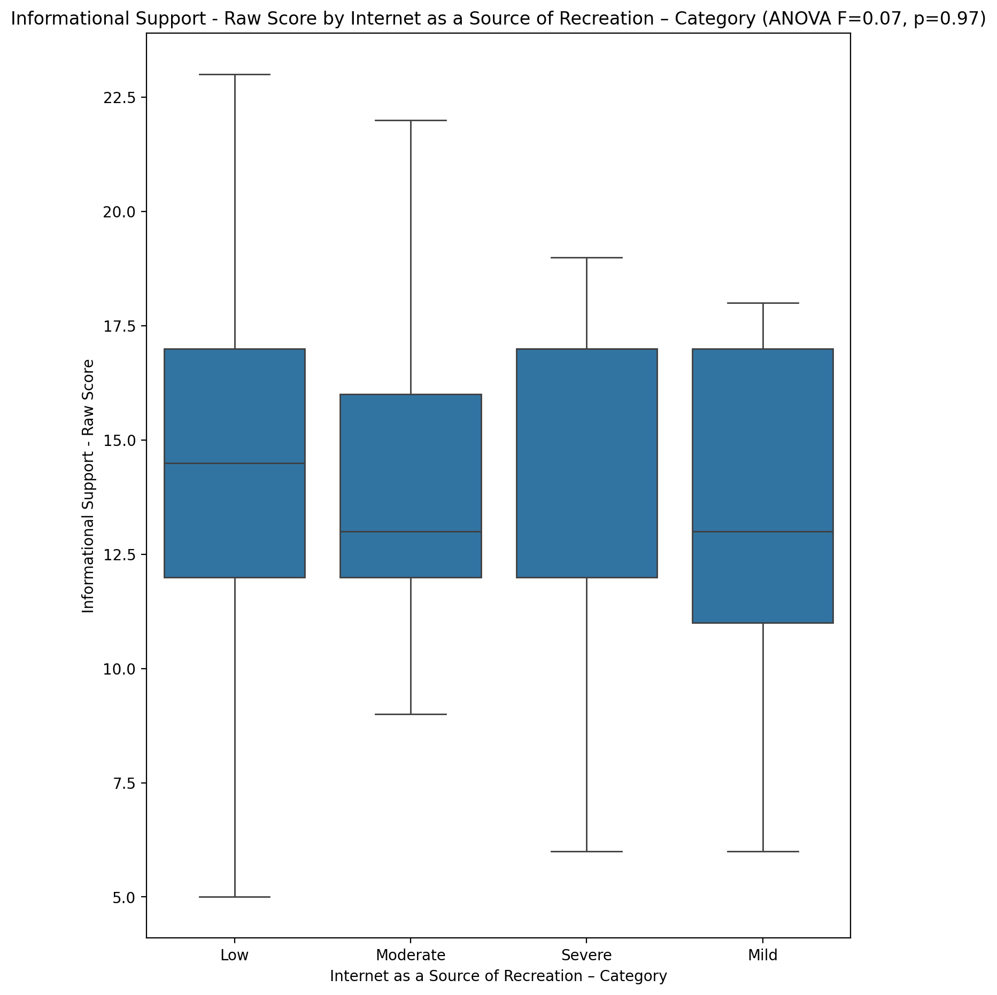

## Instrumental Support - Raw Score vs Internet as a Source of Recreation – Category

Test: anova; statistic: 0.4412806444166607; p-value: 0.7244036014262789;

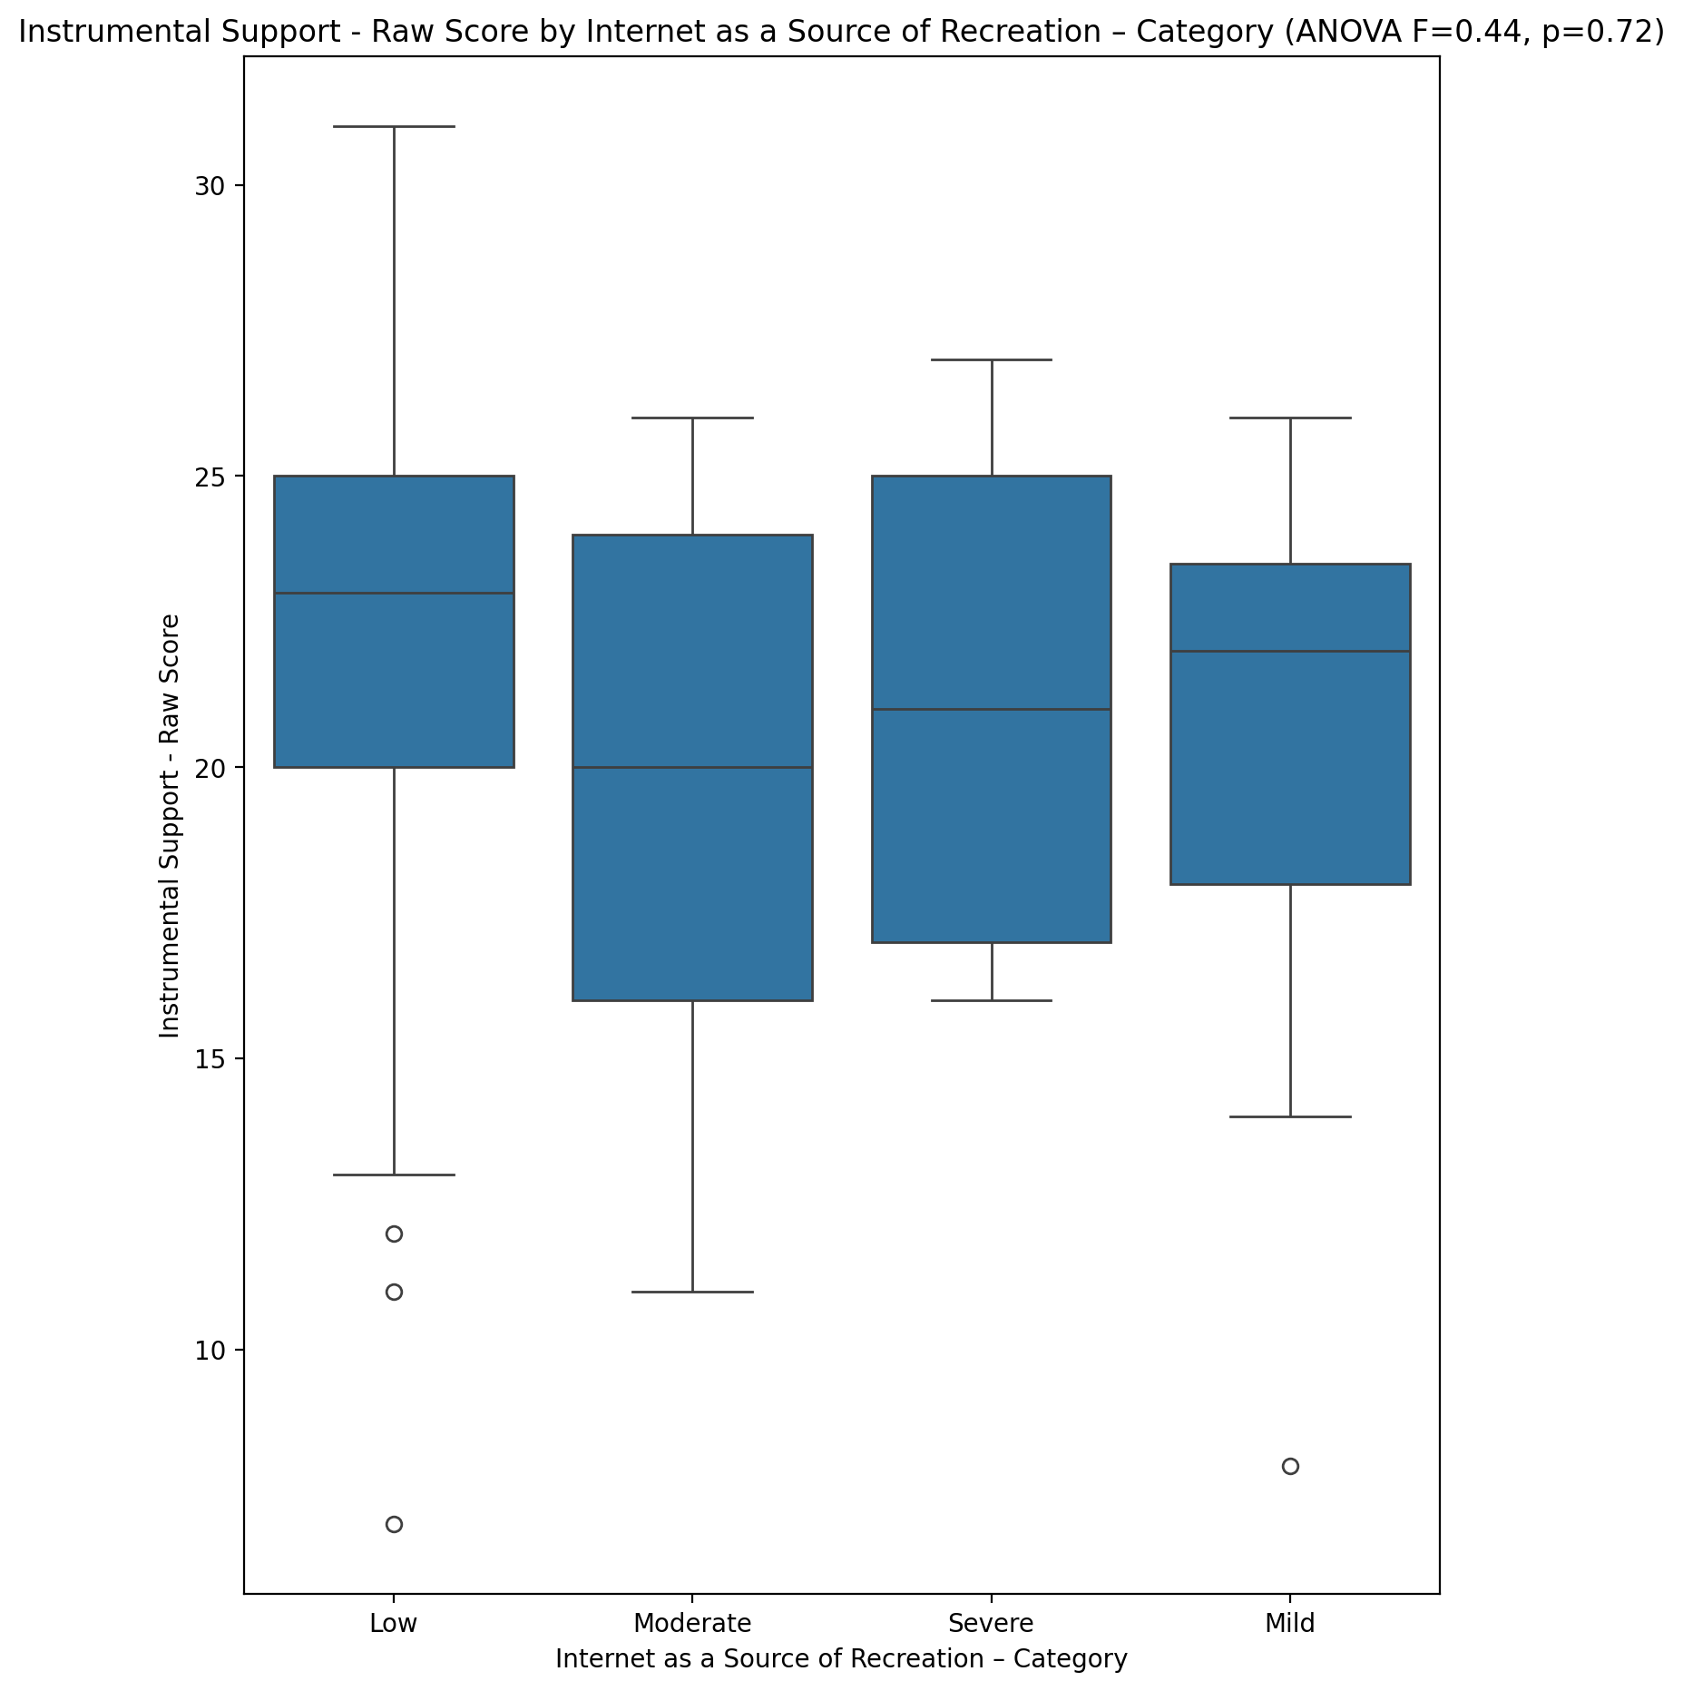

## Emotional Support - T Score vs Internet as a Source of Recreation – Category

Test: anova; statistic: 0.042433893608184135; p-value: 0.9882371578508781;

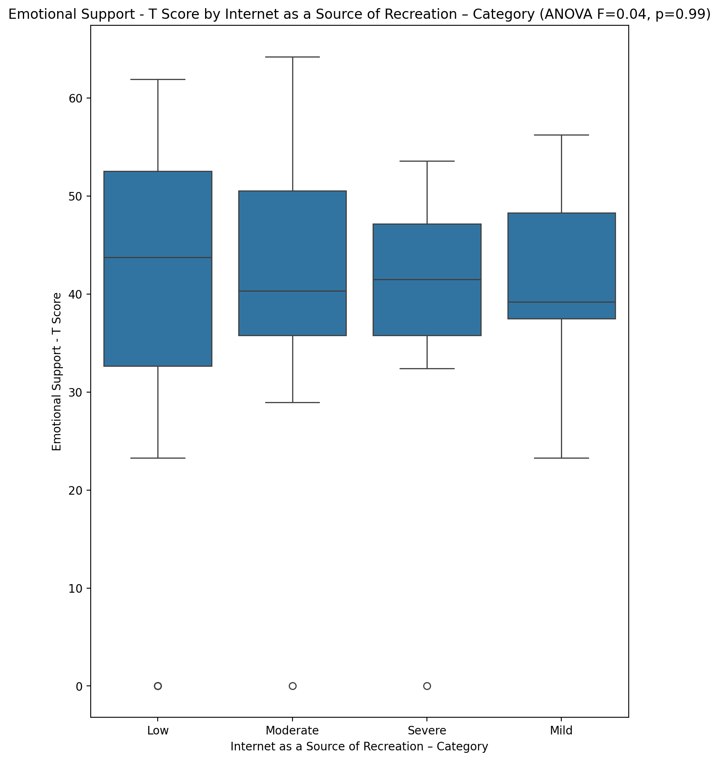

## Informational Support - T Score vs Internet as a Source of Recreation – Category

Test: anova; statistic: 0.09815985027930675; p-value: 0.9607148421445718;

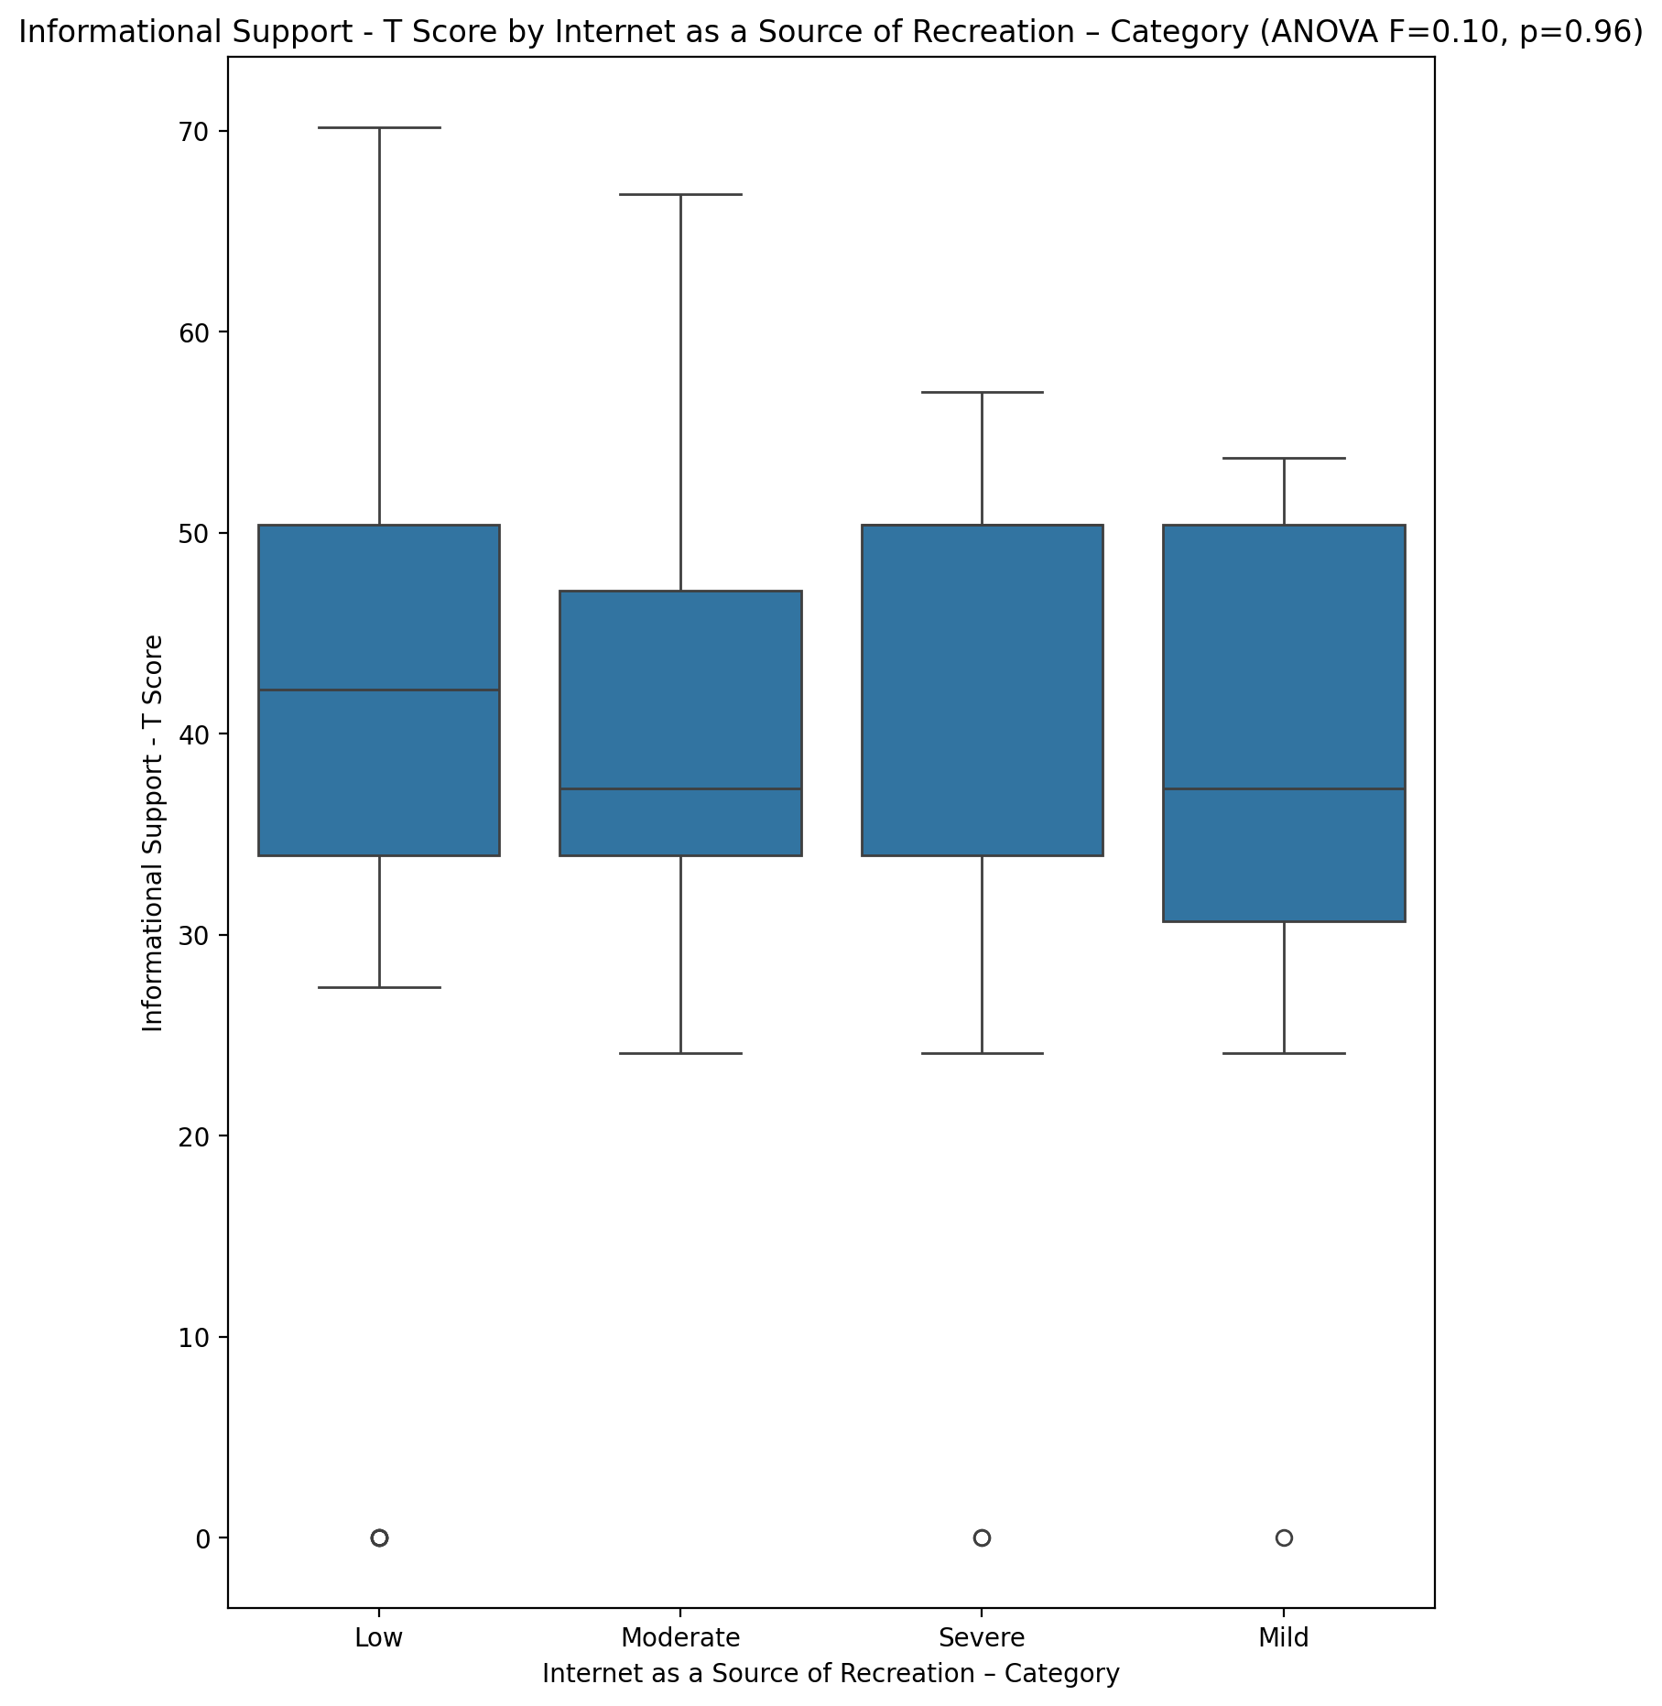

## Instrumental Support - T Score vs Internet as a Source of Recreation – Category

Test: anova; statistic: 0.20791615871894426; p-value: 0.8904947939375898;

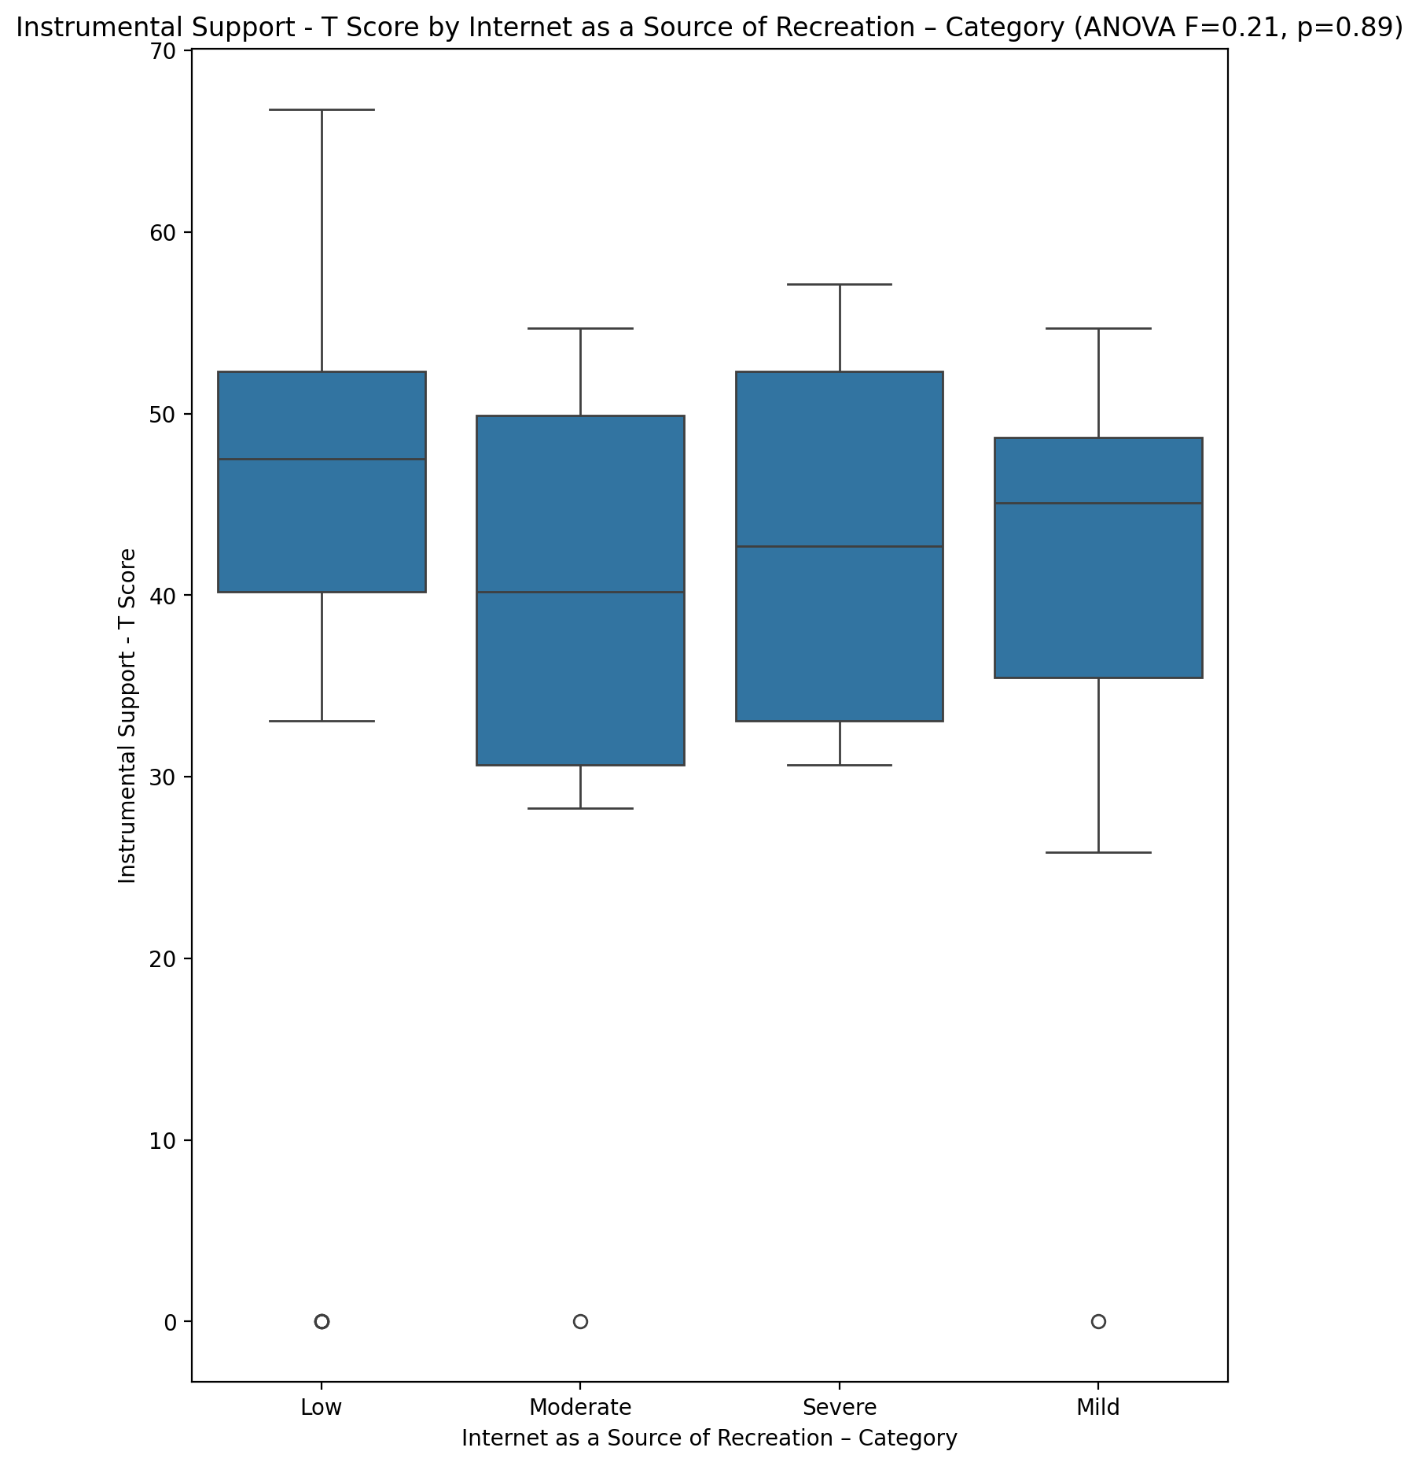

## Perceived Social Support Total T Score vs Internet as a Source of Recreation – Category

Test: anova; statistic: 0.1972629605948867; p-value: 0.8978196330037362;

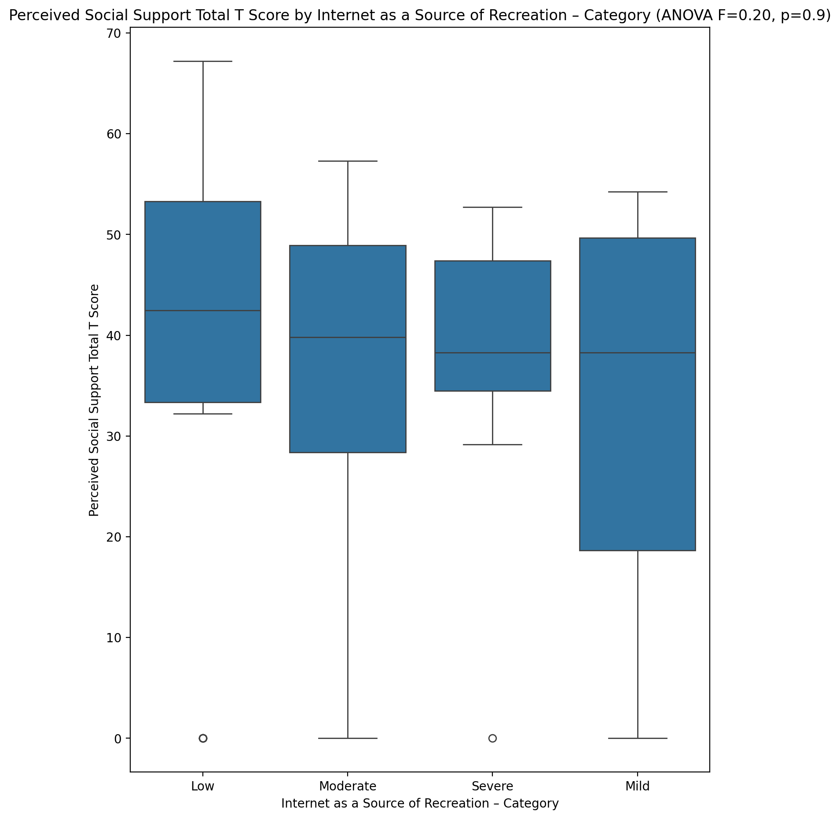

## Emotional Support - Rank vs Internet as a Source of Recreation – Category

Test: chi2; statistic: 7.769905094905095; p-value: 0.5574903608857502;

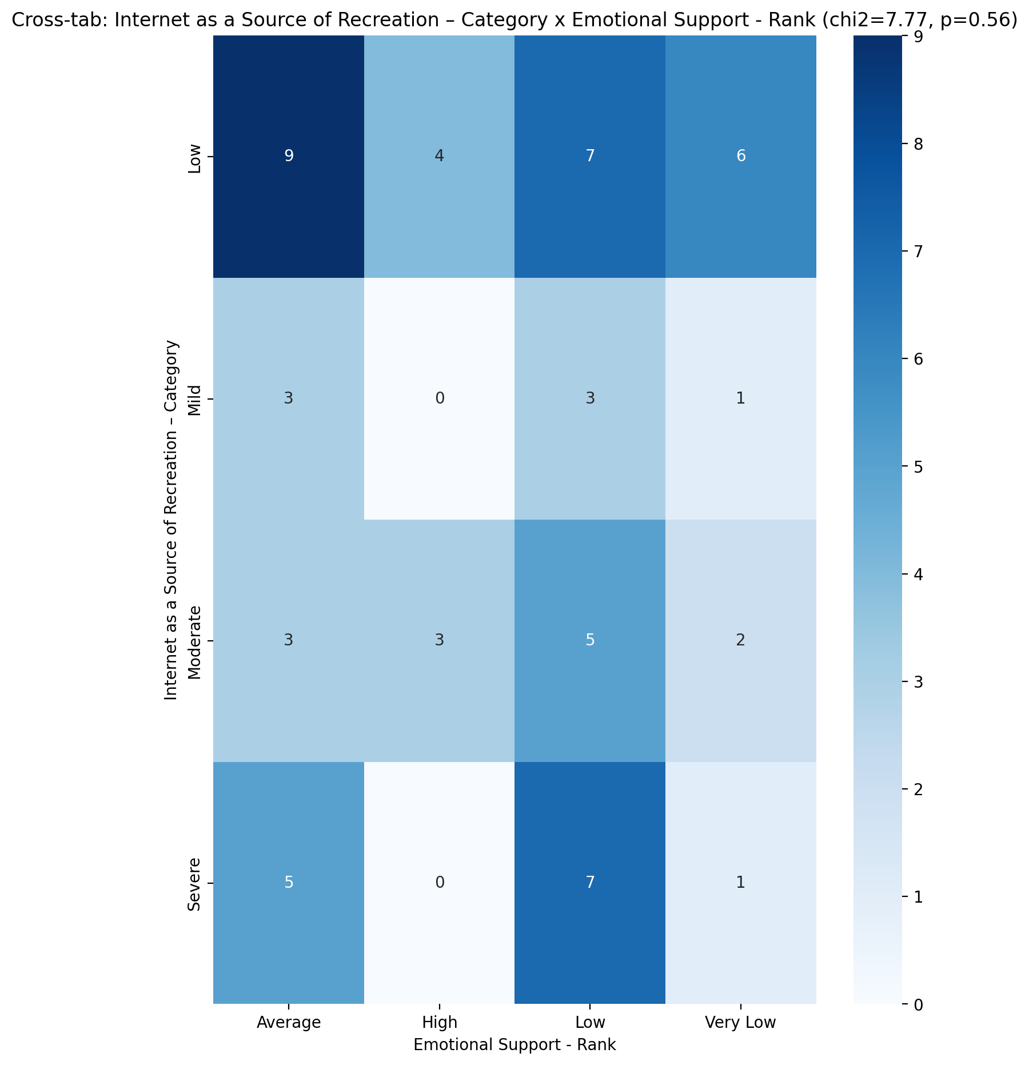

## Informational Support - Rank vs Internet as a Source of Recreation – Category

Test: chi2; statistic: 7.747680327191606; p-value: 0.8045244273378188;

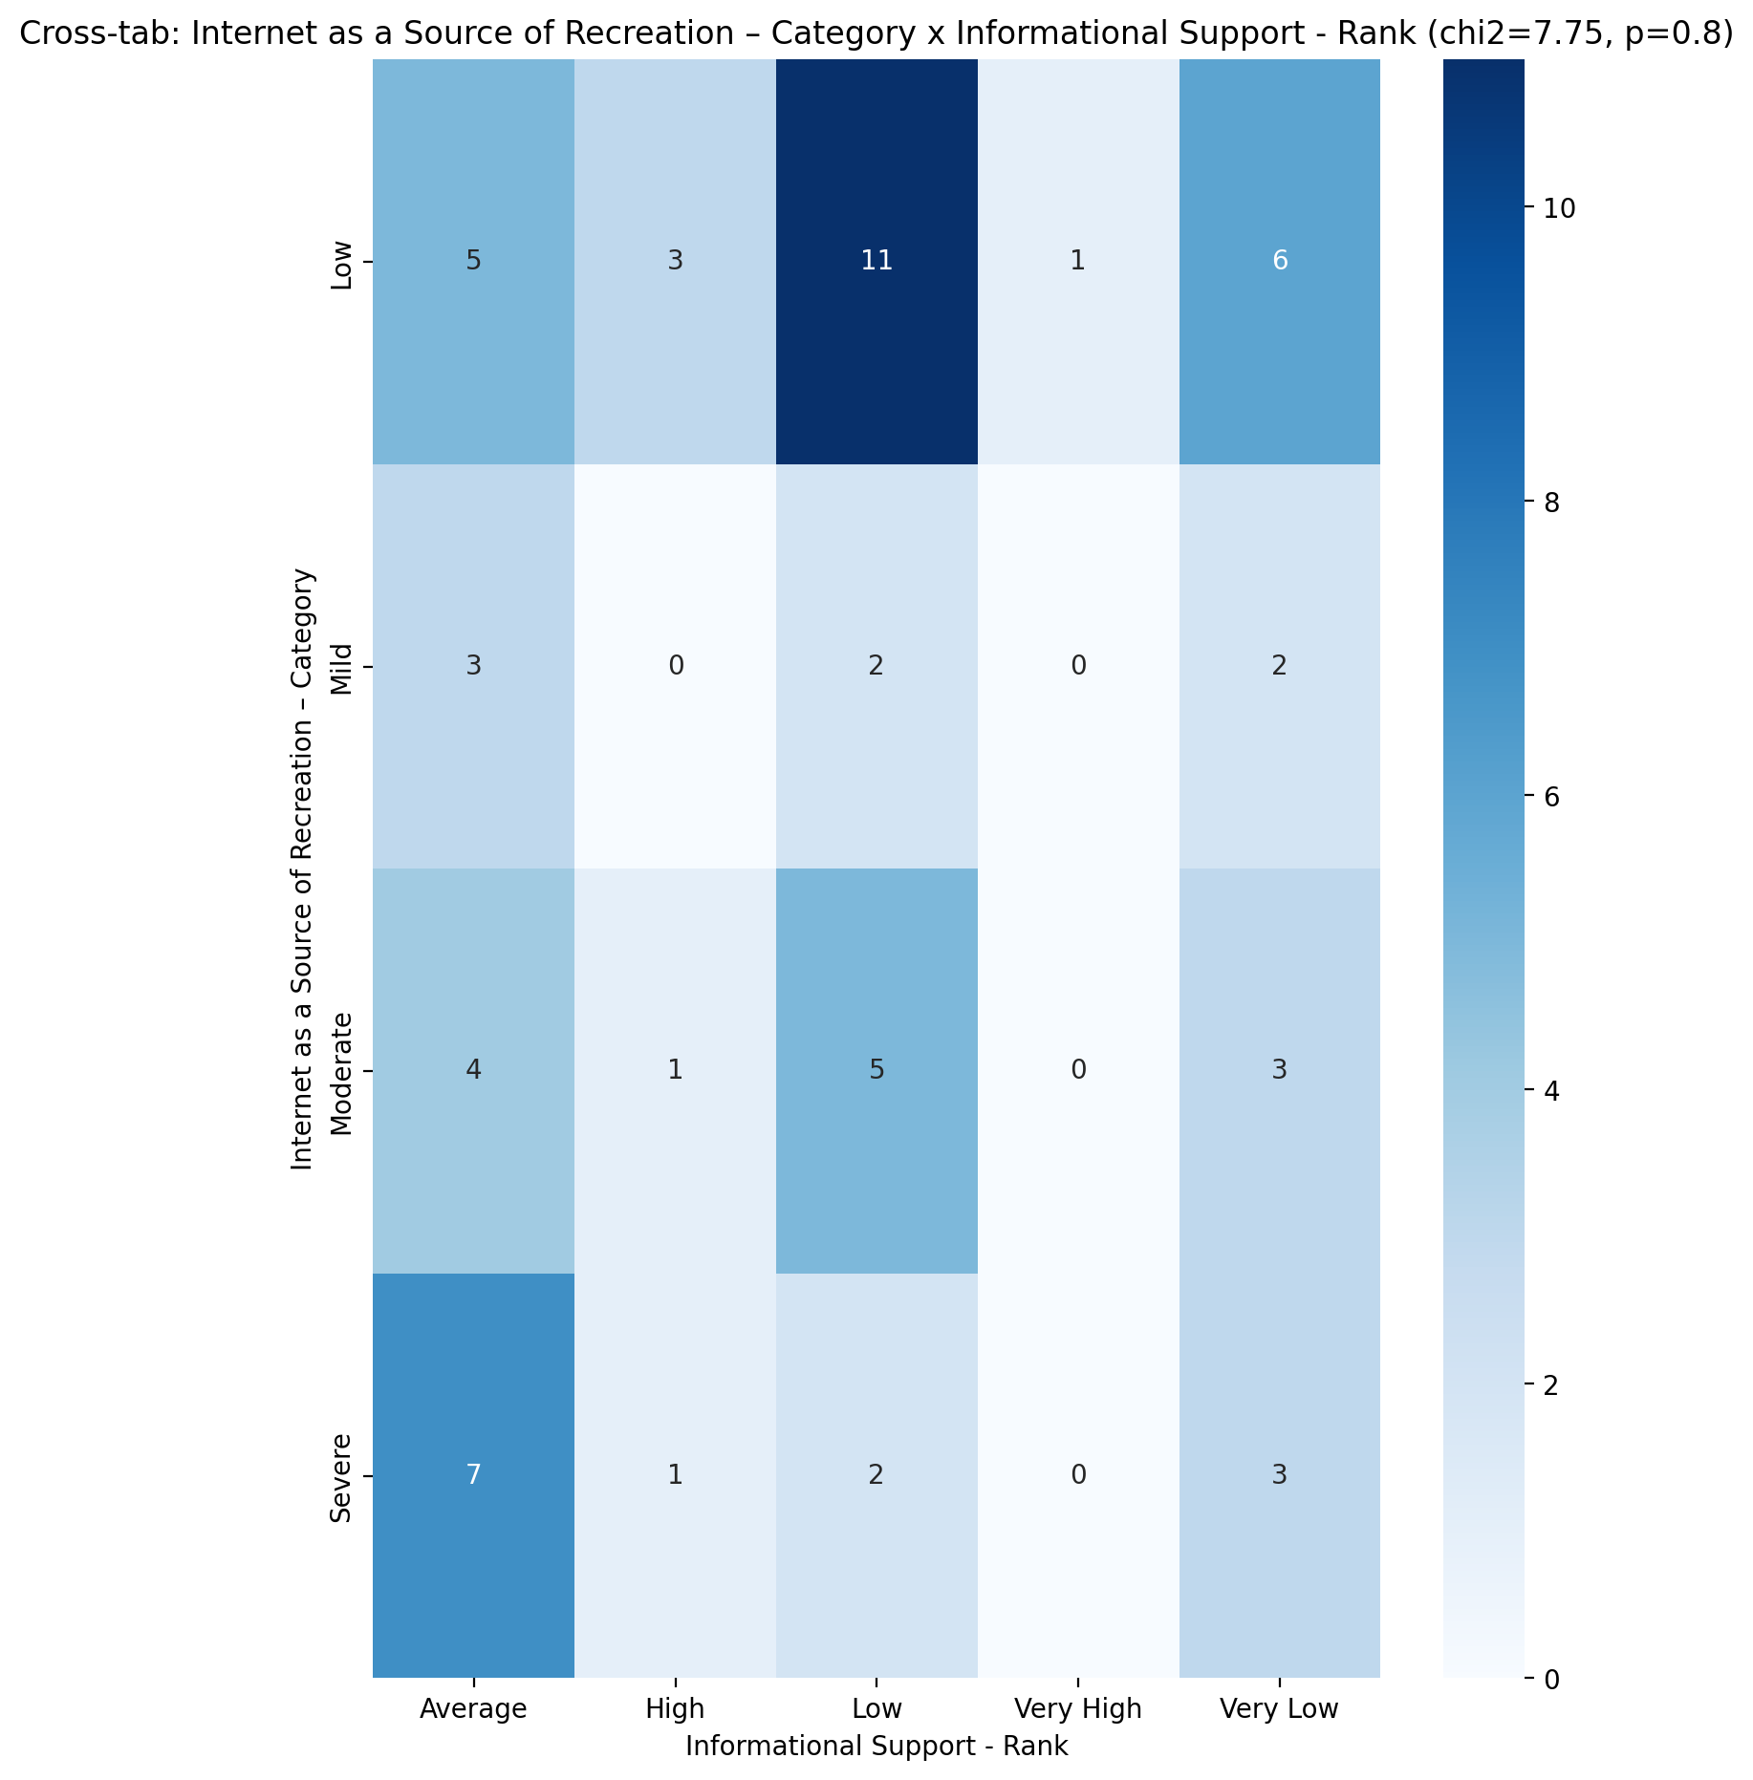

## Instrumental Support - Rank vs Internet as a Source of Recreation – Category

Test: chi2; statistic: 11.688339438339437; p-value: 0.23145483479696682;

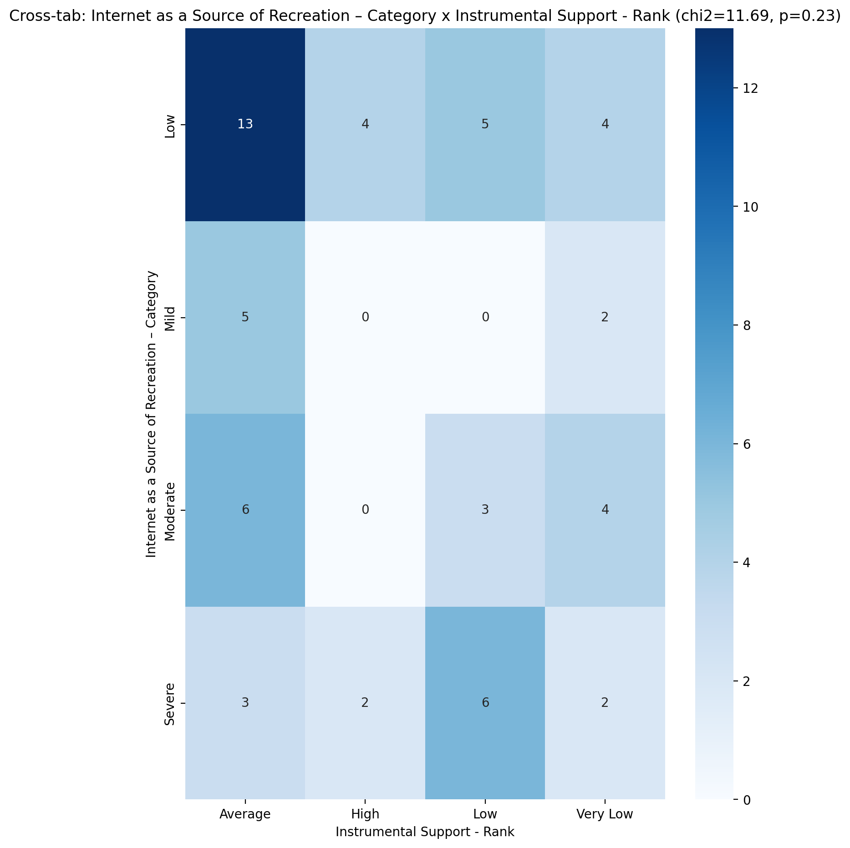

## Perceived Social Support TOTAL - Rank vs Internet as a Source of Recreation – Category

Test: chi2; statistic: 4.147977022977023; p-value: 0.9014056965613785;

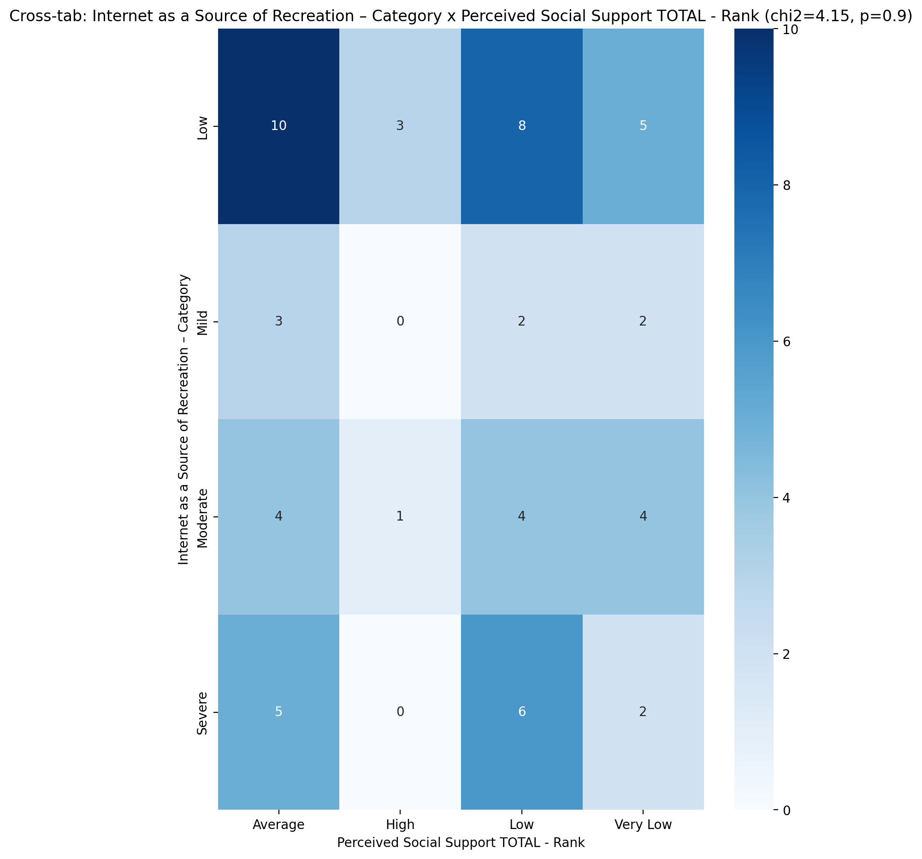

## Power Self Concept - Real Self Concept Score vs Internet as a Source of Recreation – Category

Test: anova; statistic: 1.7318583151331162; p-value: 0.17113450195766666;

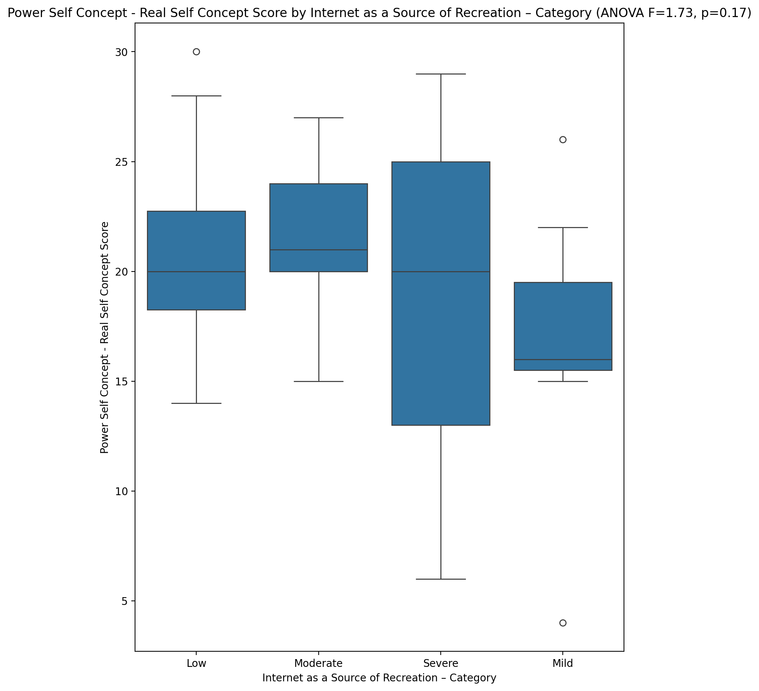

## Power Self Concept - Ideal Self Concept score vs Internet as a Source of Recreation – Category

Test: anova; statistic: 1.7779492536893409; p-value: 0.1620787958518812;

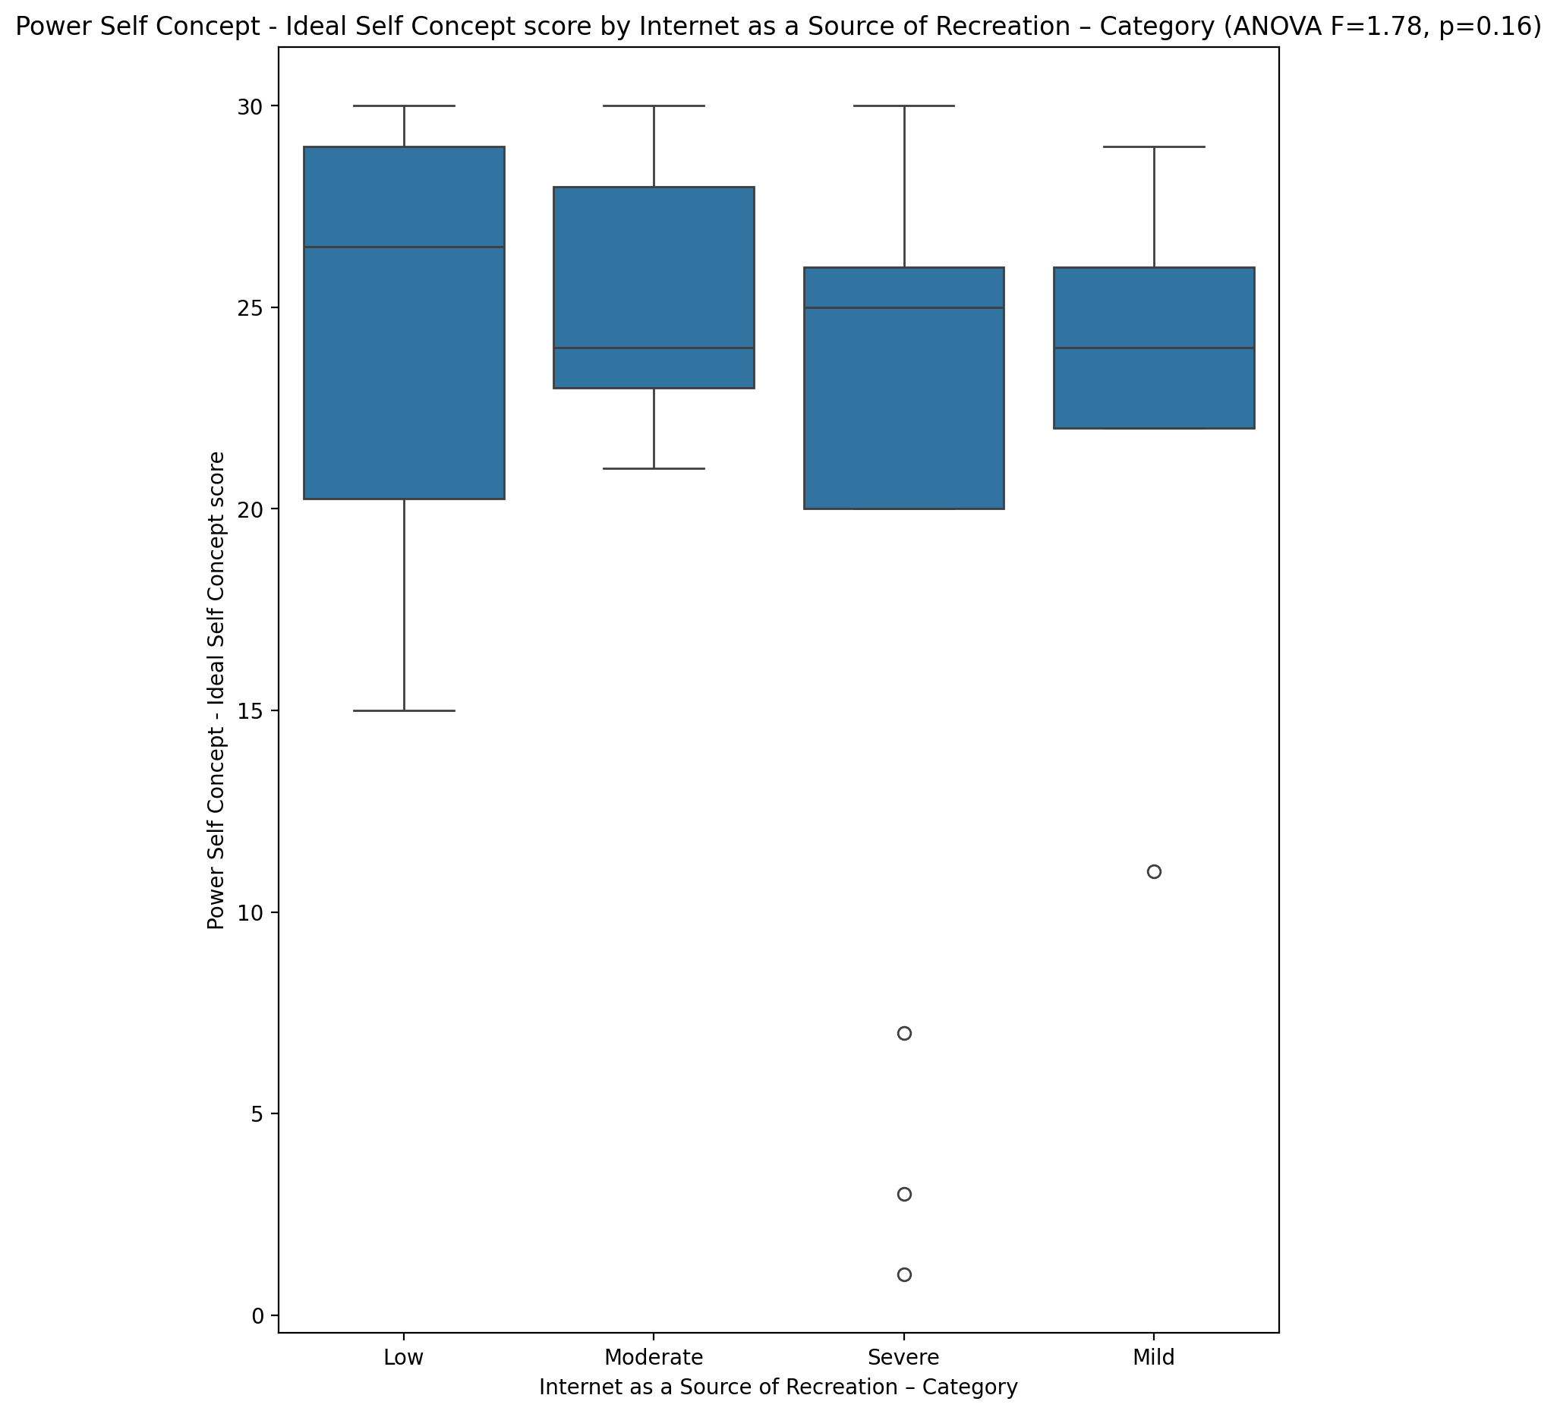

## Power Self Concept – Social Self Concept Score vs Internet as a Source of Recreation – Category

Test: anova; statistic: 2.308313155770783; p-value: 0.08653351152141524;

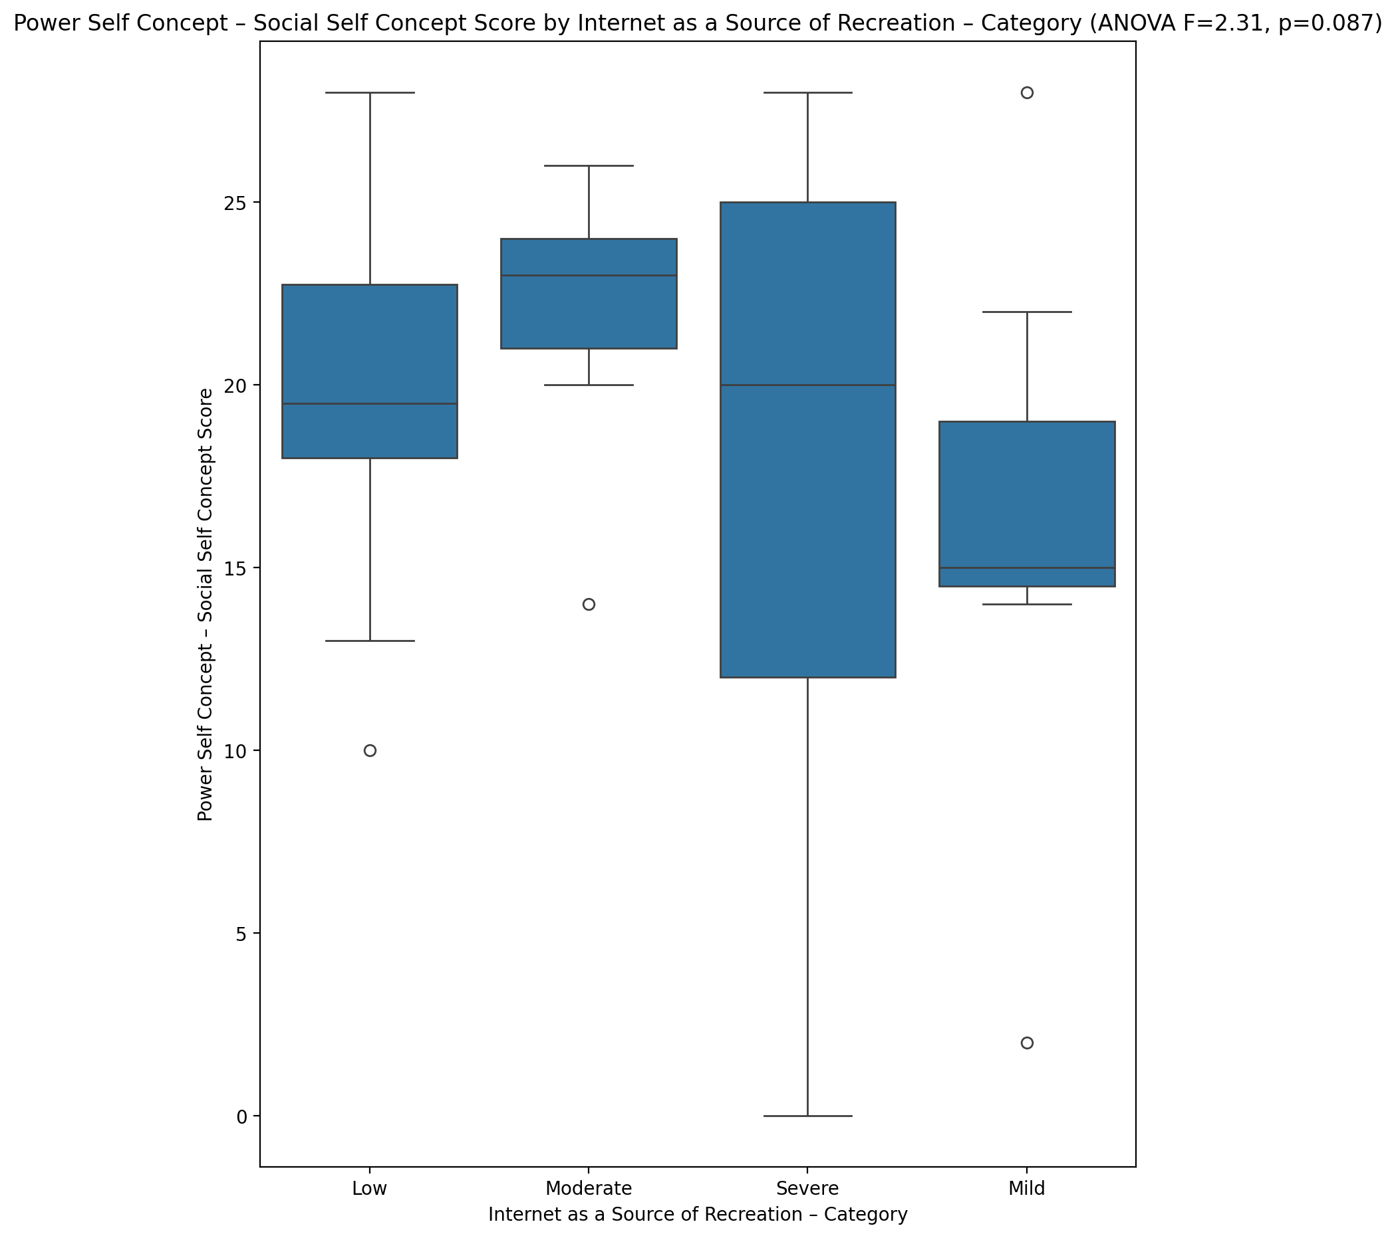

## Social Self Concept - Real Self Concept Score vs Internet as a Source of Recreation – Category

Test: anova; statistic: 0.806803758507078; p-value: 0.4955062523493259;

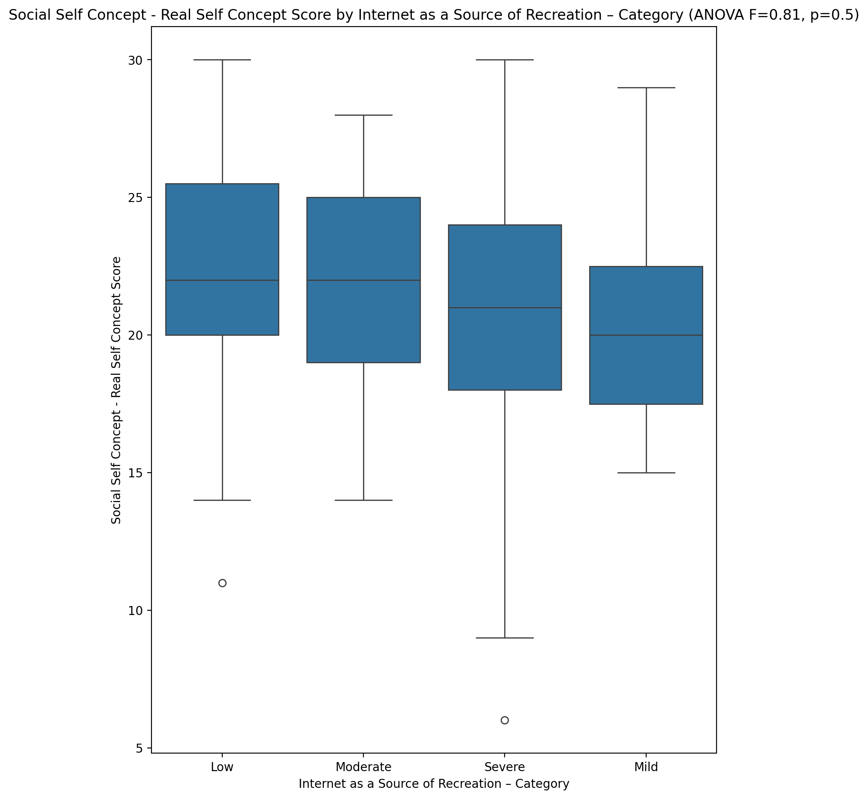

## Social Self Concept – Social Self Concept Score vs Internet as a Source of Recreation – Category

Test: anova; statistic: 2.0108098948312314; p-value: 0.12307636130593085;

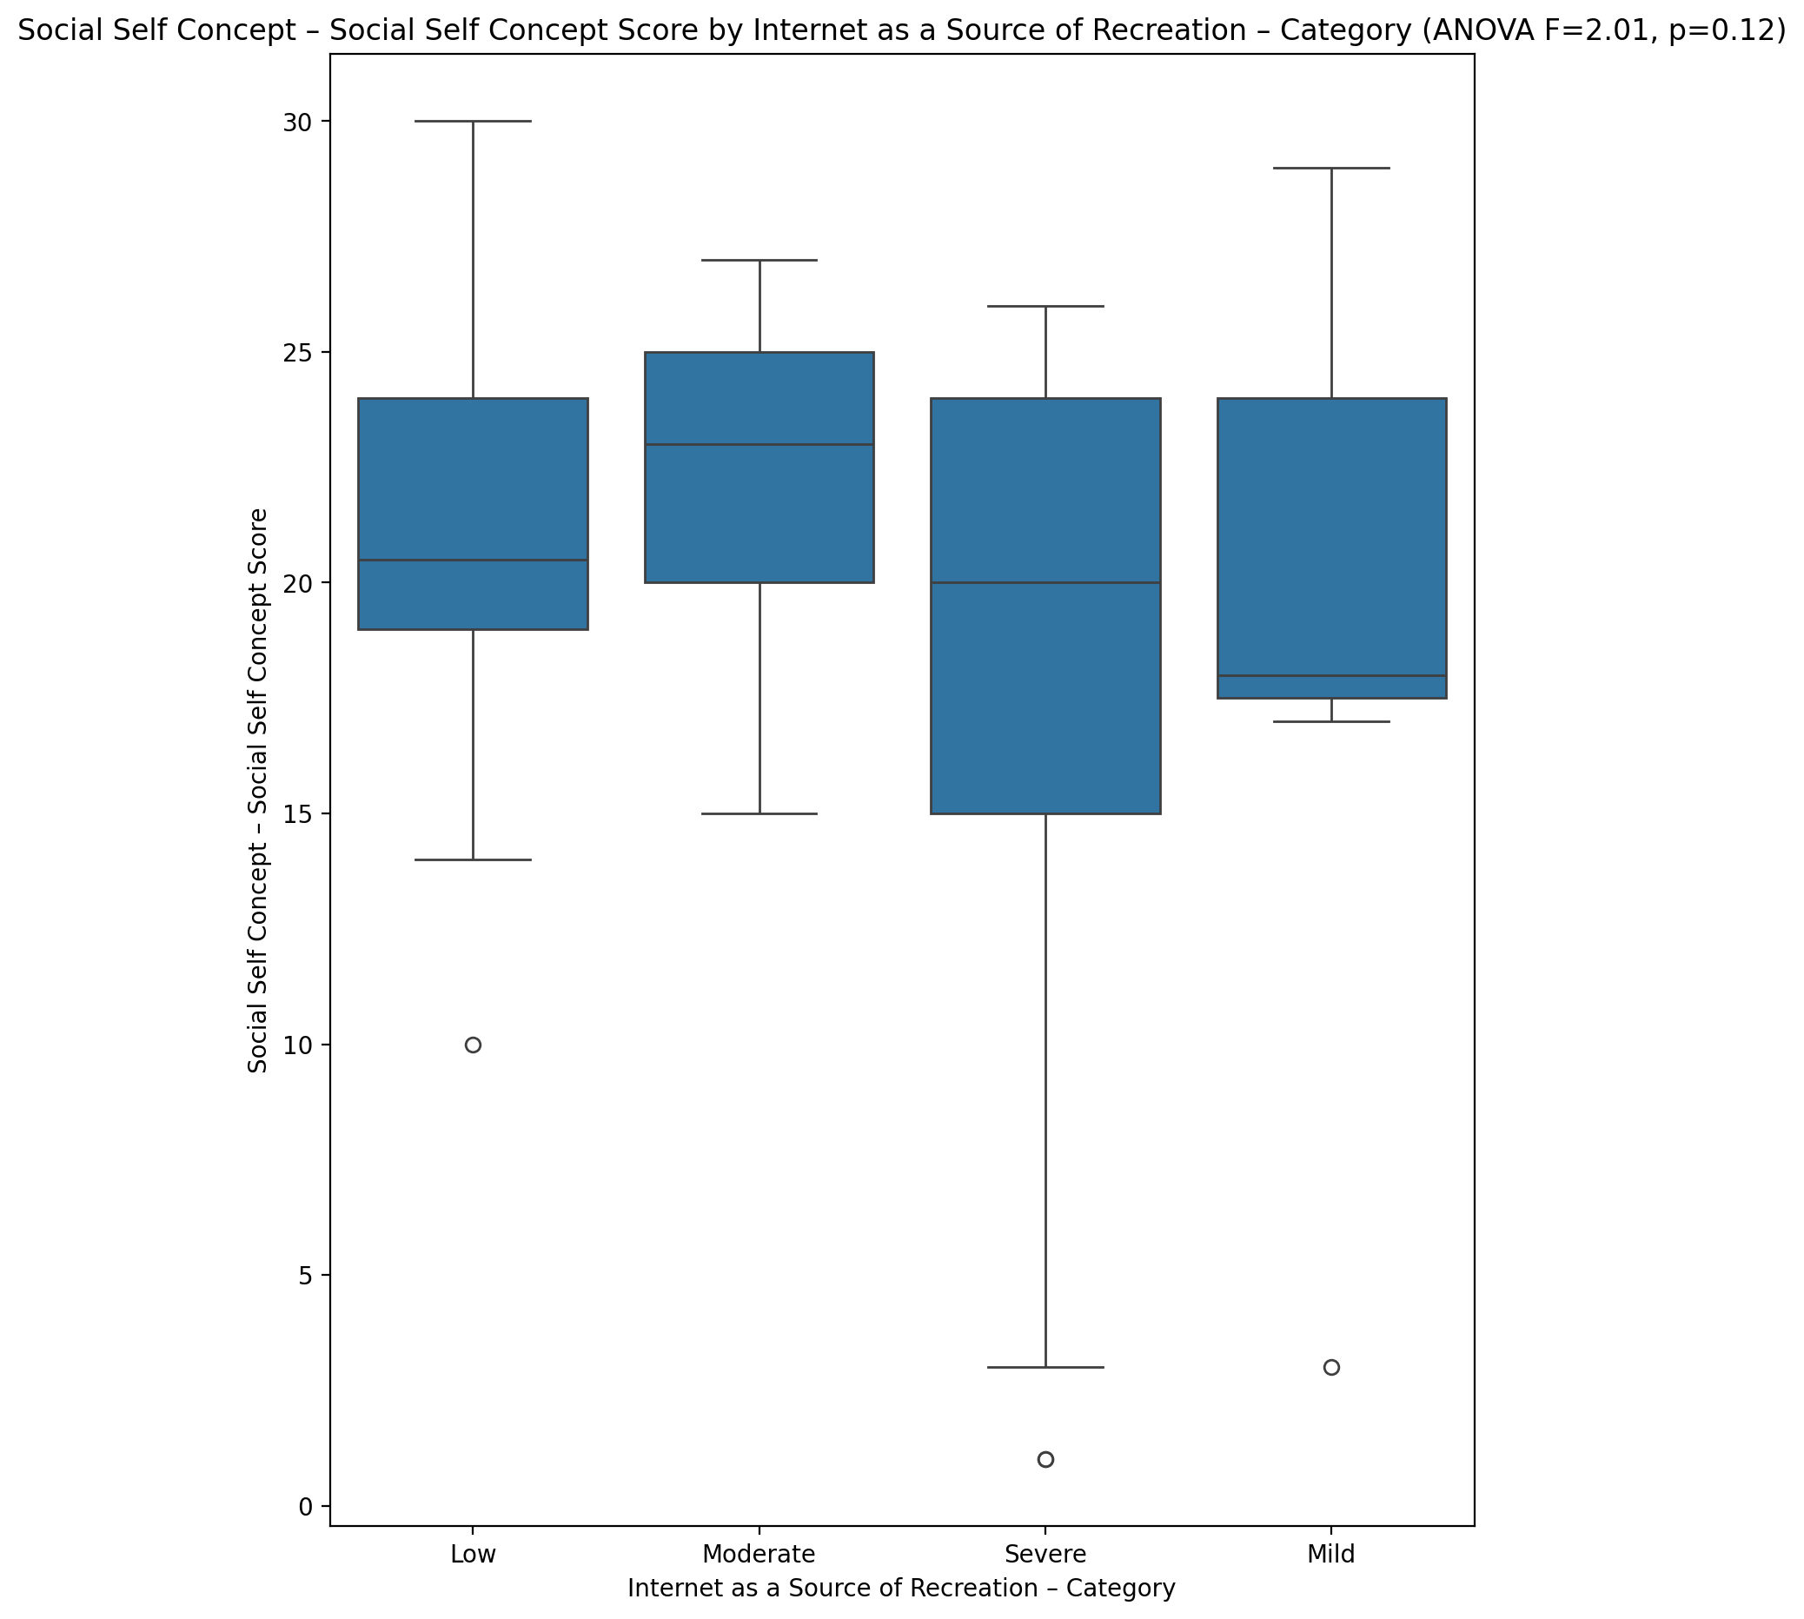

## Ability Self Concept - Real Self Concept Score vs Internet as a Source of Recreation – Category

Test: anova; statistic: 0.5939568315060777; p-value: 0.6216174921160299;

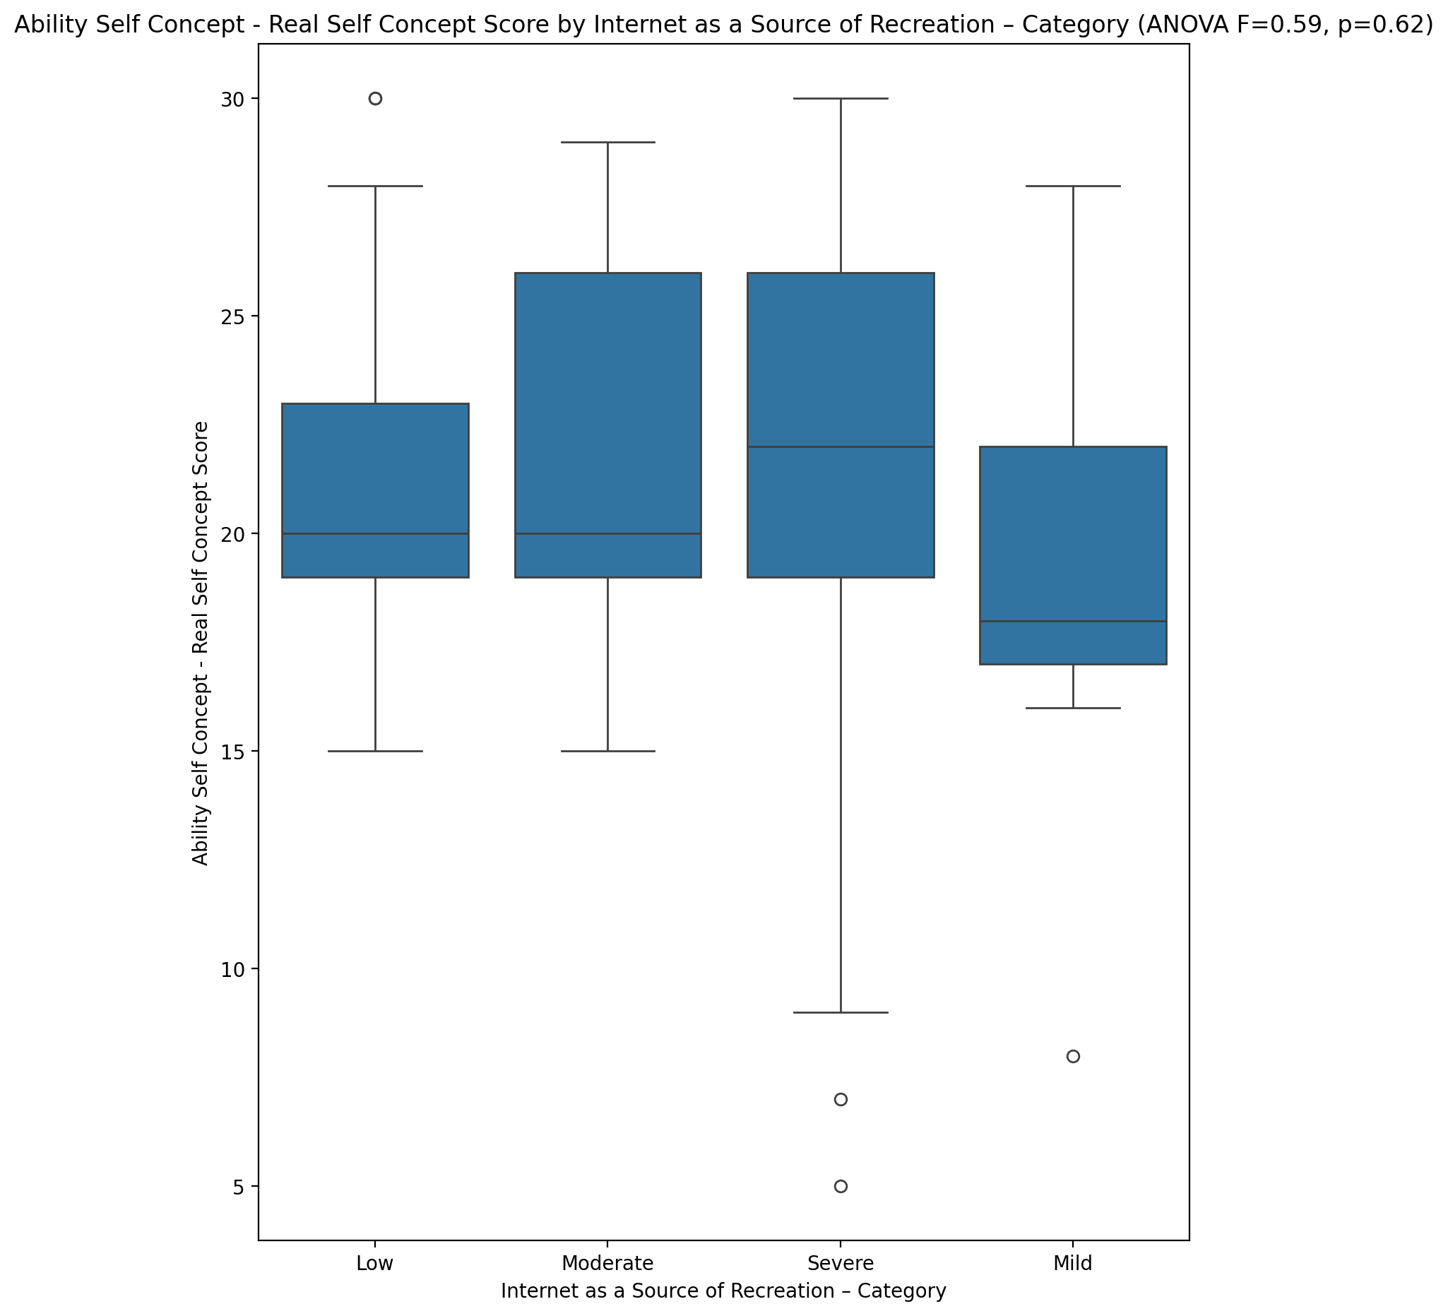

## Ability Self Concept - Ideal Self Concept Score vs Internet as a Source of Recreation – Category

Test: anova; statistic: 1.3773639997613054; p-value: 0.2593165405162424;

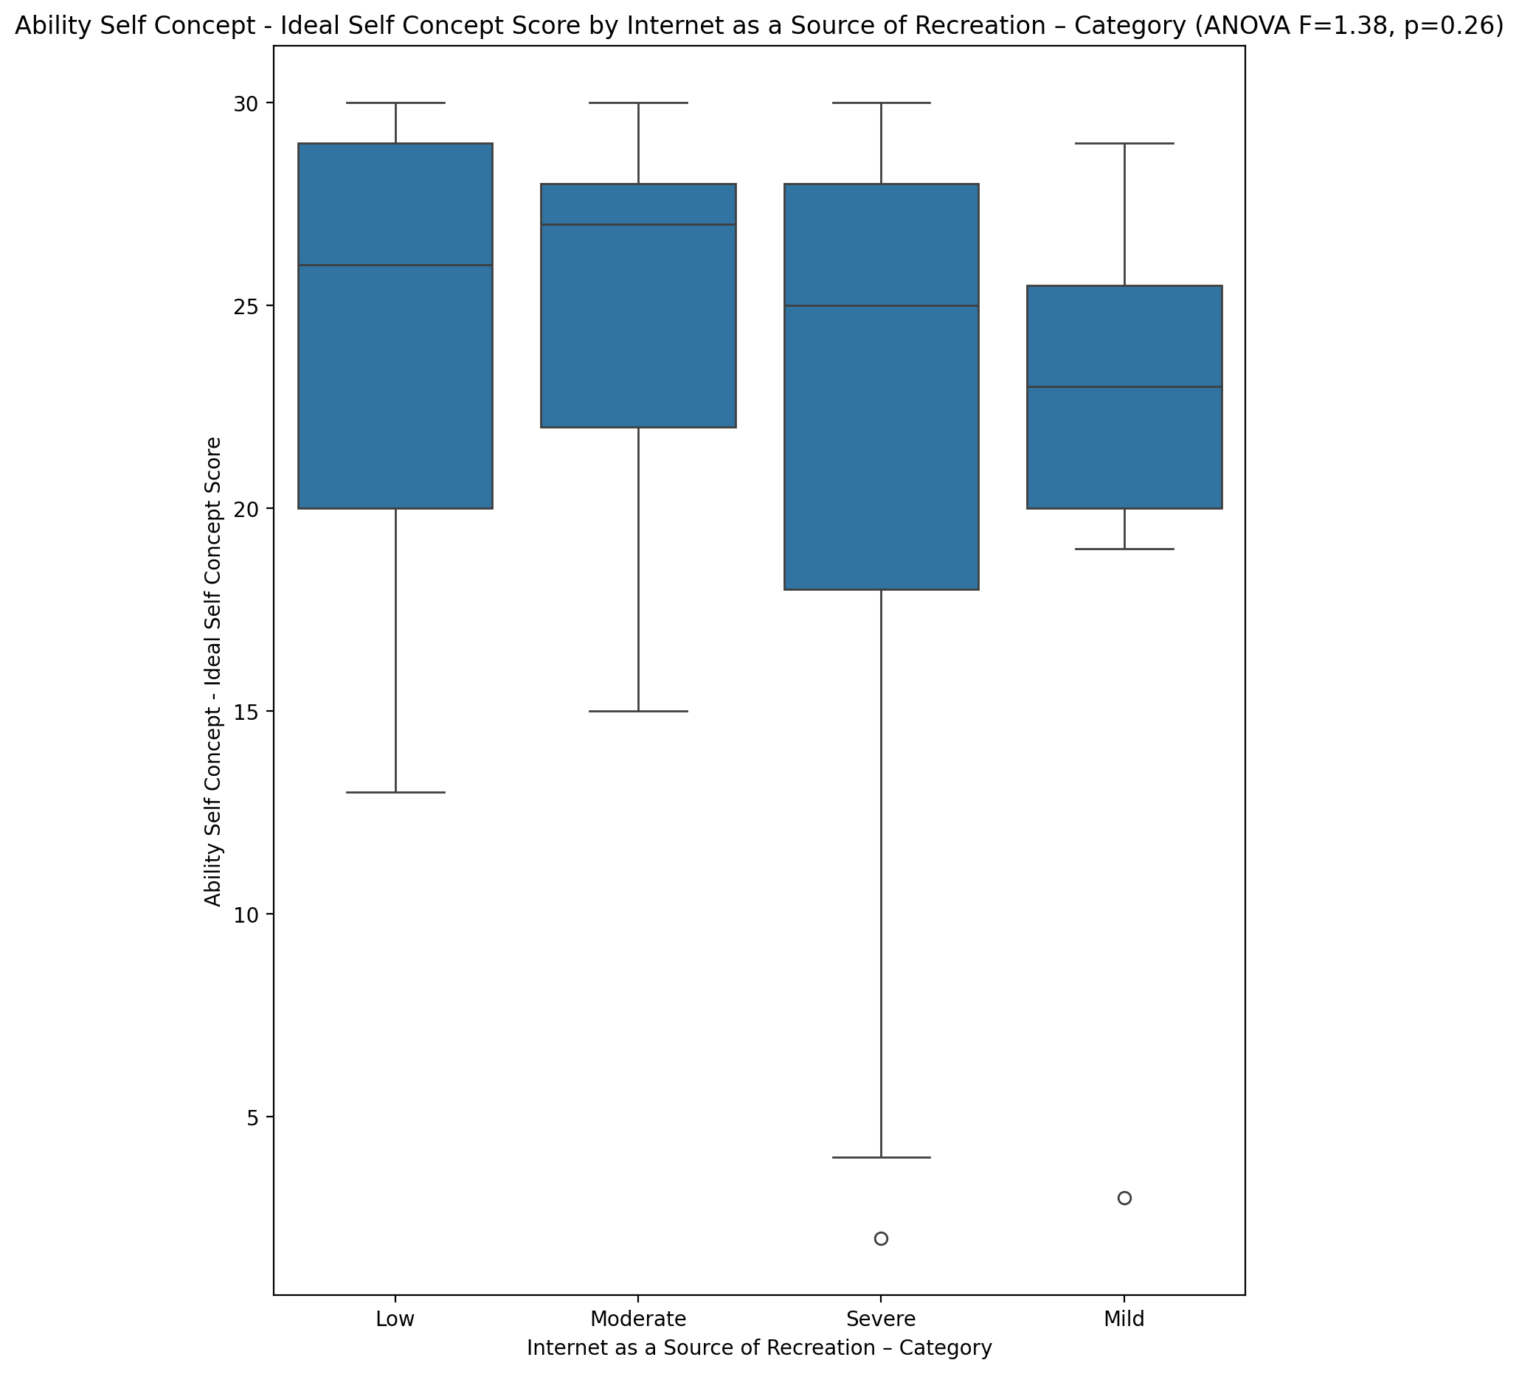

## Ability Self Concept – Social Self Concept Score vs Internet as a Source of Recreation – Category

Test: anova; statistic: 1.9106810561525542; p-value: 0.13855536357530765;

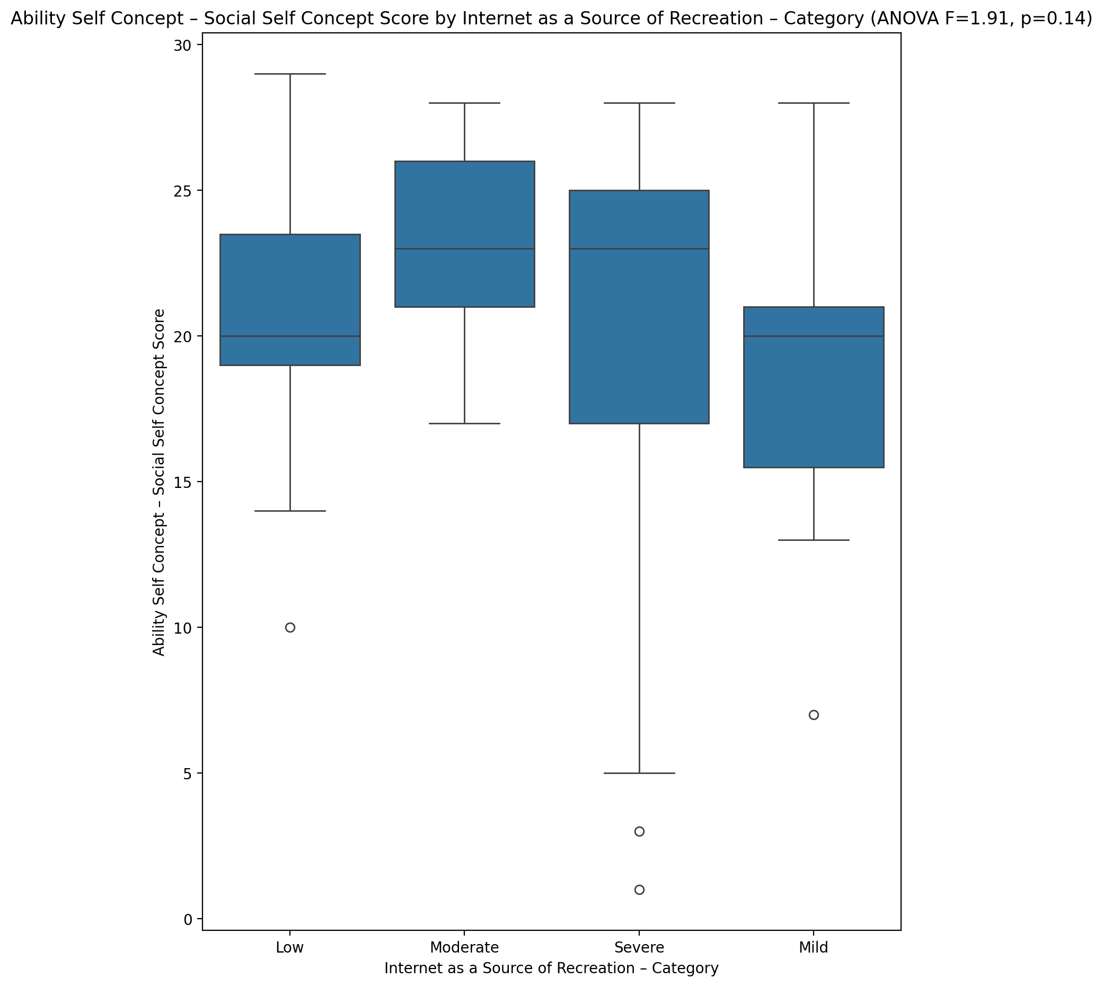

## Physical Self Concept - Real Self Concept Score vs Internet as a Source of Recreation – Category

Test: anova; statistic: 0.5315576818226916; p-value: 0.6625361152235252;

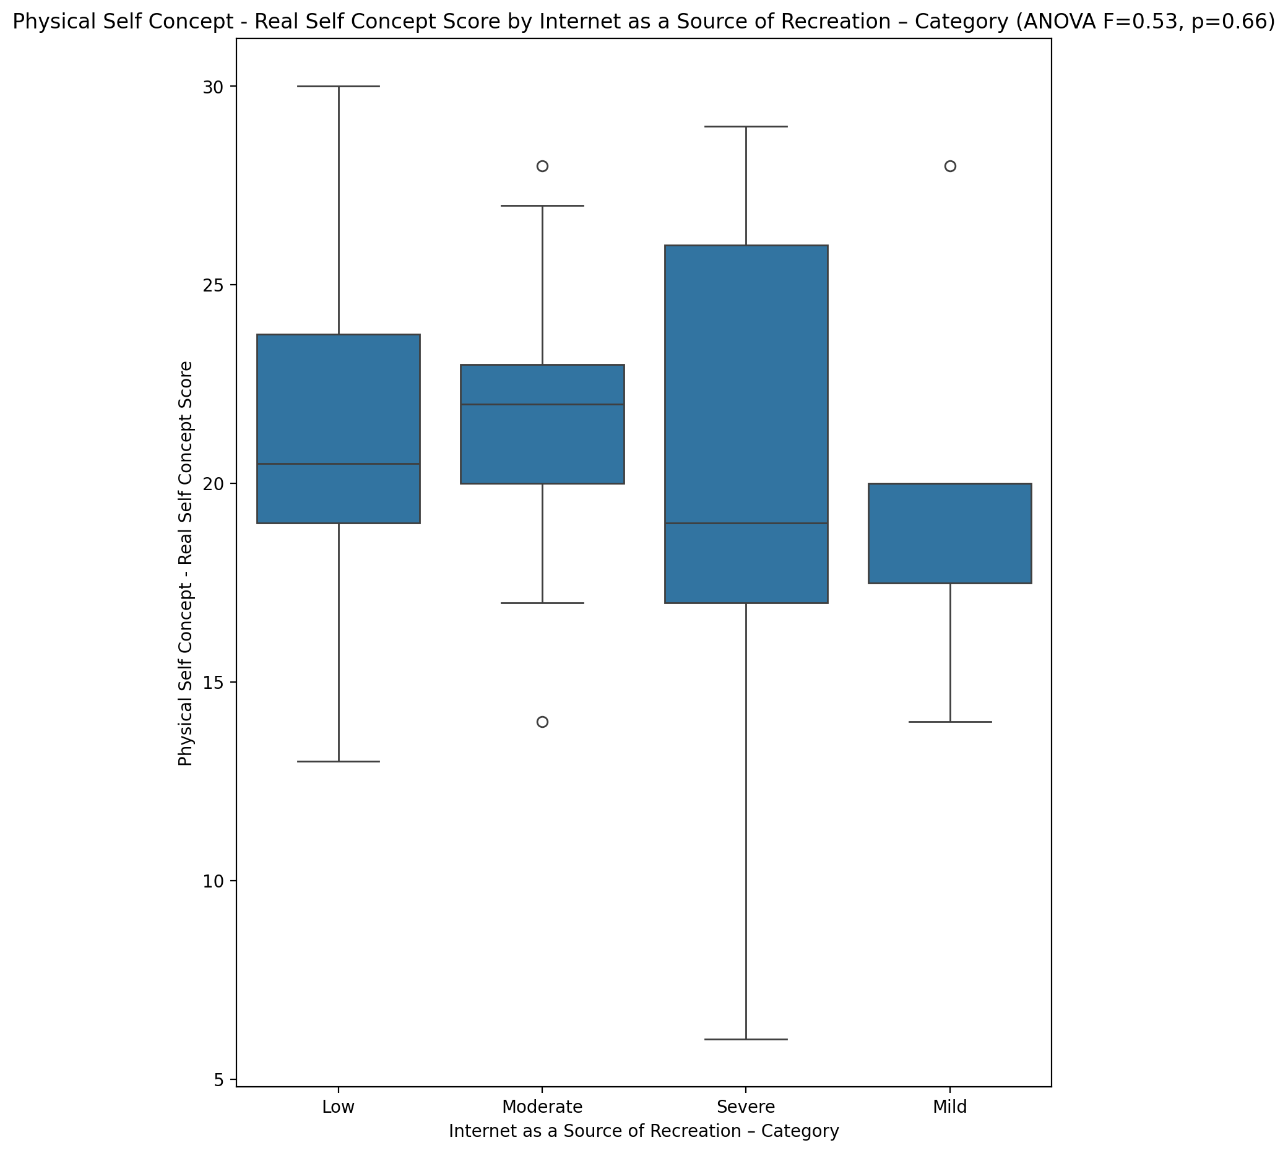

## Physical Self Concept – Ideal Self Concept Score vs Internet as a Source of Recreation – Category

Test: anova; statistic: 1.8449780729765402; p-value: 0.149744884073981;

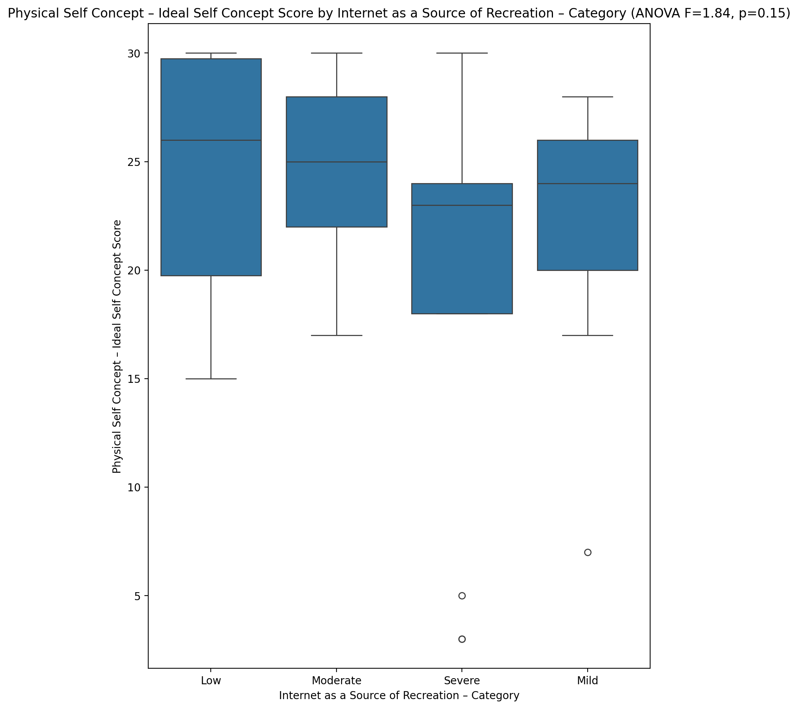

## Physical Self Concept – Social Self Concept Score vs Internet as a Source of Recreation – Category

Test: anova; statistic: 2.8264469331866438; p-value: 0.046924188063432896;

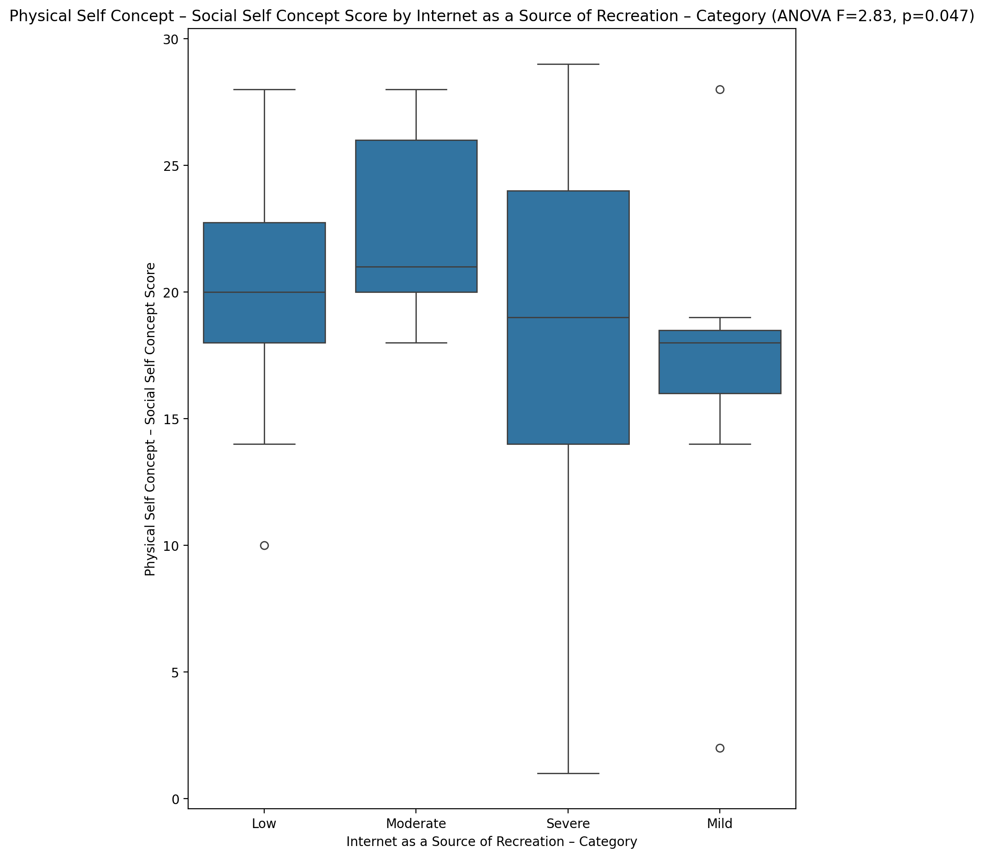

## Psychological Self Concept - Real Self Concept Score vs Internet as a Source of Recreation – Category

Test: anova; statistic: 0.8019741494981684; p-value: 0.4981260805187059;

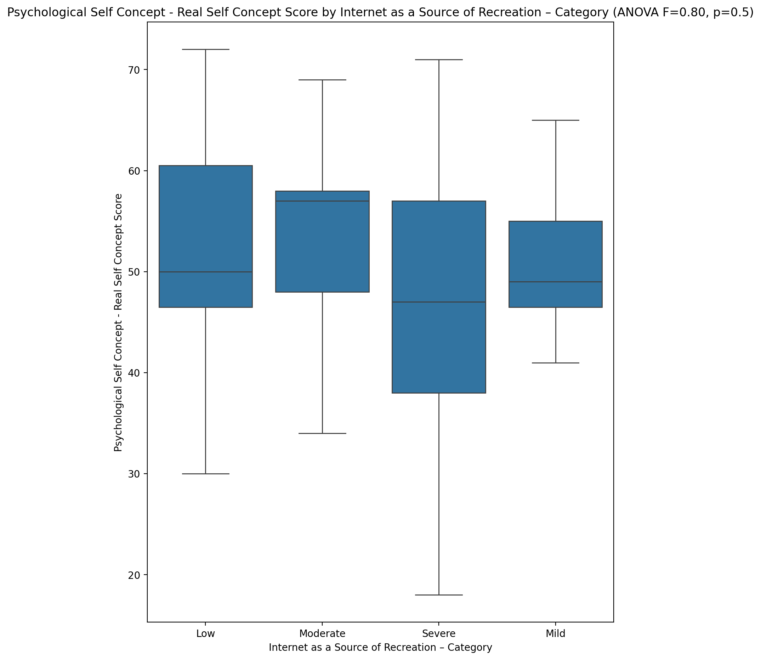

## Psychological Self Concept – Ideal Self Concept Score vs Internet as a Source of Recreation – Category

Test: anova; statistic: 1.670626128870204; p-value: 0.18393618306939333;

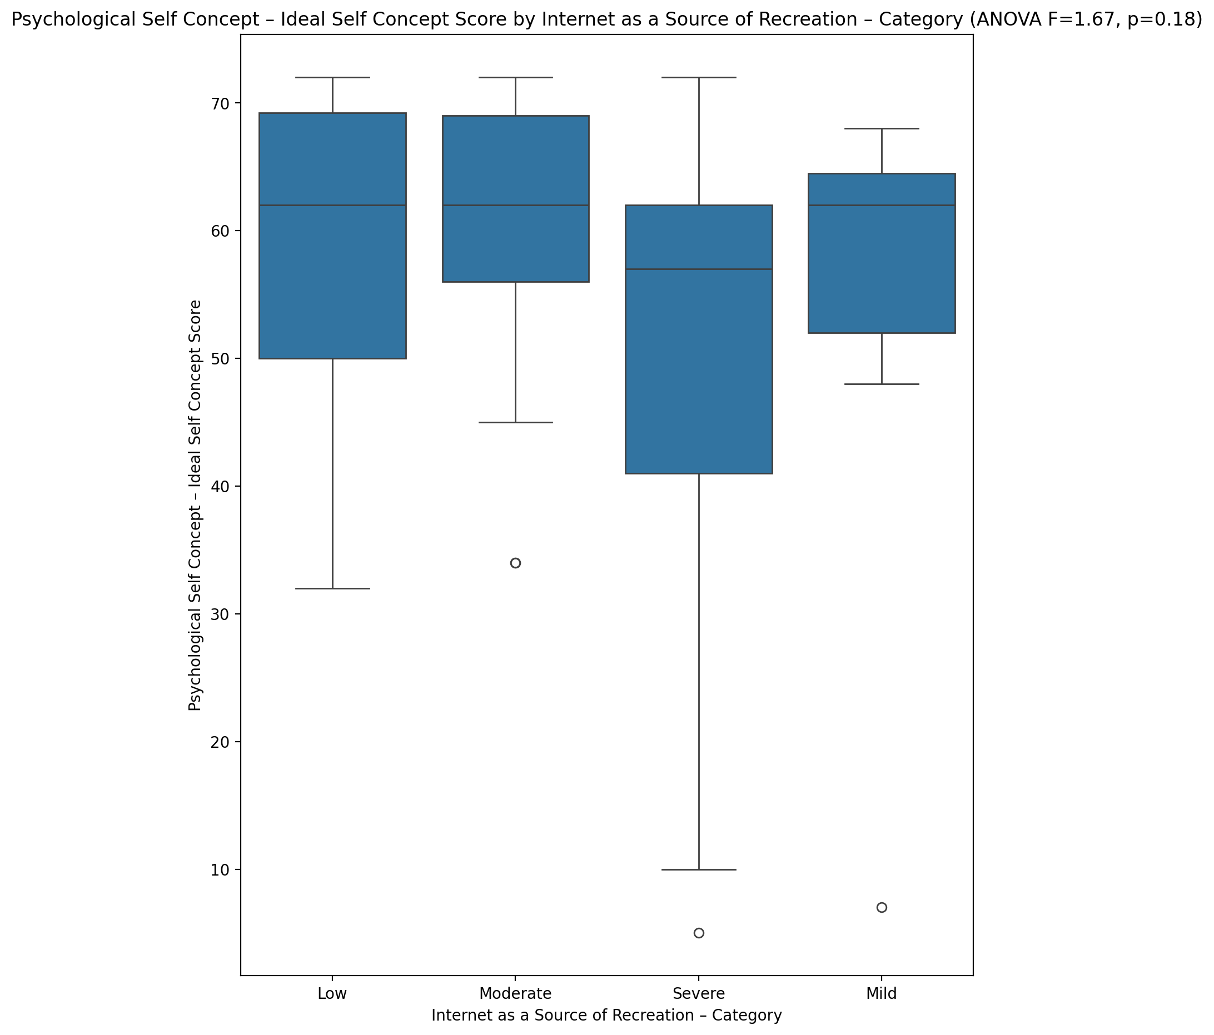

## Psychological Self Concept – Social Self Concept Score vs Internet as a Source of Recreation – Category

Test: anova; statistic: 1.6889035213305679; p-value: 0.18001988843788835;

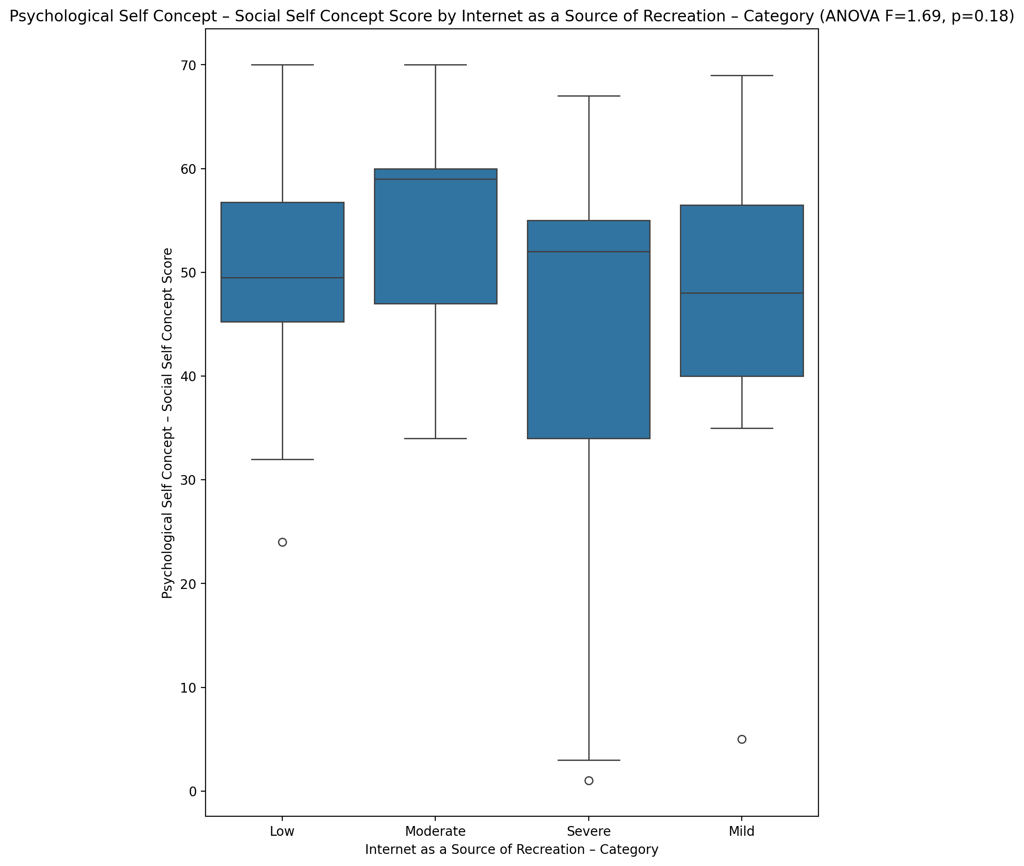

## Real Self Concept Total Score vs Internet as a Source of Recreation – Category

Test: anova; statistic: 0.7485587258779368; p-value: 0.5278564620749023;

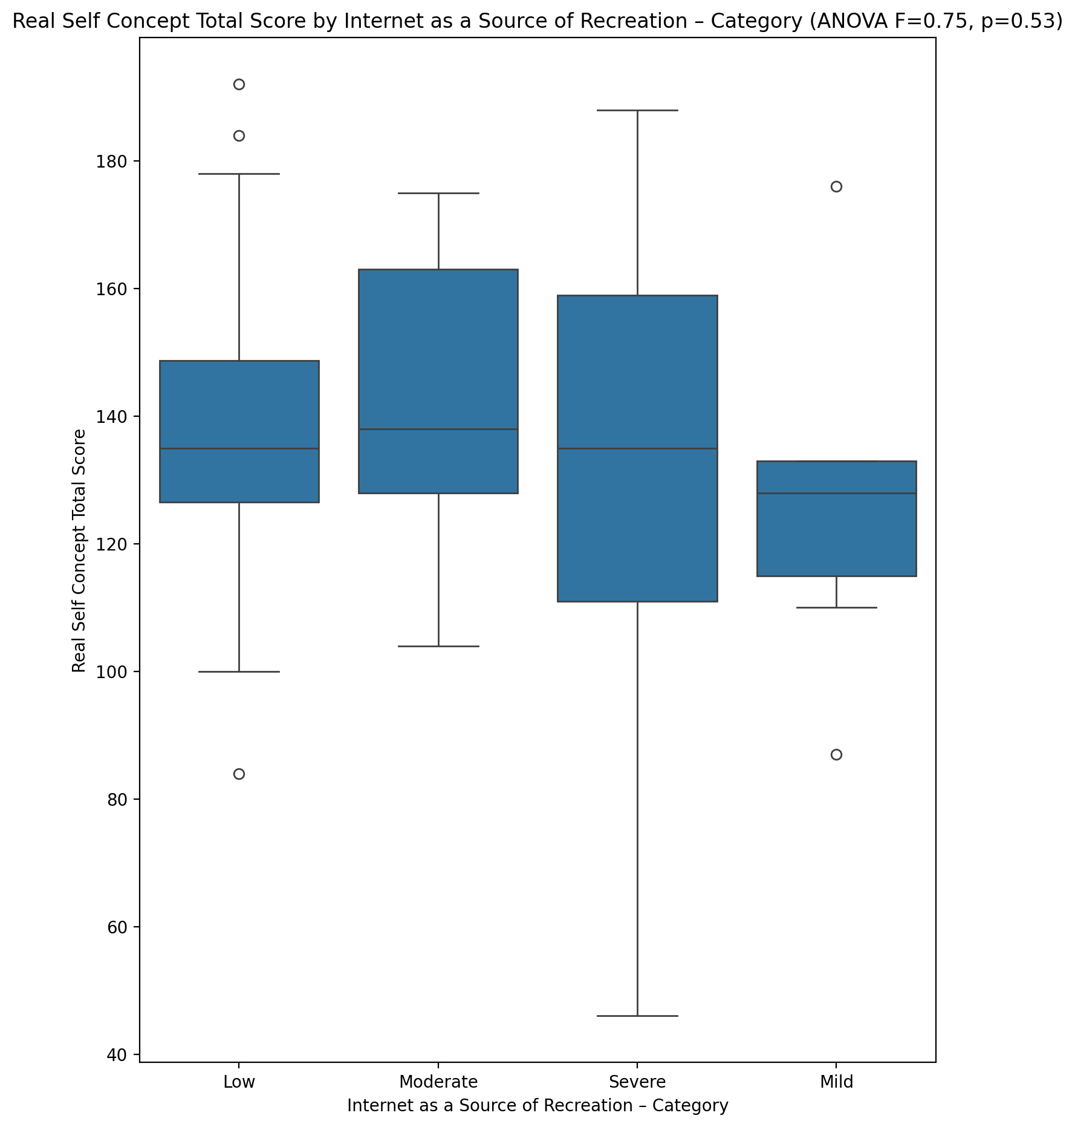

## Ideal Self Concept Total Score vs Internet as a Source of Recreation – Category

Test: anova; statistic: 1.8773561781772472; p-value: 0.14412337146709006;

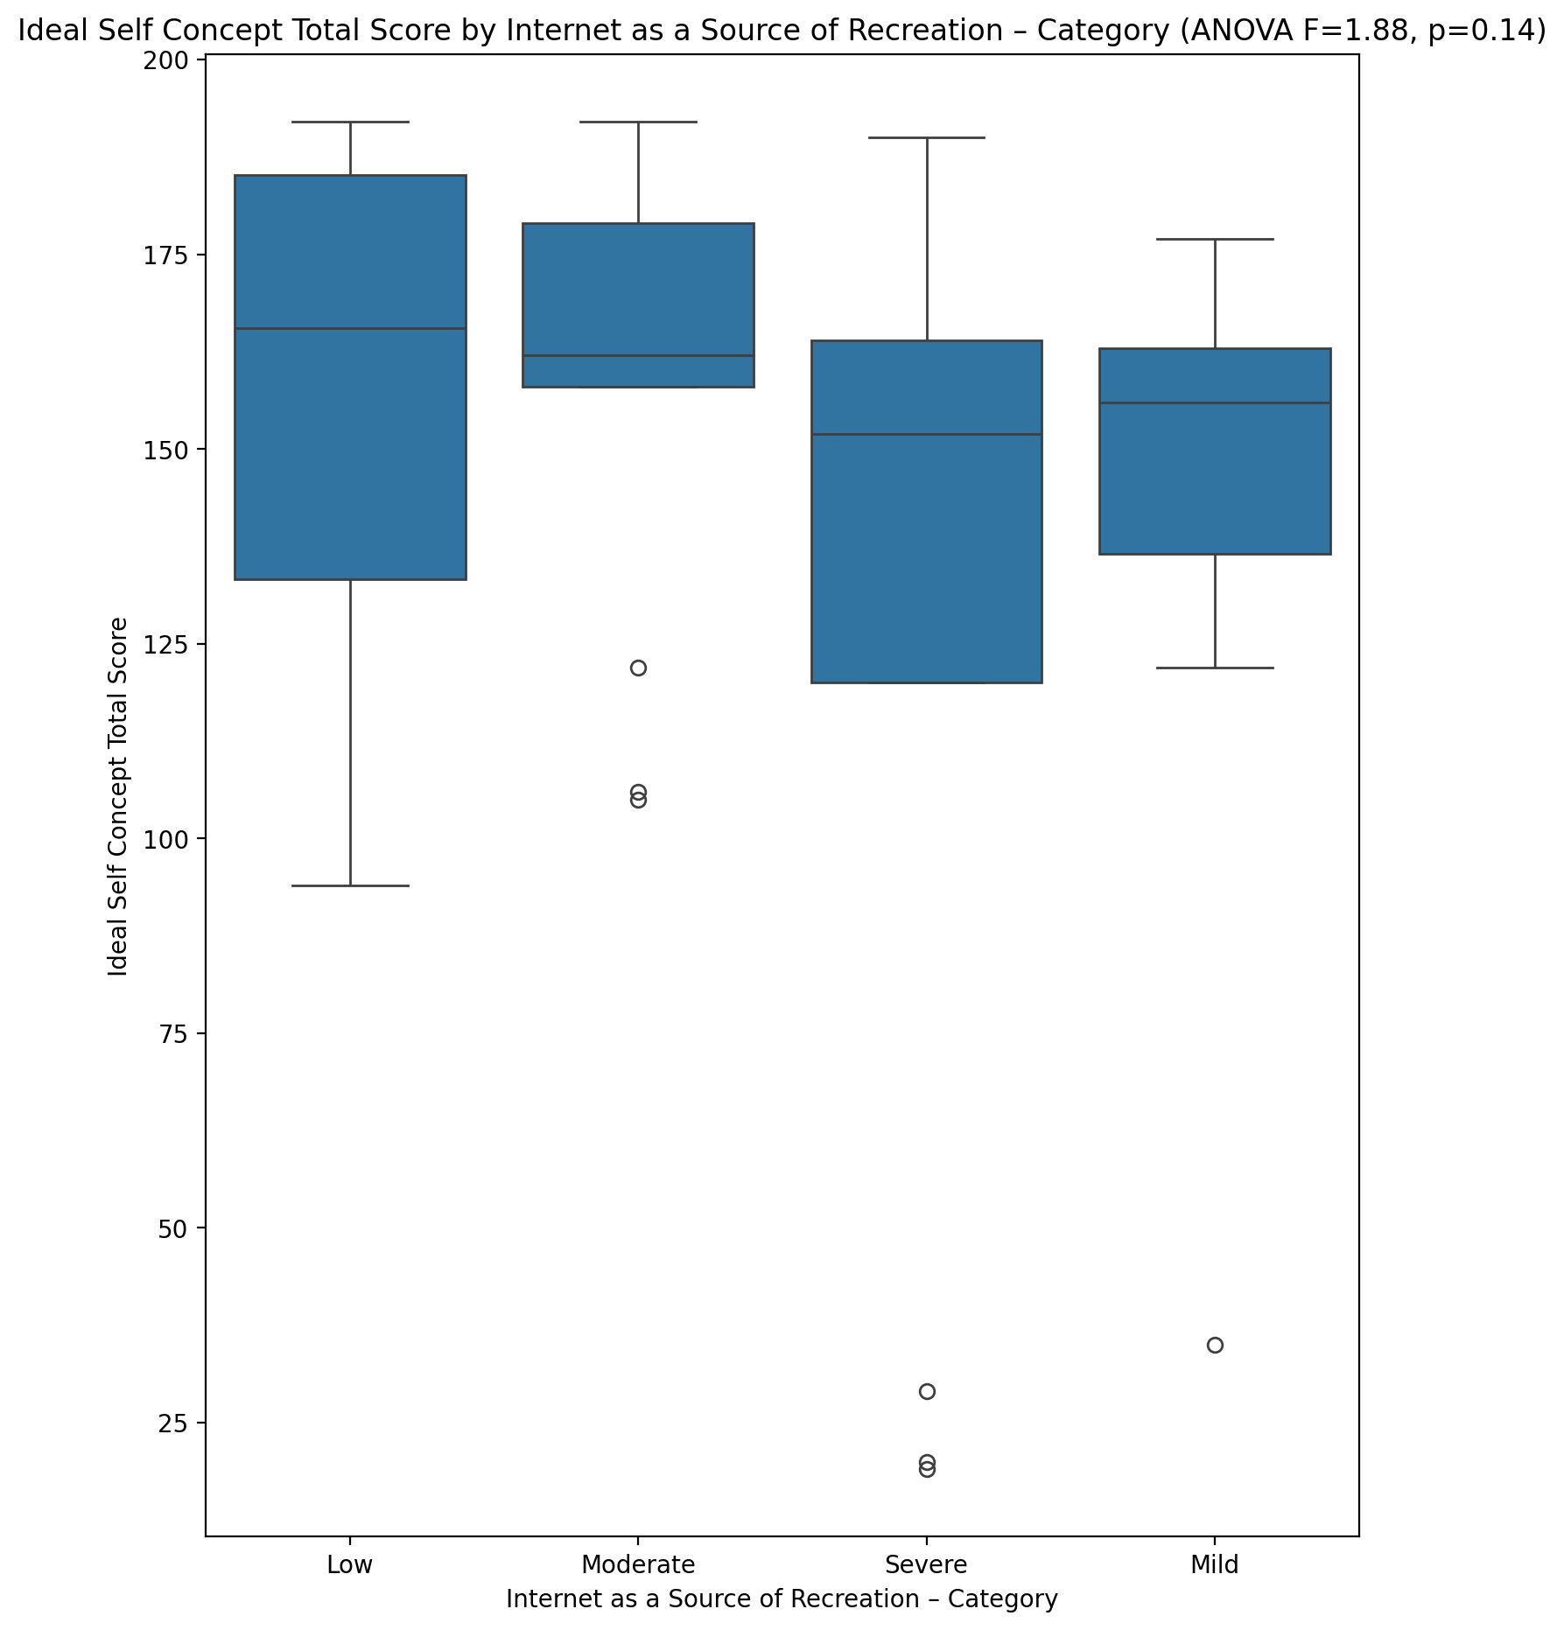

## Social Self Concept Total Score vs Internet as a Source of Recreation – Category

Test: anova; statistic: 2.095358512448683; p-value: 0.1113532804555373;

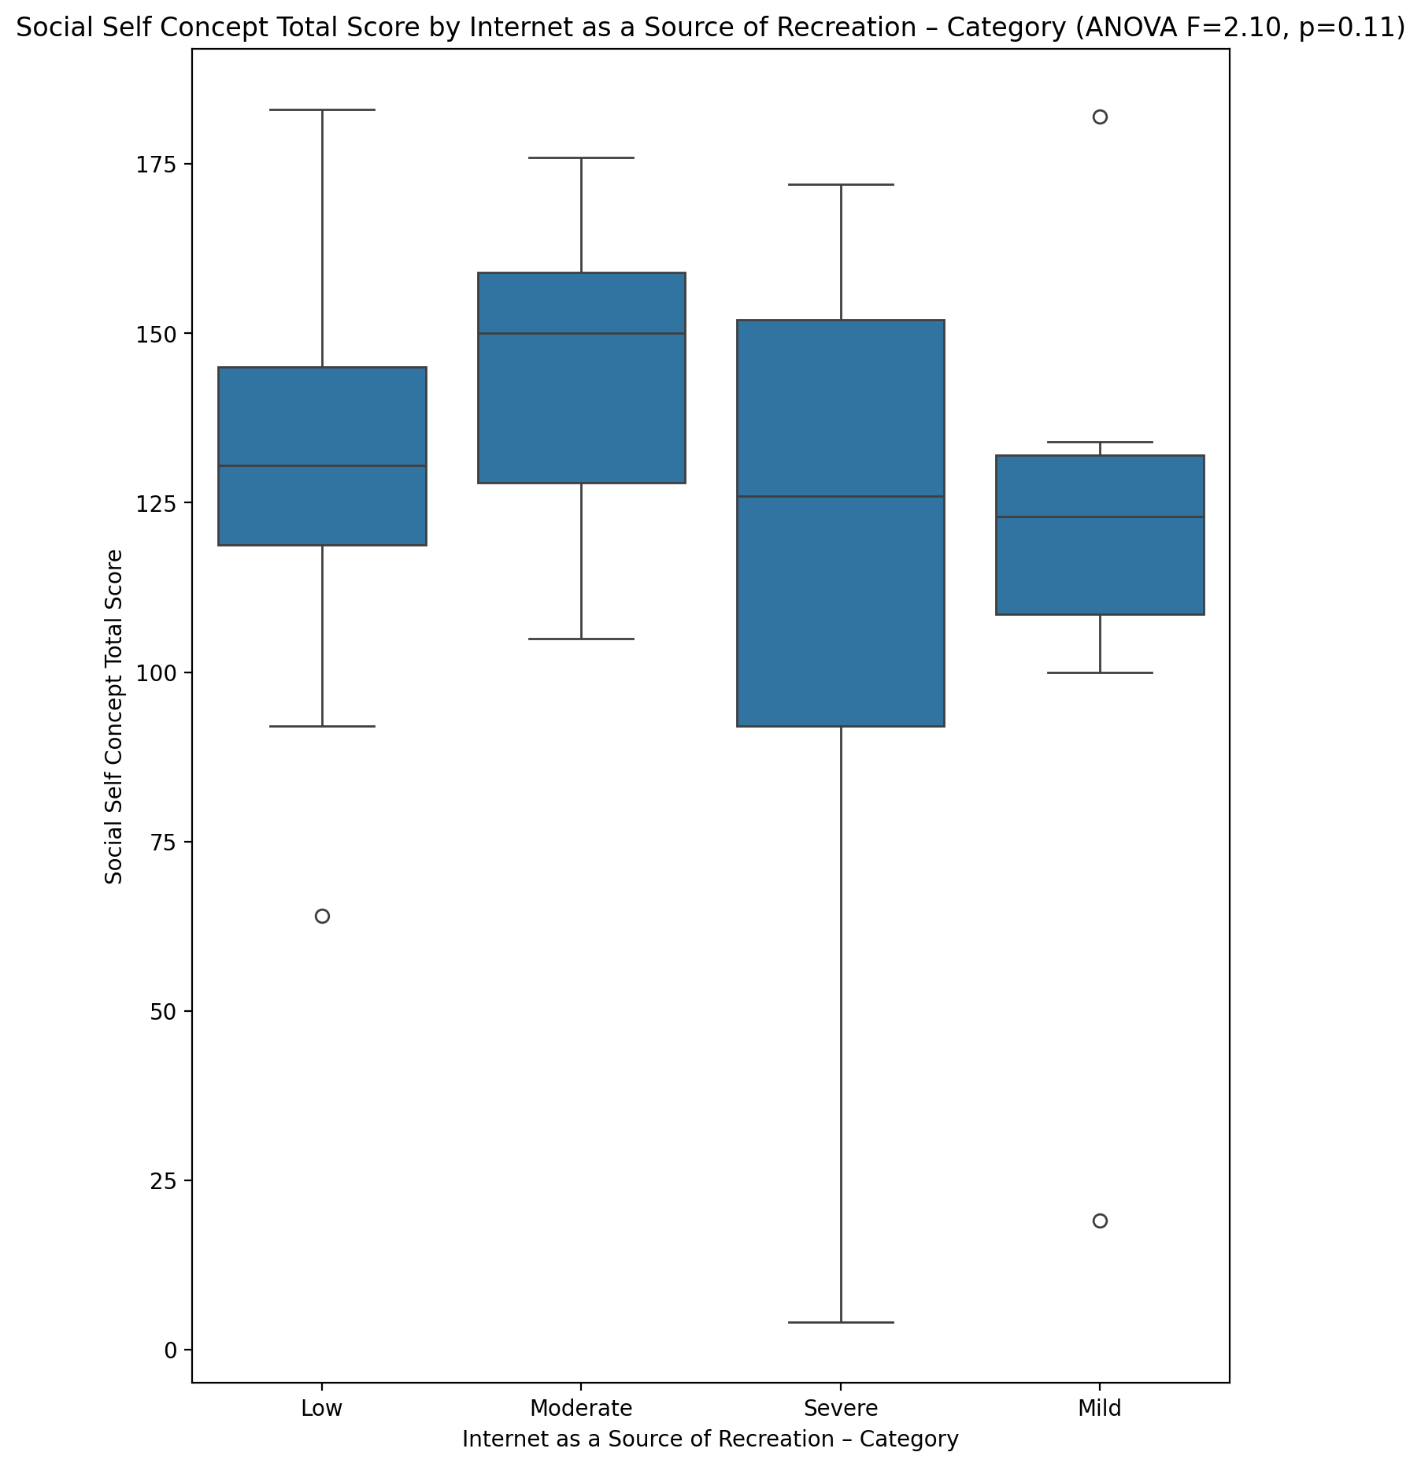

## Ideal Self Concept Total Category vs Internet as a Source of Recreation – Category

Test: chi2; statistic: 11.098865877712033; p-value: 0.08536850288891935;

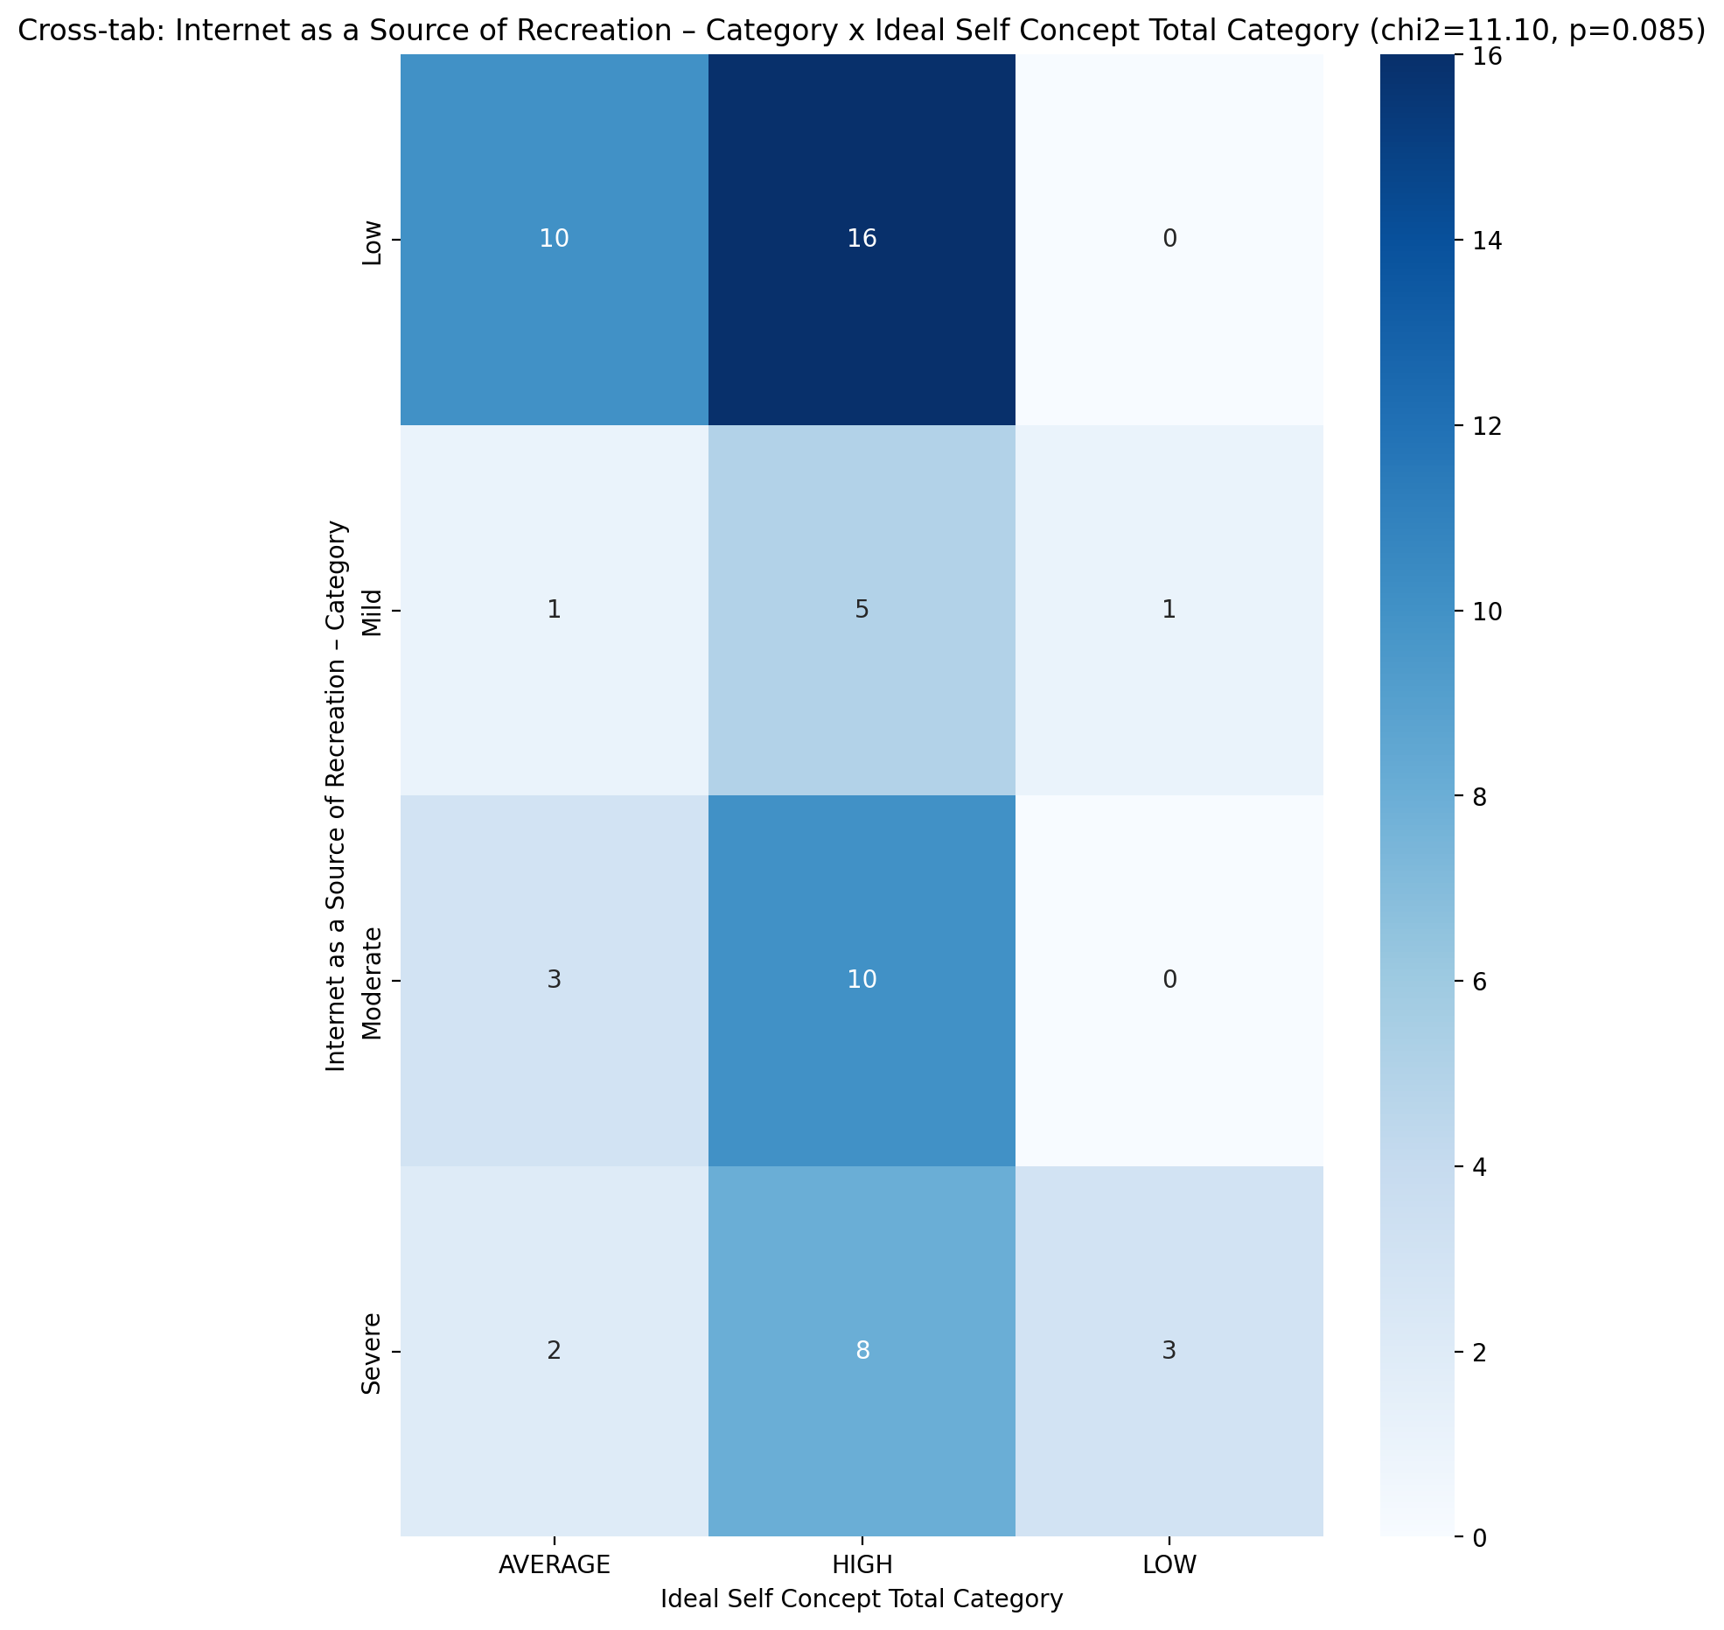

## Perceived Social Stress Score vs Internet as a Source of Recreation – Category

Test: anova; statistic: 1.4101303445628879; p-value: 0.24960778236459197;

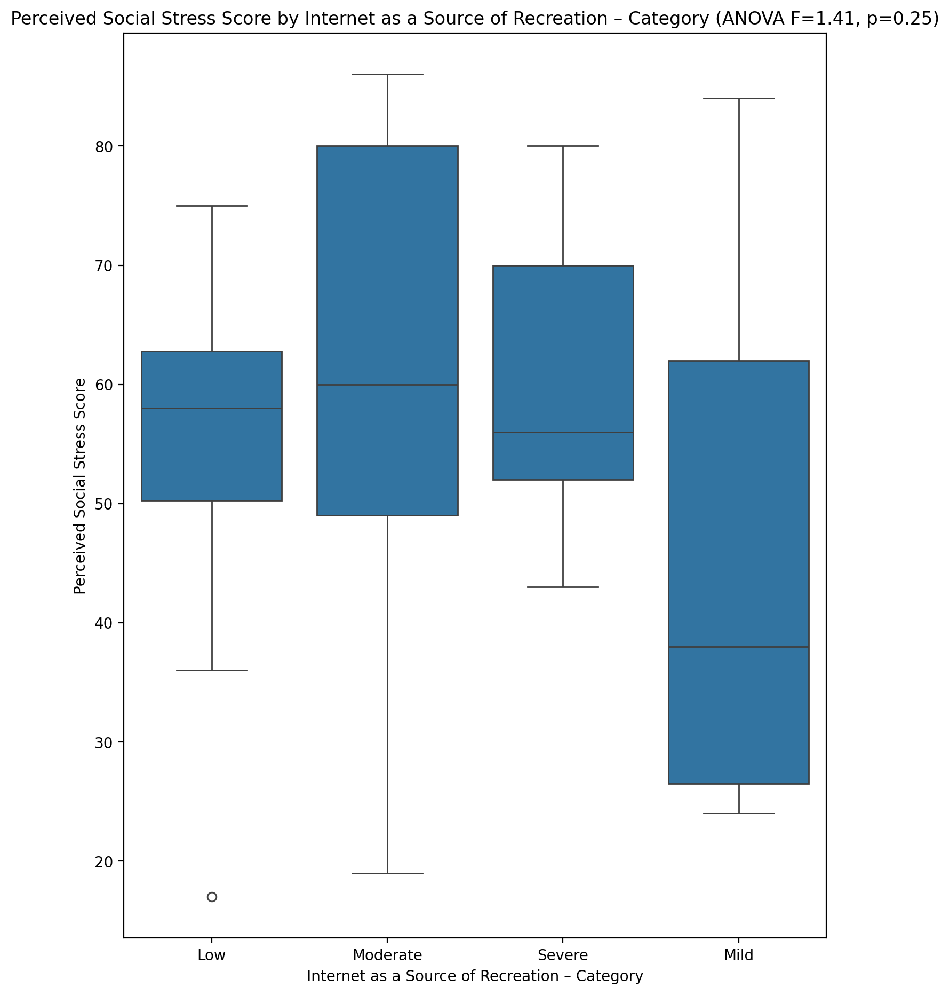

## Perceived Social Stress Category vs Internet as a Source of Recreation – Category

Test: chi2; statistic: 22.591002747252748; p-value: 0.0009456965914313248;

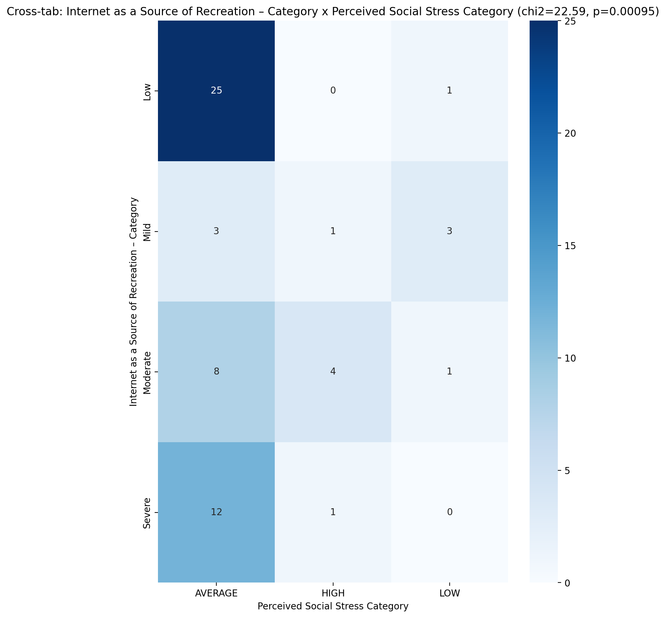

## Emotional Support - Raw Score vs Internet Usage Total Categoty

Test: anova; statistic: 1.6278419832480344; p-value: 0.19343176579031376;

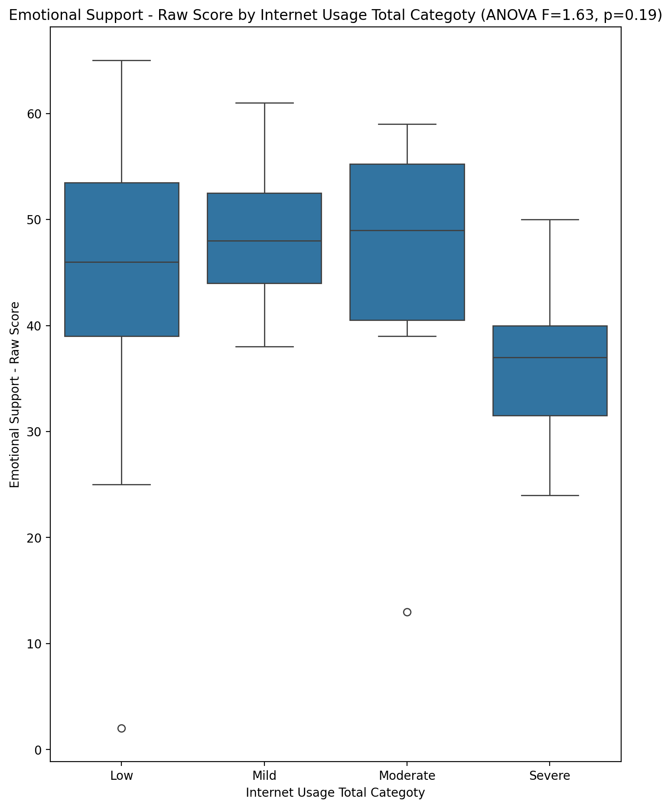

## Informational Support - Raw Score vs Internet Usage Total Categoty

Test: anova; statistic: 1.0233683240567029; p-value: 0.3894239285994699;

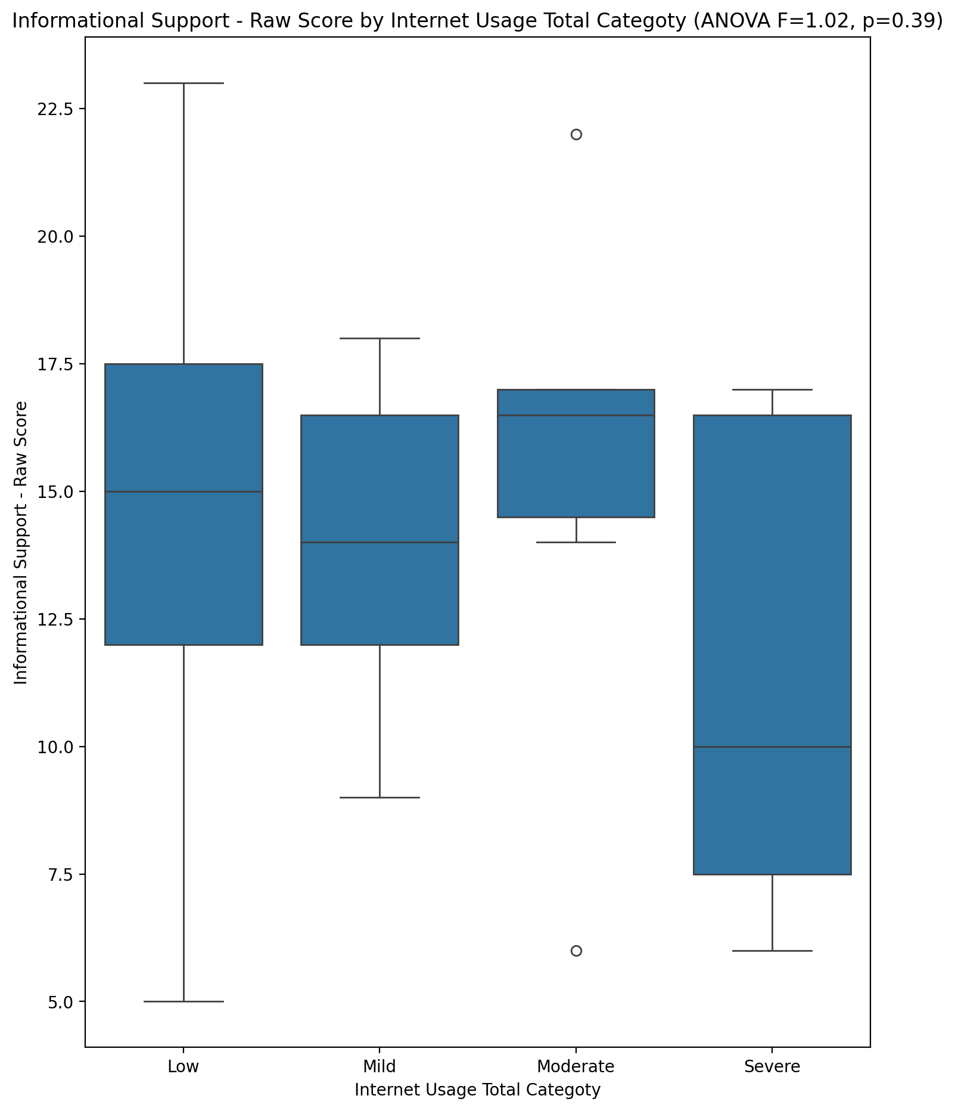

## Instrumental Support - Raw Score vs Internet Usage Total Categoty

Test: anova; statistic: 0.3560343493056127; p-value: 0.78495069149488;

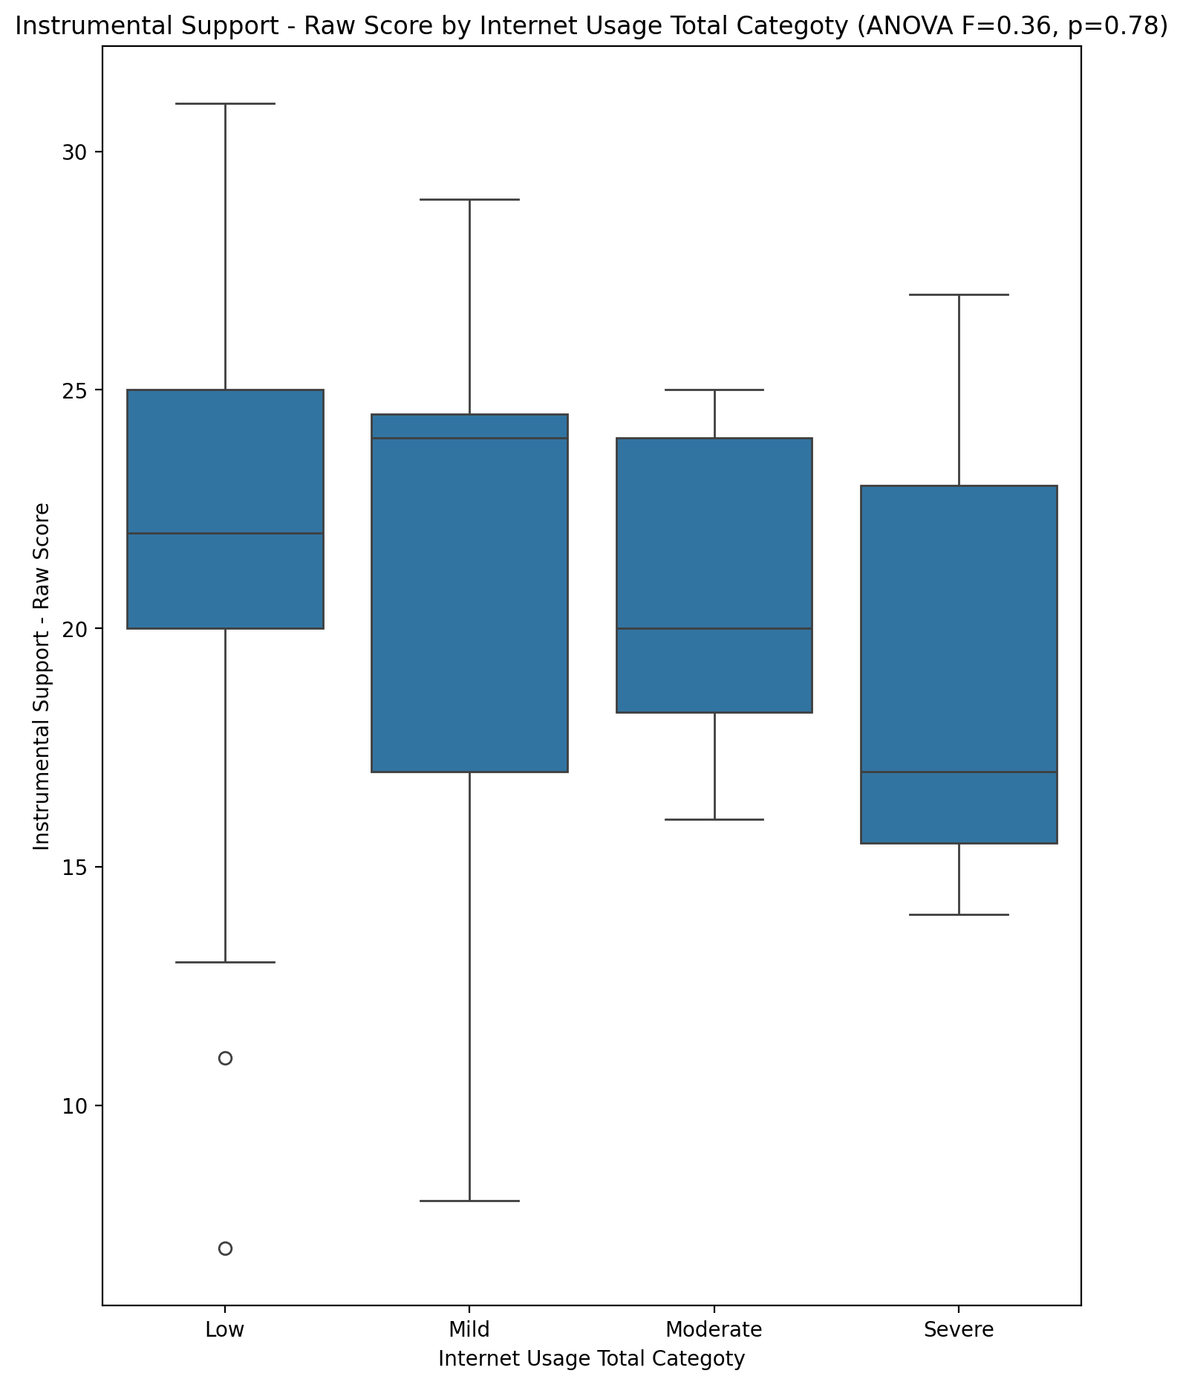

## Emotional Support - T Score vs Internet Usage Total Categoty

Test: anova; statistic: 1.745676408853829; p-value: 0.16836866783042875;

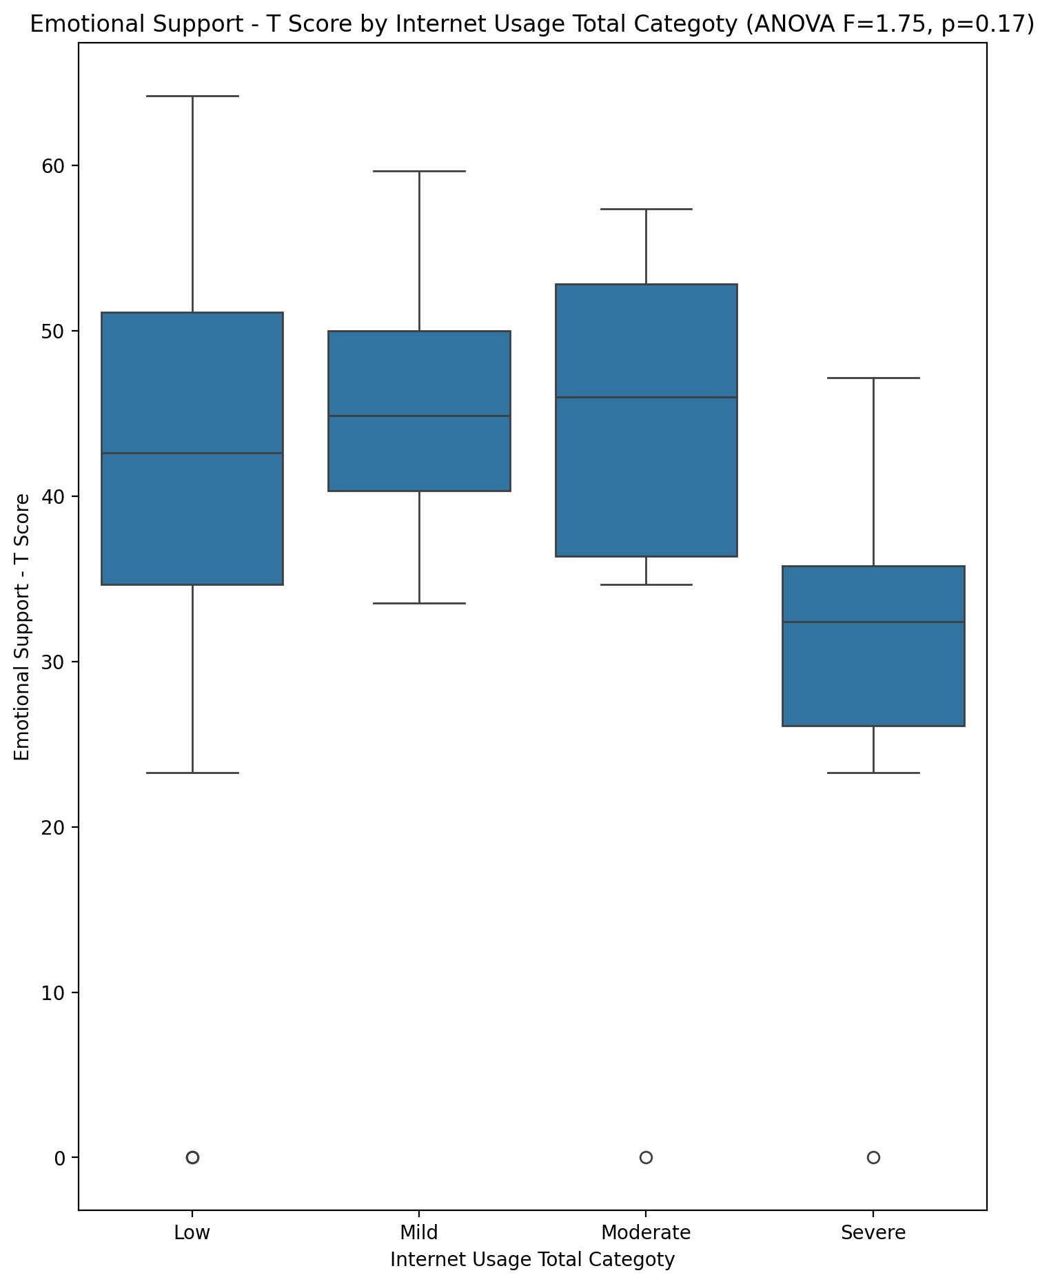

## Informational Support - T Score vs Internet Usage Total Categoty

Test: anova; statistic: 0.7905493616884017; p-value: 0.5043685100277926;

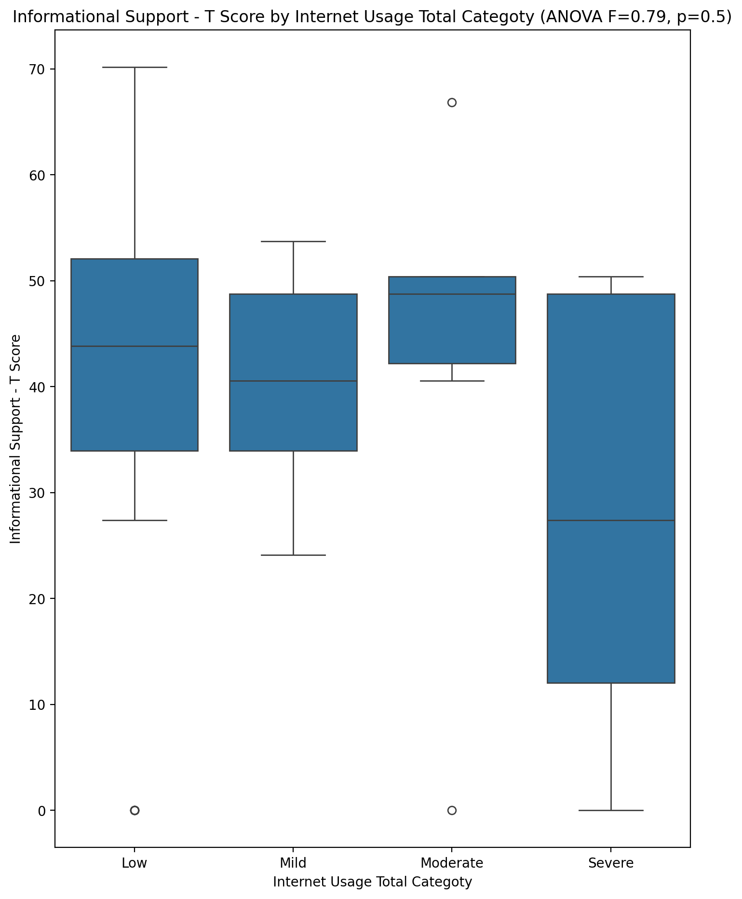

## Instrumental Support - T Score vs Internet Usage Total Categoty

Test: anova; statistic: 0.20021337948083368; p-value: 0.8957981393963281;

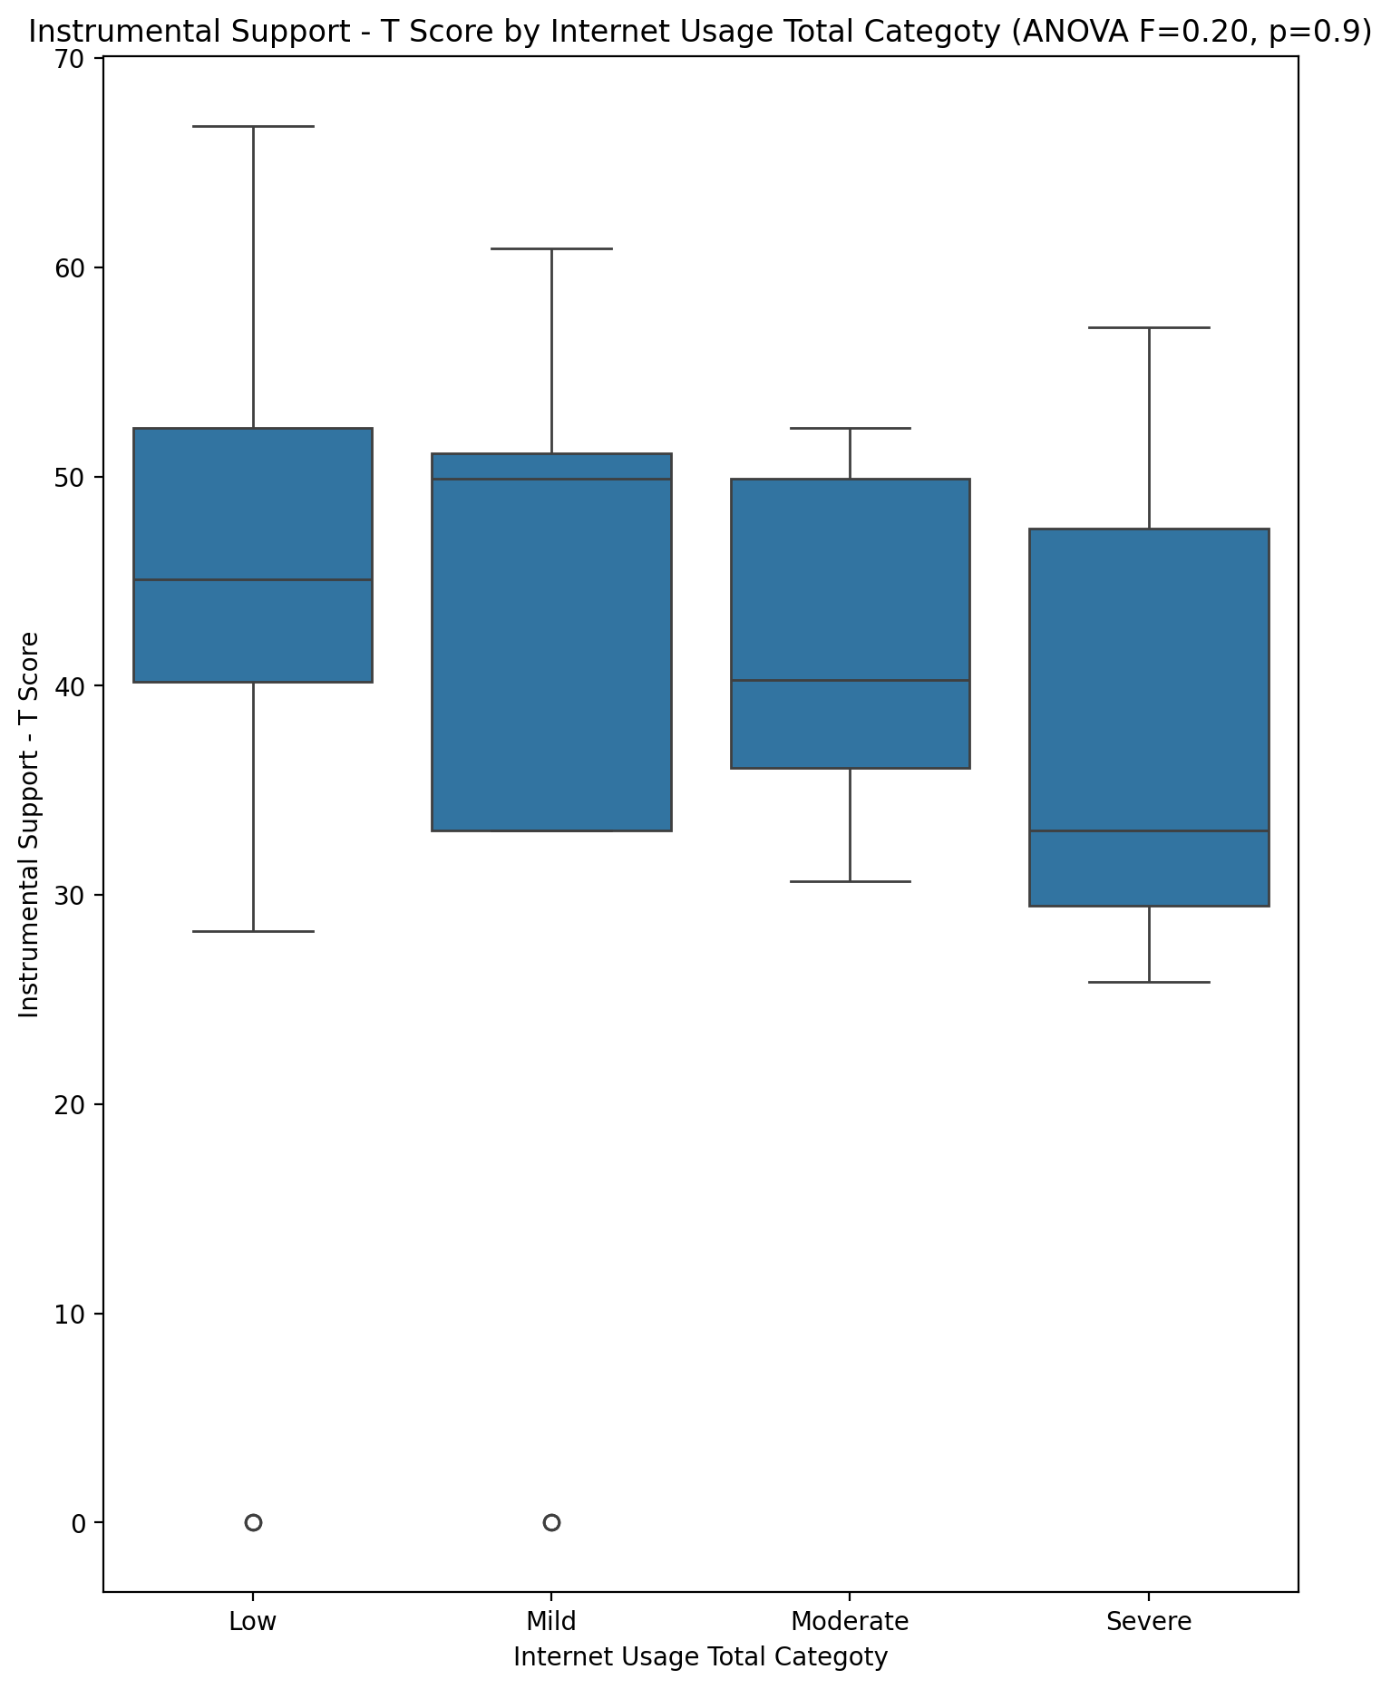

## Perceived Social Support Total T Score vs Internet Usage Total Categoty

Test: anova; statistic: 1.6904930950022359; p-value: 0.17968317142328508;

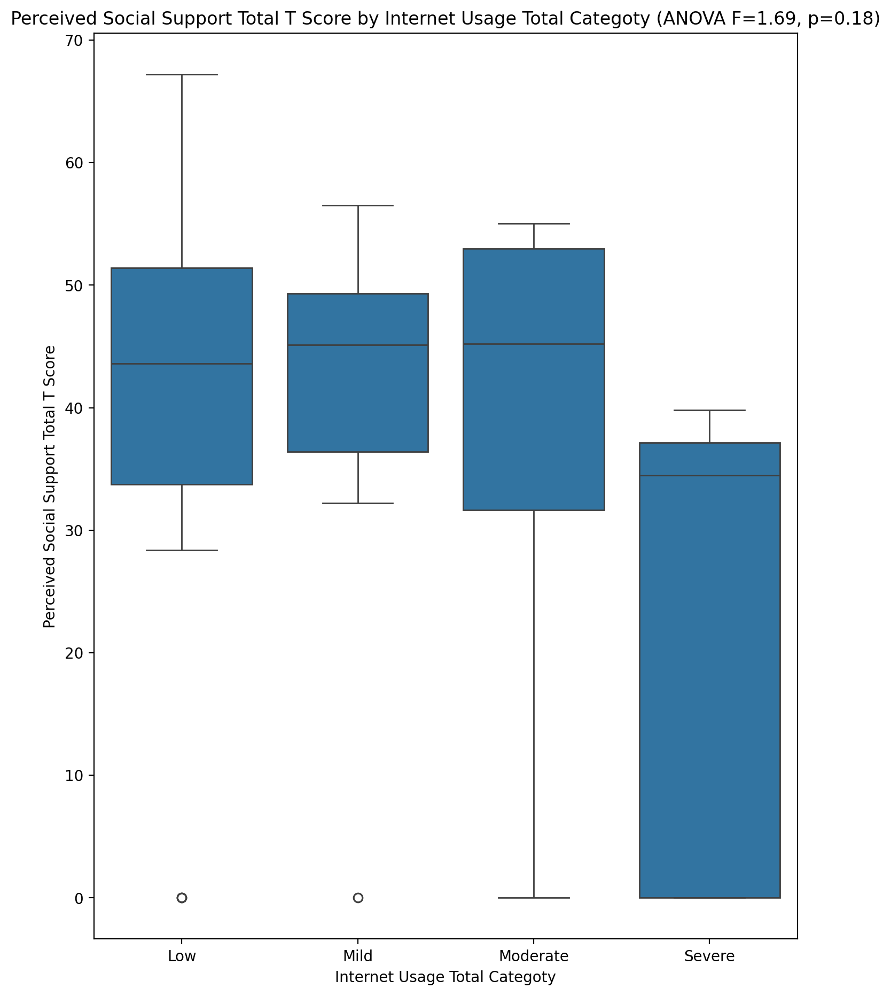

## Emotional Support - Rank vs Internet Usage Total Categoty

Test: chi2; statistic: 9.37301633850021; p-value: 0.40357794019656124;

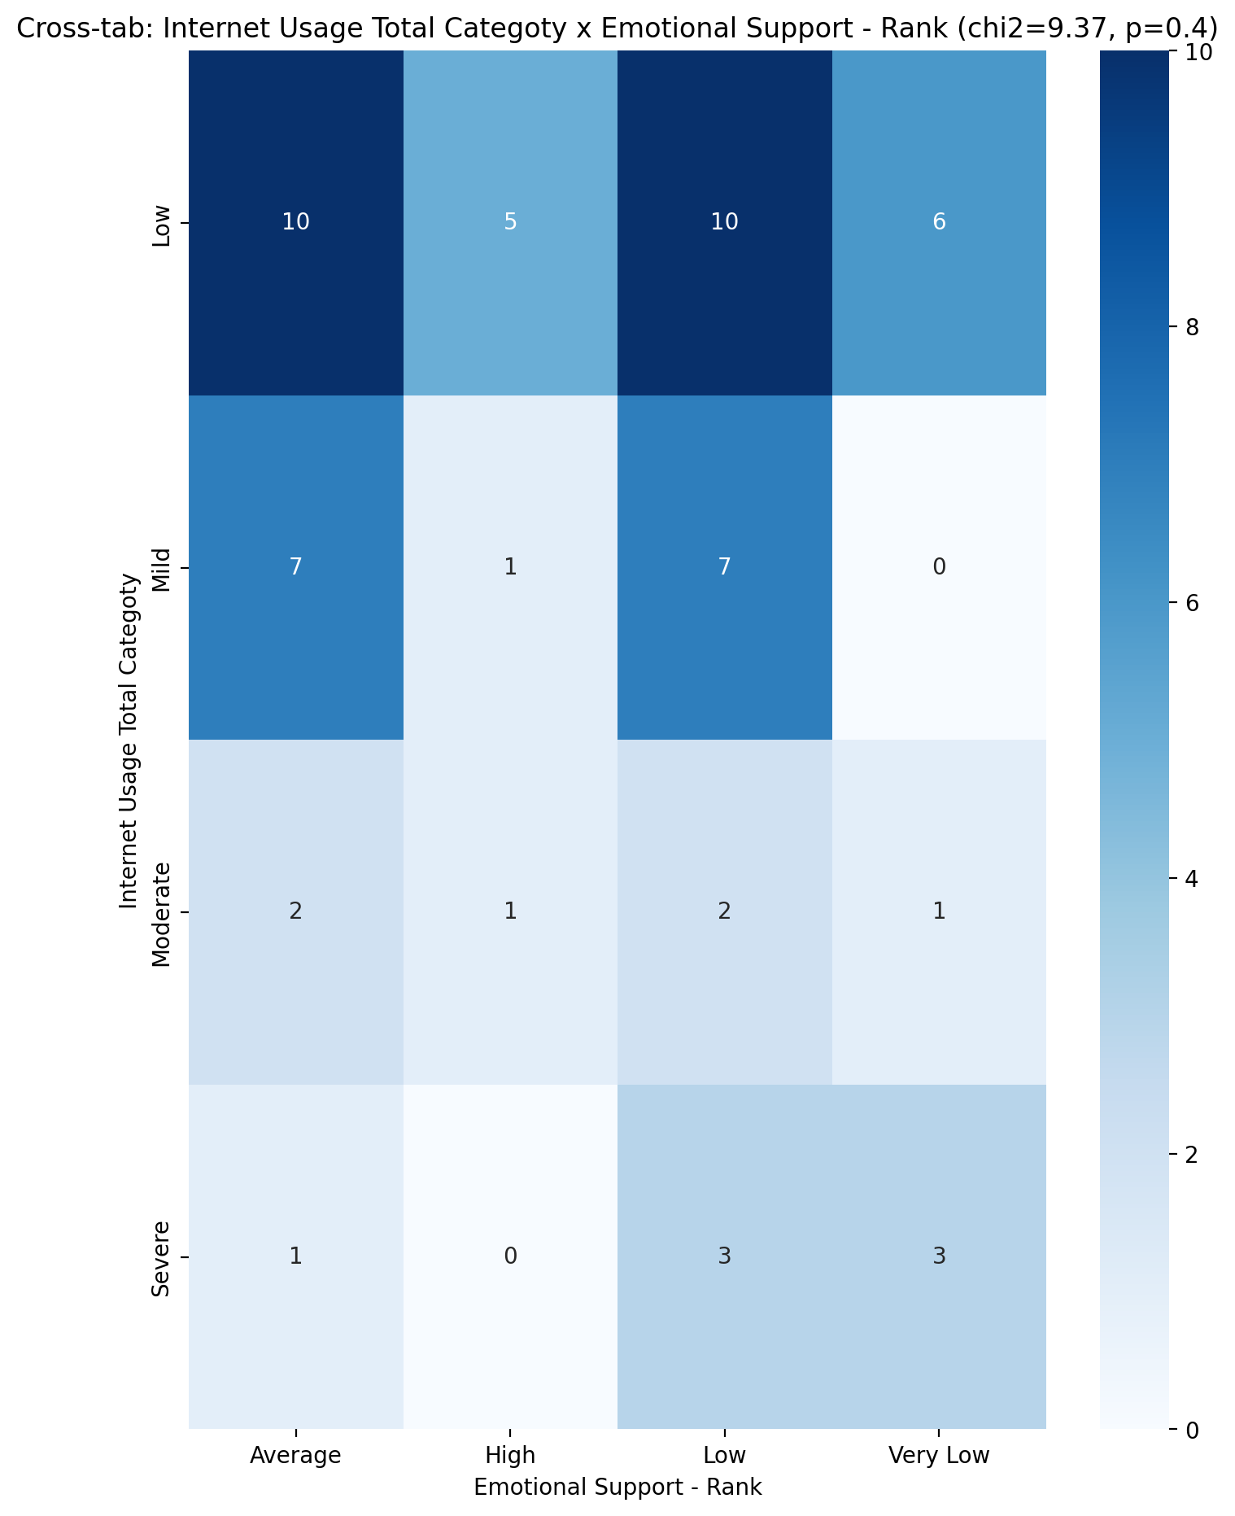

## Informational Support - Rank vs Internet Usage Total Categoty

Test: chi2; statistic: 12.7860692630193; p-value: 0.3847800167103898;

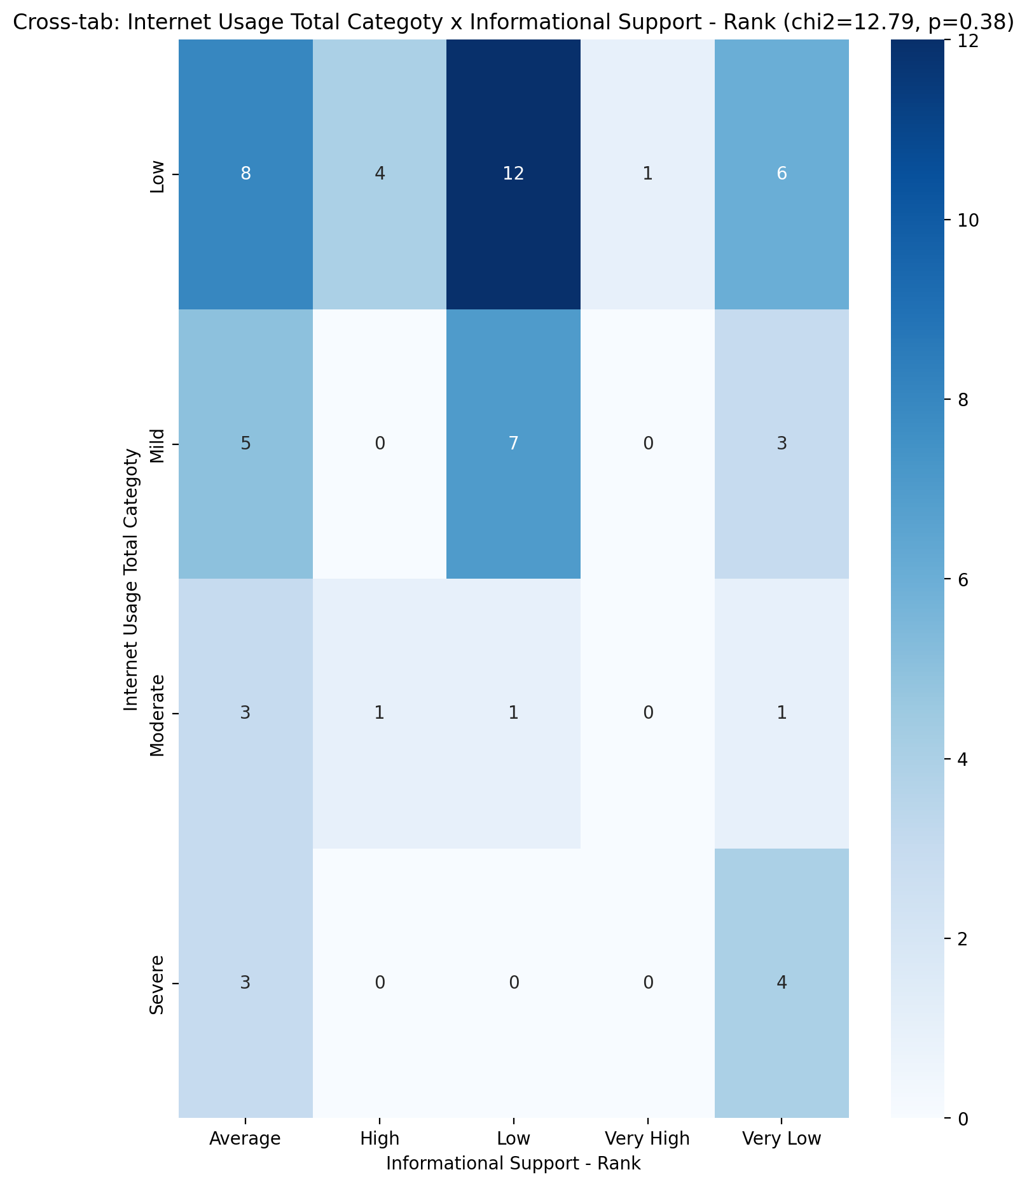

## Instrumental Support - Rank vs Internet Usage Total Categoty

Test: chi2; statistic: 9.633791927762744; p-value: 0.3809366818649528;

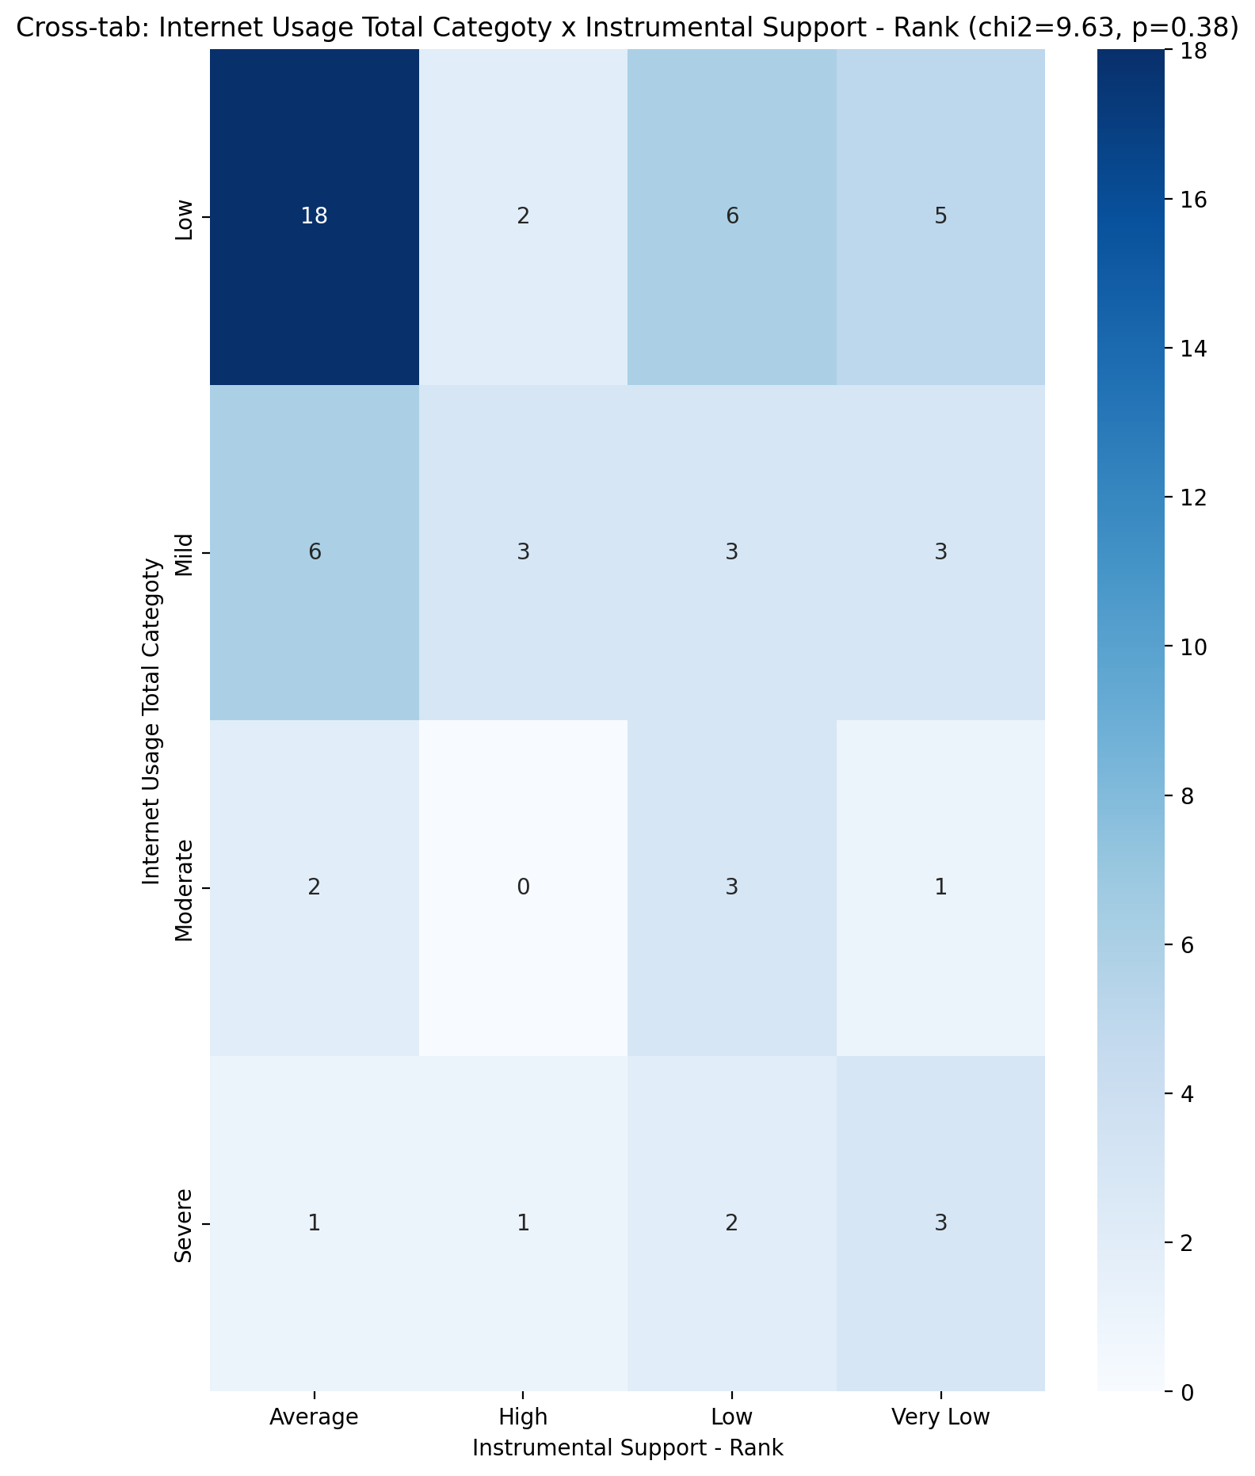

## Perceived Social Support TOTAL - Rank vs Internet Usage Total Categoty

Test: chi2; statistic: 11.554649919972501; p-value: 0.23959557661989325;

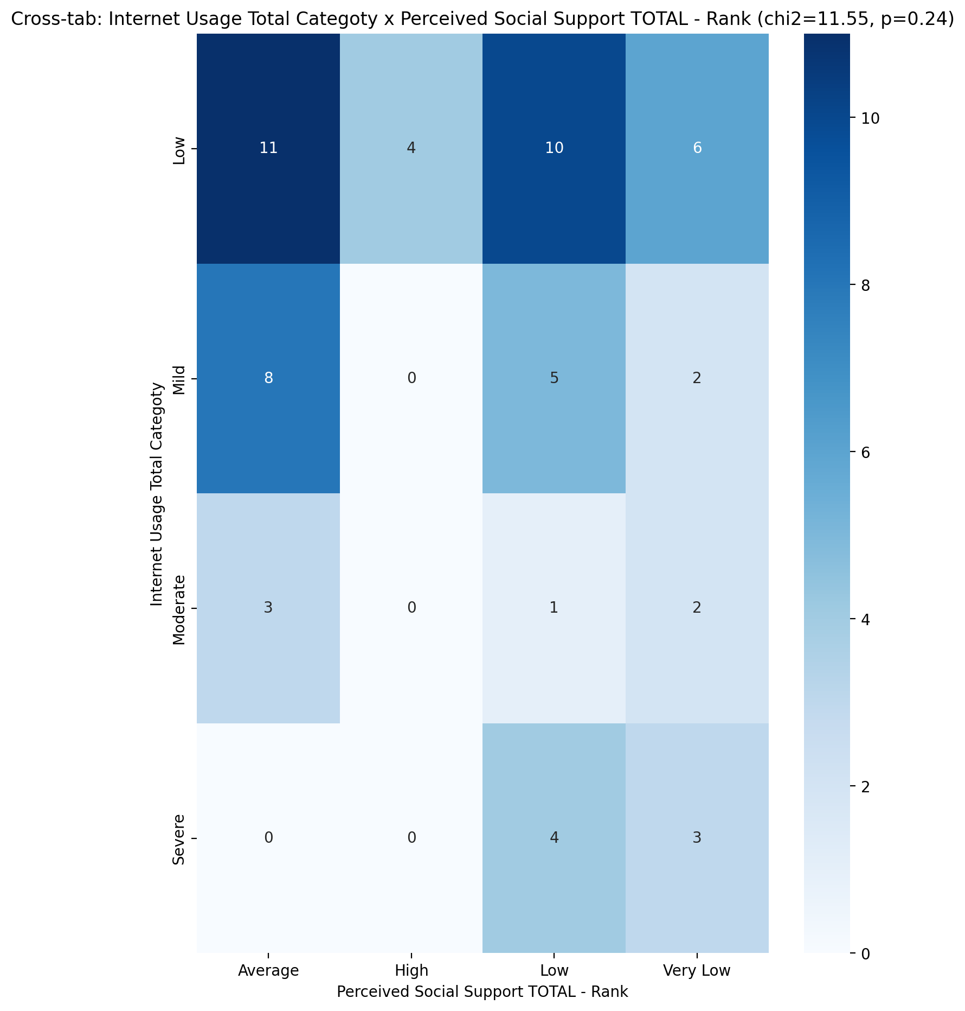

## Power Self Concept - Real Self Concept Score vs Internet Usage Total Categoty

Test: anova; statistic: 3.091640589454867; p-value: 0.034366728671602856;

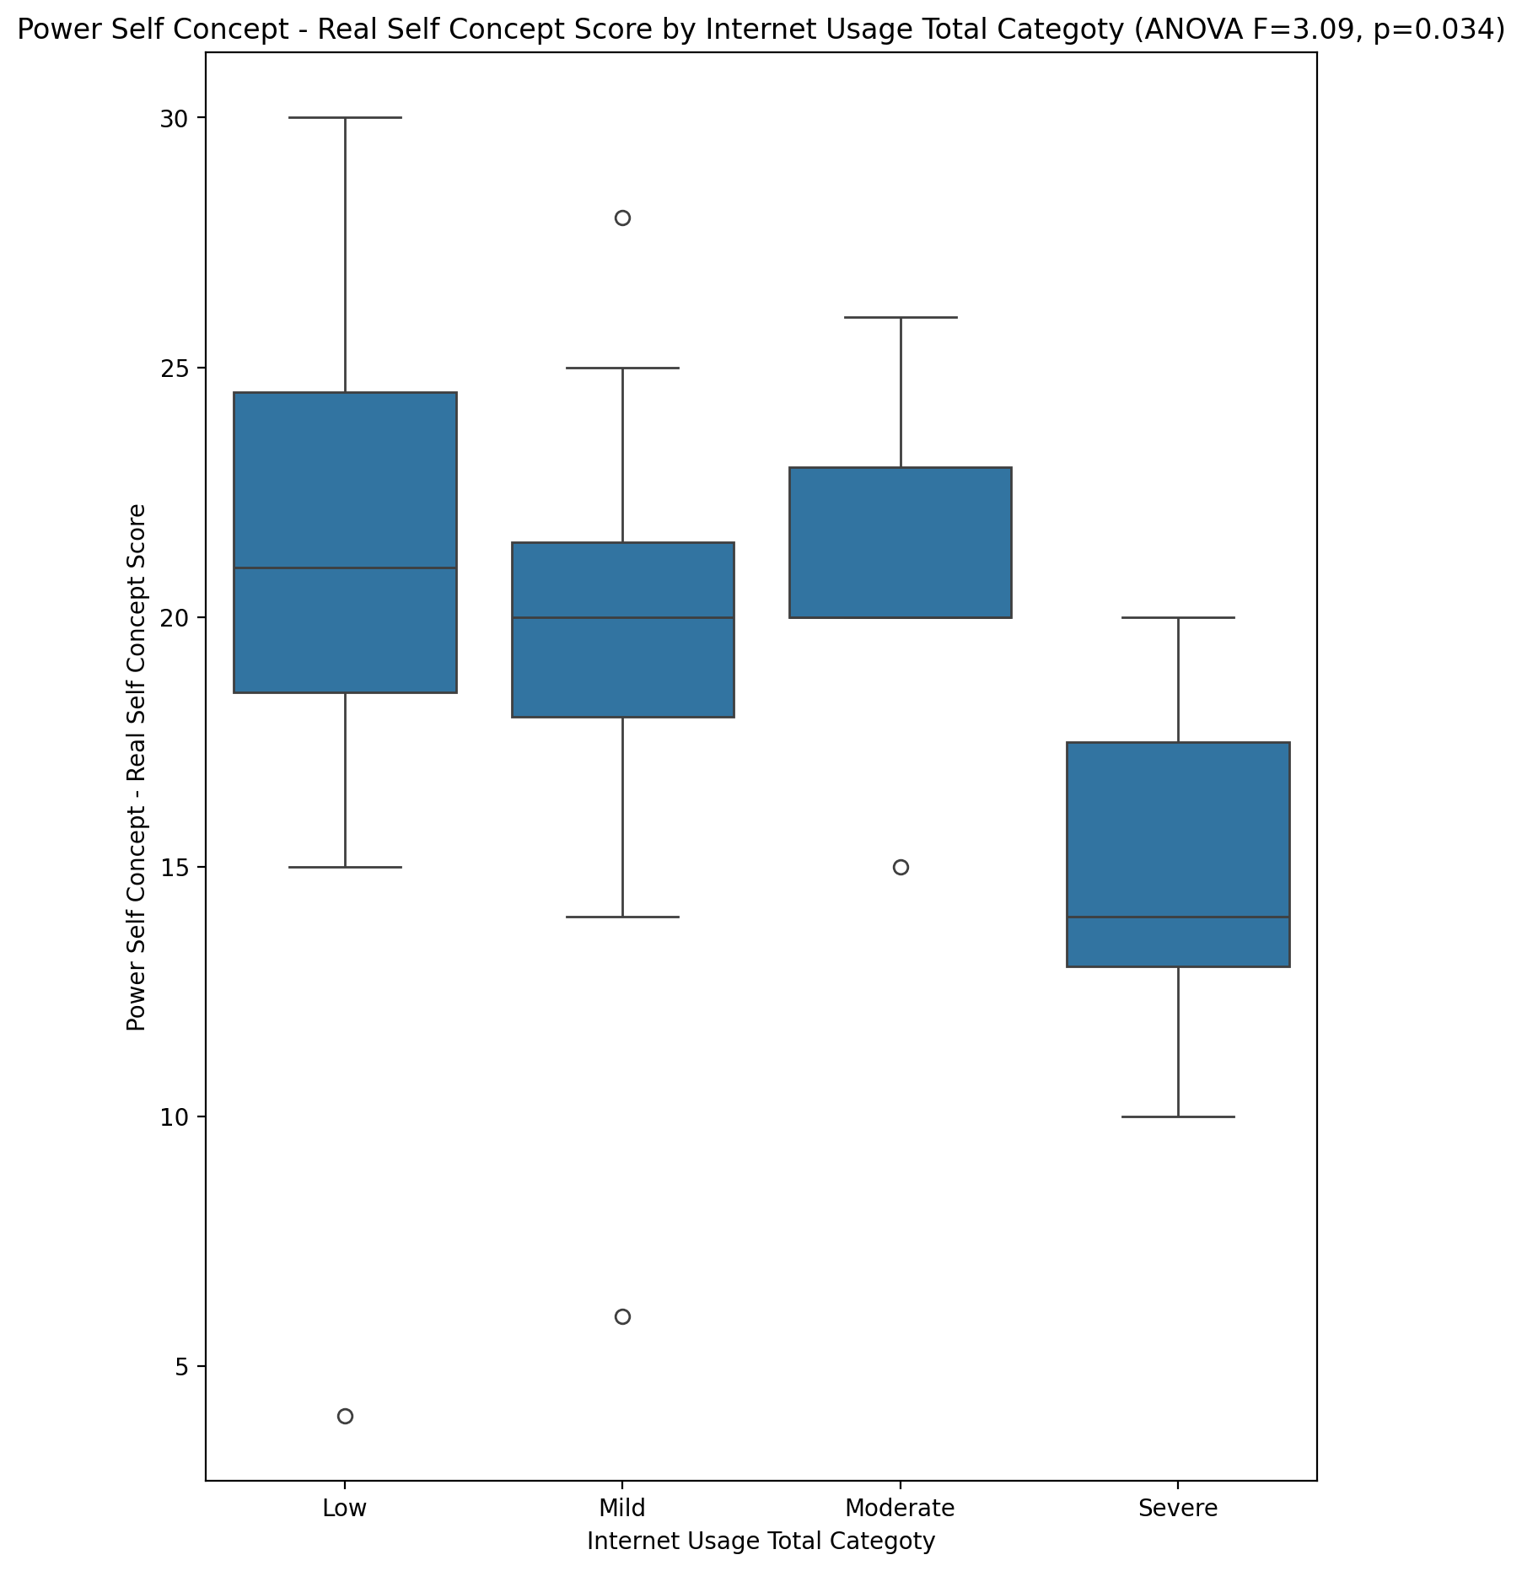

## Power Self Concept - Ideal Self Concept score vs Internet Usage Total Categoty

Test: anova; statistic: 3.1481074261708293; p-value: 0.03216828758410058;

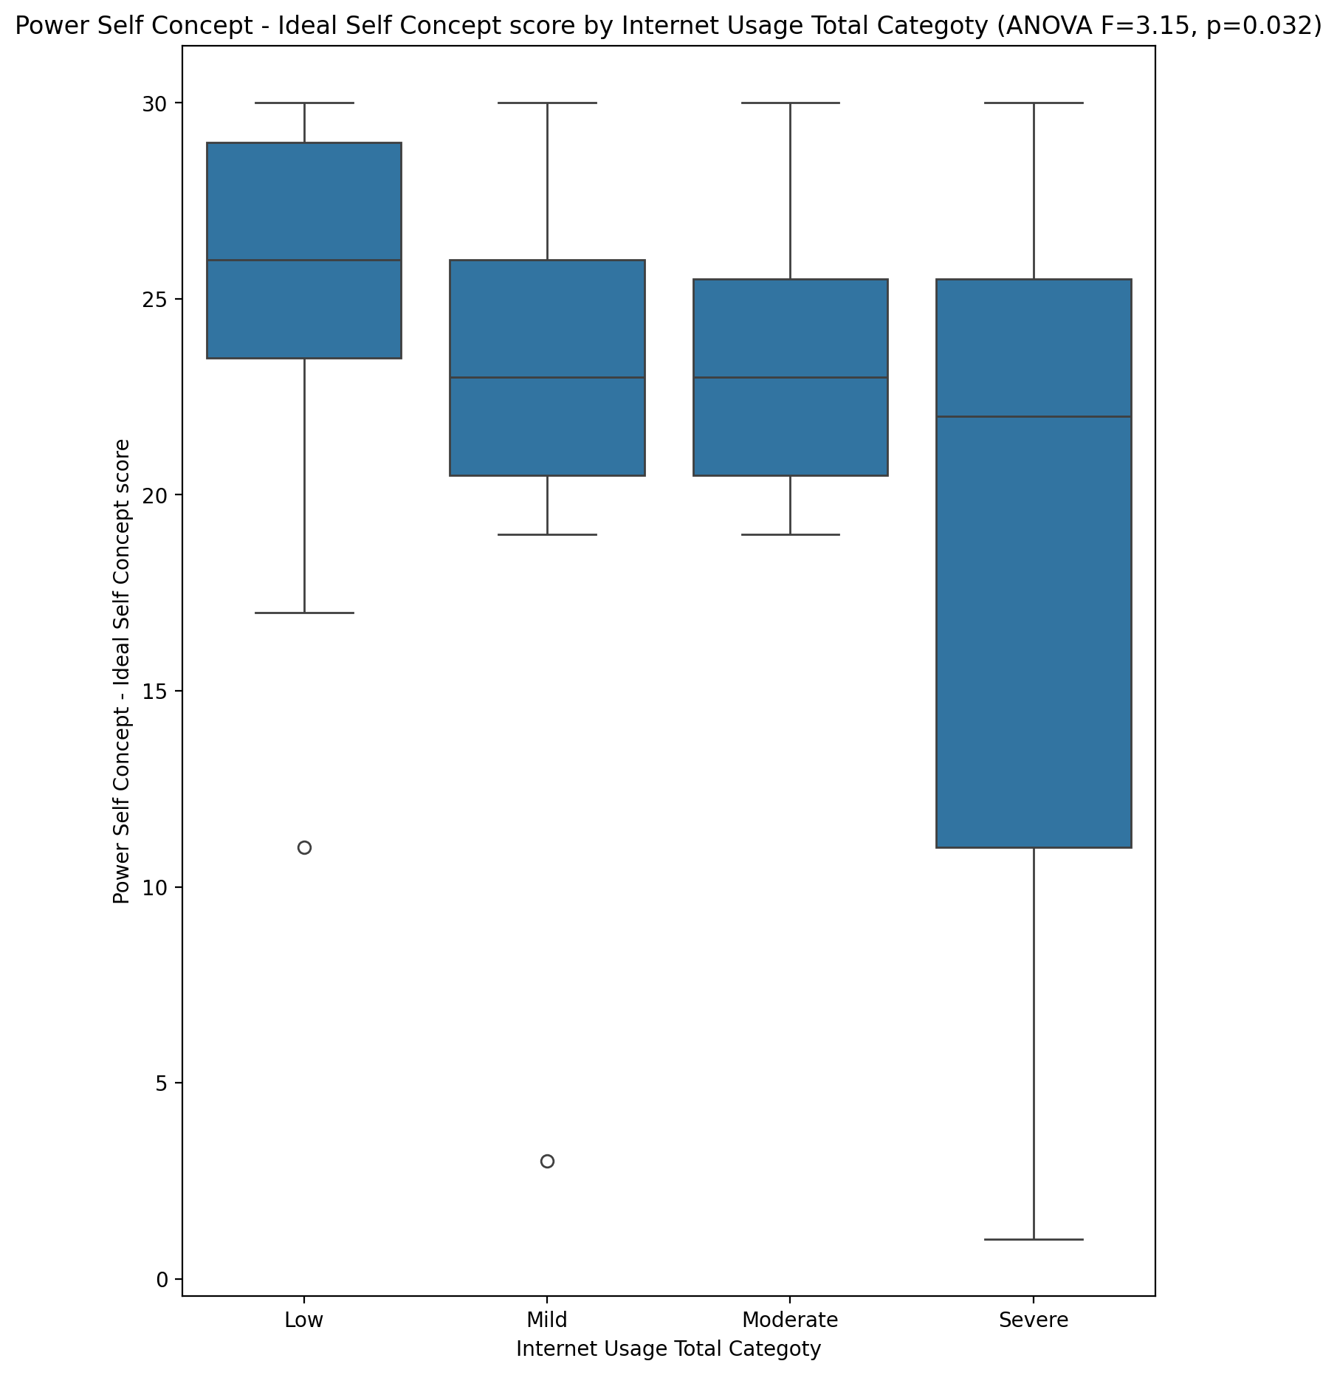

## Power Self Concept – Social Self Concept Score vs Internet Usage Total Categoty

Test: anova; statistic: 2.088305881598131; p-value: 0.11228709098181465;

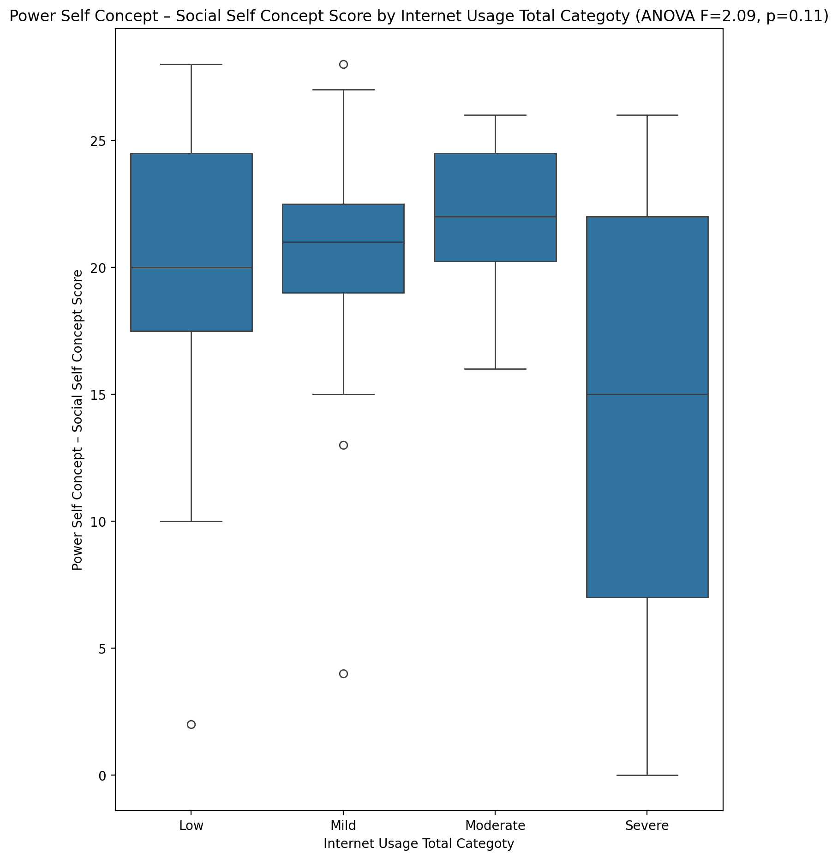

## Social Self Concept - Real Self Concept Score vs Internet Usage Total Categoty

Test: anova; statistic: 8.502885408721323; p-value: 9.846847747872766e-05;

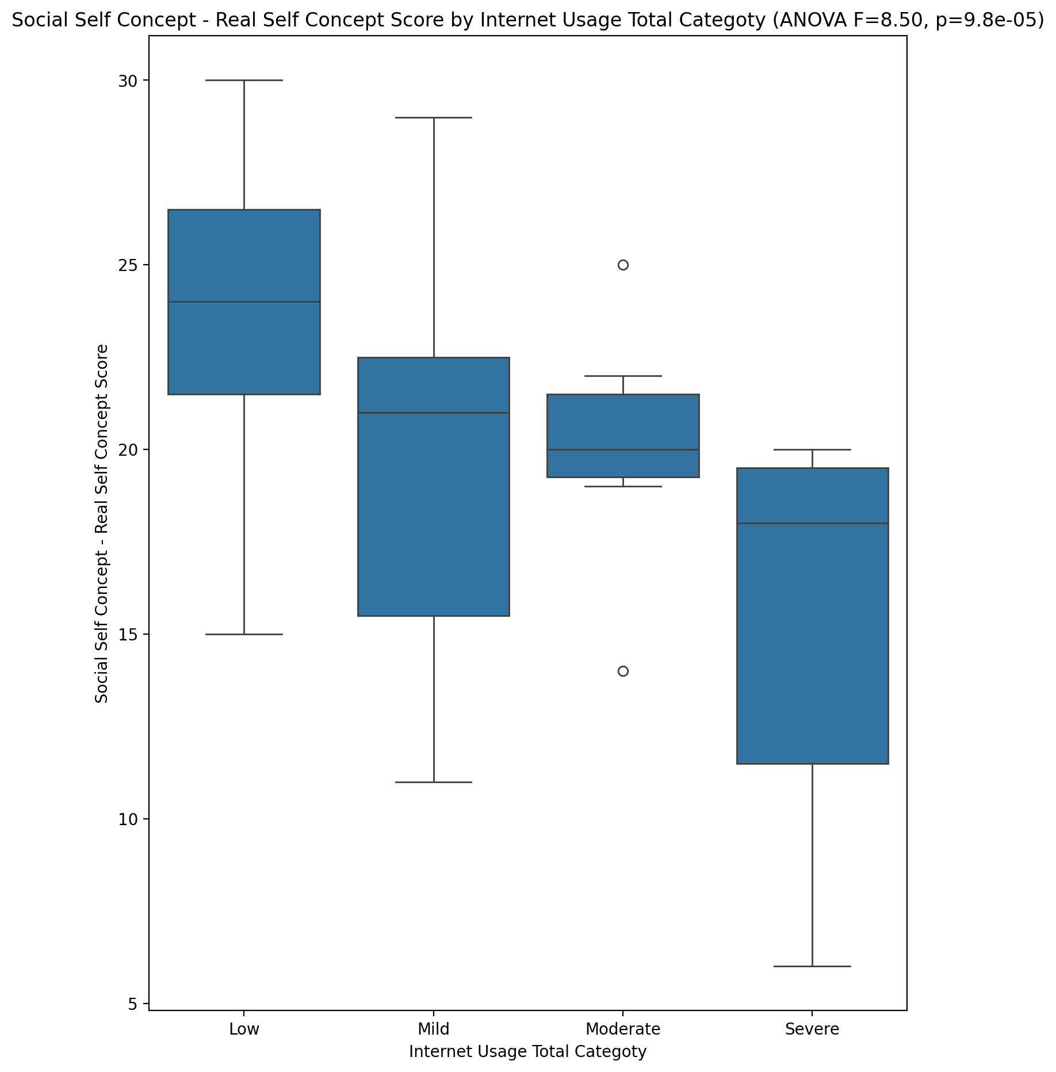

## Social Self Concept – Social Self Concept Score vs Internet Usage Total Categoty

Test: anova; statistic: 2.3623229556456087; p-value: 0.08117416522368753;

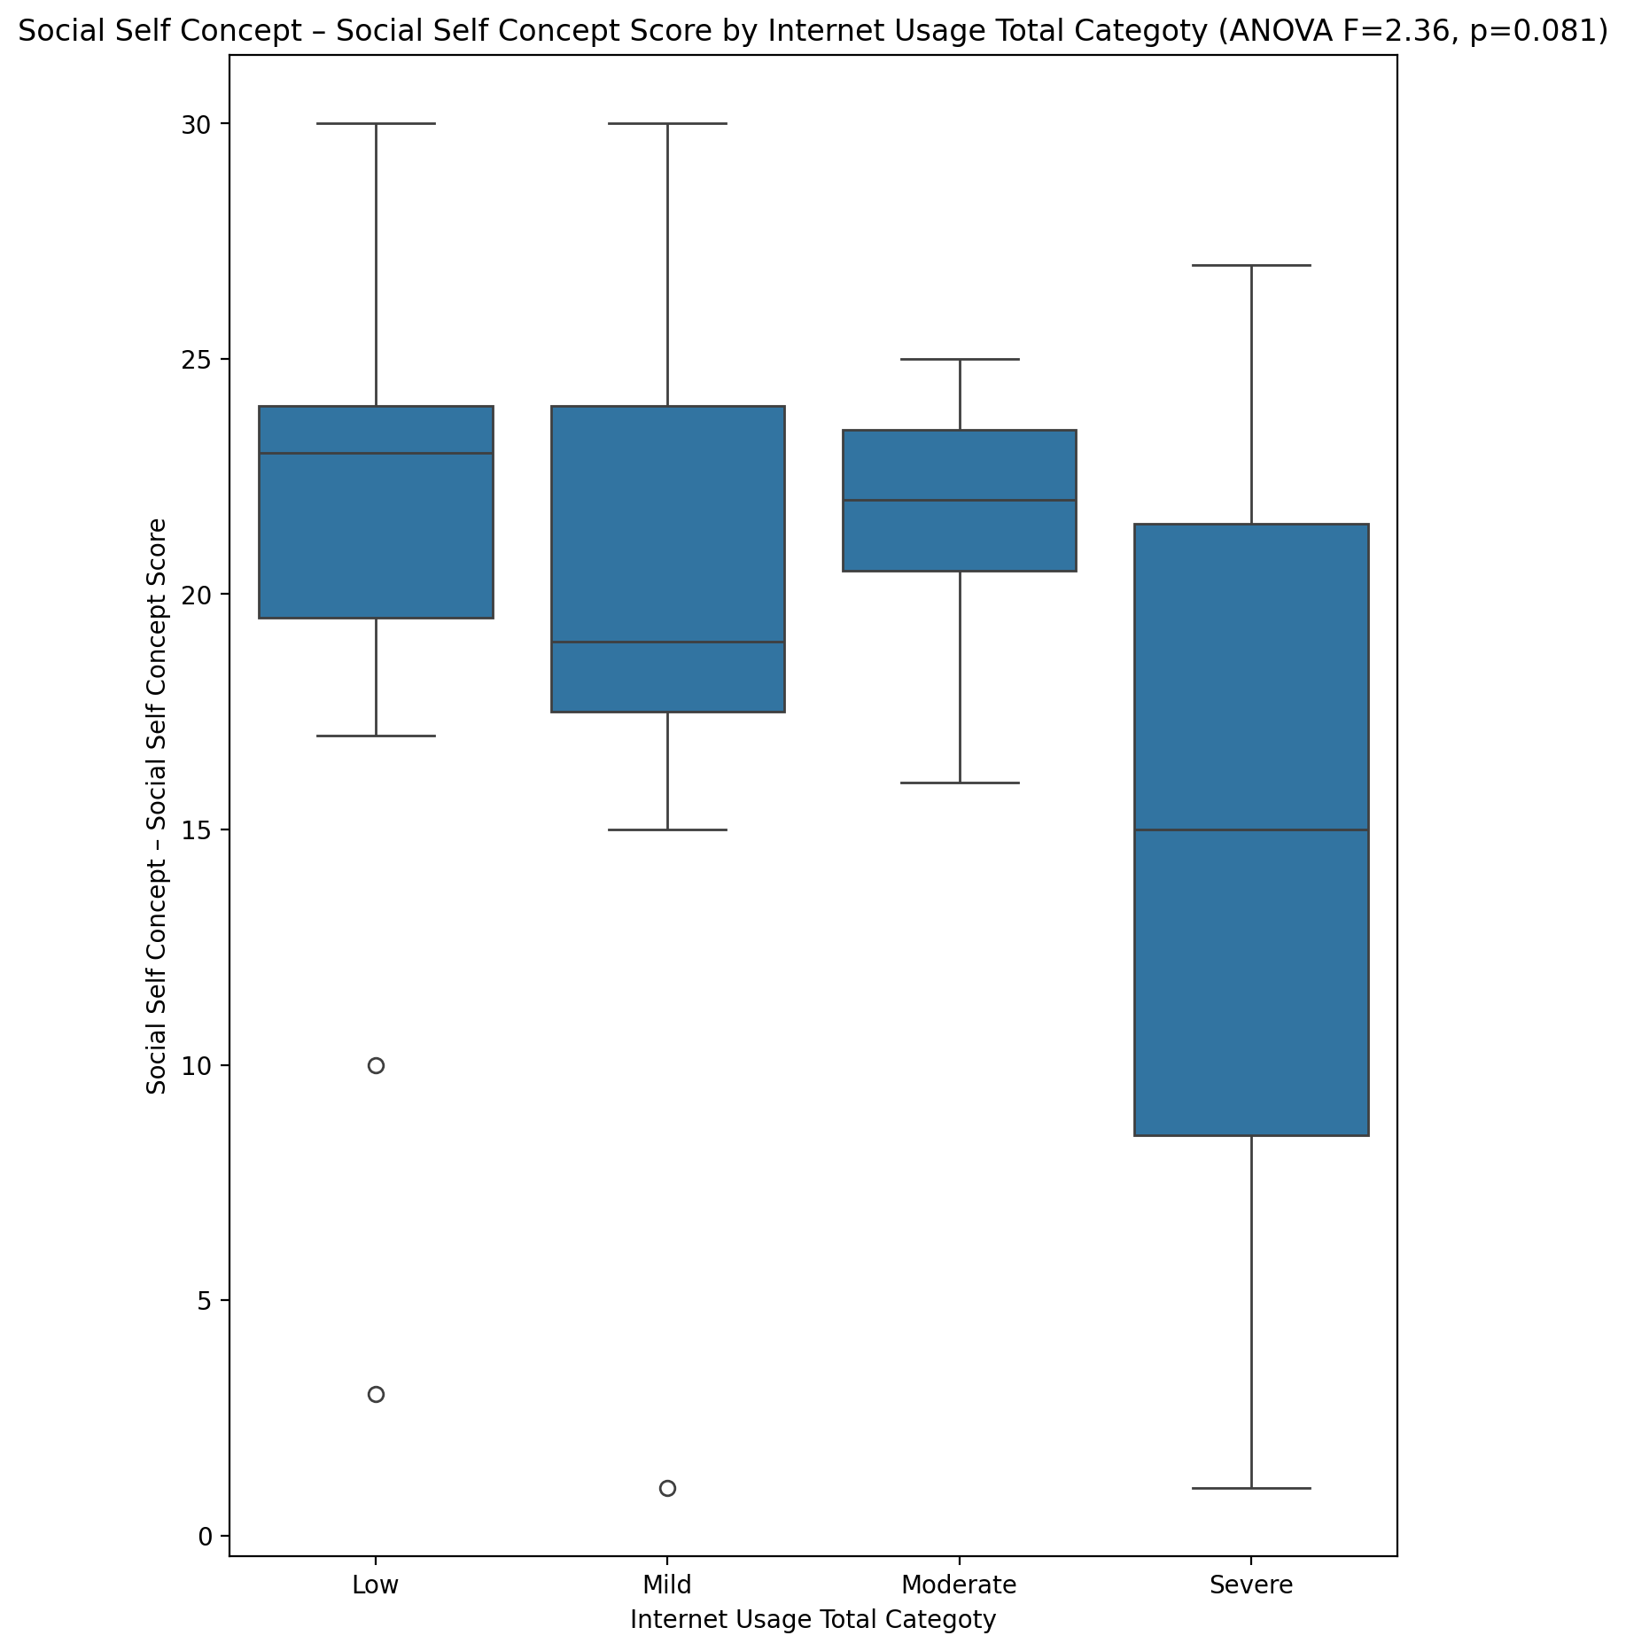

## Ability Self Concept - Real Self Concept Score vs Internet Usage Total Categoty

Test: anova; statistic: 3.999195087639441; p-value: 0.012004394566444953;

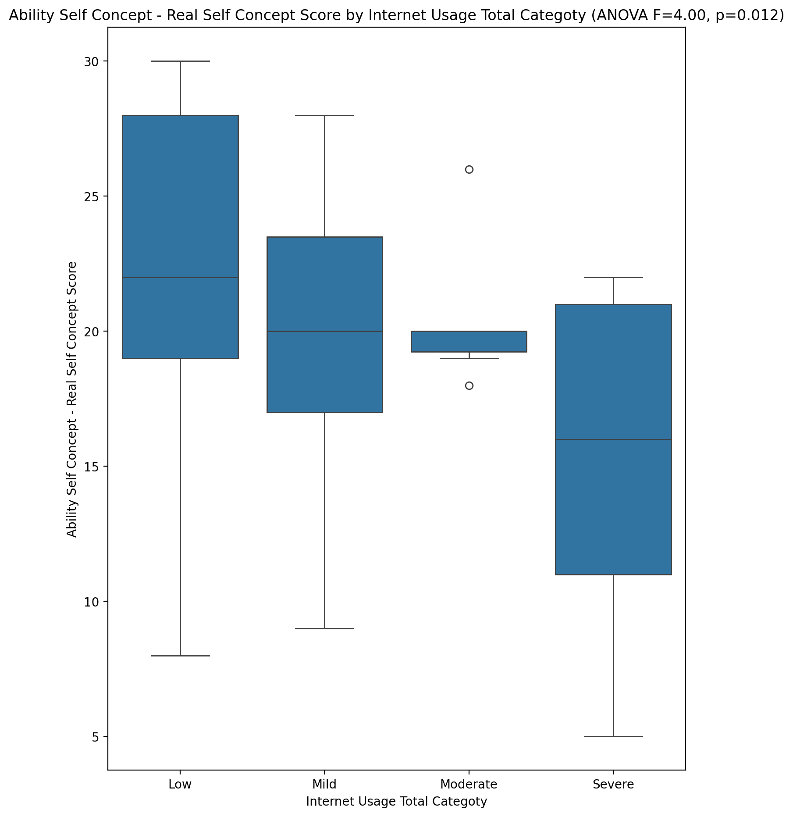

## Ability Self Concept - Ideal Self Concept Score vs Internet Usage Total Categoty

Test: anova; statistic: 1.435781510602191; p-value: 0.2422507164192686;

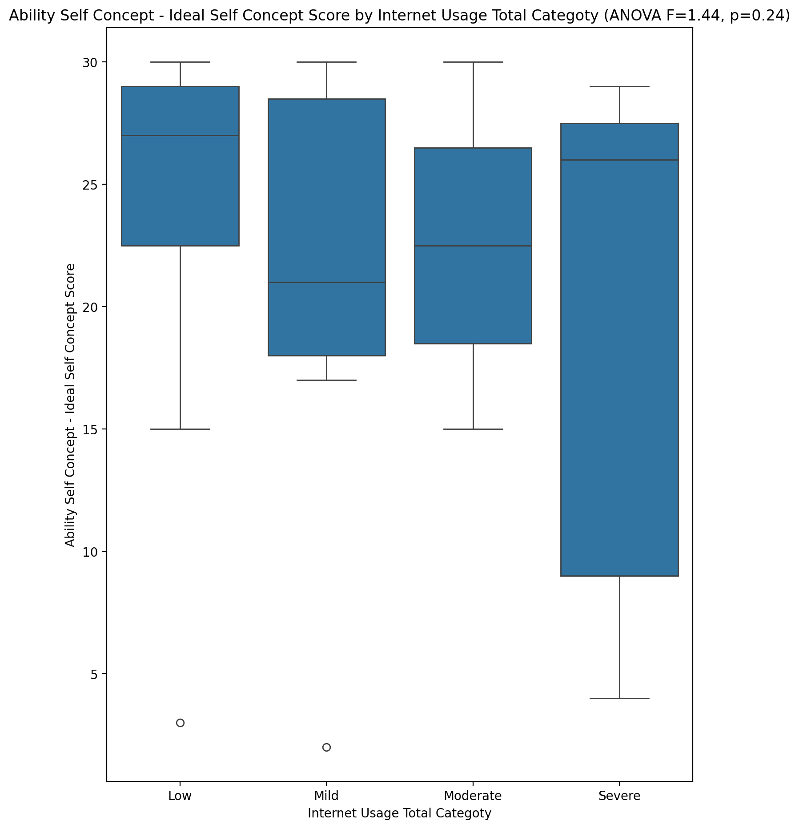

## Ability Self Concept – Social Self Concept Score vs Internet Usage Total Categoty

Test: anova; statistic: 1.4909902036823195; p-value: 0.22711548208992127;

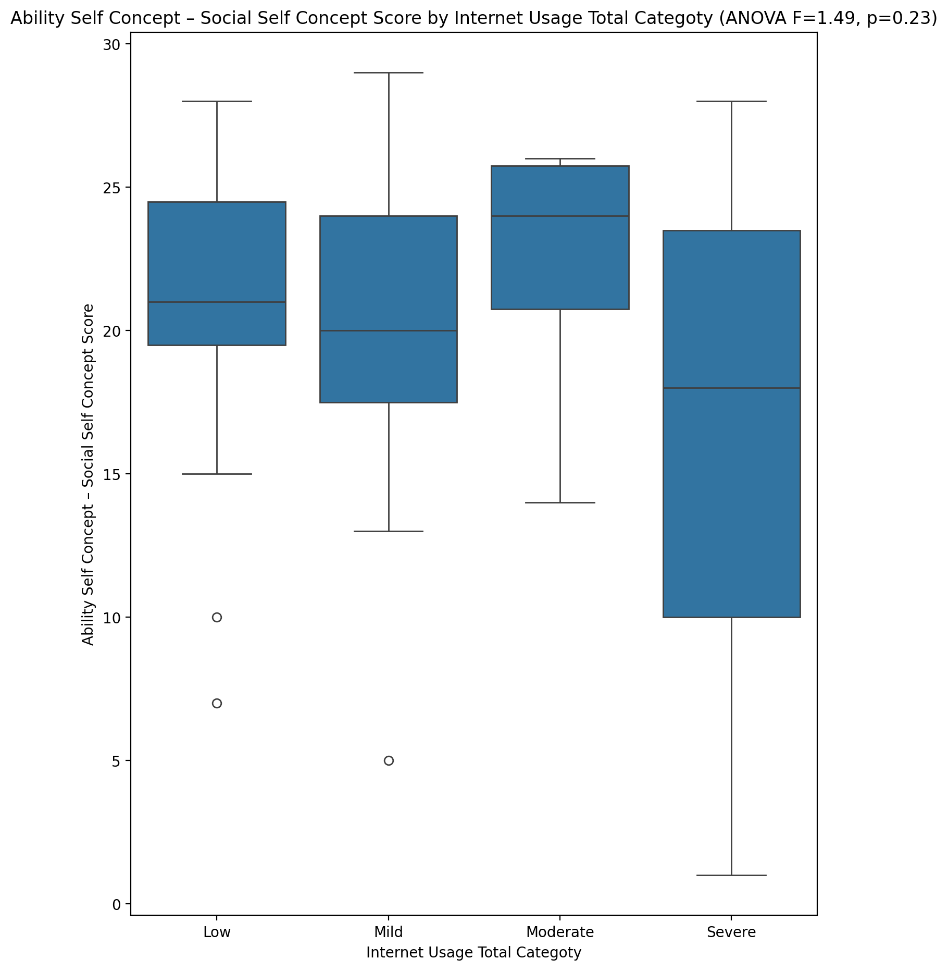

## Physical Self Concept - Real Self Concept Score vs Internet Usage Total Categoty

Test: anova; statistic: 5.499925347315021; p-value: 0.002236961535491524;

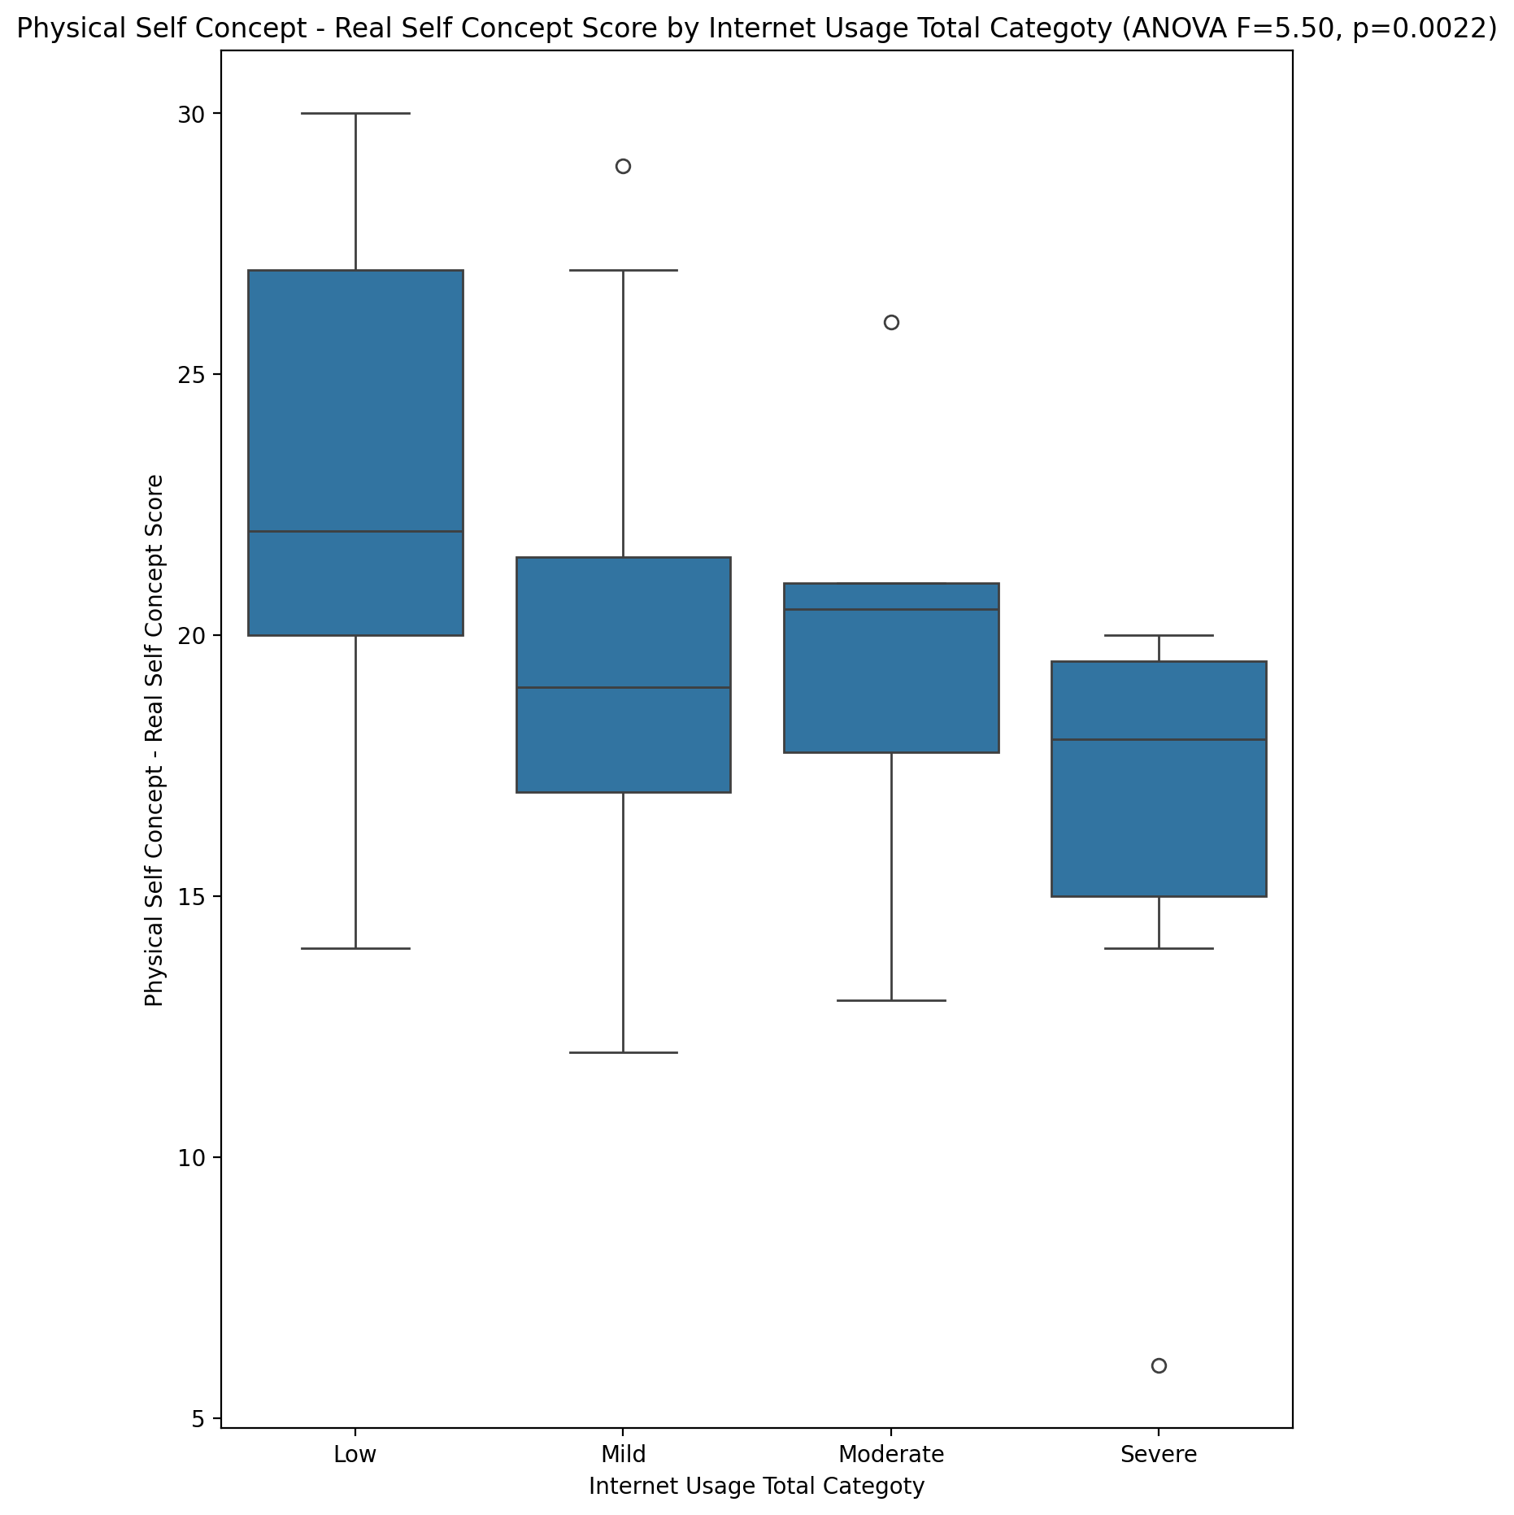

## Physical Self Concept – Ideal Self Concept Score vs Internet Usage Total Categoty

Test: anova; statistic: 1.961109969085199; p-value: 0.1305321877410929;

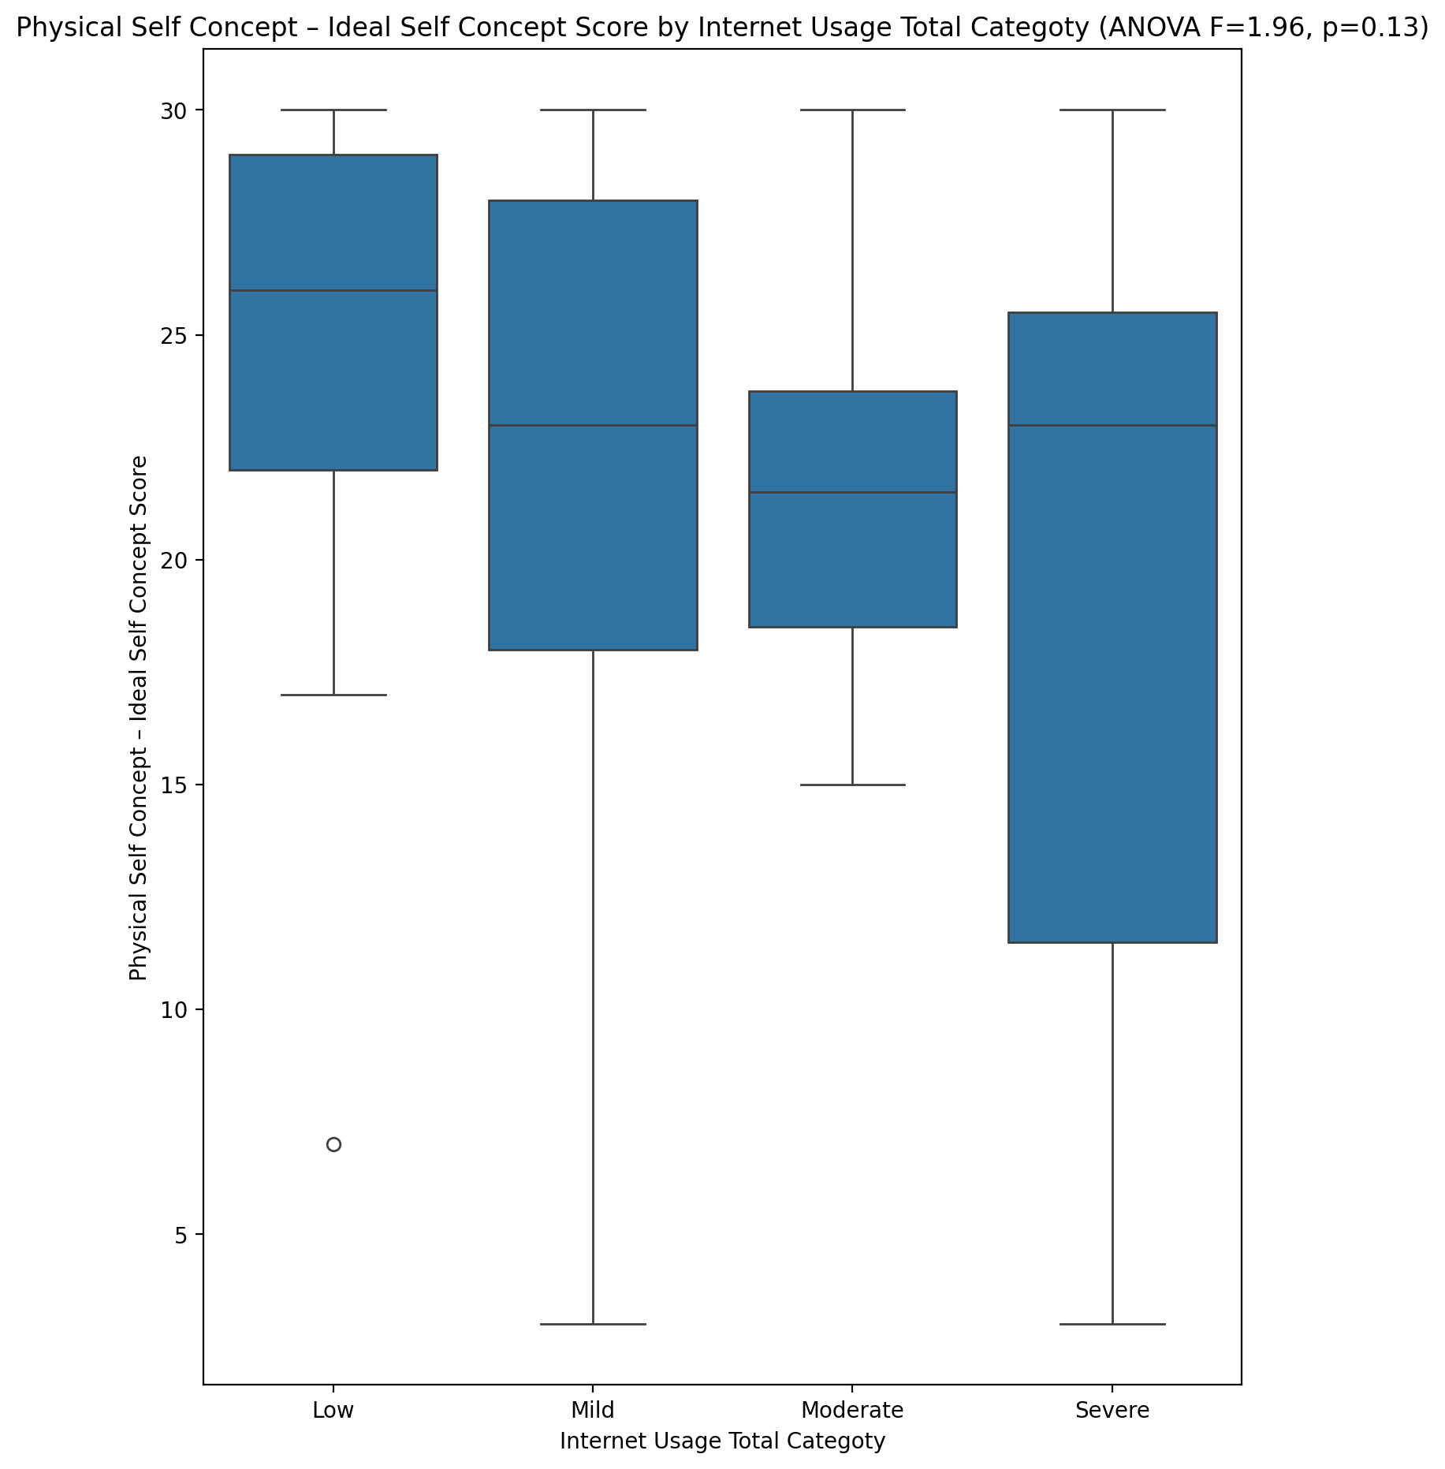

## Physical Self Concept – Social Self Concept Score vs Internet Usage Total Categoty

Test: anova; statistic: 1.7167496927154164; p-value: 0.17420966667044313;

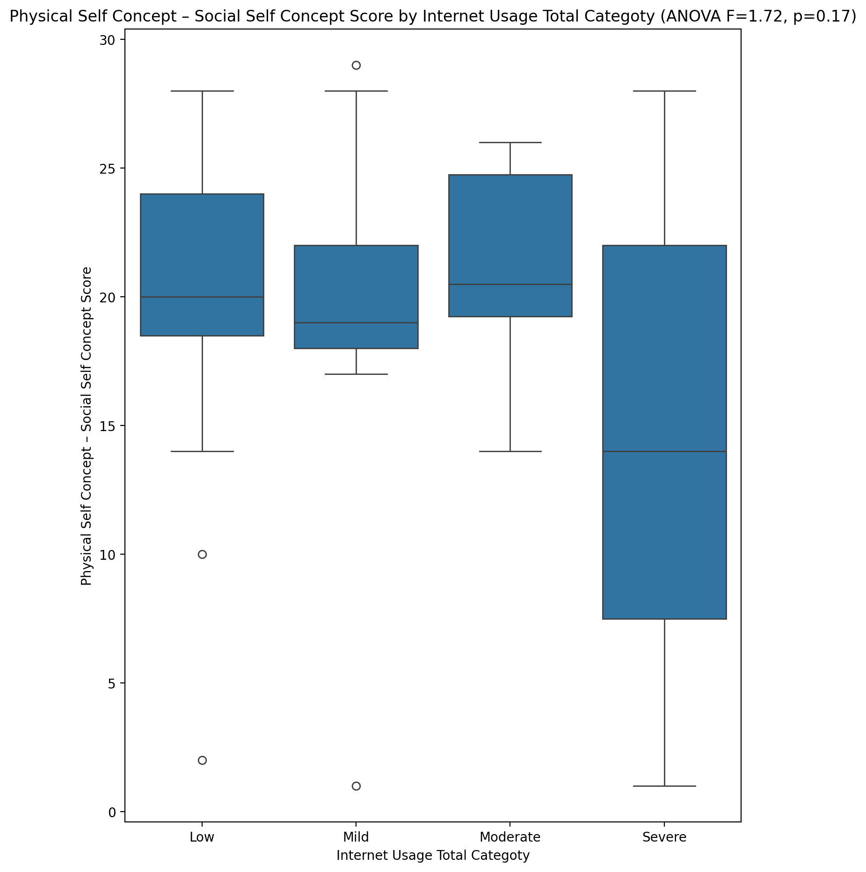

## Psychological Self Concept - Real Self Concept Score vs Internet Usage Total Categoty

Test: anova; statistic: 10.158614194067033; p-value: 2.0020313677052484e-05;

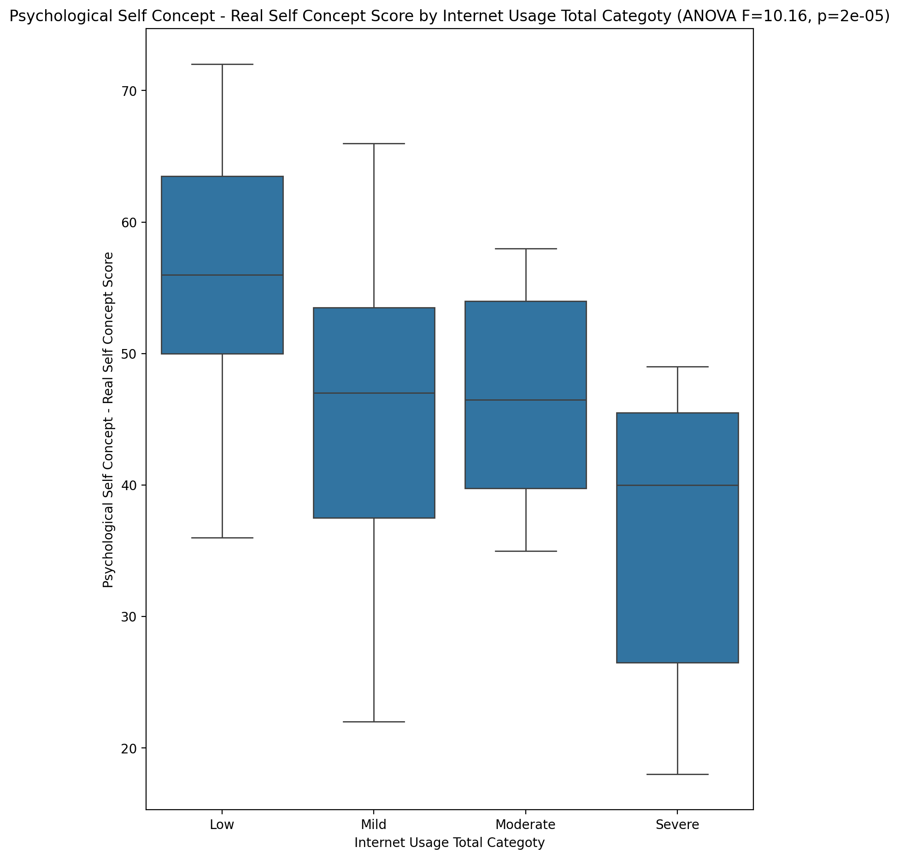

## Psychological Self Concept – Ideal Self Concept Score vs Internet Usage Total Categoty

Test: anova; statistic: 2.376730039646065; p-value: 0.07980177651620533;

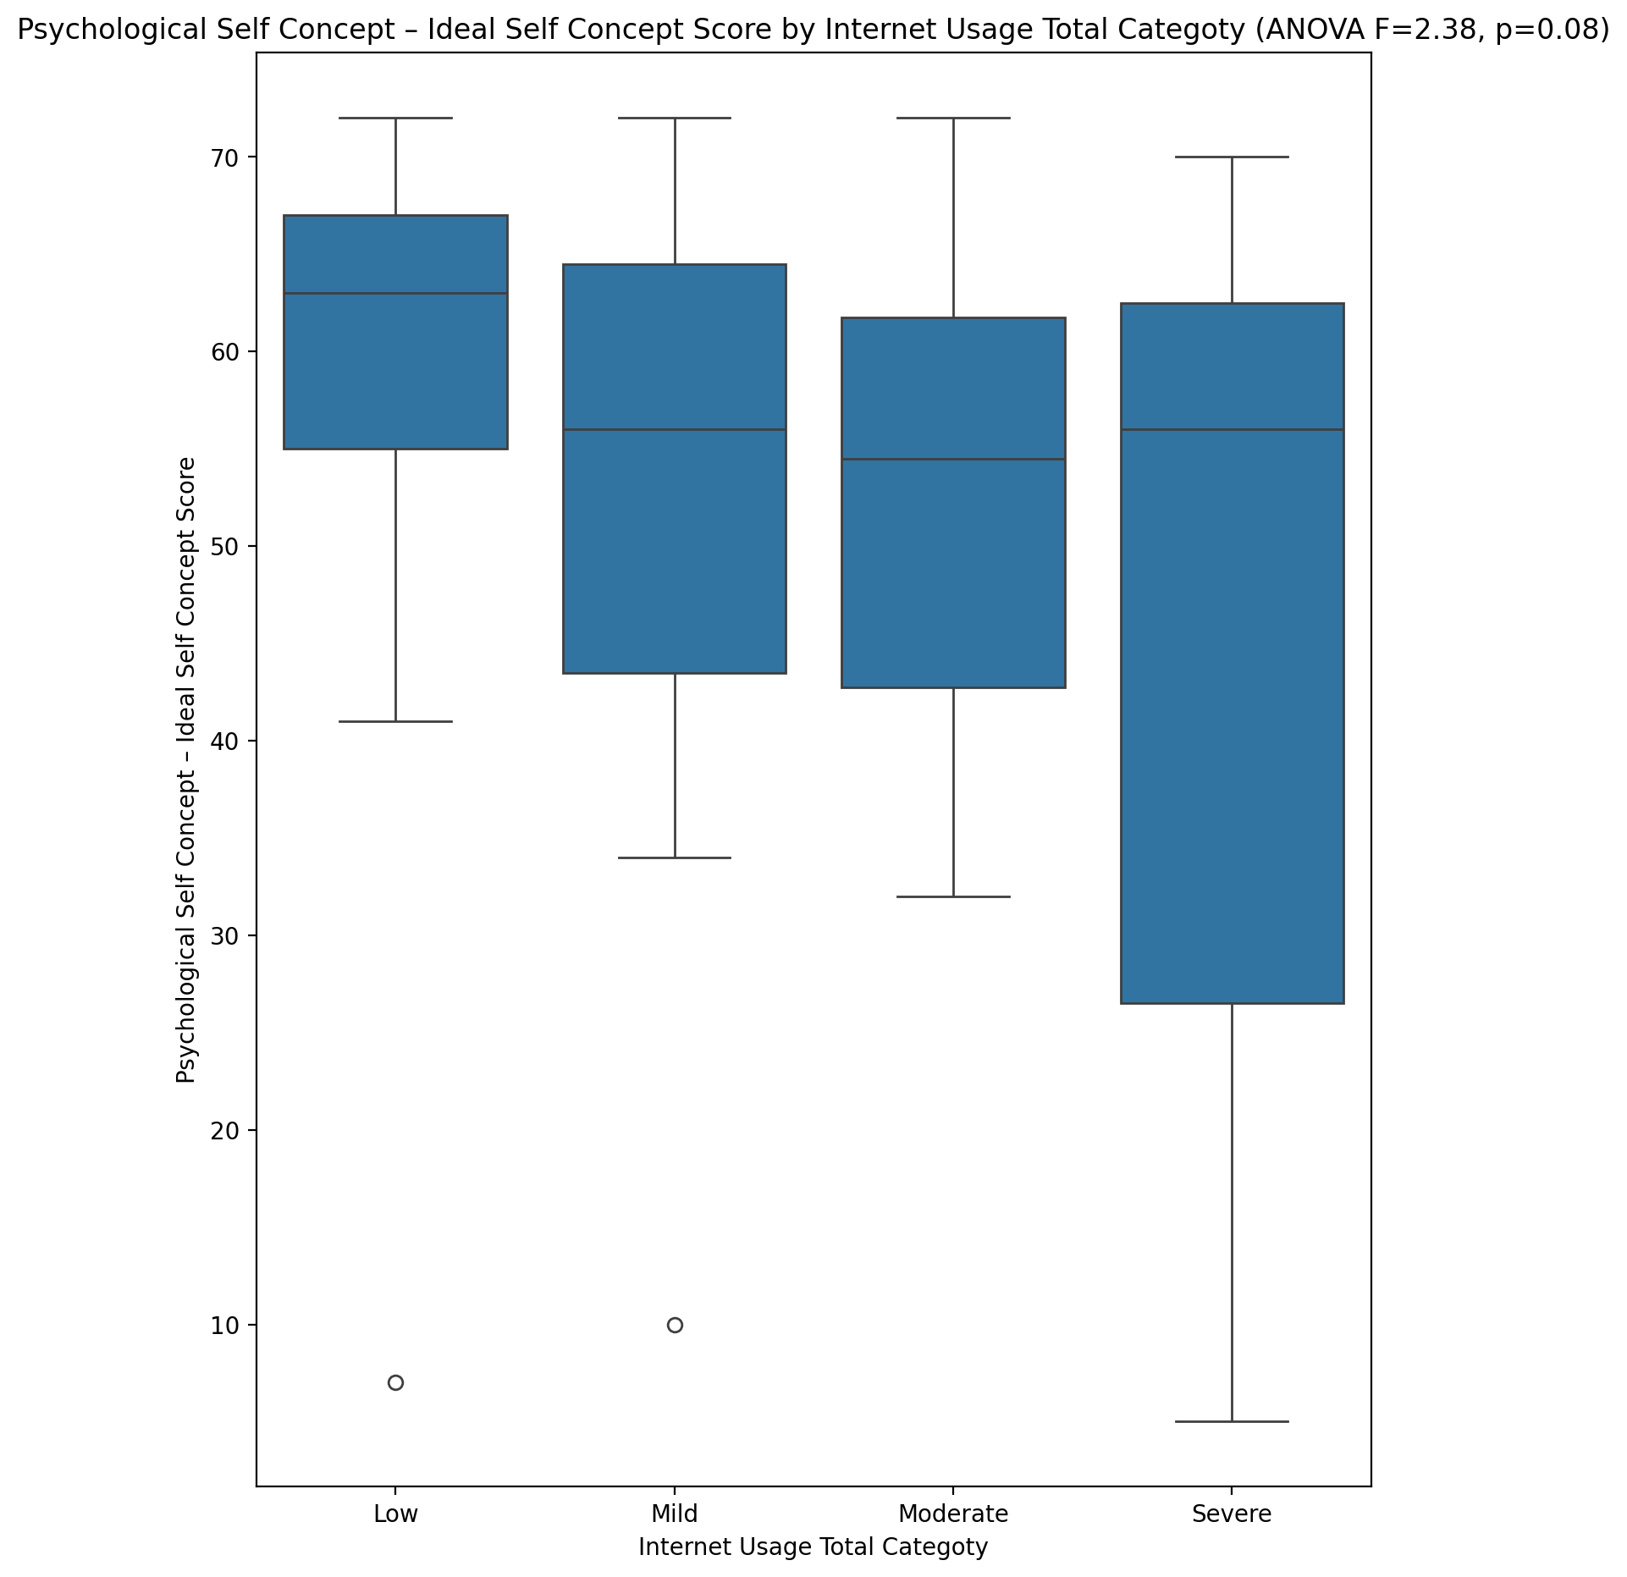

## Psychological Self Concept – Social Self Concept Score vs Internet Usage Total Categoty

Test: anova; statistic: 2.7166947451447956; p-value: 0.05340177869798097;

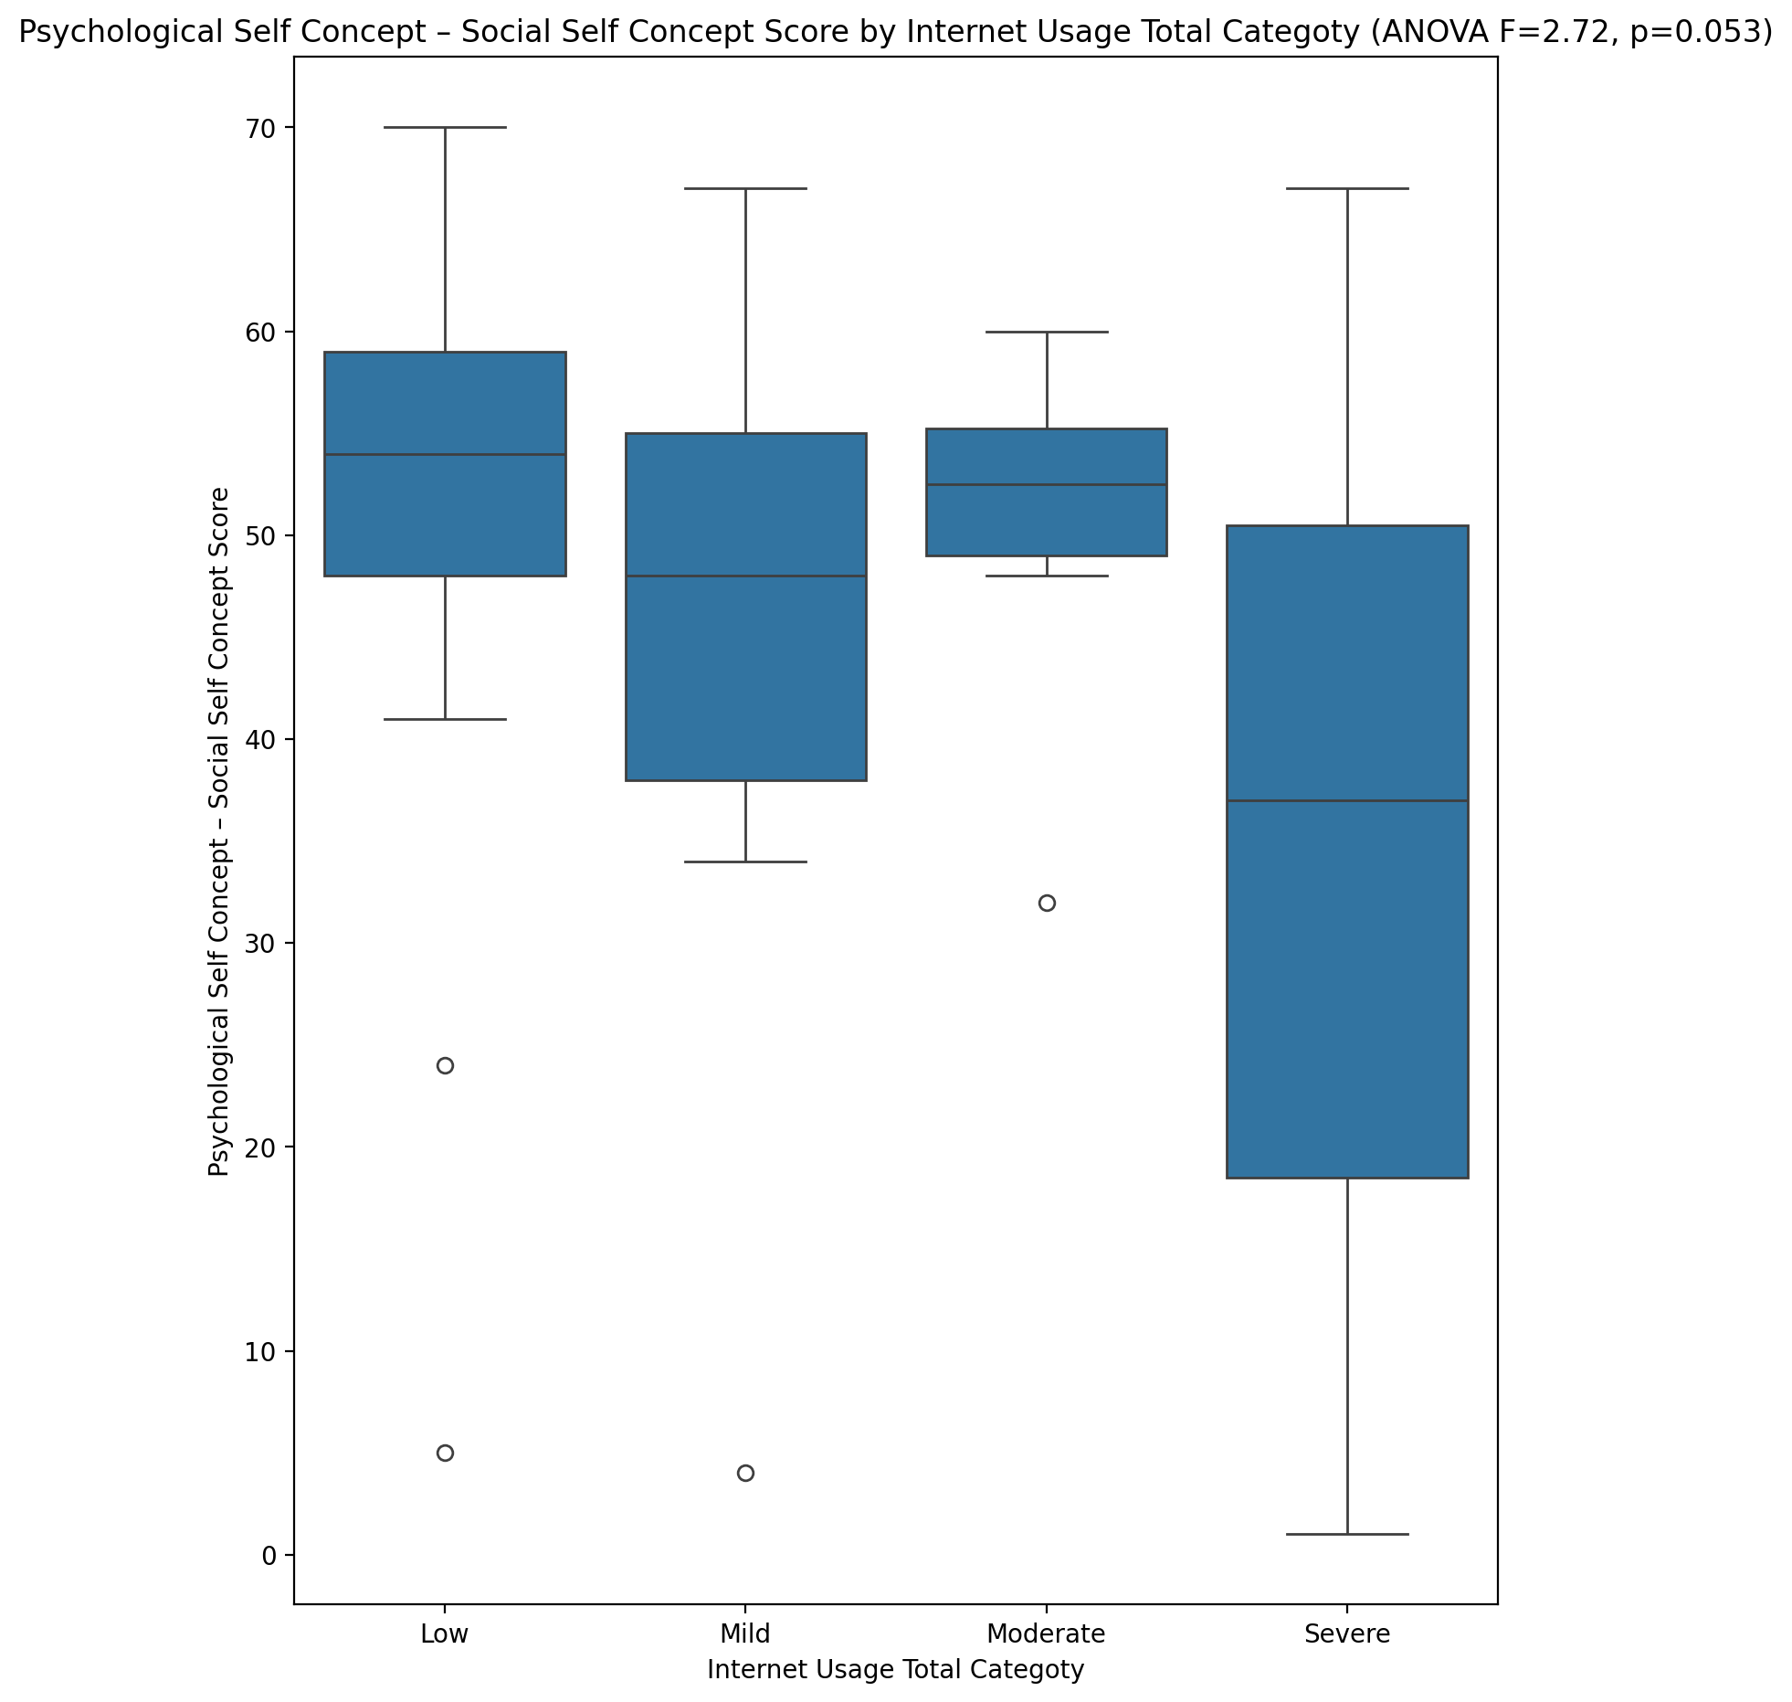

## Real Self Concept Total Score vs Internet Usage Total Categoty

Test: anova; statistic: 7.746304925344399; p-value: 0.00021001853268933225;

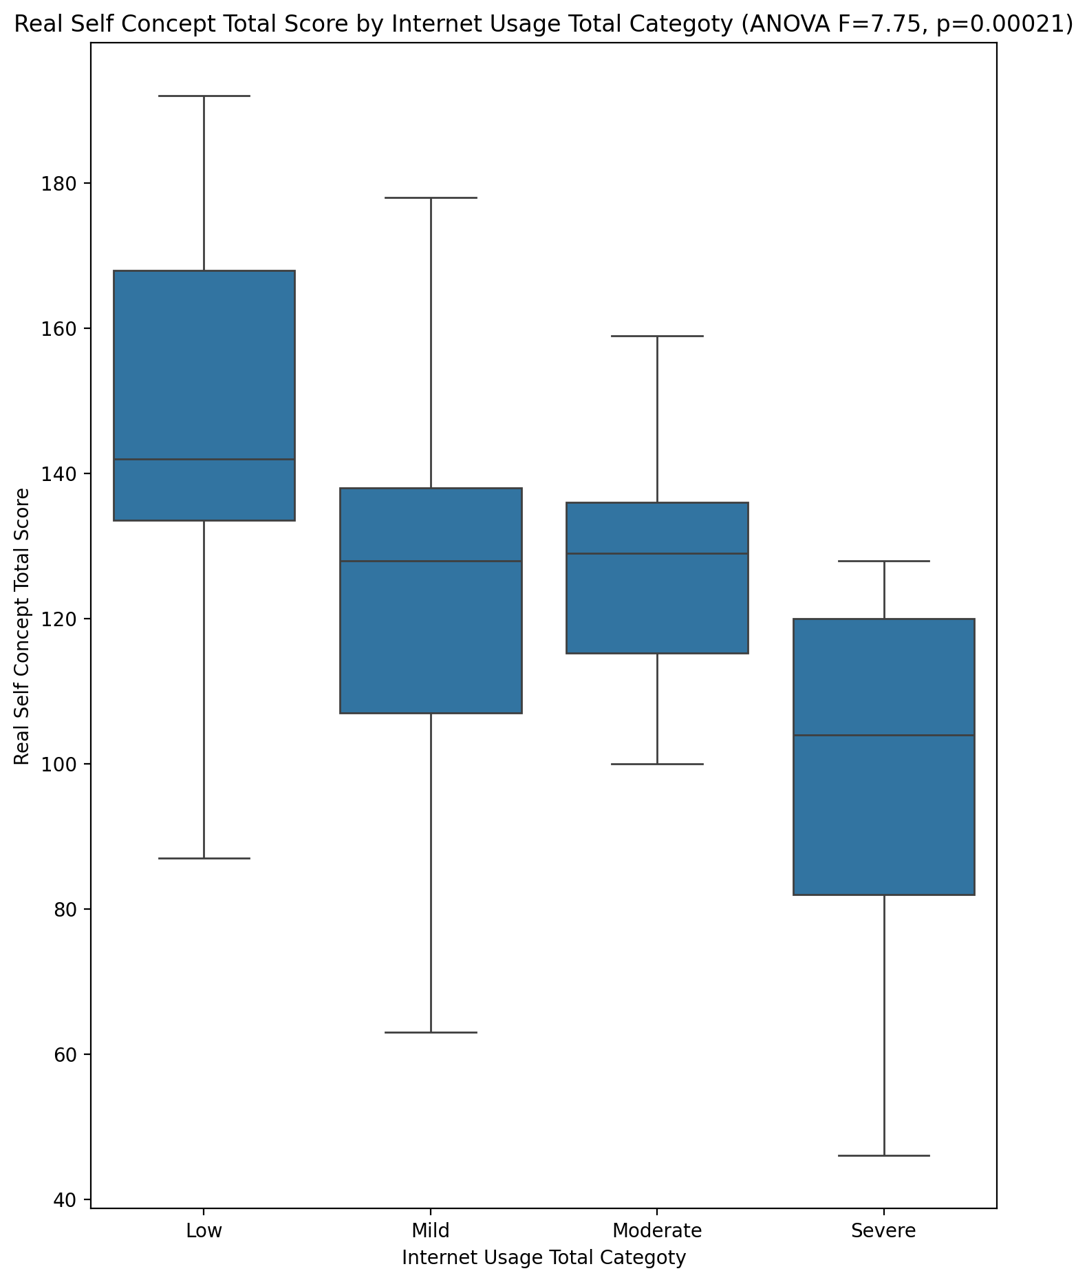

## Ideal Self Concept Total Score vs Internet Usage Total Categoty

Test: anova; statistic: 2.395159115103734; p-value: 0.07808021167285152;

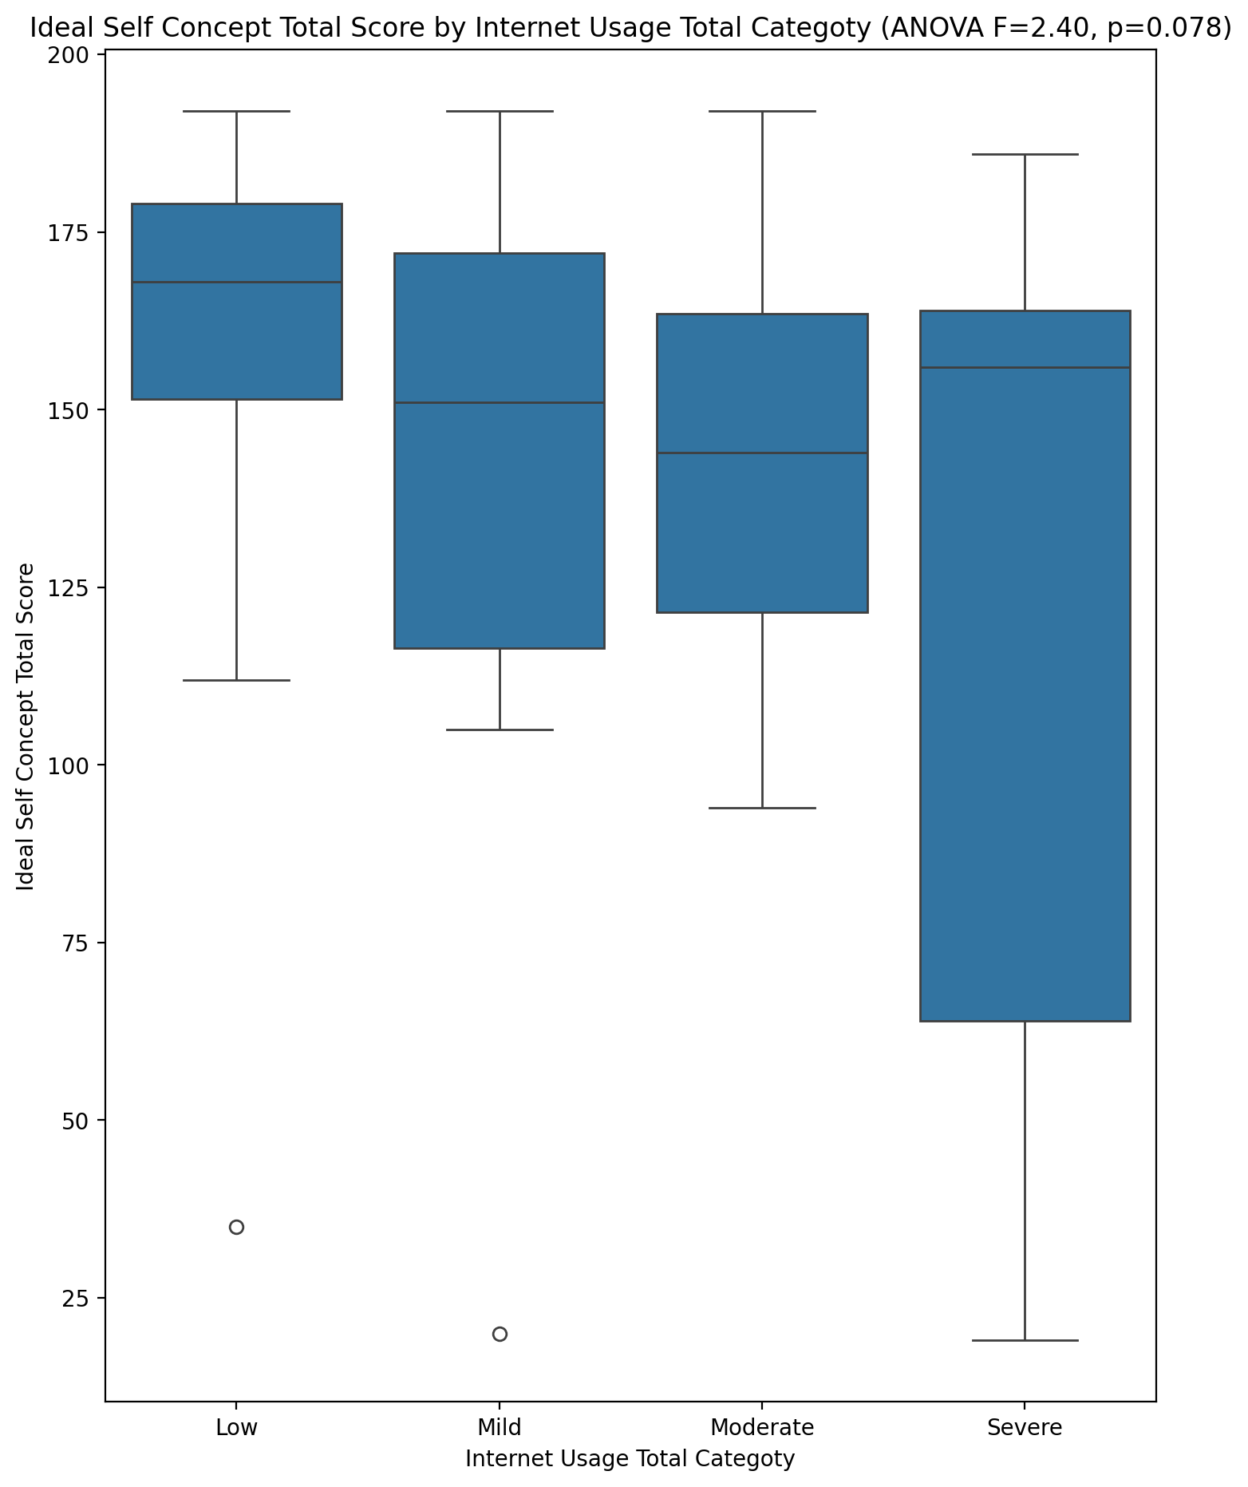

## Social Self Concept Total Score vs Internet Usage Total Categoty

Test: anova; statistic: 2.2560417630915905; p-value: 0.09205839570475946;

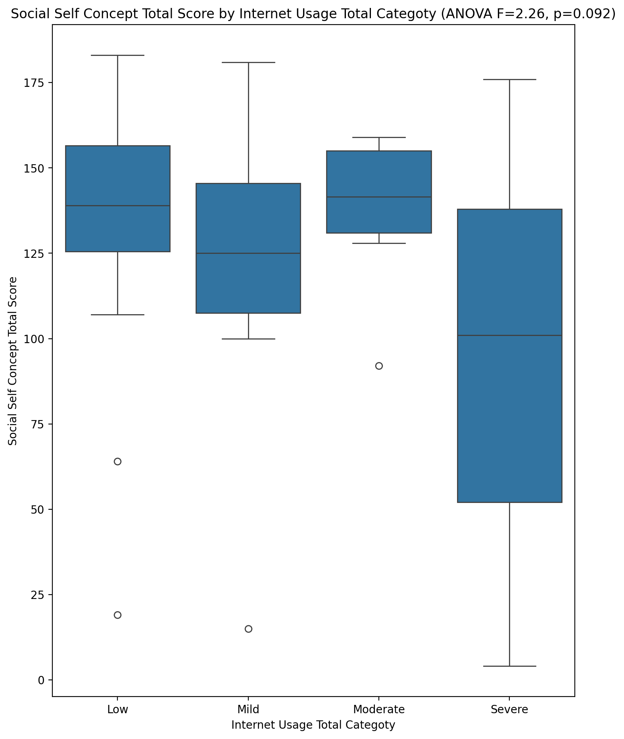

## Ideal Self Concept Total Category vs Internet Usage Total Categoty

Test: chi2; statistic: 10.368993215565798; p-value: 0.1099484846386758;

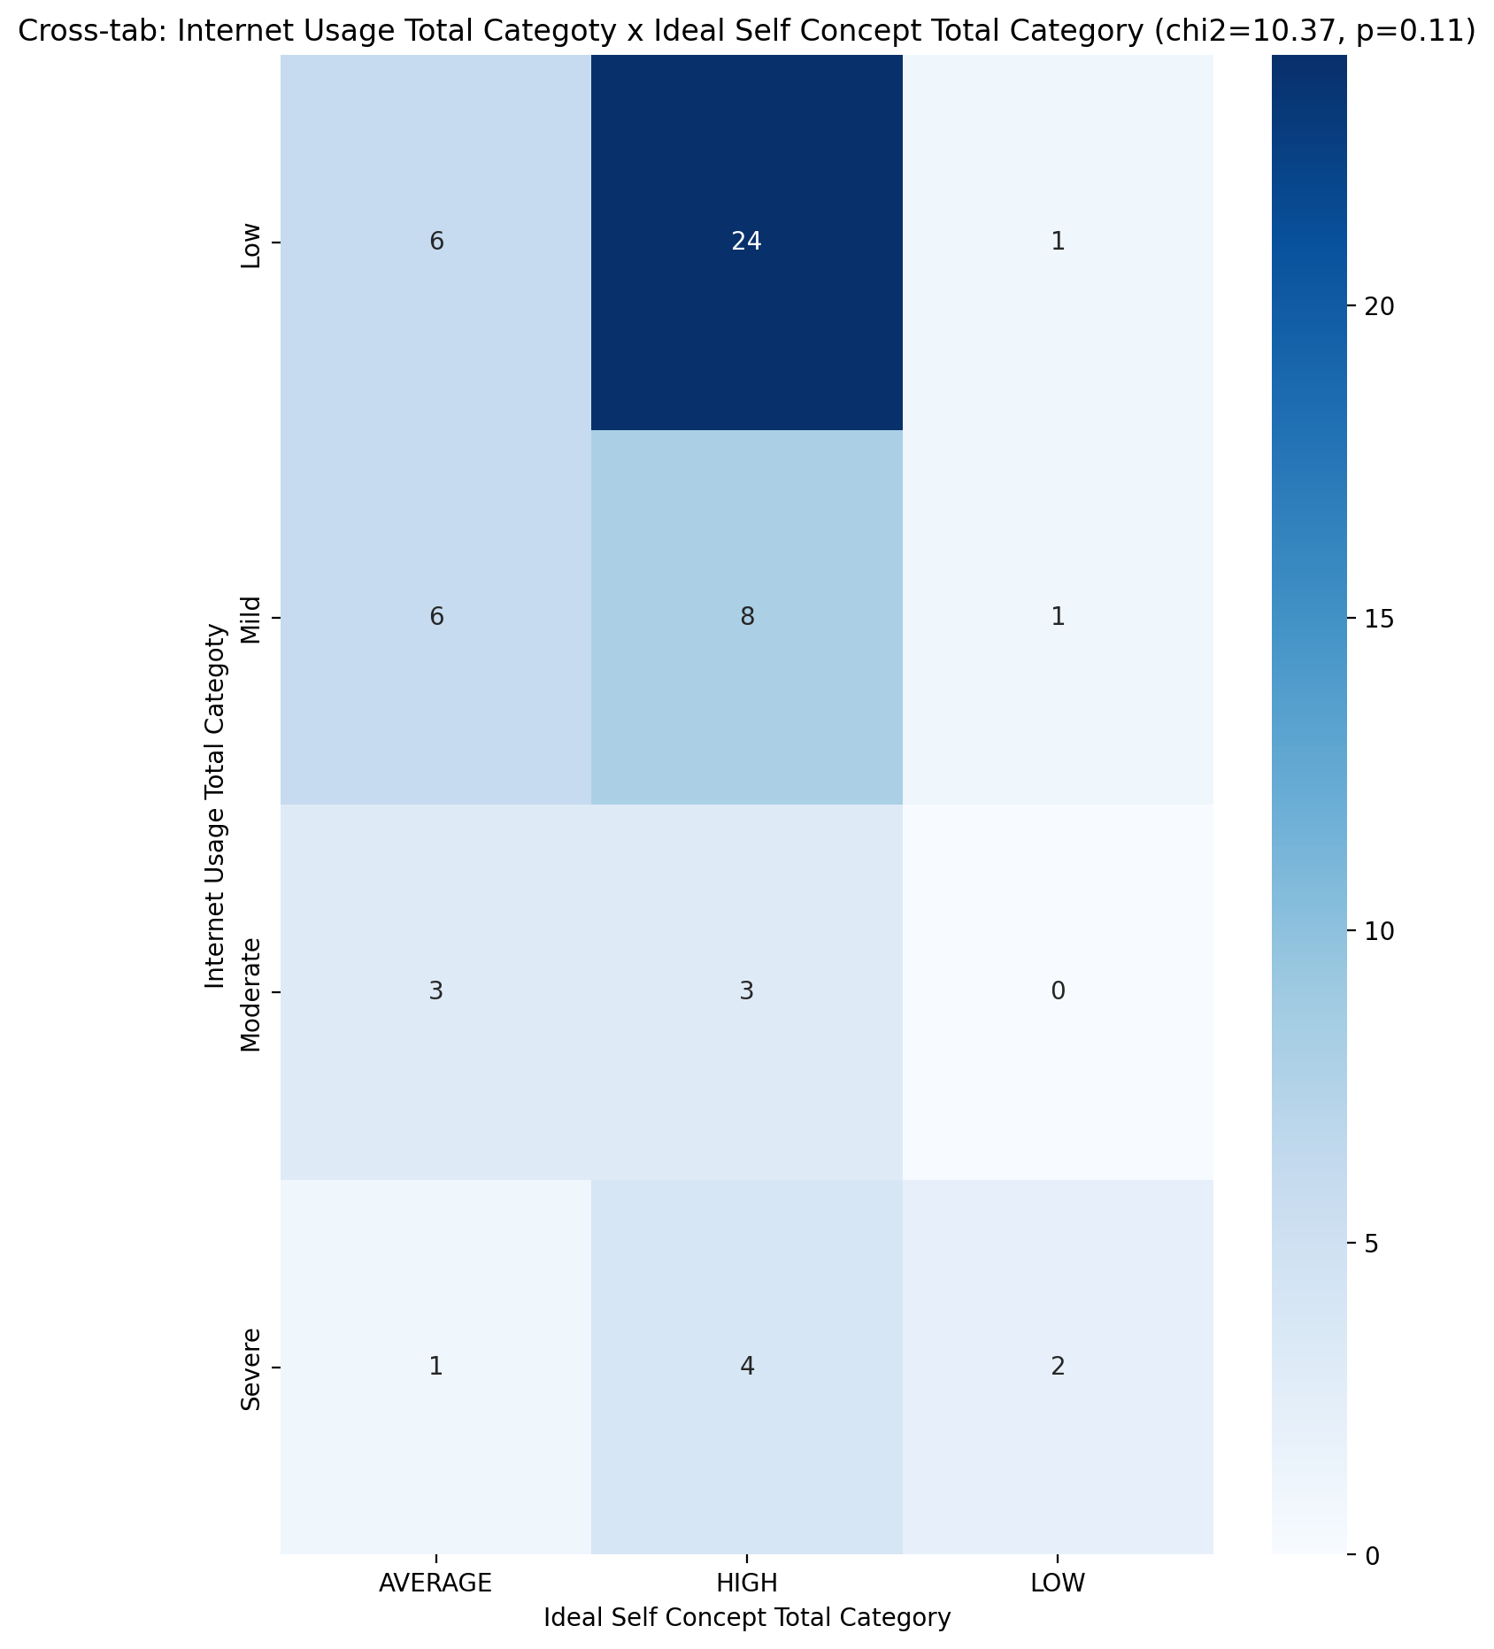

## Perceived Social Stress Score vs Internet Usage Total Categoty

Test: anova; statistic: 6.034212602368234; p-value: 0.00125386400050924;

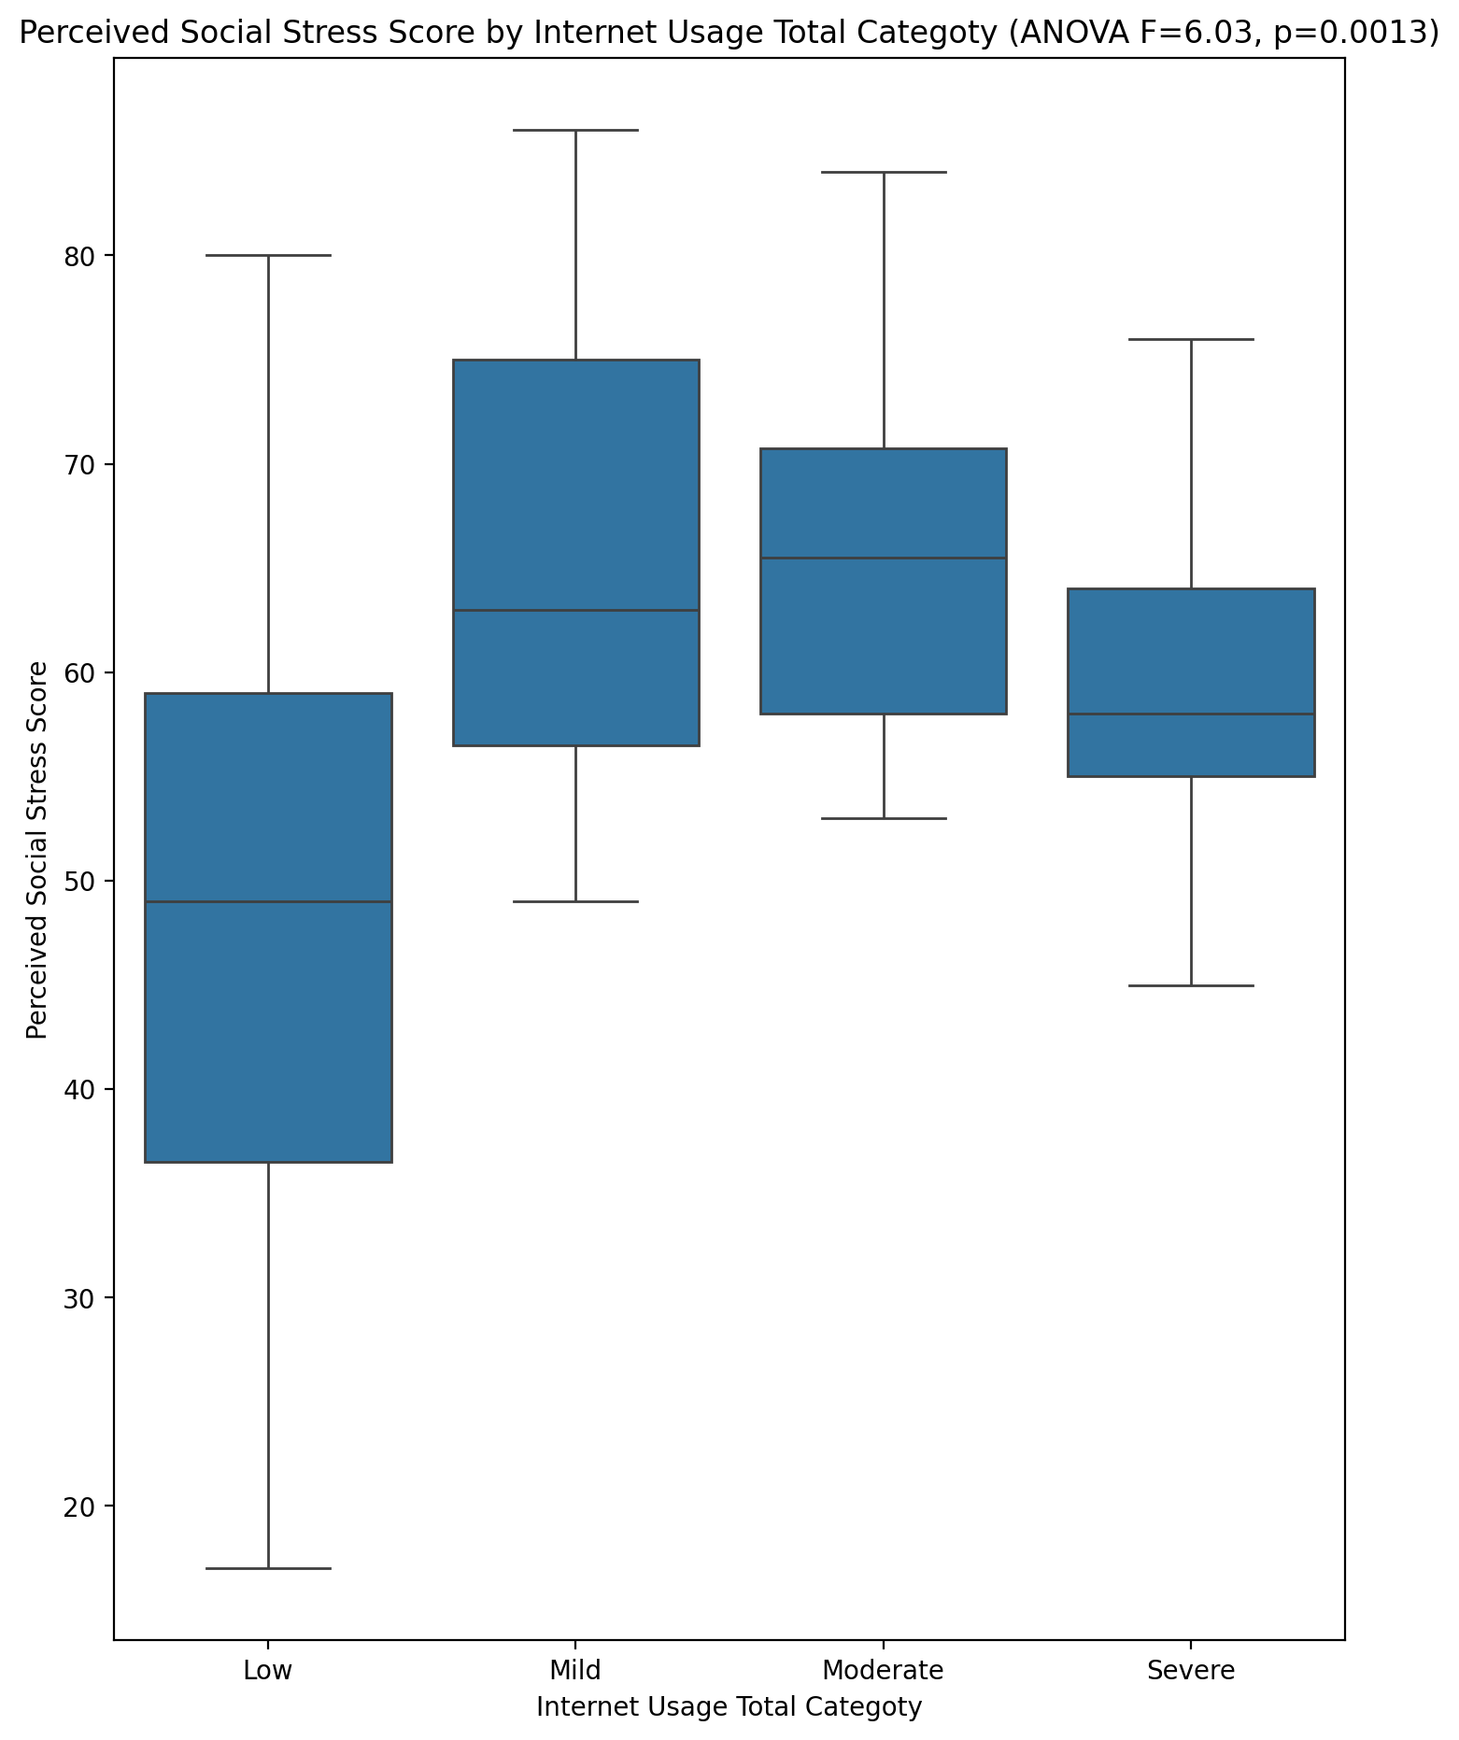

## Perceived Social Stress Category vs Internet Usage Total Categoty

Test: chi2; statistic: 11.38366935483871; p-value: 0.07721818322139605;

